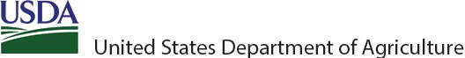

CHILD NUTRITION PROGRAM
SY 2024-25 PROSPECTIVE WAIVER STATE REQUEST FORM

Food and Nutrition Service (FNS) Child Nutrition Programs are expected to be administered in accordance with all statutory and regulatory requirements; waivers to the requirements are exceptions. However, Section 12(l) of the Richard B. Russell National School Lunch Act (NSLA), 42 U.S.C. 1760(l), provides USDA authority to waive requirements for State agencies or eligible service providers under certain circumstances.

This optional form is designed to streamline the process for State agencies requesting a prospective waiver to provide non-congregate meal service in the National School Lunch Program (NSLP), School Breakfast Program (SBP), Summer Food Service Program (SFSP), the NSLP Seamless Summer Option (SSO), and at-risk afterschool component of the Child and Adult Care Food Program (CACFP) when congregate meal service operations are limited due to natural disasters, unscheduled major building repairs, court orders relating to school safety or other issues, labor- management disputes, or, when approved by the State agency for a similar cause.

State agencies utilizing this form should continue to provide notice and information to the public about their applications for a waiver in accordance with the requirements at Section 12(l)(1)(A)(ii) of the NSLA.

- State agency submitting waiver request and responsible State agency staff contact information:

State Agency:
Florida Department of Agriculture and Consumer Services

Date (Click on box to select date.):
8/2/24

Mailing Address:
407 South Calhoun St (H2) Tallahassee, FL 32399

Name and Title of person completing this form:
Lisa Church Chief, Bureau of Child Nutrition Programs

- Region:
Click to choose your region.
Southeast Region

- Affirmation that eligible service providers participating in the waiver(s) are in good standing:
Please check one: Yes No
✔
If No, please explain:

- Description of the challenge the State agency is seeking to solve, the goal of the waiver to improve services under the Program, and the expected outcomes if the waiver is granted. [Section 12(l)(2)(A)(iii) and 12(l)(2)(A)(iv) of the NSLA]:

  - Allow local Program operators to promptly respond to situations when congregate meal service is limited or negatively impacted by unanticipated school building closures caused by natural disasters, unscheduled major building repairs, court orders relating to school safety or other issues, labor-management disputes, or, when approved by the State agency, for a similar unanticipated cause.

  - Other, please specify:

- Specific Program requirements to be waived. [Section 12(l)(2)(A)(i) of the NSLA] Please check only the requirements you are requesting to waive:

SFSP and SSO (Schools buildings are closed with no virtual learning)
The waivers in this section apply to SFSP and SSO when school is closed due to the unanticipated causes listed in section 4, above. This applies when school buildings are closed and virtual classes are not offered. If approved, these waivers are effective through June 30, 2025.
  - Non-Congregate Meal Service (SFSP/SSO)
Under NSLA, 42 U.S.C. 1753(b)(1)(A), 42 U.S.C. 1761(a)(1)(D), and Program
regulations at 7 CFR 225.6(i)(15), SFSP meals served at sites approved for congregate meal service must be served in a congregate setting and must be consumed by participants on site.
  - Meal Service Times (SFSP/SSO)
Under Program regulations at 7 CFR 210.10(l), 7 CFR 220.8(l), 7 CFR 225.16(c)(1), (2), and (3), meals served in the SFSP must follow meal service time requirements.
  - Parent and Guardian Meal Pick-Up (SFSP/SSO)
Under the NSLA, 42 U.S.C. 1761(f)(3), and Program regulations at 7 CFR 210.10(a), 7 CFR 220.2 (Breakfast), 7 CFR 220.8(a), 7 CFR 225.2 (Meals), and 7 CFR 225.9(d)(7),
meals must be served to eligible children.
  - Service of Meals at School Sites during Unanticipated School Closures (SFSP/SSO) Under the NSLA, 42 U.S.C. 1761(c)(1), and Program regulations at 7 CFR 225.6(h)(1)(iv), State agencies may approve meal service operations only at non- school sites during unanticipated school closures.
National School Lunch Program (NSLP) and School Breakfast Program (SBP) (School buildings are closed with virtual learning)

The waivers in this section are intended to provide needed flexibility to support school food authorities (SFAs) in continuing to offer nutritious meals during unanticipated school building closures due to the unanticipated causes listed in section 4, above, when virtual classes are offered. If approved, these waivers are effective through June 30, 2025.

  - Non-Congregate Meal Service (NSLP and SBP)
Under the NSLA, 42 U.S.C. 1753(b)(1)(A), and the Child Nutrition Act, 42 U.S.C. 1773(b)(1)(A), NSLP and SBP meals must be served in a congregate setting and must be consumed by participants on site.
☐■ Meal Service Times (NSLP and SBP)
Under Program regulations at 7 CFR 210.10(l) and 7 CFR 220.8(l), meals served in the NSLP and SBP must follow meal service time requirements.
  - Parent and Guardian Meal Pick Up (NSLP and SBP)
Under Program regulations at 7 CFR 210.10(a), 7 CFR 220.2 (Breakfast), and 7 CFR 220.8(a), meals must be served to eligible children.
  - Offer Versus Serve (NSLP)
Under the NSLA, 42 U.S.C. 1758(a)(3), and Program regulations at 7 CFR 210.10(e), Program operators of senior high schools (as defined by the State education agency) must participate in offer versus serve at lunch.

Child and Adult Care Food Program
The waivers in this section apply to the at-risk afterschool component of CACFP only. These waivers are intended to provide needed flexibility to support at-risk afterschool centers in continuing to offer nutritious meals during unanticipated school closures due to the unanticipated causes listed in section 4, above. If approved, these waivers are effective through June 30, 2025.
  - Non-Congregate Meal Service (CACFP)
Under the NSLA, 42 U.S.C. 1766(f)(1)(A), CACFP meals must be served in a congregate setting and must be consumed by participants on site.
  - Meal Service Times (CACFP)
Under Program regulations at 7 CFR 226.17a(m), meals served in the CACFP must follow meal service time requirements.
  - Parent and Guardian Meal Pick Up (CACFP)
Under the NSLA, 42 U.S.C. 1766(f)(1)(A) and Program regulations at 7 CFR 226.2(Meals), meals must be served to eligible children.
  - Enrichment Activity (CACFP)
Under the NSLA, 42 U.S.C. 1766(r)(2)(B), afterschool meals and snacks must be served in a school or program with an educational or enrichment purpose. FNS regulations further require at 7 CFR 226.17a(b)(1)(ii) and (iii), eligible schools and at-risk afterschool care centers to serve afterschool meals and snacks in a structured and supervised
- Detailed description of alternative procedures and anticipated impact on Program operations, including technology, State systems, and monitoring:
FDACS will utilize its administrative procedures for emergency meals as provided in Rule 5P-2.009, F.A.C. and Rule 5P-3 F.A.C., which outline the eligibility requirements, application process, requirements for the identification of meal service times and locations, meal pattern requirements, claims for reimbursement process, and record retention requirements.

In the event a School District is unable to provide meals during an unanticipated school closure, FDACS will solicit the remaining sponsors of the SFSP for the county in which the non-participating School District resides, and responses with be considered on a first come, first served basis, in accordance with Rule 5P-3 F.A.C.

FDACS also has template meal count forms that are available for download, or can be printed and shipped to program sponsors, for use during the implementation of the requested waiver if for any reason the Point of Service (POS) becomes inaccessible during an unanticipated school closure.

The Florida Automated Nutrition System (FANS) is also accessible using any standard Internet browser – desktop or mobile – so that meal counts can be entered from any location and submitted to FDACS without the need of any alternative procedures

FDACS will continue to conduct program monitoring in accordance with 7 CFR 225.7(d) throughout the implementation period of the waiver.

- Description of any steps the State has taken to address regulatory barriers at the State level. [Section 12(l)(2)(A)(ii) of the NSLA]:
  - No regulatory barriers expected at the State level.
  - If regulatory barriers are expected at the State level, please list steps taken to address them in the box below:

- Anticipated challenges State or eligible service providers may face with the waiver implementation:
  - No challenges to the State or eligible providers are anticipated with this waiver implementation.
  - If the State or eligible service providers anticipate challenges implementing this waiver, please explain in the box below:

- Description of how the waiver will not increase the overall cost of the Program to the Federal Government. If there are anticipated increases, confirm that the costs will be paid from non-Federal funds. [Section 12(l)(1)(A)(iii) of the NSLA]:
  - No anticipated increase of Federal Government costs.

  - Other, please specify:

- Anticipated waiver implementation date and time period:

  - Through June 30, 2025.

  - Other, please specify:

- Proposed monitoring and review procedures:
Meal counts and records will be maintained for meals served under the waiver. The total meals served under waiver will be submitted to FNS monthly and upon final use of the waiver in Florida during each instance of an unforeseen event.

- Link to or a copy of the public notice informing the public about the proposed waiver [Section 12(l)(1)(A)(ii) of the NSLA]:

- Signature and Title of Requesting Official:
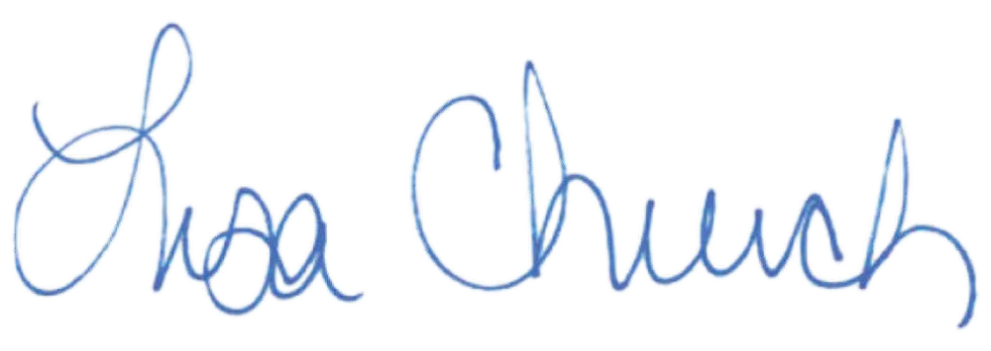

Title:

Requesting official’s email address for transmission of response:
Lisa.Church@FDACS.gov
Chief, Bureau of Child Nutrition Programs
TO BE COMPLETED BY FNS REGIONAL OFFICE:

FNS Regional Offices are requested to ensure the questions have been adequately addressed by the State agency and formulate an opinion and justification for a response to the waiver request based on their knowledge, experience and work with the State.

Date request was received at Regional Office (Click on box to select date.):

  - Check this box to confirm that the State agency has provided public notice in accordance with Section 12(l)(1)(A)(ii) of the NSLA

- Regional Office Analysis and Recommendations:

Signature from FNS Regional Office:

