68D-24.018 St. Johns River Boating Restricted Areas.
(1) For the purpose of regulating the speed and operation of vessel traffic on the St. Johns River in Lake, Seminole and Volusia Counties, Florida the following boating restricted areas are established. The boating restricted areas exclude all associated tributaries, creeks, canals, backwaters, channels, boat basins and other waterways unless otherwise designated or specifically described for inclusion:
(a) Year-Round Boating Restricted Areas.
1. Lake George Fender System: A Slow Speed Minimum Wake zone within the fender system and associated channel at the south end of Lake George, bounded on the north by a line drawn perpendicular to the centerline of the channel at the north end of the fender system and bounded on the southeast by a line drawn perpendicular to the centerline of the channel 1,500 feet south and southeast of the south end of the fender system, as depicted in Drawing A.
2. South Moon Canal:
A Slow Speed Minimum Wake zone from shoreline to shoreline in the St. Johns River, bounded on the northwest by a line drawn perpendicular to the centerline of the St. Johns River 50 feet north of the confluence of South Moon Canal and the St. Johns River and bounded on the south by a line drawn perpendicular to the centerline of the St. Johns River 850 feet south of said confluence, as depicted in Drawing B.
3. Jungle Den Canal:
A Slow Speed Minimum Wake zone from shoreline to shoreline in the St. Johns River, bounded on the northwest by a line drawn perpendicular to the centerline of the St. Johns River 50 feet northwest of the confluence of Jungle Den Canal and the St. Johns River and bounded on the south by a line drawn perpendicular to the centerline of the St. Johns River 1,250 feet south of said confluence, as depicted in Drawing C.
4. SR 40 (Astor) Bridge: A Slow Speed Minimum Wake zone from shoreline to shoreline in the St. Johns River, bounded on the north by a line drawn perpendicular to the centerline of the St. Johns River 875 feet north of the north end of the fender of the SR 40 (Astor) Bridge and bounded on the south by a line drawn perpendicular to the centerline of the St. Johns River 2,125 feet south of the south end of the fender of said bridge, as depicted in Drawing D.
5. SR 44 (Whitehair) Bridge: A Slow Speed Minimum Wake zone from shoreline to shoreline in the St. Johns River, bounded on the north by a line drawn perpendicular to the centerline of the St. Johns River 2,375 feet northwest of the northwest end of the fender of the SR 44 (Whitehair) Bridge and bounded on the south by a line drawn perpendicular to the centerline of the St. Johns River 1,025 feet south of the south end of the fender of said bridge, as depicted in Drawing E.
6. Hontoon Island State Park: A Slow Speed Minimum Wake zone from shoreline to shoreline in the St. Johns River, bounded on the north by a line drawn perpendicular to the centerline of the St. Johns River 4,025 feet northeast of the confluence of the Hontoon Dead River and the St. Johns River and bounded on the southeast by a line drawn perpendicular to the centerline of the St. Johns River 1,950 feet southeast of said confluence, as depicted in Drawing F.
7. Highbanks Boat Ramp: A Slow Speed Minimum Wake zone from shoreline to shoreline in the St. Johns River, bounded on the north by a line drawn perpendicular to the centerline of the St. Johns River 450 feet north of the centerline of Highbanks Boat Ramp and bounded on the south by a line drawn perpendicular to the centerline of the St. Johns River 350 feet south of the centerline of said boat ramp, as depicted in Drawing G.
8. Lake Monroe: A Slow Speed Minimum Wake zone from shoreline to shoreline in the St. Johns River, bounded on the west by a line drawn perpendicular to the centerline of the St. Johns River 1,075 feet west of the west end of the CSX Railroad Bridge fender and bounded on the southeast by a line drawn perpendicular to the centerline of the St. Johns River 125 feet east of the east end of the I-4 Bridge fender, to include Lake Monroe Park Basin, as depicted in Drawing H.
9. Lemon Bluff:
A Slow Speed Minimum Wake zone from shoreline to shoreline in the St. Johns River, bounded on the northeast by a line drawn perpendicular to the centerline of the St. Johns River at the northeast tip of the unnamed island (located at approximate latitude 28º 48.394' North, approximate longitude 81º 7.799' West) southeast of Lemon Bluff Boat Ramp, and bounded on the south by a line drawn perpendicular to the centerline of the St. Johns River 250 feet northwest of the southern tip of said unnamed island (located at approximate latitude 28º 48.282' North, approximate longitude 81º 7.806' West), as depicted in Drawing I.
(b) Flood Zones.
1. Astor: During flooding, an Idle Speed No Wake zone from shoreline to shoreline in the St. Johns River, bounded on the northwest by a line drawn perpendicular to the centerline of the St. Johns River 50 feet north of the confluence of South Moon Canal and the St. Johns River and bounded on the south by a line drawn perpendicular to the centerline of the St. Johns River approximately 4,160 feet south of the south end of the fender of the SR 40 (Astor) Bridge to GPS position 29° 9.37267' North 81°31.38050' West, as depicted in Drawing J, when the St. Johns River water level is in the action stage or higher when measured at the United States Geological Survey gauge at Astor (USGS site #02236125), as determined by the action stage established by the National Oceanic and Atmospheric Administration (NOAA).
2. Highbanks Boat Ramp: During flooding, an Idle Speed No Wake zone from shoreline to shoreline in the St. Johns River, bounded on the north by a line drawn perpendicular to the centerline of the St. Johns River 1,700 feet north of the centerline of Highbanks Road Boat Ramp and bounded on the southwest by a line perpendicular to the centerline of the St. Johns River 1,800 feet south of the centerline of the Highbanks Boat Ramp, as depicted in Drawing K, when the St. Johns River water level is in the action stage or higher when measured at the United States Geological Survey gauge at Sanford (USGS site #02234500), as determined by the action stage established by the NOAA.
3. Mullet Lake Park: During flooding, an Idle Speed No Wake zone from shoreline to shoreline in the St. Johns River, bounded on the east by a line drawn perpendicular to the centerline of the St. Johns River at Mullet Lake Park Boat Ramp and bounded on the west by a line drawn perpendicular to the centerline of the St. Johns River 3,000 feet west of Mullet Lake Park Boat Ramp, as depicted in Drawing L, when the St. Johns River water level is in the action stage or higher when measured at the United States Geological Survey gauge at Lake Harney (USGS site #02234000), as determined by the action stage established by the NOAA.
4. Lemon Bluff: During flooding, an Idle Speed No Wake zone from shoreline to shoreline in the St. Johns River, bounded on the northeast by a line drawn perpendicular to the centerline of the St. Johns River at the northeast tip of the unnamed island (located at approximate latitude 28º 48.394' North, approximate longitude 81º 7.799' West) southeast of Lemon Bluff Boat Ramp and bounded on the southwest by a line drawn perpendicular to the centerline of the St. Johns River 3,675 feet southwest of the southern tip of said unnamed island (located at approximate latitude 28º 48.282' North, approximate longitude 81º 7.806' West), as depicted in Drawing M, when the St. Johns River water level is in the action stage or higher when measured at the United States Geological Survey gauge at Lake Harney (USGS site #02234000), as determined by the action stage established by the NOAA.
5. Lake Monroe: During flooding, an Idle Speed No Wake zone from shoreline to shoreline in the St. Johns River, bounded on the southeast by the northwesterly side of the I-4 bridge in Sanford, Florida, and bounded on the northwest by a line drawn perpendicular to the centerline of the St. Johns River at approximate latitude 28° 50.61660ꞌ North, and approximate longitude 81° 20.23200ꞌ West, including all canals associated with St. Johns River Estates, Boat Tree Marina, the intake and discharge canals at the Sanford Power Plant, and the water basin on the north side of the River between US Highway 17/92 and I-4, as depicted in Drawing N, when the St. Johns River water level is in the action stage or higher when measured at the United States Geological Survey gauge at Sanford (USGS site #02234500), as determined by the action stage established by the NOAA.
(c) Lake, Seminole and Volusia counties are authorized to install and maintain appropriate regulatory markers demarcating the flood zones as directed by the Division of Law Enforcement within the boating restricted areas, or portions thereof, located within the respective counties. These counties may enter into agreements with public or private organizations or individuals to effect this purpose. Lake, Seminole and Volusia counties are authorized to make public service announcements to notify the public of the changes in speed zones before, during and after flooding.
(2) The boating restricted areas described in Rule 68D-24.018, F.A.C., are depicted on the following drawings:
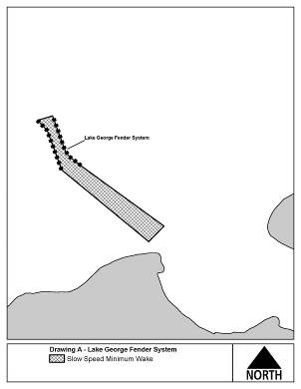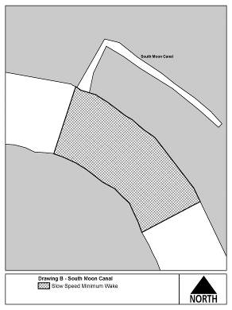

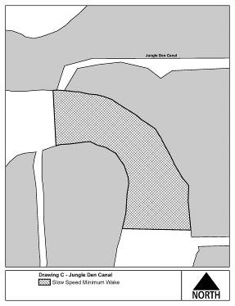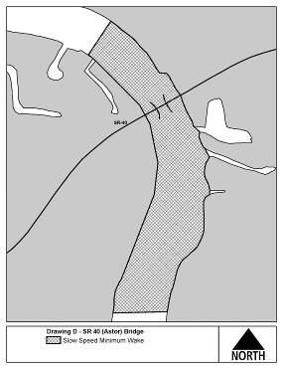

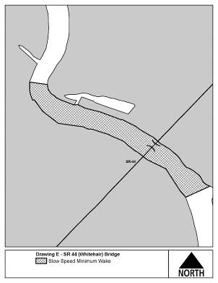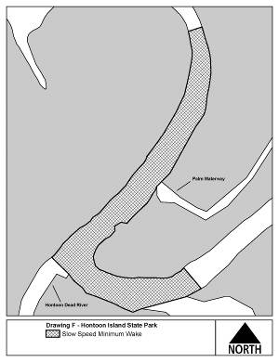

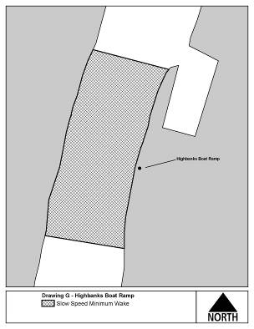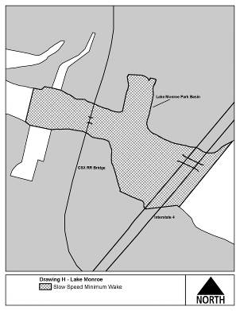

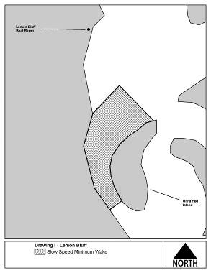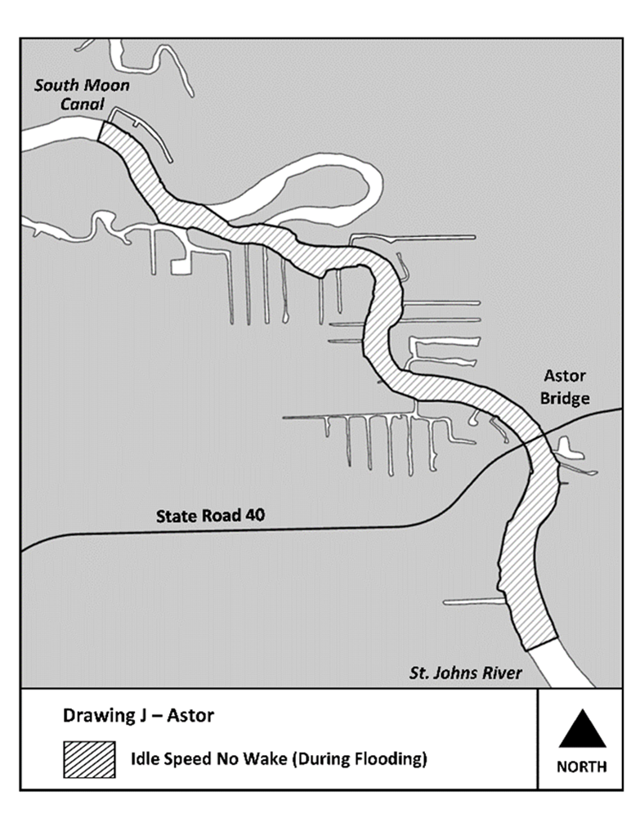

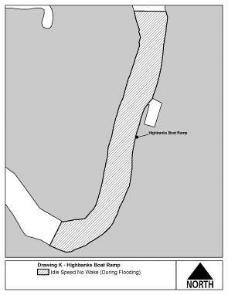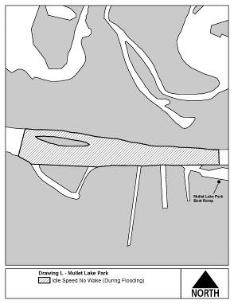

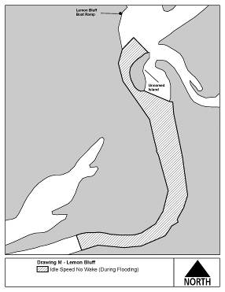

Rulemaking Authority 327.04, 327.46 FS. Law Implemented 327.33(3), 327.46 FS. History–New 6-3-92, Formerly 16N-24.018, Amended 10-3-95, 11-21-96, 2-4-98, Formerly 62N-24.018, Amended 4-22-13, 4-23-14, 2-10-20, 4-20-20, 7-6-20, 8-28-23, 12-25-24.

