68D-24.020 Suwannee and Santa Fe River Boating Restricted Areas.
(1) For the purpose of regulating the speed and operation of vessel traffic during flood events, the Suwannee and Santa Fe River Boating Restricted Areas are established, which shall include all associated and navigable tributaries, creeks, coves, bends, and backwaters unless otherwise designated or excluded.
Suwannee River Idle Speed No Wake Zones‒
(a) Zone 1: All waters in and adjacent to the river from the centerline of the U.S. 90 Bridge at Ellaville south to the centerline of the S.R. 51 Bridge at Luraville, as depicted in Drawing A. Idle Speed No Wake in effect and enforceable when the river water height is in the action stage or higher when measured at the United States Geological Survey (USGS) Ellaville gauge (USGS 02319500), as determined by the action stage established by the National Oceanic and Atmospheric Administration (NOAA).
(b) Zone 2: All waters in and adjacent to the river from the centerline of the S.R. 51 Bridge at Luraville to a line drawn perpendicular to the centerline of the river at Little River Spring, as depicted in Drawing B. Idle Speed No Wake in effect and enforceable when the river water height is in the action stage or higher when measured at the USGS Branford gauge (USGS 02320500), as determined by the action stage established by NOAA.
(c) Zone 3: All waters in and adjacent to the river from a line drawn perpendicular to the centerline of the river at Little River Spring to the centerline of the C.R. 340 Bridge at Rock Bluff, as depicted in Drawing C. Idle Speed No Wake in effect and enforceable when the river water height is in the action stage or higher when measured at the USGS Branford gauge (USGS 02320500), as determined by the action stage established by NOAA.
(d) Zone 4: All waters in and adjacent to the river from the centerline of the C.R. 340 Bridge at Rock Bluff to a line drawn perpendicular to the centerline of the river approximately 300' southwest of the New Clay Landing Boat Ramp, from a line drawn perpendicular to the centerline of the river approximately 6,000' north of the Camp Azalea Boat Ramp to a line drawn perpendicular to the centerline of the river approximately 1,300' south of the Yellow Jacket Landing, and from a line drawn perpendicular to the centerline of the river approximately 2,000' northeast of the Fowler’s Bluff Boat Ramp to a line drawn perpendicular to the centerline of the river approximately one mile southwest of the Fowler’s Bluff Boat Ramp, as depicted in Drawing D. Idle Speed No Wake in effect and enforceable when the river water height is in the action stage or higher when measured at the USGS Wilcox gauge (USGS 02323500), as determined by the action stage established by NOAA.
Santa Fe River Idle Speed No Wake Zones –
(e) Zone 5: All waters in and adjacent to the river from the River Rise in O’Leno State Park downstream to the centerline of the US 27 Bridge, as depicted in Drawing E. Idle Speed No Wake in effect and enforceable when the river water height is in the action stage or higher when measured at the USGS High Springs gauge (USGS 02321975), as determined by the action stage established by NOAA.
(f) Zone 6: All waters from the centerline of the US 27 Bridge downstream to a line drawn perpendicular to the centerline of the river, shoreline to shoreline, one-half mile upstream from the S.R. 47 Bridge, as depicted in Drawing F. Idle Speed No Wake in effect and enforceable when the river water height is in the action stage or higher when measured at the USGS Fort White gauge (USGS 02322500), as determined by the action stage established by NOAA.
(g) Zone 7: All waters in and adjacent to the river from a line drawn perpendicular to the centerline of the river, shoreline to shoreline, one-half mile upstream from the S.R. 47 Bridge, downstream to a line drawn perpendicular to the centerline of the river, shoreline to shoreline, from the westernmost point of the unnamed island located at 29° 54.527' N, 82° 46.074' W, as depicted in Drawing G. Idle Speed No Wake in effect and enforceable when the river water height is in the action stage or higher when measured at the USGS Three Rivers Estates gauge (USGS 02322703), as determined by the action stage established by NOAA.
(h) Zone 8: All waters in and adjacent to the river from a line drawn perpendicular to the centerline of the river, shoreline to shoreline, from the westernmost point of the unnamed island located at 29° 54.527' N, 82° 46.074' W downstream to the confluence of the Suwannee and Santa Fe Rivers, to include the Ichetucknee River upstream to the US 27 Bridge, as depicted in Drawing H. Idle Speed No Wake in effect and enforceable when the river water height is in the action stage or higher when measured at the USGS Three Rivers Estates gauge (USGS 02322703), as determined by the action stage established by NOAA.
(2) When in Effect – The boating restricted areas established in subsection (1) shall be active and enforceable only when the water levels reach the action stage or higher as established by NOAA. Suwanee and Santa Fe River water levels are recorded by NOAA and can be viewed on the NOAA website.
(3) The boating restricted areas described in Rule 68D-24.020, F.A.C., are depicted in the following drawings:
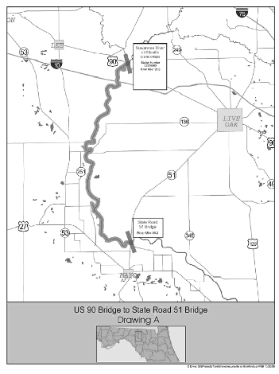
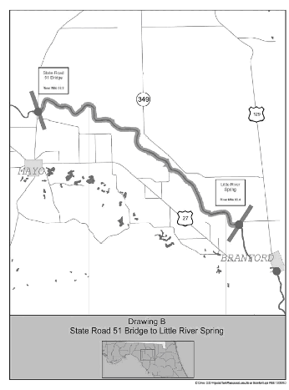
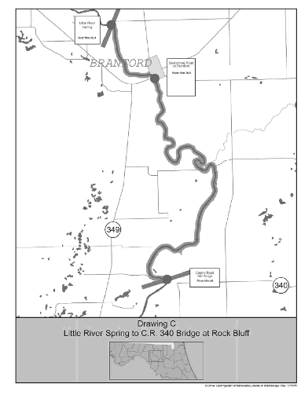
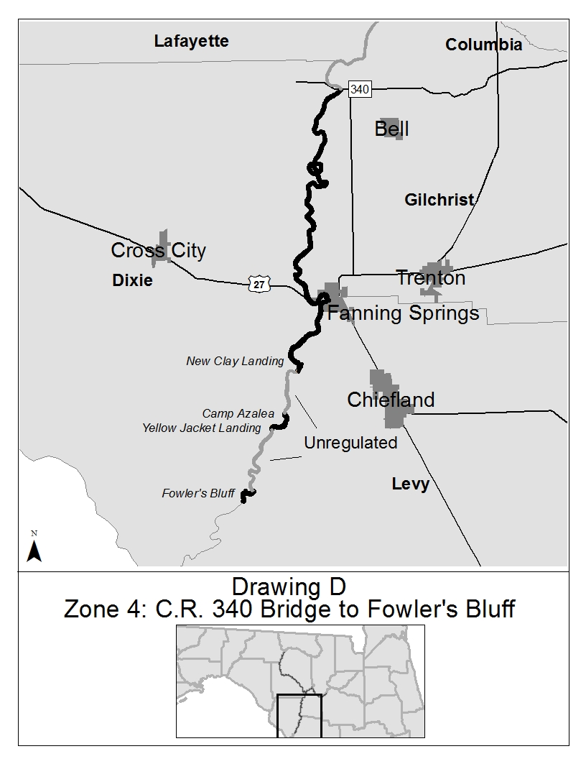
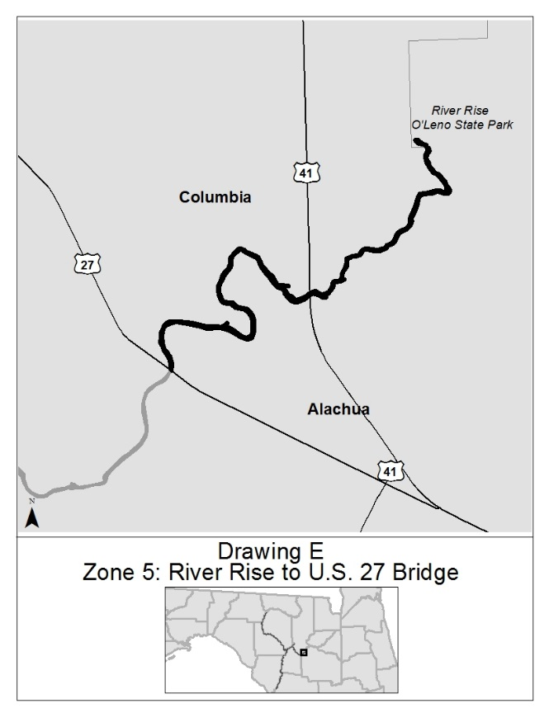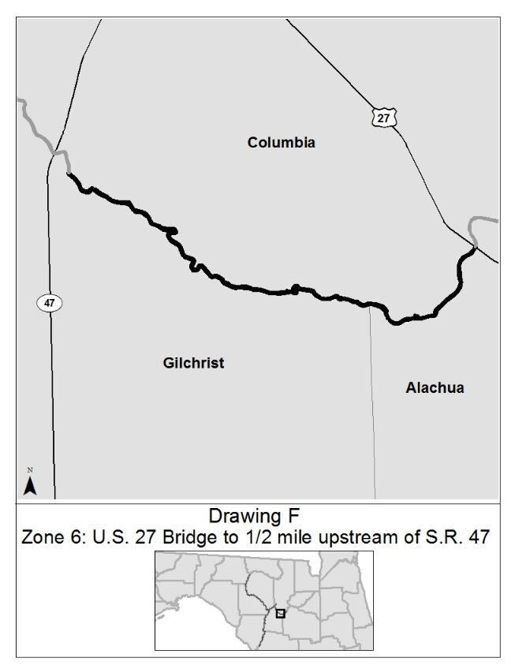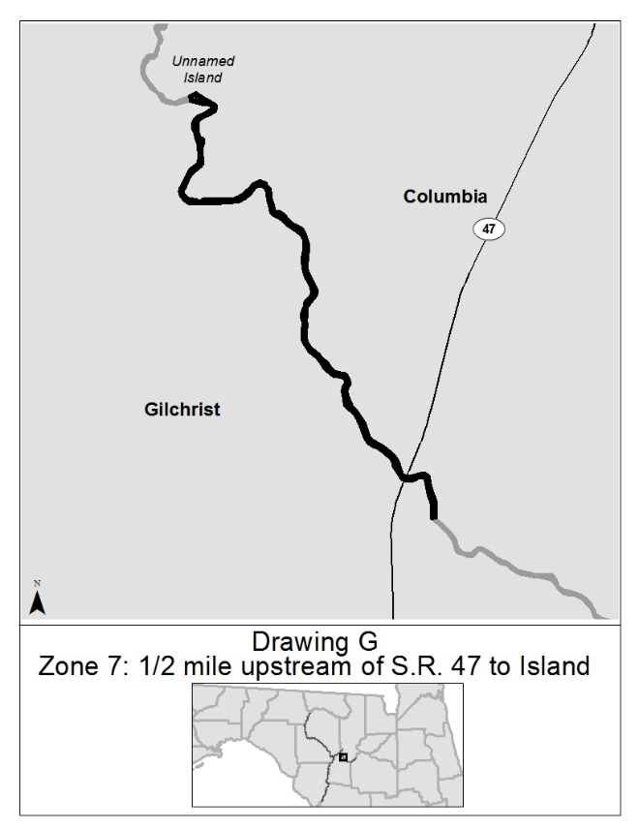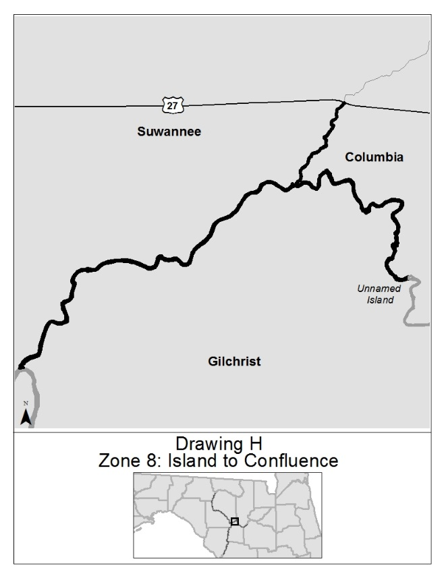
Rulemaking Authority 327.04, 327.46 FS. Law Implemented 327.46 FS. History–New 5-3-94, Formerly 16N-24.020, 62N-24.020, Amended 3-16-06, 11-4-15, 12-25-24.

