Notice of Proposed Rule

FISH AND WILDLIFE CONSERVATION COMMISSION
Vessel Registration and Boating Safety
RULE NO.: RULE TITLE:
68D-24.017 Palm Beach County Boating Restricted Areas
PURPOSE AND EFFECT: This rule amendment will establish a slow speed, minimum wake boating restricted area in an area of waterway located in Palm Beach County known as Jupiter Narrows.
SUMMARY: The proposed amended rule would create a slow speed minimum wake boating restricted area in a portion of the Florida Intracoastal Waterway in Palm Beach County, bounded on the south 300 feet north of the SR 707 (Cato’s) bridge and bounded on the north 2525 feet north of the SR 707 (Cato’s) bridge.
SUMMARY OF STATEMENT OF ESTIMATED REGULATORY COSTS AND LEGISLATIVE RATIFICATION:
The Agency has determined that this will not have an adverse impact on small business or likely increase directly or indirectly regulatory costs in excess of $200,000 in the aggregate within one year after the implementation of the rule. A SERC has not been prepared by the Agency.
The Agency has determined that the proposed rule is not expected to require legislative ratification based on the statement of estimated regulatory costs or if no SERC is required, the information expressly relied upon and described herein: The nature of the rule and the preliminary analysis conducted to determine whether a SERC was required.
Any person who wishes to provide information regarding a statement of estimated regulatory costs, or provide a proposal for a lower cost regulatory alternative must do so in writing within 21 days of this notice.
RULEMAKING AUTHORITY: 327.04, 327.46, FS.
LAW IMPLEMENTED: 327.46, FS.
IF REQUESTED WITHIN 21 DAYS OF THE DATE OF THIS NOTICE, A HEARING WILL BE SCHEDULED AND ANNOUNCED IN THE FAR.
THE PERSON TO BE CONTACTED REGARDING THE PROPOSED RULE IS: Major William Holcomb, Division of Law Enforcement, Boating and Waterways Section, 620 South Meridian Street, Tallahassee, Florida 32399, William.holcomb@myfwc.com or (850)488-6251.

THE FULL TEXT OF THE PROPOSED RULE IS:

68D-24.017 Palm Beach County Boating Restricted Areas.
(1) For the purpose of regulating speed and operation of vessel traffic on the Intracoastal Waterway within Palm Beach County, Florida, the following boating restricted areas are established:
(a) through (r) No change
(s) Jupiter Narrows - A Slow Speed Minimum Wake zone from shoreline to shoreline, in and adjacent to the Florida Intracoastal Waterway, bounded on the south by a line drawn perpendicular to the centerline of the waterway 300 feet north of the north end of the fender of the SR 707 (Cato's) Bridge, and bounded on the north by a line drawn perpendicular to the centerline of the waterway 2525 feet north of the SR 707 (Cato's) Bridge as depicted in drawing S.
(2) The boating restricted areas described in Rule 68D-24.017, F.A.C., are depicted on the following drawings:
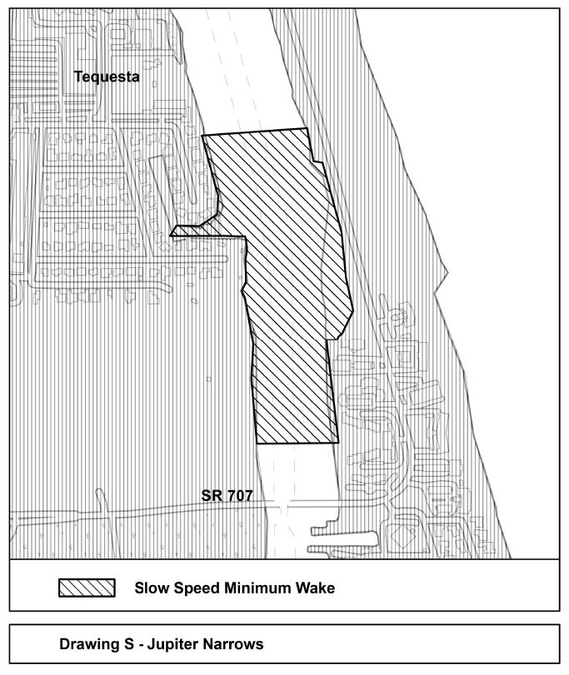
Rulemaking Authority 327.04, 327.46 FS. Law Implemented 327.46 FS. History–New 10-6-10, Amended ________.

NAME OF PERSON ORIGINATING PROPOSED RULE: Major William Holcomb, Division of Law Enforcement, Boating and Waterways Section, 620 South Meridian Street, Tallahassee, Florida 32399, William.holcomb@myfwc.com or (850)488-6251.
NAME OF AGENCY HEAD WHO APPROVED THE PROPOSED RULE: Florida Fish and Wildlife Conservation Commission
DATE PROPOSED RULE APPROVED BY AGENCY HEAD: February 26, 2025
DATE NOTICE OF PROPOSED RULE DEVELOPMENT PUBLISHED IN FAR: March 5, 2025

