Notice of Bid/Request for Proposal

OTHER AGENCIES AND ORGANIZATIONS
CITY OF KEY WEST
NOTICE OF UNSOLICITED PROPOSAL FOR PUBLIC-PRIVATE PARTNERSHIP OPPORTUNITY FOR CONSTRUCTION OF FIRE STATION NUMBER #3 FOR THE CITY OF KEY WEST
Key West, Florida, Clerk’s Office, City Hall, 1300 White Street, Key West, Florida 33040
NOTICE IS HEREBY GIVEN that the City of Key West (‘Herein after referred to as, the “City”’), Florida has received an unsolicited proposal submitted under the provisions of Section 255.065, Florida Statutes, Public-Private Partnerships, for the design, construction and financing of a new fire station for the City of Key West to be located on the site of the existing Fire Station #3 at 1525 Kennedy Dr, Key West, Florida 33040. The site is depicted below:
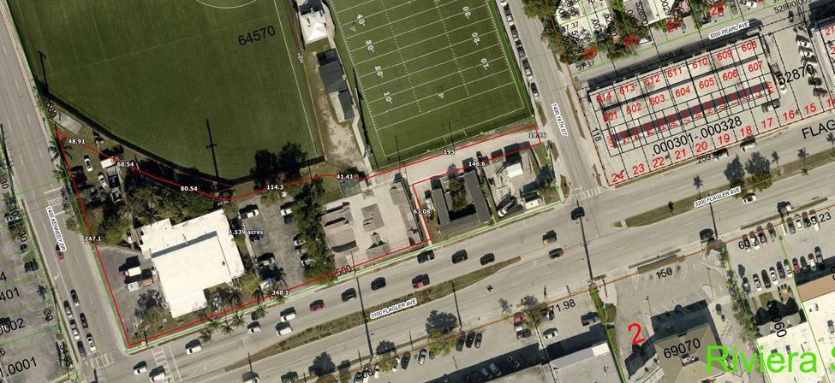
Under Section 255.065, Florida Statutes, the City is required to publish notice of the acceptance of an unsolicited proposal and a willingness to accept competing proposals. The City of Key West has determined that this unsolicited proposal is sufficient for consideration on a preliminary basis and, as such, the City will accept competing proposals for the design, construction (build) and financing of a new fire station on the site of the existing Fire Station #3 at 1525 Kennedy Dr, Key West, Florida 33040 during this notification period. No final decision has been made relative to accepting this or any proposal for this project. Persons or entities submitting competing proposals are advised that such proposals must be in compliance with Section 255.065, Florida Statutes including, but not limited to, Subsection 255.065(4), Florida Statutes.
Furthermore, the City of Key West Fire Department has indicated a preference that any proposed design for the new fire station include the following key features: a multipurpose conference room suitable for departmental training, public meetings, and community outreach events; a dedicated training tower to support firefighter training exercises; administrative office space; and sleeping quarters. Additionally, all proposals must include a functional driveway design that allows emergency vehicles to drive directly into the apparatus bays without requiring reverse entry.
The City reserves the right to reject any or all proposals, and to negotiate a comprehensive public-private partnership agreement with the Proposer whose proposal best serves the interests of the City. Nothing contained herein shall be interpreted as an obligation or binding agreement by the City regarding the Project.
Pursuant to Subsection 50.0211(3)(a), Florida Statutes, all published competitive solicitation notices can be viewed at: www.floridapublicnotices.com, a searchable Statewide repository for all published legal notices. A copy of the unsolicited proposal received by the City of Key West may be requested from the City and will be posted to DemandStar at www.demandstar.com.
The City of Key West hereby directs that proposals be submitted to the City Clerks Office, no later than 3:00 p.m., on September 10, 2025. The subject line on the email must read as follows:
Proposal for Public-Private Partnership Opportunity for Key West Fire Station #3 Project
Files that do not contain this subject line WILL BE REJECTED.
Publication Dates:
Citizen: Thursday, 07/17/2025 & 07/31/2025
Florida Administrative Register: 07/17/2025 & 07/31/2025

