Notice of Emergency Rule

DEPARTMENT OF THE LOTTERY
RULE NO.: RULE TITLE:

53ER25-41 Game Number 1603, TRIPLE RED 777’s
SUMMARY OF THE RULE: This emergency rule describes Game Number 1603, TRIPLE RED 777’s, for which the Department of the Lottery will start selling tickets on a date to be determined by the Secretary of the Department. The rule sets forth the specifics of the game, determination of winners, estimated odds of winning, and value and number of prizes in the game.
THE PERSON TO BE CONTACTED REGARDING THE EMERGENCY RULE IS: Minerva Simpson, Attorney, Department of the Lottery, 250 Marriott Drive, Tallahassee, Florida 32399-4011.

THE FULL TEXT OF THIS EMERGENCY RULE IS:

53ER25-41 Game Number 1603, TRIPLE RED 777’s.
(1) Name of Game. Game Number 1603, TRIPLE RED 777’s.
(2) Game Number 1603, TRIPLE RED 777’s is a Scratch-Off lottery game (also known as an instant lottery game).
(3) Price. TRIPLE RED 777’s lottery tickets sell for $5.00 per ticket.
(4) TRIPLE RED 777’s lottery tickets shall have a series of numbers in machine readable code (or bar code) on the back of the ticket, along with a validation number under the latex area on the ticket. To be a valid winning TRIPLE RED 777’s lottery ticket, the ticket must meet the applicable requirements of Emergency Rule 53ER23-20, Payment of Prizes.
(5) Play symbols and play symbol captions that may appear in the YOUR NUMBERS play area are below. A YOUR NUMBER play symbol and play symbol caption may be either a red or black color, except for the , , and play symbols and play symbol captions, which will only appear in red.
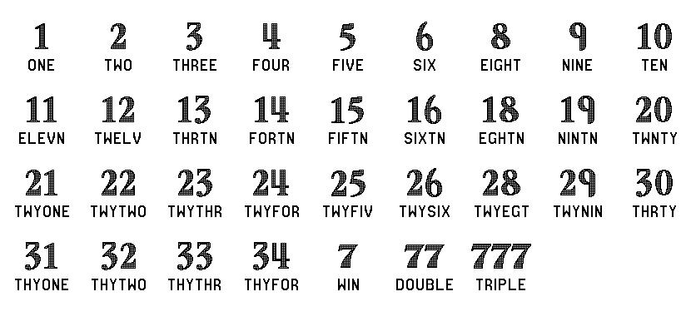
(6) Play symbols and play symbol captions that may appear in the WINNING NUMBERS play area are below. A WINNING NUMBER play symbol and play symbol caption may be either a red or black color.
(7) Prize symbols and prize symbol captions that may appear in the YOUR NUMBERS play area:
(8) Legends:
(9) Determination of Winners. A ticket having a play symbol and corresponding play symbol caption in the YOUR NUMBERS play area that matches a play symbol and corresponding play symbol caption in the WINNING NUMBERS play area shall entitle the player to the prize shown for that symbol. (The number and color must match.) A ticket having a red play symbol and corresponding play symbol caption in the YOUR NUMBERS play area shall entitle the player to the prize shown. A ticket having a red play symbol and corresponding play symbol caption in the YOUR NUMBERS play area shall entitle the player to two (2) times the prize shown. A ticket having a red play symbol and corresponding play symbol caption in the YOUR NUMBERS play area shall entitle the player to three (3) times the prize shown.
(10) $1,000,000 Prize; Payment Options.
(a) A winner of a $1,000,000 prize may choose one of two payment options for receiving his/her prize: One-Time Cash Payment or Annual Payments. At the time a ticket is validated, the terminal will produce a claim instructions ticket. The winner has sixty (60) days from the date of ticket validation to file a claim choosing the One-Time Cash Payment. If a winner does not choose the One-Time Cash Payment within the sixty (60) day timeframe, the Annual Payments method will be applied. Once the winner files a claim and exercises his/her chosen option, the election of that option shall be final. The Annual Payments method will also be final when it is applied due to a winner not making his/her payment election within sixty (60) days after ticket validation.
(b) A winner of a $1,000,000 prize who elects the One-Time Cash Payment shall receive a single cash payment of $584,000.00, less applicable federal income tax withholding.
(c) A winner of a $1,000,000 prize who elects the Annual Payment option, or has it applied, shall receive $40,000.00 per year for twenty-five (25) years, less applicable federal tax withholding.
(11) Odds of winning, value, and number of prizes:
GAME PLAY | WIN | ODDS OF 1 IN | NUMBER OF WINNERS IN 136.65 POOLS OF 120,000 TICKETS PER POOL
$5 | $5 | 8.57 | 1,913,003
$5 (RED 77) | $10 | 20.00 | 819,911
$5 x 2 | $10 | 42.86 | 382,592
$10 | $10 | 42.86 | 382,580
$5 x 4 | $20 | 300.07 | 54,648
$5 (RED 777) + $5 | $20 | 150.05 | 109,288
$5 (RED 77) x 2 | $20 | 149.94 | 109,368
$5 (RED 77) + $10 | $20 | 149.91 | 109,390
$20 | $20 | 300.00 | 54,661
$5 (RED 77) + $10 (RED 77) | $30 | 684.00 | 23,974
$10 (RED 777) | $30 | 684.83 | 23,945
$5 (RED 77) x 3 | $30 | 687.33 | 23,858
$10 + ($5 (RED 77) x 2) | $30 | 684.37 | 23,961
$30 | $30 | 1,201.78 | 13,645
$5 x 10 | $50 | 1,995.89 | 8,216
$10 x 5 | $50 | 2,987.47 | 5,489
$5 (RED 77) + ($10 (RED 77) x 2) | $50 | 521.47 | 31,446
$10 (RED 777) + $10 (RED 77) | $50 | 749.91 | 21,867
$50 | $50 | 11,995.79 | 1,367
($5 x 10) + ($10 x 5) | $100 | 2,403.73 | 6,822
$50 (RED 77) | $100 | 4,004.45 | 4,095
($10 (RED 777) x 2) + ($10 (RED 77) x 2) | $100 | 1,501.12 | 10,924
$20 x 5 | $100 | 4,005.43 | 4,094
$20 (RED 777) + ($5 (RED 77) x 4) | $100 | 1,331.57 | 12,315
($20 x 2) + $5 (RED 77) + $50 | $100 | 3,001.14 | 5,464
$100 | $100 | 11,934.67 | 1,374
($10 x 10) + ($20 x 5) | $200 | 23,974.04 | 684
$20 x 10 | $200 | 23,869.34 | 687
$50 (RED 777) + ($10 (RED 77) x 2) + $5 (RED 77) | $200 | 6,015.50 | 2,726
($10 x 10) + $50 (RED 77) | $200 | 6,004.48 | 2,731
$100 (RED 77) | $200 | 24,009.14 | 683
$200 | $200 | 23,834.65 | 688
($20 x 10) + ($50 x 4) + $100 | $500 | 7,941.04 | 2,065
$50 x 10 | $500 | 11,943.36 | 1,373
$200 (RED 77) + ($10 x 10) | $500 | 5,986.94 | 2,739
($50 x 6) + $100 (RED 77) | $500 | 4,815.93 | 3,405
$100 (RED 777) + $200 | $500 | 5,986.94 | 2,739
$500 | $500 | 12,048.67 | 1,361
($200 x 10) + ($100 x 5) | $2,500 | 118,827.83 | 138
$500 (RED 777) + $500 (RED 77) | $2,500 | 119,695.18 | 137
$500 (RED 77) + $200 (RED 77) + ($100 (RED 77) x 3) + $500 | $2,500 | 117,972.95 | 139
$2,500 | $2,500 | 120,575.29 | 136
$10,000 | $10,000 | 683,260.00 | 24
$1,000,000 ($40K/YR/25YRS)* | $1,000,000* | 4,099,560.00 | 4
*Prize amount if taken in annual payments. If a winner takes a one-time cash payment, the amount will be in accordance with subsection (10), above.
(12) The overall odds of winning some prize in Game Number 1603 are 1 in 3.92. All prizes are subject to availability at the time of ticket purchase. Prizes may be unavailable due to prior sales or other causes occurring in the normal course of business including, but not limited to, ticket damage, defect, theft, or loss.
(13) For reorders of Game Number 1603, the odds of winning, value, and number of prizes shall be proportionate to the number of tickets reordered.
(14) Payment of prizes for TRIPLE RED 777’s lottery tickets shall be made in accordance with the rule of the Florida Lottery governing payment of prizes. A copy of the current rule can be obtained from the Florida Lottery, Office of the General Counsel, 250 Marriott Drive, Tallahassee, Florida 32399-4011 or flrules.org.
Rulemaking Authority 24.105(9)(a), (b), (c), 24.109(1), 24.115(1) FS. Law Implemented 24.105(9)(a), (b), (c), 24.115(1) FS. History–New 8-11-25.

THIS RULE TAKES EFFECT UPON BEING FILED WITH THE DEPARTMENT OF THE STATE UNLESS A LATER TIME AND DATE IS SPECIFIED IN THE RULE.
EFFECTIVE DATE: 8/11/2025

