40D-2.801 Water-Use Caution Areas.
(1) When the Governing Board determines that regional action is necessary to address cumulative water withdrawals which are causing or may cause adverse impacts to the water and related land resources or the public interest, it shall declare, delineate, or modify Water-Use Caution Areas. The Governing Board shall declare a Water-Use Area by adopting a rule or issuing an order imposing special requirements for existing water users and permit Applicants to prevent or remedy site-specific problems.
(2) In determining whether an area should be declared a Water-Use Caution Area, the Governing Board shall consider the following factors:
(a) The quantity of water available for use from ground-water sources, surface water sources, or both;
(b) The quality of water available for use from ground-water sources, surface water sources, or both, including impacts such as saline water intrusion, mineralized water upconing, or pollution;
(c) Environmental systems, such as wetlands, lakes, streams, estuaries, fish and wildlife, or other natural resources;
(d) Lake stages or surface water rates of flow;
(e) Offsite land uses; and
(f) Other resources as deemed appropriate by the Governing Board.
(3) The regions described in this rule have been declared Water-Use Caution Areas by the District Governing Board. This rule reaffirms the declaration of Water-Use Caution Areas and creates conditions to be applied to water users in those areas.
(a) Northern Tampa Bay Water-Use Caution Area. To address groundwater withdrawals that have resulted in lowering of lake levels, destruction or deterioration of wetlands, reduction in streamflow, and salt water intrusion, the Governing Board declared portions of northern Hillsborough, southwestern Pasco, and Pinellas Counties a Water-Use Caution Area on June 28, 1989, pursuant to Resolution Number 934.
1. The boundary for the Northern Tampa Bay Water-Use Caution Area is as follows:
All of Pinellas County;
That portion of Pasco County within the following sections:
Township 24S, Range 16E: All Sections;
Township 25S, Range 16E: All Sections;
Township 25S, Range 17E: All Sections;
Township 26S, Range 14E: All Sections;
Township 26S, Range 15E: All Sections;
Township 26S, Range 16E: All Sections;
Township 26S, Range 17E: All Sections;
Township 26S, Range 18E: All Sections;
Township 26S, Range 19E: All Sections;
Township 26S, Range 20E: All Sections; and
That portion of Hillsborough County within the following sections;
Township 27S, Range 17E: All Sections;
Township 27S, Range 18E: All Sections;
Township 27S, Range 19E: All Sections;
Township 27S, Range 20E: All Sections;
Township 28S, Range 17E: All Sections;
Township 28S, Range 18E: All Sections;
Township 28S, Range 19E: All Sections;
Township 28S, Range 20E: All Sections;
Township 28S, Range 21E: All Sections;
Township 28S, Range 22E: All Sections;
Township 29S, Range 17E: All Sections;
Township 29S, Range 18E: All Sections;
Township 30S, Range 17E: All Sections;
Township 30S, Range 18E: All Sections;
Township 29S, Range 22E: All Sections North of State Road 60;
Township 29S, Range 21E: All Sections North of State Road 60;
Township 29S, Range 20E: All Sections North of State Road 60;
Township 29S, Range 19E: All Sections except 22-27 and 34-36.
2. Regulations applicable to this Water-Use Caution Area are contained in “Section 7.3, Basis of Review For Water Use Permit Applications.”
3. All Water Use Permits within the Water-Use Caution Area are hereby modified to conform with this Rule, and applicable permit conditions specified in “Section 7.3, Basis of Review For Water Use Permit Applications,” are incorporated into all Water Use Permits within the Water-Use Caution Area.
(b) Southern Water Use Caution Area (SWUCA). To address lowered lake levels, stream flows and ground water levels, water quality degradation and adverse impacts to water users, the Governing Board declared all or portions of Manatee, Sarasota, DeSoto, Hardee, Charlotte, Highlands, Hillsborough and Polk Counties within the District’s boundaries a Water Use Caution Area on October 26, 1992, pursuant to Resolution Number 92-10.
1. As shown in Figure 2-1, the boundary for the Southern Water Use Caution Area is as follows:
All of Manatee, Sarasota, Charlotte, Hardee, DeSoto, and Highlands Counties within the boundaries of the Southwest Florida Water Management District, and that portion of Hillsborough County within the following sections (all Townships are South; all Ranges are East):
Township 29, Range 19: All whole or partial Sections South of State Road 60;
Township 29, Range 20: All whole or partial Sections South of State Road 60;
Township 29, Range 21: All whole or partial Sections South of State Road 60;
Township 29, Range 22: All whole or partial Sections South of State Road 60;
Township 30, Range 19: All Sections;
Township 30, Range 20: All Sections;
Township 30, Range 21: All Sections;
Township 30, Range 22: All Sections;
Township 31, Range 18: All Sections;
Township 31, Range 19: All Sections;
Township 31, Range 20: All Sections;
Township 31, Range 21: All Sections;
Township 31, Range 22: All Sections;
Township 32, Range 18: All Sections;
Township 32, Range 19: All Sections;
Township 32, Range 20: All Sections;
Township 32, Range 21: All Sections;
Township 32, Range 22: All Sections;
Township 33, Range 15: All Sections;
Township 33, Range 16: All Sections;
and that portion of Polk County within the Southwest Florida Water Management District and within the following sections:
Township 26, Range 26: All whole or partial Sections South of Interstate 4;
Township 27, Range 23: All whole or partial Sections South of Interstate 4;
Township 27, Range 24: All whole or partial Sections South of Interstate 4;
Township 27, Range 25: All whole or partial Sections South of Interstate 4;
Township 27, Range 26: All Sections;
Township 27, Range 27: Sections 25 through 36;
Township 27, Range 28: Section 31;
Township 28, Range 23: All Sections;
Township 28, Range 24: All Sections;
Township 28, Range 25: All Sections;
Township 28, Range 26: All Sections;
Township 28, Range 27: All Sections;
Township 28, Range 28: All Sections;
Township 29, Range 23: All Sections;
Township 29, Range 24: All Sections;
Township 29, Range 25: All Sections;
Township 29, Range 26: All Sections;
Township 29, Range 27: All Sections;
Township 29, Range 28: All Sections;
Township 29, Range 29: Sections 19, 30, 31;
Township 30, Range 23: All Sections;
Township 30, Range 24: All Sections;
Township 30, Range 25: All Sections;
Township 30, Range 26: All Sections;
Township 30, Range 27: All Sections;
Township 30, Range 28: All Sections;
Township 30, Range 29: Sections 5, 6, 7, 8, 18, 19, 30, 31;
Township 31, Range 23: All Sections;
Township 31, Range 24: All Sections;
Township 31, Range 25: All Sections;
Township 31, Range 26: All Sections;
Township 31, Range 27: All Sections;
Township 31, Range 28: All Sections;
Township 31, Range 29: Section 6;
Township 32, Range 23: All Sections;
Township 32, Range 24: All Sections;
Township 32, Range 25: All Sections;
Township 32, Range 26: All Sections;
Township 32, Range 27: All Sections;
Township 32, Range 28: All Sections;
2. As shown in Figure 2-1, the area for the MIA of the Southern Water Use Caution Area is as follows:
Township 30, Range 19, Sections 2 through 36;
Township 30, Range 20, Sections 17 through 22; and 27 through 36;
Township 31, Range 18, all sections;
Township 31, Range 19, all sections;
Township 31, Range 20, all sections;
Township 31, Range 21, Sections 6 through 8; 17 through 20; and 29 through 32;
Township 32, Range 18, all sections;
Township 32, Range 19, all sections;
Township 32, Range 20, all sections;
Township 32, Range 21, Sections 5 through 7;
Township 33, Range 16, all sections;
Township 33, Range 17, all sections;
Township 33, Range 18, all sections;
Township 33, Range 19, all sections;
Township 33, Range 20, all sections;
Township 33, Range 21, Sections 19, 30, 31;
Township 34, Range 16, all sections;
Township 34, Range 17, all sections;
Township 34, Range 18, all sections;
Township 34, Range 19, all sections;
Township 34, Range 20, all sections;
Township 34, Range 16, all sections;
Township 34, Range 17, all sections;
Township 34, Range 18, all sections;
Township 34, Range 19, all sections;
Township 34, Range 20, all sections;
Township 34, Range 21, Sections 6 through 8; 17 through 20; and 29 through 32;
Township 35, Range 16, all sections;
Township 35, Range 17, all sections;
Township 35, Range 18, all sections;
Township 35, Range 19, all sections;
Township 35, Range 20, all sections;
Township 35, Range 21, Sections 5 through 8; 17 through 20; and 30;
Township 36, Range 17, all sections;
Township 36, Range 18, all sections;
Township 36, Range 19, Sections 1 through 24; and 27 through 32;
Township 36, Range 20, Sections 2 through 10; and 17 and 18;
Township 37, Range 17, Sections 1 through 18;
Township 37, Range 18, Sections 1 through 10; and 17 and 18.
Township 34, Range 21, Sections 6 through 8; 17 through 20; and 29 through 32;
Township 35, Range 16, all sections;
Township 35, Range 17, all sections;
Township 35, Range 18, all sections;
Township 35, Range 19, all sections;
Township 35, Range 20, all sections;
Township 35, Range 21, Sections 5 through 8; 17 through 20; and 30;
Township 36, Range 17, all sections;
Township 36, Range 18, all sections;
Township 36, Range 19, Sections 1 through 24; and 27 through 32;
Township 36, Range 20, Sections 2 through 10; and 17 and 18;
Township 37, Range 17, Sections 1 through 18;
Township 37, Range 18, Sections 1 through 10; and 17 and 18.
3. The Ridge Lakes are those lakes located anywhere within Highlands County and Polk County within the boundaries of the Southwest Florida Water Management District within the following Sections:
All of Highlands County within the boundaries of the Southwest Florida Water Management District, and that portion of Polk County within the Southwest Florida Water Management District and within the following sections (all Townships are South; all Ranges are East):
Township 26, Range 25: Partial Section 36 South of Interstate 4;
Township 26, Range 26: Partial Sections 28, 29, 31, and 32 South of Interstate 4 and whole Section 33;
Township 27, Range 25: Partial Sections 1, 2, 7, and 8 South of Interstate 4 and whole Sections 9 through 29, and 32 through 36;
Township 27, Range 26: Sections 4 through 9, 16 through 21, and 25 through 36;
Township 27, Range 27: Sections 25 through 36;
Township 27, Range 28: Section 31;
Township 28, Range 25: Sections 1 through 4, 9 through 15, 22 through 26, 35 through 36;
Township 28, Range 26: All Sections;
Township 28, Range 27: All Sections;
Township 28, Range 28: Sections 6 through 7, 17 through 22, 27 through 32, and Section 34;
Township 29, Range 25: Sections 1, 2, and 11 through 14;
Township 29, Range 26: Sections 1 through 18, and 23 through 24;
Township 29, Range 27: All Sections;
Township 29, Range 28: Sections 6 though 7, and 18 through 36;
Township 29, Range 29: Sections 19, 30, 31;
Township 30, Range 27: All Sections;
Township 30, Range 28: All Sections;
Township 30, Range 29: Sections 5 through 8, 18, 19, 30, 31;
Township 31, Range 27: All Sections;
Township 31, Range 28: All Sections;
Township 31, Range 29: Section 6;
Township 32, Range 27: All Sections;
Township 32, Range 28: All Sections.
4. Regulations applicable to this Water Use Caution Area are specified in this chapter and in the Basis of Review described in Rule 40D-2.091, F.A.C., and are incorporated into this rule. Amendments to those regulations adoped December 12, 2006, shall become effective January 1, 2007. Those amendments and regulations relating to SWUCA effective on January 1, 2003 and January 1, 2007, are not intended to affect, and shall not be construed to affect, any water use permit that does not have a withdrawal point within the SWUCA.
5. Any permit with a withdrawal point located within the boundaries of the SWUCA is deemed to be within the SWUCA. Permits with permitted withdrawals in more than one Water Use Caution Area (WUCA) shall be subject to the conservation and reporting requirements of the WUCA within which the majority of permitted quantities are withdrawn, or projected to be withdrawn, in addition to all other rule criteria, including Minimum Flows and Levels requirements, as set forth in Chapter 40D-2, F.A.C., and the Basis of Review for Water Use Permit Applications. Nothing in the rules and Basis of Review for Water Use Permitting specific to the SWUCA shall be interpreted or applied in any manner that would interfere with the Recovery Strategy for the Northern Tampa Bay Area as outlined in Rule 40D-80.073, F.A.C., or the Northern Tampa Bay New Water Supply and Ground Water Withdrawal Reduction Agreement.
6. All Water Use Permits with withdrawal points within the SWUCA are hereby modified to conform with this paragraph 40D-2.801(3)(b), F.A.C., except as provided in paragraph 5., above, and the applicable SWUCA criteria specified in the Basis of Review described in Rule 40D-2.091, F.A.C., are incorporated into all such Water Use Permits.
7. The SWUCA is a water resource caution area for purposes of Chapter 403, F.S., and Chapter 62-40, F.A.C.
Figure 2-1

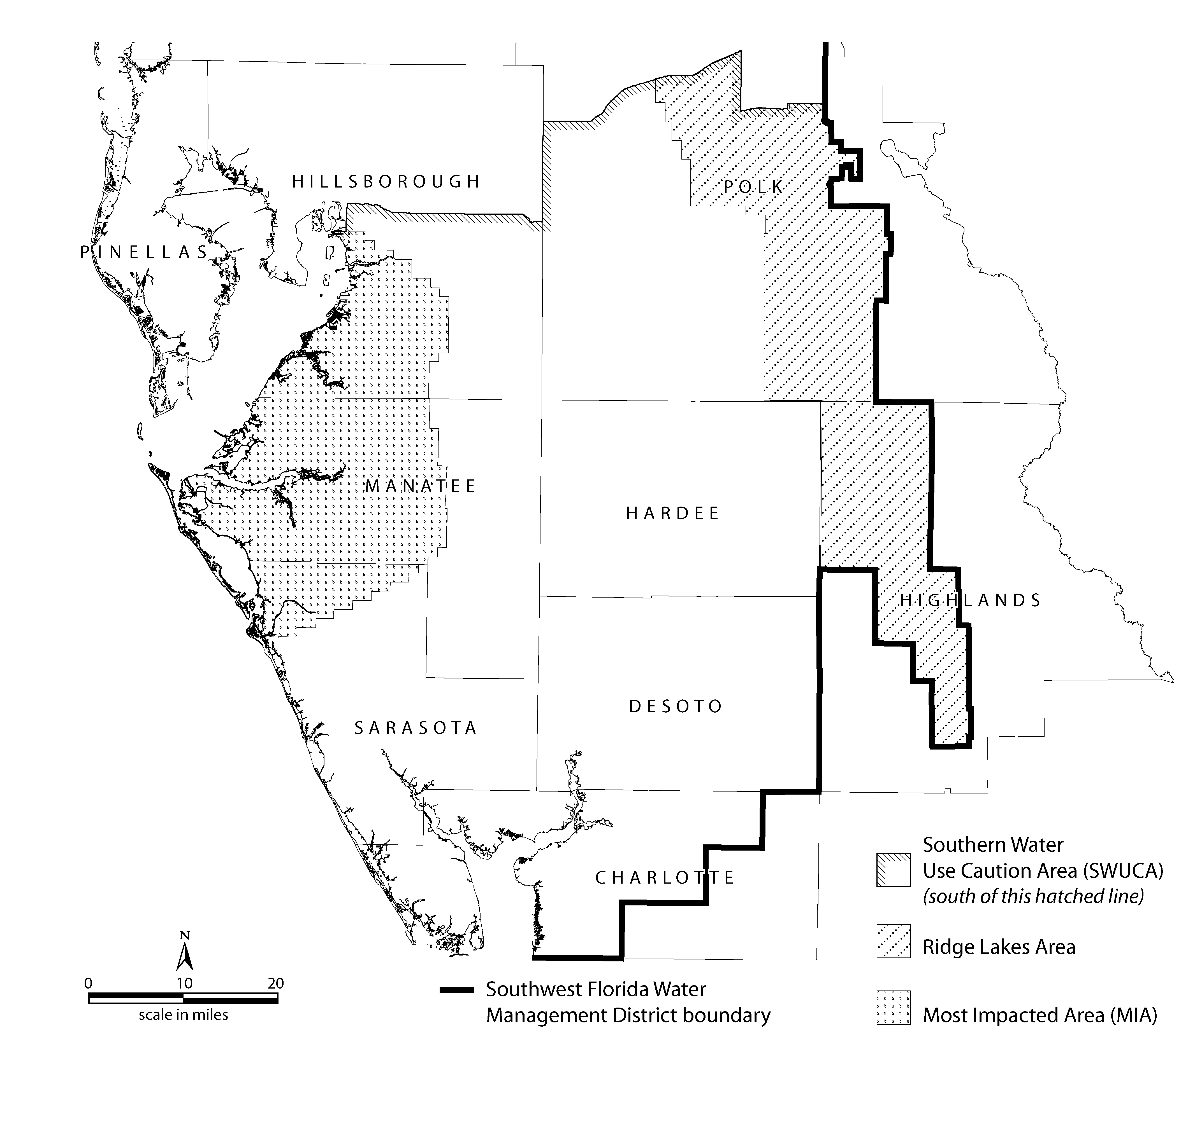
Specific Authority 373.044, 373.113, 373.171 FS. Law Implemented 373.0395, 373.042, 373.0421, 373.171, 373.216, 373.219, 373.223 FS. History–Readopted 10-5-74, Formerly 16J-3.30, Amended 10-1-89, 11-15-90, 3-1-91, 7-29-93, 1-1-03, 1-1-07.

