68D-24.144 Monroe County Boating Restricted Areas.
(1) For the purpose of regulating the anchoring of vessels in and adjacent to the Newfound Harbor Channel (also known as Pine Channel) within Monroe County, the following boating restricted area is established:
Newfound Harbor Channel (Pine Channel) – Anchoring of all sailboats and other vessels with masts is prohibited in Newfound Harbor Channel (Pine Channel), shoreline to shoreline, between Big Pine Key and Little Torch Key, from the centerline of U.S. Highway 1 south to a line drawn from the southernmost point on Little Torch Key to the southernmost point on Big Pine Key (a distance approximately 6,000 feet south of the centerline of U.S. Highway 1). If the overhead power lines are removed, the zone established in this paragraph shall no longer be in force or effect.
(2) The boating restricted area is depicted in drawing A:

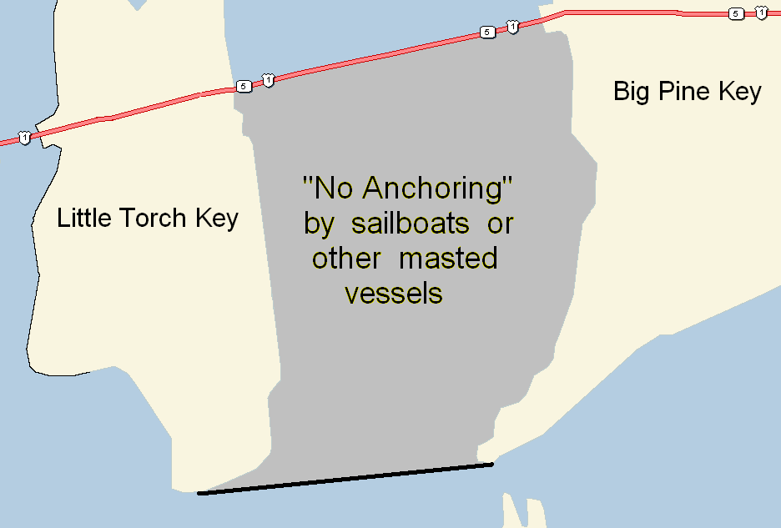

Specific Authority 327.04, 327.46 FS. Law Implemented 327.46 FS. History–New 1-10-07.

