68C-22.009 Palm Beach County Zones.
(1) For the purpose of regulating the speed and operation of motorboat traffic within the following manatee protection areas between the dates of November 15 and March 31 of each year, paragraphs (b), (d), and (e); year-round but seasonally-differentiated, paragraph (g); and year-round, paragraphs (a), (c), and (f), the Palm Beach County manatee protection zones are established as follows:
(a) Idle Speed Zone (Year-round) –
1. All waters along the westerly side of Lake Worth, bounded to the north by the southern edge of the Port of Palm Beach Turning Basin, and that line representing its westward extension, west to the mainland; bounded to the south by an east-west line one mile south of an east-west line drawn along the southern end of Peanut Island; bounded to the east by the western boundary of the marked channel of the Atlantic Intracoastal Waterway; and bounded to the west by the western shoreline of Lake Worth, unless otherwise designated under paragraph (1)(e).
2. All waters within 300 feet of the general contour of the shoreline, including associated backwaters and canals, along the easterly side of Lake Worth from a straight line drawn from Lake Worth Inlet channel flashing red marker “10” through flashing green marker “9” and southeasterly extension thereof, southeasterly to the shore of Palm Beach Island, south to an east-west line one mile south of an east-west line drawn along the southern end of Peanut Island, excluding that partially marked navigation channel south of Lake Worth Inlet along the easterly side of Lake Worth, running from daymark R “2” to daymark R “6” and thence southerly, paralleling the eastern shoreline (except as designated under paragraph (1)(b), for seasonal regulation).
3. All waters with a northerly limit being a line drawn perpendicular to the centerline of the Atlantic Intracoastal Waterway at the northerly end of the fender system of the SR 707 Bridge, the easterly limit being a due north line drawn across Jupiter Inlet from the western tip of the jetty at DuBois Park to the southwest corner of Jupiter Island (and including the small waterbody immediately adjacent to and southerly of said jetty), the westerly limit being a line drawn perpendicular to the channel of the Loxahatchee River at the northwest end of the fender system of the Florida East Coast Railroad Bridge adjacent to the SR 811 (Alternate A-1-A) Bridge, and the southerly limit being a line drawn perpendicular to the channel of the Atlantic Intracoastal Waterway at the southerly end of the fender system of the SR 706 (Indiantown Road) Bridge, including all waters of and tributaries to Sawfish Bay and the Jupiter River, and excluding the main marked channel of the Atlantic Intracoastal Waterway.
(b) Idle Speed Zone (Seasonal) – All waters of Lake Worth bounded to the north by a line drawn from Lake Worth Inlet channel flashing red marker “10” running westerly along the line of channel markers marking the northern edge of the Port of Palm Beach Turning Basin and westerly extension thereof, westward to the mainland; bounded to the northeast by a straight line drawn from flashing red marker “10” through flashing green marker “9” and southeasterly extension thereof, southeasterly to the shoreline of Palm Beach Island; bounded to the east by the eastern shoreline of Lake Worth; bounded to the west by the western shoreline of Lake Worth; and bounded to the south by an east-west line one mile south of an east-west line drawn along the southern end of Peanut Island, which are not otherwise designated under paragraph (1)(e).
(c) Slow Speed (Year-round) –
1. All waters from a line drawn perpendicular to the centerline of the Atlantic Intracoastal Waterway at the north end of the fender system of the Palmetto Park Road Bridge, southward to the south end of the fender system of the Camino Real Boulevard Bridge southerly of Lake Boca Raton, including all of Lake Boca Raton eastward to the Ocean Avenue (SR A-1-A) Bridge over the Boca Raton Inlet.
2. All waters from marker “56” (lat 26° 22' 26.380" N, long 80° 04' 25.390" W) in the northerly end of Lake Wyman southward to marker “63” (lat 26° 21' 38.240" N, long 80° 04’ 25.670” W).
3. All waters along the westerly side of Lake Worth, bounded to the north by an east-west line one mile south of an east-west line drawn along the southern end of Peanut Island; bounded to the east by the western boundary of the marked channel of the Atlantic Intracoastal Waterway; bounded to the south by the Flagler Memorial Bridge (A1A); and, bonded to the west by the western shoreline of Lake Worth.
4. All waters within 300 feet of the general contour of the shoreline from an east-west line one mile south of an east-west line drawn along the southern end of Peanut Island south to the Lantana Avenue (SR 812) Bridge in Lantana, including those nearshore waters within 300 feet of all islands, whether natural or manmade; excluding (a) the main marked channel of the Atlantic Intracoastal Waterway, and (b) that partially marked navigation channel south of Lake Worth Inlet along the easterly side of Lake Worth, running from daymark R “2” to daymark R “6” and thence southerly, paralleling the eastern shoreline, south to Flagler Memorial Bridge.
5. All waters within 300 feet of the general contour of the shoreline in the Loxahatchee River, including associated backwaters and canals, from a line drawn perpendicular to the centerline of the Loxahatchee River at the northwest end of the fender system of the Florida East Coast Railroad Bridge adjacent to the SR 811 (Alternate A1A) Bridge westward to the Loxahatchee River Road Bridge (easterly end of the C-18 Canal) on the Southwest Fork, to the Martin County/Palm Beach County line on the Northwest Fork, and to the Tequesta Drive Bridge on the North Fork.
6. All waters from the Martin County/Palm Beach County line southerly to a line drawn perpendicular to the centerline of the Atlantic Intracoastal Waterway at the northerly end of the fender system of the SR 707 Bridge, excluding the main marked channel of the Atlantic Intracoastal Waterway.
7. All waters within 300 feet of the general contour of the shoreline in the northerly end of Lake Worth from the A1A Bridge south to the Blue Heron Boulevard Bridge, excluding the main marked channel of the Atlantic Intracoastal Waterway, and including all associated backwaters and canals and the shorelines of Munyon Island and Little Munyon Island, and the shorelines of all other islands, whether natural or manmade (unless otherwise designated), and including the additional waters described as follows:
a. All waters bounded: on the northwest by a line from the northerly end of Munyon Island northeasterly to the eastern shore of Lake Worth, measured along a perpendicular to said eastern shore; on the west by the eastern shores of Munyon Island and Little Munyon Island, by a line drawn between them at the shortest distance, and by a line drawn from the southerly end of Little Munyon Island to the westerly extension of Pine Point Road (where said westerly extension intersects the eastern shoreline of Lake Worth); and on the southerly and easterly by the shoreline of Lake Worth including the shallow northerly extension of these waters lying easterly of A-1-A and southerly of Turtle Beach Road.
b. All waters northerly of the Blue Heron Boulevard (or Riviera Beach) Bridge, westerly of the marked channel of the Intracoastal Waterway, and southerly of a line drawn from marker “32” (lat 26° 47' 44" N, long 80° 02' 51.5" W), west to the mainland.
8. All waters within 300 feet of the general contour of the shoreline, including associated backwaters and canals, along the easterly side of Lake Worth from the Blue Heron Boulevard Bridge south to a straight line drawn from Lake Worth Inlet channel flashing red marker “10” through flashing green marker “9” and southeasterly extension thereof, southeasterly to the shore of Palm Beach Island, including those nearshore waters within 300 feet of Peanut Island and all other islands, whether natural or manmade; excluding:
a. The Lake Worth Inlet easterly of a line running southward from the southwest corner of Singer Island to the southern shore of the Inlet,
b. The Lake Worth Inlet Channel westerly of said line; and,
c. The main marked channel of the Atlantic Intracoastal Waterway.
9. All waters within 300 feet of the general contour of the shoreline (including the shoreline of all islands, whether natural or manmade), excluding the main marked navigation channel of the Atlantic Intracoastal Waterway, and including associated backwaters and canals, on the westerly side of Lake Worth from the Blue Heron Boulevard Bridge south to a line of channel markers marking the northern boundary of the Port of Palm Beach Turning Basin, and westward extension thereof.
10. All waters, including associated backwaters, from the Lantana Avenue Bridge (SR 812) in Lantana south to an east-west line running through flashing red marker “52” approximately 0.6 mile northerly of the East Ocean Avenue Bridge in Boynton Beach, excluding:
a. The Atlantic Intracoastal Waterway channel,
b. The area within 300 feet westerly of the western boundary of the Atlantic Intracoastal Waterway channel northerly of an east-west line running through flashing red marker “48”,
c. The area within 300 feet east of the eastern boundary of the Intracoastal Waterway channel from 300 feet southerly of the southerly end of Hypoluxo Island to an east-west line drawn along the northern edge of Pine Island (or “Beer Can Island”),
d. The portion of the backwater area to the east of Hypoluxo Island designated under sub-subparagraph (1)(c)11.g.; and,
e. The marked east-west channel of Boynton Inlet from its confluence with the Atlantic Ocean west to the marked channel of the Atlantic Intracoastal Waterway.
11. All waters within 50 feet of the general contour of the shoreline, including associated backwaters and canals unless otherwise designated, and excluding the marked navigation channel of the Atlantic Intracoastal Waterway, as follows:
a. In Lake Worth Creek from the Indiantown Bridge (SR 706) southward to its confluence with Lake Worth,
b. In Little Lake Worth,
c. From an east-west line running through flashing red marker “52” approximately 0.6 mile northerly of the East Ocean Avenue Bridge in Boynton Beach southward to marker “56” (lat 26° 22' 26.380" N, long 80° 04' 25.390" W), in the northerly end of Lake Wyman in Boca Raton,
d. From the south end of the fender system of the Camino Real Boulevard Bridge southerly of Lake Boca Raton southward approximately 1.3 miles to the Palm Beach County/Broward County line,
e. Along the northerly (Palm Beach County) side of the Hillsboro Canal (separating Palm Beach and Broward counties) from the Atlantic Intracoastal Waterway west to the west side of Military Trail (SR 809),
f. That portion of the El Rio Canal from its intersection with the Hillsboro Canal north to SR 798,
g. Those backwaters east of Hypoluxo Island from the Lantana Avenue Bridge to a line 50 feet northerly of the north end of the island lying easterly of the southerly end of Hypoluxo Island; and,
h. From a line drawn perpendicular to the centerline of the Atlantic Intracoastal Waterway running through marker “63” southward to a line drawn perpendicular to the centerline of the Atlantic Intracoastal Waterway at the north end of the fender system of the Palmetto Park Road (SR 798) Bridge.
12. All waters within the C-18 Canal from the Loxahatchee River Road Bridge westward to Structure S-46.
13. All backwaters, canals and tributaries off of Lake Worth Creek, including those waterbodies known as Jonathan’s Landing, Admiral’s Cove, and Frenchman’s Creek.
14. All waters from the northerly confluence of the North Palm Beach Waterway and Lake Worth Creek (Intracoastal Waterway) southward in the North Palm Beach Waterway to its confluence with the C-17 Canal (Earman River), westward in the C-17 Canal to the saltwater intrusion dam (S-44) approximately 4,100 feet west of the intersection of the North Palm Beach Waterway and the C-17 Canal, and eastward in the C-17 Canal to its confluence with Lake Worth, inclusive of all connecting waters southerly of the confluence of the North Palm Beach Waterway and the C-17 Canal.
15. All waters within the backwater area northerly of the Spanish River Boulevard Bridge in Boca Raton, westerly of the Atlantic Intracoastal Waterway, and southerly of NE 51st Street and easterly extension thereof.
16. All waters of the North Fork of the Loxahatchee River from the Tequesta Drive Bridge north to the Martin County/Palm Beach County line, excluding the main marked navigation channel.
17. All waters of the West Palm Beach (C-51) Canal easterly of US 1 (Structure S-155) to its confluence with the Atlantic Intracoastal Waterway.
18. All waters of the Boynton (C-16) Canal easterly of US 1 (Structure S-41) to its confluence with the Atlantic Intracoastal Waterway.
19. All waters of the C-15 Canal easterly of US 1 (Structure S-40) to its confluence with the Atlantic Intracoastal Waterway.
(d) Slow Speed (Seasonal) –
1. All waters southerly of an east-west line parallel to and one mile south of an east-west line drawn along the southern end of Peanut Island and northerly of an east-west line parallel to and 1.75 miles south of an east-west line drawn along the southern end of Peanut Island.
2. All waters of the Loxahatchee River from the northwesterly end of the fender system of the Florida East Coast Railroad Bridge adjacent to the SR 811 (Alternate A1A) Bridge westward up the river and northwesterly to the Palm Beach County/Martin County line, excluding the main (posted) navigation channel to within one-eighth (1/8) mile westerly of the northwesterly end of the fender system of the Florida East Coast Railroad Bridge.
3. All waters of the North Fork of the Loxahatchee River from its confluence with the Loxahatchee River north to the Tequesta Drive Bridge, excluding the main (posted) navigation channel.
4. All waters of the Southwest Fork of the Loxahatchee River from its confluence with the Loxahatchee River west to the Loxahatchee River Road Bridge.
5. All waters within 100 feet of the general contour of the north and south shores of Jupiter Inlet respectively from a north-south line drawn through the westerly ends of the Jupiter Inlet concrete seawalls, located approximately 600 feet west of the inlet’s confluence with the Atlantic Ocean at the southeastern tip of Jupiter Island, westerly to a north-south line drawn from the western tip of the jetty at DuBois Park to the southwest corner of Jupiter Island, excluding those waters lying waterward of each of two east-west lines drawn from the westerly ends of said seawalls westward to their point of intersection with the above-described 100-foot shoreline boundary.
6. All waters of Lake Worth bounded to the north by an east-west line drawn perpendicular to the centerline of the Atlantic Intracoastal Waterway at the north shoreline of Phil Foster Island approximately 650 feet north of the centerline of the Blue Heron Boulevard (Riviera Beach) Bridge; bounded to the east by the eastern shoreline of Lake Worth; bounded to the west by the western shoreline of Lake Worth; bounded to the south by a line drawn from flashing red marker “10” running westerly along the line of channel markers marking the northern edge of the Port of Palm Beach Turning Basin and westerly extension thereof, westward to the mainland, and bounded to the southeast by a straight line drawn from flashing red marker “10” through flashing green marker “9,” and southerly extension thereof, southeasterly to the shore of Palm Beach Island, excluding those waters within the Lake Worth Inlet easterly of a line running southward from the southwest corner of Singer Island to the southern shore of the inlet.
(e) Motorboats Probitied Zone. – All waters lying within Lake Worth, commencing at a point exactly 300 feet north of the northeast corner of the Riviera Beach Power Plant discharge canal, thence easterly to a point 100 feet west of the western boundary of the Intracoastal Waterway channel, lying within Township 42 South and Range 43 East; thence running southerly parallel to and 100 feet west of the western boundary of the Intracoastal Waterway channel for a distance of 700 feet to a point within Township 43 South and Range 43 East; thence westerly to the shoreline to a point 300 feet south of the southeast corner of the discharge canal; thence northerly 300 feet to the southeast corner of the discharge canal; thence westerly 150 feet, northerly 100 feet, and easterly 150 feet to the northeast corner of the discharge canal (inclusive of the entire waterbody comprising the Riviera Beach Power Plant discharge canal); thence northerly 300 feet to the point of origin. The precise boundaries and effective period of the zone will be posted each year between November 15 and March 31.
(f) Maximum 25 MPH Zone (Year-round) – All waters as described below: That portion of the main marked channel of the Atlantic Intracoastal Waterway from the Martin County/Palm Beach County line southerly to a line drawn perpendicular to the centerline of the Atlantic Intracoastal Waterway at the northerly end of the fender system of the SR 707 Bridge.
(g) Maximum 30 MPH Zone (June 1 through September 30)/Maximum 25 MPH Zone (Remainder of Year) – All waters as described below, except where otherwise designated or posted for more restrictive regulation for the purpose of manatee protection or boating safety:
1. That portion of the Atlantic Intracoastal Waterway, to within 50 feet of the general contour of the shoreline and including the main marked channel, from a line drawn perpendicular to the centerline of the Atlantic Intracoastal Waterway at the south end of the fender system of the State Road 706 (Indiantown) Bridge southerly to the intersection of Lake Worth Creek and Lake Worth,
2. That portion of the Atlantic Intracoastal Waterway, to within 50 feet of the general contour of the shoreline and including the main marked channel, from an east-west line running through flashing red marker “52” southerly to the Palm Beach County/Broward County line; and,
3. That portion of the marked channel of the Atlantic Intracoastal Waterway east of Boynton Canal from an east-west line running through flashing red marker “48” southerly to an east-west line running through flashing red marker “52.”
(2) Any races involving power-driven vessels within areas designated for regulation under the provisions of this rule shall be approved by all appropriate permitting agencies including but not limited to the U.S. Coast Guard, and shall receive prior approval from the Commission.
(3) Regulations restricting motorboat speed and operation, as set forth herein, are not intended to supersede any existing regulations duly established by federal, state, or local authority which are more restrictive in nature. Where differing regulations exist, regulatory markers posted shall reflect the most restrictive requirement. Permitted markers as posted are presumptive evidence of zone boundaries, as intended.
(4) Those waters designated under subparagraphs (1)(a)1. and 2., paragraph (1)(b), subparagraphs (1)(c)3., 4., 8. and 9., and (1)(d)1. and 6., wherein protection zones were previously established and enforced (as adopted March 19, 1979), shall remain unaffected by exemption provisions for the purpose of boat/motor testing as set forth under subsection 68C-22.003(7), F.A.C.
(5) The zones described in subsection 68C-22.009(1), F.A.C., herein are depicted on the following maps, labeled “Palm Beach County Manatee Protection Zones, Map A through Map F” dated November 1990, on a map labeled “Palm Beach County, 25-MPH Manatee Protection Zones, Jupiter Sound Area” dated February 1991, and on three maps labeled “Palm Beach County 25 MPH and Summer Season 30 MPH Manatee Protection Zones” with each respectively depicting the “Lake Worth Creek Area” and “Southern ICW Area (Maps 1 and 2)” dated March 1993, the latter three of which shall replace the three previously published maps labeled “Palm Beach County, 25-MPH Manatee Protection Zones” dated February 1991 and respectively depicting the “Lake Worth Creek Area” and Southern ICW Area (Maps 1 and 2): (Maps provided herewith are intended as depictions of the above-described zones. In the event of conflict between the two, the above descriptions shall prevail.)
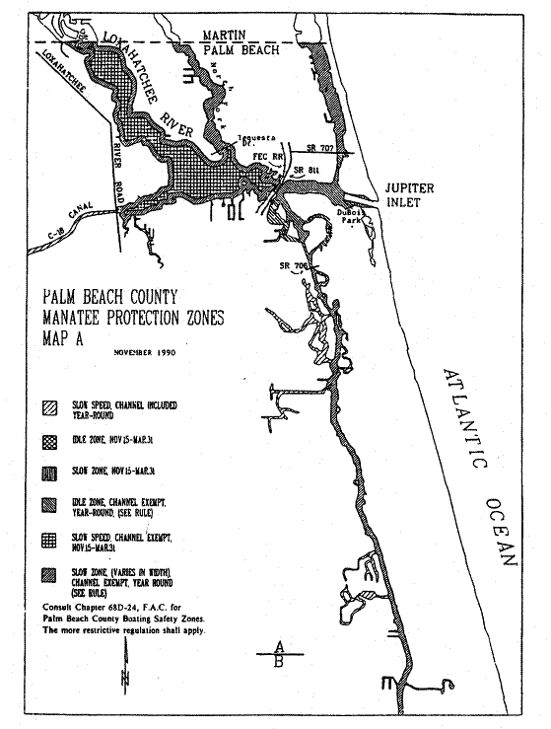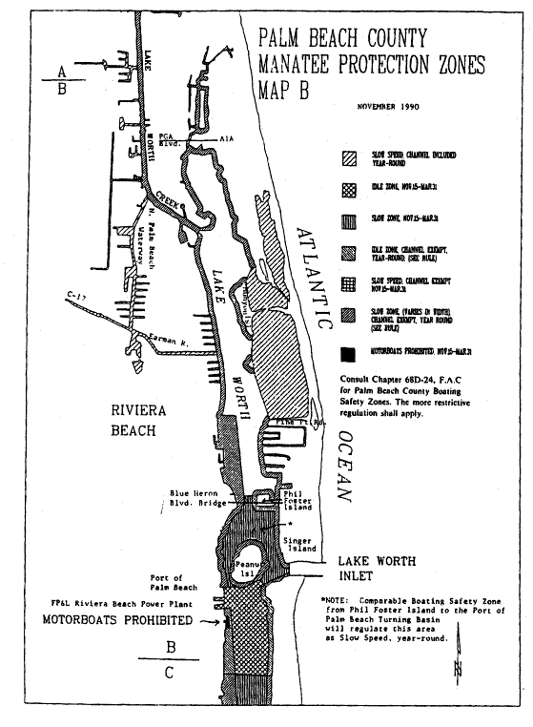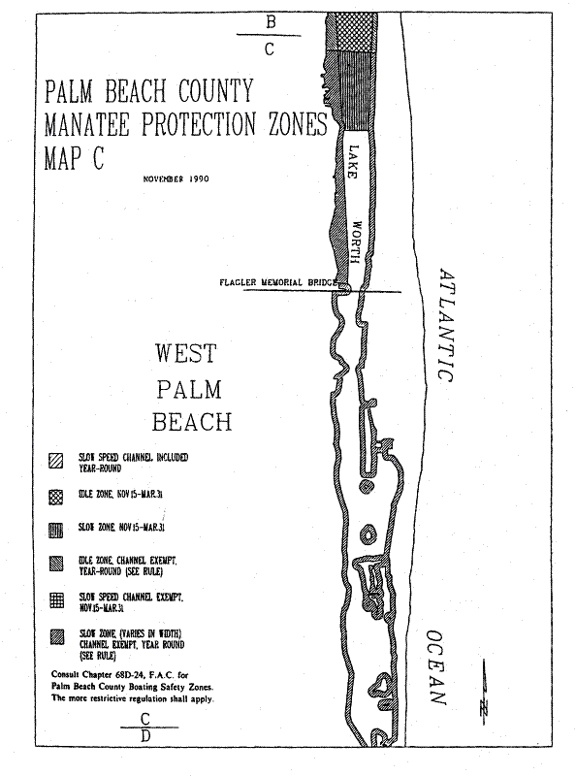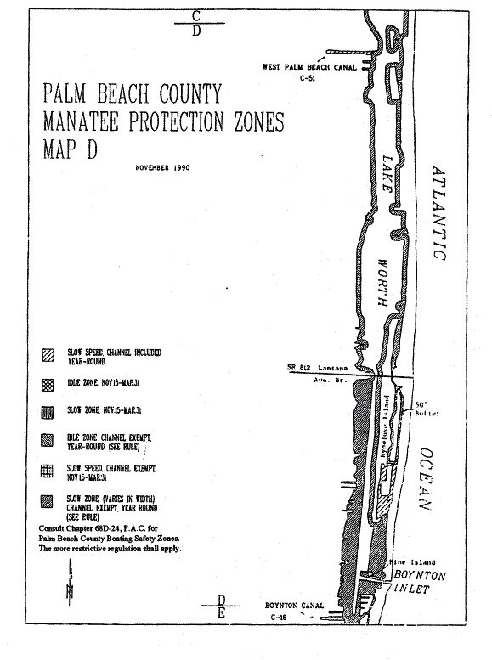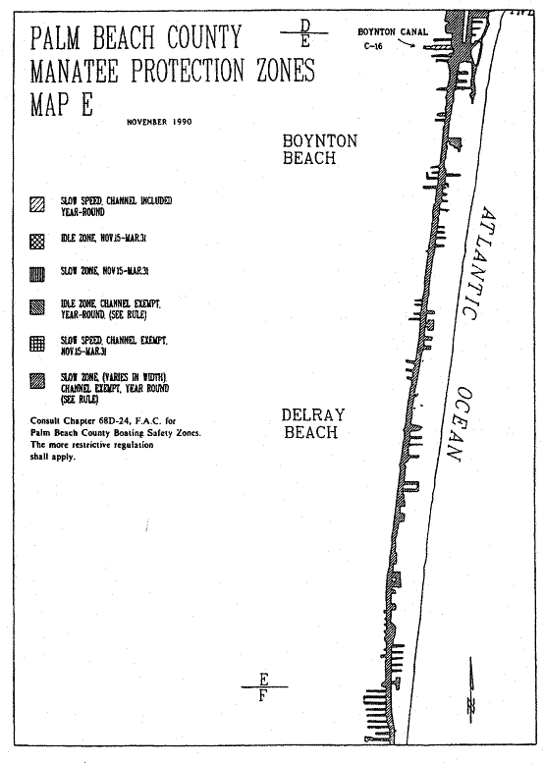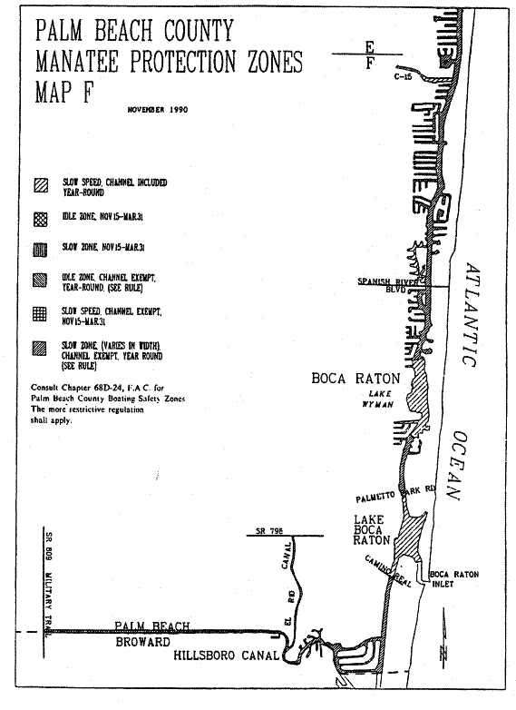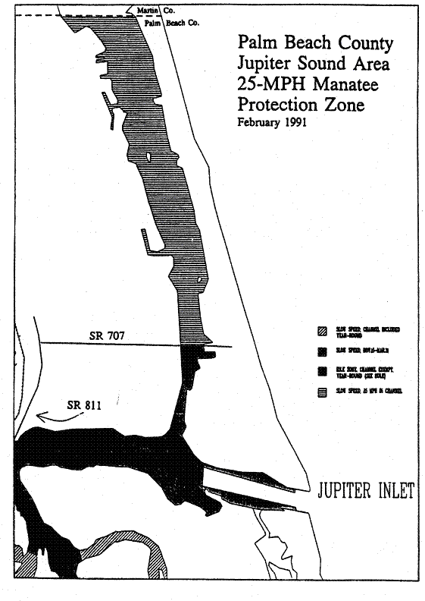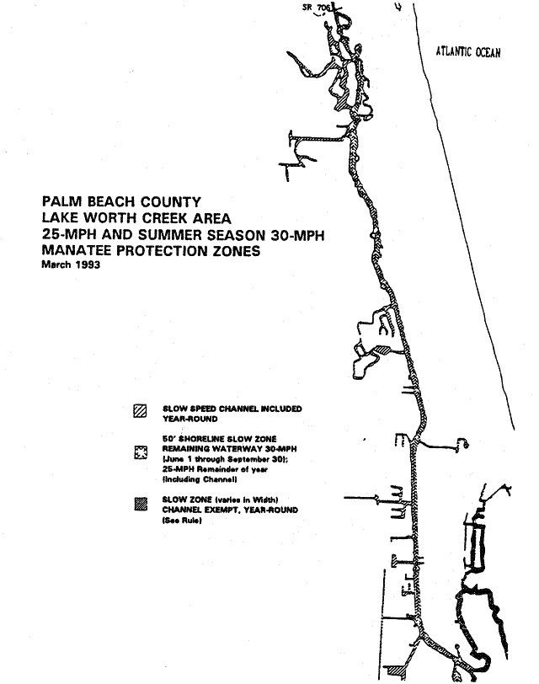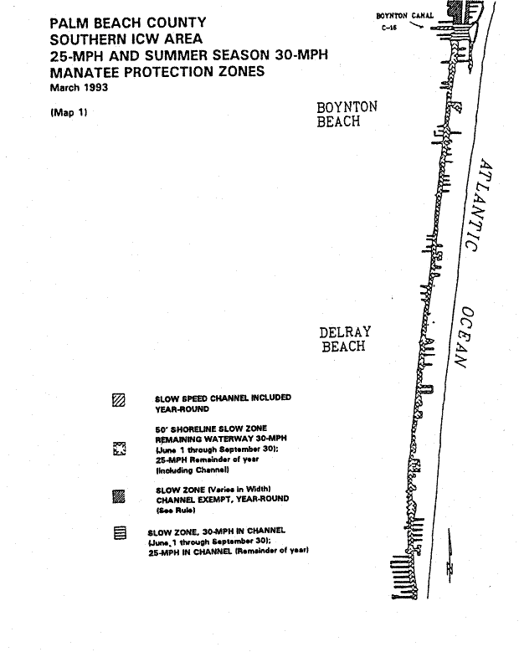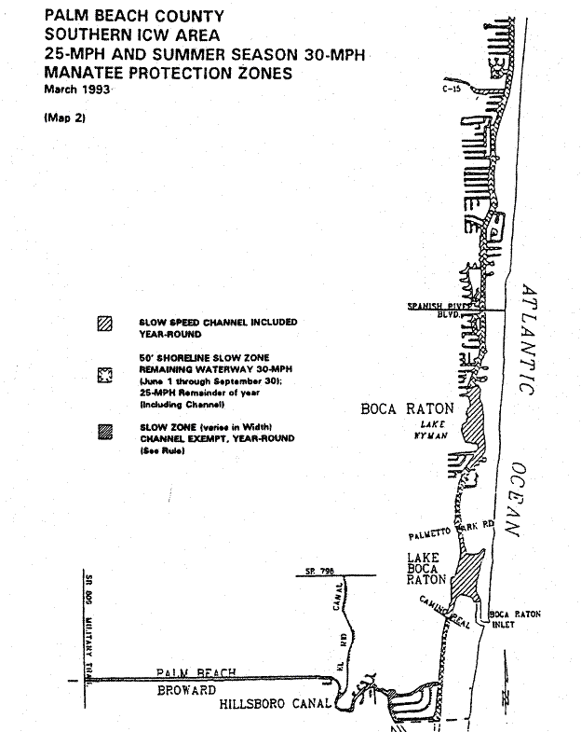
Rulemaking Authority 370.12(2)(n) FS. Law Implemented 370.12(2)(n) FS. History–New 3-19-79, Formerly 16N-22.09, Amended 2-15-90, 12-24-90, 3-13-91, 7-20-93, Formerly 16N-22.009, 62N-22.009.

