68C-22.005 Lee County Zones.
(1) The Commission hereby designates the waters within Lee County, as described below, as areas where manatee sightings are frequent and where the best available information supports the conclusion that manatees inhabit these areas on a regular or periodic basis. The primary purpose of this rule is to protect manatees from harmful collisions with motorboats and from harassment by regulating the speed and operation of motorboats within these designated areas. A secondary purpose is to protect manatee habitat. In consideration of balancing the rights of fishers, boaters, and water skiers to use the waters of the state for recreational and commercial purposes (as applicable under Section 379.2431(2)(k), F.S.), with the need to provide manatee protection, the Commission has examined the need for limited lanes, corridors, or unregulated areas that allow higher speeds through or within regulated areas. Such lanes, corridors, or areas are provided in those locations where the Commission determined that they are consistent with manatee protection needs.
(2) The following year-round and seasonal zones are established, which include all associated and navigable tributaries, lakes, creeks, coves, bends, backwaters, canals, and boat basins unless otherwise designated or excluded. Access to the No Entry zones designated in paragraph (2)(a), will be provided in accordance with procedures set forth in subsection (4), hereunder, and applicable provisions of Rule 68C-22.003, F.A.C.
(a) No Entry (November 15 ‒ March 31) – Tice Power Plant Area: All waters of the discharge canal north of the general contour of the northern shoreline of the Orange River and south of State Road No. 80; and all waters of the intake canal south of the general contour of the southern shoreline of the Caloosahatchee River on the northeast side of the power plant.
(b) Idle Speed (All Year) – All waters of the Orange River south of the river’s confluence with the Caloosahatchee River and west of the centerline of Buckingham Road, except as otherwise designated under paragraph (2)(a).
(c) Idle Speed (All Year)/ICW Channel 25 MPH (April 1 ‒ November 14) – All waters of the Caloosahatchee River east of the centerline of the Seaboard Coastline Railroad trestle that crosses Beautiful Island and west of a line that bears 147° from a point (approximate latitude 26° 41' 59'' North, approximate longitude 81° 47' 25'' West) on the southernmost tip of the mangrove peninsula at the west end of Thompson Cutoff. The portion of the marked Intracoastal Waterway (Okeechobee Waterway) channel in this area is regulated at Idle Speed between November 15 and March 31 and at a maximum speed of twenty-five (25) mph for the remainder of the year.
(d) Slow Speed (All Year) –
1. North Matlacha Pass Area: All waters of Matlacha Pass, south of a line that bears 90° and 270° from Matlacha Pass Green Channel Marker “77” (approximate latitude 26° 40' 00'' North, approximate longitude 82° 06' 00'' West), and north of Pine Island Road (State Road No. 78), excluding the portion of the marked channel otherwise designated under subparagraph (2)(h)3., and those waters described under sub-subparagraphs (2)(d)1.a. and (2)(d)1.b.
a. The following waters of Buzzard Bay are excluded from the Slow Speed zone designated under subparagraph (2)(d)1.: All waters of Buzzard Bay east and northeast of a line beginning at a point (approximate latitude 26° 40' 00'' North, approximate longitude 82° 05' 20'' West) on the southwest shoreline of an unnamed mangrove island east of Matlacha Pass Green Channel Marker “77” and bearing 219° to the northeasternmost point (approximate latitude 26° 39' 58'' North, approximate longitude 82° 05' 23'' West) of another unnamed mangrove island, then running along the eastern shoreline of said island to its southeasternmost point (approximate latitude 26° 39' 36'' North, approximate longitude 81° 05' 09'' West), then bearing 115° to the westernmost point (approximate latitude 26° 39' 34'' North, approximate longitude 82° 05' 05'' West) of the unnamed mangrove island to the southeast, then running along the western shoreline of said island to its southwesternmost point (approximate latitude 26° 39' 22'' North, approximate longitude 82° 04' 53'' West), then bearing 123° to the northwesternmost point (approximate latitude 26° 39' 21'' North, approximate longitude 82° 04' 52'' West) of an unnamed mangrove island, then running along the western shoreline of said island to its southeasternmost point (approximate latitude 26° 39' 09'' North, approximate longitude 82° 04' 44'' West), then bearing 103° to the northwesternmost point (approximate latitude 26° 39' 08'' North, approximate longitude 82° 04' 41'' West) of a peninsula on the unnamed mangrove island to the southeast, then running along the southwestern shoreline of said island to its southeasternmost point (approximate latitude 26° 38' 51'' North, approximate longitude 82° 04' 18'' West), then bearing 99° to the southernmost point (approximate latitude 26° 38' 50'' North, approximate longitude 82° 04' 03'' West) of the unnamed mangrove island to the east, then bearing 90° to the line’s terminus at a point (approximate latitude 26° 38' 50'' North, approximate longitude 82° 03' 55'' West) on the eastern shoreline of Matlacha Pass.
b. The following waters of North Pine Island Creek and Matlacha Pass are excluded from the Slow Speed zone designated under subparagraph (2)(d)1.: All waters of Pine Island Creek and Matlacha Pass north of Pine Island Road, west of a line bearing 360° from the northernmost point (approximate latitude 26° 39' 54'' North, approximate longitude 82° 06' 19'' West) of an unnamed island near the western shoreline of Matlacha Pass west of Matlacha Pass Green Channel Marker “77,” and west and southwest of a line beginning at said northernmost point of an unnamed island, then running along the eastern shoreline of said island to its southernmost point (approximate latitude 26° 39' 18'' North, approximate longitude 82° 06' 24'' West), then bearing 128° to the northernmost point (approximate latitude 26° 39' 12'' North, approximate longitude 82° 06' 17'' West) of an unnamed mangrove island to the south, then running along the eastern shoreline of said island to its southeasternmost point (approximate latitude 26° 39' 00'' North, approximate longitude 82° 06' 09'' West), then bearing 138° to a point (approximate latitude 26° 38' 45'' North, approximate longitude 82° 05' 53'' West) on the northern shoreline of Bear Key, then running along the northern shoreline of Bear Key to its easternmost point (approximate latitude 26° 38' 44'' North, approximate longitude 82° 05' 46'' West), then bearing 85° to the westernmost point (approximate latitude 26° 38' 45'' North, approximate longitude 82° 05' 32'' West) of Deer Key, then running along the northern shoreline of Deer Key to its easternmost point (approximate latitude 26° 38' 46'' North, approximate longitude 82° 05' 22'' West), then bearing 103° to the northwesternmost point (approximate latitude 26° 38' 45'' North, approximate longitude 82° 05' 17'' West) of the unnamed mangrove island to the east, then running along the western shoreline of said island to its southernmost point (approximate latitude 26° 38' 30'' North, approximate longitude 82° 05' 04'' West), then bearing 106° to the westernmost point (approximate latitude 26° 38' 30'' North, approximate longitude 82° 04' 57'' West) of the unnamed island to the southeast, then running along the northern and eastern shorelines of said island to a point (approximate latitude 26° 38' 23'' North, approximate longitude 82° 04' 51'' West) on its eastern shoreline, then bearing 113° to the northernmost point of West Island (approximate latitude 26° 38' 21'' North, approximate longitude 82° 04' 37'' West), then running along the western shoreline of West Island to the point where the line intersects Pine Island Road.
2. South Matlacha Pass Area: All waters of Matlacha Pass, St. James Creek, and San Carlos Bay, south of Pine Island Road (State Road No. 78), north of a line 500 feet northwest of and parallel to the main marked channel of the Intracoastal Waterway, west of a line that bears 302° from Intracoastal Waterway Green Channel Marker “99” (approximate latitude 26° 31' 00'' North, approximate longitude 82° 00' 52'' West), and east of a line that bears 360° from Intracoastal Waterway Red Channel Marker “10” (approximate latitude 26° 29' 16'' North, approximate longitude 82° 03' 35'' West), excluding the portions of the marked channels otherwise designated under subparagraphs (2)(h)4. and (2)(h)5., and those waters described under sub-subparagraphs (2)(d)2.a. through (2)(d)2.d.
a. The following waters in western Matlacha Pass are excluded from the Slow Speed zone designated under subparagraph (2)(d)2.: All waters of Matlacha Pass south of Pine Island Road and west of the western shoreline of West Island and a line beginning at the southernmost point (approximate latitude 26° 37' 25'' North, approximate longitude 82° 04' 17'' West) of West Island and bearing 149° to the northernmost point (approximate latitude 26° 37' 18'' North, approximate longitude 82° 04' 12'' West) of the unnamed mangrove island to the south, then running along the eastern shoreline of said island to its southernmost point (approximate latitude 26° 36' 55'' North, approximate longitude 82° 04' 02'' West), then bearing 163° to the line’s terminus at a point (approximate latitude 26° 36' 44'' North, approximate longitude 82° 03' 58'' West) on the eastern shoreline of Little Pine Island.
b. The following waters in eastern Matlacha Pass/Pontoon Bay are excluded from the Slow Speed zone designated under subparagraph (2)(d)2.: All waters of Matlacha Pass, Pontoon Bay, and associated embayments south of Pine Island Road and east of a line beginning at a point (approximate latitude 26° 38' 12'' North, approximate longitude 82° 03' 46'' West) on the northwestern shoreline of the embayment on the east side of Matlacha Pass, immediately south of Pine Island Road and then running along the eastern shoreline of the unnamed island to the south to its southeasternmost point (approximate latitude 26° 37' 30'' North, approximate longitude 82° 03' 22'' West), then bearing 163° to the northwesternmost point of the unnamed island to the south, then running along the western shoreline of said island to its southernmost point (approximate latitude 26° 37' 15'' North, approximate longitude 82° 03' 15'' West), then bearing 186° to the line’s terminus at a point (approximate latitude 26° 37' 10'' North, approximate longitude 82° 03' 16'' West) on the eastern shoreline of Matlacha Pass.
c. The following waters of South Pine Island Creek and Matlacha Pass are excluded from the Slow Speed zone designated under subparagraph (2)(d)2.: All waters of Pine Island Creek south of Pine Island Road; and all waters of Matlacha Pass, Rock Creek, and the Mud Hole, west of a line beginning at a point (approximate latitude 26° 33' 52'' North, approximate longitude 82° 04' 53'' West) on the western shoreline of Matlacha Pass and bearing 22° to a point (approximate latitude 26° 34' 09'' North, approximate longitude 82° 04' 45'' West) on the southern shoreline of the unnamed island to the northeast, then running along the southern and eastern shorelines of said island to a point (approximate latitude 26° 34' 15'' North, approximate longitude 82° 04' 39'' West) on its northeastern shoreline, then bearing 24° to a point (approximate latitude 26° 34' 21'' North, approximate longitude 82° 04' 36'' West) on the southern shoreline of the large unnamed island to the north, then running along the southern and eastern shorelines of said island to a point (approximate latitude 26° 34' 31'' North, approximate longitude 82° 04' 29'' West) on its eastern shoreline, then bearing 41° to the southernmost point (approximate latitude 26° 34' 39'' North, approximate longitude 82° 04' 22'' West) of another unnamed island to the northeast, then running along the eastern shoreline of said island to its northwesternmost point (approximate latitude 26° 35' 22'' North, approximate longitude 82° 04' 07'' West), then bearing 2° to the southernmost point (approximate latitude 26° 35' 32'' North, approximate longitude 82° 04' 07'' West) of the unnamed island to the north, then running along the eastern shoreline of said island to its northernmost point (approximate latitude 26° 35' 51'' North, approximate longitude 82° 03' 59'' West), then bearing 353° to the line’s terminus at a point (approximate latitude 26° 36' 08'' North, approximate longitude 82° 04' 01'' West) on the eastern shoreline of Little Pine Island.
d. The following waters of Punta Blanca Bay and Punta Blanca Creek are excluded from the Slow Speed zone designated under subparagraph (2)(d)2.: All waters of Punta Blanca Bay and Punta Blanca Creek, east of the eastern shoreline of Matlacha Pass and east and north of the eastern and northern shorelines of San Carlos Bay.
3. San Carlos Bay: All waters of San Carlos Bay south of the main marked channel of the Intracoastal Waterway, north and west of the Sanibel Causeway, west of a line beginning at a point (approximate latitude 26° 28' 57'' North, approximate longitude 82° 01' 04'' West) on the Sanibel Causeway, then running along the western boundary of the marked channel that runs between Sanibel Causeway and the Intracoastal Waterway to Channel Marker “15” (approximate latitude 26° 30' 24'' North, approximate longitude 82° 01' 06'' West), then bearing 339° to the line’s terminus at a point (approximate latitude 26° 30' 33'' North, approximate longitude 82° 01' 10'' West) on the southern boundary of the main marked channel of the Intracoastal Waterway, and east of a line that bears approximately 316° from the westernmost point (approximate latitude 26° 28' 34'' North, approximate longitude 82° 01' 34'' West) of the easternmost Sanibel Causeway island to Intracoastal Waterway Green Channel Marker “7” (approximate latitude 26° 29' 40'' North, approximate longitude 82° 02' 46'' West), excluding those waters within 700 feet of the Sanibel Causeway.
4. Punta Rassa and Shell Creek Area: All waters of San Carlos Bay and Punta Rassa Cove east of a line that bears 352° from the northernmost tip of the northern peninsula on Punta Rassa (approximate latitude 26° 29' 44'' North, approximate longitude 82° 00' 33'' West), and south of a line that bears 122° from Intracoastal Waterway Green Channel Marker “99” (approximate latitude 26° 31' 00'' North, approximate longitude 82° 00' 52'' West), including all waters of Shell Creek and associated waterways.
5. Mouth of the Caloosahatchee River and the Big Shell Island/Shell Point Area: All waters of San Carlos Bay and the Caloosahatchee River, including the residential canals of Cape Coral, northeast of a line that bears 302° and 122° from Intracoastal Waterway Green Channel Marker “99” (approximate latitude 26° 31' 00'' North, approximate longitude 82° 00' 52'' West), west of a line that bears 346° from Intracoastal Waterway Green Channel Marker “93” (approximate latitude 26° 31' 37'' North, approximate longitude 81° 59' 46'' West), and north and northwest of the general contour of the northwestern shoreline of Shell Point and a line that bears approximately 74° from the northernmost tip (approximate latitude 26° 31' 31'' North, approximate longitude 81° 59' 57'' West) of Shell Point to said Intracoastal Waterway Green Channel Marker “93”, excluding the waters of Jewfish Creek.
6. Caloosahatchee River Area:
a. Cape Coral to North Fort Myers Area: All waters of the Caloosahatchee River, Hancock Creek, and associated waterways of Cape Coral and North Fort Myers, east of a line that bears 346° from Intracoastal Waterway Green Channel Marker “93” (approximate latitude 26° 31' 37'' North, approximate longitude 81° 59' 46'' West), west of a line that bears 160° from a point (approximate latitude 26° 39' 25'' North, approximate longitude 81° 53' 17'' West) on the northern shoreline of the Caloosahatchee River approximately 1600 feet southwest of the centerline of U.S. Highway No. 41, and north and northwest of a line one quarter (1/4) mile south and southeast of and parallel to the general contour of the northern shoreline of the Caloosahatchee River, excluding the marked channel of the Intracoastal Waterway.
b. Shell Point to Fort Myers Area: All waters of the Caloosahatchee River, Deep Lagoon, and Whiskey Creek, southeast of a line that bears approximately 74° from the northernmost tip (approximate latitude 26° 31' 31'' North, approximate longitude 81° 59' 57'' West) of Shell Point to Intracoastal Waterway Green Channel Marker “93” (approximate latitude 26° 31' 37'' North, approximate longitude 81° 59' 46'' West), west of a line 1100 feet southwest of and parallel to the centerline of the U.S. Highway No. 41 Bridge, and south and southeast of a line 1/4 mile north and northwest of and parallel to the general contour of the southern shoreline of the Caloosahatchee River, excluding the marked channel of the Intracoastal Waterway.
c. Redfish Point Area: All waters of the Caloosahatchee River south of lines that bear 90° and 296° from Intracoastal Waterway Red Channel Marker “72” (approximate latitude 26° 32' 43" North, approximate longitude 81° 56' 16" West) and northeast of lines that bear 140° and 320° from Intracoastal Waterway Red Channel Marker “76” (approximate latitude 26° 32' 16" North, approximate longitude 81° 56' 43" West), excluding the portion of the marked Intracoastal Waterway channel otherwise designated under subparagraph (2)(h)6.
d. Fort Myers Area: All waters of the Caloosahatchee River northeast of a line 1100 feet southwest of and parallel to the centerline of the U.S. Highway No. 41 Bridge, southwest of the eastern side of the easternmost Edison Memorial Bridge, and southeast of a line one quarter (1/4) mile north and northwest of and parallel to the general contour of the southern shoreline of the Caloosahatchee River.
e. Fort Myers to Seaboard Coastline Railroad Area: All waters of the Caloosahatchee River and Billy Creek east of the eastern side of the easternmost Edison Memorial Bridge, and west of the centerline of the Seaboard Coastline Railroad trestle near Beautiful Island, excluding the portion of the marked Intracoastal Waterway channel otherwise designated under subparagraph (2)(h)7.
f. All cutoffs, oxbows, boat basins, and canals off of the Caloosahatchee River, including Owl Creek and Trout Creek, east of the centerline of the State Road No. 31 Bridge and west of the W.P. Franklin Lock and Water Control Structure.
g. W.P. Franklin Lock and Water Control Structure Area: All waters of the Caloosahatchee River within one quarter (1/4) mile east of the easternmost end of the lock and within one quarter (1/4) mile west of the westernmost end of the lock.
7. Fort Myers Beach Area: All waters of Matanzas Pass east of a line that bears 360° from the northernmost tip (approximate latitude 26° 27' 56'' North, approximate longitude 82° 58' 04'' West) of Estero Island, west of a line that bears 340° from a point (approximate latitude 26° 25' 56'' North, approximate longitude 81° 54' 25'' West) on the northern tip of an unnamed mangrove peninsula on the northeastern shoreline of Estero Island, and south and southwest of the general contour of the southwestern shorelines of the islands forming the northern shoreline of Matanzas Pass, a line that bears 312° from the northwesternmost point of Julies Island (approximate latitude 26° 26' 37'' North, approximate longitude 81° 54' 57'' West), a line that bears 104° from a point (approximate latitude 26° 27' 23'' North, approximate longitude 81° 56' 16'' West) on the southeastern tip of San Carlos Island, and a line that bears 313° from the northwesternmost point (approximate latitude 26° 28' 01'' North, approximate longitude 82° 57' 17'' West) of San Carlos Island.
8. San Carlos Island and Pelican Bay Area: All waters of Pelican Bay north of the general contour of the northeastern shoreline of San Carlos Island, east of a line that bears 313° from the northwesternmost point (approximate latitude 26° 28' 01'' North, approximate longitude 82° 57' 17'' West) of San Carlos Island, and west of the centerline of San Carlos Boulevard (State Road No. 865).
9. Ten Mile Canal and Mullock Creek Area: All waters of Mullock Creek west of U.S. Highway No. 41, and east and northeast of a line that bears 135° and 315° from Red Channel Marker “18” (approximate latitude 26° 27' 46'' North, approximate longitude 81° 52' 00'' West) and all waters of Ten Mile Canal south of a line (approximate latitude 26° 30' 00'' North) 200 feet north of the centerline of U.S. Highway No. 41, excluding the portion of Mullock Creek otherwise designated under paragraph (2)(i).
10. Intrepid Waters, Fish Trap Bay, and Imperial River Area: All waters of Intrepid Waters, Fish Trap Bay, and the Imperial River south of a line that bears 90° from a point (approximate latitude 26° 20' 51'' North, approximate longitude 81° 50' 33'' West) on the eastern shoreline of Little Hickory Island, north of the Lee County/Collier County line, and west of the centerline of the State Road No. 887 bridge, excluding the portion of the marked channel otherwise designated under subparagraph (2)(h)12.
11. Sanibel Island Area: All waters of Pine Island Sound and San Carlos Bay east and south of the Wulfert Channel, west of a line that bears 360° from the northernmost tip (approximate latitude 26° 28' 08'' North, approximate longitude 82° 03' 35'' West) of Woodrings Point, and southwest and south of a line one quarter (1/4) mile northeast and north of and parallel to the general contour of the northeastern and northern shorelines of Sanibel Island and Wulfert Keys, including all waters of Tarpon Bay and associated bayous, canals and channels north and east of the centerline of the Sanibel-Captiva Road.
(e) Slow Speed (All Year)/ICW Channel 25 MPH (April 1 ‒ November 14) – All waters of the Caloosahatchee River and Thompson Cutoff, east of a line that bears 160° from a point (approximate latitude 26° 41' 59'' North, approximate longitude 81° 47' 25'' West) on the southernmost tip of the mangrove peninsula at the western end of Thompson Cutoff, and west of a line that bears 180° from a point (approximate latitude 26° 42' 10'' North, approximate longitude 81° 46' 42'' West) on the northern shoreline of the Caloosahatchee River at the eastern end of Thompson Cutoff, except as otherwise designated under paragraph (2)(a). The portion of the marked Intracoastal Waterway (Okeechobee Waterway) channel in this area is regulated at Slow Speed between November 15 and March 31 and at a maximum speed of twenty-five (25) mph for the remainder of the year.
(f) Slow Speed (April 1 ‒ November 15)/25 MPH (Remainder of Year) –
1. Hurricane Bay Area: All waters of Hurricane Bay east of the centerline of San Carlos Boulevard (State Road No. 865), north of the general contour of the northeastern shoreline of San Carlos Island and a line that bears 104° from a point (approximate latitude 26° 27' 23'' North, approximate longitude 81° 56' 16'' West) on the southeastern tip of San Carlos Island, and west of a point (approximate latitude 26° 27' 36" North, approximate longitude 81° 55' 31" West) in the waterway connecting Hurricane Bay and Hell Peckney Bay, excluding the portions of the marked channels otherwise designated under subparagraph (2)(h)8.
2. North Estero Bay Area: All waters of Estero Bay east of a line beginning at the westernmost point (approximate latitude 26° 26' 11'' North, approximate longitude 81° 54' 32'' West) of the unnamed island southeast of Julies Island and running along the northwestern shoreline of said island to its northernmost point (approximate latitude 26° 26' 16" North, approximate longitude 81° 54' 27" West), then bearing 31° to a point (approximate latitude 26° 26' 20" North, approximate longitude 81° 54' 24" West) on the southwestern shoreline of an unnamed island to the northeast, then running along said island’s western and then northern shorelines to a point (approximate latitude 26° 26' 35" North, approximate longitude 81° 54' 23" West) on the island’s northeastern shoreline, then bearing 55° to the line’s terminus on the eastern shoreline of Hell Peckney, a line that bears 340° from a point (approximate latitude 26° 25' 56'' North, approximate longitude 81° 54' 25'' West) on the northern tip of an unnamed mangrove peninsula on the northeastern shoreline of Estero Island, and the northern shoreline of Estero Island, south of a line that bears 45° from a point (approximate latitude 26° 27' 38" North, approximate longitude 81° 52' 16" West) on the shoreline near the southern end of Hendry Creek and lines that bear 135° and 315° from Red Channel Marker “18” (approximate latitude 26° 27' 46'' North, approximate longitude 81° 52' 00'' West) in Mullock Creek, and north of a line that bears 72° from the northernmost point (approximate latitude 26° 24' 22'' North, approximate longitude 81° 52' 34'' West) of Black Island, including the waters of Buccaneer Lagoon at the southern end of Estero Island, but excluding the portions of the marked channels otherwise designated under subparagraph (2)(h)11., the Estero River, and the waters of Big Carlos Pass east of a line beginning at a point (approximate latitude 26° 24' 34'' North, approximate longitude 81° 53' 05'' West) on the eastern shoreline of Estero Island and bearing 36° to a point (approximate latitude 26° 24' 40'' North, approximate longitude 81° 53' 00'' West) on the southern shoreline of Coon Key, south of a line beginning at a point (approximate latitude 26° 24' 36'' North, approximate longitude 81° 52' 30'' West) on the eastern shoreline of Coon Key and bearing 106° to a point (approximate latitude 26° 24' 39'' North, approximate longitude 81° 52' 34'' West) on the southwestern shoreline of the unnamed mangrove island north of Black Island, and west of a line beginning at a point (approximate latitude 26° 24' 36'' North, approximate longitude 81° 52' 30'' West) on the southern shoreline of said unnamed mangrove island north of Black Island and bearing 192° to the northernmost point (approximate latitude 26° 24' 22'' North, approximate longitude 81° 52' 34'' West) of Black Island.
3. South Estero Bay and Big Hickory Bay Area: All waters of Estero Bay and Big Hickory Bay south of a line that bears 72° from the northernmost point (approximate latitude 26° 24' 22'' North, approximate longitude 81° 52' 34'' West) of Black Island, east of the centerline of State Road No. 865 (but including the waters of the embayment on the eastern side of Black Island and the waters inshore of the mouth of Big Hickory Pass that are west of State Road No. 865), and north of a line that bears 90° from a point (approximate latitude 26° 20' 51'' North, approximate longitude 81° 50' 33'' West) on the eastern shoreline of Little Hickory Island, excluding Spring Creek, the portions of the marked channels otherwise designated under subparagraph (2)(h)11., and the portion of Big Hickory Bay otherwise designated under subparagraph (2)(h)13.
(g) Slow Speed (April 1 ‒ November 15) –
1. Cayo Costa/Pelican Bay Area: All waters of Pelican Bay south and west of a line that bears 320° from a point (approximate latitude 26° 41' 32'' North, approximate longitude 82° 14' 23'' West) on the northern end of Punta Blanca Island, north and northwest of a line that bears 80° from the southernmost tip of Primo Point (approximate latitude 26° 40' 28'' North, approximate longitude 82° 14' 06'' West), and west and southwest of the western shoreline of Punta Blanca Island.
2. North Captiva Island Area: All waters of Safety Harbor west and northwest of a line that bears 198° from the southeasternmost tip (approximate latitude 26° 35' 56'' North, approximate longitude 82° 12' 50'' West) of the peninsula lying on the northeastern side of Safety Harbor.
3. Captiva Island Area: All waters of Pine Island Sound south of a line that bears 90° from the northernmost tip (approximate latitude 26° 23' 11'' North, approximate longitude 82° 11' 55'' West) of Captiva Island, north and west of the Wulfert Channel, and west and south of a line one quarter (1/4) mile east of and parallel to the general contour of the eastern shoreline of Captiva Island and Buck Key, including all waters of associated bayous, canals and channels north and east of the centerline of the Sanibel-Captiva Road.
4. Chino Island, York Island, and St. James City Area: All canals and boat basins of St. James City and the waters known as Long Cut and Short Cut; and all waters of Pine Island Sound and San Carlos Bay south of a line beginning at the southernmost tip (approximate latitude 26° 31' 28'' North, approximate longitude 82° 06' 19'' West) of a mangrove peninsula on the western shore of Pine Island approximately 2200 feet north of Galt Island and bearing 309° to the southeasternmost point (approximate latitude 26° 31' 32'' North, approximate longitude 82° 06' 25'' West) of another mangrove peninsula, then running along the southern shoreline of said peninsula to its southwesternmost point (approximate latitude 26° 31' 40'' North, approximate longitude 82° 06' 38'' West), then bearing 248° to a point (approximate latitude 26° 31' 40'' North, approximate longitude 82° 06' 39'' West) on the eastern shoreline of an unnamed mangrove island, then running along the southern shoreline of said island to its southwesternmost point (approximate latitude 26° 31' 39'' North, approximate longitude 82° 06' 44'' West), then bearing 206° to the line’s terminus at the northernmost point of the Mac Keever Keys (approximate latitude 26° 31' 09'' North, approximate longitude 82° 07' 09'' West), east of a line beginning at said northernmost point of the Mac Keever Keys and running along and between the general contour of the western shorelines of said keys to a point (approximate latitude 26° 30' 27'' North, approximate longitude 82° 07' 08'' West) on the southernmost of the Mac Keever Keys, then bearing 201° to a point (approximate latitude 26° 30' 01'' North, approximate longitude 82° 07' 19'' West) approximately 150 feet due east of the southeasternmost point of Chino Island, then bearing approximately 162° to Red Intracoastal Waterway Channel Marker “22” (approximate latitude 26° 28' 57'' North, approximate longitude 82° 06' 55'' West), then bearing approximately 117° to the line’s terminus at Red Intracoastal Waterway Channel Marker “20” (approximate latitude 26° 28' 45'' North, approximate longitude 82° 06' 38'' West), north of a line beginning at said Red Intracoastal Waterway Channel Marker “20'' and bearing 86° to a point (approximate latitude 26° 28' 50'' North, approximate longitude 82°05'48'' West) one quarter (1/4) mile south of York Island, then running parallel to and one quarter (1/4) mile south of the general contour of the southern shorelines of York Island and Pine Island to the line’s terminus at a point on a line bearing 360° from Red Intracoastal Waterway Channel Marker “10” (approximate latitude 26° 29' 16'' North, approximate longitude 82° 03' 35'' West), and west and southwest of the general contour of the western and southern shorelines of Pine Island and a line that bears 360° from said Red Intracoastal Waterway Channel Marker “10”, excluding the portion of the marked channel otherwise designated under subparagraph (2)(h)2.
(h) 25 MPH (All Year) –
1. Wulfert Channel: All waters within the marked channel known as Wulfert Channel, which connects Pine Island Sound with the Gulf of America through Blind Pass, east of the centerline of the Sanibel-Captiva Road Bridge and west of a line one-quarter (1/4) mile east of and parallel to the general contour of the eastern shoreline of Sanibel Island. This restriction is in effect only between April 1 and November 15.
2. Cherry Estates Channel: All waters of the marked channel that runs adjacent to the power lines from the Cherry Estates area of St. James City into Pine Island Sound, east of the western boundary of the zone designated under subparagraph (2)(g)4., and west of a line perpendicular to the power lines that begins at the easternmost point (approximate latitude 26° 30' 25'' North, approximate longitude 82° 06' 15'' West) of the mangrove island on the north side of the power lines approximately 1800 feet southwest of the Galt Island Causeway. This restriction is in effect only between April 1 and November 15. This designation only applies if a channel is marked in accordance with permits issued by all applicable state and federal authorities. In the absence of a properly permitted channel, this area is as designated under subparagraph (2)(g)4.
3. North Matlacha Pass Channel: All waters within the main marked channel in Matlacha Pass south of Green Channel Marker “77” (approximate latitude 26° 40' 00'' North, approximate longitude 82° 06' 00'' West) and north of a line perpendicular to the channel at a point in the channel one quarter (1/4) mile northwest of the Pine Island Road Bridge.
4. South Matlacha Pass Channel: All waters within the main marked channel in Matlacha Pass south of a line perpendicular to the channel at a point in the channel one quarter (1/4) mile southeast of the Pine Island Road Bridge, and north of a line 500 feet northwest of and parallel to the main marked channel of the Intracoastal Waterway (just north of Green Channel Marker “1”).
5. South Matlacha Pass/Sword Point Channel: All waters within the marked channel in Matlacha Pass that intersects the main Matlacha Pass channel near Green Channel Marker “15” (approximate latitude 26° 31' 57'' North, approximate longitude 82° 03' 38'' West) and intersects the main marked channel of the Intracoastal Waterway near Green Channel Marker “101” (approximate latitude 26° 30' 39'' North, approximate longitude 82° 01' 00" West).
6. ICW channel, Redfish Point Area: All waters of the marked Intracoastal Waterway channel between Red Channel Marker “72” (approximate latitude 26° 32' 43" North, approximate longitude 81° 56' 16" West) and Red Channel Marker “76” (approximate latitude 26° 32' 16" North, approximate longitude 81° 56' 43" West).
7. ICW channel, Fort Myers to Seaboard Coastline Railroad: All waters of the marked Intracoastal Waterway (Okeechobee Waterway) channel east of the eastern side of the easternmost Edison Memorial Bridge and west of the centerline of the Seaboard Coastline Railroad trestle near Beautiful Island.
8. Hurricane Bay channels: All waters within the main marked channel of Hurricane Bay east of the centerline of San Carlos Boulevard (State Road No. 865) and north of where the channel enters Matanzas Pass at Green Channel Marker “5” (approximate latitude 26° 27' 22'' North, approximate longitude 81° 56' 12'' West); and all waters within that portion of the channel leading to Bayside Estates south of Green Channel Marker “23” (approximate latitude 26° 28' 27'' North, approximate longitude 81° 56' 39" West).
9. Hell Peckney Bay: All waters of Hell Peckney Bay south and east of a point (approximate latitude 26° 27' 36" North, approximate longitude 81° 55' 31" West) in the waterway connecting Hell Peckney Bay and Hurricane Bay, northeast of the northern shorelines of Julies Island and the unnamed island immediately northwest of Julies Island, a line that bears 312° from the northwesternmost point of Julies Island (approximate latitude 26° 26' 37'' North, approximate longitude 81° 54' 57'' West), and a line that bears 306° from the westernmost point (approximate latitude 26° 26' 11'' North, approximate longitude 81° 54' 32'' West) of the unnamed island southeast of Julies Island, northwest of a line beginning at the aforementioned westernmost point (approximate latitude 26° 26' 11'' North, approximate longitude 81° 54' 32'' West) of the unnamed island southeast of Julies Island and running along the northwestern shoreline of said island to its northernmost point (approximate latitude 26° 26' 16" North, approximate longitude 81° 54' 27" West), then bearing 31° to a point (approximate latitude 26° 26' 20" North, approximate longitude 81° 54' 24" West) on the southwestern shoreline of an unnamed island to the northeast, then running along said island’s western and then northern shorelines to a point (approximate latitude 26° 26' 35" North, approximate longitude 81° 54' 23" West) on the island’s northeastern shoreline, then bearing 55° to the line’s terminus on the eastern shoreline of Hell Peckney Bay.
10. Hendry Creek: All waters of Hendry Creek north of a line that bears 45° from a point (approximate latitude 26° 27' 38" North, approximate longitude 81° 52' 16" West) on the shoreline near the southern end of Hendry Creek.
11. Estero Bay Area channels: All waters within the portions of the marked channels of Estero Bay and Big Hickory Bay as described below:
a. North Estero Bay Channel: All waters of the main marked North-South channel in northern Estero Bay from Green Channel Marker “37” (approximate latitude 26° 26' 02'' North, approximate longitude 81° 54' 29" West) to Green Channel Marker “57” (approximate latitude 26° 25' 08'' North, approximate longitude 81° 53' 29'' West).
b. South Estero Bay Channel: All waters of the main marked North-South channel in southern Estero Bay south of a line beginning at a point (approximate latitude 26° 24' 36'' North, approximate longitude 81° 52' 30'' West) on the southern shoreline of the unnamed mangrove island north of Black Island and bearing 192° to the northernmost point (approximate latitude 26° 24' 22'' North, approximate longitude 81° 52' 34'' West) of Black Island, and north and east of Red Channel Marker “62” (approximate latitude 26° 21' 31'' North, approximate longitude 81° 51' 20'' West) in Broadway Channel; and all waters within the portion of the marked channel leading to the Gulf of America through New Pass, west of the North-South channel and east of State Road No. 865.
c. Mullock Creek Channel: All waters of the marked channel leading to Mullock Creek north of a line beginning at a point (approximate latitude 26° 24' 36'' North, approximate longitude 81° 52' 30'' West) on the eastern shoreline of Coon Key and bearing 106° to a point (approximate latitude 26° 24' 39'' North, approximate longitude 81° 52' 34'' West) on the southwestern shoreline of the unnamed mangrove island north of Black Island, and south of Red Channel Marker “18” (approximate latitude 26° 27' 46'' North, approximate longitude 81° 52' 00'' West).
d. Estero River Channel: All waters of the marked channel leading from the Mullock Creek Channel to the Estero River, west of the mouth of the Estero River. This designation only applies if a channel is marked in accordance with permits issued by all applicable state and federal authorities. In the absence of a properly permitted channel, this area is as designated under subparagraph (2)(f)3.
e. Alternate Route Channel: All waters of the marked channel commonly known as Alternate Route Channel, with said channel generally running between Channel Marker “1” (approximate latitude 26° 24' 29'' North, approximate longitude 81° 51' 53'' West) and Channel Marker “10” (approximate latitude 26° 24' 00'' North, approximate longitude 81° 51' 09'' West).
f. Coconut Channel: All waters of the marked channel commonly known as Coconut Channel, with said channel generally running between Channel Marker “1” (approximate latitude 26° 23' 44'' North, approximate longitude 81° 50' 55'' West) and Channel Marker “23” (approximate latitude 26° 24' 00'' North, approximate longitude 81° 50' 30'' West).
g. Southern Passage Channel: All waters of the marked channel commonly known as Southern Passage Channel, with said channel generally running between Channel Marker “1” (approximate latitude 26° 22' 58'' North, approximate longitude 81° 51' 57'' West) and Channel Marker “22” (approximate latitude 26° 23' 27'' North, approximate longitude 81° 50' 46'' West).
h. Spring Creek Channel: All waters of the marked channel leading from the Southern Passage Channel to Spring Creek, west of the mouth of Spring Creek.
12. Fish Trap Bay Channel: That portion of the marked channel in Fish Trap Bay beginning at Channel Marker “90” (approximate latitude 26° 20' 42'' North, approximate longitude 81° 50' 33'' West) and ending at Channel Marker “101” (approximate latitude 26° 20' 09'' North, approximate longitude 81° 50' 26'' West).
13. Big Hickory Bay Area: All waters of Big Hickory Bay north of a line that bears 90° from a point (approximate latitude 26° 20' 51'' North, approximate longitude 81° 50' 33'' West) on the eastern shoreline of Little Hickory Island, west of a line beginning at a point (approximate latitude 26° 20' 48'' North, approximate longitude 81° 50' 24'' West) on the southern shoreline of Big Hickory Bay and bearing 338° to a point (approximate latitude 26° 21' 39'' North, approximate longitude 81° 50' 48'' West) on the water in the northwestern end of Big Hickory Bay near the eastern end of Broadway Channel, south of a line beginning at said point on the water in the northwestern end of Big Hickory Bay and bearing 242° to the northernmost point (approximate latitude 26° 21' 39'' North, approximate longitude 81° 50' 50'' West) of the unnamed mangrove island south of Broadway Channel, and east of the eastern shoreline of said mangrove island and a line beginning at the southernmost point of said island (approximate latitude 26° 21' 07'' North, approximate longitude 81° 50' 58'' West) and bearing 167° to a point on Little Hickory Island (approximate latitude 26° 21' 03'' North, approximate longitude 81° 50' 57'' West).
(i) Depth-depentent Slow Speed or 25 MPH – All waters of Mullock Creek, excluding side creeks and embayments, between Red Channel Marker “18” (approximate latitude 26° 27' 46'' North, approximate longitude 81° 52' 00'' West) and Green Channel Marker “47” (approximate latitude 26° 28' 11'' North, approximate longitude 81° 51' 34'' West). Slow Speed is required in this area whenever the controlling water depth is greater than two feet (2'). Speeds of up to twenty-five (25) MPH are allowed whenever the controlling water depth is two feet (2') or less. For the purposes of this zone, the controlling water depth shall be defined as the water depth at the shallowest point of the creek between channel markers “18” and “47” as measured along the route that runs over the deepest water available.
(3) Commercial Fishing Permits: The following provisions pertain to the issuance of permits to allow individuals engaged in commercial fishing activities to operate their vessels in specified areas at speeds greater than the speed limits established under subsection (2), above. Procedures related to the application for and the review and issuance of these permits are as set forth in Rule 68C-22.003, F.A.C.
(a) Permits shall be limited as follows:
1. Permits shall only be available for the zones or portions of zones described under subparagraphs (2)(d)1. through (2)(d)4., (2)(d)10., (2)(f)2., (2)(f)3., (2)(g)1., (2)(g)3., and (2)(g)4.
2. Permits shall not apply on weekends or on the holidays identified in Section 110.117, F.S.
3. Permits shall only apply to commercial fishing activities for the setting of nets to encircle fish, and shall only allow speeds up to twenty (20) mph.
(b) Permit applications may be obtained at the Commission’s Law Enforcement office at 2423 Edwards Drive, Ft. Myers, Florida, or by contacting the Commission’s Division of Law Enforcement (Boating and Waterways Section) at 620 South Meridian Street, Tallahassee, Florida 32399-1600, (850)488-5600.
(4) Access to the No Entry zones designated in paragraph (2)(a), above, will be allowed for Florida Power and Light Company employees or their authorized agents provided that entry into the zones is necessary to conduct activities associated with maintenance, emergency operations or environmental monitoring. The Commission must receive notification of the activity prior to its commencement. In the event of an emergency activity, the Commission shall be notified no more than two weeks after the activity has been commenced. All vessels used in the operation or associated with the activity shall be operated at no greater than Idle Speed while within the zones and must have an observer on board to look for manatees. All routine activities associated with maintenance and environmental monitoring shall be halted when manatees are seen in the zones. Activities that are halted because of manatee presence may only proceed after the manatee(s) leave the area of their own volition.
(5) The zones described in subsection 68C-22.005(2), F.A.C., above are shown on the following maps, labeled “Lee County Manatee Protection Zones.” The maps are intended to be depictions of the above-described zones. In the event of conflict between the two, the above descriptions shall prevail.
(6) The amendments to Rule 68C-22.005, F.A.C., as approved by the Commission on April 14 and June 15, 2005, shall take effect as soon as the regulatory markers are posted.
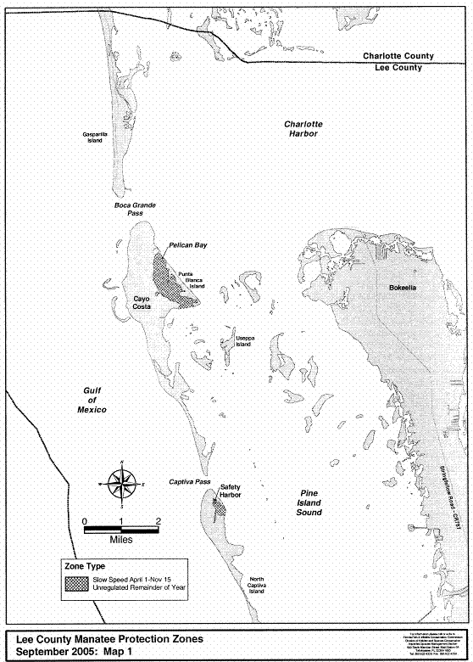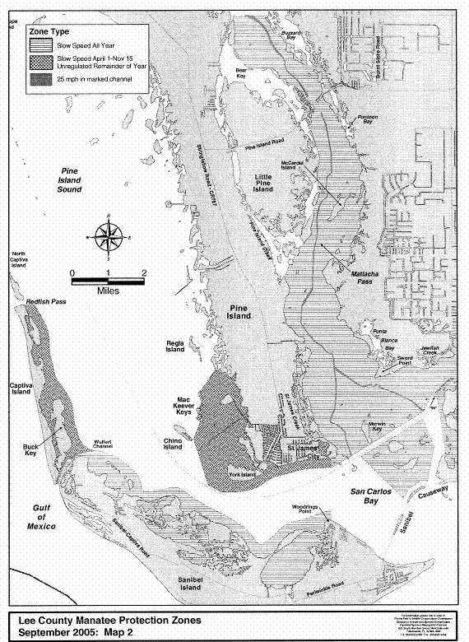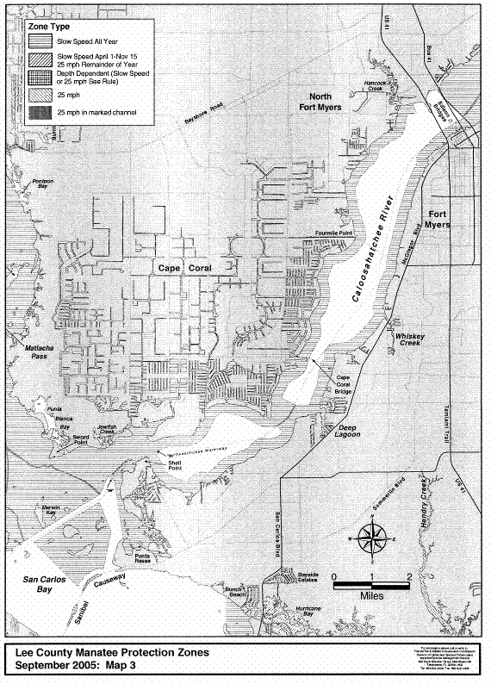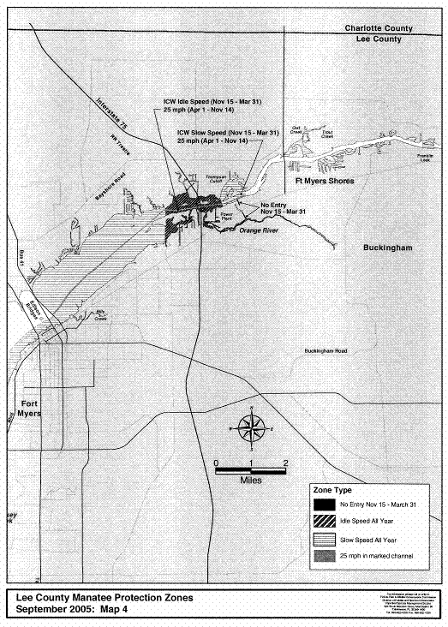
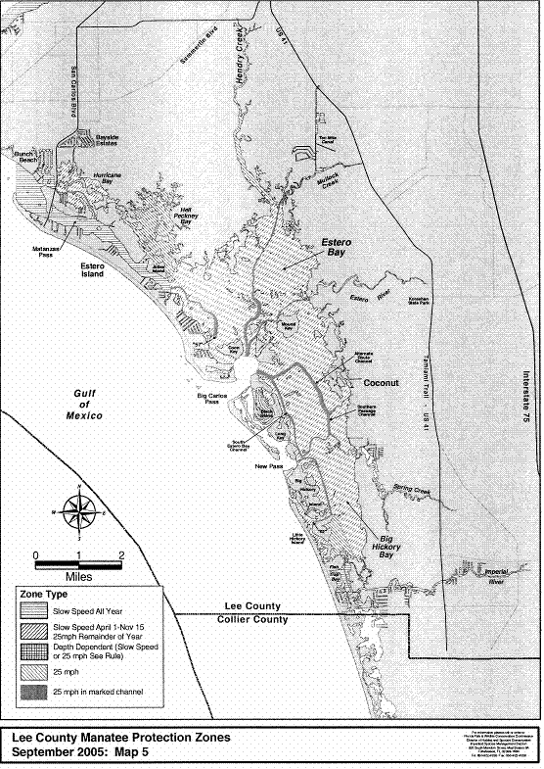
Rulemaking Authority 379.2431(2) FS. Law Implemented 379.2431(2) FS. History–New 3-19-79, Formerly 16N-22.05, Amended 12-5-89, Formerly 16N-22.005, 62N-22.005, Amended 11-30-99, 7-17-01, 9-20-05.

