68C-22.012 Volusia and Associated County (Parts of Putnam, Lake, Seminole and Flagler) Zones.
(1) The Commission designates those portions of the St. Johns River basin and the Halifax/Indian River and Tomoka River basin within Volusia and adjacent counties as areas where manatees are frequently sighted. The Commission has further determined that they are assumed to inhabit these waters periodically or continuously. This rule is for the purpose of regulating the speed and operation of motorboats in portions of these designated areas in Volusia County as well as in counties adjacent to Volusia County in portions of the St. Johns River basin and in portions of the Halifax/Indian River and Tomoka River basin. In addition to Volusia County, waters within the following counties are regulated within the provisions of this rule: Putnam, Lake, and Seminole (St. Johns River basin); and Flagler (Halifax River). In balancing the rights of fishermen, boaters, and waterskiers to use these waterways for recreational and commercial purposes (as applicable under Section 370.12(2)(j), F.S.) with the need to provide manatee protection, the Commission has examined the need for higher speed travel corridors through regulated areas. Such corridors are provided in those areas where the Commission determined, on the basis of all available information, (1) there is a need for the corridor and (2) the corridor will not result in serious threats to manatees or their habitat (as defined in Rule 68C-22.001, F.A.C.). Higher speed corridors are not provided in areas where both of the above findings were not made.
(2) For the purpose of regulating the speed and operation of motorboats in order to protect manatees within portions of the St. Johns River Basin, year-round and seasonal zones are established as follows:
(a) SLOW SPEED ZONE (Year-round) – The following described zones shall include all navigable waters and all associated and navigable tributaries, lakes, creeks, coves, bends, backwaters, canals, mosquito ditches, and boat basins, unless otherwise designated or excluded:
1. Lake George Area: All waters within 750 feet of the general contour of the westerly shoreline of Lake George and the St. Johns River southerly of a line bearing North 90° 00' 00" East (True) running through Flashing Red Channel Marker “68” (latitude 29° 23' 32" North, longitude 81° 39' 27" West) near Black Point and northerly of a line bearing South 20° 00' 00" East (True) running through the southernmost point of Rocky Point (approximate latitude 29° 20' 13" North, approximate longitude 81° 39' 30" West); and, all waters within 1500 feet of the general contour of the westerly shoreline of Lake George southwesterly of a line bearing South 20° 00' 00" East (True) running through the southernmost point of Rocky Point and westerly of the main marked channel at the confluence of the St. Johns River at the southerly end of Lake George, and northerly of a line bearing North 70° 00' 00" East (True) which lies 830 feet North 20° 00' 00" West (True) of Flashing Red Channel Marker “18” (latitude 29° 12' 05" North, longitude 81° 34' 20" West), excepting Salt Springs Creek; and that part of Lake George lying northeasterly of a line 600 feet southwesterly of and parallel with the centerline of the main marked channel at the southerly end of Lake George, southerly of a line which bears North 90° 00' 00" East (True) running through the north end of the jetty, westerly of a line which bears North 45° 00' 00" West (True) running from the shoreline at the northern tip of Zinder Point (approximate latitude 29° 12' 14" North, approximate longitude 81° 34' 10" West) and northerly of a line bearing North 70° 00' 00" East (True) which lies 830 feet North 20° 00' 00" West (True) of Flashing Red Channel Marker 18 (latitude 29° 12' 05" North, longitude 81° 24' 20" West);
2. St. Johns River from Lake George to Lake Dexter: Waters southerly of a line bearing North 70° 00' 00" East (True) which lies 830 feet North 20° 00' 00" West (True) of Flashing Red Channel Marker “18” (latitude 29° 12' 05" North, longitude 81° 34' 20" West) and northerly of a line which bears North 90° 00' 00" East (True) running through Flashing Red Channel Marker “8” (latitude 29° 07' 24" North, longitude 81° 30' 19" West), as follows:
a. Within 50 feet of the general contour of the shoreline of the St. Johns River proper; and
b. Within all tributaries, lakes, creeks, backwaters, coves, canals, and boat basins associated with the afore-described portion of the St. Johns River, including Blue Creek, Cross Creek, Hitchens Creek, Payne Creek, Axle Creek, and Morrison Creek;
3. West end of Lake Dexter: All waters outside the main marked channel of the Florida Intracoastal Waterway within that portion of Lake Dexter southerly of a line which bears North 90° 00' 00" East (True) running through Flashing Red Channel Marker “8” (latitude 29° 07' 24" North, longitude 81° 30' 19" West), and westerly of a line which bears North 00° 00' 00" East (True) running from the shoreline of Dexter Point through the shoreline of the northernmost point of the west end of Dexter Island (approximate latitude 29° 06' 06" North, approximate longitude 81° 29' 56" West), inclusive of waters northerly of a line which bears North 90° 00' 00" East (True) running through the shoreline of the northernmost point of Dexter Island (approximate latitude 29° 06' 06" North, approximate longitude 81° 29' 56" West);
4. Lake Dexter Area: All waters within 1500 feet of the general contour of the shoreline of Lake Dexter easterly of a line which bears North 00° 00' 00" East (True) running from the shoreline of Dexter Point through the general contour of the shoreline of the northernmost point of the west end of Dexter Island (approximate latitude 29° 06' 06" North, approximate longitude 81° 29' 56" West), and westerly of a line which bears North 00° 00' 00" East (True) running through the westernmost tip of the shoreline of the large unnamed island at the eastern end of the lake (approximate latitude 29° 06' 40" North, approximate longitude 81° 27' 43" West);
5. Lake Dexter/Tick Island Area: All waters within the general contour of the shoreline of those portions of Lake Dexter and Tick Island Creek easterly of a line which bears North 00° 00' 00" East (True) running through the westernmost tip of the shoreline of the large unnamed island at the eastern end of Lake Dexter (approximate latitude 29° 06' 40" North, approximate longitude 81° 27' 43" West) and westerly of a line which bears North 55° 00' 00" East (True) running from the shoreline of Tick Island to the shoreline of the westernmost point of the south bank of Cypress Branch (approximate latitude 29° 06' 54" North, approximate longitude 81° 25' 54" West), except as described under (2)(a)6., below;
6. Eph Creek, Tick Island Mud Lake, Harry's Creek Area: All waters of Eph Creek, Cross Creek, Tick Island Mud Lake, Taylor Creek, Harry’s Creek and Honey Creek southerly of the confluence of Lake Dexter with Eph Creek, easterly of the confluence of the St. Johns River with Cross Creek, westerly of the confluence of Lake Woodruff with Harry’s Creek, and northeasterly of the confluence of Honey Creek with the St. Johns River;
7. Lake Woodruff Area: All waters within 1500 feet of the general contour of the shoreline of Lake Woodruff southerly of a line which bears North 55° 00’ 00" East (True) running from the general contour of the shoreline of Tick Island to the general contour of the shoreline of the westernmost point of the south bank of Cypress Branch (approximate latitude 29° 06' 54" North, approximate longitude 81° 25' 54" West), excepting Spring Garden Creek;
8. Scoggin Creek Area: All waters of Scoggin Creek southerly of the confluence of Lake Woodruff with Scoggin Creek; including the canal southwesterly of the southwesterly shore of Lake Woodruff, easterly of Harry's Creek, and westerly of Norris Dead River;
9. Norris Dead River, Zeigler Dead River, Highland Park Canal Area: All waters of Norris Dead River and Scoggin Lake southerly of Lake Woodruff, all waters of Zeigler Dead River, all waters of Highland Park Canal, all waters of Blue Peter Lake, and Daisy Lake, and all other associated waters south of Lake Woodruff and east of the St. Johns River;
10. Spring Garden Creek Area: All waters within Spring Garden Creek northeasterly of a line which bears North 55° 00’ 00" West (True) running through the shoreline from the tip of a point of land on the southerly bank of Spring Garden Creek (approximate latitude 29° 06' 47" North, approximate longitude 81° 24' 10" West) and southerly of a line which bears North 50° 00' 00" East (True), running through the northerly tip of an unnamed island (approximate latitude 29° 07' 03" North, approximate longitude 81° 24' 10" West);
11. St. Johns River – Lake Dexter to Honey Creek Area: Waters southerly of a line which bears North 90° 00' 00" East (True) running through the shoreline of the northernmost point of the west end of Dexter Island (approximate latitude 29° 06' 00" North, approximate longitude 81° 29' 56" West) and northerly of a line running between Flashing Red Channel Marker “32” (latitude 29° 01' 59" North, longitude 81° 24' 14" West) and Green Channel Marker “31,” as follows:
a. Within 50 feet of the general contour of the shoreline of the St. Johns River proper; and
b. Within all tributaries, lakes, and creeks associated with the above-described portion of the St. Johns River, including Stagger Mud Lake, Stagger Creek, Alexander Spring Creek, Kimball Lake, Lee Lake, Adams Lake, Get Out Creek, Twin Lakes, Horseshoe Mud Lake, the St. Francis Dead River, and Honey Creek;
12. St. Johns River–Honey Creek to Beresford Peninsula Canal Area: Waters of the St. Johns River southerly of a line running between Flashing Red Channel Marker “32” (latitude 29° 01' 59" North, longitude 81° 24' 14" West) and Green Channel Marker “31” and northerly of a line which bears North 45° 00' 00" West (True) from the shoreline of the westernmost tip of the northeasterly bank of the unnamed finger canal of the Beresford Peninsula (approximate latitude 28° 58' 40" North, approximate longitude 81° 21' 33" West) to the shoreline of the western bank of the St. Johns River, as follows:
a. Within 50 feet of the general contour of the shoreline of the St. Johns River proper; and
b. Within all tributaries, lakes, and creeks associated with the above-described portion of the St. Johns River, including Mud Lake, Shell Creek, and Dean Dead River;
13. St. Johns River–Beresford Peninsula Canal to Lake Beresford Area: All waters of the
St. Johns River southerly of a line which bears North 45° 00' 00" West (True) from the shoreline of the westernmost tip of the northeasterly bank of the unnamed finger canal of the Beresford Peninsula (approximate latitude 28° 58' 40" North, approximate longitude 81° 21' 33" West) to the shoreline of the western bank of the St. Johns River and westerly of a line which bears North 90° 00' 00" East (True) running through Flashing Red Channel Marker “60” (latitude 28° 58' 42" North, longitude 81° 21' 00" West);
14. Hontoon Dead River Area: All waters of the Hontoon Dead River lying southerly and southwesterly of longitude 81° 21' 41" West at the St. Johns River near the Beresford Peninsula, including navigable portions of Snake Creek and the unnamed canals connecting Hontoon Dead River with the St. Johns River and their associated waters;
15. Lake Beresford Area: Waters of Lake Beresford as follows:
a. All waters lying northerly of latitude 29° 00' 04" North;
b. All waters within 300 feet of the general contour of the easterly and westerly shorelines of Lake Beresford southerly of latitude 29° 00' 04"
North, and northerly of a line which bears North 90° 00' 00" East (True), running through the “snag” near the western shore of Lake Beresford (approximate latitude 28° 58' 48" North, approximate longitude 81° 20' 56" West); and
c. All waters within 1,000 feet of the general contour of the westerly, southerly, and easterly shorelines lying southerly of a line which bears North 90° 00' 00" East (True) running through the “snag” near the western shore of Lake Beresford (approximate latitude 28° 58' 48" North, approximate longitude 81° 20' 56" West);
16. St. Johns River–Lake Beresford to Lake Monroe Area: Waters southerly of a line which bears North 90° 00' 00" East (True) running through Flashing Green Channel Marker “63”
(latitude 28° 58' 26" North, longitude 81° 20' 47" West) and northerly of the end of the fender system on the easterly side of the Interstate Highway 4 Bridge at the west end of Lake Monroe as follows, except as otherwise designated for seasonal or year-round regulation in paragraphs (2)(b), (c), (d) and (f):
a. All waters outside the main marked channel of the St. Johns River;
b. Those waters of the St. Johns River, from shoreline to shoreline including the marked channel, southerly of a line bearing North 90° 00' 00" East (True) running through Flashing Green Channel Marker “67” (latitude 28° 57' 30" North, longitude 81° 21' 01" West) and northerly of a line bearing North 90° 00' 00" East (True) running through Flashing Green Channel Marker “69” (latitude 28° 56' 55" North, longitude 81° 20' 46" West), and those waters from shoreline to shoreline including the marked channel southerly of a line bearing South 25° 00' 00" East (True) running through Green Channel Marker “75” (latitude 28° 56' 16" North, longitude 81° 20' 49" West) and northerly of a line bearing North 90° 00' 00" East (True) running through Flashing Green Channel Marker “81” (latitude 28° 55' 22" North, longitude 81° 21' 08" West); and
c. All tributaries, creeks, lakes, bends, coves, canals, boat basins, discharge canals, and backwaters associated with the above-described portions of the St. Johns River, including Beresford Bend, Dutchmans Bend, Florida Bend, Volusia Cove, Coxetter's Bend, Emanual Bend, Guyan Cove, The Big Whirl, July Slough, Butcher’s Bend, Butcher’s Pen Slough, and Alexander Slough; and
d. Those waters of the Wekiva River south of its confluence with the St. Johns River and north of a due East line running from the easternmost point of land (approximate latitude 28° 52’ 19" North, approximate longitude 81° 22' 13" West) on the westerly shoreline of said Wekiva River at the south side of an inlet finger leading to the south end of Chub Slough.
17. Lake Monroe Area: All waters approximately within 3000 feet of the general contour of the westerly and northerly shoreline of Lake Monroe, east of the end of the fender system on the easterly side of the Interstate Highway 4 Bridge, northerly of the northern boundary of the marked channel of the Florida Intracoastal Waterway (or as posted, with all waters to include those generally northwest of a line drawn from Red Channel Marker “4” to Green Channel Marker “13”), and northwesterly of a line which bears South 50° 00' 00" West (True) from the westernmost point of Stone Island, (approximate latitude 28° 51' 12" North and approximate longitude 81° 14' 45" West) inclusive of all waters of Bethel Creek Cove, and excluding the marked channel running southerly and west of the City of Enterprise.
(b) SLOW SPEED ZONE (Seasonal – October 15 through April 15): St. Johns River, Lake Beresford to Channel Marker “67” Area: All waters of the St. Johns River, inclusive of all marked channels and all associated waters unless otherwise designated or excluded, southerly of a line which bears North 90° 00' 00" East (True) running through Flashing Green Channel Marker “63” (latitude 28° 58' 26" North, longitude 81° 20' 47" West) and northerly of a line which bears North 90° 00' 00" East (True) running through Flashing Green Channel Marker “67” (latitude 28° 57' 30" North, longitude 81° 21' 01" West).
(c) IDLE SPEED ZONE (Year-round): St. Johns River/Blue Spring Area: All waters of the St. Johns River southerly of a line which bears North 90° 00' 00" East (True) running through Flashing Green Channel Marker “69” (latitude 28° 56' 55" North, longitude 81° 20' 46" West) and northerly of a line which bears South 25° 00' 00" East (True) running through Green Channel Marker “75” (latitude 28° 56' 16" North, longitude 81° 20' 49" West), including Blue Spring Run and all other associated waters except as otherwise designated under paragraph (2)(d), hereunder.
(d) MOTORBOATS PROHIBITED ZONE (Seasonal – October 15 through April 15) – All waters of Blue Spring Run from its confluence with the St. Johns River to and including the Spring's headwaters.
(e) MAXIMUM 30 MPH/25 MPH NIGHTTIME ZONE (Year-round) – Waters of the St. Johns River and associated lakes, as follows:
1. Lake George to Lake Dexter Area: All waters of the St. Johns River to within 50 feet of the general contour of the shoreline, and including the main marked channel, southerly of a line bearing North 70° 00’ 00" East (True) which lies 830 feet North 20° 00' 00" West (True) of Flashing Red Channel Marker “18” (latitude 29° 12' 05" North, longitude 81° 34' 20" West) and northerly of a line which bears North 90° 00' 00" East (True) running through Flashing Red Channel Marker “8” (latitude 29° 07' 24" North, longitude 81° 30' 19" West);
2. Lake Dexter: All waters of Lake Dexter, except as otherwise designated under paragraph (2)(a)4., above;
3. Lake Woodruff: All waters of Lake Woodruff, except as otherwise designated under paragraph (2)(a)7., above;
4. Lake Dexter to Honey Creek Area: All waters of the St. Johns River to within 50 feet of the general contour of the shoreline, including the main marked channel, southerly of a line which bears North 90° 00' 00" East (True) running through the shoreline of the northernmost point of Dexter Island (approximate longitude 29° 06' 00" North, approximate latitude 81° 29' 56" West) and northerly of a line running between Flashing Red Channel Marker “32” (latitude 29° 01' 59" North, longitude 81° 24' 14" West) and Green Channel Marker “31” and;
5. Lake Beresford: All waters of Lake Beresford, except as otherwise designated under paragraph (2)(a)15., above.
(f) MAXIMUM 25 MPH ZONE (Year-round) – Waters of the St. Johns River and associated lakes, as follows:
1. Honey Creek to Beresford Peninsula Canal Area: All waters of the St. Johns River to within 50 feet of the general contour of the shoreline, including the main marked channel, southerly of a line running between Flashing Red Channel Marker “32” (latitude 29° 01' 59" North, longitude 81° 24' 14" West) and Green Channel Marker “31” and northerly of a line which bears North 45° 00' 00" West (True) from the shoreline of the westernmost tip of the northeasterly bank of the unnamed finger canal of the Beresford Peninsula (approximate latitude 28° 58' 40" North, approximate longitude 81° 21' 33" West); and
2. Lake Beresford to Lake Monroe Area: All waters of the main marked channel of the Florida Intracoastal Waterway, except as otherwise designated for seasonal or year-round regulation under paragraphs (2)(a), (b), (c), and (d), above, southerly of a line which bears North 90° 00' 00" East (True) running through Flashing Green Channel Marker “63” (latitude 28° 58' 26" North, longitude 81° 20' 47" West) and northerly/northwesterly of the end of the fender system on the easterly side of the Interstate Highway 4 Bridge at the west end of Lake Monroe.
(3) For the purpose of regulating the speed and operation of motorboats within portions of the Halifax River, Indian River basin and Tomoka River zones are established as follows:
(a) SLOW SPEED ZONE (Year-round) – The following described zones shall include all navigable waters and all associated and navigable tributaries, lakes, creeks, coves, bends, backwaters, canals, mosquito ditches, and boat basins, unless otherwise designated or excluded:
1. Halifax River, Halifax Creek and Smith Creek Area: All waters of Smith Creek, Halifax Creek, and the Halifax River, excluding the main marked channel of the Atlantic Intracoastal Waterway (designated for regulation under paragraph (3)(d)1., below), southerly of a line which bears North 67° 00' 00" East (True) located 2000 feet South 29° 00' 00" East (True) of Red Intracoastal Waterway Channel Marker “22” (latitude 29° 26' 28" North, longitude 81° 06' 58" West), northerly of a line which bears North 72° 00' 00" East (True) running through Green Intracoastal Waterway Channel Marker “9” (latitude 29° 19' 54" North, longitude 81° 04' 06" West) and easterly of the general contour of the easterly shoreline of the islands lying westerly of the Intracoastal Waterway Channel between the general contour of the shoreline of the southernmost tip of a peninsula (approximate latitude 29° 22' 28" North, approximate longitude 81° 05' 12" West) and a point which lies 600 feet South 72° 00' 00" West (True) from the aforementioned Green Intracoastal Waterway Channel Marker “9”;
2. Area westerly of Smith Creek: All waters within the backwater area lying southwesterly of a line which bears approximately North 30° 00' 00" West (True) from the general contour of the shoreline at the northernmost tip of an island (approximate latitude 29° 25' 56" North, approximate longitude 81° 06' 40" West) to the general contour of the shoreline of the westerly bank of Smith Creek and southwesterly of a line which bears approximately South 15° 00' 00" East (True) from the general contour of the shoreline at the southeastern tip of the aforementioned island (approximate latitude 29° 25' 32" North, approximate longitude 81° 06' 29" West) to the general contour of the shoreline of the westerly bank of Smith Creek, near Green Intracoastal Waterway Channel Marker “23”;
3. Bulow Creek Area: All waters of Bulow Creek within Volusia County westerly of the westerly bank of Halifax Creek, with its boundary for this purpose being a line bearing approximately South 35° 00' 00" East (True) running through Red Intracoastal Waterway Channel Marker “24” (latitude 29° 24' 45" North, longitude 81° 06' 17" West);
4. Tomoka Basin and Halifax River Area: All waters within 300 feet of the general contour of the shoreline of Tomoka Basin, northerly of a line which bears approximately North 90° 00' 00" East (True) running from the shoreline of a peninsula on the westerly bank of the mouth of Tomoka River (approximate latitude 29° 20' 50" North, approximate longitude 81° 05' 19" West) to the shoreline of the easterly bank of the Tomoka River at the northernmost tip of a peninsula (approximate latitude 29° 20' 50" North, approximate longitude 81° 05' 17" West) and that part of Tomoka Basin and Halifax River westerly of the easterly shoreline of the islands lying westerly of the Intracoastal Waterway Channel between the shoreline of the southernmost tip of a peninsula (approximate latitude 29° 22' 28" North, approximate longitude 81° 05' 12" West) and a point which lies 600 feet South 72° 00' 00" West (True) from Green Intracoastal Waterway Channel Marker “9” (latitude 29° 19' 54" North, longitude 81° 04' 06" West) and southerly of Green Intracoastal Waterway Channel Marker “9” and northerly of a line which is 600 feet northerly of and parallel with the centerline of Seabreeze Bridge (State Road 430);
5. Tomoka River, Strickland, Thompson, and Dodson creeks Area: All waters of Strickland, Thompson, and Dodson creeks; and all waters of Tomoka River, southerly of a line which bears North 65° 00' 00” East (True) running through a point on the shoreline of the east bank of the Tomoka River northerly of its confluence with Strickland Creek (approximate latitude 29° 20' 19" North, approximate longitude 81° 05' 09" West) and northeasterly of latitude 29° 19' 00" North;
6. Tomoka River/Alligator Island Area: All waters of Tomoka River, southerly of a line 100 feet northwesterly of and parallel with a line bearing North 49° 00' 00" East running through the northwesternmost point of Alligator Island (approximate latitude 29° 17' 10" North, approximate longitude 81° 06' 14" West), and northerly of a line 100 feet southwesterly of and parallel with a line bearing South 65° 00' 00" East running through the southwesternmost point of Alligator Island (approximate latitude 29° 16' 36" North, approximate longitude 81° 06' 21" West);
7. Halifax River/Daytona Beach Area: All waters of the Halifax River, inclusive of the main marked channel of the Atlantic Intracoastal Waterway and any other marked channels, southerly of a line which is 600 feet northerly of and parallel with the centerline of Seabreeze Bridge (State Road 430) and northerly of a line which bears North 60° 00' 00" East (True) running through Red Intracoastal Waterway Channel Marker “40” (latitude 29° 12' 06" North, longitude 81° 00' 21" West), except as otherwise described in subparagraph (3)(e)1., hereunder;
8. Halifax River/Daytona Beach and Port Orange Area: All waters within 300 feet of the general contour of the shoreline of the Halifax River, southerly of a line which bears North 60° 00' 00" East (True) running through Red Intracoastal Waterway Channel Marker “40” (latitude 29° 12' 06" North, longitude 81° 00' 21" West), northerly of a line which bears North 68° 00' 00" East (True) running through Green Intracoastal Waterway Channel Marker “57” (latitude 29° 08' 32" North, longitude 80° 58' 17" West) between the shoreline of Halifax Estates on the east and the shoreline of an unnamed island on the west, and northerly of a line which bears North 70° 00' 00" East (True) from a point on the westerly bank of Halifax River (approximate latitude 29° 07' 43" North, approximate longitude 80° 58' 41" West) to the shoreline of an unnamed island (approximate latitude 29° 07' 53" North, approximate longitude 80° 58' 12" West), except as otherwise described in subparagraph (3)(e)2., hereunder;
9. Halifax River/Port Orange and Live Oak Point Area: All waters of the Halifax River outside the main marked channel of the Atlantic Intracoastal Waterway southerly of a line which bears North 68° 00' 00" East (True) running through Green Intracoastal Waterway Channel Marker “57” (latitude 29° 08' 32" North, longitude 80° 58' 17" West), and northerly of a line bearing North 50° 00' 00" East (True) running through Red Intracoastal Waterway Channel Marker “8” (latitude 29° 04' 07" North, longitude 80° 56' 25" West);
10. Halifax River/Wilbur Bay area: All waters of Halifax River and Wilbur Bay easterly of the westerly shoreline of various islands lying northerly of a line which bears North 90° 00' 00" East (True) running through Flashing Green Intracoastal Waterway Channel Marker “67” (latitude 29° 06' 48" North, longitude 80° 57' 20" West) and southerly of a line which bears North 68° 00' 00" East (True) running through Green Intracoastal Waterway Channel Marker “57” (latitude 29° 08' 32" North, longitude 80° 58' 17" West);
11. Halifax River/Fozzard Creek Area: All waters of the Halifax River, and all waters of Fozzard Creek, Mill Creek, and Tenmile Creek, westerly of the easterly shoreline of the islands lying westerly of the main marked channel of the Atlantic Intracoastal Waterway, southerly of a line which bears North 70° 00' 00" East (True) from a point on the westerly bank of Halifax River (approximate latitude 29° 07' 43" North, approximate longitude 80° 58' 41" West) to the shoreline of an unnamed island (approximate latitude 29° 07' 53" North, approximate longitude 80° 58' 12" West), northerly of a line which bears South 57° 00' 00" East (True) running from a point on the shoreline near the southerly end of Riverside Drive (approximate latitude 29° 06' 17" North, approximate longitude 80° 58' 05" West) to a point on the shoreline of an unnamed marsh island (approximate latitude 29° 06' 00" North, approximate longitude 80° 57' 35" West), except as otherwise designated in paragraph (3)(c)2., hereunder;
12. Dead End Creek Area: All waters of Dead End Creek, southwesterly of the easterly shoreline of an unnamed marsh island, its shoreline being a line approximately 350 feet southwesterly of and parallel with the centerline of the Atlantic Intracoastal Waterway Channel running southerly of Green Channel Marker “69”;
13. Rose Bay Area: All waters within 300 feet of the general contour of the shoreline of Rose Bay, southerly of a line which bears South 57° 00' 00" East (True) running from a point on the shoreline near the southerly end of Riverside Drive (approximate latitude 29° 06' 17" North, approximate longitude 80° 58' 05" West) to a point on the shoreline of an unnamed marsh island (approximate latitude 29° 06' 00" North, approximate longitude 80° 57' 35" West) and northeasterly of the southeasterly extension of the centerline of Harbor Road being a line bearing approximately South 30° 00' 00" East (True) from a point on the shoreline (approximate latitude 29° 05' 55" North, approximate longitude 80° 58' 06" West), excepting any marked channels which are otherwise designated;
14. Spruce Creek, Murray Creek Area: All waters of Spruce Creek, excluding marked channels as designated in (3)(c)5.b. hereunder, northerly and easterly of the centerline of U.S. Highway 1 (State Road 5), southwesterly of the southeasterly extension of the centerline of Harbor Road being a line bearing approximately South 30° 00' 00" East (True) from a point on the general contour of the shoreline (approximate latitude 29° 05' 55" North, approximate longitude 80° 58' 06" West) and westerly of a line across the mouth of Spruce Creek which line is 300 feet westerly of and parallel with the centerline of the Intracoastal Waterway right of way running southerly from Flashing Red Intracoastal Waterway Channel Marker “4” (latitude 29° 05' 15" North, longitude 80° 57' 01" West); and, that part of Murray Creek, southerly of the centerline of U.S. Highway 1 (State Road 5);
15. Spruce Creek Area: All navigable waters of Spruce Creek westerly of the centerline of the main track of the Florida East Coast Railroad, and easterly of a line 750 feet easterly of and parallel with the westerly line of Section 38, Township 16 South, Range 33 East (or approximately two-thirds of a mile west of the centerline of the main track of the Florida East Coast Railroad), except as otherwise described in (3)(c), 5.a. hereunder;
16. Strickland Bay, Turnbull Bay Area: All waters within 300 feet of the general contour of the shoreline of Strickland Bay, westerly of the centerline of U.S. Highway 1 (State Road 5) and easterly of the centerline of the main track of the Florida East Coast Railroad, and within 300 feet of the general contour of the shoreline of Turnbull Bay, northerly of a line 650 feet northerly of and parallel with the centerline of the Turnbull Bay Road Bridge crossing Turnbull Creek; and, all waters of Turnbull Creek, southerly of a line 650 feet northerly of and parallel with the centerline of the Turnbull Bay Road Bridge crossing Turnbull Creek, excepting any marked channels which are otherwise designated in (3)(c)4., hereunder;
17. Halifax River/North Indian River/Ponce de Leon Cut Area: All waters of the Ponce de Leon Cut area within the Halifax River/North Indian River, inclusive of the main marked channel of the Atlantic Intracoastal Waterway and any other marked channels, southerly of a line bearing North 65° 00' 00" East (True) running through Red Intracoastal Waterway Channel Marker “8” (latitude 29° 04' 07" North, longitude 80° 56' 25" West), and westerly of a line bearing South 25° 00' 00" East (True) from the easternmost point of an unnamed island located northwesterly of Flashing Green Intracoastal Waterway Channel Marker “19” (latitude 29° 03' 26" North, longitude 80° 54' 53" West);
18. Ponce de Leon Inlet Area: Those waters of Ponce de Leon Inlet, shoreline to shoreline, northerly of a line bearing North 90° 00' 00" East (True) running through Red Intracoastal Waterway Channel Marker “20” (latitude 29° 03' 19" North, longitude 80° 54' 45" West) and southerly of a line bearing South 73° 00' 00" West (True) running through the Flashing Green Channel Marker standing ten feet (10') above water at the end of the concrete piling west of and adjacent to the U.S. Coast Guard Station located south of the Inlet; those waters northerly of a line bearing North 90° 00' 00" East (True) located 700 feet North 00° 00' 00" East (True) of the southwesternmost point of a peninsula in the inlet (approximate latitude 29° 04' 21" North, approximate longitude 80° 55' 26" West), westerly of the Inlet to their confluence with Ponce de Leon Cut; and, those waters of Rockhouse Creek westerly of a line drawn from the easternmost point of the northern shoreline of Rockhouse Creek to the northernmost point of the southern shoreline of the Creek, thence to the confluence of these waters with Ponce de Leon Cut;
19. Indian River North/Cook Creek area: All waters of Indian River North, southerly of a line bearing North 90° 00' 00" East (True) running through Red Intracoastal Waterway Channel Marker “20” (latitude 29° 03' 19" North, longitude 80° 54' 53" West) and northerly of the centerline of the North Causeway Bridge, also known as the Coronado Beach Bridge (State Road 44), except as otherwise described in subparagraph (3)(d)6., hereunder;
20. Hunter Creek, Smyrna Creek, Inlet Creek, Cook Creek Area: All waters of Hunter Creek, Smyrna Creek, Inlet Creek, Cook Creek and other associated waters of Indian River, southwesterly of Ponce de Leon Cut, westerly of Indian River and northerly of the centerline of the North Causeway Bridge (State Road 44);
21. Indian River North/New Smyrna Beach Area: All waters of Indian River North, including the main marked channel of the Atlantic Intracoastal Waterway and all waters of Sheephead Cut, southerly of the centerline of the North Causeway Bridge, also known as Coronado Beach Bridge, (State Road 44) and northerly of a line bearing North 65° 00' 00" East (True) running through Green Intracoastal Waterway Channel Marker “43” (latitude 29° 01' 10" North, longitude 80° 55' 00" West);
22. Indian River North/Edgewater, Packwood Place Area: All waters of Indian River North, westerly of the western boundary of the main marked channel of the Atlantic Intracoastal Waterway, southerly of a line bearing North 65° 00' 00" East (True) running through Green Intracoastal Waterway Channel Marker “43” (latitude 29° 01' 10" North, longitude 80° 55' 00" West) and northerly of a line bearing North 62° 00' 00" East (True) running through Flashing Green Intracoastal Waterway Channel Marker “65” (latitude 28° 56' 23" North, longitude 80° 52' 05" West); and those waters of Indian River North, easterly of the eastern boundary of the main marked channel of the Atlantic Intracoastal Waterway, southerly of a line bearing North 65° 00' 00" East (True) running through Green Intracoastal Waterway Channel Marker “43,” (latitude 29° 01' 10" North, longitude 80° 55' 00" West), and northerly of a line bearing North 65° 00' 00" East running through Green Channel Marker “47” (latitude 29° 00' 29" North, longitude 80° 54' 34" West); and, those waters of Indian River North easterly of and within 750 feet of the eastern boundary of the main marked channel of the Atlantic Intracoastal Waterway southerly of the line running through Green Channel Marker “47” and northerly of a line which bears North 65° 00' 00" East (True) through Flashing Green Channel Marker “49,” (latitude 29° 00' 00" North, longitude 80° 54' 21" West), and those waters easterly of the eastern boundary of the main marked channel of the Atlantic Intracoastal Waterway southerly of the line running through Flashing Green Intracoastal Waterway Marker “49,” northerly of the line running through Flashing Green Intracoastal Channel Marker “65,” and westerly of a line drawn along, and running between, the western shorelines of the islands immediately east of the channel;
23. Indian River North/Packwood Place, Oak Hill Area: All waters of Indian River North, inclusive of the main marked channel of the Atlantic Intracoastal Waterway, southerly of a line bearing North 62° 00' 00" East (True) running through Flashing Green Intracoastal Waterway Channel Marker “65” (latitude 28° 56' 23" North, longitude 80° 52' 05" West), northerly of a line bearing North 60° 00' 00" East (True) running through Green Can Buoy “9A” (latitude 28° 52' 03" North, longitude 80° 49' 51" West) and westerly of a line drawn along, and running between, the westerly shorelines of the islands immediately easterly of the channel;
24. Indian River/Mosquito Lagoon Area: All waters of the Indian River westerly of the westerly boundary of the main marked channel of the Atlantic Intracoastal Waterway, southerly of a line bearing North 60° 00' 00" East (True) running through Green Can Buoy “9A” (latitude 28° 52' 03" North, longitude 80° 49' 51" West) and northerly of the Volusia County/Brevard County line; and
25. Mosquito Lagoon/Bethune Beach Subdivision Area: Mosquito Lagoon/Bethune Beach Subdivision Area: All waters of Mosquito Lagoon, westerly of the easterly shoreline of Mosquito Lagoon (generally west of the Bethune Beach Subdivision), southeasterly of a line which bears South 31° 00' 00" West running through the southwesternmost point of a marsh peninsula (approximate latitude 28° 57' 26" North, approximate longitude 80° 51' 02" West) located approximately one half mile northwest of the overhead transmission lines crossing Mosquito Lagoon, northerly of a line which bears South 70° 00' 00" West running through the northwesternmost point of an unnamed marsh island (approximate latitude 28° 56' 30" North, approximate longitude 80° 50' 11" West) located approximately one mile southeast of the above-described transmission lines (approximately one mile northeast of Turtle Mound), and easterly of a line drawn along, and running between, the eastern shorelines of the three easternmost unnamed marsh islands generally between the two above-described lines.
(b) IDLE SPEED ZONE (Year-round) – Those waters of Tomoka River, inclusive of associated and navigable tributaries, lakes, creeks, coves, bends, backwaters, canals, mosquito ditches, and boat basins, as follows, unless otherwise designated or excluded:
1. Lying southerly of a line which bears approximately North 90° 00' 00" East (True) running from the shoreline of a peninsula on the westerly bank of the mouth of Tomoka River (approximate latitude 29° 20' 50" North, approximate longitude 81° 05' 19" West) to the shoreline of the easterly bank of Tomoka River at the northernmost tip of a peninsula (approximate latitude 29° 20' 50" North, approximate longitude 81° 05' 17" West) and northerly of a line which bears North 65° 00' 00" East (True) running through a point on the shoreline of the east bank of the Tomoka River northerly of its confluence with Strickland Creek (approximate latitude 29° 20' 19" North, approximate longitude 81° 05' 09" West);
2. Lying southerly of Latitude 29° 19' 00" North and northeasterly of the centerline of U.S. Highway 1; and
3. Lying southwesterly of a line 300 feet northeasterly of and parallel with the centerline of Interstate Highway 95 and northerly of the northerly right of way line of Old Tomoka Road.
(c) MAXIMUM 25 MPH ZONE (Year-round) –
1. Tomoka River Area: All waters of Tomoka River, southerly of a line 100 feet southwesterly of and parallel with a line bearing South 65° 00' 00" East running through the southwesternmost point of Alligator Island (approximate latitude 29° 16' 36" North, approximate longitude 81° 06' 21" West), and northerly of a line 300 feet northeasterly of and parallel with the centerline of Interstate Highway 95. All navigable creeks, coves, canals, boat basins, mosquito ditches, and backwater areas associated with the above-described portion of Tomoka River shall be designated Slow Speed;
2. Halifax River/Fozzard Creek Area: All waters within marked channels (as may be posted by local government) within the westernmost portion of the Halifax River (generally north of Rose Bay) westerly of the main marked channel of the Atlantic Intracoastal Waterway as described for regulation in subparagraph (3)(a)11., except that waters of Fozzard Creek, Tenmile Creek, and Mill Creek shall remain Slow Speed throughout;
3. Rose Bay Area: All waters of Rose Bay southerly of a line which bears South 57° 00' 00" East (True) running from a point on the shoreline near the southerly end of Riverside Drive (approximate latitude 29° 06' 17" North, approximate longitude 80° 58' 05" West) to a point on the shoreline of an unnamed marsh island (approximate latitude 29° 06' 00" North, approximate longitude 80° 57' 35" West) and northeasterly of the southeasterly extension of the centerline of Harbor Road being a line bearing approximately South 30° 00' 00" East (True) from a point on the shoreline (approximate latitude 29° 05' 55" North, approximate longitude 80° 58' 06" West), except as otherwise designated in subparagraph (3)(a)13., above, but including any marked channels as may be posted by local government;
4. Strickland Bay, Turnbull Bay Area: All waters of Strickland Bay westerly of the centerline of U.S. Highway 1 (State Road 5) and easterly of the centerline of the main track of the Florida East Coast Railroad, and all waters of Turnbull Bay northerly of a line 650 feet northerly of and parallel with the centerline of the Turnbull Bay Road Bridge crossing Turnbull Creek, except as otherwise designated in subparagraph (3)(a)16., above, but including any marked channels as may be posted by local government; and
5. Spruce Creek Area:
a. Spruce Creek (West of RR Bridge): All waters within the marked channel of Spruce Creek (as may be posted by local government), westerly of the centerline of the main track of the Florida East Coast Railroad and easterly of a line 750 feet easterly of and parallel with the westerly line of Section 38, Township 16 South, Range 33 East
(or approximately two-thirds of a mile west of the centerline of the main track of the Florida East Coast Railroad); and
b. Spruce Creek (Murray Creek Area): All waters within the marked channel of Spruce Creek (as may be posted by local government) northeasterly of the centerline of U.S. Highway 1 (State Road 5) and westerly of a line across the mouth of Spruce Creek which line is 300 feet westerly of a parallel with the centerline of the right of way of the Atlantic Intracoastal Waterway running southerly from Flashing Red Intracoastal Waterway Channel Marker “4” (latitude 29° 05' 15" North, longitude 80° 57' 01" West).
(d) MAXIMUM 30 MPH/25 MPH NIGHTTIME ZONE (Year-round) – Waters of the Halifax River, Indian River, and Tomoka River basin as follows:
1. Halifax Creek/Halifax River Area: All waters within the main marked channel of the Atlantic Intracoastal Waterway southerly of a line which bears North 67° 00' 00" East (True) located 2000 feet South 29° 00' 00" East (True) of Red Intracoastal Waterway Channel Marker “22” (latitude 29° 26' 28" North, longitude 81° 06' 58" West) and northerly of a line which bears North 72° 00' 00" East (True) running through Green Intracoastal Waterway Channel Marker “9” (latitude 29° 19' 54" North, longitude 81° 04' 06" West);
2. Tomoka Basin, Halifax River Area: All waters of Tomoka Basin and Halifax River northerly of a line which bears approximately North 90° 00' 00" East (True) running from the shoreline of a peninsula on the westerly bank of the mouth of Tomoka River (approximate latitude 29° 20' 50" North, approximate longitude 81° 05' 19" West) to the shoreline of the easterly bank of Tomoka River at the northernmost tip of a peninsula (approximate latitude 29° 20' 50" North, approximate longitude 81° 05' 17" West) and that part of Tomoka Basin and Halifax River westerly of the easterly shoreline of the islands lying westerly of the Intracoastal Waterway Channel between the shoreline of the southernmost tip of a peninsula (approximate latitude 29° 22' 28" North, approximate longitude 81° 05' 12" West) and a point which lies 600 feet South 72° 00' 00" West (True) from Green Intracoastal Waterway Channel Marker “9” (latitude 29° 19' 54" North, longitude 81° 04' 06" West) and southerly of Green Intracoastal Waterway Channel Marker “9” and northerly of a line which is 600 feet northerly of and parallel with the centerline of Seabreeze Bridge (State Road 430), including the main marked channel of the Atlantic Intracoastal Waterway, excepting those waters otherwise described in paragraph (3)(a)4., above;
3. Halifax River/Daytona Beach and Port Orange Area: All waters of the Halifax River not otherwise described in paragraphs (3)(a)8. and (3)(e)2. southerly of a line which bears North 60° 00' 00" East (True) running through Red Intracoastal Waterway Channel Marker “40” (latitude 29° 12' 06" North, longitude 81° 00' 21" West), northerly of a line which bears North 68° 00' 00" East (True) running through Green Intracoastal Waterway Channel Marker “57” (latitude 29° 08' 32" North, longitude 80° 58' 17” West) between the shoreline of Halifax Estates on the east and the shoreline of an unnamed island on the west, and northerly of a line which bears North 70° 00' 00" East (True) from a point on the westerly bank of Halifax River (approximate latitude 29° 07' 43" North, approximate longitude 80° 58' 41" West) to the shoreline of an unnamed island (approximate latitude 29° 07' 53" North, approximate longitude 80° 58' 12" West);
4. Halifax River/Port Orange and Live Oak Point Area: All waters of the Halifax River within the main marked channel of the Atlantic Intracoastal Waterway, southerly of a line which bears North 68° 00' 00" East (True) running through Green Intracoastal Waterway Channel Marker “57” (latitude 29° 08' 32" North, longitude 80° 58' 17" West), and northerly of a line bearing North 65° 00' 00" East (True) running through Red Intracoastal Waterway Channel Marker “8” (latitude 29° 04' 07" North, longitude 80° 56' 25" West);
5. Ponce de Leon Inlet Area: All waters of the Ponce de Leon Inlet area not otherwise described for regulation under subparagraph (3)(a)18., above, easterly of Ponce de Leon Cut, westerly of the easterly shorelines of Halifax River and Indian River North, southerly of a line bearing North 90° 00' 00" East (True) running from the southwesternmost point of a peninsula in the inlet (approximate latitude 29° 04' 21" North, approximate longitude 80° 55' 26" West), and, in Halifax River, southerly of a line located 700 feet North 00° 00' 00" East (True) of and parallel with the above-described line (southerly of red marker “2” (approximate latitude 29° 04' 31" North, approximate longitude 80° 55' 48" West), in the channel leading to Lighthouse Marina and northwesterly of a line bearing South 73° 00' 00" West (True) running through the Flashing Green Channel Marker standing 10 feet above water at the end of the concrete piling west of and adjacent to the U.S. Coast Guard Station located south of the Inlet;
6. Indian River North/Cook Creek Area: Those waters of the Indian River North southerly of a line which bears North 90° 00' 00" East (True) running through Red Intracoastal Waterway Channel Marker “20” (latitude 29° 03' 20" North, longitude 80° 54' 43" West), westerly of the general contour of the easterly shoreline of Indian River North, northerly of a line 150 feet southerly of and parallel with the center line of “Due East Street,” and easterly of the westerly boundary of the main marked channel of the Atlantic Intracoastal Waterway; and
7. Indian River North/Mosquito Lagoon Area: All waters of Indian River and Mosquito Lagoon, except as otherwise designated in subparagraphs (3)(a)22., (3)(a)23., (3)(a)24., and (3)(a)25., southerly of a line bearing North 65° 00' 00" East (True) running through Green Intracoastal Waterway Channel Marker “47” (latitude 29° 00' 29" North, longitude 80° 54' 34" West) and northerly of the Volusia County/Brevard County line, and that section of the Atlantic Intracoastal Waterway channel southerly of a line bearing North 65° 00' 00" East running through Green Intracoastal Waterway Channel Marker “43” (latitude 29° 01' 10" North, longitude 80° 55' 00" West) and northerly of a line bearing North 62° 00' 00" East running through Flashing Green Intracoastal Waterway Channel Marker “65” (latitude 28° 56' 23" North, longitude 80° 52' 05" West), and that section of the Atlantic Intracoastal Waterway channel southerly of a line bearing North 60° 00' 00" East (True) running through Green Can Buoy “9A” (latitude 28° 52' 03" North, longitude 80° 49' 51" West) and northerly of the Volusia County/Brevard County line, excepting those waters of Callalisa Creek northerly of a line which bears North 60° 00' 00" East (True) running through Flashing Green Intracoastal Waterway Channel Marker “49” (latitude 29° 00' 04" North, longitude 80° 54' 21" West).
(e) MAXIMUM 35 MPH/25 MPH NIGHTTIME ZONE – The following zones are established year-round for watersports use purposes:
1. Seabreeze Bridge Area: That part of the Halifax River easterly of a line 100 feet easterly of and parallel with the eastern boundary of the Atlantic Intracoastal Waterway Channel, southerly of an east-west line running 50 feet south of the southern end of the fender system of the Seabreeze Bridge (State Road 430) and the shoreline of the unnamed peninsula under the Bridge, and northerly of a line 500 feet northerly of and parallel with the centerline of the Main Street Bridge; and
2. Dunlawton Bridge Area: That part of the Halifax River westerly of a line 100 feet westerly of and parallel with the western boundary of the marked Atlantic Intracoastal Waterway Channel, to within 100 feet of the westerly and southerly shorelines, southerly of a line 2150 feet northerly of and parallel with the centerline of Dunlawton Avenue Bridge (State Road A1A) and northerly of the centerline of Dunlawton Avenue Bridge.
(f) SLOW SPEED ZONE (APRIL 1 THROUGH AUGUST 31)/MAXIMUM 25 MPH ZONE (REMAINDER OF YEAR) –
1. Tomoka River Area: The waters of Tomoka River southwesterly of the centerline of U.S. Highway 1 and northerly of a line 100 feet northwesterly of and parallel with a line bearing North 49° 00' 00" East running through the northwesternmost point of Alligator Island (approximate latitude 29° 17' 10" North, approximate longitude 81° 06' 14" West). All navigable creeks, coves, canals, boat basins, mosquito ditches, and backwater areas associated with the above-described portion of Tomoka River shall be designated Slow Speed (year-round); and
2. Spruce Creek Area: All navigable waters of Spruce Creek westerly of a line 750 feet easterly of and parallel with the westerly line of Section 38, Township 16 South, Range 33 East (or approximately two-thirds of a mile west of the centerline of the main track of the Florida East Coast Railroad).
(4) For the purpose of exempting qualifying commercial fishermen and professional fishing guides from certain speed zone restrictions, as provided under Rule 68C-22.003(6), Fla. Admin. Code (F.A.C.), the following limitations, and procedures for exemption application, shall apply:
(a) Exemptions shall be considered seasonally or year-round in zones, or portions of zones, as follows:
1. St. Johns River Basin: Seasonal exemptions will be considered within zones described in paragraphs (2)(a)4., 5., 7., 9., 14. and 17., with the period of exemption being November 1 through March 31; year-round exemptions will be considered within the zones described in paragraph (2)(a)1.
2. Halifax River/Indian River Area: Year-round exemptions will be considered within the zone described in paragraph (3)(a)14. and within a portion of the zone described in (3)(a)23.; seasonal exemptions will be considered within the zones described in paragraphs (3)(a)22., 23., and 24. from November 1 through March 31.
(b) A recipient of an exemption must maintain speeds of less than 20 MPH at all times within the restricted area, and comply with the conditions specified within the notice of exemption as well as under the provisions of this rule and Rule 68C-22.003(6), Fla. Admin. Code. Examples of conditions which may be specified to promote manatee protection include seasonal constraints or days of week/holiday limitations, limitations on types of fishing activities allowed, and limitations on areas within which exemptions apply within designated manatee protection zones.
(c) Exemptions granted will not apply on weekends or state-recognized holidays.
(d) Any commercial fisherman or professional fishing guide fulfilling the requirements set forth under Rule 68C-22.003(6), Fla. Admin. Code, may apply for the exemption, one of which shall be required for each vessel so operated, by completing the application form specified. Applications for exemption in accordance with the provisions of this rule may be obtained from the Fish and Wildlife Conservation Commission, Division of Law Enforcement Offices at 1-A Max Brewer Memorial Parkway, Titusville, FL 32796 (telephone 407/383-2740) or 1239 S.W. 10th Street, Ocala, FL 34474 (telephone 352/732-1225).
(5) For the purpose of exemption from speed restrictions for airboat operation within certain areas of the St. Johns River region (not withstanding applicable federal regulations prohibiting airboat use in portions of said areas), the following limitations shall apply:
(a) Protection zones established under paragraph (2)(a) above are exempt as specified and conditioned hereunder:
1. Areas exempt from speed restrictions shall include waters with a depth of less than two feet, as follows:
a. The Lake George area (including waters regulated as slow speed northerly to Black Point), except within 600 feet of the jetties at the southern end of Lake George;
b. The Lake Woodruff area, except in those waters within one-half mile of the Lake's confluence with Tick Island Creek, Harry’s Creek, Spring Garden Creek, and the Norris Dead River;
c. The Lake Monroe Area.
2. Exemptions shall apply within the waters of tributaries, creeks, and associated backwater areas meeting the following criteria, except as provided under (5)(a)3., hereunder:
a. Waters are at a distance of more than one-half mile from their confluence with the St. Johns River proper;
b. Waters are less than two feet deep from shore to shore (but excluding from consideration those waters less than two feet deep which are adjacent to deeper navigable waters, except as provided under (5)(a)1.);
c. Waters are not within or adjacent to, or directly associated with (as for bends, oxbows), the main channel of the St. Johns River.
3. Areas excluded from consideration for exemption are:
a. The Norris Dead River, Zeigler Dead River, Blue Peter Lake, Daisy Lake, and Highland Park Canal;
b. Hontoon Dead River;
c. St. Francis Dead River; and
d. Mud Lake, Shell Creek, and associated waters.
(6) For the purpose of considering conditional exemptions from speed restrictions within certain of the Halifax River areas for the purpose of powerboat racing, the following conditions, limitations, and procedures for application shall apply:
(a) Exemption application shall be submitted, at least 90 days prior to the event requested, to the Chief, Office of Environmental Services, 620 South Meridian Street, Tallahassee, FL 32399. The letter of application must clearly state:
1. The nature and scope of the boat race, including estimated numbers and nature/configuration of vessels racing and maximum speeds anticipated;
2. The specific area within which the race is requested, described within the letter of application and depicted on a National Ocean Survey nautical chart;
3. The intended month and day (if known) of the requested event; and
4. Justification for holding the event within waters regulated for manatee protection, clearly demonstrating why an alternative site is unsuitable for the racing event.
(b) Exemption consideration shall be limited as follows:
1. Exemptions will be considered only within the area between the S.R. 600 Carlton Blank Bridge and the Orange Avenue Memorial Bridge; and
2. The season of exemption consideration shall be from October 1 through February 15; and
3. Exemptions shall be considered only during daylight hours.
(c) Upon receipt of a letter of exemption, an exemption recipient must comply with all applicable provisions of this rule and with any and all conditions and limitations within the non-transferable letter of exemption as well as with any specific notice requirements as may be requested by the Division of Law Enforcement. Failure to comply with exemption conditions, and any finding of fraudulent use and/or application for said exemption, shall be cause for its immediate revocation, including a suspension of exemption privileges prior to or during the exempted event.
(7) The zones described in Rule 68C-22.012(1), (2), and (3), are depicted on the following maps, labelled "Manatee Protection Zones – St. Johns River Basin, Volusia and Associated Counties,” dated May 1994, and “Manatee Protection Zones – Halifax and Indian River Areas, Volusia and Associated Counties,” dated May 1994, which shall replace the previously published maps. (Maps provided are intended as depictions of the abovedescribed zones. In the event of conflict between the two, the above descriptions shall prevail.)

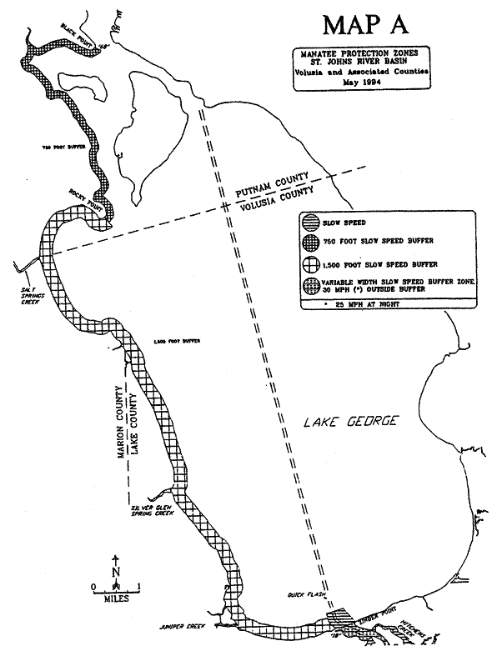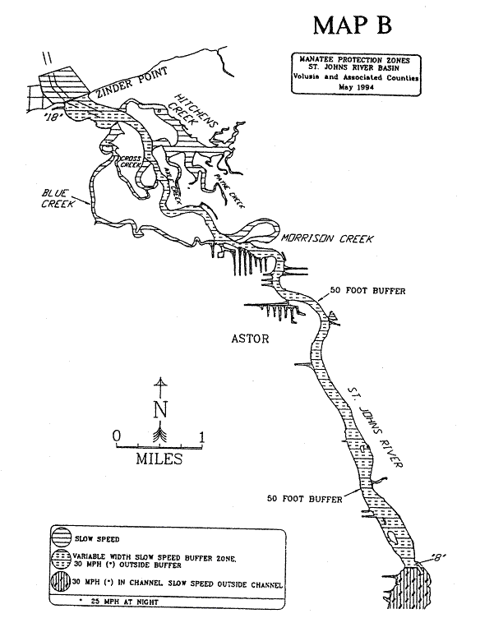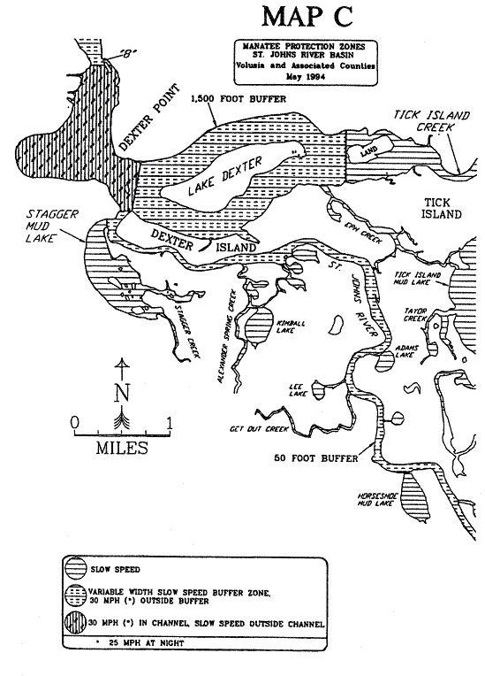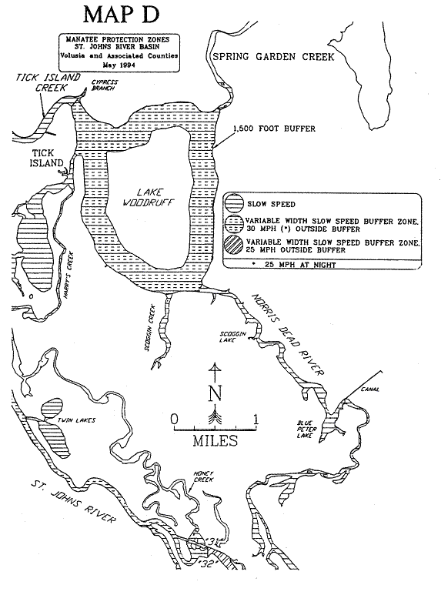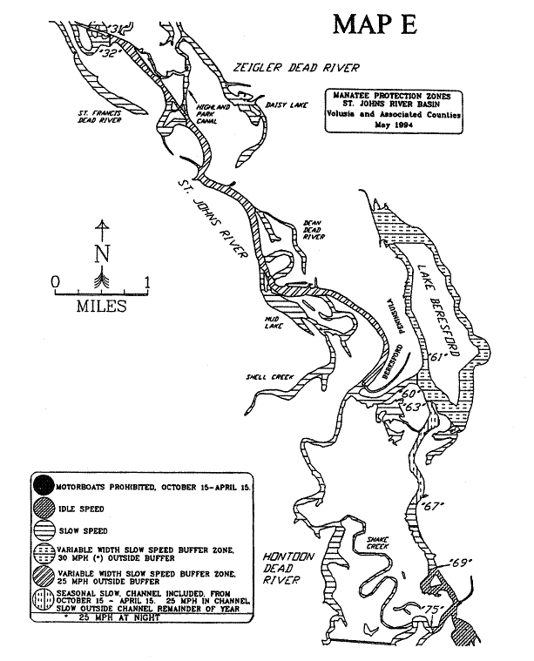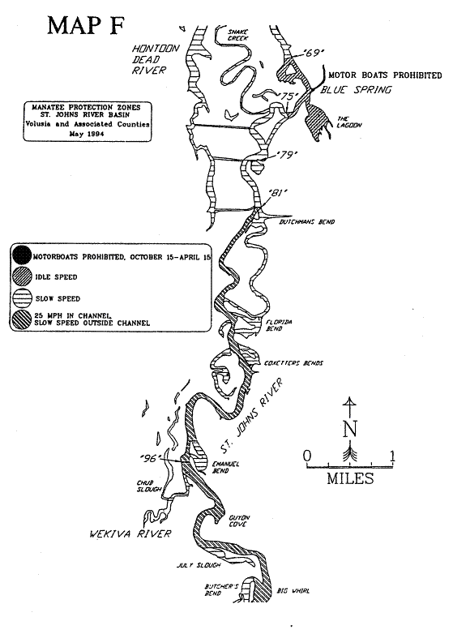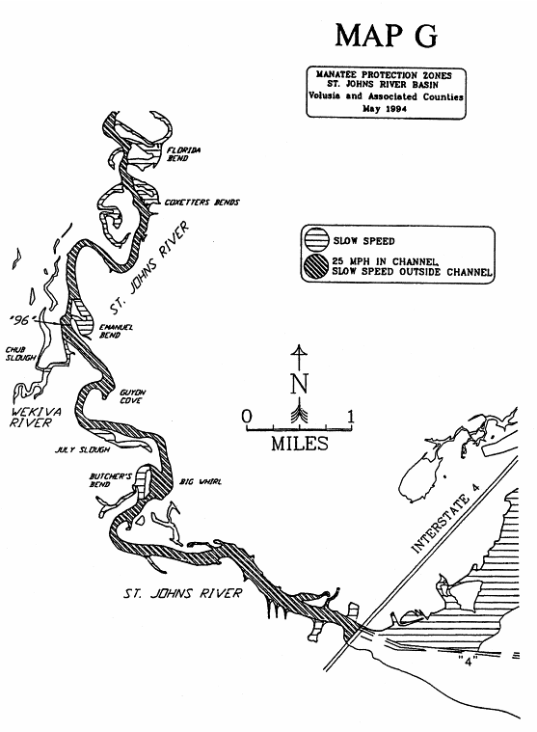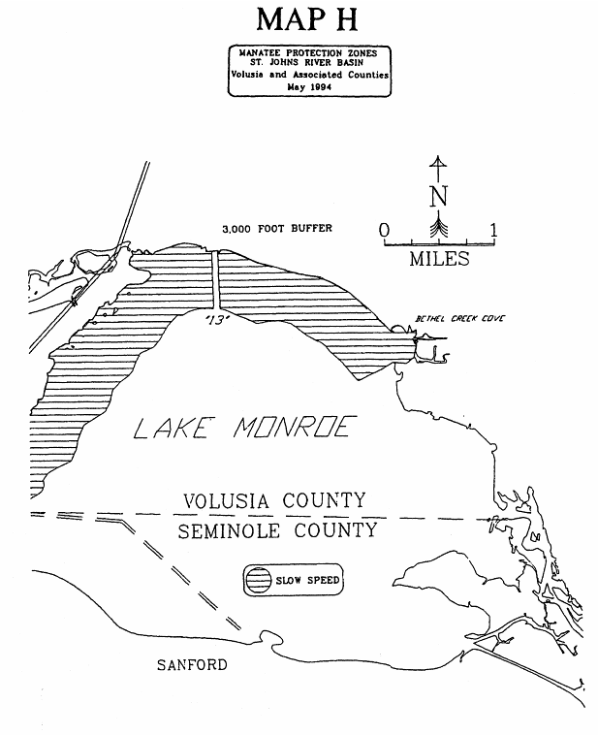
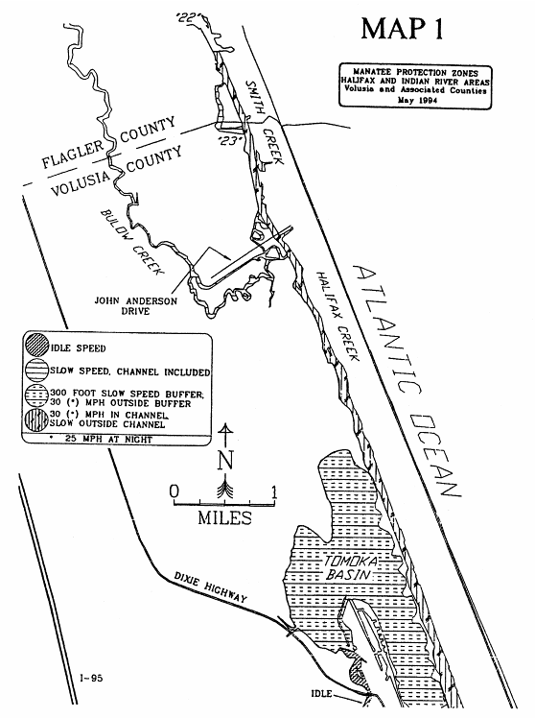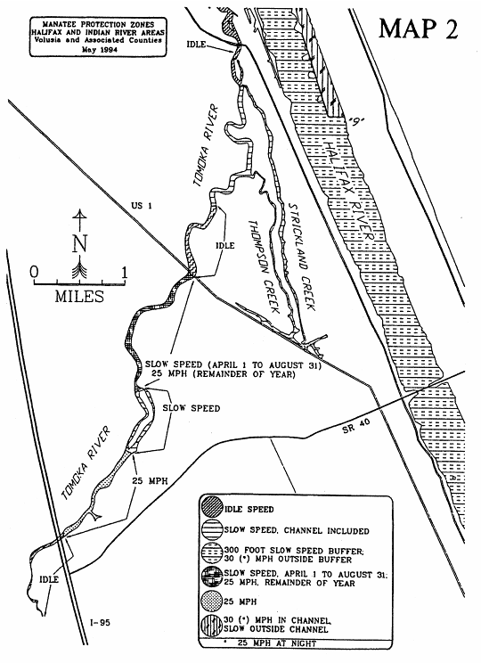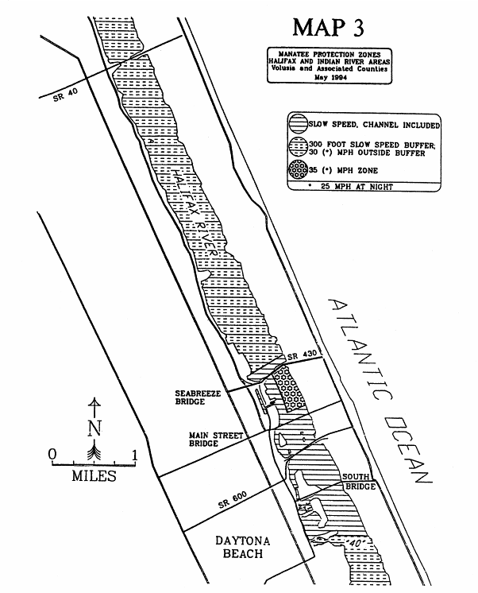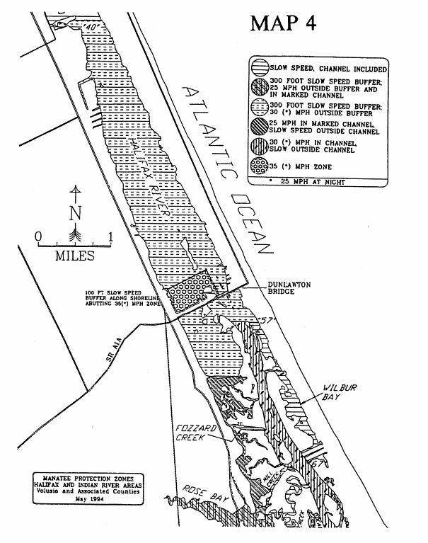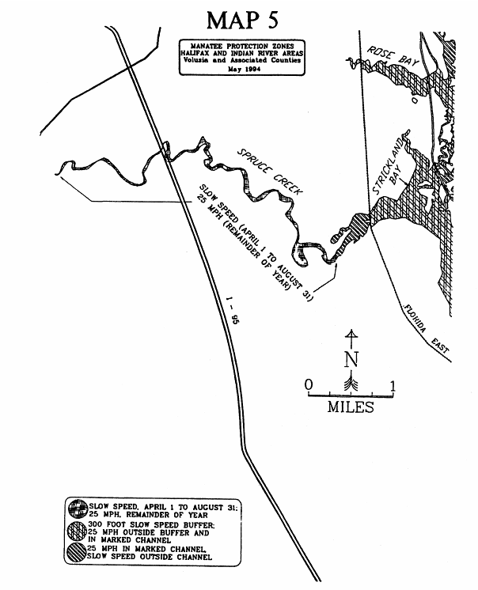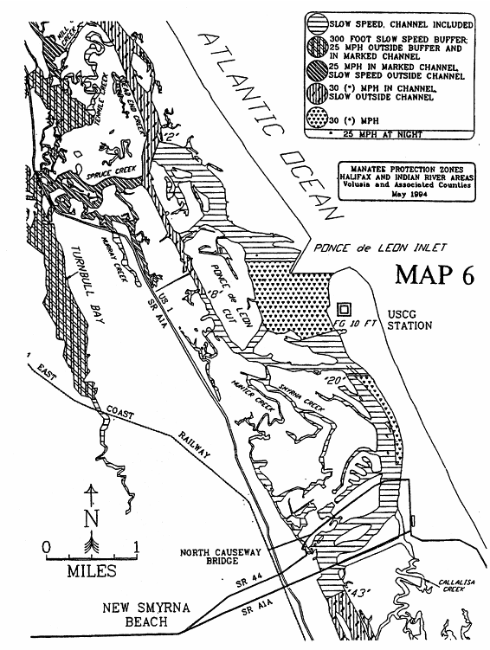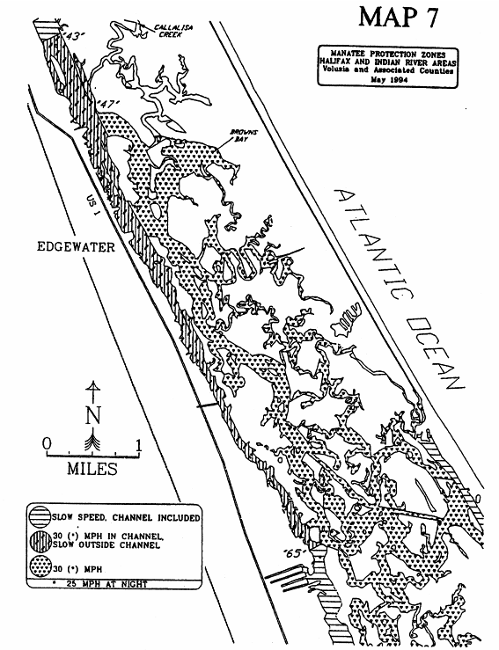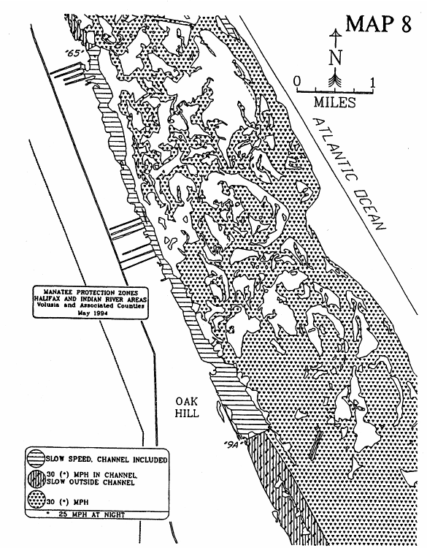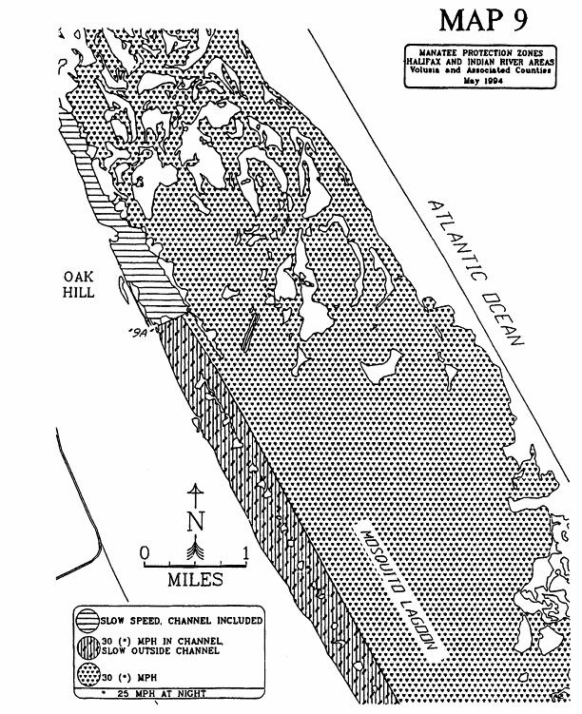

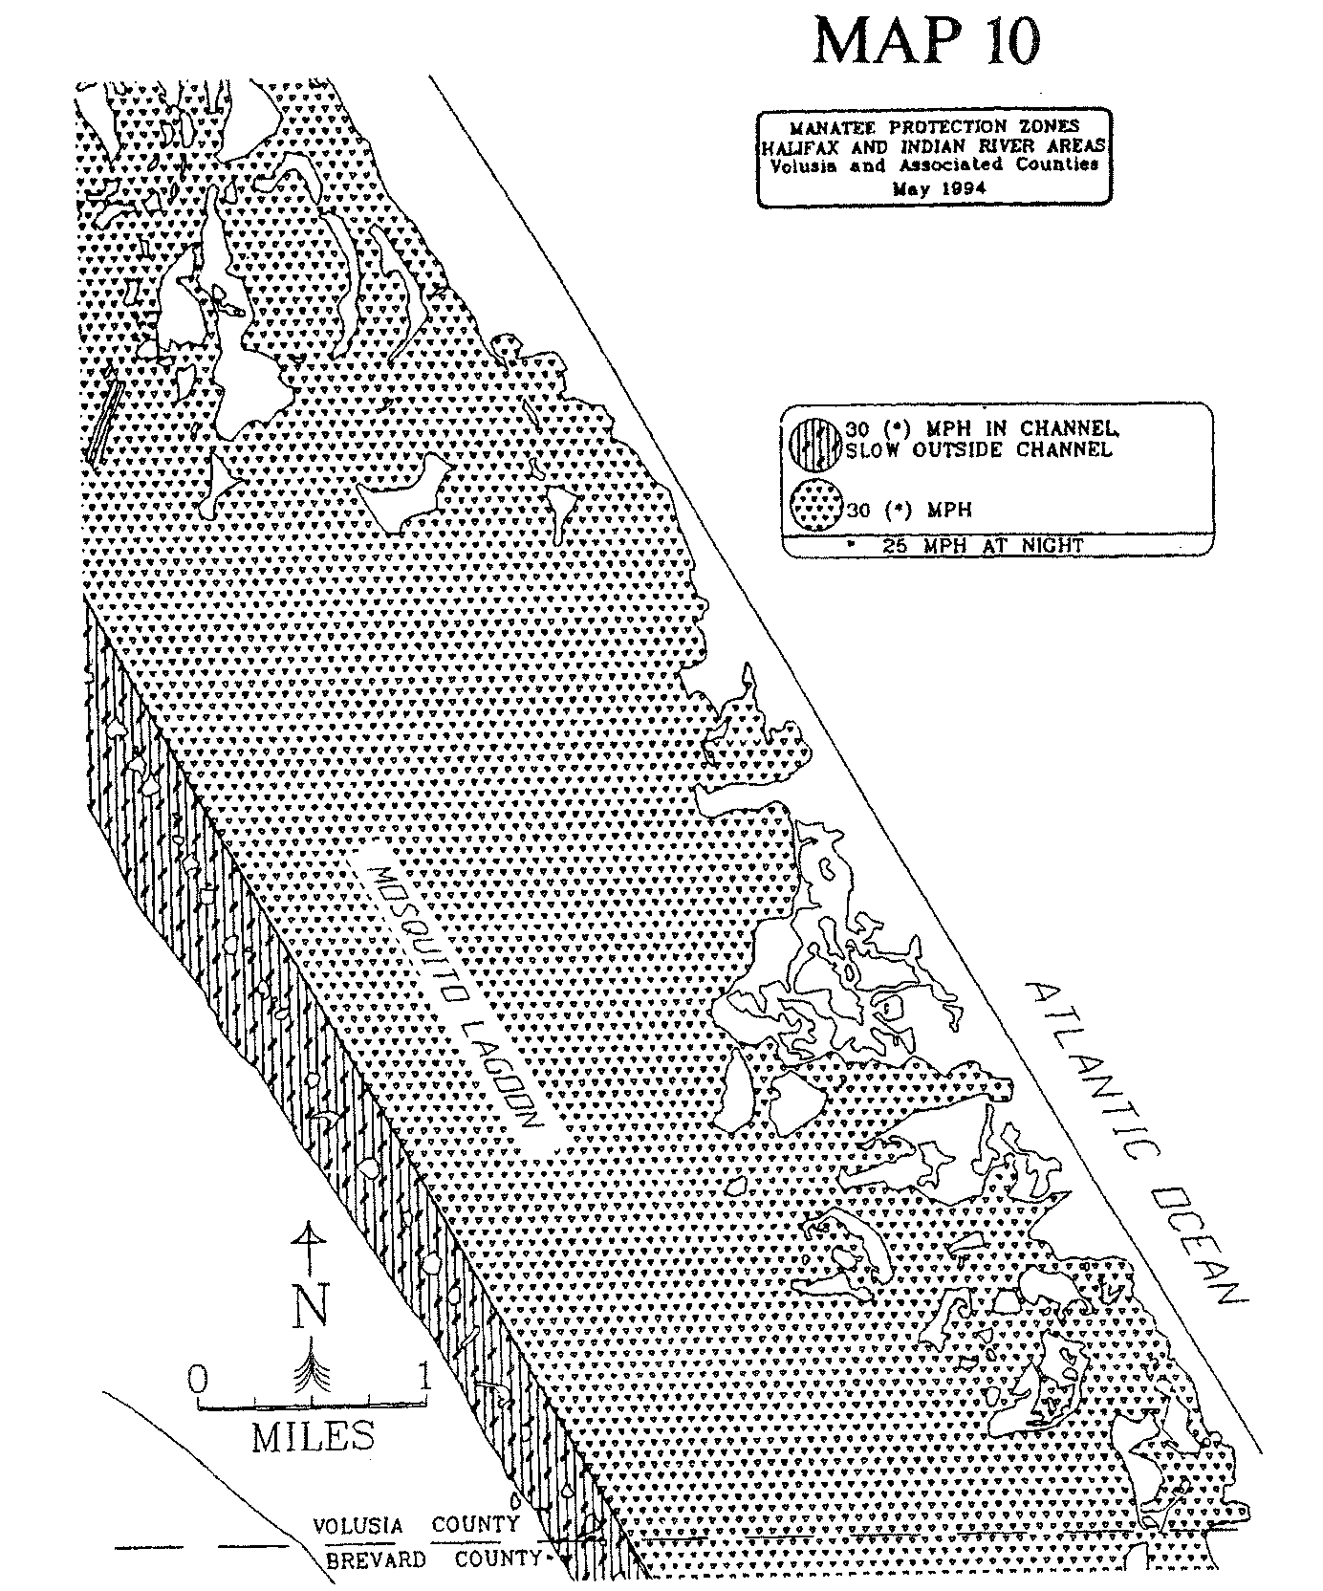

Specific Authority 370.021(1), 370.12(2)(f), (n), (o) FS. Law Implemented 370.12(2)(d), (f), (n), (o) FS. History–New 3-19-79, Formerly 16N-22.12, Amended 12-5-89, 7-25-91, 6-23-94, Formerly 16N-22.012, Amended 5-31-95, Formerly 62N-22.012.

