68C-22.010 Broward County Zones.
(1) For the purpose of regulating the speed and operation of motorboats within Broward County, the following year-round and seasonal zones are established, which shall include the described waters between the general contour of each shoreline exclusive of all associated and navigable tributaries, lakes, creeks, coves, bends, backwaters, canals, channels and boat basins unless otherwise specifically described for inclusion: (Seasonal limits, if they apply, are specified within each zone classification.)
(a) NO ENTRY ZONE (Year-round) –
1. Port Everglades Power Plant Area – Those waters of the discharge canal of the Florida Power & Light Company’s Port Everglades Power Plant, easterly of the discharge point at the plant, and northerly of a fence line located approximately 500 feet northerly of and parallel with the southerly line of Section 24, Township 50 South, Range 42 East; and those waters of the tributaries and associated waters southerly of the general contour of the southerly shoreline of the discharge canal (approximately along the southerly line of said Section 24); and
2. Lauderdale Power Plant Site Area – Those waters of the cooling canal system of the Florida Power & Light Company’s Lauderdale Power Plant, southerly of the southerly edge of the State Road 84 Bridge, westerly of S.W. 30th Avenue, southerly and easterly of the southerly and easterly shoreline of South New River Canal and northerly of the general contour of the northerly shoreline of Dania Cut-off Canal.
(b) IDLE SPEED ZONE (Year-round) – North New River Canal, South New River Canal Area: Those waters of South Fork New River, North New River Canal and South New River Canal to include its associated backwaters, westerly of the southerly extension of the centerline of S.W. 27th Avenue, easterly of the southerly extension of the centerline of S.W. 34th Avenue (New River Drive) and northerly of a line which bears North 65° 00' 00" West (True) from an angle point in the westerly boundary of Florida Power & Light Company's Lauderdale Power Plant site 460 feet south of the northwest corner of said plant site, to include those waters of Florida Power & Light Company’s canal that connects to South Fork New River lying northerly of the southerly edge of the State Road 84 Bridge.
(c) IDLE SPEED ZONE (November 15 through March 31)/SLOW SPEED ZONE (Remainder of year) –
1. Port Everglades Power Plant Area – Those waters of the Atlantic Intracoastal Waterway, shoreline to shoreline, southerly of a line which bears North 90° 00’ 00" East (True) from an angle point in the seawall on the westerly shore of the Atlantic Intracoastal Waterway (latitude 26° 05' 09" North, longitude 80° 06' 52" West) and northerly of a line which bears North 90° 00' 00" East (True) located 200 feet southerly of a sign post along the easterly shore of the Atlantic Intracoastal Waterway (latitude 26° 05' 09" North, longitude 80° 06' 52" West) and northerly of a line which bears North 90° 00' 00" East (True) located 200 feet southerly of a sign post along the easterly shore of the Atlantic Intracoastal Waterway (latitude 26° 04' 18" North, longitude 80° 06' 50" West) to include those waters of the discharge canal of Florida Power & Light Company's Port Everglades Power Plant, southerly and easterly of a fence line located approximately 500 feet northerly of the southerly line of Section 24, Township 50 South, Range 42 East, and northerly of the general contour of the southerly shoreline of the discharge canal, and all waters of Whiskey Creek northwesterly of the centerline of the northernmost Ocean Drive Bridge; and
2. South New River Canal, Dania Cut-off Canal Area – Those waters of South New River Canal southerly of a line which bears North 90° 00’ 00" East (True) located 600 feet southwesterly (as measured along the centerline of South New River Canal) of the centerline of the southerly of two Florida Power & Light Company's transmission lines located approximately 1,900 feet southerly of the northeasterly corner of Section 25, Township 50 South, Range 41 East, and northeasterly of a line which bears North 16° 00’ 00" West (True) from the northernmost point of the easterly seawall of the residential canal westerly of S.W. 42nd Terrace (approximate latitude 26° 04' 01" North, approximate longitude 80° 12' 13" West), to include the associated backwaters within the Lauderdale Power Plant site; that part of Dania Cut-off Canal westerly of the northerly extension of the centerline of S.W. 33rd Avenue and easterly of the general contour of the southeasterly shoreline of South New River Canal; and those waters of the associated canals southerly of Dania Cut-off Canal, westerly of S.W. 33rd Avenue and easterly of the general contour of the southeasterly shoreline of South New River Canal.
(d) SLOW SPEED ZONE (Year-round) –
1. Port Everglades Area – Those waters of New River, Stranahan River (to include the associated waters of the canal system of Rio Vista Development easterly of Cordova Road and that canal and associated boat basin southerly of S.E. 15th Street), Port Everglades Turning Basin, Lake Mable, and the Atlantic Intracoastal Waterway, southwesterly of a line which bears North 50° 00' 00" West (True) from the westernmost angle point of the seawall at Burnham Point (latitude 26° 06' 06" North, longitude 80° 06' 32" West), southwesterly of a line which bears approximately North 60° 00' 00" West (True) from the north-westernmost corner of the seawall of the U.S. Naval Reservation on the south side of the Port Everglades entrance channel (latitude 26° 05' 31" North, longitude 80° 06' 43" West) to the southwesternmost corner of the seawall of Harbor Heights Development (latitude 26° 05' 40" North, longitude 80° 06' 58" West), and northerly of a line which bears North 90° 00' 00" East (True) from an angle point in the seawall on the westerly shore of the Atlantic Intracoastal Waterway (latitude 26° 05' 09" North, longitude 80° 06' 52” West) to include the waters of the three boat slips on the westerly side of Port Everglades Turning Basin, excepting therefrom those waters of Lake Sylvia and the canals of Harbor Beach Development, the zone boundary being a line drawn from point to point of the seawalls forming the general contour of the easterly shoreline of Stranahan River (westerly limits of Harbor Beach Development) and the general contour of the southerly shoreline of New River (northerly limits of Harbor Beach Development);
2. Dania Cut-off Canal Area – Those waters of the Atlantic Intracoastal Waterway, shoreline to shoreline, southerly of a line which bears North 90° 00' 00" East (True) located 200 feet southerly of a sign post along the easterly shore of the Atlantic Intracoastal Waterway (latitude 26° 04' 18" North, longitude 80° 06' 50" West), and northerly of a line which bears North 90° 00' 00" East (True) from the southernmost tip of a peninsula on the westerly side of the Atlantic Intracoastal Waterway (latitude 26° 02' 55" North, longitude 80° 06' 59" West);
3. Whiskey Creek Area – Those waters of Whiskey Creek, southeasterly of the centerline of the northernmost Ocean Drive Bridge, and easterly of the general contour of the easterly shoreline of the Atlantic Intracoastal Waterway; and that portion of Whiskey Creek westerly of the general contour of the westerly shoreline of the Atlantic Intracoastal Waterway and southerly of the general contour of the southerly shoreline of Dania Cut-off Canal;
4. Hillsboro Canal Area – Those waters within 50 feet of the general contour of the southerly and southwesterly shoreline of Hillsboro Canal, northerly of the westerly extension of the general contour of the northerly shoreline of Deerfield Island Park (Capone Island), and easterly of the westerly side of the Military Trail (Powerline Road, State Road 845) Bridge; all waters of Hillsboro canal, shoreline to shoreline to include the associated boat basins and backwaters southwesterly of the southwesterly shoreline of Hillsboro Canal, southerly of the westerly extension of the general contour of the northerly shoreline of Deerfield Island Park (Capone Island), and westerly of the general contour of the westerly shoreline of the Atlantic Intracoastal Waterway; and those waters of the Atlantic Intracoastal Waterway, shoreline to shoreline, southerly of a line which bears North 89° 00' 00" East (True) from the southernmost tip of Deerfield Island Park (latitude 26° 18' 45" North, longitude 80° 04' 56" West), and northerly of a line drawn perpendicular to the centerline of the waterway 525 feet southerly of the centerline of the Hillsboro Boulevard (State Road 810) Bridge;
5. Pompano Canal Area – Those waters of Pompano Canal, northerly of the general contour of the northerly shoreline of Cypress Creek, and southeasterly of the centerline of the Cypress Road Bridge;
6. Cypress Creek Area – Those waters of Cypress Creek westerly of the centerline of the U.S. Highway 1 (State Road 5) Bridge, and easterly of the salinity control structure located approximately 300 feet easterly of Dixie Highway (State Road 811) Bridge;
7. Middle River Area – Those waters of South Fork Middle River westerly of the centerline of the U.S. Highway 1 (State Road 5) Bridge, and easterly of the centerline of the N.W. 31st Avenue Bridge; and those waters of North Fork Middle River westerly of the centerline of the U.S. Highway 1 (State Road 5) Bridge, southerly of the centerline of the Oakland Park Boulevard (State Road 816) Bridge, and easterly of the river's intersection with South Fork Middle River, near Interstate Highway I-95 (state Road 9);
8. New River Area – Those waters of New River, Tarpon River, North Fork New River and South Fork New River, northwesterly of Cordova Road, easterly of the salinity control structure in North Fork New River located approximately 600 feet westerly of N.W. 34th Avenue, and easterly of the southerly extension of the centerline of S.W. 27th Avenue across South Fork New River, to include the waters of Marina Bay (located approximately 500 feet west of the northeast corner of Section 20, Township 50 South, Range 42 East;
9. North New River Canal Area – Those waters of North New River Canal, westerly of the southerly extension of the centerline of S.W. 34th Avenue (New River Drive), and easterly of the salinity control structures located approximately 1000 feet northerly of and approximately 1400 feet southeasterly of the intersection of East Holloway Canal and North New River Canal to include all waters of the canal system of Plantation Isles Development;
10. South New River Canal Area – Those waters of South New River Canal, southerly of South Fork New River, and easterly of the westerly edge of the S.W. 100th Avenue (Golden Shoe Road) Bridge, except as otherwise designated for alternative regulation;
11. Dania Cut-off Canal Area – Those waters of Dania Cut-off Canal westerly of the general contour of the westerly shoreline of the Atlantic Intracoastal Waterway, and easterly of the northerly extension of the centerline of S.W. 33rd Avenue; and
12. C-10 Canal Area – Those waters of C-10 Canal, southerly of the general contour of the southerly shoreline of Dania Cut-off Canal, and northerly of the centerline of the Hollywood Boulevard (State Road 820) Bridge.
(e) SLOW SPEED ZONE (Weekends, November 15 through March 31) – This restrictive designation shall apply on weekends (from 7:00 a.m. to 7:00 p.m. Saturday and Sunday) for the following described waters: Atlantic Intracoastal Waterway Area – Those waters of the Atlantic Intracoastal Waterway, shoreline to shoreline, southerly of the Palm Beach County-Broward County line, and northerly of a line which bears North 50° 00’ 00" West (True) from the westernmost angle point of the seawall at Burnham Point (latitude 26° 06' 06" North, longitude 80° 06' 32" West), to include those waters of the boat basins easterly of New River Sound, southerly of East Las Olas Boulevard and northerly of Burnham Point; and those waters westerly of New River Sound, southerly of East Las Olas Boulevard and northerly of Idlewild Drive, except as otherwise designated for more restrictive regulation.
(f) SLOW SPEED ZONE (November 15 through March 31) –
1. Hillsboro Inlet Area – Those waters of the Atlantic Intracoastal Waterway, shoreline to shoreline, southerly of a line which bears North 90° 00' 00" East (True) running through Red Atlantic Intracoastal Waterway Channel Marker “68A” (latitude 26° 16' 33" North, longitude 80° 04' 52" West), and northerly of a line which bears North 90° 00' 00" East (True) located 300 feet southerly of the centerline of the N.E. 14th Street (State Road 814) Bridge, to include those waters of Hillsboro Bay and Hillsboro Inlet northwesterly of a line drawn perpendicular to the centerline of the inlet channel 150 feet northwest of the seaward extremities of the Hillsboro Inlet jetties;
2. Dania Beach Boulevard, Sheridan Street Area: Those waters westerly of the westerly boundary of the main marked channel of the Atlantic Intracoastal Waterway southerly of the northerly shoreline of the bay westerly of the peninsula on the westerly side of the Atlantic Intracoastal Waterway (latitude 26° 02' 55" North, longitude 80° 06' 59" West) located approximately 1,600 feet south of Dania Beach Boulevard, and northerly of a line which bears North 90° 00' 00" East (True) located approximately 1,940 feet south of Dania Beach Boulevard.
(g) MAXIMUM 25 MPH/SLOW SPEED BUFFER ZONE (Year-round) – This restrictive designation shall include a Slow Speed designation for all waters within 50 feet of the shorelines, and a maximum 25 MPH speed limit designation for all waters outside the 50-foot shoreline buffer (and including portions of the Atlantic Intracoastal Waterway channel where it is marked), within the following areas: Atlantic Intracoastal Waterway Area – all waters of the Atlantic Intracoastal Waterway not otherwise designated for more restrictive regulation (whether on weekends, seasonally, or year-round) within Broward County, from the Palm Beach County-Broward County line southerly to the Broward County-Dade County line.
(2) The following provisions pertain to issuance of permits within Atlantic Intracoastal Waterway areas for the purpose of powerboat racing. The following conditions, limitations, and procedures for application shall apply:
(a) Procedures related to the application for, as well as review and issuance of, these permits shall be as set forth in section 68C-22.003, F.A.C.
(b) Permits shall be limited as follows:
1. Permits shall be considered only for racing events to be held within the area between the southerly end of the fender system of the East Las Olas Bridge and a line which bears North 50° 00' 00" West (True) from the westernmost angle point of the seawall at Burnham Point (latitude 26° 06' 32" North, longitude 80° 06' 32" West);
2. Permits shall be considered only for racing events to be held between April 1 and October 31; and
3. Permits shall be considered only for racing events to be held during daylight hours.
(3) Access to the discharge canal adjacent to the Florida Power and Light Port Everglades Power Plant discharge point (and northerly of the referenced fence line) as designated as a No Entry Zone under paragraph (1)(a)1., above, shall be permitted for enforcement, emergency, and repair vessels and for other vessels for engineering or research purposes in association with operations of the Port Authority or the Commission. No permit or letter of authorization from the Commission is needed for these parties.
(4) The zones described in 68C-22.010(1) herein are depicted on the following maps (numbered 1–10 and labelled “Broward County Manatee Protection Zones”), dated February 1993 for identification: (Maps provided are intended as depictions of the above-described zones. In the event of conflict between the two, the descriptions shall prevail. Zones depicted on the February 1993 maps shall supersede those zones depicted on previously-published maps associated with rule 68C-22.010 in like geographic areas. The February 1993 maps shall become effective for purposes of this rule concurrent with its effective date.)
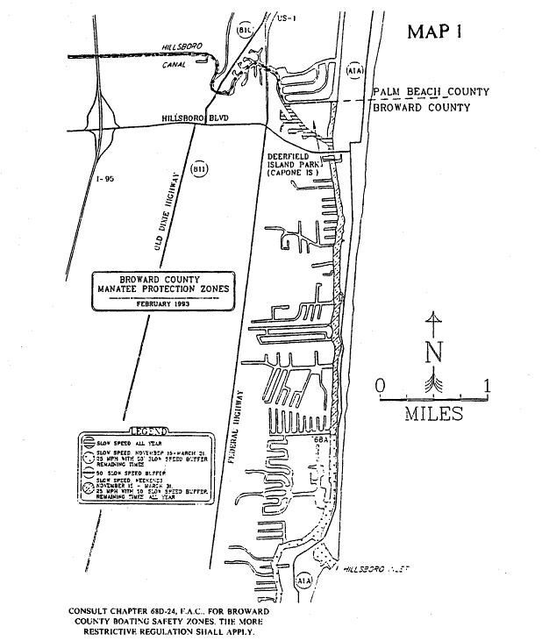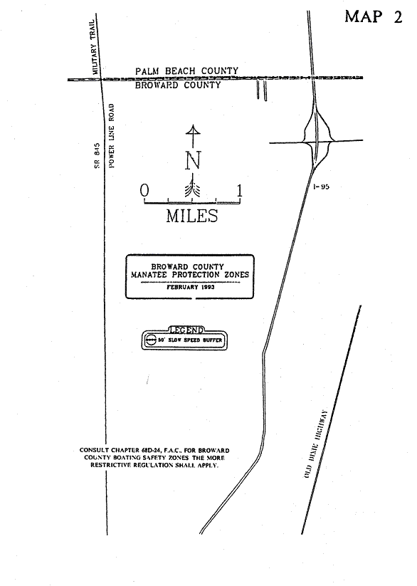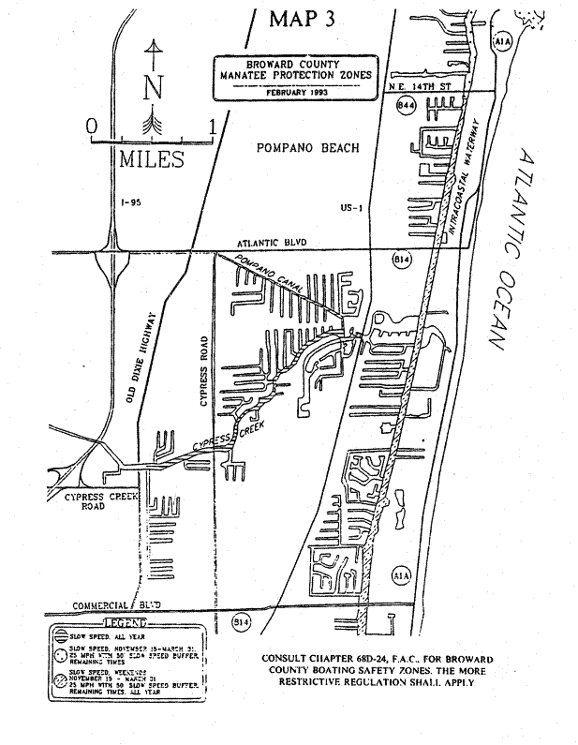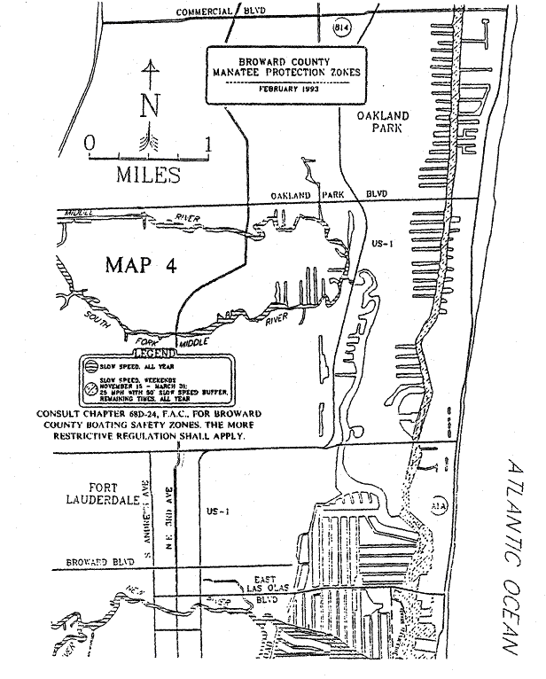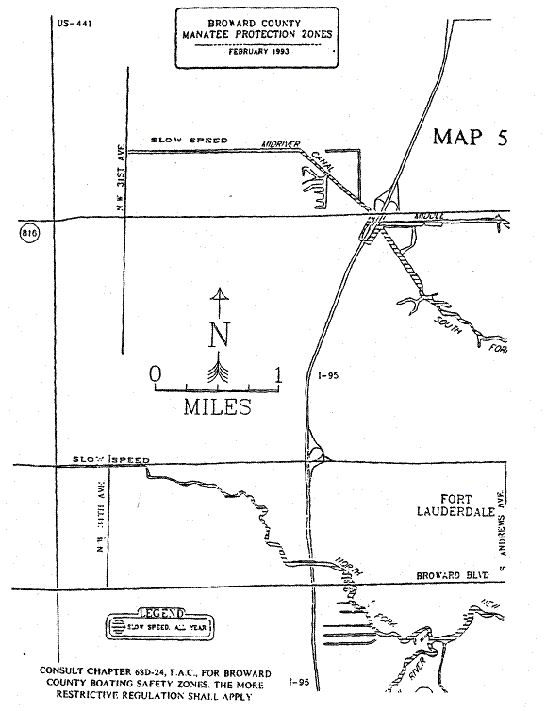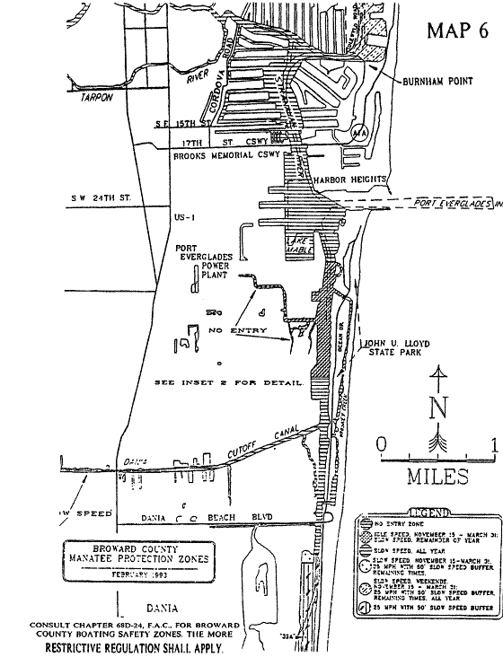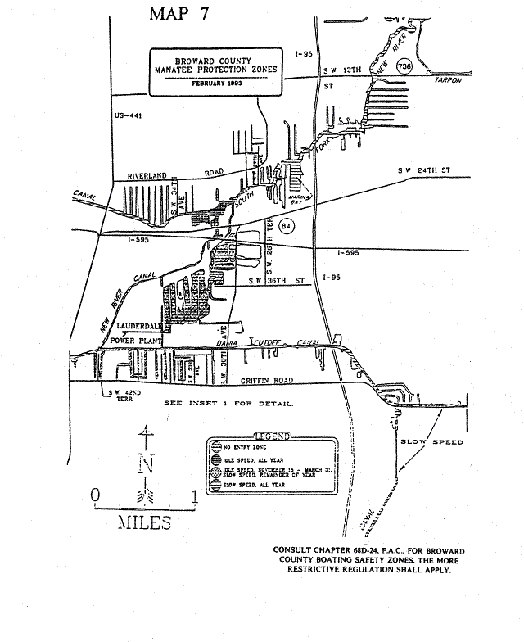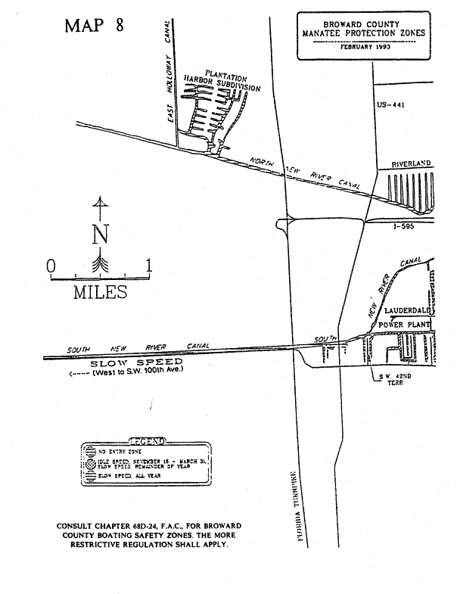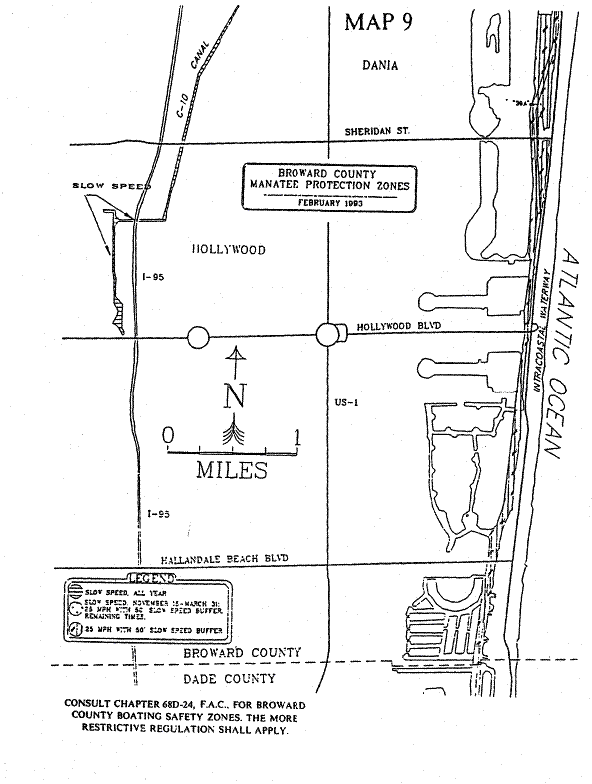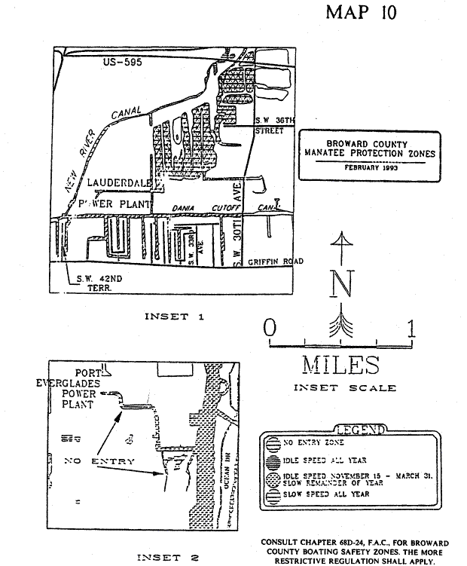
Specific Authority 370.12(2)(f), (n), (o) FS. Law Implemented 370.12(2)(f)6., (n), (o) FS. History–New 3-19-79, Formerly 16N-22.10, Amended 12-5-89, 6-16-93, Formerly 16N-22.010, Amended 12-18-94, 6-25-96, Formerly 62N-22.010.

