68C-22.011 Citrus and Associated County (Parts of Levy and Hernando) Zones.
(1) For the purpose of protecting manatees and manatee habitat in Citrus County and within closely associated portions of Levy and Hernando counties, the following year-round and seasonal zones are established, which shall include all associated and navigable tributaries, lakes, creeks, coves, bends, backwaters, canals, channels, and boat basins, unless otherwise designated or excluded: (Seasonal limits, if they apply, are specified within each zone classification.)
(a) Caution Zone (Year-round)/25 MPH Maximum Speed – Withlacoochee River: That part of the Withlacoochee River easterly of a line which bears South 00° 00' 00" West (True) running through Green Channel Marker “37” (latitude 29° 00' 04" North, longitude 82° 46' 11" West) and westerly of a line which bears approximately South 00° 00' 00" East (True) from a point on the northerly shoreline of the Withlacoochee River (approximate latitude 29° 00' 05" North, approximate longitude 82° 45' 22" West).
(b) Slow Speed Zone (Year-round) –
1. Withlacoochee River: That part of the Withlacoochee River northeasterly of a line which bears South 38° 00' 00" East (True) from the intersection of the northwesterly shoreline of the Withlacoochee River with the westerly shoreline of the Cormorant/Egret Canal (approximate latitude 29° 01' 05" North, approximate longitude 82° 43' 37" West) and northwesterly of the general contour of the southerly shoreline of the Bypass Channel on the northerly side of the Cross Florida Barge Canal in the Northeast Quarter of Section 12, Township 17 South, Range 16 East, including that portion of the Bypass Channel westerly of the spillway.
2. Homosassa River Area:
a. All waters outside the main marked channel of the Homosassa River northerly of a line which bears North 90° 00' 00" East (True) from the easternmost tip of an unnamed island southerly of Shell Island (approximate latitude 28° 46' 02" North, approximate longitude 82° 41' 18" West) passing through the southernmost shoreline of a small unnamed island to the westerly shoreline of a large unnamed island (approximate latitude 28° 46' 02" North, approximate longitude 82° 41' 03" West), northeasterly of a line which bears South 10° 00' 00" East (True) from a point on the southern shoreline of Shell Island (approximate latitude 28° 46' 07" North, approximate longitude 82° 41' 24" West) passing through the easternmost shoreline of a small unnamed mangrove island to the unnamed island south of Shell Island (approximate latitude 28° 46' 03" North, approximate longitude 82° 41' 23" West), southeasterly of a line which bears North 35° 00' 00" East (True) from the easternmost point of Shell Island (approximate latitude 28° 46' 07" North, approximate longitude 82° 41' 22" West) to a point on the southeasterly shoreline of a peninsula of the unnamed island north of Shell Island (approximate latitude 28° 46' 03" North, approximate longitude 82° 41' 17" West), southerly of a line which bears South 90° 00' 00" West (True) from a point on the southwesterly shoreline of an unnamed island southerly of False Channel (approximate latitude 28° 46' 23" North, approximate longitude 82° 40' 55" West) to the easterly shoreline of an unnamed island (approximate latitude 28° 46' 23" North, approximate longitude 82° 40' 59" West), southeasterly of a line which bears North 25° 00' 00" East (True) from the northeasternmost tip of a peninsula of the unnamed island southerly of False Channel (approximate latitude 28° 46' 31" North, approximate longitude 82° 40' 38" West) to the southernmost shoreline of a peninsula northerly of False Channel (approximate latitude 28° 46' 37" North, approximate longitude 82° 40' 36" West), southerly of a line which bears South 90° 00' 00" West (True) from a point on the easterly shoreline of the Salt River near the northerly line of Section 36, Township 19 South, Range 16 East (approximate latitude 28° 47' 20" North, approximate longitude 82° 38' 26" West) to the westerly shoreline of Salt River, westerly of a line which bears South 12° 00' 00" West from the southernmost tip of the shoreline of Lashley Point (approximate latitude 28° 47' 08" North, approximate longitude 82° 38' 08" West) to the southerly shoreline of the Homosassa River, and northerly of a line which bears South 90° 00' 00" West from the northernmost tip of a peninsula on the easterly shore of Petty Creek (approximate latitude 28° 46' 42" North, approximate longitude 82° 38' 45" West) to the westerly shoreline of Petty Creek, except as otherwise designated in paragraph 68C-22.011(1)(l), F.A.C.; and
b. That part of the Homosassa River and Halls River easterly of a line which bears North 00° 00' 00" East (True) running through the northernmost tip of the westernmost shoreline of a canal serving the Trade Winds Marina (approximate latitude 28° 47' 37" North, approximate longitude 82° 36' 22" West), westerly of the easterly line of Section 29, Township 19 South, Range 17 East, and southerly of a line being the easterly extension of the northerly shoreline of the Nature’s Resort Canal from a point on the northerly shoreline of said canal (approximate latitude 28° 48’ 12" North, approximate longitude 82° 36' 25" West).
3. Crystal River Area – Waters of Crystal River as follows:
a. That part of Crystal River easterly of a line which bears North 00° 00' 00" East (True) running through the daybeacon north of Shell Island (latitude 28° 55' 34" North, longitude 82° 41' 38" West), northwesterly of a line which bears North 45° 00' 00" East (True) running through the daybeacon northeasterly of Shell Island (latitude 28° 55' 32" North, longitude 82° 41' 26" West), northerly of the northerly shoreline of Shell Island and southerly of the unnamed island northerly of Shell Island and a line which bears North 27° 00' 00" West (True) running through the aforementioned daybeacon northeasterly of Shell Island (latitude 28° 55' 32" North, longitude 82° 41' 26" West); and
b. That part of Crystal River easterly of a line which bears North 00° 00' 00" East (True) running through a point approximately 300 feet easterly of the centerline of the trail leading to “The Rocks” on the northerly side of the river (longitude 82° 38' 26" West), westerly of a line which bears North 00° 00' 00" East (True) from the centerline of the unimproved dirt road (approximate longitude 82° 38' 18" West) approximately 350 feet westerly of the easterly line of Section 24, Township 18 South, Range 16 East; and that part of Salt River southwesterly of Crystal River, easterly of a line which bears North 00° 00' 00" East (True) from a point on the northeasterly shoreline of the unnamed island northwesterly of Little Coon Gap (approximate latitude 28° 54' 04" North, approximate longitude 82° 39' 17" West), northeasterly of a line which bears North 30° 00' 00" West (True) from a point on the westernmost point of the unnamed island southeasterly of Little Coon Gap (approximate latitude 25° 53' 58" North, approximate longitude 82° 39' 17" West) and northwesterly of a line which bears North 78° 00' 00" West (True) from the southernmost point of the peninsula on the southeasterly shoreline of Coon Gap (approximate latitude 25° 53' 48" North, approximate longitude 82° 39' 02" West).
(c) Slow Speed Zone (November 15 through April 30)/Maximum 25 MPH Zone (Remainder of Year) – Florida Power Corporation Effluent Canal Area: All waters of the Florida Power Corporation Effluent Canal westerly of the eastern terminus of the effluent canal, and that part of Crystal Bay lying easterly of a line which bears approximately North 45° 00' 00" East (True) from a point on the northerly side of a spit of land being the westerly extension of the southerly shoreline of the effluent canal, said point being located approximately 1500 feet easterly of the westerly tip of said spit (approximate latitude 29° 57' 34" North, approximate longitude 82° 44' 22" West) to the southernmost tip of the unnamed island (approximate latitude 29° 57' 58" North, approximate longitude 82° 43' 56" West), and southerly of a line which bears approximately South 75° 00' 00" East (True) from the southernmost tip of said unnamed island to the southernmost tip of a peninsula (approximate latitude 29° 57' 54" North, approximate longitude 82° 43' 40" West).
(d) Slow Speed Zone (March 1 through August 31)/Maximum 25 MPH Zone (Remainder of Year) – Withlacoochee River Area:
1. That part of the main marked channel of the Withlacoochee River northeasterly of a line which bears South 53° 00' 00" East (True) running through Green Channel Marker “33” (latitude 28° 59' 51" North, longitude 82° 46' 42" West) and southwesterly of a line which bears South 00° 00' 00" West (True) running through Green Channel Marker “37” (latitude 29° 00' 04" North, longitude 82° 46' 11" West);
2. That part of the Withlacoochee River northeasterly of a line which bears approximately South 65° 00' 00" East (True) from a point on the northerly shoreline of the Withlacoochee River (approximate latitude 29° 00' 05" North, approximate longitude 82° 45' 22" West) and southerly of a line which bears South 38° 00' 00" East (True) from the intersection of the northwesterly shoreline of the Withlacoochee River with the westerly shoreline of the Cormorant/Egret Canal (approximate latitude 29° 01' 05" North, approximate longitude 82° 43' 37" West);
3. That part of the Withlacoochee River southeasterly of the general contour of the southerly shoreline of the Cross Florida Barge Canal and westerly of the Inglis Lock (at the westerly end of Lake Rousseau); and
4. That part of Bennetts Creek southerly of the general contour of the southerly shoreline of the Withlacoochee River and East Pass northerly of a line which bears approximately South 75° 00' 00" West (True) from the southernmost tip of a peninsula (approximate latitude 28° 59' 41" North, approximate longitude 82° 44' 48" West) to the southernmost tip of a peninsula of an unnamed island southwesterly of East Pass (approximate latitude 28° 59' 37" North, approximate longitude 82° 45' 03" West), northeasterly of a line which bears North 50° 00' 00" West (True) from the northernmost tip of said unnamed island (approximate latitude 28° 59' 52" North, approximate longitude 82° 45' 17" West) to the easternmost tip of Chambers Island (approximate latitude 28° 59' 53" North, approximate longitude 82° 45' 19" West), easterly of a line which bears South 00° 00' 00" West (True) from a point on the northerly shoreline of the Withlacoochee River (approximate latitude 29° 00' 05" North, approximate longitude 82° 45' 22" West), and southwesterly of a line which bears approximately South 65° 00' 00" East (True) from the aforementioned point on the northerly shoreline of the Withlacoochee River.
(e) Slow Speed Zone (April 1 through August 31)/Maximum 25 MPH Zone (Remainder of Year) – Chassahowitzka River: That part of the Chassahowitzka River northeasterly of a line which bears North 35° 00' 00" West (True) from a point on the northwesterly shoreline of Johns Island (approximate latitude 28° 41' 23" North, approximate longitude 82° 38' 27" West) to a point on the easternmost tip of a peninsula of an unnamed island (approximate latitude 28° 41' 37" North, approximate longitude 82° 38' 38" West), southerly of a line which bears North 90° 00' 00" East (True) from a point on the northeasternmost tip of a peninsula of an unnamed island (approximate latitude 28° 41' 49" North, approximate longitude 82° 38' 34" West) to the southerly shoreline of an unnamed island (approximate latitude 28° 41' 49" North, approximate longitude 82° 38' 31" West), westerly of the easterly line of the Southwest 1/4 of Section 28, Township 20 South, Range 17 East, southeasterly of a line which bears South 30° 00' 00" West (True) from the westernmost tip of a peninsula of an unnamed island on the northerly shore of Pumpkin Creek (approximate latitude 28° 41' 57" North, approximate longitude 82° 38' 18" West) to a point on the northeasterly shoreline of an unnamed island on the southerly shore of Pumpkin Creek (latitude 28° 41' 53" North, longitude 82° 38' 22" West), southeasterly of a line which bears North 40° 00' 00" East (True) from a point on the northeasterly shoreline of an unnamed island on the southerly shore of Gator Creek (approximate latitude 28° 42' 16" North, approximate longitude 82° 37' 28" West) to a point on the southwesterly shoreline of an unnamed island on the northerly shore of Gator Creek (approximate latitude 28° 42' 19" North, approximate longitude 82° 37' 24" West), southeasterly of a line which bears North 35° 00' 00" East (True) from a point on the northeasterly shoreline of an unnamed island on the southwesterly shore of Little Gator Creek (approximate latitude 28° 42' 20" North, approximate longitude 82° 37' 18" West) to a point on the southwesterly shoreline of an unnamed island on the northeasterly shore of Little Gator Creek (approximate latitude 28° 42' 22" North, approximate longitude 82° 37' 17" West), easterly of a line which bears North 00° 00' 00" East (True) running through the easternmost tip of an unnamed island (approximate latitude 28° 42' 51" North, approximate longitude 82° 36' 57" West), southeasterly of a line which bears North 35° 00' 00" East (True) from a point on the southwesterly shoreline of Stevenson Creek (approximate latitude 28° 43' 06" North, approximate longitude 82° 36' 55" West) to a point on the northeasterly shoreline of Stevenson Creek (approximate latitude 28° 43' 17" North, approximate longitude 82° 36' 54" West), northwesterly of a line which bears North 35° 00' 00" East (True) from a point on the southwesterly shoreline of May Creek (approximate latitude 28° 41' 31" North, approximate longitude 82° 38' 07" West) to a point on the northeasterly shoreline of May Creek (approximate latitude 28° 41' 33" North, approximate longitude 82° 38' 05" West), northwesterly of a line which bears North 60° 00' 00" East (True) from a point on the southwesterly shoreline of Ryle Creek (approximate latitude 28° 42' 07" North, approximate longitude 82° 37' 08" West) to a point on the northeasterly shoreline of Ryle Creek (approximate latitude 28° 42' 08" North, approximate longitude 82° 37' 07" West), northwesterly of a line which bears North 45° 00' 00" East (True) from the northernmost tip of the westerly shoreline of Crawford Creek (approximate latitude 28° 42' 17" North, approximate longitude 82° 36' 54" West) to a point on the northernmost tip of the easterly shoreline of Crawford Creek (approximate latitude 28° 42' 18" North, approximate longitude 82° 36' 52" West), and westerly of a line which bears North 00° 00' 00" East (True) from a point on the southerly shoreline of Johnson Creek (approximate latitude 28° 42' 42" North, approximate longitude 82° 36' 37" West) to a point on the northerly shoreline of Johnson Creek (approximate latitude 28° 42' 43" North, approximate longitude 82° 36' 37" West).
(f) Slow Speed Zone (September 1 through April 30) – Kings Bay: That part of Kings Bay southeasterly of a line which bears North 53° 00' 00" East (True) from the northeasternmost point of an island on the southwesterly shore of Crystal River (approximate latitude 28° 53' 32" North, approximate longitude 82° 36' 23" West) to the southwesternmost point of a peninsula of Magnolia Shores (approximate latitude 28° 53' 38" North, approximate longitude 82° 36' 16" West), northerly of a line which bears North 67° 00' 00" East (True) from the northeasternmost tip of a peninsula over which West Auld Road passes on the southwesterly shore of Kings Bay (approximate latitude 28° 53' 04" North, approximate longitude 82° 36' 05" West) to the southernmost tip of a point of land on the northeasterly shoreline of Kings Bay (approximate latitude 28° 53' 13" North, approximate longitude 82° 35' 43" West), and southwesterly of a line which bears North 35° 00' 00" West (True) from the northernmost tip of Bonita Isle (approximate latitude 28° 53' 27" North, approximate longitude 82° 35' 51" West) to a point on the southeasternmost tip of a peninsula of Magnolia Shores (approximate latitude 28° 53' 38" North, approximate longitude 82° 36' 01" West), except as otherwise designated under sub-subparagraph (1)(i)1.d.
(g) Slow Speed Zone (October 1 through April 30)/Maximum 25 MPH Zone (Remainder of Year) –
1. Homosassa River Area: Waters of the Homosassa River as follows:
a. That part of the Homosassa River easterly of a line which bears South 12° 00' 00" West (True) from the southernmost tip of the shoreline of Lashley Point (approximate latitude 28° 47' 08" North, approximate longitude 82° 38' 08" West) to the southerly shoreline of the Homosassa River, westerly of a line which bears North 00° 00' 00" East (True) through a point 100 feet westerly of the northernmost tip of the western shoreline of Otter Creek (approximate latitude 28° 46' 55" North, approximate longitude 82° 37' 19" West) and that part of Price Creek southerly of a line which bears North 65° 00' 00" West (True) running through the southernmost tip of an unnamed island (approximate latitude 28° 47' 38" North, approximate longitude 82° 38' 04" West) including the canals and associated waters of the residential development on the south side of the Homosassa River in Section 31, Township 19 South, Range 17 East; and
b. That part of the Homosassa River easterly of the easterly line of Section 31, Township 19 South, Range 17 East and westerly of a line which bears North 00° 00' 00" East (True) running through the northernmost tip of the westernmost shoreline of a canal serving the Trade Winds Marina (approximate latitude 28° 47' 37" North, approximate longitude 82° 36' 22" West).
2. Halls River: That part of Halls River northerly of a line being the easterly extension of the northerly shoreline of the Nature's Resort Canal from a point on the northerly shoreline of said canal (approximate latitude 28° 48’ 12" North, approximate longitude 82° 36' 25" West).
(h) Maximum 25 MPH Zone in Central Corridor, Slow Speed Outside –
1. Crystal River Area: The Commission will mark a central corridor in the below-described Crystal River area, which shall be designated a “Maximum 25 MPH Zone” (year-round). All other waters outside the corridor within the below-described area shall be designated as Slow Speed.
2. Those waters of the Crystal River included within this designation are as follows:
a. That part of Crystal River including South Pass and Little South Pass northeasterly of a line which bears approximately North 20° 00' 00" West (True) from the westernmost point of the shoreline of Fort Island (approximate latitude 28° 54' 38" North, approximate longitude 82° 41' 46" West) to the southernmost point of the shoreline of Shell Island (approximate latitude 28° 55' 04" North, approximate longitude 82° 41' 57" West), southeasterly of a line which bears North 45° 00' 00" East (True) running through the daybeacon northeasterly of Shell Island (latitude 28° 55' 32" North, longitude 82° 41' 26" West) and westerly of a line which bears North 00° 00' 00" East (True) running through a point approximately 300 feet easterly of the centerline of the trail leading to “The Rocks” on the northerly side of the river (longitude 82° 38' 26" West); and
b. That part of Crystal River easterly of a line which bears North 00° 00' 00" East (True) from the centerline of the unimproved dirt road (approximate longitude 82° 38' 18" West) approximately 350 feet westerly of the easterly line of Section 24, Township 18 South, Range 16 East and northwesterly of a line which bears North 53° 00' 00" East (True) from the northeasternmost point of an island on the southwesterly shore of Crystal River (approximate latitude 28° 53' 32" North, approximate longitude 82° 36' 23” West) to the southwesternmost point of a peninsula of Magnolia Shores (approximate latitude 28° 53' 38" North, approximate longitude 82° 36' 16" West), except those canals and associated waters otherwise designated under sub-subparagraph (1)(i)1.a.
(i) Idle Speed Zone (Year-round) –
1. Crystal River Area: Waters of the Crystal River and Kings Bay as follows:
a. Those canals and associated waters north and south of Crystal River easterly of a line which bears North 00° 00' 00" East (True) from the centerline of the unimproved dirt road (approximate longitude 82° 38' 18" West) approximately 350 feet westerly of the easterly line of Section 24, Township 18 South, Range 16 East and westerly of the centerline of Commanche Street including all waters associated with the Indian River Canal;
b. That part of Kings Bay northeasterly of a line which bears North 35° 00' 00" West (True) from the northernmost tip of Bonita Isle (approximate latitude 28° 53' 27" North, approximate longitude 82° 35' 51" West) to a point on the southeasternmost tip of a peninsula of Magnolia Shores (approximate latitude 28° 53' 38" North, approximate longitude 82° 36' 01" West) including the associated waters of Magnolia Shores, Cedar Cove, Hunter’s Spring Bay and the canals of the Springs of Paradise subdivision northerly of Paradise Point Road;
c. That part of Kings Bay southerly and southeasterly of a line which bears South 23° 00' 00" West (True) from the southernmost tip of a point of land on the northeasterly shoreline of Kings Bay (approximate latitude 28° 53’ 13" North, approximate longitude 82° 35' 43" West) to the northernmost tip of Warden Key (approximate latitude 28° 52' 52" North, approximate longitude 82° 35' 53" West), and southerly and southwesterly of a line which bears South 40° 00' 00" East (True) from a point on the northeasternmost tip of a peninsula over which West Auld Road passes on the southwesterly shore of Kings Bay (approximate latitude 28° 53' 04" North, approximate longitude 82° 36' 05" West) to the aforementioned northernmost tip of Warden Key; and
d. Those waters separating the island of Crystal Shore Estates from the mainland, southerly of the centerline of Pine Street, and westerly of the general contour of the westerly shoreline of Kings Bay being a line bearing South 50° 00' 00" East from the southernmost tip of the island (approximate latitude 28° 53' 26" North, approximate longitude 82° 36' 23" West), and all waters of that drainage canal westerly of the general contour of the westerly shoreline of Kings Bay, the mouth of which is located approximately 400 feet southerly of the southernmost tip of the island of Crystal Shore Estates.
2. Homosassa River Area:
a. That part of the Homosassa River easterly of a line which bears North 17° 00' 00" West (True) from a point on the western shoreline of Shell Island (approximate latitude 28° 46' 12" North, approximate longitude 82° 41' 43" West) to the southernmost tip of a peninsula on the southern shoreline of the unnamed island north of Shell Island (approximate latitude 28° 46' 15" North, approximate longitude 82° 41' 44" West) and northwesterly of a line which bears North 35° 00' 00" East (True) from the easternmost point of Shell Island (approximate latitude 28° 46' 07" North, approximate longitude 82° 41' 22" West) to a point on the southeasterly shoreline of a peninsula of the unnamed island north of Shell Island (approximate latitude 28° 46' 03" North, approximate longitude 82° 41' 17" West);
b. That part of the Homosassa River easterly of a line which bears North 00° 00' 00" East (True) through a point 100 feet westerly of the northernmost tip of the western shoreline of 2 Otter Creek (approximate latitude 28° 46' 55" North, approximate longitude 82° 37' 19" West) and westerly of the easterly line of Section 31, Township 19 South, Range 17 East, including that part of Otter Creek and associated waters northerly of the centerline of Mason Creek Road;
c. That part of the Homosassa River easterly of the easterly line of Section 29, Township 19 South, Range 17 East, except as otherwise designated under paragraph (1)(m);
d. The canals and associated waters of the residential development northerly of the Homosassa River and easterly of Price Creek and westerly of a line which bears North 00° 00' 00" East (True) through a point 100 feet westerly of the northernmost tip of the western shoreline of Otter Creek (approximate latitude 28° 46' 55" North, approximate longitude 82° 37' 19" West);
e. The canals and associated waters of the residential development southeasterly of Halls River Road (State Road 490-A), northerly of the Homosassa River and westerly of Halls River; and
f. All waters of the Nature's Resort Canal and associated waters in Section 29, Township 19 South, Range 17 East.
3. Withlacoochee River Area: All waters of Crooked Creek, northerly of the general contour of the northerly shoreline of the Withlacoochee River, and southerly of a line bearing North 60° 00’ 00" East (True) from the intersection of the general contour of the southerly shoreline of Bird Creek with the general contour of the westerly shoreline of Crooked Creek (approximate latitude 29° 00' 35" North, approximate longitude 82° 44' 58" West).
(j) Idle Speed (September 1 through April 30) – Kings Bay: That part of Kings Bay southeasterly of a line which bears North 67° 00' 00"° East (True) from the northeasternmost tip of a peninsula over which West Auld Road passes on the southwesterly shore of Kings Bay (approximate latitude 28° 53' 04" North, approximate longitude 82° 36' 05" West) to the southernmost tip of a point of land on the northeasterly shoreline of Kings Bay (approximate latitude 28° 53' 13" North, approximate longitude 82° 35' 43" West), northwesterly of a line which bears South 23° 00' 00" West (True) from the aforementioned point on the northeasterly shoreline of Kings Bay (approximate latitude 28° 53' 13" North, approximate longitude 82° 35' 43" West) to the northernmost tip of Warden Key (approximate latitude 28° 52' 52" North, approximate longitude 82° 35' 53" West) and northeasterly of a line which bears South 40° 00' 00" East (True) from a point on the northeasternmost tip of a peninsula over which West Auld Road passes on the southwesterly shore of Kings Bay (approximate latitude 28° 53' 04" North, approximate longitude 82° 36' 05" West) to the aforementioned northernmost tip of Warden Key.
(k) Maximum 35 MPH/25 MPH Nighttime Zone (May 1 through August 31) –
1. Kings Bay: That part of Kings Bay southeasterly of a line which bears North 53° 00' 00" East (True) from the northeasternmost point of an island on the southwesterly shore of Crystal River (approximate latitude 28° 53' 32" North, approximate longitude 82° 36' 23" West) to the southwesternmost point of a peninsula of Magnolia Shores (approximate latitude 28° 53' 38" North, approximate longitude 82° 36' 16" West), northerly of a line which bears North 67° 00' 00" East (True) from the northeasternmost tip of a peninsula over which West Auld Road passes on the southwesterly shore of Kings Bay (approximate latitude 28° 53' 04" North, approximate longitude 82° 36' 05" West) to the southernmost tip of a point of land on the northeasterly shoreline of Kings Bay (approximate latitude 28° 53' 13" North, approximate longitude 82° 35' 43" West), and southwesterly of a line which bears North 35° 00' 00" West (True) from the northernmost tip of Bonita Isle (approximate latitude 28° 53' 27" North, approximate longitude 82° 35' 51" West) to a point on the southeasternmost tip of a peninsula of Magnolia Shores (approximate latitude 28° 53' 38" North, approximate longitude 82° 36' 01" West).
2. Kings Bay: That part of Kings Bay southeasterly of a line which bears North 67° 00' 00" East (True) from the northeasternmost tip of a peninsula over which West Auld Road passes on the southwesterly shore of Kings Bay (approximate latitude 28° 53' 04" North, approximate longitude 82° 36' 05" West) to the southernmost tip of a point of land on the northeasterly shoreline of Kings Bay (approximate latitude 28° 53' 13" North, approximate longitude 82° 35' 43" West), northwesterly of a line which bears South 23° 00' 00" West (True) from the aforementioned point on the northeasterly shoreline of Kings Bay (approximate latitude 28° 53' 13" North, approximate longitude 82° 35' 43" West) to the northernmost tip of Warden Key (approximate latitude 28° 52' 52" North, approximate longitude 82° 35' 53" West) and northeasterly of a line which bears South 40° 00' 00" East (True) from a point on the northeasternmost tip of a peninsula over which West Auld Road passes on the southwesterly shore of Kings Bay (approximate latitude 28° 53' 04" North, approximate longitude 82° 36' 05" West) to the aforementioned northernmost tip of Warden Key.
(l) Maximum 25 MPH Zone (Year-round) –
1. All waters of the gulf coast area of Citrus, Levy and Hernando counties, southerly of a line which bears North 90° 00' 00" East (True) from a point which lies 1500 feet North 00° 00' 00" East (True) of Green Channel Marker “35” (latitude 28° 59' 55" North, longitude 82° 46' 32" West) marking the channel entrance to the Withlacoochee River, northerly of a line running due west from a point on the northwesterly shoreline of Johns Island (approximate latitude 28° 41' 23" North, approximate longitude 82° 38' 27" West) and easterly of a sinuous line which is 1000 feet westerly of the general contour of the outer shorelines of the westernmost islands of Citrus County and the above-described portions of Levy and Hernando counties (said sinuous line is generally described as running from the aforementioned point 1500 feet north of Green Channel Marker “35”, southerly through Marker “35”; 1000 feet southwesterly of the southerly tip of Chambers Island; 1000 feet westerly of the westerly shoreline of Captain Joe Island, the small unnamed island southwesterly of the southern end of Lutrell Island and Drum Island; through the westerly boundary of Demory Gap; through Flashing Green Channel Marker “47” (latitude 28° 56' 49" North, longitude 82° 45' 12" West); through the northerly boundary of Tin Pan Gap; 1000 feet westerly of Black Point, the westernmost tip of Shell Island, the western shoreline of the small unnamed island west of Fort Island, the western shoreline of the unnamed island in Section 21, Township 18 South, Range 16 East, the northwesterly shoreline of Sandy Hook Island, Shark Point, Mangrove Point, the unnamed island north of Long Point, Long Point, Green Point, the unnamed islands north and south of Grey Mare Pass; 500 feet westerly of the westerly shoreline of Rock Island; 1000 feet southwesterly of the southwesterly shoreline of Roach Key and the southwesterly shorelines of the westerly islands of “The Suncoast Keys” group of islands; 200 feet northeasterly of Ship Rock; 1000 feet westerly of Greenleaf Key, Mendit Key, Long Point, and Drum Key; 1000 feet westerly and southerly of Chassahowitzka Point Island; 1000 feet southwesterly of the southwesterly shorelines of the westerly islands of the “Northwest Keys” group of islands and the unnamed triangular island northwest of Sugar Spot Island; and 1000 feet westerly of the westerly shoreline of Buckhorn Key); except as otherwise designated for regulation.
2. Cross Florida Barge Canal: That part of the Cross Florida Barge Canal and Cross Florida Barge Canal Channel northeasterly of a line which bears South 22° 00' 00" East (True) running through Red Channel Marker “24” (latitude 28° 57' 37" North, longitude 82° 50' 07" West) and southwesterly of the westerly end of the Inglis Lock.
3. Those waters of the main marked channel of the Homosassa River, as described in sub-subparagraph (1)(b)2.a. above.
4. All inland waters of Citrus County, except as otherwise designated above.
(m) No Entry Zone (November 15 through March 31)/Idle Speed (Remainder of Year) – Blue Waters Area of the Homosassa River:
1. Those waters southwest of a line bearing 145° from a point (approximate latitude 28° 47' 57.6" North, approximate longitude 82° 35' 23.6" West) on the southeastern shoreline of the peninsula on the north side of Blue Waters to a point (approximate latitude 28° 47' 55.7" North, approximate longitude 82° 35' 22.7" West) on the southeastern shoreline of Blue Waters (said line runs between the existing Restricted Area signs posted by the Homosassa Springs State Wildlife Park) and north of a line beginning at a point (approximate latitude 28° 47' 56.3" North, approximate longitude 82° 35' 27.1" West) on the southwestern shoreline of the peninsula on the north side of Blue Waters and bearing 139° for a distance of 117 feet to a point (approximate latitude 28° 47' 55.4" North, approximate longitude 82° 35' 26.2" West) in the water, and then bearing 91° for a distance of approximately 224 feet to the line’s terminus at a point (approximate latitude 28° 47' 55.4" North, approximate longitude 82° 35' 23.7" West) on the southeastern shoreline of Blue Waters north of the River Pavilion of the Homosassa Springs State Wildlife Park;
2. Those waters south of a line forty feet (40') north of and parallel to the general contour of the southern shoreline of the Homosassa River at Blue Waters, east of a north-south line from the point (approximate latitude 28° 47' 54.2" North, approximate longitude 82° 35' 29.8" West) where the southern shoreline of the Homosassa River at Blue Waters intersects the eastern shoreline of the first canal downstream of Blue Waters, and west of a line bearing 21° from a point (approximate latitude 28° 47' 53.2" North, approximate longitude 82° 35' 25.1" West) on the southern shoreline of the Homosassa River at Blue Waters approximately 270 feet northwest of the West Fishbowl Drive Bridge.
(2) For the purpose of exempting qualifying commercial fishermen and professional fishing guides from certain speed zone restrictions, as provided under subsection 68C-22.003(6), F.A.C., the following conditions, and procedures for exemption application shall apply:
(a) Exemptions shall apply to zones, or portions of zones, specified as follows for the purpose of setting nets to encircle fish only. Exemptions shall be considered year-round for waters described within subparagraphs 1. and 2. below, and shall be considered for the period of November 15 through January 31 for the waters described in paragraph 3., below:
1. That portion of the Crystal River outside the marked channel (within areas designated as Slow Speed) generally from the Gulf of Mexico to its confluence with the Salt River, as described in sub-subparagraph (1)(h)2.a., above.
2. That portion of the Homosassa River outside the marked channel (within areas designated as Slow Speed), generally from the Gulf of Mexico easterly to a north-south line running through channel marker “58”, as partially described in sub sub-paragraph (1)(b)2.a., above.
3. That portion of the coastal waters of Citrus County adjacent to the Florida Power Corporation Effluent Canal, as partially described in paragraph (1)(c), above.
(b) A recipient of an exemption must maintain speeds of less than 20 MPH at all times within the restricted area, and comply with any and all conditions specified within the notice of exemption as well as under the provisions of this rule and subsection 68C-22.003(6), F.A.C.
(c) Exemptions granted will not apply on weekends or state-recognized holidays.
(d) Any commercial fisherman or professional fishing guide fulfilling the requirements set forth under subsection 68C-22.003(6), F.A.C., may apply for the exemption, one of which shall be required for each vessel so operated, by completing the application form specified. Applications for exemption in accordance with the provisions of this rule may be obtained from the Fish and Wildlife Conservation Commission, Division of Law Enforcement Office, 10247 North Suncoast Boulevard, Crystal River, FL 34428-6715 (telephone 352/447-1633).
(3) The zones described in subsection 68C-22.011(1), F.A.C., are depicted on the following maps labeled “Citrus and Associated Counties Manatee Protection Zones.” The maps are intended as depictions of the above-described zones. In the event of conflict between the maps and descriptions, the descriptions shall prevail.
(4) The amendments to Rule 68C-22.011, F.A.C., as approved by the Commission on September 12, 2002, shall take effect as soon as the regulatory markers are posted.
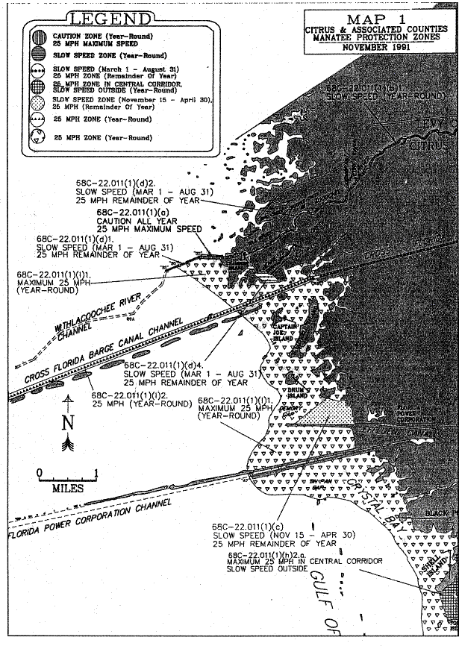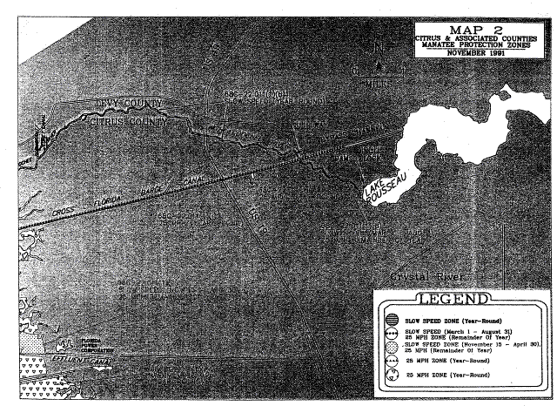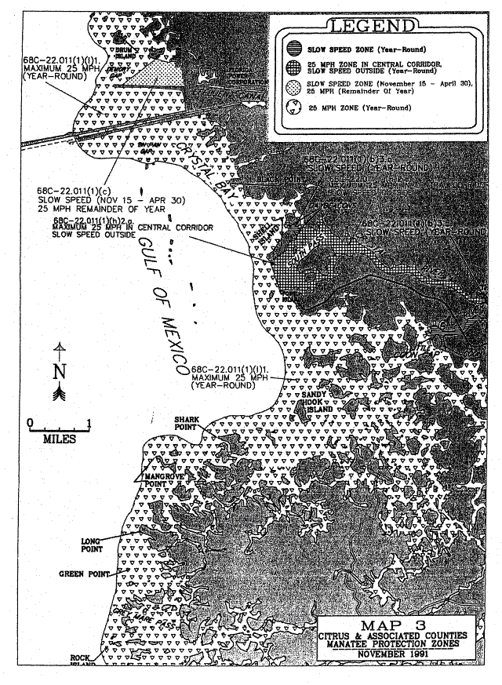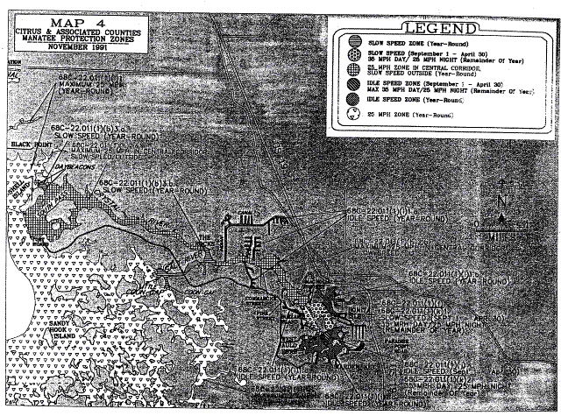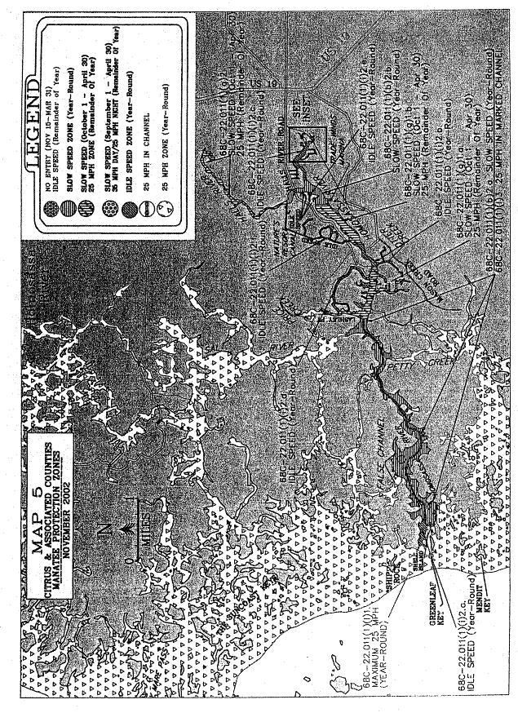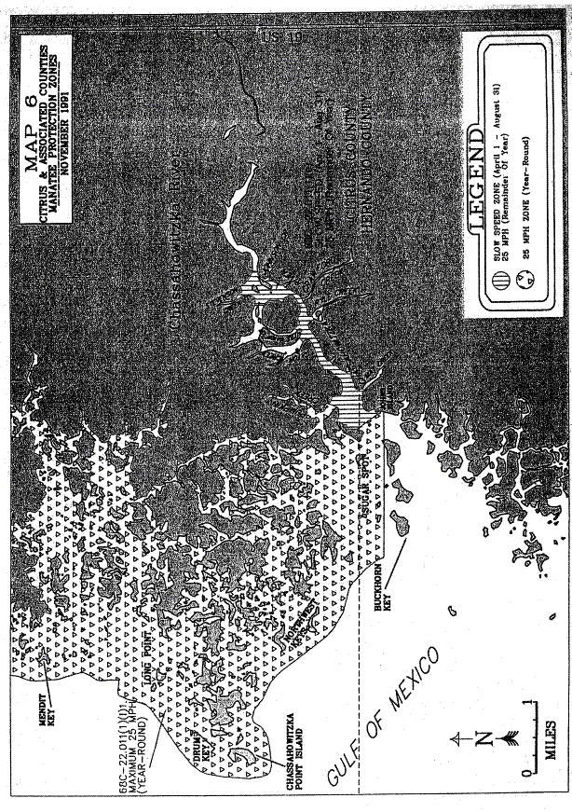
Rulemaking Authority 370.12(2)(g), (i), (n), (o) FS. Law Implemented 370.12(2)(d), (g), (i), (k), (n), (o) FS. History–New 3-19-79, Amended 2-23-81, 12-4-85, Formerly 16N-22.11, Amended 1-27-92, Formerly 16N-22.011, 62N-22.011, Amended 11-14-02.

