68C-22.014 Manatee County Zones.
(1) The Commission hereby designates the waters within Manatee County, as described below, as areas where manatee sightings are frequent and where the best available information supports the conclusion that manatees inhabit these areas on a regular or periodic basis. The primary purpose of this rule is to protect manatees from harmful collisions with motorboats and from harassment by regulating the speed and operation of motorboats within these designated areas. A secondary purpose is to protect manatee habitat. In consideration of balancing the rights of fishers, boaters, and water skiers to use the waters of the state for recreational and commercial purposes (as applicable under Section 370.12(2)(k), F.S.) with the need to provide manatee protection, the Commission has examined the need for limited lanes, corridors, or unregulated areas that allow higher speeds through or within regulated areas. Such lanes, corridors, or areas are provided in those locations where the Commission determined that they are consistent with manatee protection needs.
(2) The following zones are established, which include all associated and navigable tributaries, lakes, creeks, coves, bends, backwaters, canals, and boat basins unless otherwise designated or excluded. As used in this rule, ICW means the Intracoastal Waterway.
(a) Idle Speed (All Year) Snead Cut: All waters of the waterway commonly referred to as “Snead Cut” (connecting Terra Ceia Bay and the Manatee River) northeast of the northern shoreline of the Manatee River and southwest of the southwestern shoreline of Terra Ceia Bay.
(b) Slow Speed (All Year).
1. Bishop Harbor Area: All waters of Bishop Harbor and those nearshore waters of Tampa Bay generally north of Bishop Harbor and south of Port Manatee. The southern boundary is the southern shoreline of Bishop Harbor. The western boundary is a line beginning at a point (approximate latitude 27° 36' 25.9" North, approximate longitude 82° 34' 15.4" West) on the southern shoreline of Bishop Harbor and then bearing 346.5° for a distance of approximately 405 feet from to a point (approximate latitude 27° 36' 29.8" North, approximate longitude 82° 34' 16.6" West) in the water, then bearing 320.9° for a distance of approximately 330 feet to a point (approximate latitude 27° 36' 32.3" North, approximate longitude 82° 34' 18.9" West) in the water, then bearing 317.6° for a distance of approximately 410 feet to a point (approximate latitude 27° 36' 35.3" North, approximate longitude 82° 34' 22.0" West) in the water, then bearing 348.3° for a distance of approximately 1,100 feet to a point (approximate latitude 27° 36' 45.9" North, approximate longitude 82° 34' 24.6" West) in the water, then bearing 325.8° for a distance of approximately 538 feet to a point (approximate latitude 27° 36' 50.3" North, approximate longitude 82° 34' 28.0" West) in the water, then bearing 42.3° for a distance of approximately 1,208 feet to a point (approximate latitude 27° 36' 59.3" North, approximate longitude 82° 34' 19.1" West) in the water, and then bearing 7.4° for a distance of approximately 3,368 feet to the line's terminus at a point (approximate latitude 27° 37' 32.4" North, approximate longitude 82° 34' 15.0" West) in the water. The northern boundary is a line bearing 126.0° for a distance of approximately 2,500 feet from a point (approximate latitude 27° 37' 32.4" North, approximate longitude 82° 34' 15.0" West) in the water to a point on the eastern shoreline of Tampa Bay south of Port Manatee.
2. Miguel Bay: Those waters along the eastern side of Miguel Bay generally between Flounder Pass and the embayment in northeastern Miguel Bay. The southwestern boundary is a line bearing 325.6° from a point (approximate latitude 27° 33' 37.0" North, approximate longitude 82° 36' 15.2" West) on the southern shoreline of Miguel Bay (northeast of Flounder Pass) to a point (approximate latitude 27° 33' 40.4" North, approximate longitude 82° 36' 17.9" West) on the southwestern shoreline of an unnamed mangrove island to the north. The western boundary is a line following the southeastern shoreline of the aforementioned unnamed mangrove island from said point on its southwestern shoreline to a point (approximate latitude 27° 33' 42.7" North, approximate longitude 82° 36' 16.1" West) on the island’s northern shoreline, then bearing 12.0° to a point (approximate latitude 27° 33' 44.5" North, approximate longitude 82° 36' 15.7" West) on the southwestern shoreline of the unnamed mangrove island to the northeast, then following the southeastern shoreline of said island to a point (approximate latitude 27° 33' 49.0" North, approximate longitude 82° 36' 8.3" West) on the island's northern shoreline, then bearing 56.5° for a distance of approximately 607 feet to a point (approximate latitude 27° 33' 52.4" North, approximate longitude 82° 36' 2.7" West) in the water, then bearing 75.7° for a distance of approximately 646 feet to a point (approximate latitude 27° 33' 54.1" North, approximate longitude 82° 35' 55.7" West) in the water, and then following a line 300 feet northwest of and parallel with the eastern shoreline of Miguel Bay to the line’s terminus at a point (approximate latitude 27° 34' 19.4" North, approximate longitude 82° 35' 40.9" West) in the water. Within the embayment in northeastern Miguel Bay, the outer boundary is a line beginning at a point (approximate latitude 27° 34' 19.4" North, approximate longitude 82° 35' 40.9" West) in the water and then bearing 38.9° for a distance of approximately 260 feet to a point (approximate latitude 27° 34' 21.5" North, approximate longitude 82° 35' 39.1" West) in the water, then bearing 76.0° for a distance of approximately 365 feet to a point (approximate latitude 27° 34' 22.4" North, approximate longitude 82° 35' 35.2" West) in the water, then bearing 117.7° for a distance of approximately 750 feet to a point (approximate latitude 27° 34' 19.0" North, approximate longitude 82° 35' 27.8" West) in the water, then following a line 300 feet out from and parallel with the southern and eastern shorelines of said embayment to a point (approximate latitude 27° 34' 27.0" North, approximate longitude 82° 35' 12.5" West) in the water, and then bearing 272.2° to the line’s terminus at a point (approximate latitude 27° 34' 27.2" North, approximate longitude 82° 35' 20.7" West) on the northern shoreline. The two (2) canals on either side of Burns Road are also included in this zone.
3. Western Terra Ceia Bay Area: All waters within 500 feet of the general contour of the following shorelines:
a. South Side of Rattlesnake Key: North and east of a line bearing 110° from a point (approximate latitude 27° 32' 55.9'' North, approximate longitude 82° 37' 46.5'' West) on the eastern shoreline of Terra Ceia Point and west and northwest of a line bearing 221° from the easternmost point (approximate latitude 27° 33' 20.5'' North, approximate longitude 82° 36' 13.4'' West) of Rattlesnake Key at Flounder Pass.
b. North Side of Snead Island: All shorelines of the unnamed mangrove island immediately north of Snead Island and, on the northern and eastern sides of Snead Island, north and then east of a line bearing 270° from a point (approximate latitude 27° 31' 54.9'' North, approximate longitude 82° 38' 47.6'' West) on the western shoreline of Snead Island and north and west of Snead Cut, except as otherwise designated under paragraph (2)(a), and sub-subparagraph (2)(b)4.b.
4. Terra Ceia Bay Area:
a. All waters within 500 feet of the general contour of all shorelines of Bird Key, the northern shoreline of Terra Ceia Bay east of Flounder Pass and north of a line bearing 90° from the southwesternmost point (approximate latitude 27° 33' 22.4'' North, approximate longitude 82° 36' 10.7'' West) of the peninsula at the southeastern end of Flounder Pass, and the southeastern and eastern shorelines of Terra Ceia Bay east and north of Snead Cut, except as otherwise designated under paragraph (2)(a), and sub-subparagraph (2)(b)4.b.
b. All waters of Terra Ceia Bay south of a line bearing 296° from a point (approximate latitude 27° 31' 51.8'' North, approximate longitude 82° 35' 47.6'' West) on the southeastern shoreline of Terra Ceia Bay; All waters of Terra Ceia Bay north of a line bearing 320° from a point (approximate latitude 27° 33' 41.3'' North, approximate longitude 82° 34' 11.5'' West) on the northeastern shoreline of Terra Ceia Bay and south of Terra Ceia Bayou, and; All waters of Peterson Bayou.
5. Terra Ceia Bayou: All waters within 500 feet of the general contour of the shorelines of Terra Ceia Bayou, including those waters of Frog Creek southeast of the centerline of the Terra Ceia Road Bridge and those waters of McMullen Creek west of the centerline of the Bayshore Road Bridge.
6. Manatee River (North Side, West of I-75): All waters within 500 feet of the general contour of the shoreline, west of the western edge of the I-75 Bridge, except as otherwise designated under sub-subparagraphs (2)(b)6.a. and (2)(b)6.b., and excluding the waters east of the eastern edge of the US 41/US 301 Bridge and west of a line bearing 168.8° from a point (approximate latitude 27° 30' 29.7'' North, approximate longitude 82° 33' 35.4'' West) on the northern shoreline approximately 1,000 feet east of the US 41/US 301 Bridge. The northern and western boundary is a line bearing 270° from a point (approximate latitude 27° 31' 54.9'' North, approximate longitude 82° 38' 47.6'' West) on the western shoreline of Snead Island.
a. Snead Cut Area: All waters north of a line beginning at a point (approximate latitude 27° 31' 16.9'' North, approximate longitude 82° 37' 13.9'' West) in the water and then bearing 90.0° for a distance of approximately 2482 feet to a point (approximate latitude 27° 31' 17.1'' North, approximate longitude 82° 36' 46.5'' West) in the water, then bearing 135.0° for a distance of approximately 3866 feet to a point (approximate latitude 27° 30' 50.4'' North, approximate longitude 82° 36' 15.7'' West) in the water, then bearing 76.5° for a distance of approximately 2,449 feet to a point (approximate latitude 27° 30' 56.3'' North, approximate longitude 82° 35' 49.4'' West) in the water, then bearing 134.7° for a distance of approximately 2,241 feet to a point (approximate latitude 27° 30' 40.9'' North, approximate longitude 82° 35' 31.4'' West) in the water, and then bearing 79.0° for a distance of approximately 701 feet to the line’s terminus at a point (approximate latitude 27° 30' 42.5'' North, approximate longitude 82° 35' 23.8'' West) in the water. The eastern and western boundaries are the eastern and western ends of the aforementioned line.
b. Riverside Park to US 41/US 301 Area: All waters north of a line beginning at a point (approximate latitude 27° 30' 36.9'' North, approximate longitude 82° 34' 38.1'' West) in the water west of Riverside Park and then bearing 129.2° for a distance of approximately 970 feet to a point (approximate latitude 27° 30' 31.0'' North, approximate longitude 82° 34' 29.7'' West) in the water, then bearing 101.9° for a distance of approximately 780 feet to a point (approximate latitude 27° 30' 29.4'' North, approximate longitude 82° 34' 21.2'' West) in the water, then bearing 76.0° for a distance of approximately 487 feet to a point (approximate latitude 27° 30' 30.6'' North, approximate longitude 82° 34' 16.0'' West) in the water, then bearing 101.4° for a distance of approximately 1,469 feet to a point (approximate latitude 27° 30' 28.0'' North, approximate longitude 82° 33' 59.9'' West) in the water, then bearing 128.7° for a distance of approximately 619 feet to the line’s terminus at a point (approximate latitude 27° 30' 24.2'' North, approximate longitude 82° 33' 54.5'' West) in the water.
7. Manatee River (South Side, West of I-75): All waters within 500 feet of the general contour of the shoreline east of a line bearing 59.3° from a point (approximate latitude 27° 31' 15.6'' North, approximate longitude 82° 38' 31.4'' West) on the southern shoreline and west of the western edge of the I-75 Bridge, except as otherwise designated under subparagraphs (2)(b)9., and (2)(c)2., and excluding those waters of Warners Bayou south and west of Riverview Boulevard.
8. Manatee River (East of I-75): All waters of the Manatee River east of the western edge of the I-75 Bridge and west of the dam at the west end of Lake Manatee, except as otherwise designated under subparagraph (2)(c)3., and excluding those waters inside of the following polygon: Begin at a point (approximate latitude 27° 31' 41.4'' North, approximate longitude 82° 27' 52.1'' West) on the southern shoreline of an unnamed island in the Manatee River west of 104th Avenue East, then bear 170.2° to a point (approximate latitude 27° 31' 37.9'' North, approximate longitude 82° 27' 51.4'' West) on the shoreline that forms the southern shoreline of the main branch of the Manatee River, then follow said southern shoreline of the main branch of the Manatee River in an easterly direction to another point (approximate latitude 27° 31' 25.6'' North, approximate longitude 82° 27' 13.9'' West) on the shoreline, then bear approximately 120.8° to a point (approximate latitude 27° 31' 20.6'' North, approximate longitude 82° 27' 4.3'' West) on the northwestern shoreline of a small unnamed island, then follow the northern and eastern shorelines of said island to a point (approximate latitude 27° 31' 15.4'' North, approximate longitude 82° 26' 55.9'' West) on the island’s southeastern shoreline, then bear 156.3° for a distance of approximately 627 feet to a point (approximate latitude 27° 31' 9.7'' North, approximate longitude 82° 26' 53.0'' West) in the water, then bear 122.3° for a distance of approximately 664 feet to a point (approximate latitude 27° 31' 6.4'' North, approximate longitude 82° 26' 46.7'' West) in the water, then bear 21.2° for a distance of approximately 214 feet to a point (approximate latitude 27° 31' 8.3'' North, approximate longitude 82° 26' 45.9'' West) in the water, then bear 301.6° for a distance of approximately 492 feet to a point (approximate latitude 27° 31' 10.8'' North, approximate longitude 82° 26' 50.7'' West) in the water, then bear 339.3° for a distance of approximately 766 feet to a point (approximate latitude 27° 31' 17.8'' North, approximate longitude 82° 26' 53.7'' West) in the water, then bear approximately 317.9° to a point (approximate latitude 27° 31' 20.4'' North, approximate longitude 82° 26' 56.4'' West) on the western shoreline of a peninsula on the northern shoreline of the main branch of the Manatee River, then bear approximately 307.9° to a point (approximate latitude 27° 31' 23.0'' North, approximate longitude 82° 27' 0.3'' West) on the shoreline that forms the northern shoreline of the main branch of the Manatee River, then follow said northern shoreline of the main branch of the Manatee River in a northwesterly direction to another point (approximate latitude 27° 31' 43.1'' North, approximate longitude 82° 27' 37.4'' West) on the shoreline, then bear 270.9° to a point (approximate latitude 27° 31' 43.1'' North, approximate longitude 82° 27' 45.0'' West) on the southeastern shoreline of the aforementioned unnamed island in the Manatee River west of 104th Avenue East, then follow the southern shoreline of said island in a westerly direction back to the point of beginning.
9. Braden River: All waters south of a line bearing 90° from a point (approximate latitude 27° 30' 6.5'' North, approximate longitude 82° 32' 52.6'' West) on the western shoreline of the Braden River, except as otherwise designated under subparagraph (2)(c)2. The southern boundary is the dam located south of SR 70 (53rd Avenue East) and west of 55th Drive East.
10. Anna Maria Sound (North of SR 64):
a. All waters within 300 feet of the northeastern shoreline of Anna Maria Island, west of a line bearing 335.9° from a point (approximate latitude 27° 31' 35.0'' North, approximate longitude 82° 43' 4.8'' West) on the northwestern shoreline of School Key (near the west end of Key Royale Drive) and east of a line bearing 58.5° from a point (approximate latitude 27° 32' 21.0'' North, approximate longitude 82° 44' 31.7'' West) on the northern shoreline of Anna Maria Island, including all waters in Bimini Bay and the other interior waterways of Anna Maria Island north of SR 64.
b. Those waters north of SR 64 and generally south and east of School Key, except as otherwise designated under subparagraph (2)(c)4., and excluding those waters in the marked ICW channel and the area within 100 feet of said channel. The northern boundary is a line beginning at a point (approximate latitude 27° 30' 56.8'' North, approximate longitude 82° 42' 34.4'' West) on the southern boundary of the east-west channel immediately south of School Key, then running along the southern boundary of said channel in an easterly direction to a point (approximate latitude 27° 31' 7.2'' North, approximate longitude 82° 41' 47.3'' West) in the water south of ICW channel marker “61,” then running along the western boundary of the ICW channel for approximately 2980 feet to a point (approximate latitude 27° 30' 43.2'' North, approximate longitude 82° 41' 29.6'' West) 100 feet west of ICW channel marker “59,” and then bearing 90° to the line’s terminus on the northeastern shoreline of Perico Island. The southern boundary is the southern edge of the SR 64 Bridge. The western boundary is the shoreline of Anna Maria Island and the eastern boundary is the shoreline of Perico Island.
11. Anna Maria Sound (SR 64 to Cortez Road): All waters of Anna Maria Sound south of SR 64 (Manatee Avenue West) and north of Cortez Road (44th Avenue West), excluding those waters in the marked ICW channel and the area within 100 feet of said channel and those waters described under sub-subparagraph (2)(b)11.a. The eastern boundary of this zone is a north-south line (i.e., bearing 360° and 180°) running through channel marker “3” in Palma Sola Bay (approximate latitude 27° 28' 46.5'' North, approximate longitude 82° 41' 5.2'' West).
a. Those waters east of the ICW channel in the vicinity of the entrance channel area to Palma Sola Bay are excluded from the Slow Speed zone designated under subparagraph (2)(b)11. The northern boundary of the excluded area is a line beginning at a point (approximate latitude 27° 28' 48.0'' North, approximate longitude 82° 41' 46.0'' West) in the water, then bearing 92.5° for a distance of approximately 513 feet to a point (approximate latitude 27° 28' 47.8'' North, approximate longitude 82° 41' 40.2'' West) in the water, then bearing 79.3° for a distance of approximately 1,147 feet to a point (approximate latitude 27° 28' 50.1'' North, approximate longitude 82° 41' 27.8'' West) in the water, then bearing 96.6° for a distance of approximately 983 feet to a point (approximate latitude 27° 28' 49.1'' North, approximate longitude 82° 41' 16.9'' West) in the water, then bearing 104.7° for a distance of approximately 1087 feet to the line’s terminus on the eastern boundary of the zone. The southern boundary of the excluded area is a line beginning at a point (approximate latitude 27° 28' 30.0'' North, approximate longitude 82° 41' 37.6'' West) in the water west of Marina Court and then running in an easterly direction 300 feet north of and parallel with the general contour of the shoreline to the line’s terminus on the eastern boundary of the zone.
12. Palma Sola Bay:
a. Those waters in western Palma Sola Bay generally north of the east-west entrance channel, except as otherwise designated under subparagraph (2)(c)5. The southern and eastern boundary is a line beginning at channel marker “3'’ in Palma Sola Bay (approximate latitude 27° 28' 46.5'' North, approximate longitude 82° 41' 5.2'' West), then running in an easterly direction along the northern boundary of the marked east-west channel to channel marker “19” (approximate latitude 27° 28' 46.1'' North, approximate longitude 82° 39' 36.4'' West), then bearing 57.8° for a distance of approximately 859 feet to a point (approximate latitude 27° 28' 50.8'' North, approximate longitude 82° 39' 28.4'' West) in the water, then bearing 24.2° for a distance of approximately 1344 feet to a point (approximate latitude 27° 29' 3.0'' North, approximate longitude 82° 39' 22.4'' West) in the water, then bearing 338.4° for a distance of approximately 3,128 feet to a point (approximate latitude 27° 29' 31.6'' North, approximate longitude 82° 39' 35.6'' West) in the water, and then bearing 305.9° to the line’s terminus at a point (approximate latitude 27° 29' 31.6'' North, approximate longitude 82° 39' 35.6'' West) on the eastern shoreline of the Flamingo Cay development.
b. All waters in western Palma Sola Bay within 300 feet of the general contour of the southern shoreline, north and west of a line bearing 89.8° from a point (approximate latitude 27° 28' 16.7'' North, approximate longitude 82° 40' 7.6'' West) on the southern shoreline of Palma Sola Bay, and east of a north-south line (i.e., bearing 360° and 180°) running through channel marker “3'’ in Palma Sola Bay.
c. Those waters near the southern and eastern shores of Palma Sola Bay and south of the causeway for SR 64, inshore of a line beginning at a point (approximate latitude 27° 28' 16.7'' North, approximate longitude 82° 40' 7.6'' West) on the southern shoreline of Palma Sola Bay, then bearing 89.8° for a distance of approximately 7397 feet to a point (approximate latitude 27° 28' 18.0'' North, approximate longitude 82° 38' 39.4'' West) in the water, then bearing 45.3° for a distance of approximately 733 feet to a point (approximate latitude 27° 28' 23.1'' North, approximate longitude 82° 38' 33.7'' West) in the water, then bearing 29.9° for a distance of approximately 565 feet to a point (approximate latitude 27° 28' 28.0'' North, approximate longitude 82° 38' 30.6'' West) in the water, then bearing 327.3° for a distance of approximately 758 feet to a point (approximate latitude 27° 28' 34.3'' North, approximate longitude 82° 38' 35.2'' West) in the water, then bearing 315.5° for a distance of approximately 1624 feet to a point (approximate latitude 27° 28' 45.6'' North, approximate longitude 82° 38' 48.1'' West) in the water, then bearing 359.3° for a distance of approximately 2270 feet to a point (approximate latitude 27° 29' 8.1'' North, approximate longitude 82° 38' 48.7'' West) in the water, then bearing 21.8° for a distance of approximately 1129 feet to a point (approximate latitude 27° 29' 18.5'' North, approximate longitude 82° 38' 44.2'' West) in the water, then running in a northerly and then westerly direction 300 feet offshore of and parallel with the eastern shoreline of Palma Sola Bay and the southern shoreline of the causeway for SR 64, then in a southerly direction to a point (approximate latitude 27° 29' 31.6'' North, approximate longitude 82° 39' 35.6'' West) in the water, and then bearing 305.9° to the line’s terminus at a point (approximate latitude 27° 29' 31.6'' North, approximate longitude 82° 39' 35.6'' West) on the eastern shoreline of the Flamingo Cay development.
d. All waters within 300 feet of shore in the portion of Palma Sola Bay north of SR 64, including within 300 feet of the causeway for SR 64, and all waters north of a line beginning at a point (approximate latitude 27° 29' 59.6'' North, approximate longitude 82° 39' 30.7'' West) in the water, then bearing 55.5° for a distance of approximately 1,107 feet to a point (approximate latitude 27° 30' 5.9'' North, approximate longitude 82° 39' 20.7'' West) in the water, then bearing 73.7° for a distance of approximately 1,690 feet to a point (approximate latitude 27° 30' 10.8'' North, approximate longitude 82° 39' 2.8'' West) in the water, then bearing 89.5° for a distance of approximately 1243 feet to the line’s terminus at a point (approximate latitude 27° 30' 11.1'' North, approximate longitude 82° 38' 49.0'' West) in the water.
13. Sarasota Bay (Anna Maria Island and Jewfish Key Area):
a. All waters within 300 feet of the eastern shoreline of Anna Maria Island south of Cortez Road (44th Avenue West) and all shorelines of Leffis Key, excluding those waters south of Leffis Key that are offshore of a line beginning at a point (approximate latitude 27° 27' 3.1'' North, approximate longitude 82° 41' 15.9'' West) in the water, then bearing 267.4° for a distance of approximately 574 feet to a point (approximate latitude 27° 27' 2.8'' North, approximate longitude 82° 41' 22.3'' West), then bearing 198.4° for a distance of approximately 125 feet to a point (approximate latitude 27° 27' 1.6'' North, approximate longitude 82° 41' 22.7'' West), then bearing 158.7° for a distance of approximately 771 feet to a point (approximate latitude 27° 26' 54.5'' North, approximate longitude 82° 41' 19.5'' West), then bearing 74.4° to the line’s terminus at a point (approximate latitude 27° 26' 55.1'' North, approximate longitude 82° 41' 17.0'' West) in the water. The southern and western boundary is the centerline of the SR 789 Bridge over Longboat Pass.
b. All waters adjacent to Jewfish Key inshore of a line beginning at a point (approximate latitude 27° 26' 44.9'' North, approximate longitude 82° 40' 55.2'' West) on the northern shoreline of Jewfish Key, then bearing 349.2° for a distance of approximately 252 feet to a point (approximate latitude 27° 26' 47.3'' North, approximate longitude 82° 40' 55.8'' West) in the water, then bearing 78.5° to a point on the western boundary of the ICW, then running in a southerly direction along the western boundary of the ICW to a point (approximate latitude 27° 26' 22.8'' North, approximate longitude 82° 40' 34.4'' West) in the water, then bearing 259.4° to the line’s terminus at a point (approximate latitude 27° 26' 22.6'' North, approximate longitude 82° 40' 35.7'' West) on the southeastern shoreline of Jewfish Key.
14. Sarasota Bay (Longboat Key Area): All waters within 300 feet of the eastern shoreline of Longboat Key and all shorelines of the Sister Keys, including all waters of the areas designated under sub-subparagraphs (2)(b)14.a. and b., except as otherwise designated under subparagraph (2)(c)6. The northern boundary is a line bearing 90° from a point (approximate latitude 27° 26' 20.5'' North, approximate longitude 82° 40' 50.2'' West) on the northeastern shoreline of Longboat Key and the southern boundary is the Sarasota County line.
a. All waters generally between Longboat Key and the Sister Keys, except as otherwise designated under subparagraph (2)(c)6. The northern boundary is a line beginning at a point (approximate latitude 27° 26' 6.7'' North, approximate longitude 82° 40' 46.7'' West) on the eastern shoreline of Longboat Key, then bearing 30.0° for a distance of approximately 536 feet to a point (approximate latitude 27° 26' 11.3'' North, approximate longitude 82° 40' 43.9'' West) in the water, then bearing 343.3° for a distance of approximately 267 feet to a point (approximate latitude 27° 26' 13.8'' North, approximate longitude 82° 40' 44.8'' West) in the water, then bearing 55.6° for a distance of approximately 181 feet to a point (approximate latitude 27° 26' 14.8'' North, approximate longitude 82° 40' 43.1'' West) in the water, then bearing 91.5° for a distance of approximately 1460 feet to a point (approximate latitude 27° 26' 14.6'' North, approximate longitude 82° 40' 26.9'' West) in the water, and then bearing 151.0° to the line’s terminus at a point on the northwestern shoreline of the Sister Keys. The southern boundary is a line beginning at a point (approximate latitude 27° 25' 41.5'' North, approximate longitude 82° 39' 44.0'' West) on the southern shoreline of the Sister Keys, then bearing 130.8° for a distance of 489 feet to a point (approximate latitude 27° 25' 38.4'' North, approximate longitude 82° 39' 39.9'' West) in the water, and then bearing 207.3° to the line’s terminus at a point on the eastern shoreline of Longboat Key.
b. All waters adjacent to Longboat Key south and west of a line beginning at a point (approximate latitude 27° 24' 51.2'' North, approximate longitude 82° 39' 16.0'' West) on the eastern shoreline of Longboat Key, then bearing 90.0° for a distance of approximately 300 feet to a point (approximate latitude 27° 24' 51.2'' North, approximate longitude 82° 39' 12.5'' West) in the water, then bearing 163.2° for a distance of approximately 1,583 feet to a point (approximate latitude 27° 24' 36.1'' North, approximate longitude 82° 39' 7.1'' West) in the water, then bearing 137.2° for a distance of approximately 5500 feet to a point (approximate latitude 27° 23' 56.8'' North, approximate longitude 82° 38' 25.2'' West) in the water, then bearing 119.3° for a distance of approximately 2,604 feet to a point (approximate latitude 27° 23' 44.4'' North, approximate longitude 82° 37' 59.7'' West) in the water, then bearing 130.1° for a distance of approximately 1,971 feet to a point (approximate latitude 27° 23' 32.0'' North, approximate longitude 82° 37' 42.8'' West) in the water, then bearing 189.0° to the line’s terminus at a point on the Sarasota County line.
15. Sarasota Bay (East Side): All waters within 300 feet of the eastern shoreline of Sarasota Bay and within 300 feet of all shorelines of the small islands in the vicinity of the eastern shoreline, including all waters of the areas designated under sub-subparagraphs (2)(b)15.a. through c., except as otherwise designated under subparagraph (2)(c)6. The southern boundary is the Sarasota County line.
a. All waters northeast of a line beginning at a point (approximate latitude 27° 27' 58.5'' North, approximate longitude 82° 41' 13.7'' West) on the eastern shoreline of Sarasota Bay, then bearing 210.8° for a distance of approximately 321 feet to a point (approximate latitude 27° 27' 55.7'' North, approximate longitude 82° 41' 15.5'' West) in the water, then bearing 142.2° for a distance of approximately 1,569 feet to a point (approximate latitude 27° 27' 43.6'' North, approximate longitude 82° 41' 4.6'' West) in the water, then bearing 133.3° for a distance of approximately 9,058 feet to the line’s terminus at a point (approximate latitude 27° 26' 42.9'' North, approximate longitude 82° 39' 50.5'' West) in the water.
b. All waters north and east of a line beginning at a point (approximate latitude 27° 26' 31.9'' North, approximate longitude 82° 39' 16.0'' West) in the water south of Tidy Island, then bearing 118.0° for a distance of approximately 1,771 feet to a point (approximate latitude 27° 26' 24.2'' North, approximate longitude 82° 38' 58.8'' West) in the water, then bearing 53.2° for a distance of approximately 1363 feet to a point (approximate latitude 27° 26' 32.6'' North, approximate longitude 82° 38' 46.8'' West) in the water, then bearing 107.7° for a distance of approximately 2076 feet to the line’s terminus at a point (approximate latitude 27° 26' 26.5'' North, approximate longitude 82° 38' 24.6'' West) in the water.
c. All waters north and east of a line beginning at a point (approximate latitude 27° 24' 55.1'' North, approximate longitude 82° 35' 17.3'' West) in the water south of 26th Street West in the Bayshore Gardens area, then bearing 116.1° for a distance of approximately 1,227 feet to a point (approximate latitude 27° 24' 49.8'' North, approximate longitude 82° 35' 5.1'' West) in the water, then bearing 142.1° for a distance of approximately 867 feet to a point (approximate latitude 27° 24' 43.2'' North, approximate longitude 82° 34' 58.9'' West) in the water, then bearing 153.5° for a distance of approximately 883 feet to the line’s terminus at a point (approximate latitude 27° 24' 35.3'' North, approximate longitude 82° 34' 54.5'' West) in the water.
(c) 25 MPH (All Year).
1. Western Terra Ceia Bay/Flounder Pass Area: All waters of Flounder Pass south of a line bearing 106° from a point (approximate latitude 27° 33' 39.2'' North, approximate longitude 82° 36' 24.5'' West) on the northeastern shoreline of Rattlesnake Key; All waters of Terra Ceia Bay east of a line bearing 203.7° from a point (approximate latitude 27° 32' 55.0'' North, approximate longitude 82° 37' 47.3'' West) on the southeastern shoreline of Terra Ceia Point and west of a line beginning at a point (approximate latitude 27° 32' 34.6'' North, approximate longitude 82° 36' 21.2'' West) on the eastern shoreline of the unnamed mangrove island immediately north of Snead Island and bearing 44° to a point (approximate latitude 27° 33' 5.7'' North, approximate longitude 82° 35' 48.4'' West) in Terra Ceia Bay east of Bird Key, and then bearing 360° to the line’s terminus at a point (approximate latitude 27° 33' 33.3'' North, approximate longitude 82° 35' 48.8'' West) on the northern shoreline of Terra Ceia Bay, except as otherwise designated under subparagraph (2)(b)3., and sub-subparagraph (2)(b)4.a.
2. Braden River:
a. Those waters in the main marked channel of the Braden River from the northern boundary of the Slow Speed zone designated under subparagraph (2)(b)9., to a point 300 feet north of the centerline of the SR 64 Bridge, and from a point 300 feet south of the centerline of the SR 64 Bridge to a point (approximate latitude 27° 29' 35.2" North, approximate longitude 82° 30' 51.0" West) in the river approximately 4,500 feet upstream from the SR 64 Bridge.
b. Those waters in main branch of the Braden River, excluding all embayments and other waterways off of the main branch, southeast of a line bearing 42.0° from a point (approximate latitude 27° 29' 33.8" North, approximate longitude 82° 30' 52.4" West) on the eastern shoreline of the unnamed island to the west of Riverwalk Court, and west of a line bearing 193.2° from a point (approximate latitude 27° 29' 2.6" North, approximate longitude 82° 29' 52.3" West) on the southeastern shoreline of the unnamed island to the west of 18th Avenue East.
c. Those waters in main branch of the Braden River, excluding all embayments and other waterways off of the main branch, south of a line bearing 253.2° from a point (approximate latitude 27° 28' 48.1" North, approximate longitude 82° 29' 39.2" West) on the eastern shoreline of the Braden River south of 18th Avenue East, and northeast of a line bearing 290.1° from a point (approximate latitude 27° 28' 3.1" North, approximate longitude 82° 29' 36.1" West) on the northwestern shoreline of the peninsula north of 37th Avenue East to a point (approximate latitude 27° 28' 3.9" North, approximate longitude 82° 29' 38.6" West) on the southern shoreline of the unnamed island immediately to the west.
3. Manatee River (East of I-75): Those waters in the main marked channel of the Manatee River east of the western edge of the I-75 Bridge and west of the boat ramp at Fort Hamer, excluding the unregulated area described in subparagraph (2)(b)8.
4. Anna Maria Sound: Those waters in the portions of the following marked channels south and west of the northern boundary of the Slow Speed zone designated in sub-subparagraph (2)(b)10.b.:
a. Those waters in the marked channel south of 56th Street, east of a point (approximate latitude 27° 30' 25.6" North, approximate longitude 82° 42' 36.0" West) in the channel approximately 650 feet east of Anna Maria Island.
b. Those waters in the marked east-west channel that runs west from the ICW channel past Kingfish Boat Ramp on the north side of SR 64. The northwestern boundary is a point (approximate latitude 27° 30' 16.7" North, approximate longitude 82° 42' 37.2" West) in the channel approximately 300 feet south of the marina generally east of 52nd Street.
5. Palma Sola Bay: Those waters in the marked channel that runs from Perico Bayou into Palma Sola Bay, south of channel marker “13” (approximate latitude 27° 29' 35.7" North, approximate longitude 82° 40' 6.6" West) and north of the southern boundary of the Slow Speed zone designated under sub-subparagraph (2)(b)12.a.
6. Sarasota Bay:
a. Tidy Island Area: Those waters in the marked channel immediately north of Tidy Island and in the marked channel that runs in a southwesterly direction from the vicinity of 103rd Street Court West. The western boundary for both channels is the western boundary of the Slow Speed zone designated under subparagraph (2)(b)15.
b. Sister Keys Area: Those waters in the marked ICW channel within the Slow Speed zone designated under sub-subparagraph (2)(b)14.a.
(3) Commercial Fishing Permits: The following provisions pertain to the issuance of permits to allow individuals engaged in certain commercial fishing activities to operate their vessels in specified areas at speeds greater than the speed limits established under subsection (2), above. Procedures related to the application for and the review and issuance of these permits are as set forth in Rule 68C-22.003, F.A.C.
(a) Permits shall be limited as follows:
1. Permits shall only be available for the zones or portions of zones described under subparagraphs (2)(b)1., (2)(b)3., (2)(b)6. and (2)(b)7. (west of Snead Cut), and (2)(b)10. through (2)(b)15.
2. Permits shall not apply on weekends or on the holidays identified in Section 110.117, F.S.
3. Permits shall only apply to commercial fishing activities for the setting of nets to encircle fish, and shall only allow speeds up to twenty (20) mph.
(b) Permit applications may be obtained at the Commission’s Law Enforcement office at 5110 Gandy Blvd. in Tampa or by contacting the Commission’s Division of Law Enforcement (Boating and Waterways Section) at 620 South Meridian Street, Tallahassee, Florida 32399-1600, (850)488-5600.
(4) The zones described in subsection 68C-22.014(2), F.A.C., are depicted on the following maps, labeled "Manatee County Manatee Protection Zones.” The maps are intended to depict the above-described zones. In the event of conflict between the maps and descriptions, the descriptions shall prevail.
(5) The amendments to Rule 68C-22.014, F.A.C., as approved by the Commission on September 22, 2004, shall take effect as soon as the regulatory markers are posted.
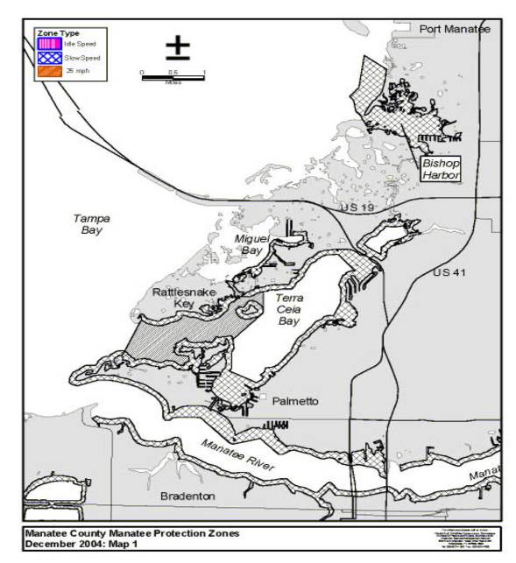
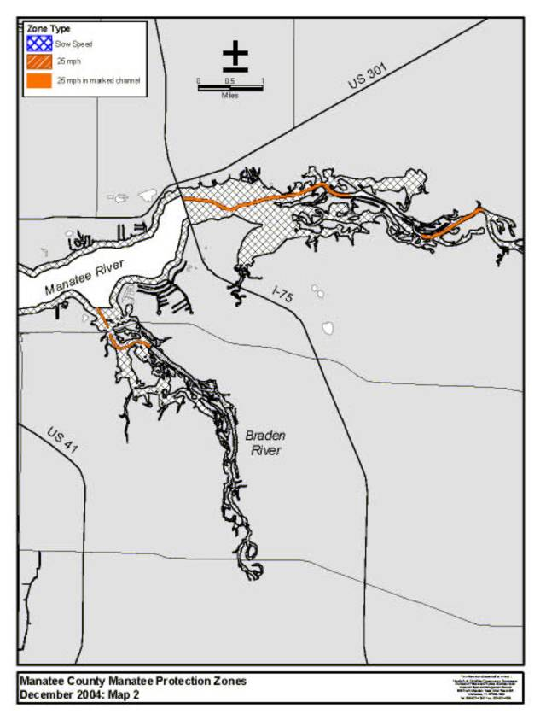

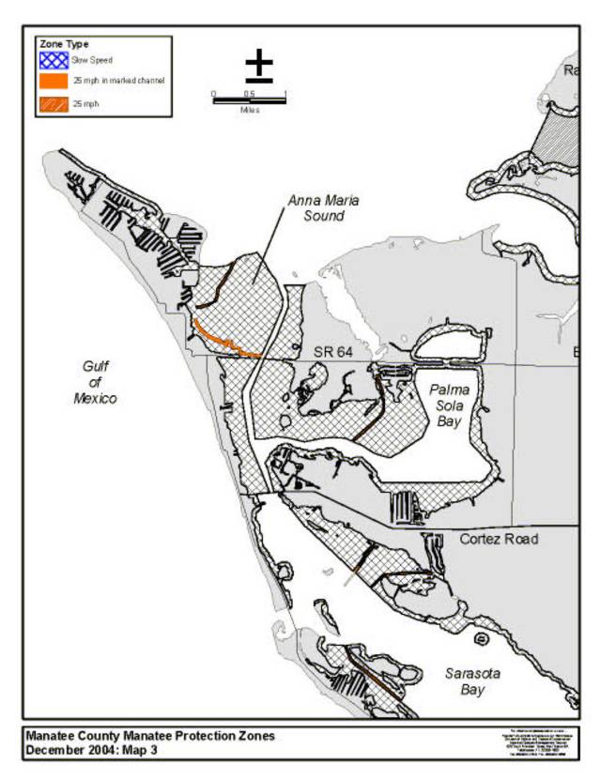

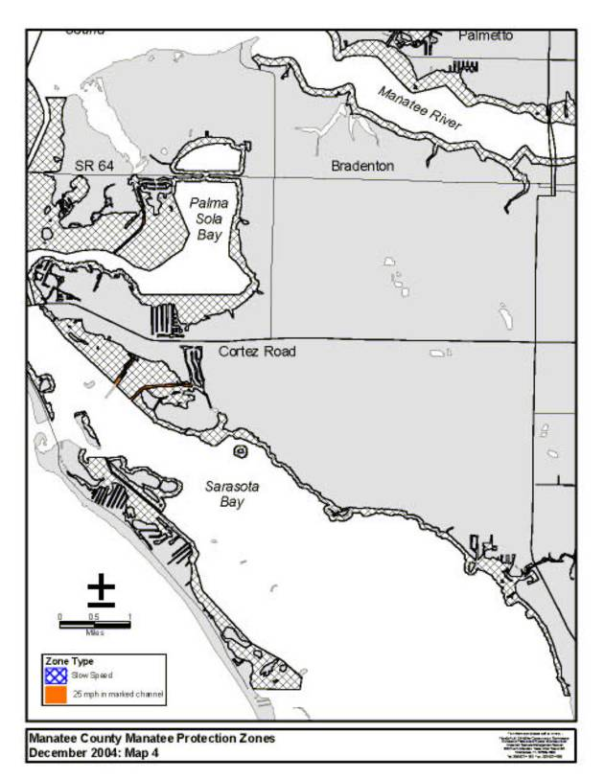
Rulemaking Authority 370.12(2)(g), (n) FS. Law Implemented 370.12(2)(d), (g), (k), (n) FS. History–New 12-12-02, Amended 1-5-05.

