68C-22.023 Collier County Zones.
(1) The Commission hereby designates the waters within Collier County, as described below, as areas where manatees are frequently seen. The Commission has further determined that manatees are assumed to inhabit these waters periodically or continuously. This rule is for the purpose of regulating the speed and operation of motorboats in portions of these designated areas. In balancing the rights of fishermen, boaters, and waterskiers to use these waterways for recreational and commercial purposes (as applicable under Section 370.12(2)(j), F.S.) with the need to provide manatee protection, the Commission has examined the need for higher speed corridors through regulated areas. Such corridors are provided in those areas where the Commission determined, on the basis of all available information, (1) there is a need for the corridor and (2) the corridor will not result in serious threats to manatees or their habitat (as defined in Rule 68C-22.001, F.A.C.). Higher speed corridors are not provided in areas where both of the above findings were not made. Regulations described herein which affect the Faka Union Canal area are unchanged from those adopted in 1983, and amended in 1988, which formerly appeared in Rule 62N-22.0161, F.A.C. Zones described herein are in effect year-round and include all associated and navigable tributaries, lakes, creeks, coves, backwaters, canals, and boat basins unless otherwise designated or excluded.
(a) No Entry – Henderson Creek/Enchanting Shores area: All waters of the basin and canal adjacent to the Enchanting Shores Trailer Park, east of a line bearing 20° beginning at a point (approximate latitude 26° 02' 54" N, approximate longitude 81° 14' 28" W) on the southern shoreline of the canal approximately fifty (50) feet east of where the canal flows into Henderson Creek (all said waters being located in Section 11, Township 51 South, Range 26 East).
(b) Idle Speed (channel included) –
1. Naples Bay area: All waters of Naples Bay and associated waters south of the US 41 bridge and north of an east-west line running through channel marker “33” (approximate latitude 26° 07' 46" N, approximate longitude 81° 47' 28" W), including the waters of Crayton Cove;
2. Gordon Pass/Port Royal area: All waters of Gordon Pass and associated waters northeast of lines which bear 160° and 340° from channel marker “7A” (approximate latitude 26° 05' 39" N, approximate longitude 81° 47' 56" W) and west and southwest of a line which bears approximately 143° from the southeasternmost point (approximate latitude 26° 05' 49" N, approximate longitude 81° 47' 51" W) of the peninsula north of channel marker “10” to the northeasternmost point (approximate latitude 26° 05' 46" N, approximate longitude 81°47'48” W) of the peninsula south of channel marker “10”; and all waters of the bay and canal system north of Admiralty Bay, including all waters of Man of War Cove, Smugglers Bay, and Morgan’s Cove;
3. Henderson Creek area: All waters of Henderson Creek and associated waters east of State Road 951, except as designated under paragraph (1)(a);
4. Marco Island/Collier Bay area: All waters of Marco River, Collier Bay, Marco Bay, and associated waters, south of the Isle of Capri, Stingaree Island, and a straight line connecting their southern shorelines, east of a line which bears 180° from the westernmost point of the Isle of Capri (approximate latitude 25° 58' 28" N, approximate longitude 81° 44' 22" W), and south and west of a line beginning at a point on Stingaree Island (approximate latitude 25° 58' 30" N, approximate longitude 81° 43' 27" W) and bearing 180° to channel marker “15” and then bearing approximately 154° to the line’s ending point on the northernmost point of the peninsula containing Orange Court (approximate latitude 25° 57' 57" N, approximate longitude 81° 43' 16” W);
5. Caxambas Bay/Roberts Bay area: All waters of Caxambas Bay, Roberts Bay, and associated waters, north of a line beginning at a point on the shoreline of Marco Island (approximate latitude 25° 54' 29" N, approximate longitude 81° 43' 04" W) (west of channel marker “4”) and bearing approximately 106° to the westernmost point of the unnamed island north of Dickman’s Island, then running along the northern shoreline of said island to its easternmost point, and then bearing approximately 92° through channel marker “13” to the line’s ending point on the shoreline of Horrs Island, and west of a line beginning at a point on Horrs Island (approximate latitude 25° 54' 13" N, approximate longitude 81° 41' 15" W) and bearing 0° to the southeasternmost point of Pass Key (approximate latitude 25° 54' 26" N, approximate longitude 81° 41' 15" W), then running along the eastern shoreline of said key to its northernmost point, then bearing approximately 338° to the southernmost point of David Key (approximate latitude 25° 54' 47" N, approximate longitude 81° 41' 24" W), then running along the southwestern shoreline of said key to its westernmost point, and then bearing 270° to the line’s ending point on the shoreline of Marco Island;
6. Goodland Bay area: All waters of Goodland Bay and associated waters, south of a line beginning at a point on the shoreline of Marco Island (approximate latitude 25° 55' 34" N, approximate longitude 81° 39' 08" W) and bearing 45° through channel marker “10” to a point on the shoreline of the unnamed island northeast of channel marker “10”, then running along the southern shoreline of said unnamed island to its easternmost point, then running 600 feet north of and parallel with the shoreline of Marco Island to the northwesternmost point of the small unnamed island east of Goodland, then running along the western shoreline of said unnamed island to its southwesternmost point, and then bearing approximately 190° to the line's ending point (approximate latitude 25° 55' 21'' N, approximate longitude 81° 38' 31'' W) on the northwestern shoreline of the large unnamed island east of channel marker “6,” and north of a line beginning at a point (approximate latitude 25° 55' 15'' N, approximate longitude 81° 38' 27'' W) on the shoreline of the large unnamed island east of channel marker “6” and bearing 245° through said channel marker to the northernmost point of the large mangrove island south of Goodland, then bearing approximately 270° to the easternmost point of the small unnamed island immediately west of said island, then running along the southern shoreline of said island to its southwesternmost point, and then bearing 290° to the line’s ending point on the shoreline of Marco Island (approximate latitude 25° 55' 10" N, approximate longitude 81° 39' 06" W);
7. Faka Union Canal/Port of the Islands area: All waters of Faka Union Canal and associated waters, south of the Tamiami Trail Bridge (US 41), and north of an east-west line 500 feet south of the southernmost east-west canal;
8. Everglades City/Barron River: All waters of the Barron River and associated waters north and east of the mouth of the river (beginning just northeast of channel marker “1”) and west of the State Road 29 Bridge.
(c) Slow Speed (channel included) –
1. Wiggins Pass/Vanderbilt Lagoon area: All waters of Wiggins Pass, Wiggins Bay, Water Turkey Bay, Vanderbilt Lagoon, and associated waters, east of a line which bears 180° from the southernmost point of Wiggins Island (approximate latitude 26° 17' 17'' N, approximate longitude 81° 49' 55" W), south of a line beginning at the southeasternmost point of Wiggins Island (approximate latitude 26° 17' 25" N, approximate longitude 81° 49' 38" W) and bearing approximately 78° to the southernmost point of the first small unnamed island to the east, then running along the southeastern shoreline of said unnamed island to its easternmost point, then bearing approximately 21° to the southwesternmost point of the unnamed island to the northeast, then running along the southern shoreline of said island to its easternmost point, then bearing approximately 80° to the southwesternmost point of the large unnamed island to the east (approximate latitude 26° 17' 29" N, approximate longitude 81° 49' 31" W), then running along the southern shoreline of said island to its southeasternmost point, then bearing approximately 100° to the southwesternmost point of the small unnamed island to the southeast (approximate latitude 26° 17' 29" N, approximate longitude 81° 49' 26" W), then running along the southern and eastern shorelines of said island to its easternmost point, then bearing approximately 25° to the easternmost point of the small unnamed island to the northeast, and then bearing approximately 350° to the line's ending point at the southwesternmost point of the peninsula (approximate latitude 26° 17' 36" N, approximate longitude 81° 49' 24" W) to the north of said unnamed island (all these islands being north of the marked channel leading into Wiggins Bay), and north and west of a line at the southern end of Wiggins Bay beginning at the northeasternmost point of the peninsula west of the Cocohatchee River (approximate latitude 26° 17' 16" N, approximate longitude 81° 48' 58" W) and bearing 90° to its ending point on the eastern shoreline of said river, including all waters of Water Turkey Bay and Vanderbilt Lagoon;
2. Gordon River area: All waters of the Gordon River, Rock Creek, and associated waters, north of the US 41 bridge;
3. The Narrows: All waters east of Keewadin Island known as “The Narrows” south of channel marker “52” (approximate latitude 26° 03' 22" N, approximate longitude 81° 46' 44" W) and north of channel marker “47” (approximate latitude 26° 02' 34" N, approximate longitude 81° 46' 31" W);
4. Flotilla Passage area: All waters of Flotilla Passage; all waters within 300 feet of the State Road 951 bridge over the Marco River (Judge Jolly Bridge) and those waters within 300 feet of shore between Flotilla Passage and said bridge; and all waters within 600 feet of the State Road 951 bridge over McIlvane Bay;
5. Goodland Bay area: All waters of Goodland Bay south of channel marker “15” in the Marco River (north of the State Road 92 bridge over Goodland Bay), except as designated under subparagraph (1)(b)6.;
6. Faka Union Canal area: All waters of Faka Union Canal, Faka Union Bay, and associated waters, south of an east-west line 500 feet south of the southernmost east-west canal and north of a line in Faka Union Bay beginning at the southernmost point of the peninsula (approximate latitude 25° 54' 02" N, approximate longitude 81° 31' 02" W) north of channel marker “42” and bearing 107° to the line's ending point on the eastern shoreline of Faka Union Bay (said line running through a point in the marked channel 16,468 feet south of the above-described northern boundary as formerly described in Rule 68C-22.0161, F.A.C.);
7. Everglades City/Chokoloskee Bay area: All waters of Chokoloskee Bay and associated waters south of a line beginning at a point on the northern shoreline of the bay (approximate latitude 25° 51' 15" N, approximate longitude 81° 23' 47" W) and bearing 180° to the northernmost point of Bear Island, then running along the western shoreline of said island to its southwesternmost point, then bearing approximately 225° to the line's ending point at the southernmost point of the unnamed spoil island (approximate latitude 25° 50' 50" N, approximate longitude 81° 24' 04" W) north of channel marker “27,” north of a line beginning at the aforementioned southernmost point of the unnamed spoil island north of channel marker “27” and bearing approximately 113° to channel marker “5” (approximate latitude 25° 50' 31" N, approximate longitude 81° 23' 16" W), and then bearing approximately 135° to the line’s ending point on the boundary of Everglades National Park (approximate latitude 25° 49' 57" N, approximate longitude 81° 22' 38" W) 1,200 feet west of the Chokoloskee Causeway, and south of the Chokoloskee Causeway.
(d) 30 MPH in Channel/Slow Speed Outside of Channel – All channels that are duly permitted by applicable state and federal authorities are included in the 30 mph channel designation. Local channels that are not duly permitted (including those marked by PVC pipes or similar materials) are not included.
1. Little Hickory Bay/Bonita Shores area: All waters of Little Hickory Bay and associated waters south of the Lee County line and north of a line beginning at a point on the western shoreline of Little Hickory Bay (approximate latitude 26° 19' 26" N, approximate longitude 81° 50' 15" W) and bearing 90° to the southernmost point of the peninsula containing Third Street West in Bonita Shores (approximate latitude 26° 19' 26" N, approximate longitude 81° 49' 58" W), and then bearing 125° to the line’s ending point on the eastern shoreline of Little Hickory Bay;
2. Wiggins Pass/South Wiggins Island area: All waters south of a line beginning at a point on the eastern shoreline of Wiggins Island (approximate latitude 26° 18' 09" N, approximate longitude 81° 49' 48" W) at the narrow section of the waterway north of Wiggins Pass and bearing 90° to the line’s ending point on the eastern shoreline of said waterway, and north of a line beginning at the southeasternmost point of Wiggins Island (approximate latitude 26° 17' 25" N, approximate longitude 81° 49' 38" W) and bearing approximately 78° to the southernmost point of the first small unnamed island to the east, then running along the southeastern shoreline of said unnamed island to its easternmost point, then bearing approximately 21° to the southwesternmost point of the unnamed island to the northeast, then running along the southern shoreline of said island to its easternmost point, then bearing approximately 80° to the southwesternmost point of the large unnamed island to the east (approximate latitude 26° 17' 29" N, approximate longitude 81° 49' 31" W), then running along the southern shoreline of said island to its southeasternmost point, then bearing approximately 100° to the southwesternmost point of the small unnamed island to the southeast (approximate latitude 26° 17' 29" N, approximate longitude 81° 49' 26" W), then running along the southern and eastern shorelines of said island to its easternmost point, then bearing approximately 25° to the easternmost point of the small unnamed island to the northeast, and then bearing approximately 350° to the line’s ending point at the southwesternmost point of the peninsula (approximate latitude 26° 17' 36" N, approximate longitude 81° 49' 24" W) to the north of said unnamed island (all these islands being north of the marked channel leading into Wiggins Bay);
3. Naples Bay/Dollar Bay area: All waters of Naples Bay, Haldeman Creek, Admiralty Bay, Dollar Bay, and associated waters, south of an east-west line running through channel marker “33” (approximate latitude 26° 07' 46" N, approximate longitude 81° 47 '28" W) and north of channel marker “52” (approximate latitude 26° 03' 22" N, approximate longitude 81° 46' 44" W), except as designated under subparagraph (1)(b)2.;
4. Inland Waterway/Halloway Island area: All waters south of channel marker “47” (approximate latitude 26° 02' 34" N, approximate longitude 81° 46' 31" W), west of a north-south line at the north end of Halloway Island running through the westernmost point (approximate latitude 26° 02' 34" N, approximate longitude 81° 46' 18" W) of the small unnamed island at the north end of Rookery Bay and at the south end of Halloway Island west of a north-south line running through channel marker “27A” (approximate latitude 26° 00' 53" N, approximate longitude 81° 45' 15" W), and north of a line beginning at a point on Keewadin Island (approximate latitude 26° 01' 04" N, approximate longitude 81° 45' 53" W) and bearing 90° to the northernmost point of Little Marco Island, then running along the eastern shoreline to a point on said island (approximate latitude 26° 00' 46" N, approximate longitude 81° 45' 30" W) south of channel marker “28A”, then bearing approximately 107° to the line's ending point at the northwesternmost point of Cannon Island (approximate latitude 26° 00' 43" N, approximate longitude 81° 45' 20" W);
5. Johnson Bay area: All waters of Johnson Bay and associated waters, east of a north-south line at the north end of Cannon Island running through channel marker “27A” (approximate latitude 26° 00' 53" N, approximate longitude 81° 45' 15" W) and at the south end of Cannon Island east of a line bearing approximately 135° from the southernmost point of the unnamed island south of Cannon Island (approximate latitude 25° 58' 40" N, approximate longitude 81° 44' 35" W) to the westernmost point of the Isle of Capri (approximate latitude 25° 58' 29" N, approximate longitude 81° 44' 23" W), south of Hall Bay, and north of the Isle of Capri, excluding the unnamed bays and backwater areas north and east of Johnson Bay;
6. Henderson Creek/Hall Bay area: All waters of Henderson Creek, Hall Bay, and associated waters, west of State Road 951, north and east of Johnson Bay, and south and east of a line beginning at a point on the southeastern shore of Halloway Island (approximate latitude 26° 01' 12" N, approximate longitude 81° 44' 43" W) and bearing 90° to the southwesternmost point (approximate latitude 26° 01' 12" N, approximate longitude 81° 44' 40" W) of the large unnamed island separating Rookery Bay and Hall Bay, then running along the eastern shoreline of said island to its northeasternmost point, then bearing approximately 15° to the southwesternmost point of the unnamed island to the northeast, then running along the eastern shoreline of said island to its southeasternmost point, then bearing approximately 62° to the line’s ending point at a point (approximate latitude 26° 01' 33" N, approximate longitude 81° 44' 15" W) on the southwestern shoreline of the peninsula forming the northwestern boundary of Henderson Creek;
7. Tarpon Bay/North Marco River area: All waters of Tarpon Bay, Marco River, and associated waters, south of the Isle of Capri, east of a line which bears 180° from the westernmost point of the Isles of Capri (approximate latitude 25° 58' 28" N, approximate longitude 81° 44' 22" W), and north and west of State Road 951, except as designated under subparagraphs (1)(b)4. and (1)(c)4.;
8. South Marco River/Addison Bay area: All waters of Marco River, Sanctuary Sound, Georgia Fruit Farm Creek, Bear Point Cove, Three Island Cove, the Muddies, Addison Bay, and associated waters, east of State Road 951, south of Unknown Bay, Upper Addison Bay, and the unnamed bays and backwater areas north and east of Bear Point Cove, Three Island Cove, and Addison Bay, and north of channel marker “15” in the Marco River (north of the State Road 92 bridge over Goodland Bay), except as designated under subparagraph (1)(c)4.;
9. Caxambas Pass/Helen Key area: All waters of Caxambas Pass, Caxambas Bay, and associated waters, south of Marco Island, Horrs Island, and a line beginning at a point on the shoreline of Marco Island (approximate latitude 25° 54' 29" N, approximate longitude 81° 43' 04" W) (west of channel marker “4”) and bearing approximately 106° to the westernmost point of the unnamed island north of Dickman’s Island, then running along the northern shoreline of said island to its easternmost point, and then bearing approximately 92° through channel marker “13” to the line’s ending point on the shoreline of Horrs Island, east of a line beginning at the southwesternmost point of Marco Island (approximate latitude 25° 54' 28" N, approximate longitude 81° 43' 43" W) and bearing 165° to a point in Caxambas Pass (approximate latitude 25° 54' 15" N, approximate longitude 81° 43' 39" W), then bearing approximately 100° to the line’s ending point on the northernmost point of Dickman’s Point (approximate latitude 25° 54' 10" N, approximate longitude 81° 43' 02" W), north and east of Kice Island, Helen Key and a line beginning at a point on the eastern shoreline of Kice Island (approximate latitude 25° 53' 13" N, approximate longitude 81° 41' 14" W) and bearing 48° to the northwesternmost point of the large unnamed island between Kice Island and Helen Key, then bearing approximately 48° to the line's ending point at the westernmost point of Helen Key (approximate latitude 25° 53' 24" N, approximate longitude 81° 41' 02" W), and west of a north-south line through channel marker “3” (north of Helen Key), excluding the waters of Grassy Bay and Little Grassy Bay;
10. Coon Key Pass/Goodland area: All waters of Coon Key Pass, Blue Hill Creek, and associated waters, south of Marco Island and a line beginning at a point (approximate latitude 25° 55' 15" N, approximate longitude 81° 38' 27" W) on the shoreline of the large unnamed island east of channel marker “6” and bearing 245° through said channel marker to the northernmost point of the large mangrove island south of Goodland, then bearing approximately 270° to the easternmost point of the small unnamed island immediately west of said island, then running along the southern shoreline of said island to its southwesternmost point, and then bearing 290° to the line’s ending point on the shoreline of Marco Island (approximate latitude 25° 55' 10" N, approximate longitude 81° 39' 06" W), east of a line beginning at a point on the southern shoreline of Marco Island (approximate latitude 25° 55' 08" N, approximate longitude 81° 39' 19" W) and bearing 180° to the northern shoreline of Horrs Island, then running along the eastern shoreline of Horrs Island to the line’s ending point at a point on the shoreline of Horrs Island (approximate latitude 25° 54' 49" N, approximate longitude 81° 39' 14" W), north of a line beginning at the aforementioned point on the shoreline of Horrs Island and bearing 90° to the northwesternmost point of an unnamed island east of Horrs Island (approximate latitude 25° 54' 49" N, approximate longitude 81° 39' 11" W), then running along the northern shoreline of said island to its easternmost point, then bearing approximately 115° to the westernmost point of the large unnamed island to the east (approximate latitude 25°54'44" N, approximate longitude 81° 39' 00" W), then running along the northern and eastern shorelines of said island to its southeasternmost point, then bearing approximately 38° to the line's ending point (approximate latitude 25° 54' 37" N, approximate longitude 81° 38' 10" W) at the southernmost point of the large unnamed island east of channel marker “6.”
(e) 30 MPH in Channel/20 MPH Outside of Channel – All channels that are duly permitted by applicable state and federal authorities are included in the 30 mph channel designation. Local channels that are not duly permitted (including those marked by PVC pipes or similar materials) are not included.
1. Little Hickory Bay area: All waters of Little Hickory Bay and associated waters south of a line beginning at a point on the western shoreline of Little Hickory Bay (approximate latitude 26° 19' 26" N, approximate longitude 81° 50' 15" W) and bearing 90° to the southernmost point of the peninsula containing Third Street West in Bonita Shores (approximate latitude 26° 19' 26" N, approximate longitude 81° 49' 58" W), and then bearing 125° to the line’s ending point on the eastern shoreline of Little Hickory Bay, and north of a line beginning at a point on the eastern shoreline of Wiggins Island (approximate latitude 26° 18' 09" N, approximate longitude 81° 49' 48" W) at the narrow section of the waterway north of Wiggins Pass and bearing 90° to the line’s ending point on the eastern shoreline of said waterway;
2. Cocohatchee River area: All waters of the Cocohatchee River and associated waters south and east of a line at the southern end of Wiggins Bay beginning at the northeasternmost point of the peninsula west of the Cocohatchee River (approximate latitude 26° 17' 16" N, approximate longitude 81° 48' 58" W) and bearing 90° to its ending point on the eastern shoreline of said river;
3. Rookery Bay area: All waters of Rookery Bay and associated waters east of the Narrows section of the Inland Waterway and a north-south line at the north end of Halloway Island running through the westernmost point (approximate latitude 26° 02' 34" N, approximate longitude 81° 46' 18" W) of the small unnamed island at the north end of Rookery Bay, and north of a line beginning at a point on the southeastern shore of Halloway Island (approximate latitude 26° 01' 12" N, approximate longitude 81° 44' 43" W) and bearing 90° to the southwesternmost point (approximate latitude 26° 01' 12" N, approximate longitude 81° 44' 40'' W) of the large unnamed island separating Rookery Bay and Hall Bay, then running along the eastern shoreline of said island to its northeasternmost point, then bearing approximately 15° to the southwesternmost point of the unnamed island to the northeast, then running along the eastern shoreline of said island to its southeasternmost point, then bearing approximately 62° to the line’s ending point at a point (approximate latitude 26° 01' 33'' N, approximate longitude 81° 44' 15'' W) on the southwestern shoreline of the peninsula forming the northwestern boundary of Henderson Creek;
4. McIlvane Bay area: All waters of McIlvane Bay, the unnamed bays and backwater areas north and east of Johnson Bay, and associated waters, north of Flotilla Passage, the Isle of Capri, and Johnson Bay, except as designated under subparagraph (1)(c)4.;
5. Unknown Bay/Upper Addison Bay area: All waters of Unknown Bay, Upper Addison Bay, and associated waters, north of Bear Point Cove, Three Islands Cove, and Addison Bay;
6. Barfield Bay/Blue Hill Bay area: All waters of Barfield Bay, Blue Hill Creek, and associated waters, north of Horrs Island, north and east of a line beginning at a point on Horrs Island (approximate latitude 25° 54' 13'' N, approximate longitude 81° 41' 15'' W) and bearing 0° to the southeasternmost point of Pass Key (approximate latitude 25° 54' 26'' N, approximate longitude 81° 41' 15'' W), then running along the eastern shoreline of said key to its northernmost point, then bearing approximately 338° to the southernmost point of David Key (approximate latitude 25° 54' 47" N, approximate longitude 81° 41' 24'' W), then running along the southwestern shoreline of said key to its westernmost point, then bearing 270° to the line’s ending point on the shoreline of Marco Island, and west of a line beginning at a point on the southern shoreline of Marco Island (approximate latitude 25° 55' 08'' N, approximate longitude 81° 39' 19'' W) and bearing 180° to the northern shoreline of Horrs Island;
7. Palm Bay/Sugar Bay area: All waters of Palm Bay, Sugar Bay, Mud Bay, and associated waters, east of Goodland Bay, the large unnamed island east of channel marker “6,” and a line beginning at the southernmost point of said unnamed island (approximate latitude 25° 54' 37" N, approximate longitude 81° 38' 10" W) and bearing approximately 157° to the line’s ending point at a point on the northwestern shoreline of Tripod Key (approximate latitude 25° 54' 30" N, approximate longitude 81° 38' 07" W);
8. Ten Thousand Islands/Faka Union Bay/Chokoloskee Bay area: All waters of the Ten Thousand Islands area (including those waters of the Blackwater River, Blackwater Bay, Faka Union Bay, and Chokoloskee Bay), east of Palm Bay, Sugar Bay, Tripod Key, and a line beginning at a point on Tripod Key (approximate latitude 25° 54' 15" N, approximate longitude 81° 37' 33" W) and bearing approximately 170° to the westernmost point of the large unnamed island northeast of Brush Island, then bearing approximately 174° to the northwesternmost point of Brush Island, then running along the western shoreline of Brush Island to the line’s ending point at the southernmost point of said island (approximate latitude 25° 53' 26" N, approximate longitude 81° 37' 22" W), and north of the Monroe County line and a line connecting the southern shorelines of all the outermost islands of the Ten Thousand Islands area, excluding all waters within the boundaries of Everglades National Park, and areas otherwise designated under subparagraphs (1)(b)7., (1)(b)8., (1)(c)6., and (1)(c)7.
(2) Commercial Fishing and Professional Guiding Permits: The following provisions pertain to the issuance of permits to allow commercial fishermen and professional fishing guides to operate their vessels in specified areas at speeds greater than the speed limits established under subsection (1), above. Procedures related to the application for and the review and issuance of these permits are as set forth in Rule 68C-22.003, F.A.C.
(a) Permits shall be limited as follows:
1. Permits shall only be issued for the zones or portions of zones described under subparagraphs (1)(c)5. and (1)(d)4. through (1)(d)9.;
2. Permits shall not authorize the recipient to operate at speeds greater than 20 MPH; and,
3. Permits shall not apply on weekends or state-recognized holidays.
(b) Permit applications may be obtained at the Fish and Wildlife Conservation Commission, Division of Law Enforcement office, 2423 Edwards Drive, Fort Myers, FL 33901 (telephone (941)332-6971).
(3) The zones described in subsection 68C-22.023(1), F.A.C., are depicted on the following maps, labelled “Collier County Manatee Protection Zones” and dated April 1997. These maps shall replace all previously published maps. Maps provided are intended as depictions of the above-described zones. In the event of conflict between the two, the above descriptions shall prevail.
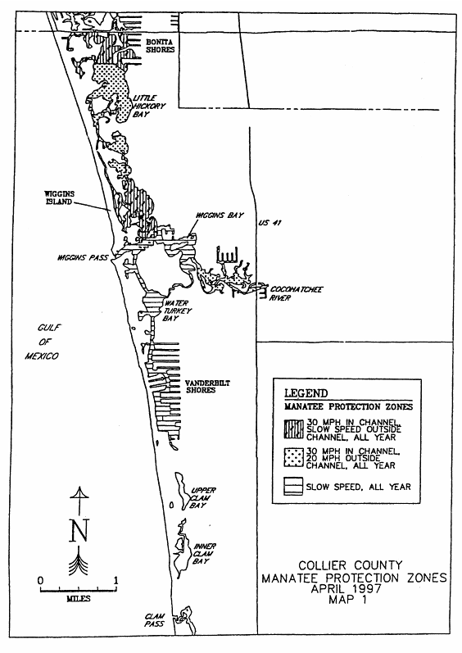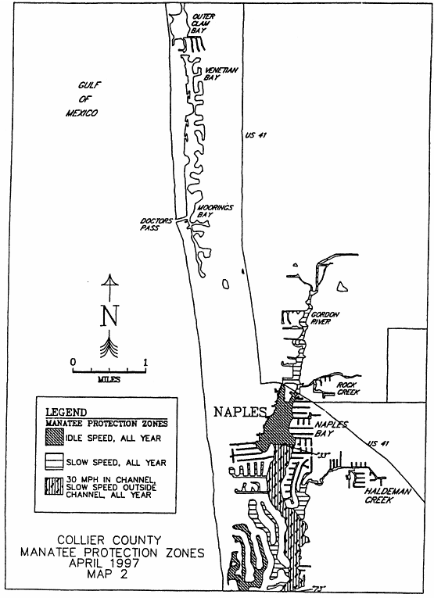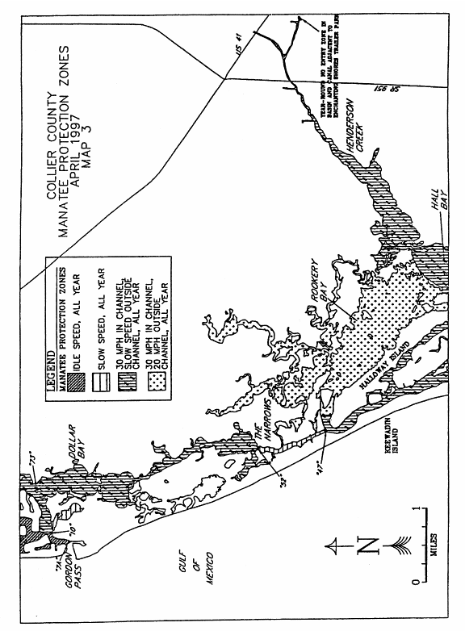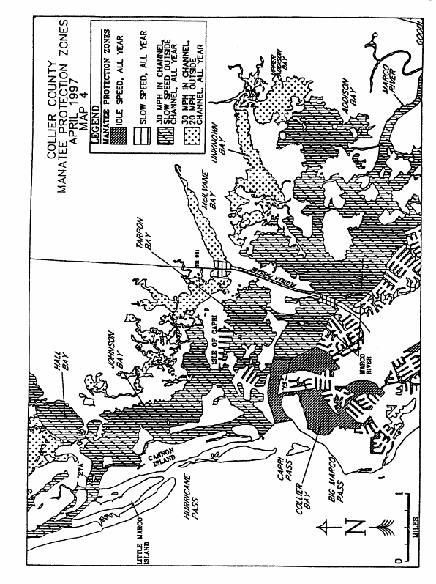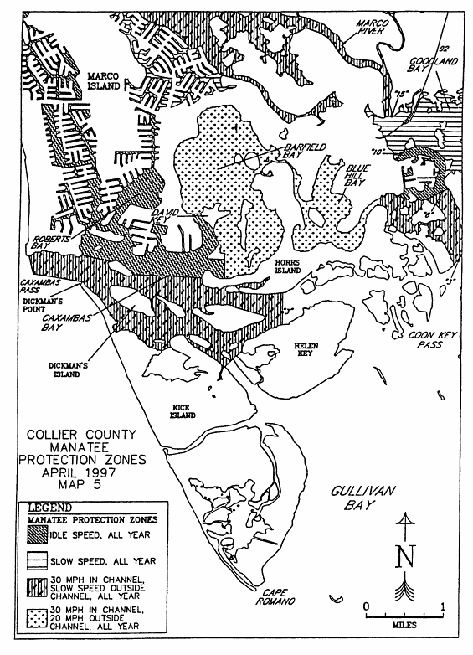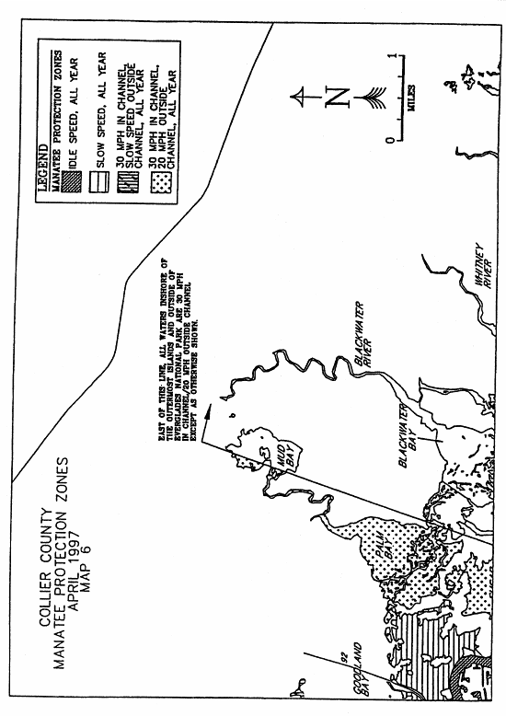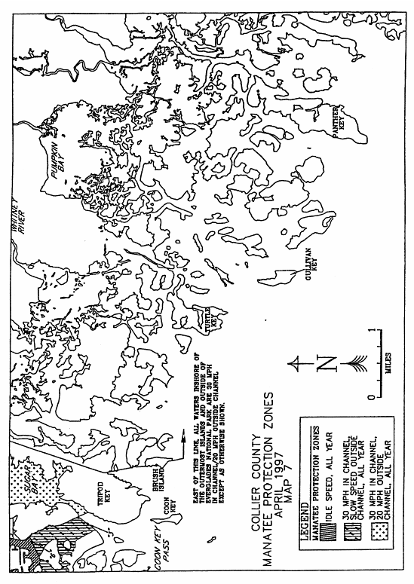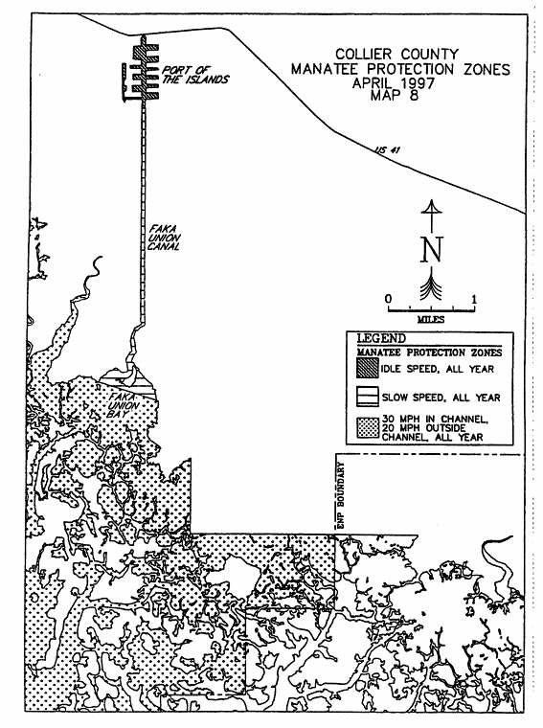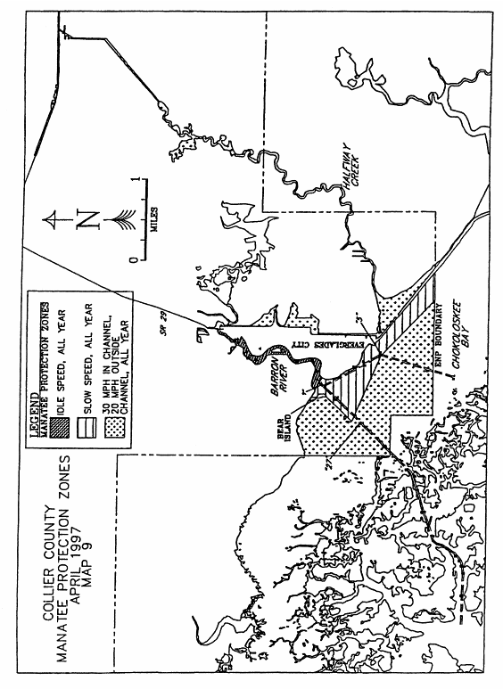
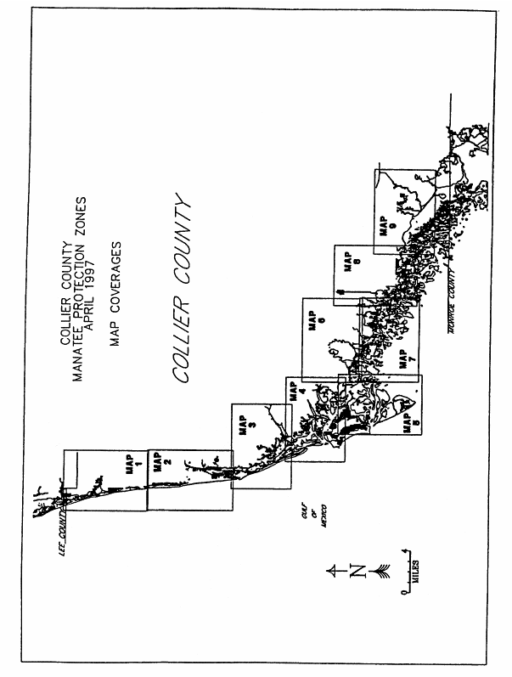
Rulemaking Authority 370.12(2)(f), (n), (o) FS. Law Implemented 370.12(2)(f)11, (n), (o) FS. History–New 8-28-90, Formerly 16N-22.023, Amended 6-5-97, Formerly 62N-22.023.

