68D-24.006 Fort Lauderdale Boating Restricted Areas.
(1) For the purpose of regulating speed and operation of vessel traffic on the Intracoastal Waterway within the City of Fort Lauderdale, Florida, the following boating restricted areas are established:
(a)1. Oakland Park Boulevard Bridge – An Idle Speed No Wake zone from shoreline to shoreline, in and adjacent to the Intracoastal Waterway, and extending 1,500 feet on both sides of the Oakland Park Boulevard Bridge, as depicted in drawing A.
2. Sunrise Boulevard Bridge –
a. An Idle Speed No Wake zone from shoreline to shoreline, in and adjacent to the Intracoastal Waterway, from a line drawn perpendicular to the centerline of the waterway 2,250 feet north of the Sunrise Boulevard Bridge to a line drawn perpendicular to the centerline of the waterway 1,500 feet south of said bridge, as depicted in drawing B.
b. A Slow Speed Minimum Wake zone from shoreline to shoreline, in and adjacent to the Intracoastal Waterway, from a line drawn perpendicular to the centerline of the waterway 1,500 feet south of the Sunrise Boulevard Bridge to a line drawn perpendicular to the centerline of the waterway 1,500 feet north of the East Las Olas Bridge, as depicted in drawing B, said zone to be in effect year-round on Saturdays, Sundays and holidays as defined in Rule 68D-24.002, F.A.C.
3. East Las Olas Bridge – An Idle Speed No Wake zone from shoreline to shoreline, in and adjacent to the Intracoastal Waterway, from a line drawn perpendicular to the centerline of the waterway 1,500 feet north of the East Las Olas Bridge to a line drawn perpendicular to the centerline of the waterway 3,300 feet south of said bridge, as depicted in drawing C.
4. Stranahan River – A Slow Down Minimum Wake zone from shoreline to shoreline, in and adjacent to the Intracoastal Waterway from a line drawn perpendicular to the centerline of the waterway 3,300 feet south of the East Las Olas Bridge to a line drawn perpendicular to the centerline of the water way 1,500 feet north of the 17th Street Causeway Bridge, as depicted in drawing C.
5. 17th Street Causeway Bridge – An Idle Speed No Wake zone from shoreline to shoreline, in and adjacent to the Intracoastal Waterway, from a line drawn perpendicular to the centerline of the waterway 1,500 feet north of the 17th Street Causeway Bridge to a line drawn perpendicular to the centerline of the waterway 800 feet south of said bridge, as depicted in drawing C.
(b) The City of Fort Lauderdale, in Broward County is empowered to install and maintain appropriate regulatory markers as directed by the Division of Law Enforcement within such boating restricted area and shall install and maintain “Resume 30 MPH/15 Inch Wake Operation” markers at the boundaries of such restricted areas, except at the boundaries of adjoining zones.
(2) The boating restricted areas are depicted on the following drawings:
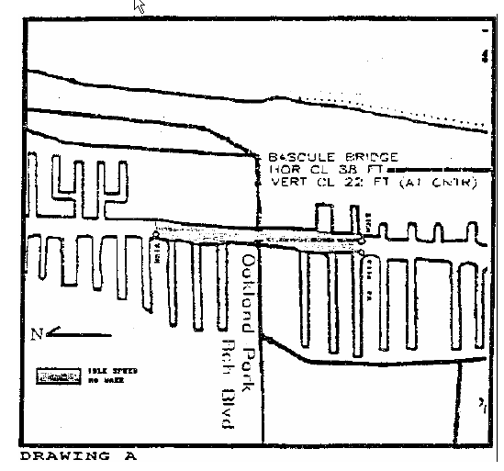
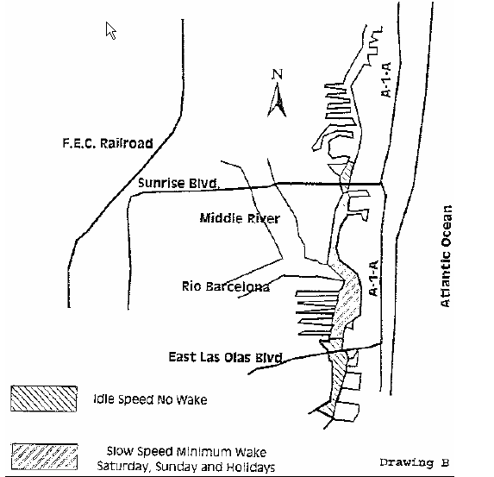
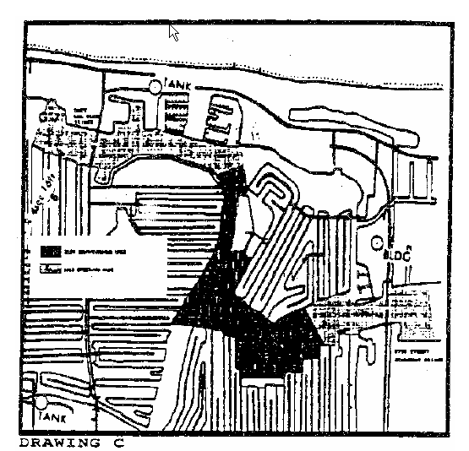
Rulemaking Authority 327.04, 327.46 FS. Law Implemented 327.46 FS. History–New 11-13-83, Formerly 16N-24.06, Amended 3-12-87, 12-7-89, Formerly 16N-24.006, Amended 9-28-98, Formerly 62N-24.006.

