68D-24.011 Okeechobee Waterway Boating Restricted Areas.
(1) For the purpose of regulating the speed and operation of vessel traffic on the Okeechobee Waterway, the following Boating Restricted Areas are established:
(a)1. Torry Island Bridge – A Slow Speed Minimum Wake zone from shoreline to shoreline, in and adjacent to the Okeechobee Waterway in Palm Beach County, bounded on the north by a line drawn perpendicular to the centerline of the Okeechobee Waterway 400 feet north of Torry Island Bridge in Belle Glade, Palm Beach County, and bounded on the south by a line drawn perpendicular to the centerline of the Okeechobee Waterway 1,400 feet south of said bridge, as depicted in drawing A.
2. Clewiston Lock Structure – An Idle Speed No Wake zone from shoreline to shoreline in and adjacent to the Okeechobee Waterway and Cauley Cut in the vicinity of Hurricane Gate and Lock Structure S-310 in Clewiston, Hendry County, within the boundaries set forth below, as depicted in drawing B:
a. In Cauley Cut, from shoreline to shoreline, from the intersection of Cauley Cut and the Okeechobee Waterway Rim Canal to a line drawn parallel to the centerline of the Okeechobee Waterway Rim Canal 150 feet northeast of the intersection of Cauley Cut and the Okeechobee Waterway Rim Canal;
b. In the Route 1 Approach Channel leading northeast toward Port Myakka, from shoreline to shoreline, from the intersection of Route 1 Approach Channel and the Okeechobee Waterway Rim Canal to a line drawn parallel to the centerline of the Okeechobee Waterway Rim Canal 150 feet northeast of the intersection of Route 1 Approach Channel and the Okeechobee Waterway Rim Canal;
c. In the Okeechobee Waterway Rim Canal, from shoreline to shoreline, from a line drawn perpendicular to the center line of the Rim Canal 150 feet southeast of Lock Structure S-310 to a line drawn perpendicular to the center line of the Rim Canal 150 feet northwest of the intersection of the Route 1 Approach Channel and the Okeechobee Waterway Rim Canal; and,
d. In the Industrial Canal, from shoreline to shoreline, from the Okeechobee Waterway Rim Canal to and including the Lock Structure.
3. Liberty Point – A Slow Speed Minimum Wake zone from shoreline to shoreline, in and adjacent to the Okeechobee Waterway Rim Canal and Myakka Cut in Glades County, bounded on the west by a line drawn perpendicular to the centerline of the Okeechobee Waterway Rim Canal 300 feet west of Liberty Point, on the southeast by a line drawn perpendicular to the centerline of the Rim Canal 600 feet southeast of Liberty Point, and on the east by a line drawn perpendicular to the centerline of the Myakka Cut 150 east of its confluence with the Rim Canal, as depicted in drawing C.
4. Palm City Bridge (C. R. 714) – A Slow Speed Minimum Wake boating restricted area, shoreline to shoreline, in and adjacent to the Okeechobee Waterway, from 200 feet north of the centerline of the Palm City Bridge to 1,500 feet south of the centerline of the Palm City Bridge at the northern tip of the island located east of Leighton Park and the public boat ramp as depicted in drawing D.
5. St. Lucie Lock and Dam Structure, the Florida Turnpike and I-95 Bridges – A Slow Speed Minimum Wake boating restricted area, shoreline to shoreline, in and adjacent to the St. Lucie Lock and Dam easterly to 1,000 feet east of the eastern span of the northbound traffic lane of I-95, as depicted in drawing E.
6. Timer Powers Park and Boat Ramp – A Slow Speed Minimum Wake boating restricted area, shoreline to shoreline, in and adjacent to the Okeechobee Waterway, from 1,000 feet northeast of the centerline of the Timer Powers Boat Ramp to 1,000 feet southwest of the centerline of the Timer Powers Boat Ramp, as depicted in drawing F.
7. Moore Haven Lock Structure and Vicinity – A Slow Speed Minimum Wake boating restricted area:
a. In the Okeechobee Waterway Rim Canal, shoreline to shoreline, from a line drawn perpendicular to the centerline of the Okeechobee Waterway Rim Canal 1,800 feet northwest of the centerline of the Moore Haven Lock Gates canal (26°50' 45.2''N/81°05'24.2''W), to a line drawn perpendicular to the centerline of the Okeechobee Waterway Rim Canal 500 feet southeast of the centerline of the Alvin Ward boat ramp (26° 50'21.8"N/81°04'46.9"W), including the area shoreline to shoreline 500 feet north from the Okeechobee Waterway Rim Canal into the Old Moore Haven Canal (26°50'40.9"N/81°05'14.4"W), and including the Moore Haven Locks canal.
b. In the lock structure and approaches, shoreline to shoreline, from the Okeechobee Waterway Rim Canal to the Caloosahatchee River.
c. In the approaches and spillway of flood control structure S-77, shoreline to shoreline, from the Okeechobee Waterway Rim Canal to the Caloosahatchee River.
d. In the Caloosahatchee River, shoreline to shoreline, from the river’s northern terminus at the lock structure to a line drawn perpendicular to the centerline of the river 1,450 feet downstream of the centerline of the US 27 Bridge (26°49' 48.3"N/81°05'30.2"W), including the area shoreline to shoreline in the Old Moore Haven Canal south of the Okeechobee Waterway Rim Canal to the Old Moore Haven Canal’s terminus as depicted in drawing G.
8. State Road 29 Bridge – A Slow Speed Minimum Wake boating restricted area in the Caloosahatchee River, shoreline to shoreline, from a line 500 feet east of and parallel to the centerline of the State Road 29 bridge to a line 2,056 feet west of and parallel to the centerline of the State Road 29 Bridge, as it crosses the Caloosahatchee River (Okeechobee Waterway), as depicted in drawing H.
(b) Martin, Palm Beach, Glades, and Hendry Counties, the City of Clewiston, the City of LaBelle, the City of Moore Haven (in coordination and cooperation with the South Florida Water Management District), are authorized to install and maintain appropriate regulatory markers as directed by the Division of Law Enforcement within the boating restricted areas, or portions thereof, located within the respective areas. These local governmental entities may enter into agreements with public or private organizations or individuals to effect this purpose.
(2) The boating restricted areas are depicted in the following drawings:
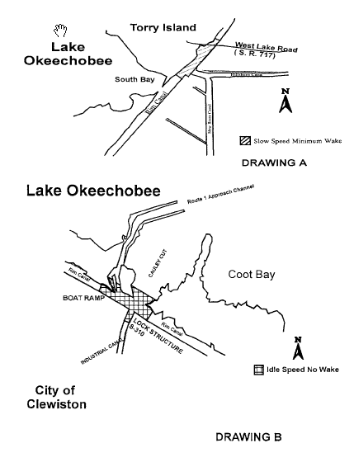

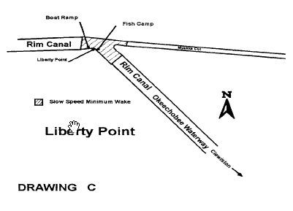

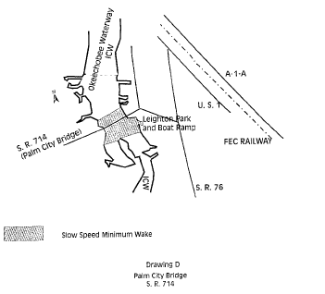

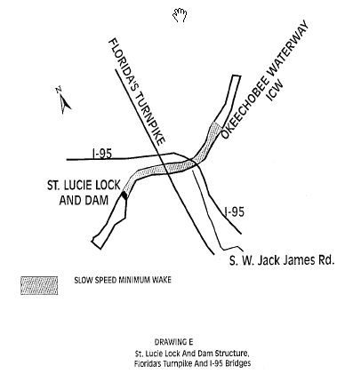

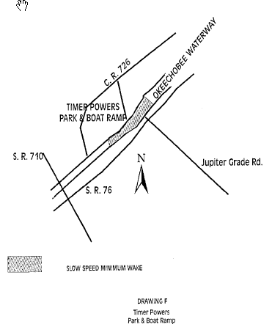

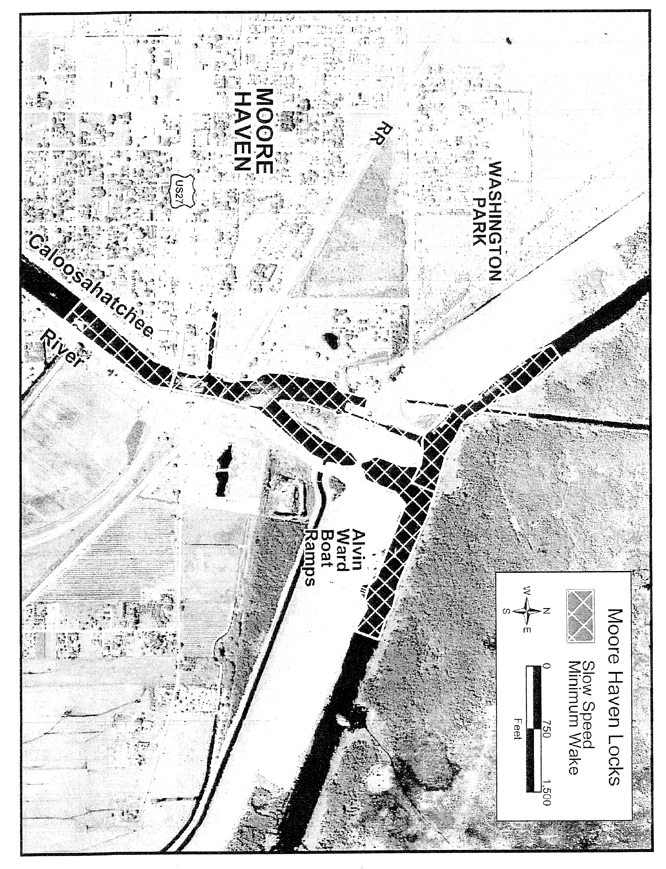

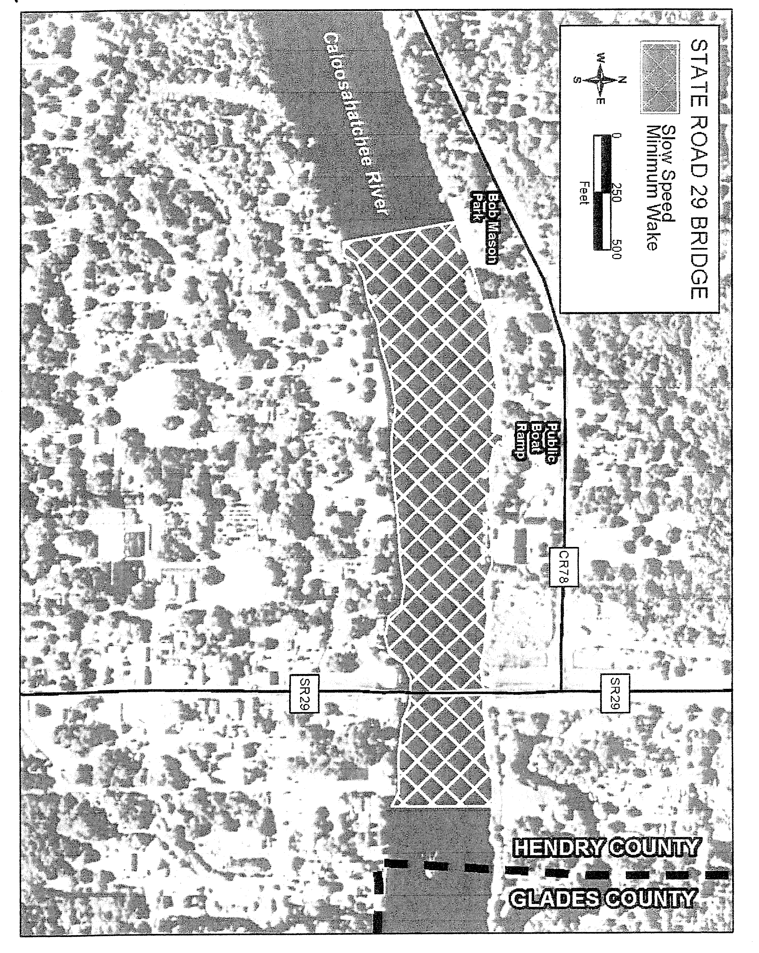

Specific Authority 327.04, 327.46 FS. Law Implemented 327.46 FS. History–New 1-5-88, Formerly 16N-24.011, Amended 1-8-96, Formerly 62N-24.011, Amended 10-2-00, 10-23-05.

