68D-24.013 Dade County Boating Restricted Areas.
(1) For the purpose of regulating the speed and operation of vessel traffic on and adjacent to the Intracoastal Waterway in the vicinities of Golden Beach, the North East 192nd Street Bridge, Biscayne Creek, Bakers Haulover Inlet, the Broad Causeway Bridge, the 79th Street Causeway Bridge, the Port of Miami, and the Rickenbacker Causeway Bridge in Dade County, Florida, the following Boating Restricted Areas are established:
(a)1. Golden Beach – 192nd Street Bridge: A Slow Down Minimum Wake Zone from shoreline to shoreline, in and adjacent to the Intracoastal Waterway, beginning at the Dade-Broward County Line and extending to a line drawn perpendicular to the centerline of the Intracoastal Waterway 500 feet south of the North East 192nd Street Bridge.
2. Biscayne Creek: An Idle Speed No Wake Zone in the Intracoastal Waterway Channel extending south from Dumfoundling Bay to Biscayne Bay, including all of Biscayne Creek.
3. Bakers Haulover Inlet: An Idle Speed No Wake Zone in and adjacent to the Intracoastal Waterway where the channels converge in the vicinity of the Bakers Haulover Inlet. This area is bounded as follows: on the west by the western edge of the channel of the Intracoastal Waterway; on the south by a line drawn due west from the southernmost point of the A1A Highway Bridge over the Bakers Haulover Inlet; on the east by the A1A Highway Bridge and the shoreline; and on the north by a line drawn due west from the shoreline to the south end of Atlantic Intracoastal Waterway Cut DA-8, approximately 3,440 feet north of the southern boundary of this zone.
4. Broad Causeway Bridge: An Idle Speed No Wake Zone in the Intracoastal Waterway Channel extending 100 yards on both sides of the Board Causeway Bridge.
5. 79th Street Causeway Bridge: An Idle Speed No Wake Zone in the Intracoastal Waterway Channel extending 100 yards on both sides of the 79th Street Causeway Bridge.
6. Port of Miami: An Idle Speed No Wake Zone in the Intracoastal Waterway Channel including approximately 1.75 miles from 100 yards north of the Venetian Causeway Bascule Bridge to the southern tip of Claughton Island.
7. Rickenbacker Causeway Bridge: An Idle Speed No Wake Zone in the Intracoastal Waterway Channel extending 100 yards on both sides of the Rickenbacker Causeway Bridge.
(b) Dade County is authorized to install and maintain appropriate regulatory markers as directed by the Division of Law Enforcement within the restricted areas. The county may enter into agreements with public or private organizations or individuals to effect this purpose.
(2) The boating restricted areas are depicted on the following drawings:
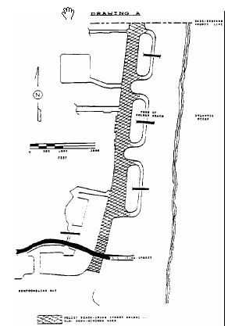
Rulemaking Authority 327.04, 327.46 FS. Law Implemented 327.46 FS. History–New 1-5-88, Amended 8-14-89, Formerly 16N-24.013, 62N-24.013.

