68D-24.015 Apalachicola River Boating Restricted Area.
(1) For the purpose of regulating the speed and operation of vessel traffic on and adjacent to the Apalachicola River within Franklin County, the following Boating Restricted Area is established:
(a) Slow Down Minimum Wake Zone – All waters lying within the Apalachicola River, from shoreline to shoreline but not including Crooked Channel, from the John Gorrie Memorial Bridge to a line drawn perpendicular to the centerline of the river 1,500 yards generally north of the John Gorrie Memorial Bridge following the thread of the river.
(b) The City of Apalachicola is authorized to install and maintain Slow Down Minimum Wake regulatory markers within the boating restricted area and shall install and maintain “Resume Normal Safe Operation” markers at the northern and southern boundaries of the boating restricted area.
(2) The boating restricted area is depicted on the following drawing:
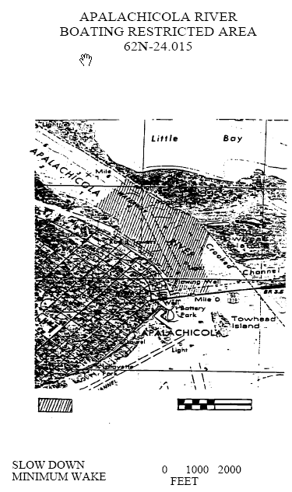
Rulemaking Authority 327.04, 327.46 FS. Law Implemented 327.46 FS. History–New 8-14-89, Formerly 16N-24.015, 62N-24.015.

