68D-24.016 Duval County Boating Restricted Areas.
(1) For the purpose of regulating the speed and operation of vessel traffic on and adjacent to the Florida Intracoastal Waterway within Duval County, the following Boating Restricted Areas are established:
(a) Slow Down Minimum Wake Zones.
1. Sisters Creek – All waters in and adjacent to the Florida Intracoastal Waterway within Sisters Creek, from shoreline to shoreline, from a line drawn perpendicular to the center line of the waterway 650 feet north of the Heckscher Drive Bridge to a line drawn from headland to headland across the mouth of Sisters Creek at its confluence with Saint Johns River, as depicted in drawing A.
2. Atlantic Boulevard Bridge – All waters in and adjacent to the Florida Intracoastal Waterway, from shoreline to shoreline from a line drawn perpendicular to the center line of the waterway 1,200 feet north of the Atlantic Boulevard Bridge to a line drawn perpendicular to the center line of the waterway 900 feet south of said bridge, as depicted in drawing B.
3. Beach Boulevard Bridge – All waters in and adjacent to the Florida Intracoastal Waterway, from shoreline to shoreline, from a line drawn perpendicular to the center line of the waterway 1,350 feet north of the Beach Boulevard Bridge to a line drawn perpendicular to the center line of the waterway 900 feet south of said bridge, as depicted in drawing C.
4. Saint Johns River:
a. All waters of the Saint Johns River, from shoreline to shoreline, from the Florida East Coast Railroad Bridge adjacent to the Acosta Bridge to the Main Street Bridge, as depicted in drawing D.
b. All waters of the Saint Johns River, from shoreline to shoreline, from the Main Street Bridge to the Hart Bridge, as depicted in drawing D. The zone established in this sub-subparagraph shall be active and enforceable only during periods of unusually high vessel traffic density. The regulatory markers posted for vessels entering this zone shall read SLOW DOWN MINIMUM WAKE WHEN FLASHING and shall have amber or yellow lights on both sides of the circle geometric shape specified in subsection 62N-18.002(3), F.A.C. The Sheriff of Duval County shall cause the lights to alternately flash whenever the zone is active. For the purposes of this sub-subparagraph, “unusually high vessel traffic density” means vessel traffic associated with: events at Riverwalk or Metropolitan Park; regattas, races, marine parades, tournaments, or exhibitions conducted pursuant to the provisions of section 327.48, F.S.; and legal holidays as specified in Section 683.01, F.S. The Sheriff of Duval County shall notify the Division of Law Enforcement each time the zone is activated or deactivated.
(b) Duval County is authorized to install and maintain appropriate regulatory markers as directed by the Division of Law Enforcement within the boating restricted areas and shall install and maintain “Resume Normal Safe Operation” markers at the boundaries of the boating restricted areas.
(2) The boating restricted areas are depicted on the following drawings:
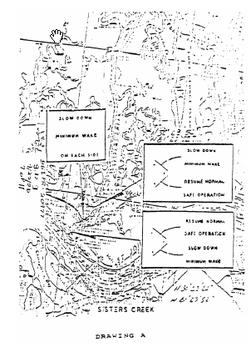
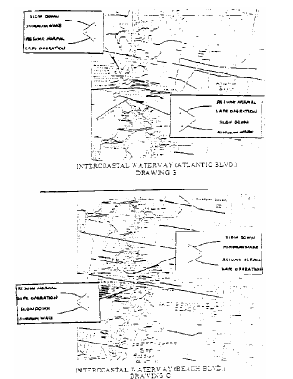
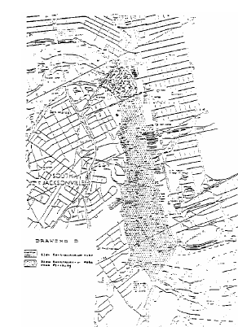
Rulemaking Authority 327.04, 327.46 FS. Law Implemented 327.46 FS. History–New 12-7-89, Formerly 16N-24.016, 62N-24.016.

