68D-24.014 Manatee County Boating Restricted Area.
(1) For the purpose of regulating the speed and operation of vessel traffic on and adjacent to the Florida Intracoastal Waterway within Manatee County, the following Boating Restricted Area is established:
(a) Slow Down Minimum Wake Zone – All waters lying within the channel of the Florida Intracoastal Waterway from a line drawn perpendicular to the centerline of the waterway 550 yards north of the Cortez Bridge to a line drawn perpendicular to the centerline of the waterway 250 yards south of the Cortez Bridge.
(b) Manatee County is authorized to install and maintain Slow Down Minimum Wake regulatory markers within the boating restricted area and shall install and maintain “Resume Normal Safe Operation” markers at the northern and southern boundaries of the boating restricted area.
(2) The boating restricted area is depicted on the following drawing:
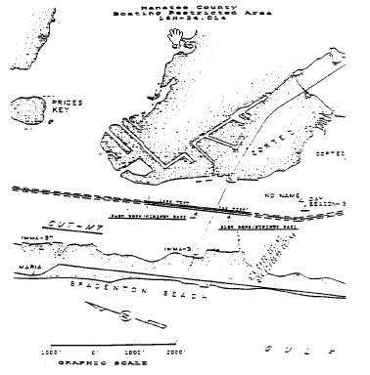
Rulemaking Authority 327.04, 327.46 FS. Law Implemented 327.46 FS. History–New 7-18-89, Formerly 16N-24.014, 62N-24.014.

