68D-24.117 Escambia County Boating Restricted Area.
(1) For the purpose of regulating the speed and operation of vessel traffic on and adjacent to the Florida Intracoastal Waterway within Escambia County, the following Boating Restricted Area is established: Florida Intracoastal Waterway between a line drawn perpendicular to the centerline of State Road 292 (Perdido Key Bridge) 5,500' feet west (30° 18' 43''/87° 26' 33'') of the Perdido Key Bridge (SR 292) and a line drawn perpendicular to the centerline of State Road 292 (Perdido Key Bridge) 3,500 feet east (30° 18' 06''/87° 25' 00''), including the waters adjacent to the Florida Intracoastal Waterway north and south to the mean high water mark as depicted in drawing A.
(2) Escambia County is authorized to install and maintain appropriate regulatory markers as directed by the Division of Law Enforcement within the boating restricted area and shall install and maintain “Idle Speed No Wake” and “Resume Normal Safe Operation” markers at the east and western boundaries of the boating restricted area.
(3) The boating restricted area is depicted in the following drawing:
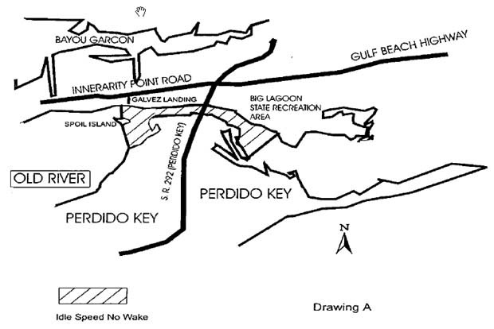

Rulemaking Authority 327.04, 327.46 FS. Law Implemented 327.46 FS. History–New 9-30-97, Formerly 62N-24.117.

