68D-24.118 Flagler County Boating Restricted Area.
(1) For the purpose of regulating speed and operation of vessel traffic on the Florida Intracoastal Waterway in Flagler County the following boating restricted area is established:
(a) SR 100 Bridge – A Slow Speed Minimum Wake boating restricted area shoreline to shoreline, in and adjacent to the Florida Intracoastal Waterway, from 500' feet south of the centerline of the SR 100 Bridge to 1,200' feet north of the centerline of the SR 100 Bridge, as depicted in Drawing A.
(b) The City of Flagler Beach is authorized to install and maintain appropriate regulatory markers as directed by the Division of Law Enforcement within the boating restricted area. The City of Flagler Beach may enter into agreements with public or private organizations or individuals to effect this purpose.
(2) The boating restricted area is depicted on the following drawing:
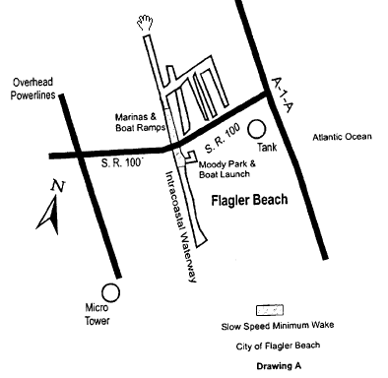
Rulemaking Authority 327.04, 327.46 FS. Law Implemented 327.33(3), 327.46 FS. History–New 3-15-98, Formerly 62N-24.118.

