68D-24.143 Martin County Boating Restricted Areas.
(1) For the purpose of regulating the speed and operation of vessel traffic on and adjacent to the Intracoastal Waterway in Martin County, Florida, the following Boating Restricted Areas are established for vessels 35 feet or more in length:
(a)1. Gleason Street Boat Ramp – A Slow Speed Minimum Wake zone from shoreline to shoreline, in and adjacent to the Intracoastal Waterway, bounded on the north by a line drawn perpendicular to the centerline of the Florida Intracoastal Waterway 600 feet north of the Gleason Street Boat Ramp and on the south by a line drawn perpendicular to the centerline of the Florida Intracoastal Waterway 300 feet south of said boat ramp, as depicted in drawing A. If the Gleason Street Boat Ramp is closed and its use as a transportation facility discontinued, the zone established in this paragraph shall no longer be in force or effect.
2. Jupiter Island – A Slow Speed Minimum Wake zone from shoreline to shoreline, in and adjacent to the Intracoastal Waterway, bounded on the north by a line drawn perpendicular to the centerline of the Florida Intracoastal Waterway 4,350 feet south of the Hobe South (State Road 708) Bridge (at marker number 33) to the centerline of the Florida Intracoastal Waterway 8,295 feet south of said bridge (at marker 35), as depicted in drawing A.
(b) The Town of Jupiter Island is authorized to install and maintain appropriate regulatory markers as directed by the Division of Law Enforcement within such boating restricted area.
(2) The boating restricted areas described in 68D-24.143 are depicted on the following drawing:

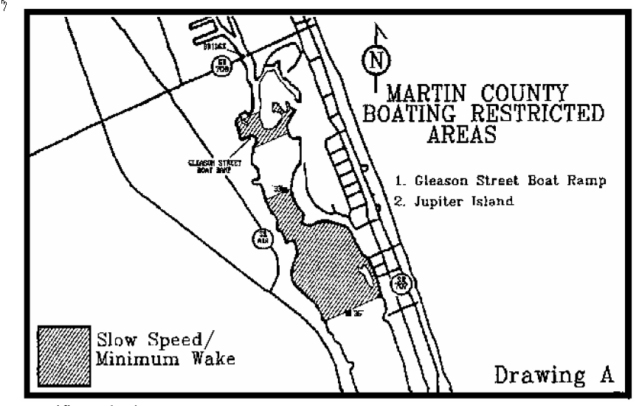
Specific Authority 327.04, 327.46 FS. Law Implemented 327.46 FS. History–New 2-25-96, Formerly 62N-24.143.

