68D-24.136 Lee County Boating Restricted Area.
(1) For the purpose of regulating the speed and operation of vessel traffic on and adjacent to the Florida Intracoastal Waterway within Lee County, the following Boating Restricted Area is established: Caloosahatchee River at the Alva Bridge – All waters of the Florida Intracoastal Waterway, shoreline to shoreline, west from the centerline of the Alva Bridge (SR 78) to 300' feet west of the most western boundary of the fuel facility property (26 42' 50.9"/81 36' 42.1") and an informational marker will be located 300' feet west (26 42' 46.2''/81 36' 43.8") of the regulatory marker and east from the centerline of the Alva Bridge (SR 78) to 300' feet east (26 42' 49"/81 36' 17") of the most eastern boundary of the Alva Public Boat Ramp and an informational marker will be located 2450' feet east (26 42' 50"/81 35' 53.3") of the most eastern boundary of the Alva Boat Ramp, as depicted in drawing A.
(2) Lee County is authorized to install and maintain appropriate regulatory markers as directed by the Division of Law Enforcement within the boating restricted area and shall install and maintain Idle Speed No Wake and “Resume Normal Safe Operation” markers at the east and western boundaries of the boating restricted area.
(3) The boating restricted area is depicted in the following drawing:
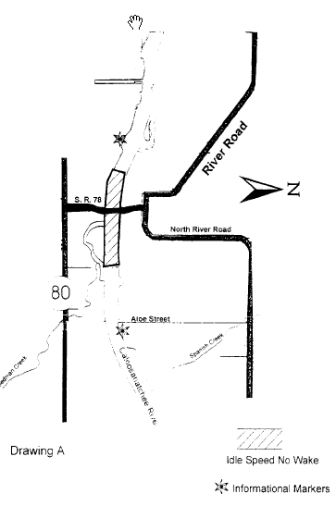
Rulemaking Authority 327.04, 327.46 FS. Law Implemented 327.46 FS. History–New 11-25-96, Formerly 62N-24.136.

