68C-22.015 Charlotte County (and Part of DeSoto County) Zones.
(1) The Commission hereby designates the waters within Charlotte County and DeSoto County, as described below, as areas where manatee sightings are frequent and where the best available information supports the conclusion that manatees inhabit these areas on a regular or periodic basis. The primary purpose of this rule is to protect manatees from harmful collisions with motorboats and from harassment by regulating the speed and operation of motorboats within these designated areas. A secondary purpose is to protect manatee habitat. In consideration of balancing the rights of fishers, boaters, and water skiers to use the waters of the state for recreational and commercial purposes (as applicable under Section 370.12(2)(k), F.S.), with the need to provide manatee protection, the Commission has examined the need for limited lanes, corridors, or unregulated areas that allow higher speeds through or within regulated areas. Such lanes, corridors, or areas are provided in those locations where the Commission determined that they are consistent with manatee protection needs.
(2) The following zones are established, which include all associated and navigable tributaries, lakes, creeks, coves, bends, backwaters, canals, and boat basins unless otherwise designated or excluded. As used in this rule, ICW means the Intracoastal Waterway.
(a) Idle Speed (All Year).
1. Turtle Bay, Southeast Entrance: Those waters east and southeast of a line beginning at the easternmost point (approximate latitude 26° 46' 23.2'' North, approximate longitude 82° 10' 30.8'' West) of a small unnamed island in the Gallagher Keys (at the southern end of Turtle Bay) and bearing 360° for a distance of approximately 2605 feet to a point (approximate latitude 26° 46' 49.1'' North, approximate longitude 82° 10' 31.0'' West) in Turtle Bay, and then bearing 68° to a point (approximate latitude 26° 47' 01.1'' North, approximate longitude 82° 09' 59.0'' West) on the eastern shoreline of Turtle Bay north of Cape Haze, and north and northwest of a line beginning at said easternmost point of a small unnamed island in the Gallagher Keys and bearing approximately 128° to the southwesternmost point (approximate latitude 26° 46' 20.1'' North, approximate longitude 82° 10' 26.4'' West) of the small unnamed island to the southeast, and then bearing 106° for a distance of approximately 960 feet to a point (approximate latitude 26° 46' 17.5'' North, approximate longitude 82° 10' 16.2'' West) in Charlotte Harbor, and then bearing 40° to a point (approximate latitude 26° 46' 50.5'' North, approximate longitude 82° 09' 46.4'' West) on the shoreline east of Cape Haze, excluding the waters in the embayment north of this point.
2. Turtle Bay, Mid-bay Area: Those waters inside of a polygon defined by the following coordinates: latitude 26° 47' 10.3'' North, longitude 82° 10' 54.5'' West (southwest); latitude 26° 47' 22.3'' North, longitude 82° 10' 50.5'' West (northwest); latitude 26° 47' 19.7'' North, longitude 82° 10' 40.5'' West (northeast), and; latitude 26° 47' 07.6'' North, longitude 82° 10' 44.4'' West (southeast).
(b) Slow Speed (All Year).
1. Lemon Bay Area: All waters of Lemon Bay south of the Sarasota/Charlotte County line, north of the Boca Grande Causeway, and west of State Road (SR) 775 (south of SR 776 on Gottfried Creek), excluding the ICW channel and the marked channel through Stump Pass as designated under subparagraph (2)(c)1., and the marked channels in Placida Harbor as designated under subparagraph (2)(c)2. Also excluded from this zone are the portion of the waterway known as “Ski Alley” south of a line bearing 258° from the northernmost point (approximate latitude 26° 54' 47.3'' North, approximate longitude 82° 21' 03.7'' West) of Peterson Island, and the areas described below:
a. The following portion of the Stump Pass area is excluded from the zone designated under subparagraph (2)(b)1.: Those waters southeast of “Ski Alley” and a line bearing 45° from a point (approximate latitude 26° 54' 03.6'' North, approximate longitude 82° 20' 26.5'' West) on the southeastern end of Peterson Island, southwest of a line bearing 106° from a point (approximate latitude 26° 54' 16.1'' North, approximate longitude 82° 20' 21.2'' West) on Whidden Key to the northernmost point (approximate latitude 26° 54' 12.8'' North, approximate longitude 82° 20' 07.3'' West) of the unnamed island southeast of Whidden Key, and northwest of a line bearing 49° from the northernmost point (approximate latitude 26° 53' 53.1'' North, approximate longitude 82° 20' 17.9'' West) of Thornton Key to a point on said unnamed island southeast of Whidden Key;
b. The following portion of the Gasparilla Pass area is excluded from the zone designated under subparagraph (2)(b)1.: Those waters southwest of a line beginning at a point (approximate latitude 26° 49' 26.2'' North, approximate longitude 82° 16' 56.3'' West) on Little Gasparilla Island and bearing 142° to a point (approximate latitude 26° 49' 12.3'' North, approximate longitude 82° 16' 44.0'' West) on Bird Key, then following the general contour of the northern and northeastern shorelines of Bird Key to a point (approximate latitude 26° 49' 03.6'' North, approximate longitude 82° 16' 34.1'' West) on the eastern shoreline of Bird Key, and then bearing 105° to the line’s terminus at the southernmost point (approximate latitude 26° 49' 01.2'' North, approximate longitude 82° 16' 24.0'' West) of the middle causeway island of the Boca Grande Causeway.
2. Peace River, US 41 Bridge to Interstate 75 (I-75) Bridge: Those waters within 1000 feet of the general contour of shorelines of the Peace River east of the centerline of the southbound US 41 Bridge and west of the centerline of the southbound I-75 Bridge, including all waters northeast of a line beginning at a point (approximate latitude 26° 57' 39.5'' North, approximate longitude 82° 01' 15.2'' West) on the southbound I-75 Bridge (approximately 1,000 feet south of Bird Key) and then bearing 289° to a point (approximate latitude 26° 57' 58.7'' North, approximate longitude 82° 02' 18.3'' West) on the northern shoreline of the Peace River.
3. Peace River, Interstate 75 (I-75) Bridge to Harbor Heights Area: All waters east of the centerline of the southbound I-75 Bridge, south and southwest of a line bearing 310° through Channel Marker “24,” and west of Shell Creek, excluding the main marked channel of the Peace River and the corridor north of Long Island and east of Bird Key as designated under subparagraph (2)(c)4., and the waters east of a line beginning at a point (approximate latitude 26° 58' 01.0'' North, approximate longitude 81° 59' 24.3'' West) on the southern shoreline of the Peace River (northeast of Harbor Avenue) and bearing 345° for a distance of approximately 1,216 feet to the southernmost point (approximate latitude 26° 58' 12.8'' North, approximate longitude 81° 59' 27.8'' West) of the peninsula to the north.
4. Shell Creek: All waters of Shell Creek east of the Peace River and west of the dam located approximately two (2) miles upstream (east) of the US 17 Bridge over Shell Creek, including the cut that connects Shell Creek to the Peace River north of Channel Marker “24” but excluding that portion of Shell Creek otherwise designated under subparagraph (2)(c)6.
5. Hunter Creek: All waters of Hunter Creek, Jim Long Lake, and associated waterways north of a line bearing 143° from a point (approximate latitude 27° 00' 57.2'' North, approximate longitude 81° 58' 36.1'' West) on the western shoreline of Hunter Creek (south of Jim Long Lake), and east of the general contour of the eastern shoreline of the Peace River.
6. Deep Creek: All waters of Deep Creek and associated waterways west of the general contour of the western shoreline of the Peace River.
(c) 25 MPH (All Year).
1. Lemon Bay Area: Those waters in the ICW channel south of the Sarasota/Charlotte County line and north of the Boca Grande Causeway, and; those waters in the marked channel in North Stump Pass northeast of a line bearing 106° from a point (approximate latitude 26° 54' 16.1'' North, approximate longitude 82° 20' 21.2'' West) on Whidden Key to the northernmost point (approximate latitude 26° 54' 12.8'' North, approximate longitude 82° 20' 07.3'' West) of the unnamed island southeast of Whidden Key.
2. Placida Harbor Area: All waters in the marked channel that runs from the ICW to Gasparilla Pass on the northwest side of the Boca Grande Causeway, and; all waters in the marked channel that runs in a general east-west direction from the marina and boat ramp basin on the northwest side of Boca Grande Causeway, across the ICW, to Little Gasparilla Island, including a “south prong” channel that runs from said east-west channel to the zone boundary between Little Gasparilla Island and Bird Key. This designation only applies if the channels are marked in accordance with permits issued by all applicable state and federal authorities and if the channel locations and marking schemes are approved in advance by the Commission. In the absence of properly permitted and approved channels, these areas are as designated under subparagraph (2)(b)1.
3. Turtle Bay: All waters of Turtle Bay, except as otherwise designated under subparagraph (2)(a)2., west and northwest of a line beginning at the easternmost point (approximate latitude 26° 46' 23.2'' North, approximate longitude 82° 10' 30.8'' West) of a small unnamed island in the Gallagher Keys (at the southern end of Turtle Bay) and bearing 360° for a distance of approximately 2605 feet to a point (approximate latitude 26° 46' 49.1'' North, approximate longitude 82° 10' 31.0'' West) in Turtle Bay, and then bearing 68° to a point (approximate latitude 26° 47' 01.1'' North, approximate longitude 82° 09' 59.0'' West) on the eastern shoreline of Turtle Bay, north of the northern shorelines of the unnamed islands in the Gallagher Keys and lines directly connecting said shorelines, and east of a line beginning at the northwesternmost point (approximate latitude 26° 46' 27.8'' North, approximate longitude 82° 11' 24.9'' West) of the westernmost of the unnamed islands in the Gallagher Keys and bearing 298° to the easternmost point (approximate latitude 26° 46' 28.6'' North, approximate longitude 82° 11' 27.0'' West) of the unnamed island to the northwest, then following said island’s eastern shoreline to its northernmost point (approximate latitude 26° 46' 37.0'' North, approximate longitude 82° 11' 33.0'' West), then bearing 356° to the southernmost point of Eagle Nest Island (approximate latitude 26° 46' 42.3'' North, approximate longitude 82° 11' 33.0'' West), then following said island’s eastern shoreline to its easternmost point (approximate latitude 26° 47' 00.4'' North, approximate longitude 82° 11' 25.3'' West), then bearing 42° for a distance of approximately 2,700 feet to a point (approximate latitude 26° 47' 20.2'' North, approximate longitude 82° 11' 05.5'' West) on the southern end of a large unnamed island on the west side of Turtle Bay, then following said island’s eastern shoreline to a point (approximate latitude 26° 48' 10.7'' North, approximate longitude 82° 10' 58.3'' West) on the northern end of said island, then bearing 3° to the line’s terminus on the western shoreline of Turtle Bay west of Cash Mound.
4. Peace River, Interstate 75 (I-75) Bridge to Harbor Heights Area: All waters in the main marked channel of the Peace River east of the centerline of the southbound I-75 Bridge, and southwest of Channel Marker “24”, and all waters within 150 feet of a line beginning at a point (approximate latitude 26° 57' 35.6'' North, approximate longitude 82° 00' 58.2'' West) in the main marked channel of the Peace River south of Bird Key and bearing 32° to a point (approximate latitude 26° 57' 49.4'' North, approximate longitude 82° 00' 48.6'' West) east of Bird Key, then bearing 22° to a point (approximate latitude 26° 58' 11.2'' North, approximate longitude 82° 00' 39.2'' West) northeast of Bird Key and northwest of Long Island, then bearing 48° to a point (approximate latitude 26° 58' 28.4'' North, approximate longitude 82° 00' 18.2'' West) west of the southern end of the unnamed island north of Long Island, then bearing 27° to a point (approximate latitude 26° 58' 44.7'' North, approximate longitude 82° 00' 09.1'' West) west of the northern end of said unnamed island north of Long Island, and then bearing 63° to the line’s terminus at a point (approximate latitude 26° 58' 53.8'' North, approximate longitude 81° 59' 49.9'' West) in the Peace River northwest of Channel Marker “24.”
5. Peace River, North of Harbor Heights Area: All waters of the Peace River and associated waterways, northeast of a line bearing 310° through Channel Marker “24” and south of the SR 761 Bridge in DeSoto County, except as otherwise designated under subparagraphs (2)(b)5. and (2)(b)6., and excluding those waters of Whidden Bay and the waterways associated with the bay west and northwest of the general contour of the western shoreline of the Peace River.
6. Shell Creek: All waters of Shell Creek west of the Railroad Trestle and east of a line bearing 172° from the southernmost point (approximate latitude 26° 58' 43.3'' North, approximate longitude 81° 59' 28.6'' West) of the peninsula on the eastern side of the cut that connects Shell Creek to the Peace River north of Channel Marker “24,” excluding the embayments and associated waterways immediately north of Shell Creek.
7. Lower Hunter Creek: All waters of Hunter Creek south of a line bearing 143° from a point (approximate latitude 27° 00' 57.2'' North, approximate longitude 81° 58' 36.1'' West) on the western shoreline of Hunter Creek (south of Jim Long Lake), and east of the general contour of the eastern shoreline of the Peace River.
(3) The zones described in subsection 68C-22.015(2), F.A.C., are depicted on the following maps, labeled “Charlotte County Manatee Protection Zones.” The maps are intended as depictions of the above-described zones. In the event of conflict between the maps and descriptions, the descriptions shall prevail.
(4) The amendments to Rule 68C-22.015, F.A.C., as approved by the Commission on June 7, 2006, shall take effect as soon as the regulatory markers are posted.
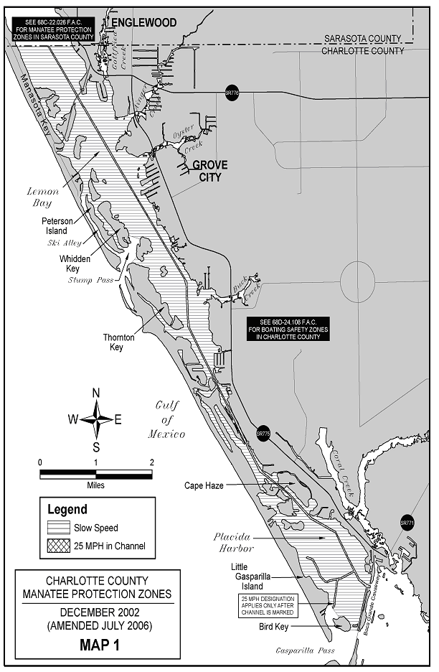
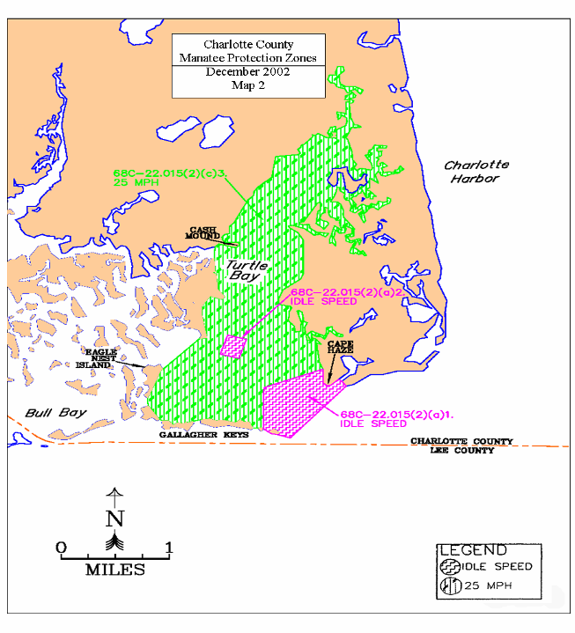
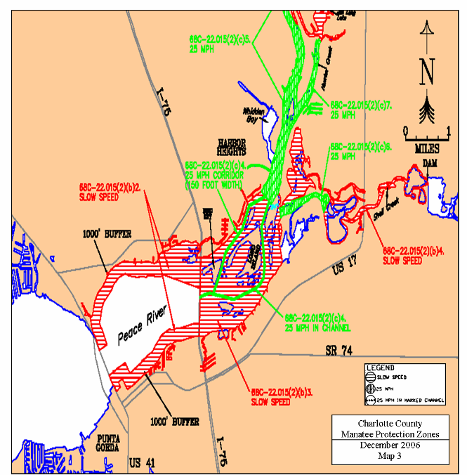
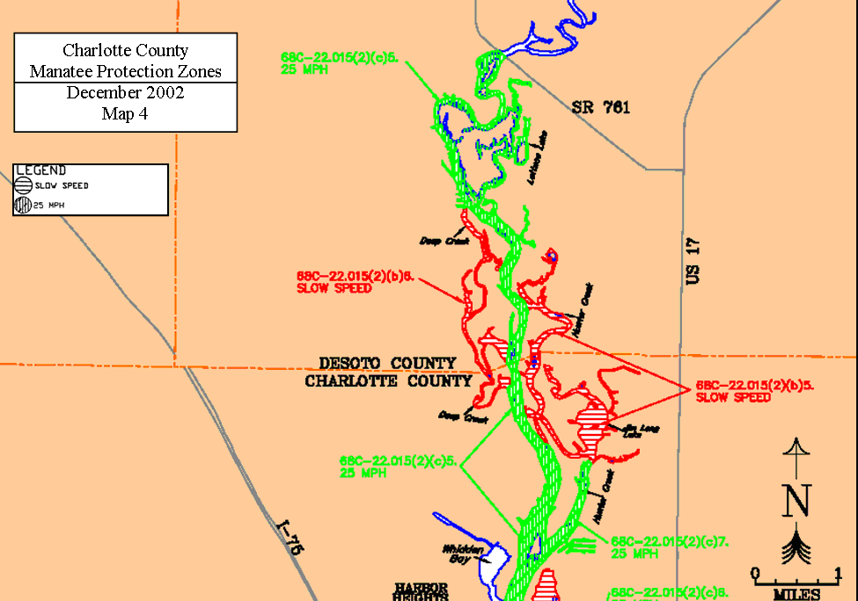
Rulemaking Authority 370.12(2)(n) FS. Law Implemented 370.12(2)(d), (k), (n) FS. History–New 12-12-02, Amended 7-23-06.

