68C-22.027 Duval County and Associated County (Parts of Clay and St. Johns) Zones.
(1) The Commission hereby designates the waters within Duval County, Clay County, and St. Johns County, as described below, as areas where manatee sightings are frequent and where the best available information supports the conclusion that manatees inhabit these areas on a regular or periodic basis. The primary purpose of this rule is to protect manatees from harmful collisions with motorboats and from harassment by regulating the speed and operation of motorboats within these designated areas. A secondary purpose is to protect manatee habitat. In consideration of balancing the rights of fishers, boaters, and water skiers to use the waters of the state for recreational and commercial purposes (as applicable under Section 370.12(2)(k), F.S.), with the need to provide manatee protection, the Commission has examined the need for limited lanes, corridors, or unregulated areas that allow higher speeds through or within regulated areas. Such lanes, corridors, or areas are provided in those locations where the Commission determined that they are consistent with manatee protection needs. All of the zones set forth below are in effect year-round and, unless otherwise stated, all zones exclude all associated waterways (tributaries, lakes, creeks, coves, bends, backwaters, canals, basins, etc.) unless explicitly included.
(a) Slow Speed, Shore-to-Shore –
1. Atlantic Intracoastal Waterway, Sisters Creek – All waters of Sisters Creek, including the Atlantic Intracoastal Waterway Channel, south of an East-West line running through Flashing Green Atlantic Intracoastal Waterway Channel Marker “83” (approximate latitude 30° 24' 04" North, approximate longitude 81° 27' 16" West), and northeast of a line which bears 310° from the southwestern corner of a seawall at the southwestern tip of Fanning Island (approximate latitude 30° 23' 19" North, approximate longitude 81° 27' 41" West) and including those backwaters east of Sisters Creek lying southwest of a line which bears 140° from the southernmost tip of Shell Island (approximate latitude 30° 23' 52" North, approximate longitude 81° 27' 21" West);
2. Atlantic Intracoastal Waterway, South of the St. Johns River – All waters of the Atlantic Intracoastal Waterway, channel included, southwest of a line which bears 280° North from the westernmost tip (approximate latitude 30° 22' 44" North, approximate longitude 81° 27' 30" West) of a peninsula west of Sherman Point on the southern side of the St. Johns River, north of a line which bears 62° running through a point 600 feet north of and on a bearing of 332° from Flashing Green Atlantic Intracoastal Waterway Channel Marker “9” (approximate latitude 30° 22' 21" North, approximate longitude 81° 27' 01" West), northeast of the general contour of the northeastern shoreline of Great Marsh Island and a line which bears 137° from the easternmost tip of Great Marsh Island (approximate latitude 30° 22' 29" North, approximate longitude 81° 27' 17" West), and west of a line which bears 360° from the northernmost tip (approximate latitude 30° 22' 29" North, approximate longitude 81° 27' 05" West) of the unnamed island east of Green Atlantic Intracoastal Waterway Channel Marker “7”;
3. St. Johns River, Main Street Bridge to Fuller Warren Bridge Area – All waters of the St. Johns River and associated waterways west (upriver) of the Main Street Bridge and north (downriver) of the Fuller Warren Bridge;
4. Julington Creek and Durbin Creek Area – All waters of Julington Creek and Durbin Creek east of a line that bears 180° from a point (approximate latitude 30° 07' 59" North, approximate longitude 81° 36' 02" West) on the northern shoreline of Julington Creek at the mouth of Oilfield Creek and west of a line that bears 180° from a point (approximate latitude 30° 08' 01" North, approximate longitude 81° 35' 43" West) on the northern shoreline of Julington Creek 300 feet east of the southern extension of Hood Landing Road (and extending south across Durbin Creek to its southern shoreline).
(b) SLOW SPEED –
1. St. Johns River, St. Johns Point to Reddie Point – Those waters of the St. Johns River lying within 300 feet of the general contour of the northern and southern shorelines of the river, excluding the federally-marked channels, west of a line that runs from the northeasternmost point of St. Johns Point at the mouth of the river to the southeasternmost point of Wards Bank, east of a line which bears 360° from the easternmost point of Sandfly Point (approximate latitude 30° 23' 10" North, approximate longitude 81° 38' 03" West) across the mouth of the Trout River, and north of a line that runs from said easternmost point of Sandfly Point to the northernmost point of Reddie Point (approximate latitude 30° 23' 22" North, approximate longitude 81° 37' 13" West); included in this zone are those waters lying within 300 feet of the general contour of the shorelines of Blount Island and of the northern shoreline of Quarantine Island (Bartram Island) between the island's easternmost and westernmost points and those waters leading into Mayport Basin within 300 feet of the general contour of the shorelines, excluding the federally-marked channel, east of a line which bears 180° from the easternmost tip of the peninsula on the northern side of Mayport Basin (approximate latitude 30° 23' 51" North, approximate longitude 81° 24' 16" West); also included in this zone are those waters within 300 feet of the general contour of the shorelines of the Broward River and Dunn Creek south of the centerline of the Heckscher Drive (State Road 105) Bridges, and those waters within 300 feet of the general contour of the shorelines of all associated waterways on the north side of the river that are east of where Nichols Creek and San Carlos Creek enter the river and south of the centerline of the Heckscher Drive (State Road 105) Bridges, except as otherwise designated in paragraph (1)(a);
2. Mill Cove – Those waters within 300 feet of the general contour of the southern shoreline of Mill Cove, west of the westernmost point of Pauline Island and east of the northernmost point of Reddie Point (approximate latitude 30° 23' 22" North, approximate longitude 81° 37' 13" West);
3. Trout River – Those waters within 300 feet of the general contour of the shorelines of the Trout River west of a line that bears 360° from the easternmost point of Sandfly Point (approximate latitude 30° 23' 10" North, approximate longitude 81° 38' 03" West) across the mouth of the Trout River and east of the Interstate 95 Bridge;
4. St. Johns River, Reddie Point to Hart Bridge Area – Those waters described below, excluding the federally-marked Florida Intracoastal Waterway channel:
a. Within 300 feet of the general contour of the western (and northern) shoreline of the St. Johns River, south (upriver) of a line that runs from the easternmost point of Sandfly Point (approximate latitude 30° 23' 10" North, approximate longitude 81° 38' 03" West) to the northernmost point of Reddie Point (approximate latitude 30° 23' 22" North, approximate longitude 81° 37' 13" West) and north and east (downriver) of the Hart Bridge, including all associated waterways and all waters of Long Branch Creek easterly of the Buffalo Avenue/Wigmore Street Bridge;
b. Within 1,000 feet of the general contour of the eastern shoreline of the St. Johns River, south (upriver) of a line that runs from the easternmost point of Sandfly Point (approximate latitude 30° 23' 10" North, approximate longitude 81° 38' 03" West) to the northernmost point of Reddie Point (approximate latitude 30° 23' 22" North, approximate longitude 81° 37' 13" West) and north (downriver) of the Hart Bridge, including all associated waterways, and all waters east of Exchange Island and a line that bears 250° from the southernmost point of Exchange Island (approximate latitude 30° 19' 18'' North, approximate longitude 81° 37' 05'' West) and west of a line that bears 73° from a point (approximate latitude 30° 18' 53'' North, approximate longitude 81° 36' 43'' West) on the southern shoreline of the Arlington River at the mouth of Little Pottsburg Creek; and also including those waters within 300 feet of the general contour of the western shoreline of Exchange Island.
5. St. Johns River, Hart Bridge to Main Street Bridge Area – All waters of the St. Johns River and associated waterways, including all waters of Miller Creek north of the Atlantic Boulevard (State Road 10) Bridge, west (upriver) of the Hart Bridge and east (downriver) of the Main Street Bridge, except in the marked channel of the Florida Intracoastal Waterway as designated in sub-paragraph (1)(c)2.
6. St. Johns River, Fuller Warren Bridge to the South Duval County Line – Those waters of the St. Johns River, south of the centerline of the Fuller Warren Bridge, north of the centerline of the Buckman (Interstate 295) Bridge (the Duval County/Clay County line) on the western shore, and west and north of the centerline of the San Jose Boulevard (State Road 13) Bridge crossing Julington Creek on the eastern shore, including: those waters of Big Fishweir Creek east of the centerline of the Herschel Street Bridge; those waters northeast of and within 500 feet of the centerline of the Ortega (Grand Avenue) Bridge; those waters of Pirates Cove (also referred to as the Venetia Yacht Basin); those waters of Mulberry Cove northwest of a line that runs from a point (approximate latitude 30° 13' 05" North, approximate longitude 81° 40' 31" West) on the northern shoreline of the cove to another point (approximate latitude 30° 12' 56" North, approximate longitude 81° 40' 46" West) on the southern shoreline; those waters of Marco Lake; those waters of Craig Creek west of the centerline of the Hendricks Avenue (State Road 13) Bridge; and those waters of Goodby’s Creek. Except for the waters northeast of the Ortega (Grand Avenue) Bridge as described above, the waters described in this paragraph shall be subject to a variable-width shoreline buffer whose width is as set forth in subsection (2), of this rule;
7. Ortega River Area – Those waters within 300 feet of the general contour of the shorelines of the Ortega River, including all associated waterways, south of the centerline of the Ortega (Grand Avenue) Bridge, north of the centerline of the Timuquana Bridge for the buffer along the eastern shoreline, and east of the southernmost point (approximate latitude 30° 15' 57" North, approximate longitude 81° 43' 36" West) of the peninsula that forms the northern shoreline of the Cedar River for the buffer along the western shoreline, including all waters within 300 feet south of the centerline of the Ortega (Grand Avenue) Bridge and all waters within 300 feet of either side of the Roosevelt Boulevard Bridge;
8. Julington Creek – All waters of Julington Creek within 450 feet of either side of the centerline of the San Jose Boulevard (State Road 13) Bridge and those waters within 300 feet of the general contour of the shorelines of Julington Creek and all associated waterways east of the centerline of the San Jose Boulevard (State Road 13) Bridge and west of a line that bears 180° from a point (approximate latitude 30° 07' 59" North, approximate longitude 81° 36' 02" West) on the northern shoreline of Julington Creek at the mouth of Oilfield Creek;
9. St. Johns River in St. Johns County, Julington Creek to Nature’s Hammock Road North – Those waters of the St. Johns River in St. Johns County, west and south of the centerline of the San Jose Boulevard (State Road 13) Bridge, and north of the western extension of Nature’s Hammock Road North. The waters described in this paragraph shall be subject to a variable-width shoreline buffer whose width is as set forth in subsection (2), of this rule;
10. St. Johns River in Clay County, Buckman Bridge to Peter Branch – Those waters of the St. Johns River in Clay County, south of the centerline of the Buckman (Interstate 295) Bridge and north of a line that bears 90° from a point on the shoreline (approximate latitude 30° 06' 05" North, approximate longitude 81° 41' 24"' West) located 300 feet south of Peter Branch. The waters described in this paragraph shall be subject to a variable-width shoreline buffer whose width is as set forth in subsection (2), of this rule;
11. Doctors Lake and Doctors Inlet Area – Those waters of Doctors Lake, Duck Creek, and Swimming Pen Creek, and including those waters of Doctors Inlet 500 feet of either side of the centerline of the US Highway 17 Bridge. Except for the waters of Doctors Inlet described above, the waters described in this paragraph shall be subject to a variable-width shoreline buffer whose width is as set forth in subsection (2), of this rule.
(c) 25 MPH
1. St. Johns River, Reddie Point to Hart Bridge Area – All waters of the St. Johns River outside of the Slow Speed areas designated in subparagraph (1)(b)4.;
2. St. Johns River, Hart Bridge to Main Street Bridge Area – All waters in the marked channel of the Florida Intracoastal Waterway west (upriver) of the Hart Bridge and east (downriver) of the Main Street Bridge.
(2) The width of the variable-width shoreline buffer referenced in subparagraphs (1)(b)6., 9., 10., and 11., above is as follows: The buffer includes at a minimum all waters within 500 feet of the general contour of the shoreline. Where there are docks that extend out farther than 300 feet into the waterway, the buffer extends out beyond the 500-foot line to include all waters shoreward of a line that runs 200 feet beyond and parallel to the dock line. For the purposes of this rule, the dock line shall be defined as a line that runs between the ends of successive docks.
(3) The zones described in subsection 68C-22.027(1), F.A.C., above are depicted on the following maps, labeled “Duval and Associated County Manatee Protection Zones”. The maps are intended to be depictions of the above-described zones. In the event of a conflict between the two, the above descriptions shall prevail.
(4) The amendments to Rule 68C-22.027, F.A.C., as approved by the Commission on December 6, 2006, shall take effect as soon as the regulatory markers are posted.
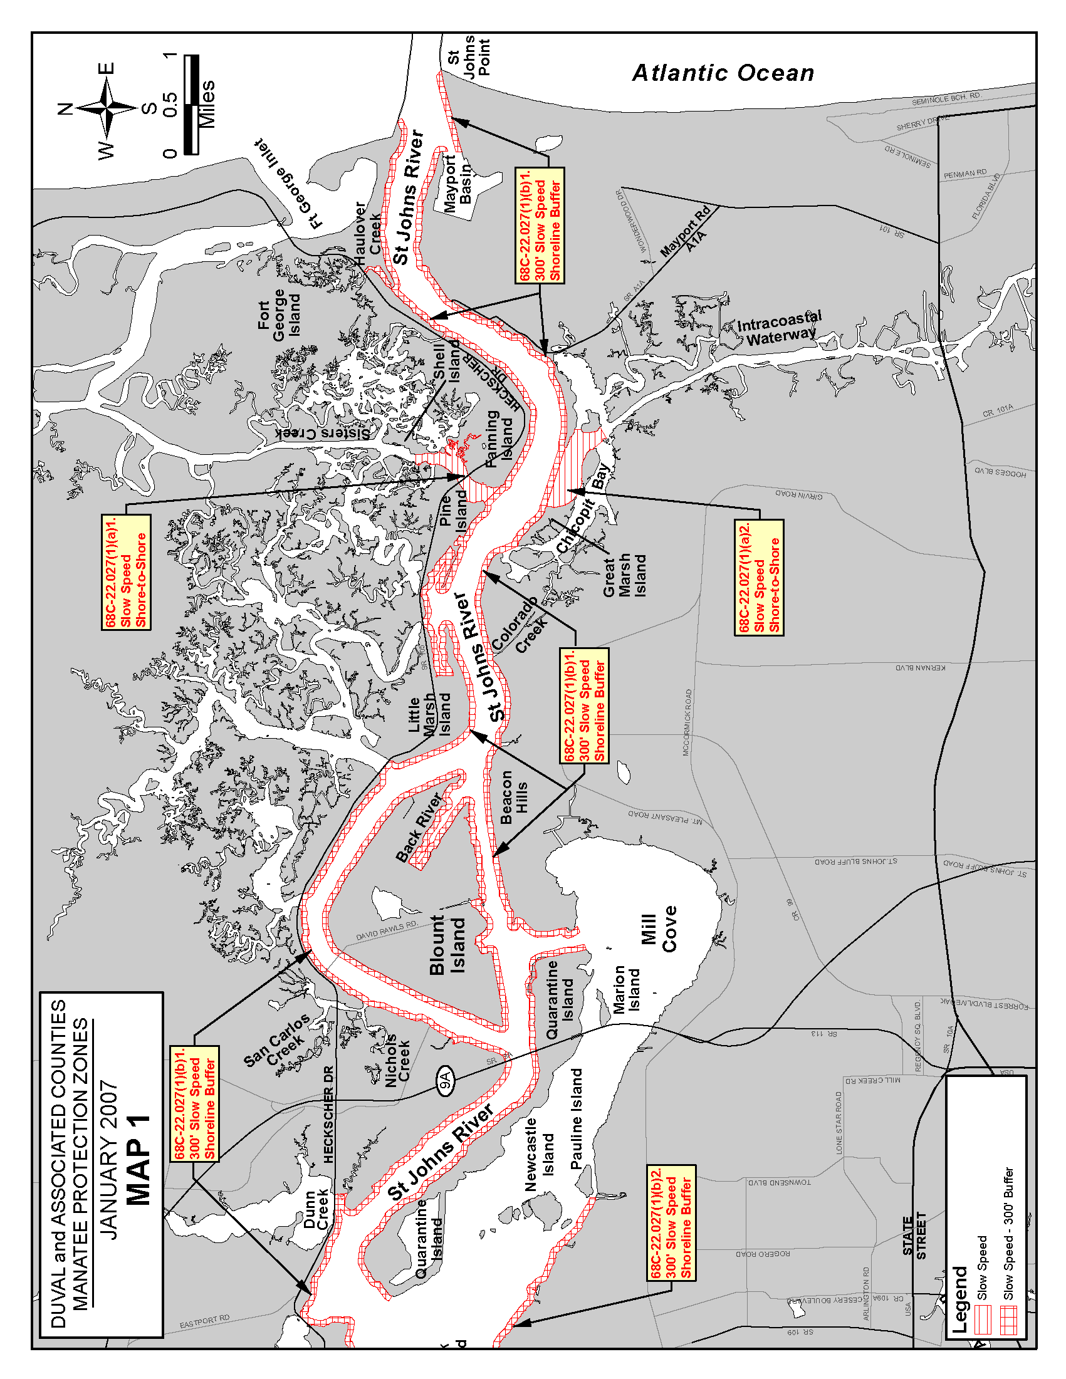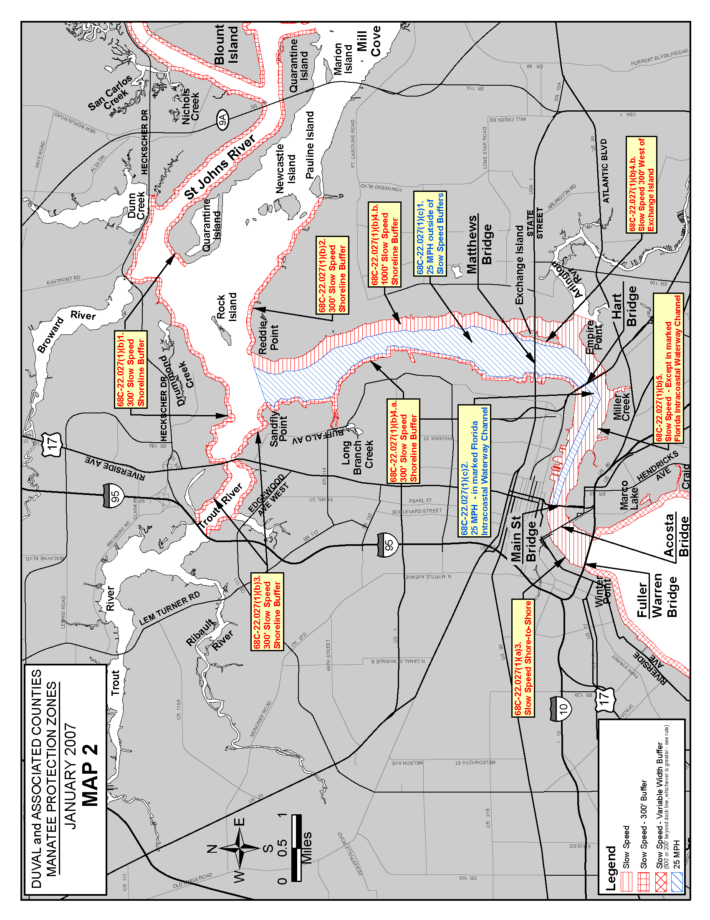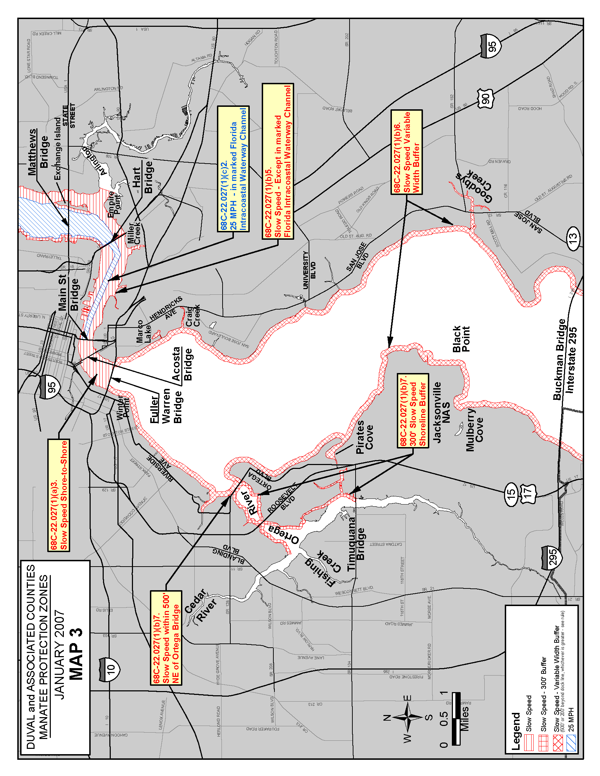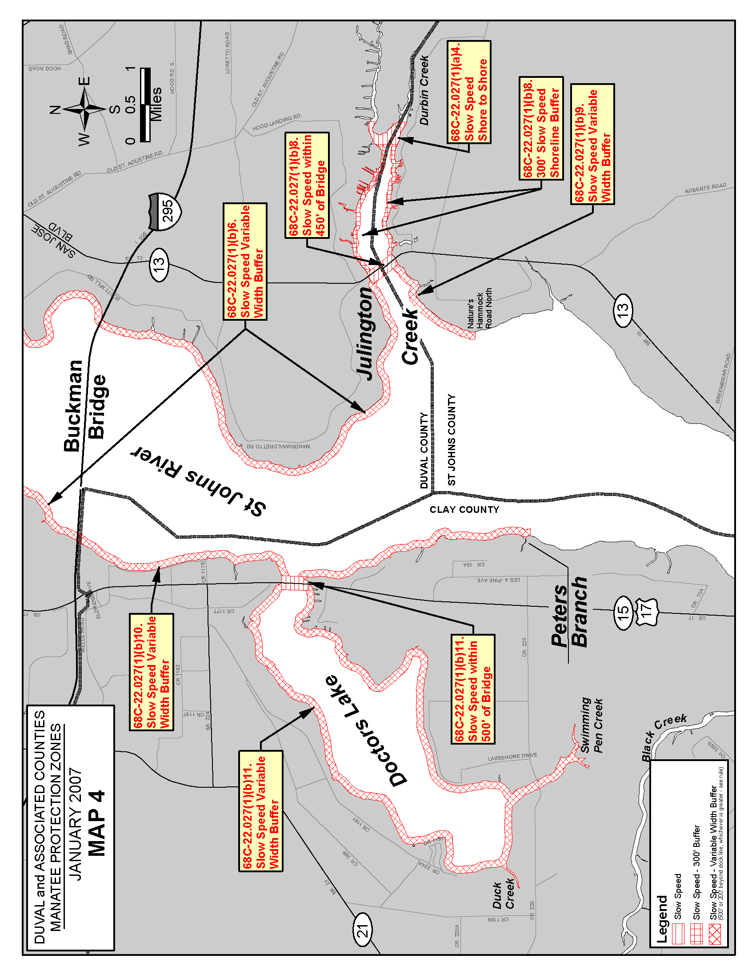
Rulemaking Authority 370.12(2)(n) FS. Law Implemented 370.12(2)(d), (k), (n) FS. History–New 12-22-92, Amended 6-16-93, Formerly 16N-22.027, 62N-22.027, Amended 8-1-00, 1-30-07.

