68D-24.109 Withlacoochee River Boating Restricted Areas.
For the purpose of regulating the speed and operation of vessel traffic on and adjacent to the Withlacoochee River within Citrus, Hernando, Marion, and Sumter Counties, the following Boating Restricted Areas are established:
(1) Idle Speed No Wake zones
(a) State Road 200 – All waters in and adjacent to the Withlacoochee River, from shoreline to shoreline, from the centerline of the S.R. 200 bridge south to Mile Marker 30 for a distance of 4 miles, and from the centerline of the S.R. 200 bridge north to Mile Marker 24 located at Camp Izzard boat ramp for a distance of 2 miles. This restriction shall be active and enforceable only when the water level of the Withlacoochee River measured at the Holder Gauge is at 6.0 feet and will remain in effect until the river recedes to 6.0 feet, as depicted in Drawing A.
(b) Turner Camp – All waters in and adjacent to the Withlacoochee River, from shoreline to shoreline, from the centerline of C.R. 581 north to Mile Marker 34 for a distance of .6 miles, and from the centerline of C.R. 581 south to Mile Marker 36 for a distance of 1.4 miles. This restriction shall be active and enforceable only when the water level of the Withlacoochee River measured at the Croom Gauge is at 9.0 feet and will remain in effect until the river recedes to below 9.0 feet, as depicted in Drawing B.
(c) Highway 44 – All waters in and adjacent to the Withlacoochee River, from shoreline to shoreline, from the centerline of Highway 44 bridge north to Mile Marker 38, located at Squire Court for a distance of 2 miles, and south from the centerline of the Highway 44 bridge south to Mile Marker 42 for a distance of 2 miles to Shawnee Trail. This restriction shall be active and enforceable only when the water level of the Withlacoochee River measured at the Croom Gauge is at 9.0 feet and will remain in effect until the river recedes to below 9.0 feet, as depicted in Drawing C.
(d) All waters in and adjacent to the Withlacoochee River, from shoreline to shoreline, from the centerline of C.R. 476 south one mile to Mile Marker 61. This restriction shall be active and enforceable only when the water level of the Withlacoochee River measured at the Croom Gauge is at 9.0 feet and will remain in effect until the river recedes to below 9.0 feet, as depicted in Drawing D.
(e) All waters in and adjacent to the Withlacoochee River, from shoreline to shoreline, from the Silver Lake Park boundary line, at Mile Marker 64, south to U.S. Highway 301, a distance of six miles, and from the centerline of U.S. Highway 301 south to the northern most end of the fender system of the CSX railroad bridge at Mile Marker 70, a distance of one mile. This restriction shall be active and enforceable only when the water level of the Withlacoochee River measured at the Trilby Gauge is at 12.0 feet and will remain in effect until the river recedes to below 12.0 feet, as depicted in Drawing E.
(2) Citrus, Hernando, Marion, and Sumter Counties are authorized to install and maintain appropriate regulatory markers as directed by the Division of Law Enforcement within the boating restricted area and shall install and maintain markers at each of the boating restricted areas for the duration of the flood period. Gauges will be monitored by the Southwest Florida Water Management District and the respective Emergency Management Offices of each county. The signage will be removed within one week after the waters have subsided.
(3) The boating restricted areas are depicted in the following drawings:

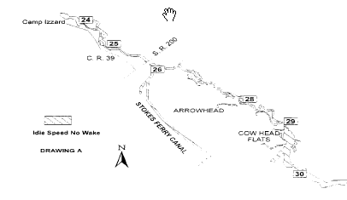

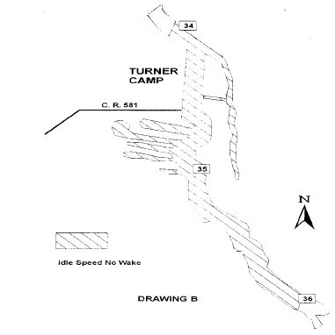

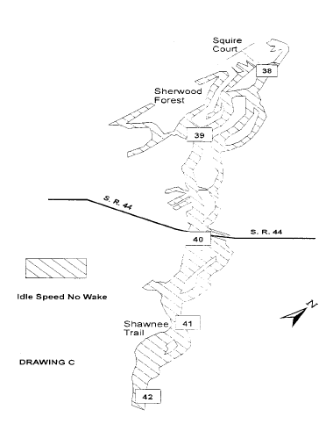

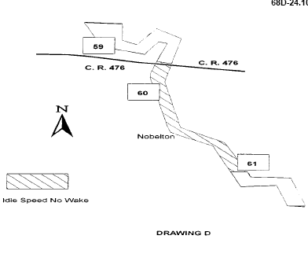

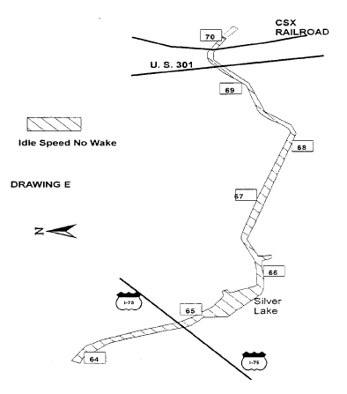
Specific Authority 327.40, 327.46 FS. Law Implemented 327.46 FS. History–New 2-10-97, Formerly 62N-24.109.

