68D-24.019 Nassau County Boating Restricted Area.
(1) For the purpose of regulating the speed and operation of vessel traffic on and adjacent to the Intracoastal Waterway within Nassau County, Florida, the following Boating Restricted Area is established:
(a) Fernandina Beach – An Idle Speed No Wake Zone zone from shoreline to shoreline in the Amelia River, from a line drawn perpendicular to the centerline of the Amelia River at the extended centerline of Dade Street to a line drawn perpendicular to the centerline of the Amelia River 400 feet south of the extended centerline of Cedar Street, and bounded on the west by a line drawn across the mouth of Bells River, as depicted in drawing A.
(b) Nassau County is authorized to install and maintain appropriate regulatory markers as directed by the Division of Law Enforcement within such boating restricted area.
(2) The boating restricted area described in Rule 68D-24.019, F.A.C., is depicted on the following drawing:
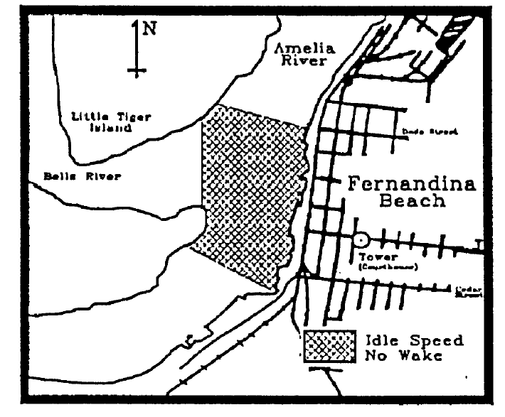
Rulemaking Authority 327.04, 327.46 FS. Law Implemented 327.46 FS. History–New 4-1-93, Formerly 16N-24.019, 62N-24.019.

