DEPARTMENT OF THE LOTTERY
RULE NUMBER: RULE TITLE:
53ER06-29 Instant Game Number 649, COOL 5’s.
SUMMARY OF THE RULE: This emergency rule describes Instant Game Number 649, "COOL 5’s," for which the Department of the Lottery will start selling tickets on a date to be determined by the Secretary of the Department. The rule sets forth the specifics of the game, determination of prizewinners; and the estimated odds of winning and number of prizes in the game.
THE PERSON TO BE CONTACTED REGARDING THE EMERGENCY RULE IS: Faith L. Schneider, Legal Analyst, Department of the Lottery, 250 Marriott Drive, Tallahassee, Florida 32399-4011.

THE FULL TEXT OF THE EMERGENCY RULE IS:
53ER06-29 Instant Game Number 649, COOL 5’s.
(1) Name of Game. Instant Game Number 649, “COOL 5’s.”
(2) Price. COOL 5’s lottery tickets sell for $5.00 per ticket.
(3) COOL 5’s lottery tickets shall have a series of numbers in machine readable code (or bar code) on the back of the ticket, along with a validation number under the latex area on the ticket. To be a valid winning COOL 5’s lottery ticket, the ticket must meet the applicable requirements of Rule 53ER06-4, Florida Administrative Code.
(4) Design of Ticket. There are three different games in Instant Game Number 649, COOL 5’s: GAME 1, GAME 2 and GAME 3.
(5) The GAME 1 play symbols and play symbol captions are as follows:

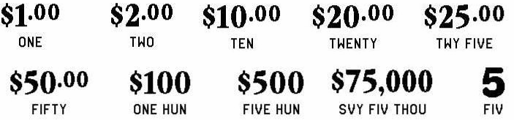

(6) The GAME 1 prize symbols and prize symbol captions are as follows:

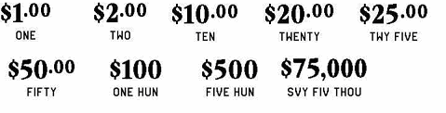
(7) The GAME 1 legend is as follows:

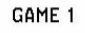

(8) The GAME 2 play symbols and play symbol captions are as follows:



(9) The GAME 2 prize symbols and prize symbol captions are as follows:

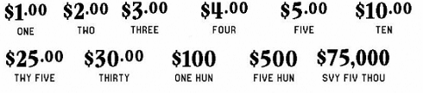

(10) The GAME 2 legends are as follows:

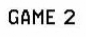

(11) The GAME 3 “YOUR NUMBER” play symbols and play symbol captions are as follows:

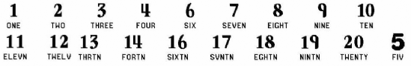

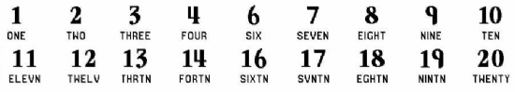
(12) The GAME 3 “WINNING NUMBER” play symbols and play symbol captions are as follows:

(13) The GAME 3 prize symbols and prize symbol captions are as follows:

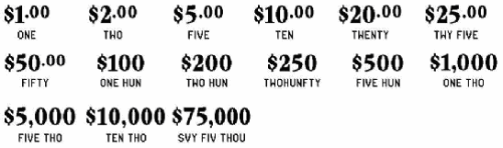

(14) The GAME 3 legends are as follows:

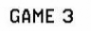

(15) Determination of Prizewinners. Each of the three games in Instant Game Number 649, COOL 5’s, uses a different play methodology. Players may win in one or more games. The determination of prizewinners for each game is as follows:
(a) GAME 1. A ticket having three like amounts in the play area shall entitle the claimant to a prize of that amount. A ticket having two like amounts and a “” symbol entitles the claimant to double that amount. The prize amounts are: $1.00, $2.00, $10.00, $20.00, $25.00, $50.00, $100, $500 and $75,000.
(b) GAME 2. A ticket having three “” symbols or three “” symbols in the same row, column or diagonal shall entitle the claimant to the corresponding prize shown in the “PRIZE BOX.” A ticket having three “” symbols in the same row, column or diagonal entitles the claimant to double the prize shown in the “PRIZE BOX.” The prizes are: $1.00, $2.00, $3.00, $4.00, $5.00, $10.00, $25.00, $30.00, $100, $500 and $75,000.
(c) GAME 3. A ticket having a number in the “YOUR NUMBERS” play area that matches either number in the “WINNING NUMBERS” play area shall entitle the claimant to the corresponding prize shown for that number. A ticket having a “” symbol in the “YOUR NUMBERS” play area entitles the claimant to double the prize shown. The prizes are: $1.00, $2.00, $5.00, $10.00, $20.00, $25.00, $50.00, $100, $200, $250, $500, $1,000, $5,000, $10,000 and $75,000.
(16) The estimated odds of winning, value and number of prizes in Instant Game Number 649 are as follows:

NUMBER OF
 |  |  | WINNERS IN
 |  |  | 42 POOLS OF
 |  | ODDS OF | 120,000 TICKETS
GAME PLAY | WIN | 1 IN | PER POOL
G3: $1 x 5 | $5 | 30.00 | 168,000
G1: $1 + G2: $2 + G3: $2 | $5 | 30.00 | 168,000
G1: $1 + G2: $2 (FIVE) | $5 | 30.00 | 168,000
G3: $5 | $5 | 30.00 | 168,000
G1: $2 + G2: $1 (FIVE) + G3: $1 x 6 | $10 | 30.00 | 168,000
G1: $1 (FIVE) + G2: $4 + G3: $2 x 2 | $10 | 60.00 | 84,000
G2: $5 + G3: $5 | $10 | 60.00 | 84,000
G1: $1 + G2: $2 (FIVE) + G3: $5 | $10 | 120.00 | 42,000
G2: $10 | $10 | 120.00 | 42,000
G2: $5 + G3: $5 (FIVE) | $15 | 120.00 | 42,000
G1: $1 (FIVE) + G2: $2 + G3: $1 + ($2 x 5) | $15 | 120.00 | 42,000
G1: $2 + G2: $3 + G3: $1 x 10 | $15 | 60.00 | 84,000
G2: $10 + G3: $5 x 3 | $25 | 400.00 | 12,600
G1: $2 + G2: $3 + G3: $10 (FIVE) | $25 | 240.00 | 21,000
G1: $10 (FIVE) + G2: $5 | $25 | 400.00 | 12,600
G1: $10 + G3: $5 x 3 | $25 | 300.00 | 16,800
G1: $10 + G2: $5 + G3: $5 (FIVE) | $25 | 400.00 | 12,600
G1: $25 | $25 | 600.00 | 8,400
G2: $5 (FIVE) + G3: $20 (FIVE) | $50 | 150.00 | 33,600
G1: $10 (FIVE) + G3: $10 + $20 | $50 | 1,200.00 | 4,200
G2: $25 (FIVE) | $50 | 1,200.00 | 4,200
G1: $25 + G3: $5 x 5 | $50 | 1,200.00 | 4,200
G1: $20 (FIVE) + G2: $5 (FIVE) | $50 | 300.00 | 16,800
G1: $50 | $50 | 1,200.00 | 4,200
G1: $10 + G2: $30 + G3: ($5 x 8) + ($10 x 2) | $100 | 3,000.00 | 1,680
G2: $25 (FIVE) + G3: $25 (FIVE) | $100 | 3,000.00 | 1,680
G1: $10 (FIVE) + G2: $5 + G3: $5 + $10 (FIVE) + $50 | $100 | 3,000.00 | 1,680
G2: $100 | $100 | 3,000.00 | 1,680
G2: $100 + G3: $50 x 8 | $500 | 20,000.00 | 252
G1: $50 (FIVE) + G2: $100 (FIVE) + G3: $100 (FIVE) | $500 | 12,000.00 | 420
G1: $500 | $500 | 12,000.00 | 420
G1: $500 (FIVE) | $1,000 | 420,000.00 | 12
G1: $100 + G3: ($200 x 2) + $250 (FIVE) | $1,000 | 420,000.00 | 12
G1: $100 + G2: $100 + G3: ($50 x 8) + ($200 x 2) | $1,000 | 420,000.00 | 12
G2: $100 + G3: $100 + ($200 x 4) | $1,000 | 420,000.00 | 12
G3: $1,000 | $1,000 | 504,000.00 | 10
G1: $500 (FIVE) + G2: $500 (FIVE) + G3: ($500 x 4) + ($1,000 x 6) | $10,000 | 1,260,000.00 | 4
G3: $5,000 (FIVE) | $10,000 | 1,680,000.00 | 3
G3: $10,000 | $10,000 | 1,680,000.00 | 3
G1, G2, G3: $75,000 | $75,000 | 1,680,000.00 | 3

(17) The overall odds of winning some prize in Instant Game Number 649 are 1 in 3.55. Prizes, including the top prizes, are subject to availability at the time of ticket purchase. Prizes may be unavailable due to prior sale or other causes occurring in the normal course of business including, but not limited to, ticket damage, defect, theft, or loss.
(18) For reorders of Instant Game Number 649, the estimated odds of winning, value and number of prizes shall be proportionate to the number of tickets reordered.
(19) By purchasing a COOL 5’s lottery ticket the player agrees to comply with and abide by all prize payment rules of the Florida Lottery.
(20) Payment of prizes for COOL 5’s lottery tickets shall be made in accordance with rules of the Florida Lottery governing payment of prizes. A copy of the current rule can be obtained from the Florida Lottery, Office of the General Counsel, 250 Marriott Drive, Tallahassee, Florida 32399-4011.

Specific Authority 24.105(9)(a), (b), (c), 24.109(1), 24.115(1) FS. Law Implemented 24.105(9)(a), (b), (c), 24.115(1) FS. History--New .

THIS EMERGENCY RULE TAKES EFFECT IMMEDIATELY UPON BEING FILED WITH THE DEPARTMENT OF STATE.
EFFECTIVE DATE: May 26, 2006

