40D-2.801 Water Use Caution Areas.
(1) When the Governing Board determines that regional action is necessary to address cumulative water withdrawals which are causing or may cause adverse impacts to the water and related land resources or the public interest, it shall declare, delineate, or modify Water-Use Caution Areas. The Governing Board shall declare a Water-Use Area by adopting a rule or issuing an order imposing special requirements for existing water users and permit Applicants to prevent or remedy site-specific problems.
(2) In determining whether an area should be declared a Water -Use Caution Area, the Governing Board shall consider the following factors:
(a) The quantity of water available for use from ground-water sources, surface water sources, or both;
(b) The quality of water available for use from ground-water sources, surface water sources, or both, including impacts such as saline water intrusion, mineralized water upconing, or pollution;
(c) Environmental systems, such as wetlands, lakes, streams, estuaries, fish and wildlife, or other natural resources;
(d) Lake stages or surface water rates of flow;
(e) Offsite land uses; and
(f) Other resources as deemed appropriate by the Governing Board.
(3) The regions described in this rule have been declared Water -Use Caution Areas by the District Governing Board. This rule reaffirms the declaration of Water -Use Caution Areas and creates conditions to be applied to water users in those areas.
(a) Northern Tampa Bay Water-Use Caution Area. To address groundwater withdrawals that have resulted in lowering of lake levels, destruction or deterioration of wetlands, reduction in streamflow, and salt water intrusion, the Governing Board declared portions of northern Hillsborough County, southwestern Pasco County, and all of Pinellas County a Water -Use Caution Area on June 28, 1989, pursuant to Resolution Number 934. The Governing Board approved expansion of the boundaries of the Water Use Caution Area in June 2007.
1. The boundary for the Northern Tampa Bay Water - Use Caution Area is as follows:
All of Pinellas County;
All of Pasco County; and
That portion of Hillsborough County within the following sections; (all Townships are South; all Ranges are East);
Township 27, Range 17: All Sections;
Township 27, Range 18: All Sections;
Township 27, Range 19: All Sections;
Township 27, Range 20: All Sections;
Township 27, Range 21: All Sections;
Township 27, Range 22: All Sections;
Township 28, Range 17: All Sections;
Township 28, Range 18: All Sections;
Township 28, Range 19: All Sections;
Township 28, Range 20: All Sections;
Township 28, Range 21: All Sections;
Township 28, Range 22: All Sections;
Township 29, Range 17: All Sections;
Township 29, Range 18: All Sections;
Township 30, Range 17: All Sections;
Township 30, Range 18: All Sections;
Township 29, Range 22: All Sections North of State Road 60;
Township 29, Range 21: All Sections North of State Road 60;
Township 29, Range 20: All Sections North of State Road 60;
Township 29, Range 19: Section 24 North of State Road 60 and all remaining Sections except 22, 23, 25, 26, 27 and 34 through 36.
2. Regulations applicable to this Water -Use Caution Area are contained in “Section 7.3, Basis of Review For Water Use Permit Applications.”
3. All Water Use Permits within the Water -Use Caution Area are hereby modified to conform with this Rule, and applicable permit conditions specified in “Section 7.3, Basis of Review For Water Use Permit Applications,” are incorporated into all Water Use Permits within the Water-Use Caution Area.
4. The Northern Tampa Bay Water Use Caution Area is a water resource caution area for purposes of Chapter 403, F.S., and Chapter 62-40, F.A.C.
(b) Southern Water Use Caution Area (SWUCA). To address lowered lake levels, stream flows and ground water levels, water quality degradation and adverse impacts to water users, the Governing Board declared all or portions of Manatee, Sarasota, DeSoto, Hardee, Charlotte, Highlands, Hillsborough and Polk Counties within the District’s boundaries a Water Use Caution Area on October 26, 1992, pursuant to Resolution Number 92-10.
1. As shown in Figure 2-1, the boundary for the Southern Water Use Caution Area is as follows:
All of Manatee, Sarasota, Charlotte, Hardee, DeSoto, and Highlands Counties within the boundaries of the Southwest Florida Water Management District, and that portion of Hillsborough County within the following sections (all Townships are South; all Ranges are East):
Township 29, Range 19: All whole or partial Sections South of State Road 60;
Township 29, Range 20: All whole or partial Sections South of State Road 60;
Township 29, Range 21: All whole or partial Sections South of State Road 60;
Township 29, Range 22: All whole or partial Sections South of State Road 60;
Township 30, Range 19: All Sections;
Township 30, Range 20: All Sections;
Township 30, Range 21: All Sections;
Township 30, Range 22: All Sections;
Township 31, Range 18: All Sections;
Township 31, Range 19: All Sections;
Township 31, Range 20: All Sections;
Township 31, Range 21: All Sections;
Township 31, Range 22: All Sections;
Township 32, Range 18: All Sections;
Township 32, Range 19: All Sections;
Township 32, Range 20: All Sections;
Township 32, Range 21: All Sections;
Township 32, Range 22: All Sections;
Township 33, Range 15: All Sections;
Township 33, Range 16: All Sections;
and that portion of Polk County within the Southwest Florida Water Management District and within the following sections:
Township 26, Range 26: All whole or partial Sections South of Interstate 4;
Township 27, Range 23: All whole or partial Sections South of Interstate 4;
Township 27, Range 24: All whole or partial Sections South of Interstate 4;
Township 27, Range 25: All whole or partial Sections South of Interstate 4;
Township 27, Range 26: All Sections;
Township 27, Range 27: Sections 25 through 36;
Township 27, Range 28: Section 31;
Township 28, Range 23: All Sections;
Township 28, Range 24: All Sections;
Township 28, Range 25: All Sections;
Township 28, Range 26: All Sections;
Township 28, Range 27: All Sections;
Township 28, Range 28: All Sections;
Township 29, Range 23: All Sections;
Township 29, Range 24: All Sections;
Township 29, Range 25: All Sections;
Township 29, Range 26: All Sections;
Township 29, Range 27: All Sections;
Township 29, Range 28: All Sections;
Township 29, Range 29: Sections 19, 30, 31;
Township 30, Range 23: All Sections;
Township 30, Range 24: All Sections;
Township 30, Range 25: All Sections;
Township 30, Range 26: All Sections;
Township 30, Range 27: All Sections;
Township 30, Range 28: All Sections;
Township 30, Range 29: Sections 5, 6, 7, 8, 18, 19, 30, 31;
Township 31, Range 23: All Sections;
Township 31, Range 24: All Sections;
Township 31, Range 25: All Sections;
Township 31, Range 26: All Sections;
Township 31, Range 27: All Sections;
Township 31, Range 28: All Sections;
Township 31, Range 29: Section 6;
Township 32, Range 23: All Sections;
Township 32, Range 24: All Sections;
Township 32, Range 25: All Sections;
Township 32, Range 26: All Sections;
Township 32, Range 27: All Sections;
Township 32, Range 28: All Sections;
2. As shown in Figure 2-1, the area for the MIA of the Southern Water Use Caution Area is as follows:
Township 30, Range 19, Sections 2 through 36;
Township 30, Range 20, Sections 17 through 22; and 27 through 36;
Township 31, Range 18, all sections;
Township 31, Range 19, all sections;
Township 31, Range 20, all sections;
Township 31, Range 21, Sections 6 through 8; 17 through 20; and 29 through 32;
Township 32, Range 18, all sections;
Township 32, Range 19, all sections;
Township 32, Range 20, all sections;
Township 32, Range 21, Sections 5 through 7;
Township 33, Range 16, all sections;
Township 33, Range 17, all sections;
Township 33, Range 18, all sections;
Township 33, Range 19, all sections;
Township 33, Range 20, all sections;
Township 33, Range 21, Sections 19, 30, 31;
Township 34, Range 16, all sections;
Township 34, Range 17, all sections;
Township 34, Range 18, all sections;
Township 34, Range 19, all sections;
Township 34, Range 20, all sections;
Township 34, Range 16, all sections;
Township 34, Range 17, all sections;
Township 34, Range 18, all sections;
Township 34, Range 19, all sections;
Township 34, Range 20, all sections;
Township 34, Range 21, Sections 6 through 8; 17 through 20; and 29 through 32;
Township 35, Range 16, all sections;
Township 35, Range 17, all sections;
Township 35, Range 18, all sections;
Township 35, Range 19, all sections;
Township 35, Range 20, all sections;
Township 35, Range 21, Sections 5 through 8; 17 through 20; and 30;
Township 36, Range 17, all sections;
Township 36, Range 18, all sections;
Township 36, Range 19, Sections 1 through 24; and 27 through 32;
Township 36, Range 20, Sections 2 through 10; and 17 and 18;
Township 37, Range 17, Sections 1 through 18;
Township 37, Range 18, Sections 1 through 10; and 17 and 18.
Township 34, Range 21, Sections 6 through 8; 17 through 20; and 29 through 32;
Township 35, Range 16, all sections;
Township 35, Range 17, all sections;
Township 35, Range 18, all sections;
Township 35, Range 19, all sections;
Township 35, Range 20, all sections;
Township 35, Range 21, Sections 5 through 8; 17 through 20; and 30;
Township 36, Range 17, all sections;
Township 36, Range 18, all sections;
Township 36, Range 19, Sections 1 through 24; and 27 through 32;
Township 36, Range 20, Sections 2 through 10; and 17 and 18;
Township 37, Range 17, Sections 1 through 18;
Township 37, Range 18, Sections 1 through 10; and 17 and 18.
3. The Ridge Lakes are those lakes located anywhere within Highlands County and Polk County within the boundaries of the Southwest Florida Water Management District within the following Sections:
All of Highlands County within the boundaries of the Southwest Florida Water Management District, and that portion of Polk County within the Southwest Florida Water Management District and within the following sections (all Townships are South; all Ranges are East):
Township 26, Range 25: Partial Section 36 South of Interstate 4;
Township 26, Range 26: Partial Sections 28, 29, 31, and 32 South of Interstate 4 and whole Section 33;
Township 27, Range 25: Partial Sections 1, 2, 7, and 8 South of Interstate 4 and whole Sections 9 through 29, and 32 through 36;
Township 27, Range 26: Sections 4 through 9, 16 through 21, and 25 through 36;
Township 27, Range 27: Sections 25 through 36;
Township 27, Range 28: Section 31;
Township 28, Range 25: Sections 1 through 4, 9 through 15, 22 through 26, 35 through 36;
Township 28, Range 26: All Sections;
Township 28, Range 27: All Sections;
Township 28, Range 28: Sections 6 through 7, 17 through 22, 27 through 32, and Section 34;
Township 29, Range 25: Sections 1, 2, and 11 through 14;
Township 29, Range 26: Sections 1 through 18, and 23 through 24;
Township 29, Range 27: All Sections;
Township 29, Range 28: Sections 6 though 7, and 18 through 36;
Township 29, Range 29: Sections 19, 30, 31;
Township 30, Range 27: All Sections;
Township 30, Range 28: All Sections;
Township 30, Range 29: Sections 5 through 8, 18, 19, 30, 31;
Township 31, Range 27: All Sections;
Township 31, Range 28: All Sections;
Township 31, Range 29: Section 6;
Township 32, Range 27: All Sections;
Township 32, Range 28: All Sections.
4. Regulations applicable to this Water Use Caution Area are specified in this chapter and in the Basis of Review described in Rule 40D-2.091, F.A.C., and are incorporated into this rule. Amendments to those regulations adoped December 12, 2006, shall become effective January 1, 2007. Those amendments and regulations relating to SWUCA effective on January 1, 2003 and January 1, 2007, are not intended to affect, and shall not be construed to affect, any water use permit that does not have a withdrawal point within the SWUCA.
5. Any permit with a withdrawal point located within the boundaries of the SWUCA is deemed to be within the SWUCA. Permits with permitted withdrawals in more than one Water Use Caution Area (WUCA) shall be subject to the conservation and reporting requirements of the WUCA within which the majority of permitted quantities are withdrawn, or projected to be withdrawn, in addition to all other rule criteria, including Minimum Flows and Levels requirements, as set forth in Chapter 40D-2, F.A.C., and the Basis of Review for Water Use Permit Applications. Nothing in the rules and Basis of Review for Water Use Permitting specific to the SWUCA shall be interpreted or applied in any manner that would interfere with the Recovery Strategy for the Northern Tampa Bay Area as outlined in Rule 40D-80.073, F.A.C., or the Northern Tampa Bay New Water Supply and Ground Water Withdrawal Reduction Agreement.
6. All Water Use Permits with withdrawal points within the SWUCA are hereby modified to conform with this paragraph 40D-2.801(3)(b), F.A.C., except as provided in paragraph 5., above, and the applicable SWUCA criteria specified in the Basis of Review described in Rule 40D-2.091, F.A.C., are incorporated into all such Water Use Permits.
7. The SWUCA is a water resource caution area for purposes of Chapter 403, F.S., and Chapter 62-40, F.A.C.
(c) Central Florida Coordination Area (“CFCA”) – The CFCA is located within portions of three water management districts and includes Polk, Orange, Osceola and Seminole counties, and southern Lake County. The portion of the CFCA located within this District is delineated below. In this area, stress on the water resources is escalating because of rapidly increasing withdrawals of groundwater. The public interest requires protection of the water resources from harm. The CFCA rules address the public interest by providing an interim regulatory framework to allow for the allocation of available groundwater in the area, subject to avoidance and mitigation measures to prevent harm, and by requiring the expeditious implementation of Supplemental Water Supply projects (as defined in Section 3.6 of the Basis of Review). This interim regulatory framework is one component of a comprehensive, joint water management district strategy for regional water resource management that also includes regional water supply planning, alternative water supply project funding and water resource investigations and analysis that will result in a long-term approach for water supply within the CFCA. The effective date of implementation of the interim CFCA rules is February 13, 2008. The interim CFCA rules shall remain in effect only through December 31, 2012, except that if the District initiates rulemaking to provide a long-term regulatory framework to replace the interim rules and a petition challenging all or part of the proposed rules is filed under Section 120.56 of the F.S., before that date, the interim rules shall remain effective until 100 days after a final determination of the validity or invalidity of the proposed rules.
1. As shown in Figure 2-2, the boundary for the portion of the Central Florida Coordination Area located within this District is as follows:
Begin at the northwest corner of Section 6, Township 23 South, Range 24 East same being on the Sumter-Lake County line and run thence south along the range line dividing Ranges 23 and 24 East, to the thread of the Withlacoochee River; thence westerly along the thread of said river, to its intersection with the range line dividing Ranges 22 and 23 East; thence south along said range line, to the township line dividing Townships 25 and 26 South; thence west along said township line, to the section line dividing Sections 3 and 4 in Township 26 South, Range 22 East; thence south along the section lines, to the township line dividing Townships 26 and 27 South; thence east along said township line, to the range line dividing Ranges 22 and 23 East; thence south along said range line, to an intersection with the range line between Ranges 22 and 23 East with the township line between Townships 32 and 33 South; thence east along said township line, to the southeast corner of Township 32 South, Range 28 East; thence north along the range line between Ranges 28 and 29 East, in Townships 32 and 31 South, to the northeast corner of Section 12 in Township 31 South, Range 28 East; thence east along the section line to the northeast corner of Section 7, Township 31 South, Range 29 East; thence north along the section line to the northwest corner of Section 17, Township 30 South, Range 29 East; thence east along the section line to the northeast corner of the west 1/2 of Section 17, Township 30 South, Range 29 East; thence north along the 1/2-section line to the northeast corner of the west 1/2 of Section 5, Township 30 South, Range 29 East; thence west along the section line to the southwest corner of Section 32, Township 29 South, Range 29 East; thence north along the section line to the northeast corner of Section 19 in Township 29 South, Range 29 East; thence west along the north boundaries of Section 19, Township 29 South, Range 29 East, and Sections 24, 23, 22, 21, and 20, Township 29 South, Range 28 East, to the northwest corner of said Section 20; thence north along the section line to the intersection of said section line with the west shore line of Lake Pierce in Township 29 South, Range 28 East; thence following the west shore of Lake Pierce to its intersection again with the west section line of Section 5, Township 29 South, Range 28 East; thence north along the section line to the northwest corner of Section 5, Township 29 South, Range 28 East; thence east along the township line to the southwest corner of Section 33, Township 28 South, Range 28 East; thence north along the section line to the northwest corner of the southwest 1/4 of the southwest 1/4 of Section 28, Township 28 South, Range 28 East; thence east along the 1/4-section line to the intersection of said 1/4-section line with Lake Pierce; thence follow the shore line northeasterly to its intersection with the 1/2-section line of Section 28, Township 28 South, Range 28 East; thence north on the 1/2-section line to the northwest corner of the southeast 1/4 of Section 28, Township 28 South, Range 28 East; thence east to the northeast corner of the southeast 1/4 of Section 28, Township 28 South, Range 28 East; thence south along the section line to the northwest corner of Section 3, Township 29 South, Range 28 East; thence east along the section line to the northeast corner of Section 3, Township 29 South, Range 28 East; thence north along the section line to the northwest corner of Section 23, Township 28 South, Range 28 East; thence west along the section line to the southwest corner of Section 16, Township 28 South, Range 28 East; thence north along the section line to the northwest corner of Section 16, Township 28 South, Range 28 East; thence west along the section line to the southwest corner of Section 8, Township 28 South, Range 28 East; thence north along the section line to the northwest corner of Section 5, Township 28 South, Range 28 East; thence west along the township line to the intersection of said township line with Lake Marion; thence following the south shore line of Lake Marion to its intersection again with said township line; thence west along the township line to the southeast corner of Section 36, Township 27 South, Range 27 East; thence north along the range line between Ranges 27 and 28 East to the intersection of said range line with Lake Marion; thence following the west shore of Lake Marion to its intersection again with the range line between Ranges 27 and 28 East; thence north along said range line, in Townships 27 and 26 South, to the northeast corner of Township 26 South, Range 27 East, being on the Polk-Osceola County line; thence west along the Polk-Osceola County line to the northwest corner of Township 26 South, Range 27 East; thence north along the section line to the Lake-Polk County line; thence west along the county line to the southwest corner of Section 32, Township 24 South, Range 26 East; thence into Lake County, north along the section lines to the northeast corner of Section 30, Township 24 South, Range 26 East; thence west along the section lines to the northeast corner of Section 28, Township 24 South, Range 25 East; thence north along the section lines to the northeast corner of Section 16, Township 24 South, Range 25 East; thence west along the section line to the northwest corner of Section 16, Township 24 South, Range 25 East; thence north along the section line to the northeast corner of Section 8, Township 24 South, Range 25 East; thence west along the section lines to the range line between Ranges 24 and 25; thence north along the range line to the northeast corner of Section 1, Township 23 South, Range 24 East, also being on the township line between Townships 22 and 23 South; thence west along the township line to the Point of Beginning.
2. Applications for groundwater withdrawals located within the areas encompassed both by the SWUCA, as described in paragraph 40D-2.801(3)(b), F.A.C., or deemed within the SWUCA pursuant to subparagraph 40D-2.801(3)(b)5. F.A.C., above, and the District's portion of the CFCA as described in paragraph 40D-2.801(3)(c), F.A.C., shall only be subject to the provisions of Chapter 40D-2, F.A.C., and the Basis of Review described in Rule 40D-2.091, F.A.C., applicable to groundwater withdrawals within the SWUCA. The CFCA provisions shall not be applicable to those permits. These provisions are in addition to all other regulations set forth in Chapter 40D-2, F.A.C., and Parts B and D of the Water Use Permit Information Manual.
3. Regulations applicable to the CFCA are specified in Rule 40D-2.321 and paragraph 40D-2.801(3)(c), F.A.C., and in Sections 1.9, 3.6 and 6.2 of the Basis of Review described in Rule 40D-2.091, F.A.C., and are incorporated into this rule, and are in addition to all other regulations set forth in Chapter 40D-2, F.A.C., and Part B and D of the Water Use Permit Information Manual. The CFCA regulations shall not be construed to affect any water use permit application that does not have a groundwater withdrawal point within the CFCA.
4. Special requirements for Public Supply Utility applicants for groundwater withdrawals are explained in the provisions under the heading “REQUIREMENTS FOR APPLICANTS FOR GROUNDWATER WITHDRAWALS WITHIN THE CENTRAL FLORIDA COORDINATION AREA” set forth in Sections 1.9, 3.6 and 6.2 of the Basis of Review described in Rule 40D-2.091, F.A.C. In addition, a Similar Applicant, as defined in Section 3.6 of the Basis of Review, is subject to those requirements.
5. In adopting the interim CFCA rules, the District acknowledges the increasing stress on the water resources in the CFCA and the mandate of the legislature to foster the development of additional water supplies and avoid the adverse effects of competition. However, the interim CFCA rules do not abrogate the rights of the Governing Board or of any other person under Section 373.233, F.S. The CFCA regulatory framework provides a comprehensive strategy for interim allocations of available groundwater and expeditious development of supplemental water supply projects, as defined in Section 3.6, paragraph A.7. under the heading Requirements For Applicants For Groundwater Withdrawals Within The Central Florida Coordination Area, in Part B, Basis of Review, of the Water Use Permit Information Manual, to minimize competition and thereby provide greater certainty of outcome than competition.
6. Any Public Supply Utility applicant, or Similar Applicant described in subparagraph 40D-2.801(3)(c)4., F.A.C., above, with an existing or proposed groundwater withdrawal point within the boundaries of the CFCA is deemed to be within the CFCA, provided that the regulation of that withdrawal is governed by subparagraph 40D-2.801(3)(c)2., F.A.C., above.
7. The CFCA is a water resource caution area for purposes of Chapter 403, F.S., and Chapter 62-40, F.A.C.
Figure 2-1
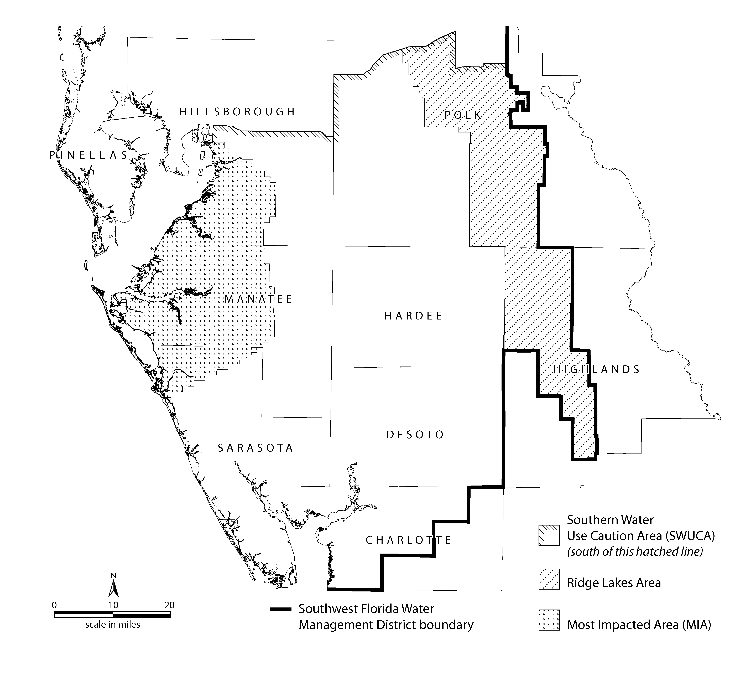
Figure 2-2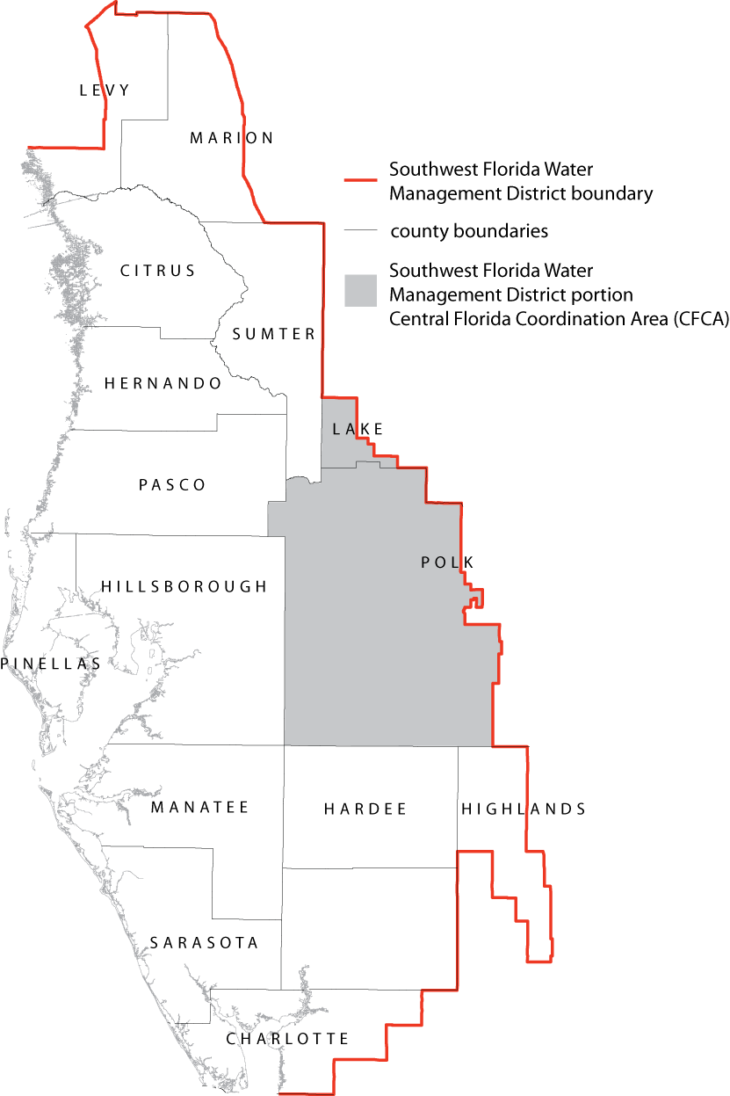

Specific Authority 373.044, 373.113, 373.171 FS. Law Implemented 373.042, 373.0421, 373.171, 373.216, 373.219, 373.223 FS. History–Readopted 10-5-74, Formerly 16J-3.30, Amended 10-1-89, 11-15-90, 3-1-91, 7-29-93, 1-1-03, 1-1-07, 10-1-07, 2-13-08, 4-7-08.

