Notice of Proposed Rule

FISH AND WILDLIFE CONSERVATION COMMISSION
Manatees
RULE NO: RULE TITLE
68C-22.027: Duval County and Associated County (Parts of Clay and St. Johns) Zones
PURPOSE AND EFFECT: The purpose of the proposed rulemaking action is to amend the Commission’s manatee protection zones in the downtown Jacksonville area (i.e., between the Fuller Warren Bridge and Reddie Point) to make the zones identical to the existing federal manatee protection zones as amended by the United States Fish and Wildlife Service in April 2005. The effect of the action would be to slightly expand and otherwise revise the Commission’s existing Slow Speed zones and add 25 MPH zones in two areas that are currently unregulated by the Commission’s rule. No changes would be made to any existing zones outside of the downtown Jacksonville area. It should be noted that the changes in the downtown area would not result in any additional on-water regulation that does not already exist pursuant to the federal zones. This action is being proposed after considering recommendations and comments made by the Duval County Local Rule Review Committee that was formed by the city of Jacksonville pursuant to Section 370.12(2)(f), F.S.
SUMMARY: The Commission’s zones in the downtown Jacksonville area would be revised as follows: [1] the width of the Slow Speed buffer along the eastern shoreline of the St. Johns River between Reddie Point and the Hart Bridge would be expanded to 1,000 feet, and a 25 MPH zone would be added between this buffer and the existing 300-foot buffer along the western shoreline; [2] a 300-foot Slow Speed buffer would be added along the western shoreline of Exchange Island; [3] the Slow Speed zone east and south of Exchange Island would be changed to a shore-to-shore Slow Speed zone that includes slightly more area at the mouth of the Arlington River; [4] the area between the Hart Bridge and the Main Street Bridge would be changed to a shore-to-shore Slow Speed zone with speeds up to 25 MPH allowed in the marked channel of the Florida Intracoastal Waterway; and [5] the area between the Main Street Bridge and the Fuller Warren Bridge would be changed to a shore-to-shore Slow Speed zone that includes the marked channel of the Florida Intracoastal Waterway. No changes would be made to any existing zones outside of the downtown Jacksonville area.
SUMMARY OF ESTIMATED REGULATORY COSTS: No Statement of Estimated Regulatory Cost was prepared.
Any person who wishes to provide information regarding a statement of estimated regulatory costs, or provide a proposal for a lower cost regulatory alternative must do so in writing within 21 days of this notice.
SPECIFIC AUTHORITY: 370.12(2)(n) FS.
LAW IMPLEMENTED: 370.12(2)(d), (k), (n) FS.
A HEARING WILL BE HELD AT THE TIME, DATE AND PLACE SHOWN BELOW:
TIME AND DATE: Wednesday, September 20, 2006, 6:00 p.m.
PLACE: City Council Chambers, First Floor, City Hall at St. James, 117 West Duval Street, Jacksonville, Florida
THE FINAL PUBLIC HEARING WILL BE HELD BY THE COMMISSION AT THE DATE, TIME AND PLACE SHOWN BELOW:
DATES AND TIME: December 6-7, 2006, To Be Announced,
PLACE: Key Largo, Florida – Specific location yet to be determined
Another notice will be published in the F.A.W. to confirm the date of the final hearing and to provide the location information. The Commission’s agenda for this meeting will indicate the specific day when this item is scheduled to be addressed.
If accommodation for a disability is needed to participate in any of the above hearings, please notify the contact person listed below at least five days before the hearing.
THE PERSON TO BE CONTACTED REGARDING THE PROPOSED RULE IS: Mr. Scott Calleson, Florida Fish and Wildlife Conservation Commission, Imperiled Species Management Section, 620 South Meridian Street, Tallahassee, Florida 32399-1600
THE FULL TEXT OF THE PROPOSED RULE IS:
68C-22.027 Duval County and Associated County (Parts of Clay and St. Johns) Zones.
(1) The Commission hereby designates the waters within Duval County, Clay County, and St. Johns County, as described below, as areas where manatee sightings are frequent and where the best available information supports the conclusion it can be assumed that manatees inhabit these areas on a regular or , periodic or continuous basis. The Commission has further determined that a likelihood of threat to manatees exists in these waters as a result of manatees and motorboats using the same areas. The primary purpose of this rule is to protect manatees from harmful collisions with motorboats and from harassment by regulating the speed and operation of motorboats within these designated areas. A secondary purpose is to protect manatee habitat. This rule will also provide additional habitat protection. In consideration of balancing the rights of fishers, boaters, and water skiers to use the waters of the state for recreational and commercial purposes (as applicable under Section 370.12(2)(k), F.S.), with the need to provide manatee protection, the Commission has examined the need for limited lanes, corridors, or unregulated areas that allow higher speeds through or within regulated areas. Such lanes, corridors, or areas are provided in those locations where the Commission determined that they are consistent with manatee protection needs. All of the zones set forth below are in effect year-round and, unless otherwise stated, all zones exclude all associated waterways (tributaries, lakes, creeks, coves, bends, backwaters, canals, basins, etc.) unless explicitly included.
(a) SLOW SPEED ZONE, SHORE-TO-SHORE
1. through 2. No change.
3. St. Johns River, Main Street Bridge to Fuller Warren Bridge Area – All waters of the St. Johns River and associated waterways west (upriver) of the Main Street Bridge and north (downriver) of the Fuller Warren Bridge;
4.3. No change.
(b) SLOW SPEED SHORELINE BUFFER ZONE
1. through 3. No change.
4. St. Johns River, Reddie Point to Hart Fuller Warren Bridge Area – Those waters described below, excluding the federally-marked Florida Intracoastal Waterway channel:
a. Within 300 feet of the general contour of the western (and northern) shoreline of the St. Johns River, south (upriver) of a line that runs from the easternmost point of Sandfly Point (approximate latitude 30°23'10'' North, approximate longitude 81°38'03'' West) to the northernmost point of Reddie Point (approximate latitude 30°23'22'' North, approximate longitude 81°37'13'' West) and north and east (downriver) of the Hart Fuller Warren Bridge, including all associated waterways and all waters of Long Branch Creek easterly of the Buffalo Avenue/Wigmore Street Bridge;
b. Within 1,000 900 feet of the general contour of the eastern shoreline of the St. Johns River, south (upriver) of a line that runs from the easternmost point of Sandfly Point (approximate latitude 30°23'10'' North, approximate longitude 81°38'03'' West) to the northernmost point of Reddie Point (approximate latitude 30°23'22'' North, approximate longitude 81°37'13'' West) and north (downriver) of the Hart Bridge, including all associated waterways, and all waters east of Exchange Island and a line that bears 250° from the southernmost point of Exchange Island (approximate latitude 30°19'18'' North, approximate longitude 81°37'05'' West) and west of a line that bears 73° from a point (approximate latitude 30°18'53'' North, approximate longitude 81°36'43'' West) on the southern shoreline of the Arlington River at the mouth of Little Pottsburg Creek; and also including those waters within 300 feet of the general contour of the western shoreline of Exchange Island a line that bears 90° from a point (approximate latitude 30°19'57'' North, approximate longitude 81°36'54'' West) in the river located 900 feet from the eastern shoreline of the river, and; all waters of the river east of a line that runs from said point to the northernmost point of Exchange Island (approximate latitude 30°19'50'' North, approximate longitude 81°36'55'' West);
c. Within 300 feet of the general contour of the eastern shoreline of the St. Johns River, south of a line that bears 90° from the northernmost point of Exchange Island (approximate latitude 30°19'50'' North, approximate longitude 81°36'55'' West) and north of a line that bears 90° from a point (approximate latitude 30°19'19'' North, approximate longitude 81°36'59'' West) on the eastern shoreline of Exchange Island;
5.d. St. Johns River, Hart Bridge to Main Street Bridge Area – All waters of the St. Johns River and associated waterways Within 600 feet of the general contour of the southern (eastern) shoreline of the St. Johns River, west of a line that bears 180° from the southernmost point of Exchange Island (approximate latitude 30°19'18'' North, approximate longitude 81°37'05'' West) and north and east of the Fuller Warren Bridge, including all waters of Miller Creek north of the Atlantic Boulevard (State Road 10) Bridge, west (upriver) of the Hart Bridge and east (downriver) of the Main Street Bridge, except in the marked channel of the Florida Intracoastal Waterway as designated in subparagraph (1)(c)2. and; all waters of the St. Johns River and the Arlington River east and south of a line that runs from the waterward end of the southern terminus of the 300-foot buffer described in sub subparagraph (1)(b)4.c. to the waterward end of the eastern terminus of the 600-foot buffer described in this paragraph, and west and north of a line that bears approximately 225° from the southernmost tip of a peninsula on the northern side of the Arlington River (approximate latitude 30°19'07'' North, approximate longitude 81°36'38'' West) to a point on the southern side of the Arlington River, east of Empire Point (approximate latitude 30°18'57'' North, approximate longitude 81°36'47'' West);
5. through 10. renumbered 6. through 11. No change.
(c) 25 MPH
1. St. Johns River, Reddie Point to Hart Bridge Area – All waters of the St. Johns River outside of the Slow Speed areas designated in subparagraph (1)(b)4.;
2. St. Johns River, Hart Bridge to Main Street Bridge Area – All waters in the marked channel of the Florida Intracoastal Waterway west (upriver) of the Hart Bridge and east (downriver) of the Main Street Bridge.
(2) The width of the variable-width shoreline buffer referenced in subparagraphs (1)(b)6.5., 9.8., 10.9., and 11.10., above is as follows: The buffer includes at a minimum all waters within 500 feet of the general contour of the shoreline. Where there are docks that extend out farther than 300 feet into the waterway, the buffer extends out beyond the 500-foot line to include all waters shoreward of a line that runs 200 feet beyond and parallel to the dock line. For the purposes of this rule, the dock line shall be defined as a line that runs between the ends of successive docks.
(3) No change.
(4) The amendments to Rule 68C-22.027, F.A.C., as approved by the Commission on [insert approval date], shall take effect as soon as the regulatory markers are posted.

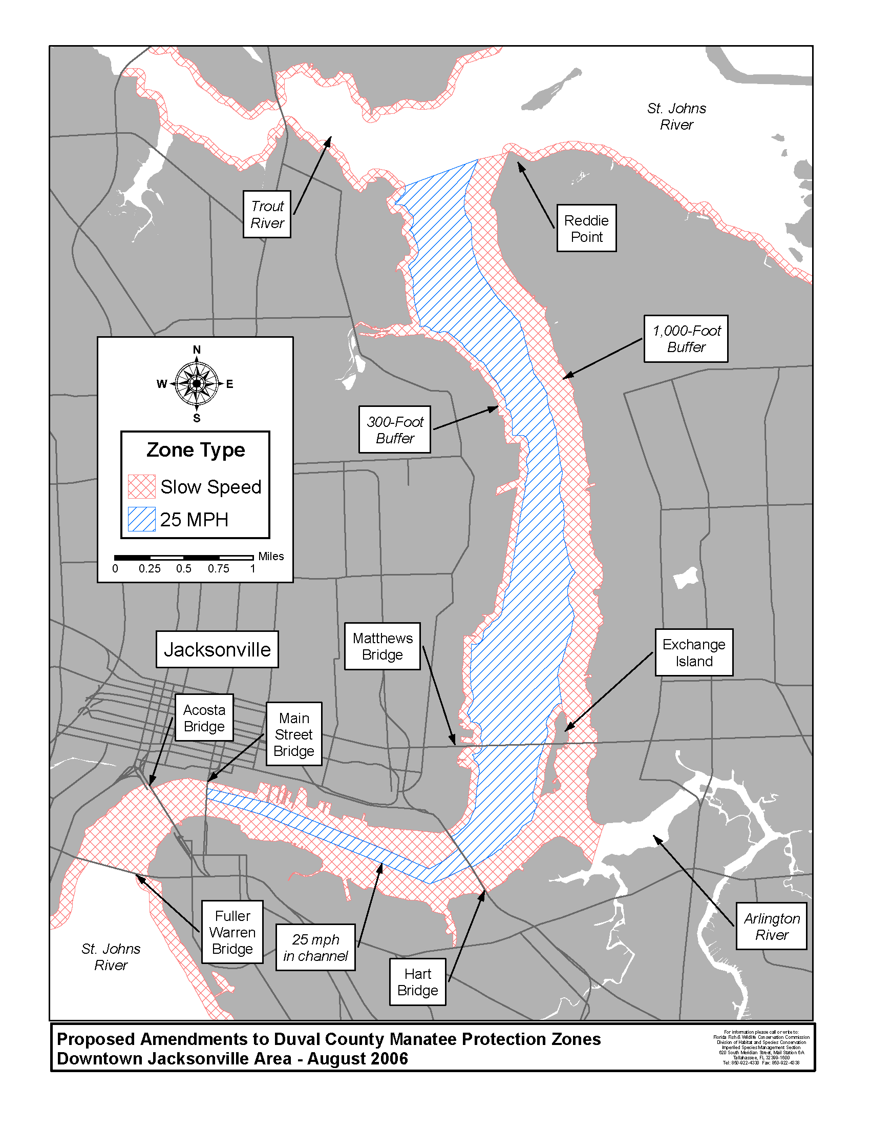
Specific Authority 370.12(2)(m) FS. Law Implemented 370.12(2)(d),(m) FS. History–New 12-22-92, Amended 6-16-93, Formerly 16N-22.027, 62N-22.027, Amended 8-1-00,__________.
NAME OF PERSON ORIGINATING PROPOSED RULE: Mr. Tim Breault, Director of the Division of Habitat and Species Conservation
NAME OF SUPERVISOR OR PERSON WHO APPROVED THE PROPOSED RULE: The Commission
DATE PROPOSED RULE APPROVED BY AGENCY HEAD: June 7, 2006
DATE NOTICE OF PROPOSED RULE DEVELOPMENT PUBLISHED IN FAW: May 26, 2006

