Notice of Proposed Rule

WATER MANAGEMENT DISTRICTS
St. Johns River Water Management District
RULE NO: RULE TITLE
40C-41.011: Policy and Purpose
40C-41.023: Basin Boundaries
40C-41.033: Implementation
40C-41.043: Application of Chapter
40C-41.063: Conditions for Issuance of Permits
PURPOSE AND EFFECT: The purposes of this proposed rule amendment are to (1) create the “Wekiva Recharge Protection Basin,” (2) create recharge criteria for certain systems located within the Wekiva Recharge Protection Basin that require an ERP pursuant to Chapters 40C-4, 40C-40, 40C-42, or 40C-44, F.A.C., (3) repeal from the Wekiva River Hydrologic Basin the recharge criteria and “Most Effective Recharge Areas” (which areas will be superceded by the new Wekiva Recharge Protection Basin), and (4) amend the Wekiva River Hydrologic Basin rules to clarify which criteria apply within the Wekiva River Hydrologic Basin and that the Wekiva recharge criteria only apply within the Wekiva Recharge Protection Basin. The effects of the proposed amendment are to (1) establish the Wekiva Recharge Protection Basin, (2) require applications to demonstrate that systems within the Wekiva Recharge Protection Basin either retain three inches of runoff from all impervious areas proposed to be constructed on type “A” soils (and percolating into the soils within 72 hours) or otherwise demonstrate that the post-development recharge capacity is equal to or greater than the pre-development recharge capacity, (3) delete the recharge criteria from the Wekiva River Hydrologic Basin, and (4) clarify that the Wekiva recharge criteria will only apply in the Wekiva Recharge Protection Basin.
SUMMARY: The proposed rule amendments would create the “Wekiva Recharge Protection Basin” in Rules 40C-41.011, 40C-41.023(4), 40C-41.033, 40C-41.043, F.A.C., and Figure 41-6, create recharge criteria for certain systems located within the Wekiva Recharge Protection Basin requiring an ERP in paragraph 40C-41.063(3)(a), F.A.C., repeal the existing recharge criteria from the Wekiva River Hydrologic Basin rules in paragraph 40C-41.063(3)(a), F.A.C., and create a requirement that the new Wekiva recharge criteria will also apply to stormwater management systems requiring permits pursuant to Rules 40C-42.022 or 40C-44.041, F.A.C., respectively in subsections 40C-41.043(5)-(6), F.A.C.
SUMMARY OF ESTIMATED REGULATORY COSTS: No Statement of Estimated Regulatory Cost was prepared.
Any person who wishes to provide information regarding a statement of estimated regulatory costs, or provide a proposal for a lower cost regulatory alternative must do so in writing within 21 days of this notice.
SPECIFIC AUTHORITY: 369.318, 373.044, 373.113, 373.418 FS.
LAW IMPLEMENTED: 369.316, 369.318, 373.413, 373.414, 373.415, 373.416, 373.418, 373.426 FS.
IF REQUESTED WITHIN 21 DAYS OF THE DATE OF THIS NOTICE, A HEARING WILL BE HELD AT THE DATE, TIME AND PLACE SHOWN BELOW:
TIME AND DATE: October 10, 2006, Following the regularly scheduled Governing Board Meeting, which begins at 1:00 p.m.
PLACE: St. Johns River Water Management District Headquarters, 4049 Reid Street, Palatka, Florida 32177-2529
If a person decides to appeal any decision with respect to any matter considered at the above listed public hearing, such person may need to ensure that a verbatim record of the proceeding is made to include testimony and evidence upon which the appeal is to be based.
Anyone requiring special accommodations to participate in this meeting is requested to advise the District at least 5 work days before the meeting by contacting Ann Freeman at (386)329-4101 or (386) 329-4450 (TDD).
THE PERSON TO BE CONTACTED REGARDING THE PROPOSED RULE IS: Norma Messer, Rules Coordinator, Office of General Counsel, St. Johns River Water Management District, 4049 Reid Street, Palatka, Florida 32177-2529, (386)329-4459, Suncom 860-4459 or email address nmesser@sjrwmd.com
THE FULL TEXT OF THE PROPOSED RULE IS:
40C-41.011 Policy and Purpose.
The rules in this chapter establish additional surface water management standards and criteria for the Upper St. Johns River Hydrologic Basin, the Ocklawaha River Hydrologic Basin, the Wekiva River Hydrologic Basin, the Wekiva Recharge Protection Basin, the Econlockhatchee River Hydrologic Basin, the Tomoka River Hydrologic Basin, the Spruce Creek Hydrologic Basin, the Sensitive Karst Areas Basin, and the Lake Apopka Hydrologic Basin, which insure that development within the basins incorporates the appropriate water quantity and water quality control and other environmental measures necessary to protect the integrity of the public investments in the basins and which minimizes adverse impacts to the water resources of the District. Standards and criteria delineated in this chapter are in addition to those criteria specified in Chapters 40C-4, 40C-40, 40C-42, and 40C-44, F.A.C., in accordance with Rule 40C-41.043, F.A.C. The standards, criteria, exemptions, and additional requirements specified in this chapter are not intended to supersede or rescind the terms and conditions of any valid surface water management permit issued by the District prior to the effective date of this chapter.
Specific Authority 369.318, 373.044, 373.113, 373.171, 373.415 FS. Law Implemented 369.318, 373.413, 373.415, 373.416 373.418, 373.426, 373.461 FS. History–New 12-7-83, Amended 5-17-87, 8-30-88, 4-3-91, 9-25-91, 11-25-98, 3-7-03,________.

40C-41.023 Basin Boundaries.
(1) through (2) No change.
(3) The Wekiva River Hydrologic Basin is that area generally depicted in Figures 41-1 and 41-6 and defined in Applicant’s Handbook, Appendix K as incorporated by reference in Rule 40C-4.091, F.A.C.
(4) The Wekiva Recharge Protection Basin is that area generally depicted in Figure 41-6 and defined in Applicant’s Handbook, Appendix K as incorporated by reference in Rule 40C-4.091, F.A.C.
(4) through (7) renumbered (5) through (8) No change.
Specific Authority 369.318, 373.044, 373.113, 373.171 FS. Law Implemented 369.316, 369.318, 373.413, 373.416, 373.426, 373.461 FS. History–New 12-7-83, Amended 5-17-87, 4-3-91, 9-25-91, 11-25-98, 3-07-03,________.

Figure 41-6 Wekiva River Hydrologic Basin and Wekiva Recharge Protection Basin
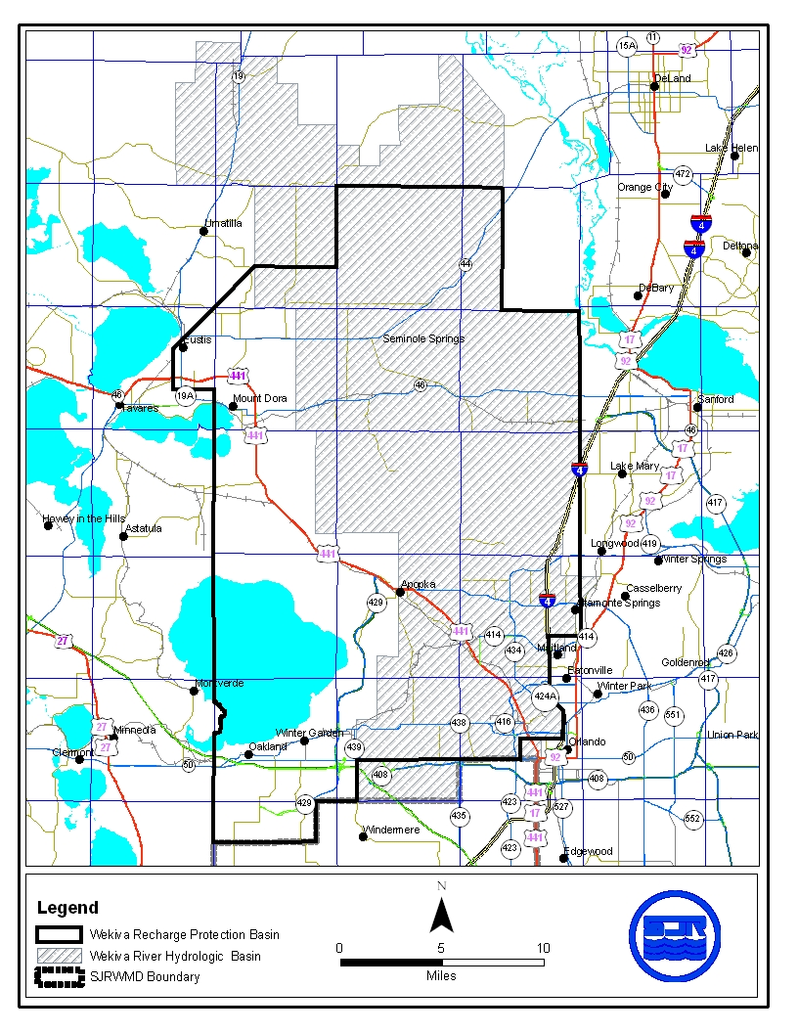
40C-41.033 Implementation.
The effective date of this chapter is December 7, 1983, for the criteria of subsections 40C-41.063(1) and (2), F.A.C.; (effective date) for the standards and criteria in paragraph 40C-41.063(3)(a), F.A.C.; May 17, 1987, for the standards of paragraphs 40C-41.063(3)(b), F.A.C.; August 30, 1988, for the standards and criteria of paragraphs 40C-41.063(3)(c), (d) and (e), F.A.C.; April 3, 1991, for the standards and criteria in subsection 40C-41.063(5), F.A.C.; September 25, 1991 for the criteria of subsection 40C-41.063(7), F.A.C.; November 25, 1998, 11-25-98 for the criteria of subsection 40C-41.063(6), F.A.C.; and March 7, 2003, for the standards and criteria in subsection 40C-41.063(8), F.A.C.
Specific Authority 369.318, 373.044, 373.113, 373.171 373.415 FS. Law Implemented 369.318, 373.413, 373.415, 373.416, 373.426, 373.461 FS. History–New 12-7-83, Amended 5-17-87, 8-30-88, 4-3-91, 9-25-91, 11-25-98, 3-7-03, 11-11-03,________.

40C-41.043 Application of Chapter.
(1) All projects located within the Upper St. Johns River Hydrologic Basin, the Ocklawaha River Hydrologic Basin, the Wekiva River Hydrologic Basin, the Wekiva Recharge Protection Basin, the Econlockhatchee River Hydrologic Basin, the Tomoka River Hydrologic Basin, the Spruce Creek Hydrologic Basin, or the Lake Apopka Hydrologic Basin, requiring permits pursuant to Rule 40C-4.041, F.A.C., shall be constructed, operated, maintained, altered, abandoned and removed in accordance with the standards and criteria specified in Rules 40C-41.063, and either 40C-4.301 and 40C-4.302, or 40C-40.302, F.A.C., unless specifically exempted in Rule 40C-41.051, F.A.C., or otherwise provided in subsection 40C-41.043(3) or 40C-41.043(4), F.A.C. The most restrictive criteria will be applicable unless the applicant provides reasonable assurance that the purposes and intent of this chapter and Chapter 40C-4, F.A.C., will be fulfilled using alternate criteria.
(2) through (4) No change.
(5) Stormwater management systems requiring permits pursuant to Rule 40C-42.022, F.A.C., that will be located within the Wekiva Recharge Protection Basin, shall be constructed, operated, maintained, altered, abandoned and removed in accordance with the standards and criteria specified in Rule 40C-42.023, F.A.C., and paragraph 40C-41.063(3)(a), F.A.C.
(6) Agricultural surface water management systems requiring permits pursuant to Rule 40C-44.041, F.A.C., that will be located within the Wekiva Recharge Protection Basin, shall be constructed, operated, maintained, altered, abandoned and removed in accordance with the standards and criteria specified in Rule 40C-44.301, F.A.C., and paragraph 40C-41.063(3)(a), F.A.C.
Specific Authority 369.318, 373.044, 373.113, 373.171, 373.415 FS. Law Implemented 369.318, 373.413, 373.415, 373.416, 373.418, 373.426, 373.461 FS. History–New 12-7-83, Amended 5-17-87, 8-30-88, 4-3-91, 9-25-91, 10-3-95, 11-25-98, 3-7-03,________.

40C-41.063 Conditions for Issuance of Permits.
(1) through (2) No change.
(3) Within the Wekiva River Hydrologic Basin or the Wekiva Recharge Protection Basin, the following standards and criteria are established:
(a) Recharge Standard – Applicants required to obtain a permit pursuant to Chapters 40C-4, 40C-40, 40C-42, or 40C-44, F.A.C., for a surface water management system located within the Wekiva Recharge Protection Basin shall demonstrate that the system provides for retention storage of three inches of runoff from all impervious areas proposed to be constructed on soils defined as a Type “A” Soils as defined by the Natural Resources Conservation Service (NRCS) Soil Survey in the following NRCS publications: Soil Survey of Flagler County Area, Florida (1997); Soil Survey of Lake County Area, Florida (1975); Soil Survey of Orange County Area, Florida (1989); Soil Survey of Seminole County Area, Florida (1990); and Soil Survey of Volusia County Area, Florida (1980), which are hereby incorporated by reference. Section 18.1 contains a list of Type “A” soils. The system shall be capable of infiltrating this storage volume through natural percolation into the surrounding soils within 72 hours. Off-site areas or regional systems may be utilized to satisfy this requirement. As an alternative, applicants may demonstrate that the post-development recharge capacity is equal to or greater than the pre-development recharge capacity. Pre-development recharge shall be based upon the land uses in place as of (effective date). Applicants may utilize existing permitted municipal master stormwater systems, in lieu of onsite retention, to demonstrate that post-development recharge is equal to or greater than pre-development recharge. Also, applicants may submit additional geotechnical information to establish whether or not a site contains Type “A” soils. Three inches of runoff from all directly connected impervious areas must be retained within the project area for projects or portions of projects in Most Effective Recharge Areas. As an alternative, applicants may demonstrate that the post-development recharge capacity is equal to or greater than the pre-development recharge capacity.
(b) Storage Standard – Within the Wekiva River Hydrologic Basin, aA system may not cause a net reduction in flood storage within the 100 year floodplain of a stream or other water course which has a drainage area of more than one square mile and which has a direct hydrologic connection to Little Wekiva River, Wekiva River, or Black Water Creek.
(c) Standards for Erosion and Sediment Control and Water Quality – Within the Wekiva River Hydrologic Basin, aA Water Quality Protection Zone shall extend one half mile from the Wekiva River, Little Wekiva River north of State Road 436, Black Water Creek, Rock Springs Run, Seminole Creek, and Sulphur Run, and shall also extend one quarter mile from any wetland abutting an Outstanding Florida Water.
1. through 3. No change.
(d) Standard for Limiting Drawdown – Within the Wekiva River Hydrologic Basin, aA Water Quantity Protection Zone shall extend 300 feet landward of the landward extent of Black Water Swamp and the wetlands abutting the Wekiva River, Little Wekiva River, Rock Springs Run, Black Water Creek, Sulphur Run, Seminole Creek, Lake Norris, and Lake Dorr. As part of providing reasonable assurance that the standard set forth in paragraph 40C-4.301(1)(d), F.A.C., is met, where any part of a system located within this zone will cause a drawdown, the applicant must provide reasonable assurance that construction, alteration, operation, or maintenance of the system will not cause ground water table drawdowns which would adversely affect the functions provided by the referenced wetlands.
The applicant shall provide an analysis which includes a determination of the magnitude and areal extend of any drawdowns, based on site specific hydrogeologic data collected by the applicant, as well as a deion of the referenced wetlands, the functions provided by these wetlands, and the predicted impacts to these functions. It is presumed that the part of this standard regarding drawdown effects will be met if the following criteria is met:
A ground water table drawdown must not occur within the Water Quantity Protection Zone.
(e) Standard for Riparian Wildlife Habitat Within the Wekiva River Hydrologic Basin
1. through 3. No change.
(4) through (8) No change.
Specific Authority 369.318, 373.044, 373.113, 373.414, 373.415, 373.418 FS. Law Implemented 369.318, 373.413, 373.414, 373.415, 373.416, 373.418, 373.426, 373.461 FS. History–New 12-7-83, Amended 5-17-87, 8-30-88, 4-3-91, 9-25-91, 7-14-92, 10-3-95, 11-25-98, 10-11-01, 3-7-03, 2-10-05,________.
NAME OF PERSON ORIGINATING PROPOSED RULE: Jeff Elledge, Director, Department of Water Resources, St. Johns River Water Management District, 4049 Reid Street, Palatka, Florida 32177-2529, (386)329-4203, suncom 860-4203
NAME OF SUPERVISOR OR PERSON WHO APPROVED THE PROPOSED RULE: Governing Board of the St. Johns River Water Management District
DATE PROPOSED RULE APPROVED BY AGENCY HEAD: August 8, 2006
DATE NOTICE OF PROPOSED RULE DEVELOPMENT PUBLISHED IN FAW: May 5, 2006

