53ER09-36 Instant Game Number 1028, MATCH & WIN™.
(1) Name of Game. Instant Game Number 1028, “MATCH & WIN™.”
(2) Price. MATCH & WIN lottery tickets sell for $3.00 per ticket.
(3) MATCH & WIN lottery tickets shall have a series of numbers in machine readable code (or bar code) on the back of the ticket, along with a validation number under the latex area on the ticket. To be a valid winning MATCH & WIN lottery ticket, the ticket must meet the applicable requirements of Rule 53ER08-89, F.A.C.
(4) The YOUR RED NUMBERS play symbols are as follows:
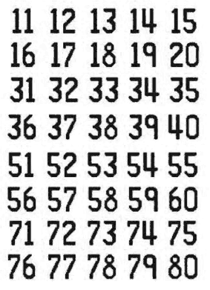
(5) The YOUR BLACK NUMBERS play symbols are as follows:
(6) The RED column and row play symbols are as follows:
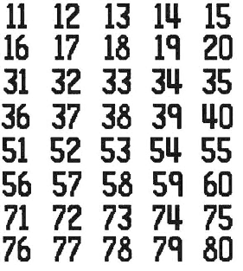
(7) The BLACK column and row play symbols are as follows:
(8) The RED prize symbols and prize symbol captions are as follows:
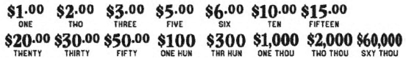
(9) The BLACK prize symbols and prize symbol captions are as follows:
(10) The legends are as follows:

(11) Determination of Prizewinners. There are three rows and eight columns on a ticket.
(a) A ticket having numbers in the “YOUR RED NUMBERS” play area that match all of the red numbers in a row entitles the claimant to the corresponding prize shown in the “RED PRIZE” area for that row.
(b) A ticket having numbers in the “YOUR BLACK NUMBERS” play area that match all of the black numbers in a row entitles the claimant to the corresponding prize shown in the “BLACK PRIZE” area for that row.
(c) A ticket having numbers in the “YOUR RED NUMBERS” that match all three numbers in a red column shall entitle the claimant to the corresponding prize shown for that column. A ticket having numbers in the “YOUR BLACK NUMBERS” that match all three numbers in a black column shall entitle the claimant to the corresponding prize shown for that column.
(d) The prizes are: $1.00, $2.00, $3.00, $5.00, $6.00, $10.00, $15.00, $20.00, $30.00, $50.00, $100, $300, $1,000, $2,000 and $60,000.
(12) The estimated odds of winning, value, and number of prizes in Instant Game Number 1028 are as follows:
 |  |  | NUMBER OF
 |  |  | WINNERS IN
 |  | ESTIMATED | 85 POOLS OF
 |  | ODDS OF | 180,000 TICKETS
GAME PLAY | WIN | 1 IN | PER POOL
$1 x 3 | $3 | 20.00 | 765,000
$3 | $3 | 20.00 | 765,000
$1 x 5 | $5 | 50.00 | 306,000
($1 x 2) + $3 | $5 | 100.00 | 153,000
$2 + $3 | $5 | 50.00 | 306,000
$5 | $5 | 100.00 | 153,000
($1 x 4) + $2 | $6 | 125.00 | 122,400
($1 x 3) + $3 | $6 | 250.00 | 61,200
$2 x 3 | $6 | 250.00 | 61,200
$3 x 2 | $6 | 250.00 | 61,200
$6 | $6 | 100.00 | 153,000
$1 x 10 | $10 | 250.00 | 61,200
$2 x 5 | $10 | 125.00 | 122,400
$1 + $3 + $6 | $10 | 250.00 | 61,200
$5 x 2 | $10 | 100.00 | 153,000
$10 | $10 | 250.00 | 61,200
($1 x 5) + ($2 x 5) | $15 | 500.00 | 30,600
$3 x 5 | $15 | 500.00 | 30,600
$5 x 3 | $15 | 500.00 | 30,600
$5 + $10 | $15 | 500.00 | 30,600
$15 | $15 | 500.00 | 30,600
$2 x 10 | $20 | 500.00 | 30,600
($3 x 3) + $5 + $6 | $20 | 500.00 | 30,600
($5 x 2) + $10 | $20 | 500.00 | 30,600
$10 x 2 | $20 | 500.00 | 30,600
$20 | $20 | 500.00 | 30,600
($2 x 6) + ($3 x 6) | $30 | 900.00 | 17,000
($5 x 4) + $10 | $30 | 900.00 | 17,000
$10 x 3 | $30 | 900.00 | 17,000
$15 x 2 | $30 | 1,000.00 | 15,300
$30 | $30 | 900.00 | 17,000
($3 x 10) + ($5 x 4) | $50 | 1,440.00 | 10,625
$5 x 10 | $50 | 1,440.00 | 10,625
$10 + ($20 x 2) | $50 | 1,440.00 | 10,625
$20 + $30 | $50 | 1,440.00 | 10,625
$50 | $50 | 1,440.00 | 10,625
($6 x 10) + ($10 x 4) | $100 | 3,600.00 | 4,250
$10 x 10 | $100 | 3,600.00 | 4,250
($10 x 5) + $20 + $30 | $100 | 3,600.00 | 4,250
$20 x 5 | $100 | 3,600.00 | 4,250
$50 x 2 | $100 | 3,600.00 | 4,250
$100 | $100 | 3,600.00 | 4,250
($10 x 10) + ($50 x 4) | $300 | 60,000.00 | 255
$30 x 10 | $300 | 60,000.00 | 255
$50 x 6 | $300 | 90,000.00 | 170
$100 x 3 | $300 | 90,000.00 | 170
$300 | $300 | 90,000.00 | 170
($50 x 8) + ($100 x 6) | $1,000 | 90,000.00 | 170
$100 x 10 | $1,000 | 180,000.00 | 85
($100 x 4) + ($300 x 2) | $1,000 | 180,000.00 | 85
$100 + ($300 x 3) | $1,000 | 180,000.00 | 85
$1,000 | $1,000 | 180,000.00 | 85
($50 x 4) + ($100 x 6) + ($300 x 4) | $2,000 | 180,000.00 | 85
$2,000 | $2,000 | 180,000.00 | 85
$60,000 | $60,000 | 765,000.00 | 20
(13) The estimated overall odds of winning some prize in Instant Game Number 1028 are 1 in 3.99. Prizes, including the top prizes, are subject to availability at the time of ticket purchase. Prizes may be unavailable due to prior sale or other causes occurring in the normal course of business including, but not limited to, ticket damage, defect, theft, or loss.
(14) For reorders of Instant Game Number 1028, the estimated odds of winning, value, and number of prizes shall be proportionate to the number of tickets reordered.
(15) By purchasing a MATCH & WIN lottery ticket the player agrees to comply with and abide by all prize payment rules of the Florida Lottery.
(16) Payment of prizes for MATCH & WIN lottery tickets shall be made in accordance with rules of the Florida Lottery governing payment of prizes.
A copy of the current rule can be obtained from the Florida Lottery, Office of the General Counsel, 250 Marriott Drive, Tallahassee, Florida 32399-4011.
Rulemaking Authority 24.109(1), 24.115(1) FS. Law Implemented 24.105(9)(a), (b), (c), 24.115(1) FS. History–New 7-10-09, Replaced by 53ER13-6.

