69A-3.012 Standards of the National Fire Protection Association and Other Standards Adopted.
(1) Except as specifically modified by statute or by the State Fire Marshal’s rules, the Florida specific edition of NFPA 101, the Life Safety Code®, 2006 edition and the Florida specific edition of NFPA 1, the Uniform Fire Code, 2006 edition, as adopted within Rule Chapter 69A-60, F.A.C., entitled the “2007 edition of the Florida Fire Prevention Code,” are hereby adopted and incorporated by reference and are applicable to those buildings and structures specified in paragraphs (a) and (b) of subsection (1) of Section 633.022, F.S. In addition, the following standards, except as specifically modified in the rule chapters in Rule Title 69A, are hereby adopted and incorporated by reference and shall take effect on the effective date of this rule, as a part of the uniform fire safety standards adopted by rule by the State Fire Marshal and are applicable to those buildings and structures specified in paragraphs (a) and (b) of subsection (1) of Section 633.022, F.S.:
NFPA 10-2002 edition, Standard for Portable Fire Extinguishers
NFPA 11-2005 edition, Standard for Low-, Medium, and High- Expansion Foam
NFPA 11A-1999 edition, Standard for Medium and High Expansion Foam Systems
NFPA 12-2005 edition, Standard on Carbon Dioxide Extinguishing Systems
NFPA 12A-2004 edition, Standard on Halon 1301 Fire Extinguishing Systems
NFPA 13-2002 edition, Standard for the Installation of Sprinkler Systems
NFPA 13D-2002 edition, Standard for the Installation of Sprinkler Systems in One- and Two- Family Dwellings and Manufactured Homes
NFPA 13R-2002 edition, Standard for the Installation of Sprinkler Systems in Residential Occupancies up to and including Four Stories in Height
NFPA 14-2003 edition, Standard for the Installation of Standpipe and Hose Systems, except 2-7 shall be omitted
NFPA 15-2001 edition, Standard for Water Spray Fixed Systems for Fire Protection
NFPA 16-2003 edition, Standard for the Installation of Foam-Water Sprinkler and Foam-Water Spray Systems
NFPA 17-2002 edition, Standard for Dry Chemical Extinguishing Systems
NFPA 17A-2002 edition, Standard on Wet Chemical Extinguishing Systems
NFPA 20-2003 edition, Standard for the Installation of Stationary Pumps for Fire Protection
NFPA 22-2003 edition, Standard for Water Tanks for Private Fire Protection
NFPA 24-2002 edition, Standards for the Installation of Private Fire Service Mains and Their Appurtenances
NFPA 25-2002 edition, Standard for the Inspection, Testing, and Maintenance of Water-Based Fire Protection Systems, except that quarterly flow tests shall be required for those systems supplied by a municipal water supply.
NFPA 30-2003 edition, Flammable and Combustible Liquids Code
NFPA 30A-2003 edition, Code for Motor fuel Dispensing Facilities and Repair Garages
NFPA 30B-2002 edition, Code for the Manufacture and Storage of Aerosol Products
NFPA 31-2001 edition, Standard for the Installation of Oil Burning Equipment
NFPA 32-2004 edition, Standards for Drycleaning Plants
NFPA 33-2003 edition, Standard for Spray Application Using Flammable and Combustible Materials
NFPA 34-2003 edition, Standard for Dipping and Coating Processes Using Flammable or Combustible Liquids
NFPA 35-2005 edition, Standard for the Manufacture of Organic Coatings
NFPA 36-2004 edition, Standard for Solvent Extraction Plants
NFPA 37-2002 edition, Standard for the Installation and Use of Stationary Combustion Engines and Gas Turbines
NFPA 40-2001 edition, Standard for the Storage and Handling of Cellulose Nitrate Film
NFPA 45-2004 edition, Standard on Fire Protection for Laboratories Using Chemicals
NFPA 50-2001 edition, Standard for Bulk Oxygen Systems at Consumer Sites
NFPA 50B-1999 edition, Standard for Liquid Hydrogen Systems at Consumer Sites
NFPA 51-2002 edition, Standard for the Design and Installation of Oxygen-Fuel Gas Systems for Welding, Cutting and Allied Processes
NFPA 51A-2001 edition, Standard for Acetylene Cylinder Charging Plants
NFPA 51B-2003 edition, Standard for Fire Prevention During Welding, Cutting and Other Hot Work
NFPA 52-2006 edition, Vehicular Fuel Systems Code
NFPA 53-2004 edition, Recommended Practice on Materials, Equipment, and Systems Used in Oxygen-Enriched Atmospheres
NFPA 54-2006 edition, National Fuel Gas Code
NFPA 55-2005 edition, Standard for the Storage, Use, and Handling of Compressed Gasses and Cryogenic Fluids in Portable and Stationary Containers, Cylinders and Tanks
NFPA 57-2002 edition, Liquefied Natural Gas Vehicular Fuel Systems Code
NFPA 58-2004 edition, Liquefied Petroleum Gas Code
NFPA 59-2004 edition, Utility LP-Gas Plant Code
NFPA 59A-2006 edition, Standard for the Production, Storage and Handling of Liquefied Natural Gas
NFPA 61-2002 edition, Standard for the Prevention of Fires and Dust Explosions in Agricultural and Food Products Facilities
NFPA 69-2002 edition, Standard on Explosion Prevention Systems
NFPA 70-2005 edition, National Electrical Code
NFPA 72-2002 edition, National Fire Alarm Code
NFPA 75-2003 edition, Standard for the Protection of information Technology Equipment
NFPA 80-1999 edition, Standard for Fire Doors and Fire Windows
NFPA 80A-2007 edition, Recommended Practice for Protection of Buildings from Exterior Fire Exposures
NFPA 82-2004 edition, Standard on Incinerators and Waste and Linen Handling Systems and Equipment
NFPA 86-2003 edition, Standard for Ovens and Furnaces
NFPA 86C-1999 edition, Standard for Industrial Furnaces Using a Special Processing Atmosphere
NFPA 86D-1999 edition, Standard for Industrial Furnaces Using Vacuum as an Atmosphere
NFPA 88A-2002 edition, Standard for Parking Structures
NFPA 90A-2002 edition, Standard for the Installation of Air Conditioning and Ventilating Systems
NFPA 90B-2006 edition, Standard for the Installation of Warm Air Heating and Air Conditioning Systems
NFPA 91-2004 edition, Standard for Exhaust Systems for Air Conveying of Vapors, Gases, Mists, and Noncombustible Particulate Solids
NFPA 92A-2006 edition, Standard for Smoke-Control Systems Utilizing barriers and Pressure Differences
NFPA 92B-2005 edition, Standard for Smoke Management Systems in Malls, Atria, and Large Spaces
NFPA 96-2004 edition, Standard for Ventilation Control and Fire Protection of Commercial Cooking Operations. Subdivision 10-2.3 of NFPA 96 applies prospectively only. Existing installations are permitted to remain in place subject to the approval of the authority having jurisdiction.
NFPA 99-2005 edition, Health Care Facilities
NFPA 99B-2005 edition, Standard for Hypobaric Facilities
NFPA 101A-2004 edition, Guide on Alternative Approaches to Life Safety
NFPA 101B-2002 edition, Standard on Means of Egress for Buildings and Structures
NFPA 102-1995 edition, Standard for Grandstands, Folding and Telescoping Seating, Tents and Membrane Structures
NFPA 105-2003 edition, Recommended Practice for the Installation of Smoke-Control Door Assemblies
NFPA 110-2005 edition, Standard for Emergency and Standby Power Systems
NFPA 111-2005 edition, Standard on Stored Electrical Energy Emergency and Standby Power Systems
NFPA 115-2003 edition, Recommended Practice on Laser Fire Protection
NFPA 120-2004 edition, Standard for Fire Prevention and Control in Coal Mines
NFPA 130-2007 edition, Standard for Fixed Guideway Transit and Passenger Rail Systems
NFPA 140-2004 edition, Standard on Motion Picture and Television Production Studio Soundstages and Approved Production Facilities
NFPA 150-2007 edition, Standard on Fire and Life Safety in Animal Housing Facilities
NFPA 160-2006 edition, Standard for Use of Flame Effects Before an Audience
NFPA 211-2003 edition, Standard for Chimneys, Fireplaces, Vents and Solid Fuel Burning Appliances
NFPA 214-2005 edition, Standard on Water-Cooling Towers
NFPA 221-2006 edition, Standard for High Challenge Fire Walls, Fire Walls and Fire Barrier Walls
NFPA 232-2000 edition, Standard for the Protection of Records
NFPA 232A-1995 edition, Guide for Fire Protection for Archives and Record Centers
NFPA 241-2004 edition, Standard for Safeguarding Construction, Alteration and Demolition Operations
NFPA 251-2006 edition, Standard Methods of Tests of Fire Endurance of Building Construction and Materials
NFPA 252-2003 edition, Standard Methods of Fire Tests of Door Assemblies
NFPA 253-2006 edition, Standard Method of Test for Critical Radiant Flux of Floor Covering Systems Using a Radiant Heat Energy Source
NFPA 255-2006 edition, Standard Method of Test of Surface Burning Characteristics of Building Materials
NFPA 256-2003 edition, Standard Methods of Fire Tests of Roof Coverings
NFPA 257-2000 edition, Standard on Fire Tests for Window and Glass Block Assemblies
NFPA 259-2003 edition, Standard Test Method for Potential Heat of Building Materials
NFPA 260-2003 edition, Standard Method of Test and Classification System for Cigarette Ignition Resistance of Components of Upholstered Furniture
NFPA 261-2003 edition, Standard Method of Test for Determining Resistance of Mock-Up Upholstered Furniture Material Assemblies to Ignition by Smoldering Cigarettes
NFPA 265-2002 edition, Standard Methods of Fire Tests for Evaluating Room Fire Growth Contribution of Textile Coverings on full Height Panels and Walls
NFPA 267-1998 edition, Standard Method of Test for Fire Characteristics of Mattresses and Bedding Assemblies Exposed to Flaming Ignition Sources
NFPA 286-2006 edition, Standard Methods of Fire Test for Evaluating Contribution of Wall and Ceiling Interior Finish to Room Fire Growth
NFPA 291-2007 edition, Recommended Practice for Fire Flow Testing and Marking of Hydrants
NFPA 303-2006 edition, Fire Protection Standards for Marinas and Boatyards
NFPA 307-2006 edition, Standard for the Construction and Fire Protection of Marine Terminals, Piers, and Wharves
NFPA 312-2006 edition, Standard for Fire Protection of Vessels During Construction, Repair and Lay-Up
NFPA 318-2006 edition, Standard for the Protection of Semiconductor Fabrication Facilities
NFPA 385-2000 edition, Standard for Tank Vehicles for Flammable and Combustible Liquids
NFPA 407-2001 edition, Standard for Aircraft Fuel Servicing
NFPA 409-2004 edition, Standard on Aircraft Hangars
NFPA 410-2004 edition, Standard on Aircraft Maintenance
NFPA 415-2002 edition, Standard on Airport Terminal Buildings, Fueling Ramp Drainage, and Loading Walkways
NFPA 418-2001 edition, Standard for Heliports
NFPA 430-2004 edition, Code for Storage of Liquid and Solid Oxidizers
NFPA 432-2002 edition, Code for Storage of Organic Peroxide Formulations
NFPA 434-2002 edition, Code for the Storage of Pesticides
NFPA 484-2006 edition, Standard for Combustible Metals
NFPA 490-2002 edition, Code for the Storage of Ammonium Nitrate
NFPA 495-2006 edition, Explosive Materials Code
NFPA 498-2006 edition, Standard for Safe Havens and Interchange Lots for Vehicles Transporting Explosives
NFPA 501-2005 edition, Standard on Manufactured Housing
NFPA 501A-2005 edition, Standard for Firesafety Criteria for Manufactured Home Installations, Sites, and Communities
NFPA 502-2008 edition, Standard for Road Tunnels, Bridges, and Other Limited Access Roadways
NFPA 505-2006 edition, Fire Safety Standard for Powered Industrial Trucks Including Type Designations, Areas of Use, Conversions, Maintenance, and Operation
NFPA 654-2006 edition, Standard for the Prevention of Fire and Dust Explosions from the Manufacturing, Processing, and Handling of Combustible Particulate Solids
NFPA 655-2001 edition, Standard for Prevention of Sulfur Fires and Explosions
NFPA 664-2002 edition, Standard for the Prevention of Fires and Explosions in Wood Processing and Woodworking Facilities
NFPA 701-2004 edition, Standard Methods of Fire Tests for Flame Propagation of Textiles and Films
NFPA 703-2006 edition, Standard for Fire Retardant-Treated Wood and Fire- Retardant Coatings for Building Materials
NFPA 704-2001 edition, Standard System for the Identification of the Fire Hazards of Materials for Emergency Response
NFPA 750-2006 edition, Standard on Water Mist Fire Protection Systems
NFPA 780-2004 edition, Standard for the Installation of Lightning Protection Systems
NFPA 820-2003 edition, Standard for Fire Protection in Wastewater Treatment and Collection Facilities
NFPA 850-2005 edition, Recommended Practice for Fire Protection for Electric Generating Plants and High Voltage Direct Current Converter Stations
NFPA 909-2005 edition, Standard for the Protection of Cultural Resources Properties – Museums, Libraries, and Places of Worship
NFPA 1122-2002 edition, Code for Model Rocketry
NFPA 1123-2006 edition, Code for Fireworks Display
NFPA 1124-2006 edition, Code for the Manufacture, Transportation, Storage, and Retail Sale of Fireworks and Pyrotechnic Articles
NFPA 1125-2001 edition, Code for the Manufacture of Model Rocket and High Power Rocket Motors
NFPA 1126-2006 edition, Standard for the Use of Pyrotechnics Before a Proximate Audience
NFPA 1127-2002 edition, Code for High Power Rocketry
NFPA 1142-2001 edition, Standard for Water Supplies for Suburban and Rural Fire Fighting
NFPA 1194-2005 edition, Standard for Recreation Vehicle Parks and Campgrounds
NFPA 1221-2007 edition, Standard for the Installation, Maintenance, and Use of Emergency Communications Systems
NFPA 1561-2005 edition, Standard on Emergency Services Incident Management System
NFPA 1962-2003 edition, Standard for the Inspection, Care, and Use of Fire Hose Including Couplings and Nozzles; and the Service Testing of Fire Hose
NFPA 1963-2003 edition, Standards for Fire Hose Connections
NFPA 2001-2004 edition, Standard on Clean Agent Fire Extinguishing Systems
The portions of 49 Code of Federal Regulations, Parts 100-177 which are referenced in Compressed Gas Association CGA C-1-1996, Methods for Hydrostatic Testing of Compressed Gas Cylinders, Compressed Gas Association CGA C-6-1993, Standards for Visual Inspection of Steel Compressed Gas Cylinders, Seventh Edition, Reaffirmed 1995, Compressed Gas Association CGA C-6.1-1995, Standards for Visual Inspection of High Pressure Aluminum Compressed Gas Cylinders, and Compressed Gas Association CGA C-6.3-1999 Guidelines for Visual Inspection and Requalification of Low Pressure Aluminum Compressed Gas Cylinders, Second Edition, and which pertain to low pressure and high pressure cylinders.
The portions of 29 Code of Federal Regulations, Parts 1900-1910 which are referenced in Compressed Gas Association CGA C-1-1996, Methods for Hydrostatic Testing of Compressed Gas Cylinders, Compressed Gas Association CGA C-6-1993, Standards for Visual Inspection of Steel Compressed Gas Cylinders, Seventh Edition, Reaffirmed 1995, Compressed Gas Association CGA C-6.1-1995, Standards for Visual Inspection of High Pressure Aluminum Compressed Gas Cylinders, and Compressed Gas Association CGA C-6.3-1999 Guidelines for Visual Inspection and Requalification of Low Pressure Aluminum Compressed Gas Cylinders, Second Edition, and which pertain to low pressure and high pressure cylinders.
Compressed Gas Association CGA C-1-1996, Methods for Hydrostatic Testing of Compressed Gas Cylinders.
Compressed Gas Association CGA C-6-1993, Standards for Visual Inspection of Steel Compressed Gas Cylinders, Seventh Edition, Reaffirmed 1995.
Compressed Gas Association CGA C-6.1-1995, Standards for Visual Inspection of High Pressure Aluminum Compressed Gas Cylinders.
Compressed Gas Association CGA C-6.3-1999, Guidelines for Visual Inspection and Requalification of Low Pressure Aluminum Compressed Gas Cylinders, Second Edition.
(2) All buildings, structures, establishments, facilities, equipment, or vehicular equipment over which the State Fire Marshal has jurisdiction which are constructed, renovated, expanded, rehabilitated, or in any other way significantly altered on or after the effective date of the adoption of the codes and standards adopted in subsection (1), above, shall conform to the requirements of the codes, standards, recommended practices, and manuals contained therein, unless the structure, establishment, or facility has been exempted from complying because the building, structure, establishment, facility, equipment, or vehicular equipment has been granted an exemption from compliance by act of the Legislature.
(3) All buildings, structures, establishments, facilities, equipment, or vehicular equipment over which the State Fire Marshal has jurisdiction which are in existence on or after the effective date of the adoption of the codes and standards adopted in subsection (1), above, shall conform to the requirements of those codes and standards within a reasonable period of time. It is understood that the correction of some fire safety violations will necessitate the employment of design professionals while other violations can be expeditiously resolved. “Within a reasonable time” is defined as the amount of time it would normally take to correct a specific fire code violation under the assumption that the property owner would begin to correct said violations upon receipt of an official document from the enforcing agency.
(4) The codes and standards published by the National Fire Protection Association, including the Florida edition of NFPA 1 and NFPA 101 as adopted in Rule Chapter 69A-60, F.A.C., may be obtained by writing to BNi, 1612 S Clementine Street, Anaheim, CA 92802. ANSI standards may be obtained from the American National Standards Institute, 1430 Broadway, New York, N.Y. 10018. ANSI/ASME standards may be obtained from the American Society of Mechanical Engineers, 345 East 47th Street, New York, N.Y. 10017. ASTM standards may be obtained from the American Society for Testing and Materials, 1916 Race Street, Philadelphia, PA 19103. UL standards may be obtained from Underwriters Laboratories, Inc., 333 Pfingston Road, Northbrook, IL 60062. All standards incorporated by reference in this rule are also available for public inspection during regular business hours at the Division currently located on the third floor (Room 326) of the Atrium Building, 325 John Knox Road, Tallahassee, Florida.
(5) The Code of Federal Regulations and the Compressed Gas Association (CGA) documents incorporated by reference in this rule are available for public inspection during regular business hours at the Division currently located on the third floor (Room 326) of the Atrium Building, 325 John Knox Road, Tallahassee, Florida.
(6) Notice required for structures with light-frame truss-type construction.
Purpose: The purpose of this rule is to require the placement of an identifying symbol on structures constructed with a light-frame truss component in a manner sufficient to warn persons conducting fire control and other emergency operations of the existence of light-frame truss-type construction in the structure.
(a) Definitions.
1. “Light-frame truss-type construction” means a type of construction whose primary structural elements are formed by a system of repetitive wood or light gauge steel framing members.
2. “Approved symbol” means a Maltese Cross measuring 8 inches horizontally and 8 inches vertically, of a bright red reflective color, designed in accordance with Figure 1.
(b) Any commercial, industrial, or any multiunit residential structure of three units or more which uses horizontal or vertical light-frame truss-type construction in any portion shall be marked with an approved symbol. Townhouses are not multiunit residential structures and therefore not subject to this rule. Each approved symbol shall include within the center circle one of the following designations:
1. Structures with light-frame truss roofs shall be marked with the letter “R”.
2. Structures with light-frame truss floor systems shall be marked with the letter “F”.
3. Structures with light-frame truss floor and roof systems shall be marked with the letters “R/F”.
(c) The approved symbol shall be placed within 24 inches to the left of the main entry door and:
1. Be permanently attached to the face of the structure on a contrasting background, or
2. Be mounted on a contrasting base material which is then permanently attached to the face of the structure.
(d) The distance above the grade, walking surface or the finished floor to the bottom of the symbol shall be not less than 4 feet (48 in).
(e) The distance above the grade, walking surface or the finished floor to the top of the symbol shall be not more than 6 feet (72 in).
(7) In single tenant structures with multiple main entry doors, such as big box retail stores, department stores and grocery stores, the authority having jurisdiction is authorized to require that other main entry doors of the structure be marked with an approved symbol to carry out the purpose in subsection (6) above.
(8) In multiple tenant structures and covered malls with multiple main entry doors, the authority having jurisdiction is authorized to require that other main entry doors be marked with an approved symbol to carry out the purpose in subsection (6) above. In such structures, approved symbols shall be marked on one side only and spaced not closer than 100 feet or at each end of the structure when such structure is less than 100 feet in length.
(9) The owner of each new structure required to comply with this section shall mark the structure with the approved symbol prior to receiving a certificate of occupancy.
(10) The owner of each existing structure required to comply with this section shall mark the structure with the approved symbol within 90 days of the effective date of this rule section.
(11) Where the owner of the structure and the authority having jurisdiction disagree as to the use of light-frame truss-type construction within the structure, the owner shall be granted not more than 45 days to provide written verification from a licensed engineer or licensed architect; otherwise the owner shall comply with the rule.
Figure 1:
Approved Symbol



Light-frame “Roof” only



Light- frame “Floor” only

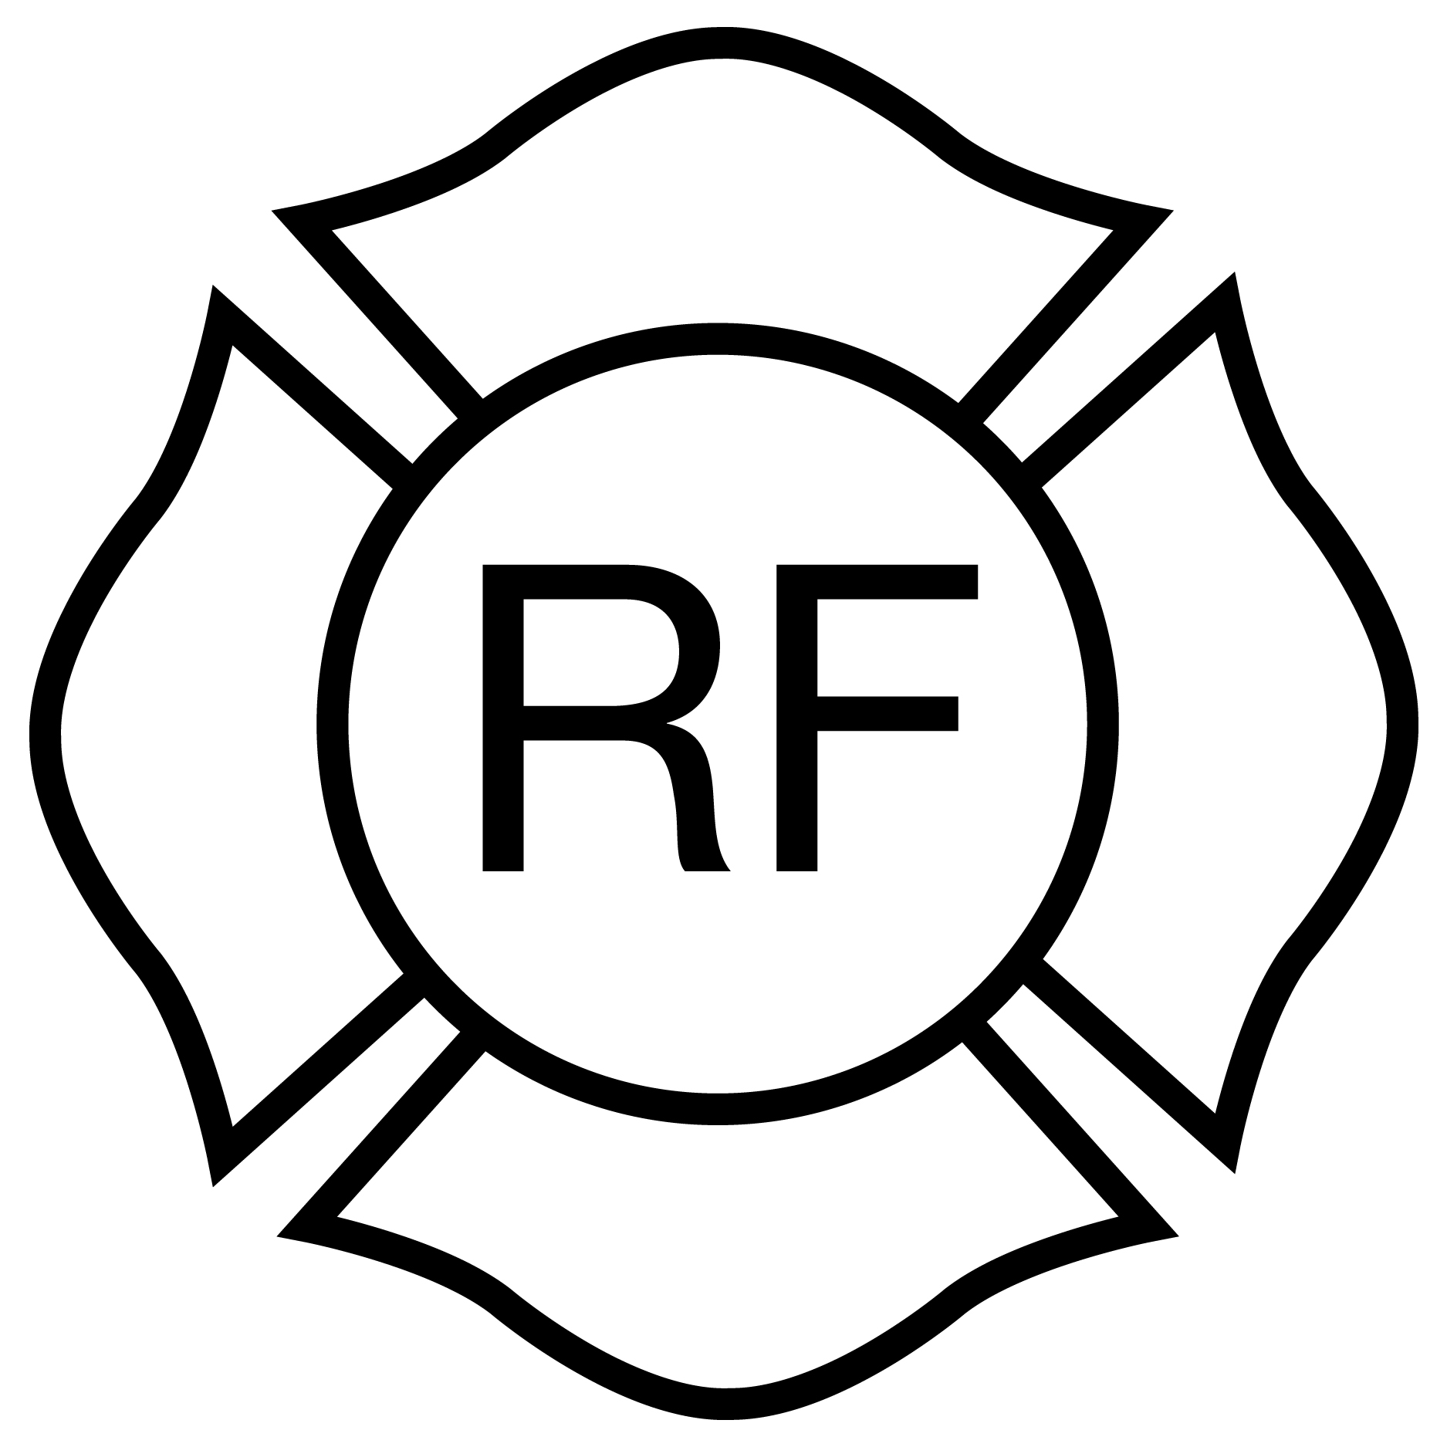

Light- frame “Floor & Roof”
Rulemaking Authority 633.01(1), 633.022, 633.0215, 633.027 FS. Law Implemented 633.01, 633.022, 633.0215, 633.027 FS. History–New 5-14-86, Amended 2-12-87, 4-8-90, 10-30-91, 4-3-95, 11-27-01, Formerly 4A-3.012, Amended 8-7-05, 5-18-08, 12-31-08, 12-13-09.

