69A-60.0081 Notice Required for Structures With Light-frame Truss-type Construction.
(1) Purpose: The purpose of this rule is to require the placement of an identifying symbol on structures constructed with a light-frame truss component in a manner sufficient to warn persons conducting fire control and other emergency operations of the existence of light-frame truss-type construction in the structure.
(2) Definitions.
(a) “Light-frame truss-type construction” means a type of construction whose primary structural elements are formed by a system of repetitive wood or light gauge steel framing members.
(b) “Approved symbol” means a Maltese Cross measuring 8 inches horizontally and 8 inches vertically, of a bright red reflective color, designed in accordance with Figure 1.
(3) Any commercial, industrial, or multiunit residential structure of three units or more, which uses horizontal or vertical light-frame truss-type construction in any portion shall be marked with an approved symbol. Townhouses are not multiunit residential structures and therefore not subject to this rule. Each approved symbol shall include within the center circle one of the following designations:
(a) Structures with light-frame truss roofs shall be marked with the letter “R”.
(b) Structures with light-frame truss floor systems shall be marked with the letter “F”.
(c) Structures with light-frame truss floor and roof systems shall be marked with the letters “RF.”
(4) The approved symbol shall be placed within 24 inches to the left of the main entry door and:
(a) Be permanently attached to the face of the structure on a contrasting background; or
(b) Be mounted on a contrasting base material which is then permanently attached to the face of the structure.
(5) The distance above the grade, walking surface or the finished floor to the bottom of the symbol shall be not less than 4 feet (48 in.).
(6) The distance above the grade, walking surface or the finished floor to the top of the symbol shall be not more than 6 feet (72 in.).
(7) In single tenant structures with multiple main entry doors, such as big box retail stores, department stores and grocery stores, the authority having jurisdiction is authorized to require that other main entry doors of the structure be marked with an approved symbol to carry out the purpose in subsection (1), above.
(8) In Multiple tenant structures and covered mall structures with multiple main entry doors, the authority having jurisdiction is authorized to require that other main entry doors of the structure be marked with an approved symbol to carry out the purpose in subsection (1), above.
(9) In multiple tenant structures and covered malls with multiple main entry doors, the authority having jurisdiction is authorized to require that other main entry doors be marked with an approved symbol to carry out the purpose in subsection (1), above. In such structures, approved symbols shall be marked on one side of the structure only and spaced not closer than 100 feet or at each end of the structure when such structure is less than 100 feet in length.
(10) The owner of each new structure required to comply with this section shall mark the structure with the approved symbol prior to receiving a certificate of occupancy.
(11) The owner of each existing structure required to comply with this section shall mark the structure with the approved symbol within 90 days of the effective date of this rule.
(12) Where the owner of the structure and the authority having jurisdiction disagree as to the use of light-frame truss-type construction within the structure, the owner shall be granted not more than 45 days to provide written verification from a licensed engineer or licensed architect; otherwise, the owner shall comply with the rule.
Figure 1:
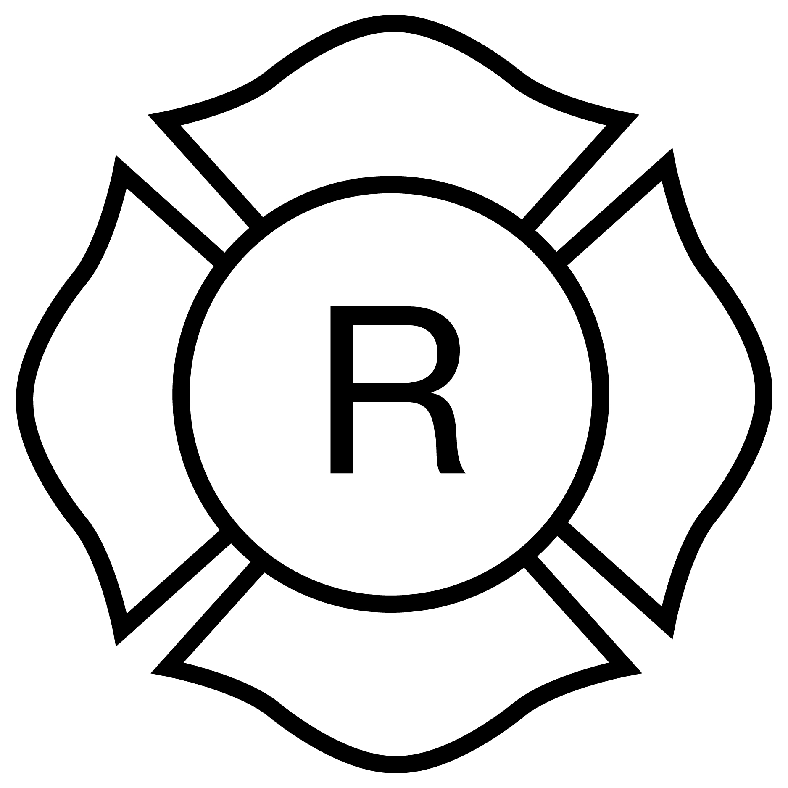
Light-frame “Roof” only

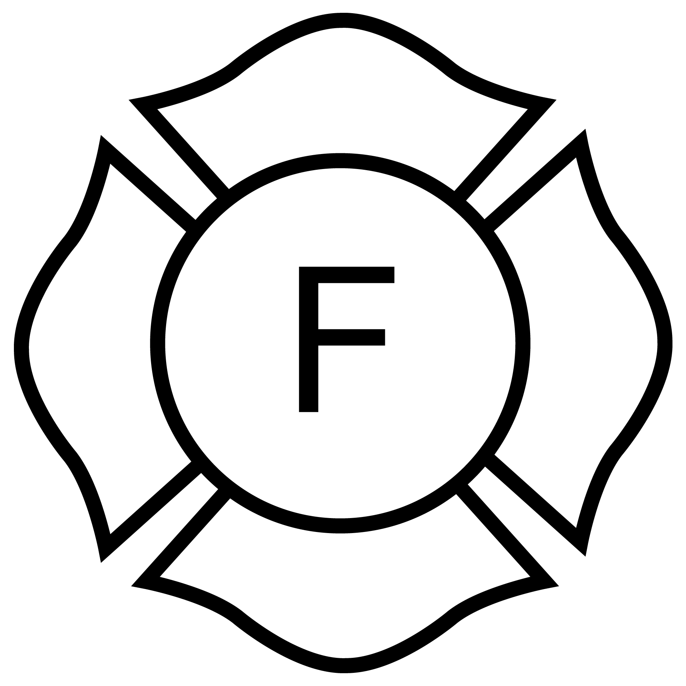
Light-frame “Floor” only

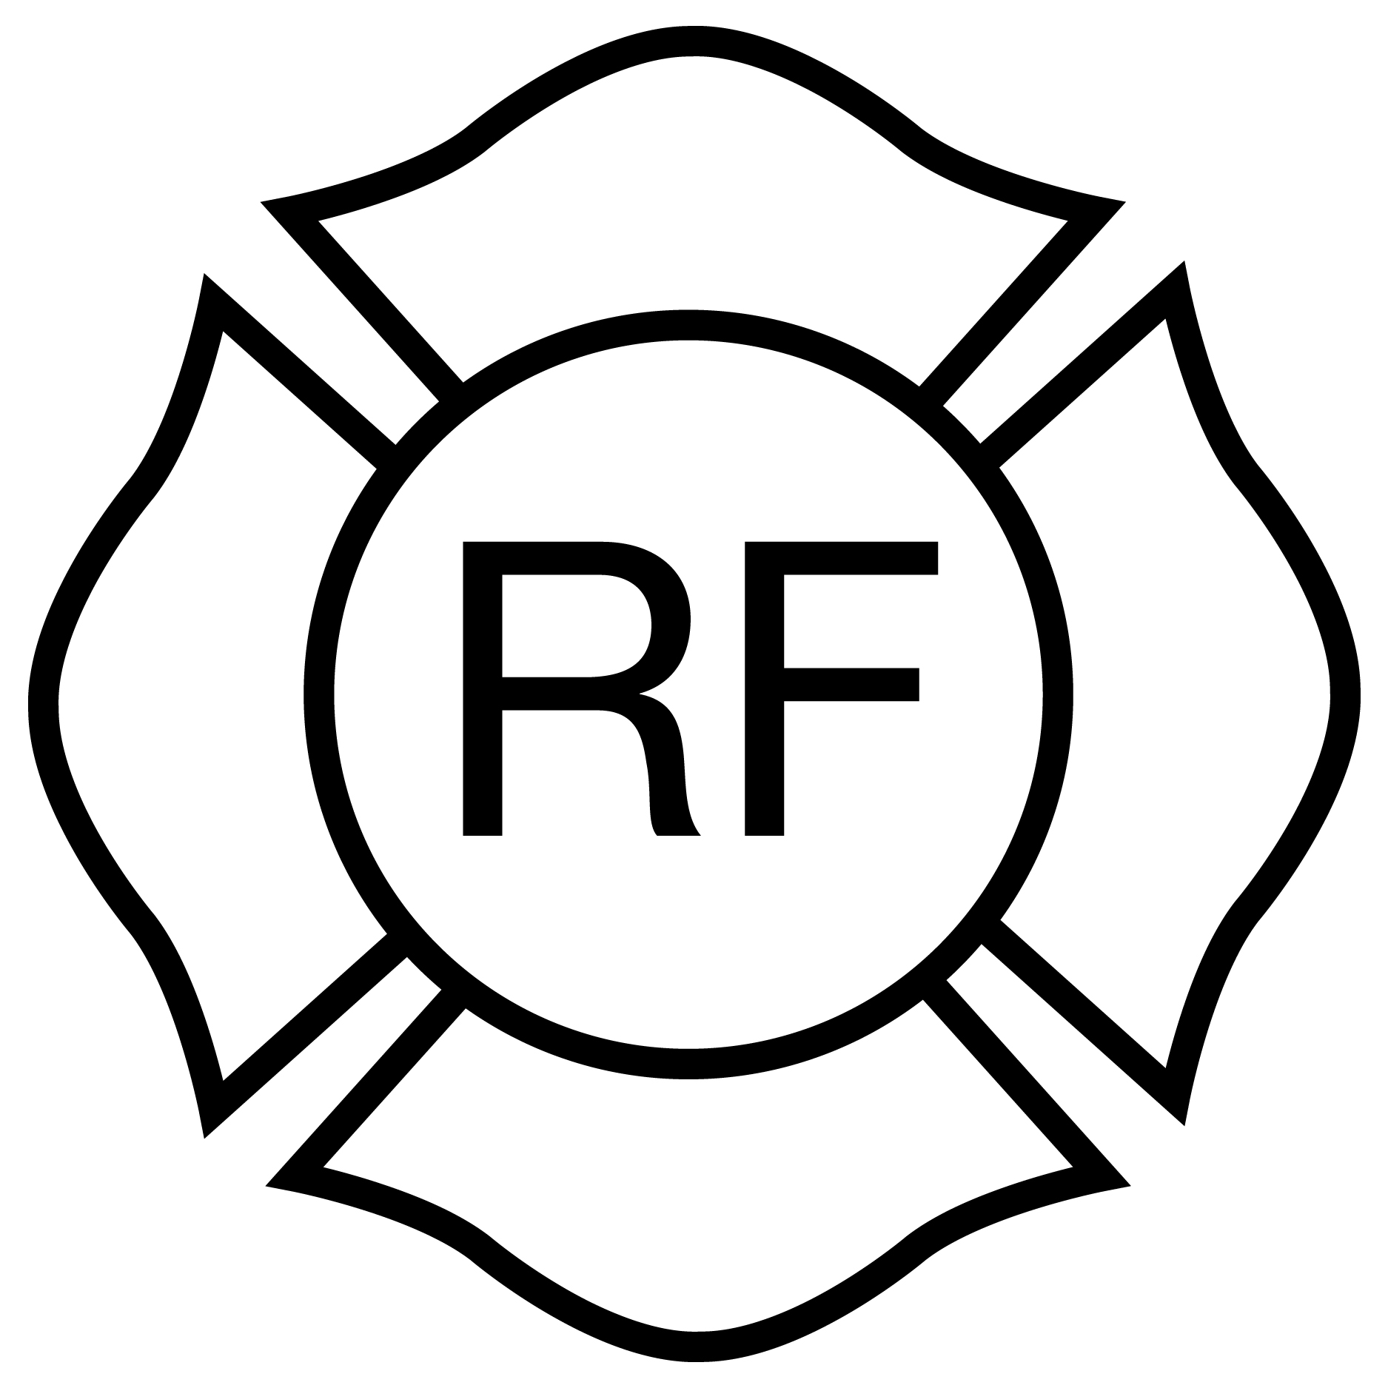
Light-frame “Floor & Roof”
Rulemaking Authority 633.104(1), 633.202, 633.206, 633.222(2) FS. Law Implemented 633.102, 633.104, 633.206, 633.222 FS. History–New 12-13-09.

