Notice of Proposed Rule

FISH AND WILDLIFE CONSERVATION COMMISSION
Vessel Registration and Boating Safety
RULE NO: RULE TITLE
68D-24.017: Palm Beach County Boating Restricted Areas
PURPOSE AND EFFECT: The purpose of this amendment is to protect vessel traffic safety on the Atlantic Intracoastal Waterway within Palm Beach County based on findings of the Palm Beach Vessel Traffic Study, analyses of boating accident and citation data, and consultation with the boating public and others who utilize the affected waterways.
SUMMARY: This rule will reduce vessel speed limits over specified portions of the Atlantic Intracoastal Waterway where necessary to manage and promote the use of this state waterway for safe and enjoyable boating. This rule creates Idle Speed No Wake zones in the vicinity of public boat ramps and public marinas with fuel docks, Slow Speed Minimum Wake zones in the vicinity of bridges and areas where vessel congestion is an issue, and a Slow Speed Minimum Wake zone on weekends and holidays from 10:00 a.m. to 6:00 p.m. in one location where vessels need to be managed to reduce congestion and large wakes during peak times of boating activity.
SUMMARY OF STATEMENT OF ESTIMATED REGULATORY COSTS: The agency has determined that this rule will not have an impact on small business. A SERC has not been prepared by the agency.
Any person who wishes to provide information regarding a statement of estimated regulatory costs, or provide a proposal for a lower cost regulatory alternative must do so in writing within 21 days of this notice.
SPECIFIC AUTHORITY: 327.04, 327.46 FS.
LAW IMPLEMENTED: 327.46 FS.
IF REQUESTED WITHIN 21 DAYS OF THE DATE OF THIS NOTICE, A HEARING WILL BE HELD AT THE DATE, TIME AND PLACE SHOWN BELOW:
DATE AND TIME: February 17-18, 2010, 8:30 a.m. – 5:00 p.m., each day
PLACE: Franklin County Courthouse, 33 Market Street, Apalachicola, Florida 32320
THE PERSON TO BE CONTACTED REGARDING THE PROPOSED RULE IS: Mr. Michael Yaun, Deputy General Counsel, 620 South Meridian Street, Tallahassee, Florida 32399-1600
THE FULL TEXT OF THE PROPOSED RULE IS:
(Substantial rewording of Rule 68D-24.017 follows. See Florida Administrative Code for present text.)
68D-24.017 Palm Beach County Boating Restricted Areas.
(1) For the purpose of regulating speed and operation of vessel traffic on the Intracoastal Waterway within Palm Beach County, Florida, the following boating restricted areas are established:
(a) Jupiter Inlet – A Slow Speed Minimum Wake zone from shoreline to shoreline, in and adjacent to the Florida Intracoastal Waterway, bounded on the north by a line drawn perpendicular to the centerline of the Florida Intracoastal Waterway 300 feet north of the north end of the fender of the SR 707 (Gomez Rd.) Bridge; bounded on the northwest by a line drawn perpendicular to the centerline of the Loxahatchee River 300 feet northwest of the northwest end of the fender of the Florida East Coast Railroad bridge located adjacent to the SR 811 (Alternate A-1-A) Bridge; bounded on the south by a line drawn perpendicular to the centerline of the Florida Intracoastal Waterway 500 feet south of the south end of the fender of the SR 706 (Indiantown Rd.) Bridge; and bounded on the east by a line drawn due north across the Jupiter Inlet from the western tip of the jetty at DuBois Park to the southwest corner of Jupiter Island, and including all waters of and tributaries to Sawfish Bay and the Jupiter River, as depicted in drawing A.
(b) Donald Ross Bridge – A Slow Speed Minimum Wake zone from shoreline to shoreline, in and adjacent to the Florida Intracoastal Waterway, bounded on the north by a line drawn perpendicular to the centerline of the Florida Intracoastal Waterway 300 feet north of the north end of the fender of the Donald Ross Bridge, and bounded on the south by a line drawn perpendicular to the centerline of the Florida Intracoastal Waterway 300 feet south of the south end of the fender of the bridge, as depicted in drawing B.
(c) Bert Winter Park Boat Ramp – An Idle Speed No Wake zone from shoreline to shoreline, in and adjacent to the Florida Intracoastal Waterway, bounded on the north by a line drawn perpendicular to the centerline of the Florida Intracoastal Waterway 300 feet north of the centerline of the Bert Winter Park boat ramp, and bounded on the south by a line drawn perpendicular to the centerline of the Florida Intracoastal Waterway 300 feet south of the centerline of the Bert Winter Park boat ramp, as depicted in drawing C.
(d) Juno Park Boat Ramp to PGA Boulevard Bridge – An Idle Speed No Wake zone from shoreline to shoreline, in and adjacent to the Florida Intracoastal Waterway, bounded on the north by a line drawn perpendicular to the centerline of the Florida Intracoastal Waterway 300 feet north of Juno Park, and bounded on the south by a line drawn perpendicular to the centerline of the Florida Intracoastal Waterway 3,000 feet south of the PGA Blvd. bridge, as depicted in drawing D.
(e) US 1 (SR 5) Bridge – An Idle Speed Minimum Wake zone from shoreline to shoreline, in and adjacent to the Florida Intracoastal Waterway, bounded on the northwest by a line drawn perpendicular to the centerline of the Florida Intracoastal Waterway 500 feet northwest of the northwest end of the fender of the US 1 (SR 5) bridge, and bounded on southeast by a line drawn perpendicular to the centerline of the Florida Intracoastal Waterway, headland to headland, across the mouth of Lake Worth Creek at its southern terminus at Lake Worth, as depicted in drawing E.
(f) Peanut Island, Blue Heron Bridge and Lake Worth Inlet – A Slow Speed Minimum Wake zone from shoreline to shoreline, in and adjacent to the Florida Intracoastal Waterway including all waters of Lake Worth, bounded on the north by a line drawn perpendicular to the centerline of the Florida Intracoastal Waterway at the north shoreline of Phil Foster Island, from the mainland at Riviera Beach to Singer Island; bounded on the southeast by a line drawn from the southwest corner of Singer Island to the nearest channel marker marking the northern edge of the Lake Worth Inlet Channel (flashing marker “8”) and running along the line of channel markers marking the northern edge of the Lake Worth Inlet Channel and the Port of Palm Beach Turning Basin to the westernmost channel marker marking the northern edge of the Port of Palm Beach Turning Basin (flashing marker “12”); and bounded on the south by a line drawn perpendicular to the centerline of the Florida Intracoastal Waterway, from the westernmost channel marker marking the northern edge of the Port of Palm Beach Turning Basin to the mainland at the southeast corner of the Port of Palm Beach Slip 1, Berth 6, Bay 49, as depicted in drawing F.
(g) Flagler Memorial Bridge – A Slow Speed Minimum Wake zone from shoreline to shoreline, in and adjacent to the Florida Intracoastal Waterway, bounded on the north by a line drawn perpendicular to the centerline of the Florida Intracoastal Waterway 1,100 feet north of the north end of the fender of the Flagler Memorial Bridge, and bounded on the south by a line drawn perpendicular to the centerline of the Florida Intracoastal Waterway 1,500 feet south of the south bridge fender, as depicted in drawing G.
(h) SR 704 (Royal Park) Bridge – A Slow Speed Minimum Wake zone from shoreline to shoreline, in and adjacent to the Florida Intracoastal Waterway, bounded on the north by a line drawn perpendicular to the centerline of the Florida Intracoastal Waterway 300 feet north of the north end of the fender of the SR 704 (Royal Park) Bridge and bounded on the south by a line drawn perpendicular to the centerline of the Florida Intracoastal Waterway 300 feet south of the southernmost dock of the Town of Palm Beach Public Docks (Peruvian Ave.), as depicted in drawing H.
(i) SR 80 (Southern Blvd.) Bridge – A Slow Speed Minimum Wake zone, in and adjacent to the Florida Intracoastal Waterway, bounded on the north by a line drawn perpendicular to the centerline of the Florida Intracoastal Waterway 300 feet north of the north end of the bridge fender of the SR 80 (Southern Blvd.) Bridge, and bounded on the east by a line drawn parallel to and 500 feet east of the centerline of the Florida Intracoastal Waterway and the western shoreline of Bingham Island and bounded on the south by a line drawn perpendicular to the centerline of the Florida Intracoastal Waterway 300 feet south of the south end of the bridge fender, as depicted in drawing I.
(j) SR 802 (Lake Worth) Bridge – A Slow Speed Minimum Wake zone from shoreline to shoreline, in and adjacent to the Florida Intracoastal Waterway, bounded on the north by a line drawn perpendicular to the centerline of the Florida Intracoastal Waterway 300 feet north of the north end of the fender of the SR 802 (Lake Worth) Bridge, and bounded on the south by a line drawn perpendicular to the centerline of the Florida Intracoastal Waterway 300 feet south of the centerline of the Bryant Park boat ramp, as depicted in drawing J.
(k) SR 812 (Lantana Ave.) Bridge – A Slow Speed Minimum Wake zone from shoreline to shoreline, in and adjacent to the Florida Intracoastal Waterway, bounded on the north by a line drawn perpendicular to the centerline of the Florida Intracoastal Waterway at the north end of Hypoluxo Island and bounded on the south by a line drawn perpendicular to the centerline of the Florida Intracoastal Waterway 300 feet south of the south end of the bridge fender, as depicted in drawing K.
(l) SR 804 (East Ocean Ave.) Bridge – An Idle Speed No Wake zone from shoreline to shoreline, in and adjacent to the Florida Intracoastal Waterway, bounded on the north by a line drawn perpendicular to the centerline of the Florida Intracoastal Waterway 575 feet north of the north end of the fender of the SR 804 (East Ocean Ave.) Bridge, and bounded on the south by a line drawn perpendicular to the centerline of the Florida Intracoastal Waterway 300 feet south of the south end of the bridge fender, as depicted in drawing L.
(m) 15th Ave. (Woolbright Rd.) Bridge – A Slow Speed Minimum Wake zone from shoreline to shoreline, in and adjacent to the Florida Intracoastal Waterway, bounded on the north by a line drawn perpendicular to the centerline of the Florida Intracoastal Waterway 300 feet north of the north end of the fender of the 15th Avenue (Woolbright Rd.) Bridge, and bounded on the south by a line drawn perpendicular to the centerline of the Florida Intracoastal Waterway 300 feet south of the south end of the bridge fender, as depicted in drawing M.
(n) NE 8th Street (George Bush Blvd.) Bridge – An Idle Speed No Wake zone from shoreline to shoreline, in and adjacent to the Florida Intracoastal Waterway, bounded on the north by a line drawn perpendicular to the centerline of the Florida Intracoastal Waterway 300 feet north of the north end of the fender of the NE 8th Street (George Bush Blvd.) Bridge, and bounded on the south by a line drawn perpendicular to the centerline of the Florida Intracoastal Waterway 600 feet south of the south end of the bridge fender, as depicted in drawing N.
(o) SR 806 (East Atlantic Ave.) Bridge – A Slow Speed Minimum Wake zone from shoreline to shoreline, in and adjacent to the Florida Intracoastal Waterway, bounded on the north by a line drawn perpendicular to the centerline of the Florida Intracoastal Waterway 300 feet north of the north end of the fender of the SR 806 (East Atlantic Ave.) Bridge, and bounded on the south by a line drawn perpendicular to the centerline of the Florida Intracoastal Waterway, 500 feet north of the centerline of the Knowles Park boat ramp, as depicted in drawing O.
(p) Knowles Park Boat Ramp – An Idle Speed No Wake zone from shoreline to shoreline, in and adjacent to the Florida Intracoastal Waterway, bounded on the north by a line drawn perpendicular to the centerline of the Florida Intracoastal Waterway, 500 feet north of the centerline of the Knowles Park boat ramp, and bounded on the south by a line drawn perpendicular to the centerline of the Florida Intracoastal Waterway 300 feet north of the north end of the fender of the 12th Street (Linton Blvd.) Bridge, as depicted in drawing P.
(q) 12th Street (Linton Blvd.) Bridge – A Slow Speed Minimum Wake zone from shoreline to shoreline, in and adjacent to the Florida Intracoastal Waterway, bounded on the north by a line drawn perpendicular to the centerline of the Florida Intracoastal Waterway 300 feet north of the north end of fender of the 12th Street (Linton Blvd.) Bridge, and bounded on the south by a line drawn perpendicular to the centerline of the Florida Intracoastal Waterway 300 feet south of the south end of the bridge fender, as depicted in drawing Q.
(r) SR 800 (Spanish River Blvd.) Bridge – A Slow Speed Minimum Wake zone from shoreline to shoreline, in and adjacent to the Florida Intracoastal Waterway, bounded on the north by a line drawn perpendicular to the centerline of the Florida Intracoastal Waterway 300 feet north of the north end of the fender of the SR 800 (Spanish River Blvd.) Bridge, and bounded on the south by a line drawn perpendicular to the centerline of the Florida Intracoastal Waterway 300 feet south of the south end of the bridge fender, as depicted in drawing R.
(s) SR 798 (Palmetto Park Rd.) Bridge and Silver Palm Park Boat Ramp Zones
1. Lake Wyman Vicinity to SR 798 (Palmetto Park Rd.) Bridge – A Slow Speed Minimum Wake zone from shoreline to shoreline, in and adjacent to the Florida Intracoastal Waterway, in the vicinity of marker 63 (which is in the southern portion of Lake Wyman), and bounded on the south by a line drawn perpendicular to the centerline of the Florida Intracoastal Waterway 300 feet north of the northern end of the fender system of the SR 798 (Palmetto Park Rd.) Bridge, as depicted in drawing S.
2. Silver Palm Park Boat Ramp and SR 798 Bridge – An Idle Speed No Wake zone from shoreline to shoreline, in and adjacent to the Florida Intracoastal Waterway, bounded on the north by a line drawn perpendicular to the centerline of the Florida Intracoastal Waterway 300 feet north of the north end of the fender of the SR 798 (Palmetto Park Rd.) Bridge, and bounded on the south by a line drawn perpendicular to the centerline of the Florida Intracoastal Waterway 500 feet south of the centerline of the Silver Palm Park boat ramp, as depicted in drawing S.
(t) A-1-A (Ocean Ave). Bridge – A Slow Speed Minimum Wake zone from shoreline to shoreline, in the Boca Raton Inlet, bounded on the northwest by a line drawn perpendicular to the centerline of the channel 300 feet northwest of the northwest end of the fender of the A-1-A (Ocean Ave.) Bridge, and bounded on the south by a line drawn perpendicular to the centerline of the channel 300 feet south of the south end of the bridge fender, as depicted in drawing T.
(u) Camino Real Zones –
1. Camino Real Bridge – A Slow Speed Minimum Wake zone from shoreline to shoreline, in and adjacent to the Florida Intracoastal Waterway, bounded on the north by a line drawn perpendicular to the centerline of the Florida Intracoastal Waterway 300 feet north of the north end of the fender of the Camino Real Bridge, and bounded on the south by a line drawn perpendicular to the centerline of the Florida Intracoastal Waterway 300 feet south of the south end of the bridge fender, as depicted in drawing U.
2. Camino Real Bridge to Palm Beach-Broward County Line – A Slow Speed Minimum Wake zone to be in effect from 10:00 a.m. to 6:00 p.m. on Saturdays, Sundays, and Holidays, in and adjacent to the Florida Intracoastal Waterway, bounded on the north by a line drawn perpendicular to the centerline of the Florida Intracoastal Waterway 300 feet south of the south end of the fender of the Camino Real Bridge, and bounded on the south by the Palm Beach-Broward County Line, as depicted in drawing U.
(2) The boating restricted areas described in Rule 68D-24.017, F.A.C., are depicted on the following drawings:
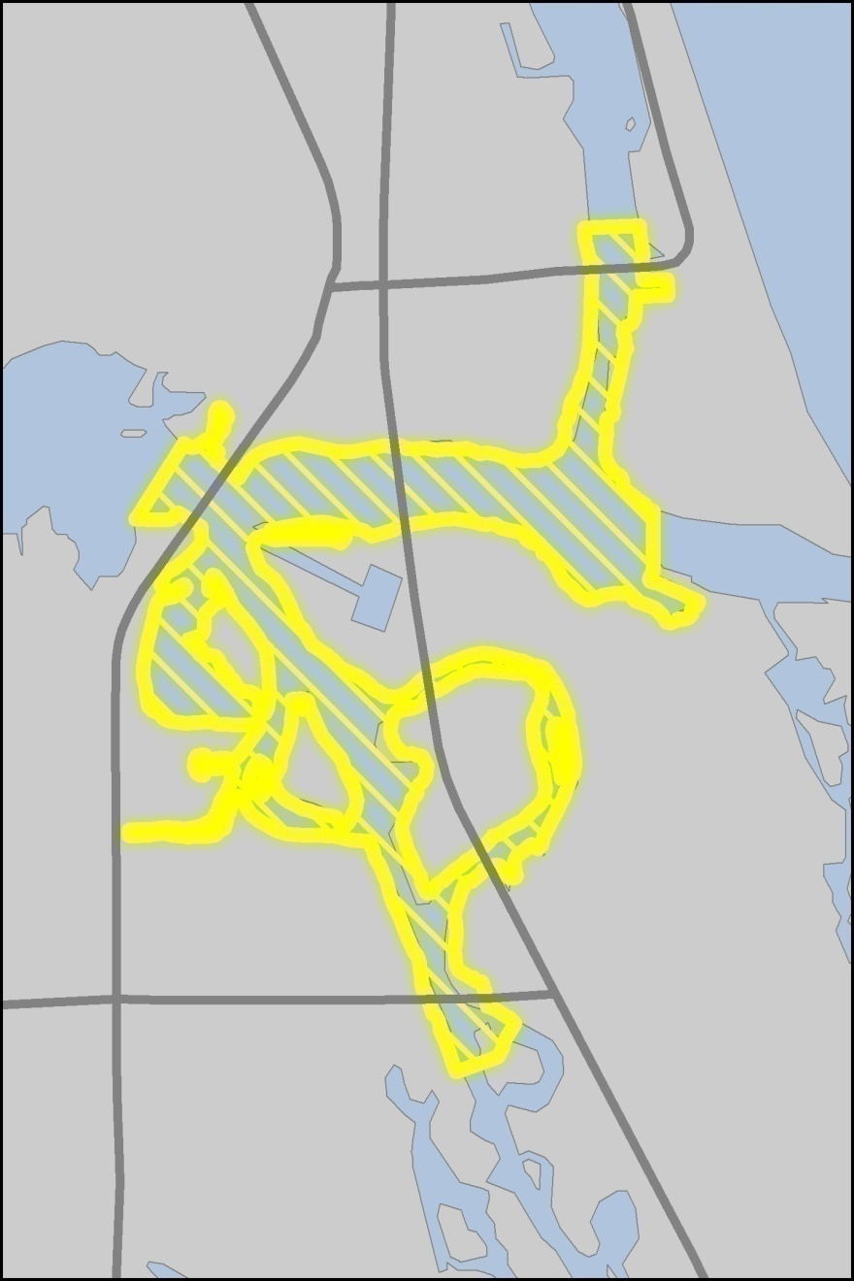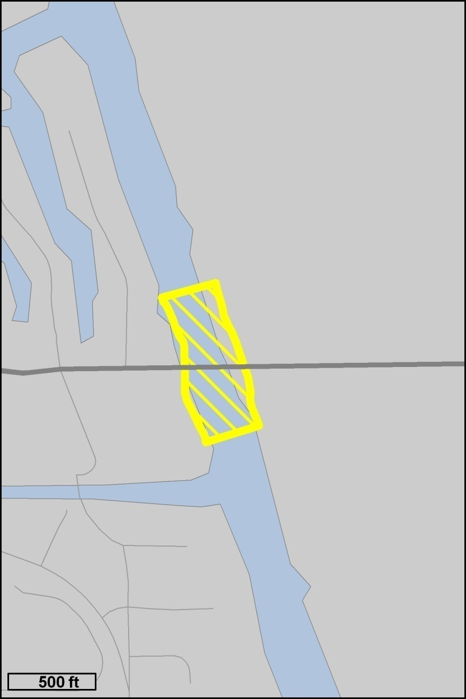
Drawing A – Jupiter Inlet
Drawing B – Donald Ross Bridge

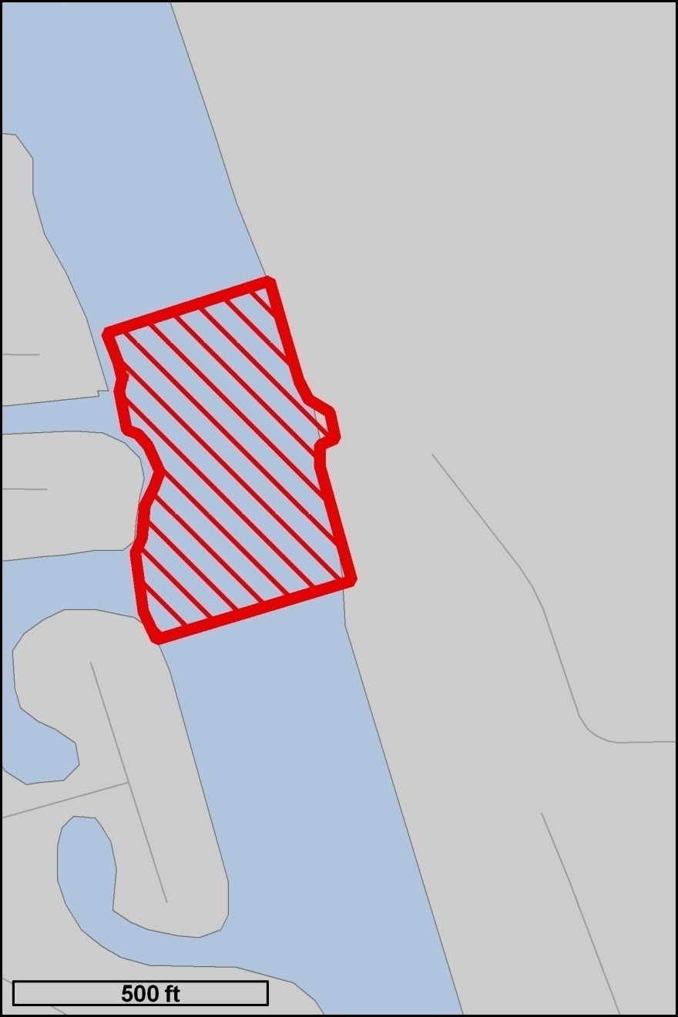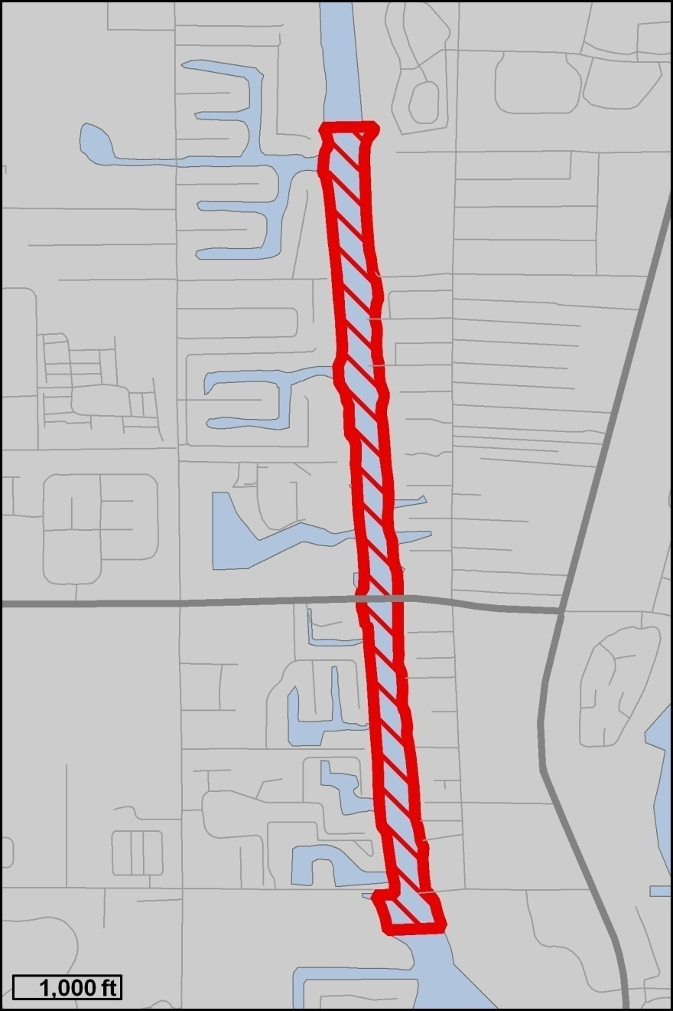
Drawing C – Bert Winter Park Boat Ramp
Drawing D – Juno Park Boat Ramp to PGA Blvd. Bridge

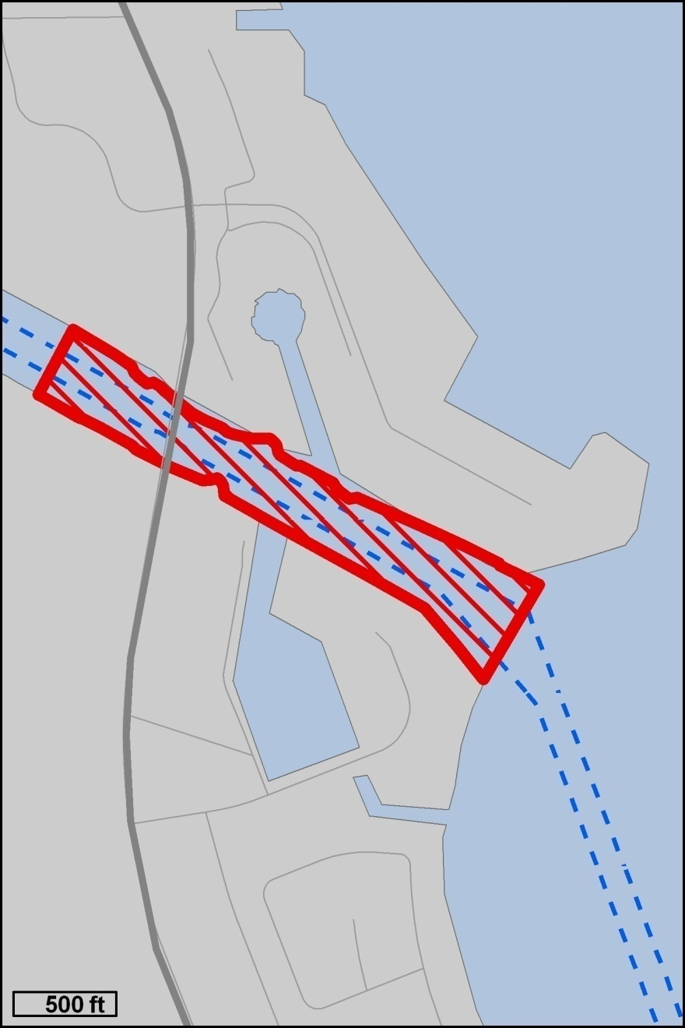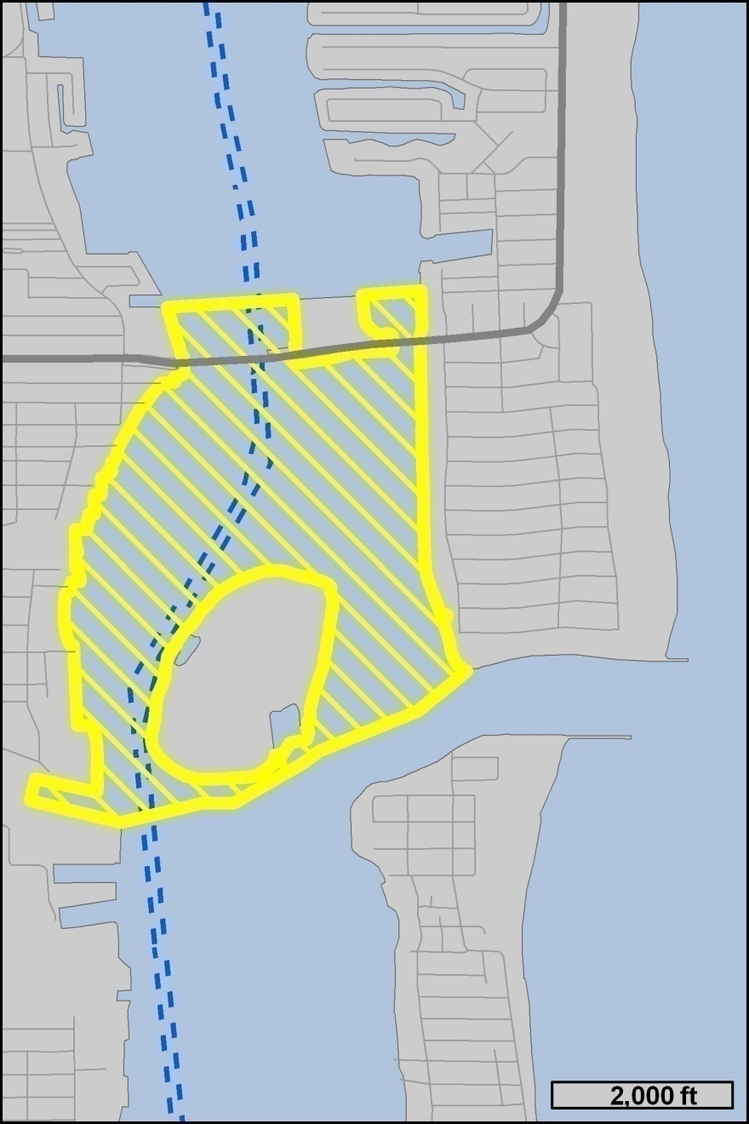
Drawing F – Peanut Island, Blue Heron Bridge and Lake Worth Inlet
Drawing E – US 1 (SR 5) Bridge

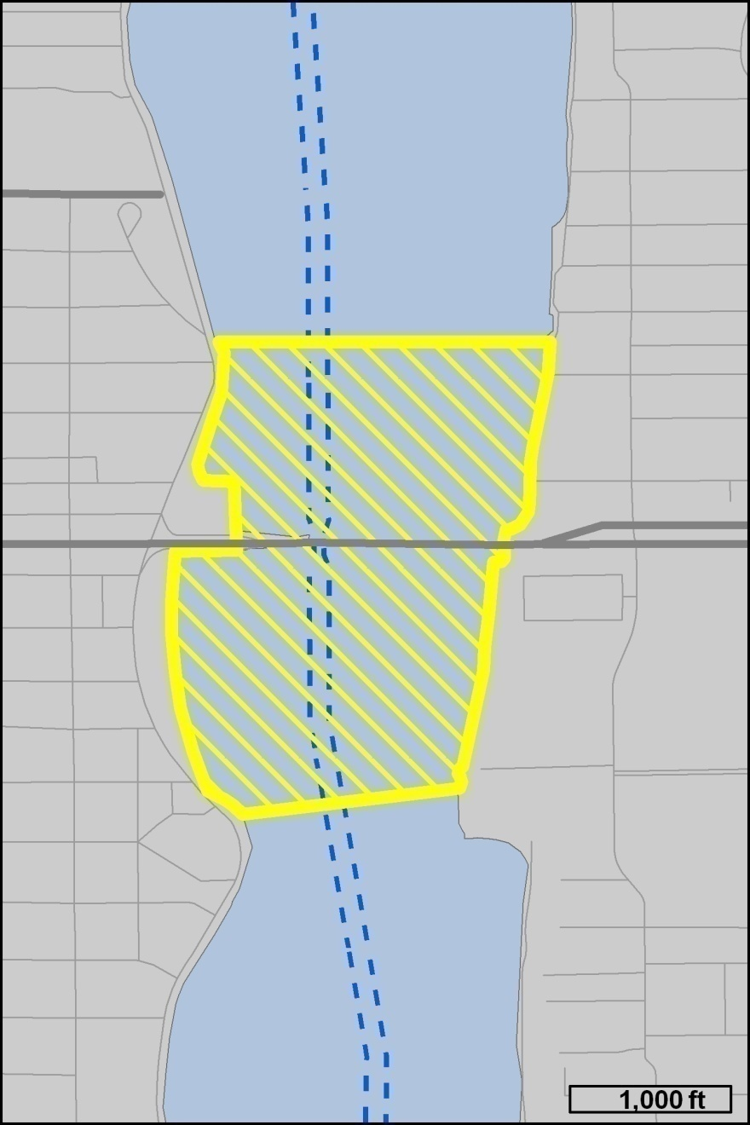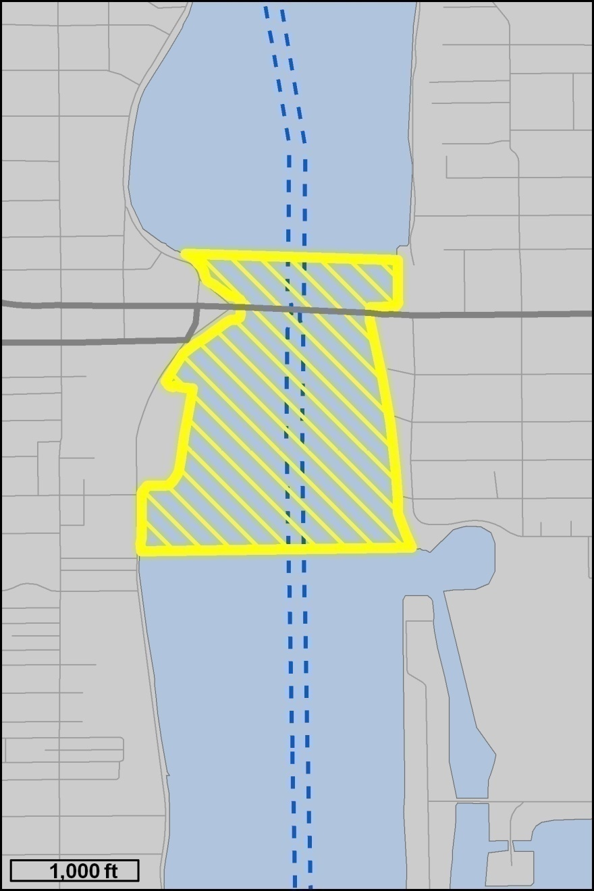
Drawing G – Flagler Memorial Bridge
Drawing H – SR 704 (Royal Park) Bridge
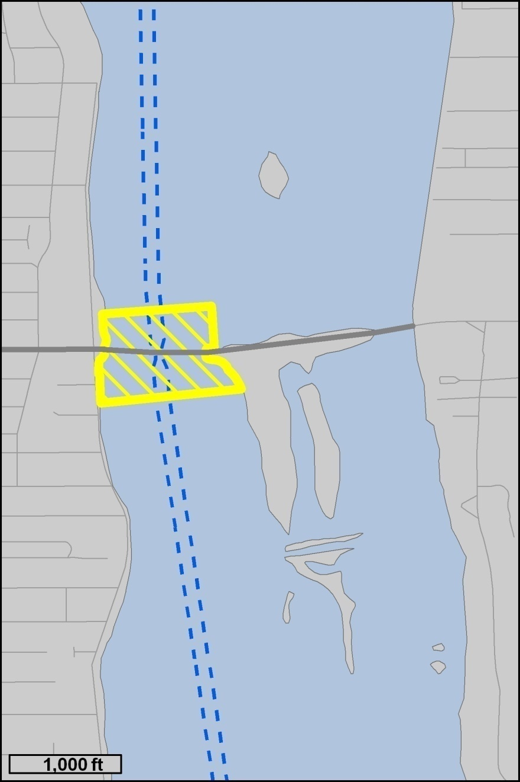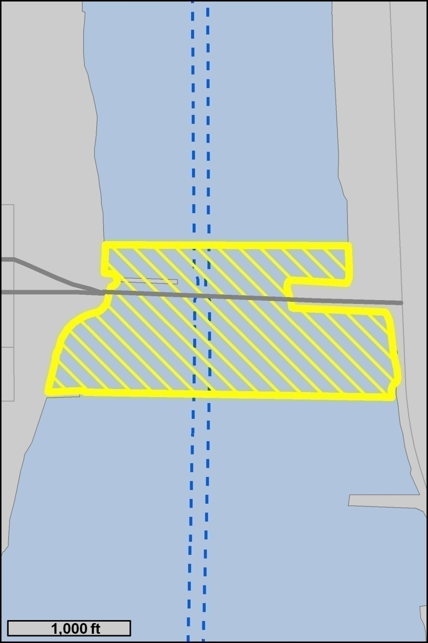
Drawing I – SR 80 (Southern Blvd.) Bridge
Drawing J – SR 802 (Lake Worth) Bridge

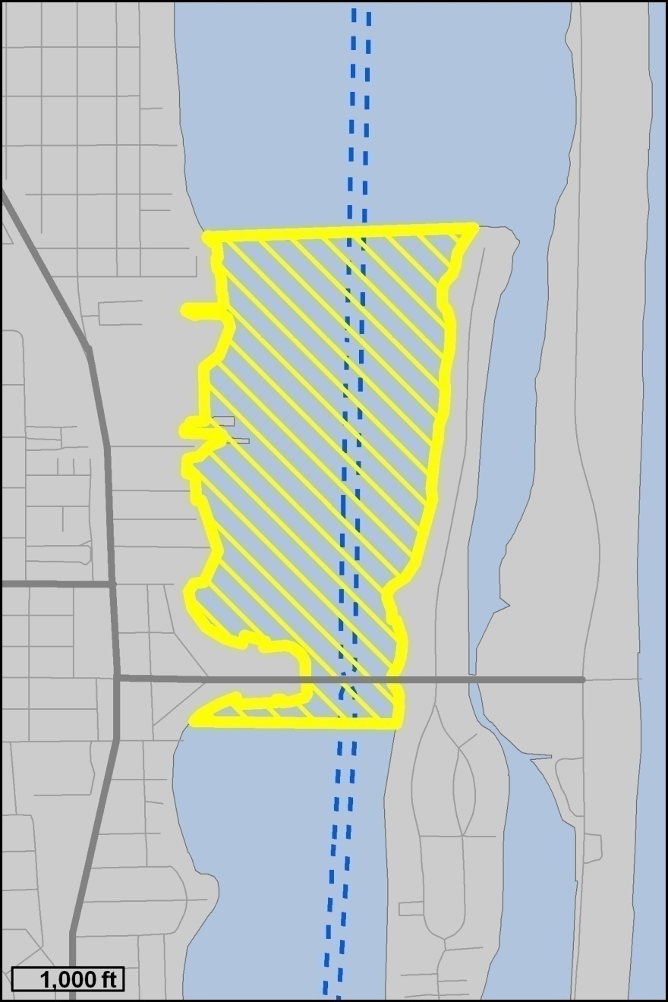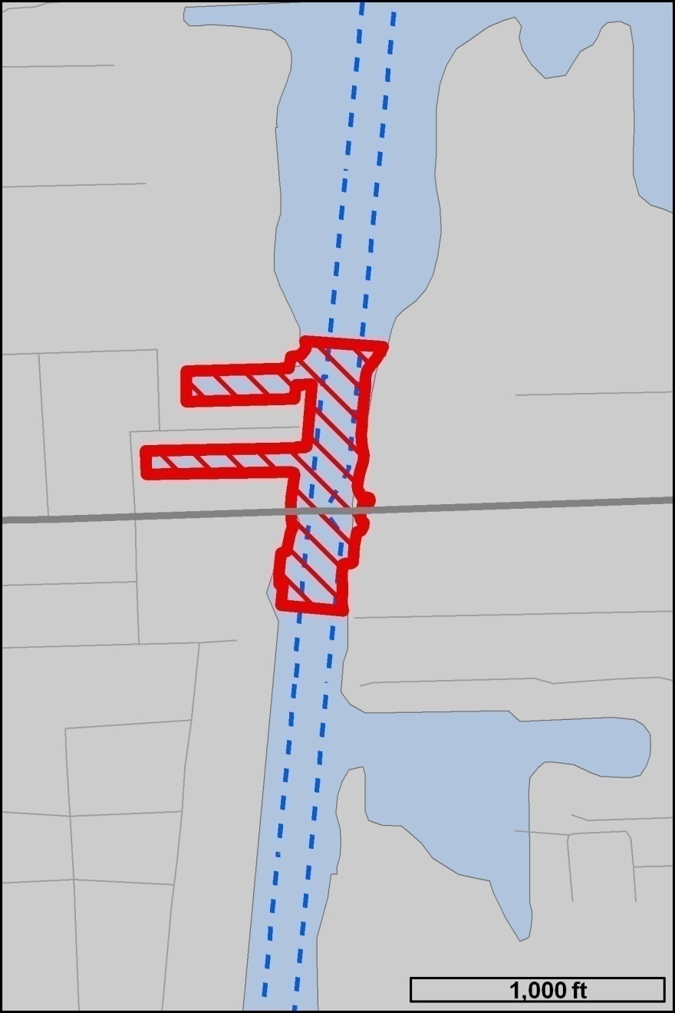
Drawing K – SR 812 (Lantana Ave.) Bridge
Drawing L – SR 804 (East Ocean Ave.) Bridge
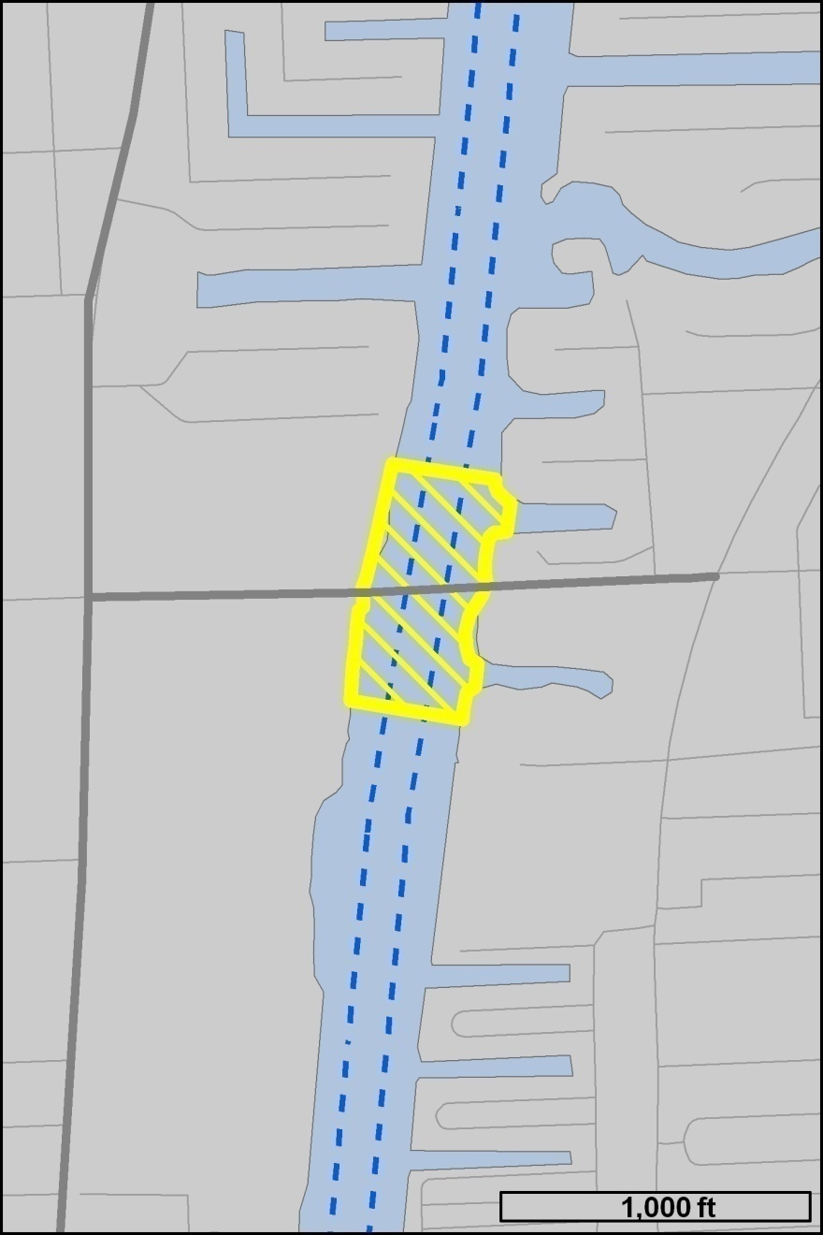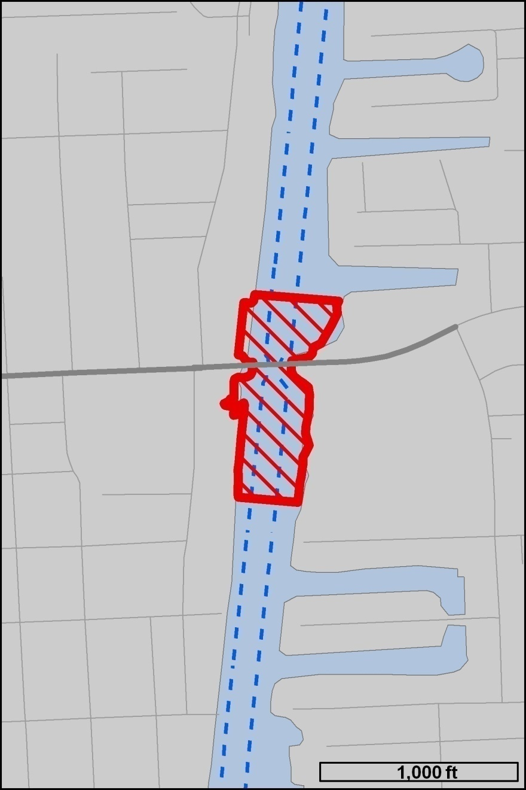
Drawing M – 15th Ave. (Woolbright Rd.) Bridge
Drawing N – NE 8th St. (George Bush Blvd.) Bridge

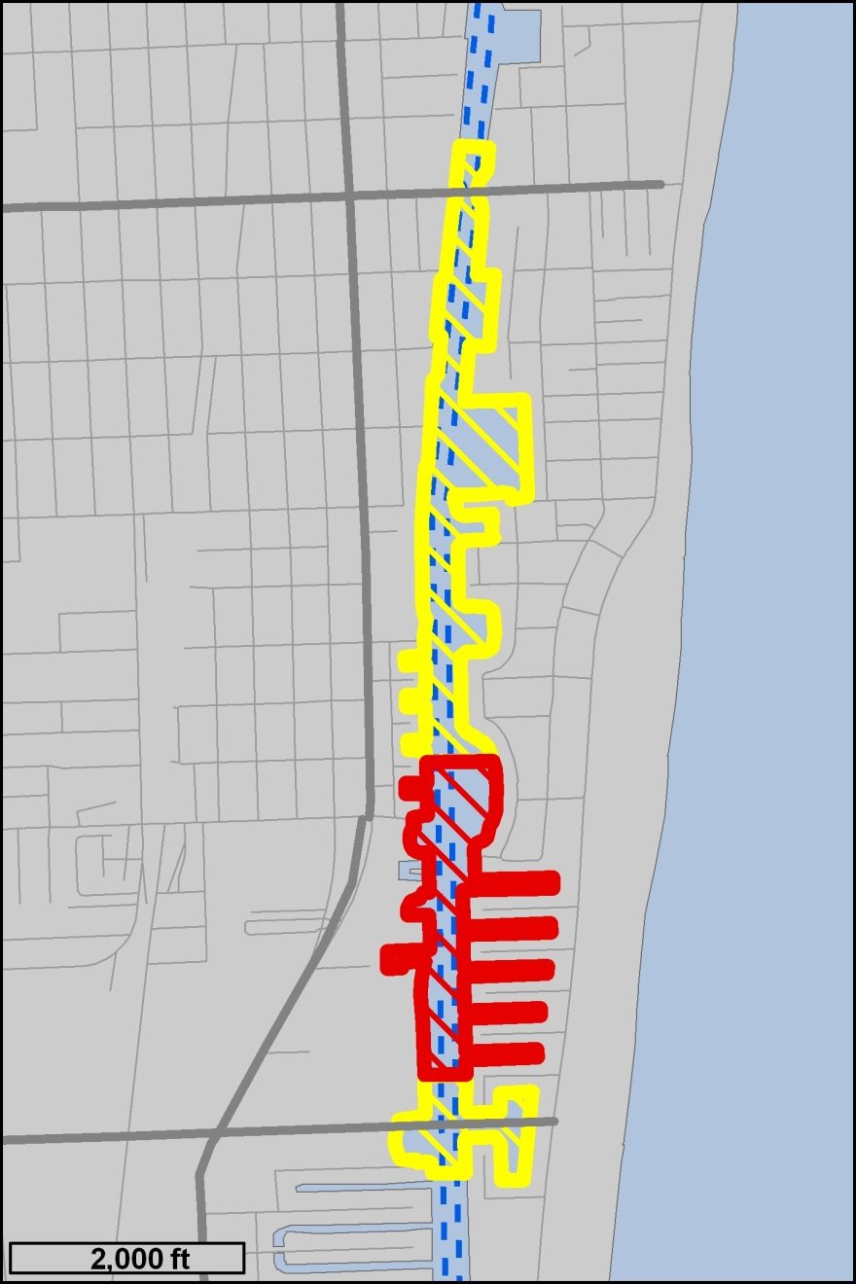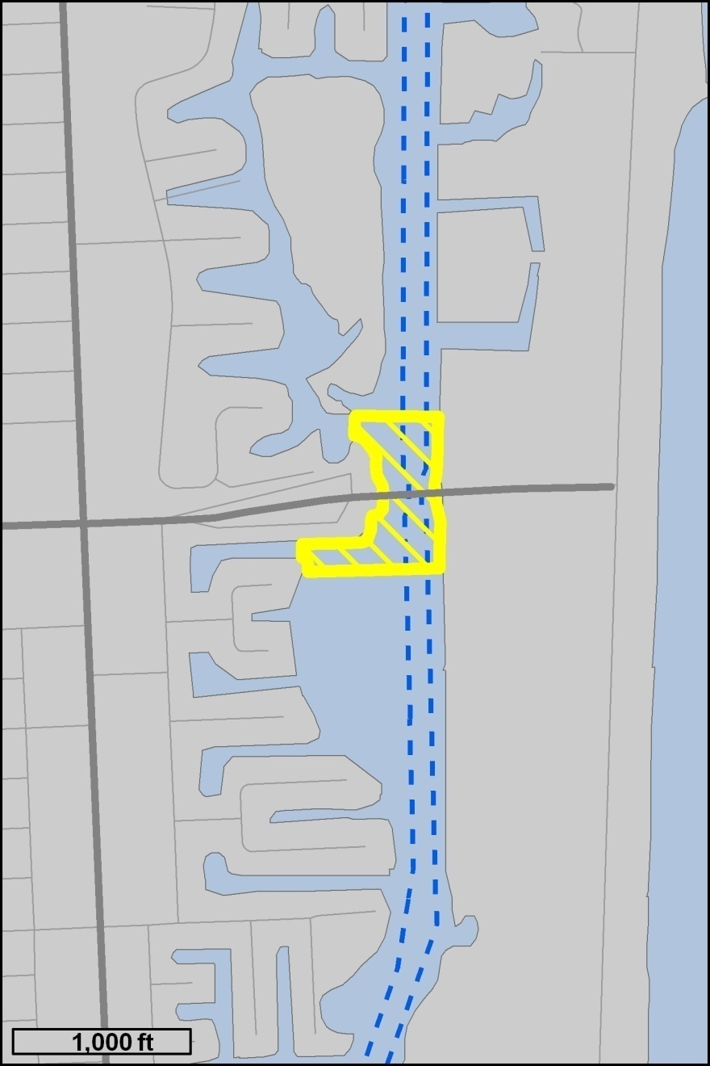
Drawings O, P and Q – SR 806 (East Atlantic Ave.) Bridge, Knowles Park and 12th St. (Linton Blvd.) Bridge
Drawing R – SR 800 (Spanish River Blvd.) Bridge
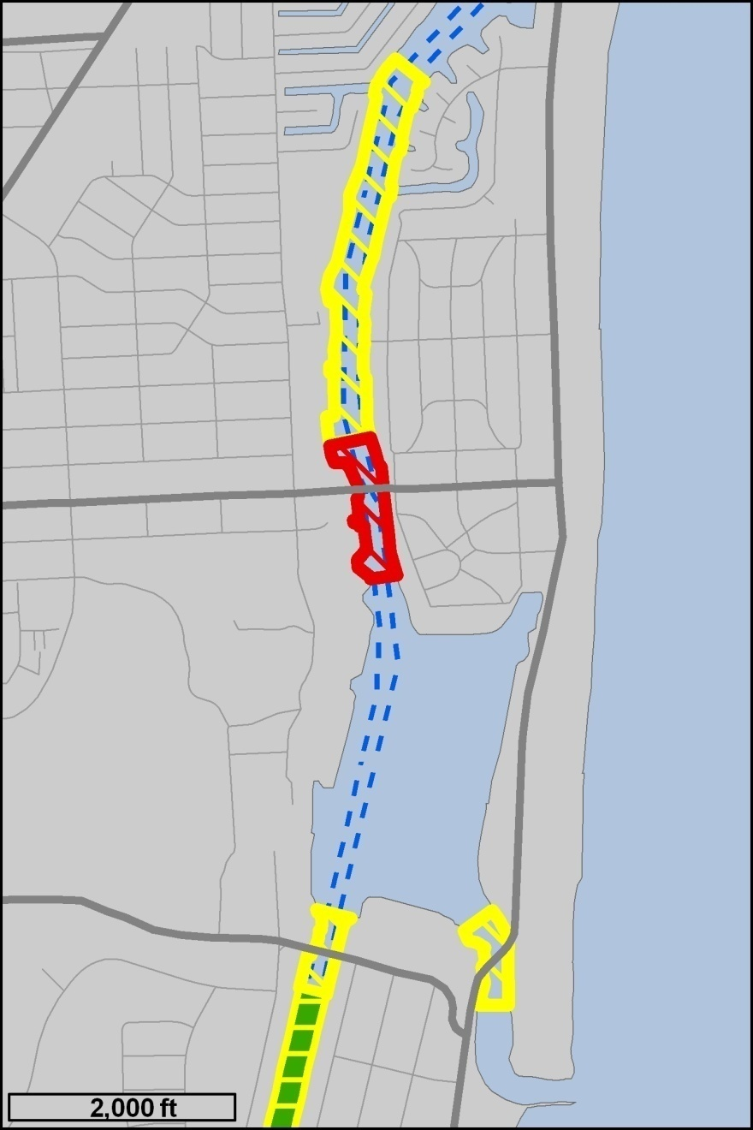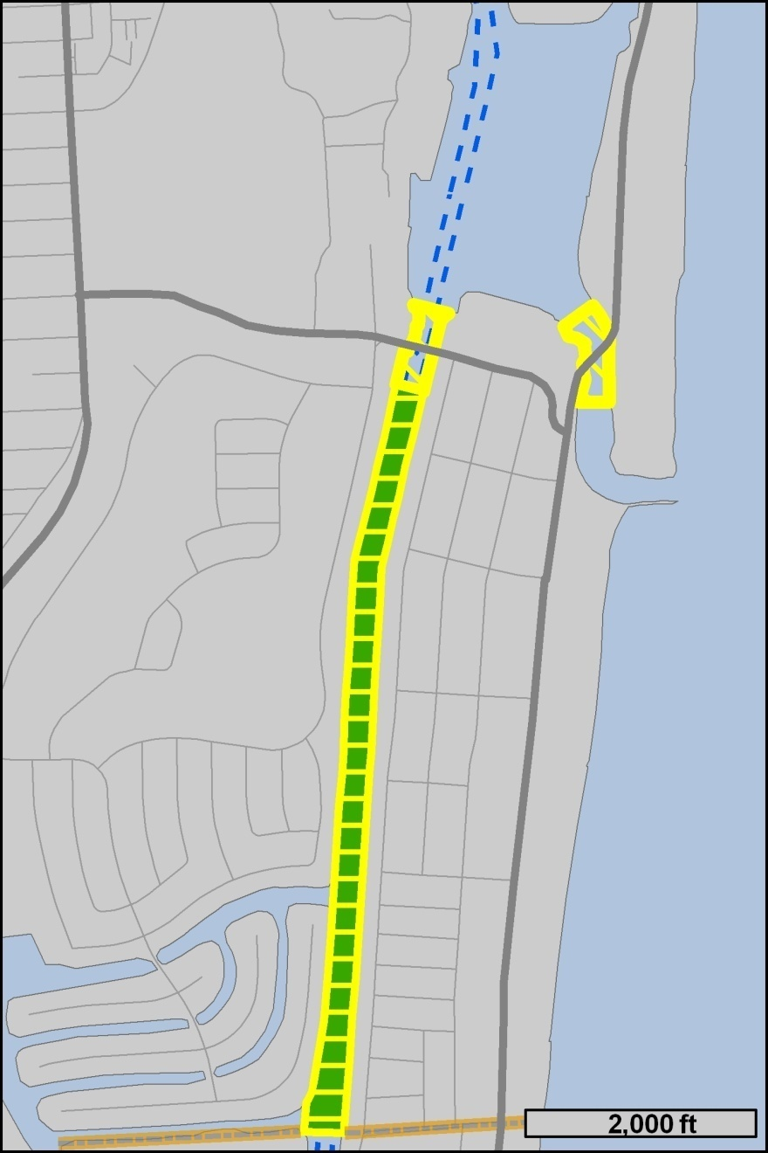
Drawing S – SR 798 (Palmetto Park Rd.) Bridge and Silver Palm Park Boat Ramp
Drawings T and U – A-1-A (Ocean Ave.) Bridge and Camino Real Zones

Rulemaking Specific Authority 327.04, 327.46 FS. Law implemented 327.46 FS. History–New 2-28-91, Amended 8-6-92, 6-14-93, Formerly 16N-24.017, Amended 10-27-97, 3-3-99, Formerly 62N-24.017, Amended________.

NAME OF PERSON ORIGINATING PROPOSED RULE: Captain Richard Moore, Boating Law Administrator, 620 South Meridian Street, Tallahassee, Florida 32399-1600
NAME OF AGENCY HEAD WHO APPROVED THE PROPOSED RULE: Florida Fish and Wildlife Conservation Commission sitting
DATE PROPOSED RULE APPROVED BY AGENCY HEAD: December 10, 2009
DATE NOTICE OF PROPOSED RULE DEVELOPMENT PUBLISHED IN FAW: July 31, 2009

