Notice of Proposed Rule

FISH AND WILDLIFE CONSERVATION COMMISSION
Manatees
RULE NO: RULE TITLE
68C-22.026: Sarasota and Associated County (Parts of Manatee and Charlotte) Zones
PURPOSE AND EFFECT: The purpose of the proposed rule making action is to improve protection of manatees and manatee habitat in Sarasota County by amending the existing regulations that limit allowable motorboat speed in portions of the county. These actions are being proposed after considering: [1] new information, analyses, and reports that have been collected, performed, or prepared since the existing zones were established; [2] existing federal manatee protection regulations in portions of the county; and [3] recommendations made by the Sarasota County Local Rule Review Committee that was formed pursuant to Section 379.2431(2)(f), F.S. The effect of the action would be to amend the zones that limit allowable motorboat speed in portions of the county and to revise other provisions of the rule, including those pertaining to the availability of permits for commercial fishing and professional fishing guide activities.
SUMMARY: New or expanded manatee protection zones would be added in the western portion of Sarasota Bay in the vicinity of New Pass and Bird Key, while the Manatee County portion of the existing zone in the Buttonwood Harbor area would be removed. Seven segments of the Intracoastal Waterway channel (totaling approximately 2.6 miles) between Siesta Key and Forked Creek (in Lemon Bay) would be changed from 25 MPH to Slow Speed, and the existing zone at Venice Inlet would be extended approximately 450 feet westward (into) the inlet. Zones would also be added in a section of Little Sarasota Bay to mirror the existing federal zones. The maps accompanying this notice show only those areas where the zones would change. Adoption of the proposed changes would increase the amount of area regulated for manatee protection in the county by 3% (313 acres) and increase the amount of time required to transit the county in the Intracoastal Waterway by 15 minutes. The section of the rule dealing with permits for commercial fishers and professional fishing guides would be amended to narrow the permits to cover only commercial fishing net-setting activities. Other changes to the rule would amend the preamble language to make it consistent with current statutory and rule language and otherwise clean up zone descriptions to improve accuracy and make the descriptions easier to understand.
SUMMARY OF STATEMENT OF ESTIMATED REGULATORY COSTS: The agency has determined that this rule will not have an impact on small business. A SERC has not been prepared by the agency.
Any person who wishes to provide information regarding a statement of estimated regulatory costs, or provide a proposal for a lower cost regulatory alternative must do so in writing within 21 days of this notice.
SPECIFIC AUTHORITY: 379.2431(2)(g), (n), (o) FS.
LAW IMPLEMENTED: 379.2431(2)(d), (g), (k), (n), (o) FS.
A HEARING WILL BE HELD AT THE DATE, TIME AND PLACE SHOWN BELOW:
DATE AND TIME: Tuesday, March 2, 2010, 6:00 p.m.
PLACE: North County Administration Center, Board Chambers, 1660 Ringling Boulevard, Sarasota, FL
THE FINAL PUBLIC HEARING WILL BE HELD BY THE COMMISSION AT THE DATES, TIME, AND PLACE SHOWN BELOW:
DATES AND TIME: April 28-29, 2010, 8:30 a.m. – 5:00 p.m.
PLACE: Florida Public Safety Institute, 215 Academy Street, Havana, FL
Another notice will be published in the F.A.W. to confirm the date and location of the final hearing. The Commission’s agenda for this meeting will indicate the specific day when this item is scheduled to be addressed.
Pursuant to the provisions of the Americans with Disabilities Act, any person requiring special accommodations to participate in either of these hearings is asked to advise the agency at least 5 days before the hearing by contacting the FWC at (850)488-6411. If you are hearing or speech impaired, please contact the agency using the Florida Relay Service, 1(800)955-8771 (TDD) or 1(800)955-8770 (Voice).
THE PERSON TO BE CONTACTED REGARDING THE PROPOSED RULE IS: Mr. Scott Calleson, Florida Fish and Wildlife Conservation Commission, Imperiled Species Management Section, 620 South Meridian Street, Tallahassee, Florida 32399-1600
THE FULL TEXT OF THE PROPOSED RULE IS:
(Substantial rewording of Rule 68C-22.026 follows. See Florida Administrative Code for present text.)
68C-22.026 Sarasota and Associated County (Parts of Manatee and Charlotte) Zones.
(1) The Commission hereby designates the waters within Sarasota County (and a small portion of Charlotte County), as described below, as areas where manatee sightings are frequent and where the best available information supports the conclusion that manatees inhabit these areas on a regular or periodic basis. The primary purpose of this rule is to protect manatees from harmful collisions with motorboats and from harassment by establishing safe havens and regulating the speed and operation of motorboats within these designated areas. A secondary purpose is to protect manatee habitat.
(a) In consideration of balancing the rights of fishers, boaters, and water skiers to use the waters of the state for recreational and commercial purposes (as applicable under Section 379.2431(2)(k), F.S.), with the need to provide manatee protection, the Commission has examined the need for limited lanes, corridors, or unregulated areas that allow higher speeds through or within regulated areas. Such lanes, corridors, or areas are provided in those locations where the Commission determined they are consistent with manatee protection needs. Access to the NO ENTRY zones designated hereunder will be provided in accordance with the procedures set forth in Rule 68C-22.003, F.A.C.
(b) All zones include all associated and navigable tributaries, lakes, creeks, coves, bends, backwaters, canals, channels and boat basins, and other waterways unless otherwise designated or excluded. Coordinates used in the descriptions of zone boundaries are referenced to the North American Datum of 1983 (NAD83).
(2) The following year-round zones are established within the coastal waters of Sarasota County:
(a) SLOW SPEED –
1. Buttonwood Harbor, Cranes Bayou Area: All waters of Buttonwood Harbor and Cranes Bayou; and, all waters of Sarasota Bay, north of Buttonwood Harbor, east of Longboat Key, south of the Manatee County line, and west of a line that bears 6° from the westernmost point of Buttonwood Point (approximate latitude 27° 23' 10" North, approximate longitude 82° 37' 47" West);
2. Whitaker Bayou Area: All waters of Whitaker Bayou south of the centerline of the 27th Street Bridge; and, those waters of Sarasota Bay within 300 feet of the eastern shoreline of Sarasota Bay, south of a line that bears 270° from a point at the intersection of the northern shoreline of Whitaker Bayou with the eastern shoreline of Sarasota Bay (approximate latitude 27° 21' 12" North, approximate longitude 82° 33' 08" West), and north of the westerly extension of the seawall forming the northern shore of the entrance to the Hyatt Boat Basin;
3. New Pass: All waters of New Pass and Sarasota Bay, south and west of a line that begins at the northeasternmost tip of Quick Point on Longboat Key (approximate latitude 27° 20' 20" North, approximate longitude 82° 34' 55" West) and bears 345° for a distance of approximately 400 feet to Point No. 1 in Sarasota Bay (latitude 27° 20' 24" North, longitude 82° 34' 56" West) then bears 87° for a distance of approximately 2285 feet to Point No. 2 in Sarasota Bay (latitude 27° 20' 25" North, longitude 82° 34' 31" West) then bears 128° for a distance of approximately 1130 feet to Point No. 3 in Sarasota Bay (latitude 27° 20' 18" North, longitude 82° 34' 21" West) roughly 600 feet east of Lighted Green Channel Marker “13” (latitude 27° 20' 18" North, longitude 82° 34' 28" West), north of Lido Key, City Island, and a line running from the northernmost point of City Island to the aforementioned Point No. 3, and northeast of a line that bears 320° through Green Day Marker “9” (approximate latitude 27° 19' 53" North, approximate longitude 82° 35' 04" West);
4. City Island Lagoon Area: All waters of Sarasota Bay, including the City Island Lagoon area, southwest of a line that bears 125° from a point in Sarasota Bay (latitude 27° 20' 18" North, longitude 82° 34' 21" West) to the northernmost point of Bird Key (approximate latitude 27° 19' 45" North, approximate longitude 82° 33' 31" West), northwest of Bird Key and Coon Key and the centerline of the John Ringling Boulevard Bridges (connecting Bird Key to Coon Key and Coon Key to St. Armands Key), northeast of St. Armands Key and the shoreline of City Island adjacent to John Ringling Parkway running northwest from St. Armands Key and the centerline of the John Ringling Parkway Bridge connecting St. Armands Key to City Island, and southeast of Lido Key, City Island, and a line running from the northernmost point of City Island to the aforementioned point in Sarasota Bay;
5. Lido Key Area: All waters of Sarasota Bay south of Coon Key and St. Armands Key and the centerline of the John Ringling Boulevard Bridges (connecting Bird Key to Coon Key, Coon Key to St. Armands Key, and St. Armands Key to Lido Key), east of Lido Key, west of Bird Key and the centerlines of the Bird Key Drive Bridges and the Wild Turkey Lane Bridge, and northwest of a line that bears 218° from the southernmost point of Bird Key (approximate latitude 27° 18' 36" North, approximate longitude 82° 33' 36" West) to a point on the eastern shoreline of Lido Key (approximate latitude 27° 18' 17" North, approximate longitude 82° 33' 53" West), except as otherwise designated under paragraph (2)(e);
6. Bird Key Area: All waters of the basin on the northeast side of Bird Key east of the centerline of the northern Bird Key Drive Bridge; and, those waters of Sarasota Bay west of a line that begins at a point on the eastern shoreline of Bird Key (approximate latitude 27° 19' 16" North, approximate longitude 82° 33' 21" West) roughly 850 feet southeast of the northernmost point of land containing Meadow Lark Drive, then bears 19° for a distance of approximately 350 feet to Point No. 1 in Sarasota Bay (latitude 27° 19' 19" North, longitude 82° 33' 19" West) then bears 344° for a distance of approximately 1150 feet to Point No. 2 in Sarasota Bay (latitude 27° 19' 30" North, longitude 82° 33' 23" West) then bears 315° for a distance of approximately 1080 feet to the line’s terminus at a point on the northeast shoreline of Bird Key (approximate latitude 27° 19' 38" North, approximate longitude 82° 33' 31" West);
7. Hudson Bayou Area: All waters of Hudson Bayou to its headwaters and that part of Sarasota Bay within 300 feet of the general contour of the eastern shoreline of Sarasota Bay, south of a line that bears 270° from a point at the intersection of the northern shoreline of Hudson Bayou with the eastern shoreline of Sarasota Bay (approximate latitude 27° 19' 29" North, approximate longitude 82° 32' 28" West), and north of a line that bears 270° from a point on the southwestern shoreline of the peninsula that contains Vista Drive (approximate latitude 27° 18' 59" North, approximate longitude 82° 32' 43" West);
8. Roberts Bay Area (north): All waters of Roberts Bay south of the centerline of the Siesta Drive Bridge (State Road 789) (connecting Bay Island with the mainland) and north of a line located 775 feet south of and parallel with a line that bears 78° running through Green Intracoastal Waterway Channel Marker “75” (approximate latitude 27° 16' 46" North, approximate longitude 82° 32' 41" West), including all waters of Hansen Bayou south of the general contour of the northern shoreline of Siesta Key, South Coconut Bayou, Coconut Bayou, and all waters associated with the Grand Canal waterway system throughout Siesta Key, except as otherwise designated under paragraphs (2)(d) and (2)(e);
9. Little Sarasota Bay, Phillippi Creek Area: All waters of Little Sarasota Bay south of a line located 775 feet south of and parallel with a line that bears 78° running through Flashing Green Intracoastal Waterway Channel Marker “75” (approximate latitude 27° 16' 46" North, approximate longitude 82° 32' 41" West), and north of a line located 250 feet south of and parallel with a line that bears 50° running through Green Intracoastal Waterway Channel Marker “61” (approximate latitude 27° 15' 07" North, approximate longitude 82° 31' 48" West); and, all waters of Phillippi Creek southwest of the dam located northeast of the Tuttle Avenue Bridge;
10. Little Sarasota Bay Area: All waters of Little Sarasota Bay, including all waters of Blind Pass Lagoon, Midnight Pass Lagoon, North Creek and Catfish Creek to the headwaters of said creeks, south of a line located 250 feet south of and parallel with a line that bears 50° running through Green Intracoastal Waterway Channel Marker “61” (approximate latitude 27° 15' 07" North, approximate longitude 82° 31' 48" West), and north of the centerline of the Blackburn Point Bridge (County Road 789), except as otherwise designated under paragraph (2)(e);
11. Little Sarasota Bay, Dryman Bay and South Creek Area: All waters of Little Sarasota Bay, Dryman Bay, and Blackburn Bay south of the centerline of the Blackburn Point Bridge and north of a line that bears 90° running through Green Intracoastal Waterway Channel Marker “23” (approximate latitude 27° 09' 38" North, approximate longitude 82° 29' 03" West); and, all waters of South Creek to the dam in Oscar Scherer State Park;
12. Blackburn Bay Area: All waters of Blackburn Bay south of a line that bears 90° running through Green Intracoastal Waterway Channel Marker “23” (approximate latitude 27° 09' 38" North, approximate longitude 82° 29' 03" West), and north of a line that bears 90° running through Green Intracoastal Waterway Channel Marker “13” (approximate latitude 27° 07' 53" North, approximate longitude 82° 28' 13" West), except as otherwise designated under paragraph (2)(e);
13. Blackburn Bay, Lyons Bay, Dona Bay, Shakett Creek and Venice Inlet Area: All waters of Blackburn Bay, Lyons Bay, Dona Bay, and Venice Inlet, south of a line that bears 90° running through Green Intracoastal Waterway Channel Marker “13” (approximate latitude 27° 07' 53" North, approximate longitude 82° 28' 13" West), north of a line that bears approximately 68° running through Red Intracoastal Waterway Channel Marker “16” (approximate latitude 27° 06' 47" North, approximate longitude 82° 27' 37" West) to the northernmost tip of land of the Enchanted Island Subdivision containing Anchorage Drive (approximate latitude 27° 06' 51" North, approximate longitude 82° 27' 26" West), and, east of a line that bears 170° running through Green Venice Inlet Day Beacon “3” (approximate latitude 27° 06' 48" North, approximate longitude 82° 28' 02" West); and all waters of Shakett Creek south of the control structure southwest of Interstate Highway 75, including all waters of Fox Creek and Salt Creek to the headwaters of said creeks;
14. Roberts Bay (south) Area: Those waters of Roberts Bay, as follows, except as otherwise designated under paragraph (2)(e):
a. Those waters of Roberts Bay south of a line that bears approximately 68° running through Red Intracoastal Waterway Channel Marker “16” (approximate latitude 27° 06' 47" North, approximate longitude 82° 27' 37" West) to the northernmost tip of land of the Enchanted Island Subdivision containing Anchorage Drive (approximate latitude 27° 06' 51" North, approximate longitude 82° 27' 26" West), and, and west of a line that bears 360° running through Red Intracoastal Waterway Channel Marker “12” (approximate latitude 27° 06' 34" North, approximate longitude 82° 27' 19" West); and
b. Those waters of Roberts Bay east of a line that bears 360° running through Red Intracoastal Waterway Channel Marker “12” (approximate latitude 27° 06' 34" North, approximate longitude 82° 27' 19" West), northwest of a line that bears 60° running through Red Intracoastal Waterway Channel Marker “8” (approximate latitude 27° 06' 26" North, approximate longitude 82° 26' 54" West), south of the northern boundary of the main marked channel of the Intracoastal Waterway between Red Intracoastal Waterway Channel Marker “12” and Red Intracoastal Waterway Channel Marker “10” (approximate latitude 27° 06' 34" North, approximate longitude 82° 27' 00" West), and south of a line that bears 60° from Red Intracoastal Waterway Channel Marker “10” to the eastern shoreline of Roberts Bay;
15. Roberts Bay (South), Curry Creek and Blackburn Canal Area: Those waters of Roberts Bay within 100 feet of the general contour of the eastern shoreline of Roberts Bay west of U.S. Highway 41, north of a line that bears 60° from Red Intracoastal Waterway Channel Marker “10” (approximate latitude 27° 06' 34" North, approximate longitude 82° 27' 00" West) to the eastern shoreline of Roberts Bay, and east of a line that bears 180° from a point on the northern shoreline of Roberts Bay (approximate latitude 27° 06' 49" North, approximate longitude 82° 27' 01" West); and, all waters of Curry Creek from Roberts Bay to the Myakka River, and all waters of Blackburn Canal to its headwaters;
16. Hatchett Creek: All waters of Hatchett Creek west of the centerline of U.S. Highway 41 (Venice By-Pass), south of a line that bears 60° running through Red Intracoastal Waterway Channel Marker “8” (approximate latitude 27° 06' 26" North, approximate longitude 82° 26' 54" West), and north of a line that bears 25° located 400 feet southeast of the centerline of the U.S. 41 (Business) Bridge, as measured along the centerline of the Intracoastal Waterway;
17. Country Club Estates Area: All waters of the boat basin serving the Country Club Estates mobile home park, southwest of the general contour of the southwestern shoreline of the Venice Airport Canal; and
18. Alligator Creek, Lemon Bay Area: All waters of Alligator Creek southwest of the centerline of the U.S. Highway 41 Bridge; and, all waters of Lemon Bay southeast of a line that bears 50° running through Red Intracoastal Waterway Channel Marker “52” (approximate latitude 27° 02' 46" North, approximate longitude 82° 25' 59" West), and north of the Sarasota/Charlotte County line, except as otherwise designated under paragraphs (2)(b) and (2)(e).
(b) IDLE SPEED –
1. Hyatt Boat Basin: All waters of the Hyatt Boat Basin and that portion of Sarasota Bay east of a line that bears 180° from a point in Sarasota Bay (approximate latitude 27° 20' 19" North, approximate longitude 82° 33' 07" West) 300 feet west of the corner of the seawall at the southwest corner of the Hyatt site (approximate latitude 27° 20' 19" North, approximate longitude 82° 33' 03" West), and south of a line that bears 90° from the aforementioned point in Sarasota Bay to the corner of the seawall at the southwest corner of the Hyatt site; and
2. Forked Creek Area: All waters of Forked Creek east of its confluence with Lemon Bay; and, all waters of Waterford Canal, Windsor Canal, Greenlawn Channel, Fairview Channel, and North Branch.
(c) NO ENTRY – Pansy Bayou: All waters of that body of water commonly known as Pansy Bayou (being that body of water north and west of St. Armands Key), west of the centerline of the northbound lane of John Ringling Parkway, and north of the centerline of the westbound lane of John Ringling Boulevard.
(d) MAXIMUM 35 MPH –
1. Roberts Bay (north) Area: Those waters of Roberts Bay surrounding the spoil island commonly referred to as “Skiers Island” located approximately 700 feet west of the Intracoastal Waterway near Green Intracoastal Waterway Channel Marker “79” (approximate latitude 27° 17' 18" North, approximate longitude 82° 32' 47" West), bounded on the north by a line that bears 90° located 300 feet north of the northernmost tip of the shoreline of the spoil island, bounded on the south by a line that bears 90° located 300 feet south of the southernmost tip of the shoreline of the spoil island, bounded on the west by a line 300 feet west of and parallel with the general contour of the western shoreline of the spoil island, and bounded on the east by the western boundary of the main marked channel of the Intracoastal Waterway; and
2. Roberts Bay (south) Area: Those waters of Roberts Bay, east of a line that bears 360° running through Red Intracoastal Waterway Channel Marker “12” (approximate latitude 27° 06' 34" North, approximate longitude 82° 27' 19" West), north of the northern boundary of the main marked channel of the Intracoastal Waterway between Red Intracoastal Waterway Channel Marker “12” and Red Intracoastal Waterway Channel Marker “10” (approximate latitude 27° 06' 34" North, approximate longitude 82° 27' 00" West) and a line that bears 60° from Red Intracoastal Waterway Channel Marker “10” to the eastern shoreline of Roberts Bay, and west of U.S. Highway 41, excluding those waters within 100 feet of the shoreline as designated under subparagraph (2)(a)15.
(e) MAXIMUM 25 MPH –
1. Lido Key Area: All waters of the unnamed main marked channel south of the centerline of the John Ringling Boulevard Bridge connecting Bird Key to Coon Key, and north of a line that bears 218° from the southernmost point of Bird Key (approximate latitude 27° 18' 36" North, approximate longitude 82° 33' 36" West) to a point on the eastern shoreline of Lido Key (approximate latitude 27° 18' 17" North, approximate longitude 82° 33' 53" West);
2. Roberts Bay (north): All waters of the main marked channel of the Intracoastal Waterway south of a line that bears 90° from the southernmost point of Big Edward’s Island (approximate latitude 27° 17'436" North, approximate longitude 82° 32' 48" West), and north of a line that bears 78° running through Green Intracoastal Waterway Channel Marker “75” (approximate latitude 27° 16' 46" North, approximate longitude 82° 32' 41" West);
3. Little Sarasota Bay Area: All waters of the main marked channel of the Intracoastal Waterway south of a line located 250 feet south of and parallel with a line that bears 50° running through Green Intracoastal Waterway Channel Marker “61” (approximate latitude 27° 15' 07" North, approximate longitude 82° 31' 48" West), and north of the centerline of the Blackburn Point Bridge (County Road 789);
4. Blackburn Bay Area: All waters of the main marked channel of the Intracoastal Waterway south of a line that bears 90° running through Green Intracoastal Waterway Channel Marker “23” (approximate latitude 27° 09' 38" North, approximate longitude 82° 29' 03” West), and north of a line that bears 78° running through Green Intracoastal Waterway Channel Marker “15” (approximate latitude 27° 08' 25" North, approximate longitude 82° 28' 16" West);
5. Roberts Bay (south) Area: All waters of the main marked channel of the Intracoastal Waterway south of a line that bears approximately 68° running through Red Intracoastal Waterway Channel Marker “16” (approximate latitude 27° 06' 47" North, approximate longitude 82° 27' 37" West) and northwest of a line that bears 60° running through Red Intracoastal Waterway Channel Marker “8” (approximate latitude 27° 06' 26" North, approximate longitude 82° 26' 54" West);
6. Venice Airport Canal: All waters of the Venice Airport Canal, south of a line that bears 25° located 400 feet southeast of the centerline of the U.S. 41 (Business) Bridge, as measured along the centerline of the Intracoastal Waterway, and northwest of a line that bears 50° running through Red Intracoastal Waterway Channel Marker “52” (approximate latitude 27° 02' 46" North, approximate longitude 82° 25' 59" West), except those waters northwest of the canal associated with Red Lake;
7. North Lemon Bay Area: All waters of the main marked channel of the Intracoastal Waterway southeast of a line that bears 50° running through Red Intracoastal Waterway Channel Marker “52” (approximate latitude 27° 02' 46" North, approximate longitude 82° 25' 59" West), and north of the centerline of the Manasota Beach Bridge (County Road 774);
8. Central Lemon Bay Area: All waters of the main marked channel of the Intracoastal Waterway south of a line 1000 feet south of and parallel with the centerline of the Manasota Beach Bridge (County Road 774) and north of a line 1400 feet south of and parallel with a line that bears 57° running through Green Intracoastal Waterway Channel Marker “39” (approximate latitude 26° 59' 52" North, approximate longitude 82° 24' 07" West); and,
9. South Lemon Bay Area: All waters of the main marked channel of the Intracoastal Waterway south of a line 1100 feet north of and parallel with a line that bears 53° running through Green Intracoastal Waterway Channel Marker “37” (approximate latitude 26° 59' 10" North, approximate longitude 82° 23' 36" West, and north of the Sarasota County/Charlotte County line.
(3) The following year-round and seasonal zones are established within the Myakka River-Big Slough area of Sarasota County and associated waters of Charlotte County:
(a) SLOW SPEED –
1. Myakka River Area: All waters of the Myakka River northwest of the Sarasota County/Charlotte County line and southwest of the western line of Myakka River State Park (said line being the westerly line of Section 7, Township 38 South, Range 20 East), including all associated waters in and around the Warm Mineral Springs development, and Deer Prairie Creek to its headwaters, excluding the section of Salt Creek and Warm Mineral Springs upstream (northeast) of the weir (approximate latitude 27° 03' 17" North, approximate longitude 82° 15' 52" West) located approximately 2300 feet downstream (southwest) of the headwaters of Warm Mineral Springs and also excluding the area otherwise designated for seasonal regulation under paragraph (3)(b) when said seasonal zone is in effect; and
2. Big Slough Area: Those waters of Big Slough and associated waterways northeast of the Myakka River and southwest of the dam north of U.S. Highway 41.
(b) NO ENTRY (November 15 – March 15) – Warm Mineral Springs/Salt Creek Area: Those waters of Salt Creek and Warm Mineral Springs north of the centerline of U.S. Highway 41, south of the weir (approximate latitude 27° 03’ 17" North, approximate longitude 82° 15' 52" West) located approximately 2300 feet downstream (southwest) of the headwaters of Warm Mineral Springs, and west of a line bearing 6° from a point (approximate latitude 27° 02' 56" North, approximate longitude 82° 15' 43" West) on the southern shoreline of Salt Creek approximately 2600 feet east of the confluence with the Warm Mineral Springs run.
(4) Commercial Fishing Permits: The following provisions pertain to the issuance of permits to allow individuals engaged in commercial fishing activities to operate their vessels in specified areas at speeds greater than the speed limits established under subsection (2) above. Procedures related to the application for and the review and issuance of these permits are as set forth in Rule 68C-22.003, F.A.C.
(a) Permits shall be limited as follows:
1. Permits shall only be available for the zones or portions of zones described under subparagraphs (2)(a)1., (2)(a)2., (2)(a)9. through (2)(a)17., and (2)(a)19., above;
2. Permits shall not apply on weekends or on the holidays identified in Section 110.117, F.S.; and,
3. Permits shall only apply to commercial fishing activities for the setting of nets to encircle fish, and shall only allow speeds up to 20 mph.
(b) Permit applications may be obtained from the Commission’s Law Enforcement office at 5110 Gandy Boulevard, Tampa, Florida, or by contacting the Commission’s Division of Law Enforcement (Boating and Waterways Section) at 620 South Meridian Street, Tallahassee, Florida 32399-1600, (850)488-5600.
(5) The zones described in subsections 68C-22.026(2) and (3), F.A.C., are depicted on the following maps labeled “Sarasota County Manatee Protection Zones.” The maps are intended as depictions of the above-described zones. In the event of conflict between the maps and descriptions, the descriptions shall prevail.
(6) The amendments to Rule 68C-22.026, F.A.C., as approved by the Commission on [insert approval date], shall take effect as soon as the regulatory markers are posted.

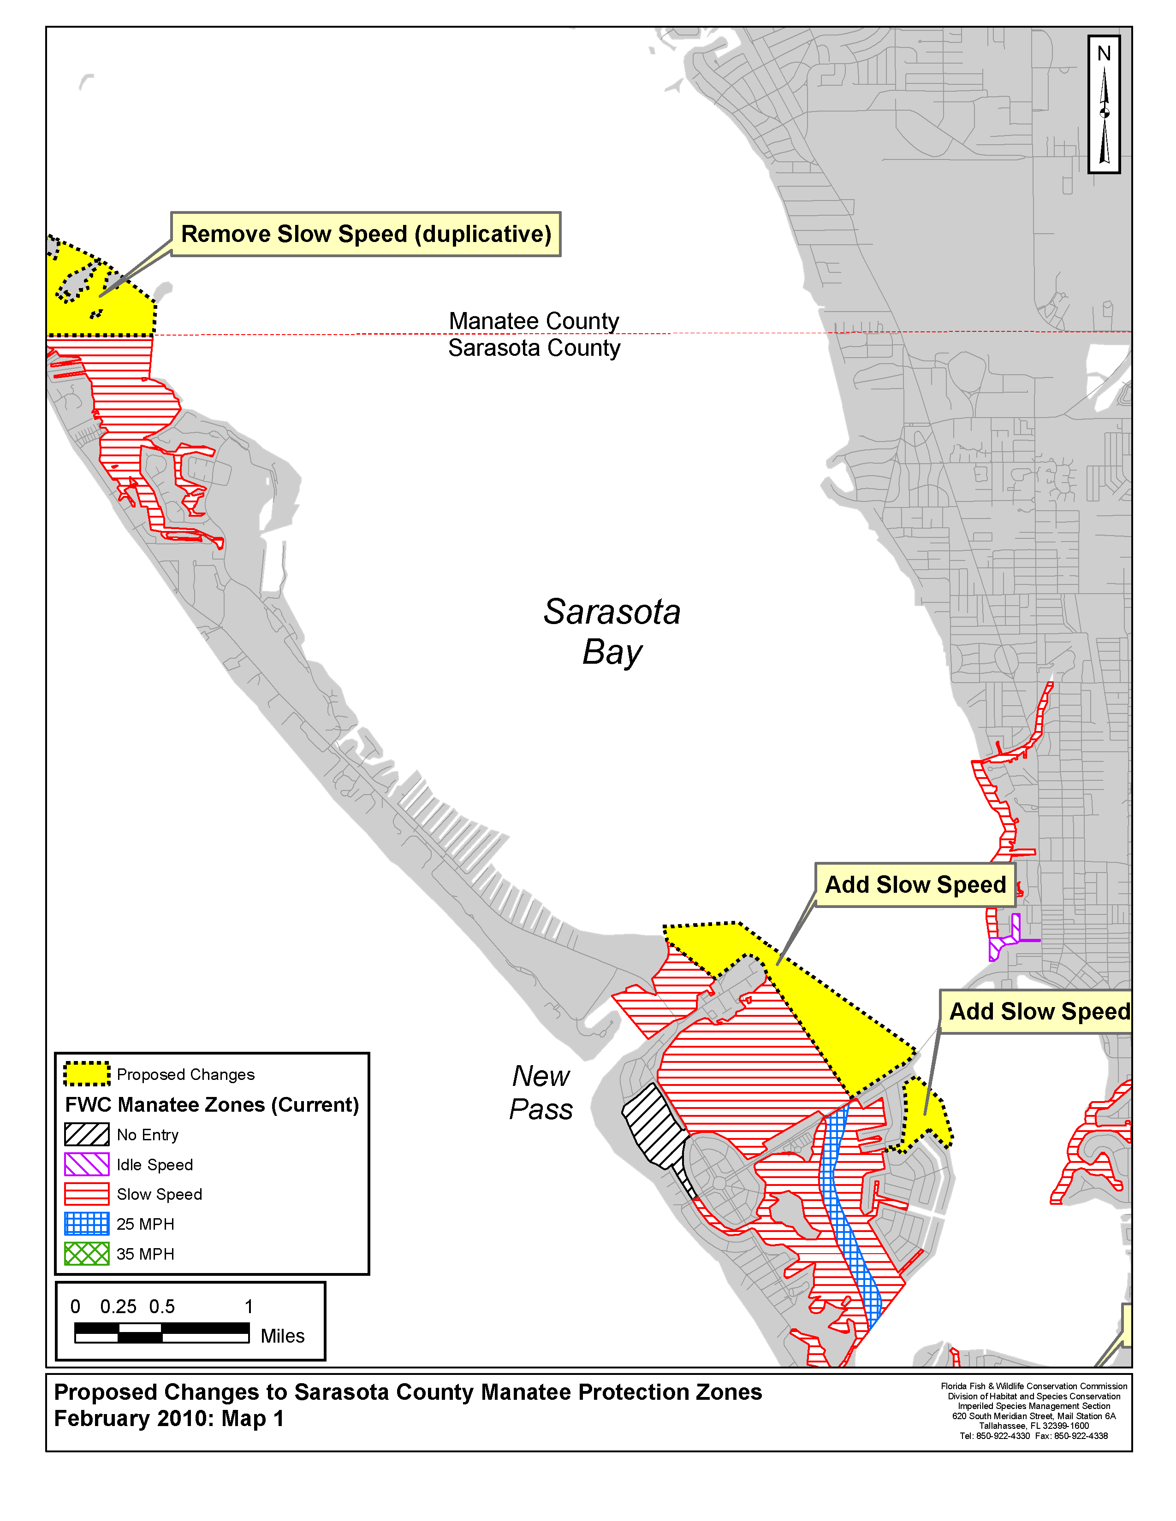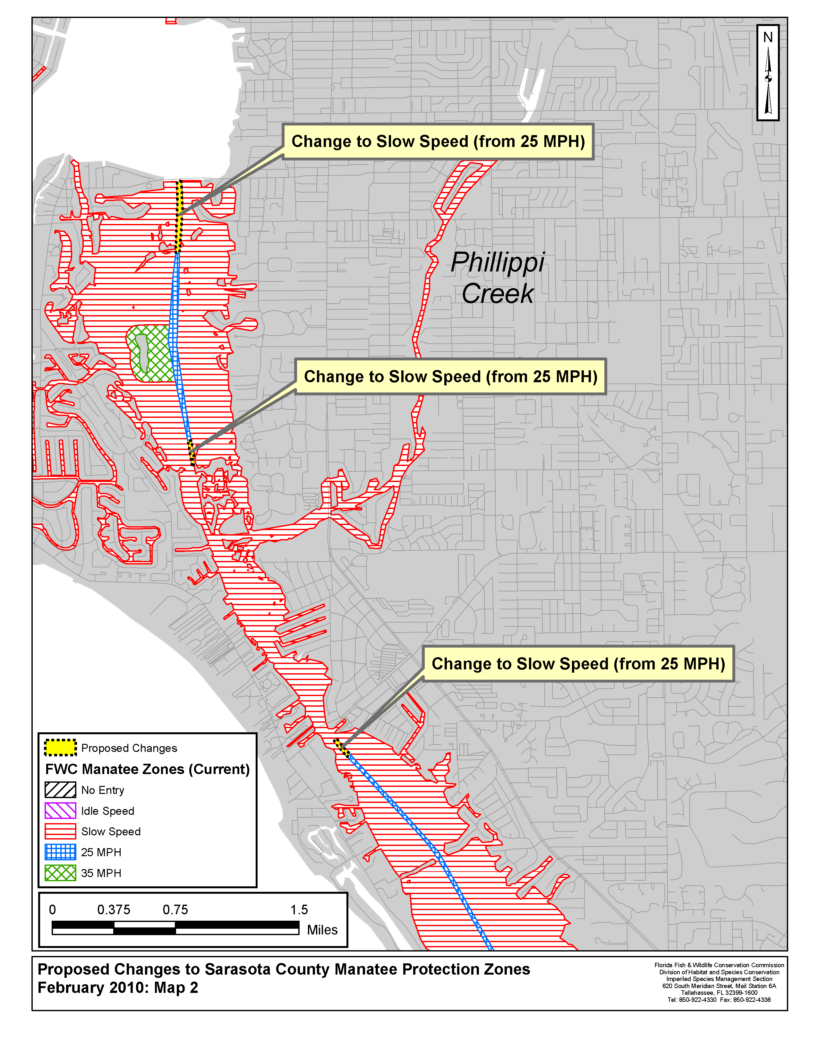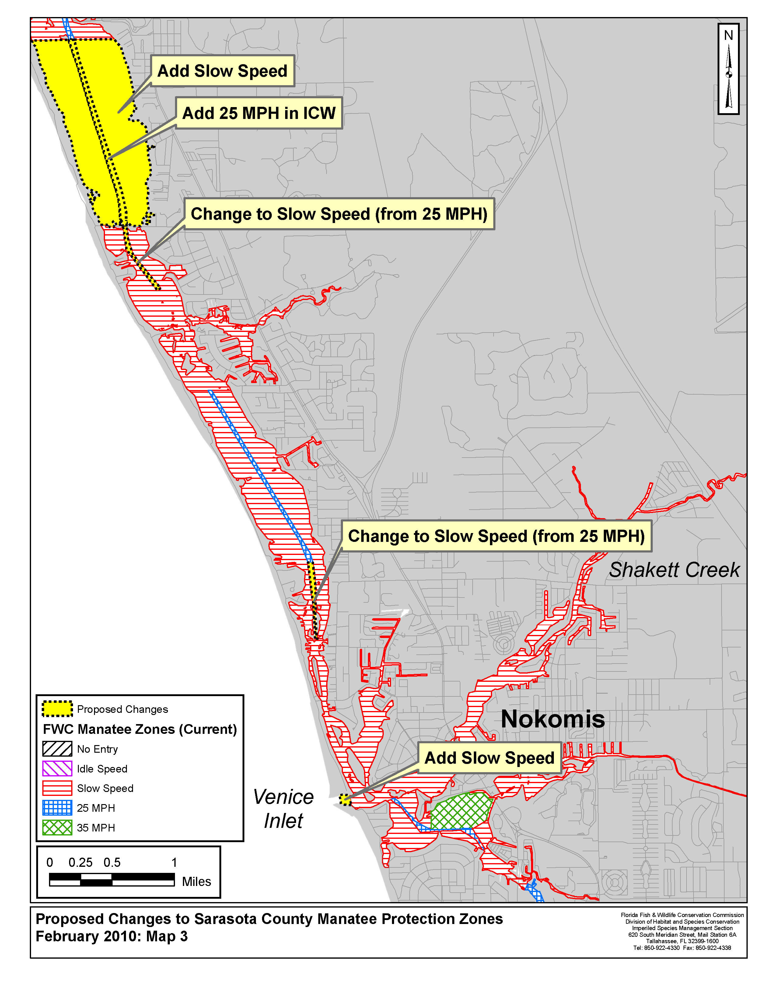

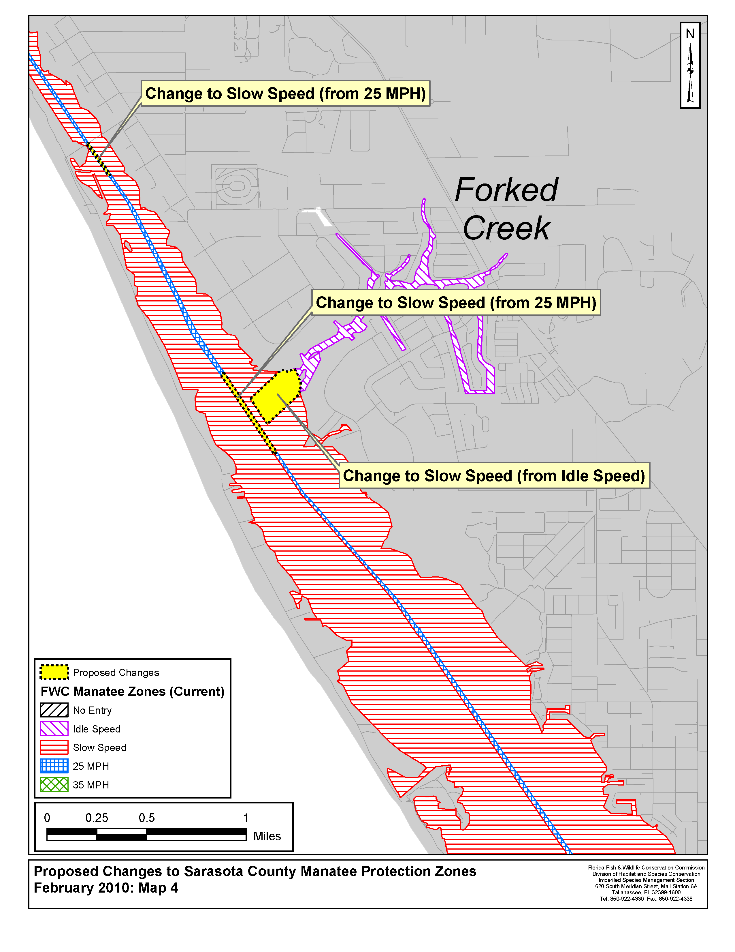
Rulemaking Specific Authority 379.2431 370.12(2)(g), (n), (o) FS. Law Implemented 379.2431 370.12(2)(d), (g), (f), (k), (n), (o) FS. History–New 1-27-92, Formerly 16N-22.026, 62N-22.026, Amended 12-12-02,________.

NAME OF PERSON ORIGINATING PROPOSED RULE: Mr. Tim Breault, Director of the Division of Habitat and Species Conservation
NAME OF AGENCY HEAD WHO APPROVED THE PROPOSED RULE: Commissioners of the Florida Fish and Wildlife Conservation Commission
DATE PROPOSED RULE APPROVED BY AGENCY HEAD: December 9, 2009
DATE NOTICE OF PROPOSED RULE DEVELOPMENT PUBLISHED IN FAW: November 25, 2009

