40E-10.051 Water Reservation Areas: Upper East Coast Planning Area.
North Fork of the St. Lucie River, as defined in subsection 40E-10.021(3), F.A.C.:
(1) Surface waters up to and including the mean monthly flow of 130 cubic feet per second flowing over the Gordy Road Structure from November 1st through May 31st; see Appendix 3, Figure 3-2; are reserved from allocation. The water reserved under this Rule will be available for fish and wildlife upon formal determination of the Governing Board, pursuant to state and federal law, that any one or all of the Comprehensive Everglades Restoration Plan’s C-23/C-24 North and South Reservoirs and STA Project are operational.
(2) Reservations contained in this Rule and the criteria contained in section 3.11.2 of the “Basis of Review for Water Use Permit Applications within the South Florida Water Management District,” incorporated by reference in Rule 40E-2.091, F.A.C., shall be revised pursuant to Section 373.223(4), F.S., in light of changed conditions or new information and concurrent with the approval specified in subsection (1), above.
Notwithstanding the above, presently existing legal uses for the duration of a permit existing on March 18, 2010 are determined to be not contrary to the public interest pursuant to Section 373.223(4), F.S.
Rulemaking Authority 373.044, 373.113, 373.171 FS. Law Implemented 373.016, 373.026, 373.036, 373.1501, 373.1502, 373.219, 373.223, 373.4592, 373.4595, 373.470 FS. History–New-3-18-10.
APPENDIX 1 TO CHAPTER 40E-10
LEGAL DESCRIPTION OF PICAYUNE STRAND
AS DEFINED IN SUBSECTION 40E-10.021(1)
A tract of land in Townships 50, 51 and 52 South, Ranges 27 and 28 East, Collier County, Florida, more particularly described as follows:
Beginning at the Southeast Corner of Section 25, Township 51 South, Range 28 East, Collier County, Florida, run S 89°10'50'' W, 2659.84 feet to the South Quarter Corner of said Section 25; thence S 89°09'41'' W, 2659.37 feet to the Southwest Corner of said Section 25; thence S 00°19'11'' W, 2611.61 feet to the East Quarter Corner of Section 35 of said Township 51 South, Range 28 East;
thence S 88°56'33'' W, 2652.73 feet to the Northeast Corner of the Southwest Quarter of said Section 35; thence S 00°18'15'' W, 2614.86 feet to the South Quarter Corner of said Section 35; thence S 88°54'23'' W, 2650.59 feet to the Southwest Corner of Section 35; thence S 88°50'39'' W, 2639.94 feet to the South Quarter Corner of Section 34 of said Township 51 South, Range 28 East;
thence S 89°00'23'' W, 2652.66 feet to the Southwest Corner of said Section 34;
thence S 88°44'21” W along the north line of the Northeast Quarter of Section 4, Township 52 South, Range 28 East, 1450.32 feet to the Northeast Corner of those lands described in Official Record Book 2624, Page 2509, Public Records of Collier County, Florida; thence S 00°27'37'' E along the east line of said lands, 6308.01 feet; thence continuing along said east line, S 89°34'56'' W, 16.37 feet;
thence continuing along said east line, S 00°25'04'' E, 360.00 feet to the north right-of-way line of U.S. Highway 41; thence westerly along the north right-of-way line of U.S. Highway 41, S 84°52'54'' W, 327.99 feet; thence N 05°07'06'' W, 39.00 feet to a point on a non-tangent curve; thence westerly 900.69 feet along the arc of said curve, concave to the northeast, having a radius of 1835.08 feet, a central angle of 28°07'18'' and a chord of 891.68 feet, bearing N 81°03'27'' W;
thence S 23°00'12'' W, 39.00 feet; thence N 66°59'48'' W, 5570.19 feet to a point of curvature; thence northwesterly 800.00 feet along the arc of a curve, concave to the southwest, having a radius of 17224.80 feet, a central angle of 02°39'40'' and a chord of 799.93 feet, bearing N 68°19'38'' W to a point of tangency;
thence N 69°39'28'' W, 6844.52 feet; thence N 20°20'32'' E, 39.00 feet to a point on a non-tangent curve; thence northwesterly 671.08 feet along the arc of said curve, concave to the northeast, having a radius of 1835.08 feet, a central angle of 20°57'10'' and a chord of 667.35 feet, bearing N 59°10’53'' W; thence S 41°17’43” W, 39.00 feet; thence N 48°42'17'' W, 6815.31 feet to a point of curvature; thence northwesterly 442.16 feet along the arc of a curve, concave to the southwest, having a radius of 725.20 feet, a central angle of 34°56'02'' and a chord of 435.35 feet, bearing N 66°10'19'' W to a point of tangency; thence N 83°38'20'' W, 300.77 feet to the intersection of the north right-of-way line of U.S. Highway 41 with the west line of Section 36, Township 51 South, Range 27 East;
thence N 00°03'59'' E along the west line of said Section 36, 1586.32 feet to the Northwest Corner of Section 36; thence N 01°15'40'' W, 2658.40 feet, to the West Quarter Corner of Section 25 of said Township 51 South, Range 27 East;
thence N 01°17'06'' W, 2656.42 feet to the Northwest Corner of said Section 25;
thence N 01°16'05'' W, 2655.83 feet to the West Quarter Corner of Section 24 of said Township 51 South, Range 27 East; thence N 01°16'15'' W, 2656.76 feet to the Northwest Corner of said Section 24; thence N 00°19'01'' E, 2764.38 feet to the West Quarter Corner of Section 13 of said Township 51 South, Range 27 East; thence N 00°19'04'' E, 2764.32 feet to the Northwest Corner of said Section 13; thence N 01°15'53'' E, 2764.69 feet to the West Quarter Corner of Section 12 of said Township 51 South, Range 27 East; thence N 01°16'08'' E, 2764.72 feet to the Northwest Corner of said Section 12; thence N 00°37'07'' E, 2763.78 feet to the West Quarter Corner of Section 1 of said Township 51 South, Range 27 East; thence N 00°35'09'' E, 2732.08 feet to the Northwest Corner of said Section 1; thence N 01°09'58'' E, 2697.35 feet to the West Quarter Corner of Section 36 of Township 50 South, Range 27 East; thence N 01°14’25'' E, 2554.73 feet to the Northwest Corner of said Section 36; thence N 00°49'11'' E, 2618.76 feet to the West Quarter Corner of Section 25 of said Township 50 South, Range 27 East;
thence N 01°30'13'' E, 2623.02 feet to the Northwest Corner of said Section 25;
thence N 01°14'51'' E, 2643.78 feet to the West Quarter Corner of Section 24 of said Township 50 South, Range 27 East; thence N 00°55’45'' E, 2647.27 feet to the Northwest Corner of said Section 24; thence N 89°04’28'' W, 2655.08 feet to the South Quarter Corner of Section 14 of said Township 50 South, Range 27 East; thence N 89°06’09'' W, 2673.56 feet to the Southwest Corner of said Section 14; thence N 01°20’52'' E, 2642.45 feet to the West Quarter Corner of said Section 14; thence N 01°02'27'' E, 2638.34 feet to the Northwest Corner of said Section 14; thence S 88°57’18” E, 2650.45 feet to the North Quarter Corner of said Section 14; thence S 89°16’05” E, 2679.46 feet to the Northeast Corner of said Section 14; thence N 00°32'07'' E, 2629.53 feet to the West Quarter Corner of Section 12 of said Township 50 South, Range 27 East; thence N 00°05'55'' E, 2655.64 feet to the Northwest Corner of said Section 12; thence N 00°35'20'' E, 2638.33 feet to the West Quarter Corner of Section 1 of said Township 50 South, Range 27 East; thence N 09°11'51'' W along the west line of the Northwest Quarter of said Section 1 a distance of 2352.20 feet to the intersection with the south line of the south drainage right-of-way of Interstate 75; thence easterly along said line, N 89°40’16” E, 2640.00 feet; thence S 88°14'35'' E, 2676.02 feet;
thence S 89°13'04'' E, 2656.26 feet; thence N 89°51'50'' E, 2650.84 feet;
thence N 89°28’53'' E, 2647.15 feet; thence S 89°53’38'' E, 2654.08 feet;
thence S 89°59'57'' E, 2650.10 feet; thence N 89°51'03'' E, 2650.97 feet;
thence S 89°32'18'' E, 2648.17 feet; thence N 89°47'26'' E, 2686.92 feet;
thence N 00°23'28'' W, 124.56 feet; thence S 89°54'09'' E, 2649.59 feet;
thence S 89°56'18'' E, 2651.63 feet; thence N 89°41'16'' E, 2652.50 feet;
thence S 89°49'15'' E, 2651.54 feet to the intersection of the south line of said south drainage right-of-way with the east line of Section 1, Township 50 South, Range 28 East; thence S 00°18'22'' E along the east line of the Northeast Quarter of said Section 1 a distance of 2460.78 feet to the East Quarter Corner of said Section 1; thence S 00°18'26'' E, 2663.16 feet to the Southeast Corner of said Section 1; thence S 00°19'17'' E, 2661.71 feet to the East Quarter Corner of Section 12 of said Township 50 South, Range 28 East; thence S 00°18'47'' E, 2661.88 feet to the Southeast Corner of said Section 12; thence S 00°18'10'' E, 2662.06 feet to the East Quarter Corner of Section 13 of said Township 50 South, Range 28 East; thence S 00°18'16'' E, 2662.13 feet to the Southeast Corner of said Section 13; thence S 00°18'16'' E, 2662.14 feet to the East Quarter Corner of Section 24 of said Township 50 South, Range 28 East; thence S 00°17'28'' E, 2661.81 feet to the Southeast Corner of said Section 24; thence S 00°17'38'' E, 2674.16 feet to the East Quarter Corner of Section 25 of said Township 50 South, Range 28 East; thence S 00°10'00'' E, 2674.56 feet to the Southeast Corner of said Section 25; thence S 00°13'47'' E, 2674.47 feet to the East Quarter Corner of Section 36 of said Township 50 South, Range 28 East; thence S 00°13'47'' E, 2674.49 feet to the Southeast Corner of said Section 36; thence S 00°51'18'' E, 2682.32 feet to the East Quarter Corner of Section 1 of Township 51 South, Range 28 East; thence S 00°51'18'' E, 2682.32 feet to the Southeast Corner of said Section 1; thence S 00°28'26” W, 2596.09 feet to the East Quarter Corner of Section 12 of said Township 51 South, Range 28 East; thence S 00°41'47'' W, 2598.68 feet to the Southeast Corner of said Section 12; thence southerly along the east line of Section 13, Township 51 South, Range 28 East, S 00°35'55'' W, 5191.01 feet to the Southeast Corner of said Section 13; thence S 00°36'41'' W, 2596.95 feet to the East Quarter Corner of Section 24 of said Township 51 South, Range 28 East; thence S 00°34'08'' W, 2597.43 feet to the Southeast Corner of said Section 24; thence S 00°33'57'' W, 2596.90 feet to the East Quarter Corner of Section 25 of said Township 51 South, Range 28 East; thence S 00°34'27'' W, 2597.76 feet to the Southeast Corner of said Section 25 and the Point of Beginning.
APPENDIX 2 TO CHAPTER 40E-10
Appendix 3: Upper East Coast Reservation Water Bodies
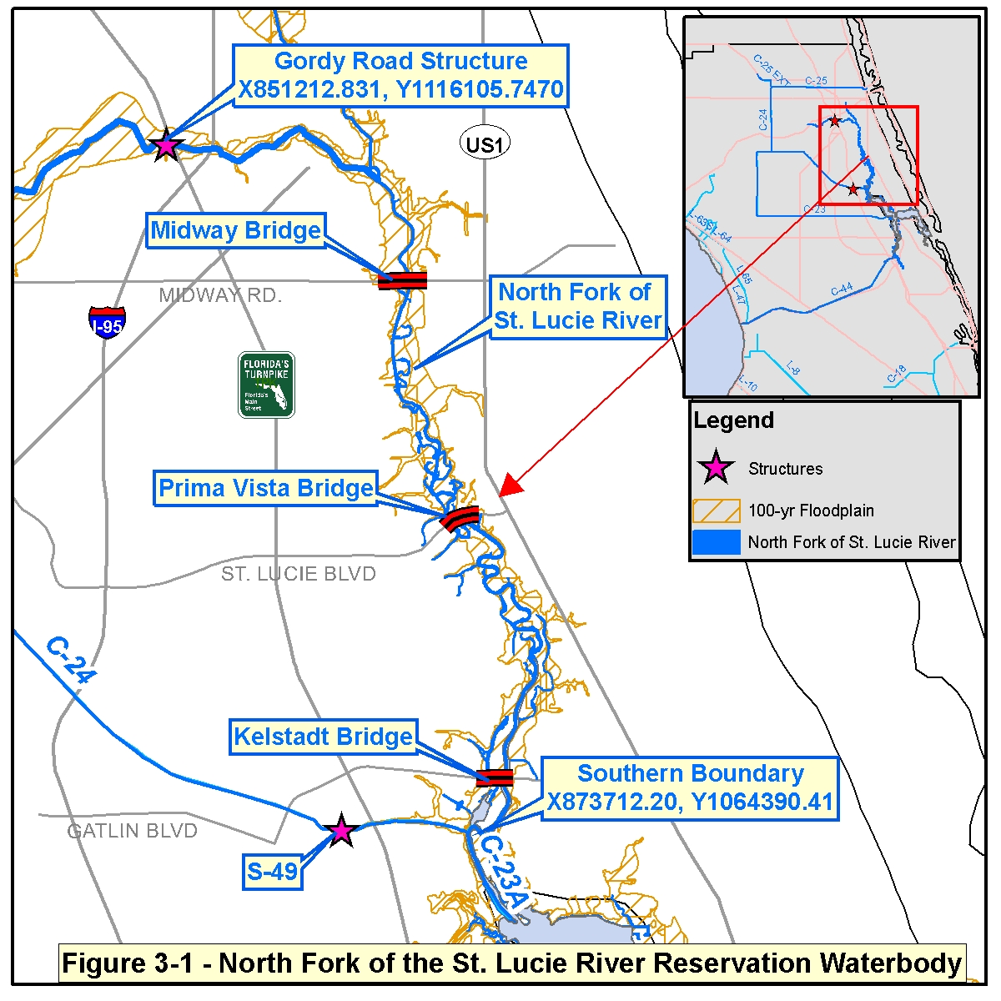

Figure 3-2: Water Reserved for the North Fork of the St Lucie River

Figures

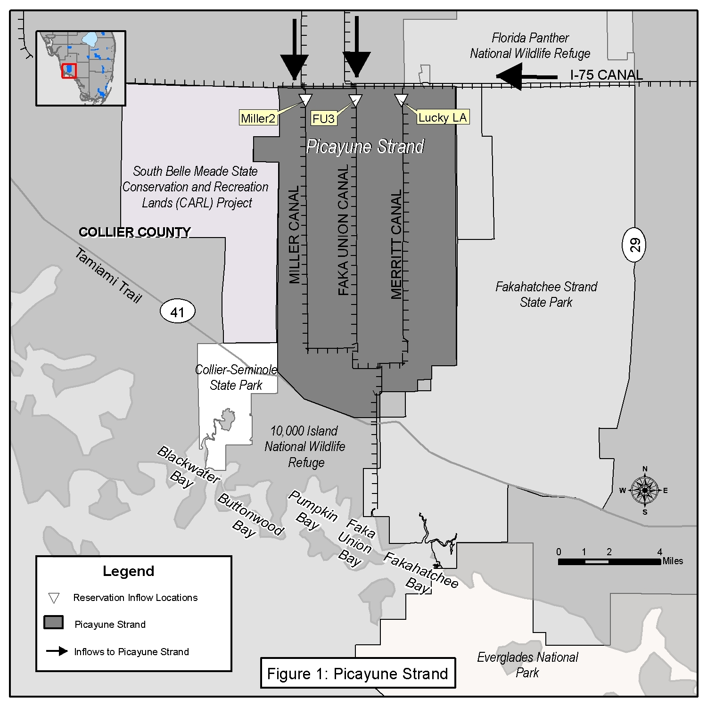

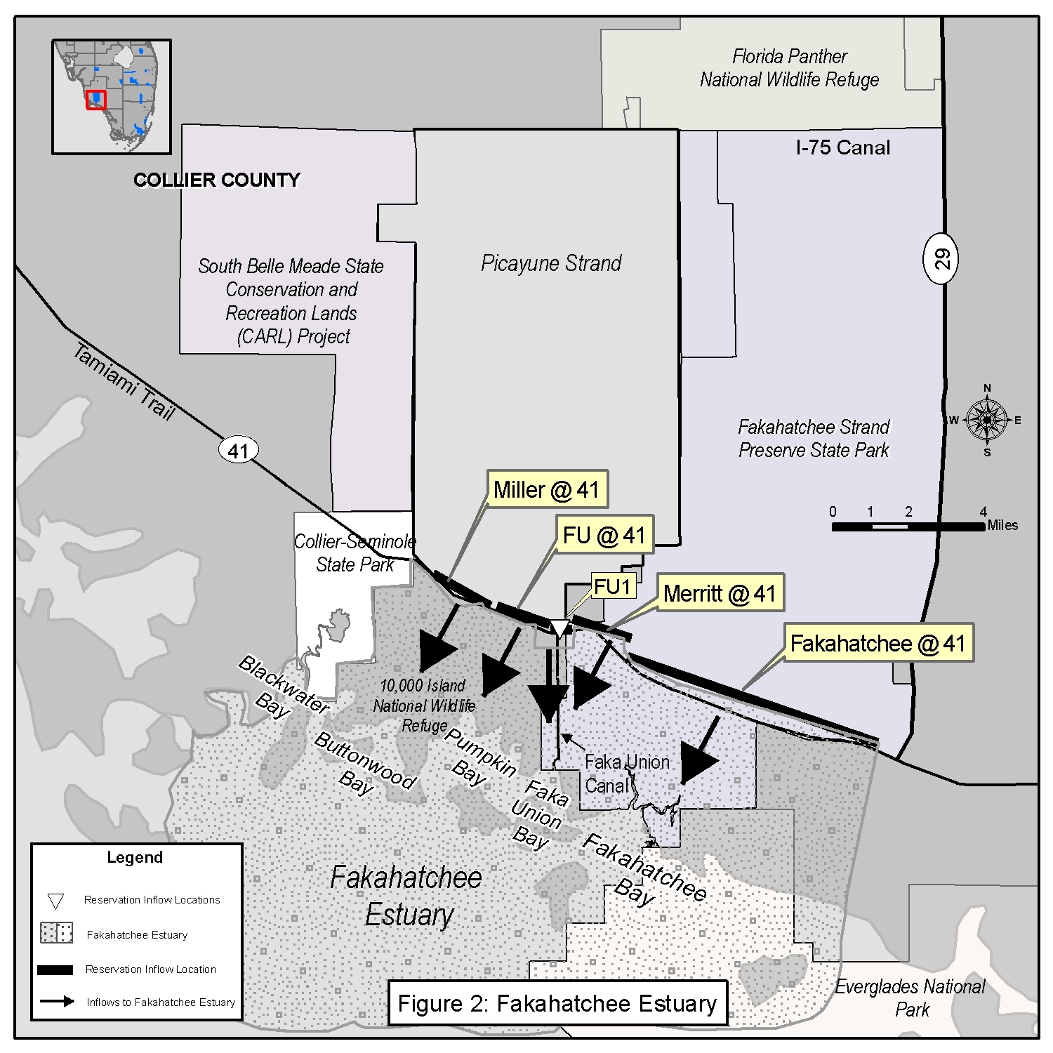
Figure 3.A. Simulated Surface Water Inflow From Miller Canal Near I-75
Volume Probability Curve - 1988 Through 2000
0
200
400
600
800
1,000
1,200
1,400
1,600
1,800
0%
10%
20%
30%
40%
50%
60%
70%
80%
90%
100%
Percent Time Equaled or Exceeded
Flow (Acre-feet/Day)
2000 W/Project

Figure 3.B. Simulated Surface Water Inflow From Miller Canal Near I-75
Volume Probability Curve - Wet Season (June 1 - Oct 31)
0
200
400
600
800
1000
1200
1400
1600
1800
0%
10%
20%
30%
40%
50%
60%
70%
80%
90%
100%
Percent Time Equaled or Exceeded
Flow (Acre-feet/Day)
2000 W/Project

Figure 3.C. Simulated Surface Water Inflow From Miller Canal Near I-75
Volume Probability Curve - Dry Season (Nov 1 - May 31)
0
200
400
600
800
1000
1200
1400
1600
1800
0%
10%
20%
30%
40%
50%
60%
70%
80%
90%
100%
Percent Time Equaled or Exceeded
Flow (Acre-feet/Day)
2000 W/Project

Figure 4.A. Simulated Surface Water Inflow From Faka Union Canal Near I-75
Volume Probability Curve - 1988 Through 2000
0
500
1,000
1,500
2,000
2,500
3,000
0%
10%
20%
30%
40%
50%
60%
70%
80%
90%
100%
Percent Time Equaled or Exceeded
Flow (Acre-feet/Day)
2000 W/Project

Figure 4.B. Simulated Surface Water Inflow From Faka Union Canal Near I-75
Volume Probability Curve - Wet Season (June 1-Oct 31)
0
500
1000
1500
2000
2500
3000
0%
10%
20%
30%
40%
50%
60%
70%
80%
90%
100%
Percent Time Equaled or Exceeded
Flow (Acre-feet/Day)
2000 W/Project

Figure 4.C. Simulated Surface Water Inflow From Faka Union Canal Near I-75
Volume Probability Curve - Dry Season (Nov 1 - May 31)
0
500
1000
1500
2000
2500
3000
0%
10%
20%
30%
40%
50%
60%
70%
80%
90%
100%
Percent of Time Equaled or Exceeded
Flow (Acre-feet/Day)
2000 W/Project

Figure 5.A. Simulated Surface Water Inflow From Merritt Canal Near I-75
Volume Probability Curve - 1988 Through 2000
0
200
400
600
800
1,000
1,200
1,400
0%
10%
20%
30%
40%
50%
60%
70%
80%
90%
100%
Percent Time Equaled or Exceeded
Flow (Acre-feet/Day)
2000 W/Project

Figure 5.B. Simualted Surface Water Inflow From Merritt Canal Near I-75
Volume Probability Curve - Wet Season (June 1 - Oct 31)
0
200
400
600
800
1000
1200
1400
0%
10%
20%
30%
40%
50%
60%
70%
80%
90%
100%
Percent Time Equaled or Exceeded
Flow (Acre-feet/Day)
2000 W/Project

Figure 5.C. Simulated Surface Water Inflow From Merritt Canal Near I-75
Volume Probability Curve - Dry Season (Nov 1 - May 31)
0
200
400
600
800
1000
1200
1400
0%
10%
20%
30%
40%
50%
60%
70%
80%
90%
100%
Percent Time Equaled or Exceeded
Flow (Acre-feet/Day)
2000 W/Project

