Notice of Emergency Rule

DEPARTMENT OF THE LOTTERY
Departmental
RULE NO.: RULE TITLE:
53ER06-2: Instant Game Number 636, LUCKY FOR LIFE
SUMMARY OF THE RULE: LUCKY FOR LIFE, for which the Department of the Lottery will start selling tickets on a date to be determined by the Secretary of the Department. The rule sets forth the specifics of the game; determination of prizewinners; estimated odds of winning, value and number of prizes in the game.
THE PERSON TO BE CONTACTED REGARDING THE EMERGENCY RULE IS: Faith L. Schneider, Legal Analyst, Department of the Lottery, 250 Marriott Drive, Tallahassee, Florida 32399-4011

THE FULL TEXT OF THE EMERGENCY RULE IS:

53ER06-2 Instant Game Number 636, LUCKY FOR LIFE.
(1) Name of Game. Instant Game Number 636, “LUCKY FOR LIFE.”
(2) Price. LUCKY FOR LIFE lottery tickets sell for $20.00 per ticket.
(3) LUCKY FOR LIFE lottery tickets shall have a series of numbers in Machine Readable Code (or bar code) on the back of the ticket, along with a Void If Removed Number under the latex area on the ticket. To be a valid winning LUCKY FOR LIFE lottery ticket, the ticket must meet the applicable requirements of Rule 53ER05-73, F.A.C.
(4) The “YOUR NUMBERS” play symbols and play symbol captions are as follows:

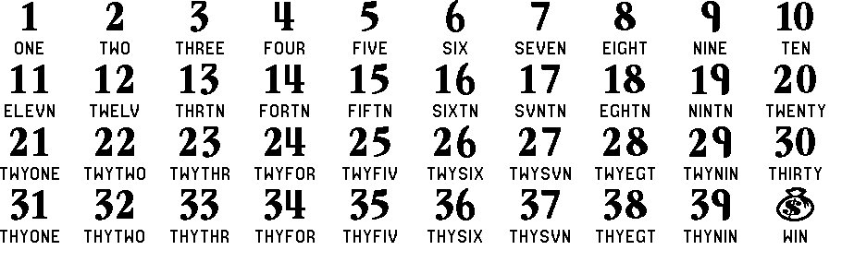

(5) The "WINNING NUMBERS" play symbols and play symbol captions are as follows:

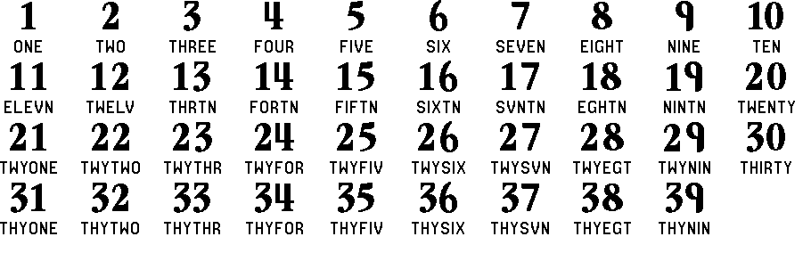

(6) The prize symbols and prize symbol captions are as follows:

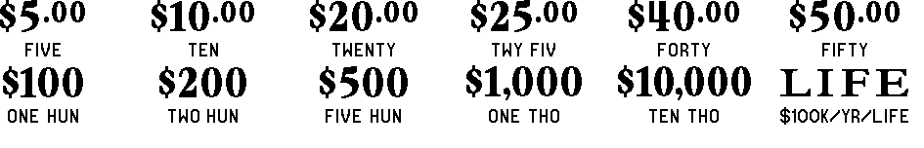

(8) The legends are as follows:

(9) Determination of Prizewinners.
(a) A ticket having a number in the "YOUR NUMBERS" play area that matches any number in the “WINNING NUMBERS” play area shall entitle the claimant to the corresponding prize shown for that number. A ticket may have up to twenty-five sets of matching numbers. The prizes are: $5.00, $10.00, $20.00, $25.00, $40.00, $50.00, $100, $200, $500, $1,000, $10,000 and . 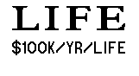
(b) A ticket having a “ ” symbol in the “YOUR NUMBERS” play area shall entitle the claimant to a prize of $500.
(c) The winner of a “$100,000 a year for life” prize may choose one of two payment options for receiving his or her prize. Payment options are “Cash Option” and “Annual Payment.” At the time a “$100,000 a year for life” prize is claimed, the terminal will produce a player claim instructions ticket. The winner has sixty (60) days from the date the player claim instructions ticket is produced to file a claim choosing the Cash Option. If a winner does not choose the Cash Option within such time, the Annual Payment option will be applied. Once the winner signs the Winner Claim Form and exercises the winner’s chosen option, the election of that option shall be final. Winner Claim Form DOL-173-2, Revised 9/05, and Spanish Winner Claim Form DOL-173-S, Revised 9/05, are incorporated herein by reference and may be obtained from the Florida Lottery, Winner Validation, 250 Marriott Drive, Tallahassee, Florida 32399-4016.
(d) Cash Option prizes will be paid in a single cash payment equal to the amount of cash required to purchase U.S. Government Securities that would fund $2,000,000 payable over a twenty year period, less applicable federal withholding taxes. This figure will be determined during the week following the date on which the “$100,000 a year for life” prize is claimed by obtaining quotes from at least two investment sources. The quote costing the least to fund the twenty year payment stream, had the annual payment option been selected, will be the amount of the Cash Option prize.
(e) Annual Payment prizes claimed by an individual will be paid in equal annual installments of $100,000 for the life of the winner, with a minimum of twenty annual payments, less applicable federal withholding taxes. Annual Payment prizes claimed by a trust, corporation or other legal entity shall consist of twenty annual payments of $100,000 each, less applicable federal withholding taxes.
(f) Any interest or earnings accruing on a “$100,000 a year for life” prize prior to the prize payment or purchase of securities, under either the Cash Option or the Annual Payment Option, shall accrue to the State of Florida and not to the winner.
(10) The estimated odds of winning, value and number of prizes in Instant Game Number 636 are as follows:

NUMBER OF

WINNERS IN
 |  | ESTIMATED | 230 POOLS OF
 |  | ODDS OF | 120,000 TICKETS
GAME PLAY | WIN | 1 IN | PER POOL
$5 x 4 | $20 | 15.00 | 1,840,000
$10 x 2 | $20 | 15.00 | 1,840,000
$20 | $20 | 30.00 | 920,000
$10 x 4 | $40 | 60.00 | 460,000
($10 x 2) + $20 | $40 | 60.00 | 460,000
$20 x 2 | $40 | 120.00 | 230,000
$5 + $10 + $25 | $40 | 120.00 | 230,000
$40 | $40 | 60.00 | 460,000
$25 x 2 | $50 | 60.00 | 460,000
$50 | $50 | 60.00 | 460,000
$5 x 20 | $100 | 120.00 | 230,000
$25 x 4 | $100 | 200.00 | 138,000
($20 x 3) + $40 | $100 | 150.00 | 184,000
$20 x 5 | $100 | 200.00 | 138,000
$100 | $100 | 120.00 | 230,000
$20 x 25 | $500 | 1,200.00 | 23,000
$25 x 20 | $500 | 1,200.00 | 23,000
$50 x 10 | $500 | 2,400.00 | 11,500
$100 x 5 | $500 | 2,400.00 | 11,500
$500 (MONEYBAG) | $500 | 300.00 | 92,000
$40 x 25 | $1,000 | 20,000.00 | 1,380
$100 x 10 | $1,000 | 20,000.00 | 1,380
$200 x 5 | $1,000 | 30,000.00 | 920
$500 x 2 | $1,000 | 30,000.00 | 920
$1,000 | $1,000 | 30,000.00 | 920
$1,000 x 10 | $10,000 | 40,000.00 | 690
$10,000 | $10,000 | 40,000.00 | 690
LIFE ($100,000 a year for LIFE) | Top Prize | 3,450,000.00 | 8

(11) The estimated overall odds of winning some prize in Instant Game Number 636 are 1 in 3.27. Prizes, including the top prizes, are subject to availability at the time of ticket purchase. Prizes may be unavailable due to prior sale or other causes occurring in the normal course of business including, but not limited to, ticket damage, defect, theft or loss.
(12) For reorders of Instant Game Number 636, the estimated odds of winning, value and number of prizes shall be proportionate to the number of tickets reordered.
(13) By purchasing a LUCKY FOR LIFE lottery ticket the player agrees to comply with and abide by all prize payment rules of the Florida Lottery.
(14) Payment of prizes for LUCKY FOR LIFE lottery tickets shall be made in accordance with rules of the Florida Lottery governing payment of prizes. A copy of the current rule can be obtained from the Florida Lottery, Office of the General Counsel, 250 Marriott Drive, Tallahassee, Florida 32399-4011.
Specific Authority 24.105(9)(a),(b),(c), 24.109(1), 24.115(1) FS. Law Implemented 24.105(9)(a),(b),(c), 24.115(1) FS. History–New 1-20-06.

THIS EMERGENCY RULE TAKES EFFECT IMMEDIATELY UPON BEING FILED WITH THE DEPARTMENT OF STATE.
EFFECTIVE DATE: January 20, 2006

