Notice of Emergency Rule

DEPARTMENT OF THE LOTTERY
Departmental
RULE NO.: RULE TITLE:
53ER06-3 Instant Game Number 629, RUBY RED 7s
SUMMARY OF THE RULE: This emergency rule describes Instant Game Number 629, RUBY RED 7s, for which the Department of the Lottery will start selling tickets on a date to be determined by the Secretary of the Department. The rule sets forth the specifics of the game; determination of prizewinners; estimated odds of winning, value and number of prizes in the game.
THE PERSON TO BE CONTACTED REGARDING THE EMERGENCY RULE IS: Faith L. Schneider, Legal Analyst, Department of the Lottery, 250 Marriott Drive, Tallahassee, Florida 32399-4011

THE FULL TEXT OF THE EMERGENCY RULE IS:

53ER06-3 Instant Game Number 629, RUBY RED 7s.
(1) Name of Game. Instant Game Number 629, “RUBY RED 7s.”
(2) Price. RUBY RED 7s lottery tickets sell for $2.00 per ticket.
(3) RUBY RED 7s lottery tickets shall have a series of numbers in machine readable code (or bar code) on the back of the ticket, along with a validation number under the latex area on the ticket. To be a valid winning RUBY RED 7s lottery ticket, the ticket must meet the applicable requirements of Rule 53ER05-73, F.A.C.
(4) The black play symbols and play symbol captions are as follows:

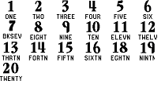
(5) The red play symbols and play symbol captions are as follows:

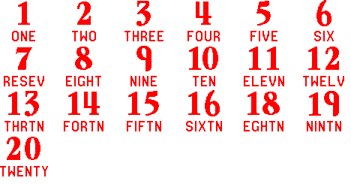
(6) The prize symbols and prize symbol captions are as follows:

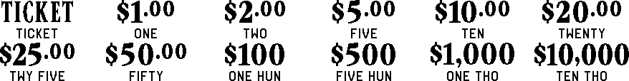

(7) Determination of Prizewinners.
(a) A ticket having a black " 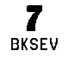" symbol in the play area shall entitle the claimant to the corresponding prize shown for that symbol. A ticket having a red "" symbol in the play area shall entitle the claimant to double the corresponding prize shown for that symbol.
(b) The prize amounts are: TICKET, $1.00, $2.00, $5.00, $10.00, $20.00, $25.00, $50.00, $100, $500, $1,000 and $10,000. A claimant who is entitled to a prize of a “TICKET” shall be entitled to a prize of a $2.00 instant ticket or combination of instant tickets with a total value of $2.00, except as follows. A person who submits by mail a RUBY RED 7s lottery ticket which entitles the claimant to a prize of a $2.00 ticket and whose mailing address is outside the state of Florida will receive a check for $2.00 in lieu of an actual ticket.
(8) The estimated odds of winning, value and number of prizes in Instant Game Number 629 are as follows:

NUMBER OF
WINNERS IN
 |  |  | 56 POOLS OF
 |  | ODDS OF | 180,000 TICKETS
GAME PLAY | WIN | 1 IN | PER POOL
TICKET | $2 TICKET | 10.00 | 1,008,000
$2 | $2 | 25.00 | 403,200
$2 x 2 | $4 | 37.50 | 268,800
$1 + ($2 x 2) | $5 | 37.50 | 268,800
$5 | $5 | 37.50 | 268,800
$1 + ($2 x 2) + $5 | $10 | 150.00 | 67,200
$5 (RED "7") | $10 | 50.00 | 201,600
$10 | $10 | 150.00 | 67,200
$5 x 5 | $25 | 150.00 | 67,200
($5 x 2) + ($10 x 4) | $50 | 1,200.00 | 8,400
$25 (RED "7") | $50 | 600.00 | 16,800
$50 | $50 | 1,200.00 | 8,400
$10 x 10 | $100 | 9,000.00 | 1,120
$50 (RED "7") | $100 | 3,600.00 | 2,800
$100 | $100 | 9,000.00 | 1,120
$20 x 10 | $200 | 22,500.00 | 448
$500 (RED "7") | $1,000 | 360,000.00 | 28
$1,000 | $1,000 | 1,260,000.00 | 8
$1,000 x 10 | $10,000 | 3,360,000.00 | 3
$10,000 | $10,000 | 3,360,000.00 | 3

(9) The estimated overall odds of winning some prize in Instant Game Number 629 are 1 in 3.79. Prizes, including the top prizes, are subject to availability at the time of ticket purchase. Prizes may be unavailable due to prior sale or other causes occurring in the normal course of business including, but not limited to, ticket damage, defect, theft or loss.
(10) For reorders of Instant Game Number 629, the estimated odds of winning, value and number of prizes shall be proportionate to the number of tickets reordered.
(11) By purchasing a RUBY RED 7s lottery ticket the player agrees to comply with and abide by all prize payment rules of the Florida Lottery.
(12) Payment of prizes for RUBY RED 7s lottery tickets shall be made in accordance with rules of the Florida Lottery governing payment of prizes. A copy of the current rule can be obtained from the Florida Lottery, Office of the General Counsel, 250 Marriott Drive, Tallahassee, Florida 32399-4011.
Specific Authority 24.105(9)(a),(b),(c), 24.109(1), 24.115(1) FS. Law Implemented 24.105(9)(a),(b),(c), 24.115(1) FS. History–New 1-20-06.

THIS EMERGENCY RULE TAKES EFFECT IMMEDIATELY UPON BEING FILED WITH THE DEPARTMENT OF STATE.
EFFECTIVE DATE: January 20, 2006

