Notice of Proposed Rule

FISH AND WILDLIFE CONSERVATION COMMISSION
Manatees
RULE NO.: RULE TITLE:
68C-22.015 Charlotte County (and Part of DeSoto County) Zones
PURPOSE AND EFFECT: The purpose of the proposed rulemaking action is to amend the existing manatee protection zones in the Placida Harbor area of southern Lemon Bay to provide an additional 25 mph channel for access to southern Little Gasparilla Island. The effect of the action would be to allow speeds up to 25 mph (instead of Slow Speed as is currently required) in an additional navigation channel, if Charlotte County marks the channel in a manner approved by the Commission. This action is being proposed after considering recommendations and comments made by the Charlotte County Local Rule Review Committee that was formed by the County pursuant to Section 370.12(2)(f), F.S.
SUMMARY: A new 25 mph channel would be authorized in Placida Harbor to provide additional higher speed access to southern Little Gasparilla Island. The new channel would be a south prong off of the 25 mph channel that is already authorized by the existing rule. No changes would be made to any of the other existing zones in Charlotte County.
SUMMARY OF STATEMENT OF ESTIMATED REGULATORY COSTS: No Statement of Estimated Regulatory Costs (SERC) was prepared.
Any person who wishes to provide information regarding a statement of estimated regulatory costs, or provide a proposal for a lower cost regulatory alternative must do so in writing within 21 days of this notice.
SPECIFIC AUTHORITY: 370.12(2)(n) FS.
LAW IMPLEMENTED: 370.12(2)(d), (k), (n) FS.
A HEARING WILL BE HELD AT THE DATE, TIME AND PLACE SHOWN BELOW:
DATE AND TIME: Tuesday, March 7, 2006, 6:00 p.m.
PLACE: Tringali Park Community Center, 3460 North Access Road, Englewood, Florida
THE FINAL PUBLIC HEARING WILL BE HELD BY THE COMMISSION AT THE DATE, TIME AND PLACE SHOWN BELOW:
DATES AND TIME: June 7-8, 2006, To be announced
PLACE: West Palm Beach, Florida (Specific location to be determined)
Another notice will be published in the FAW to confirm the date of the final hearing and to provide the location information. The Commissions agenda for this meeting will indicate the specific day when this item is scheduled to be addressed.
If accommodation for a disability is needed to participate in any of the above hearings, please notify the contact person listed below at least five days before the hearing.
THE PERSON TO BE CONTACTED REGARDING THE PROPOSED RULE IS: Mr. Scott Calleson, Florida Fish and Wildlife Conservation Commission, Imperiled Species Management Section, 620 South Meridian Street, Tallahassee, Florida 32399-1600

THE FULL TEXT OF THE PROPOSED RULE IS:

68C-22.015 Charlotte County (and Part of DeSoto County) Zones.
(1) The Commission hereby designates the waters within Charlotte County and DeSoto County, as described below, as areas where manatee sightings are frequent and where the best available information supports the conclusion it can be assumed that manatees inhabit these areas on a regular or, periodic or continuous basis. The Commission has further determined that a likelihood of threat to manatees exists in these waters as a result of manatees and motorboats using the same areas. The primary purpose of this rule is to protect manatees from harmful collisions with motorboats and from harassment by regulating the speed and operation of motorboats within these designated areas. A secondary purpose is to protect manatee habitat. In consideration of balancing the rights of fishers, boaters, and water skiers to use the waters of the state these waterways for recreational and commercial purposes (as applicable under Section 370.12(2)(k), F.S.), with the need to provide manatee protection, the Commission has examined the need for limited lanes, corridors, or unregulated areas that allow higher speeds unregulated areas or higher speed travel corridors through or within regulated areas. Such lanes, corridors, or areas or corridors are provided in those locations where the Commission determined that they are consistent with manatee protection needs, on the basis of all available information, that (1) there is a need for the area or corridor and (2) the area or corridor will not result in serious threats to manatees or their habitat. Unregulated areas or higher speed corridors are not provided in locations where both of the above findings were not made.
(2) The following zones are established, which shall include all associated and navigable tributaries, lakes, creeks, coves, bends, backwaters, canals, and boat basins unless otherwise designated or excluded. As used in this rule, ICW means the Intracoastal Waterway.
(a) No change.
(b) SLOW SPEED (All Year).
1. Lemon Bay Area: All waters of Lemon Bay south of the Sarasota/Charlotte County line, north of the Boca Grande Causeway, and west of State Road (SR) 775 (south of SR 776 on Gottfried Creek), excluding the ICW channel and the marked channel through Stump Pass as designated under subparagraph (2)(c)1. and the marked channels in Placida Harbor as designated under subparagraph (2)(c)2. Also excluded from this zone are the portion of the waterway known as “Ski Alley” south of a line bearing 258° from the northernmost point (approximate latitude 26°54'47.3'' North, approximate longitude 82°21'03.7'' West) of Peterson Island, and the areas described below:
a. through b. No change.
2. through 6. No change.
(c) 25 MPH (All Year).
1. No change.
2. Placida Harbor Area: All waters in the marked channel that runs from the ICW to Gasparilla Pass on the northwest side of the Boca Grande Causeway, and; all waters in the marked channel that runs in a general east-west direction from the marina and boat ramp basin on the northwest side of Boca Grande Causeway, across the ICW, to Little Gasparilla Island, including a “south prong” channel that runs from said east-west channel to the zone boundary between Little Gasparilla Island and Bird Key. This designation only applies if the channels are marked in accordance with permits issued by all applicable state and federal authorities and if the channel locations and marking schemes are approved in advance by the Commission. In the absence of properly permitted and approved channels, these areas are as designated under subparagraph (2)(b)1.
3. through 7. No change.
(3) No change.
(4) The amendments to Rule 68C-22.015, F.A.C., as approved by the Commission on [insert approval date] September 12, 2002, shall take effect as soon as the regulatory markers are posted.
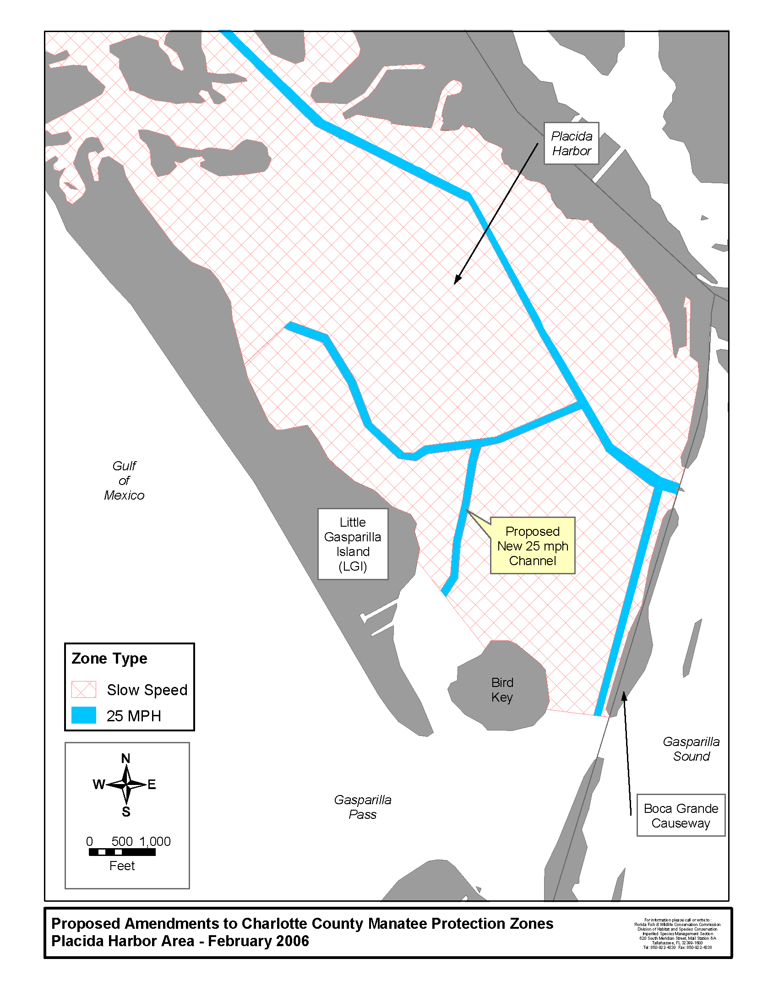Specific Authority 370.12(2)(n) FS. Law Implemented 370.12(2)(d),(k),(n) FS. History–New 12-12-02, Amended ________.

NAME OF PERSON ORIGINATING PROPOSED RULE: Mr. Tim Breault, Director of the Division of Habitat and Species Conservation
NAME OF SUPERVISOR OR PERSON WHO APPROVED THE PROPOSED RULE: The Commission
DATE PROPOSED RULE APPROVED BY AGENCY HEAD: November 30, 2005
DATE NOTICE OF PROPOSED RULE DEVELOPMENT PUBLISHED IN FAW: November 18, 2005

