Notice of Emergency Rule

WATER MANAGEMENT DISTRICTS
Southwest Florida Water Management District
Rule No.: RULE TITLE
40DER10-1: Dover/Plant City Area Frost-Freeze
SPECIFIC REASONS FOR FINDING AN IMMEDIATE DANGER TO THE PUBLIC HEALTH, SAFETY OR WELFARE: The Dover/Plant City area is one of the largest strawberry production areas in the country. When a frost/freeze event occurs strawberry and other similar commodity farmers and aquaculture operations pump large quantities of water to protect their crops. Due to the pumping, the Floridan aquifer level drops, sinkholes occur and some local residents’ wells stop working. Depending on the freeze event numerous sinkholes occur and up to 250 dry wells have been reported. From January 3-13, 2010, temperatures in eastern Hillsborough County dropped below 34 degrees for 11 consecutive days. As a result, area farmers again pumped large quantities of groundwater to protect their crops. During this event, this combined pumping dropped the aquifer level 60 feet and caused more than 750 temporarily dry wells for neighboring homeowners. Although pumping groundwater for freeze protection is a best management practice for strawberry, citrus and other industries and was authorized by their water use permits, pursuant to their permits farmers were responsible for fixing hundreds of dry wells. However, problems with the current permit requirements became evident during the January 2010 freeze. The problems included that the permit requirements did not require well mitigation for many of the residents’ dry wells leading many residents to be without water for extended periods or to pay themselves the costs necessary to restore their wells to service. Additionally, some farmers were required to mitigate many wells, some over 100 wells, while other farmers did not have to mitigate any wells. The District had to address provision of water service to some of the residents through an emergency order. A year later the District is still working to resolve complaints and issues resulting from the January 2010 freeze event.
To address these frost/freeze issues for future freeze events, and the District held numerous public and stakeholder meetings and a series of technical work sessions to receive feedback from key stakeholders. The information gathered at these meetings helped staff develop recommendations to prevent a similar situation from happening in the future. These recommendations included amendments to District rules, including changes to farmers water use permit conditions. The District’s objective was to have the rule amendments in effect before the first freeze event might occur in the winter of 2010/2011. Due to the desire of the District to allow extended public input on the rules, the rules will not be in effect until late in the winter, at the earliest.
Frost/freeze events have now already occurred in December 2010 in the Dover/Plant City area and the District is receiving dry well complaints. The weather forecast is for additional freezing temperatures in the Dover/Plant City area and yet to come are the weeks and months with the statistically most frequent freeze events.
Imminent freeze events pose an immediate danger to the public welfare due to the likely interruption of water service for residents in the area and the potential for sinkholes.
The proposed emergency rules will protect the public interest by ensuring that within the Dover/Plant City area everyone with a dry well complaint and those responsible for mitigation of freeze impacts will be subject to a comprehensive, orderly, expeditious and equitable process for addressing impacts and restoring water service.
REASON FOR CONCLUDING THAT THE PROCEDURE IS FAIR UNDER THE CIRCUMSTANCES: The procedure used by the District to adopt the emergency rule is fair under the circumstances. Affected persons have had a minimum of one week prior notice of the emergency rule. The District included the proposed emergency rule in the Governing Board’s monthly meeting packet which is available to the public at a minimum of seven days prior to the day that the Board and Executive Director approved and filed the emergency rule for adoption. The public is given an opportunity to comment on all matters before the Board during its meetings. The Board’s meeting packet information is posted on the District’s website. The draft emergency rule was provided to the strawberry growers affected by the emergency rule 14 days prior to the Board and Executive Director action on the rule. The emergency rule will be posted on the District’s website and will be provided to all affected permittees.
SUMMARY: The rules define the geographic area within which they apply. Within the applicable geographic area, permits are subject to a process that assigns responsibility for the investigation and potential mitigation of dry well complaints resulting from frost/freeze crop protection pumpage. Within the applicable geographic area, permits are made subject to a process for the investigation and potential mitigation of the dry wells and persons with wells affected by the frost/freeze pumping are advised that they may avail themselves of the process that assigns responsibility for investigation and mitigation of their dry wells. Finally, a standard impact mitigation condition included in permits in the applicable geographic area are replaced with an alternative mitigation condition.
THE PERSON TO BE CONTACTED REGARDING THE EMERGENCY RULE IS: Pamela Gifford, Office of General Counsel, 2379 Broad St., Brooksville, FL 34604-6899, (352)796-7211, (4156) (OGC #2010010)
THE FULL TEXT OF THE EMERGENCY RULE IS:
40DER10-1 Dover/Plant City Area Frost-Freeze.
(1) DOVER/PLANT CITY AREA – Effective as of December 15, 2010, the area subject to this emergency rule is the Dover/Plant City Area within Hillsborough and Polk Counties within the following sections (all Townships are South; all Ranges are East). The boundary of the area is depicted in Figure ER-1.
Township 27, Range 20: Sections 25, 26, 35 and 36;
Township 27, Range 21: Sections 25 through 36;
Township 27, Range 22: Sections 25 through 36;
Township 27, Range 23: Sections 29 through 32;
Township 28, Range 20: Sections 1, 2, 11 through 14, 23 through 26, 35 and 36;
Township 28, Range 21: All Sections;
Township 28, Range 22: All Sections;
Township 28, Range 23: Sections 5 through 8, 17 through 20, and 29 through 32;
Township 29, Range 20: Sections 1, 2, 11 through 14, 23 through 26, 35 and 36;
Township 29, Range 21: All Sections;
Township 29, Range 22: All Sections;
Township 29, Range 23: Sections 5 through 8, 17 through 20, and 29 through 32;
Township 30, Range 20: Sections 1, 2, 11 and 12;
Township 30, Range 21: Sections 1 through 12;
Township 30, Range 22: Sections 1 through 12;
Township 30, Range 23: Sections 5 through 8.
(2) ASSIGNMENT OF RESPONSIBILITY FOR FROST/FREEZE WITHDRAWAL-RELATED WELL COMPLAINTS TO PERMITTEES WITHIN THE DOVER/PLANT CITY AREA – The responsibility of existing and new permittees with a withdrawal point within the Dover/Plant City Area to investigate and resolve frost/freeze withdrawal-related well complaints shall be determined as follows:
(a) Floridan Aquifer Drawdown Contribution – The District shall determine the Floridan aquifer drawdown resulting from each permittee’s permitted frost/freeze groundwater withdrawals through groundwater computer modeling simulation. The modeling shall account for each permittee’s ground water frost/freeze protection quantities, the specific location of the withdrawal site and include the duration of the design event.
(b) Allocation Ratio – The District shall determine an allocation ratio for each permittee with frost/freeze groundwater quantities. The District shall determine each permittee’s percent of the total of frost/freeze groundwater quantities permitted within the Dover/Plant City Area. The percent is then converted into an allocation ratio. For example, a permittee who is permitted 2% of the overall groundwater frost/freeze protection quantities in the area would have a ratio of 1:50 and would only be eligible to be assigned one well complaint for every 50 received.
(c) Legal Existing Use Date – The District shall determine each permittee’s existing legal use date based on when the permit was issued with the current water use quantities.
(d) Impact Location – As each well complaint is received, the coordinates for the impacted well shall be entered into the model to determine the aquifer drawdown caused by each permittee at those coordinates.
(e) Assignment of Responsibility – The responsibility to investigate and resolve the complaint is then assigned to the permittee that caused the greatest drawdown at a particular site, except:
1. If the permittee’s existing legal use date precedes that of the complainant’s well.
2. If the permittee has already been assigned all the complaints it is responsible for based on its allocation ratio.
3. If the permittee is determined not to have been withdrawing ground water.
If subparagraph (2)(e)1., 2. or 3. applies, then the process in this subsection (2) is repeated for the permittee who has the next greatest drawdown at the complainant’s site.
(3) INVESTIGATION OF FROST/FREEZE PROTECTION WITHDRAWAL-RELATED WELL COMPLAINTS BY PERMITTEES WITHIN THE DOVER/PLANT CITY AREA – Permits in effect as of December 15, 2010, with a withdrawal within the Dover/Plant City Area shall have any permit conditions requiring investigation of frost/freeze, crop protection withdrawal-related well complaints within a specified area or distance removed and replaced with the following permit condition. Permits issued on or after December 15, 2010, or for uses permitted prior to December 15, 2010, that include frost/freeze protection, crop protection, and that do not have a specific condition requiring complaint investigations shall also include this permit condition.
(a) Frost/Freeze Withdrawal-related Well Complaints.
Well Evaluation and Temporary Supply.
After the District receives a well complaint and determines that there is a responsible permittee, as provided in this emergency Rule 40DER10-1, the District will then notify the responsible permittee of the complaint. It will also inform the complainant of the responsible permittee.
(b) Estimates of Repairs.
1. The permittee shall arrange with the complainant for the evaluation and preparation of an estimate for restoration of water service to the complainant. The evaluation shall occur within 24 hours of the receipt of the complaint by the permittee, unless the complainant agrees to a longer time period. The permittee shall notify the District of the date and time for the evaluation of the complainant’s well. Selection of a water well contractor to undertake either the repair or replacement of the complainant’s well is at the discretion of the permittee, as long as the water well contractor has a license in good standing issued by a water management district. If only a pump repair is required, the person doing the repair shall have the appropriate occupational license.
2. Alternatively, the complainant and the permittee can jointly arrange for the evaluation and preparation of an estimate to address the well complaint. If this option is chosen, then the evaluation must occur within 24 hours of the receipt of the complaint by the permittee, unless the complainant agrees to a longer time period.
3. The permittee shall provide a temporary water supply to the complainant within five hours of the completion of the well evaluation and continue to provide the temporary water supply until water service is restored to the complainant’s well as long as the complainant cooperates with the permittee in the repair of the complainant’s well.
(c) Restoration of Water Supply.
1. If the evaluation indicates that groundwater pumping for frost/freeze crop protection resulted in loss of the complainant’s water service, the permittee shall pay for the work necessary to restore water service to the complainant.
2. If the well evaluation does not occur within 24 hours or within a longer time period agreed to by the complainant or a temporary water supply is not provided within five hours of the well evaluation, the complainant may arrange for the evaluation and repair or replacement of the well as necessary to restore water supply and a temporary water supply if needed. Once the complainant provides a detailed accounting of well repair or replacement expenditures, and expenses for a temporary water supply if applicable, to the District and the permittee, the permittee shall reimburse the complainant within 30 days of permittee’s receipt of the detailed accounting for the well repair or replacement expenditures, as well as the expenses for a temporary water supply if applicable, or provide a report to the District within seven days of the receipt by the permittee of disputed costs. This report shall detail why the permittee is not responsible for reimbursing all of the funds expended by the complainant for the well repair or replacement, and a temporary water supply if applicable. The permittee shall provide a copy of this report to the complainant. The District will review the report and determine the appropriate reimbursement based on the cause of the well complaint and the appropriate remedy.
(d) Pre-Complaint Repairs.
If a complainant has expended funds for a well repair or replacement before submitting a well complaint to the District, and upon filing the complaint within 14 days of the water use permittee’s pumping that resulted in interference, the District determines that there is a responsible permittee as provided in (2) above, if the complainant provides a detailed accounting of expenditures for well repair or replacement, and for a temporary water supply if applicable, then the responsible permittee shall reimburse the complainant for its actual expenditures, not to exceed $1,500 within 30 days of permittee’s receipt of the detailed accounting of the expenditures or provide a report to the District within seven days of the receipt by the permittee of disputed costs. This report shall detail why the permittee is not responsible for reimbursing all of the funds expended by the complainant for the well repair or replacement, and temporary water supply if applicable. The permittee shall provide a copy of this report to the complainant. The District will review the report and determine the appropriate reimbursement based on the cause of the well complaint and the appropriate remedy.
(e) Permittee’s Mitigation Activities and Report.
1. The permittee shall inform the District as to how the permittee intends to proceed to mitigate the complaint within one business day after notice of responsibility to mitigate the complaint is delivered by the District to the permittee via electronic mail, phone call or message, or facsimile transmission, or within three business days after depositing a letter to permittee in the U.S. Mail.
2. If the permittee informs the District that it has determined that it is not responsible for mitigation of the complaint, then the permittee must provide a full explanation for its position. If, after the District has reviewed the permittee’s response, the District determines that the permittee is still responsible for mitigating the complaint, the permittee shall proceed with full mitigation of the complaint as set forth in this condition.
3. All well complaints shall be fully mitigated by the permittee as soon as is practicable. Full mitigation of the well complaint shall be restoration of the complainant’s well to pre-impact condition or better, including the pressure levels, discharge quantity, and water quality. Full mitigation of the well complaint necessitates the construction of a new well for the complainant if the existing well cannot be restored to pre-impact condition.
4. Within one business day after the complaint is fully mitigated, the permittee shall provide a report to the District in which the permittee details the activities undertaken by either the complainant or the permittee to mitigate the complaint as well as any reimbursements made by the permittee to the complainant. The permittee shall provide a copy of this report to the complainant. The District will review the report submitted by the permittee and may require additional action by the permittee if the District determines that the complaint has not been fully mitigated.
(f) If the permittee makes a good-faith effort to comply with the response process set forth above but is unable to repair or replace the well because of the lack of cooperation of the complainant, the permittee may request that the District deem the permittee to have satisfied this permit condition.
(g) Time is of the essence of this permit condition and each of its provisions. For example, the full mitigation of a complaint does not excuse the failure to timely comply with each of the provisions of this condition.
(4) AVAILABILITY OF MITIGATION PROCESS FOR IMPACTS TO EXISTING LEGAL USES – Persons who believe that groundwater pumping by a water use permittee for frost/freeze protection has interfered with the person’s existing legal use of groundwater may seek mitigation based upon the process set forth in subsection (3), above. An example of interference with the person’s existing legal use of groundwater is that the person’s well pump no longer operates. In order to seek mitigation through this process such persons must provide the District with their name, address, phone number and the location of their affected groundwater well within 14 days of the water use permittee’s pumping that resulted in the interference.
(5) STANDARD PERMIT CONDITION.
(a) The following condition is removed from all existing permits with a withdrawal point located within the Dover/Plant City Area as of December 15, 2010:
The Permittee shall mitigate any adverse impact to environmental features or offsite land uses as a result of withdrawals. When adverse impacts occur or are imminent, the District shall require the Permittee to mitigate the impacts. Adverse impacts include the following:
1. Significant reduction in levels or flows in water bodies such as lakes, impoundments, wetlands, springs, streams, or other watercourses.
2. Sinkholes or subsidence caused by reduction in water levels.
3. Damage to crops and other vegetation causing financial harm to the owner.
4. Damage to the habitat of endangered or threatened species.
(b) All permits with a withdrawal point within the Dover/Plant City Area shall include the following condition:
The Permittee shall mitigate any unacceptable adverse impact resulting from withdrawals to environmental features, Minimum Flows or Minimum Levels, or offsite land uses, as specified in subsection 40D-2.301(1), F.A.C., and the Water Use Permit Information Manual, Part B, the Basis of Review for Water Use Permit Applications, Chapter 4. Should unanticipated or unmitigated unacceptable adverse impacts occur, the Permittee shall be required to expeditiously mitigate the impacts.
Rulemaking Authority 120.54(4), 373.044, 373.113, 373.171 FS. Law Implemented 120.54(4), 373.216, 373.219, 373.223, 373.239 FS. History–New 12-15-10.

Figure ER-1

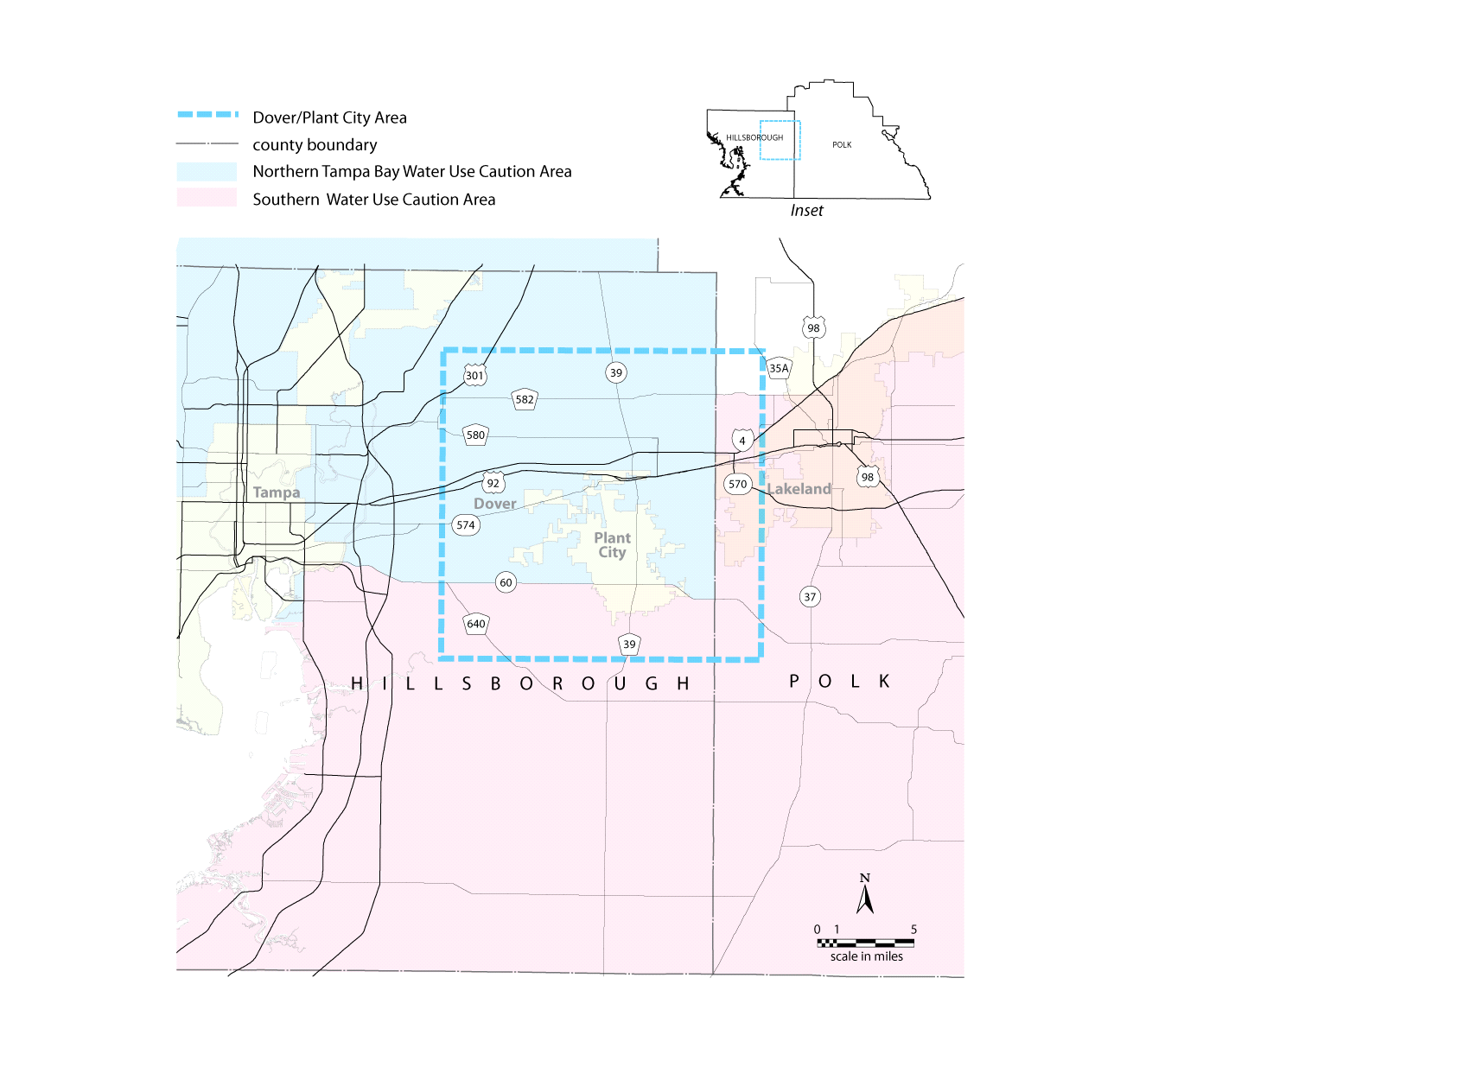

THIS RULE TAKES EFFECT UPON BEING FILED WITH THE DEPARTMENT OF STATE UNLESS A LATER TIME AND DATE IS SPECIFIED IN THE RULE.
EFFECTIVE DATE: December 15, 2010

