Notice of Proposed Rule
WATER MANAGEMENT DISTRICTS
Southwest Florida Water Management District
Rule No.: RULE TITLE
40D-8.626: Minimum Aquifer Levels
PURPOSE AND EFFECT: In January 2010, farmers in the Dover/Plant City area pumped large quantities of groundwater to protect their crops. This combined pumping dropped the aquifer level 60 feet and caused more than 750 temporarily dry wells for neighboring homeowners. Pumping groundwater for freeze protection is a best management practice for strawberry, citrus, and other industries and is authorized by water use permits. However, the farmers were responsible for fixing hundreds of the dry wells. Amendments to Chapter 40D-8, F.A.C., are being made as part of a rulemaking package, which will also include amendments to Chapters 40D-1, 40D-2, and 40D-80, F.A.C., to prevent a similar situation. Effective and complete implementation of the current phase of the management strategy for the Dover/Plant City area frost/freeze crop protection pumping is dependent on each of the proposed amendments to Chapters 40D-1, 40D-2, 40D-8 and 40D-80, F.A.C. Particularly, amendments to Chapter 40D-8 will establish a Minimum Aquifer Level and Minimum Aquifer Level Protection Zone providing a minimum aquifer elevation for the Dover/Plant city area to prevent significant harm from frost/freeze pumpage. The Minimum Aquifer Level is established as part of a comprehensive management program intended to arrest water level declines during frost/freeze events to minimize the potential for impacts to existing legal uses and sinkhole occurrence. The aquifer level at District well DV-1 Suwannee is affected by local and regional groundwater withdrawals. In order to address the effects of local and regional groundwater withdrawals and the variable hydrogeologic factors within the region, a Minimum Aquifer Level Protection Zone is established under proposed Chapter 40D-8. In establishing the Minimum Aquifer Level, the District has determined that the actual water level is below the Minimum Aquifer Level when certain pumping and climatic conditions occur. Therefore, this rulemaking package also proposes a Minimum Aquifer Recovery Strategy under proposed amendments to Chapter 40D-80, F.A.C. Also, this rulemaking package contains amendments to Chapter 40D-2, F.A.C., which sets forth the regulatory portion of the rulemaking package. Additionally, the amendments to Chapters 40D-1 and 40D-2, F.A.C., will incorporate revised and new District water use permit application forms to implement the provisions of the proposed companion amendments to Chapters 40D-2, 40D-8 and 40D-80, F.A.C., to be used in the proposed Dover/Plant City Water Use Caution Area (DPCWUCA).
SUMMARY: Amendments to Chapter 40D-8, F.A.C., will establish a Minimum Aquifer Level and Minimum Aquifer Level Protection Zone providing a minimum aquifer elevation for the Dover/Plant city area to prevent significant harm from frost/freeze pumpage. The minimum aquifer level is the 10 ft potentiometric surface elevation at District Well DV-1 Suwannee. Compliance with the Minimum Aquifer Level is evaluated using a groundwater flow model simulation of the permitted groundwater frost/freeze withdrawals in the DPCWUCA, which is being established in companion rule amendments to Chapter 40D-2, F.A.C. Based on the annual simulation, if the resulting potentiometric level is at or above 10 ft NGVD at well DV-1 Suwannee, compliance with the Minimum Aquifer Level is achieved. If the resulting level is below 10 ft NGVD at well DV-1 Suwannee, compliance is not achieved. Once the Minimum Aquifer Level is achieved, if the actual potentiometric level falls below the Minimum Aquifer Level during a frost/freeze event, the District shall investigate the cause, re-evaluate the Minimum Aquifer Level, and determine the appropriate recovery strategy. Permittees do not have to demonstrate individual compliance with the Minimum Aquifer Level, only the Minimum Aquifer Protection Zone.
The Minimum Level Protection Zone proposed under amendments to Chapter 40D-8, F.A.C. is defined as an area within the boundary of the 30 ft drawdown contour for the January 2010 frost/freeze event. Proposed amendments to Chapter 40D-2, F.A.C. and the Water Use Permit Basis of Review, Part B (BOR) provide particular compliance regulations based on whether there would be adverse impacts from withdrawals that would impact the Minimum Level Protection Zone.
SUMMARY OF STATEMENT OF ESTIMATED REGULATORY COSTS: From January 3-13, 2010, for the first time during the period that records have been kept, temperatures in eastern Hillsborough County and western Polk County dropped below 34 degrees for 11 consecutive days. As a result, area farmers pumped large quantities of groundwater to protect their crops. This combined pumping dropped the aquifer level 60 feet, contributed to the more than 140 sinkholes and caused more than 750 neighboring groundwater wells to be damaged or to temporarily go dry. Under Florida Statute and District water use permitting rules this damage is not allowable. Therefore, in response to the 2010 freeze event combined with previous freeze events that also resulted in dry wells and sinkholes in the Dover/Plant City area, the District is revising its rules in Chapters 40D-1, 40D-2, 40D-8, and 40D-80, F.A.C., to reduce the potential for impacts from groundwater pumping during future freeze events. The District is establishing a Water Use Caution Area, a Minimum Aquifer Level, a Minimum Aquifer Protection Zone and a Minimum Aquifer Level Recovery Strategy to manage permits authorized to withdraw groundwater for frost/freeze crop protection. The objective of the Recovery Strategy is by January 2020, to reduce groundwater withdrawals for frost/freeze protection by 20% from January 2010 quantities to lessen the potential that drawdown during a future frost/freeze event would lower the aquifer level at District Well DV-1 Suwannee below 10 feet NGVD. The intent is to lessen the likelihood of domestic well failures and sinkhole formation over time in the Dover/Plant City area during freeze events when groundwater is pumped to protect valuable but cold sensitive crops. Permittees and applicants that typically use groundwater for frost/freeze crop protection and most likely affected by the proposed rules are strawberry, citrus, blueberry, nursery and tropical fish farms.
During rule development the District considered many options including: (1) an across the board reduction in water quantities; (2) requiring water use permittees to obtain insurance to cover mitigation costs, and (3) relying on existing rules to deny application for permits on an application by application, case by case basis. However, while the District could require immediate changes or cutbacks by permittees, the District believed that the economic cost to permittees would be too great and opted for a regulatory program that does not reduce quantities on existing permits unless economically feasible alternative means are available and sets a reduction goal of 20 percent over 10 years.
Relying solely on a regulatory approach, such as across the board cuts in frost/freeze quantities or limiting the duration of allowable pumping during frost freeze events could have a significant impact on the agricultural and overall economy of the area. Unlike some other crops that can be insured against natural disasters such as hail, there is no “freeze event” subsidized crop insurance for strawberries, the main crop in the area. Further, such insurance generally requires the grower to make every effort to protect the crop, including pumping groundwater. The grower would be responsible for any losses due to freezes. Therefore, the grower will utilize permitted frost/freeze protection water quantities and/or a financially feasible alternative means to protect the crop.
The regulatory provisions of the recovery strategy are designed primarily to restrict any new impacts from frost/freeze withdrawals on groundwater levels in the Minimum Aquifer Level Protection Zone. This is accomplished by restricting new increases in frost/freeze protection groundwater quantities that affect the Minimum Aquifer Level Protection Zone so that water levels will not be lowered even further during frost/freeze events. To some extent, frost/freeze protection groundwater quantities may be reduced through rule provisions such as “net benefit” when an increase in frost/freeze protection is requested. In that case where one permittee requests an increase in frost/freeze protection groundwater quantities, another permittee can agree that a specified portion of its groundwater withdrawal will be reduced and reserved to protect the aquifer level.
The primary method for reducing existing groundwater withdrawals for frost/freeze protection in and around the Minimum Aquifer Level Protection Zone will be non-regulatory. The focus of this effort is to provide further financial incentives for water users to adopt technologies that reduce groundwater use such as the use of tailwater recovery systems and protection methods other than water such as crop cloths and crop enclosures.
In accordance with statute and District rule, to prevent further water level declines during frost/freeze events, new groundwater quantities for cold protection that impact the Minimum Aquifer Level Protection Zone will not be permitted. Applicants for new frost freeze groundwater quantities may eliminate the impact by relocating withdrawals, developing alternative sources or means of cold protection, or providing a net benefit that offsets the impact of the proposed withdrawals plus a 20% net benefit. Alternative sources or means of cold protection range from $581 to $3,700 per acre farmed per year for row and tree crops and approximately $78 per hundred square feet of pond for fish farms. Per acre costs vary by the type of crop grown and the size of the farm.
Existing permitted groundwater quantities for cold protection that impact the Minimum Aquifer Level Protection Zone will not be affected. However when existing water use permittees apply for renewal of their permits that have cold protection quantities that impact the Minimum Aquifer Protection Zone, they will have to incur the cost to investigate the feasibility of alternative cold protection methods (costs addressed above) and implement them if economically, technically and environmentally feasible to reduce existing impacts. As part of the non-regulatory portion of the recovery strategy, the District intends to fund 75% of the equipment costs of alternative cold protection measures that reduce cold protection withdrawals within in the DPCWUCA and 50% to 75% of equipment costs for projects outside the DPCWUCA that reduce impacts on the Minimum Aquifer Level Protection Zone, significantly reducing the costs, which are only incurred after finding that they are feasible, addressed above. Proposed relocation and net benefit provisions are designed to lessen the impact of the proposed rules by allowing the movement and expansion of the affected agricultural industries so long as the relocation does not increase cold protection impacts and the expansion contributes to lessening of such impacts.
To better monitor and model cold protection impacts, the District will provide meters and automatic meter reading (AMR) devices to existing permittees that do not have them and:
• have groundwater cold protection quantities or crops that typically require cold protection quantities in the DPCWUCA, and
• have 100,000 gpd or more of groundwater permitted in the DPCWUCA.
New permttiees that meet the above conditions will as one of the permit conditions have to purchase, install and maintain the required meters at an annualized cost range of $10 to $103 per acre per withdrawal site. The District will pay the AMR data collection and transmission subscription costs for both existing and new permittees required to meter and use AMR devices.
Current permit conditions in the Dover/Plant City area generally place the burden of well complaint investigation and repair on more recent permittees. Proposed revisions will significantly reduce the likelihood that an individual permittee will have to incur the costs of multiple well mitigation investigations and repairs as often occurred in the 2010 freeze event.
To provide flow meters, AMR devices, AMR data reporting subscriptions and revise well mitigation allocation methods, the District will incur approximately $6.1 million in one-time and $582,000 in recurring annual costs. The proposed revisions are not anticipated to generate rule implementation costs to any other state or local agencies nor are they anticipated to have any effects on state or local revenues.
No small cities or counties are affected by the proposed rules. Only those small businesses that exceed the permitting thresholds in Rule 40D-2.041, F.A.C. and have, would typically use, or request new groundwater quantities for frost/freeze protection in the DPCWUCA, or whose existing or proposed groundwater frost/freeze protection withdrawals outside the DPCWUCA that would impact the Minimum Aquifer Level Protection Zone, will be affected as previously described. As noted above, the District will reduce the cost to existing small businesses that must comply with the rule by providing meters and AMR devices, and covering the costs of AMR data reporting subscriptions so as to minimize costs to small businesses resulting from the regulation designed to allow the small business to continue to operate in compliance with statute and District rule. The District also intends to cost share the alternative frost/freeze protection costs that are deemed economically, technically and environmentally feasible that existing small business permittees may have to incur.
Any person who wishes to provide information regarding a statement of estimated regulatory costs, or provide a proposal for a lower cost regulatory alternative must do so in writing within 21 days of this notice.
SPECIFIC AUTHORITY: 373.044, 373.113, 373.171 FS.
LAW IMPLEMENTED: 373.036, 373.042, 373.0421, 373.709 FS.
IF REQUESTED WITHIN 21 DAYS OF THE DATE OF THIS NOTICE, A HEARING WILL BE HELD AT THE DATE, TIME AND PLACE SHOWN BELOW(IF NOT REQUESTED, THIS HEARING WILL NOT BE HELD):
DATE AND TIME: January 25, 2011, 9:00 a.m.
PLACE: Southwest Florida Water Management District, Tampa Service Office, 7601 US 301, Tampa, FL 33637
Pursuant to the provisions of the Americans with Disabilities Act, any person requiring special accommodations to participate in this workshop/meeting is asked to advise the agency at least 5 days before the workshop/meeting by contacting: The Southwest Florida Water Management District Human Resources Director, 2379 Broad Street, Brooksville, Florida 34604-6899; telephone (352)796-7211, ext. 4702 or 1(800)423-1476 (FL only), ext. 4702; TDD (FL only) 1(800)231-6103; or mail to ADACoordinator@swfwmd.state.fl.us. If you are hearing or speech impaired, please contact the agency using the Florida Relay Service, 1(800)955-8771 (TDD) or 1(800)955-8770 (Voice).
THE PERSON TO BE CONTACTED REGARDING THE PROPOSED RULE IS: Pamela Gifford, Office of General Counsel, 2379 Broad St., Brooksville, FL 34604-6899, (352)796-7211 (4156) (OGC #2010010)
THE FULL TEXT OF THE PROPOSED RULE IS:
40D-8.626 Minimum Aquifer Levels.
(1) through (2) No change.
(3) Dover/Plant City Water Use Caution Area Minimum Aquifer Level.
(a) The District has determined that ground water withdrawals in the Dover/Plant City area have contributed to water level declines that are significantly harmful to the water resources of the area. The Minimum Aquifer Level is established as part of a comprehensive management program intended to arrest water level declines during frost/freeze events to minimize the potential for impacts to existing legal uses and sinkhole occurrence.
(b) The Minimum Aquifer Level is the 10 ft. potentiometric surface elevation (NGVD 1929) at District Well DV-1 Suwannee, located as shown in Figure 8-4. The Minimum Aquifer Level is the level below which the greatest impact occurred in terms of well failures and sinkholes during the 2010 frost/freeze event.
(c) The Minimum Aquifer Level at DV-1 Suwannee is affected by local and regional groundwater withdrawals. In order to address the effects of local and regional groundwater withdrawals and the variable hydrogeologic factors within the region, a Minimum Aquifer Level Protection Zone is established. The Minimum Aquifer Protection Zone is the area within the 30 ft. drawdown contour that resulted from the January, 2010 frost/freeze event, as shown in Figure 8-4. The digital description of the geographic area is available from the District as ArcGIS Geographic Information System feature class Minimum Aquifer Level Protection Zone.
(d) Compliance with the Minimum Aquifer Level is evaluated using a ground water flow model simulation of the permitted groundwater frost/freeze withdrawals in the Dover/Plant City WUCA. Based on an annual simulation, if the resulting potentiometric level is at or above 10 ft NGVD at well DV-1 Suwannee, compliance with the Minimum Aquifer Level is achieved. If the resulting level is below 10 ft. NGVD (1929) at well DV-1 Suwannee, compliance with the Minimum Aquifer Level is not achieved. Once the Minimum Aquifer Level is achieved based on the annual simulation, if the actual potentiometric level falls below the Minimum Aquifer Level during a frost/freeze event, the District shall investigate the cause, re-evaluate the Minimum Aquifer Level and determine the appropriate recovery strategy.

Figure 8-4. Minimum Aquifer Level Site DV-1 Suwannee and Minimum Aquifer Level Protection Zone

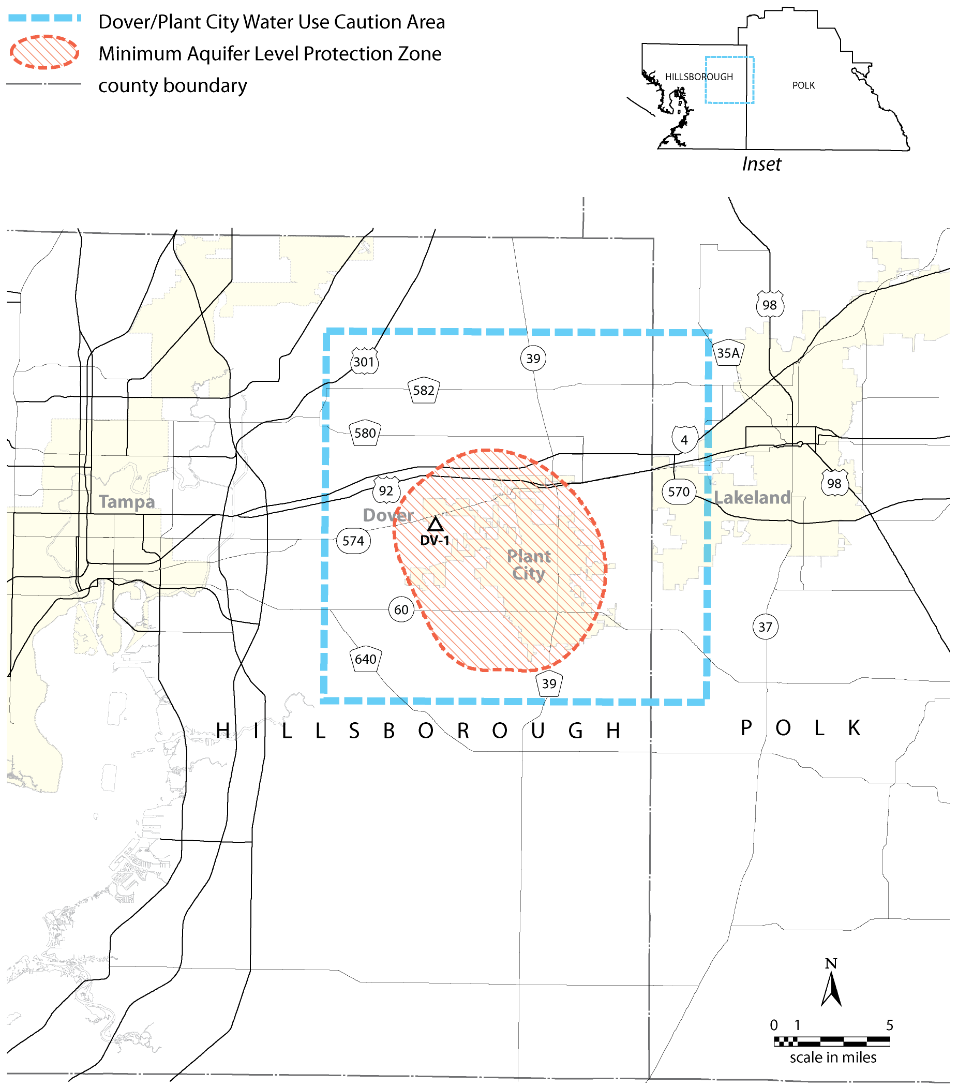
Rulemaking Authority 373.044, 373.113, 373.171 FS. Law Implemented 373.036, 373.0361, 373.0395, 373.042, 373.0421, 373.709 FS. History–New 8-7-00, Amended 1-1-07,________.

NAME OF PERSON ORIGINATING PROPOSED RULE: Alba Mas, Tampa Regulation Manager, 7601 Highway 301 North, Tampa, FL 33637-6759, (813)985-7481 (Ext. 2000)
NAME OF AGENCY HEAD WHO APPROVED THE PROPOSED RULE: Southwest Florida Water Management District Governing Board
DATE PROPOSED RULE APPROVED BY AGENCY HEAD: December 14, 2010
DATE NOTICE OF PROPOSED RULE DEVELOPMENT PUBLISHED IN FAW: November 12, 2010

