Notice of Proposed Rule

FISH AND WILDLIFE CONSERVATION COMMISSION
Vessel Registration and Boating Safety
Rule No. : RULE TITLE :
68D-24.155: St. Johns County Boating Restricted Areas
PURPOSE AND EFFECT: The purpose of this amendment is to provide for public safety at the St. Augustine Municipal Marina fuel dock adjacent to the Atlantic Intracoastal Waterway within St. Johns County.
SUMMARY: This rule amendment extends the already existing 500 foot Idle Speed No Wake Zone south of the Bridge of Lions an additional 275 feet to provide for public safety at the St. Augustine Municipal Marina fuel dock.
SUMMARY OF STATEMENT OF ESTIMATED REGULATORY COSTS: The Agency has determined that this will not have an impact on small business. An SERC has not been prepared by the agency.
Any person who wishes to provide information regarding a statement of estimated regulatory costs, or provide a proposal for a lower cost regulatory alternative must do so in writing within 21 days of this notice.
RULEMAKING AUTHORITY: 327.04, 327.46 FS.
LAW IMPLEMENTED: 327.46 FS.
A HEARING WILL BE HELD AT THE DATE, TIME AND PLACE SHOWN BELOW:
DATES AND TIME: April 6-7, 2011, 8:30 a.m. – 5:00 p.m., each day
PLACE: Florida Public Safety Institute, 215 Academy Drive, Havana, FL 32333
Pursuant to the provisions of the Americans with Disabilities Act, any person requiring special accommodations to participate in this workshop/meeting is asked to advise the agency at least 5 days before the workshop/meeting by contacting: ADA Coordinator, at (850)488-6411. If you are hearing or speech impaired, please contact the agency using the Florida Relay Service, 1(800)955-8771 (TDD) or 1(800)955-8770 (Voice).
THE PERSON TO BE CONTACTED REGARDING THE PROPOSED RULE IS: Ryan Moreau, Florida Fish and Wildlife Conservation Commission, Division of Law Enforcement, Boating and Waterways Section, 620 South Meridian Street, Tallahassee, Florida 32399-1600, ryan.moreau@myfwc.com.

THE FULL TEXT OF THE PROPOSED RULE IS:
68D-24.155 St. Johns County Boating Restricted Areas.
(1) For the purpose of regulating speed and operation of vessel traffic on the Florida Intracoastal Waterway within St. Johns County, Florida, the following boating restricted areas are established:
(a)1. S. R. 210 – Palm Valley Bridge – An Idle Speed No Wake boating restricted area shoreline to shoreline, in and adjacent to the Florida Intracoastal Waterway, 500' north of the centerline of the S. R. 210 Bridge, south to 500' south of the centerline of the S. R. 210 Bridge, as depicted in Drawing A.
(b)2. Vilano Beach Bridge (Tolomato River) – An Idle Speed No Wake boating restricted area shoreline to shoreline, in and adjacent to the Florida Intracoastal Waterway, 500' north of the centerline of the Vilano Beach Bridge, south to 500' south of the centerline of the Vilano Beach Bridge, as depicted in Drawing B.
(c)3. Bridge of Lions (Matanzas River) – An Idle Speed No Wake boating restricted area shoreline to shoreline, in and adjacent to the Florida Intracoastal Waterway, 500' north of the centerline of the Bridge of Lions Bridge, south to 775' 500' south of the centerline of the Bridge of Lions Bridge at the centerline of the ICW, as depicted in Drawing C.
(d)4. S. R. 312 Bridge (Matanzas River) – An Idle Speed No Wake boating restricted area shoreline to shoreline, in and adjacent to the Florida Intracoastal Waterway, 500' north of the centerline of the S. R. 312 Bridge, south to 500' south of the centerline of the S. R. 312 Bridge, as depicted in Drawing D.
(e)5. Crescent Beach Bridge at S. R. 206 (Mantanzas River) – An Idle Speed No Wake boating restricted area in and adjacent to the Florida Intracoastal Waterway, 500' north of the Crescent Beach Bridge, south to 500' south of the centerline of the Crescent Beach Bridge, as depicted in Drawing E.
(f)6. Devil’s Elbow Boat Ramp – A Slow Speed Minimum Wake zone from 500 feet north (29°45'16N''/81°14'58W'') of the centerline of the Devil’s Elbow Boat Ramp to 500 feet south (29°45'07N''/81°14'59W'') of the centerline of the Devil’s Elbow Boat Ramp in and adjacent to the Florida Intracoastal Waterway as depicted in Drawing F.
(b) St. Johns County is authorized to install and maintain appropriate regulatory markers as directed by the Division of Law Enforcement within the boating restricted areas. St. Johns County may enter into agreements with public or private organizations or individuals to effect this purpose.
(2) The boating restricted areas are depicted on the following drawings:
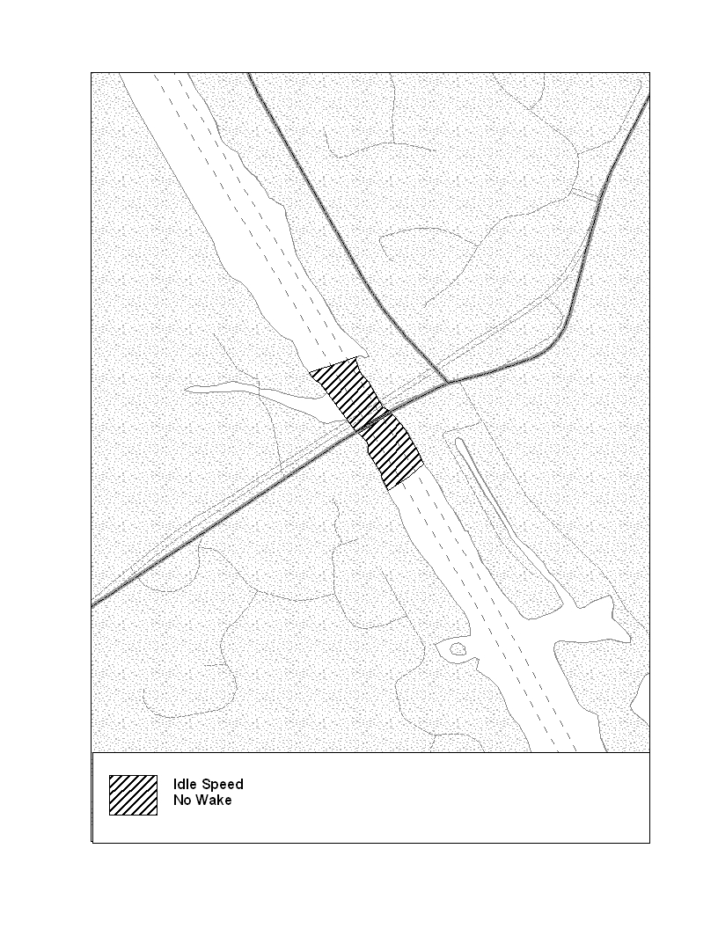 | 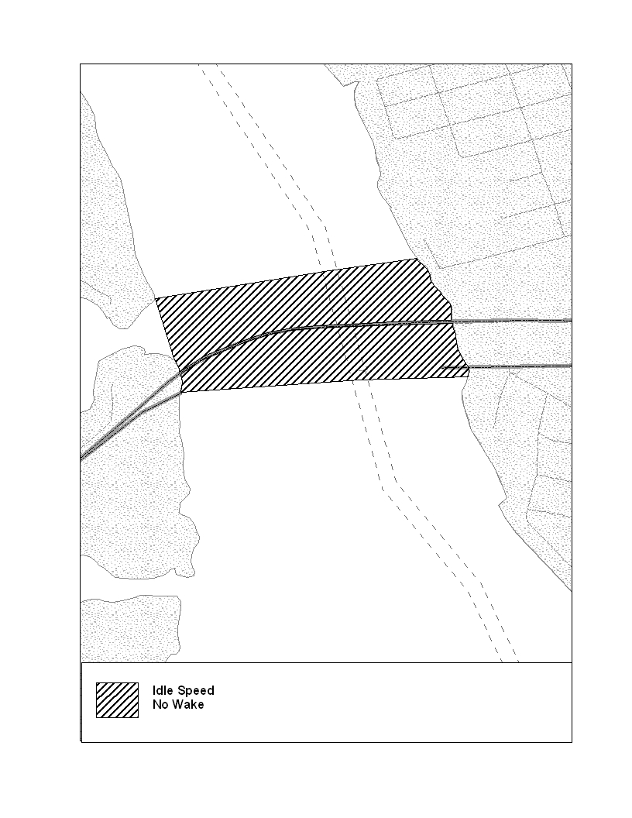
Drawing A – Palm Valley Bridge S.R. 210 | Drawing B – Vilano Beach Bridge
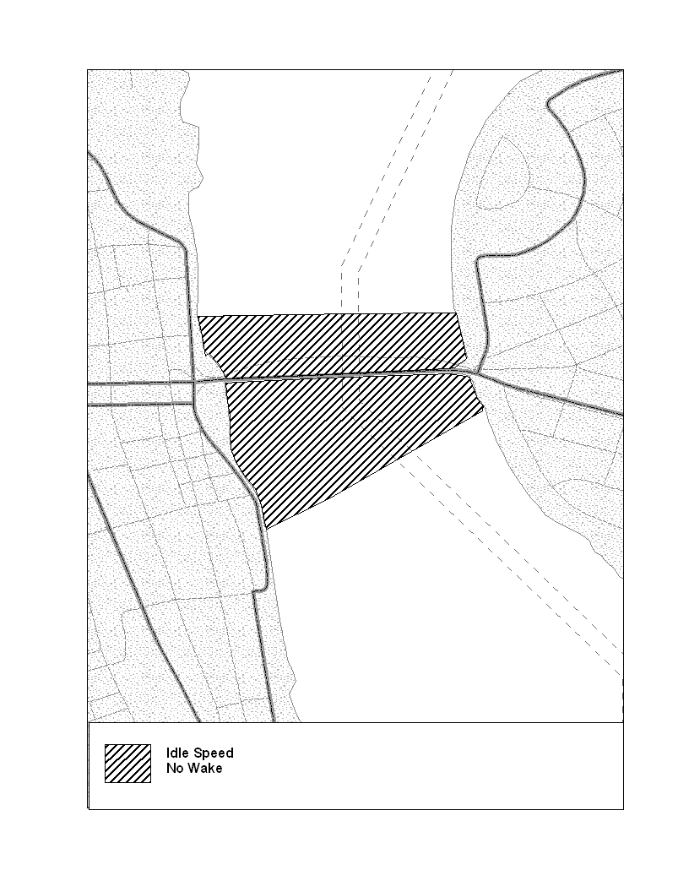 | 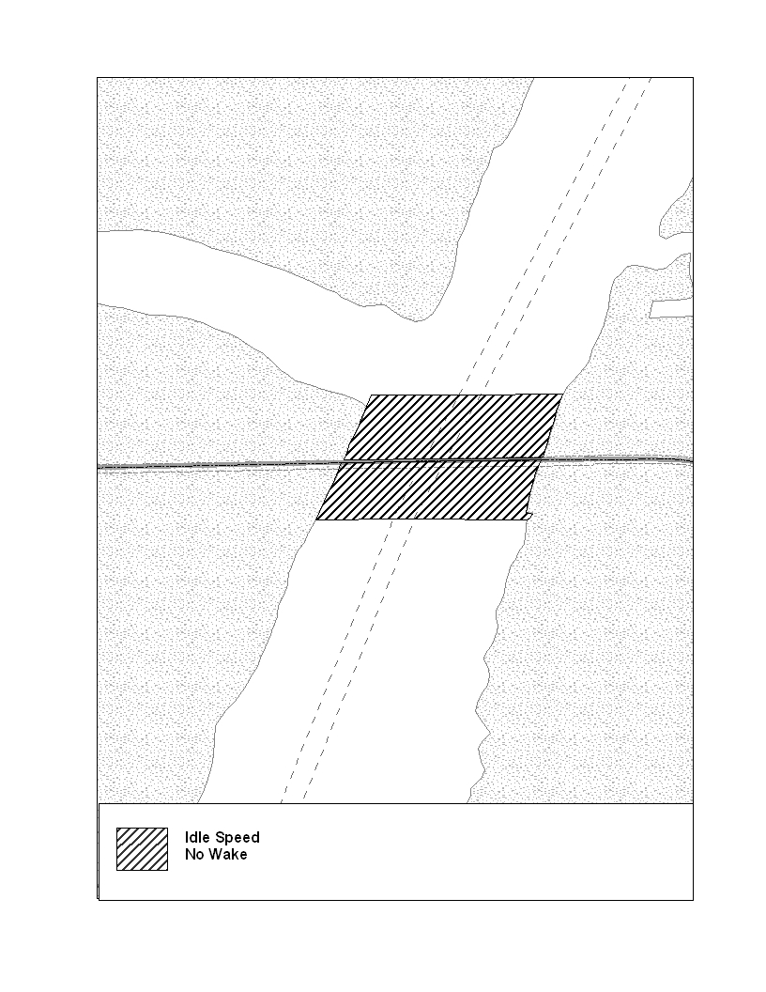
Drawing C – Bridge of Lions | Drawing D – S.R. 312 Bridge
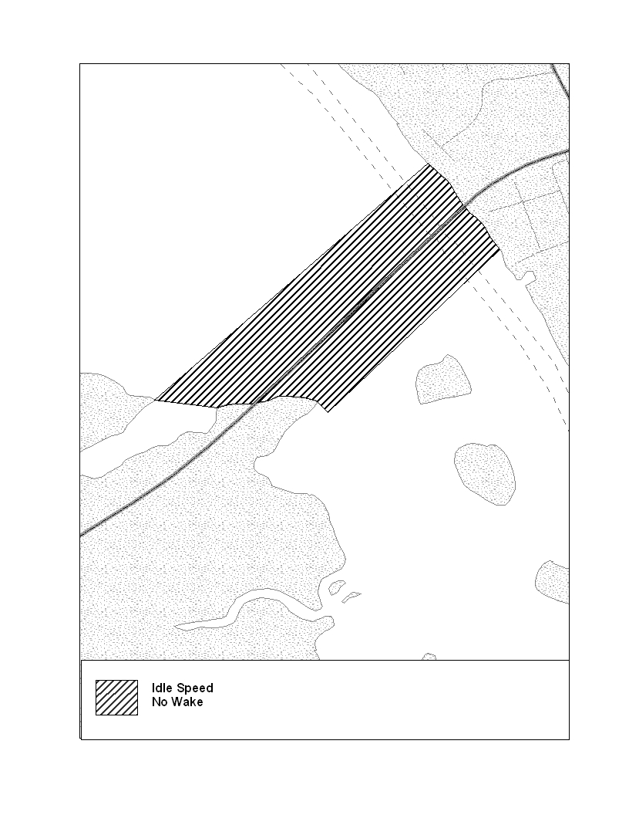 | 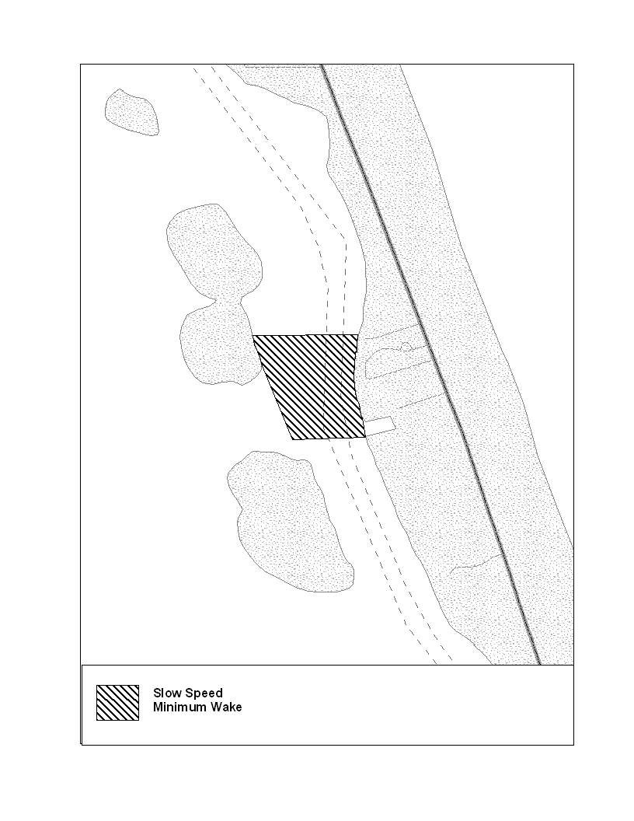
Drawing E – Crescent Beach Bridge | Drawing F – Devil’s Elbow Boat Ramp
Rulemaking Specific Authority 327.04, 327.46 FS. Law Implemented 327.46 FS. History–New 12-11-97, Formerly 62N-24.155, Amended 11-14-01,_________.

NAME OF PERSON ORIGINATING PROPOSED RULE: Colonel Jim Brown, Florida Fish and Wildlife Conservation Commission, Division of Law Enforcement, 620 South Meridian Street, Tallahassee, Florida 32399-1600
NAME OF AGENCY HEAD WHO APPROVED THE PROPOSED RULE: Florida Fish and Wildlife Conservation Commission
DATE PROPOSED RULE APPROVED BY AGENCY HEAD: February 23, 2011
DATE NOTICE OF PROPOSED RULE DEVELOPMENT PUBLISHED IN FAW: September 24, 2010

