CHAPTER 40A-2

REGULATION OF CONSUMPTIVE USES OF WATER

40A-2.011 Policy and Purpose

40A-2.021 Definitions

40A-2.031 Implementation (Repealed)

40A-2.041 Permits Required

40A-2.051 Exemptions

40A-2.061 General Water Use Permit – Criteria, Limitations and Conditions

40A-2.101 Content of Application

40A-2.121 Application Processing, Notice and Hearing Requirements (Repealed)

40A-2.141 Request for Additional Information; Incomplete Application (Repealed)

40A-2.201 Permit Processing Fee

40A-2.223 Reservation of Water

40A-2.301 Conditions for Issuance of Permits

40A-2.302 General Water Use Permit – Criteria, Limitations and Conditions (Transferred)

40A-2.311 Competing Applications (Repealed)

40A-2.321 Duration of Permits

40A-2.331 Modification of Permits

40A-2.341 Revocation of Permits (Repealed)

40A-2.342 Permit Denial (Repealed)

40A-2.351 Transfer of Permits

40A-2.361 Renewal of Permits

40A-2.381 Limiting Conditions

40A-2.441 Temporary Permits (Repealed)

40A-2.501 Permit Classification

40A-2.511 Declaration of Water Shortage

40A-2.801 Declaration of Water Resource Caution Areas

40A-2.802 Water Resource Caution Areas

40A-2.901 Forms

40A-2.902 Areal Boundary Maps for Water Use Permitting

40A-2.903 Permitting Capacity Table (Repealed)

40A-2.904 Areal Boundary Maps for Water Resource Caution Areas

40A-2.011 Policy and Purpose.
The purpose of this chapter is to implement the provisions of Part II of Chapter 373, F.S., and the Water Resource Implementation Rule set forth in Chapter 62-40, F.A.C. Additional rules relating to water use are found in Chapter 40A-1, F.A.C., entitled General and Procedural, Chapter 40A-3, F.A.C., entitled Regulation of Wells and Chapter 40A-21, F.A.C., entitled Water Shortage Plan.
Rulemaking Authority 373.044, 373.113, 373.171 FS. Law Implemented 373.171, 373.216, 373.219 FS. History–New 10-1-82, Amended 1-5-86, 10-1-95, 7-1-98, 5-29-14.

40A-2.021 Definitions.
(1) Alternative water supply – a water source that meets the definition in Section 373.019, F.S.
(2) Annual average daily withdrawal – an amount of water that is equal to the total volume of water withdrawn or diverted from all sources during one year divided by 365 days, and expressed in gallons per day (gpd).
(3) Applicant’s Handbook – a document providing additional guidance and direction to applicants and Permittees regarding this rule.
(4) Annual withdrawal – the quantity of water withdrawn or diverted during any 365 day period.
(5) Aquifer remediation use – the withdrawal of groundwater for the authorized removal of contaminants for the purposes of restoring water quality.
(6) Area of Resource Concern – areas delineated on the map contained in Rule 40A-2.902, F.A.C., where resource concerns exist related to water availability, water quality, high anticipated growth in demand or other factors.
(7) Base flow – the sustained or fair-weather streamflow. Base flow is the difference between streamflow (total runoff) and direct runoff. Base flow originates from rainwater that percolates downward to the water table and moves laterally through the groundwater aquifer toward the streams.
(8) Capacity – the amount of water that can be withdrawn or diverted by a ground or surface water pump within a 24-hour period. The capacity of a pump is derived by multiplying the rating of a pump in gallons per minute by 1,440 minutes (24 hours), expressed in gallons per day.
(9) Closed system – an air conditioning/heat pump supply well and return flow well used to inject water carrying no additives into the same permeable zone from which the water was withdrawn by the supply well.
(10) Department – the Florida Department of Environmental Protection.
(11) Disapproved facility – a facility that has been formally disapproved or deemed unsuitable by the District, or Department.
(12) District – the Northwest Florida Water Management District.
(13) District offices – locations staffed by District personnel from which materials incorporated by reference into the rule can be obtained. These are:
District Headquarters, Permitting Section, 152 Water Management Drive, Havana, FL 32333-9700.
(14) Domestic use or domestic consumption – the self-supplied use of water for individual personal household purposes such as drinking, bathing, cooking, sanitation or cleaning, which occurs in a private residence, and includes no more than one rental residence or no more than four non-rental residences served by one well.
(15) Facility – structure that allows for the withdrawal or diversion of water from a particular source. Facilities include, but are not limited to, wells, pumps, pipelines, flumes, canals, ditches, swales, artificial ponds, etc.
(16) Florida-friendly landscaping – a landscaping method detailing nine principles that conserve water, protect the environment, are adaptable to local conditions, and are drought tolerant as outlined in Section 373.185, F.S.
(17) General Water Use Permit – a permit granted by rule to an entity for those non-exempt water uses that meet specific criteria outlines in this chapter.
(18) Governing Board – the Governing Board of the Northwest Florida Water Management District created under section 373.073, F.S.
(19) Harm – harm occurs when a use, diversion or withdrawal causes adverse impact to an existing legal use of water, offsite land use, water resource or environmental feature associated with the resource. De minimus impacts do not constitute harm.
(20) Heating or cooling use – a type of commercial water use involving heating, air-conditioning, or other cooling uses.
(21) Illegally constructed facility – a well constructed or repaired without the appropriate permit having been issued pursuant to Chapter 40A-3, F.A.C., or that is not compliant with the requirements of Chapter 40A-3, F.A.C.
(22) Impact offset ‒ the use of reclaimed water to reduce or eliminate a harmful impact that has occurred or would otherwise occur as a result of other surface water or groundwater withdrawals as described in section 2.2.3.3 of the Water Use Permit Applicant’s Handbook and in subsection 62-40.416(7), F.A.C.
(23) Individual Water Use Permit – a permit granted by the Governing Board or Executive Director, subject to the evaluation and approval of the application pursuant to procedures described in Rule 40A-1.203, F.A.C.
(24) Maximum daily withdrawal – the maximum volume of water withdrawn or diverted during any consecutive 24 hour period, expressed in gallons per day.
(25) Maximum monthly withdrawal – the maximum volume of water withdrawn or diverted during any given month of the year, expressed in gallons.
(26) Minimum flow – the minimum flow for a water course at which further withdrawals would be significantly harmful to the water resources or ecology of the area.
(27) Minimum level – the minimum water level for groundwater in an aquifer or for a surface water body at which further withdrawals would be significantly harmful to the water resources of the area.
(28) Non-potable water use – water not utilized for domestic use, public water supply or other human consumption as defined herein.
(29) Reasonable-beneficial use – the use of water in such quantity as is necessary for economic and efficient utilization for a purpose and in a manner which is both reasonable and consistent with the public interest.
(30) Reclaimed water – as defined in Section 373.019, F.S., water that has received at least secondary treatment and basic disinfection, and is reused after flowing out of a wastewater treatment facility.
(31) Secondary use – use of water by an entity, separate from a water supplier (as defined herein), whose source of water, in whole or in part, is from a water supplier.
(32) Substitution credit – the use of reclaimed water to replace all or a portion of an existing permitted use of resource-limited surface water or groundwater, allowing a different user or use to initiate a withdrawal or increase its withdrawal from the same resource-limited surface water or groundwater source, provided that the withdrawal creates no net adverse impact on the limited water resource or creates a net positive impact if required by the district rule as part of a strategy to protect or recover a water resource, as described in section 2.2.3.3 of the Water Use Permit Applicant’s Handbook.
(33) System – two or more water withdrawal or diversion facilities which are derived from or used to serve properties that are physically proximate and either share the same infrastructure or are operated as a common enterprise.
(34) Water Resource Caution Area – a geographic area, officially designated by the Governing Board by rule that is experiencing, or is anticipated to experience within the next 20 years, critical water resource problems as provided by the criteria identified in subsection 40A-2.801(1), F.A.C.
(35) Water supplier – an entity, such as a water utility or regional water authority, that has obtained a water use permit to withdraw water, of which some portion is distributed to another entity for a secondary use.
(36) Water use – the use, diversion or withdrawal of water regulated under this chapter.
(37) Well casing size – the nominal diameter (within 0.5 inch) of the water bearing casing at the upper terminus (e.g., 4-inch well casing means casing 4.5 inches outside diameter as a standard dimension).
Rulemaking Authority 373.044, 373.113, 373.171 FS. Law Implemented 373.171, 373.216 FS. History–New 10-1-82, Amended 5-17-83, 3-1-84, 1-5-86, 8-1-89, 5-31-92, 11-2-92, 11-1-93, 10-1-95, 7-1-98, 1-1-05, 2-27-06, 5-29-14, 4-29-15.

40A-2.031 Implementation.
Rulemaking Authority 373.044, 373.113 FS. Law Implemented 373.103(1), 373.216, 373.226 FS. History–New 10-1-82, Amended 3-1-84, 1-5-86, Repealed 7-1-98.

40A-2.041 Permits Required.
(1) Unless expressly exempted by law or District rule, a water use permit must be obtained from the District prior to any use, withdrawal, or diversion of water.
(2) The District issues water use permits in two forms, Individual Water Use Permits and General Water Use Permits. General Water Use Permits are issued by rule.
(3) An individual permit is required for any use of water which is non-exempt and does not qualify for a General Water Use Permit by rule in accordance with Rule 40A-2.061, F.A.C.
(4) Under certain circumstances, the District is authorized to issue a temporary water use permit pursuant to Section 373.244, F.S.
(5) A water user shall obtain one permit for all withdrawals and diversions that are intended to serve contiguous property. Two or more properties represented by their owners to be separate properties shall be aggregated and treated as a single property for permitting purposes when the District determines that the properties are physically proximate and either (a) share the same withdrawal facilities and related infrastructure or (b) are operated as a common enterprise. However, when multiple use types, as defined in Rule 40A-2.501, F.A.C., are served by separate withdrawal facilities, the District is authorized to issue separate individual permits.
Rulemaking Authority 373.044, 373.113, 373.116, 373.118, 373.171 FS. Law Implemented 373.171, 373.219, 373.226 FS. History–New 10-1-82, Amended 1-5-86, 5-4-87, 8-1-89, 5-31-92, 11-1-93, 10-1-95, 7-1-98, 1-1-05, 2-27-06, 5-29-14.

40A-2.051 Exemptions.
No permit is required under Rule 40A-2.041, F.A.C., for water used strictly for domestic use which occurs in a private residence, and includes no more than one rental residence or no more than four non-rental residences served by one well.
Rulemaking Authority 373.044, 373.113, 373.171 FS. Law Implemented 373.171, 373.216, 373.219 FS. History–New 10-1-82, Amended 5-17-83, 3-1-84, 1-5-86, 8-1-89, 5-31-92, 11-2-92, 10-1-95, 7-1-98, 1-1-05, 2-27-06, 1-4-10, 5-29-14.

40A-2.061 General Water Use Permits by Rule.
(1) General Water Use Permit by Rule.
(a) The Board hereby grants a General Water Use Permit for all non-exempt, water uses of water that satisfy the following criteria:
1. Have a cumulative average annual daily withdrawal less than 100,000 gallons per day on an annual basis;
2. Are from facilities having a cumulative withdrawal capacity of less than 1,000,000 gallons per day;
3. Are from groundwater wells less than eight (8) inches in diameter;
4. Are from surface water facilities which have a cumulative intake diameter less than six (6) inches;
5. Are consistent with requirements of any applicable mandatory reuse zones; and
6. Are not within a Water Resource Caution Area or Area of Resource Concern as delineated in Rule 40A-2.902, F.A.C.
(b) The General Permit by rule shall be subject to the Standard conditions in section 5.1 and the applicable Specific conditions for the use type in section 5.2.1 of the Water Use Permit Applicant’s Handbook, effective April 29, 2015, (http://www.flrules.org/Gateway/reference.asp?No=Ref-05281), and hereby incorporated by reference in its entirety and can be obtained from the District’s website (nwfwater.com) or from District offices upon request.
(2) General Water Use Permit by Rule for Short-Term Projects.
(a) The Board hereby grants a General Water Use Permit for the use of water in conjunction with the following short-term projects: dewatering operations as described in Rule 40A-2.501, F.A.C., for purposes such as utility construction and foundation installation; lake drawdown for construction or repair; hydrostatic pipeline testing; exploratory groundwater testing; or aquifer performance tests; provided the use meets the following criteria:
1. Has a duration of 180 days or less;
2. Has a maximum daily withdrawal of less than five (5) million gallons;
3. Has a maximum total project withdrawal or diversion of:
a. Less than 100 million gallons for dewatering operations if all discharge is retained on the project site;
b. Less than 100 million gallons for lake drawdown; or
c. Less than 35 million gallons for projects other than dewatering or lake drawdown.
4. Dewatering is occurring only in the uppermost, water table aquifer.
5. Will not dewater to a depth below 0.0 feet NGVD within 1,000 feet of saline water laterally, except when dewatering water with a chloride concentration of greater than 1,000 milligrams per liter;
6. Will not occur within 500 feet of a wastewater treatment plant rapid-rate land application system permitted under Part IV of Chapter 62-610, F.A.C.; and,
7. Will not occur within 1,000 feet of any known groundwater contamination in the water bearing zone being dewatered.
(b) Linear projects, such as roads, utilities, or pipelines, qualify for multiple General Water Use Permits by Rule having a rolling 90-day duration, in which the dewatering operation at the end of each 90-day period occurs more than one (1) linear mile from the location at the beginning of each 90-day period.
(c) The General Water Use Permit by rule shall be subject to the Standard conditions in section 5.1 of the Water Use Permit Applicant’s Handbook.
(3) General Water Use Permit by Rule for Closed-Loop Systems.
(a) The Board hereby grants a General Water Use Permit for the use of water in closed-loop, cooling/heating systems for swimming pools and air conditioning units provided the following criteria are met:
1. The system withdraws less than an annual daily average of 100,000 gallons;
2. The withdrawal and discharge points are on property legally controlled by the permittee;
3. The water is discharged to the same source, aquifer, or permeable zone from which it is withdrawn;
4. The discharge or injection has been permitted by the Department or is exempt from such permitting;
5. The water has no contact or mixing with other water sources, additives, and chemicals; and
6. The use is not from the Floridan Aquifer within the Santa Rosa, Okaloosa, and Walton County Water Resource Caution Area.
(b) The General Water Use Permit by rule shall be subject to the Standard conditions in section 5.1 and the applicable Specific conditions for the use type in section 5.2.1 of the Water Use Permit Applicant’s Handbook.
(4) General Water Use Permit by Rule for Aquifer Remediation Activities.
(a) The Board hereby grants a General Water Use Permit for the use of water for aquifer or groundwater remediation, provided the following criteria are met:
1. The project is conducted according to a Remedial Action Plan approved by the federal, state or local agency having legal jurisdiction over such activities;
2. The treated effluent is returned via infiltration or direct injection into the same source, aquifer, or permeable zone from which it is withdrawn; and
3. The treated effluent meets applicable Department water quality standards.
(b) The General Water Use Permit by rule shall be subject to the Standard conditions in section 5.1 of the Water Use Permit Applicant’s Handbook.
(5) General Water Use Permit by Rule for Specific Uses in Portions of Gadsden County.
(a) The Board hereby grants a General Water Use Permit for water uses in the Upper Telogia Creek Drainage Basin Water Resource Caution Area and Area of Resource Concern of Gadsden County, provided the following criteria are met:
1. The system has an annual average daily withdrawal less than 15,000 gallons;
2. Groundwater is withdrawn from wells that are four (4) inches or less in diameter;
3. Surface water facilities have a cumulative diameter less than four (4) inches;
4. Surface water use does not exceed ten (10) percent of the base flow of the supplying water body; and
5. Use is consistent with requirements of any applicable mandatory reuse zones.
(b) The General Water Use Permit by rule shall be subject to the Standard conditions in section 5.1 and the applicable Specific conditions for the use type in section 5.2.1 of the Water Use Permit Applicant’s Handbook.
(6) General Water Use Permit by Rule for Specific Uses in Portions of Santa Rosa County.
(a) The Board hereby grants a General Water Use Permit for water uses in the Water Resource Caution Area of Santa Rosa County, provided the following criteria are met:
1. The system has an annual average daily withdrawal less than 15,000 gallons;
2. Groundwater is withdrawn from wells that are four (4) inches or less in diameter and have a total depth of 100 feet or less;
3. Surface water facilities have a cumulative diameter less than four (4) inches; and
4. Use is consistent with requirements of any applicable mandatory reuse zones.
(b) The General Water Use Permit by rule shall be subject to the Standard conditions in section 5.1 and the applicable Specific conditions for the use type in section 5.2.1 of the Water Use Permit Applicant’s Handbook.
(7) General Water Use Permit by Rule for Specific Uses in Portions of Okaloosa and Walton Counties.
(a) The Board hereby grants a General Water Use Permit for water uses in the Water Resource Caution Area of Okaloosa and Walton counties, provided the following criteria are met:
1. The system has an annual average daily withdrawal less than 15,000 gallons;
2. Groundwater is withdrawn from wells that are four (4) inches or less in diameter and do not penetrate any competent and continuous confining formation;
3. Surface water facilities have a cumulative diameter less than four (4) inches; and
4. Use is consistent with requirements of any applicable mandatory reuse zones.
(b) The General Water Use Permit by rule shall be subject to the Standard conditions in section 5.1 and the applicable Specific conditions for the use type in section 5.2.1 of the Water Use Permit Applicant’s Handbook.
(8) General Water Use Permit by Rule for Specific Uses in Portions of Bay County.
(a) The Board hereby grants a General Water Use Permit for water uses in the Area of Resource Concern of Bay County, provided the following criteria are met:
1. The system has an annual average daily withdrawal less than 100,000 gallons;
2. Groundwater is withdrawn from wells that are less than six (6) inches in diameter;
3. Surface water facilities have a cumulative diameter less than four (4) inches; and
4. Use is consistent with requirements of any applicable mandatory reuse zones.
(b) The General Water Use Permit by rule shall be subject to the Standard conditions in section 5.1 and the applicable Specific conditions for the use type in section 5.2.1 of the Water Use Permit Applicant’s Handbook.
(9) The permittee shall not utilize the facility associated with a General Water Use Permit by rule for any type of water use other than those authorized under Rule 40A-2.061, F.A.C.
(10) For a use that qualifies for a General Water Use Permit to be afforded protection as an existing legal use in the evaluation of subsequent applications, all withdrawal facilities must be registered, at the time the use begins, with the District in one of the following ways:
(a) The issuance of a well construction permit by the District pursuant to Chapter 40A-3, F.A.C.;
(b) The registration of any legally constructed well by submittal of the facility information required on the well construction permit application; or
(c) The registration of any surface water facility by submittal of: the information required in the Water Use Permit Application (Form 160), Section IV – Sources of Water, in the table “Summary of Surface Water Facilities”; the owner’s name and address; and a map showing the intake location.
(11) Notwithstanding the criteria enumerated for any General Water Use Permit in this section, a general water use permit is not authorized for any uses, withdrawals or diversions of water from an illegally constructed or disapproved facility.
(12) Notwithstanding the criteria enumerated for any General Water Use Permit in this section, an individual permit is required for all uses, withdrawals or diversions of water for which evidence indicates the use is likely to cause harm to existing legal uses, offsite land uses or water resources and related environmental features.
(13) Any person whose withdrawal otherwise meets the criteria for a General Water Use Permit by Rule may submit an application to obtain an individual permit at their discretion.
Rulemaking Authority 373.044, 373.113, 373.171 FS. Law Implemented 373.118, 373.216 FS. History–New 1-5-86, Amended 5-31-92, 11-2-92, 11-1-93, 10-1-95, 1-1-05, Formerly 40A-2.302, Amended 5-29-14, 4-29-15.

40A-2.101 Content of Application.
(1) In order to obtain an individual permit, an applicant shall file with the District a Water Use Permit Application including any necessary supplemental forms and attachments required for the type of permit and the water use(s) for which application is being made. The application shall consist of all completed forms, attachments, the correct application fee identified in Rule 40A-2.201, F.A.C., and other documentation submitted in support of the application, which shall constitute information sufficient to demonstrate that the water use meets the criteria and conditions established in Rule 40A-2.301, F.A.C.
(2) The following District forms shall be used to request a new permit or to request renewal or modification of an existing permit. All permit application forms described in this section have been approved by the District Governing Board and are hereby incorporated by reference into this rule. Forms are available from the District’s website (nwfwater.com) or from District offices.
(3) All Individual Water Use Permit applications whether for: a new permit; formal modification of an existing permit or renewal of an existing permit, shall be made using the Water Use Permit Application, Form No. 160, effective May 29, 2014, (https://www.flrules.org/gateway/reference.asp?NO=Ref-03846). Applicants shall also submit one or more of the following supplemental forms, as appropriate, for each type of water use, as defined in Rule 40A-2.501, F.A.C., being proposed in the permit application:
(a) Supplemental Form A – Agricultural Use, Form No. 160A, effective May 29, 2014,
(http://www.flrules.org/Gateway/reference.asp?No=Ref-03847).
(b) Supplemental Form B – Industrial/Commercial Use, Form No. 160B, effective May 29, 2014,
(http://www.flrules.org/Gateway/reference.asp?No=Ref-03848).
(c) Supplemental Form C – Landscape/Recreation Use, Form No. 160C, effective April 29, 2015,
(http://www.flrules.org/Gateway/reference.asp?No=Ref-05283).
(d) Supplemental Form D – Mining/Dewatering Use, Form No. 160D, effective May 29, 2014,
(http://www.flrules.org/Gateway/reference.asp?No=Ref-03850).
(e) Supplemental Form E – Public Supply Use, Form No. 160E, effective May 29, 2014,
(http://www.flrules.org/Gateway/reference.asp?No=Ref-03851).
(f) Supplemental Form F – Other Use, Form No. 160F, effective May 29, 2014,
(http://www.flrules.org/Gateway/reference.asp?No=Ref-03852).
(g) Supplemental Form G – Institutional Use, Form No. 160G, effective May 29, 2014,
(http://www.flrules.org/Gateway/reference.asp?No=Ref-03853).
(h) Supplemental Form H – Diversion and Impoundment, Form No. 160H, effective May 29, 2014,
(http://www.flrules.org/Gateway/reference.asp?No=Ref-03854).
(i) All applications for non-potable use shall include reuse feasibility information required per section 2.2.3.1 of the Water Use Permit Applicant’s Handbook. Information from the reuse provider shall be submitted on the Reuse Feasibility Information form, NWFWMD Form No. 174, effective November 1, 2013 (http://www.flrules.org/Gateway/reference.asp?No=Ref-03261).
(4) Applicants proposing an impact offset through the use of reclaimed water to reduce or eliminate a harmful impact must provide substantiating materials to show that the proposed offset meets the criteria of subsection 62-40.416(7), F.A.C., effective May 6, 2013, (http://www.flrules.org/Gateway/reference.asp?No=Ref-04144) which is hereby incorporated by reference and can be obtained from the District’s website (nwfwater.com) or from District offices upon request.
(5) Applicants proposing the use of a substitution credit derived from the use of reclaimed water must provide substantiating materials to show that what they are proposing meets the criteria of subsection 62-40.416(8), F.A.C., effective May 6, 2013, (http://www.flrules.org/Gateway/reference.asp?No=Ref-04144) which is hereby incorporated by reference and can be obtained from the District’s website (nwfwater.com) or from District offices upon request.
(6) Applicants proposing to use water for supplementation must provide substantiating materials to show that what they are proposing meets the criteria of subsection 62-40.416(9), F.A.C., effective May 3, 2014, (https://www.flrules.org/Gateway/View_notice.asp?id=14527707).
Rulemaking Authority 373.044, 373.113, 373.171 FS. Law Implemented 373.109, 373.223, 373.229, 373.250, 403.0877 FS. History–New 10-1-82, Amended 1-5-86, 5-31-92, 11-2-92, 11-1-93, 10-1-95, 7-1-98, 1-4-10, 10-20-13, 1-15-14, 5-29-14, 4-29-15.

40A-2.121 Application Processing, Notice and Hearing Requirements.
Rulemaking Authority 373.044, 373.113 FS. Law Implemented 373.116, 373.229 FS. History–New 10-1-82, Amended 1-5-86, 11-1-93, 10-1-95, Repealed 7-1-98.

40A-2.141 Request for Additional Information; Incomplete Application.
Rulemaking Authority 373.044 FS. Law Implemented 120.60, 373.219, 373.229, 373.232 FS. History–New 10-1-82, Repealed 1-5-86.

40A-2.201 Fees.
There shall be a non-refundable water use permit application processing fee according to the following schedule for all new, modification, or renewal applications:
Annual Average Daily Withdrawal Processing Fee*
Amounts (Gallons)
Less than 25,000 gallons per day, average $100.00
25,000 to 99,999 gallons per day, average $250.00
100,000 to 499,999 gallons per day, average $500.00
500,000 to 999,999 gallons per day, average $1,000.00
1,000,000 to 1,999,999 gallons per day, average $2,000.00
2,000,000 gallons or more per day, average $3,000.00
Permit Transfer or Letter Modification $50.00
Temporary Permit (in addition to the fees identified above) $50.00
*Any county or municipality meeting the criteria specified in Section 218.075, F.S., may request a reduction in the required fee amount as provided in Rule 40A-1.2025, F.A.C.
**No transfer fee is required if the transfer is processed in conjunction with a permit modification or renewal.
Rulemaking Authority 373.044, 373.113, 373.171 FS. Law Implemented 373.109 FS. History–New 10-1-82, Amended 1-5-86, 8-1-89, 1-1-90, 1-1-91, 10-1-95, 5-29-14.

40A-2.223 Reservation of Water.
(1) At U.S. Geological Survey gauging station No. 02358000, Apalachicola River at Chattahoochee, the magnitude, duration and frequency of observed flows are reserved for the protection of fish and wildlife of the river, floodplain and Apalachicola Bay.
(2) At U.S. Geological Survey gauging station No. 02358700, Apalachicola River near Blountstown, the magnitude, duration and frequency of observed flows are reserved for the protection of fish and wildlife of the river, floodplain and Apalachicola Bay.
(3) At and below U.S. Geological Survey gauging station No. 02359170, Apalachicola River near Sumatra, the magnitude, duration and frequency of observed flows are reserved for the protection of fish and wildlife of the river, floodplain and Apalachicola Bay.
(4) At U.S. Geological Survey gauging station No. 02359000, Chipola River near Altha, the magnitude, duration and frequency of observed flows are reserved for the protection of fish and wildlife of the Chipola River, Apalachicola River, the associated floodplains and Apalachicola Bay.
(5) The Governing Board finds that consumptive withdrawals of surface water from the main stem of the Apalachicola River are not in the public interest and therefore reserves from use by permit the flows specified in subsections (1), (2) and (3). Such reservation is made for all seasons of the year.
(6) The Governing Board finds that consumptive withdrawals of surface water from the main stem of the Chipola River and the Chipola Cutoff are not in the public interest and, therefore, reserves from use by permit the flows specified in subsection (4). Such reservation is made for all seasons of the year.
(7) For purposes of this Rule 40A-2.223, F.A.C., consumptive withdrawals shall mean withdrawals minus returns but shall not include evaporative losses. Diversions of surface water for cooling purposes, fish and wildlife propagation, fish and wildlife refuge, water based migratory bird hunting refuges and similar diversions are exempt from the provisions of this Rule 40A-2.223, F.A.C., provided that such diverted water, minus evapotranspiration, is returned to the Apalachicola River Basin.
(8) Nothing in this section shall exempt diversions as specified in subsection (7) from obtaining water use permits required elsewhere in this Chapter 40A-2, F.A.C.
(9) The Governing Board finds that surface water withdrawals by the City of Port St. Joe from the Chipola River is an alternative water supply as contemplated by Sections 373.019 and 373.707, F.S., and are therefore exempt from the provisions of this Rule 40A-2.223, F.A.C. Nothing in this section shall exempt the City of Port St. Joe from the permitting requirements of this Chapter 40A-2, F.A.C.
Rulemaking Authority 373.044, 373.113, 373.171, 373.216, 373.219 FS. Law Implemented 373.216, 373.219, 373.223 FS. History–New 2-27-06, Amended 5-29-14.

40A-2.301 Conditions for Issuance.
(1) To obtain a water use permit, renewal, or modification, an applicant must provide reasonable assurance that the proposed water use, on an individual and cumulative basis:
(a) Is a reasonable-beneficial use;
(b) Will not interfere with any presently existing legal use of water; and
(c) Is consistent with the public interest.
(2) In order to provide reasonable assurances that the water use is reasonable-beneficial, an applicant shall demonstrate that the use:
(a) Is a quantity that is necessary for economic and efficient use;
(b) Is for a purpose and occurs in a manner that is both reasonable and consistent with the public interest;
(c) Will utilize a water source that is suitable for the consumptive use;
(d) Will utilize a water source that is capable of producing the requested amount;
(e) Except when the use is for human food preparation or direct human consumption, will utilize the lowest quality water source that is suitable for the purpose and is technically, environmentally, and economically feasible;
(f) Will not cause harm to existing offsite land uses resulting from hydrologic alterations;
(g) Will not cause harm to the water resources of the area in any of the following ways:
1. Will not cause harmful water quality impacts to the water source resulting from the withdrawal or diversion;
2. Will not cause harmful water quality impacts from dewatering discharge to receiving waters;
3. Will not cause harmful saline water intrusion or harmful upconing;
4. Will not cause harmful hydrologic alterations to natural systems, including wetlands or other surface waters; and
5. Will not otherwise cause harmful hydrologic alterations to the water resources of the area;
(h) Is in accordance with any minimum flow or level and implementation strategy established pursuant to Sections 373.042 and 373.0421, F.S.; and
(i) Will not use water reserved pursuant to Section 373.223(4), F.S.
Rulemaking Authority 373.044, 373.113, 373.171 FS. Law Implemented 373.042, 373.0421, 373.185, 373.219, 373.223, 373.226, 373.227, 373.228, 373.229, 373.232, 373.236, 373.239, 373.250 FS. History–New 10-1-82, Amended 5-17-85, 1-5-86, 11-1-93, 10-1-95, 5-29-14.

40A-2.302 General Water Use Permit – Criteria, Limitations and Conditions.
Rulemaking Authority 373.044, 373.113, 373.171 FS. Law Implemented 373.118, 373.216 FS. History–New 1-5-86, Amended 5-31-92, 11-2-92, 11-1-93, 10-1-95, 1-1-05, Transferred to 40A-2.061.

40A-2.311 Competing Applications.
Rulemaking Authority 373.044, 373.113, 373.171 FS. Law Implemented 373.233, 373.216 FS. History–New 10-1-82, Amended 10-1-95, Repealed by Section 3, Chapter 2012-31, Laws of Florida, 5-27-12.

40A-2.321 Duration of Permits.
The Governing Board or Executive Director shall specify for each water use permit issued (new, modification, or renewal) a specific period of time the permit will be valid. The District shall notify the permit applicant, pursuant to the provisions of Rule 40A-1.203, F.A.C., of the recommended duration for the requested permit. The Governing Board or Executive Director is authorized to approve permit durations up to the statutory limits specified in Section 373.236, F.S., provided that the applicant demonstrates reasonable assurance that the proposed use meets the conditions for issuance in Rule 40A-2.301, F.A.C., for the requested duration. Otherwise, the Governing Board or Executive Director is authorized to issue permits for a shorter duration that reflects the period for which such reasonable assurances can be provided. Special duration factors listed in section 1.5.1 of the Water Use Permit Applicant’s Handbook shall be considered in determining permit durations.
(1) The District shall extend a permit duration for public water supply utilities which have demonstrated water savings achieved through implementation of a water conservation plan. The definition of a goal-based water conservation plan and the length of the extension will be determined as described in section 2.3.7.8 of the Water Use Permit Applicant’s Handbook.
(2) The Governing Board is authorized to grant a permit of lesser duration than those specified above, in order to address special duration factors as described in section 1.5.1 of the Water Use Permit Applicant’s Handbook or to provide for the protection of the resource or existing legal uses (e.g., insufficient data for long-term authorization) or for other considerations as provided by Section 373.236, F.S.
(3) Nothing herein shall preclude or otherwise prevent the Governing Board from terminating, revoking, or temporarily suspending any permit in accordance with these rules or taking such other action as may be provided for in the permit.
Rulemaking Authority 373.044, 373.113, 373.171 FS. Law Implemented 373.185, 373.219, 373.236 FS. History–New 10-1-82, Amended 5-17-83, 1-5-86, 11-2-92, 7-1-98, 5-29-14.

40A-2.331 Modification of Permits.
(1) A permittee may seek modification of any terms of an unexpired permit pursuant to Section 373.239, F.S.
(2) The District shall modify a permit, or delete or modify any limiting conditions on a permit, to insure the continued reasonable-beneficial use of water or to protect the water resources of the District.
(3) Modifications shall be requested by either:
(a) Formal application, using the appropriate application forms incorporated in subsection 40A-2.101(1), F.A.C., and including the appropriate fee. Formal modification applications that are made in the last year of the permit term shall be processed as a renewal application with modification, if renewal of the permit is desired by the permittee. Upon request and documentation by the permittee, modification applications that are deemed by the District to be substantial, as described in the Water Use Permit Applicant’s Handbook section 1.4.4.1, shall be processed as a renewal application with modification. A request for formal modification shall be treated as a new application and shall be reviewed in accordance with the rules in effect at the time the modification application is filed.
(b) Letter request, on the Water Use Permit Letter Modification Request Form, Form No. 161, effective May 29, 2014, (http://www.flrules.org/Gateway/reference.asp?No=Ref-03863), which is hereby incorporated by reference into this section and available from the District’s website (nwfwater.com) or from District offices, including a description of the proposed modification and the appropriate fees. Letter requests can be utilized provided that:
1. The proposed modification involves water use of less than 100,000 gallons per day and the permittee establishes that a change in conditions has resulted in the water allowed under the permit becoming inadequate for the permittee’s need or that the proposed modification would result in a more efficient utilization of water than is possible under the existing permit;
2. The annual average daily withdrawal or diversion will not increase by more than 10% of the total permitted quantity;
3. The total permitted withdrawal or diversion from any surface water body, including the proposed modification, will not exceed 10% of the baseflow or storage volume of the waterbody;
4. The use(s) of the water will not change, except to discontinue and remove any use(s);
5. The source(s) of water will not change, except to add reuse;
6. The modification does not cause the permit to exceed any delegation limits set by the Governing Board for final agency action at staff level;
7. The proposed changes would not cause impacts beyond those considered in the initial permit;
8. The proposed modification will not affect a Reservation of Water identified in Rule 40A-2.223, F.A.C., or affect an established Minimum Flow or Level;
9. The proposed modification will not extend a permit duration, except as provided for in Rule 40A-2.321, F.A.C., as incentive for water conservation; and,
10. Well replacements must be constructed within the same aquifer unit, be located within 300 feet of the original well, be located at least 300 feet from wetlands, lakes, and springs, and have a pumping capacity less than or equal to the original well.
(c) There is no limit to the number of letter modifications that a permittee may request during a permit term, provided that the sum total of the withdrawal or diversion quantity modifications do not exceed the limits specified in paragraph (3)(b) above.
(d) A request for modification by letter in accordance with paragraph (3)(b) above need only provide information and meet the conditions for issuance in Rule 40A-2.301, F.A.C., that relate to the modification request, in accordance with Section 373.239(2), F.S. A permit which has expired or which has been revoked shall not be subject to modification.
(e) If the District determines that a request for letter modification does not meet the qualifications stated above, the applicant will be informed that the desired changes must be made through the formal modification process.
(f) Approval authority for letter modification requests shall rest with the Executive Director and be exercised without a hearing. If a request for a letter modification is not authorized by the Executive Director, the Permittee may, at his discretion, apply for formal modification of the permit.
Rulemaking Authority 373.044, 373.113, 373.171 FS. Law Implemented 373.171, 373.223, 373.239 FS. History–New 10-1-82, Amended 1-5-86, 10-1-95, 7-1-98, 5-29-14, 4-29-15.

40A-2.341 Revocation of Permits.
Rulemaking Authority 373.044, 373.113, 373.171, 373.216 FS. Law Implemented 120.60, 373.243 FS. History–New 1-5-86, Repealed 7-1-98.

40A-2.342 Permit Denial.
Rulemaking Authority 373.044 FS. Law Implemented 373.171, 373.219, 373.223 FS. History–New 10-1-82, Repealed 1-5-86.

40A-2.351 Transfer of Permits.
(1) A Permittee may request that the District transfer his Individual Water Use Permit to another entity with that entity’s consent provided that the Permittee is compliant with the terms and conditions of the permit and that appropriate legal control is maintained.
(2) Persons who wish to continue an existing, permitted water use and who have acquired ownership or legal control of permitted water withdrawal or diversion facilities or the land on which the facilities are located must apply to transfer the permit to themselves within 45 days of acquiring ownership or legal control of such facilities or such land.
(3) A request for permit transfer shall be made using NWFWMD Form No. 163 (Request for Water Use Permit Transfer, effective May 29, 2014, (http://www.flrules.org/Gateway/reference.asp?No=Ref-03864), which is hereby incorporated by reference and available from the District’s website (nwfwater.com) or from District Offices; and must include the required processing fee. The District will transfer the permit provided all aspects of the permit except for the Permittee remain the same. All terms and conditions of the permit being transferred shall be binding on the transferee.
(4) Persons who apply to transfer a permit under subsection (1) above, and who propose to change the source, use type or withdrawal or diversion quantities from those specified on the existing permit must also submit an application to modify the permit.
(5) A General Water Use Permit is hereby transferred by rule to the entity that has ownership or controlling interest of the point of water withdrawal or diversion.
Rulemaking Authority 373.044, 373.113, 373.171 FS. Law Implemented 373.109, 373.118, 373.216, 373.219 FS. History–New 10-1-82, Amended 5-31-92, 11-1-93, 10-1-95, 1-4-10, 5-29-14.

40A-2.361 Renewal of Permits.
(1) Applications for renewal of Individual Water Use Permits shall be made no earlier than one year prior to the expiration of the permit. Application for a permit renewal is timely only if received by the District not later than the expiration date of the existing permit.
(2) All Individual Water Use Permit renewal applications shall be treated in the same manner as the initial application.
Rulemaking Authority 373.044, 373.113, 373.171 FS. Law Implemented 373.216, 373.239 FS. History–New 10-1-82, Amended 1-5-86, 11-1-93, 10-1-95, 5-29-14, 4-29-15.

40A-2.381 Limiting Conditions.
(1) The District shall impose upon any permit issued pursuant to this chapter such reasonable conditions as are necessary to: provide for the monitoring of the authorized use; provide for the use of reclaimed water; provide that the withdrawal and use of water is consistent with the policies of the District; prevent the level of the potentiometric surface of an aquifer, or the level of a surface water body, to be drawn below any minimum level established by the Board; and to provide that the authorized withdrawal is not harmful to the water resources of the District. Applicants shall be notified pursuant to Rule 40A-1.203, F.A.C., of any conditions imposed upon their permit.
(2) Every permit acquired under this Chapter shall include standard terms which describe the following information:
(a) Permittee’s name and address;
(b) Permit number;
(c) Date permit application filed;
(d) Date permit granted;
(e) Permit expiration date;
(f) Water source classification(s);
(g) Water use classification;
(h) Property location;
(i) Authorized withdrawal or diversion amounts; and
(j) Withdrawal locations.
(3) Every permit acquired under this chapter shall include the standard conditions in section 5.1 of the Water Use Permit Applicant’s Handbook which impose certain limitations on the permitted water withdrawal.
(4) In addition to the standard terms and conditions, the District shall impose specific conditions as set forth in Rule 40A-2.802, F.A.C., and 5.2 of the Water Use Permit Applicant’s Handbook, or other specific conditions appropriate to any specific use type or project.
(5) If water use reporting is required, the permittee shall submit the data required on the form specified in the permit. The District forms described in this section are hereby incorporated by reference and are available from the District’s website (nwfwater.com) or from District offices. The form specified shall be either:
(a) Water Use/Pumpage Report Form, NWFWMD Form No. 166, effective May 29, 2014,
(http://www.flrules.org/Gateway/reference.asp?No=Ref-03865);
(b) Periodic Water Use Reporting Form, NWFWMD Form No. 173, effective May 29, 2014,
(http://www.flrules.org/Gateway/reference.asp?No=Ref-03872); or
(c) Water Use Summary Reporting Form, NWFWMD Form No. 172, effective May 29, 2014,
(http://www.flrules.org/Gateway/reference.asp?No=Ref-03871).
(6) If water use reporting is required, the permittee shall submit the data required on the form specified in the permit for accuracy verification. The District forms described in this section are hereby incorporated by reference and are available from the District’s website (nwfwater.com) or from District offices. The form specified shall be completed on either one of the following forms at a frequency specified in the permit:
(a) Flow Meter Accuracy Report Form No. 170, effective May 29, 2014,
(http://www.flrules.org/Gateway/reference.asp?No=Ref-03869); or
(b) Alternative Method Flow Verification Report Form No. 171, effective May 29, 2014,
(http://www.flrules.org/Gateway/reference.asp?No=Ref-03870).
(7) If authorized water use is for agricultural or landscape/recreation irrigation, the permittee shall submit the data required on the form specified in the permit. The District forms described in this section are hereby incorporated by reference and are available from the District’s website (nwfwater.com) or from District offices. The form(s) specified shall be:
(a) Annual Crop Summary Report Form No. 168, effective May 29, 2014,
(http://www.flrules.org/Gateway/reference.asp?No=Ref-03867); and/or
(b) Crop Protection Report Form No. 169, effective May 29, 2014,
(http://www.flrules.org/Gateway/reference.asp?No=Ref-03868).
(8) If water quality reporting is required, the permittee shall submit the data required on the Water Quality Report Form No. 167, effective May 29, 2014, (http://www.flrules.org/Gateway/reference.asp?No=Ref-03866), which is hereby incorporated by reference and available from the District’s website (nwfwater.com) or from District offices.
Rulemaking Authority 373.044, 373.113, 373.171 FS. Law Implemented 373.042, 373.216, 373.219, 373.223, 373.250 FS. History–New 1-5-86, Amended 5-31-92, 10-1-95, 1-4-10, 5-29-14, 4-29-15.

40A-2.441 Temporary Permits.
Rulemaking Authority 373.044, 373.113, 373.171 FS. Law Implemented 373.216, 373.219, 373.244 FS. History–New 10-1-82, Amended 1-5-86, 5-31-92, 10-1-95, 1-1-05, Repealed 5-29-14.

40A-2.501 Permit Classification.
Each permit shall be classified according to source and use. The use classification shall be as follows, and the listing does not establish any priority ranking of classes:
(1) Agricultural Use – the use of water associated with the irrigation of crops (including biofuel), greenhouse and nursery products, sod, forage, and pasture and non-irrigation uses associated with freeze protection, livestock and other domestic animals, aquaculture, and other uses associated with agricultural operations.
(2) Commercial Use – The self-supplied use of water (indoor and outdoor) associated with the production of goods or provisions of services by a commercial establishment. Commercial establishments include general businesses, office complexes, commercial cooling and heating, beverage processing plants, food processing, restaurants, gas stations, hotels, car washes, laundry facilities and the use of water at zoos, theme parks, waterslides, and attractions.
(3) Dewatering Use – the removal of water to control surface or groundwater when performing activities such as construction or excavation.
(4) Diversion and Impoundment – The diversion or extraction of surface water into impoundments and delivery systems designed for such purposes as maintaining structural integrity, maintaining control elevations for groundwater recharge, and supplying water to meet the reasonable – beneficial demands of secondary uses.
(5) Industrial Use – The use of water (indoor and outdoor) associated with the production of goods or provisions of services by a self-supplied industrial facility. Industrial uses include manufacturing plants, chemical processing plants, power generation plants, and other industrial facilities.
(6) Institutional Use – The use of water (indoor and outdoor) associated with the production of goods or provisions of services by a self-supplied institutional establishment which includes hospitals, group home/assisted living facilities, churches, prisons, schools, universities and military bases.
(7) Landscape Irrigation Use – The use of water for landscape irrigation including parks, common areas, large lawns and landscaped areas, cemeteries, medians and public right-of-ways.
(8) Mining Use – The use of water associated with the extraction, transport and processing of subsurface materials and minerals.
(9) Other Use – The use of water for aquifer remediation; environmental augmentation; cleaning and maintenance; and other purposes not described in Rule 40A-2.501, F.A.C.
(10) Public Supply Use – The use of water provided by any municipality, county, regional water supply authority, special district, public or privately owned water utility, multijurisdictional water supply authority, or other entity consistent with the Florida Safe Drinking Water Act, for human consumption and other purposes.
(11) Recreation Use – The use of water for the creation, maintenance and operation of recreational facilities such as golf courses, athletic fields, playgrounds; water-based recreation areas for hunting, fishing, boating, swimming, or for wildlife enhancement.
Rulemaking Authority 373.044, 373.113, 373.171 FS. Law Implemented 373.171, 373.246 FS. History–New 10-1-82, Amended 1-5-86, 5-31-92, 11-1-93, 7-1-98, 5-29-14.

40A-2.511 Declaration of Water Shortage.
The Governing Board shall implement water shortage declarations pursuant to the provisions of Chapter 40A-21, F.A.C.
Rulemaking Authority 373.044, 373.113, 373.171 FS. Law Implemented 373.175, 373.246 FS. History–New 10-1-82, Amended 1-5-86, 5-31-92.

40A-2.801 Declaration of Water Resource Caution Areas.
(1) The Governing Board is authorized to declare any portion of the District to be a Water Resource Caution Area. The Governing Board will consider the following criteria when determining whether to designate an area of the district a Water Resource Caution Area:
(a) Areas where fresh water resources are experiencing, or which are anticipated to experience within the next 20 years, significant or widespread reductions in water levels, salt water intrusion, mineralization, upconing of lower quality water, man induced contamination, or any other degradation;
(b) Areas experiencing, or which are anticipated to experience within the next 20 years, reductions in ground or surface water quantity or quality which adversely impacts existing legal users, or the environmental resources of the District, such as flora or fauna;
(c) Areas where existing water supply sources are not expected to be sufficient to meet projected demands for the next 20 years, or which will be required to use advanced water treatment technology or the importation of water to meet projected demands; and,
(d) Areas where Phase III, Extreme Water Shortages, or Phase IV, Critical Water Shortage, restrictions have been imposed on a frequent basis.
(2) Within a Water Resource Caution Area, the Board shall establish such permit thresholds, management and minimum levels, and limiting conditions as are necessary to monitor, manage, and control the use of water. The Board, as provided by Rule 40A-2.331, F.A.C., shall modify and condition any existing permit to provide for the protection of the water resources of the District.
Rulemaking Authority 373.044, 373.113, 373.171 FS. Law Implemented 373.0421, 373.0361, 373.216, 373.219, 373.223, 373.246 FS. History–New 10-1-82, Amended 1-5-86, 8-1-89, 5-31-92, 11-1-93, 10-1-95, 5-29-14.

40A-2.802 Water Resource Caution Areas.
The Governing Board designates the following areas as Water Resource Caution Areas. Designated Water Resource Caution Areas within the District are identified in Figures 2-2 and 2-3.
(1) Santa Rosa, Okaloosa, and Walton Counties.
The District has determined that the coastal area of Santa Rosa, Okaloosa, and Walton counties has limited potable water resources, are experiencing increasing water use demands and significant reductions in groundwater levels, and will potentially have to use advanced treatment technology, or the importation of water to meet future demands. To address the expanding demands and continued depletion of the area’s limited potable water resources, the Board hereby declares the area south of the Eglin Air Force Base in Santa Rosa, Okaloosa, and Walton counties, also the area extending south of SR-20 to the Bay County Line in Walton County, as a Water Resource Caution Area (See Figure 2-2). By means of this designation the following criteria are stipulated:
(a) An Individual Water Use Permit is required for all non-exempt groundwater withdrawals that are not granted a General Water Use Permit by rule in subsection 40A-2.061(6) or (7), F.A.C. The only exempt withdrawals are those designated in Rule 40A-2.051, F.A.C.;
(b) New and expanded uses of the Floridan Aquifer System for golf course, recreation, or landscape irrigation, or other non-potable uses, are determined not to be consistent with the public interest and are prohibited by the Board. However, the Governing Board shall consider the granting of an exemption to provide for the issuance of an Individual Water Use Permit if the following conditions are met:
1. A written exemption request is submitted as part of the permit application;
2. The use of reclaimed water is determined not to be economically, environmentally or technically feasible;
3. A commitment is provided by the applicant to utilize reclaimed water when determined feasible and to abandon and plug any Floridan Aquifer System well(s) at the time reclaimed water is utilized;
4. Hydrological data is submitted which demonstrates that no other source of ground or surface water can be utilized for the proposed use;
5. Water of the lowest acceptable quality available will be utilized for the proposed use;
6. Water conservation measures are identified that will be implemented at the time of authorization, and over the duration of the permit, to encourage and promote water conservation and efficiency in the use of the area’s water resources (conservation measures shall specifically provide for the reduction of irrigation water uses when applicable);
7. An undue economic hardship will threaten the livelihood of the applicant if the exemption request is not granted or if the applicant has to obtain water from a public water supply system; and
8. The request is determined reasonable-beneficial, and in the public interest and will not interfere with any existing legal uses.
(c) As authorized by Section 373.219, F.S., to ensure water use is consistent with the overall objectives of the District, permits granted to public water supply utilities within the Water Resource Caution Area shall be conditioned to require the submittal of water conservation plans, programs, and measures which shall be evaluated on their effectiveness to reduce water use demand and promote the efficient use of the area’s water supplies.
1. The plans, programs, and measures will be reviewed specifically for standards and implementation schedules intended to reduce annual average residential per capita water consumption to 110 gallons per day through such actions as adoption of water conservation-based rate structures, reduction of leaks to 10 percent or less of the water withdrawn, implementation of water conservation public education programs, etc.
2. Water conservation plans, programs, and measures developed by local governments operating water supply utilities will also be reviewed to determine if a Florida-friendly landscape ordinance meeting the requirements of Sections 373.185(2)(a)-(f), F.S., and an ordinance requiring the installation of a rain/moisture sensor cutoff device on automatic irrigation systems pursuant to Section 373.62, F.S., have been adopted.
3. Utilities operating wastewater treatment plants shall include in the plan an analysis of the economic, environmental, and technical feasibility of providing reclaimed water for reuse within five years and of providing total reuse of reclaimed water within 20 years.
(d) Public water supply systems shall be required to actively participate and aid in the implementation of the goals and plans of the Walton-Okaloosa-Santa Rosa Regional Utility Authority.
(e) Golf course and industrial users which withdraw water from the Floridan Aquifer System shall be required to develop, adopt, and implement water conservation plans and measures to encourage and promote water conservation and efficiency in the use of the area’s water supplies, and to utilize reclaimed water if determined to be economically, environmentally, and technically feasible.
(2) Upper Telogia Creek Drainage Basin, Gadsden County.
The District has determined that areas of Gadsden County have experienced reductions in water supplies and have experienced continued competition for the available water resources. Water use within portions of the County, if not properly managed, has the potential of negatively impacting the water resources, the economic base, and the agricultural industry of the County; as well as, public supply and domestic well users. To provide for the comprehensive management of the water supplies within a portion of Gadsden County, the Board hereby declares the Upper Telogia Creek Drainage Basin located within Gadsden County, Florida, as determined by United States Geological Survey 7.5 Minute Topographic Maps named, “Gretna”, “Sycamore,” and “Mt. Pleasant”, a Water Resource Caution Area (Figure 2-3). By means of this designation the following criteria are stipulated:
(a) An Individual Water Use Permit is required for all non-exempt groundwater withdrawals that are not granted a General Water Use Permit by rule in subsection 40A-2.061(5), F.A.C. The only exempt withdrawals are those designated by Rule 40A-2.051, F.A.C.;
(b) As authorized by Section 373.219, F.S., to ensure water use is consistent with the overall objectives of the District, permits granted to public water supply utilities within the Water Resource Caution Area shall be conditioned to require the submittal of water conservation plans, programs, and measures which shall be evaluated on their effectiveness to reduce water use demands and promote water reuse and the efficient use of the area’s water supplies. Utilities which are presently treating wastewater, or which will treat wastewater in the future, shall include in the plan an analysis of the economic, environmental and technical feasibility of providing reclaimed water for reuse within five years, and of providing total reuse of reclaimed water within 20 years; and
(d) Golf course and industrial users which shall be required to develop, adopt, and implement water conservation plans and measures to encourage and promote water conservation and efficiency in the use of the area’s water supplies, and to utilize reclaimed water if it is determined to be economically, environmentally, and technically feasible.
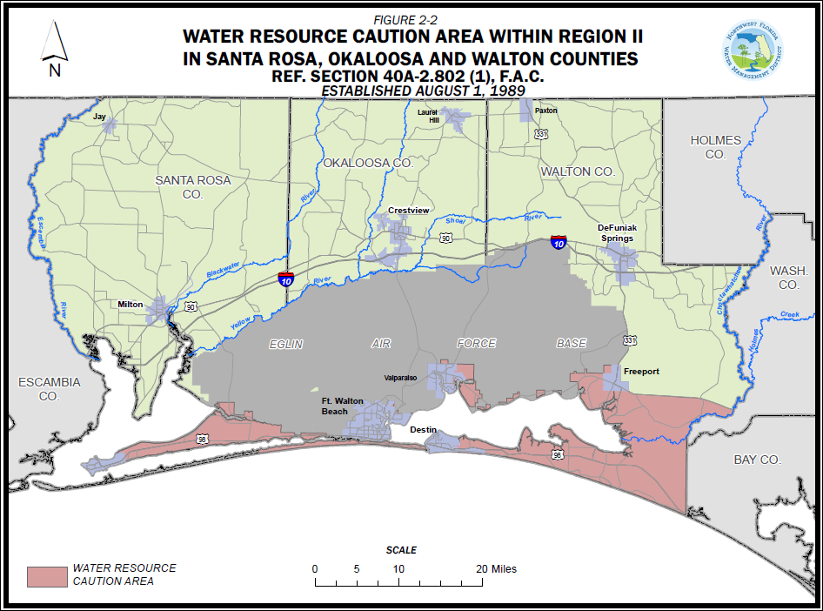

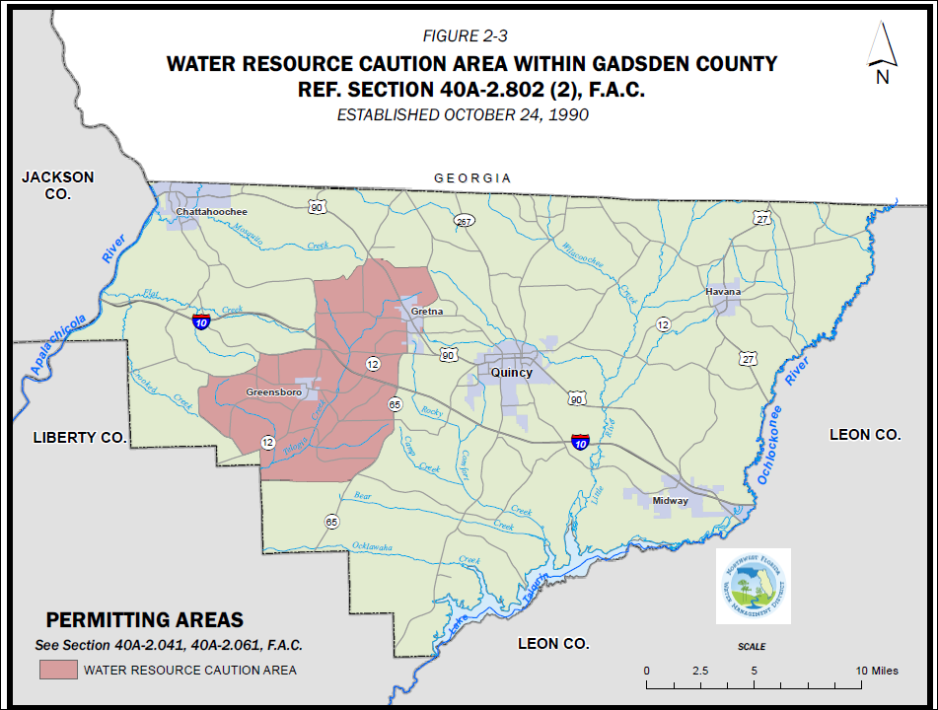
Rulemaking Authority 373.044, 373.171, 373.223 FS. Law Implemented 373.219, 373.223, 373.250 FS. History–New 8-1-89, Amended 5-31-92, 11-1-93, 10-1-95, 5-29-14.

40A-2.901 Forms.
(1) The following forms are used in the implementation of this chapter:
(a) Water Use Permit Application, Form No. 160, effective May 29, 2014,
(http://www.flrules.org/Gateway/reference.asp?No=Ref-03846), and incorporated by reference in Rule 40A-2.101, F.A.C.;
(b) Supplemental Form A – Agricultural Use, Form No. 160A, effective May 29, 2014,
(http://www.flrules.org/Gateway/reference.asp?No=Ref-03847), and incorporated by reference in Rule 40A-2.101, F.A.C.;
(c) Supplemental Form B – Industrial / Commercial Use, Form No. 160B, effective May 29, 2014,
(http://www.flrules.org/Gateway/reference.asp?No=Ref-03848), and incorporated by reference in Rule 40A-2.101, F.A.C.;
(d) Supplemental Form C – Landscape / Recreation Use, Form No. 160C, effective May 29, 2014,
(http://www.flrules.org/Gateway/reference.asp?No=Ref-03849), and incorporated by reference in Rule 40A-2.101, F.A.C.;
(e) Supplemental Form D – Mining / Dewatering Use, Form No. 160D, effective May 29, 2014,
(http://www.flrules.org/Gateway/reference.asp?No=Ref-03850), and incorporated by reference in Rule 40A-2.101, F.A.C.;
(f) Supplemental Form E – Public Supply Use, Form No. 160E, effective May 29, 2014,
(http://www.flrules.org/Gateway/reference.asp?No=Ref-03851), and incorporated by reference in Rule 40A-2.101, F.A.C.;
(g) Supplemental Form F – Other Use, Form No. 160F, effective May 29, 2014,
(http://www.flrules.org/Gateway/reference.asp?No=Ref-03852), and incorporated by reference in Rule 40A-2.101, F.A.C.;
(h) Supplemental Form G – Institutional Use, Form No. 160G, effective May 29, 2014,
(http://www.flrules.org/Gateway/reference.asp?No=Ref-03853), and incorporated by reference in Rule 40A-2.101, F.A.C.;
(i) Supplemental Form H – Diversion and Impoundment, Form No. 160H, effective May 29, 2014,
(http://www.flrules.org/Gateway/reference.asp?No=Ref-03854), and incorporated by reference in Rule 40A-2.101, F.A.C.;
(j) Water Use/Pumpage Water Use Permit Report Form No. 166, effective May 29, 2014,
(http://www.flrules.org/Gateway/reference.asp?No=Ref-03865), and incorporated by reference in Rule 40A-2.381, F.A.C.;
(k) Periodic Water Use Reporting Form, NWFWMD Form No. 173, effective May 29, 2014,
(http://www.flrules.org/Gateway/reference.asp?No=Ref-03872), and incorporated by reference in Rule 40A-2.381, F.A.C.;
(l) Water Use Summary Reporting Form, NWFWMD Form No. 172, effective May 29, 2014,
(http://www.flrules.org/Gateway/reference.asp?No=Ref-03871), and incorporated by reference in Rule 40A-2.381, F.A.C.;
(m) Flow Meter Accuracy Report, Form No. 170, effective May 29, 2014,
(http://www.flrules.org/Gateway/reference.asp?No=Ref-03869), and incorporated by reference in Rule 40A-2.381, F.A.C.;
(n) Alternative Method Flow Verification Report, Form No. 171, effective May 29, 2014,
(http://www.flrules.org/Gateway/reference.asp?No=Ref-03870), and incorporated by reference in Rule 40A-2.381, F.A.C.;
(o) Annual Crop Summary Report Form No. 168, effective May 29, 2014,
(http://www.flrules.org/Gateway/reference.asp?No=Ref-03867), and incorporated by reference in Rule 40A-2.381, F.A.C.;
(p) Crop Protection Report Form No. 169, effective May 29, 2014,
(http://www.flrules.org/Gateway/reference.asp?No=Ref-03868), and incorporated by reference in Rule 40A-2.381, F.A.C.;
(q) If water quality reporting is required, the permittee shall submit the data required on the Water Quality Report Form No. 167, effective May 29, 2014, (http://www.flrules.org/Gateway/reference.asp?No=Ref-03866), and incorporated by reference in rule 40A-2.381, F.A.C.;
(r) Water Use Permit Letter Modification Request Form, Form No. 161, effective May 29, 2014,
(http://www.flrules.org/Gateway/reference.asp?No=Ref-03863), and incorporated by reference in Rule 40A-2.331, F.A.C.;
(s) Water Use Permit Transfer Form, NWFWMD Form No. 163, effective May 29, 2014,
(http://www.flrules.org/Gateway/reference.asp?No=Ref-03864), and incorporated by reference in Rule 40A-2.351, F.A.C.; and,
(t) Reuse Feasibility Information, Form No. 174, effective November 1, 2013,
(http://www.flrules.org/Gateway/reference.asp?No=Ref-03261), and incorporated by reference in Rule 40A-2.101, F.A.C.
(2) These forms are available from the District website (nwfwater.com) and from the District offices listed in subsection 40A-2.021(13), F.A.C.
Rulemaking Authority 373.044, 373.171 FS. Law Implemented 373.116, 373.219, 373.229 FS. History–New 10-1-82, Amended 1-5-86, 8-1-89, 5-31-92, 10-1-95, 7-1-98, 1-4-10, 10-20-13, 1-15-14, 5-29-14, 4-29-15.

40A-2.902 Areal Boundary Maps for Water Use Permitting.
General areal boundaries for Water Resource Caution Areas and Areas of Resource Concern are established for the implementation of water use permitting pursuant to this chapter and are indicated in Figures 2-1, 2-2, and 2-3. These boundaries are depicted in detail on the following maps: Water Resource Caution Area Map for Santa Rosa County (http://www.flrules.org/Gateway/reference.asp?No=Ref-05287); Water Resource Caution Area Map for Okaloosa County (http://www.flrules.org/Gateway/reference.asp?No=Ref-05286); Water Resource Caution Area Map for Walton County (http://www.flrules.org/Gateway/reference.asp?No=Ref-05288); Upper Telogia Creek Drainage Basin Water Resource Caution Area and Area of Resource Concern Map for Gadsden County (http://www.flrules.org/Gateway/reference.asp?No=Ref-05285); and Area of Resource Concern Map for Bay County (http://www.flrules.org/Gateway/reference.asp?No=Ref-05284), and are hereby incorporated by reference (effective April 29, 2015). Copies of these maps can be obtained from the District’s website (nwfwater.com) or from the Northwest Florida Water Management District, 81 Water Management Drive, Havana, Florida 32333-4712.

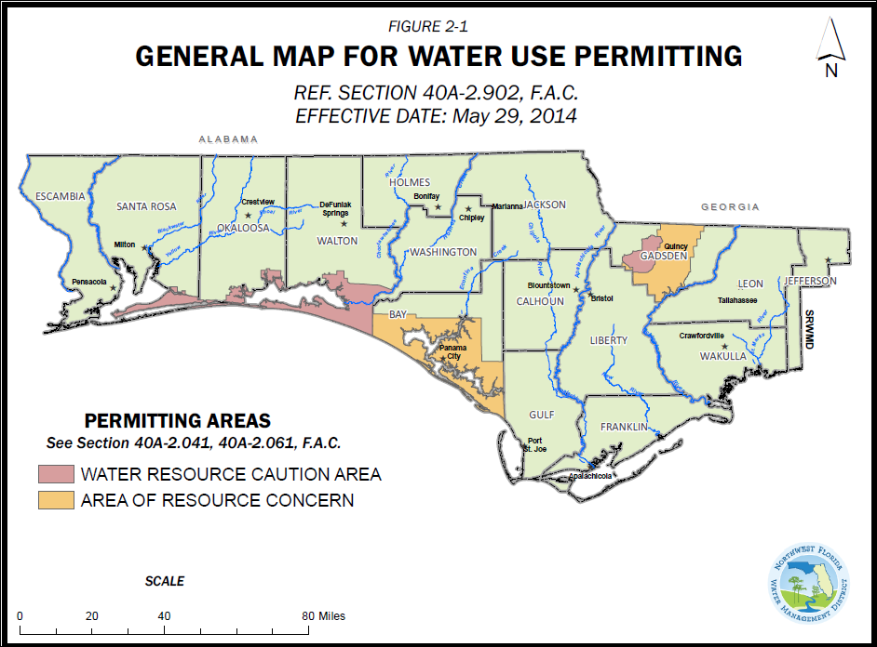

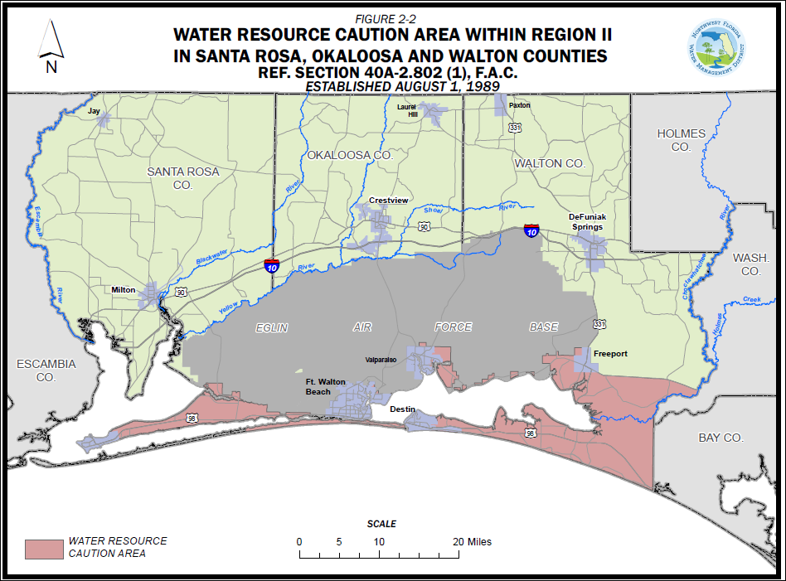

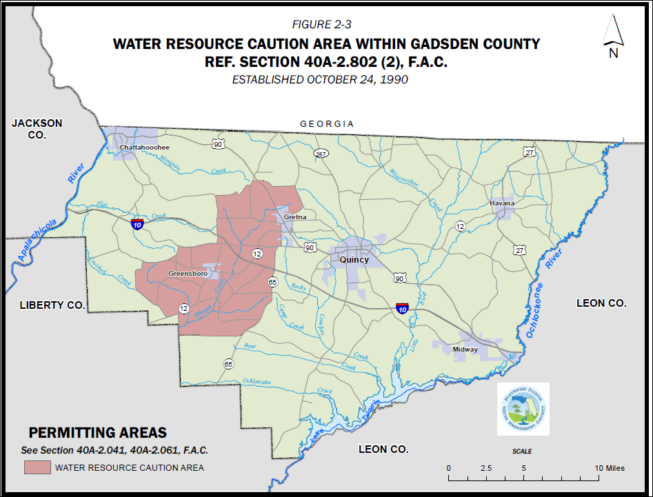
Rulemaking Authority 373.044, 373.171 FS. Law Implemented 373.216 FS. History–New 10-1-82, Amended 1-5-86, 5-4-87, 8-1-89, 5-31-92, 7-1-98, 1-1-05, 5-29-14, 4-29-15.

40A-2.903 Permitting Capacity Table.
Rulemaking Authority 373.044, 373.171 FS. Law Implemented 373.216, 373.171 FS. History–New 10-1-82, Repealed 1-5-86.

40A-2.904 Areal Boundary Maps for Water Resource Caution Areas.
(1) Areal boundaries for the Santa Rosa, Okaloosa, and Walton County Water Resource Caution Area encompassing the area south of Eglin Air Force Base in Santa Rosa, (http://www.flrules.org/Gateway/reference.asp?No=Ref-03875), Okaloosa (http://www.flrules.org/Gateway/reference.asp?No=Ref-03874), and Walton County, (http://www.flrules.org/Gateway/reference.asp?No=Ref-03877), also the area extending south of SR-20 in Walton County to the Bay County, (http://www.flrules.org/Gateway/reference.asp?No=Ref-03876), Line are established for the implementation of water use permitting pursuant to this chapter and are indicated in Figure 2-2. These boundaries are depicted in specific detail for each of these counties on general county highway maps. These maps are hereby incorporated by reference and can be obtained from the District’s website (nwfwater.com) or from District offices.
(2) Areal boundaries for the Upper Telogia Creek Drainage Basin Water Resource Caution Area are established for the implementation of water use permitting pursuant to this Chapter and are indicated in Figure 2-3. These boundaries are depicted in detail on the Gadsden County, (http://www.flrules.org/Gateway/reference.asp?No=Ref-03873), general county highway map. This map is hereby incorporated by reference and can be obtained from the District’s website (nwfwater.com) or from District offices.

Rulemaking Authority 373.044, 373.171 FS. Law Implemented 373.216 FS. History–New 8-1-89, Amended 5-31-92, 11-1-93, 5-29-14.

