CHAPTER 40E-10

Water Reservations

40E-10.011 Policy and Purpose

40E-10.021 Definitions

40E-10.031 Water Reservations Implementation

40E-10.041 Water Reservation Areas: Lower West Coast Planning Area

40E-10.051 Water Reservation Areas: Upper East Coast Planning Area

40E-10.061 Water Reservation Areas: Lower East Coast Planning Area

40E-10.071 Water Reservation Areas: Upper and Lower Kissimmee Basin Planning Areas

40E-10.011 Policy and Purpose.
The purpose of this chapter is to define the quantity, location and timing of waters reserved from allocation for the protection of fish and wildlife pursuant to Section 373.223(4), F.S., for specified waterbodies. Water reservations are implemented in the water use program pursuant to Chapter 40E-2, F.A.C.
Rulemaking Authority 373.044, 373.113, 373.171 FS. Law Implemented 373.016, 373.026, 373.036, 373.1501, 373.1502, 373.219, 373.223, 373.4592, 373.4595, 373.470 FS. History–New 7-2-09, Amended 7-14-14.

40E-10.021 Definitions.
(1) Fakahatchee Estuary – The area within the Ten Thousand Islands region including the following river/bay systems, from west to east: Blackwater River/Blackwater Bay, Whitney River/Buttonwood Bay, Pumpkin River/Pumpkin Bay, Wood River, Little Wood River and Faka Union Canal/Faka Union Bay, and Fakahatchee Bay as depicted in Figure 1-3 Fakahatchee Estuary.
(2) Picayune Strand – The area located southwest of the Florida Panther National Wildlife Refuge, north of the Ten Thousand Islands NWR, east of the South Belle Meade State Conservation and Recreation Lands (CARL) Project, west of the Fakahatchee Strand Preserve State Park, and northeast of Collier-Seminole State Park as depicted in Figure 1-2 Picayune Strand. The legal description of the Picayune Strand is contained in Appendix 1.
(3) North Fork of the St. Lucie River – The area that extends from the Gordy Road structure (state plane coordinates, x851212.831, y1116105.7470), to the confluence of the North Fork of the St. Lucie River and the C-24 canal (state plane coordinates, x873,712.20, y1064,390.41) as depicted in Appendix 2, Figure 2-1.
(4) Nearshore Central Biscayne Bay – The area within Biscayne Bay up to 1640 feet (500 meters) from the shoreline beginning south of Shoal Point extending southward to north of Turkey Point as depicted in Figure 3-1.
(5) Caloosahatchee River – The surface waters that flow through the S-79 structure, combined with tributary contributions below S-79 that collectively flow southwest to San Carlos Bay, as defined in subsection 40E-8.021(2), F.A.C.
(6) Caloosahatchee River (C-43) West Basin Storage Reservoir – A reservoir located in Hendry County, Florida, west of the City of LaBelle on the east side of the Townsend Canal and south of SR 80 as described in Appendix 1-12, and depicted in Figure 1-13 (also known as the ‘C-43 Reservoir’).
(7) Everglades Agricultural Area (EAA) Reservoir – A reservoir located in Palm Beach County, Florida, south of the City of South Bay between the Miami and North New River Canals as described in Appendix 3 and depicted in Figure 3-5.
(8) For the Upper Chains of Lakes, Headwaters Revitalization Lakes, and Kissimmee River water reservation, the following definitions apply:
(a) Lakes Hart-Mary Jane Reservation Waterbodies – Lake Hart, Lake Mary Jane, Lake Whippoorwill, Whippoorwill Canal, and the Central and Southern Florida Flood Control Project canals that occur between the S-57 and S-62 structures in Orange and Osceola counties, as depicted in Appendix 4, Figures 4-1 and 4-2A.
(b) Lakes Myrtle-Preston-Joel Reservation Waterbodies – Lake Myrtle, Lake Preston, Lake Joel, Myrtle/Preston Canal, and the Central and Southern Florida Flood Control Project canals that occur between the S-57 and S-58 structures in Osceola County, as depicted in Appendix 4, Figures 4-1 and 4-3A.
(c) East Lake Tohopekaliga Reservation Waterbodies – East Lake Tohopekaliga, Fells Cove, Ajay Lake, Lake Runnymede, Runnymede Canal, and the Central and Southern Florida Flood Control Project canals that occur between the S-59 and S-62 structures in Orange and Osceola counties, as depicted in Appendix 4, Figures 4-1 and 4-4A.
(d) Lake Tohopekaliga Reservation Waterbodies – Lake Tohopekaliga and the Central and Southern Florida Flood Control Project canals that occur between the S-59 and S-61 structures in Osceola County, as depicted in Appendix 4, Figures 4-1 and 4-5A.
(e) Alligator Chain of Lakes Reservation Waterbodies – Alligator Chain of Lakes, including Lake Center, Coon Lake, Trout Lake, Lake Lizzie, Brick Lake, Alligator Lake, Live Oak Lake, and Sardine Lake; Center/Coon, Live Oak, Sardine, and Brick canals; and the Central and Southern Florida Flood Control Project canals that occur between the S-58 and S-60 structures in Osceola County, as depicted in Appendix 4, Figures 4-1 and 4-6A.
(f) Lake Gentry Reservation Waterbodies – Lake Gentry and the Central and Southern Florida Flood Control Project canals that occur between the S-60 and S-63A structures in Osceola County, as depicted in Appendix 4, Figures 4-1 and 4-7A.
(g) Headwaters Revitalization Lakes Reservation Waterbodies – Lake Kissimmee, Lake Hatchineha, Tiger Lake, Tiger Creek, Cypress Lake, Zipprer Canal east of the G-103 structure, Jackson Canal downstream of the G-111 structure, and the Central and Southern Florida Flood Control Project canals that occur between the S-61, S-63A, and S-65 structures in Osceola and Polk counties, as depicted in Appendix 4, Figures 4-1 and 4-8A.
(h) Kissimmee River Reservation Waterbodies – The Kissimmee River and its 100-year floodplain between the S-65 and S-65D structures, Istokpoga Canal and the floodplain located east of the S-67 structure; and the C-38 Canal and remnant river channels between the S-65D and S-65E structures in Polk, Osceola, Okeechobee and Highlands counties, as depicted in Appendix 4, Figures 4-1 and 4-9.
(i) Upper Chain of Lakes Reservation Waterbodies – Refers to the collective waterbodies defined in paragraphs (8)(a)–(8)(f) above, as depicted in Figure 4-1.
(j) Contributing Waterbodies – All wetlands and other surface waters, including canals and ditches, that contribute surface water to a reservation waterbody, as depicted in Figures 4-1, 4-4A, 4-5A, 4-6A, 4-7A, 4-8A, and 4-9.
Rulemaking Authority 373.044, 373.113, 373.171 FS. Law Implemented 373.016, 373.026, 373.036, 373.1501, 373.1502, 373.219, 373.223, 373.4592, 373.4595, 373.470 FS. History–New 7-2-09, Amended 3-18-10, 7-21-13, 7-16-14, 1-31-21, 3-10-21.
Editor’s Note: Please see the Word document for Chapter 40E-10 for the inclusion of the appendices referenced in the above rule text.

40E-10.031 Water Reservations Implementation.
(1) Applicants for consumptive use permits shall meet the requirements of this rule by providing reasonable assurances that Rule 40E-2.301, F.A.C., and Section 3.11 of the “Applicant’s Handbook for Water Use Permit Applications within the South Florida Water Management District,” incorporated by reference in Rules 40E-2.091, F.A.C., are met.
(2) Water reserved for the protection of fish and wildlife contained within the Picayune Strand and Fakahatchee Estuary is defined in subsections 40E-10.041(1)-(2), F.A.C.
(3) Water reserved for the protection of fish and wildlife contained within the North Fork of the St. Lucie River is defined in subsection 40E-10.051(1), F.A.C.
(4) Water reserved for the protection of fish and wildlife contained within Nearshore Central Biscayne Bay is defined in subsections 40E-10.061(1)-(2), F.A.C.
(5) Water reserved for the protection of fish and wildlife contained within and released, via operation, from the Caloosahatchee River (C-43) west Basin Storage Reservoir is defined in subsection 40E-10.041(3), F.A.C.
(6) Water reserved for the protection of fish and wildlife released via operation from the EAA Reservoir is defined in paragraph 40E-10.061(3)(a), F.A.C.
(7) Water reserved for the protection of fish and wildlife contained within the Upper Chain of Lakes, Headwaters Revitalization Lakes, Kissimmee River, and Contributing Waterbodies is defined in Subsections 40E-10.071(1)-(3), F.A.C. These water reservation rules do not adjudicate property rights or dictate the operation of the Central & Southern Florida Flood Control Project (C&SF Project).
Rulemaking Authority 373.044, 373.113, 373.171 FS. Law Implemented 373.016, 373.026, 373.036, 373.1501, 373.1502, 373.219, 373.223, 373.4592, 373.4595, 373.470 FS. History–New 7-2-09, Amended 3-18-10, 7-21-13, 7-14-14, 7-16-14, 1-31-21, 3-10-21.

40E-10.041 Water Reservation Areas: Lower West Coast Planning Area.
(1) Picayune Strand as defined in subsection 40E-10.021(2), F.A.C.:
(a) Surface waters:
1. All surface water contained within the Picayune Strand are reserved from allocation (see Figure 1).
2. All surface water flowing into the Picayune Strand identified below is reserved from allocation:
(I) The surface water flows depicted on Figures 1-4.A, B, and C, simulated at weir ‘Miller2’ within the Miller Canal (see Figure 1-2);
(II) The surface water flows depicted on Figures 1-5.A, B, and C, simulated at weir ‘FU3’ within the Faka Union Canal (see Figure 1-2); and
(III) The surface water flows depicted on Figures 1-6.A, B, and C simulated at spillway ‘Lucky LA’ within the Merritt Canal (see Figure 1-2).
(b) Groundwater: All groundwater in the water table and unconfined portions of Lower Tamiami aquifer underlying the Picayune Strand is reserved from allocation.
(2) Fakahatchee Estuary as defined in subsection 40E-10.021(1), F.A.C.:
(a) Surface waters:
The surface water flows into the Fakahatchee Estuary identified below are reserved from allocation:
1. The surface water flows depicted on Figures 1-7.A, B, and C simulated at Faka Union Canal at structure FU1 (See Figure 1-3);
2. The surface water flows depicted on Figures 1-8.A, B, and C simulated at ‘Miller@41’ transect (beginning at coordinate 471365.13N, 599423.29 E Southeast to 479226.67N, 595105.77E (delivering surface water to Blackwater Bay and Buttonwood Bay) see Figure 1-3);
3. The surface water flows depicted on Figures 1-9.A, B, and C simulated at ‘FU@41’ transect (beginning at coordinate 480427.89N, 595005.67E Southeast to 487735.34N, 592478.09E (delivering surface water to Pumpkin Bay) see Figure 1-3);
4. The surface water flows depicted on Figures 1-10.A, B, and C simulated at ‘Merritt@41’ transect (beginning at coordinate 490942.49N, 593218.49E flowing Southeast to 499050.54N, 590515.81E (delivering surface water to Faka Union Bay) see Figure 1-3); and
5. The surface water flows depicted on Figures 1-11.A, B, and C simulated at ‘Fakahatchee@41’ transect (beginning at coordinate 498623.81N, 587955.37E Southeast to 533587.95N, 575807.53E (delivering surface water to Fakahatchee Bay) see Figure 1-3).
(b) Groundwater: All groundwater in the water table and unconfined portions of Lower Tamiami aquifer underlying the Fakahatchee Estuary is reserved from allocation.
Reservations contained in subparagraphs 1. and 2. Above, shall be reviewed in light of changed conditions or new information by December 31, 2014.
(3) Caloosahatchee River (C-43) West Basin Storage Reservoir:
(a) All surface water contained within and released, via operation, from the Caloosahatchee River (C-43) West Basin Storage Reservoir is reserved from allocation.
(b) The water reserved under this subsection will be available for fish and wildlife upon a formal determination of the Governing Board, pursuant to state and federal law, that the Caloosahatchee River (C-43) West Basin Storage Reservoir is operational.
(c) The reservation contained in this subsection and the criteria contained in Section 3.11.4 of the “Applicant’s Handbook for Water Use Permit Applications within the South Florida Water Management District,” incorporated by reference in Rule 40E-2.091, F.A.C., shall be revised pursuant to Section 373.223(4), F.S., in light of changed conditions or new information and prior to the approval described in paragraph (3)(b) above.
Rulemaking Authority 373.044, 373.113, 373.171 FS. Law Implemented 373.016, 373.026, 373.036, 373.1501, 373.1502, 373.219, 373.223, 373.4592, 373.4595, 373.470 FS. History–New 7-2-09, Amended 3-18-10, 7-21-13, 7-16-14, 3-15-17.
Editor’s Note: Please see the Word document for Chapter 40E-10, F.A.C., for the inclusion of the appendices referenced in the above rule text.

40E-10.051 Water Reservation Areas: Upper East Coast Planning Area.
North Fork of the St. Lucie River, as defined in subsection 40E-10.021(3), F.A.C.:
Surface waters up to and including the mean monthly flow of 130 cubic feet per second flowing over the Gordy Road Structure from November 1st through May 31st; see Appendix 2, Figure 2-2; are reserved from allocation. The water reserved under this rule will be available for fish and wildlife upon formal determination of the Governing Board, pursuant to state and federal law, that any one or all of the Comprehensive Everglades Restoration Plan’s C-23/C-24 North and South Reservoirs and STA Project are operational. Reservations contained in this rule and the criteria contained in section 3.11.2 of the “Applicant’s Handbook for Water Use Permit Applications within the South Florida Water Management District,” incorporated by reference in Rule 40E-2.091, F.A.C., shall be revised pursuant to Section 373.223(4), F.S., in light of changed conditions or new information and concurrent with the approval specified, above.
Rulemaking Authority 373.044, 373.113, 373.171 FS. Law Implemented 373.016, 373.026, 373.036, 373.1501, 373.1502, 373.219, 373.223, 373.4592, 373.4595, 373.470 FS. History–New 3-18-10, Amended 7-21-13, 7-14-14, 3-15-17.
Editor’s Note: Please see the Word document for Chapter 40E-10, F.A.C., for the inclusion of the appendices referenced in the above rule text.

40E-10.061 Water Reservation Areas: Lower East Coast Planning Area.
(1) Nearshore Central Biscayne Bay as defined in subsection 40E-10.021(6), F.A.C.:
All surface water contained within Nearshore Central Biscayne Bay is reserved from allocation (see Figure 3-1).
(2) Surface water flowing into Nearshore Central Biscayne Bay as identified below is reserved from allocation:
(a) Surface water flows depicted on Figures 3-2.A and 3-2.B through S-123 derived from the following contributing canal reaches:
1. The C-100A canal upstream of S-123 to S-120 including all integrated conveyance canals.
2. The C-100C canal upstream of S-123 to S-119 including all integrated conveyance canals.
3. The C-100B canal upstream of S-123 to S-122 including all integrated conveyance canals.
4. The C-100 canal upstream of S-123 to S-118 including all integrated conveyance canals.
(b) Surface water flows depicted on Figures 3-3.A and 3-3.B through S-21 derived from the following contributing canal reaches:
1. The L-31E borrow canal upstream of S-21 to the canal terminus.
2. The C-1 canal upstream of S-21 to S-122 and S-149 including all integrated conveyance canals.
3. The C-1 canal upstream of S-21 to the C-1W canal and S-338 including all integrated conveyance canals.
(c) Surface water flows depicted on Figures 3-4.A and 3-4.B which is the combined flow through S-21A, S-20G, and S-20F as derived from the following contributing canal reaches:
1. The C-102 canal connecting to the C-102 N canal upstream of S-21A to S-195.
2. The C-102 canal upstream of S-21A to S-165.
3. The L-31E borrow canal upstream of S-21A to its terminus near S-21 including the Gould’s Canal.
4. The L-31E borrow canal upstream of S-21A south to S-20G.
5. The Military canal upstream of S-20G.
6. The C-103 canal upstream of S-20F to S-179.
7. The L-31E borrow canal upstream of S-20F to S-20G including all integrated conveyance canals.
8. The L-31E borrow canal from S-20F south to the North Canal.
9. The North Canal.
10. The L-31E borrow canal from S-20F south to the Florida City Canal.
11. The Florida City Canal from Southwest 107th Avenue to its confluence with the L-31E borrow canal.
Reservations contained in the section shall be reviewed in light of changed conditions or new information.
(3) EAA Reservoir:
(a) All surface water released, via operation, from the EAA Reservoir that is directed to the Lower East Coast Everglades Waterbodies through Structures S-624, S-625, and S-626 (see Figure 3-6) is reserved from allocation.
(b) The water prospectively reserved under this subsection is not available for fish and wildlife until the Governing Board makes a formal determination, pursuant to state and federal law, that the EAA Reservoir is operational.
(c) Within 90 days of approval of the Final Project Operating Manual or Final System Operating Manual for the EAA Reservoir, the District shall publish a Notice of Rule Development to revise the reservation contained in paragraph 40E-10.061(3)(a), F.A.C., above, and criteria in Section 3.11.6 of the Applicant’s Handbook, incorporated by reference in Rule 40E-2.091, F.A.C. Said rulemaking must result in an adopted rule that is in effect, unless subject to legal proceedings or legislative ratification, within two years of publication of the Notice of Rule Development and before the EAA Reservoir is deemed operational pursuant to paragraph 40E-10.061(3)(b), F.A.C., above.
(d) The reservation contained in paragraph 40E-10.061(3)(a), F.A.C., above, and the criteria contained in Section 3.11.6 of the “Applicant’s Handbook for Water Use Permit Applications within the South Florida Water Management District” (Applicant’s Handbook), incorporated by reference in Rule 40E-2.091, F.A.C., shall be revised in light of changed conditions or new information.
(e) Water released from the EAA Reservoir through structure S-628 is not reserved.
Rulemaking Authority 373.044, 373.113, 373.171 FS. Law Implemented 373.016, 373.026, 373.036, 373.1501, 373.1502, 373.219, 373.223, 373.4592, 373.4595, 373.470 FS. History–New 7-21-13, Amended 3-15-17, 1-31-21.
Editor’s Note: Please see the Word document for Chapter 40E-10, F.A.C., for the inclusion of the appendices referenced in the above rule text.

40E-10.071 Water Reservation Areas: Upper and Lower Kissimmee Basin Planning Areas.
(1) Upper Chain of Lakes
(a) Lakes Hart-Mary Jane Reservation Waterbodies, as defined in paragraph 40E-10.021(8)(a), F.A.C.:
1. Surface Water: All surface water in Lakes Hart-Mary Jane (Figure 4-2A) up to the water reservation stages depicted in Figure 4-2B and listed in Table 4-2 is reserved from additional allocations.
2. Groundwater: Surficial aquifer system groundwater contributing to Lakes Hart-Mary Jane that is required for the protection of fish and wildlife is reserved from allocation in accordance with Subsection 3.11.5 of the Applicant’s Handbook, incorporated by reference in Rule 40E-2.091, F.A.C., effective March 21, 2021.
(b) Lakes Myrtle-Preston-Joel Reservation Waterbodies, as defined in paragraph 40E-10.021(8)(b), F.A.C.:
1.Surface Water: All surface water in Lakes Myrtle-Preston-Joel (Figure 4-3A) up to the water reservation stages depicted in Figure 4-3B and listed in Table 4-3 is reserved from additional allocations.
2. Groundwater: Surficial aquifer system groundwater contributing to Lakes Myrtle-Preston-Joel that is required for the protection of fish and wildlife is reserved from allocation in accordance with Subsection 3.11.5 of the Applicant’s Handbook, incorporated by reference in Rule 40E-2.091, F.A.C., effective March 21, 2021.
(c) East Lake Tohopekaliga Reservation Waterbodies, as defined in paragraph 40E-10.021(8)(c), F.A.C., and Contributing Waterbodies, as defined in paragraph 40E-10.021(8)(j), F.A.C.:
1. Surface Water: All surface water in East Lake Tohopekaliga (Figure 4-4A) up to the water reservation stages depicted in Figure 4-4B and listed in Table 4-4 is reserved from additional allocations.
2. Groundwater: Surficial aquifer system groundwater contributing to East Lake Tohopekaliga or its contributing waterbodies that is required for the protection of fish and wildlife is reserved from allocation in accordance with Subsection 3.11.5 of the Applicant’s Handbook, incorporated by reference in Rule 40E-2.091, F.A.C., effective March 21, 2021.
3. Contributing Waterbodies: Surface water that is required for the protection of fish and wildlife is reserved from allocation in accordance with Subsection 3.11.5 of the Applicant’s Handbook, incorporated by reference in Rule 40E-2.091, F.A.C., effective March 21, 2021.
(d) Lake Tohopekaliga Reservation Waterbodies, as defined in paragraph 40E-10.021(8)(d), F.A.C., and Contributing Waterbodies, as defined in paragraph 40E-10.021(8)(j), F.A.C.:
1. Surface Water: All surface water in Lake Tohopekaliga (Figure 4-5A) up to the water reservation stages depicted in Figure 4-5B and listed in Table 4-5 is reserved from additional allocations.
2. Groundwater: Surficial aquifer system groundwater contributing to Lake Tohopekaliga or its contributing waterbodies that is required for the protection of fish and wildlife is reserved from allocation in accordance with Subsection 3.11.5 of the Applicant’s Handbook, incorporated by reference in Rule 40E-2.091, F.A.C., effective March 21, 2021.
3. Contributing Waterbodies: Surface water that is required for the protection of fish and wildlife is reserved from allocation in accordance with Subsection 3.11.5 of the Applicant’s Handbook, incorporated by reference in Rule 40E-2.091, F.A.C., effective March 21, 2021.
(e) Alligator Chain of Lakes Reservation Waterbodies, as defined in paragraph 40E-10.021(8)(e), F.A.C., and Contributing Waterbodies, as defined in paragraph 40E-10.021(8)(j), F.A.C.:
1. Surface Water: All surface water in the Alligator Chain of Lakes (Figure 4-6A) up to the water reservation stages depicted in Figure 4-6B and listed in Table 4-6 is reserved from additional allocations.
2. Groundwater: Surficial aquifer system groundwater contributing to the Alligator Chain of Lakes or its contributing waterbodies that is required for the protection of fish and wildlife is reserved from allocation in accordance with Subsection 3.11.5 of the Applicant’s Handbook, incorporated by reference in Rule 40E-2.091, F.A.C., effective March 21, 2021.
3. Contributing Waterbodies: Surface water that is required for the protection of fish and wildlife is reserved from allocation in accordance with Subsection 3.11.5 of the Applicant’s Handbook, incorporated by reference in Rule 40E-2.091, F.A.C., effective March 21, 2021.
(f) Lake Gentry Reservation Waterbodies, as defined in paragraph 40E-10.021(8)(f), F.A.C., and Contributing Waterbodies, as defined in paragraph 40E-10.021(8)(j), F.A.C.:
1. Surface Water: All surface water in Lake Gentry (Figure 4-7A) up to the water reservation stages depicted in Figure 4-7B and listed in Table 4-7 is reserved from additional allocations.
2. Groundwater: Surficial aquifer system groundwater contributing to Lake Gentry or its contributing waterbodies that is required for the protection of fish and wildlife is reserved from allocation in accordance with Subsection 3.11.5 of the Applicant’s Handbook, incorporated by reference in Rule 40E-2.091, F.A.C., effective March 21, 2021.
3. Contributing Waterbodies: Surface water that is required for the protection of fish and wildlife is reserved from allocation in accordance with Subsection 3.11.5 of the Applicant’s Handbook, incorporated by reference in Rule 40E-2.091, F.A.C., effective March 21, 2021.
(2) Headwaters Revitalization Lakes Reservation Waterbodies, as defined in paragraph 40E-10.021(8)(g), F.A.C., and Contributing Waterbodies, as defined in paragraph 40E-10.021(8)(j), F.A.C.:
(a) Surface Water: All surface water in the Headwaters Revitalization Lakes (Figure 4-8A; Figure 4-8B; Table 4-8) is reserved from additional allocations.
(b) Groundwater: Surficial aquifer system groundwater contributing to the Headwaters Revitalization Lakes or their contributing waterbodies that is required for the protection of fish and wildlife is reserved from allocation in accordance with Subsection 3.11.5 of the Applicant’s Handbook, incorporated by reference in Rule 40E-2.091, F.A.C., effective March 21, 2021.
(c) Contributing Waterbodies: Surface water that is required for the protection of fish and wildlife is reserved from allocation in accordance with Subsection 3.11.5 of the Applicant’s Handbook, incorporated by reference in Rule 40E-2.091, F.A.C., effective March 21, 2021.
(3) Kissimmee River Reservation Waterbodies, as defined in paragraph 40E-10.021(8)(h), F.A.C., and Contributing Waterbodies, as defined in paragraph 40E-10.021(8)(j), F.A.C.:
(a) Surface Water: All surface water in the Kissimmee River (Figure 4-9) is reserved from additional allocations in accordance with Subsection 3.11.5 of the Applicant’s Handbook, incorporated by reference in Rule 40E-2.091, F.A.C., effective March 21, 2021.
(b) Groundwater: Surficial aquifer system groundwater contributing to the Kissimmee River or its contributing waterbodies that is required for the protection of fish and wildlife is reserved from allocation in accordance with Subsection 3.11.5 of the Applicant’s Handbook, incorporated by reference in Rule 40E-2.091, F.A.C., effective March 21, 2021.
(c) Contributing Waterbodies: Surface water that is required for the protection of fish and wildlife is reserved from allocation in accordance with Subsection 3.11.5 of the Applicant’s Handbook, incorporated by reference in Rule 40E-2.091, F.A.C., effective March 21, 2021.
(4) The reservation contained in this rule and the criteria contained in Subsection 3.11.5 of the “Applicant’s Handbook for Water Use Permit Applications within the South Florida Water Management District,” incorporated by reference in Rule 40E-2.091, F.A.C., effective March 21, 2021, shall be reviewed and revised pursuant to Section 373.223(4), F.S., in light of changed conditions or new information, including any revised regulation schedules.
Rulemaking Authority 373.044, 373.113, 373.171 FS. Laws Implemented 373.016, 373.026, 373.036, 373.1501, 373.1502, 373.219, 373.223, 373.4592, 373.4595, 373.470 FS. History‒New 3-21-21.
Editor’s Note: Please see the Word document for Chapter 40E-10 for the inclusion of the appendices referenced in the above rule text.
APPENDIX 1 LOWER WEST COAST PLANNING AREA
1-1 LEGAL DESCRIPTION OF PICAYUNE STRAND AS DEFINED IN SUBSECTION 40E-10.021(1), F.A.C.
A tract of land in Townships 50, 51 and 52 South, Ranges 27 and 28 East, Collier County, Florida, more particularly described as follows:
Beginning at the Southeast Corner of Section 25, Township 51 South, Range 28 East, Collier County, Florida, run S89°10'50''W, 2659.84 feet to the South Quarter Corner of said Section 25; thence S89°09'41''W, 2659.37 feet to the Southwest Corner of said Section 25; thence S00°19'11''W, 2611.61 feet to the East Quarter Corner of Section 35 of said Township 51 South, Range 28 East;
thence S88°56'33''W, 2652.73 feet to the Northeast Corner of the Southwest Quarter of said Section 35; thence S00°18'15''W, 2614.86 feet to the South Quarter Corner of said Section 35; thence S88°54'23''W, 2650.59 feet to the Southwest Corner of Section 35; thence S88°50'39''W, 2639.94 feet to the South Quarter Corner of Section 34 of said Township 51 South, Range 28 East;
thence S89°00'23''W, 2652.66 feet to the Southwest Corner of said Section 34;
thence S88°44'21''W along the north line of the Northeast Quarter of Section 4, Township 52 South, Range 28 East, 1450.32 feet to the Northeast Corner of those lands described in Official Record Book 2624, Page 2509, Public Records of Collier County, Florida; thence S00°27'37''E along the east line of said lands, 6308.01 feet; thence continuing along said east line, S89°34'56''W, 16.37 feet;
thence continuing along said east line, S00°25'04''E, 360.00 feet to the north right-of-way line of U.S. Highway 41; thence westerly along the north right-of-way line of U.S. Highway 41, S84°52'54''W, 327.99 feet; thence N05°07'06''W, 39.00 feet to a point on a non-tangent curve; thence westerly 900.69 feet along the arc of said curve, concave to the northeast, having a radius of 1835.08 feet, a central angle of 28°07'18'' and a chord of 891.68 feet, bearing N81°03'27''W;
thence S23°00'12''W, 39.00 feet; thence N66°59'48''W, 5570.19 feet to a point of curvature; thence northwesterly 800.00 feet along the arc of a curve, concave to the southwest, having a radius of 17224.80 feet, a central angle of 02°39'40'' and a chord of 799.93 feet, bearing N°68°19'38''W to a point of tangency;
thence N69°39'28''W, 6844.52 feet; thence N20°20'32''E, 39.00 feet to a point on a non-tangent curve; thence northwesterly 671.08 feet along the arc of said curve, concave to the northeast, having a radius of 1835.08 feet, a central angle of 20°57'10'' and a chord of 667.35 feet, bearing N59°10ꞌ53''W; thence S41°17ꞌ43ꞌꞌW, 39.00 feet; thence N48°42'17''W, 6815.31 feet to a point of curvature; thence northwesterly 442.16 feet along the arc of a curve, concave to the southwest, having a radius of 725.20 feet, a central angle of 34°56'02'' and a chord of 435.35 feet, bearing N66°10'19''W to a point of tangency; thence N83°38'20''W, 300.77 feet to the intersection of the north right-of-way line of U.S. Highway 41 with the west line of Section 36, Township 51 South, Range 27 East;
thence N00°03'59''E along the west line of said Section 36, 1586.32 feet to the Northwest Corner of Section 36; thence N01°15'40''W, 2658.40 feet, to the West Quarter Corner of Section 25 of said Township 51 South, Range 27 East;
thence N01°17'06''W, 2656.42 feet to the Northwest Corner of said Section 25;
thence N01°16'05''W, 2655.83 feet to the West Quarter Corner of Section 24 of said Township 51 South, Range 27 East; thence N01°16'15''W, 2656.76 feet to the Northwest Corner of said Section 24; thence N00°19'01''E, 2764.38 feet to the West Quarter Corner of Section 13 of said Township 51 South, Range 27 East; thence N00°19'04''E, 2764.32 feet to the Northwest Corner of said Section 13; thence N01°15'53''E, 2764.69 feet to the West Quarter Corner of Section 12 of said Township 51 South, Range 27 East; thence N01°16'08''E, 2764.72 feet to the Northwest Corner of said Section 12; thence N00°37'07''E, 2763.78 feet to the West Quarter Corner of Section 1 of said Township 51 South, Range 27 East; thence N00°35'09''E, 2732.08 feet to the Northwest Corner of said Section 1; thence N01°09'58''E, 2697.35 feet to the West Quarter Corner of Section 36 of Township 50 South, Range 27 East; thence N01°14ꞌ25''E, 2554.73 feet to the Northwest Corner of said Section 36; thence N00°49'11''E, 2618.76 feet to the West Quarter Corner of Section 25 of said Township 50 South, Range 27 East;
thence N01°30'13''E, 2623.02 feet to the Northwest Corner of said Section 25;
thence N01°14'51''E, 2643.78 feet to the West Quarter Corner of Section 24 of said Township 50 South, Range 27 East; thence N00°55ꞌ45''E, 2647.27 feet to the Northwest Corner of said Section 24; thence N89°04ꞌ28''W, 2655.08 feet to the South Quarter Corner of Section 14 of said Township 50 South, Range 27 East; thence N89°06ꞌ09''W, 2673.56 feet to the Southwest Corner of said Section 14; thence N01°20ꞌ52''E, 2642.45 feet to the West Quarter Corner of said Section 14; thence N01°02'27''E, 2638.34 feet to the Northwest Corner of said Section 14; thence S88°57ꞌ18ꞌꞌE, 2650.45 feet to the North Quarter Corner of said Section 14; thence S89°16ꞌ05ꞌꞌE, 2679.46 feet to the Northeast Corner of said Section 14; thence N00°32'07''E, 2629.53 feet to the West Quarter Corner of Section 12 of said Township 50 South, Range 27 East; thence N00°05'55''E, 2655.64 feet to the Northwest Corner of said Section 12; thence N00°35'20''E, 2638.33 feet to the West Quarter Corner of Section 1 of said Township 50 South, Range 27 East; thence N09°11'51''W along the west line of the Northwest Quarter of said Section 1 a distance of 2352.20 feet to the intersection with the south line of the south drainage right-of-way of Interstate 75; thence easterly along said line, N89°40ꞌ16ꞌꞌE, 2640.00 feet; thence S88°14'35''E, 2676.02 feet;
thence S89°13'04''E, 2656.26 feet; thence N89°51'50''E, 2650.84 feet;
thence N89°28ꞌ53''E, 2647.15 feet; thence S89°53ꞌ38''E, 2654.08 feet;
thence S89°59'57''E, 2650.10 feet; thence N89°51'03''E, 2650.97 feet;
thence S89°32'18''E, 2648.17 feet; thence N89°47'26''E, 2686.92 feet;
thence N00°23'28''W, 124.56 feet; thence S89°54'09''E, 2649.59 feet;
thence S89°56'18''E, 2651.63 feet; thence N89°41'16''E, 2652.50 feet;
thence S89°49'15'ꞌE, 2651.54 feet to the intersection of the south line of said south drainage right-of-way with the east line of Section 1, Township 50 South, Range 28 East; thence S00°18'22''E along the east line of the Northeast Quarter of said Section 1 a distance of 2460.78 feet to the East Quarter Corner of said Section 1; thence S00°18'26''E, 2663.16 feet to the Southeast Corner of said Section 1; thence S00°19'17''E, 2661.71 feet to the East Quarter Corner of Section 12 of said Township 50 South, Range 28 East; thence S00°18'47''E, 2661.88 feet to the Southeast Corner of said Section 12; thence S00°18'10''E, 2662.06 feet to the East Quarter Corner of Section 13 of said Township 50 South, Range 28 East; thence S00°18'16''E, 2662.13 feet to the Southeast Corner of said Section 13; thence S00°18'16''E, 2662.14 feet to the East Quarter Corner of Section 24 of said Township 50 South, Range 28 East; thence S00°17'28''E, 2661.81 feet to the Southeast Corner of said Section 24; thence S00°17'38''E, 2674.16 feet to the East Quarter Corner of Section 25 of said Township 50 South, Range 28 East; thence S00°10'00''E, 2674.56 feet to the Southeast Corner of said Section 25; thence S00°13'47''E, 2674.47 feet to the East Quarter Corner of Section 36 of said Township 50 South, Range 28 East; thence S00°13'47''E, 2674.49 feet to the Southeast Corner of said Section 36; thence S00°51'18''E, 2682.32 feet to the East Quarter Corner of Section 1 of Township 51 South, Range 28 East; thence S00°51'18''E, 2682.32 feet to the Southeast Corner of said Section 1; thence S00°28'26ꞌꞌW, 2596.09 feet to the East Quarter Corner of Section 12 of said Township 51 South, Range 28 East; thence S00°41'47''W, 2598.68 feet to the Southeast Corner of said Section 12; thence southerly along the east line of Section 13, Township 51 South, Range 28 East, S00°35'55''W, 5191.01 feet to the Southeast Corner of said Section 13; thence S00°36'41''W, 2596.95 feet to the East Quarter Corner of Section 24 of said Township 51 South, Range 28 East; thence S00°34'08''W, 2597.43 feet to the Southeast Corner of said Section 24; thence S00°33'57''W, 2596.90 feet to the East Quarter Corner of Section 25 of said Township 51 South, Range 28 East; thence S00°34'27''W, 2597.76 feet to the Southeast Corner of said Section 25 and the Point of Beginning.
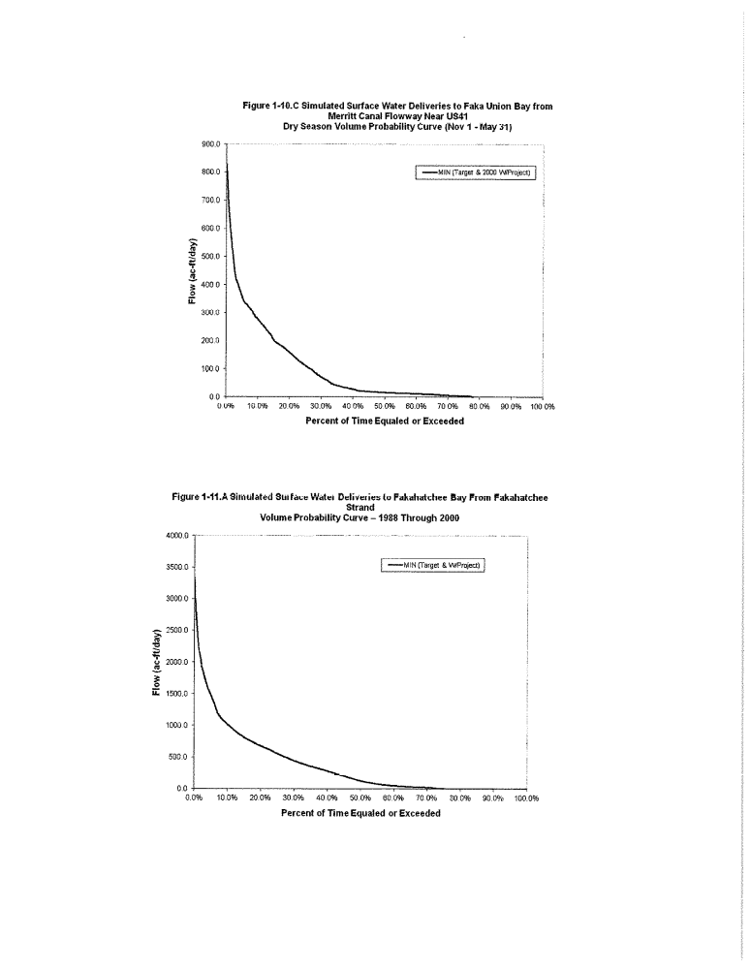
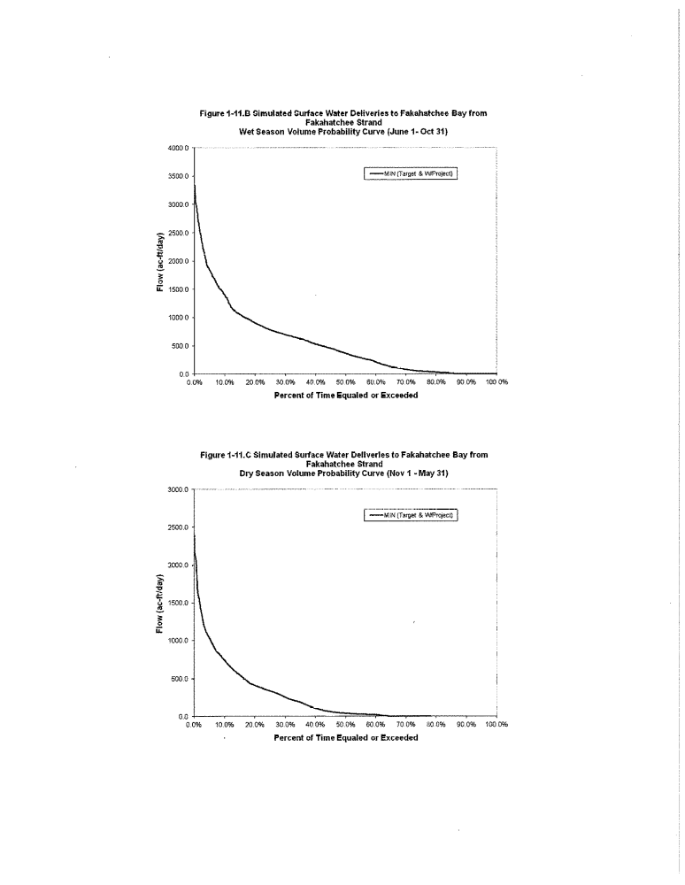
1-12 LEGAL DESCRIPTION OF CALOOSAHATCHEE RIVER C-43 WEST
BASIN STORAGE RESERVOIR
Caloosahatchee River
C-43 West Basin Storage Reservoir
A parcel of land lying in Sections 31, 32, 33, 34, 35 and 36, Township 43 South, Range 28 East, Section 31, Township 43 South, Range 29 East, Section 6, Township 44 South, Range 29 East, and Sections 1, 2, 3, 4, 5, 6, 7, 8, 9, 10, 11 and 12, Township 44 South Range 28 East, Hendry County Florida, being more particularly described as follows:
Beginning at the Northwest corner of the East 1/2 of said Section 31, Township 43 South, Range 28 East; Thence, S89°51'14"E, along the North line of said East 1/2 , a distance of 2,635.83 feet to the Northwest corner of said Section 32;
Thence, N89°26'04"E, along the North line of the Northwest 1/4 of Section 32, a distance of 2,650.29 feet to the North quarter corner of section 32;
Thence, N89°27'01"E, along the North line of the Northeast 1/4 of Section 32 , a distance of 2,651.17 feet to the Northwest corner of said section 33;
Thence, N89°39'17"E, along the North line of the Northwest 1/4 of Section 33, a distance of 2,644.00 feet to the North 1/4 corner of Section 33;
Thence, N89°40'58"E, along the North line of the Northeast 1/4 of Section 33, a distance of 2,644.65 feet to the Northwest corner of said Section 34;
Thence, N89°24'50"E, along the North line of the Northwest 1/4 of Section 34, a distance of 2,644.35 feet to the North 1/4 corner of Section 34;
Thence, N89°25'57"E, along the North line of the Northeast 1/4 of Section 34, a distance of 2,644.21 feet to the Northwest corner of said Section 35;
Thence, N89°13'34"E, along the North line of the Northwest 1/4 of Section 35, a distance of 2,652.53 feet to the North 1/4 corner of Section 35;
Thence, N89°25'25"E, along the North line of Northeast 1/4 of Section 35, a distance of 2,650.20 feet to the Northwest corner of said Section 36;
Thence, N89°39'37"E, along the North line of the Northwest 1/4 of Section 36, a distance of 2,642.30 feet to the North 1/4 corner of Section 36;
Thence, N89°39'50"E, along the North line of the Northeast 1/4 of Section 36, a distance of 1,436.88 feet to an East corner of the Berry land as described in Official Record Book 605, page 1149, public records of Hendry County;
Thence , continue N 89°39'50"E, along said North line 1205.97 feet to the Northwest corner of said Section 31, Township 43 South, Range 29 East;
Thence, N89°39'59"E, along the North line of said Section 31, Township 43 South, Range 29 East for 1878.01 feet to an intersection with a line parallel with and 1,877.97 feet Easterly of, as measured perpendicular to the West line of said Section 31, Township 43 South, Range 29 East;
Thence, S00°09'39"E, along said parallel line for 5298.32 feet to an intersection with a line parallel with and 1877.97 feet Easterly of, as measured perpendicular to the West line of said Section 6, Township 44 South, Range 29 East;
Thence, S00°13'51"E, along said parallel line for 5241.63 feet to an intersection with the South line of the Southwest quarter of said Section 6, Township 44 South, Range 29 East;
Thence, N89°53'18''W, along said South line for 1878.00 feet to the Southwest corner of said Section 6 also being the Northeast corner of said Section 12, Township 44 South, Range 28 East;
Thence, S00°33'18"E, along the East line of Section 12, a distance of 5,310.64 feet to the Southeast corner of Section 12;
Thence, S89°30'12''W, along the South line of the Southeast 1/4 of Section 12, a distance of 2,634.72 feet to the South 1/4 corner;
Thence, S89°09'14''W, along the South line of the Southwest 1/4, a distance of 2,632.48 feet to the Southeast corner of said Section 11;
Thence, S87°42'48''W, along the South line of the Southeast 1/4 of Section 11, a distance of 2,640.48 feet to the South 1/4 corner of section 11;
Thence, S87°51'34''W, along the South line of the Southwest 1/4 of Section 11, a distance of 2,641.90 feet to the Southeast corner of said Section 10;
Thence, N89°40'57''W, along the South line of the Southeast 1/4 of Section 10 , a distance of 2,643.20 feet to the South 1/4 corner of Section 10;
Thence, N89°41'44''W, along the South line of the Southwest 1/4 of Section 10, a distance of 2,643.59 feet to the Southeast corner of said Section 9;
Thence, N89°47'36''W, along the South line of the Southeast 1/4 of Section 9, a distance of 2,654.46 feet to the South 1/4 corner of Section 9;
Thence, N89°47'39''W, along the South line of the Southwest 1/4 of Section 9, a distance of 2,201.47 feet to a point of curvature with the arc of a circular curve to the right having a radius of 459.30 feet and a central angle of 89°13'48"; thence Northwesterly along the arc of said curve, for 715.29 feet to a point of tangency on the West line of Section 9;
Thence, N00°34'21''W, along the West line of Section 9, a distance of 2,230.83 feet to an intersection with a line being 50 feet Northerly of, as measured at right angles and parallel with the South line of the North 1/2 of said Section 8;
Thence, N89°52'19''W, along said parallel line, a distance of 5,287.36 feet;
Thence, N44°21'33''W, a distance of 2,971.24 feet;
Thence, N32°48'36''W, a distance of 535.22 feet to an intersection with a line being 300 feet Easterly of, as measured at right angles and parallel to the West line of the East 1/2 of Section 6, Township 44 South, Range 28 East;
Thence, S89°40'57''W, along the South line of section 6, Township 44 South, Range 28 East, a distance of 300.00 feet to the West line of the East 1/2 ;
Thence, N00°21'09''W, along said West line, a distance of 5,287.40 feet to the South 1/4 corner of said Section 31;
Thence, N00°21'57''W, along the West line of the East 1/2 of Section 31, a distance of 5,275.89 feet to the Point of Beginning.

Figure 1-13. Caloosahatchee River (C-43) West Basin Storage Reservoir Project Location
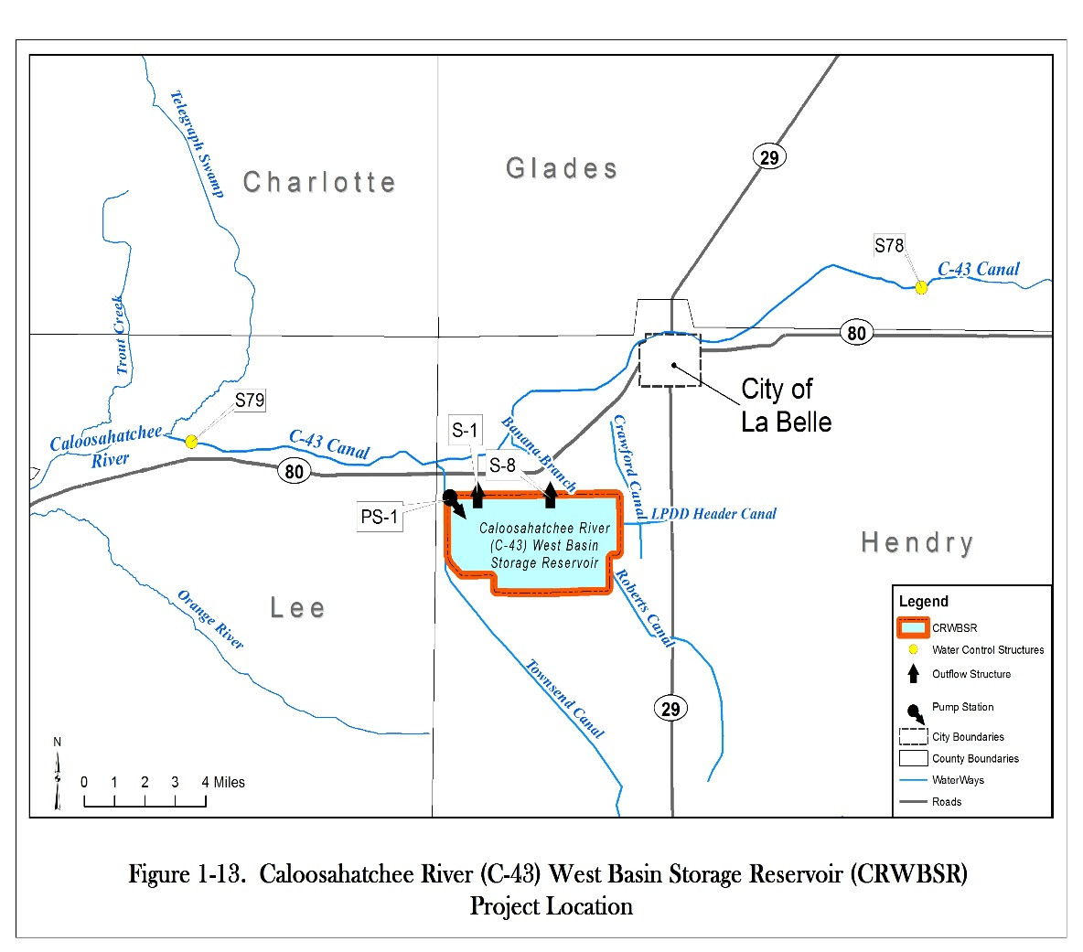

APPENDIX 2 UPPER EAST COAST PLANNING AREA
2-1 Upper East Coast Reservation Waterbodies
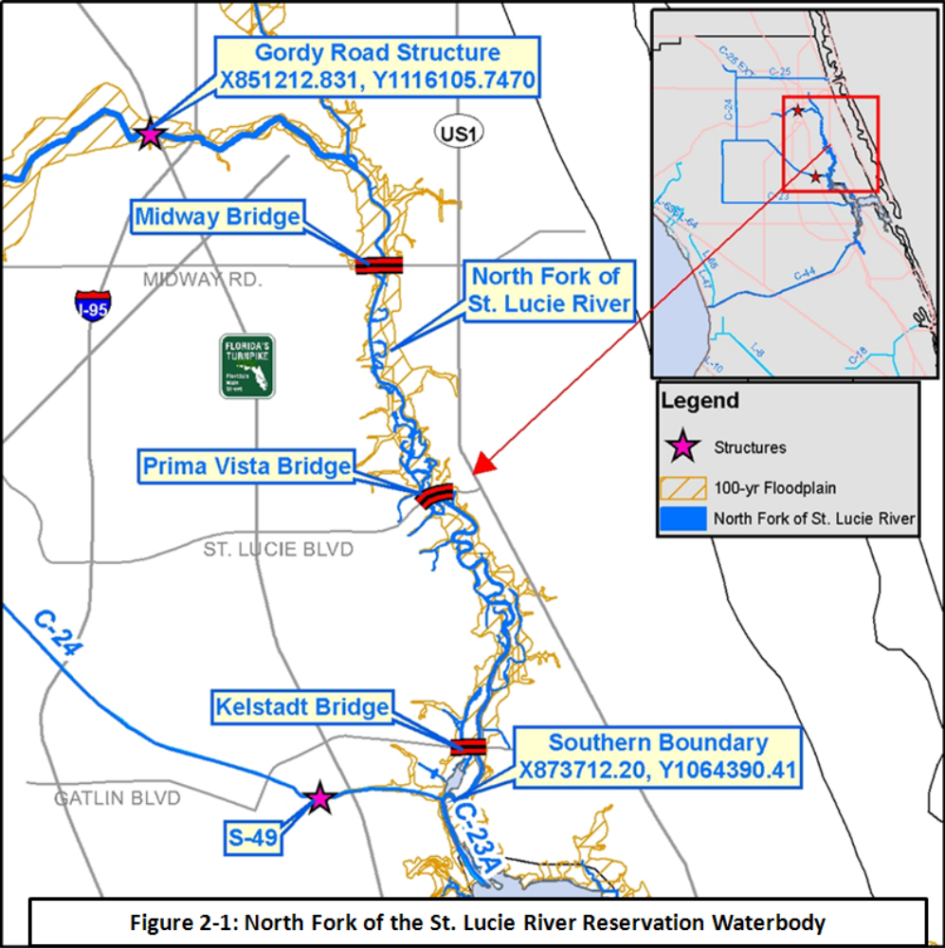
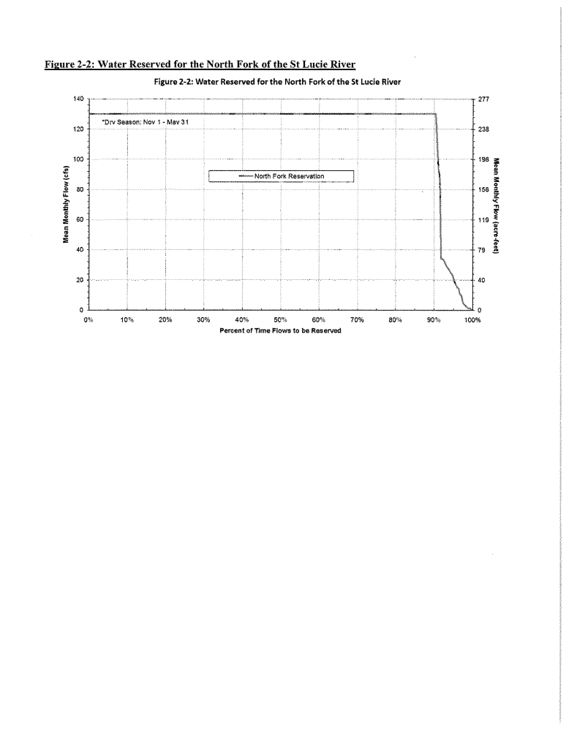

Appendix 3: Lower East Coast Planning Area
Figure 3-1 Nearshore Central Biscayne Bay Reservation Waterbody and Protected Canal Reaches
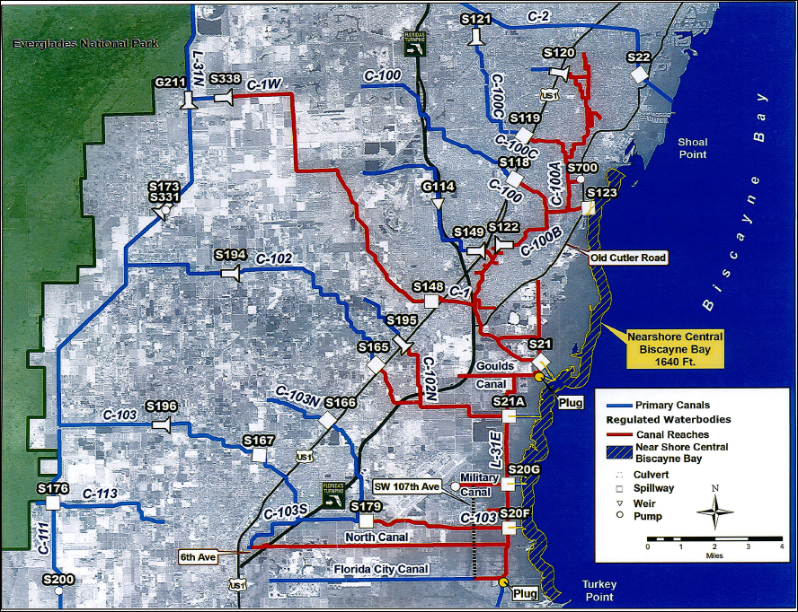

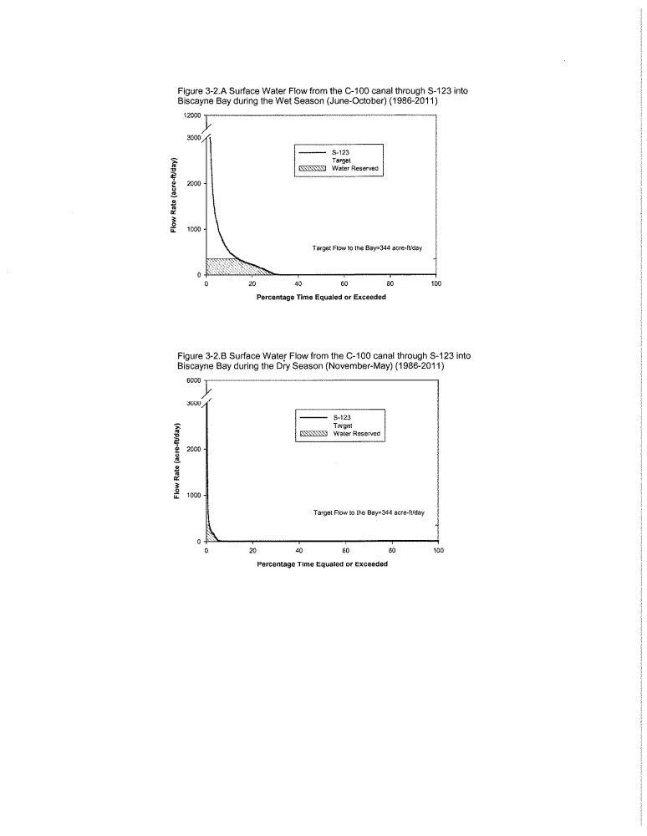

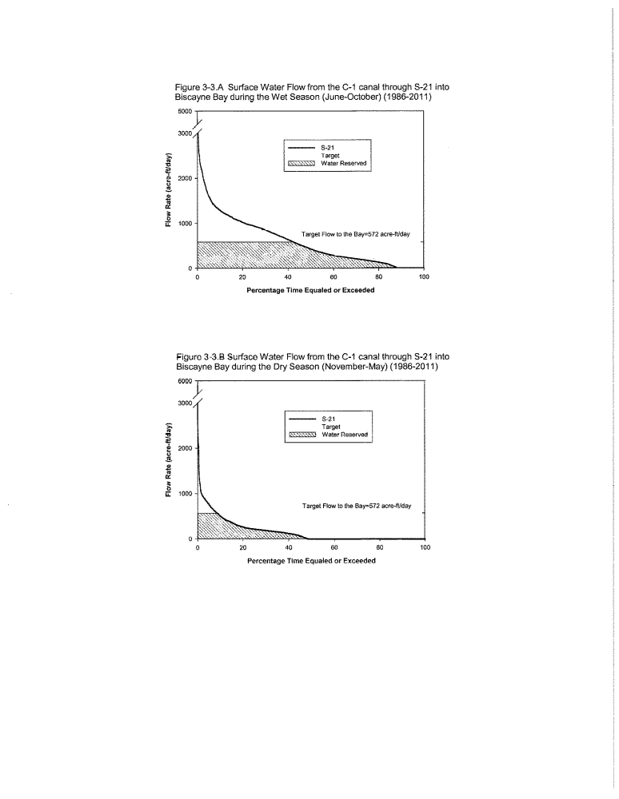

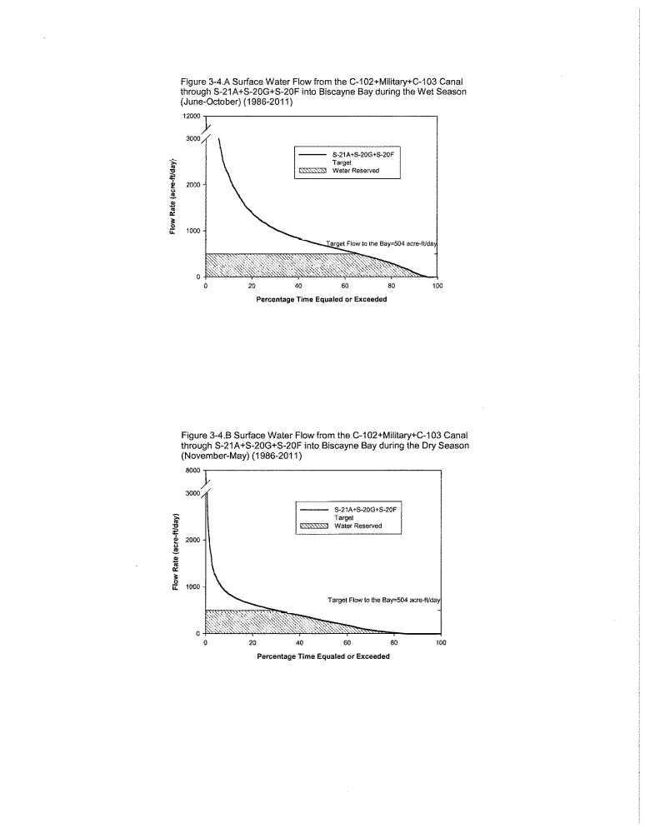
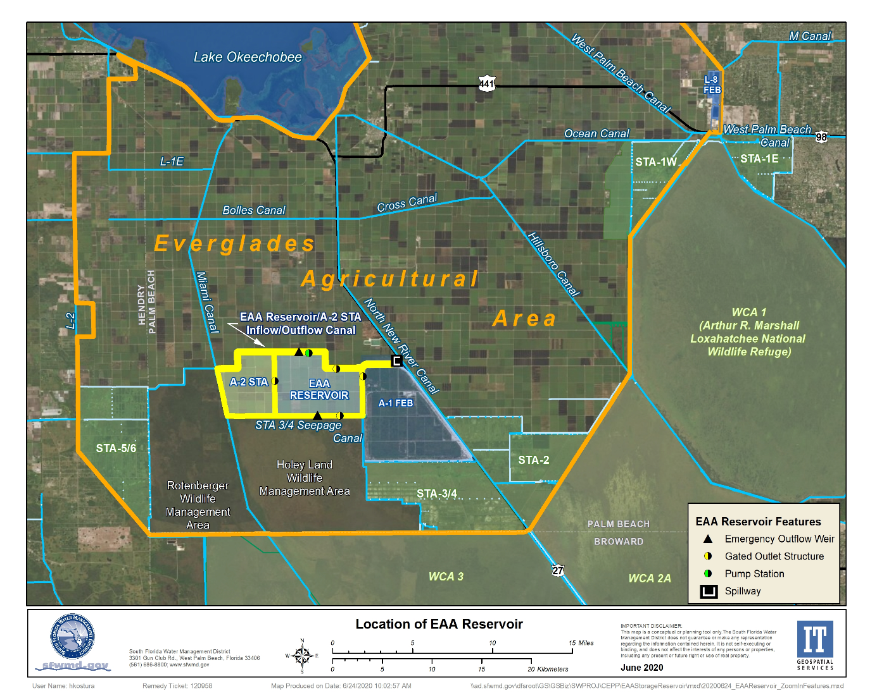
Figure 3-5. Location of the EAA Reservoir.
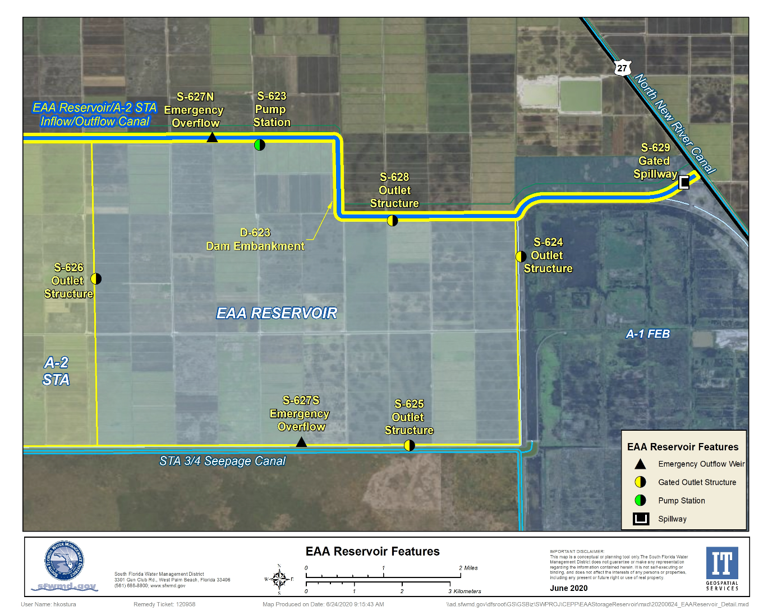
Figure 3-6. Key Features of the EAA Reservoir.
Appendix 4: Upper and Lower Kissimmee Basin
Planning Areas
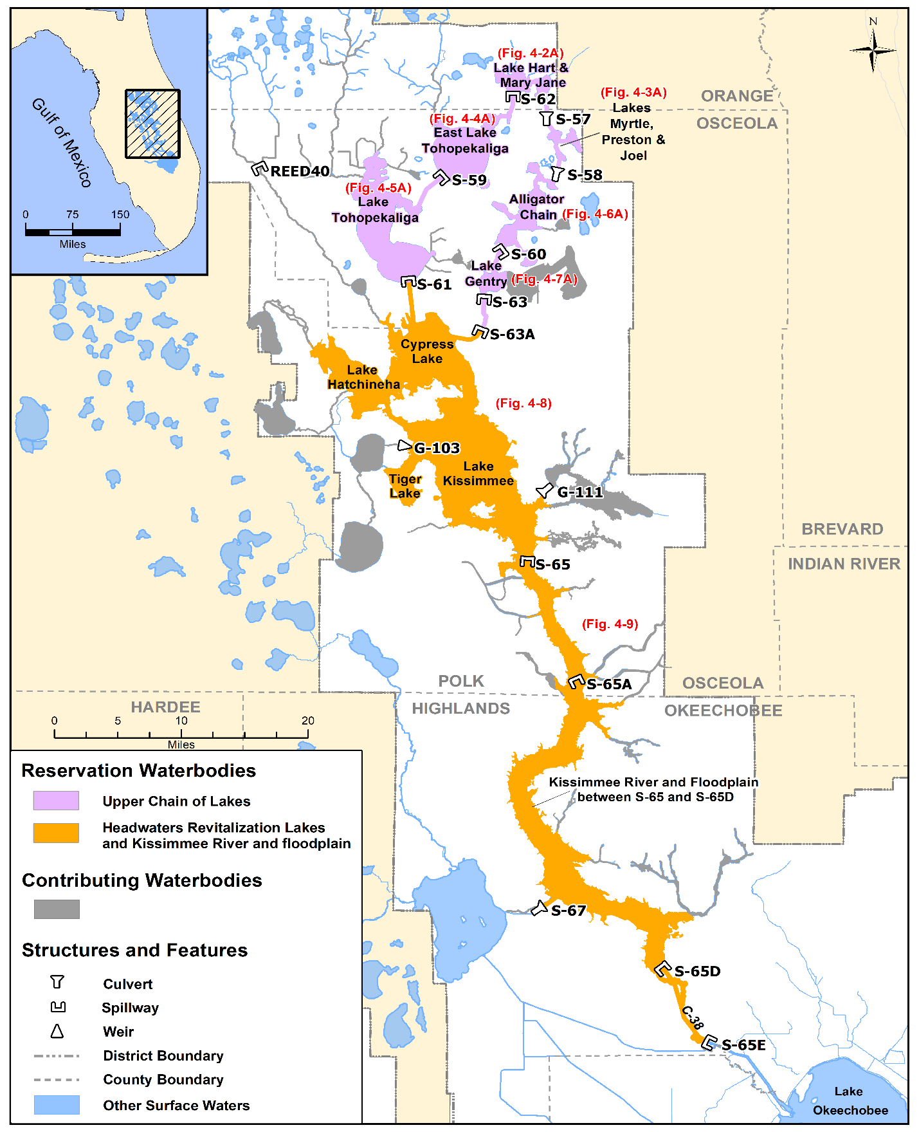
Figure 4-1. Kissimmee River and Chain of Lakes reservation and contributing waterbodies.

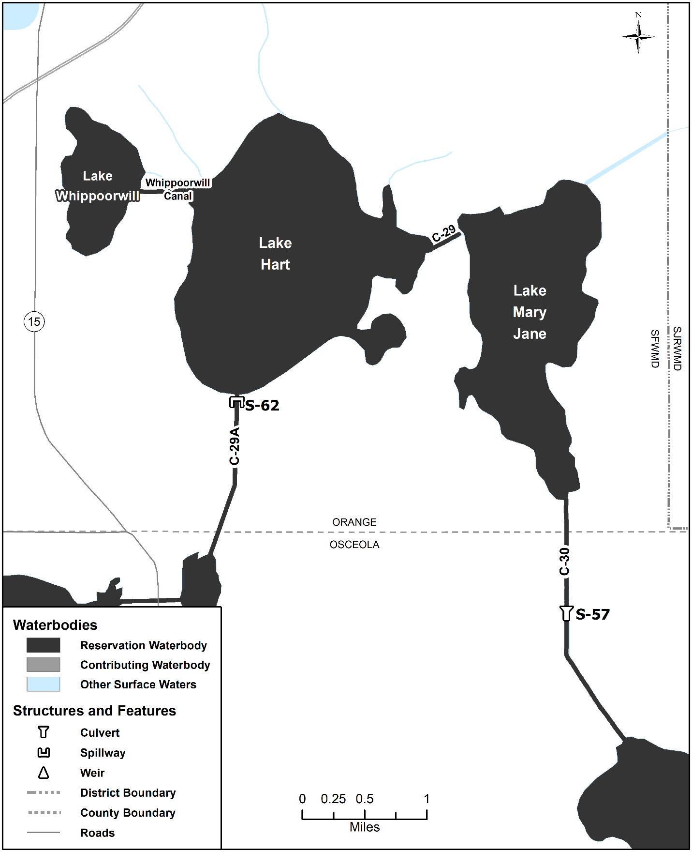
Figure 4-2A. Lakes Hart-Mary Jane reservation waterbodies (no contributing waterbodies present). Unlabeled waterbodies in this figure are not included in this reservation waterbody group.

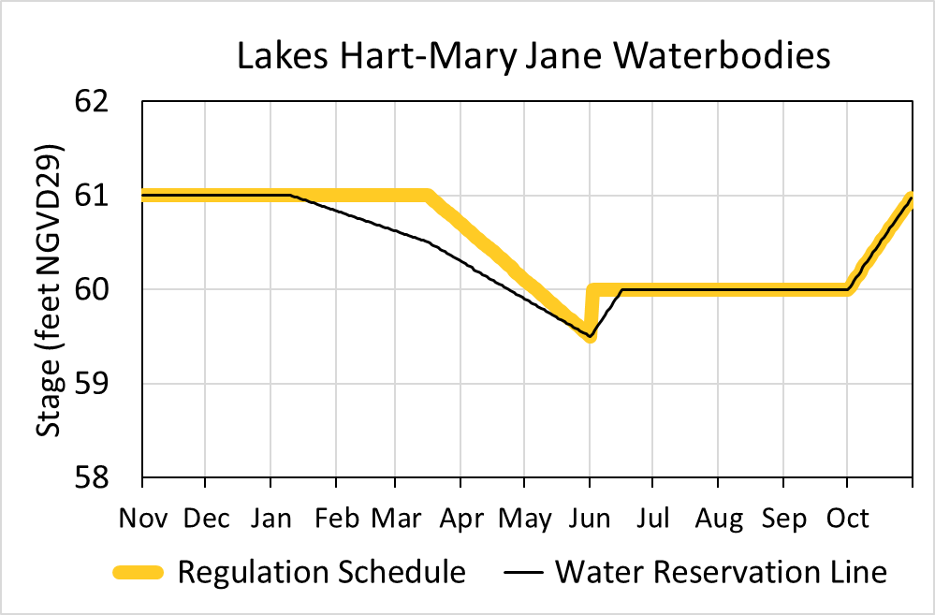
Figure 4-2B. Hydrograph of the current regulation schedule and the water reservation stage at S-62 (water reservation line) for Lakes Hart-Mary Jane reservation waterbodies. The water reservation line is derived from data in Table 4-2.

Table 4-2. Maximum daily water reservation stages at S-62 for Lakes Hart-Mary Jane reservation waterbodies (black line in Figure 4-2B).
Day | January | February | March | April | May | June | July | August | September | October | November | December
1 | 61.00 | 60.83 | 60.62 | 60.29 | 59.90 | 59.50 | 60.00 | 60.00 | 60.00 | 60.00 | 61.00 | 61.00
2 | 61.00 | 60.82 | 60.61 | 60.28 | 59.89 | 59.53 | 60.00 | 60.00 | 60.00 | 60.03 | 61.00 | 61.00
3 | 61.00 | 60.82 | 60.60 | 60.27 | 59.88 | 59.57 | 60.00 | 60.00 | 60.00 | 60.06 | 61.00 | 61.00
4 | 61.00 | 60.81 | 60.59 | 60.25 | 59.86 | 59.60 | 60.00 | 60.00 | 60.00 | 60.10 | 61.00 | 61.00
5 | 61.00 | 60.80 | 60.58 | 60.24 | 59.85 | 59.63 | 60.00 | 60.00 | 60.00 | 60.13 | 61.00 | 61.00
6 | 61.00 | 60.79 | 60.58 | 60.23 | 59.84 | 59.67 | 60.00 | 60.00 | 60.00 | 60.16 | 61.00 | 61.00
7 | 61.00 | 60.78 | 60.57 | 60.21 | 59.82 | 59.70 | 60.00 | 60.00 | 60.00 | 60.19 | 61.00 | 61.00
8 | 61.00 | 60.78 | 60.56 | 60.20 | 59.81 | 59.73 | 60.00 | 60.00 | 60.00 | 60.23 | 61.00 | 61.00
9 | 61.00 | 60.77 | 60.55 | 60.19 | 59.80 | 59.77 | 60.00 | 60.00 | 60.00 | 60.26 | 61.00 | 61.00
10 | 61.00 | 60.76 | 60.55 | 60.18 | 59.79 | 59.80 | 60.00 | 60.00 | 60.00 | 60.29 | 61.00 | 61.00
11 | 60.99 | 60.75 | 60.54 | 60.16 | 59.77 | 59.83 | 60.00 | 60.00 | 60.00 | 60.32 | 61.00 | 61.00
12 | 60.98 | 60.75 | 60.53 | 60.15 | 59.76 | 59.87 | 60.00 | 60.00 | 60.00 | 60.35 | 61.00 | 61.00
13 | 60.98 | 60.74 | 60.52 | 60.14 | 59.75 | 59.90 | 60.00 | 60.00 | 60.00 | 60.39 | 61.00 | 61.00
14 | 60.97 | 60.73 | 60.52 | 60.12 | 59.73 | 59.93 | 60.00 | 60.00 | 60.00 | 60.42 | 61.00 | 61.00
15 | 60.96 | 60.72 | 60.51 | 60.11 | 59.72 | 59.97 | 60.00 | 60.00 | 60.00 | 60.45 | 61.00 | 61.00
16 | 60.95 | 60.72 | 60.50 | 60.10 | 59.71 | 60.00 | 60.00 | 60.00 | 60.00 | 60.48 | 61.00 | 61.00
17 | 60.95 | 60.71 | 60.49 | 60.08 | 59.69 | 60.00 | 60.00 | 60.00 | 60.00 | 60.52 | 61.00 | 61.00
18 | 60.94 | 60.70 | 60.47 | 60.07 | 59.68 | 60.00 | 60.00 | 60.00 | 60.00 | 60.55 | 61.00 | 61.00
19 | 60.93 | 60.69 | 60.46 | 60.06 | 59.67 | 60.00 | 60.00 | 60.00 | 60.00 | 60.58 | 61.00 | 61.00
20 | 60.92 | 60.68 | 60.45 | 60.05 | 59.66 | 60.00 | 60.00 | 60.00 | 60.00 | 60.61 | 61.00 | 61.00
21 | 60.92 | 60.68 | 60.44 | 60.03 | 59.64 | 60.00 | 60.00 | 60.00 | 60.00 | 60.65 | 61.00 | 61.00
22 | 60.91 | 60.67 | 60.42 | 60.02 | 59.63 | 60.00 | 60.00 | 60.00 | 60.00 | 60.68 | 61.00 | 61.00
23 | 60.90 | 60.66 | 60.41 | 60.01 | 59.62 | 60.00 | 60.00 | 60.00 | 60.00 | 60.71 | 61.00 | 61.00
24 | 60.89 | 60.65 | 60.40 | 59.99 | 59.60 | 60.00 | 60.00 | 60.00 | 60.00 | 60.74 | 61.00 | 61.00
25 | 60.88 | 60.65 | 60.38 | 59.98 | 59.59 | 60.00 | 60.00 | 60.00 | 60.00 | 60.77 | 61.00 | 61.00
26 | 60.88 | 60.64 | 60.37 | 59.97 | 59.58 | 60.00 | 60.00 | 60.00 | 60.00 | 60.81 | 61.00 | 61.00
27 | 60.87 | 60.63 | 60.36 | 59.95 | 59.56 | 60.00 | 60.00 | 60.00 | 60.00 | 60.84 | 61.00 | 61.00
28 | 60.86 | 60.62 | 60.34 | 59.94 | 59.55 | 60.00 | 60.00 | 60.00 | 60.00 | 60.87 | 61.00 | 61.00
29 | 60.85 |  | 60.33 | 59.93 | 59.54 | 60.00 | 60.00 | 60.00 | 60.00 | 60.90 | 61.00 | 61.00
30 | 60.85 |  | 60.32 | 59.92 | 59.53 | 60.00 | 60.00 | 60.00 | 60.00 | 60.94 | 61.00 | 61.00
31 | 60.84 |  | 60.31 |  | 59.51 |  | 60.00 | 60.00 |  | 60.97 |  | 61.00

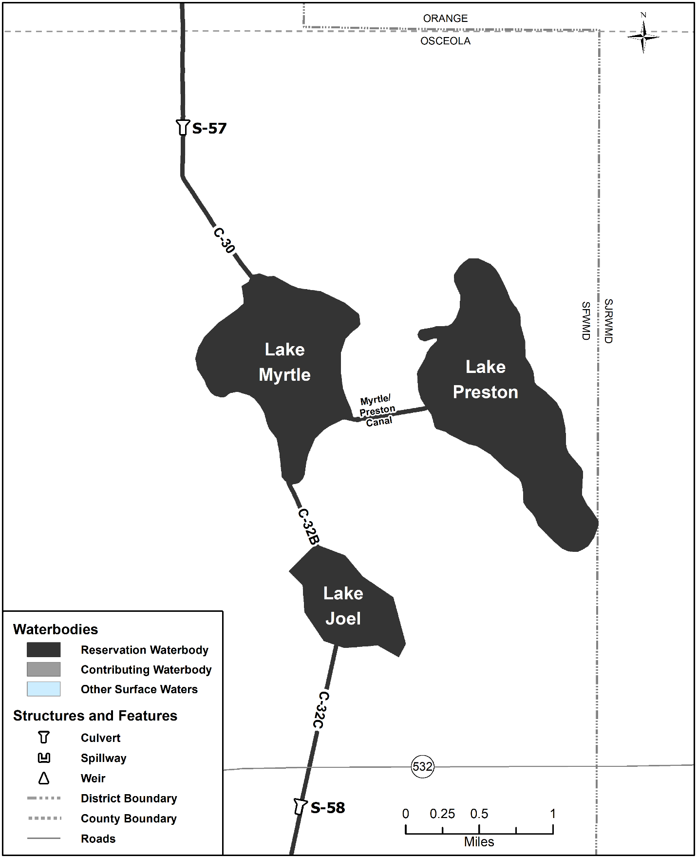
Figure 4-3A. Lakes Myrtle-Preston-Joel reservation waterbodies (no contributing waterbodies present). Unlabeled waterbodies in this figure are not included in this reservation waterbody group.

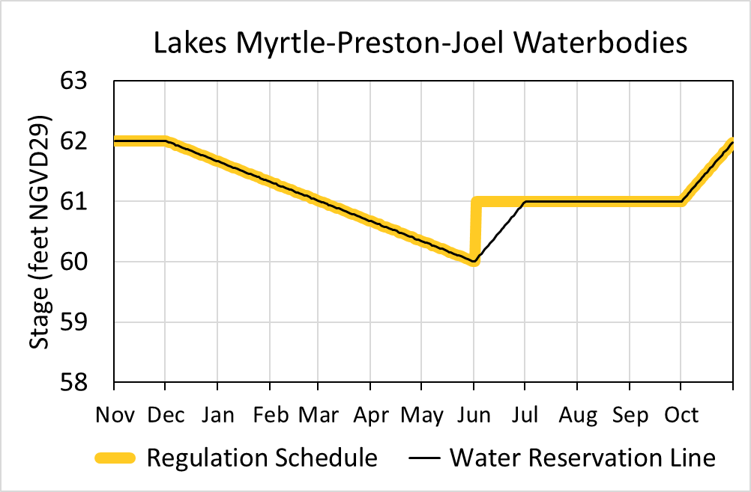
Figure 4-3B. Hydrograph of the current regulation schedule and the water reservation stage at S-57 (water reservation line) for Lakes Myrtle-Preston-Joel reservation waterbodies. The water reservation line is derived from data in Table 4-3.

Table 4-3. Maximum daily water reservation stages at S-57 for Lakes Myrtle-Preston-Joel reservation waterbodies (black line in Figure 4-3B).
Day | January | February | March | April | May | June | July | August | September | October | November | December
1 | 61.66 | 61.32 | 61.01 | 60.67 | 60.34 | 60.00 | 61.00 | 61.00 | 61.00 | 61.00 | 62.00 | 62.00
2 | 61.65 | 61.31 | 61.00 | 60.66 | 60.33 | 60.03 | 61.00 | 61.00 | 61.00 | 61.03 | 62.00 | 61.99
3 | 61.64 | 61.30 | 60.99 | 60.65 | 60.32 | 60.07 | 61.00 | 61.00 | 61.00 | 61.06 | 62.00 | 61.98
4 | 61.63 | 61.29 | 60.98 | 60.64 | 60.31 | 60.10 | 61.00 | 61.00 | 61.00 | 61.10 | 62.00 | 61.97
5 | 61.62 | 61.27 | 60.97 | 60.63 | 60.30 | 60.13 | 61.00 | 61.00 | 61.00 | 61.13 | 62.00 | 61.96
6 | 61.60 | 61.26 | 60.96 | 60.62 | 60.29 | 60.17 | 61.00 | 61.00 | 61.00 | 61.16 | 62.00 | 61.95
7 | 61.59 | 61.25 | 60.94 | 60.60 | 60.27 | 60.20 | 61.00 | 61.00 | 61.00 | 61.19 | 62.00 | 61.93
8 | 61.58 | 61.24 | 60.93 | 60.59 | 60.26 | 60.23 | 61.00 | 61.00 | 61.00 | 61.23 | 62.00 | 61.92
9 | 61.57 | 61.23 | 60.92 | 60.58 | 60.25 | 60.27 | 61.00 | 61.00 | 61.00 | 61.26 | 62.00 | 61.91
10 | 61.56 | 61.22 | 60.91 | 60.57 | 60.24 | 60.30 | 61.00 | 61.00 | 61.00 | 61.29 | 62.00 | 61.90
11 | 61.55 | 61.21 | 60.90 | 60.56 | 60.23 | 60.33 | 61.00 | 61.00 | 61.00 | 61.32 | 62.00 | 61.89
12 | 61.54 | 61.20 | 60.89 | 60.55 | 60.22 | 60.37 | 61.00 | 61.00 | 61.00 | 61.35 | 62.00 | 61.88
13 | 61.53 | 61.19 | 60.88 | 60.54 | 60.21 | 60.40 | 61.00 | 61.00 | 61.00 | 61.39 | 62.00 | 61.87
14 | 61.52 | 61.18 | 60.87 | 60.53 | 60.20 | 60.43 | 61.00 | 61.00 | 61.00 | 61.42 | 62.00 | 61.86
15 | 61.51 | 61.16 | 60.86 | 60.52 | 60.19 | 60.47 | 61.00 | 61.00 | 61.00 | 61.45 | 62.00 | 61.85
16 | 61.49 | 61.15 | 60.85 | 60.51 | 60.18 | 60.50 | 61.00 | 61.00 | 61.00 | 61.48 | 62.00 | 61.84
17 | 61.48 | 61.14 | 60.84 | 60.49 | 60.16 | 60.53 | 61.00 | 61.00 | 61.00 | 61.52 | 62.00 | 61.83
18 | 61.47 | 61.13 | 60.82 | 60.48 | 60.15 | 60.57 | 61.00 | 61.00 | 61.00 | 61.55 | 62.00 | 61.81
19 | 61.46 | 61.12 | 60.81 | 60.47 | 60.14 | 60.60 | 61.00 | 61.00 | 61.00 | 61.58 | 62.00 | 61.80
20 | 61.45 | 61.11 | 60.80 | 60.46 | 60.13 | 60.63 | 61.00 | 61.00 | 61.00 | 61.61 | 62.00 | 61.79
21 | 61.44 | 61.10 | 60.79 | 60.45 | 60.12 | 60.67 | 61.00 | 61.00 | 61.00 | 61.65 | 62.00 | 61.78
22 | 61.43 | 61.09 | 60.78 | 60.44 | 60.11 | 60.70 | 61.00 | 61.00 | 61.00 | 61.68 | 62.00 | 61.77
23 | 61.42 | 61.08 | 60.77 | 60.43 | 60.10 | 60.73 | 61.00 | 61.00 | 61.00 | 61.71 | 62.00 | 61.76
24 | 61.41 | 61.07 | 60.76 | 60.42 | 60.09 | 60.77 | 61.00 | 61.00 | 61.00 | 61.74 | 62.00 | 61.75
25 | 61.40 | 61.05 | 60.75 | 60.41 | 60.08 | 60.80 | 61.00 | 61.00 | 61.00 | 61.77 | 62.00 | 61.74
26 | 61.38 | 61.04 | 60.74 | 60.40 | 60.07 | 60.83 | 61.00 | 61.00 | 61.00 | 61.81 | 62.00 | 61.73
27 | 61.37 | 61.03 | 60.73 | 60.38 | 60.05 | 60.87 | 61.00 | 61.00 | 61.00 | 61.84 | 62.00 | 61.72
28 | 61.36 | 61.02 | 60.71 | 60.37 | 60.04 | 60.90 | 61.00 | 61.00 | 61.00 | 61.87 | 62.00 | 61.70
29 | 61.35 |  | 60.70 | 60.36 | 60.03 | 60.93 | 61.00 | 61.00 | 61.00 | 61.90 | 62.00 | 61.69
30 | 61.34 |  | 60.69 | 60.35 | 60.02 | 60.97 | 61.00 | 61.00 | 61.00 | 61.94 | 62.00 | 61.68
31 | 61.33 |  | 60.68 |  | 60.01 |  | 61.00 | 61.00 |  | 61.97 |  | 61.67

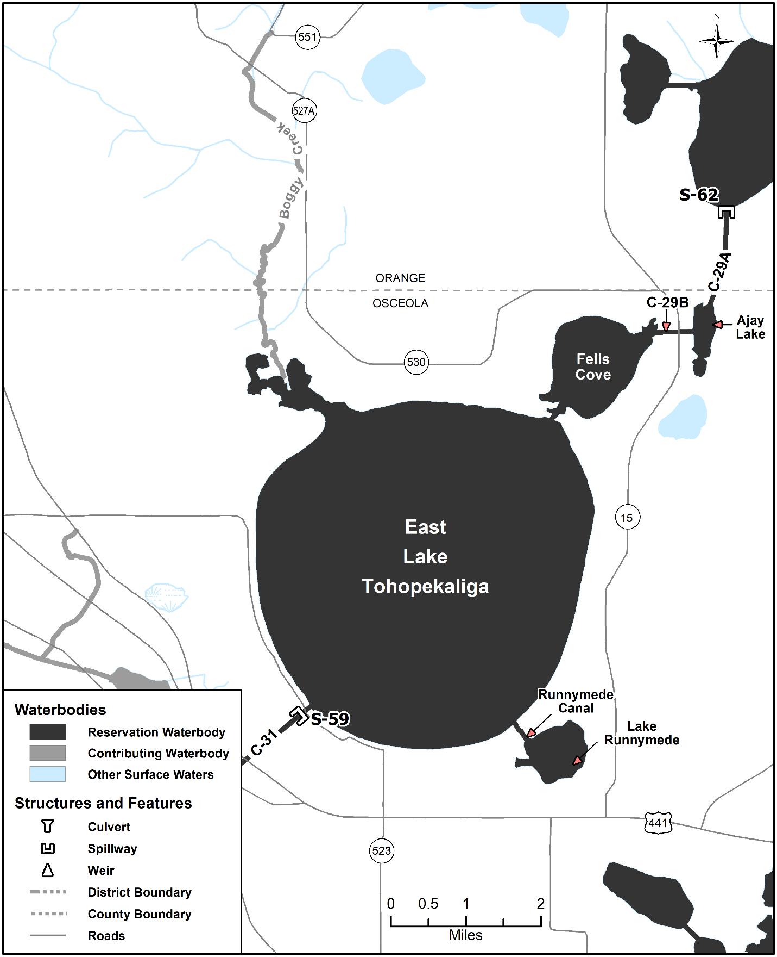
Figure 4-4A. East Lake Tohopekaliga reservation and contributing waterbodies. Unlabeled waterbodies in this figure are not included in this reservation/contributing waterbody group.

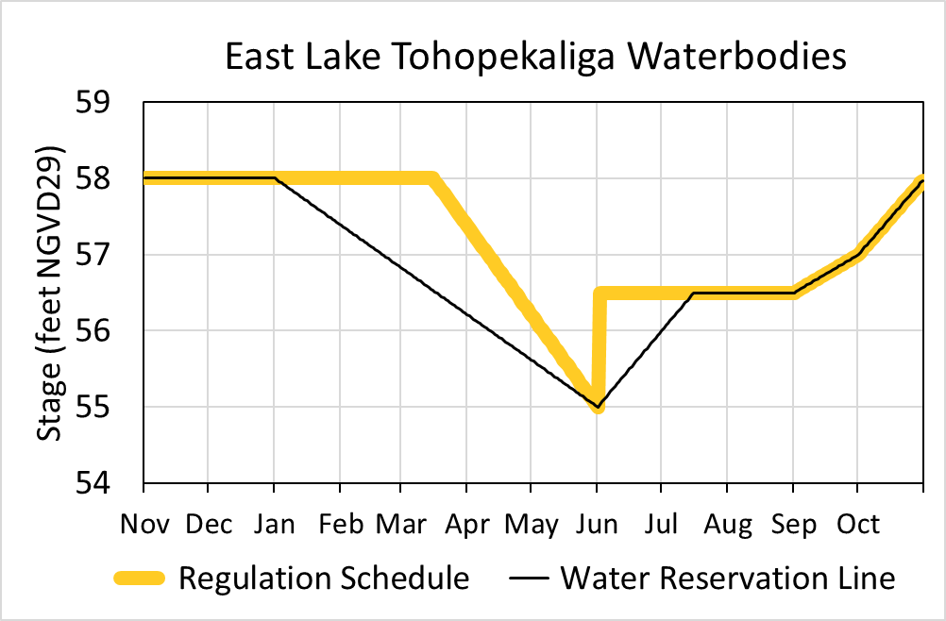
Figure 4-4B. Hydrograph of the current regulation schedule and the water reservation stage at S-59 (water reservation line) for East Lake Tohopekaliga reservation waterbodies. The water reservation line is derived from data in Table 4-4.

Table 4-4. Maximum daily water reservation stages at S-59 for East Lake Tohopekaliga reservation waterbodies (black line in Figure 4-4B).
Day | January | February | March | April | May | June | July | August | September | October | November | December
1 | 58.00 | 57.38 | 56.83 | 56.21 | 55.62 | 55.00 | 56.00 | 56.50 | 56.50 | 57.00 | 58.00 | 58.00
2 | 57.98 | 57.36 | 56.81 | 56.19 | 55.60 | 55.03 | 56.03 | 56.50 | 56.52 | 57.03 | 58.00 | 58.00
3 | 57.96 | 57.34 | 56.79 | 56.17 | 55.58 | 55.07 | 56.07 | 56.50 | 56.53 | 57.06 | 58.00 | 58.00
4 | 57.94 | 57.32 | 56.77 | 56.15 | 55.56 | 55.10 | 56.10 | 56.50 | 56.55 | 57.10 | 58.00 | 58.00
5 | 57.92 | 57.30 | 56.75 | 56.13 | 55.54 | 55.13 | 56.13 | 56.50 | 56.57 | 57.13 | 58.00 | 58.00
6 | 57.90 | 57.28 | 56.73 | 56.11 | 55.52 | 55.17 | 56.17 | 56.50 | 56.58 | 57.16 | 58.00 | 58.00
7 | 57.88 | 57.26 | 56.71 | 56.09 | 55.50 | 55.20 | 56.20 | 56.50 | 56.60 | 57.19 | 58.00 | 58.00
8 | 57.86 | 57.25 | 56.69 | 56.07 | 55.48 | 55.23 | 56.23 | 56.50 | 56.62 | 57.23 | 58.00 | 58.00
9 | 57.84 | 57.23 | 56.67 | 56.05 | 55.46 | 55.27 | 56.27 | 56.50 | 56.63 | 57.26 | 58.00 | 58.00
10 | 57.82 | 57.21 | 56.65 | 56.03 | 55.44 | 55.30 | 56.30 | 56.50 | 56.65 | 57.29 | 58.00 | 58.00
11 | 57.80 | 57.19 | 56.63 | 56.01 | 55.42 | 55.33 | 56.33 | 56.50 | 56.67 | 57.32 | 58.00 | 58.00
12 | 57.78 | 57.17 | 56.61 | 55.99 | 55.40 | 55.37 | 56.37 | 56.50 | 56.68 | 57.35 | 58.00 | 58.00
13 | 57.76 | 57.15 | 56.59 | 55.97 | 55.38 | 55.40 | 56.40 | 56.50 | 56.70 | 57.39 | 58.00 | 58.00
14 | 57.74 | 57.13 | 56.57 | 55.95 | 55.36 | 55.43 | 56.43 | 56.50 | 56.72 | 57.42 | 58.00 | 58.00
15 | 57.72 | 57.11 | 56.55 | 55.93 | 55.34 | 55.47 | 56.47 | 56.50 | 56.73 | 57.45 | 58.00 | 58.00
16 | 57.70 | 57.09 | 56.53 | 55.91 | 55.32 | 55.50 | 56.50 | 56.50 | 56.75 | 57.48 | 58.00 | 58.00
17 | 57.68 | 57.07 | 56.51 | 55.89 | 55.30 | 55.53 | 56.50 | 56.50 | 56.77 | 57.52 | 58.00 | 58.00
18 | 57.66 | 57.05 | 56.49 | 55.87 | 55.28 | 55.57 | 56.50 | 56.50 | 56.78 | 57.55 | 58.00 | 58.00
19 | 57.64 | 57.03 | 56.47 | 55.85 | 55.26 | 55.60 | 56.50 | 56.50 | 56.80 | 57.58 | 58.00 | 58.00
20 | 57.62 | 57.01 | 56.45 | 55.83 | 55.24 | 55.63 | 56.50 | 56.50 | 56.82 | 57.61 | 58.00 | 58.00
21 | 57.60 | 56.99 | 56.43 | 55.81 | 55.22 | 55.67 | 56.50 | 56.50 | 56.83 | 57.65 | 58.00 | 58.00
22 | 57.58 | 56.97 | 56.41 | 55.79 | 55.20 | 55.70 | 56.50 | 56.50 | 56.85 | 57.68 | 58.00 | 58.00
23 | 57.56 | 56.95 | 56.39 | 55.77 | 55.18 | 55.73 | 56.50 | 56.50 | 56.87 | 57.71 | 58.00 | 58.00
24 | 57.54 | 56.93 | 56.37 | 55.75 | 55.16 | 55.77 | 56.50 | 56.50 | 56.88 | 57.74 | 58.00 | 58.00
25 | 57.52 | 56.91 | 56.35 | 55.74 | 55.14 | 55.80 | 56.50 | 56.50 | 56.90 | 57.77 | 58.00 | 58.00
26 | 57.50 | 56.89 | 56.33 | 55.72 | 55.12 | 55.83 | 56.50 | 56.50 | 56.92 | 57.81 | 58.00 | 58.00
27 | 57.48 | 56.87 | 56.31 | 55.70 | 55.10 | 55.87 | 56.50 | 56.50 | 56.93 | 57.84 | 58.00 | 58.00
28 | 57.46 | 56.85 | 56.29 | 55.68 | 55.08 | 55.90 | 56.50 | 56.50 | 56.95 | 57.87 | 58.00 | 58.00
29 | 57.44 |  | 56.27 | 55.66 | 55.06 | 55.93 | 56.50 | 56.50 | 56.97 | 57.90 | 58.00 | 58.00
30 | 57.42 |  | 56.25 | 55.64 | 55.04 | 55.97 | 56.50 | 56.50 | 56.98 | 57.94 | 58.00 | 58.00
31 | 57.40 |  | 56.23 |  | 55.02 |  | 56.50 | 56.50 |  | 57.97 |  | 58.00

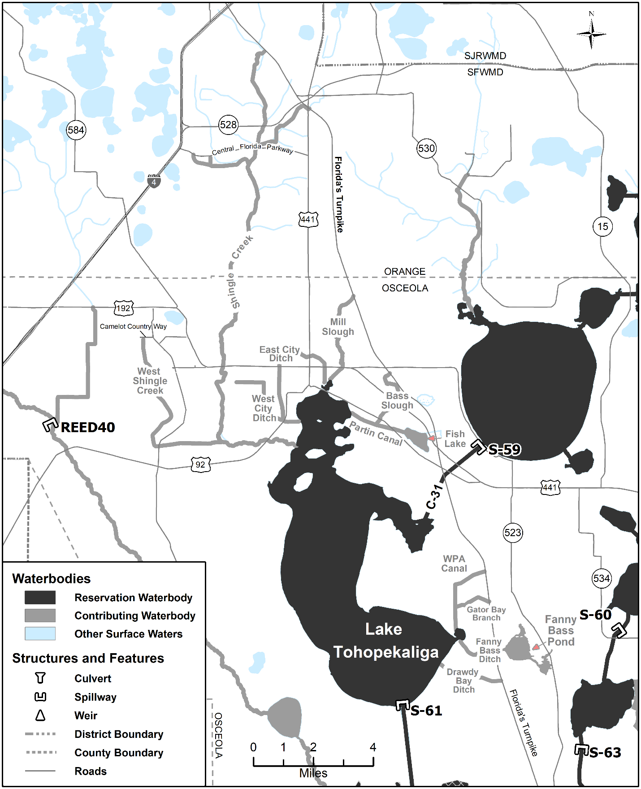
Figure 4-5A. Lake Tohopekaliga reservation and contributing waterbodies. Unlabeled waterbodies in this figure are not included in this reservation/contributing waterbody group.

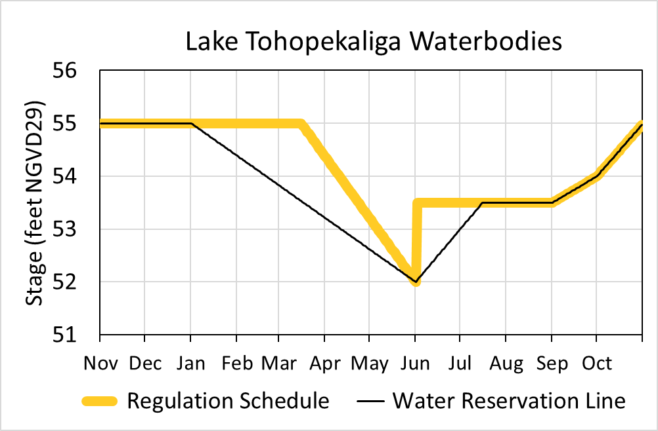
Figure 4-5B. Hydrograph of the current regulation schedule and the water reservation stage at S-61 (water reservation line) for Lake Tohopekaliga reservation waterbodies. The water reservation line is derived from data in Table 4-5.

Table 4-5. Maximum daily water reservation stages at S-61 for Lake Tohopekaliga reservation waterbodies (black line in Figure 4-5B).
Day | January | February | March | April | May | June | July | August | September | October | November | December
1 | 55.00 | 54.38 | 53.83 | 53.21 | 52.62 | 52.00 | 53.00 | 53.50 | 53.50 | 54.00 | 55.00 | 55.00
2 | 54.98 | 54.36 | 53.81 | 53.19 | 52.60 | 52.03 | 53.03 | 53.50 | 53.52 | 54.03 | 55.00 | 55.00
3 | 54.96 | 54.34 | 53.79 | 53.17 | 52.58 | 52.07 | 53.07 | 53.50 | 53.53 | 54.06 | 55.00 | 55.00
4 | 54.94 | 54.32 | 53.77 | 53.15 | 52.56 | 52.10 | 53.10 | 53.50 | 53.55 | 54.10 | 55.00 | 55.00
5 | 54.92 | 54.30 | 53.75 | 53.13 | 52.54 | 52.13 | 53.13 | 53.50 | 53.57 | 54.13 | 55.00 | 55.00
6 | 54.90 | 54.28 | 53.73 | 53.11 | 52.52 | 52.17 | 53.17 | 53.50 | 53.58 | 54.16 | 55.00 | 55.00
7 | 54.88 | 54.26 | 53.71 | 53.09 | 52.50 | 52.20 | 53.20 | 53.50 | 53.60 | 54.19 | 55.00 | 55.00
8 | 54.86 | 54.25 | 53.69 | 53.07 | 52.48 | 52.23 | 53.23 | 53.50 | 53.62 | 54.23 | 55.00 | 55.00
9 | 54.84 | 54.23 | 53.67 | 53.05 | 52.46 | 52.27 | 53.27 | 53.50 | 53.63 | 54.26 | 55.00 | 55.00
10 | 54.82 | 54.21 | 53.65 | 53.03 | 52.44 | 52.30 | 53.30 | 53.50 | 53.65 | 54.29 | 55.00 | 55.00
11 | 54.80 | 54.19 | 53.63 | 53.01 | 52.42 | 52.33 | 53.33 | 53.50 | 53.67 | 54.32 | 55.00 | 55.00
12 | 54.78 | 54.17 | 53.61 | 52.99 | 52.40 | 52.37 | 53.37 | 53.50 | 53.68 | 54.35 | 55.00 | 55.00
13 | 54.76 | 54.15 | 53.59 | 52.97 | 52.38 | 52.40 | 53.40 | 53.50 | 53.70 | 54.39 | 55.00 | 55.00
14 | 54.74 | 54.13 | 53.57 | 52.95 | 52.36 | 52.43 | 53.43 | 53.50 | 53.72 | 54.42 | 55.00 | 55.00
15 | 54.72 | 54.11 | 53.55 | 52.93 | 52.34 | 52.47 | 53.47 | 53.50 | 53.73 | 54.45 | 55.00 | 55.00
16 | 54.70 | 54.09 | 53.53 | 52.91 | 52.32 | 52.50 | 53.50 | 53.50 | 53.75 | 54.48 | 55.00 | 55.00
17 | 54.68 | 54.07 | 53.51 | 52.89 | 52.30 | 52.53 | 53.50 | 53.50 | 53.77 | 54.52 | 55.00 | 55.00
18 | 54.66 | 54.05 | 53.49 | 52.87 | 52.28 | 52.57 | 53.50 | 53.50 | 53.78 | 54.55 | 55.00 | 55.00
19 | 54.64 | 54.03 | 53.47 | 52.85 | 52.26 | 52.60 | 53.50 | 53.50 | 53.80 | 54.58 | 55.00 | 55.00
20 | 54.62 | 54.01 | 53.45 | 52.83 | 52.24 | 52.63 | 53.50 | 53.50 | 53.82 | 54.61 | 55.00 | 55.00
21 | 54.60 | 53.99 | 53.43 | 52.81 | 52.22 | 52.67 | 53.50 | 53.50 | 53.83 | 54.65 | 55.00 | 55.00
22 | 54.58 | 53.97 | 53.41 | 52.79 | 52.20 | 52.70 | 53.50 | 53.50 | 53.85 | 54.68 | 55.00 | 55.00
23 | 54.56 | 53.95 | 53.39 | 52.77 | 52.18 | 52.73 | 53.50 | 53.50 | 53.87 | 54.71 | 55.00 | 55.00
24 | 54.54 | 53.93 | 53.37 | 52.75 | 52.16 | 52.77 | 53.50 | 53.50 | 53.88 | 54.74 | 55.00 | 55.00
25 | 54.52 | 53.91 | 53.35 | 52.74 | 52.14 | 52.80 | 53.50 | 53.50 | 53.90 | 54.77 | 55.00 | 55.00
26 | 54.50 | 53.89 | 53.33 | 52.72 | 52.12 | 52.83 | 53.50 | 53.50 | 53.92 | 54.81 | 55.00 | 55.00
27 | 54.48 | 53.87 | 53.31 | 52.70 | 52.10 | 52.87 | 53.50 | 53.50 | 53.93 | 54.84 | 55.00 | 55.00
28 | 54.46 | 53.85 | 53.29 | 52.68 | 52.08 | 52.90 | 53.50 | 53.50 | 53.95 | 54.87 | 55.00 | 55.00
29 | 54.44 |  | 53.27 | 52.66 | 52.06 | 52.93 | 53.50 | 53.50 | 53.97 | 54.90 | 55.00 | 55.00
30 | 54.42 |  | 53.25 | 52.64 | 52.04 | 52.97 | 53.50 | 53.50 | 53.98 | 54.94 | 55.00 | 55.00
31 | 54.40 |  | 53.23 |  | 52.02 |  | 53.50 | 53.50 |  | 54.97 |  | 55.00

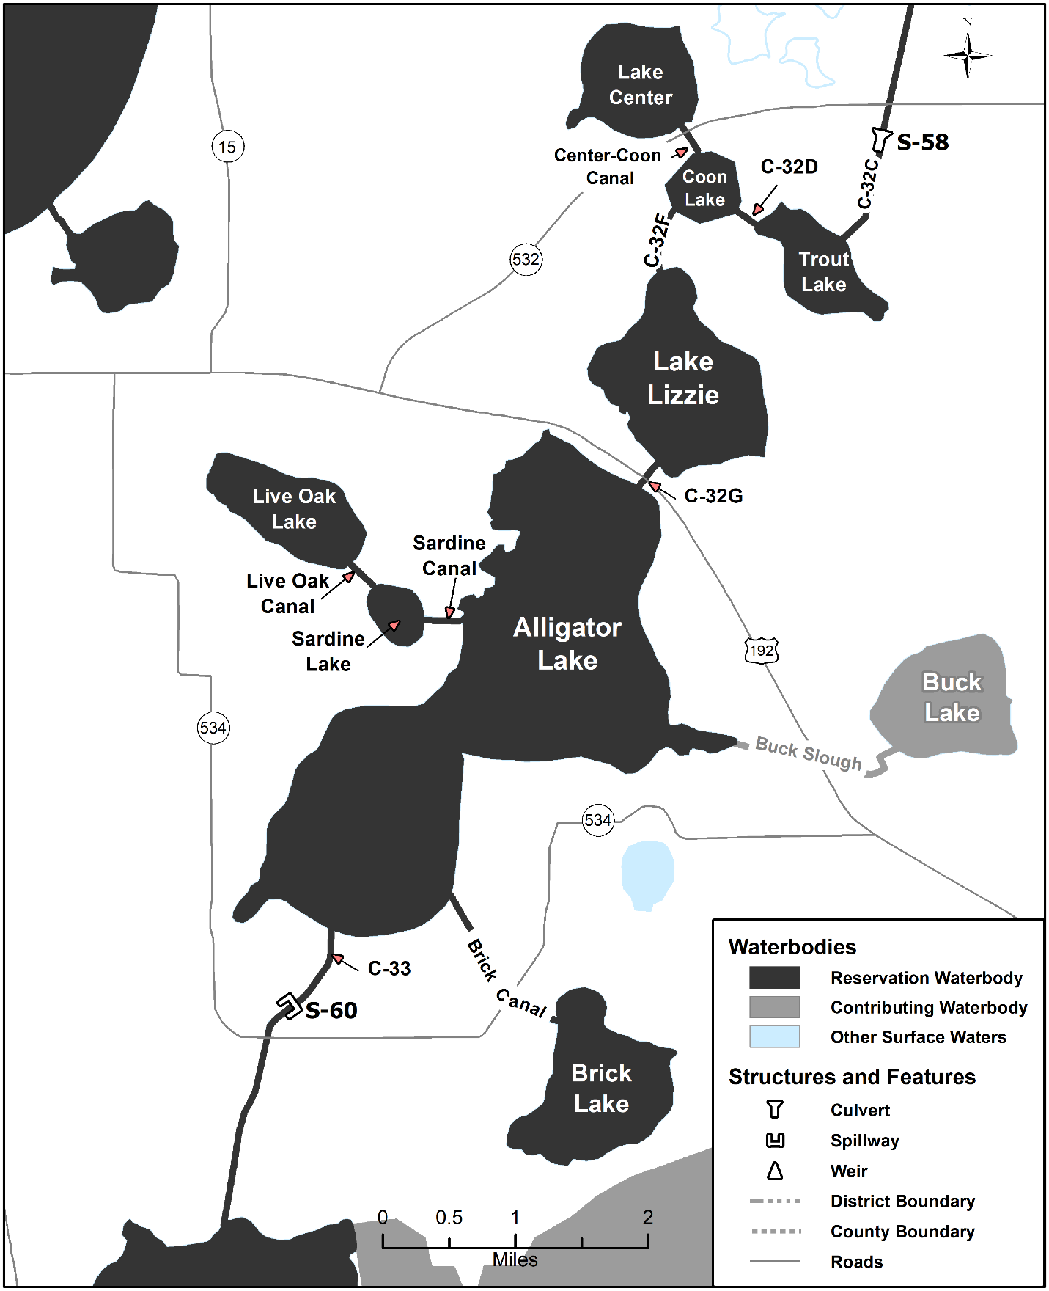
Figure 4-6A. Alligator Chain of Lakes reservation and contributing waterbodies. Unlabeled waterbodies in this figure are not included in this reservation/contributing waterbody group.

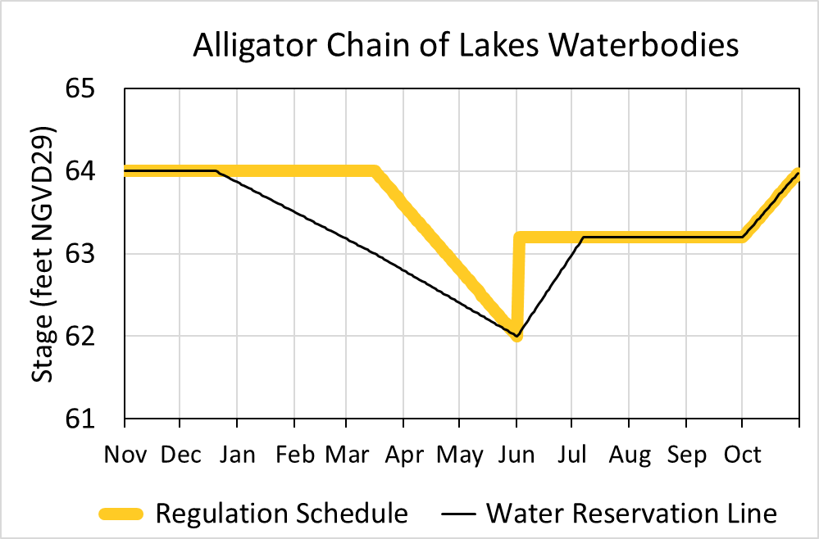
Figure 4-6B. Hydrograph of the current regulation schedule and the water reservation stage at S-60 (water reservation line) for Alligator Chain of Lakes reservation waterbodies. The water reservation line is derived from data in Table 4-6.

Table 4-6. Maximum daily water reservation stages at S-60 for Alligator Chain of Lakes reservation waterbodies (black line in Figure 4-6B).
Day | January | February | March | April | May | June | July | August | September | October | November | December
1 | 63.86 | 63.50 | 63.17 | 62.79 | 62.40 | 62.00 | 63.00 | 63.20 | 63.20 | 63.20 | 64.00 | 64.00
2 | 63.85 | 63.49 | 63.16 | 62.78 | 62.39 | 62.03 | 63.03 | 63.20 | 63.20 | 63.23 | 64.00 | 64.00
3 | 63.84 | 63.48 | 63.15 | 62.77 | 62.38 | 62.07 | 63.07 | 63.20 | 63.20 | 63.25 | 64.00 | 64.00
4 | 63.83 | 63.47 | 63.14 | 62.75 | 62.36 | 62.10 | 63.10 | 63.20 | 63.20 | 63.28 | 64.00 | 64.00
5 | 63.81 | 63.45 | 63.13 | 62.74 | 62.35 | 62.13 | 63.13 | 63.20 | 63.20 | 63.30 | 64.00 | 64.00
6 | 63.80 | 63.44 | 63.12 | 62.73 | 62.34 | 62.17 | 63.17 | 63.20 | 63.20 | 63.33 | 64.00 | 64.00
7 | 63.79 | 63.43 | 63.10 | 62.71 | 62.32 | 62.20 | 63.20 | 63.20 | 63.20 | 63.35 | 64.00 | 64.00
8 | 63.78 | 63.42 | 63.09 | 62.70 | 62.31 | 62.23 | 63.20 | 63.20 | 63.20 | 63.38 | 64.00 | 64.00
9 | 63.77 | 63.41 | 63.08 | 62.69 | 62.30 | 62.27 | 63.20 | 63.20 | 63.20 | 63.41 | 64.00 | 64.00
10 | 63.76 | 63.40 | 63.07 | 62.68 | 62.29 | 62.30 | 63.20 | 63.20 | 63.20 | 63.43 | 64.00 | 64.00
11 | 63.74 | 63.38 | 63.06 | 62.66 | 62.27 | 62.33 | 63.20 | 63.20 | 63.20 | 63.46 | 64.00 | 64.00
12 | 63.73 | 63.37 | 63.05 | 62.65 | 62.26 | 62.37 | 63.20 | 63.20 | 63.20 | 63.48 | 64.00 | 64.00
13 | 63.72 | 63.36 | 63.03 | 62.64 | 62.25 | 62.40 | 63.20 | 63.20 | 63.20 | 63.51 | 64.00 | 64.00
14 | 63.71 | 63.35 | 63.02 | 62.62 | 62.23 | 62.43 | 63.20 | 63.20 | 63.20 | 63.54 | 64.00 | 64.00
15 | 63.70 | 63.34 | 63.01 | 62.61 | 62.22 | 62.47 | 63.20 | 63.20 | 63.20 | 63.56 | 64.00 | 64.00
16 | 63.69 | 63.33 | 63.00 | 62.60 | 62.21 | 62.50 | 63.20 | 63.20 | 63.20 | 63.59 | 64.00 | 64.00
17 | 63.67 | 63.31 | 62.99 | 62.58 | 62.19 | 62.53 | 63.20 | 63.20 | 63.20 | 63.61 | 64.00 | 64.00
18 | 63.66 | 63.30 | 62.97 | 62.57 | 62.18 | 62.57 | 63.20 | 63.20 | 63.20 | 63.64 | 64.00 | 64.00
19 | 63.65 | 63.29 | 62.96 | 62.56 | 62.17 | 62.60 | 63.20 | 63.20 | 63.20 | 63.66 | 64.00 | 64.00
20 | 63.64 | 63.28 | 62.95 | 62.55 | 62.16 | 62.63 | 63.20 | 63.20 | 63.20 | 63.69 | 64.00 | 64.00
21 | 63.63 | 63.27 | 62.94 | 62.53 | 62.14 | 62.67 | 63.20 | 63.20 | 63.20 | 63.72 | 64.00 | 63.99
22 | 63.62 | 63.26 | 62.92 | 62.52 | 62.13 | 62.70 | 63.20 | 63.20 | 63.20 | 63.74 | 64.00 | 63.98
23 | 63.60 | 63.24 | 62.91 | 62.51 | 62.12 | 62.73 | 63.20 | 63.20 | 63.20 | 63.77 | 64.00 | 63.97
24 | 63.59 | 63.23 | 62.90 | 62.49 | 62.10 | 62.77 | 63.20 | 63.20 | 63.20 | 63.79 | 64.00 | 63.95
25 | 63.58 | 63.22 | 62.88 | 62.48 | 62.09 | 62.80 | 63.20 | 63.20 | 63.20 | 63.82 | 64.00 | 63.94
26 | 63.57 | 63.21 | 62.87 | 62.47 | 62.08 | 62.83 | 63.20 | 63.20 | 63.20 | 63.85 | 64.00 | 63.93
27 | 63.56 | 63.20 | 62.86 | 62.45 | 62.06 | 62.87 | 63.20 | 63.20 | 63.20 | 63.87 | 64.00 | 63.92
28 | 63.55 | 63.19 | 62.84 | 62.44 | 62.05 | 62.90 | 63.20 | 63.20 | 63.20 | 63.90 | 64.00 | 63.91
29 | 63.53 |  | 62.83 | 62.43 | 62.04 | 62.93 | 63.20 | 63.20 | 63.20 | 63.92 | 64.00 | 63.90
30 | 63.52 |  | 62.82 | 62.42 | 62.03 | 62.97 | 63.20 | 63.20 | 63.20 | 63.95 | 64.00 | 63.88
31 | 63.51 |  | 62.81 |  | 62.01 |  | 63.20 | 63.20 |  | 63.97 |  | 63.87

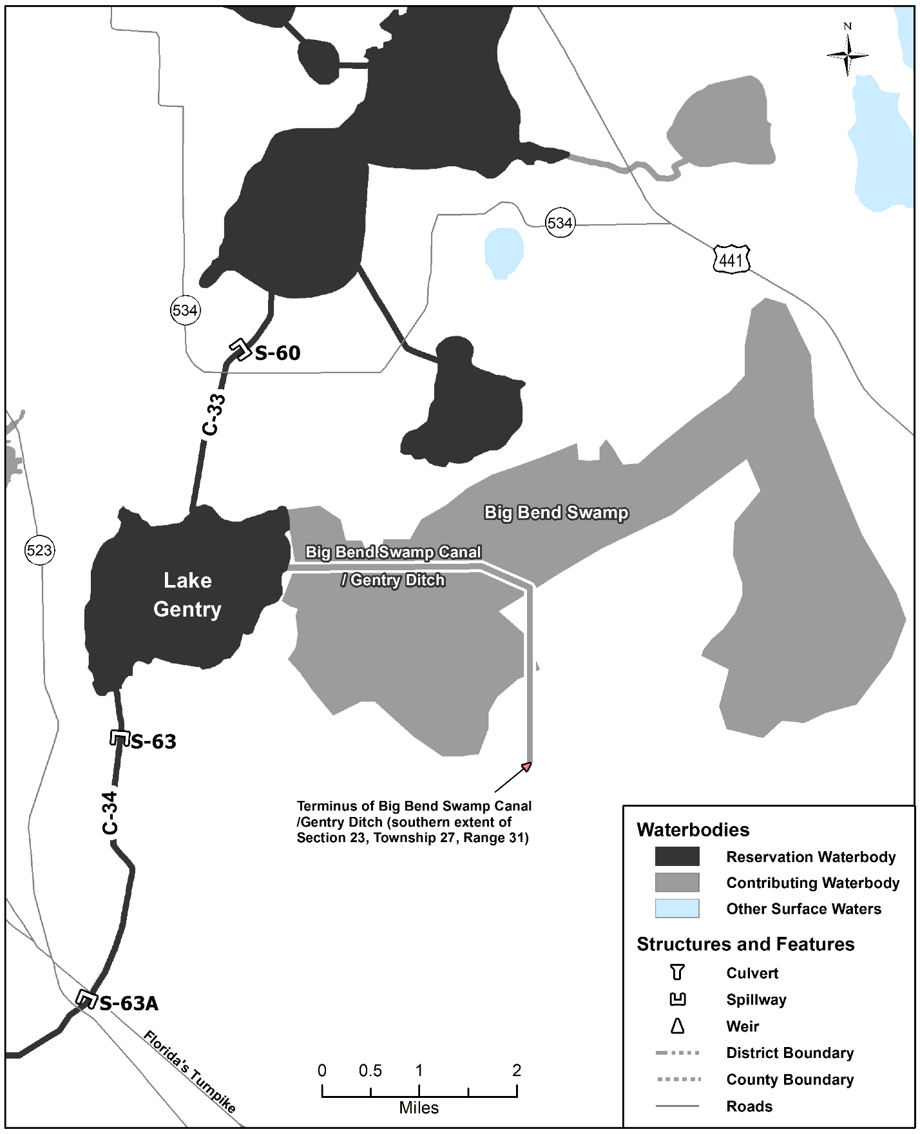
Figure 4-7A. Lake Gentry reservation and contributing waterbodies. Unlabeled waterbodies in this figure are not included in this reservation/contributing waterbody group.

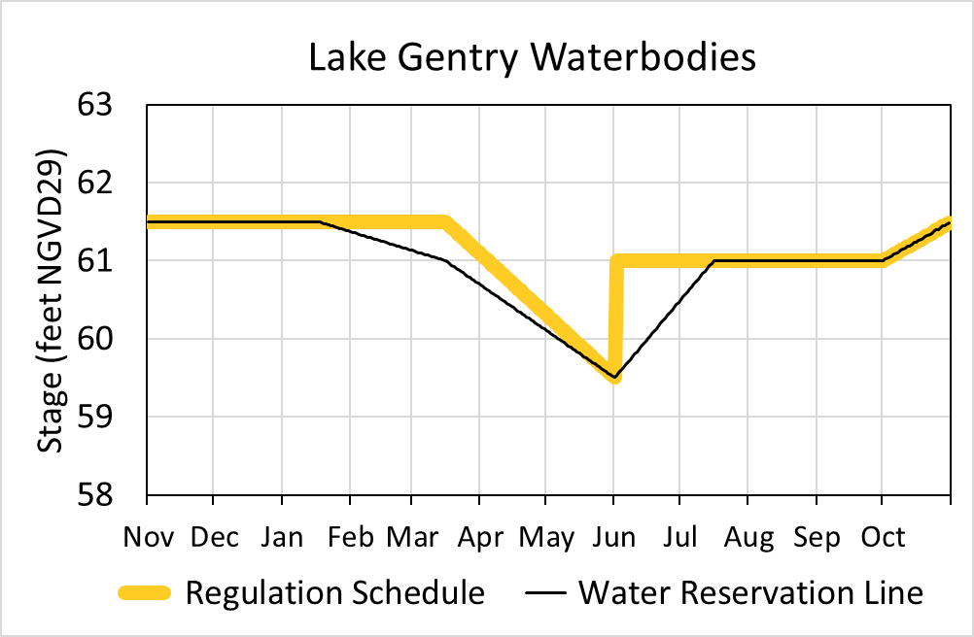
Figure 4-7B. Hydrograph of the current regulation schedule and the water reservation stage at S-63 (water reservation line) for Lake Gentry reservation waterbodies. The water reservation line is derived from data in Table 4-7.

Table 4-7. Maximum daily water reservation stages at S-63 for Lake Gentry reservation waterbodies (black line in Figure 4-7B).
Day | January | February | March | April | May | June | July | August | September | October | November | December
1 | 61.50 | 61.37 | 61.13 | 60.69 | 60.10 | 59.50 | 60.50 | 61.00 | 61.00 | 61.00 | 61.50 | 61.50
2 | 61.50 | 61.36 | 61.12 | 60.67 | 60.08 | 59.53 | 60.53 | 61.00 | 61.00 | 61.02 | 61.50 | 61.50
3 | 61.50 | 61.35 | 61.11 | 60.65 | 60.06 | 59.57 | 60.57 | 61.00 | 61.00 | 61.03 | 61.50 | 61.50
4 | 61.50 | 61.34 | 61.10 | 60.63 | 60.05 | 59.60 | 60.60 | 61.00 | 61.00 | 61.05 | 61.50 | 61.50
5 | 61.50 | 61.34 | 61.09 | 60.61 | 60.03 | 59.63 | 60.63 | 61.00 | 61.00 | 61.06 | 61.50 | 61.50
6 | 61.50 | 61.33 | 61.09 | 60.59 | 60.01 | 59.67 | 60.67 | 61.00 | 61.00 | 61.08 | 61.50 | 61.50
7 | 61.50 | 61.32 | 61.08 | 60.57 | 59.99 | 59.70 | 60.70 | 61.00 | 61.00 | 61.10 | 61.50 | 61.50
8 | 61.50 | 61.31 | 61.07 | 60.55 | 59.97 | 59.73 | 60.73 | 61.00 | 61.00 | 61.11 | 61.50 | 61.50
9 | 61.50 | 61.30 | 61.06 | 60.53 | 59.95 | 59.77 | 60.77 | 61.00 | 61.00 | 61.13 | 61.50 | 61.50
10 | 61.50 | 61.29 | 61.05 | 60.51 | 59.93 | 59.80 | 60.80 | 61.00 | 61.00 | 61.15 | 61.50 | 61.50
11 | 61.50 | 61.28 | 61.04 | 60.49 | 59.91 | 59.83 | 60.83 | 61.00 | 61.00 | 61.16 | 61.50 | 61.50
12 | 61.50 | 61.28 | 61.03 | 60.47 | 59.89 | 59.87 | 60.87 | 61.00 | 61.00 | 61.18 | 61.50 | 61.50
13 | 61.50 | 61.27 | 61.03 | 60.45 | 59.87 | 59.90 | 60.90 | 61.00 | 61.00 | 61.19 | 61.50 | 61.50
14 | 61.50 | 61.26 | 61.02 | 60.44 | 59.85 | 59.93 | 60.93 | 61.00 | 61.00 | 61.21 | 61.50 | 61.50
15 | 61.50 | 61.25 | 61.01 | 60.42 | 59.83 | 59.97 | 60.97 | 61.00 | 61.00 | 61.23 | 61.50 | 61.50
16 | 61.50 | 61.24 | 61.00 | 60.40 | 59.81 | 60.00 | 61.00 | 61.00 | 61.00 | 61.24 | 61.50 | 61.50
17 | 61.50 | 61.23 | 60.98 | 60.38 | 59.79 | 60.03 | 61.00 | 61.00 | 61.00 | 61.26 | 61.50 | 61.50
18 | 61.49 | 61.22 | 60.96 | 60.36 | 59.77 | 60.07 | 61.00 | 61.00 | 61.00 | 61.27 | 61.50 | 61.50
19 | 61.48 | 61.22 | 60.94 | 60.34 | 59.75 | 60.10 | 61.00 | 61.00 | 61.00 | 61.29 | 61.50 | 61.50
20 | 61.47 | 61.21 | 60.92 | 60.32 | 59.73 | 60.13 | 61.00 | 61.00 | 61.00 | 61.31 | 61.50 | 61.50
21 | 61.47 | 61.20 | 60.90 | 60.30 | 59.71 | 60.17 | 61.00 | 61.00 | 61.00 | 61.32 | 61.50 | 61.50
22 | 61.46 | 61.19 | 60.88 | 60.28 | 59.69 | 60.20 | 61.00 | 61.00 | 61.00 | 61.34 | 61.50 | 61.50
23 | 61.45 | 61.18 | 60.86 | 60.26 | 59.68 | 60.23 | 61.00 | 61.00 | 61.00 | 61.35 | 61.50 | 61.50
24 | 61.44 | 61.17 | 60.84 | 60.24 | 59.66 | 60.27 | 61.00 | 61.00 | 61.00 | 61.37 | 61.50 | 61.50
25 | 61.43 | 61.16 | 60.82 | 60.22 | 59.64 | 60.30 | 61.00 | 61.00 | 61.00 | 61.39 | 61.50 | 61.50
26 | 61.42 | 61.16 | 60.81 | 60.20 | 59.62 | 60.33 | 61.00 | 61.00 | 61.00 | 61.40 | 61.50 | 61.50
27 | 61.41 | 61.15 | 60.79 | 60.18 | 59.60 | 60.37 | 61.00 | 61.00 | 61.00 | 61.42 | 61.50 | 61.50
28 | 61.41 | 61.14 | 60.77 | 60.16 | 59.58 | 60.40 | 61.00 | 61.00 | 61.00 | 61.44 | 61.50 | 61.50
29 | 61.40 |  | 60.75 | 60.14 | 59.56 | 60.43 | 61.00 | 61.00 | 61.00 | 61.45 | 61.50 | 61.50
30 | 61.39 |  | 60.73 | 60.12 | 59.54 | 60.47 | 61.00 | 61.00 | 61.00 | 61.47 | 61.50 | 61.50
31 | 61.38 |  | 60.71 |  | 59.52 |  | 61.00 | 61.00 |  | 61.48 |  | 61.50

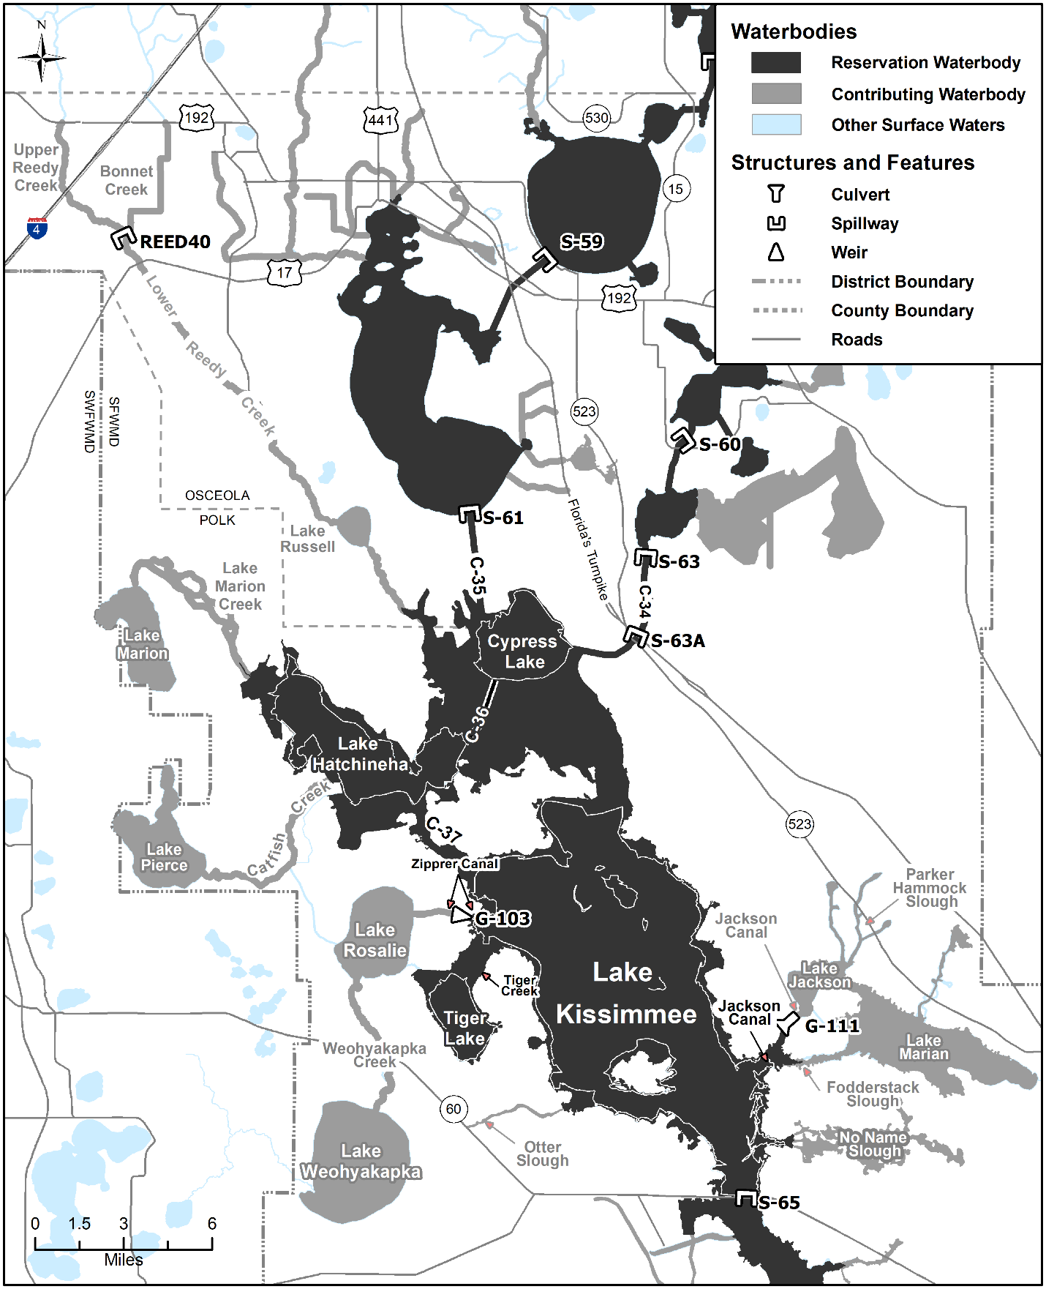
Figure 4-8A. Headwaters Revitalization Lakes reservation and contributing waterbodies. Unlabeled waterbodies in this figure are not included in this reservation/contributing waterbody group.
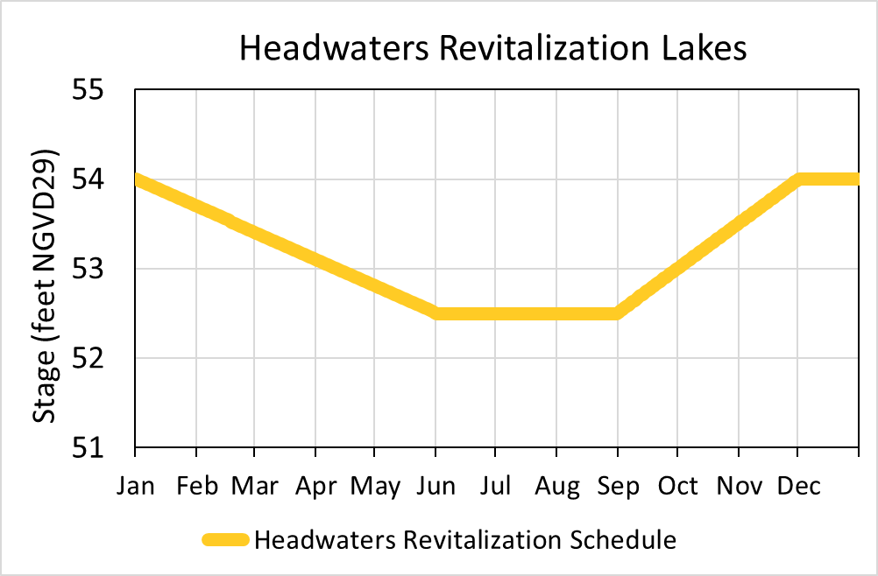
Figure 4-8B. Hydrograph of the authorized Headwaters Revitalization Schedule (HRS) at S-65 (derived from data in Table 4-8) for the Headwaters Revitalization Lakes reservation waterbodies.

Table 4-8. Stages for the Headwaters Revitalization Lakes reservation waterbodies (yellow line in Figure 4-8B).
Day | January | February | March | April | May | June | July | August | September | October | November | December
1 | 54.00 | 53.69 | 53.41 | 53.10 | 52.81 | 52.50 | 52.50 | 52.50 | 52.52 | 53.01 | 53.51 | 54.00
2 | 53.99 | 53.68 | 53.40 | 53.09 | 52.80 | 52.50 | 52.50 | 52.50 | 52.53 | 53.02 | 53.53 | 54.00
3 | 53.98 | 53.67 | 53.39 | 53.08 | 52.79 | 52.50 | 52.50 | 52.50 | 52.55 | 53.04 | 53.54 | 54.00
4 | 53.97 | 53.66 | 53.38 | 53.07 | 52.78 | 52.50 | 52.50 | 52.50 | 52.57 | 53.05 | 53.56 | 54.00
5 | 53.96 | 53.65 | 53.37 | 53.06 | 52.77 | 52.50 | 52.50 | 52.50 | 52.58 | 53.07 | 53.58 | 54.00
6 | 53.95 | 53.64 | 53.36 | 53.05 | 52.76 | 52.50 | 52.50 | 52.50 | 52.60 | 53.09 | 53.59 | 54.00
7 | 53.94 | 53.63 | 53.35 | 53.04 | 52.75 | 52.50 | 52.50 | 52.50 | 52.61 | 53.10 | 53.61 | 54.00
8 | 53.93 | 53.63 | 53.34 | 53.03 | 52.74 | 52.50 | 52.50 | 52.50 | 52.63 | 53.12 | 53.62 | 54.00
9 | 53.92 | 53.62 | 53.33 | 53.02 | 52.73 | 52.50 | 52.50 | 52.50 | 52.65 | 53.14 | 53.64 | 54.00
10 | 53.91 | 53.61 | 53.32 | 53.01 | 52.72 | 52.50 | 52.50 | 52.50 | 52.66 | 53.15 | 53.66 | 54.00
11 | 53.90 | 53.60 | 53.31 | 53.00 | 52.71 | 52.50 | 52.50 | 52.50 | 52.68 | 53.17 | 53.67 | 54.00
12 | 53.89 | 53.59 | 53.30 | 52.99 | 52.70 | 52.50 | 52.50 | 52.50 | 52.70 | 53.18 | 53.69 | 54.00
13 | 53.88 | 53.58 | 53.29 | 52.98 | 52.69 | 52.50 | 52.50 | 52.50 | 52.71 | 53.20 | 53.71 | 54.00
14 | 53.87 | 53.57 | 53.28 | 52.97 | 52.68 | 52.50 | 52.50 | 52.50 | 52.73 | 53.22 | 53.72 | 54.00
15 | 53.86 | 53.56 | 53.27 | 52.96 | 52.67 | 52.50 | 52.50 | 52.50 | 52.74 | 53.23 | 53.74 | 54.00
16 | 53.85 | 53.55 | 53.26 | 52.95 | 52.66 | 52.50 | 52.50 | 52.50 | 52.76 | 53.25 | 53.76 | 54.00
17 | 53.84 | 53.54 | 53.25 | 52.94 | 52.65 | 52.50 | 52.50 | 52.50 | 52.78 | 53.27 | 53.77 | 54.00
18 | 53.83 | 53.53 | 53.24 | 52.93 | 52.64 | 52.50 | 52.50 | 52.50 | 52.79 | 53.28 | 53.79 | 54.00
19 | 53.82 | 53.52 | 53.23 | 52.92 | 52.63 | 52.50 | 52.50 | 52.50 | 52.81 | 53.30 | 53.80 | 54.00
20 | 53.81 | 53.51 | 53.22 | 52.91 | 52.62 | 52.50 | 52.50 | 52.50 | 52.83 | 53.32 | 53.82 | 54.00
21 | 53.80 | 53.50 | 53.21 | 52.90 | 52.61 | 52.50 | 52.50 | 52.50 | 52.84 | 53.33 | 53.84 | 54.00
22 | 53.79 | 53.49 | 53.20 | 52.89 | 52.60 | 52.50 | 52.50 | 52.50 | 52.86 | 53.35 | 53.85 | 54.00
23 | 53.78 | 53.48 | 53.19 | 52.88 | 52.59 | 52.50 | 52.50 | 52.50 | 52.88 | 53.36 | 53.87 | 54.00
24 | 53.77 | 53.47 | 53.18 | 52.88 | 52.58 | 52.50 | 52.50 | 52.50 | 52.89 | 53.38 | 53.89 | 54.00
25 | 53.76 | 53.46 | 53.17 | 52.87 | 52.57 | 52.50 | 52.50 | 52.50 | 52.91 | 53.40 | 53.90 | 54.00
26 | 53.75 | 53.45 | 53.16 | 52.86 | 52.56 | 52.50 | 52.50 | 52.50 | 52.92 | 53.41 | 53.92 | 54.00
27 | 53.74 | 53.44 | 53.15 | 52.85 | 52.55 | 52.50 | 52.50 | 52.50 | 52.94 | 53.43 | 53.93 | 54.00
28 | 53.73 | 53.43 | 53.14 | 52.84 | 52.54 | 52.50 | 52.50 | 52.50 | 52.96 | 53.45 | 53.95 | 54.00
29 | 53.72 | 53.42 | 53.13 | 52.83 | 52.53 | 52.50 | 52.50 | 52.50 | 52.97 | 53.46 | 53.97 | 54.00
30 | 53.71 |  | 53.12 | 52.82 | 52.52 | 52.50 | 52.50 | 52.50 | 52.99 | 53.48 | 53.98 | 54.00
31 | 53.70 |  | 53.11 |  | 52.51 |  | 52.50 | 52.50 |  | 53.49 |  | 54.00

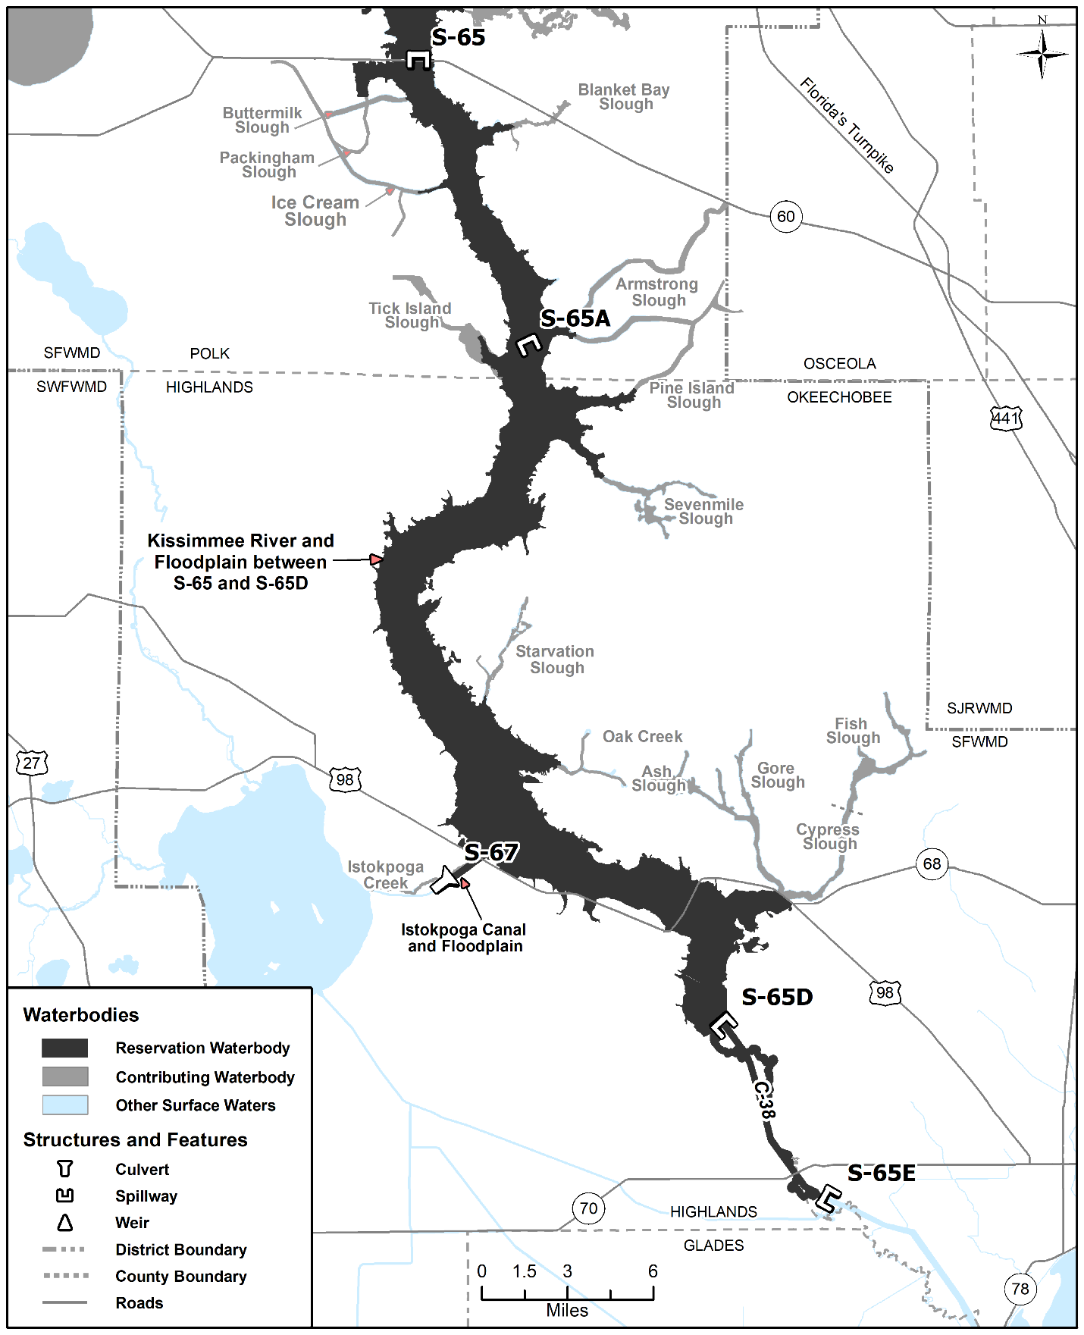
Figure 4-9. Kissimmee River reservation and contributing waterbodies. Unlabeled waterbodies in this figure are not included in this reservation/contributing waterbody group.

