CHAPTER 68C-22

THE FLORIDA MANATEE SANCTUARY ACT

68C-22.001 Scope and Purpose

68C-22.002 Definitions

68C-22.003 Regulated Activities

68C-22.004 Management Provisions

68C-22.005 Lee County Zones

68C-22.006 Brevard County Zones

68C-22.007 Indian River County Zones

68C-22.008 St. Lucie County Zones

68C-22.009 Palm Beach County Zones

68C-22.010 Broward County Zones

68C-22.011 Citrus and Associated County (Parts of Levy and Hernando) Zones

68C-22.012 Volusia County and Associated County (Parts of Putnam, Lake, and Seminole) Zones

68C-22.013 Hillsborough County Zones

68C-22.014 Manatee County Zones

68C-22.015 Charlotte County (and Part of DeSoto County) Zones

68C-22.016 Pinellas County Zones

68C-22.023 Collier County Zones

68C-22.024 Martin County Zones

68C-22.025 Dade County Zones

68C-22.026 Sarasota County Zones

68C-22.027 Duval County and Associated County (Parts of Clay and St. Johns) Zones

68C-22.028 Flagler County Zones

68C-22.001 Scope and Purpose.
(1) This rule chapter implements Section 379.2431(2), F.S., (the Florida Manatee Sanctuary Act) by establishing restrictions to protect manatees from harmful collisions with motorboats and from harassment; to protect manatee habitat, such as seagrass beds, from destruction by boats or other human activity; and to provide limited safe havens where manatees can rest, feed, reproduce, give birth or nurse undisturbed by human activity. The Commission shall only regulate motorboat speed and operation in areas where manatees are frequently sighted and the best available scientific information, as well as other available, relevant, and reliable information supports the conclusion that manatees inhabit such areas on a regular or periodic basis. Information considered by the Commission may include but is not limited to manatee surveys, observations, available studies of food sources, and water depths.
(2) When establishing manatee protection zones as provided above, the Commission shall utilize the standards provided under paragraph (2)(a), below, in determining whether restrictions are necessary to protect manatees or manatee habitat. The Commission shall not establish restrictions that result in undue interference with the rights of fishers, boaters, and water skiers (as they apply under Section 379.2431(2)(k), F.S.).
(a) The Commission utilizes the following standards in determining whether restrictions are necessary to protect manatees or manatee habitats in areas of regular or periodic manatee use:
1. Restrictions are necessary if the absence of adequate restrictions will likely result in:
a. Injury or death to manatees, or
b. Harassment of manatees, or
c. Destruction of essential manatee habitat.
2. In determining whether restrictions are necessary, the Commission will consider, but not be limited to an examination of, the following factors:
a. The patterns and intensity of known boating activities in the area,
b. Seasonal and/or year-round patterns of manatee use,
c. The number of manatees that the Commission has concluded use the area on a regular or periodic basis,
d. The manatee mortality trends within the area,
e. The existence of features within the area that are essential to the survival of, or are known to attract, manatees, such as seagrasses or other food sources, favorable water depths, and fresh or warm water sources,
f. The characteristics of the waterway; and,
g. Whether the Commission’s measurable biological goals that define manatee recovery are being achieved in the region that is being considered.
(b) Regarding the measurable biological goals referenced in paragraph (2)(a), above, in regions where the goals are being achieved, the Commission shall give great weight to existing state manatee protection rules; however, the Commission may amend existing rules or adopt new rules in these areas to address risks or circumstances in a particular area or water body.
(c) In consideration of balancing the rights of fishers, boaters, and water skiers to use waters for recreational and commercial purposes (as applicable under Section 379.2431(2)(k), F.S.), with the necessity for boat speed regulation to protect manatees and manatee habitat in identified manatee use areas, the Commission may designate limited lanes or corridors to provide for reasonable motorboat speeds (twenty-five (25) mph or greater) or not regulate sufficient portions in order to accommodate activities that require higher speeds, upon a finding that such lanes, corridors, or areas are consistent with manatee protection needs.
Rulemaking Authority 370.12(2)(g)-(j), (l), (n), (o), 372.072(6) FS. Law Implemented 370.12(2)(d), (g)-(l), (n), (o), 372.072(6) FS. History–New 3-19-79, Formerly 16N-22.01, Amended 12-30-86, 6-16-93, 9-9-93, Formerly 16N-22.001, Amended 5-31-95, 6-25-96, 5-12-98, Formerly 62N-22.001, Amended 12-23-03, 11-8-05.

68C-22.002 Definitions.
When used in these rules, the following words shall have the indicated meanings unless the context clearly indicates otherwise:
(1) “Idle Speed” and “Idle Speed No Wake” may be used interchangeably and mean that a vessel must proceed at a speed no greater than that which will maintain steerageway and headway. At no time is any vessel required to proceed so slowly that the operator is unable to maintain control over the vessel or any other vessel or object that it has under tow.
(2) “Miles” means statute miles.
(3) “Motorboats prohibited zone” as used in Chapter 68C-22, F.A.C., is synonymous with the definition of the “no power-driven vessels” zone defined in paragraph 68D-23.103(2)(d), F.A.C., and means that all vessels equipped with any mechanical means of propulsion are prohibited from entering the marked area unless the mechanical means of propulsion is not in use and, if possible to do so, is tilted or raised out of the water.
(4) “Slow Speed” and “Slow Speed Minimum Wake” may be used interchangeably and mean that a vessel must be fully off plane and completely settled into the water. The vessel must then proceed at a speed which is reasonable and prudent under the prevailing circumstances so as to avoid the creation of an excessive wake or other hazardous condition which endangers or is likely to endanger other vessels or other persons using the waterway. Due to the different speeds at which vessels of different sizes and configurations may travel while in compliance with this definition, there is no specific numerical speed assigned to Slow Speed. A vessel that is:
(a) Operating on plane is not proceeding at this speed;
(b) In the process of coming off plane and settling into the water or coming up onto plane is not proceeding at this speed;
(c) Operating at a speed that creates an excessive wake or other hazardous condition which unreasonably or unnecessarily endangers other vessels or other persons using the waterway, or is likely to do so, is not proceeding at this speed;
(d) Completely off plane and which has fully settled into the water and is proceeding at a reasonable and prudent speed with little or no wake is proceeding at this speed.
(5) “Maximum 25 MPH Speed Zone” means a controlled area within which a vessel’s speed made good over the bottom, measured in statute miles, shall not exceed twenty-five (25) miles per hour. Although it is the intention of the Commission to allow those vessels capable of attaining a planning configuration at twenty-five (25) MPH to do so, this speed limit shall not be construed as permitting the reckless or careless operation of a vessel, in violation of Section 327.33, F.S., or authorizing any vessel to travel at an unsafe speed, in violation of navigation rule 6, as adopted pursuant to Section 327.33, F.S., by reason of:
(a) Having an elevated bow which restricts visibility, or
(b) Producing an excessive wake or other hazardous condition that endangers or is likely to endanger other vessels, other persons using the waterway, or natural resources of the state.
(6) “Maximum 30 MPH Speed Zone” means a controlled area within which a vessel’s speed made good over the bottom, measured in statute miles, shall not exceed thirty (30) miles per hour. Although it is the intention of the Commission to allow those vessels capable of attaining a planning configuration at thirty (30) MPH to do so, this speed limit shall not be construed as permitting the reckless or careless operation of a vessel, in violation of Section 327.33, F.S., or authorizing any vessel to travel at an unsafe speed, in violation of navigation rule 6, as adopted pursuant to Section 327.33, F.S., by reason of:
(a) Having an elevated bow which restricts visibility, or
(b) Producing an excessive wake or other hazardous condition that endangers or is likely to endanger other vessels, other persons using the waterway, or natural resources of the state.
(7) “Maximum 35 MPH Speed Zone” means a controlled area within which a vessel’s speed made good over the bottom, measured in statute miles, shall not exceed thirty-five (35) miles per hour. Although it is the intention of the Commission to allow those vessels capable of attaining a planning configuration at thirty-five (35) MPH to do so, this speed limit shall not be construed as permitting the reckless or careless operation of a vessel, in violation of Section 327.33, F.S., or authorizing any vessel to travel at an unsafe speed, in violation of navigation rule 6, as adopted pursuant to Section 327.33, F.S., by reason of:
(a) Having an elevated bow which restricts visibility, or
(b) Producing an excessive wake or other hazardous condition that endangers or is likely to endanger other vessels, other persons using the waterway, or natural resources of the state.
(8) “Shoreline” means the point where the water meets the land at any point in time.
(9) “General Contour of the Shoreline” means a line defined as the most waterward of the outside edge of emergent aquatic vegetation, if present, or a line of Mean Low Water as defined in Chapter 177, Part II, F.S., as approximated on NOAA nautical charts. Waters lying landward of this line are to be included up to the shoreline, as defined under subsection (8), above. Emergent aquatic vegetation shall include plants rooted in the ground that extend above the surface of the water.
(10) “Channel” means a navigation route that is marked by aids to navigation that have been authorized by permits issued by all required state and federal authorities.
(11) “No Entry Zone” or “No Entry Area” means a controlled area where all vessels and all persons, either in vessels or swimming, diving, wading, or fishing (except from an adjacent bank or bridge when using poles or lines which are not equipped with a fishing line retrieval mechanism, e.g., a cane pole) are prohibited from entering.
(12) “Authorized Resident” means any person owning a fee or leasehold interest in real property or a boating facility immediately adjacent to a motorboats prohibited zone or a no entry zone.
(13) “Rights of Fishers, Boaters, and Water Skiers” (as they apply under Section 379.2431(2)(k), F.S.), means that fishers, boaters, and water skiers have the right to use the waters of the State of Florida for recreational or commercial purposes in a manner consistent with all applicable federal, state and local laws and regulations. Such laws and regulations include, but are not limited to, those governing the operation and safety of vessels on the water to promote public safety, environmental/natural resource protection, and/or responsible use of the waters of the state.
(14) “Undue Interference” with the rights of fishers, boaters, and water skiers (as it applies under Section 379.2431(2)(k), F.S.) occurs:
(a) If the Commission regulates boat speeds generally throughout the waters of the state, or
(b) If the Commission establishes regulations that encompass a larger geographic area or time frame than is warranted; set speed limits that are more restrictive than are warranted; encompass an area where the Commission has not determined that restrictions are necessary to protect manatees or manatee habitat pursuant to paragraph 68C-22.001(2)(a), F.A.C.; or fail to provide limited lanes or corridors providing for reasonable motorboat speeds, as called for in paragraph 68C-22.001(2)(c), F.A.C.
(15) “Planning” means riding on or near the water’s surface as a result of the hydrodynamic forces on a vessel’s hull, sponsons, foils or other surfaces. A vessel is considered “on plane” when it is being operated at or above the speed necessary to keep the vessel planning.
(16) “Wake” means all changes in the vertical height of the water’s surface caused by the passage of a vessel including, but not limited to, a vessel’s bow wave, stern wave, and propeller wash.
(17) “Harassment” means any intentional or negligent act or omission which creates the likelihood of causing an injury to a manatee by annoying it to such an extent as to significantly disrupt normal behavioral patterns which include, breeding, feeding or sheltering. The intentional provision of any type of food to manatees not in captivity shall be considered harassment under this definition, unless authorized by a valid federal or state permit.
(18) “Maximum 20 MPH Speed Zone” means a controlled area within which a vessel’s speed made good over the bottom, measured in statute miles, shall not exceed twenty (20) miles per hour. Although it is the intention of the Commission to allow those vessels capable of attaining a planing configuration at twenty (20) MPH to do so, this speed limit shall not be construed as permitting the reckless or careless operation of a vessel, in violation of Section 327.33, F.S., or authorizing any vessel to travel at an unsafe speed, in violation of navigation rule 6, as adopted pursuant to Section 327.33, F.S., by reason of:
(a) Having an elevated bow which restricts visibility, or
(b) Producing an excessive wake or other hazardous condition that endangers or is likely to endanger other vessels, other persons using the waterway, or natural resources of the state.
Rulemaking Authority 379.2431(2) FS. Law Implemented 379.2431(2) FS. History–New 3-19-79, Amended 11-23-83, Formerly 16N-22.02, Amended 12-30-86, 12-24-90, 12-25-91, 6-16-93, 9-9-93, Formerly 16N-22.002, Amended 5-31-95, 6-25-96, 5-12-98, Formerly 62N-22.002, Amended 12-23-03.

68C-22.003 Regulated Activities.
(1) General Guidelines and Application Procedures: This rule sets forth criteria pertaining to the regulation of the speed and operation of vessel traffic and other activities which are otherwise prohibited by Chapter 68C-22, F.A.C. Permits for such regulated activities shall be issued only as provided hereunder. Permits shall be issued only upon a finding by the Commission that activities as described in this section will not pose a serious threat to manatees, and that such activities are justified. Determinations of justification of need will be made based on the criteria given under each specific subsection.
Permits shall not be granted for activities within “Motorboats Prohibited” or “No Entry” zones, except as explicitly provided for in this section.
(a) In considering applications for permits under this section, a “serious threat to manatees” exists if, due to the nature, location, or frequency of the activity proposed, its conduct can be reasonably expected to result in either (1) injury or death to manatees, (2) a significant disruption of the manatee’s normal use, behavior or migratory patterns, or (3) disturbance which would lead to or cause destruction of essential manatee habitat. In making its determination, the Commission’s examination will include an evaluation of the following factors:
1. Patterns of manatee use of the area, both seasonal and year-round,
2. The number of manatees known or assumed to occur in or seasonally use the area,
3. The manatee mortality trends within the area,
4. The existence of features within the area which are essential to the survival of, or are known to attract, manatees, such as seagrasses or other food sources, favorable water depths, and fresh or warm water sources,
5. The cumulative effect of the requested activities in light of other permits previously granted or currently being considered by the Commission and known vessel traffic patterns and densities in the area; and,
6. The characteristics of the waterway and of the vessel(s)/motor(s) which would be operated by the applicant.
(b) Applications for permits to conduct activities described in this section should be submitted as far in advance of the requested activities as possible and must be submitted to the Chief of the Office of Environmental Services, Florida Fish and Wildlife Conservation Commission, 620 South Meridian Street, Tallahassee, FL 32399. Information which must be submitted is described in each specific subsection. If an application does not contain sufficient information to enable the Office to evaluate the request, the Office shall request any needed information within thirty (30) days of receipt of the request. The Office shall respond by letter (issuing a permit or denying the request) as quickly as is practical and must respond within ninety (90) days of receipt of all necessary information.
(c) When issuing a permit, the Commission may place conditions on the permit as necessary to protect manatees. Examples of types of conditions which may be specified include seasonal constraints, use of screens or barriers, restrictions on types of permitted activities, restrictions relative to time of day, day of week, or weather conditions when permits are in effect, use of specialized equipment (e.g., propeller guards or jet drives, speedometers) when feasible and such use would not defeat the purpose of the requested activity, additional water quality precautions, sea grass protection or protection of associated marine life or vegetation, temporary marking or permit display, limitations on intensity of activity, pre-activity monitoring, use of manatee observers, and after-activity reports. The specific conditions, if any, that are placed on a permit will be dependent on the specifics of the request. Acceptance of the permit shall constitute evidence that the recipient agrees to comply with the conditions set forth in the permit.
(d) The Commission retains the right to modify or rescind a permit should information become available indicating that the permitted activity is likely to create a serious threat to manatees or that the permit (in its current form) is not needed by the recipient. Before a permit is modified or rescinded, the permit holder shall be given an opportunity to discuss with the Commission the reasons for the modification or rescission. Unless an immediate threat to manatees is likely, the Commission shall wait at least thirty (30) days after notifying the permit holder before taking action on the permit. If a single manatee is struck or killed by a vessel operating pursuant to a permit under these provisions, the permit shall be immediately re-evaluated by the Commission to determine if the permit needs to be modified or rescinded.
(e) Receipt of a permit does not release a holder from the duty to comply with all federal, state, and local regulations (other than Chapter 68C-22, F.A.C.) governing the operation of vessels on navigable waterways or pertaining to protection of the West Indian (Florida) manatee. Permit issuance does not constitute authorization for the recipient to kill, injure, or harass a manatee while operating under a permit.
(f) Failure to comply with the permit or associated conditions, or any finding of fraudulent use or application for said permit, shall be cause for the immediate revocation of the permit.
(2) Law Enforcement: Any authorized law enforcement officer may engage in any activity otherwise prohibited by Chapter 68C-22, F.A.C., if:
(a) The officer is acting in the performance of his or her official duties, and entry into a “Motorboats Prohibited” or “No Entry” zone as defined in Rule 68C-22.002, F.A.C. is reasonably warranted, or
(b) The activity is being conducted to directly protect manatees, to enhance the propagation or survival of manatees, or it is reasonably required to enforce other provisions of Chapter 68C-22, F.A.C.
(3) Emergency Situations: Any person may engage in water-borne activity otherwise prohibited by Chapter 68C-22, F.A.C., if such activity is reasonably necessary to prevent the loss of life or property due to emergency circumstances, or to render emergency assistance.
(4) General Activities: For the purpose of issuing authorizations to allow the performance of certain activities which are otherwise prohibited by Chapter 68C-22, F.A.C., (including activities prohibited by “Motorboats Prohibited” or “No Entry” zones as defined in Rule 68C-22.002, F.A.C., as provided in subsection (1), permits shall be issued by the Commission only upon both a showing of a justification of need by the applicant and a determination of an absence of serious threat to manatees in association with the requested activity. Permits shall only be issued for activities which: are necessary to carry out a prerequisite of permitting by federal, state, or local governments (or are a condition to or are otherwise authorized by a valid permit), are necessary for habitat restoration or environmental protection purposes, are necessary for other scientific or educational purposes or for the enhancement of propagation or survival of the manatee, or are necessary for purposes of construction, maintenance, or repair to adjacent property owner’s facilities including maintenance dredging and debris removal. Permitted activities may not, either intentionally or negligently, molest, harass, collide with, injure or harm manatees. When operating under a permit within “Motorboats Prohibited” or “No Entry” zones, vessels shall be operated at no greater than idle speed.
(a) Permits are non-transferable and shall only be considered upon written application as specified hereunder. Copies of any associated permits must be submitted with the request. The application must, at a minimum, contain enough information to demonstrate:
1. The nature and scope of the activity to be conducted within the restricted area, including the number of vessels to be involved, the type and configuration of the vessels, and the maximum speeds necessary,
2. The specific area within which the activity would be conducted, described in the application and depicted on a nautical chart,
3. The period of time for which the permit is needed, limited to specific dates if possible; and,
4. Justification for conducting the activity within waters regulated for manatee protection, clearly demonstrating why an alternative site is unsuitable or unavailable.
(b) Permits granted under the provisions of this subsection shall be effective only for the time period specified in the permit, and only in the areas specified in the notice.
(5) Resident Access to Limited Entry Areas: Any authorized resident or his/her guests who must cross a “Motorboats Prohibited” or “No Entry” zone as defined in Rule 68C-22.002, F.A.C., for the sole purpose of water access by boat to private residences, boat houses, or boat docks, shall be authorized access by obtaining and affixing an identifying insignia to his/her vessel. Motorboats shall be operated at no greater than idle speed while within the zone.
(a) To obtain authorization, authorized residents must submit a signed letter providing the following information and documentation:
1. The name, mailing address, and telephone number of the authorized resident,
2. A description of the vessel(s) to be permitted, including a copy(ies) of the current vessel registration(s),
3. A map showing the location of the property to which access is required in relation to the “No Entry” or “Motorboats Prohibited” zone,
4. Verification of property ownership, rental or lease. For property owners, acceptable forms of verification include the property’s tax assessment, a current utilities or telephone bill, or a mortgage agreement. For residents renting or leasing the property, acceptable forms of verification include the rental or lease agreement, or a current utilities or telephone bill. To be acceptable, the document used for verification must be in the authorized resident’s name.
(b) Upon review and approval of the application by the Office of Environmental Services, an identifying decal or other insignia shall be issued, free of charge, to authorized residents. (Two (2) insignias or decals per authorized resident shall also be issued free of charge for use by authorized guests, with additional guest decals available upon justification of need.)
(6) Commercial Fishing and Professional Guiding: The following provisions pertain to qualifying commercial fishermen and professional fishing guides. In those speed zones wherein such intent was provided and specified at the time of zone establishment and as provided in subsection (1), permits shall be issued by the Commission only upon both a showing of a justification of need by the applicant and a determination of an absence of serious threat to manatees in association with the requested activity.
(a) In considering applications for permits under this subsection, a justification of need will be based on a finding of hardship. A hardship will be found to exist if an applicant can demonstrate the following:
1. Commercial fishing or professional guiding, as appropriate, is either:
a. The applicant’s principal occupation, in that a majority of the applicant’s work week is spent in pursuit of that occupation, or
b. A significant source of income for the applicant, in that a minimum of twenty-five percent (25%) of the applicant’s gross annual income is attributable to revenue derived from that occupation,
2. The applicant’s customary fishing or guiding practices would be significantly curtailed as a result of the restrictions for which a permit is sought in that at least twenty-five percent (25%) of the applicant’s gross annual income would be lost if a permit is not granted because sufficient alternative sites or methods for carrying out the activity in question are not available to the applicant; and,
3. The applicant’s compliance with the restrictions for which a permit is sought will result in a significant economic or physical burden being borne by the applicant.
(b) Upon a determination by the Office of Environmental Services that such a permit will not result in serious threats to manatees and that a hardship exists as a result of the speed restrictions imposed, commercial fishermen fulfilling the following requirements shall be granted a permit;
1. Possession of a current Saltwater Products License issued pursuant to Section 379.361, F.S., or of an equivalent freshwater license issued pursuant to Section 379.363, F.S., (if only freshwater species are taken), a current commercial vessel registration, and any other license(s) as may be required of commercial fishermen to operate within the particular county in which a permit is sought; and,
2. Completion of the permit application referenced in paragraph (6)(d) hereunder, including submittal of copies of all documents required in subparagraph (b)1., above.
(c) Upon a determination by the Office of Environmental Services that such a permit will not result in serious threats to manatees and that a hardship exists as a result of the speed restrictions imposed, professional fishing guides fulfilling the following requirements shall be granted a permit:
1. Possession of a current commercial vessel registration,
2. Possession of a current license from the U.S. Coast Guard authorizing the carriage of passengers for hire on the waters for which the permit is sought,
3. Possession of a current saltwater fishing license in accordance with Section 379.354, F.S., for vessels carrying customers wherein a fee is paid directly or indirectly (if saltwater species are taken),
4. Possession of other current occupational license(s) as may be required of professional fishing guides to operate within the particular county in which the permit is sought; and,
5. Completion of the permit application referenced in paragraph (6)(d), hereunder, including submittal of copies of all documents required in subparagraphs (c)1. through (c)4., above.
(d) A permit application form (“Application for Permit, Manatee Protection Zones”), Form No. FWC 68C-22.003-6 (6/96), which is hereby incorporated by reference, may be obtained from the Fish and Wildlife Conservation Commission, Office of Environmental Services, 620 South Meridian Street, Tallahassee, FL 32399, or from the Division of Law Enforcement office as designated under specific manatee protection zone rule provisions. The form shall include items for completion by commercial fishermen and professional fishing guides, imparting information necessary: (1) to show a justification of need by the applicant; and (2) for the Commission to make a determination as to the potential impacts of allowing the requested activities within specified regulated areas.
(e) Acceptance of a permit shall constitute evidence that the recipient agrees to maintain speeds of twenty (20) mph or less at all times while operating under a permit within the restricted area and to comply with any and all conditions set forth within the permit. (Examples of other types of conditions which may be specified to promote manatee protection are described in subsection 68C-22.003(1), F.A.C.)
(f) Permits granted under the provisions of this section shall be effective only for the time period specified in the permit, and only in the areas specified in the notice. Permits may only be utilized by the fisherman or guide in whose name it is issued, only while aboard the vessel identified on the permit, and only when engaged in their customary fishing or guiding practices, as applicable. For guides, permits apply only when paying customers are aboard.
(7) Testing of Motors or Vessels by Manufacturers: The following provisions pertain to boat motor and vessel testing operations by manufacturers. As provided in subsection (1), permits shall be issued by the Commission only upon both a showing of justification of need by the applicant and a determination of an absence of serious threat to manatees in association with the requested activity. Permits shall be in effect for five (5) years, or for a shorter period if requested by the applicant, and shall only be issued upon written application as specified within paragraph (7)(a), hereunder. Permits are non-transferable and shall only be issued from speed restrictions appearing in Chapter 68C-22, F.A.C., which were established after June 1, 1990.
(a) Permits shall be granted only upon:
1. Submission of a request in writing to the Office of Environmental Services clearly stating:
a. The geographic areas within which testing is to be conducted (The written description shall be accompanied by navigational charts or boater guide maps clearly indicating the proposed test course location and route),
b. The types of vessels/motors to be tested,
c. The estimated number of motors or vessels to be tested annually,
d. The estimated maximum number of motors or vessels to be tested at any one time within the restricted area,
e. The estimated maximum speeds at which vessels will travel during the tests; and,
f. The estimated number of qualified employees to work as vessel operators, and a brief description of their qualifications.
2. Submission of a statement of justification of need to utilize specific waterways or specific portions of waterways within areas for which manatee speed zone protection has been established, clearly demonstrating a substantial hardship (economic, operational or other) to the manufacturer. Such a statement must detail why, and under what circumstances, other waters are inappropriate for such testing purposes.
(b) Acceptance of a permit shall constitute evidence that the recipient (and his/her authorized employees) agrees to:
1. Carry on the vessel a copy of the permit and, an identification as an employee of a corporation or firm actively engaged in the manufacture of boat motors or vessels,
2. Unless otherwise provided in the permit, operate only between sun-up and sundown, Monday through Friday, and sun-up Saturday through noon, not on Sundays or on state-recognized holidays; and,
3. Comply with any and all conditions set forth in the permit. (Examples of other types of conditions which may be specified to promote manatee protection are described in subsection 68C-22.003(1), F.A.C.)
(c) For the purposes of this rule, the following definitions shall apply:
1. Testing – The act by a manufacturer of evaluating a boat motor or vessel for the purposes of determining its operational characteristics. Such operational characteristics shall include, but not be limited to, those pertaining to product designs, endurance, performance, and safety.
2. Boat motor manufacturer – An entity engaged in the production of boat motors from basic components for the purpose of sale.
3. Vessel manufacturer – An entity engaged in the production of vessels from basic components for the purpose of sale.
4. Vessel – Vessel is synonymous with boat, as referenced in Section 1(b), Article VII, of the State Constitution, and includes every description of watercraft, barge, and airboat other than a seaplane on the water used or capable of being used as a means of transportation on water.
(8) Resident Access Through Speed-controlled Areas: For the sole purpose of allowing ingress and egress to persons who must travel through speed zones established under Chapter 68C-22, F.A.C., to access private residences, boat houses, or boat docks, except as provided under subsections (4) and (5), above, who would otherwise be physically precluded water access because of speed restrictions (such that shoaling or other physical factors would require residents to exceed such speed restrictions), the Commission shall grant a non-transferable resident permit upon a demonstration of just cause, as set forth in paragraph (8)(a), hereunder, and upon a finding that issuance of such a permit will not pose a serious threat to manatees.
(a) The Office of Environmental Services, upon review by the Division of Law Enforcement, will consider a request for such a resident permit upon the receipt of a signed explanatory letter of intent from the affected resident clearly demonstrating:
1. The need to exceed speed restrictions for ingress and egress purposes,
2. Justification for traveling at speeds greater than those established within designated zone on the basis of vessel and boat motor types/horsepower,
3. Evidence of property ownership or residency in said property,
4. Areas, as marked on an accompanying map and clearly described with permanent landmarks, where shoaling or other physical circumstances warrant exception to restrictive provisions, and the minimum area/distance required for travel at speeds greater than those established within the designated zone; and,
5. Description(s) and vessel registration number(s) for vessel(s) owned by said resident for which a permit is requested.
(b) Acceptance of a permit shall constitute evidence that the recipient agrees to maintain speeds of twenty-five (25) MPH or less at all times while operating under a permit unless otherwise provided in the permit, to hold said permit on the vessel at all times, and to comply with any and all conditions set forth within the permit. (Examples of other types of conditions which may be specified to promote manatee protection are described in subsection 68C-22.003(1), F.A.C.)
(c) Permits granted under the provisions of this subsection shall be effective only for the time period specified in the permit, and only in the areas specified in the notice.
(d) If the area for which a permit has been issued is dredged, the permit recipient shall so notify the Commission.
(9) Boat Races: The following provisions pertain to powerboat racing. In those speed zones wherein such intent was provided and specified at the time of zone establishment and as provided in subsection (1), permits shall be issued by the Commission only upon both a showing of a justification of need by the applicant and a determination of an absence of serious threat to manatees in association with the requested activity. Permits are non-transferable and shall only be considered upon written application as specified hereunder.
(a) The application must, at a minimum, contain enough information to demonstrate:
1. The nature and scope of the racing event, including estimated numbers of vessels to be involved, the nature and configuration of the vessels, and the maximum speeds anticipated,
2. The specific area within which the racing event is requested, described in the application and depicted on a nautical chart,
3. The intended date(s) of the racing event; and,
4. Justification for holding the racing event within waters regulated for manatee protection, clearly demonstrating why an alternative site is unsuitable or unavailable.
(b) Failure to comply with the permit or associated conditions, or any finding of fraudulent use or application for said permit, shall be cause for the immediate revocation of the permit, including suspension of permit privileges prior to or during the permitted event. (Examples of types of conditions which may be specified to promote manatee protection are described in subsection 68C-22.003(1), F.A.C.)
(c) If a single manatee is struck or killed by a vessel operating above the posted speed limit pursuant to a permit under these provisions, the permit shall be automatically and immediately rescinded.
(d) Permits granted under the provisions of this subsection shall be effective only for the time period specified in the permit, and only in the areas specified in the permit.
Rulemaking Authority 379.2431(2) FS. Law Implemented 379.2431(2) FS. History–New 3-19-79, Formerly 16N-22.03, Amended 12-30-86, 8-28-90, 12-25-91, 6-16-93, Formerly 16N-22.003, Amended 6-25-96, 5-12-98, Formerly 62N-22.003.

68C-22.004 Management Provisions.
Regulations established pursuant to Section 379.2431(2), F.S., and Rule 68C-22.001, F.A.C., shall be marked by regulatory markers that conform to Chapter 68D-23, F.A.C., Uniform Waterway Markers in Florida Waters. Where conflicting speed or operational restrictions are established by law or pursuant to law, the more restrictive shall be posted and shall apply.
Rulemaking Authority 379.2431(2) FS. Law Implemented 379.2431(2) FS. History–New 3-19-79, Formerly 16N-22.04, Amended 12-30-86, 12-25-91, Formerly 16N-22.004, 62N-22.004, Amended 12-23-03.

68C-22.005 Lee County Zones.
(1) The Commission hereby designates the waters within Lee County, as described below, as areas where manatee sightings are frequent and where the best available information supports the conclusion that manatees inhabit these areas on a regular or periodic basis. The primary purpose of this rule is to protect manatees from harmful collisions with motorboats and from harassment by regulating the speed and operation of motorboats within these designated areas. A secondary purpose is to protect manatee habitat. In consideration of balancing the rights of fishers, boaters, and water skiers to use the waters of the state for recreational and commercial purposes (as applicable under Section 379.2431(2)(k), F.S.), with the need to provide manatee protection, the Commission has examined the need for limited lanes, corridors, or unregulated areas that allow higher speeds through or within regulated areas. Such lanes, corridors, or areas are provided in those locations where the Commission determined that they are consistent with manatee protection needs.
(2) The following year-round and seasonal zones are established, which include all associated and navigable tributaries, lakes, creeks, coves, bends, backwaters, canals, and boat basins unless otherwise designated or excluded. Access to the No Entry zones designated in paragraph (2)(a), will be provided in accordance with procedures set forth in subsection (4), hereunder, and applicable provisions of Rule 68C-22.003, F.A.C.
(a) No Entry (November 15 ‒ March 31) – Tice Power Plant Area: All waters of the discharge canal north of the general contour of the northern shoreline of the Orange River and south of State Road No. 80; and all waters of the intake canal south of the general contour of the southern shoreline of the Caloosahatchee River on the northeast side of the power plant.
(b) Idle Speed (All Year) – All waters of the Orange River south of the river’s confluence with the Caloosahatchee River and west of the centerline of Buckingham Road, except as otherwise designated under paragraph (2)(a).
(c) Idle Speed (All Year)/ICW Channel 25 MPH (April 1 ‒ November 14) – All waters of the Caloosahatchee River east of the centerline of the Seaboard Coastline Railroad trestle that crosses Beautiful Island and west of a line that bears 147° from a point (approximate latitude 26° 41' 59'' North, approximate longitude 81° 47' 25'' West) on the southernmost tip of the mangrove peninsula at the west end of Thompson Cutoff. The portion of the marked Intracoastal Waterway (Okeechobee Waterway) channel in this area is regulated at Idle Speed between November 15 and March 31 and at a maximum speed of twenty-five (25) mph for the remainder of the year.
(d) Slow Speed (All Year) –
1. North Matlacha Pass Area: All waters of Matlacha Pass, south of a line that bears 90° and 270° from Matlacha Pass Green Channel Marker “77” (approximate latitude 26° 40' 00'' North, approximate longitude 82° 06' 00'' West), and north of Pine Island Road (State Road No. 78), excluding the portion of the marked channel otherwise designated under subparagraph (2)(h)3., and those waters described under sub-subparagraphs (2)(d)1.a. and (2)(d)1.b.
a. The following waters of Buzzard Bay are excluded from the Slow Speed zone designated under subparagraph (2)(d)1.: All waters of Buzzard Bay east and northeast of a line beginning at a point (approximate latitude 26° 40' 00'' North, approximate longitude 82° 05' 20'' West) on the southwest shoreline of an unnamed mangrove island east of Matlacha Pass Green Channel Marker “77” and bearing 219° to the northeasternmost point (approximate latitude 26° 39' 58'' North, approximate longitude 82° 05' 23'' West) of another unnamed mangrove island, then running along the eastern shoreline of said island to its southeasternmost point (approximate latitude 26° 39' 36'' North, approximate longitude 81° 05' 09'' West), then bearing 115° to the westernmost point (approximate latitude 26° 39' 34'' North, approximate longitude 82° 05' 05'' West) of the unnamed mangrove island to the southeast, then running along the western shoreline of said island to its southwesternmost point (approximate latitude 26° 39' 22'' North, approximate longitude 82° 04' 53'' West), then bearing 123° to the northwesternmost point (approximate latitude 26° 39' 21'' North, approximate longitude 82° 04' 52'' West) of an unnamed mangrove island, then running along the western shoreline of said island to its southeasternmost point (approximate latitude 26° 39' 09'' North, approximate longitude 82° 04' 44'' West), then bearing 103° to the northwesternmost point (approximate latitude 26° 39' 08'' North, approximate longitude 82° 04' 41'' West) of a peninsula on the unnamed mangrove island to the southeast, then running along the southwestern shoreline of said island to its southeasternmost point (approximate latitude 26° 38' 51'' North, approximate longitude 82° 04' 18'' West), then bearing 99° to the southernmost point (approximate latitude 26° 38' 50'' North, approximate longitude 82° 04' 03'' West) of the unnamed mangrove island to the east, then bearing 90° to the line’s terminus at a point (approximate latitude 26° 38' 50'' North, approximate longitude 82° 03' 55'' West) on the eastern shoreline of Matlacha Pass.
b. The following waters of North Pine Island Creek and Matlacha Pass are excluded from the Slow Speed zone designated under subparagraph (2)(d)1.: All waters of Pine Island Creek and Matlacha Pass north of Pine Island Road, west of a line bearing 360° from the northernmost point (approximate latitude 26° 39' 54'' North, approximate longitude 82° 06' 19'' West) of an unnamed island near the western shoreline of Matlacha Pass west of Matlacha Pass Green Channel Marker “77,” and west and southwest of a line beginning at said northernmost point of an unnamed island, then running along the eastern shoreline of said island to its southernmost point (approximate latitude 26° 39' 18'' North, approximate longitude 82° 06' 24'' West), then bearing 128° to the northernmost point (approximate latitude 26° 39' 12'' North, approximate longitude 82° 06' 17'' West) of an unnamed mangrove island to the south, then running along the eastern shoreline of said island to its southeasternmost point (approximate latitude 26° 39' 00'' North, approximate longitude 82° 06' 09'' West), then bearing 138° to a point (approximate latitude 26° 38' 45'' North, approximate longitude 82° 05' 53'' West) on the northern shoreline of Bear Key, then running along the northern shoreline of Bear Key to its easternmost point (approximate latitude 26° 38' 44'' North, approximate longitude 82° 05' 46'' West), then bearing 85° to the westernmost point (approximate latitude 26° 38' 45'' North, approximate longitude 82° 05' 32'' West) of Deer Key, then running along the northern shoreline of Deer Key to its easternmost point (approximate latitude 26° 38' 46'' North, approximate longitude 82° 05' 22'' West), then bearing 103° to the northwesternmost point (approximate latitude 26° 38' 45'' North, approximate longitude 82° 05' 17'' West) of the unnamed mangrove island to the east, then running along the western shoreline of said island to its southernmost point (approximate latitude 26° 38' 30'' North, approximate longitude 82° 05' 04'' West), then bearing 106° to the westernmost point (approximate latitude 26° 38' 30'' North, approximate longitude 82° 04' 57'' West) of the unnamed island to the southeast, then running along the northern and eastern shorelines of said island to a point (approximate latitude 26° 38' 23'' North, approximate longitude 82° 04' 51'' West) on its eastern shoreline, then bearing 113° to the northernmost point of West Island (approximate latitude 26° 38' 21'' North, approximate longitude 82° 04' 37'' West), then running along the western shoreline of West Island to the point where the line intersects Pine Island Road.
2. South Matlacha Pass Area: All waters of Matlacha Pass, St. James Creek, and San Carlos Bay, south of Pine Island Road (State Road No. 78), north of a line 500 feet northwest of and parallel to the main marked channel of the Intracoastal Waterway, west of a line that bears 302° from Intracoastal Waterway Green Channel Marker “99” (approximate latitude 26° 31' 00'' North, approximate longitude 82° 00' 52'' West), and east of a line that bears 360° from Intracoastal Waterway Red Channel Marker “10” (approximate latitude 26° 29' 16'' North, approximate longitude 82° 03' 35'' West), excluding the portions of the marked channels otherwise designated under subparagraphs (2)(h)4. and (2)(h)5., and those waters described under sub-subparagraphs (2)(d)2.a. through (2)(d)2.d.
a. The following waters in western Matlacha Pass are excluded from the Slow Speed zone designated under subparagraph (2)(d)2.: All waters of Matlacha Pass south of Pine Island Road and west of the western shoreline of West Island and a line beginning at the southernmost point (approximate latitude 26° 37' 25'' North, approximate longitude 82° 04' 17'' West) of West Island and bearing 149° to the northernmost point (approximate latitude 26° 37' 18'' North, approximate longitude 82° 04' 12'' West) of the unnamed mangrove island to the south, then running along the eastern shoreline of said island to its southernmost point (approximate latitude 26° 36' 55'' North, approximate longitude 82° 04' 02'' West), then bearing 163° to the line’s terminus at a point (approximate latitude 26° 36' 44'' North, approximate longitude 82° 03' 58'' West) on the eastern shoreline of Little Pine Island.
b. The following waters in eastern Matlacha Pass/Pontoon Bay are excluded from the Slow Speed zone designated under subparagraph (2)(d)2.: All waters of Matlacha Pass, Pontoon Bay, and associated embayments south of Pine Island Road and east of a line beginning at a point (approximate latitude 26° 38' 12'' North, approximate longitude 82° 03' 46'' West) on the northwestern shoreline of the embayment on the east side of Matlacha Pass, immediately south of Pine Island Road and then running along the eastern shoreline of the unnamed island to the south to its southeasternmost point (approximate latitude 26° 37' 30'' North, approximate longitude 82° 03' 22'' West), then bearing 163° to the northwesternmost point of the unnamed island to the south, then running along the western shoreline of said island to its southernmost point (approximate latitude 26° 37' 15'' North, approximate longitude 82° 03' 15'' West), then bearing 186° to the line’s terminus at a point (approximate latitude 26° 37' 10'' North, approximate longitude 82° 03' 16'' West) on the eastern shoreline of Matlacha Pass.
c. The following waters of South Pine Island Creek and Matlacha Pass are excluded from the Slow Speed zone designated under subparagraph (2)(d)2.: All waters of Pine Island Creek south of Pine Island Road; and all waters of Matlacha Pass, Rock Creek, and the Mud Hole, west of a line beginning at a point (approximate latitude 26° 33' 52'' North, approximate longitude 82° 04' 53'' West) on the western shoreline of Matlacha Pass and bearing 22° to a point (approximate latitude 26° 34' 09'' North, approximate longitude 82° 04' 45'' West) on the southern shoreline of the unnamed island to the northeast, then running along the southern and eastern shorelines of said island to a point (approximate latitude 26° 34' 15'' North, approximate longitude 82° 04' 39'' West) on its northeastern shoreline, then bearing 24° to a point (approximate latitude 26° 34' 21'' North, approximate longitude 82° 04' 36'' West) on the southern shoreline of the large unnamed island to the north, then running along the southern and eastern shorelines of said island to a point (approximate latitude 26° 34' 31'' North, approximate longitude 82° 04' 29'' West) on its eastern shoreline, then bearing 41° to the southernmost point (approximate latitude 26° 34' 39'' North, approximate longitude 82° 04' 22'' West) of another unnamed island to the northeast, then running along the eastern shoreline of said island to its northwesternmost point (approximate latitude 26° 35' 22'' North, approximate longitude 82° 04' 07'' West), then bearing 2° to the southernmost point (approximate latitude 26° 35' 32'' North, approximate longitude 82° 04' 07'' West) of the unnamed island to the north, then running along the eastern shoreline of said island to its northernmost point (approximate latitude 26° 35' 51'' North, approximate longitude 82° 03' 59'' West), then bearing 353° to the line’s terminus at a point (approximate latitude 26° 36' 08'' North, approximate longitude 82° 04' 01'' West) on the eastern shoreline of Little Pine Island.
d. The following waters of Punta Blanca Bay and Punta Blanca Creek are excluded from the Slow Speed zone designated under subparagraph (2)(d)2.: All waters of Punta Blanca Bay and Punta Blanca Creek, east of the eastern shoreline of Matlacha Pass and east and north of the eastern and northern shorelines of San Carlos Bay.
3. San Carlos Bay: All waters of San Carlos Bay south of the main marked channel of the Intracoastal Waterway, north and west of the Sanibel Causeway, west of a line beginning at a point (approximate latitude 26° 28' 57'' North, approximate longitude 82° 01' 04'' West) on the Sanibel Causeway, then running along the western boundary of the marked channel that runs between Sanibel Causeway and the Intracoastal Waterway to Channel Marker “15” (approximate latitude 26° 30' 24'' North, approximate longitude 82° 01' 06'' West), then bearing 339° to the line’s terminus at a point (approximate latitude 26° 30' 33'' North, approximate longitude 82° 01' 10'' West) on the southern boundary of the main marked channel of the Intracoastal Waterway, and east of a line that bears approximately 316° from the westernmost point (approximate latitude 26° 28' 34'' North, approximate longitude 82° 01' 34'' West) of the easternmost Sanibel Causeway island to Intracoastal Waterway Green Channel Marker “7” (approximate latitude 26° 29' 40'' North, approximate longitude 82° 02' 46'' West), excluding those waters within 700 feet of the Sanibel Causeway.
4. Punta Rassa and Shell Creek Area: All waters of San Carlos Bay and Punta Rassa Cove east of a line that bears 352° from the northernmost tip of the northern peninsula on Punta Rassa (approximate latitude 26° 29' 44'' North, approximate longitude 82° 00' 33'' West), and south of a line that bears 122° from Intracoastal Waterway Green Channel Marker “99” (approximate latitude 26° 31' 00'' North, approximate longitude 82° 00' 52'' West), including all waters of Shell Creek and associated waterways.
5. Mouth of the Caloosahatchee River and the Big Shell Island/Shell Point Area: All waters of San Carlos Bay and the Caloosahatchee River, including the residential canals of Cape Coral, northeast of a line that bears 302° and 122° from Intracoastal Waterway Green Channel Marker “99” (approximate latitude 26° 31' 00'' North, approximate longitude 82° 00' 52'' West), west of a line that bears 346° from Intracoastal Waterway Green Channel Marker “93” (approximate latitude 26° 31' 37'' North, approximate longitude 81° 59' 46'' West), and north and northwest of the general contour of the northwestern shoreline of Shell Point and a line that bears approximately 74° from the northernmost tip (approximate latitude 26° 31' 31'' North, approximate longitude 81° 59' 57'' West) of Shell Point to said Intracoastal Waterway Green Channel Marker “93”, excluding the waters of Jewfish Creek.
6. Caloosahatchee River Area:
a. Cape Coral to North Fort Myers Area: All waters of the Caloosahatchee River, Hancock Creek, and associated waterways of Cape Coral and North Fort Myers, east of a line that bears 346° from Intracoastal Waterway Green Channel Marker “93” (approximate latitude 26° 31' 37'' North, approximate longitude 81° 59' 46'' West), west of a line that bears 160° from a point (approximate latitude 26° 39' 25'' North, approximate longitude 81° 53' 17'' West) on the northern shoreline of the Caloosahatchee River approximately 1600 feet southwest of the centerline of U.S. Highway No. 41, and north and northwest of a line one quarter (1/4) mile south and southeast of and parallel to the general contour of the northern shoreline of the Caloosahatchee River, excluding the marked channel of the Intracoastal Waterway.
b. Shell Point to Fort Myers Area: All waters of the Caloosahatchee River, Deep Lagoon, and Whiskey Creek, southeast of a line that bears approximately 74° from the northernmost tip (approximate latitude 26° 31' 31'' North, approximate longitude 81° 59' 57'' West) of Shell Point to Intracoastal Waterway Green Channel Marker “93” (approximate latitude 26° 31' 37'' North, approximate longitude 81° 59' 46'' West), west of a line 1100 feet southwest of and parallel to the centerline of the U.S. Highway No. 41 Bridge, and south and southeast of a line 1/4 mile north and northwest of and parallel to the general contour of the southern shoreline of the Caloosahatchee River, excluding the marked channel of the Intracoastal Waterway.
c. Redfish Point Area: All waters of the Caloosahatchee River south of lines that bear 90° and 296° from Intracoastal Waterway Red Channel Marker “72” (approximate latitude 26° 32' 43" North, approximate longitude 81° 56' 16" West) and northeast of lines that bear 140° and 320° from Intracoastal Waterway Red Channel Marker “76” (approximate latitude 26° 32' 16" North, approximate longitude 81° 56' 43" West), excluding the portion of the marked Intracoastal Waterway channel otherwise designated under subparagraph (2)(h)6.
d. Fort Myers Area: All waters of the Caloosahatchee River northeast of a line 1100 feet southwest of and parallel to the centerline of the U.S. Highway No. 41 Bridge, southwest of the eastern side of the easternmost Edison Memorial Bridge, and southeast of a line one quarter (1/4) mile north and northwest of and parallel to the general contour of the southern shoreline of the Caloosahatchee River.
e. Fort Myers to Seaboard Coastline Railroad Area: All waters of the Caloosahatchee River and Billy Creek east of the eastern side of the easternmost Edison Memorial Bridge, and west of the centerline of the Seaboard Coastline Railroad trestle near Beautiful Island, excluding the portion of the marked Intracoastal Waterway channel otherwise designated under subparagraph (2)(h)7.
f. All cutoffs, oxbows, boat basins, and canals off of the Caloosahatchee River, including Owl Creek and Trout Creek, east of the centerline of the State Road No. 31 Bridge and west of the W.P. Franklin Lock and Water Control Structure.
g. W.P. Franklin Lock and Water Control Structure Area: All waters of the Caloosahatchee River within one quarter (1/4) mile east of the easternmost end of the lock and within one quarter (1/4) mile west of the westernmost end of the lock.
7. Fort Myers Beach Area: All waters of Matanzas Pass east of a line that bears 360° from the northernmost tip (approximate latitude 26° 27' 56'' North, approximate longitude 82° 58' 04'' West) of Estero Island, west of a line that bears 340° from a point (approximate latitude 26° 25' 56'' North, approximate longitude 81° 54' 25'' West) on the northern tip of an unnamed mangrove peninsula on the northeastern shoreline of Estero Island, and south and southwest of the general contour of the southwestern shorelines of the islands forming the northern shoreline of Matanzas Pass, a line that bears 312° from the northwesternmost point of Julies Island (approximate latitude 26° 26' 37'' North, approximate longitude 81° 54' 57'' West), a line that bears 104° from a point (approximate latitude 26° 27' 23'' North, approximate longitude 81° 56' 16'' West) on the southeastern tip of San Carlos Island, and a line that bears 313° from the northwesternmost point (approximate latitude 26° 28' 01'' North, approximate longitude 82° 57' 17'' West) of San Carlos Island.
8. San Carlos Island and Pelican Bay Area: All waters of Pelican Bay north of the general contour of the northeastern shoreline of San Carlos Island, east of a line that bears 313° from the northwesternmost point (approximate latitude 26° 28' 01'' North, approximate longitude 82° 57' 17'' West) of San Carlos Island, and west of the centerline of San Carlos Boulevard (State Road No. 865).
9. Ten Mile Canal and Mullock Creek Area: All waters of Mullock Creek west of U.S. Highway No. 41, and east and northeast of a line that bears 135° and 315° from Red Channel Marker “18” (approximate latitude 26° 27' 46'' North, approximate longitude 81° 52' 00'' West) and all waters of Ten Mile Canal south of a line (approximate latitude 26° 30' 00'' North) 200 feet north of the centerline of U.S. Highway No. 41, excluding the portion of Mullock Creek otherwise designated under paragraph (2)(i).
10. Intrepid Waters, Fish Trap Bay, and Imperial River Area: All waters of Intrepid Waters, Fish Trap Bay, and the Imperial River south of a line that bears 90° from a point (approximate latitude 26° 20' 51'' North, approximate longitude 81° 50' 33'' West) on the eastern shoreline of Little Hickory Island, north of the Lee County/Collier County line, and west of the centerline of the State Road No. 887 bridge, excluding the portion of the marked channel otherwise designated under subparagraph (2)(h)12.
11. Sanibel Island Area: All waters of Pine Island Sound and San Carlos Bay east and south of the Wulfert Channel, west of a line that bears 360° from the northernmost tip (approximate latitude 26° 28' 08'' North, approximate longitude 82° 03' 35'' West) of Woodrings Point, and southwest and south of a line one quarter (1/4) mile northeast and north of and parallel to the general contour of the northeastern and northern shorelines of Sanibel Island and Wulfert Keys, including all waters of Tarpon Bay and associated bayous, canals and channels north and east of the centerline of the Sanibel-Captiva Road.
(e) Slow Speed (All Year)/ICW Channel 25 MPH (April 1 ‒ November 14) – All waters of the Caloosahatchee River and Thompson Cutoff, east of a line that bears 160° from a point (approximate latitude 26° 41' 59'' North, approximate longitude 81° 47' 25'' West) on the southernmost tip of the mangrove peninsula at the western end of Thompson Cutoff, and west of a line that bears 180° from a point (approximate latitude 26° 42' 10'' North, approximate longitude 81° 46' 42'' West) on the northern shoreline of the Caloosahatchee River at the eastern end of Thompson Cutoff, except as otherwise designated under paragraph (2)(a). The portion of the marked Intracoastal Waterway (Okeechobee Waterway) channel in this area is regulated at Slow Speed between November 15 and March 31 and at a maximum speed of twenty-five (25) mph for the remainder of the year.
(f) Slow Speed (April 1 ‒ November 15)/25 MPH (Remainder of Year) –
1. Hurricane Bay Area: All waters of Hurricane Bay east of the centerline of San Carlos Boulevard (State Road No. 865), north of the general contour of the northeastern shoreline of San Carlos Island and a line that bears 104° from a point (approximate latitude 26° 27' 23'' North, approximate longitude 81° 56' 16'' West) on the southeastern tip of San Carlos Island, and west of a point (approximate latitude 26° 27' 36" North, approximate longitude 81° 55' 31" West) in the waterway connecting Hurricane Bay and Hell Peckney Bay, excluding the portions of the marked channels otherwise designated under subparagraph (2)(h)8.
2. North Estero Bay Area: All waters of Estero Bay east of a line beginning at the westernmost point (approximate latitude 26° 26' 11'' North, approximate longitude 81° 54' 32'' West) of the unnamed island southeast of Julies Island and running along the northwestern shoreline of said island to its northernmost point (approximate latitude 26° 26' 16" North, approximate longitude 81° 54' 27" West), then bearing 31° to a point (approximate latitude 26° 26' 20" North, approximate longitude 81° 54' 24" West) on the southwestern shoreline of an unnamed island to the northeast, then running along said island’s western and then northern shorelines to a point (approximate latitude 26° 26' 35" North, approximate longitude 81° 54' 23" West) on the island’s northeastern shoreline, then bearing 55° to the line’s terminus on the eastern shoreline of Hell Peckney, a line that bears 340° from a point (approximate latitude 26° 25' 56'' North, approximate longitude 81° 54' 25'' West) on the northern tip of an unnamed mangrove peninsula on the northeastern shoreline of Estero Island, and the northern shoreline of Estero Island, south of a line that bears 45° from a point (approximate latitude 26° 27' 38" North, approximate longitude 81° 52' 16" West) on the shoreline near the southern end of Hendry Creek and lines that bear 135° and 315° from Red Channel Marker “18” (approximate latitude 26° 27' 46'' North, approximate longitude 81° 52' 00'' West) in Mullock Creek, and north of a line that bears 72° from the northernmost point (approximate latitude 26° 24' 22'' North, approximate longitude 81° 52' 34'' West) of Black Island, including the waters of Buccaneer Lagoon at the southern end of Estero Island, but excluding the portions of the marked channels otherwise designated under subparagraph (2)(h)11., the Estero River, and the waters of Big Carlos Pass east of a line beginning at a point (approximate latitude 26° 24' 34'' North, approximate longitude 81° 53' 05'' West) on the eastern shoreline of Estero Island and bearing 36° to a point (approximate latitude 26° 24' 40'' North, approximate longitude 81° 53' 00'' West) on the southern shoreline of Coon Key, south of a line beginning at a point (approximate latitude 26° 24' 36'' North, approximate longitude 81° 52' 30'' West) on the eastern shoreline of Coon Key and bearing 106° to a point (approximate latitude 26° 24' 39'' North, approximate longitude 81° 52' 34'' West) on the southwestern shoreline of the unnamed mangrove island north of Black Island, and west of a line beginning at a point (approximate latitude 26° 24' 36'' North, approximate longitude 81° 52' 30'' West) on the southern shoreline of said unnamed mangrove island north of Black Island and bearing 192° to the northernmost point (approximate latitude 26° 24' 22'' North, approximate longitude 81° 52' 34'' West) of Black Island.
3. South Estero Bay and Big Hickory Bay Area: All waters of Estero Bay and Big Hickory Bay south of a line that bears 72° from the northernmost point (approximate latitude 26° 24' 22'' North, approximate longitude 81° 52' 34'' West) of Black Island, east of the centerline of State Road No. 865 (but including the waters of the embayment on the eastern side of Black Island and the waters inshore of the mouth of Big Hickory Pass that are west of State Road No. 865), and north of a line that bears 90° from a point (approximate latitude 26° 20' 51'' North, approximate longitude 81° 50' 33'' West) on the eastern shoreline of Little Hickory Island, excluding Spring Creek, the portions of the marked channels otherwise designated under subparagraph (2)(h)11., and the portion of Big Hickory Bay otherwise designated under subparagraph (2)(h)13.
(g) Slow Speed (April 1 ‒ November 15) –
1. Cayo Costa/Pelican Bay Area: All waters of Pelican Bay south and west of a line that bears 320° from a point (approximate latitude 26° 41' 32'' North, approximate longitude 82° 14' 23'' West) on the northern end of Punta Blanca Island, north and northwest of a line that bears 80° from the southernmost tip of Primo Point (approximate latitude 26° 40' 28'' North, approximate longitude 82° 14' 06'' West), and west and southwest of the western shoreline of Punta Blanca Island.
2. North Captiva Island Area: All waters of Safety Harbor west and northwest of a line that bears 198° from the southeasternmost tip (approximate latitude 26° 35' 56'' North, approximate longitude 82° 12' 50'' West) of the peninsula lying on the northeastern side of Safety Harbor.
3. Captiva Island Area: All waters of Pine Island Sound south of a line that bears 90° from the northernmost tip (approximate latitude 26° 23' 11'' North, approximate longitude 82° 11' 55'' West) of Captiva Island, north and west of the Wulfert Channel, and west and south of a line one quarter (1/4) mile east of and parallel to the general contour of the eastern shoreline of Captiva Island and Buck Key, including all waters of associated bayous, canals and channels north and east of the centerline of the Sanibel-Captiva Road.
4. Chino Island, York Island, and St. James City Area: All canals and boat basins of St. James City and the waters known as Long Cut and Short Cut; and all waters of Pine Island Sound and San Carlos Bay south of a line beginning at the southernmost tip (approximate latitude 26° 31' 28'' North, approximate longitude 82° 06' 19'' West) of a mangrove peninsula on the western shore of Pine Island approximately 2200 feet north of Galt Island and bearing 309° to the southeasternmost point (approximate latitude 26° 31' 32'' North, approximate longitude 82° 06' 25'' West) of another mangrove peninsula, then running along the southern shoreline of said peninsula to its southwesternmost point (approximate latitude 26° 31' 40'' North, approximate longitude 82° 06' 38'' West), then bearing 248° to a point (approximate latitude 26° 31' 40'' North, approximate longitude 82° 06' 39'' West) on the eastern shoreline of an unnamed mangrove island, then running along the southern shoreline of said island to its southwesternmost point (approximate latitude 26° 31' 39'' North, approximate longitude 82° 06' 44'' West), then bearing 206° to the line’s terminus at the northernmost point of the Mac Keever Keys (approximate latitude 26° 31' 09'' North, approximate longitude 82° 07' 09'' West), east of a line beginning at said northernmost point of the Mac Keever Keys and running along and between the general contour of the western shorelines of said keys to a point (approximate latitude 26° 30' 27'' North, approximate longitude 82° 07' 08'' West) on the southernmost of the Mac Keever Keys, then bearing 201° to a point (approximate latitude 26° 30' 01'' North, approximate longitude 82° 07' 19'' West) approximately 150 feet due east of the southeasternmost point of Chino Island, then bearing approximately 162° to Red Intracoastal Waterway Channel Marker “22” (approximate latitude 26° 28' 57'' North, approximate longitude 82° 06' 55'' West), then bearing approximately 117° to the line’s terminus at Red Intracoastal Waterway Channel Marker “20” (approximate latitude 26° 28' 45'' North, approximate longitude 82° 06' 38'' West), north of a line beginning at said Red Intracoastal Waterway Channel Marker “20'' and bearing 86° to a point (approximate latitude 26° 28' 50'' North, approximate longitude 82°05'48'' West) one quarter (1/4) mile south of York Island, then running parallel to and one quarter (1/4) mile south of the general contour of the southern shorelines of York Island and Pine Island to the line’s terminus at a point on a line bearing 360° from Red Intracoastal Waterway Channel Marker “10” (approximate latitude 26° 29' 16'' North, approximate longitude 82° 03' 35'' West), and west and southwest of the general contour of the western and southern shorelines of Pine Island and a line that bears 360° from said Red Intracoastal Waterway Channel Marker “10”, excluding the portion of the marked channel otherwise designated under subparagraph (2)(h)2.
(h) 25 MPH (All Year) –
1. Wulfert Channel: All waters within the marked channel known as Wulfert Channel, which connects Pine Island Sound with the Gulf of Mexico through Blind Pass, east of the centerline of the Sanibel-Captiva Road Bridge and west of a line one-quarter (1/4) mile east of and parallel to the general contour of the eastern shoreline of Sanibel Island. This restriction is in effect only between April 1 and November 15.
2. Cherry Estates Channel: All waters of the marked channel that runs adjacent to the power lines from the Cherry Estates area of St. James City into Pine Island Sound, east of the western boundary of the zone designated under subparagraph (2)(g)4., and west of a line perpendicular to the power lines that begins at the easternmost point (approximate latitude 26° 30' 25'' North, approximate longitude 82° 06' 15'' West) of the mangrove island on the north side of the power lines approximately 1800 feet southwest of the Galt Island Causeway. This restriction is in effect only between April 1 and November 15. This designation only applies if a channel is marked in accordance with permits issued by all applicable state and federal authorities. In the absence of a properly permitted channel, this area is as designated under subparagraph (2)(g)4.
3. North Matlacha Pass Channel: All waters within the main marked channel in Matlacha Pass south of Green Channel Marker “77” (approximate latitude 26° 40' 00'' North, approximate longitude 82° 06' 00'' West) and north of a line perpendicular to the channel at a point in the channel one quarter (1/4) mile northwest of the Pine Island Road Bridge.
4. South Matlacha Pass Channel: All waters within the main marked channel in Matlacha Pass south of a line perpendicular to the channel at a point in the channel one quarter (1/4) mile southeast of the Pine Island Road Bridge, and north of a line 500 feet northwest of and parallel to the main marked channel of the Intracoastal Waterway (just north of Green Channel Marker “1”).
5. South Matlacha Pass/Sword Point Channel: All waters within the marked channel in Matlacha Pass that intersects the main Matlacha Pass channel near Green Channel Marker “15” (approximate latitude 26° 31' 57'' North, approximate longitude 82° 03' 38'' West) and intersects the main marked channel of the Intracoastal Waterway near Green Channel Marker “101” (approximate latitude 26° 30' 39'' North, approximate longitude 82° 01' 00" West).
6. ICW channel, Redfish Point Area: All waters of the marked Intracoastal Waterway channel between Red Channel Marker “72” (approximate latitude 26° 32' 43" North, approximate longitude 81° 56' 16" West) and Red Channel Marker “76” (approximate latitude 26° 32' 16" North, approximate longitude 81° 56' 43" West).
7. ICW channel, Fort Myers to Seaboard Coastline Railroad: All waters of the marked Intracoastal Waterway (Okeechobee Waterway) channel east of the eastern side of the easternmost Edison Memorial Bridge and west of the centerline of the Seaboard Coastline Railroad trestle near Beautiful Island.
8. Hurricane Bay channels: All waters within the main marked channel of Hurricane Bay east of the centerline of San Carlos Boulevard (State Road No. 865) and north of where the channel enters Matanzas Pass at Green Channel Marker “5” (approximate latitude 26° 27' 22'' North, approximate longitude 81° 56' 12'' West); and all waters within that portion of the channel leading to Bayside Estates south of Green Channel Marker “23” (approximate latitude 26° 28' 27'' North, approximate longitude 81° 56' 39" West).
9. Hell Peckney Bay: All waters of Hell Peckney Bay south and east of a point (approximate latitude 26° 27' 36" North, approximate longitude 81° 55' 31" West) in the waterway connecting Hell Peckney Bay and Hurricane Bay, northeast of the northern shorelines of Julies Island and the unnamed island immediately northwest of Julies Island, a line that bears 312° from the northwesternmost point of Julies Island (approximate latitude 26° 26' 37'' North, approximate longitude 81° 54' 57'' West), and a line that bears 306° from the westernmost point (approximate latitude 26° 26' 11'' North, approximate longitude 81° 54' 32'' West) of the unnamed island southeast of Julies Island, northwest of a line beginning at the aforementioned westernmost point (approximate latitude 26° 26' 11'' North, approximate longitude 81° 54' 32'' West) of the unnamed island southeast of Julies Island and running along the northwestern shoreline of said island to its northernmost point (approximate latitude 26° 26' 16" North, approximate longitude 81° 54' 27" West), then bearing 31° to a point (approximate latitude 26° 26' 20" North, approximate longitude 81° 54' 24" West) on the southwestern shoreline of an unnamed island to the northeast, then running along said island’s western and then northern shorelines to a point (approximate latitude 26° 26' 35" North, approximate longitude 81° 54' 23" West) on the island’s northeastern shoreline, then bearing 55° to the line’s terminus on the eastern shoreline of Hell Peckney Bay.
10. Hendry Creek: All waters of Hendry Creek north of a line that bears 45° from a point (approximate latitude 26° 27' 38" North, approximate longitude 81° 52' 16" West) on the shoreline near the southern end of Hendry Creek.
11. Estero Bay Area channels: All waters within the portions of the marked channels of Estero Bay and Big Hickory Bay as described below:
a. North Estero Bay Channel: All waters of the main marked North-South channel in northern Estero Bay from Green Channel Marker “37” (approximate latitude 26° 26' 02'' North, approximate longitude 81° 54' 29" West) to Green Channel Marker “57” (approximate latitude 26° 25' 08'' North, approximate longitude 81° 53' 29'' West).
b. South Estero Bay Channel: All waters of the main marked North-South channel in southern Estero Bay south of a line beginning at a point (approximate latitude 26° 24' 36'' North, approximate longitude 81° 52' 30'' West) on the southern shoreline of the unnamed mangrove island north of Black Island and bearing 192° to the northernmost point (approximate latitude 26° 24' 22'' North, approximate longitude 81° 52' 34'' West) of Black Island, and north and east of Red Channel Marker “62” (approximate latitude 26° 21' 31'' North, approximate longitude 81° 51' 20'' West) in Broadway Channel; and all waters within the portion of the marked channel leading to the Gulf of Mexico through New Pass, west of the North-South channel and east of State Road No. 865.
c. Mullock Creek Channel: All waters of the marked channel leading to Mullock Creek north of a line beginning at a point (approximate latitude 26° 24' 36'' North, approximate longitude 81° 52' 30'' West) on the eastern shoreline of Coon Key and bearing 106° to a point (approximate latitude 26° 24' 39'' North, approximate longitude 81° 52' 34'' West) on the southwestern shoreline of the unnamed mangrove island north of Black Island, and south of Red Channel Marker “18” (approximate latitude 26° 27' 46'' North, approximate longitude 81° 52' 00'' West).
d. Estero River Channel: All waters of the marked channel leading from the Mullock Creek Channel to the Estero River, west of the mouth of the Estero River. This designation only applies if a channel is marked in accordance with permits issued by all applicable state and federal authorities. In the absence of a properly permitted channel, this area is as designated under subparagraph (2)(f)3.
e. Alternate Route Channel: All waters of the marked channel commonly known as Alternate Route Channel, with said channel generally running between Channel Marker “1” (approximate latitude 26° 24' 29'' North, approximate longitude 81° 51' 53'' West) and Channel Marker “10” (approximate latitude 26° 24' 00'' North, approximate longitude 81° 51' 09'' West).
f. Coconut Channel: All waters of the marked channel commonly known as Coconut Channel, with said channel generally running between Channel Marker “1” (approximate latitude 26° 23' 44'' North, approximate longitude 81° 50' 55'' West) and Channel Marker “23” (approximate latitude 26° 24' 00'' North, approximate longitude 81° 50' 30'' West).
g. Southern Passage Channel: All waters of the marked channel commonly known as Southern Passage Channel, with said channel generally running between Channel Marker “1” (approximate latitude 26° 22' 58'' North, approximate longitude 81° 51' 57'' West) and Channel Marker “22” (approximate latitude 26° 23' 27'' North, approximate longitude 81° 50' 46'' West).
h. Spring Creek Channel: All waters of the marked channel leading from the Southern Passage Channel to Spring Creek, west of the mouth of Spring Creek.
12. Fish Trap Bay Channel: That portion of the marked channel in Fish Trap Bay beginning at Channel Marker “90” (approximate latitude 26° 20' 42'' North, approximate longitude 81° 50' 33'' West) and ending at Channel Marker “101” (approximate latitude 26° 20' 09'' North, approximate longitude 81° 50' 26'' West).
13. Big Hickory Bay Area: All waters of Big Hickory Bay north of a line that bears 90° from a point (approximate latitude 26° 20' 51'' North, approximate longitude 81° 50' 33'' West) on the eastern shoreline of Little Hickory Island, west of a line beginning at a point (approximate latitude 26° 20' 48'' North, approximate longitude 81° 50' 24'' West) on the southern shoreline of Big Hickory Bay and bearing 338° to a point (approximate latitude 26° 21' 39'' North, approximate longitude 81° 50' 48'' West) on the water in the northwestern end of Big Hickory Bay near the eastern end of Broadway Channel, south of a line beginning at said point on the water in the northwestern end of Big Hickory Bay and bearing 242° to the northernmost point (approximate latitude 26° 21' 39'' North, approximate longitude 81° 50' 50'' West) of the unnamed mangrove island south of Broadway Channel, and east of the eastern shoreline of said mangrove island and a line beginning at the southernmost point of said island (approximate latitude 26° 21' 07'' North, approximate longitude 81° 50' 58'' West) and bearing 167° to a point on Little Hickory Island (approximate latitude 26° 21' 03'' North, approximate longitude 81° 50' 57'' West).
(i) Depth-depentent Slow Speed or 25 MPH – All waters of Mullock Creek, excluding side creeks and embayments, between Red Channel Marker “18” (approximate latitude 26° 27' 46'' North, approximate longitude 81° 52' 00'' West) and Green Channel Marker “47” (approximate latitude 26° 28' 11'' North, approximate longitude 81° 51' 34'' West). Slow Speed is required in this area whenever the controlling water depth is greater than two feet (2'). Speeds of up to twenty-five (25) MPH are allowed whenever the controlling water depth is two feet (2') or less. For the purposes of this zone, the controlling water depth shall be defined as the water depth at the shallowest point of the creek between channel markers “18” and “47” as measured along the route that runs over the deepest water available.
(3) Commercial Fishing Permits: The following provisions pertain to the issuance of permits to allow individuals engaged in commercial fishing activities to operate their vessels in specified areas at speeds greater than the speed limits established under subsection (2), above. Procedures related to the application for and the review and issuance of these permits are as set forth in Rule 68C-22.003, F.A.C.
(a) Permits shall be limited as follows:
1. Permits shall only be available for the zones or portions of zones described under subparagraphs (2)(d)1. through (2)(d)4., (2)(d)10., (2)(f)2., (2)(f)3., (2)(g)1., (2)(g)3., and (2)(g)4.
2. Permits shall not apply on weekends or on the holidays identified in Section 110.117, F.S.
3. Permits shall only apply to commercial fishing activities for the setting of nets to encircle fish, and shall only allow speeds up to twenty (20) mph.
(b) Permit applications may be obtained at the Commission’s Law Enforcement office at 2423 Edwards Drive, Ft. Myers, Florida, or by contacting the Commission’s Division of Law Enforcement (Boating and Waterways Section) at 620 South Meridian Street, Tallahassee, Florida 32399-1600, (850)488-5600.
(4) Access to the No Entry zones designated in paragraph (2)(a), above, will be allowed for Florida Power and Light Company employees or their authorized agents provided that entry into the zones is necessary to conduct activities associated with maintenance, emergency operations or environmental monitoring. The Commission must receive notification of the activity prior to its commencement. In the event of an emergency activity, the Commission shall be notified no more than two weeks after the activity has been commenced. All vessels used in the operation or associated with the activity shall be operated at no greater than Idle Speed while within the zones and must have an observer on board to look for manatees. All routine activities associated with maintenance and environmental monitoring shall be halted when manatees are seen in the zones. Activities that are halted because of manatee presence may only proceed after the manatee(s) leave the area of their own volition.
(5) The zones described in subsection 68C-22.005(2), F.A.C., above are shown on the following maps, labeled “Lee County Manatee Protection Zones.” The maps are intended to be depictions of the above-described zones. In the event of conflict between the two, the above descriptions shall prevail.
(6) The amendments to Rule 68C-22.005, F.A.C., as approved by the Commission on April 14 and June 15, 2005, shall take effect as soon as the regulatory markers are posted.
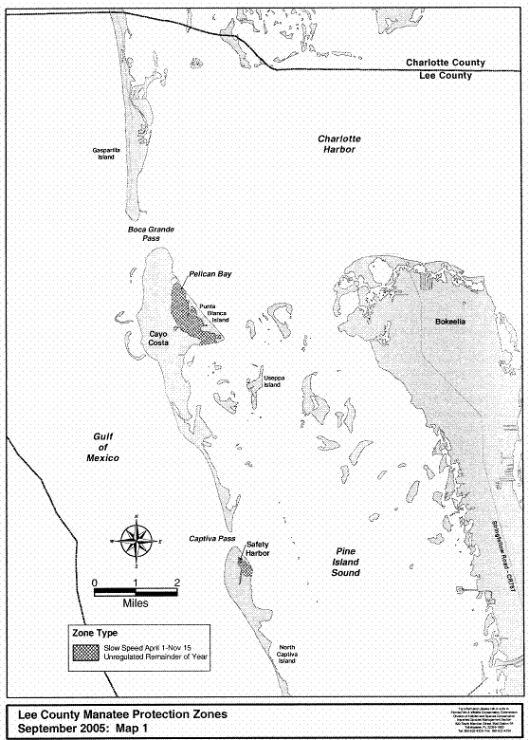
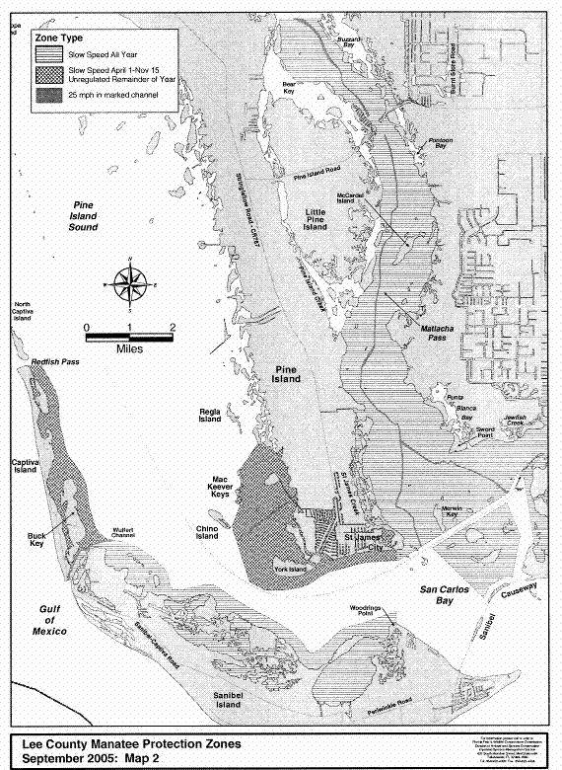
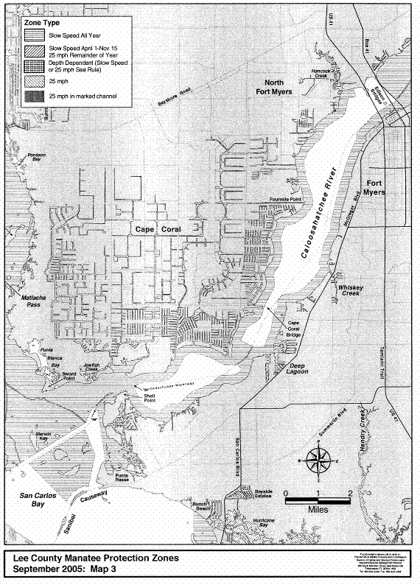

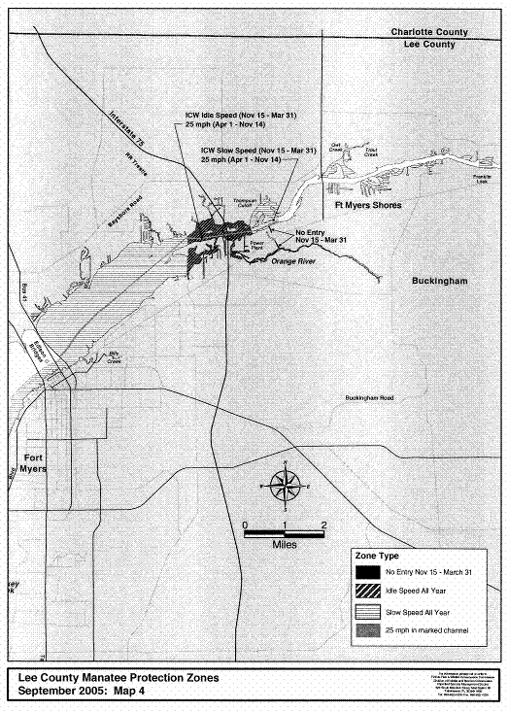

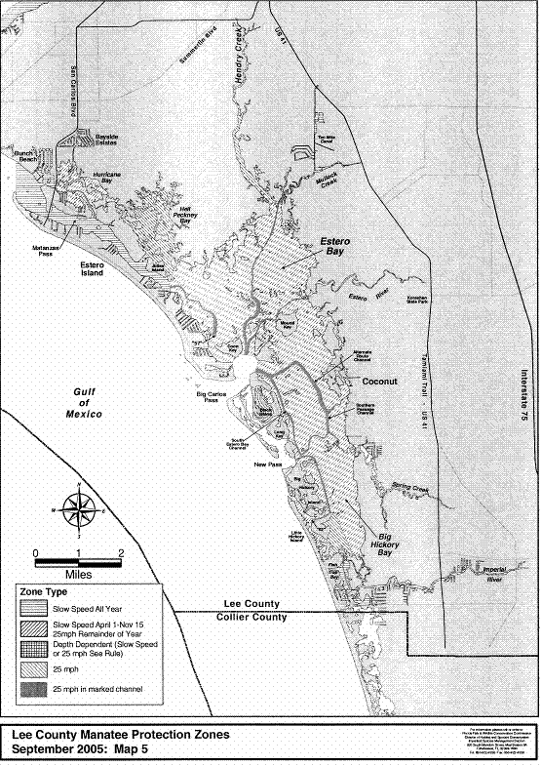
Rulemaking Authority 379.2431(2) FS. Law Implemented 379.2431(2) FS. History–New 3-19-79, Formerly 16N-22.05, Amended 12-5-89, Formerly 16N-22.005, 62N-22.005, Amended 11-30-99, 7-17-01, 9-20-05.

68C-22.006 Brevard County Zones.
(1) The Commission hereby designates the waters within Brevard County, as described below, as areas where manatee sightings are frequent and where it can be assumed that manatees inhabit on a regular, periodic or continuous basis. The Commission has further determined that a likelihood of threat to manatees exists in these waters as a result of manatees and motorboats using the same areas. The primary purpose of this rule is to protect manatees from harmful collisions with motorboats and from harassment by regulating the speed and operation of motorboats within these designated areas. A secondary purpose is to protect manatee habitat. In balancing the rights of fishers, boaters, and water skiers to use these waterways for recreational and commercial purposes (as applicable under Section 379.2431(2)(k), F.S.) with the need to provide manatee protection, the Commission has examined the need for unregulated areas or higher speed travel corridors through regulated areas. Such areas or corridors are provided in those locations where the Commission determined, on the basis of all available information, (1) there is a need for the area or corridor and (2) the area or corridor will not result in serious threats to manatees or their habitat. Unregulated areas or higher speed corridors are not provided in locations where both of the above findings were not made.
(2) The following year-round and seasonal zones are established, which shall include all associated and navigable tributaries, lakes, creeks, coves, bends, backwaters, canals, and boat basins unless otherwise designated or excluded. As used in this rule, ICW means the Intracoastal Waterway. Access to the No Entry and Motorboats Prohibited zones designated in paragraphs (2)(a) and (b), will be provided in accordance with procedures set forth in subsection (4), hereunder, and applicable provisions of Rule 68C-22.003, F.A.C.
(a) No Entry (November 15 ‒ March 31)
1. Indian River, Reliant Corporation Delespine Power Plant Area: All waters within the discharge canal of the Reliant Corporation Delespine power plant, and; All waters southerly of a line extending eastward from and following the same bearing as the southernmost seawall of the power plant discharge canal, with said line bearing approximately 70°, westerly of a line 250 feet east of and parallel to the western shoreline of the Indian River, and northerly of the jetty on the north side of the power plant intake canal.
2. Indian River, FPL Frontenac Power Plant Area: All waters in the vicinity of the Florida Power and Light (FPL) Frontenac power plant southerly of a line connecting the northern guy wires of the power poles immediately north of the FPL Unit 2 discharge area from the western shoreline of the Indian River to the third power pole east of the western shoreline (approximately 1,650 feet east of the shoreline), and westerly of a line running from said third power pole to the easternmost point (approximate latitude 28° 28' 07'' North, approximate longitude 80° 45′ 19′′ West) of the jetty on the north side of the FPL intake canal.
(b) Motorboats Prohibited (All Year, except as noted) ‒
1. Indian River, Reliant Corporation Delespine Power Plant Area: All waters in the vicinity of the Reliant Corporation Delespine power plant southerly of a line bearing 90° from a point (approximate latitude 28° 29' 41'' North, approximate longitude 80° 46' 35'' West) on the western shoreline of the Indian River ninety-five feet (95') north of the northernmost seawall of the power plant discharge canal, westerly of a line 250 feet east of and parallel to the western shoreline of the Indian River, and northerly of a line extending eastward from and following the same bearing as the southernmost seawall of the power plant discharge canal, with said line bearing approximately 70°. This zone is in effect from November 15 through March 31.
2. C-54 Canal: All waters of the C-54 Canal (South Florida Water Management District Canal 54) east of the spillway (approximate latitude 27° 49' 50'' North, approximate longitude 80° 32' 24'' West) and west of a line drawn perpendicular to the northern shoreline of the C-54 Canal at a point (approximate latitude 27° 49' 55'' North, approximate longitude 80° 32' 00'' West) on the northern shoreline 2,500 feet east of the spillway.
(c) Idle Speed (All Year, except as noted) ‒
1. Indian River, Power Plant Area: All waters west of the western boundary of the ICW channel, south of a line bearing 90° from a point (approximate latitude 28° 30' 13'' North, approximate longitude 80° 46' 48'' West) on the western shoreline of the Indian River approximately three-quarters (3/4) of a mile north of the Delespine power plant discharge canal, and north of a line bearing 90° from a point (approximate latitude 28° 27' 27'' North, approximate longitude 80° 45' 43'' West) on the western shoreline of the Indian River approximately three-fourths of a mile south of the Frontenac power plant discharge canal, except as otherwise designated under paragraph (2)(a) and subparagraph (b)1. This zone is in effect from November 15 through March 31.
2. Banana River, Cape Canaveral Area: All waters north of a line bearing 270° from the southwesternmost point (approximate latitude 28° 23' 29'' North, approximate longitude 80° 37' 10'' West) of Long Point in Cape Canaveral to a point (approximate latitude 28° 23' 29'' North, approximate longitude 80° 37' 49'' West) in the Banana River approximately 3,500 feet west of Long Point, and east of a line bearing 331° from said point in the Banana River to a point (approximate latitude 28° 24' 16'' North, approximate longitude 80° 38' 19'' West) on the State Road 528 Causeway (west of State Road 401).
3. Banana River, Manatee Cove Area: All waters of Manatee Cove (on the east side of the Banana River, just south of State Road 520) east of a line at the mouth of the cove running between a point (approximate latitude 28° 21' 21'' North, approximate longitude 80° 36' 52'' West) on the northern shoreline and a point (approximate latitude 28° 21' 09'' North, approximate longitude 80° 36' 51'' West) on the southern shoreline.
4. Turkey Creek: All waters of Turkey Creek north and east (downstream) of Melbourne-Tillman Drainage District structure MS-1 and south and west of a line at the mouth of Turkey Creek that runs from the southeasternmost point (approximate latitude 28° 02' 21'' North, approximate longitude 80° 34' 48'' West) of Castaway Point to the northeasternmost point (approximate latitude 28° 02' 14'' North, approximate longitude 80° 34' 43'' West) of Palm Bay Point.
5. Sebastian Inlet Area: All waters of the cove on the northern side of Sebastian Inlet (commonly known as Campbell Cove) northwest of a line running between the two (2) rock jetties at the entrance to the cove.
6. Sebastian River Area: All waters of the North Prong of Sebastian River, and; All waters of the North Fork Sebastian River (also known as Sebastian Creek) and the C-54 Canal west of a north-south line from a point (approximate latitude 27° 50' 08'' North, approximate longitude 80° 31' 02'' West) on the northern shoreline of the North Fork Sebastian River at the intersection of the river and the North Prong and east of a line drawn perpendicular to the northern shoreline of the C-54 Canal at a point (approximate latitude 27° 49' 55'' North, approximate longitude 80° 32' 00'' West) on the northern shoreline 2,500 feet east of the spillway.
(d) Slow Speed (All Year)
1. Mosquito Lagoon: All waters west of the ICW channel, south of the Volusia County/Brevard County line, and north of ICW channel marker “43”, and; All waters of Mosquito Lagoon (including the ICW channel) south of ICW channel marker “43,” southwest of a line commencing at ICW channel marker “43” and then running to ICW channel marker “45” and then on a bearing of 132° for a distance of 1,000 feet to the line’s terminus at a point in Mosquito Lagoon (approximate latitude 28° 44' 35'' North, approximate longitude 80° 44' 35'' West), and north of a line running from said point in Mosquito Lagoon on a bearing of 221° to the western shoreline of Mosquito Lagoon.
2. Indian River, Turnbull Basin Area: All waters south and east of a line commencing at a point (approximate latitude 28° 44' 36'' North, approximate longitude 80° 46' 19'' West) on the eastern shoreline of Turnbull Basin (about one (1) mile north of Haulover Canal) and then bearing 193° to a point 1,500 feet northwest of the ICW channel, then running in a southwesterly direction 1,500 feet northwest of and parallel with the ICW channel to a point (approximate latitude 28° 41' 22'' North, approximate longitude 80° 49' 05'' West) 1,500 feet northwest of ICW channel marker “12,” and then running in a southerly direction 1,500 feet west of and parallel with the ICW channel to the Florida East Coast Railroad Bridge, including all waters west of the ICW channel and south of an east-west line 1,500 feet north of the point where the Florida East Coast Railroad Bridge crosses over the ICW, but excluding the ICW channel as designated under subparagraph (2)(e)2.
3. Indian River, Titusville Area: All waters west of the ICW channel south of the Florida East Coast Railroad Bridge and north of the State Road 402 Bridge and Causeway.
4. Indian River, State Road 402 (Max Brewer Causeway) to State Road 405 (NASA Parkway): All waters within 2,000 feet of the general contour of the western shoreline of the Indian River, excluding the ICW channel where the channel is less than 2,000 feet from the western shore; All waters within one (1) mile of the general contour of the eastern shoreline of the Indian River south and east of a point (approximate latitude 28° 36' 04'' North, approximate longitude 80° 44' 44'' West) on the western shoreline of Peacock’s Pocket (northwest of Banana Creek), and; All waters south of an east-west line 3,400 feet north of the point where the State Road 405 Bridge crosses over the ICW, excluding the ICW channel as designated under subparagraph (2)(e)3.
5. Indian River, State Road 405 (NASA Parkway) to State Road 528 (Bennett Causeway): All waters north of an east-west line 3,000 feet south of the point where the State Road 405 Bridge crosses over the ICW, excluding the ICW channel as designated under subparagraph (2)(e)3.; All waters west of the ICW channel and north of the overhead power transmission line that crosses the western shoreline of the Indian River approximately 1,200 feet north of State Road 528, excepting those areas otherwise designated for seasonal regulation under paragraph (2)(a), subparagraphs (b)1. and (c)1., when said seasonal zones are in effect; All waters south of said overhead power transmission line and west of a north-south line running through the second power pole east of the western shoreline; All waters within one half (1/2) mile of the eastern shoreline of the Indian River north of a point (approximate latitude 28° 25' 47'' North, approximate longitude 80° 43' 24'' West) on the eastern shoreline of the Indian River 1,500 feet south of the canal on the southern side of Meadow Lark Lane, including all waters of Rinkers Canal, and; All waters east of the ICW channel and south of the overhead power transmission line that crosses the eastern shoreline of the Indian River approximately 3,900 feet north of State Road 528.
6. Indian River, State Road 528 (Bennett Causeway) to State Road 518 (Eau Gallie Causeway): All waters within 1,000 feet of the general contour of the western shoreline of the Indian River; All waters south of State Road 528 and within 500 feet of the State Road 528 Causeway, within 500 feet of the State Road 520 Causeway, within 500 feet of the State Road 404 Causeway, and north of State Road 518 and within 500 feet of the State Road 518 Causeway; All waters within 1,000 feet of the general contour of the eastern shoreline of the Indian River between State Road 528 and State Road 520; All waters east of the ICW channel from State Road 520 to an east-west line 300 feet south of the southernmost point (approximate latitude 28° 19' 22'' North, approximate longitude 80° 42' 00'' West) of the spoil island east of ICW channel marker “80,” and; All waters within 500 feet of the general contour of the eastern shoreline of the Indian River south of the aforementioned east-west line and north of State Road 404 (Pineda Causeway).
7. Indian River, State Road 518 (Eau Gallie Causeway) to Cape Malabar: All waters within 1,000 feet of the general contour of the eastern shoreline of the Indian River; All waters south of State Road 518 and within 500 feet of the State Road 518 Causeway and within 500 feet of the State Road 192 Causeway; All waters within 1,000 feet of the general contour of the western shoreline of the Indian River south of State Road 518 and north of the easternmost point (approximate latitude 28° 02' 24'' North, approximate longitude 80° 34' 48'' West) of Castaway Point (including all waters of the Eau Gallie River and Crane Creek), and; All waters south of said easternmost point of Castaway Point, north of Cape Malabar, and west of a line commencing at a point (approximate latitude 28° 02' 29'' North, approximate longitude 80° 34' 38'' West) in the Indian River 1,000 feet northeast of said easternmost point of Castaway Point, then bearing 130° to the westernmost point (approximate latitude 28°02' 15'' North, approximate longitude 80° 34' 19'' West) of the spoil site west of ICW channel marker “14,” then bearing 153° to the westernmost point (approximate latitude 28° 01' 32'' North, approximate longitude 80° 33' 55'' West) of the spoil site southwest of ICW channel marker “15,” then bearing 138° to the line’s terminus at a point (approximate latitude 28° 01' 12'' North, approximate longitude 80° 33' 35'' West) in the Indian River approximately 2,400 feet northeast of Cape Malabar.
8. Indian River, Cape Malabar to Grant: All waters within 1,000 feet of the general contour of the eastern shoreline of the Indian River south of Cape Malabar and north of a point (approximate latitude 27° 55' 59'' North, approximate longitude 80° 30' 30'' West) on the eastern shoreline of the Indian River (north of Mullet Creek); All waters south of Cape Malabar, north of the spoil island between ICW channel markers “25” and “27,” and west of a line commencing at a point (approximate latitude 28° 01' 12'' North, approximate longitude 80° 33' 35'' West) in the Indian River approximately 2,400 feet northeast of Cape Malabar, then bearing 157° to the easternmost point (approximate latitude 28° 00' 26'' North, approximate longitude 80° 33' 13'' West) of the spoil site between ICW channel markers “16” and “17,” then bearing 152° to the easternmost point (approximate latitude 27° 59' 21'' North, approximate longitude 80° 32' 35'' West) of the spoil island west of ICW channel marker “22,” then bearing 166° to the line’s terminus at the easternmost point (approximate latitude 27° 57' 50'' North, approximate longitude 80° 32' 10'' West) of the spoil island between ICW channel markers “25” and “27”; All waters within 1,000 feet of the general contour of the western shoreline of the Indian River south of said spoil island between ICW channel markers “25” and “27,” and north of ICW channel marker “35,” and; All waters west of the ICW channel between ICW channel markers “35” and “38.”
9. Indian River, Grant to the Indian River County Line: All waters west of the ICW channel between ICW channel marker “38” and the Brevard County/Indian River County line, including those waters east of the centerline of the U.S. 1 Bridge over the Sebastian River, and; All waters within 1,500 feet of the general contour of the eastern shoreline of the Indian River, south of a point (approximate latitude 27° 55' 59'' North, approximate longitude 80° 30' 30'' West) on the eastern shoreline of the Indian River (north of Mullet Creek) and north of an east-west line running through ICW channel marker “59” (approximate latitude 27° 51' 38'' North, approximate longitude 80° 28' 57'' West), including those waters within 1,500 feet west of the westernmost edge of the Mullet Creek Islands, within 1,500 feet west of the westernmost edge of the islands south of Mathers Cove, within 1,500 feet west of the westernmost edge of Long Point, and within 1,500 feet west of the westernmost extensions of Campbell Pocket south to said east-west line running through ICW channel marker “59,” and; All waters of the Indian River and Sebastian Inlet east of the ICW channel, south of said east-west line running through ICW channel marker “59,” north of the Brevard County/Indian River County line, and west of a line 200 feet southwest of and parallel with the centerline of the State Road A1A Bridge, except as otherwise designated under subparagraph (2)(c)5., and excluding the marked Sebastian Inlet channel.
10. Sebastian River Area: All waters of the Sebastian River (including waters also known as San Sebastian Bay), the South Fork San Sebastian River (also known as St. Sebastian River, Sebastian River and Sebastian Creek), and the North Fork Sebastian River (also known as Sebastian Creek) within Brevard County west of the centerline of the US 1 Bridge and east of a north-south line from a point (approximate latitude 27° 50' 08'' North, approximate longitude 80° 31' 02'' West) on the northern shoreline of the North Fork Sebastian River at the intersection of the river and the North Prong of Sebastian River.
11. Canaveral Barge Canal: All waters of the Canaveral Barge Canal east of the general contour of the eastern shoreline of the Indian River and west of the general contour of the western shoreline of the Banana River.
12. Sykes Creek and Kiwanis Basin: All waters of Sykes Creek and Kiwanis Basin south of the Canaveral Barge Canal and north of the centerline of State Road 520.
13. Newfound Harbor: All waters south of State Road 520 and within 1,000 feet of the State Road 520 Bridge and Causeway; All waters within 1,000 feet of the general contour of the western shoreline of Newfound Harbor north of the runway for the Merritt Island Airport (approximately one mile south of State Road 520), and; All waters within 1,000 feet of the general contour of the eastern shoreline of Newfound Harbor and an extension of said shoreline to a point 1,000 feet south of Buck Point.
14. Banana River, North of State Road 528: All waters within 1,500 feet of the general contour of the western shoreline of the Banana River south of a point (approximate latitude 28° 26' 10'' North, approximate longitude 80° 39' 35'' West) on the shoreline near Kars Park on the boundary of the federal No Motor zone; All waters south of an east-west line running through the westernmost point (approximate latitude 28° 24' 42'' North, approximate longitude 80° 38' 34'' West) of the first spoil island north of the Canaveral Locks (commonly known as Ski Island), including those waters in Port Canaveral west of State Road 401, and; All waters east and south of a line commencing at the northernmost point (approximate latitude 28° 24' 44'' North, approximate longitude 80° 38' 32'' West) of Ski Island, then running to the southernmost point (approximate latitude 28° 24' 55'' North, approximate longitude 80° 38' 31'' West) of the second spoil island north of the Canaveral Locks, then following the eastern shoreline of said spoil island to its northernmost point, then bearing 6° to a point (approximate latitude 28° 25' 09'' North, approximate longitude 80° 38' 29'' West) in the Banana River underneath the overhead power transmission line south of the third spoil island north of Canaveral Locks, then following said transmission line (which is the boundary of the federal No Motor zone) in an easterly direction to the line’s terminus at a point (approximate latitude 28° 25' 16'' North, approximate longitude 80° 36' 13'' West) on the eastern shoreline of the Banana River.
15. Banana River, State Road 528 to State Road 520: All waters south of State Road 528, east of a line bearing 180° from the easternmost point (approximate latitude 28° 24' 18'' North, approximate longitude 80° 38' 53'' West) of the central State Road 528 Causeway, and north of an east-west line 1,000 feet south of the point where the State Road 528 Bridge crosses over the main Banana River channel, except as otherwise designated under subparagraph (2)(c)2.; All waters west of a line running from a point (approximate latitude 28° 24' 16'' North, approximate longitude 80° 39' 30'' West) on the State Road 528 Causeway east of the western State Road 528 Relief Bridge to a point (approximate latitude 28° 21' 26'' North, approximate longitude 80° 39' 32'' West) on the State Road 520 Causeway approximately 1,200 feet west of the water storage tanks, and; All waters south of a line bearing 270° from the southwesternmost point (approximate latitude 28° 23' 29'' North, approximate longitude 80° 37' 10'' West) of Long Point in Cape Canaveral to a point (approximate latitude 28° 23' 29'' North, approximate longitude 80° 37' 49'' West) in the Banana River approximately 3,500 feet west of Long Point, and east of a line bearing 174° from said point in the Banana River to a point (approximate latitude 28° 21' 28'' North, approximate longitude 80° 37' 35'' West) on the State Road 520 Causeway approximately 1,000 feet west of Cape Canaveral Hospital Complex.
16. Banana River, Cocoa Beach Area: All waters east of a line bearing 186° from the westernmost point (approximate latitude 28° 21' 26'' North, approximate longitude 80° 38' 52'' West) of the State Road 520 Causeway east of the main Banana River channel, and within 1,000 feet south of the State Road 520 Causeway; All waters within 1,000 feet of the general contour of the western shoreline of the Banana River, south of State Road 520 and north of Buck Point and an extension of said shoreline to a point 1,000 feet south of Buck Point, excluding the main Banana River channel where the channel is less than 1,000 feet from the western shoreline, and; All waters east of a line commencing at a point (approximate latitude 28° 21' 25'' North, approximate longitude 80° 38' 30'' West) on the State Road 520 Causeway (approximately 2,000 feet east of the State Road 520 Bridge over the main Banana River channel), then bearing 190° to a point (approximate latitude 28° 19' 15'' North, approximate longitude 80° 38' 55'' West) in the Banana River approximately 1,900 feet west of the northwesternmost point of the Cocoa Beach Municipal Park, then bearing 270° to a point (approximate latitude 28° 18' 38'' North, approximate longitude 80° 38' 55'' West) in the Banana River approximately 1,700 feet west of the southwesternmost point of the Cocoa Beach Municipal Park, then bearing 171° for approximately 3,000 feet to a point (approximate latitude 28° 18' 07'' North, approximate longitude 80° 38' 50'' West) in the Banana River east of channel marker “15,” then bearing 124° to a point (approximate latitude 28° 16' 52'' North, approximate longitude 80° 36' 45'' West) in the Banana River 1,000 feet west of the eastern shoreline of the Banana River, then heading in a southerly direction 1,000 feet west of and parallel with the eastern shoreline of the Banana River to the line’s terminus at a point (approximate latitude 28° 15' 51'' North, approximate longitude 80° 36' 38'' West) in the Banana River near the northern boundary of Patrick Air Force Base.
17. Banana River, South of Cocoa Beach to State Road 404 (Pineda Causeway): All waters south of an east-west line running through the southernmost point (approximate latitude 28° 16' 19'' North, approximate longitude 80° 39' 25'' West) of the more southerly of the two islands east of Macaw Way (on Merritt Island) and west of a line bearing 162° from said southernmost point to State Road 404; All waters south and east of the overhead power transmission line in the Banana River adjacent to Patrick Air Force Base, and; All waters north of the centerline of State Road 404 and within 2,000 feet of the State Road 404 Bridges and Causeway, excluding the main Banana River channel as designated under subparagraph (2)(e)5.
18. Banana River, South of State Road 404 (Pineda Causeway): All waters south of the centerline of State Road 404, including those waters east of a line bearing 270° from the southernmost point (approximate latitude 28° 08' 32'' North, approximate longitude 80° 36' 15'' West) of Merritt Island (commonly known as Dragon Point) to the Eau Gallie Causeway, excluding the main Banana River channel as designated under subparagraph (2)(e)5.
(e) 25 MPH (All Year)
1. Mosquito Lagoon: All waters in the ICW channel south of the Volusia County/Brevard County line and north of ICW channel marker “43” (north of Haulover Canal).
2. Indian River, Turnbull Basin and Titusville Area: All waters in the ICW channel southwest of ICW channel marker “1” (southwest of Haulover Canal) and north of an east-west line 1,200 feet south of the point where the Florida East Coast Railroad Bridge crosses over the ICW.
3. Indian River, State Road 405 (NASA Parkway) Area: All waters in the ICW channel south of an east-west line 3,400 feet north of the point where the State Road 405 Bridge crosses over the ICW and north of an east-west line 3,000 feet south of the point where the State Road 405 Bridge crosses over the ICW.
4. South Indian River Area: All waters in the ICW channel south of ICW channel marker “59” and north of the Brevard County/Indian River County line.
5. South Banana River Area: All waters in the main Banana River channel south of a point in the channel 2,000 feet north of the State Road 404 Bridge, and north of a point (approximate latitude 28° 09' 15'' North, approximate longitude 80° 36' 32'' West) in the channel on the northern boundary of the local Idle Speed zone approximately 1,900 feet north of the Mathers Bridge.
(3) Commercial Fishing and Professional Fishing Guide Permits: The following provisions pertain to the issuance of permits to allow individuals engaged in commercial fishing and professional fishing guide activities to operate their vessels in specified areas at speeds greater than the speed limits established under subsection (2), above. Procedures related to the application for and the review and issuance of these permits are as set forth in Rule 68C-22.003, F.A.C.
(a) Permits shall be limited as follows:
1. Permits shall only be available for the zones or portions of zones described under subparagraphs (2)(d)1. through (2)(d)9., and (2)(d)13. through (2)(d)18.
2. Permits shall not apply on weekends or on the holidays identified in Section 110.117, F.S.
(b) Permit applications may be obtained at the Commission’s Law Enforcement office at 1-A Max Brewer Memorial Parkway in Titusville or by contacting the Commission at Mail Station OES-BPS, 620 South Meridian Street, Tallahassee, Florida 32399, (850)922-4330.
(4) Access to the No Entry and Motorboats Prohibited zones is allowed for Reliant Corporation employees or their authorized agents (for the zones designated under subparagraphs (2)(a)1. and (b)1.), and for Florida Power and Light Company employees or their authorized agents (for the zone designated under subparagraph (2)(a)2.) provided that entry into the zones is necessary to conduct activities associated with power plant maintenance, emergency operations or environmental monitoring. The Commission must receive notification of the activity prior to its commencement. In the event of an emergency activity, the Commission shall be notified no more than one week after the activity has been commenced. All vessels used in the operation or associated with the activity shall be operated at no greater than Idle Speed while within the zones and must have an observer on board to look for manatees.
(5) The zones described in subsection 68C-22.006(2), F.A.C., are depicted on the following maps, labeled “Brevard County Manatee Protection Zones.” The maps are intended as depictions of the above-described zones. In the event of conflict between the maps and descriptions, the descriptions shall prevail.
(6) The amendments of subsections 68C-22.006(2) through (5), F.A.C., as approved by the commission on May 23, 2001, shall become effective when the requisite regulatory signage is posted or erected in the designated waterway or segment of waterway of Brevard County or six (6) months from the date the rule amendments are filed for adoption, whichever is sooner.
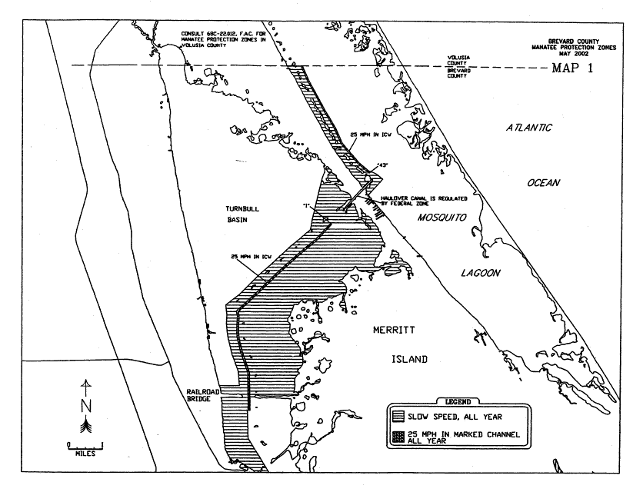
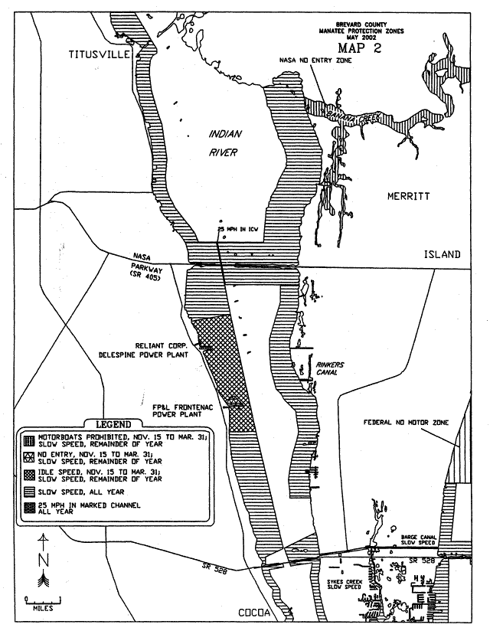
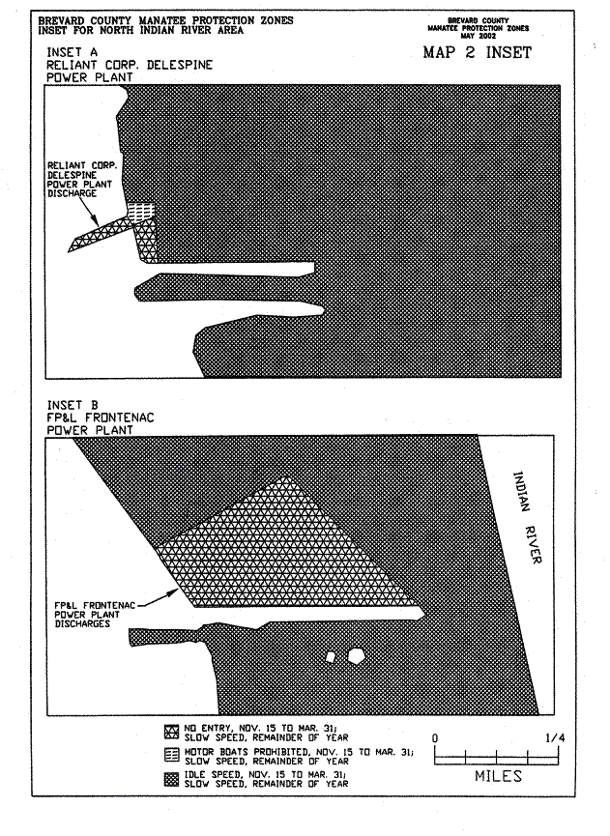
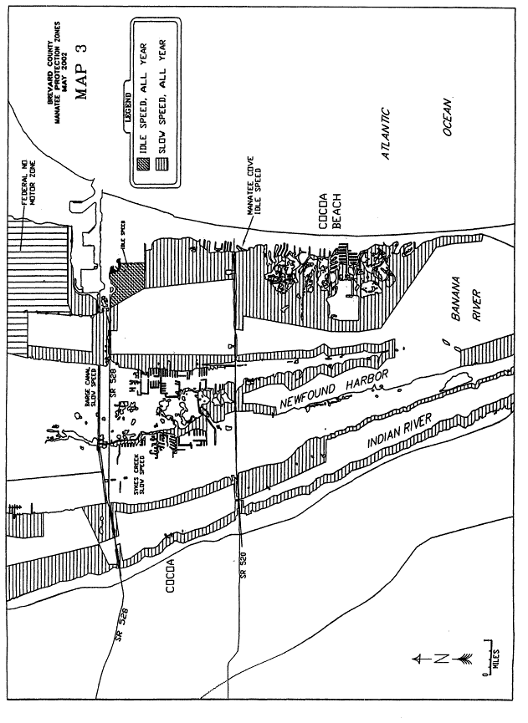
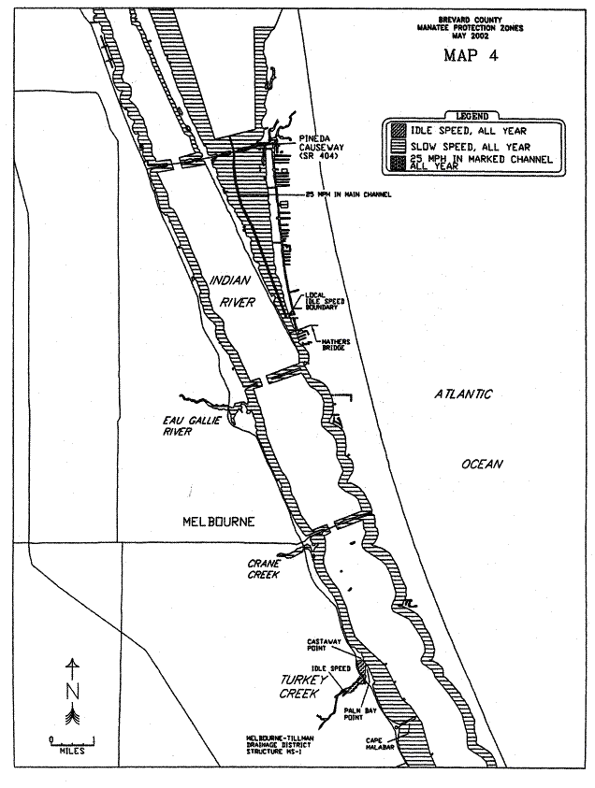
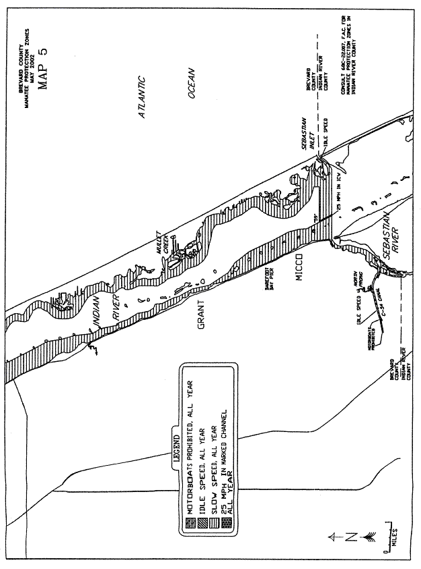
Rulemaking Authority 379.2431(2) FS. Law Implemented 379.2431(2) FS. History–New 3-19-79, Formerly 16N-22.06, Amended 12-20-89, 8-28-90, 7-25-91, 8-18-92, Formerly 16N-22.006, Amended 10-12-94, 12-29-98, Formerly 62N-22.006, Amended 6-24-02.

68C-22.007 Indian River County Zones.
(1) For the purpose of protecting manatees and manatee habitat in Indian River County, the following year-round and seasonal zones are established, which shall include all associated and navigable tributaries, lakes, creeks, coves, bends, backwaters, canals, channels and boat basins, unless otherwise designated or excluded:
(a) Idle Speed Zone (Year-round) –
1. Indian River, Sebastian River Area: All waters within 1000 feet of the westerly shoreline of Indian River, southerly of a line which bears North 90° 00' 00'' East (True) running through the northernmost point of land of the peninsula over which US Highway 1 (State Road 5) passes (approximate latitude 27° 51' 12" North, approximate longitude 80° 29' 27" West), and northerly of a line which bears North 90° 00' 00" East (True) from a point on the westerly shoreline of Indian River 700 feet northwesterly of the intersection of the extension of the centerline of County Road 505 with the westerly shoreline of Indian River (approximate latitude 27° 50' 46" North, approximate longitude 80° 29' 05" West),
2. 110th Street Area: All waters of the canals immediately north and south of 110th Street, westerly of the general contour of the westerly shoreline of Indian River,
3. Island Harbor Road Area: All waters of the marina between North Island Harbor Road and South Island Harbor Road, westerly of the general contour of the westerly shoreline of Indian River,
4. Durrance Road Area: All waters of the canals southerly of Durrance Road, northerly of 93rd Lane, and westerly of the general contour of the westerly shoreline of Indian River,
5. Hobart Lodge Marina Area: All waters of the Hobart Lodge Marina canals, westerly of a line which bears South 00° 00' 00" West (True) from the easternmost tip of the peninsula on the northerly shoreline of the southernmost canal (approximate latitude 27° 44′ 10" North, approximate longitude 80° 25' 07" West),
6. Grand Harbor Development Marina Area: All waters of the Grand Harbor Development Marina, all waters of the canal system northerly of the Grand Harbor Development Marina in Sections 11, 13 and 14, Township 32 South, Range 39 East, and those waters of the North Canal, westerly of the general contour of the westerly shoreline of Indian River Narrows, and easterly of the centerline of US Highway 1,
7. Johns Island Creek Area: All waters of Johns Island Creek and associated canals or waterways, southerly of a line which bears North 90° 00' 00'' East (True) running through the northernmost tip of an unnamed island (approximate latitude 27° 42' 20" North, approximate longitude 80° 23' 01'' West), northerly and easterly of a line which bears North 00° 00' 00" East (True) running through the westernmost tip of a peninsula (approximate latitude 27° 41' 01" North, approximate longitude 80° 22' 51" West),
8. Indian River, Vero Beach Area: Those waters of the main canal and associated waters, westerly of the general contour of the westerly shoreline of Indian River, and easterly of the flood gate located approximately 200 feet easterly of Country Club Drive; and all waters of those canals southerly of Royal Palm Boulevard, northerly of Harbor Drive South, and westerly of the general contour of the westerly shoreline of the Indian River, excepting that area otherwise designated for seasonal regulation under paragraph (1)(e), when said seasonal zone is in effect,
9. South Canal Area: All waters of South Canal and associated waters, westerly of the general contour of the westerly shoreline of Indian River, and easterly of the centerline of US Highway 1 (State Road 5),
10. Crawford Creek Area: All waters of Crawford Creek northerly of a line which bears South 70° 00' 00" West (True) from the southernmost tip of Crawford Point (approximate latitude 27° 35' 29" North, approximate longitude 80° 21' 52" West),
11. River Shores Development Area: All waters of the canals north and south of 12th Place S.E. in Sections 29 and 30, Township 33 South, Range 40 East, westerly of the general contour of the westerly shoreline of Indian River,
12. Vero Shores Area: All waters of the Vero Shores canals westerly of the general contour of the westerly shoreline of Indian River; and,
13. Indian River, Porpoise Point to Head Cove Area: All waters of Indian River within 1000 feet of the general contour of the westernmost shoreline of Porpoise Point and the Moorings residential development including all waters of Porpoise Bay, Head Cove Pocket, Head Cove and all associated waters, southerly of a line which bears South 90° 00' 00′′ West (True) from the westernmost point of the shoreline of Porpoise Point (approximate latitude 27° 35' 30" North, approximate longitude 80° 20' 51'' West), northerly of a line which bears South 90° 00' 00" West from the westernmost point of an unnamed island at the southern end of Head Cove (approximate latitude 27° 34' 28" North, approximate longitude 80° 20' 22" West), and northerly of the westerly extension of the northerly shoreline of the canal between Island Drive and Harbor Lane.
(b) Slow Speed Zone (Year-round) –
1. St. Sebastian River Area: All navigable waters of the St. Sebastian River (also commonly known as Sebastian River, San Sebastian River and Sebastian Creek, and including those waters known as San Sebastian Bay), and the South Fork St. Sebastian River within Indian River County westerly and southwesterly of the centerline of the US 1 Bridge, and northerly of the centerline of the S.R. 512 Bridge.
2. Indian River Area: All waters of the Indian River and Indian River Narrows including Vossinbury Creek, westerly of a line 100 feet westerly of and parallel with the westerly boundary of the main marked channel of the Atlantic Intracoastal Waterway, southerly of the Indian River County/Brevard County line, and northerly of the Indian River County/St. Lucie County line, except as otherwise excluded or designated for alternative regulation,
3. Indian River, Sebastian Inlet Area: All waters of Indian River and Sebastian Inlet, unless otherwise designated, exclusive of the marked Sebastian Inlet channel and any extension of said channel to be marked by local, state, or federal government (portions of which may be otherwise designated for regulation), southerly of the Indian River County/Brevard County line, northerly of a line which bears North 60° 00' 00" East (True) from Red Intracoastal Waterway Channel Marker “64” (latitude 27° 50' 21" North, longitude 80° 28' 16" West), easterly of a line 100 feet easterly of and parallel with the easterly boundary of the main marked channel of the Atlantic Intracoastal Waterway, and southwesterly of a line 200 feet southwesterly of and parallel with the centerline of the State Road A1A Bridge,
4. Indian River, Coconut Point to Big Slough Area: All waters within 600 feet of the general contour of the easterly shoreline of Indian River, southerly of a line which bears North 60° 00' 00" East (True) from Red Intracoastal Waterway Channel Marker “64” (latitude 27° 50' 21" North, longitude 80° 28' 16" West), and northwesterly of a line which bears North 45° 00' 00" East (True) from the northernmost point of Black Point (approximate latitude 27° 48' 40" North, approximate longitude 80° 26' 24" West),
5. Indian River, Big Slough to Wabasso Beach Road Bridge Area – All waters of Big Slough, North Hole and South Hole southeasterly of a line which bears North 45° 00' 00" East (True) from the northernmost point of Black Point (approximate latitude 27° 48' 40" North, approximate longitude 80° 26' 24" West); Collins Hole, Turtle Pen Slough and those waters of Indian River within 600 feet of the general contour of the northerly and westerly shoreline of the Black Point peninsula, the general contour of the northerly, westerly and southerly shoreline of Roseate Island, and the general contour of the southwesterly shoreline of Sprat Point, all waters of Sprat Creek and East Channel northeasterly and easterly of the general contour of the northeasterly shoreline of Roosevelt Island, the easterly shoreline of North Horseshoe Island, Horseshoe Island, Plug Island and Preachers Island; and those waters of Indian River easterly of a line 100 feet easterly of and parallel with the easterly boundary of the main marked Channel of the Atlantic Intracoastal Waterway, southerly of a line which bears North 90° 00' 00" East (True) running through Flashing Green Intracoastal Waterway Channel Marker “71” (latitude 27° 47' 29" North, longitude 80° 26' 40" West), southeasterly, southerly and southwesterly of a line 600 feet northwesterly, northerly and northeasterly of the general contour of the northwesterly, northerly and easterly shoreline of Pauls Island, and westerly of the general contour of the westerly shoreline of Middle Island, Nelson Island and Horseshoe Island and Preachers Island, and northerly of the centerline of the Wabasso Beach Road (County Road 510) Bridge,
6. Indian River, Wabasso Beach Road Bridge to Erwin Cove Area: All waters of Indian River and Indian River Narrows, including Michael Creek, Johns Island Creek, Chambers Cove, Stingray Creek, McCullers Cove, Jandrew Cove, Bethel Creek, Riomar Creek, North Creek, South Creek and Erwin Cove, easterly of a line 100 feet easterly of and parallel with the easterly boundary of the main marked channel of the Atlantic Intracoastal Waterway, southerly of the centerline of the Wabasso Beach Road (County Road 510) Bridge, and northerly of a line which bears North 65° 30' 00" East (True) running through Green Intracoastal Waterway Channel Marker “149” (latitude 27° 37' 24" North, longitude 80° 22' 08" West), except as otherwise designated, LESS: all waters of Gifford Cut easterly of the general contour of the westerly shoreline of Gifford Cut, said general contour line extending across the mouth of any tributary or backwater area, westerly of the general contour of the easterly shoreline of Gifford Cut, said general contour line extending across the mouth of any tributary or backwater area, southerly of a line which bears North 90° 00' 00" East (True) running through the northernmost tip of a peninsula (approximate latitude 27° 40' 36" North, approximate longitude 80° 22' 37" West), and northerly of a line which bears North 90° 00' 00" East (True) from the southernmost tip of a small unnamed island (approximate latitude 27° 40' 02" North, approximate longitude 80° 22' 17" West),
7. Jungle Trail Narrows to Hole-in-the-Wall Island Area: All waters of the Indian River, Jungle Trails Narrows, and associated waters, south of a line bearing 40° from a point (approximate latitude 27° 45' 20.6" North, approximate longitude 80° 24' 37.6" West) on the northeastern shoreline of Pine Island, north of a line bearing 80° from a point (approximate latitude 27° 43' 09.2" North, approximate longitude 80° 24' 03.2" West) on the eastern shoreline of Hole-in-the-Wall Island to a point (approximate latitude 27° 43' 11.9" North, approximate longitude 80° 23' 45.6" West) on the western shoreline of Barker Island, west of the eastern shoreline of Jungle Trail Narrows and a line bearing 194° from a point (approximate latitude 27° 43' 29.8" North, approximate longitude 80°23'36.6" West) on the eastern shoreline to a point (approximate latitude 27° 43' 19.8" North, approximate longitude 80° 23' 39.5" West) on the northern shoreline of Barker Island, and east of a line that begins at a point (approximate latitude 27° 43' 09.2" North, approximate longitude 80° 24' 03.2" West) on the eastern shoreline of Hole-in-the-Wall Island and runs northerly along the shoreline of Hole-in-the-Wall Island for a distance of 1290 feet to another point (approximate latitude 27° 43' 21.8" North, approximate longitude 80° 24' 05.3" West) on the eastern shoreline of Hole-in-the-Wall Island, then bears 19° to a point (approximate latitude 27° 43' 32.3" North, approximate longitude 80° 24' 01.1" West) on the southwestern shoreline of Pine Island, and then runs southeasterly then northerly along the southwestern and then eastern shorelines of Pine Island to the line’s terminus at a point (approximate latitude 27° 45' 20.6" North, approximate longitude 80° 24' 37.6" West) on the northeastern shoreline of Pine Island, excepting those waters of the Atlantic Intracoastal Waterway channel and associated waters otherwise designated under sub-subparagraph (1)(d)1.b.,
8. Indian River, Porpoise Point to St. Lucie County Line Area: All waters of Indian River and Round Island Creek easterly of a line 100 feet easterly or and parallel with the easterly boundary of the main marked channel of the Atlantic Intracoastal Waterway, southerly of a line which bears South 90° 00' 00" West (True) from the westernmost point of the shoreline of Porpoise Point (approximate latitude 27° 35' 30" North, approximate longitude 80° 20' 51" West), and northerly of the Indian River County/St. Lucie County line, except as otherwise designated for alternative regulation; and,
9. Atlantic Intracoastal Waterway, Merrill Barber Bridge Area: That portion of the main marked channel of the Atlantic Intracoastal Waterway and those waters within 100 feet of the eastern and western boundaries of said channel described as follows: Southerly of Green Intracoastal Waterway Channel Marker “137” (latitude 27° 39' 31" North, longitude 80° 22' 37" West), and northerly of the centerline of the Merrill Barber (State Road 60) Bridge.
(c) Slow Speed Zone (November 1 through April 30)/Unregulated Remainder of Year –
1. Indian River, Sebastian Inlet Marina to Duck Point Area: All waters of Indian River easterly of a line 600 feet easterly of and parallel with the general contour of the westerly shoreline of Indian River, westerly of a line 100 feet westerly of and parallel with the westerly boundary of the main marked channel of the Atlantic Intracoastal Waterway, southerly of a line which bears North 67° 00' 00" East (True) running through Red Intracoastal Waterway Channel Marker “66” (latitude 27° 49' 33" North, longitude 80° 27' 54" West), and northerly of a line which bears North 90° 00' 00" East (True) running through Green Intracoastal Waterway Channel Marker “75” (latitude 27° 46' 17" North, longitude 80° 25' 49" West); and those waters of Indian River easterly of a line 100 feet easterly of and parallel with the easterly boundary of the main marked channel of the Atlantic Intracoastal Waterway, westerly of a line 1600 feet northeasterly of and parallel with the centerline of the main marked channel of the Atlantic Intracoastal Waterway, southerly of a line which bears North 67° 00' 00" East (True) running through Red Intracoastal Waterway Channel Marker “66” (latitude 27° 49' 33" North, longitude 80° 27' 54" West), and northerly of a line which bears North 90° 00' 00′′ East (True) running through Flashing Green Intracoastal Waterway Channel Marker “67” (latitude 27° 48' 45" North, longitude 80° 27' 29" West).
2. Indian River, Hobart Lodge to Grand Harbor Development Area: All waters of Indian River, east of the general contour of the western shoreline of Indian River, north and west of a line that begins at a point (approximate latitude 27° 43' 21.8" North, approximate longitude 80° 24' 05.3" West) on the eastern shoreline of Hole-in-the-Wall Island then bears 19° to a point (approximate latitude 27° 43' 32.3" North, approximate longitude 80° 24' 01.1" West) on the southwestern shoreline of Pine Island and then runs northerly along the western shoreline of Pine Island, south and west of a line bearing 80° from a point (approximate latitude 27° 43' 09.2" North, approximate longitude 80° 24' 03.2" West) on the eastern shoreline of Hole-in-the-Wall Island to a point 100 feet west of the western boundary of the Atlantic Intracoastal Waterway, then running southerly 100 feet west of and parallel with the western boundary of the main marked channel of the Atlantic Intracoastal Waterway, southerly of a line which bears 90° from a point (approximate latitude 27° 44' 19.4" North, approximate longitude 80° 25' 18.4" West) on the western shoreline of the Indian River located 1000 feet north of the easternmost tip of the peninsula on the northern shoreline of the southernmost canal of the Hobart Lodge Marina canals (approximate latitude 27° 44' 10" North, approximate longitude 80° 25' 07" West), and north of a line which bears 90°, running through Red Intracoastal Waterway Channel Marker “120” (latitude 27° 42' 04" North), longitude 80° 23' 8" West).
3. Indian River, Crawford Point to Indian River County/St. Lucie County Line Area: All waters of Indian River, westerly of a line 100 feet westerly of and parallel with the westerly boundary of the main marked channel of the Atlantic Intracoastal Waterway, southerly of a line which bears South 90° 00' 00" West (True) from the westernmost point of the shoreline of Porpoise Point (approximate latitude 27° 35' 40" North, approximate longitude 80° 20' 50" West), and northerly of the Indian River County/St. Lucie County line; and,
(d) Maximum 30 MPH Zone (Year-round) –
1. Atlantic Intracoastal Waterway Areas: Those portions of the main marked channel of the Atlantic Intracoastal Waterway, including those waters within 100 feet of its eastern and western boundaries, described as follows:
a. Southerly of the Brevard County/Indian River County line and northerly of Flashing Green Intracoastal Waterway Channel Marker “67” (latitude 27° 48' 45" North, longitude 80° 27' 29" West),
b. South of Red Intracoastal Waterway Channel Marker “78” (approximate latitude 27° 45' 53.7" North, approximate longitude 80° 25' 17.3" West), and north of a line bearing 80° from a point (approximate latitude 27° 43' 09.2" North, approximate longitude 80° 24' 03.2" West) on the eastern shoreline of Hole-in-the-Wall Island to a point (approximate latitude 27° 43' 11.9" North, approximate longitude 80° 23' 45.6" West) on the western shoreline of Barker Island,
c. South of a line bearing 80° from a point (approximate latitude 27° 43' 09.2" North, approximate longitude 80° 24' 03.2" West) on the eastern shoreline of Hole-in-the-Wall Island to a point (approximate latitude 27° 43' 11.9" North, approximate longitude 80° 23' 45.6" West) on the western shoreline of Barker Island, and north of Green Intracoastal Waterway Channel Marker “137” (approximate latitude 27° 39' 30.9" North, approximate longitude 80° 22' 36.8" West),
d. Southerly of the centerline of the Merrill Barber (State Road 60) Bridge and northerly of a line which bears North 65° 30' 00" East (True) running through Green Intracoastal Waterway Channel Marker “149” (approximate latitude 27° 37' 24" North, longitude 80° 22' 08" West); and,
e. Southerly of a line which bears South 90° 00' 00" West (True) from the westernmost point of the shoreline of Porpoise Point (approximate latitude 27° 35' 40" North, approximate longitude 80° 21' 51" West), and northerly of the Indian River County/St. Lucie County line.
2. Sebastian Inlet Channel Area: That portion of the Sebastian Inlet channel commencing at a point in a line 100 feet easterly of and parallel with the easterly boundary of the main marked channel of the Atlantic Intracoastal Waterway located 850 feet northwesterly of Red Intracoastal Waterway Channel Marker “64” (latitude 27° 50' 21" North, longitude 80° 28' 16" West) as measured along said Intracoastal Waterway, thence North 45° 00' 00" East (True) approximately 3000 feet to the southwesterly end of the following described submerged land:
A parcel of submerged land lying in Sections 19, 20 & 30, Township 30 South, Range 39 East, more particularly described as follows: Commencing at the South East corner of Section 20, Township 30 South, Range 39 East, Indian River County, Florida, with coordinates in the Florida State Plane Coordinate System (East Zone) of Northing = 1,278,661.00, Easting = 679,740.59; run N 88° 24' 20" W a distance of 3,863.85 feet to a point; thence run N 25° 08' 47" W a distance of 1,376.36 feet to the POINT OF BEGINNING with coordinates in the Florida State Plane Coordinate System (East Zone) of Northing = 1,280,014.43, Easting = 675,293.38; thence run N 41° 23' 01" W a distance of 70.71 feet; thence run S 84° 50' 30" W a distance of 845.40 feet; thence run S 67° 44' 43" W a distance of 541.87 feet; thence run S 55° 37' 36" W a distance of 512.66 feet; thence run S 43° 57' 27" W a distance of 598.03 feet; thence run S 30° 34' 21" W a distance of 549.47 feet; thence run S 31° 04' 16" W a distance of 796.59 feet to a point of intersection with the easterly right-of-way line of cut no. 2 of the Intracoastal Waterway (1,750 foot right-of-way); thence run S 13° 55' 45" E a distance of 70.71 feet along said easterly right-of-way line; thence leaving said easterly right-of-way line, run N 76° 04' 15" E a distance of 70.71 feet; thence run N 43° 41' 31" E a distance of 826.00 feet; thence run N 29° 54' 28" E a distance of 494.12 feet; thence run N 48° 34' 30" E a distance of 524.99 feet; thence run N 55° 04' 52" E a distance of 488.05 feet; thence run N 71° 31' 49" E a distance of 538.22 feet; thence run N 85° 23' 45" E a distance of 299.90 feet; thence run N 53° 16' 48" E a distance of 515.49 feet to the POINT OF BEGINNING, containing an area of 23.29 acres more or less.
And including all waters described within the above submerged land, and that part of the Sebastian Inlet channel to a point 1,000 feet North 90° 00' 00" East (True) from the easterly end of the above-described submerged land.
The exact boundaries of the above-described Sebastian Inlet channel are contingent upon the configuration of said channel subsequent to dredging and actual marking of the channel by appropriate jurisdictional authority.
(e) No Entry Zone (November 15 through March 31) – Vero Beach Power Plant Area: All waters of the westernmost of the three north-south canals immediately north of the Vero Beach Municipal Power Plant (north of 17th Street) and those waters of the east-west entrance canal west of a line bearing 174° from the southernmost point (approximate latitude 27° 38' 03.0" North, approximate longitude 80° 22' 41.0" West) of the western shoreline of the middle north-south canal.
(f) Unregulated Areas –
1. Indian River, North of Wabasso Beach Road Bridge Area: All waters of Indian River easterly of a line 600 feet easterly of and parallel with the westerly shoreline of Indian River, westerly of a line 100 feet westerly of and parallel with the westerly boundary of the main marked channel of the Atlantic Intracoastal Waterway, southerly of a line which bears South 58° 00' 00" West (True) running through Green Intracoastal Waterway Channel Marker “75” (latitude 27° 46' 17" North, longitude 80° 25' 49" West), northwesterly of a line 200 feet northwesterly of and parallel with the centerline of the Wabasso Beach Road (County Road 510) Bridge, and southwesterly and northwesterly of a line 600 feet southwesterly and northwesterly of the general contour of the southwesterly and northwesterly shoreline of Wabasso Island,
2. Indian River, South of Wabasso Beach Road Bridge Area: All waters of Indian River, easterly of a line 1,000 feet easterly of and parallel with the westerly shoreline of the Indian River, southeasterly of a line 200 feet southeasterly of and parallel with the centerline of the Wabasso Beach Road (County Road 510) Bridge, westerly of the general contour of the westerly shorelines of Wabasso and Pine Islands, southwesterly of the centerline of the Live Oak Drive Bridge connecting Wabasso and Pine Islands, and northerly of a line which bears North 90° 00' 00" East (True) located 1,000 feet northerly of the easternmost tip of the peninsula on the northerly shoreline of the southernmost canal of the Hobart Lodge Marina canals (approximate latitude 27° 44' 10" North, approximate longitude 80° 25' 07'' West); and,
3. Indian River, Erwin Cove to Porpoise Point Area – All waters of Indian River, exclusive of the main marked channel of the Atlantic Intracoastal Waterway and those waters within 100 feet of the easterly and westerly boundaries of said main marked channel, southerly of a line which bears North 65° 30' 00" East (True) running through Green Intracoastal Waterway Channel Marker “149” (latitude 27° 37' 24" North, approximate longitude 80° 22' 08" West), and northerly of a line which bears South 90° 00' 00" West (True) from the westernmost point of the shoreline of Porpoise Point (approximate latitude 27° 35' 40" North, approximate longitude 80° 20' 51" West).
(2) For the purpose of exempting qualifying commercial fishermen and professional fishing guides from certain speed zone restrictions, as provided under subsection 68C-22.003(6), F.A.C., the following conditions, and procedures for exemption application shall apply:
(a) Exemptions shall apply seasonally and year-round to zones, or portions of zones, specified as follows:
1. Year-round exemptions, with speeds not to exceed 20 MPH, will be considered within the zones described or partially described in subparagraphs (1)(b)2., 4., 5., and 6., above,
2. Year-round exemptions, for the purpose of setting nets to encircle fish only, will be considered within the zones described or partially described in subparagraphs (1)(b)2., 3., 6., and 7., above; and,
3. Seasonal exemptions (from November 1 through April 30) for the purpose of setting nets to encircle fish only will be considered in the zone described or partially described in subparagraphs (1)(c)3. and 4.
4. Seasonal exemptions (from November 1 through April 30), with speeds not to exceed 20 MPH, will be considered in the zones described or partially described in subparagraphs (1)(c)1. and 2.
(b) A recipient of an exemption must maintain speeds of less than 20 MPH at all times within the restricted area, and comply with any and all conditions specified within the notice of exemption as well as under all appropriate provisions of this rule and subsection 68C-22.003(6), F.A.C.
(c) Exemptions granted will not apply on weekends (sunrise on Saturday through sunset on Sunday) or on state-recognized holidays (sunrise to sunset).
(d) Any commercial fisherman or professional fishing guide fulfilling the requirements set forth under subsection 68C-22.003(6), F.A.C., may apply for the exemption, one of which shall be required for each vessel so operated, by completing the application form specified. Applications for exemption in accordance with the provisions of this rule may be obtained from the Fish and Wildlife Conservation Commission, Division of Law Enforcement Office, 1-A Max Brewer Memorial Parkway, Titusville, Florida 32796-2885, (407)383-2740.
(3) The zones described in subsection 68C-22.007(1), F.A.C., are depicted on the following maps labeled “Indian River County Manatee Protection Zones.” The maps are intended as depictions of the above-described zones. In the event of conflict between the maps and descriptions, the descriptions shall prevail.
(4) The amendments to Rule 68C-22.007, F.A.C., as approved by the Commission on September 12, 2002, shall take effect as soon as the regulatory markers are posted.
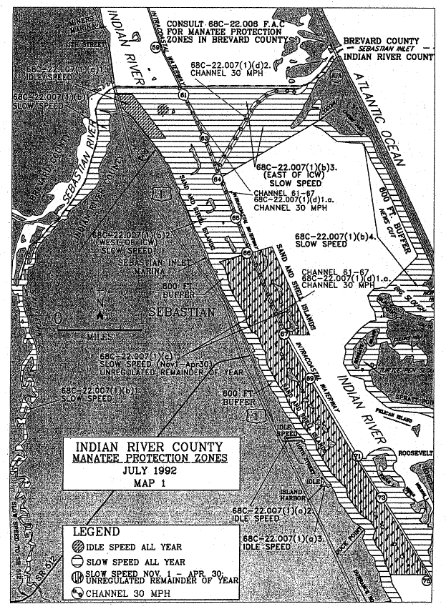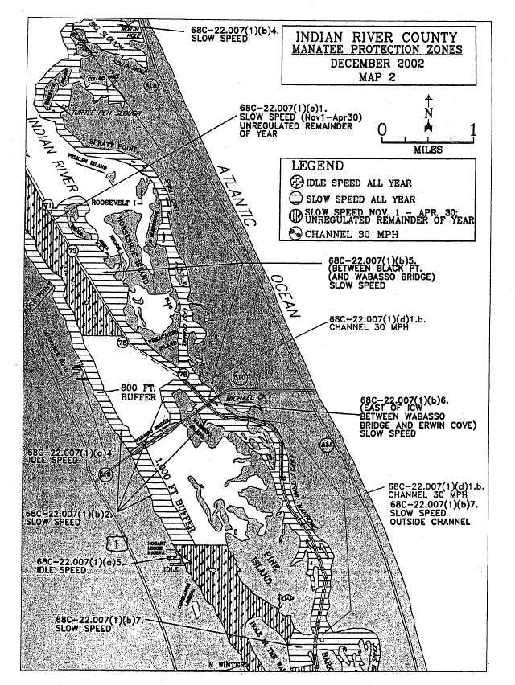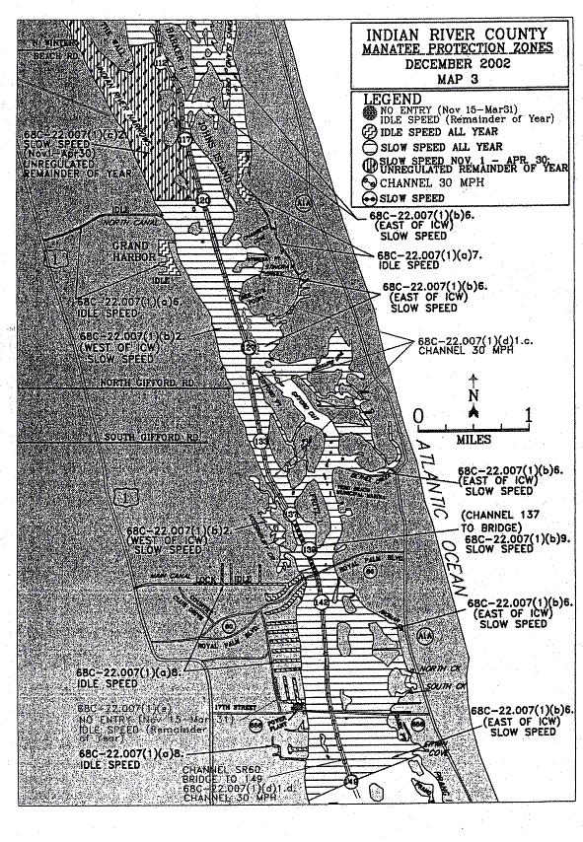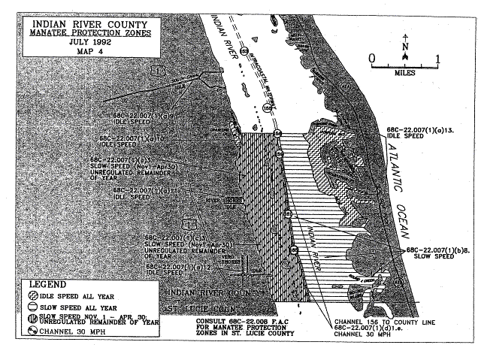
Rulemaking Authority 379.2431(2) FS. Law Implemented 379.2431(2) FS. History–New 3-19-79, Formerly 16N-22.07, Amended 12-3-87, 8-28-90, 10-21-91, 8-18-92, Formerly 16N-22.007, 62N-22.007, Amended 12-12-02.

68C-22.008 St. Lucie County Zones.
(1) The Commission designates those portions of the Indian River and North Fork St. Lucie River, including all associated waters, within St. Lucie County as areas where manatees are frequently sighted. The Commission has further determined that manatees are assumed to inhabit these waters periodically or continuously. This rule is for the purpose of regulating the speed and operation of motorboats in portions of these designated areas in St. Lucie County.
(2) For the purpose of regulating the speed and operation of motorboats within St. Lucie County, the following year-round and seasonal zones are established, which shall include all associated and navigable tributaries, lakes, creeks, coves, bends, backwaters, canals, and boat basins unless otherwise designated or excluded: (Access to the No Entry and Motorboats Prohibited zones designated below in paragraphs (2)(a) and (2)(b), respectively, will be provided in accordance with procedures set forth in subsection (4), hereunder, and applicable provisions under section 68C-22.003, F.A.C.)
(a) No Entry Zone (Year-round) – Harbor Branch Area: Those waters of the Harbor Branch waterway including all associated canals and boat basins westerly of a due south line from the westernmost point of the rail system associated with the hoist on the northern side and near the western end of said Harbor Branch waterway (approximate latitude 27° 32' 03" North, approximate longitude 80° 21' 24" West).
(b) Motorboats Prohibited Zone (November 15 through March 31)/Idle Speed Zone (Remainder of Year) – Moore’s Creek Area: Those waters of Moore’s Creek lying westerly of the general contour of the westerly shoreline of Indian River, and easterly of the centerline of the Indian River Drive Bridge.
(c) Idle Speed Zone (Year-round) –
1. Harbor Branch Area: Those waters of the Harbor Branch waterway including all associated canals and boat basins, westerly of a line drawn across the eastern extremities of the north and south jetties at the entrance of said waterway and easterly of a due south line from the westernmost point of the rail system associated with the hoist on the northern side and near the western end of said Harbor Branch waterway (approximate latitude 27° 32' 03" North, approximate longitude 80° 21' 24" West),
2. Garfield Cut Area: Those waters of Garfield Cut, including the canal system of the Queens Cove residential development and all other associated waters easterly and northeasterly of a line which bears North 11° 00' 00" West from a point on the westerly side of Garfield Point (approximate latitude 27° 30' 54" North, approximate longitude 80° 19' 38" West), with said line running approximately through privately maintained channel marker “8”,
3. Jack Island Area: Those waters lying easterly and northeasterly of Jack Island, northerly of lines which bear North 65° 00' 00" West and North 65° 00' 00" East from the northeasternmost tip of an unnamed mangrove island lying on the south side of Snapper Cut (approximate latitude 27° 29' 17" North, approximate longitude 80° 18' 49" West), and southerly of a line which bears East from the southernmost tip of a peninsula near the north end of the easterly side of Jack Island (approximate latitude 27° 30' 13" North, approximate longitude 80° 18' 33" West), including the waters of the bay immediately west of said peninsula and the canals of Coastal Coves residential area,
4. Ft. Pierce Cut, Wildcat Cove Area: Those waters of Ft. Pierce Cut and Wildcat Cove, including the canal system of the Coral Cove development, northeasterly of a line which bears North 60° 00' 00" West from a point approximately 2640 feet northeasterly of Cook Point on the southeasterly side of the Ft. Pierce Cut (approximate latitude 27°29'08" North, approximate longitude 80° 18' 28" West),
5. North Beach Causeway to Delaware Avenue Area: Those waters of Indian River, westerly of a line 100 feet westerly of and parallel with the westerly boundary of the Atlantic Intercoastal Waterway, southerly of the centerline of the North Beach Causeway Bridge, and northerly of a line which bears South 69° 00' 00" West running through Green Atlantic Intracoastal Waterway Channel Marker “189” (latitude 27° 26' 39" North, longitude 80° 18' 44" West), including those waters of Taylor Creek easterly of the centerline of the North 25th Street Bridge and those waters of Belcher Canal easterly of the salinity control structure located near the North 14th Street Bridge, except as designated for alternative regulation under paragraph (2)(b),
6. Little Mud Creek Area: Those waters of Little Mud Creek, easterly of a line which bears approximately South 27° 00' 00" East from the tip of a peninsula on the northerly shoreline of Little Mud Creek (approximate latitude 27° 22' 38" North, approximate longitude 80° 15' 36" West) to the westernmost tip of a peninsula on the southerly shoreline of Little Mud Creek (approximate latitude 27° 22' 30" North, approximate longitude 80° 15' 33" West), and westerly of the centerline of the US Highway A-1-A Bridge,
7. Big Mud Creek Area: Those waters of Big Mud Creek, easterly of a line which bears North 25° 00' 00" East from the northernmost tip of Herman Bay Point (approximate latitude 27° 20' 58" North, approximate longitude 80° 15' 32" West), and westerly of the centerline of the US Highway A-1-A Bridge.
(d) Slow Speed Zone (Year-round) –
1. Blue Hole Point Area: Those waters of Indian River, channel included, southerly of the Indian River County/St. Lucie County line, and northerly of an East-West line running through Green Atlantic Intracoastal Waterway Channel Marker “173” (latitude 27° 31' 14" North, longitude 80° 20' 18" West), including the waters of Big Starvation Cove, the unnamed backwater northeasterly of Big Starvation Cove in the Northwest 1/4 of Section 3, Township 34 South, Range 40 East, and all the waters of Blue Hole Creek, except as otherwise designated for alternative regulation under subparagraphs (2)(c)1. and (2)(h)1.,
2. Indrio to North Beach Causeway Area: Those waters within 600 feet of the general contour of the westerly shoreline of Indian River, southerly of an East-West line running through Green Atlantic Intracoastal Waterway Channel Marker “173” (latitude 27° 31' 14" North, longitude 80° 20' 18" West), and northerly of the centerline of the North Beach Causeway Bridge,
3. Snapper Cut, Southern Jack Island Area: Those waters of the Indian River within 300 feet of the general contour of the westerly and southwesterly shoreline of Jack Island, southerly and southeasterly of a line which bears West from a point on the westerly shoreline of Jack Island (approximate latitude 27° 29' 38" North, approximate longitude 80° 19' 19" West) and northerly and northwesterly of a line which bears North 41° 00' 00" East from the northwesterly tip (approximate latitude 27° 29' 12" North, approximate longitude 80° 19' 02" West) of the unnamed mangrove island that forms the southern boundary of Snapper Cut; and all waters of Snapper Cut and the Indian River easterly and southeasterly of a line which bears North 41° 00' 00" East from said northwesterly tip of the unnamed mangrove island southerly of Jack Island, southwesterly of a line which bears North 65° 00' 00" West from the northeasternmost tip of said unnamed mangrove island (approximate latitude 27° 29' 17" North, approximate longitude 80°18' 49" West), and northerly of the northern shoreline of said unnamed mangrove island that forms the southern boundary of Snapper Cut,
4. Ft. Pierce Inlet Area: Those waters of Indian River and the Ft. Pierce Inlet, northeasterly of a line 100 feet northeasterly of and parallel with the northeasterly boundary of the main marked channel of the Atlantic Intracoastal Waterway, westerly and northwesterly of a line which bears South from a point on the northerly shoreline of Ft. Pierce Inlet approximately 800 feet southwesterly of the southerly end of Beach Boulevard (approximate latitude 27° 28' 20" North, approximate longitude 80° 17' 45" West), southerly of the centerlines of the North Beach Causeway bridges, and northerly of the general contour of the northerly shoreline of Causeway Island and the centerline of the South Beach Causeway Bridge, except as designated for alternative regulation under subparagraphs (2)(e)2. and (2)(g)1., and excepting the following described waters: Those waters of Indian River southeasterly of the general contour of the southerly shoreline of the North Beach Causeway, northeasterly of a line which bears South 30° 00' 00" East from the southernmost tip of a peninsula near the southwest end of said causeway (approximate latitude 27° 28' 20" North, approximate longitude 80° 19' 14" West), northeasterly of a line which bears North 65° 00' 00" West from a Red Isophase 6 Second Range Light (latitude 27° 28 '02" North, longitude 80° 18' 56" West), northwesterly of a line which bears approximately North 80° 00' 00" East from said Red Isophase 6 Second Range Light, westerly of the general contour of the westerly shoreline of the unnamed mangrove island westerly of the privately maintained channel leading to Jim Island, and southwesterly of a line which bears North 30° 00' 00" West from the northernmost tip of said unnamed mangrove island (approximate latitude 27° 28' 22" North, approximate longitude 80° 18' 40" West); also excepting those waters of Tucker Cove, northwesterly of a line which bears North 30° 00' 00" East from the easternmost tip of Coon Island (approximate latitude 27° 28' 25" North, approximate longitude 80° 17' 55" West), northeasterly of a line which bears approximately North 50° 00' 00" West from said easternmost tip of Coon Island to the easternmost tip of the small unnamed island immediately north of the eastern end of Coon Island, northeasterly of the general contour of the northeasterly shoreline of said unnamed island, and northeasterly of a line which bears approximately North 35° 00' 00" West from the northernmost tip of said unnamed island to the easternmost tip of a peninsula on the westerly shore of Tucker Cove (approximate latitude 27° 28' 34" North, approximate longitude 80° 18' 13" West),
5. Causeway Island Area: Those waters of Indian River northeasterly of a line 100 feet northeasterly of and parallel with the northeasterly boundary line of the main marked channel of the Atlantic Intracoastal Waterway, southerly of the centerline of the South Beach Causeway Bridge and the general contour of the southerly shoreline of Causeway Island, southwesterly of a line 2,500 feet northeasterly of and parallel with said northeasterly boundary line, and northerly of a line which bears North 69° 00' 00" East running through Green Atlantic Intracoastal Waterway Channel Marker “189” (latitude 27° 26' 39" North, longitude 80° 18' 44" West); those waters of Indian River and Faber Cove lying northerly and northeasterly of an East-West line which runs through private red channel marker “12A” (approximate latitude 27° 27' 41" North, approximate longitude 80° 18' 04" West); and those waters of Indian River lying northerly of the northern boundary of the privately maintained channel on the south side of Causeway Island, northeasterly of a line 2,500 feet northeasterly of and parallel with the northeasterly boundary of the main marked channel of said Intracoastal Waterway, southerly and southwesterly of said East-West line which runs through private red channel marker “12A,” and southerly of the general contour of the southerly shoreline of Causeway Island,
6. Delaware Avenue to St. Lucie County/Martin County Line Area: Those waters of Indian River westerly of a line 200 feet southwesterly of and parallel with the southwesterly boundary line of the main marked channel of the Atlantic Intracoastal Waterway, southeasterly of a line which bears South 69° 00' 00" West running through Green Atlantic Intracoastal Waterway Channel Marker “189” (latitude 27° 26' 39" North, longitude 80° 18' 44" West), and northerly of the St. Lucie County/Martin County line,
7. Hook Point to Bear Point Cove Area: Those waters of the Indian River within 1,000 feet of the general contour of the easterly shoreline of said Indian River, southerly of a due West line from a point on said easterly shoreline (approximate latitude 27° 26' 03" North, approximate longitude 80° 17' 51'' West), said point lying approximately 5,800 feet southerly of Hook Point, and northerly and westerly of a line which bears South from the southern tip of Bear Point (approximate latitude 27° 25' 41" North, approximate longitude 80° 17' 18" West); and those waters of Bear Point Cove northerly of a line which bears West from a point located on the easterly shoreline of Indian River (approximate latitude 27° 25' 30" North, approximate longitude 80° 16' 56" West), easterly of a line that bears South from the southern tip of Bear Point (approximate latitude 27° 25' 41" North, approximate longitude 80° 17' 18" West), and northeasterly of a line that bears South 85° 00' 00" East from a point on the aforementioned line bearing South located 1,000 feet southerly of the southerly shoreline of Bear Point to a point on aforementioned line bearing West located 1,000 feet westerly of the easterly shoreline of Indian River,
8. Bear Point Cove to Herman Bay Area: Those waters of the Indian River within 1,000 feet of the general contour of the easterly shoreline of the Indian River, southerly of a line which bears West from a point on the easterly shoreline of the Indian River (approximate latitude 27° 25' 30" North, approximate longitude 80° 16' 56" West), and northerly of a line which bears West from the southernmost tip of a peninsula on the northwesterly shoreline of Herman Bay (approximate latitude 27° 20' 18" North, approximate longitude 80° 14' 55" West); and those waters easterly of a line that bears North 04° 00' 00" East from a point 1,000 feet West of the westernmost tip of Herman Bay Point (approximate latitude 27° 20' 55" North, approximate longitude 80° 15' 36" West) and those waters of Pete Stones Creek and Middle Cove lying southwesterly of the centerlines of the US Highway A-1-A bridges, excepting the waters of Blind Creek and those waters designated for alternative regulation under subparagraphs (2)(c)6. and (2)(c)7.,
9. Nettles Island Area: Those waters of the Indian River, including associated canals and boat basins lying southeasterly of a line which bears South 35° 00' 00" West from the southernmost tip of a mangrove peninsula (approximate latitude 27° 17' 30" North, approximate longitude 80° 13' 40" West) to a point 600 feet northwesterly of the northwest tip of Nettles Island, northeasterly of a line 600 feet southwesterly of and parallel with the general contour of the southwesterly shoreline of Nettles Island, and northerly and northeasterly of a line which bears North 85° 00' 00" West from a point on the easterly shoreline of the Indian River (approximate latitude 27° 16' 03" North, approximate longitude 80° 12' 52" West) to a point 600 feet southwesterly of the southwest tip of Nettles Island; and those waters (including all associated canals and boat basins) lying within 600 feet of the general contour of the easterly shoreline of the Indian River southerly of a line which bears North 85° 00' 00" West from a point on the easterly shoreline of the Indian River (approximate latitude 27° 16' 03" North, approximate longitude 80° 12' 52" West) and northerly of the St. Lucie County/Martin County line,
10. North Fork St. Lucie River Area: Those portions of North Fork St. Lucie River described as follows:
a. Those waters within 600 feet of the general contour of the southwesterly shoreline of said river, northwesterly of the St. Lucie County/Martin County line, and westerly and southerly of a line which bears South from the easternmost tip of the peninsula between North Fork St. Lucie River and Blakeslee Creek (approximate latitude 27° 14' 32" North, approximate longitude 80° 19' 16" West), including all navigable waters of Blakeslee Creek, but excluding the waters of Brill and Winters creeks,
b. Those waters within 600 feet of the general contour of the northeasterly shoreline of said river, northwesterly of the St. Lucie County/Martin County line, and northerly and easterly of a line which bears East 600 feet from the southernmost tip of Greenridge Point (approximate latitude 27° 14' 28" North, approximate longitude 80° 18' 42" West), including all navigable waters of Howard Creek,
c. Those waters of Kitching Cove northwesterly of a line which bears North 60° 00' 00" East from the easternmost tip of a peninsula on the westerly shore of Kitching Cove (approximate latitude 27° 14' 44" North, approximate longitude 80° 19' 17" West),
d. Those waters of C-24 Diversion Canal westerly of the centerline of the Florida Turnpike (Sunshine State Parkway) and easterly of the canal control structure located approximately 2,100 feet westerly of said centerline,
e. Those waters within 1,300 feet downstream and 1,800 feet upstream of said river’s confluence with C-24 Diversion Canal; those waters of the C-24 Diversion Canal easterly of the centerline of the Southbend Boulevard Bridge; and all waters of Mud Cove and Long Creek, including the canal north of Port St. Lucie Boulevard that connects Long Creek to said river,
f. Those waters westerly of approximate longitude 80° 19' 05" West, northerly of approximate latitude 27° 18' 07" North, southerly of approximate latitude 27° 18' 15" North, and easterly of Coral Reef Street, including the waters of the creek and canal easterly of Coral Reef Street,
g. Those waters within 1,000 feet upstream and 2,300 feet downstream of said river’s confluence with the waterway lying south of Calmosa Drive, including said waterway and the waterway lying west of Degan Drive,
h. Those waters northeasterly of the south end of the cut through located approximately 1,000 feet northwesterly of the centerline of the Prima Vista Boulevard Bridge and those waters easterly and northeasterly of the north end of said cut through located approximately 2,300 feet northwesterly of said centerline,
i. All other navigable side creeks and canals not described above or otherwise designated (as depicted on Maps 5-8).
(e) Slow Speed Zone (November 15 through April 30)/Maximum 30 MPH Speed Zone (Remainder of Year) –
1. Intracoastal Waterway, Ft. Pierce Inlet Area: That portion of the main marked channel of the Atlantic Intracoastal Waterway, and those waters within 100 feet of the eastern and western boundaries of said channel, southeasterly of the centerline of the North Beach Causeway Bridge, and northerly of a line which bears North 69° 00' 00" East running through Green Atlantic Intracoastal Waterway Channel Marker “189” (latitude 27° 26' 39" North, longitude 80° 18' 44" West); and,
2. Shark Cut, Ft. Pierce Inlet Area: That portion of Shark Cut (Swash Channel) within the channel to be marked by local government (said marked channel to generally follow the contours of the natural channel and not to exceed 250 feet in width), northwesterly of the northern boundary line of the main marked east-west channel leading out of Ft. Pierce Inlet and southeasterly of the northeastern boundary of the main marked channel of the Atlantic Intracoastal Waterway.
(f) Slow Speed Zone (November 15 through April 15) – Fish House Cove Area: Those waters of Indian River and Fish House Cove easterly and northeasterly of a line 100 feet easterly of and parallel with the northeasterly boundary of the main marked channel of the Atlantic Intracoastal Waterway, southerly of an East-West line running through Green Atlantic Intracoastal Waterway Channel Marker “173” (latitude 27° 31' 14" North, longitude 80° 20' 18" West), westerly of the general contour of the easterly shoreline of the Indian River and Fish House Cove and a line which bears North 11° 00' 00" West from a point on the westerly side of Garfield Point (approximate latitude 27° 30' 54" North, approximate longitude 80° 19' 38" West), northerly of the general contour of the southerly shoreline of Fish House Cove and the northwesterly shoreline of an unnamed island on the north side of Old Inlet and a line which bears North 45° 00' 00" East from the northernmost tip of said unnamed island (approximate latitude 27° 30' 22" North, approximate longitude 80° 19' 39" West), and northerly and northwesterly of a line which bears South 71° 00' 00" West from a point on the southwestern shoreline of last said unnamed island (approximate latitude 27° 30' 10" North, approximate longitude 80° 19' 43" West), including the waters of the privately maintained channel leading into Garfield Cut from a line 100 feet northeasterly of and parallel with the northeasterly boundary of the main marked channel of the Atlantic Intracoastal Waterway, except as designated for alternative regulation under subparagraph (2)(c)2.
(g) Maximum 25 MPH Speed Zone (Year-round) –
1. Coon Island, Jim Island Area: That portion of the privately maintained channel westerly of Coon Island and southerly and easterly of Jim Island, northerly and northwesterly of a line bearing North 67° 00' 00" East from Green Beacon “5” (approximate latitude 27° 28' 08" North, approximate longitude 80° 18' 28" West) and southerly and southeasterly of a line bearing East from Green Beacon “11” (approximate latitude 27° 28' 41" North, approximate longitude 80° 18' 38'' West); and,
2. North Fork St. Lucie River, North of Port St. Lucie Boulevard Area: Those waters of North Fork St. Lucie River, Five Mile Creek and Ten Mile Creek lying between the general contour of the shorelines (excepting associated and navigable tributaries, oxbows, lakes, creeks, coves, backwaters, canals and boat basins, and those waters designated for alternative regulation under subparagraph (2)(d)10.), northerly of approximate latitude 27° 18' 15" North, including those waters of the cut-through beginning at a point located approximately 1,000 feet northeasterly of the centerline of Prima Vista Boulevard and terminating at a point approximately 2,300 feet northwesterly of said centerline (as depicted on Maps 6-8).
(h) Maximum 30 MPH Speed Zone (Year-round) –
1. Blue Hole Point Area: That portion of the main marked channel of the Atlantic Intracoastal Waterway and those waters within 100 feet of the eastern and western boundaries of said channel, southerly of the Indian River County/St. Lucie County line, and northerly of a line which bears North 77° 00' 00" East running through Green Atlantic Intracoastal Waterway Channel Marker “171” (latitude 27° 32' 10" North, longitude 80° 20' 33" West); and,
2. North Fork St. Lucie River, Greenridge Point to Port St. Lucie Boulevard Area: Those waters of the North Fork St. Lucie River lying between the general contour of the shorelines of the river (excepting associated and navigable tributaries, oxbows, lakes, creeks, coves, backwaters, canals and boat basins, and those waters designated for alternative regulation under subparagraph (2)(d)10.), northerly of a line which bears East from the easternmost tip of the peninsula between North Fork St. Lucie River and Blakeslee Creek (approximate latitude 27° 14' 32" North, approximate longitude 80° 19' 16" West), and southerly of approximate latitude 27° 18' 07" North (as depicted on Maps 5-6).
(3) For the purpose of exempting qualifying commercial fishermen and professional fishing guides from certain speed zone restrictions, as provided under subsection 68C-22.003(6), F.A.C., the following limitations and procedures for exemption application shall apply:
(a) Exemptions shall be considered seasonally or year-round in zones, or portions of zones, described under subparagraphs (2)(d)1. through (2)(d)9. and under paragraph (2)(f).
(b) A recipient of an exemption must maintain speeds of 20 MPH or less at all times within the restricted area and comply with all conditions specified within the notice of exemption, under the provisions of this rule or subsection 68C-22.003(6), F.A.C.
(c) Exemptions granted will not apply on weekends and state-recognized holidays.
(d) Any commercial fisherman or professional fishing guide fulfilling the requirements set forth under subsection 68C-22.003(6), F.A.C. shall be considered for an exemption, one of which shall be required for each vessel so operated, by completing the application form specified. Applications for exemption in accordance with the provisions of this rule may be obtained from the Fish and Wildlife Conservation Commission, Division of Law Enforcement Office, 1300 Marcinski Road, Jupiter, FL 33477 (telephone (407)624-6935).
(4) Access to the No Entry and Motorboats Prohibited zones designated in paragraphs (2)(a) and (2)(b), above, will be allowed as follows:
(a) Research vessels affiliated with the Harbor Branch Oceanographic Institute will be authorized access to the No Entry zone designated in paragraph (2)(a), for ingress and egress purposes only, in accordance with applicable provisions of Rule 68C-22.003, F.A.C.
(b) Operators of sailboats who are leasing dock space from the public marina within the seasonal Motorboats Prohibited zone designated in paragraph (2)(b), will be authorized access to said dock space for ingress and egress purposes only, in accordance with subsection 68C-22.003(5), F.A.C.
(c) Exemptions for access to the zones designated in paragraphs (2)(a) and (2)(b), if applied for and granted, will be issued to the owners of the respective upland facilities, with guest passes being issued for individual vessels. The owner/operator of the upland facility shall be responsible for issuing guest passes to operators of vessels prior to said vessels entering the respective zones and shall be responsible for informing recipients of guest passes of all applicable restrictions and requirements. For identification purposes, guest passes must be prominently displayed on the vessel while the vessel is within the subject restricted area.
(d) Operators of vessels within the zones designated in paragraph (2)(a) or (2)(b), are to take extreme care while operating within the zones so as not to, either intentionally or negligently, molest, harass, injure, or otherwise harm manatees. Operators will not be held harmless from any actions on their part that result in the harassment, injury or death of a manatee while operating their vessels within these zones.
(5) The zones described in subsection 68C-22.008(2), F.A.C., are depicted on the following maps, labelled “St. Lucie County Manatee Protection Zones” and dated July 1994, which shall replace all previously published maps. Maps provided are intended as depictions of the above-described zones. In the event of conflict between the two, the above descriptions shall prevail.
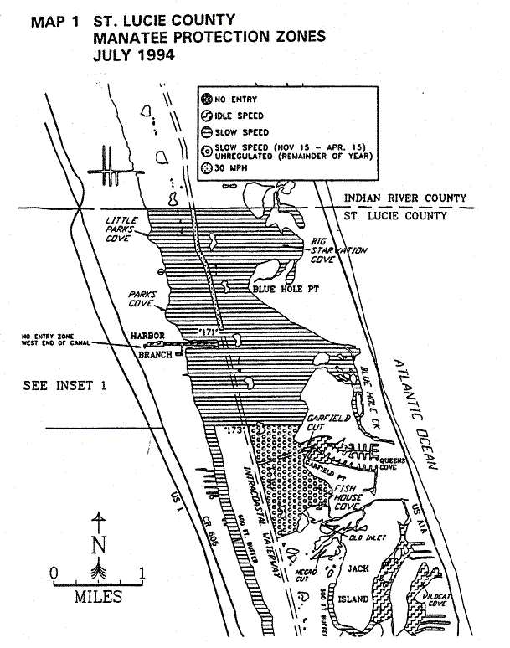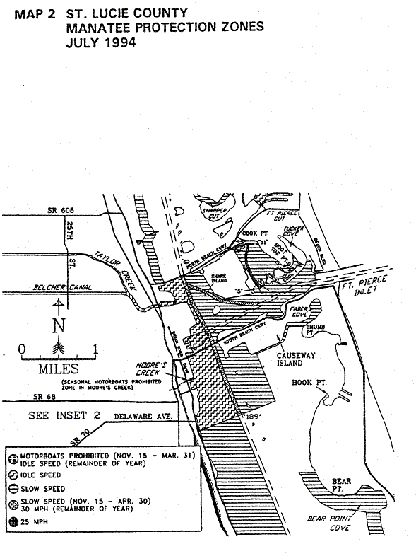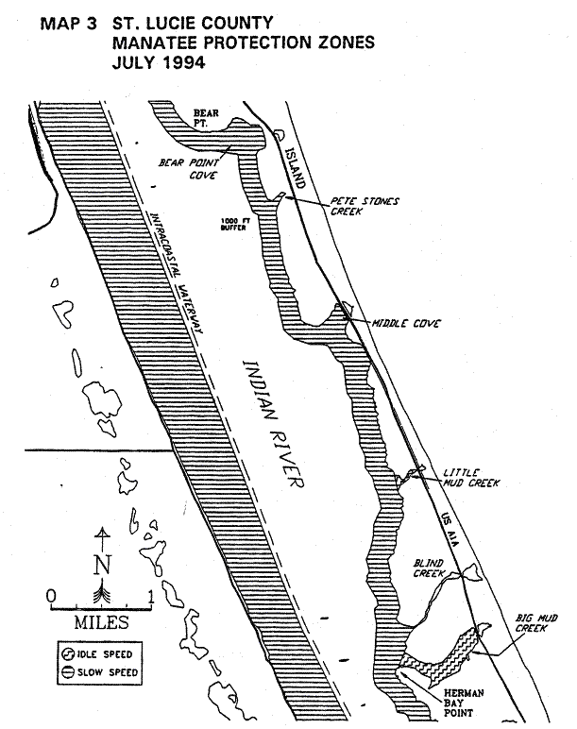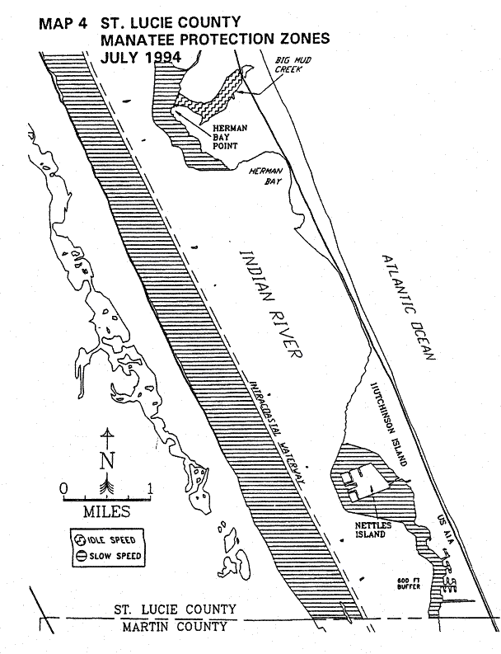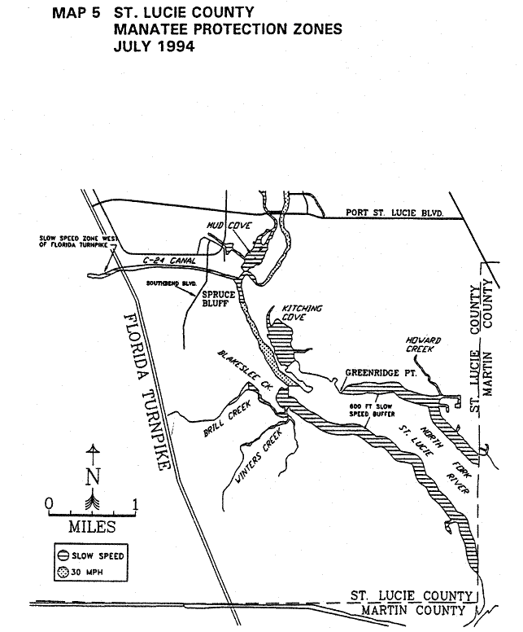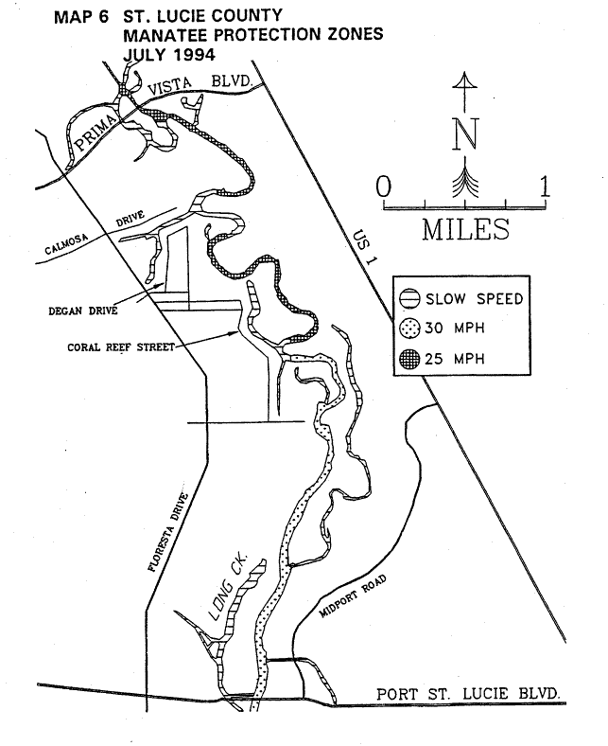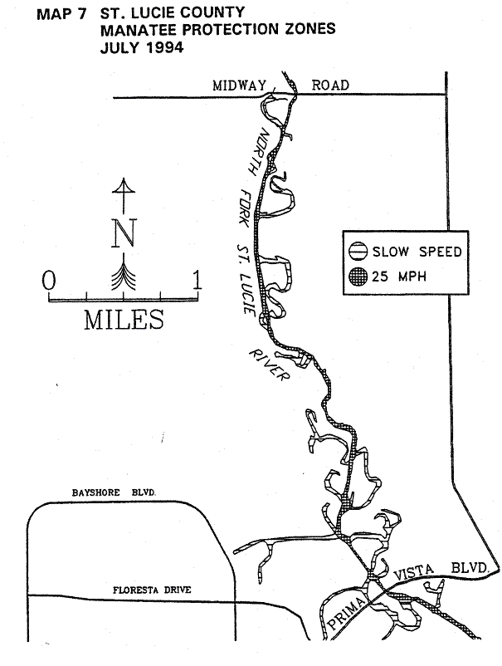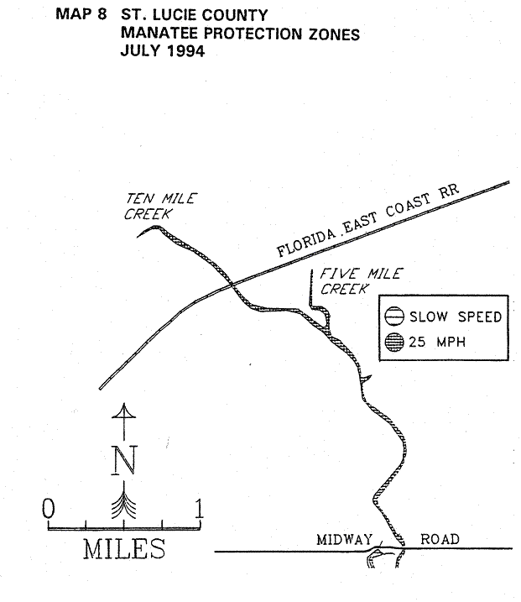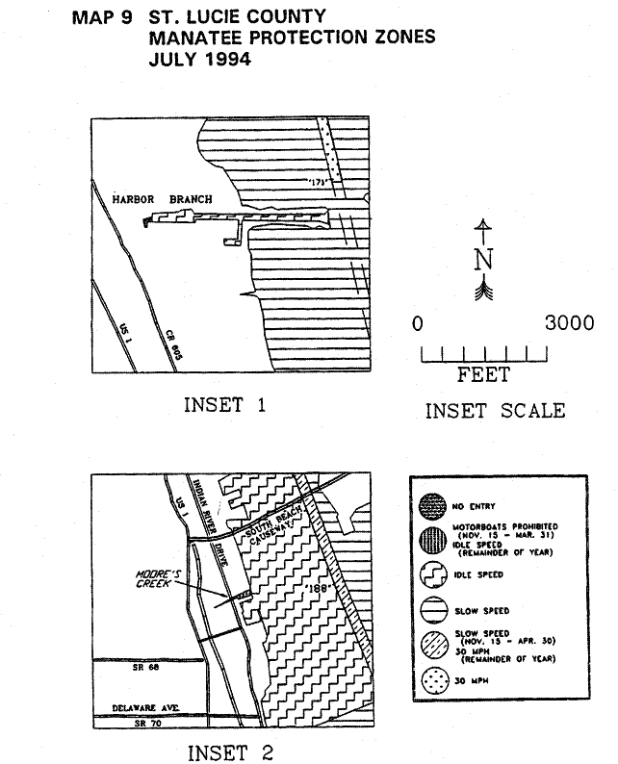
Rulemaking Authority 370.12(2)(f), (n), (o) FS. Law Implemented 370.12(2)(f), (4)(n), (o) FS. History–New 3-19-79, Formerly 16N-22.08, Amended 8-16-94, Formerly 16N-22.008, 62N-22.008.

68C-22.009 Palm Beach County Zones.
(1) For the purpose of regulating the speed and operation of motorboat traffic within the following manatee protection areas between the dates of November 15 and March 31 of each year, paragraphs (b), (d), and (e); year-round but seasonally-differentiated, paragraph (g); and year-round, paragraphs (a), (c), and (f), the Palm Beach County manatee protection zones are established as follows:
(a) Idle Speed Zone (Year-round) –
1. All waters along the westerly side of Lake Worth, bounded to the north by the southern edge of the Port of Palm Beach Turning Basin, and that line representing its westward extension, west to the mainland; bounded to the south by an east-west line one mile south of an east-west line drawn along the southern end of Peanut Island; bounded to the east by the western boundary of the marked channel of the Atlantic Intracoastal Waterway; and bounded to the west by the western shoreline of Lake Worth, unless otherwise designated under paragraph (1)(e).
2. All waters within 300 feet of the general contour of the shoreline, including associated backwaters and canals, along the easterly side of Lake Worth from a straight line drawn from Lake Worth Inlet channel flashing red marker “10” through flashing green marker “9” and southeasterly extension thereof, southeasterly to the shore of Palm Beach Island, south to an east-west line one mile south of an east-west line drawn along the southern end of Peanut Island, excluding that partially marked navigation channel south of Lake Worth Inlet along the easterly side of Lake Worth, running from daymark R “2” to daymark R “6” and thence southerly, paralleling the eastern shoreline (except as designated under paragraph (1)(b), for seasonal regulation).
3. All waters with a northerly limit being a line drawn perpendicular to the centerline of the Atlantic Intracoastal Waterway at the northerly end of the fender system of the SR 707 Bridge, the easterly limit being a due north line drawn across Jupiter Inlet from the western tip of the jetty at DuBois Park to the southwest corner of Jupiter Island (and including the small waterbody immediately adjacent to and southerly of said jetty), the westerly limit being a line drawn perpendicular to the channel of the Loxahatchee River at the northwest end of the fender system of the Florida East Coast Railroad Bridge adjacent to the SR 811 (Alternate A-1-A) Bridge, and the southerly limit being a line drawn perpendicular to the channel of the Atlantic Intracoastal Waterway at the southerly end of the fender system of the SR 706 (Indiantown Road) Bridge, including all waters of and tributaries to Sawfish Bay and the Jupiter River, and excluding the main marked channel of the Atlantic Intracoastal Waterway.
(b) Idle Speed Zone (Seasonal) – All waters of Lake Worth bounded to the north by a line drawn from Lake Worth Inlet channel flashing red marker “10” running westerly along the line of channel markers marking the northern edge of the Port of Palm Beach Turning Basin and westerly extension thereof, westward to the mainland; bounded to the northeast by a straight line drawn from flashing red marker “10” through flashing green marker “9” and southeasterly extension thereof, southeasterly to the shoreline of Palm Beach Island; bounded to the east by the eastern shoreline of Lake Worth; bounded to the west by the western shoreline of Lake Worth; and bounded to the south by an east-west line one mile south of an east-west line drawn along the southern end of Peanut Island, which are not otherwise designated under paragraph (1)(e).
(c) Slow Speed (Year-round) –
1. All waters from a line drawn perpendicular to the centerline of the Atlantic Intracoastal Waterway at the north end of the fender system of the Palmetto Park Road Bridge, southward to the south end of the fender system of the Camino Real Boulevard Bridge southerly of Lake Boca Raton, including all of Lake Boca Raton eastward to the Ocean Avenue (SR A-1-A) Bridge over the Boca Raton Inlet.
2. All waters from marker “56” (lat 26° 22' 26.380" N, long 80° 04' 25.390" W) in the northerly end of Lake Wyman southward to marker “63” (lat 26° 21' 38.240" N, long 80° 04’ 25.670” W).
3. All waters along the westerly side of Lake Worth, bounded to the north by an east-west line one mile south of an east-west line drawn along the southern end of Peanut Island; bounded to the east by the western boundary of the marked channel of the Atlantic Intracoastal Waterway; bounded to the south by the Flagler Memorial Bridge (A1A); and, bonded to the west by the western shoreline of Lake Worth.
4. All waters within 300 feet of the general contour of the shoreline from an east-west line one mile south of an east-west line drawn along the southern end of Peanut Island south to the Lantana Avenue (SR 812) Bridge in Lantana, including those nearshore waters within 300 feet of all islands, whether natural or manmade; excluding (a) the main marked channel of the Atlantic Intracoastal Waterway, and (b) that partially marked navigation channel south of Lake Worth Inlet along the easterly side of Lake Worth, running from daymark R “2” to daymark R “6” and thence southerly, paralleling the eastern shoreline, south to Flagler Memorial Bridge.
5. All waters within 300 feet of the general contour of the shoreline in the Loxahatchee River, including associated backwaters and canals, from a line drawn perpendicular to the centerline of the Loxahatchee River at the northwest end of the fender system of the Florida East Coast Railroad Bridge adjacent to the SR 811 (Alternate A1A) Bridge westward to the Loxahatchee River Road Bridge (easterly end of the C-18 Canal) on the Southwest Fork, to the Martin County/Palm Beach County line on the Northwest Fork, and to the Tequesta Drive Bridge on the North Fork.
6. All waters from the Martin County/Palm Beach County line southerly to a line drawn perpendicular to the centerline of the Atlantic Intracoastal Waterway at the northerly end of the fender system of the SR 707 Bridge, excluding the main marked channel of the Atlantic Intracoastal Waterway.
7. All waters within 300 feet of the general contour of the shoreline in the northerly end of Lake Worth from the A1A Bridge south to the Blue Heron Boulevard Bridge, excluding the main marked channel of the Atlantic Intracoastal Waterway, and including all associated backwaters and canals and the shorelines of Munyon Island and Little Munyon Island, and the shorelines of all other islands, whether natural or manmade (unless otherwise designated), and including the additional waters described as follows:
a. All waters bounded: on the northwest by a line from the northerly end of Munyon Island northeasterly to the eastern shore of Lake Worth, measured along a perpendicular to said eastern shore; on the west by the eastern shores of Munyon Island and Little Munyon Island, by a line drawn between them at the shortest distance, and by a line drawn from the southerly end of Little Munyon Island to the westerly extension of Pine Point Road (where said westerly extension intersects the eastern shoreline of Lake Worth); and on the southerly and easterly by the shoreline of Lake Worth including the shallow northerly extension of these waters lying easterly of A-1-A and southerly of Turtle Beach Road.
b. All waters northerly of the Blue Heron Boulevard (or Riviera Beach) Bridge, westerly of the marked channel of the Intracoastal Waterway, and southerly of a line drawn from marker “32” (lat 26° 47' 44" N, long 80° 02' 51.5" W), west to the mainland.
8. All waters within 300 feet of the general contour of the shoreline, including associated backwaters and canals, along the easterly side of Lake Worth from the Blue Heron Boulevard Bridge south to a straight line drawn from Lake Worth Inlet channel flashing red marker “10” through flashing green marker “9” and southeasterly extension thereof, southeasterly to the shore of Palm Beach Island, including those nearshore waters within 300 feet of Peanut Island and all other islands, whether natural or manmade; excluding:
a. The Lake Worth Inlet easterly of a line running southward from the southwest corner of Singer Island to the southern shore of the Inlet,
b. The Lake Worth Inlet Channel westerly of said line; and,
c. The main marked channel of the Atlantic Intracoastal Waterway.
9. All waters within 300 feet of the general contour of the shoreline (including the shoreline of all islands, whether natural or manmade), excluding the main marked navigation channel of the Atlantic Intracoastal Waterway, and including associated backwaters and canals, on the westerly side of Lake Worth from the Blue Heron Boulevard Bridge south to a line of channel markers marking the northern boundary of the Port of Palm Beach Turning Basin, and westward extension thereof.
10. All waters, including associated backwaters, from the Lantana Avenue Bridge (SR 812) in Lantana south to an east-west line running through flashing red marker “52” approximately 0.6 mile northerly of the East Ocean Avenue Bridge in Boynton Beach, excluding:
a. The Atlantic Intracoastal Waterway channel,
b. The area within 300 feet westerly of the western boundary of the Atlantic Intracoastal Waterway channel northerly of an east-west line running through flashing red marker “48”,
c. The area within 300 feet east of the eastern boundary of the Intracoastal Waterway channel from 300 feet southerly of the southerly end of Hypoluxo Island to an east-west line drawn along the northern edge of Pine Island (or “Beer Can Island”),
d. The portion of the backwater area to the east of Hypoluxo Island designated under sub-subparagraph (1)(c)11.g.; and,
e. The marked east-west channel of Boynton Inlet from its confluence with the Atlantic Ocean west to the marked channel of the Atlantic Intracoastal Waterway.
11. All waters within 50 feet of the general contour of the shoreline, including associated backwaters and canals unless otherwise designated, and excluding the marked navigation channel of the Atlantic Intracoastal Waterway, as follows:
a. In Lake Worth Creek from the Indiantown Bridge (SR 706) southward to its confluence with Lake Worth,
b. In Little Lake Worth,
c. From an east-west line running through flashing red marker “52” approximately 0.6 mile northerly of the East Ocean Avenue Bridge in Boynton Beach southward to marker “56” (lat 26° 22' 26.380" N, long 80° 04' 25.390" W), in the northerly end of Lake Wyman in Boca Raton,
d. From the south end of the fender system of the Camino Real Boulevard Bridge southerly of Lake Boca Raton southward approximately 1.3 miles to the Palm Beach County/Broward County line,
e. Along the northerly (Palm Beach County) side of the Hillsboro Canal (separating Palm Beach and Broward counties) from the Atlantic Intracoastal Waterway west to the west side of Military Trail (SR 809),
f. That portion of the El Rio Canal from its intersection with the Hillsboro Canal north to SR 798,
g. Those backwaters east of Hypoluxo Island from the Lantana Avenue Bridge to a line 50 feet northerly of the north end of the island lying easterly of the southerly end of Hypoluxo Island; and,
h. From a line drawn perpendicular to the centerline of the Atlantic Intracoastal Waterway running through marker “63” southward to a line drawn perpendicular to the centerline of the Atlantic Intracoastal Waterway at the north end of the fender system of the Palmetto Park Road (SR 798) Bridge.
12. All waters within the C-18 Canal from the Loxahatchee River Road Bridge westward to Structure S-46.
13. All backwaters, canals and tributaries off of Lake Worth Creek, including those waterbodies known as Jonathan’s Landing, Admiral’s Cove, and Frenchman’s Creek.
14. All waters from the northerly confluence of the North Palm Beach Waterway and Lake Worth Creek (Intracoastal Waterway) southward in the North Palm Beach Waterway to its confluence with the C-17 Canal (Earman River), westward in the C-17 Canal to the saltwater intrusion dam (S-44) approximately 4,100 feet west of the intersection of the North Palm Beach Waterway and the C-17 Canal, and eastward in the C-17 Canal to its confluence with Lake Worth, inclusive of all connecting waters southerly of the confluence of the North Palm Beach Waterway and the C-17 Canal.
15. All waters within the backwater area northerly of the Spanish River Boulevard Bridge in Boca Raton, westerly of the Atlantic Intracoastal Waterway, and southerly of NE 51st Street and easterly extension thereof.
16. All waters of the North Fork of the Loxahatchee River from the Tequesta Drive Bridge north to the Martin County/Palm Beach County line, excluding the main marked navigation channel.
17. All waters of the West Palm Beach (C-51) Canal easterly of US 1 (Structure S-155) to its confluence with the Atlantic Intracoastal Waterway.
18. All waters of the Boynton (C-16) Canal easterly of US 1 (Structure S-41) to its confluence with the Atlantic Intracoastal Waterway.
19. All waters of the C-15 Canal easterly of US 1 (Structure S-40) to its confluence with the Atlantic Intracoastal Waterway.
(d) Slow Speed (Seasonal) –
1. All waters southerly of an east-west line parallel to and one mile south of an east-west line drawn along the southern end of Peanut Island and northerly of an east-west line parallel to and 1.75 miles south of an east-west line drawn along the southern end of Peanut Island.
2. All waters of the Loxahatchee River from the northwesterly end of the fender system of the Florida East Coast Railroad Bridge adjacent to the SR 811 (Alternate A1A) Bridge westward up the river and northwesterly to the Palm Beach County/Martin County line, excluding the main (posted) navigation channel to within one-eighth (1/8) mile westerly of the northwesterly end of the fender system of the Florida East Coast Railroad Bridge.
3. All waters of the North Fork of the Loxahatchee River from its confluence with the Loxahatchee River north to the Tequesta Drive Bridge, excluding the main (posted) navigation channel.
4. All waters of the Southwest Fork of the Loxahatchee River from its confluence with the Loxahatchee River west to the Loxahatchee River Road Bridge.
5. All waters within 100 feet of the general contour of the north and south shores of Jupiter Inlet respectively from a north-south line drawn through the westerly ends of the Jupiter Inlet concrete seawalls, located approximately 600 feet west of the inlet’s confluence with the Atlantic Ocean at the southeastern tip of Jupiter Island, westerly to a north-south line drawn from the western tip of the jetty at DuBois Park to the southwest corner of Jupiter Island, excluding those waters lying waterward of each of two east-west lines drawn from the westerly ends of said seawalls westward to their point of intersection with the above-described 100-foot shoreline boundary.
6. All waters of Lake Worth bounded to the north by an east-west line drawn perpendicular to the centerline of the Atlantic Intracoastal Waterway at the north shoreline of Phil Foster Island approximately 650 feet north of the centerline of the Blue Heron Boulevard (Riviera Beach) Bridge; bounded to the east by the eastern shoreline of Lake Worth; bounded to the west by the western shoreline of Lake Worth; bounded to the south by a line drawn from flashing red marker “10” running westerly along the line of channel markers marking the northern edge of the Port of Palm Beach Turning Basin and westerly extension thereof, westward to the mainland, and bounded to the southeast by a straight line drawn from flashing red marker “10” through flashing green marker “9,” and southerly extension thereof, southeasterly to the shore of Palm Beach Island, excluding those waters within the Lake Worth Inlet easterly of a line running southward from the southwest corner of Singer Island to the southern shore of the inlet.
(e) Motorboats Probitied Zone. – All waters lying within Lake Worth, commencing at a point exactly 300 feet north of the northeast corner of the Riviera Beach Power Plant discharge canal, thence easterly to a point 100 feet west of the western boundary of the Intracoastal Waterway channel, lying within Township 42 South and Range 43 East; thence running southerly parallel to and 100 feet west of the western boundary of the Intracoastal Waterway channel for a distance of 700 feet to a point within Township 43 South and Range 43 East; thence westerly to the shoreline to a point 300 feet south of the southeast corner of the discharge canal; thence northerly 300 feet to the southeast corner of the discharge canal; thence westerly 150 feet, northerly 100 feet, and easterly 150 feet to the northeast corner of the discharge canal (inclusive of the entire waterbody comprising the Riviera Beach Power Plant discharge canal); thence northerly 300 feet to the point of origin. The precise boundaries and effective period of the zone will be posted each year between November 15 and March 31.
(f) Maximum 25 MPH Zone (Year-round) – All waters as described below: That portion of the main marked channel of the Atlantic Intracoastal Waterway from the Martin County/Palm Beach County line southerly to a line drawn perpendicular to the centerline of the Atlantic Intracoastal Waterway at the northerly end of the fender system of the SR 707 Bridge.
(g) Maximum 30 MPH Zone (June 1 through September 30)/Maximum 25 MPH Zone (Remainder of Year) – All waters as described below, except where otherwise designated or posted for more restrictive regulation for the purpose of manatee protection or boating safety:
1. That portion of the Atlantic Intracoastal Waterway, to within 50 feet of the general contour of the shoreline and including the main marked channel, from a line drawn perpendicular to the centerline of the Atlantic Intracoastal Waterway at the south end of the fender system of the State Road 706 (Indiantown) Bridge southerly to the intersection of Lake Worth Creek and Lake Worth,
2. That portion of the Atlantic Intracoastal Waterway, to within 50 feet of the general contour of the shoreline and including the main marked channel, from an east-west line running through flashing red marker “52” southerly to the Palm Beach County/Broward County line; and,
3. That portion of the marked channel of the Atlantic Intracoastal Waterway east of Boynton Canal from an east-west line running through flashing red marker “48” southerly to an east-west line running through flashing red marker “52.”
(2) Any races involving power-driven vessels within areas designated for regulation under the provisions of this rule shall be approved by all appropriate permitting agencies including but not limited to the U.S. Coast Guard, and shall receive prior approval from the Commission.
(3) Regulations restricting motorboat speed and operation, as set forth herein, are not intended to supersede any existing regulations duly established by federal, state, or local authority which are more restrictive in nature. Where differing regulations exist, regulatory markers posted shall reflect the most restrictive requirement. Permitted markers as posted are presumptive evidence of zone boundaries, as intended.
(4) Those waters designated under subparagraphs (1)(a)1. and 2., paragraph (1)(b), subparagraphs (1)(c)3., 4., 8. and 9., and (1)(d)1. and 6., wherein protection zones were previously established and enforced (as adopted March 19, 1979), shall remain unaffected by exemption provisions for the purpose of boat/motor testing as set forth under subsection 68C-22.003(7), F.A.C.
(5) The zones described in subsection 68C-22.009(1), F.A.C., herein are depicted on the following maps, labeled “Palm Beach County Manatee Protection Zones, Map A through Map F” dated November 1990, on a map labeled “Palm Beach County, 25-MPH Manatee Protection Zones, Jupiter Sound Area” dated February 1991, and on three maps labeled “Palm Beach County 25 MPH and Summer Season 30 MPH Manatee Protection Zones” with each respectively depicting the “Lake Worth Creek Area” and “Southern ICW Area (Maps 1 and 2)” dated March 1993, the latter three of which shall replace the three previously published maps labeled “Palm Beach County, 25-MPH Manatee Protection Zones” dated February 1991 and respectively depicting the “Lake Worth Creek Area” and Southern ICW Area (Maps 1 and 2): (Maps provided herewith are intended as depictions of the above-described zones. In the event of conflict between the two, the above descriptions shall prevail.)
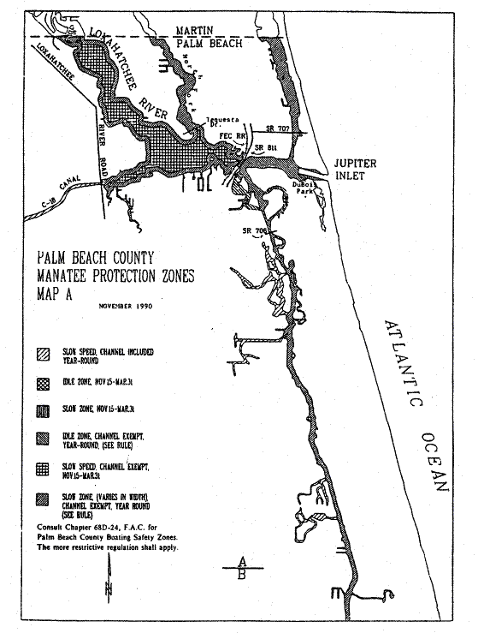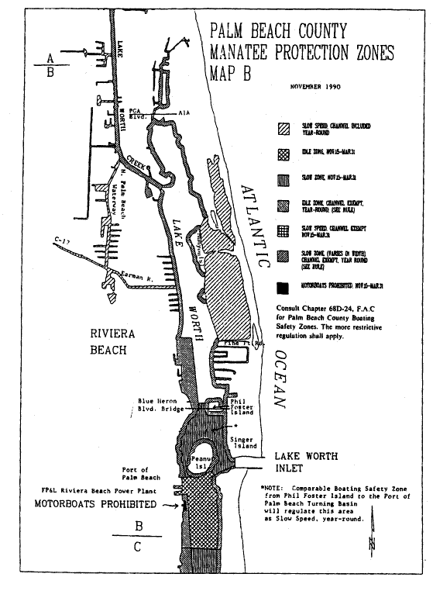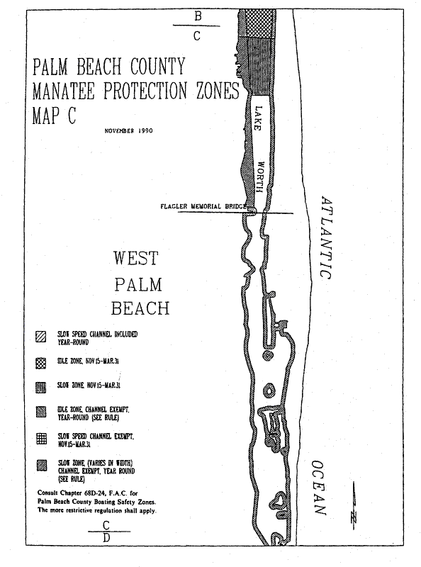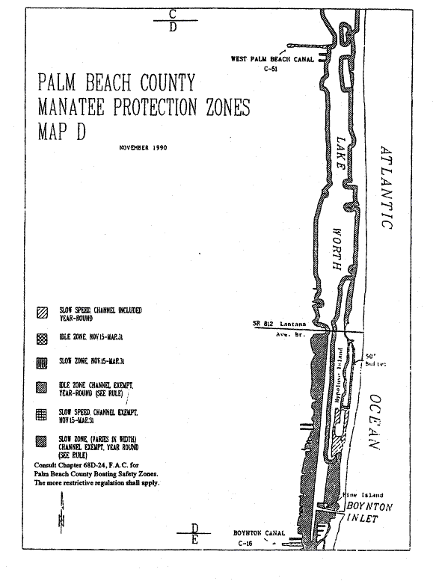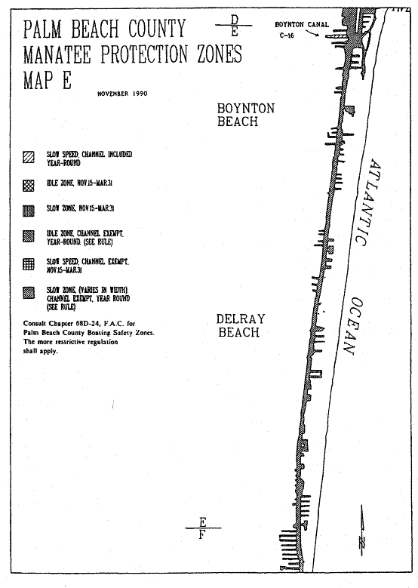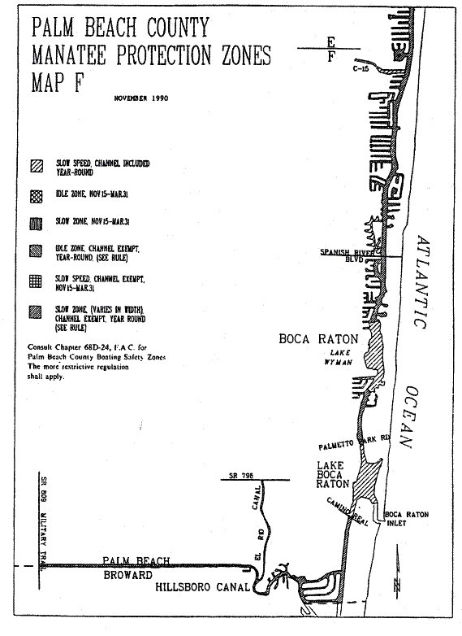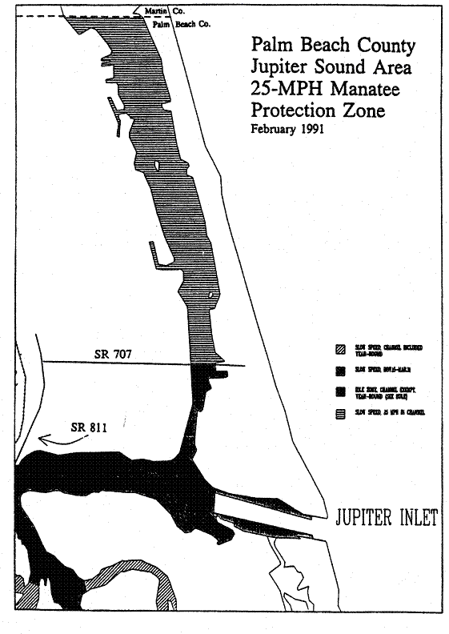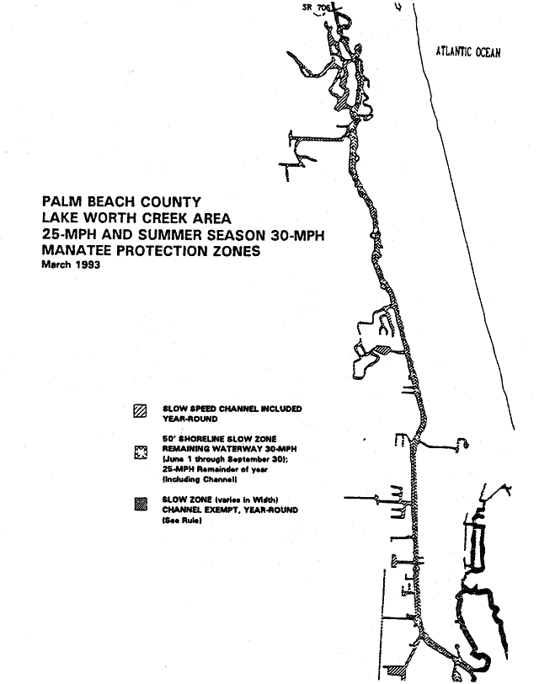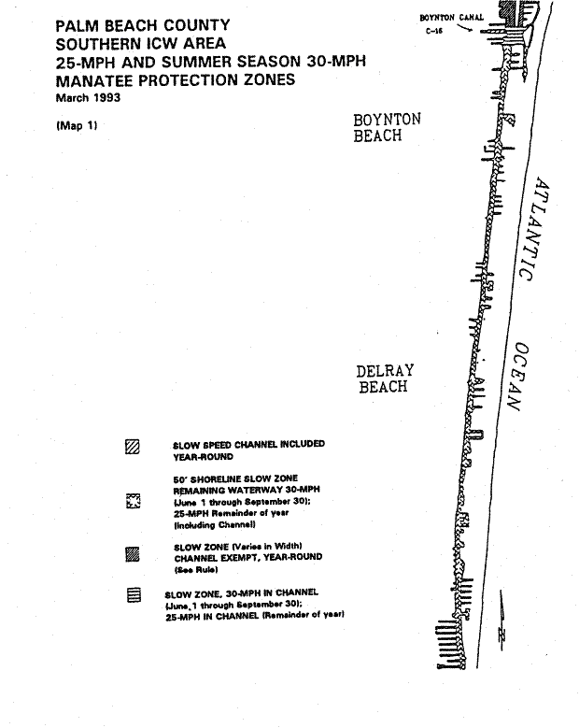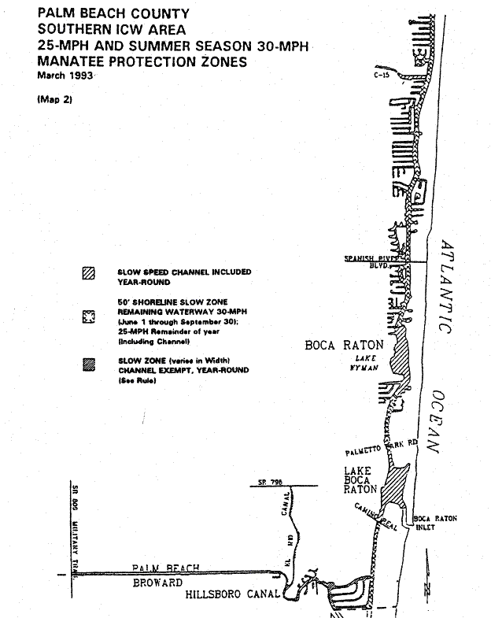
Rulemaking Authority 370.12(2)(n) FS. Law Implemented 370.12(2)(n) FS. History–New 3-19-79, Formerly 16N-22.09, Amended 2-15-90, 12-24-90, 3-13-91, 7-20-93, Formerly 16N-22.009, 62N-22.009.

68C-22.010 Broward County Zones.
(1)(a) The Commission hereby designates the waters within Broward County, as described below, as areas where manatee sightings are frequent and where the best available information supports the conclusion that manatees inhabit these areas on a regular or periodic basis. The primary purpose of this rule is to protect manatees from harmful collisions with motorboats and from harassment by establishing safe havens and regulating the speed and operation of motorboats within these designated areas. A secondary purpose is to protect manatee habitat.
(b) In consideration of balancing the rights of fishers, boaters, and water skiers to use the waters of the state for recreational and commercial purposes (as applicable under Section 379.2431(k), F.S.), with the need to provide manatee protection, the Commission has examined the need for limited lanes, corridors, or unregulated areas that allow higher speeds through or within regulated areas. Such lanes, corridors, or areas are provided in those locations where the Commission determined they are consistent with manatee protection needs.
(2) The following year-round and seasonal zones are established, which exclude all associated and navigable tributaries, lakes, creeks, coves, bends, backwaters, canals, channels and boat basins, and other waterways unless otherwise designated or specifically described for inclusion. Coordinates used in the descriptions of zone boundaries are referenced to the North American Datum of 1983 (NAD83). Access to the NO ENTRY zones designated hereunder will be provided in accordance with subsection (4), below, and applicable provisions of Rule 68C-22.003, F.A.C.
(a) No Entry –
1. Port Everglades Power Plant Area – Those waters of the discharge canal of the Florida Power & Light Company’s Port Everglades Power Plant and associated waterways, south and east of the discharge points at the plant (westernmost point of canal at approximate latitude 26° 05' 04" North, approximate longitude 80° 07' 35" West), and west of a line that bears 196° from a point on the seawall along the northern shoreline of the discharge canal at the canal’s intersection with the Intracoastal Waterway (approximate latitude 26° 04' 43" North, approximate longitude 80° 06' 56" West) to a point on the southern shoreline of the discharge canal (approximate latitude 26° 04' 41" North, approximate longitude 80° 06' 56" West); and those waters of the tributaries and associated waters south of the discharge canal; and,
2. Lauderdale Power Plant Area – Those waters of the cooling ponds and canal system of the Florida Power & Light Company’s Lauderdale Power Plant, south of the southern edge of the State Road 84 Bridge, west of S.W. 29th Avenue and S.W. 30th Avenue, south and east of the southern and eastern shoreline of South New River Canal (also shown as South Fork New River on some maps) and north of S.W. 42nd Street and S.W. 43rd Court.
(b) Idle Speed – North New River Canal, South New River Canal Area: Those waters of South Fork New River, North New River Canal and South New River Canal, and associated waterways, west of the southerly extension of the centerline of S.W. 27th Avenue, east of the southerly extension of the centerline of S.W. 34th Avenue and north of a line that bears 295° from a point on the eastern shoreline of South New River Canal (approximate latitude 26° 04' 50" North, approximate longitude 80° 11' 11" West) roughly 1300 feet southwest of the eastbound Interstate 595 Bridge over the South New River Canal (also shown as South Fork New River on some maps), to include those waters of Florida Power & Light Company’s canal that connects to South Fork New River lying north of the southern edge of the State Road 84 Bridge.
(c) Idle Speed (November 15 through March 31)/Slow Speed (Remainder of year) –
1. Port Everglades Power Plant Area – Those waters of the Atlantic Intracoastal Waterway, shoreline to shoreline, south of a line that bears 90° from an angle point in the seawall on the western shoreline of the Intracoastal Waterway (approximate latitude 26° 05' 10" North, approximate longitude 80° 06' 51" West) and north of a line that bears 270° from a point on the on the eastern shoreline of the Intracoastal Waterway (approximate latitude 26° 04' 16" North, approximate longitude 80° 06' 49" West) roughly 2300 north of where Dania Cut-off Canal intersects the Intracoastal Waterway, including all waters of Whiskey Creek northwest of the centerline of the northernmost Ocean Drive Bridge; and,
2. South New River Canal, Dania Cut-off Canal Area – All waters of South New River Canal and Dania Cut-off Canal, including associated waterways, south of a line that bears 90° from a point on the western shoreline of South New River Canal (approximate latitude 26° 04' 16" North, approximate longitude 80° 12' 04" West) roughly 1,300 north of where Dania Cut-off Canal intersects South New River Canal, east of a line that bears 344° from the northernmost point of the eastern seawall of the residential canal west of S.W. 42nd Terrace (approximate latitude 26° 04' 02" North, approximate longitude 80° 12' 12" West), and west of the northerly extension of the centerline of S.W. 33rd Avenue.
(d) Slow Speed –
1. Hillsboro Canal and Deerfield Island Park Area – Those waters within 50 feet of the general contour of the southern and southwestern shoreline of Hillsboro Canal, north of the westerly extension of the general contour of the northern shoreline of Deerfield Island Park (Capone Island), and east of the western side of the Military Trail Bridge; all waters of Hillsboro Canal and associated waterways, shoreline to shoreline, south of the westerly extension of the general contour of the northern shoreline of Deerfield Island Park (Capone Island), and west of the general contour of the western shoreline of the Intracoastal Waterway; and all waters of the Atlantic Intracoastal Waterway and associated waterways, shoreline to shoreline, south of a line that bears North 89° from the southernmost tip of Deerfield Island Park (latitude 26° 18' 57" North, longitude 80° 04' 55" West), and north of a line drawn perpendicular to the centerline of the waterway 525 feet south of the centerline of the Hillsboro Boulevard (State Road 810) Bridge,
2. Hillsboro Inlet Area – Those waters of the Atlantic Intracoastal Waterway, shoreline to shoreline, south of a line drawn perpendicular to the centerline of the waterway running through Red Atlantic Intracoastal Waterway Channel Marker “68A” (approximate latitude 26° 16' 33" North, approximate longitude 80° 04' 52" West), and north of a line drawn perpendicular to the centerline of the waterway 1,850 feet south of the centerline of the N.E. 14th Street Bridge, to include those waters of Hillsboro Bay and Hillsboro Inlet northwest of a line drawn perpendicular to the centerline of the inlet channel 150 feet northwest of the seaward extremity of the southwestern Hillsboro Inlet jetty,
3. Cypress Creek and Pompano Canal – Those waters of Cypress Creek west of the centerline of the US Highway 1 Bridge, and east of the salinity control structure located approximately 300 feet east of the Dixie Highway (State Road 811) Bridge; and those waters of Pompano Canal north of Cypress Creek and southeast of the centerline of the South Cypress Road Bridge,
4. Middle River Area – Those waters of South Fork Middle River west of the centerline of the US Highway 1 Bridge, and east of the centerline of the N.W. 31st Avenue Bridge; and those waters of North Fork Middle River west of the centerline of the US Highway 1 Bridge, south of the centerline of the Oakland Park Boulevard (State Road 816) Bridge, and east of the river’s intersection with South Fork Middle River, near Interstate I-95,
5. Port Everglades Area – Those waters of New River, Stranahan River (including the canals and associated waterways west of the Intracoastal Waterway, east of Cordova Road, and north of S.E. 17th Street), Port Everglades Turning Basin, Lake Mable, and the Atlantic Intracoastal Waterway, east of the northerly extension of Cordova Road, south and west of a line that bears 310° from the westernmost angle point of the seawall at Burnham Point (approximate latitude 26° 06' 38" North, approximate longitude 80° 06' 32" West), south and west of a line that bears approximately 300° from the northwesternmost corner of the seawall of the U.S. Naval Reservation on the south side of the Port Everglades entrance channel (approximate latitude 26° 05' 33" North, approximate longitude 80° 06' 41" West) to the southwesternmost corner of the seawall of Harbor Heights Development (approximate latitude 26° 05' 42" North, approximate longitude 80° 06' 58" West), and north of a line that bears 90° from an angle point in the seawall on the western shoreline of the Intracoastal Waterway (approximate latitude 26° 05' 10" North, approximate longitude 80° 06' 51" West) to include the waters of the three boat slips on the western side of Port Everglades Turning Basin; waters specifically excluded from this zone are those waters of Sylvan Lake and the canals and other associated waterways of Harbor Beach Development, with the zone boundary being a line drawn from point to point along the western ends of the seawalls forming the general contour of the eastern shoreline of Stranahan River (western limits of Harbor Beach Development) and the general contour of the southern shoreline of New River (northern limits of Harbor Beach Development),
6. Atlantic Intracoastal Waterway, Dania Cut-off Canal Area to South of Dania Beach Boulevard – Those waters of the Atlantic Intracoastal Waterway, shoreline to shoreline, south of a line that bears 270° from a point on the eastern shoreline of the Intracoastal Waterway (approximate latitude 26° 04' 16" North, approximate longitude 80° 06' 49" West) roughly 2,300 north of where Dania Cut-off Canal intersects the Intracoastal Waterway, and north of a line that bears 90° from the southernmost tip of a peninsula on the western side of the Intracoastal Waterway (approximate latitude 26° 02' 55" North, approximate longitude 80° 06' 58" West) roughly 1,600 feet south of the Dania Beach Boulevard Bridge; and all waters west of the western boundary of the main marked channel of the Intracoastal Waterway in the vicinity of the aforementioned peninsula, south of the northern shoreline of the bay to the west of the aforementioned peninsula, and north of a line roughly 1,940 feet south of the Dania Beach Boulevard Bridge that bears 90° from a point on the western shoreline (approximate latitude 26° 02' 52" North, approximate longitude 80° 07' 03" West),
7. Whiskey Creek Area – Those waters of Whiskey Creek, southeast of the centerline of the northernmost Ocean Drive Bridge, and east of the eastern shoreline of the Intracoastal Waterway,
8. New River Area – Those waters of New River, Tarpon River, North Fork New River and South Fork New River, west of the northerly extension of Cordova Road, east of the salinity control structure in North Fork New River located approximately 600 feet west of N.W. 34th Avenue, and east of the southerly extension of the centerline of S.W. 27th Avenue across South Fork New River, to include the waters of Marina Bay (located just to the west of Interstate 95),
9. North New River Canal Area – Those waters of North New River Canal, west of the southerly extension of the centerline of S.W. 34th Avenue, and east of the salinity control structures located approximately 1,000 feet north of and approximately 1,400 feet east of the intersection of East Holloway Canal and North New River Canal, including all waters of the canal system of the Plantation Isles Development south of Peters Road and west of S.W. 53rd Avenue and S.W. 54th Avenue,
10. South New River Canal Area – Those waters of South New River Canal, south of South Fork New River, and east of the S.W. 100th Avenue Bridge, except as otherwise designated for alternative regulation,
11. Dania Cut-off Canal Area – Those waters of Dania Cut-off Canal west of the western shoreline of the Intracoastal Waterway, and east of the northerly extension of the centerline of S.W. 33rd Avenue, including all waters of that portion of Whiskey Creek and associated waterways west of the western shoreline of the Intracoastal Waterway and south of the southern shoreline of Dania Cut-off Canal; and,
12. C-10 Canal – Those waters of C-10 Canal, south of the southern shoreline of Dania Cut-off Canal, and north of the centerline of the Hollywood Boulevard (State Road 820) Bridge.
(e) Slow Speed (Weekends and Holidays, November 15 through March 31) – This zone applies on weekends and those holidays identified in Section 110.117, F.S., that occur during this period (from 7:00 a.m. to 7:00 p.m.) for the following described waters: Those waters of the Atlantic Intracoastal Waterway, shoreline to shoreline, south of a line drawn perpendicular to the centerline of the waterway 500 feet south of the centerline of the Atlantic Boulevard Bridge, and north of a line that bears 310° from the westernmost angle point of the seawall at Burnham Point (approximate latitude 26° 06' 38" North, approximate longitude 80° 06' 32" West), including all boat basins and associated waterways south of East Las Olas Boulevard; and all waters of Lake Santa Barbara and associated waterways west of the Intracoastal Waterway and east of the centerline of the US Highway 1 Bridge over Cypress Creek.
(f) Slow Speed (November 15 through March 31) –
1. Palm Beach County line to Channel Marker “68A”: Those waters of the Atlantic Intracostal Waterway, shoreline to shoreline, south of the Palm Beach County line and north of a line drawn perpendicular to the centerline of the waterway running through Red Atlantic Intracoastal Waterway Channel Marker “68A” (approximate latitude 26° 16' 33" North, approximate longitude 80° 04' 52" West), except as otherwise designated for more restrictive regulation; and,
2. Atlantic Boulevard Area: Those waters of the Atlantic Intracostal Waterway, shoreline to shoreline, south of a line drawn perpendicular to the centerline of the waterway 1,850 feet south of the centerline of the N.E. 14th Street Bridge, and north of a line drawn perpendicular to the centerline of the waterway 500 feet south of the centerline of the Atlantic Boulevard Bridge.
(g) Maximum 25 MPH/Slow Speed Buffer – This zone includes a Slow Speed designation for all waters within 50 feet of the shorelines, and a maximum 25 MPH speed limit designation for all waters outside the 50-foot shoreline buffer (and including portions of the Atlantic Intracoastal Waterway channel where it is marked), within the following areas: All waters of the Atlantic Intracoastal Waterway when not otherwise designated for more restrictive regulation south of the Palm Beach County-Broward County line, and north of the Broward County-Miami-Dade County line, including all waters of Lake Santa Barbara and associated waterways west of the Intracoastal Waterway and east of the centerline of the U.S. Highway 1 Bridge over Cypress Creek.
(3) The following provisions pertain to issuance of permits for the purpose of powerboat racing within the Atlantic Intracoastal Waterway. The following conditions, limitations, and procedures shall apply:
(a) Procedures related to the application for, as well as review and issuance of, these permits shall be as set forth in Rule 68C-22.003, F.A.C.
(b) Permits shall be limited as follows:
1. Permits shall be considered only for racing events to be held within the area between the southern end of the fender system of the East Las Olas Bridge and a line that bears 310° from the westernmost angle point of the seawall at Burnham Point (approximate latitude 26° 06' 38" North, approximate longitude 80° 06' 32" West),
2. Permits shall be considered only for racing events to be held between April 1 and October 31; and,
3. Permits shall be considered only for racing events to be held during daylight hours.
(4) Access to the discharge canal adjacent to the Florida Power and Light Port Everglades Power Plant as designated as a No Entry Zone under subparagraph (2)(a)1., above, shall be permitted for enforcement, emergency, and repair vessels and for other vessels for engineering or research purposes in association with operations of the Port Authority or the Commission. No permit or letter of authorization from the Commission is needed for these parties.
(5) Maps depicting the zones described in this rule are available on the agency’s website at http://myfwc.com. The maps are intended only as visual aids and do not have regulatory effect; therefore, in the event of conflict between the maps and the descriptions of the zones provided by this rule, the rule text shall prevail.
Rulemaking Authority 370.12(2) FS. Law Implemented 370.12(2) FS. History–New 3-19-79, Formerly 16N-22.10, Amended 12-5-89, 6-16-93, Formerly 16N-22.010, Amended 12-18-94, 6-25-96, Formerly 62N-22.010, Amended 11-14-11.

68C-22.011 Citrus and Associated County (Parts of Levy and Hernando) Zones.
(1) For the purpose of protecting manatees and manatee habitat in Citrus County and within closely associated portions of Levy and Hernando counties, the following year-round and seasonal zones are established, which shall include all associated and navigable tributaries, lakes, creeks, coves, bends, backwaters, canals, channels, and boat basins, unless otherwise designated or excluded: (Seasonal limits, if they apply, are specified within each zone classification.)
(a) Caution Zone (Year-round)/25 MPH Maximum Speed – Withlacoochee River: That part of the Withlacoochee River easterly of a line which bears South 00° 00' 00" West (True) running through Green Channel Marker “37” (latitude 29° 00' 04" North, longitude 82° 46' 11" West) and westerly of a line which bears approximately South 00° 00' 00" East (True) from a point on the northerly shoreline of the Withlacoochee River (approximate latitude 29° 00' 05" North, approximate longitude 82° 45' 22" West).
(b) Slow Speed Zone (Year-round) –
1. Withlacoochee River: That part of the Withlacoochee River northeasterly of a line which bears South 38° 00' 00" East (True) from the intersection of the northwesterly shoreline of the Withlacoochee River with the westerly shoreline of the Cormorant/Egret Canal (approximate latitude 29° 01' 05" North, approximate longitude 82° 43' 37" West) and northwesterly of the general contour of the southerly shoreline of the Bypass Channel on the northerly side of the Cross Florida Barge Canal in the Northeast Quarter of Section 12, Township 17 South, Range 16 East, including that portion of the Bypass Channel westerly of the spillway.
2. Homosassa River Area:
a. All waters outside the main marked channel of the Homosassa River northerly of a line which bears North 90° 00' 00" East (True) from the easternmost tip of an unnamed island southerly of Shell Island (approximate latitude 28° 46' 02" North, approximate longitude 82° 41' 18" West) passing through the southernmost shoreline of a small unnamed island to the westerly shoreline of a large unnamed island (approximate latitude 28° 46' 02" North, approximate longitude 82° 41' 03" West), northeasterly of a line which bears South 10° 00' 00" East (True) from a point on the southern shoreline of Shell Island (approximate latitude 28° 46' 07" North, approximate longitude 82° 41' 24" West) passing through the easternmost shoreline of a small unnamed mangrove island to the unnamed island south of Shell Island (approximate latitude 28° 46' 03" North, approximate longitude 82° 41' 23" West), southeasterly of a line which bears North 35° 00' 00" East (True) from the easternmost point of Shell Island (approximate latitude 28° 46' 07" North, approximate longitude 82° 41' 22" West) to a point on the southeasterly shoreline of a peninsula of the unnamed island north of Shell Island (approximate latitude 28° 46' 03" North, approximate longitude 82° 41' 17" West), southerly of a line which bears South 90° 00' 00" West (True) from a point on the southwesterly shoreline of an unnamed island southerly of False Channel (approximate latitude 28° 46' 23" North, approximate longitude 82° 40' 55" West) to the easterly shoreline of an unnamed island (approximate latitude 28° 46' 23" North, approximate longitude 82° 40' 59" West), southeasterly of a line which bears North 25° 00' 00" East (True) from the northeasternmost tip of a peninsula of the unnamed island southerly of False Channel (approximate latitude 28° 46' 31" North, approximate longitude 82° 40' 38" West) to the southernmost shoreline of a peninsula northerly of False Channel (approximate latitude 28° 46' 37" North, approximate longitude 82° 40' 36" West), southerly of a line which bears South 90° 00' 00" West (True) from a point on the easterly shoreline of the Salt River near the northerly line of Section 36, Township 19 South, Range 16 East (approximate latitude 28° 47' 20" North, approximate longitude 82° 38' 26" West) to the westerly shoreline of Salt River, westerly of a line which bears South 12° 00' 00" West from the southernmost tip of the shoreline of Lashley Point (approximate latitude 28° 47' 08" North, approximate longitude 82° 38' 08" West) to the southerly shoreline of the Homosassa River, and northerly of a line which bears South 90° 00' 00" West from the northernmost tip of a peninsula on the easterly shore of Petty Creek (approximate latitude 28° 46' 42" North, approximate longitude 82° 38' 45" West) to the westerly shoreline of Petty Creek, except as otherwise designated in paragraph 68C-22.011(1)(l), F.A.C.; and,
b. That part of the Homosassa River and Halls River easterly of a line which bears North 00° 00' 00" East (True) running through the northernmost tip of the westernmost shoreline of a canal serving the Trade Winds Marina (approximate latitude 28° 47' 37" North, approximate longitude 82° 36' 22" West), westerly of the easterly line of Section 29, Township 19 South, Range 17 East, and southerly of a line being the easterly extension of the northerly shoreline of the Nature’s Resort Canal from a point on the northerly shoreline of said canal (approximate latitude 28° 48' 12" North, approximate longitude 82° 36' 25" West).
3. Crystal River Area – Waters of Crystal River as follows:
a. That part of Crystal River easterly of a line which bears North 00° 00' 00" East (True) running through the daybeacon north of Shell Island (latitude 28° 55' 34" North, longitude 82° 41' 38" West), northwesterly of a line which bears North 45° 00' 00" East (True) running through the daybeacon northeasterly of Shell Island (latitude 28° 55' 32" North, longitude 82° 41' 26" West), northerly of the northerly shoreline of Shell Island and southerly of the unnamed island northerly of Shell Island and a line which bears North 27° 00' 00" West (True) running through the aforementioned daybeacon northeasterly of Shell Island (latitude 28° 55' 32" North, longitude 82° 41' 26" West); and,
b. That part of Crystal River easterly of a line which bears North 00° 00' 00" East (True) running through a point approximately 300 feet easterly of the centerline of the trail leading to “The Rocks” on the northerly side of the river (longitude 82° 38' 26" West), westerly of a line which bears North 00° 00' 00" East (True) from the centerline of the unimproved dirt road (approximate longitude 82° 38' 18" West) approximately 350 feet westerly of the easterly line of Section 24, Township 18 South, Range 16 East; and that part of Salt River southwesterly of Crystal River, easterly of a line which bears North 00° 00' 00" East (True) from a point on the northeasterly shoreline of the unnamed island northwesterly of Little Coon Gap (approximate latitude 28° 54' 04" North, approximate longitude 82° 39' 17" West), northeasterly of a line which bears North 30° 00' 00" West (True) from a point on the westernmost point of the unnamed island southeasterly of Little Coon Gap (approximate latitude 25° 53' 58" North, approximate longitude 82° 39' 17" West) and northwesterly of a line which bears North 78° 00' 00" West (True) from the southernmost point of the peninsula on the southeasterly shoreline of Coon Gap (approximate latitude 25° 53' 48" North, approximate longitude 82° 39' 02" West).
(c) Slow Speed Zone (November 15 through April 30)/Maximum 25 MPH Zone (Remainder of Year) – Florida Power Corporation Effluent Canal Area: All waters of the Florida Power Corporation Effluent Canal westerly of the eastern terminus of the effluent canal, and that part of Crystal Bay lying easterly of a line which bears approximately North 45° 00' 00" East (True) from a point on the northerly side of a spit of land being the westerly extension of the southerly shoreline of the effluent canal, said point being located approximately 1,500 feet easterly of the westerly tip of said spit (approximate latitude 29° 57' 34" North, approximate longitude 82° 44' 22" West) to the southernmost tip of the unnamed island (approximate latitude 29° 57' 58" North, approximate longitude 82° 43' 56" West), and southerly of a line which bears approximately South 75° 00' 00" East (True) from the southernmost tip of said unnamed island to the southernmost tip of a peninsula (approximate latitude 29° 57' 54" North, approximate longitude 82° 43' 40" West).
(d) Slow Speed Zone (March 1 through August 31)/Maximum 25 MPH Zone (Remainder of Year) – Withlacoochee River Area:
1. That part of the main marked channel of the Withlacoochee River northeasterly of a line which bears South 53° 00' 00" East (True) running through Green Channel Marker “33” (latitude 28° 59' 51" North, longitude 82° 46' 42" West) and southwesterly of a line which bears South 00° 00' 00" West (True) running through Green Channel Marker “37” (latitude 29° 00' 04" North, longitude 82° 46' 11" West);
2. That part of the Withlacoochee River northeasterly of a line which bears approximately South 65° 00' 00" East (True) from a point on the northerly shoreline of the Withlacoochee River (approximate latitude 29° 00' 05" North, approximate longitude 82° 45' 22" West) and southerly of a line which bears South 38° 00' 00" East (True) from the intersection of the northwesterly shoreline of the Withlacoochee River with the westerly shoreline of the Cormorant/Egret Canal (approximate latitude 29° 01' 05" North, approximate longitude 82° 43' 37" West);
3. That part of the Withlacoochee River southeasterly of the general contour of the southerly shoreline of the Cross Florida Barge Canal and westerly of the Inglis Lock (at the westerly end of Lake Rousseau); and,
4. That part of Bennetts Creek southerly of the general contour of the southerly shoreline of the Withlacoochee River and East Pass northerly of a line which bears approximately South 75° 00' 00" West (True) from the southernmost tip of a peninsula (approximate latitude 28° 59' 41" North, approximate longitude 82° 44' 48" West) to the southernmost tip of a peninsula of an unnamed island southwesterly of East Pass (approximate latitude 28° 59' 37" North, approximate longitude 82° 45' 03" West), northeasterly of a line which bears North 50° 00' 00" West (True) from the northernmost tip of said unnamed island (approximate latitude 28° 59' 52" North, approximate longitude 82° 45' 17" West) to the easternmost tip of Chambers Island (approximate latitude 28° 59' 53" North, approximate longitude 82° 45' 19" West), easterly of a line which bears South 00° 00' 00" West (True) from a point on the northerly shoreline of the Withlacoochee River (approximate latitude 29° 00' 05" North, approximate longitude 82° 45' 22" West), and southwesterly of a line which bears approximately South 65° 00' 00" East (True) from the aforementioned point on the northerly shoreline of the Withlacoochee River.
(e) Slow Speed Zone (April 1 through August 31)/Maximum 25 MPH Zone (Remainder of Year) – Chassahowitzka River: That part of the Chassahowitzka River northeasterly of a line which bears North 35° 00' 00" West (True) from a point on the northwesterly shoreline of Johns Island (approximate latitude 28° 41' 23" North, approximate longitude 82° 38' 27" West) to a point on the easternmost tip of a peninsula of an unnamed island (approximate latitude 28° 41' 37" North, approximate longitude 82° 38' 38" West), southerly of a line which bears North 90° 00' 00" East (True) from a point on the northeasternmost tip of a peninsula of an unnamed island (approximate latitude 28° 41' 49" North, approximate longitude 82° 38' 34" West) to the southerly shoreline of an unnamed island (approximate latitude 28° 41' 49" North, approximate longitude 82° 38' 31" West), westerly of the easterly line of the Southwest 1/4 of Section 28, Township 20 South, Range 17 East, southeasterly of a line which bears South 30° 00' 00" West (True) from the westernmost tip of a peninsula of an unnamed island on the northerly shore of Pumpkin Creek (approximate latitude 28° 41' 57" North, approximate longitude 82° 38' 18" West) to a point on the northeasterly shoreline of an unnamed island on the southerly shore of Pumpkin Creek (latitude 28° 41' 53" North, longitude 82° 38' 22" West), southeasterly of a line which bears North 40° 00' 00" East (True) from a point on the northeasterly shoreline of an unnamed island on the southerly shore of Gator Creek (approximate latitude 28° 42' 16" North, approximate longitude 82° 37' 28" West) to a point on the southwesterly shoreline of an unnamed island on the northerly shore of Gator Creek (approximate latitude 28° 42' 19" North, approximate longitude 82° 37' 24" West), southeasterly of a line which bears North 35° 00' 00" East (True) from a point on the northeasterly shoreline of an unnamed island on the southwesterly shore of Little Gator Creek (approximate latitude 28° 42' 20" North, approximate longitude 82° 37' 18" West) to a point on the southwesterly shoreline of an unnamed island on the northeasterly shore of Little Gator Creek (approximate latitude 28° 42' 22" North, approximate longitude 82° 37' 17" West), easterly of a line which bears North 00° 00' 00" East (True) running through the easternmost tip of an unnamed island (approximate latitude 28° 42' 51" North, approximate longitude 82° 36' 57" West), southeasterly of a line which bears North 35° 00' 00" East (True) from a point on the southwesterly shoreline of Stevenson Creek (approximate latitude 28° 43' 06" North, approximate longitude 82° 36' 55" West) to a point on the northeasterly shoreline of Stevenson Creek (approximate latitude 28° 43' 17" North, approximate longitude 82° 36' 54" West), northwesterly of a line which bears North 35° 00' 00" East (True) from a point on the southwesterly shoreline of May Creek (approximate latitude 28° 41' 31" North, approximate longitude 82° 38' 07" West) to a point on the northeasterly shoreline of May Creek (approximate latitude 28° 41' 33" North, approximate longitude 82° 38' 05" West), northwesterly of a line which bears North 60° 00' 00" East (True) from a point on the southwesterly shoreline of Ryle Creek (approximate latitude 28° 42' 07" North, approximate longitude 82° 37' 08" West) to a point on the northeasterly shoreline of Ryle Creek (approximate latitude 28° 42' 08" North, approximate longitude 82° 37' 07" West), northwesterly of a line which bears North 45° 00' 00" East (True) from the northernmost tip of the westerly shoreline of Crawford Creek (approximate latitude 28° 42' 17" North, approximate longitude 82° 36' 54" West) to a point on the northernmost tip of the easterly shoreline of Crawford Creek (approximate latitude 28° 42' 18" North, approximate longitude 82° 36' 52" West), and westerly of a line which bears North 00° 00' 00" East (True) from a point on the southerly shoreline of Johnson Creek (approximate latitude 28° 42' 42" North, approximate longitude 82° 36' 37" West) to a point on the northerly shoreline of Johnson Creek (approximate latitude 28° 42' 43" North, approximate longitude 82° 36' 37" West).
(f) Slow Speed Zone (September 1 through April 30) – Kings Bay: That part of Kings Bay southeasterly of a line which bears North 53° 00' 00" East (True) from the northeasternmost point of an island on the southwesterly shore of Crystal River (approximate latitude 28° 53' 32" North, approximate longitude 82° 36' 23" West) to the southwesternmost point of a peninsula of Magnolia Shores (approximate latitude 28° 53' 38" North, approximate longitude 82° 36' 16" West), northerly of a line which bears North 67° 00' 00" East (True) from the northeasternmost tip of a peninsula over which West Auld Road passes on the southwesterly shore of Kings Bay (approximate latitude 28° 53' 04" North, approximate longitude 82° 36' 05" West) to the southernmost tip of a point of land on the northeasterly shoreline of Kings Bay (approximate latitude 28° 53' 13" North, approximate longitude 82° 35' 43" West), and southwesterly of a line which bears North 35° 00' 00" West (True) from the northernmost tip of Bonita Isle (approximate latitude 28° 53' 27" North, approximate longitude 82° 35' 51" West) to a point on the southeasternmost tip of a peninsula of Magnolia Shores (approximate latitude 28° 53' 38" North, approximate longitude 82° 36' 01" West), except as otherwise designated under sub-subparagraph (1)(i)1.d.
(g) Slow Speed Zone (October 1 through April 30)/Maximum 25 MPH Zone (Remainder of Year) –
1. Homosassa River Area: Waters of the Homosassa River as follows:
a. That part of the Homosassa River easterly of a line which bears South 12° 00' 00" West (True) from the southernmost tip of the shoreline of Lashley Point (approximate latitude 28° 47' 08" North, approximate longitude 82° 38' 08" West) to the southerly shoreline of the Homosassa River, westerly of a line which bears North 00° 00' 00" East (True) through a point 100 feet westerly of the northernmost tip of the western shoreline of Otter Creek (approximate latitude 28° 46' 55" North, approximate longitude 82° 37' 19" West) and that part of Price Creek southerly of a line which bears North 65° 00' 00" West (True) running through the southernmost tip of an unnamed island (approximate latitude 28° 47' 38" North, approximate longitude 82° 38' 04" West) including the canals and associated waters of the residential development on the south side of the Homosassa River in Section 31, Township 19 South, Range 17 East; and,
b. That part of the Homosassa River easterly of a line that bears 142° from a point (approximate latitude 28° 47' 16'' North, approximate longitude 82° 36' 58'' West) on the northern shoreline of the Homosassa River and westerly of a line that bears 360° running through the northernmost tip of the western shoreline of a canal serving the Trade Winds Marina (approximate latitude 28° 47' 38" North, approximate longitude 82° 36' 21" West), including those waterways south of the river easterly of a line that bears 180° from a point (approximate latitude 28° 47' 8'' North, approximate longitude 82° 36' 59'' West) on the northern shoreline of the waterway that intersects the river southeast of Monkey Island (near the western terminus of West Xanadu Path).
2. Halls River: That part of Halls River northerly of a line being the easterly extension of the northerly shoreline of the Nature’s Resort Canal from a point on the northerly shoreline of said canal (approximate latitude 28° 48' 12" North, approximate longitude 82° 36' 25" West).
(h) Maximum 25 MPH Zone in Central Corridor, Slow Speed Outside –
1. Crystal River Area: The Commission will mark a central corridor in the below-described Crystal River area, which shall be designated a “Maximum 25 MPH Zone” (year-round). All other waters outside the corridor within the below-described area shall be designated as Slow Speed.
2. Those waters of the Crystal River included within this designation are as follows:
a. That part of Crystal River including South Pass and Little South Pass northeasterly of a line which bears approximately North 20° 00' 00" West (True) from the westernmost point of the shoreline of Fort Island (approximate latitude 28° 54' 38" North, approximate longitude 82° 41' 46" West) to the southernmost point of the shoreline of Shell Island (approximate latitude 28° 55' 04" North, approximate longitude 82° 41' 57" West), southeasterly of a line which bears North 45° 00' 00" East (True) running through the daybeacon northeasterly of Shell Island (latitude 28° 55' 32" North, longitude 82° 41' 26" West) and westerly of a line which bears North 00° 00' 00" East (True) running through a point approximately 300 feet easterly of the centerline of the trail leading to “The Rocks” on the northerly side of the river (longitude 82° 38' 26" West); and,
b. That part of Crystal River easterly of a line which bears North 00° 00' 00" East (True) from the centerline of the unimproved dirt road (approximate longitude 82° 38' 18" West) approximately 350 feet westerly of the easterly line of Section 24, Township 18 South, Range 16 East and northwesterly of a line which bears North 53° 00' 00" East (True) from the northeasternmost point of an island on the southwesterly shore of Crystal River (approximate latitude 28° 53' 32" North, approximate longitude 82° 36' 23'' West) to the southwesternmost point of a peninsula of Magnolia Shores (approximate latitude 28° 53' 38" North, approximate longitude 82° 36' 16" West), except those canals and associated waters otherwise designated under sub-subparagraph (1)(i)1.a.
(i) Idle Speed Zone (Year-round) –
1. Crystal River Area: Waters of the Crystal River and Kings Bay as follows:
a. Those canals and associated waters north and south of Crystal River easterly of a line which bears North 00° 00' 00" East (True) from the centerline of the unimproved dirt road (approximate longitude 82° 38' 18" West) approximately 350 feet westerly of the easterly line of Section 24, Township 18 South, Range 16 East and westerly of the centerline of Commanche Street including all waters associated with the Indian River Canal,
b. That part of Kings Bay northeasterly of a line which bears North 35° 00' 00" West (True) from the northernmost tip of Bonita Isle (approximate latitude 28° 53' 27" North, approximate longitude 82° 35' 51" West) to a point on the southeasternmost tip of a peninsula of Magnolia Shores (approximate latitude 28° 53' 38" North, approximate longitude 82° 36' 01" West) including the associated waters of Magnolia Shores, Cedar Cove, Hunter’s Spring Bay and the canals of the Springs of Paradise subdivision northerly of Paradise Point Road,
c. That part of Kings Bay southerly and southeasterly of a line which bears South 23° 00' 00" West (True) from the southernmost tip of a point of land on the northeasterly shoreline of Kings Bay (approximate latitude 28° 53' 13" North, approximate longitude 82° 35' 43" West) to the northernmost tip of Warden Key (approximate latitude 28° 52' 52" North, approximate longitude 82° 35' 53" West), and southerly and southwesterly of a line which bears South 40° 00' 00" East (True) from a point on the northeasternmost tip of a peninsula over which West Auld Road passes on the southwesterly shore of Kings Bay (approximate latitude 28° 53' 04" North, approximate longitude 82° 36' 05" West) to the aforementioned northernmost tip of Warden Key; and,
d. Those waters separating the island of Crystal Shore Estates from the mainland, southerly of the centerline of Pine Street, and westerly of the general contour of the westerly shoreline of Kings Bay being a line bearing South 50° 00' 00" East from the southernmost tip of the island (approximate latitude 28° 53' 26" North, approximate longitude 82° 36' 23" West), and all waters of that drainage canal westerly of the general contour of the westerly shoreline of Kings Bay, the mouth of which is located approximately 400 feet southerly of the southernmost tip of the island of Crystal Shore Estates.
2. Homosassa River Area:
a. That part of the Homosassa River easterly of a line which bears North 17° 00' 00" West (True) from a point on the western shoreline of Shell Island (approximate latitude 28° 46' 12" North, approximate longitude 82° 41' 43" West) to the southernmost tip of a peninsula on the southern shoreline of the unnamed island north of Shell Island (approximate latitude 28° 46' 15" North, approximate longitude 82° 41' 44" West) and northwesterly of a line which bears North 35° 00' 00" East (True) from the easternmost point of Shell Island (approximate latitude 28° 46' 07" North, approximate longitude 82° 41' 22" West) to a point on the southeasterly shoreline of a peninsula of the unnamed island north of Shell Island (approximate latitude 28° 46' 03" North, approximate longitude 82° 41' 17" West),
b. That part of the Homosassa River easterly of a line that bears North 360° through a point 100 feet westerly of the northernmost tip of the western shoreline of Otter Creek (approximate latitude 28° 46' 55" North, approximate longitude 82° 37' 19" West) and westerly of a line that bears 142° from a point (approximate latitude 28° 47' 16'' North, approximate longitude 82° 36' 58'' West) on the northern shoreline of the Homosassa River, including that part of Otter Creek and associated waters northerly of the centerline of Mason Creek Road,
c. That part of the Homosassa River easterly of the easterly line of Section 29, Township 19 South, Range 17 East, except as otherwise designated under paragraph (1)(m),
d. The canals and associated waters of the residential development northerly of the Homosassa River and easterly of Price Creek and westerly of a line which bears North 00° 00' 00" East (True) through a point 100 feet westerly of the northernmost tip of the western shoreline of Otter Creek (approximate latitude 28° 46' 55" North, approximate longitude 82° 37' 19" West),
e. The canals and associated waters of the residential development southeasterly of Halls River Road (State Road 490-A), northerly of the Homosassa River and westerly of Halls River; and,
f. All waters of the Nature’s Resort Canal and associated waters in Section 29, Township 19 South, Range 17 East.
3. Withlacoochee River Area: All waters of Crooked Creek, northerly of the general contour of the northerly shoreline of the Withlacoochee River, and southerly of a line bearing North 60° 00' 00" East (True) from the intersection of the general contour of the southerly shoreline of Bird Creek with the general contour of the westerly shoreline of Crooked Creek (approximate latitude 29° 00' 35" North, approximate longitude 82° 44' 58" West).
(j) Idle Speed (September 1 through April 30) – Kings Bay: That part of Kings Bay southeasterly of a line which bears North 67° 00' 00" East (True) from the northeasternmost tip of a peninsula over which West Auld Road passes on the southwesterly shore of Kings Bay (approximate latitude 28° 53' 04" North, approximate longitude 82° 36' 05" West) to the southernmost tip of a point of land on the northeasterly shoreline of Kings Bay (approximate latitude 28° 53' 13" North, approximate longitude 82° 35' 43" West), northwesterly of a line which bears South 23° 00' 00" West (True) from the aforementioned point on the northeasterly shoreline of Kings Bay (approximate latitude 28° 53' 13" North, approximate longitude 82° 35' 43" West) to the northernmost tip of Warden Key (approximate latitude 28° 52' 52" North, approximate longitude 82° 35' 53" West) and northeasterly of a line which bears South 40° 00' 00" East (True) from a point on the northeasternmost tip of a peninsula over which West Auld Road passes on the southwesterly shore of Kings Bay (approximate latitude 28° 53' 04" North, approximate longitude 82° 36' 05" West) to the aforementioned northernmost tip of Warden Key.
(k) Maximum 35 MPH/25 MPH Nighttime Zone (May 1 through August 31) –
1. Kings Bay: That part of Kings Bay southeasterly of a line which bears North 53° 00' 00" East (True) from the northeasternmost point of an island on the southwesterly shore of Crystal River (approximate latitude 28° 53' 32" North, approximate longitude 82° 36' 23" West) to the southwesternmost point of a peninsula of Magnolia Shores (approximate latitude 28° 53' 38" North, approximate longitude 82° 36' 16" West), northerly of a line which bears North 67° 00' 00" East (True) from the northeasternmost tip of a peninsula over which West Auld Road passes on the southwesterly shore of Kings Bay (approximate latitude 28° 53' 04" North, approximate longitude 82° 36' 05" West) to the southernmost tip of a point of land on the northeasterly shoreline of Kings Bay (approximate latitude 28° 53' 13" North, approximate longitude 82° 35' 43" West), and southwesterly of a line which bears North 35° 00' 00" West (True) from the northernmost tip of Bonita Isle (approximate latitude 28° 53' 27" North, approximate longitude 82° 35' 51" West) to a point on the southeasternmost tip of a peninsula of Magnolia Shores (approximate latitude 28° 53' 38" North, approximate longitude 82° 36' 01" West).
2. Kings Bay: That part of Kings Bay southeasterly of a line which bears North 67° 00' 00" East (True) from the northeasternmost tip of a peninsula over which West Auld Road passes on the southwesterly shore of Kings Bay (approximate latitude 28° 53' 04" North, approximate longitude 82° 36' 05" West) to the southernmost tip of a point of land on the northeasterly shoreline of Kings Bay (approximate latitude 28° 53' 13" North, approximate longitude 82° 35' 43" West), northwesterly of a line which bears South 23° 00' 00" West (True) from the aforementioned point on the northeasterly shoreline of Kings Bay (approximate latitude 28° 53' 13" North, approximate longitude 82° 35' 43" West) to the northernmost tip of Warden Key (approximate latitude 28° 52' 52" North, approximate longitude 82° 35' 53" West) and northeasterly of a line which bears South 40° 00' 00" East (True) from a point on the northeasternmost tip of a peninsula over which West Auld Road passes on the southwesterly shore of Kings Bay (approximate latitude 28° 53' 04" North, approximate longitude 82° 36' 05" West) to the aforementioned northernmost tip of Warden Key.
(l) Maximum 25 MPH Zone (Year-round) –
1. All waters of the gulf coast area of Citrus, Levy and Hernando counties, southerly of a line which bears North 90° 00' 00" East (True) from a point which lies 1500 feet North 00° 00' 00" East (True) of Green Channel Marker “35” (latitude 28° 59' 55" North, longitude 82° 46' 32" West) marking the channel entrance to the Withlacoochee River, northerly of a line running due west from a point on the northwesterly shoreline of Johns Island (approximate latitude 28° 41' 23" North, approximate longitude 82° 38' 27" West) and easterly of a sinuous line which is 1,000 feet westerly of the general contour of the outer shorelines of the westernmost islands of Citrus County and the above-described portions of Levy and Hernando counties (said sinuous line is generally described as running from the aforementioned point 1,500 feet north of Green Channel Marker “35”, southerly through Marker “35”; 1,000 feet southwesterly of the southerly tip of Chambers Island; 1,000 feet westerly of the westerly shoreline of Captain Joe Island, the small unnamed island southwesterly of the southern end of Lutrell Island and Drum Island; through the westerly boundary of Demory Gap; through Flashing Green Channel Marker “47” (latitude 28° 56' 49" North, longitude 82° 45' 12" West); through the northerly boundary of Tin Pan Gap; 1,000 feet westerly of Black Point, the westernmost tip of Shell Island, the western shoreline of the small unnamed island west of Fort Island, the western shoreline of the unnamed island in Section 21, Township 18 South, Range 16 East, the northwesterly shoreline of Sandy Hook Island, Shark Point, Mangrove Point, the unnamed island north of Long Point, Long Point, Green Point, the unnamed islands north and south of Grey Mare Pass; 500 feet westerly of the westerly shoreline of Rock Island; 1,000 feet southwesterly of the southwesterly shoreline of Roach Key and the southwesterly shorelines of the westerly islands of “The Suncoast Keys” group of islands; 200 feet northeasterly of Ship Rock; 1,000 feet westerly of Greenleaf Key, Mendit Key, Long Point, and Drum Key; 1,000 feet westerly and southerly of Chassahowitzka Point Island; 1,000 feet southwesterly of the southwesterly shorelines of the westerly islands of the “Northwest Keys” group of islands and the unnamed triangular island northwest of Sugar Spot Island; and 1,000 feet westerly of the westerly shoreline of Buckhorn Key); except as otherwise designated for regulation.
2. Cross Florida Barge Canal: That part of the Cross Florida Barge Canal and Cross Florida Barge Canal Channel northeasterly of a line which bears South 22° 00' 00" East (True) running through Red Channel Marker “24” (latitude 28° 57' 37" North, longitude 82° 50' 07" West) and southwesterly of the westerly end of the Inglis Lock.
3. Those waters of the main marked channel of the Homosassa River, as described in sub-subparagraph (1)(b)2.a., above.
4. All inland waters of Citrus County, except as otherwise designated above.
(m) No Entry Zone (November 15 through March 31)/Idle Speed (Remainder of Year) – Blue Waters Area of the Homosassa River:
1. Those waters southwest of a line bearing 145° from a point (approximate latitude 28° 47' 57.6" North, approximate longitude 82° 35' 23.6" West) on the southeastern shoreline of the peninsula on the north side of Blue Waters to a point (approximate latitude 28° 47' 55.7" North, approximate longitude 82° 35' 22.7" West) on the southeastern shoreline of Blue Waters (said line runs between the existing Restricted Area signs posted by the Homosassa Springs State Wildlife Park) and north of a line beginning at a point (approximate latitude 28° 47' 56.3" North, approximate longitude 82° 35' 27.1" West) on the southwestern shoreline of the peninsula on the north side of Blue Waters and bearing 139° for a distance of 117 feet to a point (approximate latitude 28° 47' 55.4" North, approximate longitude 82° 35' 26.2" West) in the water, and then bearing 91° for a distance of approximately 224 feet to the line’s terminus at a point (approximate latitude 28° 47' 55.4" North, approximate longitude 82° 35' 23.7" West) on the southeastern shoreline of Blue Waters north of the River Pavilion of the Homosassa Springs State Wildlife Park;
2. Those waters south of a line forty feet (40') north of and parallel to the general contour of the southern shoreline of the Homosassa River at Blue Waters, east of a north-south line from the point (approximate latitude 28° 47' 54.2" North, approximate longitude 82° 35' 29.8" West) where the southern shoreline of the Homosassa River at Blue Waters intersects the eastern shoreline of the first canal downstream of Blue Waters, and west of a line bearing 21° from a point (approximate latitude 28° 47' 53.2" North, approximate longitude 82° 35' 25.1" West) on the southern shoreline of the Homosassa River at Blue Waters approximately 270 feet northwest of the West Fishbowl Drive Bridge.
(2) For the purpose of exempting qualifying commercial fishermen and professional fishing guides from certain speed zone restrictions, as provided under subsection 68C-22.003(6), F.A.C., the following conditions, and procedures for exemption application shall apply:
(a) Exemptions shall apply to zones, or portions of zones, specified as follows for the purpose of setting nets to encircle fish only. Exemptions shall be considered year-round for waters described within subparagraphs 1. and 2., below, and shall be considered for the period of November 15 through January 31 for the waters described in paragraph 3., below:
1. That portion of the Crystal River outside the marked channel (within areas designated as Slow Speed) generally from the Gulf of Mexico to its confluence with the Salt River, as described in sub-subparagraph (1)(h)2.a., above.
2. That portion of the Homosassa River outside the marked channel (within areas designated as Slow Speed), generally from the Gulf of Mexico easterly to a north-south line running through channel marker “58”, as partially described in sub-sub-paragraph (1)(b)2.a., above.
3. That portion of the coastal waters of Citrus County adjacent to the Florida Power Corporation Effluent Canal, as partially described in paragraph (1)(c), above.
(b) A recipient of an exemption must maintain speeds of less than 20 MPH at all times within the restricted area, and comply with any and all conditions specified within the notice of exemption as well as under the provisions of this rule and subsection 68C-22.003(6), F.A.C.
(c) Exemptions granted will not apply on weekends or state-recognized holidays.
(d) Any commercial fisherman or professional fishing guide fulfilling the requirements set forth under subsection 68C-22.003(6), F.A.C., may apply for the exemption, one of which shall be required for each vessel so operated, by completing the application form specified. Applications for exemption in accordance with the provisions of this rule may be obtained from the Fish and Wildlife Conservation Commission, Division of Law Enforcement Office, 10247 North Suncoast Boulevard, Crystal River, FL 34428-6715 (telephone (352)447-1633).
(3) Maps depicting the zones described in this rule are available on the agency’s website at http://myfwc.com. The maps are intended only as visual aids and do not have regulatory effect; therefore, in the event of conflict between the maps and the descriptions of the zones provided by this rule, the rule text shall prevail.
Rulemaking Authority 379.2431(2) FS. Law Implemented 379.2431(2) FS. History–New 3-19-79, Amended 2-23-81, 12-4-85, Formerly 16N-22.11, Amended 1-27-92, Formerly 16N-22.011, 62N-22.011, Amended 11-14-02, 4-24-16.

68C-22.012 Volusia County and Associated County (Parts of Putnam, Lake, and Seminole) Zones.
(1) The Commission designates those portions of the St. Johns River basin and the Halifax/Indian River and Tomoka River basin within Volusia and adjacent counties, as described below, as areas where manatees are frequently sighted. The Commission has further determined that they are assumed to inhabit these waters periodically or continuously. This rule is for the purpose of regulating the speed and operation of motorboats in these designated areas in Volusia County as well as in counties adjacent to Volusia County in portions of the St. Johns River basin. In addition to Volusia County, waters within the following counties are regulated within the provisions of this rule: Putnam, Lake, and Seminole. In balancing the rights of fishermen, boaters, and waterskiers to use these waterways for recreational and commercial purposes (as applicable under Section 379.2431(2)(k), F.S.) with the need to provide manatee protection, the Commission has examined the need for higher speed travel corridors through regulated areas. Such corridors are provided in those areas where the Commission determined, on the basis of all available information, (1) there is a need for the corridor and (2) the corridor will not result in serious threats to manatees or their habitat (as defined in Rule 68C-22.001, F.A.C.). Higher speed corridors are not provided in areas where both of the above findings were not made.
(2) For the purpose of regulating the speed and operation of motorboats in order to protect manatees within portions of the St. Johns River Basin, year-round and seasonal zones are established as follows:
(a) Slow Speed Zone (Year-round) – The following described zones shall include all navigable waters and all associated and navigable tributaries, lakes, creeks, coves, bends, backwaters, canals, mosquito ditches, and boat basins, unless otherwise designated or excluded:
1. Lake George Area: All waters within 750 feet of the general contour of the westerly shoreline of Lake George and the St. Johns River southerly of a line bearing North 90° 00' 00" East (True) running through Flashing Red Channel Marker “68” (latitude 29° 23' 32" North, longitude 81° 39' 27" West) near Black Point and northerly of a line bearing South 20° 00' 00" East (True) running through the southernmost point of Rocky Point (approximate latitude 29° 20' 13" North, approximate longitude 81° 39' 30" West); and, all waters within 1,500 feet of the general contour of the westerly shoreline of Lake George southwesterly of a line bearing South 20° 00' 00" East (True) running through the southernmost point of Rocky Point and westerly of the main marked channel at the confluence of the St. Johns River at the southerly end of Lake George, and northerly of a line bearing North 70° 00' 00" East (True) which lies 830 feet North 20° 00' 00" West (True) of Flashing Red Channel Marker “18” (latitude 29° 12' 05" North, longitude 81° 34' 20" West), excepting Salt Springs Creek; and that part of Lake George lying northeasterly of a line 600 feet southwesterly of and parallel with the centerline of the main marked channel at the southerly end of Lake George, southerly of a line which bears North 90° 00' 00" East (True) running through the north end of the jetty, westerly of a line which bears North 45° 00' 00" West (True) running from the shoreline at the northern tip of Zinder Point (approximate latitude 29° 12' 14" North, approximate longitude 81° 34' 10" West) and northerly of a line bearing North 70° 00' 00" East (True) which lies 830 feet North 20° 00' 00" West (True) of Flashing Red Channel Marker 18 (latitude 29° 12' 05" North, longitude 81° 24' 20" West);
2. St. Johns River from Lake George to Lake Dexter: Waters southerly of a line bearing North 70° 00' 00" East (True) which lies 830 feet North 20° 00' 00" West (True) of Flashing Red Channel Marker “18” (latitude 29° 12' 05" North, longitude 81° 34' 20" West) and northerly of a line which bears North 90° 00' 00" East (True) running through Flashing Red Channel Marker “8” (latitude 29° 07' 24" North, longitude 81° 30' 19" West), as follows:
a. Within 50 feet of the general contour of the shoreline of the St. Johns River proper; and,
b. Within all tributaries, lakes, creeks, backwaters, coves, canals, and boat basins associated with the afore-described portion of the St. Johns River, including Blue Creek, Cross Creek, Hitchens Creek, Payne Creek, Axle Creek, and Morrison Creek;
3. West end of Lake Dexter: All waters outside the main marked channel of the Florida Intracoastal Waterway within that portion of Lake Dexter southerly of a line which bears North 90° 00' 00" East (True) running through Flashing Red Channel Marker “8” (latitude 29° 07' 24" North, longitude 81° 30' 19" West), and westerly of a line which bears North 00° 00' 00" East (True) running from the shoreline of Dexter Point through the shoreline of the northernmost point of the west end of Dexter Island (approximate latitude 29° 06' 06" North, approximate longitude 81° 29' 56" West), inclusive of waters northerly of a line which bears North 90° 00' 00" East (True) running through the shoreline of the northernmost point of Dexter Island (approximate latitude 29° 06' 06" North, approximate longitude 81° 29' 56" West),
4. Lake Dexter Area: All waters within 1500 feet of the general contour of the shoreline of Lake Dexter easterly of a line which bears North 00° 00' 00" East (True) running from the shoreline of Dexter Point through the general contour of the shoreline of the northernmost point of the west end of Dexter Island (approximate latitude 29° 06' 06" North, approximate longitude 81° 29' 56" West), and westerly of a line which bears North 00° 00' 00" East (True) running through the westernmost tip of the shoreline of the large unnamed island at the eastern end of the lake (approximate latitude 29° 06' 40" North, approximate longitude 81° 27' 43" West),
5. Lake Dexter/Tick Island Area: All waters within the general contour of the shoreline of those portions of Lake Dexter and Tick Island Creek easterly of a line which bears North 00° 00' 00" East (True) running through the westernmost tip of the shoreline of the large unnamed island at the eastern end of Lake Dexter (approximate latitude 29° 06' 40" North, approximate longitude 81° 27' 43" West) and westerly of a line which bears North 55° 00' 00" East (True) running from the shoreline of Tick Island to the shoreline of the westernmost point of the south bank of Cypress Branch (approximate latitude 29° 06' 54" North, approximate longitude 81° 25' 54" West), except as described under subparagraph (2)(a)6., below,
6. Eph Creek, Tick Island Mud Lake, Harry's Creek Area: All waters of Eph Creek, Cross Creek, Tick Island Mud Lake, Taylor Creek, Harry’s Creek and Honey Creek southerly of the confluence of Lake Dexter with Eph Creek, easterly of the confluence of the St. Johns River with Cross Creek, westerly of the confluence of Lake Woodruff with Harry’s Creek, and northeasterly of the confluence of Honey Creek with the St. Johns River,
7. Lake Woodruff Area: All waters within 1,500 feet of the general contour of the shoreline of Lake Woodruff southerly of a line which bears North 55° 00’ 00" East (True) running from the general contour of the shoreline of Tick Island to the general contour of the shoreline of the westernmost point of the south bank of Cypress Branch (approximate latitude 29° 06' 54" North, approximate longitude 81° 25' 54" West), excepting Spring Garden Creek,
8. Scoggin Creek Area: All waters of Scoggin Creek southerly of the confluence of Lake Woodruff with Scoggin Creek; including the canal southwesterly of the southwesterly shore of Lake Woodruff, easterly of Harry’s Creek, and westerly of Norris Dead River,
9. Norris Dead River, Zeigler Dead River, Highland Park Canal Area: All waters of Norris Dead River and Scoggin Lake southerly of Lake Woodruff, all waters of Zeigler Dead River, all waters of Highland Park Canal, all waters of Blue Peter Lake, and Daisy Lake, and all other associated waters south of Lake Woodruff and east of the St. Johns River,
10. Spring Garden Creek Area: All waters within Spring Garden Creek northeasterly of a line which bears North 55° 00’ 00" West (True) running through the shoreline from the tip of a point of land on the southerly bank of Spring Garden Creek (approximate latitude 29° 06' 47" North, approximate longitude 81° 24' 10" West) and southerly of a line which bears North 50° 00' 00" East (True), running through the northerly tip of an unnamed island (approximate latitude 29° 07' 03" North, approximate longitude 81° 24' 10" West),
11. St. Johns River – Lake Dexter to Honey Creek Area: Waters southerly of a line which bears North 90° 00' 00" East (True) running through the shoreline of the northernmost point of the west end of Dexter Island (approximate latitude 29° 06' 00" North, approximate longitude 81° 29' 56" West) and northerly of a line running between Flashing Red Channel Marker “32” (latitude 29° 01' 59" North, longitude 81° 24' 14" West) and Green Channel Marker “31,” as follows:
a. Within 50 feet of the general contour of the shoreline of the St. Johns River proper; and,
b. Within all tributaries, lakes, and creeks associated with the above-described portion of the St. Johns River, including Stagger Mud Lake, Stagger Creek, Alexander Spring Creek, Kimball Lake, Lee Lake, Adams Lake, Get Out Creek, Twin Lakes, Horseshoe Mud Lake, the St. Francis Dead River, and Honey Creek;
12. St. Johns River–Honey Creek to Beresford Peninsula Canal Area: Waters of the St. Johns River southerly of a line running between Flashing Red Channel Marker “32” (latitude 29° 01' 59" North, longitude 81° 24' 14" West) and Green Channel Marker “31” and northerly of a line which bears North 45° 00' 00" West (True) from the shoreline of the westernmost tip of the northeasterly bank of the unnamed finger canal of the Beresford Peninsula (approximate latitude 28° 58' 40" North, approximate longitude 81° 21' 33" West) to the shoreline of the western bank of the St. Johns River, as follows:
a. Within 50 feet of the general contour of the shoreline of the St. Johns River proper; and,
b. Within all tributaries, lakes, and creeks associated with the above-described portion of the St. Johns River, including Mud Lake, Shell Creek, and Dean Dead River;
13. St. Johns River-Beresford Peninsula Canal to Lake Beresford Area: All waters of the St. Johns River southerly of a line which bears North 45° 00' 00" West (True) from the shoreline of the westernmost tip of the northeasterly bank of the unnamed finger canal of the Beresford Peninsula (approximate latitude 28° 58' 40" North, approximate longitude 81° 21' 33" West) to the shoreline of the western bank of the St. Johns River and westerly of a line which bears North 90° 00' 00" East (True) running through Flashing Red Channel Marker “60” (latitude 28° 58' 42" North, longitude 81° 21' 00" West),
14. Hontoon Dead River Area: All waters of the Hontoon Dead River lying southerly and southwesterly of longitude 81° 21' 41" West at the St. Johns River near the Beresford Peninsula, including navigable portions of Snake Creek and the unnamed canals connecting Hontoon Dead River with the St. Johns River and their associated waters;
15. Lake Beresford Area: Waters of Lake Beresford as follows:
a. All waters lying northerly of latitude 29° 00' 04" North,
b. All waters within 300 feet of the general contour of the easterly and westerly shorelines of Lake Beresford southerly of latitude 29° 00' 04" North, and northerly of a line which bears North 90° 00' 00" East (True), running through the “snag” near the western shore of Lake Beresford (approximate latitude 28° 58' 48" North, approximate longitude 81° 20' 56" West); and,
c. All waters within 1,000 feet of the general contour of the westerly, southerly, and easterly shorelines lying southerly of a line which bears North 90° 00' 00" East (True) running through the “snag” near the western shore of Lake Beresford (approximate latitude 28° 58' 48" North, approximate longitude 81° 20' 56" West);
16. St. Johns River-Lake Beresford to Lake Monroe Area: Waters southerly of a line which bears North 90° 00' 00" East (True) running through Flashing Green Channel Marker “63” (latitude 28° 58' 26" North, longitude 81° 20' 47" West) and northerly of the end of the fender system on the easterly side of the Interstate Highway 4 Bridge at the west end of Lake Monroe as follows, except as otherwise designated for seasonal or year-round regulation in paragraphs (2)(b), (c), (d) and (f):
a. All waters outside the main marked channel of the St. Johns River,
b. Those waters of the St. Johns River, from shoreline to shoreline including the marked channel, southerly of a line bearing North 90° 00' 00" East (True) running through Flashing Green Channel Marker “67” (latitude 28° 57' 30" North, longitude 81° 21' 01" West) and northerly of a line bearing North 90° 00' 00" East (True) running through Flashing Green Channel Marker “69” (latitude 28° 56' 55" North, longitude 81° 20' 46" West), and those waters from shoreline to shoreline including the marked channel southerly of a line bearing South 25° 00' 00" East (True) running through Green Channel Marker “75” (latitude 28° 56' 16" North, longitude 81° 20' 49" West) and northerly of a line bearing North 90° 00' 00" East (True) running through Flashing Green Channel Marker “81” (latitude 28° 55' 22" North, longitude 81° 21' 08" West); and,
c. All tributaries, creeks, lakes, bends, coves, canals, boat basins, discharge canals, and backwaters associated with the above-described portions of the St. Johns River, including Beresford Bend, Dutchmans Bend, Florida Bend, Volusia Cove, Coxetter’s Bend, Emanual Bend, Guyan Cove, The Big Whirl, July Slough, Butcher’s Bend, Butcher’s Pen Slough, and Alexander Slough; and,
d. Those waters of the Wekiva River south of its confluence with the St. Johns River and north of a due East line running from the easternmost point of land (approximate latitude 28° 52' 19" North, approximate longitude 81° 22' 13" West) on the westerly shoreline of said Wekiva River at the south side of an inlet finger leading to the south end of Chub Slough.
17. Lake Monroe Area: All waters approximately within 3000 feet of the general contour of the westerly and northerly shoreline of Lake Monroe, east of the end of the fender system on the easterly side of the Interstate Highway 4 Bridge, northerly of the northern boundary of the marked channel of the Florida Intracoastal Waterway (or as posted, with all waters to include those generally northwest of a line drawn from Red Channel Marker “4” to Green Channel Marker “13”), and northwesterly of a line which bears South 50° 00' 00" West (True) from the westernmost point of Stone Island, (approximate latitude 28° 51' 12" North and approximate longitude 81° 14' 45" West) inclusive of all waters of Bethel Creek Cove, and excluding the marked channel running southerly and west of the City of Enterprise.
(b) Slow Speed Zone (Seasonal – October 15 through April 15): St. Johns River, Lake Beresford to Channel Marker “67” Area: All waters of the St. Johns River, inclusive of all marked channels and all associated waters unless otherwise designated or excluded, southerly of a line which bears North 90° 00' 00" East (True) running through Flashing Green Channel Marker “63” (latitude 28° 58' 26" North, longitude 81° 20' 47" West) and northerly of a line which bears North 90° 00' 00" East (True) running through Flashing Green Channel Marker “67” (latitude 28° 57' 30" North, longitude 81° 21' 01" West).
(c) Idle Speed Zone (Year-round): St. Johns River/Blue Spring Area: All waters of the St. Johns River southerly of a line which bears North 90° 00' 00" East (True) running through Flashing Green Channel Marker “69” (latitude 28° 56' 55" North, longitude 81° 20' 46" West) and northerly of a line which bears South 25° 00' 00" East (True) running through Green Channel Marker “75” (latitude 28° 56' 16" North, longitude 81° 20' 49" West), including Blue Spring Run and all other associated waters except as otherwise designated under paragraph (2)(d), hereunder.
(d) Motorboats Prohibited Zone (Seasonal – October 15 through April 15) – All waters of Blue Spring Run from its confluence with the St. Johns River to and including the Spring’s headwaters.
(e) Maximum 30 MPH/25 MPH Nighttime Zone (Year-round) – Waters of the St. Johns River and associated lakes, as follows:
1. Lake George to Lake Dexter Area: All waters of the St. Johns River to within 50 feet of the general contour of the shoreline, and including the main marked channel, southerly of a line bearing North 70° 00' 00" East (True) which lies 830 feet North 20° 00' 00" West (True) of Flashing Red Channel Marker “18” (latitude 29° 12' 05" North, longitude 81° 34' 20" West) and northerly of a line which bears North 90° 00' 00" East (True) running through Flashing Red Channel Marker “8” (latitude 29° 07' 24" North, longitude 81° 30' 19" West),
2. Lake Dexter: All waters of Lake Dexter, except as otherwise designated under subparagraph (2)(a)4., above,
3. Lake Woodruff: All waters of Lake Woodruff, except as otherwise designated under subparagraph (2)(a)7., above,
4. Lake Dexter to Honey Creek Area: All waters of the St. Johns River to within 50 feet of the general contour of the shoreline, including the main marked channel, southerly of a line which bears North 90° 00' 00" East (True) running through the shoreline of the northernmost point of Dexter Island (approximate longitude 29° 06' 00" North, approximate latitude 81° 29' 56" West) and northerly of a line running between Flashing Red Channel Marker “32” (latitude 29° 01' 59" North, longitude 81° 24' 14" West) and Green Channel Marker “31”; and,
5. Lake Beresford: All waters of Lake Beresford, except as otherwise designated under subparagraph (2)(a)15., above.
(f) Maximum 25 MPH Zone (Year-round) – Waters of the St. Johns River and associated lakes, as follows:
1. Honey Creek to Beresford Peninsula Canal Area: All waters of the St. Johns River to within 50 feet of the general contour of the shoreline, including the main marked channel, southerly of a line running between Flashing Red Channel Marker “32” (latitude 29° 01' 59" North, longitude 81° 24' 14" West) and Green Channel Marker “31” and northerly of a line which bears North 45° 00' 00" West (True) from the shoreline of the westernmost tip of the northeasterly bank of the unnamed finger canal of the Beresford Peninsula (approximate latitude 28° 58' 40" North, approximate longitude 81° 21' 33" West); and,
2. Lake Beresford to Lake Monroe Area: All waters of the main marked channel of the Florida Intracoastal Waterway, except as otherwise designated for seasonal or year-round regulation under paragraphs (2)(a), (b), (c), and (d), above, southerly of a line which bears North 90° 00' 00" East (True) running through Flashing Green Channel Marker “63” (latitude 28° 58' 26" North, longitude 81° 20' 47" West) and northerly/northwesterly of the end of the fender system on the easterly side of the Interstate Highway 4 Bridge at the west end of Lake Monroe.
(3) For the purpose of regulating the speed and operation of motorboats within portions of the Halifax River, Indian River basin and Tomoka River zones are established as follows:
(a) Slow Speed Zone (Year-round) – The following described zones shall include all navigable waters and all associated and navigable tributaries, lakes, creeks, coves, bends, backwaters, canals, mosquito ditches, and boat basins, unless otherwise designated or excluded:
1. Halifax River, Halifax Creek and Smith Creek Area: All waters of Smith Creek, Halifax Creek, and the Halifax River, excluding the main marked channel of the Atlantic Intracoastal Waterway (designated for regulation under subparagraph (3)(d)1., below), southerly of the Flagler County/Volusia County line, northerly of a line which bears North 72° 00' 00" East (True) running through Green Intracoastal Waterway Channel Marker “9” (latitude 29° 19' 54" North, longitude 81° 04' 06" West) and easterly of the general contour of the easterly shoreline of the islands lying westerly of the Intracoastal Waterway Channel between the general contour of the shoreline of the southernmost tip of a peninsula (approximate latitude 29° 22' 28" North, approximate longitude 81° 05' 12" West) and a point which lies 600 feet South 72° 00' 00" West (True) from the aforementioned Green Intracoastal Waterway Channel Marker “9”;
2. Area westerly of Smith Creek: All waters within the backwater area lying westerly of a line which bears approximately South 15° 00' 00" East (True) from the general contour of the shoreline at the southeastern tip of an island (approximate latitude 29° 25' 32" North, approximate longitude 81° 06' 29" West) to the general contour of the shoreline of the westerly bank of Smith Creek, near Green Intracoastal Waterway Channel Marker “23” and southerly of the Flagler County/Volusia county line;
3. Bulow Creek Area: All waters of Bulow Creek within Volusia County westerly of the westerly bank of Halifax Creek, with its boundary for this purpose being a line bearing approximately South 35° 00' 00" East (True) running through Red Intracoastal Waterway Channel Marker “24” (latitude 29° 24' 45" North, longitude 81° 06' 17" West);
4. Tomoka Basin and Halifax River Area: All waters within 300 feet of the general contour of the shoreline of Tomoka Basin, northerly of a line which bears approximately North 90° 00' 00" East (True) running from the shoreline of a peninsula on the westerly bank of the mouth of Tomoka River (approximate latitude 29° 20' 50" North, approximate longitude 81° 05' 19" West) to the shoreline of the easterly bank of the Tomoka River at the northernmost tip of a peninsula (approximate latitude 29° 20' 50" North, approximate longitude 81° 05' 17" West) and that part of Tomoka Basin and Halifax River westerly of the easterly shoreline of the islands lying westerly of the Intracoastal Waterway Channel between the shoreline of the southernmost tip of a peninsula (approximate latitude 29° 22' 28" North, approximate longitude 81° 05' 12" West) and a point which lies 600 feet South 72° 00' 00" West (True) from Green Intracoastal Waterway Channel Marker “9” (latitude 29° 19' 54" North, longitude 81° 04' 06" West) and southerly of Green Intracoastal Waterway Channel Marker “9” and northerly of a line which is 600 feet northerly of and parallel with the centerline of Seabreeze Bridge (State Road 430);
5. Tomoka River, Strickland, Thompson, and Dodson creeks Area: All waters of Strickland, Thompson, and Dodson creeks; and all waters of Tomoka River, southerly of a line which bears North 65° 00' 00'' East (True) running through a point on the shoreline of the east bank of the Tomoka River northerly of its confluence with Strickland Creek (approximate latitude 29° 20' 19" North, approximate longitude 81° 05' 09" West) and northeasterly of latitude 29° 19' 00" North;
6. Tomoka River/Alligator Island Area: All waters of Tomoka River, southerly of a line 100 feet northwesterly of and parallel with a line bearing North 49° 00' 00" East running through the northwesternmost point of Alligator Island (approximate latitude 29° 17' 10" North, approximate longitude 81° 06' 14" West), and northerly of a line 100 feet southwesterly of and parallel with a line bearing South 65° 00' 00" East running through the southwesternmost point of Alligator Island (approximate latitude 29° 16' 36" North, approximate longitude 81° 06' 21" West);
7. Halifax River/Daytona Beach Area: All waters of the Halifax River, inclusive of the main marked channel of the Atlantic Intracoastal Waterway and any other marked channels, southerly of a line which is 600 feet northerly of and parallel with the centerline of Seabreeze Bridge (State Road 430) and northerly of a line which bears North 60° 00' 00" East (True) running through Red Intracoastal Waterway Channel Marker “40” (latitude 29° 12' 06" North, longitude 81° 00' 21" West), except as otherwise described in subparagraph (3)(e)1., hereunder;
8. Halifax River/Daytona Beach and Port Orange Area: All waters within 300 feet of the general contour of the shoreline of the Halifax River, southerly of a line which bears North 60° 00' 00" East (True) running through Red Intracoastal Waterway Channel Marker “40” (latitude 29° 12' 06" North, longitude 81° 00' 21" West), northerly of a line which bears North 68° 00' 00" East (True) running through Green Intracoastal Waterway Channel Marker “57” (latitude 29° 08' 32" North, longitude 80° 58' 17" West) between the shoreline of Halifax Estates on the east and the shoreline of an unnamed island on the west, and northerly of a line which bears North 70° 00' 00" East (True) from a point on the westerly bank of Halifax River (approximate latitude 29° 07' 43" North, approximate longitude 80° 58' 41" West) to the shoreline of an unnamed island (approximate latitude 29° 07' 53" North, approximate longitude 80° 58' 12" West), except as otherwise described in subparagraph (3)(e)2., hereunder;
9. Halifax River/Port Orange and Live Oak Point Area: All waters of the Halifax River outside the main marked channel of the Atlantic Intracoastal Waterway southerly of a line which bears North 68° 00' 00" East (True) running through Green Intracoastal Waterway Channel Marker “57” (latitude 29° 08' 32" North, longitude 80° 58' 17" West), and northerly of a line bearing North 50° 00' 00" East (True) running through Red Intracoastal Waterway Channel Marker “8” (latitude 29° 04' 07" North, longitude 80° 56' 25" West);
10. Halifax River/Wilbur Bay area: All waters of Halifax River and Wilbur Bay easterly of the westerly shoreline of various islands lying northerly of a line which bears North 90° 00' 00" East (True) running through Flashing Green Intracoastal Waterway Channel Marker “67” (latitude 29° 06' 48" North, longitude 80° 57' 20" West) and southerly of a line which bears North 68° 00' 00" East (True) running through Green Intracoastal Waterway Channel Marker “57” (latitude 29° 08' 32" North, longitude 80° 58' 17" West);
11. Halifax River/Fozzard Creek Area: All waters of the Halifax River, and all waters of Fozzard Creek, Mill Creek, and Tenmile Creek, westerly of the easterly shoreline of the islands lying westerly of the main marked channel of the Atlantic Intracoastal Waterway, southerly of a line which bears North 70° 00' 00" East (True) from a point on the westerly bank of Halifax River (approximate latitude 29° 07' 43" North, approximate longitude 80° 58' 41" West) to the shoreline of an unnamed island (approximate latitude 29° 07' 53" North, approximate longitude 80° 58' 12" West), northerly of a line which bears South 57° 00' 00" East (True) running from a point on the shoreline near the southerly end of Riverside Drive (approximate latitude 29° 06' 17" North, approximate longitude 80° 58' 05" West) to a point on the shoreline of an unnamed marsh island (approximate latitude 29° 06' 00" North, approximate longitude 80° 57' 35" West), except as otherwise designated in subparagraph (3)(c)2., hereunder;
12. Dead End Creek Area: All waters of Dead End Creek, southwesterly of the easterly shoreline of an unnamed marsh island, its shoreline being a line approximately 350 feet southwesterly of and parallel with the centerline of the Atlantic Intracoastal Waterway Channel running southerly of Green Channel Marker “69”;
13. Rose Bay Area: All waters within 300 feet of the general contour of the shoreline of Rose Bay, southerly of a line which bears South 57° 00' 00" East (True) running from a point on the shoreline near the southerly end of Riverside Drive (approximate latitude 29° 06' 17" North, approximate longitude 80° 58' 05" West) to a point on the shoreline of an unnamed marsh island (approximate latitude 29° 06' 00" North, approximate longitude 80° 57' 35" West) and northeasterly of the southeasterly extension of the centerline of Harbor Road being a line bearing approximately South 30° 00' 00" East (True) from a point on the shoreline (approximate latitude 29° 05' 55" North, approximate longitude 80° 58' 06" West), excepting any marked channels which are otherwise designated;
14. Spruce Creek, Murray Creek Area: All waters of Spruce Creek, excluding marked channels as designated in sub-subparagraph (3)(c)5.b., hereunder, northerly and easterly of the centerline of US Highway 1 (State Road 5), southwesterly of the southeasterly extension of the centerline of Harbor Road being a line bearing approximately South 30° 00' 00" East (True) from a point on the general contour of the shoreline (approximate latitude 29° 05' 55" North, approximate longitude 80° 58' 06" West) and westerly of a line across the mouth of Spruce Creek which line is 300 feet westerly of and parallel with the centerline of the Intracoastal Waterway right of way running southerly from Flashing Red Intracoastal Waterway Channel Marker “4” (latitude 29° 05' 15" North, longitude 80° 57' 01" West); and, that part of Murray Creek, southerly of the centerline of US Highway 1 (State Road 5);
15. Spruce Creek Area: All navigable waters of Spruce Creek westerly of the centerline of the main track of the Florida East Coast Railroad, and easterly of a line 750 feet easterly of and parallel with the westerly line of Section 38, Township 16 South, Range 33 East (or approximately two-thirds of a mile west of the centerline of the main track of the Florida East Coast Railroad), except as otherwise described in sub-subparagraph (3)(c), 5.a., hereunder;
16. Strickland Bay, Turnbull Bay Area: All waters within 300 feet of the general contour of the shoreline of Strickland Bay, westerly of the centerline of US Highway 1 (State Road 5) and easterly of the centerline of the main track of the Florida East Coast Railroad, and within 300 feet of the general contour of the shoreline of Turnbull Bay, northerly of a line 650 feet northerly of and parallel with the centerline of the Turnbull Bay Road Bridge crossing Turnbull Creek; and, all waters of Turnbull Creek, southerly of a line 650 feet northerly of and parallel with the centerline of the Turnbull Bay Road Bridge crossing Turnbull Creek, excepting any marked channels which are otherwise designated in subparagraph (3)(c)4., hereunder;
17. Halifax River/North Indian River/Ponce de Leon Cut Area: All waters of the Ponce de Leon Cut area within the Halifax River/North Indian River, inclusive of the main marked channel of the Atlantic Intracoastal Waterway and any other marked channels, southerly of a line bearing North 65° 00' 00" East (True) running through Red Intracoastal Waterway Channel Marker “8” (latitude 29° 04' 07" North, longitude 80° 56' 25" West), and westerly of a line bearing South 25° 00' 00" East (True) from the easternmost point of an unnamed island located northwesterly of Flashing Green Intracoastal Waterway Channel Marker “19” (latitude 29° 03' 26" North, longitude 80° 54' 53" West);
18. Ponce de Leon Inlet Area: Those waters of Ponce de Leon Inlet, shoreline to shoreline, northerly of a line bearing North 90° 00' 00" East (True) running through Red Intracoastal Waterway Channel Marker “20” (latitude 29° 03' 19" North, longitude 80° 54' 45" West) and southerly of a line bearing South 73° 00' 00" West (True) running through the Flashing Green Channel Marker standing ten feet (10') above water at the end of the concrete piling west of and adjacent to the U.S. Coast Guard Station located south of the Inlet; those waters northerly of a line bearing North 90° 00' 00" East (True) located 700 feet North 00° 00' 00" East (True) of the southwesternmost point of a peninsula in the inlet (approximate latitude 29° 04' 21" North, approximate longitude 80° 55' 26" West), westerly of the Inlet to their confluence with Ponce de Leon Cut; and, those waters of Rockhouse Creek westerly of a line drawn from the easternmost point of the northern shoreline of Rockhouse Creek to the northernmost point of the southern shoreline of the Creek, thence to the confluence of these waters with Ponce de Leon Cut;
19. Indian River North/Cook Creek area: All waters of Indian River North, southerly of a line bearing North 90° 00' 00" East (True) running through Red Intracoastal Waterway Channel Marker “20” (latitude 29° 03' 19" North, longitude 80° 54' 53" West) and northerly of the centerline of the North Causeway Bridge, also known as the Coronado Beach Bridge (State Road 44), except as otherwise described in subparagraph (3)(d)6., hereunder;
20. Hunter Creek, Smyrna Creek, Inlet Creek, Cook Creek Area: All waters of Hunter Creek, Smyrna Creek, Inlet Creek, Cook Creek and other associated waters of Indian River, southwesterly of Ponce de Leon Cut, westerly of Indian River and northerly of the centerline of the North Causeway Bridge (State Road 44);
21. Indian River North/New Smyrna Beach Area: All waters of Indian River North, including the main marked channel of the Atlantic Intracoastal Waterway and all waters of Sheephead Cut, southerly of the centerline of the North Causeway Bridge, also known as Coronado Beach Bridge, (State Road 44) and northerly of a line bearing North 65° 00' 00" East (True) running through Green Intracoastal Waterway Channel Marker “43” (latitude 29° 01' 10" North, longitude 80° 55' 00" West);
22. Indian River North/Edgewater, Packwood Place Area: All waters of Indian River North, westerly of the western boundary of the main marked channel of the Atlantic Intracoastal Waterway, southerly of a line bearing North 65° 00' 00" East (True) running through Green Intracoastal Waterway Channel Marker “43” (latitude 29° 01' 10" North, longitude 80° 55' 00" West) and northerly of a line bearing North 62° 00' 00" East (True) running through Flashing Green Intracoastal Waterway Channel Marker “65” (latitude 28° 56' 23" North, longitude 80° 52' 05" West); and those waters of Indian River North, easterly of the eastern boundary of the main marked channel of the Atlantic Intracoastal Waterway, southerly of a line bearing North 65° 00' 00" East (True) running through Green Intracoastal Waterway Channel Marker “43,” (latitude 29° 01' 10" North, longitude 80° 55' 00" West), and northerly of a line bearing North 65° 00' 00" East running through Green Channel Marker “47” (latitude 29° 00' 29" North, longitude 80° 54' 34" West); and, those waters of Indian River North easterly of and within 750 feet of the eastern boundary of the main marked channel of the Atlantic Intracoastal Waterway southerly of the line running through Green Channel Marker “47” and northerly of a line which bears North 65° 00' 00" East (True) through Flashing Green Channel Marker “49,” (latitude 29° 00' 00" North, longitude 80° 54' 21" West), and those waters easterly of the eastern boundary of the main marked channel of the Atlantic Intracoastal Waterway southerly of the line running through Flashing Green Intracoastal Waterway Marker “49,” northerly of the line running through Flashing Green Intracoastal Channel Marker “65,” and westerly of a line drawn along, and running between, the western shorelines of the islands immediately east of the channel;
23. Indian River North/Packwood Place, Oak Hill Area: All waters of Indian River North, inclusive of the main marked channel of the Atlantic Intracoastal Waterway, southerly of a line bearing North 62° 00' 00" East (True) running through Flashing Green Intracoastal Waterway Channel Marker “65” (latitude 28° 56' 23" North, longitude 80° 52' 05" West), northerly of a line bearing North 60° 00' 00" East (True) running through Green Can Buoy “9A” (latitude 28° 52' 03" North, longitude 80° 49' 51" West) and westerly of a line drawn along, and running between, the westerly shorelines of the islands immediately easterly of the channel;
24. Indian River/Mosquito Lagoon Area: All waters of the Indian River westerly of the westerly boundary of the main marked channel of the Atlantic Intracoastal Waterway, southerly of a line bearing North 60° 00' 00" East (True) running through Green Can Buoy “9A” (latitude 28° 52' 03" North, longitude 80° 49' 51" West) and northerly of the Volusia County/Brevard County line; and,
25. Mosquito Lagoon/Bethune Beach Subdivision Area: Mosquito Lagoon/Bethune Beach Subdivision Area: All waters of Mosquito Lagoon, westerly of the easterly shoreline of Mosquito Lagoon (generally west of the Bethune Beach Subdivision), southeasterly of a line which bears South 31° 00' 00" West running through the southwesternmost point of a marsh peninsula (approximate latitude 28° 57' 26" North, approximate longitude 80° 51' 02" West) located approximately one half mile northwest of the overhead transmission lines crossing Mosquito Lagoon, northerly of a line which bears South 70° 00' 00" West running through the northwesternmost point of an unnamed marsh island (approximate latitude 28° 56' 30" North, approximate longitude 80° 50' 11" West) located approximately one mile southeast of the above-described transmission lines (approximately one mile northeast of Turtle Mound), and easterly of a line drawn along, and running between, the eastern shorelines of the three easternmost unnamed marsh islands generally between the two above-described lines.
(b) Idle Speed Zone (Year-round) – Those waters of Tomoka River, inclusive of associated and navigable tributaries, lakes, creeks, coves, bends, backwaters, canals, mosquito ditches, and boat basins, as follows, unless otherwise designated or excluded:
1. Lying southerly of a line which bears approximately North 90° 00' 00" East (True) running from the shoreline of a peninsula on the westerly bank of the mouth of Tomoka River (approximate latitude 29° 20' 50" North, approximate longitude 81° 05' 19" West) to the shoreline of the easterly bank of Tomoka River at the northernmost tip of a peninsula (approximate latitude 29° 20' 50" North, approximate longitude 81° 05' 17" West) and northerly of a line which bears North 65° 00' 00" East (True) running through a point on the shoreline of the east bank of the Tomoka River northerly of its confluence with Strickland Creek (approximate latitude 29° 20' 19" North, approximate longitude 81° 05' 09" West);
2. Lying southerly of Latitude 29° 19' 00" North and northeasterly of the centerline of US Highway 1; and,
3. Lying southwesterly of a line 300 feet northeasterly of and parallel with the centerline of Interstate Highway 95 and northerly of the northerly right of way line of Old Tomoka Road.
(c) Maximum 25 MPH Zone (Year-round) –
1. Tomoka River Area: All waters of Tomoka River, southerly of a line 100 feet southwesterly of and parallel with a line bearing South 65° 00' 00" East running through the southwesternmost point of Alligator Island (approximate latitude 29° 16' 36" North, approximate longitude 81° 06' 21" West), and northerly of a line 300 feet northeasterly of and parallel with the centerline of Interstate Highway 95. All navigable creeks, coves, canals, boat basins, mosquito ditches, and backwater areas associated with the above-described portion of Tomoka River shall be designated Slow Speed;
2. Halifax River/Fozzard Creek Area: All waters within marked channels (as may be posted by local government) within the westernmost portion of the Halifax River (generally north of Rose Bay) westerly of the main marked channel of the Atlantic Intracoastal Waterway as described for regulation in subparagraph (3)(a)11., except that waters of Fozzard Creek, Tenmile Creek, and Mill Creek shall remain Slow Speed throughout;
3. Rose Bay Area: All waters of Rose Bay southerly of a line which bears South 57° 00' 00" East (True) running from a point on the shoreline near the southerly end of Riverside Drive (approximate latitude 29° 06' 17" North, approximate longitude 80° 58' 05" West) to a point on the shoreline of an unnamed marsh island (approximate latitude 29° 06' 00" North, approximate longitude 80° 57' 35" West) and northeasterly of the southeasterly extension of the centerline of Harbor Road being a line bearing approximately South 30° 00' 00" East (True) from a point on the shoreline (approximate latitude 29° 05' 55" North, approximate longitude 80° 58' 06" West), except as otherwise designated in subparagraph (3)(a)13., above, but including any marked channels as may be posted by local government;
4. Strickland Bay, Turnbull Bay Area: All waters of Strickland Bay westerly of the centerline of U.S. Highway 1 (State Road 5) and easterly of the centerline of the main track of the Florida East Coast Railroad, and all waters of Turnbull Bay northerly of a line 650 feet northerly of and parallel with the centerline of the Turnbull Bay Road Bridge crossing Turnbull Creek, except as otherwise designated in subparagraph (3)(a)16., above, but including any marked channels as may be posted by local government; and,
5. Spruce Creek Area:
a. Spruce Creek (West of RR Bridge): All waters within the marked channel of Spruce Creek (as may be posted by local government), westerly of the centerline of the main track of the Florida East Coast Railroad and easterly of a line 750 feet easterly of and parallel with the westerly line of Section 38, Township 16 South, Range 33 East (or approximately two-thirds of a mile west of the centerline of the main track of the Florida East Coast Railroad); and,
b. Spruce Creek (Murray Creek Area): All waters within the marked channel of Spruce Creek (as may be posted by local government) northeasterly of the centerline of US Highway 1 (State Road 5) and westerly of a line across the mouth of Spruce Creek which line is 300 feet westerly of a parallel with the centerline of the right of way of the Atlantic Intracoastal Waterway running southerly from Flashing Red Intracoastal Waterway Channel Marker “4” (latitude 29° 05' 15" North, longitude 80° 57' 01" West).
(d) Maximum 30 MPH/25 MPH Nighttime Zone (Year-round) – Waters of the Halifax River, Indian River, and Tomoka River basin as follows:
1. Halifax Creek/Halifax River Area: All waters within the main marked channel of the Atlantic Intracoastal Waterway southerly of the Flagler County/Volusia County line and northerly of a line which bears North 72° 00' 00" East (True) running through Green Intracoastal Waterway Channel Marker “9” (latitude 29° 19' 54" North, longitude 81° 04' 06" West);
2. Tomoka Basin, Halifax River Area: All waters of Tomoka Basin and Halifax River northerly of a line which bears approximately North 90° 00' 00" East (True) running from the shoreline of a peninsula on the westerly bank of the mouth of Tomoka River (approximate latitude 29° 20' 50" North, approximate longitude 81° 05' 19" West) to the shoreline of the easterly bank of Tomoka River at the northernmost tip of a peninsula (approximate latitude 29° 20' 50" North, approximate longitude 81° 05' 17" West) and that part of Tomoka Basin and Halifax River westerly of the easterly shoreline of the islands lying westerly of the Intracoastal Waterway Channel between the shoreline of the southernmost tip of a peninsula (approximate latitude 29° 22' 28" North, approximate longitude 81° 05' 12" West) and a point which lies 600 feet South 72° 00' 00" West (True) from Green Intracoastal Waterway Channel Marker “9” (latitude 29° 19' 54" North, longitude 81° 04' 06" West) and southerly of Green Intracoastal Waterway Channel Marker “9” and northerly of a line which is 600 feet northerly of and parallel with the centerline of Seabreeze Bridge (State Road 430), including the main marked channel of the Atlantic Intracoastal Waterway, excepting those waters otherwise described in subparagraph (3)(a)4., above;
3. Halifax River/Daytona Beach and Port Orange Area: All waters of the Halifax River not otherwise described in subparagraphs (3)(a)8. and (3)(e)2., southerly of a line which bears North 60° 00' 00" East (True) running through Red Intracoastal Waterway Channel Marker “40” (latitude 29° 12' 06" North, longitude 81° 00' 21" West), northerly of a line which bears North 68° 00' 00" East (True) running through Green Intracoastal Waterway Channel Marker “57” (latitude 29° 08' 32" North, longitude 80° 58' 17” West) between the shoreline of Halifax Estates on the east and the shoreline of an unnamed island on the west, and northerly of a line which bears North 70° 00' 00" East (True) from a point on the westerly bank of Halifax River (approximate latitude 29° 07' 43" North, approximate longitude 80° 58' 41" West) to the shoreline of an unnamed island (approximate latitude 29° 07' 53" North, approximate longitude 80° 58' 12" West);
4. Halifax River/Port Orange and Live Oak Point Area: All waters of the Halifax River within the main marked channel of the Atlantic Intracoastal Waterway, southerly of a line which bears North 68° 00' 00" East (True) running through Green Intracoastal Waterway Channel Marker “57” (latitude 29° 08' 32" North, longitude 80° 58' 17" West), and northerly of a line bearing North 65° 00' 00" East (True) running through Red Intracoastal Waterway Channel Marker “8” (latitude 29° 04' 07" North, longitude 80° 56' 25" West);
5. Ponce de Leon Inlet Area: All waters of the Ponce de Leon Inlet area not otherwise described for regulation under subparagraph (3)(a)18., above, easterly of Ponce de Leon Cut, westerly of the easterly shorelines of Halifax River and Indian River North, southerly of a line bearing North 90° 00' 00" East (True) running from the southwesternmost point of a peninsula in the inlet (approximate latitude 29° 04' 21" North, approximate longitude 80° 55' 26" West), and, in Halifax River, southerly of a line located 700 feet North 00° 00' 00" East (True) of and parallel with the above-described line (southerly of red marker “2” (approximate latitude 29° 04' 31" North, approximate longitude 80° 55' 48" West), in the channel leading to Lighthouse Marina and northwesterly of a line bearing South 73° 00' 00" West (True) running through the Flashing Green Channel Marker standing 10 feet above water at the end of the concrete piling west of and adjacent to the U.S. Coast Guard Station located south of the Inlet;
6. Indian River North/Cook Creek Area: Those waters of the Indian River North southerly of a line which bears North 90° 00' 00" East (True) running through Red Intracoastal Waterway Channel Marker “20” (latitude 29° 03' 20" North, longitude 80° 54' 43" West), westerly of the general contour of the easterly shoreline of Indian River North, northerly of a line 150 feet southerly of and parallel with the center line of “Due East Street,” and easterly of the westerly boundary of the main marked channel of the Atlantic Intracoastal Waterway; and,
7. Indian River North/Mosquito Lagoon Area: All waters of Indian River and Mosquito Lagoon, except as otherwise designated in subparagraphs (3)(a)22., (3)(a)23., (3)(a)24., and (3)(a)25., southerly of a line bearing North 65° 00' 00" East (True) running through Green Intracoastal Waterway Channel Marker “47” (latitude 29° 00' 29" North, longitude 80° 54' 34" West) and northerly of the Volusia County/Brevard County line, and that section of the Atlantic Intracoastal Waterway channel southerly of a line bearing North 65° 00' 00" East running through Green Intracoastal Waterway Channel Marker “43” (latitude 29° 01' 10" North, longitude 80° 55' 00" West) and northerly of a line bearing North 62° 00' 00" East running through Flashing Green Intracoastal Waterway Channel Marker “65” (latitude 28° 56' 23" North, longitude 80° 52' 05" West), and that section of the Atlantic Intracoastal Waterway channel southerly of a line bearing North 60° 00' 00" East (True) running through Green Can Buoy “9A” (latitude 28° 52' 03" North, longitude 80° 49' 51" West) and northerly of the Volusia County/Brevard County line, excepting those waters of Callalisa Creek northerly of a line which bears North 60° 00' 00" East (True) running through Flashing Green Intracoastal Waterway Channel Marker “49” (latitude 29° 00' 04" North, longitude 80° 54' 21" West).
(e) Maximum 35 MPH/25 MPH Nighttime Zone – The following zones are established year-round for watersports use purposes:
1. Seabreeze Bridge Area: That part of the Halifax River easterly of a line 100 feet easterly of and parallel with the eastern boundary of the Atlantic Intracoastal Waterway Channel, southerly of an east-west line running 50 feet south of the southern end of the fender system of the Seabreeze Bridge (State Road 430) and the shoreline of the unnamed peninsula under the Bridge, and northerly of a line 500 feet northerly of and parallel with the centerline of the Main Street Bridge; and,
2. Dunlawton Bridge Area: That part of the Halifax River westerly of a line 100 feet westerly of and parallel with the western boundary of the marked Atlantic Intracoastal Waterway Channel, to within 100 feet of the westerly and southerly shorelines, southerly of a line 2150 feet northerly of and parallel with the centerline of Dunlawton Avenue Bridge (State Road A1A) and northerly of the centerline of Dunlawton Avenue Bridge.
(f) Slow Speed Zone (April 1 through August 31)/Maximum 25 MPH Zone (Remainder of Year) –
1. Tomoka River Area: The waters of Tomoka River southwesterly of the centerline of US Highway 1 and northerly of a line 100 feet northwesterly of and parallel with a line bearing North 49° 00' 00" East running through the northwesternmost point of Alligator Island (approximate latitude 29° 17' 10" North, approximate longitude 81° 06' 14" West). All navigable creeks, coves, canals, boat basins, mosquito ditches, and backwater areas associated with the above-described portion of Tomoka River shall be designated Slow Speed (year-round); and,
2. Spruce Creek Area: All navigable waters of Spruce Creek westerly of a line 750 feet easterly of and parallel with the westerly line of Section 38, Township 16 South, Range 33 East (or approximately two-thirds of a mile west of the centerline of the main track of the Florida East Coast Railroad).
(4) For the purpose of exempting qualifying commercial fishermen and professional fishing guides from certain speed zone restrictions, as provided under subsection 68C-22.003(6), Florida Administrative Code (F.A.C.), the following limitations, and procedures for exemption application, shall apply:
(a) Exemptions shall be considered seasonally or year-round in zones, or portions of zones, as follows:
1. St. Johns River Basin: Seasonal exemptions will be considered within zones described in subparagraphs (2)(a)4., 5., 7., 9., 14. and 17., with the period of exemption being November 1 through March 31; year-round exemptions will be considered within the zones described in subparagraph (2)(a)1.
2. Halifax River/Indian River Area: Year-round exemptions will be considered within the zone described in subparagraph (3)(a)14., and within a portion of the zone described in subparagraph (3)(a)23.; seasonal exemptions will be considered within the zones described in subparagraphs (3)(a)22., 23., and 24., from November 1 through March 31.
(b) A recipient of an exemption must maintain speeds of less than 20 MPH at all times within the restricted area, and comply with the conditions specified within the notice of exemption as well as under the provisions of this rule and subsection 68C-22.003(6), F.A.C. Examples of conditions which may be specified to promote manatee protection include seasonal constraints or days of week/holiday limitations, limitations on types of fishing activities allowed, and limitations on areas within which exemptions apply within designated manatee protection zones.
(c) Exemptions granted will not apply on weekends or state-recognized holidays.
(d) Any commercial fisherman or professional fishing guide fulfilling the requirements set forth under subsection 68C-22.003(6), F.A.C., may apply for the exemption, one of which shall be required for each vessel so operated, by completing the application form specified. Applications for exemption in accordance with the provisions of this rule may be obtained from the Fish and Wildlife Conservation Commission, Division of Law Enforcement Offices at 1-A Max Brewer Memorial Parkway, Titusville, FL 32796 (telephone 407/383-2740) or 1239 S.W. 10th Street, Ocala, FL 34474 (telephone 352/732-1225).
(5) For the purpose of exemption from speed restrictions for airboat operation within certain areas of the St. Johns River region (not withstanding applicable federal regulations prohibiting airboat use in portions of said areas), the following limitations shall apply:
(a) Protection zones established under paragraph (2)(a), above, are exempt as specified and conditioned hereunder:
1. Areas exempt from speed restrictions shall include waters with a depth of less than two feet, as follows:
a. The Lake George area (including waters regulated as slow speed northerly to Black Point), except within 600 feet of the jetties at the southern end of Lake George;
b. The Lake Woodruff area, except in those waters within one-half mile of the Lake’s confluence with Tick Island Creek, Harry’s Creek, Spring Garden Creek, and the Norris Dead River;
c. The Lake Monroe Area.
2. Exemptions shall apply within the waters of tributaries, creeks, and associated backwater areas meeting the following criteria, except as provided under subparagraph (5)(a)3., hereunder:
a. Waters are at a distance of more than one-half mile from their confluence with the St. Johns River proper;
b. Waters are less than two feet deep from shore to shore (but excluding from consideration those waters less than two feet deep which are adjacent to deeper navigable waters, except as provided under subparagraph (5)(a)1.);
c. Waters are not within or adjacent to, or directly associated with (as for bends, oxbows), the main channel of the St. Johns River.
3. Areas excluded from consideration for exemption are:
a. The Norris Dead River, Zeigler Dead River, Blue Peter Lake, Daisy Lake, and Highland Park Canal;
b. Hontoon Dead River;
c. St. Francis Dead River; and,
d. Mud Lake, Shell Creek, and associated waters.
(6) For the purpose of considering conditional exemptions from speed restrictions within certain of the Halifax River areas for the purpose of powerboat racing, the following conditions, limitations, and procedures for application shall apply:
(a) Exemption application shall be submitted, at least 90 days prior to the event requested, to the Chief, Office of Environmental Services, 620 South Meridian Street, Tallahassee, FL 32399. The letter of application must clearly state:
1. The nature and scope of the boat race, including estimated numbers and nature/configuration of vessels racing and maximum speeds anticipated;
2. The specific area within which the race is requested, described within the letter of application and depicted on a National Ocean Survey nautical chart;
3. The intended month and day (if known) of the requested event; and,
4. Justification for holding the event within waters regulated for manatee protection, clearly demonstrating why an alternative site is unsuitable for the racing event.
(b) Exemption consideration shall be limited as follows:
1. Exemptions will be considered only within the area between the S.R. 600 Carlton Blank Bridge and the Orange Avenue Memorial Bridge; and,
2. The season of exemption consideration shall be from October 1 through February 15; and,
3. Exemptions shall be considered only during daylight hours.
(c) Upon receipt of a letter of exemption, an exemption recipient must comply with all applicable provisions of this rule and with any and all conditions and limitations within the non-transferable letter of exemption as well as with any specific notice requirements as may be requested by the Division of Law Enforcement. Failure to comply with exemption conditions, and any finding of fraudulent use and/or application for said exemption, shall be cause for its immediate revocation, including a suspension of exemption privileges prior to or during the exempted event.
(7) Maps depicting the zones described in this rule are available on the agency’s website at http://myfwc.com. The maps are intended only as visual aids and do not have regulatory effect; therefore, in the event of conflict between the maps and the descriptions of the zones provided by this rule, the rule text shall prevail.
Rulemaking Authority 370.021(1), 370.12(2)(f), (n), (o) FS. Law Implemented 370.12(2)(d), (f), (n), (o) FS. History–New 3-19-79, Formerly 16N-22.12, Amended 12-5-89, 7-25-91, 6-23-94, Formerly 16N-22.012, Amended 5-31-95, Formerly 62N-22.012, Amended 6-13-12.

68C-22.013 Hillsborough County Zones.
(1) The Commission hereby designates the waters within Hillsborough County, as described below, as areas where manatee sightings are frequent and where the best available information supports the conclusion that manatees inhabit these areas on a regular or periodic basis. The primary purpose of this rule is to protect manatees from harmful collisions with motorboats and from harassment by regulating the speed and operation of motorboats within these designated areas. A secondary purpose is to protect manatee habitat. In consideration of balancing the rights of fishers, boaters, and water skiers to use the waters of the state for recreational and commercial purposes (as applicable under Section 370.12(2)(k), F.S.) with the need to provide manatee protection, the Commission has examined the need for limited lanes, corridors, or unregulated areas that allow higher speeds through or within regulated areas. Such lanes, corridors, or areas are provided in those locations where the Commission determined that they are consistent with manatee protection needs.
(2) The following zones are established, which include all associated and navigable tributaries, lakes, creeks, coves, bends, backwaters, canals, and boat basins unless otherwise designated or excluded.
(a) No Entry (November 15 – March 31) Apollo Beach Area: All waters of the discharge canal of the Tampa Electric Company Big Bend Electric Generating Station east of a line bearing 193.6° from a point (approximate latitude 27° 47' 37.9" North, approximate longitude 82° 24' 42.7" West) on the northern shoreline of the discharge canal to a point (approximate latitude 27° 47' 33.8" North, approximate longitude 82° 24' 43.7" West) in the water along the existing fence line on the southern side of the discharge canal. The southern boundary is the southern shoreline of the discharge canal and a line bearing 271.6° for a distance of approximately 3039 feet from a point (approximate latitude 27° 47' 33.3" North, approximate longitude 82° 24' 9.9" West) on the southern shoreline to the aforementioned point on the existing fence line.
(b) Idle Speed (November 15 – March 31) Apollo Beach Area: Those waters south of the Apollo Beach No Entry zone, generally east of the hammerhead portion of Apollo Beach, and north of Apollo Beach Boulevard, excluding the waters of Newman Branch and the canal system southeast of Dolphin Cove Drive. The northern boundary is the southern boundary of the No Entry zone described in paragraph (2)(a), and a line following the existing fence line beginning at a point (approximate latitude 27° 47' 33.8" North, approximate longitude 82° 24' 43.7" West) in the water on the fence line and bearing 301.7° to another point (approximate latitude 27° 47' 34.9" North, approximate longitude 82° 24' 45.8" West) on the fence line and then bearing 271.6° to the line’s terminus at a point (approximate latitude 27° 47' 35.1" North, approximate longitude 82° 24'5 3.8" West) at the western end of the fence line. The western boundary is a line bearing 180° from the aforementioned point at the western end of the existing fence line to a point (approximate latitude 27° 47' 33.5" North, approximate longitude 82° 24' 53.8" West) on the northern shoreline of the hammerhead portion of Apollo Beach and then following the northern and eastern shorelines of the hammerhead portion of Apollo Beach to a point (approximate latitude 27° 46' 57.4" North, approximate longitude 82° 25' 4.2" West) on the shoreline of the peninsula that contains Dolphin Cove Drive. The eastern boundary is the general contour of the eastern shoreline of Tampa Bay south of the Apollo Beach No Entry zone to a point (approximate latitude 27° 46' 58.6" North, approximate longitude 82° 25' 2.5" West) on the southwestern shoreline of the mangrove peninsula west of Newman Branch and a line bearing 232.0° from said point on the mangrove peninsula to the aforementioned point on the shoreline of the peninsula that contains Dolphin Cove Drive.
(c) Idle Speed (All Year) – Little Manatee River/Bahia Beach: Those waters in the basin south and west of Bahia Beach Boulevard, including the seagrass area and entrance channel southwest of the basin. The southern and western boundary is a line bearing 323.6° for a distance of approximately 290 feet from a point (approximate latitude 27° 43' 19.1" North, approximate longitude 82° 28' 44.7" West) on the eastern shoreline of a canal on Shell Point to a point (approximate latitude 27° 43' 21.4" North, approximate longitude 82° 28' 46.7" West) in the water near the edge of the seagrass area, then bearing 338.1° for a distance of approximately 568 feet to a point (approximate latitude 27° 43' 26.5" North, approximate longitude 82° 28' 49.0" West) in the water, and then bearing 48.4° for a distance of approximately 864 feet to a point (approximate latitude 27° 43' 32.4" North, approximate longitude 82° 28' 41.9" West) on the southwestern shoreline of Bahia Beach.
(d) Slow Speed (All Year, except as otherwise designated).
1. Alafia River: All waters in the Alafia River outside of the main marked channel east of a line bearing 360° from a point (approximate latitude 27° 51' 10.0'' North, approximate longitude 82° 23' 54.2'' West) on the southern shoreline of the Alafia River at the river’s confluence with Hillsborough Bay, and west of the centerline of the US Highway 41 Bridge.
2. Apollo Beach Area: Those waters of Tampa Bay west of the Apollo Beach No Entry zone described in paragraph (2)(a), and bounded on the north and south by existing Hillsborough County zones and on the west by a line connecting the western boundaries of said Hillsborough County zones. The northern boundary is a line bearing 254.8° from a point (approximate latitude 27° 47' 37.9" North, approximate longitude 82° 24' 42.7" West) on the northern shoreline of the discharge canal of the Tampa Electric Company Big Bend Electric Generating Station to a point (approximate latitude 27° 47' 37.2" North, approximate longitude 82° 24' 44.9" West) on the southeastern shoreline of the unnamed island west of the generating station and then following the southern and western shorelines of said island to a point (approximate latitude 27° 47' 53.8" North, approximate longitude 82° 25' 3.8" West) on the northwestern shoreline of the island and then bearing 275.4° for a distance of approximately 598 feet to a point (approximate latitude 27° 47' 54.2" North, approximate longitude 82° 25' 10.5" West) in the water at the southwestern boundary of an existing Hillsborough County zone. The southern boundary is the northern boundary of the Idle Speed zone described in paragraph (2)(b), and a line beginning at a point (approximate latitude 27° 47' 33.5" North, approximate longitude 82° 24' 53.8" West) on the northern shoreline of the hammerhead portion of Apollo Beach and then following the northern and western shorelines of the hammerhead portion of Apollo Beach to a point (approximate latitude 27° 47' 35.1" North, approximate longitude 82° 25' 8.0" West) on the northwestern shoreline and then bearing 295.4° for a distance of approximately 739 feet to a point (approximate latitude 27°47'38.3" North, approximate longitude 82° 25' 15.5" West) in the water at the northwestern boundary of an existing Hillsborough County zone. The western boundary is a line bearing 196.2° from the aforementioned point in the water at the southwestern boundary of an existing Hillsborough County zone to the aforementioned point in the water at the northwestern boundary of an existing Hillsborough County zone.
3. Old Tampa Bay Area:
a. South of the Howard Frankland Bridge: All waters north of the Gandy Boulevard Bridge, south of the Howard Frankland Bridge, and east of a line beginning at a point (approximate latitude 27° 53' 24.0" North, approximate longitude 82° 32' 43.4" West) in the water under the westbound lane of Gandy Boulevard (approximately 1015 feet southwest of where Gandy Boulevard crosses the eastern shoreline of Old Tampa Bay) and then bearing 348.7° for a distance of approximately 475 feet to a point (approximate latitude 27° 53' 28.6" North, approximate longitude 82° 32' 44.5" West) in the water, then bearing 11.5° for a distance of approximately 700 feet to a point (approximate latitude 27° 53' 35.4" North, approximate longitude 82° 32' 43.1" West) in the water, then bearing 19.7° for a distance of approximately 4590 feet to a point (approximate latitude 27° 54' 18.3" North, approximate longitude 82° 32' 26.4" West) in the water, then bearing 15.2° for a distance of approximately 3155 feet to a point (approximate latitude 27° 54' 48.6" North, approximate longitude 82° 32' 17.6" West) in the water, then bearing 8.2° for a distance of approximately 1855 feet to a point (approximate latitude 27° 55' 6.8" North, approximate longitude 82° 32' 14.9" West) in the water, then bearing 11.7° for a distance of approximately 1660 feet to a point (approximate latitude 27° 55' 22.9" North, approximate longitude 82° 32' 11.4" West) in the water, then bearing 3.1° for a distance of approximately 617 feet to a point (approximate latitude 27° 55' 29.2" North, approximate longitude 82° 32' 11.1" West) in the water, then bearing 347.3° for a distance of approximately 919 feet to a point (approximate latitude 27° 55' 37.9" North, approximate longitude 82° 32' 13.5" West) in the water, then bearing 334.8° for a distance of approximately 1735 feet to a point (approximate latitude 27° 55' 53.4" North, approximate longitude 82° 32' 22.0" West) in the water, then bearing 298.0° for a distance of approximately 2315 feet to a point (approximate latitude 27° 56' 3.9" North, approximate longitude 82° 32' 44.9" West) in the water, then bearing 290.2° for a distance of approximately 998 feet to a point (approximate latitude 27° 56' 7.2" North, approximate longitude 82° 32' 55.4" West) in the water, then bearing 313.6° for a distance of approximately 526 feet to a point (approximate latitude 27° 56' 10.7" North, approximate longitude 82° 32' 59.7" West) in the water, then bearing 333.6° for a distance of approximately 884 feet to a point (approximate latitude 27° 56' 18.4" North, approximate longitude 82° 33' 4.2" West) in the water, and then bearing 349.0° for a distance of approximately 645 feet to the line's terminus at a point (approximate latitude 27° 56' 24.7" North, approximate longitude 82° 33' 5.7" West) on the southern shoreline of the causeway for the Howard Frankland Bridge (approximately 1289 feet southwest of where Interstate 275 crosses the eastern shoreline of Old Tampa Bay), except as otherwise designated under sub-subparagraph (2)(e)4.a.
b. Rocky Point Area: All waters north of the Howard Frankland Bridge and northeast of a line bearing 321.6° from a point (approximate latitude 27° 56' 26.6" North, approximate longitude 82° 33' 6.2" West) on the northern shoreline of the causeway for the Howard Frankland Bridge to a point (approximate latitude 27° 57' 42.8" North, approximate longitude 82° 34' 16.0" West) on the southwestern shoreline of Rocky Point.
c. North of Courtney Campbell Causeway (April 1 – November 15): All waters north of the Courtney Campbell Causeway and east of a line bearing 360° from a point (approximate latitude 27° 58' 24.5" North, approximate longitude 82° 35' 57.2" West) on the northern shoreline of the Courtney Campbell Causeway to a point on the northeastern shoreline of Old Tampa Bay east of the mouth of Rocky Creek, except as otherwise designated under sub-subparagraph (2)(e)4.b., and excluding those waters of the canal system and basin of the Dana Shores area east of a line bearing 346.7° from a point (approximate latitude 27° 58' 21.5" North, approximate longitude 82° 33' 56.0" West) on the southern shoreline of the entrance canal to a point (approximate latitude 27° 58' 23.7" North, approximate longitude 82° 33' 56.6" West) on the northern shoreline of the entrance canal.
(e) 25 MPH (All Year, except as otherwise designated).
1. Alafia River, West of US Highway 41: All waters in the main marked channel of the Alafia River east of a line bearing 360° from a point (approximate latitude 27° 51' 10.0'' North, approximate longitude 82° 23' 54.2'' West) on the southern shoreline of the Alafia River at the river’s confluence with Hillsborough Bay, and west of the centerline of the US Highway 41 Bridge.
2. Alafia River, US Highway 41 to Interstate 75: All waters of the Alafia River east of the centerline of the US Highway 41 Bridge and west of the centerline of the Interstate 75 Bridge.
3. Little Manatee River: All waters of the Manatee River and the portion of Tampa Bay south and east of a line beginning at a point (approximate latitude 27° 43' 32.4" North, approximate longitude 82° 28' 41.9" West) on the southwestern shoreline of Bahia Beach and then bearing 288.8° for a distance of approximately 576 feet to a point (approximate latitude 27° 43' 34.1" North, approximate longitude 82° 28' 48.0" West) in the water, then bearing 220.7° for a distance of approximately 1503 feet to a point (approximate latitude 27° 43' 22.7" North, approximate longitude 82° 28' 58.8" West) in the water, then bearing 207.3° for a distance of approximately 661 feet to a point (approximate latitude 27° 43' 16.9" North, approximate longitude 82° 29' 2.1" West) in the water, then bearing 226.5° for a distance of approximately 483 feet to a point (approximate latitude 27° 43' 13.5" North, approximate longitude 82° 29' 5.9" West) in the water, then bearing 199.8° to a point (approximate latitude 27° 43' 9.9" North, approximate longitude 82° 29' 7.3" West) on the northeastern shoreline of Tropical Island, then following the northeastern shoreline to a point (approximate latitude 27° 42' 59.0" North, approximate longitude 82° 28' 53.0" West) on the eastern shoreline of said island, then following the southern shoreline to a point (approximate latitude 27° 43' 4.0" North, approximate longitude 82° 29' 15.1" West) near the western end of said island, then bearing 264.0° to a point (approximate latitude 27° 43' 2.6" North, approximate longitude 82° 29' 27.7" West) on the eastern shoreline of Sand Key (the large unnamed mangrove island to the west of Tropical Island), then following the eastern shoreline of Sand Key to a point (approximate latitude 27° 42' 43.1" North, approximate longitude 82° 29' 30.3" West) on the southern shoreline, then bearing 145.3° to the line's terminus at a point (approximate latitude 27° 42' 41.6" North, approximate longitude 82° 29' 29.1" West) on the shoreline of the mangrove peninsula west of Seabreeze Drive.
4. Old Tampa Bay Area: Those waters in the portions of the following marked channels east of the western boundary of the Slow Speed zones designated in subparagraph (2)(d)3.:
a. South of the Howard Frankland Bridge: Those waters in the marked channel leading to Culbreath Bayou west of channel marker “9” (approximate latitude 27° 56' 13.1" North, approximate longitude 82° 31' 56.4" West); and those waters in the portion of the marked channel south of the Howard Frankland Bridge (south of Mariner Drive) west of channel marker “12” (approximate latitude 27° 56' 25.4" North, approximate longitude 82° 32' 17.9" West), but excluding the north-south portion of the channel between channel marker “12” and channel marker “16.”
b. North of Courtney Campbell Causeway (April 1 – November 15): Those waters in the marked east-west channel leading to Dana Shores (generally east of channel marker “5”) west of channel marker “23” (approximate latitude 27° 58' 18.8" North, approximate longitude 82° 34' 10.0" West).
(3) The zones described in subsection 68C-22.013(2), F.A.C., are depicted on the following maps, labeled “Hillsborough County Manatee Protection Zones.” The maps are intended to depict the above-described zones. In the event of conflict between the maps and descriptions, the descriptions shall prevail.
(4) The amendments to Rule 68C-22.013, F.A.C., as approved by the Commission on September 22, 2004, shall take effect as soon as the regulatory markers are posted.
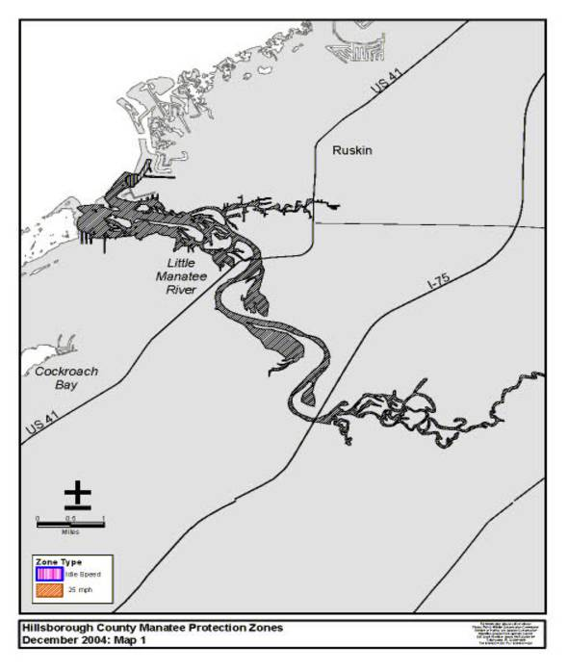
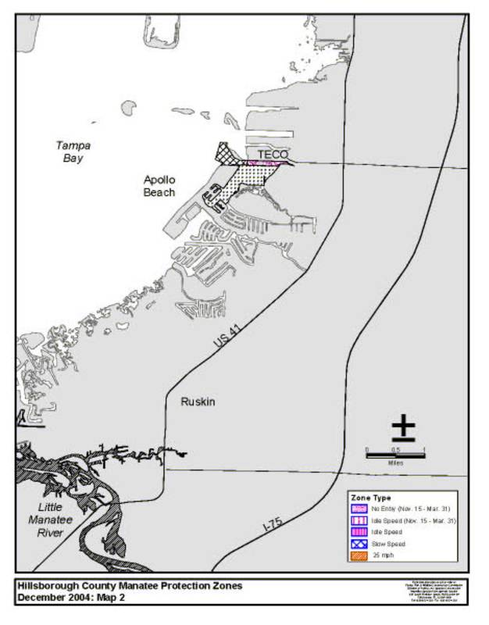
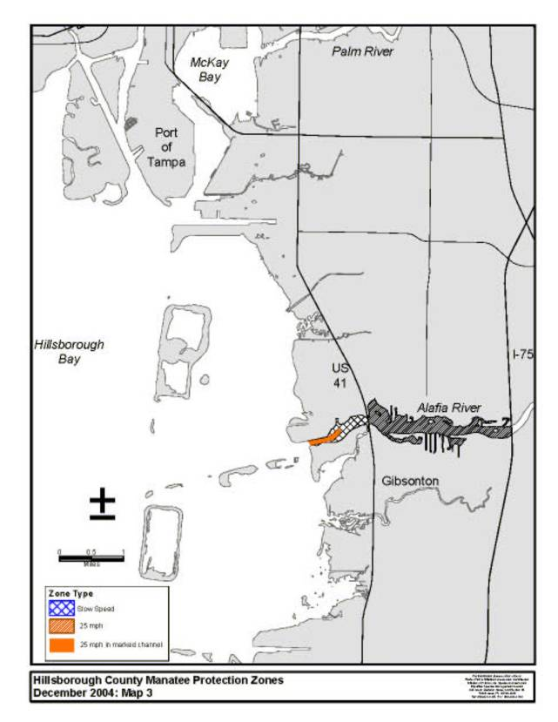
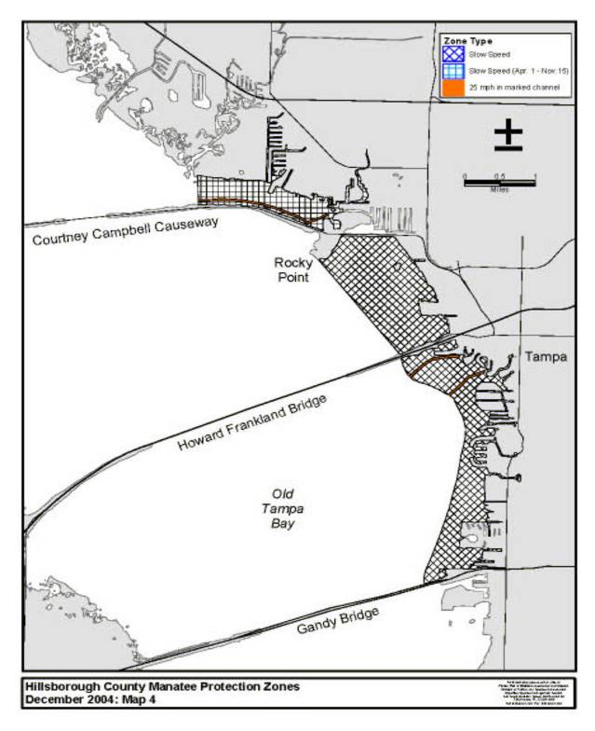
Rulemaking Authority 370.12(2)(g), (n), (o) FS. Law Implemented 370.12(2)(d), (g), (k), (n) FS. History–New 3-19-79, Formerly 16N-22.13, 16N-22.013, 62N-22.013, Amended 12-12-02, 1-5-05.

68C-22.014 Manatee County Zones.
(1) The Commission hereby designates the waters within Manatee County, as described below, as areas where manatee sightings are frequent and where the best available information supports the conclusion that manatees inhabit these areas on a regular or periodic basis. The primary purpose of this rule is to protect manatees from harmful collisions with motorboats and from harassment by regulating the speed and operation of motorboats within these designated areas. A secondary purpose is to protect manatee habitat. In consideration of balancing the rights of fishers, boaters, and water skiers to use the waters of the state for recreational and commercial purposes (as applicable under Section 370.12(2)(k), F.S.) with the need to provide manatee protection, the Commission has examined the need for limited lanes, corridors, or unregulated areas that allow higher speeds through or within regulated areas. Such lanes, corridors, or areas are provided in those locations where the Commission determined that they are consistent with manatee protection needs.
(2) The following zones are established, which include all associated and navigable tributaries, lakes, creeks, coves, bends, backwaters, canals, and boat basins unless otherwise designated or excluded. As used in this rule, ICW means the Intracoastal Waterway.
(a) Idle Speed (All Year) Snead Cut: All waters of the waterway commonly referred to as “Snead Cut” (connecting Terra Ceia Bay and the Manatee River) northeast of the northern shoreline of the Manatee River and southwest of the southwestern shoreline of Terra Ceia Bay.
(b) Slow Speed (All Year).
1. Bishop Harbor Area: All waters of Bishop Harbor and those nearshore waters of Tampa Bay generally north of Bishop Harbor and south of Port Manatee. The southern boundary is the southern shoreline of Bishop Harbor. The western boundary is a line beginning at a point (approximate latitude 27° 36' 25.9" North, approximate longitude 82° 34' 15.4" West) on the southern shoreline of Bishop Harbor and then bearing 346.5° for a distance of approximately 405 feet from to a point (approximate latitude 27° 36' 29.8" North, approximate longitude 82° 34' 16.6" West) in the water, then bearing 320.9° for a distance of approximately 330 feet to a point (approximate latitude 27° 36' 32.3" North, approximate longitude 82° 34' 18.9" West) in the water, then bearing 317.6° for a distance of approximately 410 feet to a point (approximate latitude 27° 36' 35.3" North, approximate longitude 82° 34' 22.0" West) in the water, then bearing 348.3° for a distance of approximately 1,100 feet to a point (approximate latitude 27° 36' 45.9" North, approximate longitude 82° 34' 24.6" West) in the water, then bearing 325.8° for a distance of approximately 538 feet to a point (approximate latitude 27° 36' 50.3" North, approximate longitude 82° 34' 28.0" West) in the water, then bearing 42.3° for a distance of approximately 1,208 feet to a point (approximate latitude 27° 36' 59.3" North, approximate longitude 82° 34' 19.1" West) in the water, and then bearing 7.4° for a distance of approximately 3,368 feet to the line's terminus at a point (approximate latitude 27° 37' 32.4" North, approximate longitude 82° 34' 15.0" West) in the water. The northern boundary is a line bearing 126.0° for a distance of approximately 2,500 feet from a point (approximate latitude 27° 37' 32.4" North, approximate longitude 82° 34' 15.0" West) in the water to a point on the eastern shoreline of Tampa Bay south of Port Manatee.
2. Miguel Bay: Those waters along the eastern side of Miguel Bay generally between Flounder Pass and the embayment in northeastern Miguel Bay. The southwestern boundary is a line bearing 325.6° from a point (approximate latitude 27° 33' 37.0" North, approximate longitude 82° 36' 15.2" West) on the southern shoreline of Miguel Bay (northeast of Flounder Pass) to a point (approximate latitude 27° 33' 40.4" North, approximate longitude 82° 36' 17.9" West) on the southwestern shoreline of an unnamed mangrove island to the north. The western boundary is a line following the southeastern shoreline of the aforementioned unnamed mangrove island from said point on its southwestern shoreline to a point (approximate latitude 27° 33' 42.7" North, approximate longitude 82° 36' 16.1" West) on the island’s northern shoreline, then bearing 12.0° to a point (approximate latitude 27° 33' 44.5" North, approximate longitude 82° 36' 15.7" West) on the southwestern shoreline of the unnamed mangrove island to the northeast, then following the southeastern shoreline of said island to a point (approximate latitude 27° 33' 49.0" North, approximate longitude 82° 36' 8.3" West) on the island's northern shoreline, then bearing 56.5° for a distance of approximately 607 feet to a point (approximate latitude 27° 33' 52.4" North, approximate longitude 82° 36' 2.7" West) in the water, then bearing 75.7° for a distance of approximately 646 feet to a point (approximate latitude 27° 33' 54.1" North, approximate longitude 82° 35' 55.7" West) in the water, and then following a line 300 feet northwest of and parallel with the eastern shoreline of Miguel Bay to the line’s terminus at a point (approximate latitude 27° 34' 19.4" North, approximate longitude 82° 35' 40.9" West) in the water. Within the embayment in northeastern Miguel Bay, the outer boundary is a line beginning at a point (approximate latitude 27° 34' 19.4" North, approximate longitude 82° 35' 40.9" West) in the water and then bearing 38.9° for a distance of approximately 260 feet to a point (approximate latitude 27° 34' 21.5" North, approximate longitude 82° 35' 39.1" West) in the water, then bearing 76.0° for a distance of approximately 365 feet to a point (approximate latitude 27° 34' 22.4" North, approximate longitude 82° 35' 35.2" West) in the water, then bearing 117.7° for a distance of approximately 750 feet to a point (approximate latitude 27° 34' 19.0" North, approximate longitude 82° 35' 27.8" West) in the water, then following a line 300 feet out from and parallel with the southern and eastern shorelines of said embayment to a point (approximate latitude 27° 34' 27.0" North, approximate longitude 82° 35' 12.5" West) in the water, and then bearing 272.2° to the line’s terminus at a point (approximate latitude 27° 34' 27.2" North, approximate longitude 82° 35' 20.7" West) on the northern shoreline. The two (2) canals on either side of Burns Road are also included in this zone.
3. Western Terra Ceia Bay Area: All waters within 500 feet of the general contour of the following shorelines:
a. South Side of Rattlesnake Key: North and east of a line bearing 110° from a point (approximate latitude 27° 32' 55.9'' North, approximate longitude 82° 37' 46.5'' West) on the eastern shoreline of Terra Ceia Point and west and northwest of a line bearing 221° from the easternmost point (approximate latitude 27° 33' 20.5'' North, approximate longitude 82° 36' 13.4'' West) of Rattlesnake Key at Flounder Pass.
b. North Side of Snead Island: All shorelines of the unnamed mangrove island immediately north of Snead Island and, on the northern and eastern sides of Snead Island, north and then east of a line bearing 270° from a point (approximate latitude 27° 31' 54.9'' North, approximate longitude 82° 38' 47.6'' West) on the western shoreline of Snead Island and north and west of Snead Cut, except as otherwise designated under paragraph (2)(a), and sub-subparagraph (2)(b)4.b.
4. Terra Ceia Bay Area:
a. All waters within 500 feet of the general contour of all shorelines of Bird Key, the northern shoreline of Terra Ceia Bay east of Flounder Pass and north of a line bearing 90° from the southwesternmost point (approximate latitude 27° 33' 22.4'' North, approximate longitude 82° 36' 10.7'' West) of the peninsula at the southeastern end of Flounder Pass, and the southeastern and eastern shorelines of Terra Ceia Bay east and north of Snead Cut, except as otherwise designated under paragraph (2)(a), and sub-subparagraph (2)(b)4.b.
b. All waters of Terra Ceia Bay south of a line bearing 296° from a point (approximate latitude 27° 31' 51.8'' North, approximate longitude 82° 35' 47.6'' West) on the southeastern shoreline of Terra Ceia Bay; All waters of Terra Ceia Bay north of a line bearing 320° from a point (approximate latitude 27° 33' 41.3'' North, approximate longitude 82° 34' 11.5'' West) on the northeastern shoreline of Terra Ceia Bay and south of Terra Ceia Bayou, and; All waters of Peterson Bayou.
5. Terra Ceia Bayou: All waters within 500 feet of the general contour of the shorelines of Terra Ceia Bayou, including those waters of Frog Creek southeast of the centerline of the Terra Ceia Road Bridge and those waters of McMullen Creek west of the centerline of the Bayshore Road Bridge.
6. Manatee River (North Side, West of I-75): All waters within 500 feet of the general contour of the shoreline, west of the western edge of the I-75 Bridge, except as otherwise designated under sub-subparagraphs (2)(b)6.a. and (2)(b)6.b., and excluding the waters east of the eastern edge of the US 41/US 301 Bridge and west of a line bearing 168.8° from a point (approximate latitude 27° 30' 29.7'' North, approximate longitude 82° 33' 35.4'' West) on the northern shoreline approximately 1,000 feet east of the US 41/US 301 Bridge. The northern and western boundary is a line bearing 270° from a point (approximate latitude 27° 31' 54.9'' North, approximate longitude 82° 38' 47.6'' West) on the western shoreline of Snead Island.
a. Snead Cut Area: All waters north of a line beginning at a point (approximate latitude 27° 31' 16.9'' North, approximate longitude 82° 37' 13.9'' West) in the water and then bearing 90.0° for a distance of approximately 2482 feet to a point (approximate latitude 27° 31' 17.1'' North, approximate longitude 82° 36' 46.5'' West) in the water, then bearing 135.0° for a distance of approximately 3866 feet to a point (approximate latitude 27° 30' 50.4'' North, approximate longitude 82° 36' 15.7'' West) in the water, then bearing 76.5° for a distance of approximately 2,449 feet to a point (approximate latitude 27° 30' 56.3'' North, approximate longitude 82° 35' 49.4'' West) in the water, then bearing 134.7° for a distance of approximately 2,241 feet to a point (approximate latitude 27° 30' 40.9'' North, approximate longitude 82° 35' 31.4'' West) in the water, and then bearing 79.0° for a distance of approximately 701 feet to the line’s terminus at a point (approximate latitude 27° 30' 42.5'' North, approximate longitude 82° 35' 23.8'' West) in the water. The eastern and western boundaries are the eastern and western ends of the aforementioned line.
b. Riverside Park to US 41/US 301 Area: All waters north of a line beginning at a point (approximate latitude 27° 30' 36.9'' North, approximate longitude 82° 34' 38.1'' West) in the water west of Riverside Park and then bearing 129.2° for a distance of approximately 970 feet to a point (approximate latitude 27° 30' 31.0'' North, approximate longitude 82° 34' 29.7'' West) in the water, then bearing 101.9° for a distance of approximately 780 feet to a point (approximate latitude 27° 30' 29.4'' North, approximate longitude 82° 34' 21.2'' West) in the water, then bearing 76.0° for a distance of approximately 487 feet to a point (approximate latitude 27° 30' 30.6'' North, approximate longitude 82° 34' 16.0'' West) in the water, then bearing 101.4° for a distance of approximately 1,469 feet to a point (approximate latitude 27° 30' 28.0'' North, approximate longitude 82° 33' 59.9'' West) in the water, then bearing 128.7° for a distance of approximately 619 feet to the line’s terminus at a point (approximate latitude 27° 30' 24.2'' North, approximate longitude 82° 33' 54.5'' West) in the water.
7. Manatee River (South Side, West of I-75): All waters within 500 feet of the general contour of the shoreline east of a line bearing 59.3° from a point (approximate latitude 27° 31' 15.6'' North, approximate longitude 82° 38' 31.4'' West) on the southern shoreline and west of the western edge of the I-75 Bridge, except as otherwise designated under subparagraphs (2)(b)9., and (2)(c)2., and excluding those waters of Warners Bayou south and west of Riverview Boulevard.
8. Manatee River (East of I-75): All waters of the Manatee River east of the western edge of the I-75 Bridge and west of the dam at the west end of Lake Manatee, except as otherwise designated under subparagraph (2)(c)3., and excluding those waters inside of the following polygon: Begin at a point (approximate latitude 27° 31' 41.4'' North, approximate longitude 82° 27' 52.1'' West) on the southern shoreline of an unnamed island in the Manatee River west of 104th Avenue East, then bear 170.2° to a point (approximate latitude 27° 31' 37.9'' North, approximate longitude 82° 27' 51.4'' West) on the shoreline that forms the southern shoreline of the main branch of the Manatee River, then follow said southern shoreline of the main branch of the Manatee River in an easterly direction to another point (approximate latitude 27° 31' 25.6'' North, approximate longitude 82° 27' 13.9'' West) on the shoreline, then bear approximately 120.8° to a point (approximate latitude 27° 31' 20.6'' North, approximate longitude 82° 27' 4.3'' West) on the northwestern shoreline of a small unnamed island, then follow the northern and eastern shorelines of said island to a point (approximate latitude 27° 31' 15.4'' North, approximate longitude 82° 26' 55.9'' West) on the island’s southeastern shoreline, then bear 156.3° for a distance of approximately 627 feet to a point (approximate latitude 27° 31' 9.7'' North, approximate longitude 82° 26' 53.0'' West) in the water, then bear 122.3° for a distance of approximately 664 feet to a point (approximate latitude 27° 31' 6.4'' North, approximate longitude 82° 26' 46.7'' West) in the water, then bear 21.2° for a distance of approximately 214 feet to a point (approximate latitude 27° 31' 8.3'' North, approximate longitude 82° 26' 45.9'' West) in the water, then bear 301.6° for a distance of approximately 492 feet to a point (approximate latitude 27° 31' 10.8'' North, approximate longitude 82° 26' 50.7'' West) in the water, then bear 339.3° for a distance of approximately 766 feet to a point (approximate latitude 27° 31' 17.8'' North, approximate longitude 82° 26' 53.7'' West) in the water, then bear approximately 317.9° to a point (approximate latitude 27° 31' 20.4'' North, approximate longitude 82° 26' 56.4'' West) on the western shoreline of a peninsula on the northern shoreline of the main branch of the Manatee River, then bear approximately 307.9° to a point (approximate latitude 27° 31' 23.0'' North, approximate longitude 82° 27' 0.3'' West) on the shoreline that forms the northern shoreline of the main branch of the Manatee River, then follow said northern shoreline of the main branch of the Manatee River in a northwesterly direction to another point (approximate latitude 27° 31' 43.1'' North, approximate longitude 82° 27' 37.4'' West) on the shoreline, then bear 270.9° to a point (approximate latitude 27° 31' 43.1'' North, approximate longitude 82° 27' 45.0'' West) on the southeastern shoreline of the aforementioned unnamed island in the Manatee River west of 104th Avenue East, then follow the southern shoreline of said island in a westerly direction back to the point of beginning.
9. Braden River: All waters south of a line bearing 90° from a point (approximate latitude 27° 30' 6.5'' North, approximate longitude 82° 32' 52.6'' West) on the western shoreline of the Braden River, except as otherwise designated under subparagraph (2)(c)2. The southern boundary is the dam located south of SR 70 (53rd Avenue East) and west of 55th Drive East.
10. Anna Maria Sound (North of SR 64):
a. All waters within 300 feet of the northeastern shoreline of Anna Maria Island, west of a line bearing 335.9° from a point (approximate latitude 27° 31' 35.0'' North, approximate longitude 82° 43' 4.8'' West) on the northwestern shoreline of School Key (near the west end of Key Royale Drive) and east of a line bearing 58.5° from a point (approximate latitude 27° 32' 21.0'' North, approximate longitude 82° 44' 31.7'' West) on the northern shoreline of Anna Maria Island, including all waters in Bimini Bay and the other interior waterways of Anna Maria Island north of SR 64.
b. Those waters north of SR 64 and generally south and east of School Key, except as otherwise designated under subparagraph (2)(c)4., and excluding those waters in the marked ICW channel and the area within 100 feet of said channel. The northern boundary is a line beginning at a point (approximate latitude 27° 30' 56.8'' North, approximate longitude 82° 42' 34.4'' West) on the southern boundary of the east-west channel immediately south of School Key, then running along the southern boundary of said channel in an easterly direction to a point (approximate latitude 27° 31' 7.2'' North, approximate longitude 82° 41' 47.3'' West) in the water south of ICW channel marker “61,” then running along the western boundary of the ICW channel for approximately 2980 feet to a point (approximate latitude 27° 30' 43.2'' North, approximate longitude 82° 41' 29.6'' West) 100 feet west of ICW channel marker “59,” and then bearing 90° to the line’s terminus on the northeastern shoreline of Perico Island. The southern boundary is the southern edge of the SR 64 Bridge. The western boundary is the shoreline of Anna Maria Island and the eastern boundary is the shoreline of Perico Island.
11. Anna Maria Sound (SR 64 to Cortez Road): All waters of Anna Maria Sound south of SR 64 (Manatee Avenue West) and north of Cortez Road (44th Avenue West), excluding those waters in the marked ICW channel and the area within 100 feet of said channel and those waters described under sub-subparagraph (2)(b)11.a. The eastern boundary of this zone is a north-south line (i.e., bearing 360° and 180°) running through channel marker “3” in Palma Sola Bay (approximate latitude 27° 28' 46.5'' North, approximate longitude 82° 41' 5.2'' West).
a. Those waters east of the ICW channel in the vicinity of the entrance channel area to Palma Sola Bay are excluded from the Slow Speed zone designated under subparagraph (2)(b)11. The northern boundary of the excluded area is a line beginning at a point (approximate latitude 27° 28' 48.0'' North, approximate longitude 82° 41' 46.0'' West) in the water, then bearing 92.5° for a distance of approximately 513 feet to a point (approximate latitude 27° 28' 47.8'' North, approximate longitude 82° 41' 40.2'' West) in the water, then bearing 79.3° for a distance of approximately 1,147 feet to a point (approximate latitude 27° 28' 50.1'' North, approximate longitude 82° 41' 27.8'' West) in the water, then bearing 96.6° for a distance of approximately 983 feet to a point (approximate latitude 27° 28' 49.1'' North, approximate longitude 82° 41' 16.9'' West) in the water, then bearing 104.7° for a distance of approximately 1087 feet to the line’s terminus on the eastern boundary of the zone. The southern boundary of the excluded area is a line beginning at a point (approximate latitude 27° 28' 30.0'' North, approximate longitude 82° 41' 37.6'' West) in the water west of Marina Court and then running in an easterly direction 300 feet north of and parallel with the general contour of the shoreline to the line’s terminus on the eastern boundary of the zone.
12. Palma Sola Bay:
a. Those waters in western Palma Sola Bay generally north of the east-west entrance channel, except as otherwise designated under subparagraph (2)(c)5. The southern and eastern boundary is a line beginning at channel marker “3'’ in Palma Sola Bay (approximate latitude 27° 28' 46.5'' North, approximate longitude 82° 41' 5.2'' West), then running in an easterly direction along the northern boundary of the marked east-west channel to channel marker “19” (approximate latitude 27° 28' 46.1'' North, approximate longitude 82° 39' 36.4'' West), then bearing 57.8° for a distance of approximately 859 feet to a point (approximate latitude 27° 28' 50.8'' North, approximate longitude 82° 39' 28.4'' West) in the water, then bearing 24.2° for a distance of approximately 1344 feet to a point (approximate latitude 27° 29' 3.0'' North, approximate longitude 82° 39' 22.4'' West) in the water, then bearing 338.4° for a distance of approximately 3,128 feet to a point (approximate latitude 27° 29' 31.6'' North, approximate longitude 82° 39' 35.6'' West) in the water, and then bearing 305.9° to the line’s terminus at a point (approximate latitude 27° 29' 31.6'' North, approximate longitude 82° 39' 35.6'' West) on the eastern shoreline of the Flamingo Cay development.
b. All waters in western Palma Sola Bay within 300 feet of the general contour of the southern shoreline, north and west of a line bearing 89.8° from a point (approximate latitude 27° 28' 16.7'' North, approximate longitude 82° 40' 7.6'' West) on the southern shoreline of Palma Sola Bay, and east of a north-south line (i.e., bearing 360° and 180°) running through channel marker “3'’ in Palma Sola Bay.
c. Those waters near the southern and eastern shores of Palma Sola Bay and south of the causeway for SR 64, inshore of a line beginning at a point (approximate latitude 27° 28' 16.7'' North, approximate longitude 82° 40' 7.6'' West) on the southern shoreline of Palma Sola Bay, then bearing 89.8° for a distance of approximately 7397 feet to a point (approximate latitude 27° 28' 18.0'' North, approximate longitude 82° 38' 39.4'' West) in the water, then bearing 45.3° for a distance of approximately 733 feet to a point (approximate latitude 27° 28' 23.1'' North, approximate longitude 82° 38' 33.7'' West) in the water, then bearing 29.9° for a distance of approximately 565 feet to a point (approximate latitude 27° 28' 28.0'' North, approximate longitude 82° 38' 30.6'' West) in the water, then bearing 327.3° for a distance of approximately 758 feet to a point (approximate latitude 27° 28' 34.3'' North, approximate longitude 82° 38' 35.2'' West) in the water, then bearing 315.5° for a distance of approximately 1624 feet to a point (approximate latitude 27° 28' 45.6'' North, approximate longitude 82° 38' 48.1'' West) in the water, then bearing 359.3° for a distance of approximately 2270 feet to a point (approximate latitude 27° 29' 8.1'' North, approximate longitude 82° 38' 48.7'' West) in the water, then bearing 21.8° for a distance of approximately 1129 feet to a point (approximate latitude 27° 29' 18.5'' North, approximate longitude 82° 38' 44.2'' West) in the water, then running in a northerly and then westerly direction 300 feet offshore of and parallel with the eastern shoreline of Palma Sola Bay and the southern shoreline of the causeway for SR 64, then in a southerly direction to a point (approximate latitude 27° 29' 31.6'' North, approximate longitude 82° 39' 35.6'' West) in the water, and then bearing 305.9° to the line’s terminus at a point (approximate latitude 27° 29' 31.6'' North, approximate longitude 82° 39' 35.6'' West) on the eastern shoreline of the Flamingo Cay development.
d. All waters within 300 feet of shore in the portion of Palma Sola Bay north of SR 64, including within 300 feet of the causeway for SR 64, and all waters north of a line beginning at a point (approximate latitude 27° 29' 59.6'' North, approximate longitude 82° 39' 30.7'' West) in the water, then bearing 55.5° for a distance of approximately 1,107 feet to a point (approximate latitude 27° 30' 5.9'' North, approximate longitude 82° 39' 20.7'' West) in the water, then bearing 73.7° for a distance of approximately 1,690 feet to a point (approximate latitude 27° 30' 10.8'' North, approximate longitude 82° 39' 2.8'' West) in the water, then bearing 89.5° for a distance of approximately 1243 feet to the line’s terminus at a point (approximate latitude 27° 30' 11.1'' North, approximate longitude 82° 38' 49.0'' West) in the water.
13. Sarasota Bay (Anna Maria Island and Jewfish Key Area):
a. All waters within 300 feet of the eastern shoreline of Anna Maria Island south of Cortez Road (44th Avenue West) and all shorelines of Leffis Key, excluding those waters south of Leffis Key that are offshore of a line beginning at a point (approximate latitude 27° 27' 3.1'' North, approximate longitude 82° 41' 15.9'' West) in the water, then bearing 267.4° for a distance of approximately 574 feet to a point (approximate latitude 27° 27' 2.8'' North, approximate longitude 82° 41' 22.3'' West), then bearing 198.4° for a distance of approximately 125 feet to a point (approximate latitude 27° 27' 1.6'' North, approximate longitude 82° 41' 22.7'' West), then bearing 158.7° for a distance of approximately 771 feet to a point (approximate latitude 27° 26' 54.5'' North, approximate longitude 82° 41' 19.5'' West), then bearing 74.4° to the line’s terminus at a point (approximate latitude 27° 26' 55.1'' North, approximate longitude 82° 41' 17.0'' West) in the water. The southern and western boundary is the centerline of the SR 789 Bridge over Longboat Pass.
b. All waters adjacent to Jewfish Key inshore of a line beginning at a point (approximate latitude 27° 26' 44.9'' North, approximate longitude 82° 40' 55.2'' West) on the northern shoreline of Jewfish Key, then bearing 349.2° for a distance of approximately 252 feet to a point (approximate latitude 27° 26' 47.3'' North, approximate longitude 82° 40' 55.8'' West) in the water, then bearing 78.5° to a point on the western boundary of the ICW, then running in a southerly direction along the western boundary of the ICW to a point (approximate latitude 27° 26' 22.8'' North, approximate longitude 82° 40' 34.4'' West) in the water, then bearing 259.4° to the line’s terminus at a point (approximate latitude 27° 26' 22.6'' North, approximate longitude 82° 40' 35.7'' West) on the southeastern shoreline of Jewfish Key.
14. Sarasota Bay (Longboat Key Area): All waters within 300 feet of the eastern shoreline of Longboat Key and all shorelines of the Sister Keys, including all waters of the areas designated under sub-subparagraphs (2)(b)14.a. and b., except as otherwise designated under subparagraph (2)(c)6. The northern boundary is a line bearing 90° from a point (approximate latitude 27° 26' 20.5'' North, approximate longitude 82° 40' 50.2'' West) on the northeastern shoreline of Longboat Key and the southern boundary is the Sarasota County line.
a. All waters generally between Longboat Key and the Sister Keys, except as otherwise designated under subparagraph (2)(c)6. The northern boundary is a line beginning at a point (approximate latitude 27° 26' 6.7'' North, approximate longitude 82° 40' 46.7'' West) on the eastern shoreline of Longboat Key, then bearing 30.0° for a distance of approximately 536 feet to a point (approximate latitude 27° 26' 11.3'' North, approximate longitude 82° 40' 43.9'' West) in the water, then bearing 343.3° for a distance of approximately 267 feet to a point (approximate latitude 27° 26' 13.8'' North, approximate longitude 82° 40' 44.8'' West) in the water, then bearing 55.6° for a distance of approximately 181 feet to a point (approximate latitude 27° 26' 14.8'' North, approximate longitude 82° 40' 43.1'' West) in the water, then bearing 91.5° for a distance of approximately 1460 feet to a point (approximate latitude 27° 26' 14.6'' North, approximate longitude 82° 40' 26.9'' West) in the water, and then bearing 151.0° to the line’s terminus at a point on the northwestern shoreline of the Sister Keys. The southern boundary is a line beginning at a point (approximate latitude 27° 25' 41.5'' North, approximate longitude 82° 39' 44.0'' West) on the southern shoreline of the Sister Keys, then bearing 130.8° for a distance of 489 feet to a point (approximate latitude 27° 25' 38.4'' North, approximate longitude 82° 39' 39.9'' West) in the water, and then bearing 207.3° to the line’s terminus at a point on the eastern shoreline of Longboat Key.
b. All waters adjacent to Longboat Key south and west of a line beginning at a point (approximate latitude 27° 24' 51.2'' North, approximate longitude 82° 39' 16.0'' West) on the eastern shoreline of Longboat Key, then bearing 90.0° for a distance of approximately 300 feet to a point (approximate latitude 27° 24' 51.2'' North, approximate longitude 82° 39' 12.5'' West) in the water, then bearing 163.2° for a distance of approximately 1,583 feet to a point (approximate latitude 27° 24' 36.1'' North, approximate longitude 82° 39' 7.1'' West) in the water, then bearing 137.2° for a distance of approximately 5500 feet to a point (approximate latitude 27° 23' 56.8'' North, approximate longitude 82° 38' 25.2'' West) in the water, then bearing 119.3° for a distance of approximately 2,604 feet to a point (approximate latitude 27° 23' 44.4'' North, approximate longitude 82° 37' 59.7'' West) in the water, then bearing 130.1° for a distance of approximately 1,971 feet to a point (approximate latitude 27° 23' 32.0'' North, approximate longitude 82° 37' 42.8'' West) in the water, then bearing 189.0° to the line’s terminus at a point on the Sarasota County line.
15. Sarasota Bay (East Side): All waters within 300 feet of the eastern shoreline of Sarasota Bay and within 300 feet of all shorelines of the small islands in the vicinity of the eastern shoreline, including all waters of the areas designated under sub-subparagraphs (2)(b)15.a. through c., except as otherwise designated under subparagraph (2)(c)6. The southern boundary is the Sarasota County line.
a. All waters northeast of a line beginning at a point (approximate latitude 27° 27' 58.5'' North, approximate longitude 82° 41' 13.7'' West) on the eastern shoreline of Sarasota Bay, then bearing 210.8° for a distance of approximately 321 feet to a point (approximate latitude 27° 27' 55.7'' North, approximate longitude 82° 41' 15.5'' West) in the water, then bearing 142.2° for a distance of approximately 1,569 feet to a point (approximate latitude 27° 27' 43.6'' North, approximate longitude 82° 41' 4.6'' West) in the water, then bearing 133.3° for a distance of approximately 9,058 feet to the line’s terminus at a point (approximate latitude 27° 26' 42.9'' North, approximate longitude 82° 39' 50.5'' West) in the water.
b. All waters north and east of a line beginning at a point (approximate latitude 27° 26' 31.9'' North, approximate longitude 82° 39' 16.0'' West) in the water south of Tidy Island, then bearing 118.0° for a distance of approximately 1,771 feet to a point (approximate latitude 27° 26' 24.2'' North, approximate longitude 82° 38' 58.8'' West) in the water, then bearing 53.2° for a distance of approximately 1363 feet to a point (approximate latitude 27° 26' 32.6'' North, approximate longitude 82° 38' 46.8'' West) in the water, then bearing 107.7° for a distance of approximately 2076 feet to the line’s terminus at a point (approximate latitude 27° 26' 26.5'' North, approximate longitude 82° 38' 24.6'' West) in the water.
c. All waters north and east of a line beginning at a point (approximate latitude 27° 24' 55.1'' North, approximate longitude 82° 35' 17.3'' West) in the water south of 26th Street West in the Bayshore Gardens area, then bearing 116.1° for a distance of approximately 1,227 feet to a point (approximate latitude 27° 24' 49.8'' North, approximate longitude 82° 35' 5.1'' West) in the water, then bearing 142.1° for a distance of approximately 867 feet to a point (approximate latitude 27° 24' 43.2'' North, approximate longitude 82° 34' 58.9'' West) in the water, then bearing 153.5° for a distance of approximately 883 feet to the line’s terminus at a point (approximate latitude 27° 24' 35.3'' North, approximate longitude 82° 34' 54.5'' West) in the water.
(c) 25 MPH (All Year).
1. Western Terra Ceia Bay/Flounder Pass Area: All waters of Flounder Pass south of a line bearing 106° from a point (approximate latitude 27° 33' 39.2'' North, approximate longitude 82° 36' 24.5'' West) on the northeastern shoreline of Rattlesnake Key; All waters of Terra Ceia Bay east of a line bearing 203.7° from a point (approximate latitude 27° 32' 55.0'' North, approximate longitude 82° 37' 47.3'' West) on the southeastern shoreline of Terra Ceia Point and west of a line beginning at a point (approximate latitude 27° 32' 34.6'' North, approximate longitude 82° 36' 21.2'' West) on the eastern shoreline of the unnamed mangrove island immediately north of Snead Island and bearing 44° to a point (approximate latitude 27° 33' 5.7'' North, approximate longitude 82° 35' 48.4'' West) in Terra Ceia Bay east of Bird Key, and then bearing 360° to the line’s terminus at a point (approximate latitude 27° 33' 33.3'' North, approximate longitude 82° 35' 48.8'' West) on the northern shoreline of Terra Ceia Bay, except as otherwise designated under subparagraph (2)(b)3., and sub-subparagraph (2)(b)4.a.
2. Braden River:
a. Those waters in the main marked channel of the Braden River from the northern boundary of the Slow Speed zone designated under subparagraph (2)(b)9., to a point 300 feet north of the centerline of the SR 64 Bridge, and from a point 300 feet south of the centerline of the SR 64 Bridge to a point (approximate latitude 27° 29' 35.2" North, approximate longitude 82° 30' 51.0" West) in the river approximately 4,500 feet upstream from the SR 64 Bridge.
b. Those waters in main branch of the Braden River, excluding all embayments and other waterways off of the main branch, southeast of a line bearing 42.0° from a point (approximate latitude 27° 29' 33.8" North, approximate longitude 82° 30' 52.4" West) on the eastern shoreline of the unnamed island to the west of Riverwalk Court, and west of a line bearing 193.2° from a point (approximate latitude 27° 29' 2.6" North, approximate longitude 82° 29' 52.3" West) on the southeastern shoreline of the unnamed island to the west of 18th Avenue East.
c. Those waters in main branch of the Braden River, excluding all embayments and other waterways off of the main branch, south of a line bearing 253.2° from a point (approximate latitude 27° 28' 48.1" North, approximate longitude 82° 29' 39.2" West) on the eastern shoreline of the Braden River south of 18th Avenue East, and northeast of a line bearing 290.1° from a point (approximate latitude 27° 28' 3.1" North, approximate longitude 82° 29' 36.1" West) on the northwestern shoreline of the peninsula north of 37th Avenue East to a point (approximate latitude 27° 28' 3.9" North, approximate longitude 82° 29' 38.6" West) on the southern shoreline of the unnamed island immediately to the west.
3. Manatee River (East of I-75): Those waters in the main marked channel of the Manatee River east of the western edge of the I-75 Bridge and west of the boat ramp at Fort Hamer, excluding the unregulated area described in subparagraph (2)(b)8.
4. Anna Maria Sound: Those waters in the portions of the following marked channels south and west of the northern boundary of the Slow Speed zone designated in sub-subparagraph (2)(b)10.b.:
a. Those waters in the marked channel south of 56th Street, east of a point (approximate latitude 27° 30' 25.6" North, approximate longitude 82° 42' 36.0" West) in the channel approximately 650 feet east of Anna Maria Island.
b. Those waters in the marked east-west channel that runs west from the ICW channel past Kingfish Boat Ramp on the north side of SR 64. The northwestern boundary is a point (approximate latitude 27° 30' 16.7" North, approximate longitude 82° 42' 37.2" West) in the channel approximately 300 feet south of the marina generally east of 52nd Street.
5. Palma Sola Bay: Those waters in the marked channel that runs from Perico Bayou into Palma Sola Bay, south of channel marker “13” (approximate latitude 27° 29' 35.7" North, approximate longitude 82° 40' 6.6" West) and north of the southern boundary of the Slow Speed zone designated under sub-subparagraph (2)(b)12.a.
6. Sarasota Bay:
a. Tidy Island Area: Those waters in the marked channel immediately north of Tidy Island and in the marked channel that runs in a southwesterly direction from the vicinity of 103rd Street Court West. The western boundary for both channels is the western boundary of the Slow Speed zone designated under subparagraph (2)(b)15.
b. Sister Keys Area: Those waters in the marked ICW channel within the Slow Speed zone designated under sub-subparagraph (2)(b)14.a.
(3) Commercial Fishing Permits: The following provisions pertain to the issuance of permits to allow individuals engaged in certain commercial fishing activities to operate their vessels in specified areas at speeds greater than the speed limits established under subsection (2), above. Procedures related to the application for and the review and issuance of these permits are as set forth in Rule 68C-22.003, F.A.C.
(a) Permits shall be limited as follows:
1. Permits shall only be available for the zones or portions of zones described under subparagraphs (2)(b)1., (2)(b)3., (2)(b)6. and (2)(b)7. (west of Snead Cut), and (2)(b)10. through (2)(b)15.
2. Permits shall not apply on weekends or on the holidays identified in Section 110.117, F.S.
3. Permits shall only apply to commercial fishing activities for the setting of nets to encircle fish, and shall only allow speeds up to twenty (20) mph.
(b) Permit applications may be obtained at the Commission’s Law Enforcement office at 5110 Gandy Blvd. in Tampa or by contacting the Commission’s Division of Law Enforcement (Boating and Waterways Section) at 620 South Meridian Street, Tallahassee, Florida 32399-1600, (850)488-5600.
(4) The zones described in subsection 68C-22.014(2), F.A.C., are depicted on the following maps, labeled "Manatee County Manatee Protection Zones.” The maps are intended to depict the above-described zones. In the event of conflict between the maps and descriptions, the descriptions shall prevail.
(5) The amendments to Rule 68C-22.014, F.A.C., as approved by the Commission on September 22, 2004, shall take effect as soon as the regulatory markers are posted.
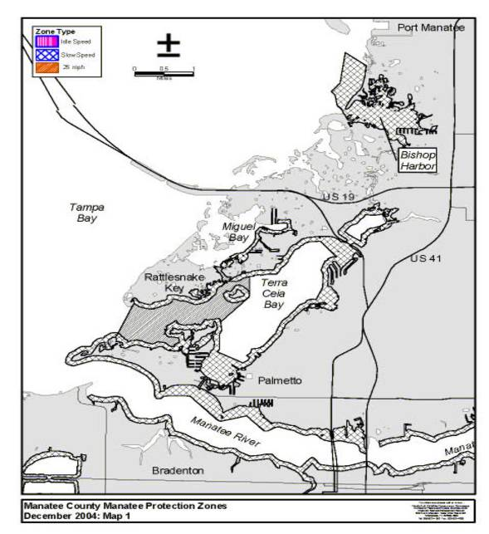
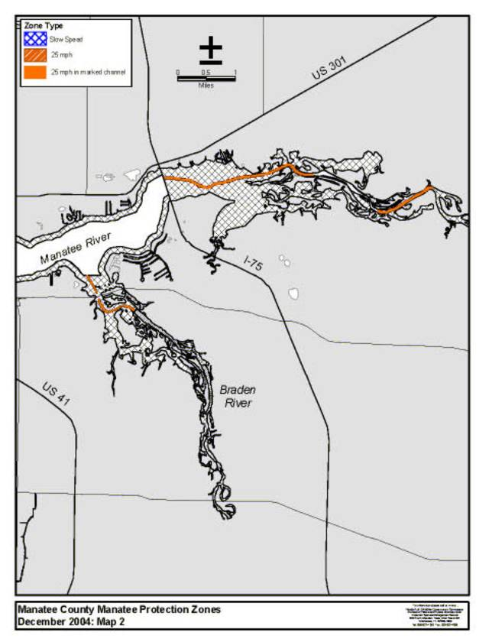

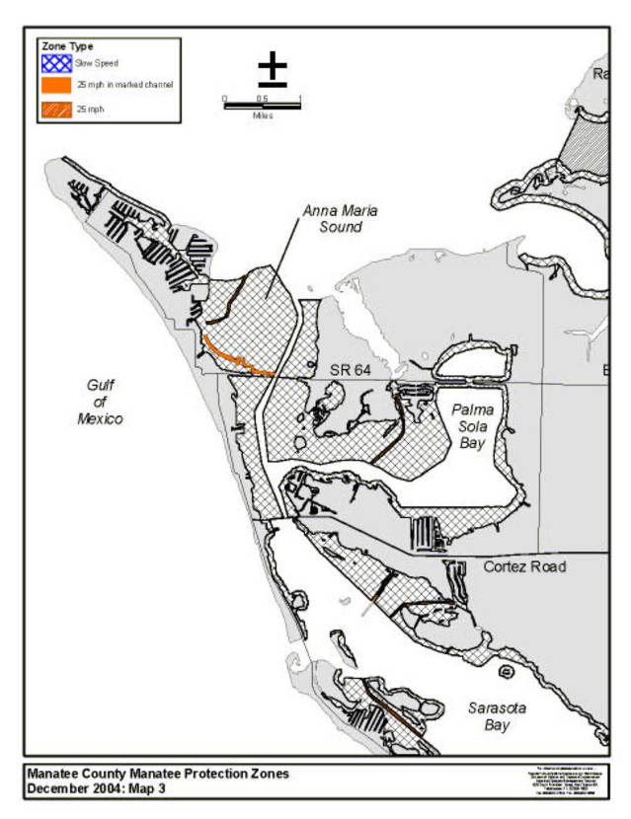

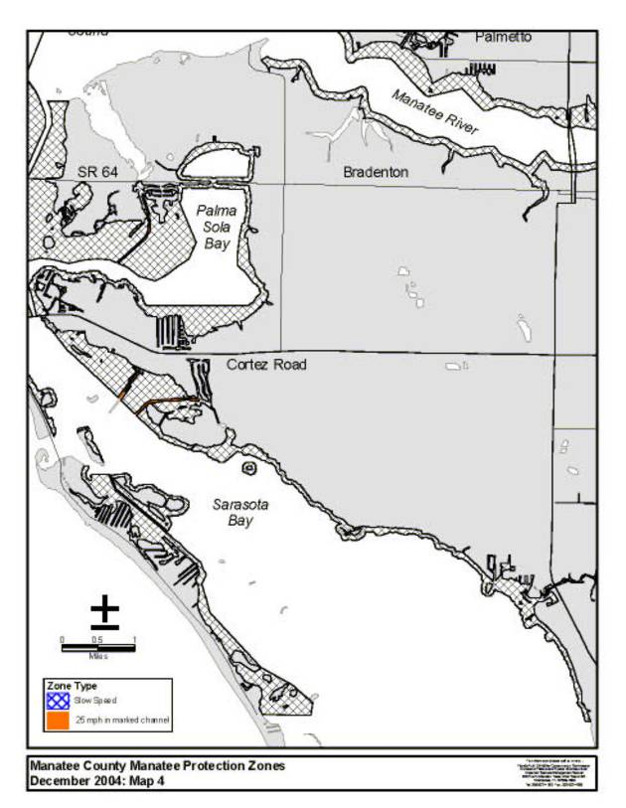
Rulemaking Authority 370.12(2)(g), (n) FS. Law Implemented 370.12(2)(d), (g), (k), (n) FS. History–New 12-12-02, Amended 1-5-05.

68C-22.015 Charlotte County (and Part of DeSoto County) Zones.
(1) The Commission hereby designates the waters within Charlotte County and DeSoto County, as described below, as areas where manatee sightings are frequent and where the best available information supports the conclusion that manatees inhabit these areas on a regular or periodic basis. The primary purpose of this rule is to protect manatees from harmful collisions with motorboats and from harassment by regulating the speed and operation of motorboats within these designated areas. A secondary purpose is to protect manatee habitat. In consideration of balancing the rights of fishers, boaters, and water skiers to use the waters of the state for recreational and commercial purposes (as applicable under Section 370.12(2)(k), F.S.), with the need to provide manatee protection, the Commission has examined the need for limited lanes, corridors, or unregulated areas that allow higher speeds through or within regulated areas. Such lanes, corridors, or areas are provided in those locations where the Commission determined that they are consistent with manatee protection needs.
(2) The following zones are established, which include all associated and navigable tributaries, lakes, creeks, coves, bends, backwaters, canals, and boat basins unless otherwise designated or excluded. As used in this rule, ICW means the Intracoastal Waterway.
(a) Idle Speed (All Year).
1. Turtle Bay, Southeast Entrance: Those waters east and southeast of a line beginning at the easternmost point (approximate latitude 26° 46' 23.2'' North, approximate longitude 82° 10' 30.8'' West) of a small unnamed island in the Gallagher Keys (at the southern end of Turtle Bay) and bearing 360° for a distance of approximately 2605 feet to a point (approximate latitude 26° 46' 49.1'' North, approximate longitude 82° 10' 31.0'' West) in Turtle Bay, and then bearing 68° to a point (approximate latitude 26° 47' 01.1'' North, approximate longitude 82° 09' 59.0'' West) on the eastern shoreline of Turtle Bay north of Cape Haze, and north and northwest of a line beginning at said easternmost point of a small unnamed island in the Gallagher Keys and bearing approximately 128° to the southwesternmost point (approximate latitude 26° 46' 20.1'' North, approximate longitude 82° 10' 26.4'' West) of the small unnamed island to the southeast, and then bearing 106° for a distance of approximately 960 feet to a point (approximate latitude 26° 46' 17.5'' North, approximate longitude 82° 10' 16.2'' West) in Charlotte Harbor, and then bearing 40° to a point (approximate latitude 26° 46' 50.5'' North, approximate longitude 82° 09' 46.4'' West) on the shoreline east of Cape Haze, excluding the waters in the embayment north of this point.
2. Turtle Bay, Mid-bay Area: Those waters inside of a polygon defined by the following coordinates: latitude 26° 47' 10.3'' North, longitude 82° 10' 54.5'' West (southwest); latitude 26° 47' 22.3'' North, longitude 82° 10' 50.5'' West (northwest); latitude 26° 47' 19.7'' North, longitude 82° 10' 40.5'' West (northeast), and; latitude 26° 47' 07.6'' North, longitude 82° 10' 44.4'' West (southeast).
(b) Slow Speed (All Year).
1. Lemon Bay Area: All waters of Lemon Bay south of the Sarasota/Charlotte County line, north of the Boca Grande Causeway, and west of State Road (SR) 775 (south of SR 776 on Gottfried Creek), excluding the ICW channel and the marked channel through Stump Pass as designated under subparagraph (2)(c)1., and the marked channels in Placida Harbor as designated under subparagraph (2)(c)2. Also excluded from this zone are the portion of the waterway known as “Ski Alley” south of a line bearing 258° from the northernmost point (approximate latitude 26° 54' 47.3'' North, approximate longitude 82° 21' 03.7'' West) of Peterson Island, and the areas described below:
a. The following portion of the Stump Pass area is excluded from the zone designated under subparagraph (2)(b)1.: Those waters southeast of “Ski Alley” and a line bearing 45° from a point (approximate latitude 26° 54' 03.6'' North, approximate longitude 82° 20' 26.5'' West) on the southeastern end of Peterson Island, southwest of a line bearing 106° from a point (approximate latitude 26° 54' 16.1'' North, approximate longitude 82° 20' 21.2'' West) on Whidden Key to the northernmost point (approximate latitude 26° 54' 12.8'' North, approximate longitude 82° 20' 07.3'' West) of the unnamed island southeast of Whidden Key, and northwest of a line bearing 49° from the northernmost point (approximate latitude 26° 53' 53.1'' North, approximate longitude 82° 20' 17.9'' West) of Thornton Key to a point on said unnamed island southeast of Whidden Key;
b. The following portion of the Gasparilla Pass area is excluded from the zone designated under subparagraph (2)(b)1.: Those waters southwest of a line beginning at a point (approximate latitude 26° 49' 26.2'' North, approximate longitude 82° 16' 56.3'' West) on Little Gasparilla Island and bearing 142° to a point (approximate latitude 26° 49' 12.3'' North, approximate longitude 82° 16' 44.0'' West) on Bird Key, then following the general contour of the northern and northeastern shorelines of Bird Key to a point (approximate latitude 26° 49' 03.6'' North, approximate longitude 82° 16' 34.1'' West) on the eastern shoreline of Bird Key, and then bearing 105° to the line’s terminus at the southernmost point (approximate latitude 26° 49' 01.2'' North, approximate longitude 82° 16' 24.0'' West) of the middle causeway island of the Boca Grande Causeway.
2. Peace River, US 41 Bridge to Interstate 75 (I-75) Bridge: Those waters within 1000 feet of the general contour of shorelines of the Peace River east of the centerline of the southbound US 41 Bridge and west of the centerline of the southbound I-75 Bridge, including all waters northeast of a line beginning at a point (approximate latitude 26° 57' 39.5'' North, approximate longitude 82° 01' 15.2'' West) on the southbound I-75 Bridge (approximately 1,000 feet south of Bird Key) and then bearing 289° to a point (approximate latitude 26° 57' 58.7'' North, approximate longitude 82° 02' 18.3'' West) on the northern shoreline of the Peace River.
3. Peace River, Interstate 75 (I-75) Bridge to Harbor Heights Area: All waters east of the centerline of the southbound I-75 Bridge, south and southwest of a line bearing 310° through Channel Marker “24,” and west of Shell Creek, excluding the main marked channel of the Peace River and the corridor north of Long Island and east of Bird Key as designated under subparagraph (2)(c)4., and the waters east of a line beginning at a point (approximate latitude 26° 58' 01.0'' North, approximate longitude 81° 59' 24.3'' West) on the southern shoreline of the Peace River (northeast of Harbor Avenue) and bearing 345° for a distance of approximately 1,216 feet to the southernmost point (approximate latitude 26° 58' 12.8'' North, approximate longitude 81° 59' 27.8'' West) of the peninsula to the north.
4. Shell Creek: All waters of Shell Creek east of the Peace River and west of the dam located approximately two (2) miles upstream (east) of the US 17 Bridge over Shell Creek, including the cut that connects Shell Creek to the Peace River north of Channel Marker “24” but excluding that portion of Shell Creek otherwise designated under subparagraph (2)(c)6.
5. Hunter Creek: All waters of Hunter Creek, Jim Long Lake, and associated waterways north of a line bearing 143° from a point (approximate latitude 27° 00' 57.2'' North, approximate longitude 81° 58' 36.1'' West) on the western shoreline of Hunter Creek (south of Jim Long Lake), and east of the general contour of the eastern shoreline of the Peace River.
6. Deep Creek: All waters of Deep Creek and associated waterways west of the general contour of the western shoreline of the Peace River.
(c) 25 MPH (All Year).
1. Lemon Bay Area: Those waters in the ICW channel south of the Sarasota/Charlotte County line and north of the Boca Grande Causeway, and; those waters in the marked channel in North Stump Pass northeast of a line bearing 106° from a point (approximate latitude 26° 54' 16.1'' North, approximate longitude 82° 20' 21.2'' West) on Whidden Key to the northernmost point (approximate latitude 26° 54' 12.8'' North, approximate longitude 82° 20' 07.3'' West) of the unnamed island southeast of Whidden Key.
2. Placida Harbor Area: All waters in the marked channel that runs from the ICW to Gasparilla Pass on the northwest side of the Boca Grande Causeway, and; all waters in the marked channel that runs in a general east-west direction from the marina and boat ramp basin on the northwest side of Boca Grande Causeway, across the ICW, to Little Gasparilla Island, including a “south prong” channel that runs from said east-west channel to the zone boundary between Little Gasparilla Island and Bird Key. This designation only applies if the channels are marked in accordance with permits issued by all applicable state and federal authorities and if the channel locations and marking schemes are approved in advance by the Commission. In the absence of properly permitted and approved channels, these areas are as designated under subparagraph (2)(b)1.
3. Turtle Bay: All waters of Turtle Bay, except as otherwise designated under subparagraph (2)(a)2., west and northwest of a line beginning at the easternmost point (approximate latitude 26° 46' 23.2'' North, approximate longitude 82° 10' 30.8'' West) of a small unnamed island in the Gallagher Keys (at the southern end of Turtle Bay) and bearing 360° for a distance of approximately 2605 feet to a point (approximate latitude 26° 46' 49.1'' North, approximate longitude 82° 10' 31.0'' West) in Turtle Bay, and then bearing 68° to a point (approximate latitude 26° 47' 01.1'' North, approximate longitude 82° 09' 59.0'' West) on the eastern shoreline of Turtle Bay, north of the northern shorelines of the unnamed islands in the Gallagher Keys and lines directly connecting said shorelines, and east of a line beginning at the northwesternmost point (approximate latitude 26° 46' 27.8'' North, approximate longitude 82° 11' 24.9'' West) of the westernmost of the unnamed islands in the Gallagher Keys and bearing 298° to the easternmost point (approximate latitude 26° 46' 28.6'' North, approximate longitude 82° 11' 27.0'' West) of the unnamed island to the northwest, then following said island’s eastern shoreline to its northernmost point (approximate latitude 26° 46' 37.0'' North, approximate longitude 82° 11' 33.0'' West), then bearing 356° to the southernmost point of Eagle Nest Island (approximate latitude 26° 46' 42.3'' North, approximate longitude 82° 11' 33.0'' West), then following said island’s eastern shoreline to its easternmost point (approximate latitude 26° 47' 00.4'' North, approximate longitude 82° 11' 25.3'' West), then bearing 42° for a distance of approximately 2,700 feet to a point (approximate latitude 26° 47' 20.2'' North, approximate longitude 82° 11' 05.5'' West) on the southern end of a large unnamed island on the west side of Turtle Bay, then following said island’s eastern shoreline to a point (approximate latitude 26° 48' 10.7'' North, approximate longitude 82° 10' 58.3'' West) on the northern end of said island, then bearing 3° to the line’s terminus on the western shoreline of Turtle Bay west of Cash Mound.
4. Peace River, Interstate 75 (I-75) Bridge to Harbor Heights Area: All waters in the main marked channel of the Peace River east of the centerline of the southbound I-75 Bridge, and southwest of Channel Marker “24”, and all waters within 150 feet of a line beginning at a point (approximate latitude 26° 57' 35.6'' North, approximate longitude 82° 00' 58.2'' West) in the main marked channel of the Peace River south of Bird Key and bearing 32° to a point (approximate latitude 26° 57' 49.4'' North, approximate longitude 82° 00' 48.6'' West) east of Bird Key, then bearing 22° to a point (approximate latitude 26° 58' 11.2'' North, approximate longitude 82° 00' 39.2'' West) northeast of Bird Key and northwest of Long Island, then bearing 48° to a point (approximate latitude 26° 58' 28.4'' North, approximate longitude 82° 00' 18.2'' West) west of the southern end of the unnamed island north of Long Island, then bearing 27° to a point (approximate latitude 26° 58' 44.7'' North, approximate longitude 82° 00' 09.1'' West) west of the northern end of said unnamed island north of Long Island, and then bearing 63° to the line’s terminus at a point (approximate latitude 26° 58' 53.8'' North, approximate longitude 81° 59' 49.9'' West) in the Peace River northwest of Channel Marker “24.”
5. Peace River, North of Harbor Heights Area: All waters of the Peace River and associated waterways, northeast of a line bearing 310° through Channel Marker “24” and south of the SR 761 Bridge in DeSoto County, except as otherwise designated under subparagraphs (2)(b)5. and (2)(b)6., and excluding those waters of Whidden Bay and the waterways associated with the bay west and northwest of the general contour of the western shoreline of the Peace River.
6. Shell Creek: All waters of Shell Creek west of the Railroad Trestle and east of a line bearing 172° from the southernmost point (approximate latitude 26° 58' 43.3'' North, approximate longitude 81° 59' 28.6'' West) of the peninsula on the eastern side of the cut that connects Shell Creek to the Peace River north of Channel Marker “24,” excluding the embayments and associated waterways immediately north of Shell Creek.
7. Lower Hunter Creek: All waters of Hunter Creek south of a line bearing 143° from a point (approximate latitude 27° 00' 57.2'' North, approximate longitude 81° 58' 36.1'' West) on the western shoreline of Hunter Creek (south of Jim Long Lake), and east of the general contour of the eastern shoreline of the Peace River.
(3) The zones described in subsection 68C-22.015(2), F.A.C., are depicted on the following maps, labeled “Charlotte County Manatee Protection Zones.” The maps are intended as depictions of the above-described zones. In the event of conflict between the maps and descriptions, the descriptions shall prevail.
(4) The amendments to Rule 68C-22.015, F.A.C., as approved by the Commission on June 7, 2006, shall take effect as soon as the regulatory markers are posted.
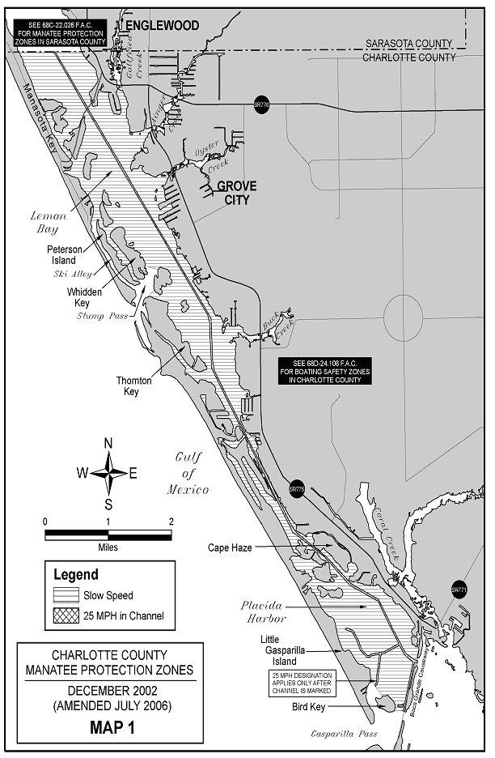

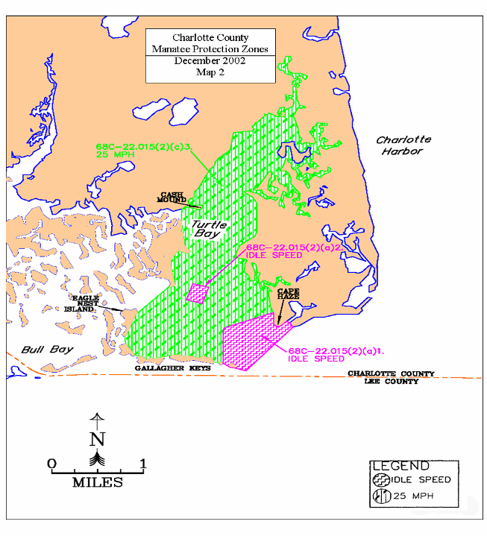

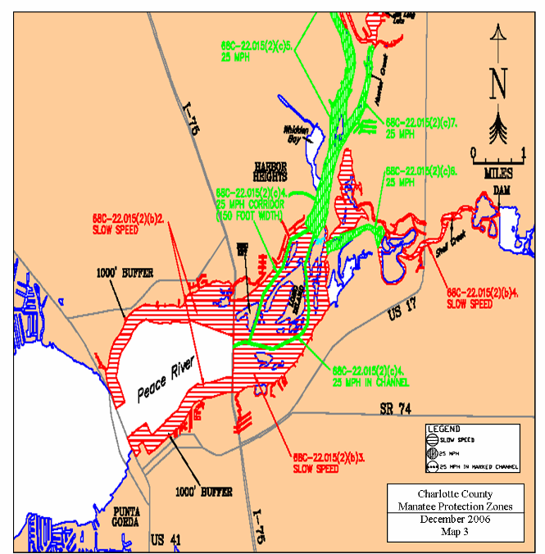

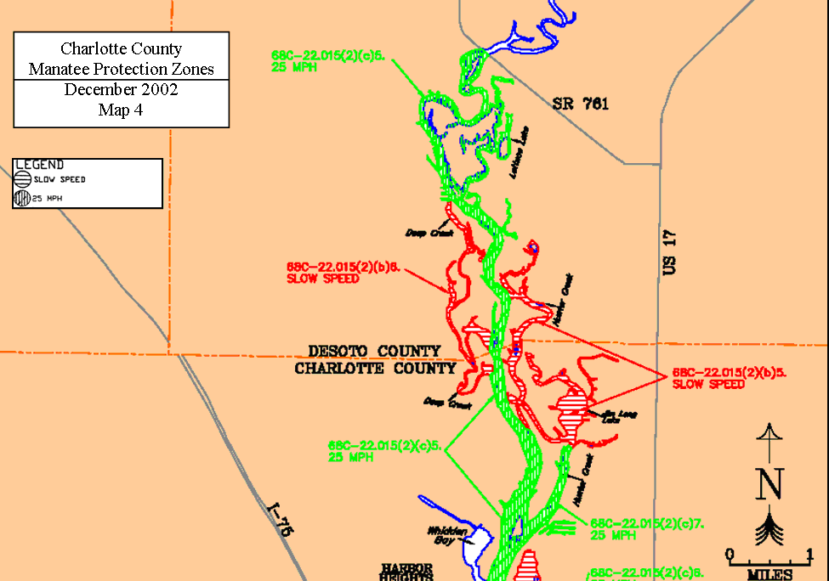

Rulemaking Authority 370.12(2)(n) FS. Law Implemented 370.12(2)(d), (k), (n) FS. History–New 12-12-02, Amended 7-23-06.

68C-22.016 Pinellas County Zones.
(1) The Commission hereby designates the waters within Pinellas County, as described below, as areas where manatee sightings are frequent and where the best available information supports the conclusion that manatees inhabit these areas on a regular or periodic basis. The primary purpose of this rule is to protect manatees from harmful collisions with motorboats and from harassment by regulating the speed and operation of motorboats within these designated areas. A secondary purpose is to protect manatee habitat. In consideration of balancing the rights of fishers, boaters, and water skiers to use the waters of the state for recreational and commercial purposes (as applicable under Section 379.2431(2)(k), F.S.) with the need to provide manatee protection, the Commission has examined the need for limited lanes, corridors, or unregulated areas that allow higher speeds through or within regulated areas. Such lanes, corridors, or areas are provided in those locations where the Commission determined they are consistent with manatee protection needs.
(2) The following year-round and seasonal zones are established, which include all associated and navigable tributaries, lakes, creeks, coves, bends, backwaters, canals, channels, boat basins, and other waterways unless otherwise designated or excluded. Coordinates used in the descriptions of zone boundaries are referenced to the North American Datum of 1983 (NAD83) using the HARN Florida GDL Albers projection.
(a) Slow Speed (year-round) ‒
1. Anclote River, Tarpon Bayou, Spring Bayou Area: All waters east of a line that bears 46° from a point (approximate latitude 28° 9' 44.0'' North, approximate longitude 82° 46' 47.6'' West) on the southern shoreline of the Anclote River (about 800 feet southeast of North Florida Avenue), and west of a line that bears 346° from a point (approximate latitude 28° 9' 24.4'' North, approximate longitude 82° 45' 51.6'' West) on the southern shoreline of the Anclote River (about 100 feet west of Roosevelt Blvd.), including all waters of Spring Bayou and Tarpon Bayou north of a line that bears 270° from a point (approximate latitude 28° 8' 45.6'' North, approximate longitude 82° 45' 43.4'' West) on the shoreline on the south side of the boat ramp at Craig Park, but excluding Kreamer Bayou and associated waters west and south of a line that bears 358° from a point (approximate latitude 28° 9' 26.2'' North, approximate longitude 82° 46' 12.0'' West) on the northern shoreline of Chesapeake Point to the southern shoreline of the peninsula that contains Bayshore Drive and North Casamia Circle;
2. Clearwater Area:
a. All waters, including the Intracoastal Waterway channel, north of the centerline of the Memorial Causeway (SR 60) Bridge, south of a line that bears 283° from a point (approximate latitude 27° 58' 29.8'' North, approximate longitude 82° 48' 11.3'' West) on the western shoreline of the peninsula that contains the Seminole Street boat ramp to the eastern shoreline of the island that contains Windward Island Road, and east of a line that bears 188° from a point (approximate latitude 27° 58' 23.7'' North, approximate longitude 82° 48' 39.6'' West) on the southern shoreline of the island that contains Windward Island Road to the northern shoreline of the Memorial Causeway; and,
b. All waters east of the marked channel of the Intracoastal Waterway, north of the aforementioned line that bears 283° from the western shoreline of the peninsula that contains the Seminole Street boat ramp and south of a line that bears 271° from a point (approximate latitude 27° 59' 20.5'' North, approximate longitude 82° 47' 55.9'' West) on the shoreline of the peninsula on the south side of Stevenson Creek that contains Venetian Point Drive;
3. Narrows Area: All waters outside of the marked channel of the Intracoastal Waterway (ICW) south of a line that bears 58° from a point (approximate latitude 27° 51' 52.3'' North, approximate longitude 82° 50' 49.7'' West) on the western shoreline of The Narrows (about 7340 feet south of the Indian Rocks Beach/Walsingham Road (SR 688) Bridge, running through green ICW channel marker 27), and north of a line that bears 83° from a point (approximate latitude 27° 51' 3.3'' North, approximate longitude 82° 50' 32.4'' West) on the western shoreline of The Narrows (about 350 feet south of green ICW channel marker 19);
4. Johns Pass Area: All waters of Johns Pass and Boca Ciega Bay (excluding the residential canals and side waterways of Madeira Beach and Treasure Island) east of the centerline of the Gulf Boulevard (SR 699) Bridge, and west of the following line: Begin at a point (approximate latitude 27° 47' 43.5'' North, approximate longitude 82° 46' 49.5'' West) on the eastern shoreline of the island that contains Johns Pass Avenue, then bear 96° for a distance of approximately 2,310 feet to a point (latitude 27° 47' 41.0'' North, longitude 82° 46' 23.9'' West) in the water northeast of Little Bird Key, then bear 135° for a distance of approximately 3,095 feet to another point (approximate latitude 27° 47' 19.1'' North, approximate longitude 82° 45' 59.8'' West) in the water, then bear 202° to the line’s terminus on the northeastern shoreline of the peninsula that contains 126th Avenue;
5. Boca Ciega Isle Area: All waters south of 55th Avenue, north of 41st Avenue, and west of the following line: Begin at a point (approximate latitude 27° 43' 51.4'' North, approximate longitude 82° 44' 11.9'' West) on the southeastern shoreline of the peninsula that contains Pali Way, then bear 170° for a distance of approximately 2,400 feet to a point (approximate latitude 27° 43' 28.0'' North, approximate longitude 82° 44' 7.6'' West) in the water northwest of Boca Ciega Isle, then bear 123° for a distance of approximately 290 feet to another point (approximate latitude 27° 43' 26.4'' North, approximate longitude 82° 44' 4.9'' West) in the water, then bear 50° for a distance of approximately 2510 feet to a point (approximate latitude 27° 43' 42.1'' North, approximate longitude 82° 43' 43.2'' West) in the water north of Boca Ciega Isle (west of red Intracoastal Waterway channel marker 30), then bear 155° for a distance of approximately 2,430 feet to a point (approximate latitude 27° 43' 20.1'' North, approximate longitude 82° 43' 32.1'' West) in the water (west of green Intracoastal Waterway channel marker 29), then bear 198° to the line’s terminus on the eastern shoreline of the peninsula that contains 41st Avenue;
6. Broadwater Area: All waters in the canal system between 42nd Avenue South and 46th Avenue South, east of a line that bears 12° from a point (approximate latitude 27° 43' 50.9'' North, approximate longitude 82° 41' 33.8'' West) on the shoreline of the peninsula that contains 45th Street South; and all waters of the canal system between 48th Avenue South and 49th Avenue South, east of a line that bears 191° from a point (approximate latitude 27° 43' 30.1'' North, approximate longitude 82° 41' 40.6'' West) on the shoreline of the peninsula that contains 48th Street South;
7. Indian Key, Frenchman Creek Area: All waters of Frenchman Creek; and all waters north of Indian Key and a line that bears 66° from a point (approximate latitude 27° 42' 16.0'' North, approximate longitude 82° 41' 5.3'' West) on the eastern shoreline of Indian Key to a point (approximate latitude 27° 42' 22.1'' North, approximate longitude 82° 40' 49.7'' West) on the eastern shoreline of Boca Ciega Bay, south of 62nd Avenue South and a line that bears 81° from a point (approximate latitude 27° 42' 38.3'' North, approximate longitude 82° 41' 33.2'' West) on the eastern shoreline of the peninsula that contains 62nd Avenue South, and east of a line beginning at a point (approximate latitude 27° 42' 8.4'' North, approximate longitude 82° 41' 52.5'' West) in the water approximately 120 feet west of Indian Key, then bearing 15° for a distance of approximately 1350 feet to a point (approximate latitude 27° 42' 21.2'' North, approximate longitude 82° 41' 48.4'' West) in the water, then bearing 355° to the line’s terminus on the southwestern shoreline of the peninsula that contains 62nd Avenue South, excluding those water within 200 feet of said peninsula west of a line that bears 150° from a point (approximate latitude 27° 42' 37.1'' North, approximate longitude 82° 41' 34.1'' West) on the southern shoreline;
8. Fort De Soto Area: All waters of Mullet Key Bayou and associated waters east and north of Anderson Boulevard, west of Pinellas Bayway South, and south of a line that bears 358° from a point (approximate latitude 27° 38' 36.4'' North, approximate longitude 82° 43' 52.5'' West) on the northern shoreline of Mullet Key to a point (latitude 27° 38' 39.2'' North, longitude 82° 43' 52.5'' West) in the water then bears 85° to a point (approximate latitude 27° 38' 42.2'' North, approximate longitude 82° 43' 5.6'' West) on the western shoreline of Madelaine Key (southwest of the boat ramps).
(b) Slow Speed (April 1 – November 15) ‒
1. Safety Harbor Area: All waters south and east of the centerline of the SR 580 Bridge and inshore of the following line: Begin at a point (approximate latitude 28° 0' 8.2'' North, approximate longitude 82° 40' 43.2'' West) on the western shoreline of Old Tampa Bay, then bear 80° for a distance of approximately 1,620 feet to a point (approximate latitude 28° 0' 10.8'' North, approximate longitude 82° 40' 25.3'' West) in the water, then bear 12° for a distance of approximately 1,245 feet to a point (approximate latitude 28° 0' 22.8'' North, approximate longitude 82° 40' 22.2'' West) in the water, then bear 333° for a distance of approximately 1,055 feet to a point (approximate latitude 28° 0' 32.2'' North, approximate longitude 82° 40' 27.4'' West) in the water, then bear 321° for a distance of approximately 2,920 feet to a point (approximate latitude 28° 0' 54.8'' North, approximate longitude 82° 40' 47.7'' West) in the water, then bear 335° for a distance of approximately 1,990 feet to a point (approximate latitude 28° 1' 12.7'' North, approximate longitude 82° 40' 56.8'' West) in the water, then bear 348° for a distance of approximately 1,650 feet to a point (approximate latitude 28° 1' 28.7'' North, approximate longitude 82° 41' 0.5'' West) in the water, then bear 41° for a distance of approximately 1,560 feet to a point (approximate latitude 28° 1' 40.2'' North, approximate longitude 82° 40' 48.8'' West) in the water, then bear 79° for a distance of approximately 2,125 feet to a point (approximate latitude 28° 1' 44.1'' North, approximate longitude 82° 40' 25.5'' West) in the water, then bear 101° for a distance of approximately 905 feet to a point (approximate latitude 28° 1' 42.3'' North, approximate longitude 82° 40' 15.6'' West) in the water, then bear 139° for a distance of approximately 1,280 feet to a point (approximate latitude 28° 1' 32.7'' North, approximate longitude 82° 40' 6.4'' West) in the water, then bear 172° for a distance of approximately 635 feet to a point (approximate latitude 28° 1' 26.4'' North, approximate longitude 82° 40' 5.4'' West) in the water, then bear 190° for a distance of approximately 1,750 feet to a point (approximate latitude 28° 1' 9.4'' North, approximate longitude 82° 40' 9.0'' West) in the water, then bear 201° for a distance of approximately 555 feet to a point (approximate latitude 28° 1' 4.3'' North, approximate longitude 82° 40' 11.3'' West) in the water, then bear 183° for a distance of approximately 1,035 feet to a point (approximate latitude 28° 0' 54.1'' North, approximate longitude 82° 40' 12.0'' West) in the water, then bear 168° for a distance of approximately 705 feet to a point (approximate latitude 28° 0' 47.3'' North, approximate longitude 82° 40' 10.4'' West) in the water, then bear 143° for a distance of approximately 715 feet to a point (approximate latitude 28° 0' 41.6'' North, approximate longitude 82° 40' 5.6'' West) in the water, then bear 164° for a distance of approximately 1,610 feet to a point (approximate latitude 28° 0' 26.3'' North, approximate longitude 82° 40' 0.9'' West) in the water, then bear 174° for a distance of approximately 1,205 feet to a point (approximate latitude 28° 0' 14.4'' North, approximate longitude 82° 39' 59.6'' West) in the water, then bear 88° for a distance of approximately 870 feet to the line’s terminus on the eastern shoreline of Safety Harbor;
2. North of Courtney Campbell Causeway: All waters north of Courtney Campbell Causeway, south of a line that bears 80° from a point (approximate latitude 28° 0' 8.2'' North, approximate longitude 82° 40' 43.2'' West) on the western shoreline of Old Tampa Bay, and west of the following line: Begin at a point (approximate latitude 27° 57' 46.2'' North, approximate longitude 82° 41' 8.4'' West) on the northern shoreline of the Courtney Campbell Causeway, then bear 13° for a distance of approximately 2,825 feet to a point (approximate latitude 27° 58' 13.3'' North, approximate longitude 82° 41' 1.0'' West) in the water, then bear 28° for a distance of approximately 2,000 feet to a point (approximate latitude 27° 58' 30.6'' North, approximate longitude 82° 40' 50.2'' West) in the water, then bear 327° for a distance of approximately 1,310 feet to a point (approximate latitude 27° 58' 41.6'' North, approximate longitude 82° 40' 58.0'' West) in the water, then bear 346° for a distance of approximately 2,840 feet to a point (approximate latitude 27° 59' 8.9'' North, approximate longitude 82° 41' 5.2'' West) in the water, then bear 5° for a distance of approximately 680 feet to a point (approximate latitude 27° 59' 15.6'' North, approximate longitude 82° 41' 4.4'' West) in the water, then bear 36° for a distance of approximately 4,410 feet to a point (approximate latitude 27° 59' 50.8'' North, approximate longitude 82° 40' 35.3'' West) in the water, then bear 29° for a distance of approximately 1,365 feet to a point (approximate latitude 28° 0' 2.5'' North, approximate longitude 82° 40' 27.7'' West) in the water, then bearing 13° for a distance of approximately 870 feet to the line’s terminus on the aforementioned line that bears 80° from a point on the western shoreline of Old Tampa Bay.
(c) Slow Speed (April 1 – October 31) ‒
1. Indian Rocks Beach Area: All waters south of a line that bears 114° from a point (approximate latitude 27° 54' 29.1'' North, approximate longitude 82° 50' 6.3'' West) on the shoreline of the peninsula that contains Harbor Drive North to the western shoreline of the island that contains Buttonwood Lane, and north of the centerline of the Indian Rocks Beach/Walsingham Road (SR 688) Bridge, including the waters of McKay Creek west of the centerline of Indian Rocks Road, but excluding the marked channel of the Intracoastal Waterway and the following areas:
a. The basin between 20th Avenue and Harbor Drive, west of a line that bears 6° from a point (approximate latitude 27° 54' 17.4'' North, approximate longitude 82° 50' 31.9'' West) on the shoreline of the peninsula that contains 20th Avenue Parkway; and,
b. The basins between 12th Avenue and 20th Avenue, west of a line that bears 46° from a point (approximate latitude 27° 53' 51.2'' North, approximate longitude 82° 50' 26.1'' West) on the shoreline of the peninsula that contains 12th Avenue to the shoreline of the peninsula that contains 20th Avenue;
2. Redington Shores Area: All waters east of a line that bears 189° from a point (approximate latitude 27° 50' 4.1'' North, approximate longitude 82° 49' 49.8'' West) on the southern shoreline of Conch Key (about 250 feet east of red Intracoastal Waterway channel marker 4), west of the peninsula that contains Oakhurst Drive, and north of the following line: Begin at the southern terminus of the aforementioned line from Conch Key, then run approximately 1,500 feet east along the northern shoreline of the peninsula that contains 182nd Avenue East to the easternmost point (approximate latitude 27° 49' 56.0'' North, approximate longitude 82° 49' 35.7'' West) of the peninsula, then bear 28° for a distance of approximately 540 feet to a point (approximate latitude 27° 50' 0.6'' North, approximate longitude 82° 49' 32.9'' West) in the water on the northern boundary of the marked channel of the Intracoastal Waterway (about 220 feet east of red Intracoastal Waterway channel marker 2), then run in a southeasterly direction along the northern boundary of the marked channel of the Intracoastal Waterway for a distance of approximately 2,040 feet to red Intracoastal Waterway channel marker 24 (approximate latitude 27° 49' 51.4'' North, approximate longitude 82° 49' 12.5'' West), then bear 102° to a point (approximate latitude 27° 49' 47.3'' North, approximate longitude 82° 48' 52.5'' West) on the northwestern shoreline of the large unnamed island south of Boca Ciega Millennium Park, then run along the northern and eastern shorelines of said island to a point (approximate latitude 27° 49' 40.2'' North, approximate longitude 82° 48' 46.0'' West) on its southeastern shoreline, then bear 113° to a point (approximate latitude 27° 49' 34.5'' North, approximate longitude 82° 48' 31.2'' West) on the northwestern shoreline of the unnamed island to the southeast, then run along the northern and eastern shorelines of said island to a point (approximate latitude 27° 49' 28.8'' North, approximate longitude 82° 48' 24.1'' West) on its southeastern shoreline, then bear 129° to the line’s terminus at a point on the western shoreline of the peninsula that contains Oakhurst Drive;
3. West of War Veteran’s Memorial Park: All waters north of a line that bears 131° from a point (approximate latitude 27° 48' 37.5'' North, approximate longitude 82° 47' 16.2'' West) on the shoreline of Boca Ciega Bay near Madeira Beach Elementary School and runs approximately 6,225 feet to a point (latitude 27° 47' 56.8'' North, longitude 82° 46' 24.1'' West) in the water then bears 83° to a point (approximate latitude 27° 47' 57.8'' North, approximate longitude 82° 46' 13.6'' West) on the western shoreline of Turtlecrawl Point in War Veteran’s Memorial Park, excluding the basin east of Bay Pines Terrace;
4. Long Bayou, Dog Leg Key Area: All waters east of the following line: Begin at a point (latitude 27° 48' 6.1'' North, longitude 82° 45' 52.7'' West) in the water west of Dog Leg Key and east of Bay Pines channel marker 16, then bear 176° for a distance of approximately 325 feet to another point (approximate latitude 27° 48' 2.9'' North, approximate longitude 82° 45' 52.5'' West) in the water, then bear 143° for a distance of approximately 3,130 feet to Jungle Beach channel marker 7 (approximate latitude 27° 47' 37.9'' North, approximate longitude 82° 45' 31.8'' West), then bear 154° for a distance of approximately 1,580 feet to another point (approximate latitude 27° 47' 23.8'' North, approximate longitude 82° 45' 24.3'' West) in the water, then bear 141° to the line’s terminus at a point (approximate latitude 27° 47' 18.6'' North, approximate longitude 82° 45' 19.7'' West) in the water approximately 315 feet west of the eastern shoreline of Boca Ciega Bay just to the north of the Jungle Prada boat ramp, south of the following line: Begin at a point (approximate latitude 27° 48' 9.2'' North, approximate longitude 82° 45' 27.4'' West) on the eastern shoreline of Long Bayou (near 33rd Avenue North), then bear 260° to a point on the eastern shoreline of Dog Leg Key, then run along the southern shoreline of Dog Leg Key to a point on the western shoreline, then bear 257° to the line’s terminus at the aforementioned point in the water east of Bay Pines channel marker 16, and north of a line that bears 275° from a point (approximate latitude 27° 47' 18.3'' North, approximate longitude 82° 45' 16.2'' West) on the eastern shoreline of Boca Ciega Bay just to the north of the Jungle Prada boat ramp;
5. North of Treasure Island Causeway: All waters south of a line that bears 275° from a point (approximate latitude 27° 47' 18.3'' North, approximate longitude 82° 45' 16.2'' West) on the eastern shoreline of Boca Ciega Bay just to the north of the Jungle Prada boat ramp, north of the centerline of the Treasure Island/Central Avenue Bridge, and west of the following line: Begin at a point (approximate latitude 27° 47' 18.6'' North, approximate longitude 82° 45' 19.7'' West) in the water approximately 315 feet west of the eastern shoreline of Boca Ciega Bay just to the north of the Jungle Prada boat ramp, then bear 190° for a distance of approximately 1,585 feet to another point (approximate latitude 27° 47' 3.2'' North, approximate longitude 82° 45' 23.0'' West) in the water, then bear 152° for a distance of approximately 3,450 feet to a point (approximate latitude 27° 46' 32.9'' North, approximate longitude 82° 45' 5.4'' West) in the water northeast of Intracoastal Waterway channel marker 16, then bear approximately 183° for a distance of approximately 1,330 feet to a point (approximate latitude 27° 46' 19.8'' North, approximate longitude 82° 45' 6.5'' West) in the water (corresponding to the current northeast corner of a state boating safety zone), then bear 179° to the line’s terminus on the Treasure Island Causeway;
6. 79th Street South, South Pasadena Area: All waters south of a line that bears 231° from a point (approximate latitude 27° 45' 44.4'' North, approximate longitude 82° 44' 30.1'' West) on the eastern shoreline of Boca Ciega Bay (near the southwesterly extension of Villa Grande Avenue South) to the eastern shoreline of the peninsula that contains 9th Avenue South (including those waters in the basin between 9th Avenue South and 10th Avenue South and in the basin between 10th Avenue South and 79th Street South), and north of the following line: Begin at a point (approximate latitude 27° 45' 18.1'' North, approximate longitude 82° 45' 2.6'' West) on the southern shoreline of the peninsula that contains the southernmost section of 79th Street South, then bear 134° to the northernmost point (approximate latitude 27° 45' 16.4'' North, approximate longitude 82° 45' 0.7'' West) of Deadman Key, then run along the eastern shoreline of Deadman Key to a point (approximate latitude 27° 45' 9.9'' North, approximate longitude 82° 44' 56.8'' West) on the shoreline, then bear 90° to the westernmost point of the island that contains Sun Island Drive South, then run along the northwestern and northern shorelines to a point (approximate latitude 27° 45' 15.6'' North, approximate longitude 82° 44' 42.9'' West) on the northwestern shoreline of the peninsula that contains the northern extension of Sun Island Drive South, then run along the northern shoreline of said peninsula to a point (approximate latitude 27° 45' 15.6'' North, approximate longitude 82° 44' 40.1'' West) on its northeastern shoreline, then bear 93° to a point (approximate latitude 27° 45' 15.3'' North, approximate longitude 82° 44' 36.1'' West) on the northwestern shoreline of the peninsula that contains Bay Island Drive South, then run along the northern shoreline of said peninsula to a point (approximate latitude 27° 45' 15.2'' North, approximate longitude 82° 44' 33.5'' West) on its northeastern shoreline, then bear 90° to the line’s terminus on the eastern shoreline of Boca Ciega Bay (about 250 feet north of Huffman Way);
7. Pasadena Avenue Area:
a. All waters, including the Intracoastal Waterway channel, south of a line that bears 261° from a point (approximate latitude 27° 45' 22.4'' North, approximate longitude 82° 45' 18.9'' West) on the shoreline of the peninsula that contains 13th Avenue South, north and west of the centerline of the Pasadena Avenue South (SR 693) Bridge, and west of a line that bears 134° from a point (approximate latitude 27° 45' 18.1'' North, approximate longitude 82° 45' 2.6'' West) on the southern shoreline of the peninsula that contains the southernmost section of 79th Street South to the northernmost point (approximate latitude 27° 45' 16.4'' North, approximate longitude 82° 45' 0.7'' West) of Deadman Key, excluding the basin between 79th Street South and 80th Street South; and,
b. All waters, including the Intracoastal Waterway channel, east and south of the centerline of the Pasadena Avenue South (SR 693) Bridge, south of a line that bears 100° from a point (approximate latitude 27° 44' 50.5'' North, approximate longitude 82° 44' 43.7'' West) on the southeastern shoreline of Deadman Key to a point (approximate latitude 27° 44' 47.3'' North, approximate longitude 82° 44' 24.0'' West) on the western shoreline of Pasadena Isle and then runs along the southern shoreline of said isle to a point (approximate latitude 27° 44' 37.3'' North, approximate longitude 82° 44' 5.2'' West) on its southern shoreline, and north and west of a line that bears 178° from the aforementioned point on the southern shoreline of Pasadena Isle for a distance of approximately 300 feet to a point (latitude 27° 44' 34.3'' North, longitude 82° 44' 5.2'' West) in the water southeast of South Pasadena Marina channel marker 2 and then bears 229° to a point (approximate latitude 27° 44' 25.7'' North, approximate longitude 82° 44' 16.8'' West) on the eastern shoreline of the peninsula that contains 64th Avenue;
8. Pasadena Golf Club Area: All waters of Bear Creek west and south of La Plaza Avenue South; and all waters east of the centerline of the Shore Drive South Bridge to Pasadena Isle, and north of the following line: Begin at a point (approximate latitude 27° 44' 37.3'' North, approximate longitude 82° 44' 5.2'' West) on the southern shoreline of Pasadena Isle, then bear 178° for a distance of approximately 300 feet to a point (latitude 27° 44' 34.3'' North, longitude 82° 44' 5.2'' West) in the water southeast of South Pasadena Marina channel marker 2, then bear 139° for a distance of approximately 1490 feet to a point (approximate latitude 27° 44' 23.1'' North, approximate longitude 82° 43' 54.4'' West) in the water (east of red Intracoastal Waterway channel marker 34), then bear 99° for a distance of approximately 2,590 feet to a point (approximate latitude 27° 44' 19.0'' North, approximate longitude 82° 43' 25.9'' West) in the water south of Kipps Colony, then bear 36° to the line’s terminus on the southwestern shoreline of the peninsula that contains Bayview Circle South;
9. Isle Del Sol Area: All waters west of the Pinellas Bayway South, north of a line that bears 311° from a point (approximate latitude 27° 41' 42.8'' North, approximate longitude 82° 43' 1.4'' West) on the western shoreline of the Pinellas Bayway South Causeway to a point (latitude 27° 41' 58.1'' North, longitude 82° 43' 21.0'' West) in the water (northeast of red Intracoastal Waterway channel marker 24), and east of a line bearing 8° from said point in the water east of channel marker 24 to a point (approximate latitude 27° 42' 12.8'' North, approximate longitude 82° 43' 18.3'' West) on the southern shoreline of Isle Del Sol;
10. Tierra Verde Area: All waters south of a line that bears 108° from a point (approximate latitude 27° 40' 57.5'' North, approximate longitude 82° 43' 8.6'' West) on the eastern shoreline of Paradise Key, west of a line that bears 179° from a point (approximate latitude 27° 40' 33.3'' North, approximate longitude 82° 41' 47.3'' West) in the water northwest of Tarpon Key to a point (approximate latitude 27° 39' 28.0'' North, approximate longitude 82° 41' 47.0'' West) in the water on the northern boundary of the marked channel in Bunces Pass, north of the marked channel in Bunces Pass, and east of the Pinellas Bayway South, excluding the canals north of 13th Street East and the deeper water area bounded on the east by a line that bears 182° from a point (approximate latitude 27° 40' 55.5'' North, approximate longitude 82° 43' 1.9'' West) in the water south of Little Bird Key to a point (approximate latitude 27° 40' 24.5'' North, approximate longitude 82° 43' 3.5'' West) in the water east of 13th Street East and bounded on the south by a line that bears 107° from a point (approximate latitude 27° 40' 26.4'' North, approximate longitude 82° 43' 10.0'' West) on the shoreline of the peninsula that contains 13th Street East to the aforementioned point in the water east of 13th Street East.
(d) Slow Speed (November 15 – March 31) – Whitcomb Bayou Area: All waters of Whitcomb Bayou south of a line that bears 270° from a point (approximate latitude 28° 8' 45.6'' North, approximate longitude 82° 45' 43.4'' West) on the shoreline on the south side of the boat ramp at Craig Park.
(3) Commercial Fishing Permits: The following provisions pertain to the issuance of permits to allow individuals engaged in commercial fishing activities to operate their vessels in specified areas at speeds greater than the speed limits established under subsection (2), above. Procedures related to the application for and the review and issuance of these permits are as set forth in Rule 68C-22.003, F.A.C.
(a) Permits shall be limited as follows:
1. Permits shall only be available for the zones or portions of zones described under subparagraphs (2)(a)2., (2)(a)4., (2)(a)5., (2)(a)7., (2)(c)1. through (2)(c)5., and (2)(c)7. through (2)(c)10., above;
2. Permits shall not apply on weekends or on the holidays identified in Section 110.117, F.S.; and,
3. Permits shall only apply to commercial fishing activities for the setting of nets to encircle fish, and shall only allow speeds up to 20 mph.
(b) Permit applications may be obtained from the Commission’s Law Enforcement office at 5110 Gandy Boulevard, Tampa, Florida, or by contacting the Commission’s Imperiled Species Management Section at 620 South Meridian Street, Tallahassee, Florida 32399-1600 (e-mail: ManateeZonePermit@MyFWC.com; (850)922-4330).
(4) Maps depicting the zones described in this rule are available on the agency’s website at http://myfwc.com. The maps are intended only as visual aids and do not have regulatory effect; therefore, in the event of conflict between the maps and the descriptions of the zones provided by this rule, the rule text shall prevail.
Rulemaking Authority 379.2431(2) FS. Law Implemented 379.2431(2) FS. History–New 1-5-05, Amended 1-18-16.

68C-22.023 Collier County Zones.
(1) The Commission hereby designates the waters within Collier County, as described below, as areas where manatee sightings are frequent and where the best available information supports the conclusion that manatees inhabit these areas on a regular or periodic basis. The primary purpose of this rule is to protect manatees from harmful collisions with motorboats and from harassment by regulating the speed and operation of motorboats within these designated areas. A secondary purpose is to protect manatee habitat. In consideration of balancing the rights of fishers, boaters, and water skiers to use the waters of the state for recreational and commercial purposes (as applicable under Section 379.2431(2)(k), F.S.) with the need to provide manatee protection, the Commission has examined the need for limited lanes, corridors, or unregulated areas that allow higher speeds through or within regulated areas. Such lanes, corridors, or areas are provided in those locations where the Commission determined they are consistent with manatee protection needs.
(2) The following year-round zones are established, which include all associated and navigable tributaries, lakes, creeks, coves, bends, backwaters, canals, channels, boat basins, and other waterways unless otherwise designated or excluded. Coordinates used in the descriptions of zone boundaries are referenced to the North American Datum of 1983 (NAD83_2011) using the Florida GDL Albers projection. Access to the NO ENTRY zone designated in paragraph (2)(a)2., will be provided in accordance with procedures set forth in subsection (4), hereunder, and applicable provisions of Rule 68C-22.003, F.A.C.
(a) NO ENTRY –
1. Henderson Creek/Enchanting Shores area: All waters of the basin and canal adjacent to the Enchanting Shores Trailer Park, east of a line bearing 20° beginning at a point (approximate latitude 26° 02' 58.2" N, approximate longitude 81° 41' 14.6" W) on the southern shoreline of the canal approximately fifty (50) feet east of where the canal flows into Henderson Creek; and,
2. Faka Union Canal area: All waters of the basins, canals, and associated waters of the warm water manatee refuge oxbow west of and adjacent to the Faka Union Canal, south of an east-west line 745' south and north of east-west line 2200' south of the southernmost east-west canal of Port of the Islands.
(b) IDLE SPEED (channel included) –
1. Henderson Creek area: All waters of Henderson Creek and associated waters east of the centerline of Collier Boulevard (State Road 951) bridges, and southwest of a structure north of the Tamiami Trail (US 41) bridge, except as designated under subparagraph (2)(a)1.;
2. Marco Island/Collier Bay area: All waters of Collier Bay, and associated waters south of the mouth of Marco Bay/Marco River, and north of San Marco Road (State Road 92);
3. Caxambas Bay/Roberts Bay area: All waters of Caxambas Bay, Roberts Bay, and associated waters, north of a line beginning at a point on the shoreline of Marco Island (approximate latitude 25° 54' 29.3" N, approximate longitude 81° 43' 06" W) (west of channel marker “8”) and bearing approximately 106° to the westernmost point of the unnamed island north of Dickman’s Island, then running along the northern shoreline of said island to its easternmost point (approximate latitude 25° 54' 16.8" N, approximate longitude 81° 42' 23.6" W), and then bearing approximately 91° (through channel marker “13”) to the line’s ending point on the shoreline of Horrs Island (approximate latitude 25° 54' 15.2" N, approximate longitude 81° 41' 31.7" W), south and west of a line beginning at a point on Horrs Island (approximate latitude 25° 54' 13.8" N, approximate longitude 81° 41' 15.2" W) and bearing 360° to the southeasternmost point of Pass Key (approximate latitude 25° 54' 27.6" N, approximate longitude 81° 41' 14.9" W), then running along the eastern shoreline of said key to its northernmost point (approximate latitude 25° 54' 37.1" N, approximate longitude 81° 41' 18.9" W), then bearing approximately 349° to the southernmost point of David Key, then running along the southwestern shoreline of said key to its westernmost point (approximate latitude 25° 54' 57.8" N, approximate longitude 81° 41' 33" W), and then bearing 270° to the line’s ending point on the shoreline of Marco Island, and south of San Marco Road (State Road 92); and,
4. Faka Union Canal/Port of the Islands area: All waters of Faka Union Canal and associated waters, south of the centerline of the Tamiami Trail (US 41) bridges, and north of an east-west line 500 feet south of the southernmost east-west canal.
(c) SLOW SPEED –
1. Little Hickory Bay/Bonita Shores area: All waters of Little Hickory Bay and associated waters south of the Lee County line and north of a line beginning at a point on the western shoreline of Little Hickory Bay (approximate latitude 26° 19' 28.2" N, approximate longitude 81° 50' 13.7" W) and bearing 90° to the southernmost point of the peninsula containing Third Street West in Bonita Shores (approximate latitude 26° 19' 27.9" N, approximate longitude 81° 49' 57.4" W), and then bearing 125° to the line’s ending point on the eastern shoreline of Little Hickory Bay, except as designated under subparagraph (2)(e)1.;
2. Wiggins Pass/Vanderbilt Lagoon area: All waters of Wiggins Pass, Wiggins Bay, Water Turkey Bay, Vanderbilt Lagoon, and associated waters, east of a line which bears 180° from the southernmost point of Wiggins Island (approximate latitude 26° 17' 22.6'' N, approximate longitude 81° 49' 50.5" W), south of a line beginning at a point on the eastern shoreline of Wiggins Island (approximate latitude 26° 18' 10.2" N, approximate longitude 81° 49' 47.6" W) at the narrow section of the waterway north of Wiggins Pass and bearing 90° to the line’s ending point on the eastern shoreline of said waterway (approximate latitude 26° 18' 10.2" N, approximate longitude 81° 49' 46" W), and north and west of a line at the southern end of Wiggins Bay beginning at the northeasternmost point of the peninsula west of the Cocohatchee River (approximate latitude 26° 17' 16.8" N, approximate longitude 81° 48' 57.2" W) and bearing 90° to its ending point on the eastern shoreline of said river, including all waters of Water Turkey Bay and Vanderbilt Lagoon, except as designated under subparagraph (2)(e)1.;
3. Doctors Pass/Moorings Bay area: All waters of Doctors Pass, Moorings Bay, and associated waters, east of a line which bears 168.5° from the northern shoreline of Doctors Pass (approximate latitude 26° 10' 27.2'' N, approximate longitude 81° 48' 53.6" W);
4. Gordon River area: All waters of the Gordon River, Rock Creek, and associated waters, north of the centerline of the Tamiami Trail (US 41) bridges, south of the structure at Golden Gate Parkway (County Road 886) (approximate latitude 26° 10' 27.2'' N, approximate longitude 81° 48' 53.6" W), and west of the structure at Golden Gate Main Canal (approximate latitude 26° 10' 4.4'' N, approximate longitude 81° 48' 27.1" W);
5. Naples Bay/Gordon Pass/Dollar Bay area: All waters of Naples Bay, Gordon Pass, Admiralty Bay, Port Royal, Bartell Bay, and associated waters south of the centerline of the Tamiami Trail (US 41) bridges, north of a line beginning at a point on the eastern shoreline of Keewadin Island (approximate latitude 26° 03' 23.3" N, approximate longitude 81° 46' 45.4" W) and then bearing 90° through channel marker “52” to the line’s ending point on the eastern shoreline at the north end of “The Narrows” (approximate latitude 26° 03' 23.3" N, approximate longitude 81° 46' 42.7" W), northeast of a line beginning at a point on the southern shoreline of Gordon Pass (approximate latitude 26° 05' 30.9" N, approximate longitude 81° 47' 55.2" W) and then bearing 336° through channel marker “7” to the line’s ending point on the northern shoreline of Gordan Pass (approximate latitude 26° 5' 38.3" N, approximate longitude 81° 47' 58.6" W), and west of the structure northeast of Tamiami Trail (US 41) bridges, in Haldeman Creek, except as designated under subparagraph (2)(e)2.;
6. The Narrows: All waters east of Keewadin Island known as “The Narrows,” south of a line beginning at a point on the eastern shoreline of Keewadin Island (approximate latitude 26° 03' 23.3" N, approximate longitude 81° 46' 45.4" W) and then bearing 90° through channel marker “52” to the line’s ending point on on the eastern shoreline at the north end of “The Narrows” (approximate latitude 26° 03' 23.3" N, approximate longitude 81° 46' 42.7" W), and northwest of a line beginning at a point on the eastern shoreline of Keewadin Island (approximate latitude 26° 02' 33" N, approximate longitude 81° 46' 31.4" W) and then bearing 54° through channel marker “47” to the line’s ending point on the southwest shoreline of an unnamed island at the south end of “The Narrows” (approximate latitude 26° 02' 35.8" N, approximate longitude 81° 46' 27.1" W);
7. Halloway Island North area: All waters of the inland waterway south of a line beginning at a point on the eastern shoreline of Keewadin Island (approximate latitude 26° 02' 33" N, approximate longitude 81° 46' 31.4" W) and then bearing 54° through channel marker “47” to the line’s ending point on the southwest shoreline of an unnamed island at the south end of “The Narrows” (approximate latitude 26° 02' 35.8" N, approximate longitude 81° 46' 27.1" W), north of a line bearing 60° through channel marker “44” (approximate latitude 26° 02' 20.1" N, approximate longitude 81° 46' 27.3" W), and west of a line bearing 180° at the north end of Halloway Island running through the westernmost point (approximate latitude 26° 02' 33.8" N, approximate longitude 81° 46' 16" W) of the small unnamed island at the north end of Rookery Bay;
8. Inland Waterway/Halloway Island area: All waters of the inland waterway and associated waters, south of a line bearing 60° through channel marker “44” (approximate latitude 26° 02' 20.1" N, approximate longitude 81° 46' 27.3" W), west of a line bearing 180° at the south end of Halloway Island running through channel marker “27A” (approximate latitude 26° 0' 53.1" N, approximate longitude 81° 45' 13.8" W), north of a line beginning at the northern most point of Little Marco Island (approximate latitude 26° 01' 05" N, approximate longitude 81° 45' 44.2" W) and then bearing 247° to a point on the eastern shoreline of Keewadin Island (approximate latitude 26° 01' 02.1" N, approximate longitude 81° 45' 52.4" W), and north of a line beginning at a point on the eastern shoreline of Little Marco Island (approximate latitude 26° 00' 42.8" N, approximate longitude 81° 45' 30.4" W) and then bearing 90° to a point on the eastern shoreline of Cannon Island (approximate latitude 26° 00' 42.8" N, approximate longitude 81° 45' 19.3" W), except as designated under subparagraph (2)(e)3.;
9. Johnson Bay area: All waters of Johnson Bay and associated waters, east of a line bearing 180° at the south end of Halloway Island running through channel marker “27A” (approximate latitude 26° 00' 53.1" N, approximate longitude 81° 45' 13.8" W), south of a line at Hall Bay beginning on the southeastern shoreline of Halloway Island (approximate latitude 26° 00' 55.2" N, approximate longitude 81° 44' 36.9" W) and bearing 90° to a point on the eastern shoreline of the waterway (approximate latitude 26° 00' 55.2" N, approximate longitude 81° 44' 32.3'' W), and northeast of a line bearing 136° from a point on the south end of the unnamed island south of Cannon Island (approximate latitude 25° 58' 43.3" N, approximate longitude 81° 44' 33.8'' W) to a point on the southwestern shoreline of the Isle of Capri in Capri Pass (approximate latitude 25° 58' 31.6" N, approximate longitude 81° 44' 21.7'' W), excluding the unnamed bays and backwater areas north and east of Johnson Bay as designated under paragraph (2)(d)4., except as designated under subparagraph (2)(e)6.;
10. Henderson Creek/Hall Bay area: All waters of Henderson Creek, Hall Bay, and associated waters, west of the centerline of Collier Boulevard (State Road 951) bridges, north and east of Johnson Bay beginning at a point on the southeastern shoreline of Halloway Island (approximate latitude 26° 00' 55.2" N, approximate longitude 81° 44' 36.9" W) and bearing 90° to a point on the eastern shoreline of the waterway (approximate latitude 26° 00' 55.2" N, approximate longitude 81° 44' 32.3'' W), and south and east of a line beginning at a point on the southeastern shore of Halloway Island (approximate latitude 26° 01' 13.2" N, approximate longitude 81° 44' 42.8" W) and bearing 90° to the southwesternmost point (approximate latitude 26° 01' 13.2" N, approximate longitude 81° 44' 38.8'' W) of the large unnamed island separating Rookery Bay and Hall Bay, then running along the eastern shoreline of said island to its northeasternmost point (approximate latitude 26° 01' 23.3" N, approximate longitude 81° 44' 31.6 '' W), then bearing approximately 15° to the southwesternmost point of the unnamed island to the northeast (approximate latitude 26° 01' 27.4" N, approximate longitude 81° 44' 30.3'' W), then running along the eastern shoreline of said island to its southeasternmost point, then bearing approximately 60° to the line’s ending point at a point (approximate latitude 26° 01' 34.4'' N, approximate longitude 81° 44' 15.6'' W) on the southwestern shoreline of the peninsula forming the northwestern boundary of Henderson Creek, except as designated under subparagraphs (2)(e)4. and (2)(e)5.;
11. Marco River/Tarpon Bay area: All waters of Tarpon Bay, Marco River, Marco Bay, Factory Bay and associated waters, east of a line bearing 164° from point on the southwestern shoreline of the Isle of Capri (approximate latitude 25° 58' 30.1" N, approximate longitude 81° 44' 21'' W) to the line’s ending point at a point (approximate latitude 25° 58' 17.8'' N, approximate longitude 81° 44' 17.3'' W) on the northwestern shoreline of Marco Island, north of Collier Bay, and west of the centerline of Collier Boulevard (State Road 951) bridges over Marco River (Judge Jolly Bridge), except as designated under paragraph (2)(e)7.;
12. Flotilla Passage area: All waters of Flotilla Passage, north of a line bearing 260° from the southernmost point of the mangrove island to the east of Flotilla Passage (approximate latitude 25° 58' 01.1" N, approximate longitude 81° 42' 26'' W) to the line’s ending point at a point (approximate latitude 25° 58' 1'' N, approximate longitude 81° 42' 28.2'' W) on the southeastern shoreline of the Bear Point causeway, and all waters within 600 feet of the Collier Boulevard (State Road 951) bridge over McIlvane Bay;
13. South Marco River/Addison Bay area: All waters of Marco River, Big Marco River, East Marco Bay, Sanctuary Sound, Georgia Fruit Farm Creek, Bear Point Cove, Three Island Cove, The Muddies, Addison Bay, and associated waters, east of the centerline of Collier Boulevard (State Road 951) bridges over Marco River (Judge Jolly Bridge), south of Unknown Bay, Upper Addison Bay, and the unnamed bays and backwater areas north and east of Bear Point Cove, Three Island Cove, and Addison Bay, and north of a line bearing 265° through channel marker “15” (approximate latitude 25° 56' 04.4" N, approximate longitude 81° 39' 14.1" W) in the Marco River (north of the San Marco Road/State Road 92 bridge over Goodland Bay), except as designated under subparagraphs (2)(e)8. and (2)(e)9.;
14. Goodland Bay/Coon Key Pass area: All waters of Goodland Bay, Coon Key Pass, Blue Hill Creek, and associated waters, west of Palm Bay, south of a line bearing 265° through channel marker “15” (approximate latitude 25° 56' 04.4" N, approximate longitude 81° 39' 14.1" W) in the Marco River (north of the San Marco Road/State Road 92 bridge over Goodland Bay), north and west of a line beginning at the southernmost point of the unnamed mangrove island between Sugar Bay and Coon Key Pass (approximate latitude 25° 54' 38'' N, approximate longitude 81° 38' 09.6'' W) and bearing 219° to the southeastern shoreline of an unnamed island on the western shoreline of Coon Key Pass (approximate latitude 25° 54' 23.7'' N, approximate longitude 81° 38' 23'' W), then running along the northern shoreline of said island to its northwesternmost point (approximate latitude 25° 54' 45.8'' N, approximate longitude 81° 38' 58.7'' W), then bearing 298° to the line’s ending point on the northeastern shoreline of Horrs Island (approximate latitude 25° 54' 52.9'' N, approximate longitude 81° 39' 12.7'' W), and east of a line beginning at a point on the southern shoreline of Marco Island (approximate latitude 25° 55' 08.3'' N, approximate longitude 81° 39' 19'' W) and bearing 180° to a point on the northern shoreline of Horrs Island (approximate latitude 25° 55' 04.3'' N, approximate longitude 81° 39' 19'' W), except as designated under subparagraph (2)(e)10.;
15. Caxambas Bay/Helen Key area: All waters of Caxambas Pass, Caxambas Bay, and associated waters, south of a line beginning at a point on the shoreline of Marco Island (approximate latitude 25° 54' 29.3" N, approximate longitude 81° 43' 06" W) (west of channel marker “8”) and bearing approximately 106° to the westernmost point of the unnamed island north of Dickman’s Island, then running along the northern shoreline of said island to its easternmost point (approximate latitude 25° 54' 16.8" N, approximate longitude 81° 42' 23.6" W), and then bearing approximately 91° (through channel marker “13”) to the line’s ending point on the shoreline of Horrs Island (approximate latitude 25° 54' 15.2" N, approximate longitude 81° 41' 31.7" W), east of a line beginning at the southwesternmost point of Marco Island (approximate latitude 25° 54' 29.4" N, approximate longitude 81° 43' 42.6" W) and bearing 165° to a point in Caxambas Pass (approximate latitude 25° 54' 13.7" N, approximate longitude 81° 43' 38.2" W), then bearing approximately 100° to the line’s ending point on the northernmost point of Dickman’s Point (approximate latitude 25° 54' 06.3" N, approximate longitude 81° 42' 56" W), north and east of Kice Island, and north of a line beginning at a point on the eastern shoreline of Kice Island (approximate latitude 25° 53' 25.4" N, approximate longitude 81° 42' 01.9" W) and bearing 66° to the northwesternmost point of the large unnamed island between Kice Island and Helen Key, then running along the north and east shoreline of said island to its easternmost point (approximate latitude 25° 53' 15.4" N, approximate longitude 81° 41' 15.2" W), then bearing approximately 48° to the line’s ending point on the western shoreline of Helen Key (approximate latitude 25° 53' 26.1" N, approximate longitude 81° 41' 01.6" W), and west of a line beginning at a point on Horrs Island (approximate latitude 25° 54' 04.3" N, approximate longitude 81° 40' 33.5" W) and bearing 180° (through channel marker “3”) to the northern shoreline of Helen Key (approximate latitude 25° 53' 42.3" N, approximate longitude 81° 40' 33.5" W), except as designated under subparagraphs (2)(e)11., (2)(e)12., and (2)(e)13.;
16. Faka Union Canal area: All waters of Faka Union Canal, Faka Union Bay, and associated waters, south of an east-west line 500 feet south of the southernmost east-west canal, and north of a line in Faka Union Bay beginning at the southernmost point of the peninsula (approximate latitude 25° 54' 03.5" N, approximate longitude 81° 31' 01.4" W) north of channel marker “43” and bearing 107° to the line’s ending point on the eastern shoreline of Faka Union Bay (approximate latitude 25° 53' 51.4" N, approximate longitude 81° 30' 21" W), except as designated under subparagraph (2)(a)2.; and,
17. Barron River/Everglades City/Chokoloskee Bay area: All waters of Barron River, and associated waters, west of the Collier Avenue (State Road 29) bridge; and all waters of Chokoloskee Bay, and associated waters, south and east of a line beginning at a point on the northern shoreline of the bay (approximate latitude 25° 51' 18.5" N, approximate longitude 81° 23' 46.7" W) and bearing 180° to the northernmost point of Bear Island (approximate latitude 25° 51' 13.1" N, approximate longitude 81° 23' 46.7" W), then running along the western shoreline of said island to its southwesternmost point (approximate latitude 25° 51' 07.2" N, approximate longitude 81° 23' 45.4" W), then bearing approximately 225° to northernmost point of the unnamed spoil island north of channel marker “27”, then running along the eastern shorline of said island to its southernmost point (approximate latitude 25° 50' 50.5" N, approximate longitude 81° 24' 04.4" W), north of a line beginning at the aforementioned southernmost point of the unnamed spoil island north of channel marker “27” and bearing approximately 112° to channel marker “5” (approximate latitude 25° 50' 31.8" N, approximate longitude 81° 23' 16.1" W), then bearing approximately 135° to a point on the Everglades National Park boundary (approximate latitude 25° 50' 02.2" N, approximate longitude 81° 22' 44.6" W), and then bearing approximately 89° to the line’s ending point on the Chokoloskee Causeway (State Road 29) (approximate latitude 25° 50' 02.2" N, approximate longitude 81° 22' 24.9" W), and south of the Chokoloskee Causeway (State Road 29).
(d) 20 MPH –
1. Little Hickory Bay area: All waters of Little Hickory Bay and associated waters south of a line beginning at a point on the western shoreline of Little Hickory Bay (approximate latitude 26° 19' 28.2" N, approximate longitude 81° 50' 13.7" W) and bearing 90° to the southernmost point of the peninsula containing Third Street West in Bonita Shores (approximate latitude 26° 19' 27.9" N, approximate longitude 81° 49' 57.4" W), and then bearing 125° to the line’s ending point on the eastern shoreline of Little Hickory Bay, and north of a line beginning at a point on the eastern shoreline of Wiggins Island (approximate latitude 26° 18' 10.2" N, approximate longitude 81° 49' 47.6" W) at the narrow section of the waterway north of Wiggins Pass and bearing 90° to the line’s ending point on the eastern shoreline of said waterway (approximate latitude 26° 18' 10.2" N, approximate longitude 81° 49' 46" W, except as designated under subparagraph (2)(e)1.;
2. Cocohatchee River area: All waters of the Cocohatchee River and associated waters south and east of a line at the southern end of Wiggins Bay beginning at the northeasternmost point of the peninsula west of the Cocohatchee River (approximate latitude 26° 17' 16.8" N, approximate longitude 81° 48' 57.2" W) and bearing 90° to its ending point on the eastern shoreline of said river, and west of the centerline of Tamiami Trail N (US 41) bridge;
3. Rookery Bay area: All waters of Rookery Bay and associated waters east of “The Narrows” section of the Inland Waterway and line bearing 180° running through the westernmost point (approximate latitude 26° 02' 33.8" N, approximate longitude 81° 46' 16" W) of the small unnamed island at the north end of Rookery Bay, and north of a line beginning at a point on the southeastern shore of Halloway Island (approximate latitude 26° 01' 13.2" N, approximate longitude 81° 44' 42.8" W) and bearing 90° to the southwesternmost point (approximate latitude 26° 01' 13.2" N, approximate longitude 81° 44' 38.8'' W) of the large unnamed island separating Rookery Bay and Hall Bay, then running along the eastern shoreline of said island to its northeasternmost point (approximate latitude 26° 01' 23.3" N, approximate longitude 81° 44' 31.6 '' W), then bearing approximately 15° to the southwesternmost point of the unnamed island to the northeast (approximate latitude 26° 01' 27.4" N, approximate longitude 81° 44' 30.3'' W), then running along the eastern shoreline of said island to its southeasternmost point, then bearing approximately 60° to the line’s ending point at a point (approximate latitude 26° 01' 34.4'' N, approximate longitude 81° 44' 15.6'' W) on the southwestern shoreline of the peninsula forming the northwestern boundary of Henderson Creek;
4. East of Johnson Bay area: All waters of the unnamed bays and backwater areas north and east of Johnson Bay, north of Flotilla Passage and the Isle of Capri, and west of the Collier Boulevard (State Road 951) bridge over McIlvane Bay, except as designated under subparagraph (2)(c)12.;
5. Barfield Bay/Blue Hill Bay area: All waters of Barfield Bay, Blue Hill Creek, and associated waters, north of Horrs Island, north and east of a line beginning at a point on Horrs Island (approximate latitude 25° 54' 13.8" N, approximate longitude 81° 41' 15.2" W) and bearing 360° to the southeasternmost point of Pass Key (approximate latitude 25° 54' 27.6" N, approximate longitude 81° 41' 14.9" W), then running along the eastern shoreline of said key to its northernmost point (approximate latitude 25° 54' 37.1" N, approximate longitude 81° 41' 18.9" W), then bearing approximately 349° to the southernmost point of David Key, then running along the southwestern shoreline of said key to its westernmost point (approximate latitude 25° 54' 57.8" N, approximate longitude 81° 41' 33" W), and then bearing 270° to the line’s ending point on the shoreline of Marco Island, and west of a line beginning at a point on the southern shoreline of Marco Island (approximate latitude 25° 55' 08.3'' N, approximate longitude 81° 39' 19'' W) and bearing 180° to a point on the northern shoreline of Horrs Island (approximate latitude 25° 55' 04.3'' N, approximate longitude 81° 39' 19'' W);
6. Palm Bay/Sugar Bay area: All waters of Palm Bay, Sugar Bay, Mud Bay, and associated waters, east of Goodland Bay, northeast of a line beginning at the southernmost point of the unnamed mangrove island between Sugar Bay and Coon Key Pass (approximate latitude 25° 54' 38'' N, approximate longitude 81° 38' 09.6'' W) and bearing 157° to the line’s ending point on the northwestern shoreline of Tripod Key (approximate latitude 25° 54' 30.3'' N, approximate longitude 81° 38' 06.1'' W); and,
7. Ten Thousand Islands/Faka Union Bay/Chokoloskee Bay area: All waters of the Ten Thousand Islands area (including those waters of the Blackwater River, Blackwater Bay, Faka Union Bay, and Chokoloskee Bay), east of Palm Bay, Sugar Bay, Tripod Key, and a line beginning at a point on Tripod Key (approximate latitude 25° 54' 14.1" N, approximate longitude 81° 37' 31.2" W) and bearing approximately 170° to the westernmost point of the large unnamed island northeast of Brush Island (approximate latitude 25° 53' 58.1" N, approximate longitude 81° 37' 28.5" W), then bearing approximately 174° to the northwesternmost point of Brush Island (approximate latitude 25° 53' 47.7" N, approximate longitude 81° 37' 27.5" W), then running along the western shoreline of Brush Island to the line’s ending point at the southernmost point of said island (approximate latitude 25° 53' 29.2" N, approximate longitude 81° 37' 21.2" W), and north of the Monroe County line and a line connecting the southern shorelines of all the outermost islands of the Ten Thousand Islands area, excluding all waters within the boundaries of Everglades National Park, and areas otherwise designated under subparagraphs (2)(a)2., (2)(b)4., (2)(c)16-17., and (2)(e)14-17.
(e) 30 MPH –
1. Little Hickory Bay/Wiggins Pass area: All waters in the marked channel south of the Lee/Collier County line and north of a line beginning at the southeasternmost point of Wiggins Island (approximate latitude 26° 17' 26.2" N, approximate longitude 81° 49' 38.9" W) and bearing approximately 79° to the southernmost point of the first small unnamed island to the east (approximate latitude 26° 17' 26.9" N, approximate longitude 81° 49' 34.1" W);
2. Naples Bay/Gordon Pass/Dollar Bay area: All waters in the north-south marked channel south of channel marker “33” (approximate latitude 26° 07' 45.9" N, approximate longitude 81° 47' 28.1" W) in Naples Bay and north of channel marker “52” (approximate latitude 26° 03' 23.3" N, approximate longitude 81° 46' 43.5" W) at the north end of The Narrows; in the marked channel of Haldeman Creek north to marker to “3” (approximate latitude 26° 6' 54.2" N, approximate longitude 81° 47' 9.8" W); in the east-west marked channel inside of Gordon Pass east of channel marker “10” and west of a line beginning at the southernmost point of the peninsula containing Bayview Park (approximate latitude 26° 06' 06.8" N, approximate longitude 81° 47' 04" W) and bearing 180° to its ending point on the southern shoreline (approximate latitude 26° 06' 03.8" N, approximate longitude 81° 47' 04" W);
3. Inland Waterway/Halloway Island area: All waters in the north-south marked channel south of channel marker “44” (approximate latitude 26° 02' 20.1" N, approximate longitude 81° 46' 27.3" W) and north of channel marker “31” (approximate latitude 26° 01' 05.9" N, approximate longitude 81° 45' 44" W);
4. Hall Bay area: All waters in the marked channel northeast of channel marker “1” (approximate latitude 26° 01' 14.7" N, approximate longitude 81° 44' 23.3" W) and southwest of channel marker “3” (approximate latitude 26° 01' 31.7" N, approximate longitude 81° 44' 12.7" W);
5. Hall Bay/Henderson Creek area: All waters in the marked channel northeast of a line bearing 360° beginning at a point on the eastern shoreline of Shell Island (approximate latitude 26° 01' 33.1" N, approximate longitude 81° 44' 01.9" W) and southwest of channel marker “7” (approximate latitude 26° 02' 0.5" N, approximate longitude 81° 43' 20" W);
6. Johnson Bay/Capri Pass area: All waters in the north-south marked channel south of channel marker “27A” (approximate latitude 26° 00' 53.1" N, approximate longitude 81° 45' 13.8" W) and north of channel marker “2A” (approximate latitude 25° 58' 47.7" N, approximate longitude 81° 44' 17.6" W); and in the east-west marked channel northeast of a line bearing 136° from a point on the south end of the unnamed island south of Cannon Island (approximate latitude 25° 58' 43.3" N, approximate longitude 81° 44' 33.8'' W) to a point on the southwestern shoreline of the Isle of Capri in Capri Pass (approximate latitude 25° 58' 31.6" N, approximate longitude 81° 44' 21.7'' W), and southwest of channel marker “9” (approximate latitude 25° 59' 07.9" N, approximate longitude 81° 43' 41.8" W);
7. Marco River area: All waters in the marked channel of Marco River southeast of channel marker “15” (approximate latitude 25° 58' 17.7" N, approximate longitude 81° 43' 26.2" W) and north and west of a point 360' northwest of the centerline of the Collier Boulevard (State Road 951) bridges over Marco River (Judge Jolly Bridge);
8. Bear Point Cove/Addison Bay area: All waters in the east-west marked channel north of Charity Island, north and east of a point 360' southeast of the centerline of the Collier Boulevard (State Road 951) bridges over Marco River (Judge Jolly Bridge) and west of channel marker “1” (approximate latitude 25° 58' 03.1" N, approximate longitude 81° 40' 32.8" W) in Addison Bay;
9. Big Marco River area: All waters in the east-west marked channel south of Charity Island, south and east of a point 360’ southeast of the centerline of the Collier Boulevard (State Road 951) bridges over Marco River (Judge Jolly Bridge) and north of channel marker “15” (approximate latitude 25° 56' 04.4" N, approximate longitude 81° 39' 14.1" W) on the north side of the San Marco Road/State Road 92 bridge over Goodland Bay;
10. Coon Key Pass area: All waters in the north-south marked channel south of channel marker “6” (approximate latitude 25° 55' 13.9" N, approximate longitude 81° 38' 28.9" W) and north of a line bearing 219° beginning at the southernmost point of the unnamed mangrove island between Sugar Bay and Coon Key Pass (approximate latitude 25° 54' 38'' N, approximate longitude 81° 38' 09.6'' W) to the southeastern shoreline of an unnamed island on the eastern shoreline of Coon Key Pass (approximate latitude 25° 54' 23.7'' N, approximate longitude 81° 38' 23'' W);
11. Caxambas Pass area: All waters in the east-west marked channel south and west of a line beginning at a point on the shoreline of Marco Island (approximate latitude 25° 54' 29.3" N, approximate longitude 81° 43' 06" W) (west of channel marker “8”) and bearing approximately 106° to the westernmost point of the unnamed island north of Dickman’s Island, and north and east of a line beginning at the southwesternmost point of Marco Island (approximate latitude 25° 54' 29.4" N, approximate longitude 81° 43' 42.6" W) and bearing 165°;
12. Caxambas Bay area: All waters in the east-west marked channel north of Fred Key, west of channel marker “3” (approximate latitude 25° 55' 13.9" N, approximate longitude 81° 38' 28.9" W) and south of channel marker “13” (approximate latitude 25° 54' 15.4" N, approximate longitude 81° 41' 38.3" W); and in the connecting east-west channel north of Dickmans Island and Curry Island east of channel marker “6” (approximate latitude 25° 54' 15.2" N, approximate longitude 81° 42' 36.6" W) to the connecting point between markers “7” and “9”;
13. Snook Hole Channel area: All waters in the east-west marked channel north of Kice Island, north and west of a line beginning at the easternmost point of the large unnamed island between Kice Island and Helen Key (approximate latitude 25° 53' 15.4" N, approximate longitude 81° 41' 15.2" W), then bearing approximately 48° to the line’s ending point on the western shoreline of Helen Key (approximate latitude 25° 53' 26.1" N, approximate longitude 81° 41' 01.6" W), south and east of channel marker “12” (approximate latitude 25° 53' 53" N, approximate longitude 81° 42' 38.8" W);
14. Shell Key/Blackwater Bay/Blackwater River area: All waters in the north-south marked channel north of Shell Key, north and east of channel marker “2” (approximate latitude 25° 55' 03.6" N, approximate longitude 81° 36' 45.5" W) and south and west of channel marker “22” (approximate latitude 25° 56' 19" N, approximate longitude 81° 35' 28" W);
15. Panther Key/Faka Union Bay area: All waters in the north-south marked channel, north and east of a line connecting Panther Key and Round Key (between channel markers “4” and “5”), and south of a line in Faka Union Bay beginning at the southernmost point of the peninsula (approximate latitude 25° 54' 03.5" N, approximate longitude 81° 31' 01.4" W) north of channel marker “43” and bearing 107° to the line’s ending point on the eastern shoreline of Faka Union Bay (approximate latitude 25° 53' 51.4" N, approximate longitude 81° 30' 21" W);
16. Indian Key Pass/Chokoloskee Bay area: All waters in the north-south marked channel, north and east of the Everglades National Park Boundary, and south and west of a line beginning at the southernmost point of the unnamed spoil island (approximate latitude 25° 50' 50.5" N, approximate longitude 81° 24' 04.4" W) and bearing approximately 112° to channel marker “5” (approximate latitude 25° 50' 31.8" N, approximate longitude 81° 23' 16.1" W);
17. Sandfly Pass/Chokoloskee Bay area: All waters in the north-south marked channel, north and east of the Everglades National Park Boundary, and south and west of channel marker “5” (approximate latitude 25° 50' 31.8" N, approximate longitude 81° 23' 16.1" W).
(3) Commercial Fishing and Professional Guiding Permits: The following provisions pertain to the issuance of permits to allow commercial fishermen and professional fishing guides to operate their vessels in specified areas at speeds greater than the speed limits established under subsection (2), above. Procedures related to the application for and the review and issuance of these permits are as set forth in Rule 68C-22.003, F.A.C.
(a) Permits shall be limited as follows:
1. Permits shall only be issued for the zones or portions of zones described under subparagraphs (2)(c)9., (2)(c)10., (2)(c)11., (2)(c)13., (2)(c)14. and (2)(c)15.;
2. Permits shall not authorize the recipient to operate at speeds greater than 20 MPH within the restricted area, and;
3. Permits shall not apply on weekends or on the holidays identified in Section 110.117, F.S.
(b) Permit applications may be obtained by contacting the Commission’s Imperiled Species Management Section at 620 South Meridian Street, Tallahassee, FL 32399-1600 (email: ManateeZonePermit@MyFWC.com; (850)922-4330)).
(4) Access to the No Entry zones designated in paragraph (2)(a)2., above, will be allowed for the Rookery Bay National Estuarine Research Reserve, South Florida Water Management District, and Florida Department of Environmental Protection employees or their authorized agents provided that entry into the zones is necessary to conduct activities associated with maintenance, emergency operations or environmental monitoring. The Commission must receive notification of the activity prior to its commencement. In the event of an emergency activity, the Commission shall be notified no more than two weeks after the activity has been commenced. All vessels used in the operation or associated with the activity shall be operated at no greater than Idle Speed while within the zones and must have an observer on board to look for manatees. All routine activities associated with maintenance and environmental monitoring shall be halted when manatees are seen in the zones. Activities that are halted because of manatee presence may only proceed after the manatee(s) leave the area of their own volition.
(5) Maps depicting the zones described in this rule are available on the agency’s website at http://myfwc.com. The maps are intended only as visual aids and do not have regulatory effect; therefore, in the event of conflict between the maps and the descriptions of the zones provided by this rule, the rule text shall prevail.
Rulemaking Authority 379.2431(2) FS. Law Implemented 379.2431(2) FS. History–New 8-28-90, Formerly 16N-22.023, Amended 6-5-97, Formerly 62N-22.023, Amended 2-19-18.

68C-22.024 Martin County Zones.
(1) For the purpose of regulating the speed and operation of motorboats year-round, the Martin County zones are established as follows:
(a) Slow Speed Zone –
1. All navigable inland waters within Martin County within 600 feet waterward of the general contour of the shoreline, unless otherwise designated or excepted, inclusive of all associated backwaters, bayous, creeks, and canals (unless specifically excluded or otherwise designated), and excepting marked or maintained navigation channels unless otherwise designated. The following areas are specifically excluded from this designation: the C-23 Canal west of the South Florida Water Management District water control structure “S-48”; the Lake Okeechobee Waterway southwesterly of St. Lucie Locks; the Lake Okeechobee rim canal; and nearshore waters immediately adjacent to the “Jensen Beach Causeway Islands” (under the Jensen Beach Bridge, on the easterly side of the Atlantic Intracoastal Waterway) and immediately adjacent to the “Stuart Causeway Islands” (under the Ocean Boulevard (Stuart Causeway) Bridge, on the easterly side of the Atlantic Intracoastal Waterway) except as provided under paragraph (9)(a), hereunder. Waters so regulated within this designation shall include, but not be limited to, the following:
a. That portion of the St. Lucie River within Martin County, westerly to the St. Lucie County/Martin County line (and inclusive of those waters westward in the C-23 Canal to the South Florida Water Management District water control structure “S-48”), southerly (in the South Fork) to the centerline of the Palm City Bridge, and easterly/southeasterly to an east-west line drawn from Hell Gate Point to the eastern shore of the St. Lucie River, excluding that portion of the North Fork of the St. Lucie River known as “Ski Point,” or “Speedy Point,” northwesterly of the Roosevelt/US 1 Bridge (beginning at a line running through day mark “R 2” and the southwesterly extreme of said point, running northerly for a distance of 500 feet following the general contour of the shoreline), and excluding the main marked channel of the St. Lucie River.
b. In the “cross roads” area of the intersection of the St. Lucie River and the Indian River, that portion from an east-west line drawn from Hell Gate Point to the eastern shore of the St. Lucie River, thence:
(I) Southerly, southeasterly, and northerly, following the contour of the shoreline, to a northern boundary represented by an east-west line drawn from daymark “G 235” (lat 27° 10' 38.477" N, long 80° 11' 03.939" W) to the western side of the Indian River, excluding the main marked channel of the St. Lucie River; and,
(II) Southerly and easterly, along the western and southern shoreline, to the western boundary of the main marked channel of the Atlantic Intracoastal Waterway, excluding the main marked channel of the St. Lucie River.
c. On the east side of the Indian River, that portion northerly of an east-west line, drawn from day mark “R 230” (lat 27° 11' 53.51" N, long 80° 11' 16.28" W) to the eastern shore of the Indian River, north to the Martin County/St. Lucie County line, excluding that portion of the waterfront area commonly known as “Cat Cove” lying within 600 feet of the shoreline with the southerly limit being 200 feet northeasterly of the Ocean Boulevard (Stuart Causeway) Bridge and the northerly limit being .25 mile northerly of the Ocean Boulevard (Stuart Causeway) Bridge.
2. All waters of the St. Lucie River/Okeechobee Waterway, outside of the main marked navigation channel, from the centerline of the Palm City Bridge southward to the St. Lucie Locks.
3. All waters lying outside of the marked Atlantic Intracoastal Waterway channel from the St. Lucie Inlet southward to the Martin County/Palm Beach County line, inclusive of those waterbodies commonly known as “Peck Lake,” “Hole in the Wall,” and “The Narrows,” unless otherwise designated or excepted.
4. All waters within that waterbody commonly known as “Manatee Pocket,” inclusive of “Manatee Creek.”
5. Those portions of the Atlantic Intracoastal Waterway within its main marked channel, as follows:
a. Between day marks “G 13” (lat 27° 08' 30.120" N, long 80° 09' 43.590" W) and “R 16” (lat 27° 07' 39.560" N, long 80° 09' 05.720" W);
b. Between an east-west line drawn perpendicular to the centerline of the Atlantic Intracoastal Waterway 50 feet north of day mark “R 44” (lat 29° 00' 26" N, long 80° 05' 45" W) and day mark “G 49” (lat 26° 59' 16.060" N, long 80° 05' 26.820" W); and,
c. From day mark “G 21” (lat 27° 06' 31" N, long 80° 08' 30" W) south to the north end of the fender system of the SR 708 Bridge.
6. All waters of the Loxahatchee River lying outside of the marked navigation channel from the Martin County/Palm Beach County line northward through the boundaries of the Jonathan Dickinson State Park.
7. All waters within Martin County westerly of the marked Atlantic Intracoastal Waterway channel in the Indian River from day mark “G 235” (lat 27° 10' 38.477" N, long 80° 11' 03.939" W) northward to the Martin County/St. Lucie County line.
8. All waters within Martin County near the “cross roads” area of the intersection of the Indian River and the St. Lucie River lying easterly of the marked Atlantic Intracoastal Waterway channel of the Indian River, with the southerly limit being a line running eastward from day mark “G 235” (lat 27° 10' 38.477" N, long 80° 11' 03.939" W), the northerly limit being a line running eastward from day mark “R 230” (lat 27° 11' 53.510" N, long 80° 11' 16.280" W), and the easterly limit being the eastern shoreline of the Indian River. (The actual legal and enforceable boundaries of this zone will be established by markers or buoys, upon marking and posting of the area.)
9. All waters within Martin County within the immediate vicinity of, and within 200 feet of all faces of, all bridges, locks and other water control structures, unless otherwise designated.
10. All waters within the north and south 100 feet of the “oxbow” adjacent to the main section of the old St. Lucie River, South Fork as described in subparagraph (1)(b)5., hereunder. (The actual legal and enforceable boundaries of this zone will be established by markers or buoys, upon marking and posting of the area.)
(b) Maximum 25 MPH Zone –
1. All waters within Martin County within the “cross roads” area of the intersection of the Indian River and the St. Lucie River, unless otherwise designated and which are outside of the Slow Speed Zone, with the northerly limit in the Indian River being an east-west line drawn from shore to shore through day mark “G 235” (lat 27° 10' 38.477" N, long 80° 11' 03.939" W), the southerly limit being day mark “G 1” (lat 27° 09' 43.649" N, long 80° 10' 39.947" W) at the Great Pocket, the westerly/northwesterly limit being an east-west line drawn from Hell Gate Point to the eastern shore of the St. Lucie River, and the easterly limit being the waterward extreme of the entrance to the St. Lucie Inlet.
2. All waters within 600 feet of the general contour of the shoreline easterly of the Atlantic Intracoastal Waterway within the “cross roads” area described in subparagraph (1)(b)1., above, inclusive of private channels and the channel commonly known as “Sailfish Point.”
3. All waters within the marked channel of the Atlantic Intracoastal Waterway, unless otherwise designated, from day mark “G 1” (lat 27° 09' 43.649" N, long 80° 10' 39.947" W) in the Indian River Great Pocket southward to the Martin County/Palm Beach County line.
4. All waters of the St. Lucie/Okeechobee Waterway, within its marked channel in the St. Lucie River, from the centerline of the Palm City Bridge to the St. Lucie Locks.
5. All waters within the “oxbow” section of the old St. Lucie River South Fork outside of the canalized portion of the South Fork, easterly of Midway Island, between day mark “37” (lat 27° 08' 57.380" N, long 80° 15' 37.730" W) and day mark “39” (lat 27° 08' 18.580" N, long 80° 15' 44.170" W) and that portion of the old river branching off of the oxbow and to the south of it, in the form of a lake. That portion described in subparagraph (1)(a)10., above, shall be excluded from this designation.
6. All waters within the marked navigation channel of the Loxahatchee River from the Martin County/Palm Beach County line northward through the boundaries of the Jonathan Dickinson State Park.
7. All waters in the Indian River within the marked channel of the Atlantic Intracoastal Waterway from day mark “R 230” (lat 27° 11' 53.51" N, long 80° 11' 16.28" W) to day mark “G 235” (lat 27° 10' 38.477" N, long 80° 11' 03.939" W).
(2) That portion of Lake Okeechobee within Martin County is exempt from speed restrictions under the provisions of this rule.
(3) Those waters designated under subparagraphs (1)(a)1.b., (1)(a)3., (1)(a)5., (1)(a)6., (1)(b)1., (1)(b)3., and (1)(b)6., wherein protection zones were previously established and enforced (as adopted March 19, 1979), shall remain unaffected by exemption provisions for the purpose of boat/motor testing as set forth under subsection 68C-22.003(7), F.A.C.
(4) It is provided that any motorboat operator who has reason to believe that a manatee may be present within 200 feet shall operate his or her vessel at no greater than Idle Speed.
(5) For the purpose of exempting qualifying commercial fishermen and professional fishing guides from certain speed zone restrictions, as provided under subsection 68C-22.003(6), F.A.C., the following conditions, and procedures for exemption application, shall aly:
(a) Exemptions shall apply to zones described under subparagraphs (1)(a)1., 2., 3., 4., 6., 7., 8., 9., and 10., above, except as conditioned hereunder. From November 15 through March 31, exemptions shall be considered within the zones described under subparagraph (1)(a)3., (within those waters lying outside the marked channel of the Atlantic Intracoastal Waterway) only for the purpose of setting nets.
(b) A recipient of such an exemption must maintain speeds of less than 20 mph at all times within the restricted area, and comply with any and all conditions specified within the notice of exemption, as well as under the provisions of this rule.
(c) Exemptions granted will not apply on weekends or state-recognized holidays (except during the period from November 15 through March 31, when exemptions may apply on state-recognized holidays).
(d) Any commercial fishermen or professional fishing guide fulfilling the requirements set forth under subsection 68C-22.003(6), F.A.C., may apply for said exemption, one of which shall be required for each vessel so operated, by completing the application form specified. Applications for exemption in accordance with the provisions of this rule may be obtained from the Fish and Wildlife Conservation Commission, Division of Law Enforcement office, 13000 Marcinski Road, Jupiter, FL 33477 (telephone (561)624-6935).
(6) Regulations restricting motorboat speed and operation, as set forth herein, are not intended to supersede any existing regulations duly established by federal, state, or local authority which are more restrictive in nature. Permitted markers as posted are presumptive evidence of zone boundaries, as intended.
(7) The zones described in subsection 68C-22.024(1), F.A.C., herein are depicted on the following maps, labeled “Martin County Manatee Protection Zones, Map A through Map D” and dated November 1990: (Maps provided herewith are intended as depictions of the above described zones. In the event of conflict between the two, the above descriptions shall prevail.)
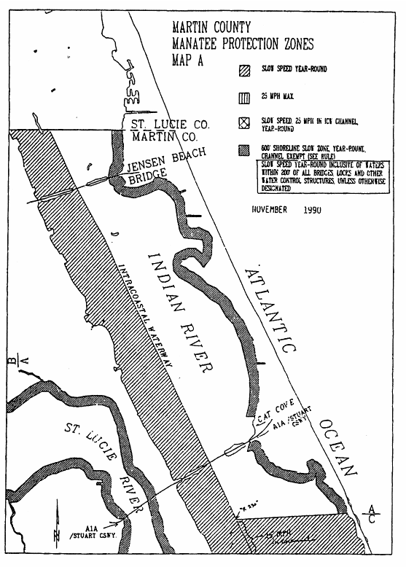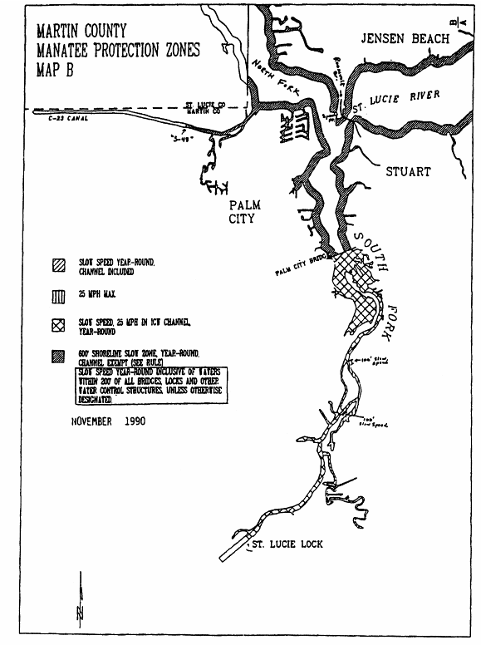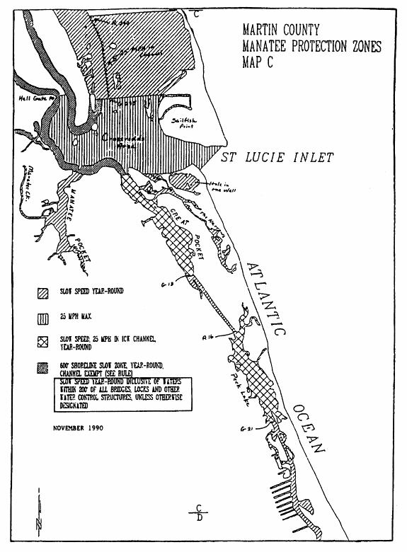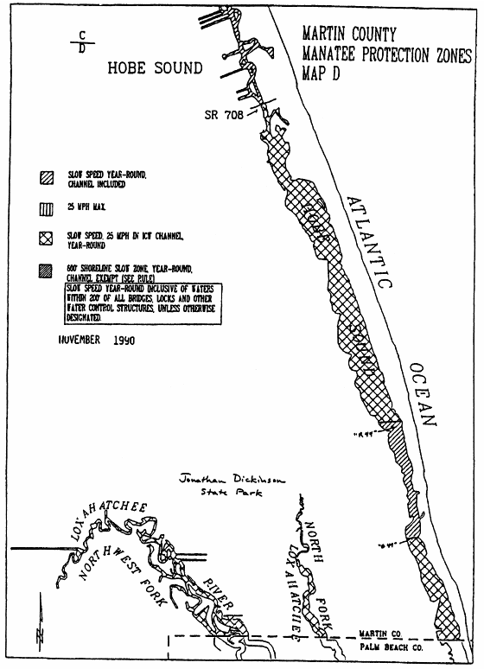
Rulemaking Authority 370.12(2)(f), (g), (n) FS. Law Implemented 370.12(2)(f), (g), (n) FS. History–New 12-24-90, Formerly 16N-22.024, 62N-22.024.

68C-22.025 Dade County Zones.
(1) For the purpose of regulating the speed and operation of motorboats within Dade County, the following year-round and seasonal zones are established, which shall include all associated and navigable tributaries, lakes, creeks, coves, bends, backwaters, canals, channels and boat basins, unless otherwise designated or excluded: (Provisions setting forth procedures for resident access to “No Entry” and “Motorboats Prohibited” Zones are given under subsection 68C-22.003, F.A.C.)
(a) Slow Speed Zone (Year-round) –
1. Dumfoundling Bay Area – All waters of Dumfoundling Bay and all those waters northerly of Dumfoundling Bay through which the Intracoastal Waterway passes, including the main marked channel of the Intracoastal Waterway, southerly of the Dade/Broward County line easterly of a line across the entrance of the canal to Maule Lake which bears North 90° 00' 00" East (True) from a point on the southerly shoreline of said canal (approximate latitude 25° 56' 17" North, approximate longitude 80° 08' 02" West) and northerly of the southerly shoreline of Dumfoundling Bay (approximate latitude 25° 56' 15" North), and including all canals and waterways connecting thereto, except as otherwise designated under paragraph (1)(b);
2. Maule Lake Area – All waters of Maule Lake northerly of a line which bears North 90° 00' 00" East (True) from a point at the intersection of the southern shoreline of Royal Glades Canal with the western shoreline of Oleta River (approximate latitude 25° 55' 43" North, approximate longitude 80° 09' 02" West), easterly of Salinity Control Structure S-29 in the Royal Glades Canal and easterly of the centerline of the Biscayne Boulevard (US Highway 1) Bridge over the Oleta River, southerly of a line across the entrance to Little Lake Maule which bears North 90° 00' 00" East (True) from the southernmost tip of land on the west side of the entrance to Little Lake Maule (approximate latitude 25° 56' 18" North, approximate longitude 80° 08' 27" West), including the canal connecting Maule Lake with Dumfoundling Bay and all of the canals lying westerly of N.E. 35th Avenue;
3. Biscayne Creek Area – All waters of Biscayne Creek including the main marked channel of the Intracoastal Waterway southerly of the southerly shoreline of Dumfoundling Bay (approximate latitude 25° 56' 15" North), easterly of a line across the mouth of the Oleta River which bears North 07° 00' 00" West (True) from a point on the southerly shoreline of Oleta River (approximate latitude 25°55'43" North, approximate longitude 80° 07 52" West) and northerly of a line which bears North 90° 00' 00" East (True) running through Flashing Red Intracoastal Waterway Channel Marker “60” (latitude 25° 55' 20" North, longitude 80° 07' 47" West);
4. Snake Creek, Royal Glades Canal Area – All waters of Snake Creek and Royal Glades Canal westerly of Salinity Control Structure S-29 in the Royal Glades Canal near the southwest end of Maule Lake and southeasterly of the centerline of the Interstate Highway 95 (State Road 9) Bridge, including all waters of Sky Lake and Little Sky Lake;
5. Oleta State Park Area – All waters of Biscayne Bay and Indian Creek southerly of a line which bears North 90° 00' 00" East (True) running through Flashing Red Intracoastal Waterway Channel Marker “60” (latitude 25° 55' 20" North, longitude 80° 07' 47" West), easterly of the centerline of the Biscayne Boulevard (US Highway 1) Bridge over L Arch Creek, westerly of the centerline of the Collins Avenue (US Highway A1A) Bridge and northerly of the centerline of the Broad Causeway, 96th Street Bridges, excepting therefrom those portions of the main marked channel of the Intracoastal Waterway lying between Flashing Green Intracoastal Waterway Channel Marker “3” (latitude 25° 55' 10" North, longitude 80° 07' 34" West) and Flashing Green Intracoastal Waterway Channel Marker “5” (latitude 25° 54' 34" North, longitude 80° 07' 31" West) and between Flashing Green Intracoastal Waterway Channel Marker “9” (latitude 25° 53' 59" North, longitude 80° 07' 57" West) and the centerline of the Broad Causeway Bridge;
6. Broad Causeway to John F. Kennedy (79th Street) Causeway Area – Those waters of Biscayne Bay westerly of the western boundary of the main marked channel of the Intracoastal Waterway and those waters of Biscayne Bay and Indian River easterly of the easterly boundary of the main marked channel of the Intracoastal Waterway and easterly of a line 1000 feet westerly of the general contour of the westerly shorelines of Indian Creek Village Island, the unnamed peninsula of land over which Stillwater Drive passes, the northerly shoreline of Biscayne Point, and easterly of the eastern boundary of the marked channel of the Meloy or East Channel, southerly of the centerline of the Broad Causeway, 96th Street Bridges and northerly of the centerline of the John F. Kennedy Causeway, 71st Street Bridges; and those waters of Biscayne Bay easterly of the easterly boundary of the main marked channel of the Intracoastal Waterway, westerly of the westerly boundary of the marked channel of the Meloy or East Channel, northerly of the centerline of the John F. Kennedy Causeway Bridges, and southerly of the following described line: BEGIN at Green Intracoastal Waterway Channel Marker “21” (latitude 25° 51' 32" North, longitude 80° 09' 49" West); thence North 90° 00' 00" East (True) to a line 1,000 feet easterly of and parallel with the seawall on the eastern side of Harbor Island; thence southerly along said parallel line to a line which bears South 90° 00' 00" West (True) from the westernmost point of the southerly shoreline of the Normandy Waterway (approximate latitude 25° 51' 10" North, approximate longitude 80° 08' 48" West); thence easterly along said line to the easterly boundary of the marked channel of the Meloy or East Channel and the TERMINATION of said line, except as otherwise designated under paragraphs (1)(b), (1)(g), and (1)(h);
7. John F. Kennedy (79th Street) Causeway to Julia Tuttle Causeway Area – All waters of Biscayne Bay, Indian Creek and Surprise Lake exclusive of the main marked channels of the Intracoastal Waterway and the Meloy or East Channel southerly of the centerline of the John F. Kennedy Causeway and 71st Street Bridges and northerly of the centerline of the Julia Tuttle Causeway and Arthur Godfrey Road Bridges; excepting therefrom the waters of Little River westerly of the general contour of the westerly shoreline of Biscayne Bay; and except as otherwise designated under paragraphs (1)(b), (1)(g), and (1)(i);
8. Julia Tuttle Causeway to Venetian Causeway Area – Those waters of Biscayne Bay westerly of the westerly boundary of the main marked channel of the Intracoastal Waterway and those waters of Biscayne Bay and Sunset Lake easterly of the easterly boundary of the marked channel of the Meloy or East Channel, all southerly of the centerline of the Julia Tuttle Causeway and Arthur Godfrey Road Bridges and northerly of the centerline of the Venetian Causeway Bridges; and that part of Biscayne Bay easterly of the easterly boundary of the main marked channel of the Intracoastal Waterway, westerly of the westerly boundary of the marked channel of the Meloy or East Channel, southerly of the centerline of the Julia Tuttle Causeway Bridges and northerly of the following described line: BEGIN at Flashing Green Intracoastal Waterway Channel Marker “45” (latitude 25° 47' 48" North, longitude 80° 10' 45" West); thence South 78° 00' 00" East (True) to a line which is 2,500 feet perpendicularly distant southeasterly of and parallel with the eastern boundary of the main marked channel of the Intracoastal Waterway; thence northeasterly along said parallel line to a line which is 1,000 feet southerly of and parallel with the southerly shoreline of the island over which the Julia Tuttle Causeway (36th Street) passes; thence easterly along said parallel line 3,500 feet, more or less, to the easternmost line of concrete pilings; thence southerly along the line of the concrete pilings to a line which bears North 90° 00' 00" East (True) running through a piling marking the Meloy or East Channel (approximate latitude 25° 48' 00" North, approximate longitude 80° 09' 01" West); thence east along said line to the westerly boundary of the marked channel of the Meloy or East Channel and the POINT OF TERMINATION; and that part of Biscayne Bay easterly of the easterly boundary of the main marked channel of the Intracoastal Waterway and westerly of the easterly boundary of the marked channel of the Meloy or East Channel, southerly of the following described line: a line 1,000 feet northerly of and parallel with the general contour of the northerly shorelines of Biscayne, San Marco, San Manno, DiLido and Rivo Alto Islands (except that part lying northerly of the southernmost row of concrete pilings approximately 750 feet northerly of DiLido Island) and southerly of a line which bears North 90° 00' 00" East (True) from the northernmost tip of Rivo Alto Island (latitude 25° 47' 38" North) from a point 1,000 feet easterly of the easterly shoreline of Rivo Alto Island to the easterly boundary of the marked channel of the Meloy or East Channel, except as otherwise designated under paragraphs (1)(b), (1)(g), and (1)(h);
9. Venetian Causeway to MacArthur Causeway Area – All waters of Biscayne Bay, Collins Canal and Indian Creek, including the main marked channel of the Intracoastal Waterway southerly of the centerline of the Venetian Causeway and Arthur Godfrey Road Bridges and northerly of the centerline of the MacArthur Causeway Bridges, except as otherwise designated under paragraphs (1)(g), and (1)(i);
10. MacArthur Causeway to Miami River Area – Those waters of Biscayne Bay westerly of the westerly boundary of the main marked channel of the Intracoastal Waterway southerly of the centerline of the MacArthur Causeway Bridge and northerly of the northerly boundary of the channel entrance to the Miami River; and those waters of Biscayne Bay easterly of the easterly boundary of the main marked channel of the Intracoastal Waterway, southerly of the extension of the line of the northerly seawall of Dodge Island northwesterly to the easterly boundary of the main marked channel of the Intracoastal Waterway, northerly of a line which bears approximately North 82° 00' 00" East (True) from the northeasternmost tip of Claughton Island to a corner of the seawall on the southerly side of Dodge Island (approximate latitude 25° 46' 18" North, approximate longitude 80° 10' 17" West) and westerly and southwesterly of the following described line: BEGIN at a point on the southwesterly shoreline of Dodge Island (approximate latitude 25° 46' 28" North, approximate longitude 80° 10' 46" West); thence South 27° 00' 00" West (True) a distance of 700 feet; thence South 43° 00' 00" East (True) a distance of 800 feet; thence North 26° 00' 00" East (True) a distance of 600 feet more or less to the southerly boundary of Fisherman’s Channel; thence South 64° 00' 00" East (True) along the southerly boundary of Fisherman’s Channel a distance of 1,200 feet more or less to the aforementioned line running from the northeasternmost tip of Claughton Island to a corner of the seawall on the southerly side of Dodge Island for the POINT OF TERMINATION;
11. Claughton Island, Point View Area – Those waters of Biscayne Bay southerly of the line of the northerly seawall of Claughton Island extended from Brickell Point on the mainland to the northerly seawall of Claughton Island, northerly of a line being the southeasterly extension of the centerline of S.W. 15th Road and westerly of a line 1,000 feet easterly of the general contour of the westerly shoreline of Biscayne Bay opposite Point View to a point 100 feet easterly of the easterly boundary of the main marked channel of the Intracoastal Waterway at a point which bears south 75° 00' 00'' East (True) from a point on the southernmost tip of Claughton Island (approximate latitude 25° 45' 48'' North, approximate longitude 80° 11' 06'' West);
12. Point View to Cutler Area – All waters within 1,000 feet of the general contour of the westerly shoreline of Biscayne Bay southerly of a line being the southeasterly extension of the centerline of S.W. 15th Road and northerly of a line which bears North 90° 00' 00" East (True) from the southern edge of Cutler Drain Canal No. C-100 to include all waters within 1,000 feet each way of the centerline of the privately maintained channel northeasterly of Chicken Key to a point 1,000 feet southeasterly of Red Channel Marker “2” (latitude 25° 36' 41" North, longitude 80° 16' 25" West), all waters within 1,000 feet of the shoreline of all islands (natural or artificial) associated with this area, all waters of Cutler Drain Canal No. C-100 easterly of the control gate located approximately 750 feet easterly of Old Cutler Road, all waters of Snapper Creek Canal No. C-2 southeasterly of the floodgate located approximately 500 feet north and 200 feet east of the intersection of Killian Drive and S.W. 57th Avenue and all waters associated with the canal system surrounding Gables Estates, the Park area north of Gables Estates, Isla Dorado, Isla Grande and the canals west, south and east of Isla Marina; excepting therefrom waters of the Coral Gables Waterway;
13. Black Point to Turkey Point Area – All waters within 1,000 feet of the general contour of the westerly shoreline of Biscayne Bay southerly of a line 1,000 feet northerly of and parallel with the northerly edge of the breakwater on the north side of Black Creek Canal and Goulds Canal Channel including all waters within 1,000 feet of the outer edges of the breakwaters north and south of said Channel to a point 1,000 feet southeasterly of the easternmost end of the breakwater (approximate latitude 25° 31' 39" North, approximate longitude 80° 18' 25" West) and northwesterly of a line which bears North 60° 00' 00" East (True) from the easternmost point of the shoreleline at Turkey Point (approximate latitude 25° 26' 18" North, approximate longitude 80° 19' 03" West) to include all waters within 1000 feet each way of the centerline of the marked channel of “North Canal” to a point 1000 feet easterly of Flashing Red Channel Marker “2” (latitude 25° 27' 46" North, longitude 80° 19' 11" West) and all waters within 1,000 feet of the shoreline of all islands (natural or artificial) associated with this area, all waters of Florida City Canal easterly of a line located 1,000 feet westerly of and parallel with a line which bears North 00° 00' 00" East (True) from the intersection of the westerly shoreline of Biscayne Bay with the southerly shoreline of the Florida City Canal (approximate latitude 25° 26' 52" North, approximate longitude 80° 19' 51" West), Mowry Canal No. C-103 easterly of the gauging station located immediately east of Canal No. L 31 E., Military Canal easterly of the flood gate located immediately east of Canal No. L 31 E., and Princeton Canal No. C-102 easterly of the control gate located approximately 250 feet easterly of Canal No. L 31 E., except as otherwise designated in paragraph (1)(c);
14. Norris Cut Area – All waters of Norris Cut southwesterly of Fisher and, northeasterly of Virginia Key, easterly of a line which bears approximately South 12° 00' 00" West (True) from a point on the southwestern shoreline of Fisher Island (approximate latitude 25° 45' 44" North, approximate longitude 80° 08' 57" West) to a point on the northwestern shoreline of Virginia Key (approximate latitude 25° 45' 24" North, approximate longitude 80° 09' 02" West) and westerly of a line which bears approximately South 15° 00' 00" West (True) from a point on the southernmost tip of the shoreline of Fisher Island (approximate latitude 25° 45' 19" North, approximate longitude 80° 08' 25" West) to a point on the shoreline of the northernmost tip of a peninsula of Virginia Key (approximate latitude 25° 44' 50" North, approximate longitude 80° 08' 33" West) including all waters of Lamar Lake; and that part of Biscayne Bay within 1,000 feet of the southwesterly and westerly shorelines of Fisher Island and the westerly shoreline extended northerly, westerly of the aforementioned line which bears approximately South 12° 00' 00" West (True) from a point on the southwestern shoreline of Fisher Island and southerly of the southerly boundary of Fisherman’s Channel;
15. Key Biscayne Area – All waters of Biscayne Bay within 1,000 feet of the southwesterly shoreline of Virginia Key southeasterly of a line which bears South 75° 00' 00" West (True) from the intersection of the centerline of Rickenbacker Causeway with the centerline of the northernmost entrance to the Seaquarium (latitude 25° 44' 09" North, longitude 80° 09' 57" West) and southwesterly of a line 1,000 feet southwesterly of and parallel with the centerline of Bear Cut Bridge; all waters of Bear Cut between the centerline of Bear Cut Bridge and a line 1,000 feet southwesterly of and parallel with the centerline of Bear Cut Bridge; all waters of Biscayne Bay within 1,000 feet of the general contour of the westerly and southerly shoreline of the island of Key Biscayne southwesterly of a line 1,000 feet southwesterly of and parallel with the centerline of Bear Cut Bridge and westerly of a line which bears South 00° 00' 00" West (True) from the Cape Florida Old Lighthouse Tower (latitude 25° 39' 58" North, longitude 80° 09' 22" West); and all waters within 1,000 feet of the shoreline of all islands (natural or artificial) associated with this area;
16. Biscayne Canal Area – All waters of Biscayne Canal westerly of the general contour of the western shoreline of Biscayne Bay and southeasterly of the southeasterly edge of the Interstate Highway 95 (State Road 9) Bridge and including an unnamed lake and associated waters in Sections 14, 22 and 23, Township 52 South, Range 41 East, southerly of Biscayne Canal, southeasterly of Interstate Highway 95 (State Road 9) and easterly of a line approximately 100 feet westerly of and parallel with the centerline of N.W. 19th Avenue, except as otherwise designated for seasonal regulation;
17. Tamiami Canal, Blue Lagoon Area – All waters of the Tamiami Canal and Blue Lagoon Lakes southwesterly of the general contour of the southwestern shoreline of the Miami River and easterly of the centerline of Red Road (State Road 959), except as otherwise designated under paragraph (1)(j), hereunder;
18. Intracoastal Waterway, Green Channel Marker “21” to Claughton Island Area – All waters of Biscayne Bay not otherwise described as a speed restrictive zone easterly of the westerly boundary of the main marked channel of the Intracoastal Waterway and westerly of a line 100 feet easterly of and parallel with the easterly boundary of the main marked channel of the Intracoastal Waterway southerly of Green Intracoastal Waterway Channel Marker “21” (latitude 25° 51' 32" North, longitude 80° 09' 49" West) and northerly of a line which bears South 75° 00' 00" East (True) from a point on the southernmost tip of Claughton Island (approximate latitude 25° 45' 48" North, approximate longitude 80° 11' 06" West);
19. Aerojet Canal No. C-111 Area – All waters of the Aerojet Canal No. C-111 northwesterly of the general contour of the northwesterly shoreline of Manatee Bay and southeasterly of a line perpendicular to the canal at a point 300 feet northwesterly of the control gate near the boat ramp in the Southwest 1/4 of Section 16, Township 59 South, Range 39 East (approximate latitude 25° 17' 13" North, approximate longitude 80° 26' 32" West);
20. Little Lake Maule Area – Those waters of Little Lake Maule easterly of the general contour of the easterly shoreline of the main body of Little Lake Maule (approximate longitude 80° 08' 23" West);
21. MacArthur Causeway to Rickenbacker Causeway Area – Those waters of Biscayne Bay exclusive of the main marked channel of the Intracoastal Waterway within 1000 feet of the general contour of the northerly shoreline of the islands over which Rickenbacker Causeway passes and within 1000 feet of the centerline of the William M. Powell Bridge, southeasterly of a line 1000 feet southeasterly of and parallel with the general contour of the westerly shoreline of Biscayne Bay, and southwesterly of the northwesterly extension of the general contour of the southerly shoreline of the Marine Stadium, including the boat basin northeasterly of the easterly end of the William M. Powell Bridge; and,
22. Flagler Memorial Monument Area – Those waters of Biscayne Bay lying within 100 feet of the general contour of the southwesterly, northwesterly and northeasterly shoreline of the Flagler Memorial Monument Island, southwesterly of a line which bears North 52° 00' 00" West (True) running through Red Nun Bouy “2” (latitude 25° 47' 05" North, longitude 80° 09' 01" West), westerly of a line bearing North 90° 00' 00" East (True) running through Red Nun Bouy “2,” northerly of latitude 25° 47' 00" North, and northeasterly of a line which bears North 52° 00' 00" West (True) located 100 feet southwesterly of the southwesternmost tip of the Flagler Memorial Monument Island.
(b) Slow Speed Zone (November 15 through April 30)/MAXIMUM 30 MPH ZONE (Remainder of Year) –
1. Meloy or East Channel, Surprise Lake to Sunset Islands Area – Those waters of the Marked Channel of the Meloy or East Channel southerly of a line bearing South 75° 00' 00" East (True) running through Red Channel Marker “16” (latitude 25° 49' 10" North, longitude 80° 08' 24" West) and northerly of a line which bears North 90° 00' 00" East (True) running through Red Channel Marker “22” (latitude 25° 48' 24" North, longitude 80° 08' 56" West);
2. Dumfoundling Bay Area – Those waters within the main marked channel of the Intracoastal Waterway, southerly of the northerly boundary of the main marked channel leading westerly from the Intracoastal Waterway (approximate latitude 25° 56' 58" North, approximate longitude 80° 07' 37" West) and northerly of a line which bears South 57° 00' 00" East (True) running through Flashing Red Intracoastal Waterway Channel Marker “52” (latitude 25° 56' 26" North, longitude 80° 07' 52" West);
3. Broad Causeway to John F. Kennedy Causeway Area – Those waters within the main marked channel of the Intracoastal Waterway, southerly of a line which bears South 55° 00' 00" East (True) running through Green Intracoastal Waterway Channel Marker “21” (latitude 25° 51' 32" North, longitude 80° 09' 49" West), and northerly of a line which bears South 86° 00' 00" East (True) running through Red Privately Maintained Channel Marker “2” (latitude 25° 51' 00" North, longitude 80° 10' 17" West); and,
4. John F. Kennedy Causeway to Venetian Causeway Area – Those waters within the main marked channel of the Intracoastal Waterway, southerly of a line which bears South 86° 00' 00" East (True) running through Green Intracoastal Waterway Channel Marker “31” (latitude 25° 49' 57" North, longitude 80° 10' 18" West), and northerly of a line 100 feet northerly of and parallel with the centerline of the Venetian Causeway Bridge.
(c) Idle Speed Zone (Year-round) –
1. Little Lake Maule Area – All waters of Little Lake Maule northerly of a line across the entrance to Little Lake Maule which bears North 90° 00' 00" East (True) from the southernmost tip of land on the west side of the entrance to Little Lake Maule (approximate latitude 25° 56' 18" North, approximate longitude 80° 08' 27" West) and westerly of the general contour of the easterly shoreline of the main body of Little Lake Maule (approximate longitude 80° 08' 23" West);
2. Oleta River Northwesterly of Maule Lake Area – Those waters of Oleta River northwesterly of the centerline of the Biscayne Boulevard (US Highway 1) Bridge;
3. Little River Area – Those waters of Little River north and south of Belle Meade Island westerly of the general contour of the westerly shoreline of Biscayne Bay and southerly of Salinity Control Structure S-27, except as otherwise designated for seasonal regulation;
4. Miami River Area – Those waters of Biscayne Bay southerly of the northerly shoreline of the Miami River and the northerly boundary of the Miami River Channel, northerly of the northerly seawall of Claughton Island and said line extended from Brickell Point on the mainland to the northerly seawall of Claughton Island, and westerly of the western boundary of the main marked channel of the Intracoastal Waterway; and all waters of the Miami River southeasterly of the centerline of State Road 953 (S.E. 8th Avenue, N.W. 42nd Avenue) including all waters of Palmer Lake, the South Fork of the Miami River easterly of N.W. 37th Avenue (Douglas Road) and Seybold Canal, excluding waters of the Tamiami Canal;
5. Coral Gables Canal Area – Those waters of the Coral Gables Waterway westerly of the general contour of the westerly shoreline of Biscayne Bay and northerly of the general contour of the northerly shoreline of Isla Marina, and those waters of the Coral Gables Canal easterly of the centerline of the Alhambra Circle Bridge including that canal northeasterly of the Coral Gables Canal northerly of Avenue Vilabella and westerly of Riviera Drive, that portion of the canal loop westerly of the Coral Gables Canal, northerly of Alhambra Circle, southerly of the Elevated Bridge, and that portion of the canal loop running through the University of Miami Campus and adjacent to the Biltmore Golf Course, northerly of the centerline of the Pisano Avenue Bridge, except as otherwise designated for seasonal regulation;
6. Black Creek Canal Area – Those waters of the Black Creek Canal and the Black Point Marina Basin southerly of a line bearing North 60° 00' 00" East (True) located 50 feet southeasterly of the southernmost tip of the shoreline of the peninsula northeast of the entrance to the Black Point Marina Basin (approximate latitude 25° 32' 23" North); those waters of the Goulds Canal easterly of the southerly extension of the centerline of S.W. 87th Avenue; and those waters of Biscayne Bay within the channel representing the extension of the Black Creek and Goulds Canals to a point opposite the easterly end of the breakwater on the northerly side of said channel (approximate latitude 25° 31' 39" North, approximate longitude 80° 18' 25" West);
7. Oleta River Area – All waters of the Oleta River southerly of a line which bears North 90° 00' 00" East (True) from a point at the intersection of the southern shoreline of Royal Glades Canal with the western shoreline of Oleta River (approximate latitude 25° 55' 43" North, approximate longitude 80° 09' 02" West) and westerly of a line across the mouth of the Oleta River at Biscayne Creek which bears North 07° 00' 00" West (True) from a point on the southerly shoreline of Oleta River (approximate latitude 25° 55' 43" North, approximate longitude 80° 07' 52" West); and,
8. Convoy Point Area – Those waters of North Canal and the channel of North Canal, westerly of the easterly shoreline of the waterway leading into Convoy Point, and easterly of the centerline of the North Cal Drive Bridge to include the waterways of Convoy Point and the boat basins of Homestead Bayfront County Park.
(d) Motorboats Prohibited Zone (Year-round) – Fisher Island Area: Those waters of the Atlantic Ocean within 400 feet of the general contour of the southeasterly shoreline of Fisher Island southerly of the breakwater on the southerly side of Government Cut and northerly of a line which bears South 50° 00' 00" East (True) from a point on the southernmost tip of the shoreline of Fisher Island (approximate latitude 25° 45' 19" North, approximate longitude 80° 08' 25" West).
(e) No Entry Zone (Year-round) –
1. Virginia Key Area – Those waters of Biscayne Bay westerly of the westerly shoreline of Virginia Key, northerly of the northerly shoreline of the peninsula of land on the northerly side of the Marine Stadium, southeasterly of a line bearing North 33° 00' 00" East (True) from the northwesternmost tip of the shoreline of said peninsula (approximate latitude 25° 45' 03" North, approximate longitude 80° 10' 23" West) and southerly of a line bearing North 56° 00' 00" West (True) from a point on the northwestern shoreline of Virginia Key (approximate latitude 25° 45' 24" North, approximate longitude 80° 09' 02" West); and,
2. Black Creek Canal Area – Those waters of the Black Creek Canal and the Black Point Marina Basin southerly of Salinity Control Structure S-21 and northerly of a line bearing North 60° 00' 00" East (True) located 50 feet southeasterly of the southernmost tip of the shoreline of the peninsula northeast of the entrance to the Black Point Marina Basin (approximate latitude 25° 32' 23" North).
(f) No Entry Zone (November 15 through April 30) –
1. Biscayne Canal Area – Those waters of the Biscayne Canal southeasterly of Salinity Control Structure S-28 and westerly of the southerly extension of the easterly shoreline of the small basin northerly of and associated with the Biscayne Canal near N.E. 10th Court, including all waters within said basin;
2. Little River Area – Those waters of Little River westerly of the centerline of the Biscayne Boulevard (U.S. Highway 1) Bridge and southerly of Salinity Control Structure S-27; and,
3. Coral Gables Canal Area – Those waters of the Coral Gables Canal northwesterly of the centerline of the Elevated Bridge northwesterly of and parallel with US Highway 1 and southerly of the centerline of the Bird Road (S.W. 40th Street) Bridge including that part of the canal loop and associated portions of this water system westerly of the Coral Gables Canal adjacent to the Biltmore Golf Course northerly of the centerline of the Pisano Avenue Bridge, that canal northeasterly of the Coral Gables Canal northerly of Avenue Vilabella and westerly of Riviera Drive, and that part of the canal loop and associated portions of this water system westerly of the Coral Gables Canal northeasterly of Alhambra Circle, southerly of US Highway 1 and northwesterly of the northerly extension of the centerline of Trionto Street.
(g) Maximum 30 MPH Zone –
1. Oleta State Park Area – Those waters within the main marked channel of the Intracoastal Waterway lying between Flashing Green Intracoastal Waterway Channel Marker “3” (latitude 25° 55' 10" North, longitude 80° 07' 34" West) and Flashing Green Intracoastal Waterway Channel Marker “5” (latitude 25° 54' 34" North, longitude 80° 07' 31" West) and between Flashing Green Intracoastal Waterway Channel Marker “9” (latitude 25° 53' 59" North, longitude 80° 07' 57" West) and a line bearing South 55° 00' 00" East (True) located 300 feet South 35° 00' 00" West (True) of the centerline of the Broad Causeway Bridge as me measured along the centerline of the Intracoastal Waterway;
2. John F. Kennedy Causeway to Julia Tuttle/Venetian Causeway Area – Those waters within the marked channel of the Meloy or East Channel southerly of a line which bears South 90° 00' 00" West (True) from the westernmost point of the southerly shoreline of the Normandy Waterway (approximate latitude 25° 51' 10" North, approximate longitude 80° 08' 48" West) and northerly of a line which bears North 90° 00' 00" East (True) running through a piling marking the Meloy or East Channel (approximate latitude 25° 48' 00" North, approximate longitude 80° 09' 01" West), except as otherwise designated for seasonal regulation under paragraph (1)(b); and,
3. Venetian Causeway to MacArthur Causeway Area – Those waters within the channel commonly known as the Meloy or East Channel (to be marked upon zone establishment) generally southerly of marker R “30” and a line which bears North 90° 00' 00" East (True) from the northernmost tip of Rivo Alto Island (latitude 25° 47' 38" North), such channel passing through the opening of the Venetian Causeway bascule bridge, and northerly of the centerline of the easternmost span of the MacArthur Causeway Bridge.
(h) Slow Speed Zone (November 15 through April 30)/Maximum 35 MPH Zone (Remainder of Year) –
1. Broad Causeway to John F. Kennedy Causeway Area – Those waters of Biscayne Bay, easterly of the easterly boundary of the marked channel of the Meloy or East Channel and the northerly extension of said channel near Flashing Red Channel Marker “2” (latitude 25° 52' 08" North, longitude 80° 08' 41" West), southerly of a line which bears North 90° 00' 00" East (True) located 200 feet southerly of the southernmost tip of Indian Creek Village Island, westerly of a line which bears North 00° 00' 00" East (True) located 200 feet westerly of the westerly tip of the unnamed peninsula of land over which Stillwater Drive passes, southerly of a line 200 feet southerly of and parallel with the general contour of the southerly shoreline of said unnamed peninsula, northwesterly and northerly of a line 200 feet northwesterly and northerly of the general contour of the northerly shoreline of that island over which Cleveland Road passes, and northerly of said line extended westerly to the easterly boundary of the marked channel of the Meloy or East Channel; and,
2. Julia Tuttle Causeway to Venetian Causeway Area – Those waters of Biscayne Bay, easterly of the easterly boundary of the marked channel of the Meloy or East Channel, southerly of a line 200 feet southerly of and parallel with the general contour of the southerly shoreline of the island over which the Julia Tuttle Causeway passes, northwesterly of a line 200 feet northwesterly of and parallel with the general contour of the shoreline of Miami Beach Island in the vicinity of North Bay Road, and northerly of a line which bears North 90° 00' 00" East (True) located 200 feet northerly of the northernmost tip of the northernmost island of the Sunset Islands.
(i) Maximum 35 MPH Zone (Year-round) –
1. John F. Kennedy (79th Street) Causeway to Julia Tuttle Causeway Area – Those waters of Biscayne Bay, easterly of the easterly boundary of the marked channel of the Meloy or East Channel, southerly of a line which bears South 60° 00' 00" West (True) running through Flashing Green Channel Marker “11” (latitude 25° 50' 49" North, longitude 80° 07' 59" West), northerly of a line which bears North 90° 00' 00" East (True) located 1300 feet South 00° 00' 00" West (True) of Red Channel Marker “12B” (latitude 25° 49' 57" North, longitude 80° 08' 04" West), southwesterly of a line 200 feet southwesterly of and parallel with the general contour of the southwesterly shoreline of La Gorce Island, westerly of a line which bears South 00° 00' 00" West (True) at longitude 80° 07' 55" West between La Gorce Island and the island on which the La Gorce Golf Course lies, and westerly of a line 200 feet westerly of and parallel with the general contour of the westerly shoreline of the island on which the La Gorce Golf Course lies; and,
2. Venetian Causeway to MacArthur Causeway Area – Those waters of Biscayne Bay, westerly of the westerly boundary of the channel (to be marked upon zone establishment) commonly known as the Meloy or East Channel, northerly of a line which bears North 90° 00' 00" East (True) located 200 feet northerly of the northernmost tip of Star Island, northeasterly of a line which is 200 feet northeasterly of and parallel with the general contour of the northeasterly shoreline of Hibiscus Island, southeasterly of a line which bears South 25° 00' 00" West running through the southernmost tip of Di Lido Island (approximate latitude 25° 47' 18" North, approximate longitude 80° 09' 32" West), southerly of a line which bears North 90° 00' 00" East (True) located 200 feet southerly of the southernmost tip of Rivo Alto Island, southerly of a line which bears North 90° 00' 00" East (True) easterly of Rivo Alto Island located 300 feet northerly of the southernmost tip of Rivo Alto Island, and southeasterly of a line 200 feet southeasterly of and parallel with the general contour of the southeasterly shorelines of Di Lido and Rivo Alto Islands, excepting therefrom the Flagler Memorial Monument Area designated under paragraph (1)(a).
(j) Maximum 35 MPH Zone (Transitional) – The waters herein described shall be designated a 35 MPH zone for explicit use by personal watercraft for a period of one year from the effective date of this rule. After said one-year period, the below described area shall revert to designation as Slow Speed, year-round. Blue Lagoon Lakes Area: That portion of the northerly body of Blue Lagoon Lake, westerly of a line which bears North 00° 00' 00" East (True) running through the easternmost tip of a peninsula (approximate latitude 25° 46' 54" North, approximate longitude 80° 16' 37'' West) LESS that portion of the northerly 200 feet of the lake easterly of a line 200 feet easterly of and parallel with the general contour of the westerly shoreline of the lake.
(2) The zones described in subection 68C-22.025(1), F.A.C., herein are depicted on the following maps, labeled “Dade County Manatee Protection Zones, Maps 1-9,” inclusive of insets and associated maps, dated October 1991 for identification: (Maps provided are intended as depictions of the above-described zones. In the event of conflict between the two, the above descriptions shall prevail. The October 1991 maps shall become effective for purposes of this rule concurrent with its effective date.)
Rulemaking Authority 370.12(2)(f), (g), (n) FS. Law Implemented 370.12(2)(f), (g), (n) FS. History–New 12-25-91, Formerly 16N-22.025, 62N-22.025.

68C-22.026 Sarasota County Zones.
(1) The Commission hereby designates the waters within Sarasota County (and a small portion of Charlotte County), as described below, as areas where manatee sightings are frequent and where the best available information supports the conclusion that manatees inhabit these areas on a regular or periodic basis. The primary purpose of this rule is to protect manatees from harmful collisions with motorboats and from harassment by establishing safe havens and regulating the speed and operation of motorboats within these designated areas. A secondary purpose is to protect manatee habitat.
(a) In consideration of balancing the rights of fishers, boaters, and water skiers to use the waters of the state for recreational and commercial purposes (as applicable under Section 379.2431(2)(k), F.S.), with the need to provide manatee protection, the Commission has examined the need for limited lanes, corridors, or unregulated areas that allow higher speeds through or within regulated areas. Such lanes, corridors, or areas are provided in those locations where the Commission determined they are consistent with manatee protection needs. Access to the NO ENTRY zones designated hereunder will be provided in accordance with the procedures set forth in Rule 68C-22.003, F.A.C.
(b) All zones include all associated and navigable tributaries, lakes, creeks, coves, bends, backwaters, canals, channels and boat basins, and other waterways unless otherwise designated or excluded. Coordinates used in the descriptions of zone boundaries are referenced to the North American Datum of 1983 (NAD83).
(2) The following year-round zones are established within the coastal waters of Sarasota County:
(a) Slow Speed.
1. Buttonwood Harbor, Cranes Bayou Area: All waters of Buttonwood Harbor and Cranes Bayou; and, all waters of Sarasota Bay, north of Buttonwood Harbor, east of Longboat Key, south of the Manatee County line, and west of a line that bears 6° from the westernmost point of Buttonwood Point (approximate latitude 27° 23' 10" North, approximate longitude 82° 37' 47" West);
2. Whitaker Bayou Area: All waters of Whitaker Bayou south of the centerline of the 27th Street Bridge; and, those waters of Sarasota Bay within 300 feet of the eastern shoreline of Sarasota Bay, south of a line that bears 270° from a point at the intersection of the northern shoreline of Whitaker Bayou with the eastern shoreline of Sarasota Bay (approximate latitude 27° 21' 12" North, approximate longitude 82° 33' 08" West), and north of the westerly extension of the seawall forming the northern shore of the entrance to the Hyatt Boat Basin;
3. New Pass: All waters of New Pass and Sarasota Bay, south and west of a line that begins at the northeasternmost tip of Quick Point on Longboat Key (approximate latitude 27° 20' 20" North, approximate longitude 82° 34' 55" West) and bears 345° for a distance of approximately 400 feet to Point No. 1 in Sarasota Bay (latitude 27° 20' 24" North, longitude 82° 34' 56" West) then bears 87° for a distance of approximately 2,285 feet to Point No. 2 in Sarasota Bay (latitude 27° 20' 25" North, longitude 82° 34' 31" West) then bears 128° for a distance of approximately 1,130 feet to Point No. 3 in Sarasota Bay (latitude 27° 20' 18" North, longitude 82° 34' 21" West) roughly 600 feet east of Lighted Green Channel Marker “13” (latitude 27° 20' 18" North, longitude 82° 34' 28" West), north of Lido Key, City Island, and a line running from the northernmost point of City Island to the aforementioned Point No. 3, and northeast of a line that bears 320° through Green Day Marker “9” (approximate latitude 27° 19' 53" North, approximate longitude 82° 35' 04" West);
4. City Island Lagoon Area: All waters of Sarasota Bay, including the City Island Lagoon area, southwest of a line that bears 125° from a point in Sarasota Bay (latitude 27° 20' 18" North, longitude 82° 34' 21" West) to the northernmost point of Bird Key (approximate latitude 27° 19' 45" North, approximate longitude 82° 33' 31" West), northwest of Bird Key and Coon Key and the centerline of the John Ringling Boulevard Bridges (connecting Bird Key to Coon Key and Coon Key to St. Armands Key), northeast of St. Armands Key and the shoreline of City Island adjacent to John Ringling Parkway running northwest from St. Armands Key and the centerline of the John Ringling Parkway Bridge connecting St. Armands Key to City Island, and southeast of Lido Key, City Island, and a line running from the northernmost point of City Island to the aforementioned point in Sarasota Bay;
5. Lido Key Area: All waters of Sarasota Bay south of Coon Key and St. Armands Key and the centerline of the John Ringling Boulevard Bridges (connecting Bird Key to Coon Key, Coon Key to St. Armands Key, and St. Armands Key to Lido Key), east of Lido Key, west of Bird Key and the centerlines of the Bird Key Drive Bridges and the Wild Turkey Lane Bridge, and northwest of a line that bears 218° from the southernmost point of Bird Key (approximate latitude 27° 18' 36" North, approximate longitude 82° 33' 36" West) to a point on the eastern shoreline of Lido Key (approximate latitude 27° 18' 17" North, approximate longitude 82° 33' 53" West), except as otherwise designated under paragraph (2)(e);
6. Bird Key Area: All waters of the basin on the northeast side of Bird Key east of the centerline of the northern Bird Key Drive Bridge; and, those waters of Sarasota Bay west of a line that begins at a point on the eastern shoreline of Bird Key (approximate latitude 27° 19' 16" North, approximate longitude 82° 33' 21" West) roughly 850 feet southeast of the northernmost point of land containing Meadow Lark Drive, then bears 19° for a distance of approximately 350 feet to Point No. 1 in Sarasota Bay (latitude 27° 19' 19" North, longitude 82° 33' 19" West) then bears 344° for a distance of approximately 1,150 feet to Point No. 2 in Sarasota Bay (latitude 27° 19' 30" North, longitude 82° 33' 23" West) then bears 315° for a distance of approximately 1080 feet to the line’s terminus at a point on the northeast shoreline of Bird Key (approximate latitude 27° 19' 38" North, approximate longitude 82° 33' 31" West);
7. Hudson Bayou Area: All waters of Hudson Bayou to its headwaters and that part of Sarasota Bay within 300 feet of the general contour of the eastern shoreline of Sarasota Bay, south of a line that bears 270° from a point at the intersection of the northern shoreline of Hudson Bayou with the eastern shoreline of Sarasota Bay (approximate latitude 27° 19' 29" North, approximate longitude 82° 32' 28" West), and north of a line that bears 270° from a point on the southwestern shoreline of the peninsula that contains Vista Drive (approximate latitude 27° 18' 59" North, approximate longitude 82° 32' 43" West);
8. Roberts Bay Area (north): All waters of Roberts Bay south of the centerline of the Siesta Drive Bridge (State Road 789) (connecting Bay Island with the mainland) and north of a line located 775 feet south of and parallel with a line that bears 78° running through Green Intracoastal Waterway Channel Marker “75” (approximate latitude 27° 16' 46" North, approximate longitude 82° 32' 41" West), including all waters of Hansen Bayou south of the general contour of the northern shoreline of Siesta Key, South Coconut Bayou, Coconut Bayou, and all waters associated with the Grand Canal waterway system throughout Siesta Key, except as otherwise designated under paragraphs (2)(d) and (2)(e);
9. Little Sarasota Bay, Phillippi Creek Area: All waters of Little Sarasota Bay south of a line located 775 feet south of and parallel with a line that bears 78° running through Flashing Green Intracoastal Waterway Channel Marker “75” (approximate latitude 27° 16' 46" North, approximate longitude 82° 32' 41" West), and north of a line located 250 feet south of and parallel with a line that bears 50° running through Green Intracoastal Waterway Channel Marker “61” (approximate latitude 27° 15' 07" North, approximate longitude 82° 31' 48" West); and, all waters of Phillippi Creek southwest of the dam located northeast of the Tuttle Avenue Bridge;
10. Little Sarasota Bay Area: All waters of Little Sarasota Bay, including all waters of Blind Pass Lagoon, Midnight Pass Lagoon, North Creek and Catfish Creek to the headwaters of said creeks, south of a line located 250 feet south of and parallel with a line that bears 50° running through Green Intracoastal Waterway Channel Marker “61” (approximate latitude 27° 15' 07" North, approximate longitude 82° 31' 48" West), and north of the centerline of the Blackburn Point Bridge (County Road 789), except as otherwise designated under paragraph (2)(e);
11. Little Sarasota Bay, Dryman Bay and South Creek Area: All waters of Little Sarasota Bay, Dryman Bay, and Blackburn Bay south of the centerline of the Blackburn Point Bridge and north of a line that bears 90° running through Green Intracoastal Waterway Channel Marker “23” (approximate latitude 27° 09' 38" North, approximate longitude 82° 29' 03" West); and, all waters of South Creek to the dam in Oscar Scherer State Park;
12. Blackburn Bay Area: All waters of Blackburn Bay south of a line that bears 90° running through Green Intracoastal Waterway Channel Marker “23” (approximate latitude 27° 09' 38" North, approximate longitude 82° 29' 03" West), and north of a line that bears 90° running through Green Intracoastal Waterway Channel Marker “13” (approximate latitude 27° 07' 53" North, approximate longitude 82° 28' 13" West), except as otherwise designated under paragraph (2)(e);
13. Blackburn Bay, Lyons Bay, Dona Bay, Shakett Creek and Venice Inlet Area: All waters of Blackburn Bay, Lyons Bay, Dona Bay, and Venice Inlet, south of a line that bears 90° running through Green Intracoastal Waterway Channel Marker “13” (approximate latitude 27° 07' 53" North, approximate longitude 82° 28' 13" West), north of a line that bears approximately 68° running through Red Intracoastal Waterway Channel Marker “16” (approximate latitude 27° 06' 47" North, approximate longitude 82° 27' 37" West) to the northernmost tip of land of the Enchanted Island Subdivision containing Anchorage Drive (approximate latitude 27° 06' 51" North, approximate longitude 82° 27' 26" West), and, east of a line that bears 170° running through Green Venice Inlet Day Beacon “3” (approximate latitude 27° 06' 48" North, approximate longitude 82° 28' 02" West); and all waters of Shakett Creek south of the control structure southwest of Interstate Highway 75, including all waters of Fox Creek and Salt Creek to the headwaters of said creeks;
14. Roberts Bay (south) Area: Those waters of Roberts Bay, as follows, except as otherwise designated under paragraph (2)(e):
a. Those waters of Roberts Bay south of a line that bears approximately 68° running through Red Intracoastal Waterway Channel Marker “16” (approximate latitude 27° 06' 47" North, approximate longitude 82° 27' 37" West) to the northernmost tip of land of the Enchanted Island Subdivision containing Anchorage Drive (approximate latitude 27° 06' 51" North, approximate longitude 82° 27' 26" West), and, and west of a line that bears 360° running through Red Intracoastal Waterway Channel Marker “12” (approximate latitude 27° 06' 34" North, approximate longitude 82° 27' 19" West); and,
b. Those waters of Roberts Bay east of a line that bears 360° running through Red Intracoastal Waterway Channel Marker “12” (approximate latitude 27° 06' 34" North, approximate longitude 82° 27' 19" West), northwest of a line that bears 60° running through Red Intracoastal Waterway Channel Marker “8” (approximate latitude 27° 06' 26" North, approximate longitude 82° 26' 54" West), south of the northern boundary of the main marked channel of the Intracoastal Waterway between Red Intracoastal Waterway Channel Marker “12” and Red Intracoastal Waterway Channel Marker “10” (approximate latitude 27° 06' 34" North, approximate longitude 82° 27' 00" West), and south of a line that bears 60° from Red Intracoastal Waterway Channel Marker “10” to the eastern shoreline of Roberts Bay;
15. Roberts Bay (South), Curry Creek and Blackburn Canal Area: Those waters of Roberts Bay within 100 feet of the general contour of the eastern shoreline of Roberts Bay west of US Highway 41, north of a line that bears 60° from Red Intracoastal Waterway Channel Marker “10” (approximate latitude 27° 06' 34" North, approximate longitude 82° 27' 00" West) to the eastern shoreline of Roberts Bay, and east of a line that bears 180° from a point on the northern shoreline of Roberts Bay (approximate latitude 27° 06' 49" North, approximate longitude 82° 27' 01" West); and, all waters of Curry Creek from Roberts Bay to the Myakka River, and all waters of Blackburn Canal to its headwaters;
16. Hatchett Creek: All waters of Hatchett Creek west of the centerline of U.S. Highway 41 (Venice By-Pass), south of a line that bears 60° running through Red Intracoastal Waterway Channel Marker “8” (approximate latitude 27° 06' 26" North, approximate longitude 82° 26' 54" West), and north of a line that bears 25° located 400 feet southeast of the centerline of the US 41 (Business) Bridge, as measured along the centerline of the Intracoastal Waterway;
17. Country Club Estates Area: All waters of the boat basin serving the Country Club Estates mobile home park, southwest of the general contour of the southwestern shoreline of the Venice Airport Canal; and,
18. Alligator Creek, Lemon Bay Area: All waters of Alligator Creek southwest of the centerline of the US Highway 41 Bridge; and, all waters of Lemon Bay southeast of a line that bears 50° running through Red Intracoastal Waterway Channel Marker “52” (approximate latitude 27° 02' 46" North, approximate longitude 82° 25' 59" West), and north of the Sarasota/Charlotte County line, except as otherwise designated under paragraphs (2)(b) and (2)(e).
(b) Idle Speed.
1. Hyatt Boat Basin: All waters of the Hyatt Boat Basin and that portion of Sarasota Bay east of a line that bears 180° from a point in Sarasota Bay (approximate latitude 27° 20' 19" North, approximate longitude 82° 33' 07" West) 300 feet west of the corner of the seawall at the southwest corner of the Hyatt site (approximate latitude 27° 20' 19" North, approximate longitude 82° 33' 03" West), and south of a line that bears 90° from the aforementioned point in Sarasota Bay to the corner of the seawall at the southwest corner of the Hyatt site; and
2. Forked Creek Area: All waters of Forked Creek east of its confluence with Lemon Bay; and, all waters of Waterford Canal, Windsor Canal, Greenlawn Channel, Fairview Channel, and North Branch.
(c) No Entry – Pansy Bayou: All waters of that body of water commonly known as Pansy Bayou (being that body of water north and west of St. Armands Key), west of the centerline of the northbound lane of John Ringling Parkway, and north of the centerline of the westbound lane of John Ringling Boulevard.
(d) Maximum 35 MPH.
1. Roberts Bay (north) Area: Those waters of Roberts Bay surrounding the spoil island commonly referred to as “Skiers Island” located approximately 700 feet west of the Intracoastal Waterway near Green Intracoastal Waterway Channel Marker “79” (approximate latitude 27° 17' 18" North, approximate longitude 82° 32' 47" West), bounded on the north by a line that bears 90° located 300 feet north of the northernmost tip of the shoreline of the spoil island, bounded on the south by a line that bears 90° located 300 feet south of the southernmost tip of the shoreline of the spoil island, bounded on the west by a line 300 feet west of and parallel with the general contour of the western shoreline of the spoil island, and bounded on the east by the western boundary of the main marked channel of the Intracoastal Waterway; and,
2. Roberts Bay (south) Area: Those waters of Roberts Bay, east of a line that bears 360° running through Red Intracoastal Waterway Channel Marker “12” (approximate latitude 27° 06' 34" North, approximate longitude 82° 27' 19" West), north of the northern boundary of the main marked channel of the Intracoastal Waterway between Red Intracoastal Waterway Channel Marker “12” and Red Intracoastal Waterway Channel Marker “10” (approximate latitude 27° 06' 34" North, approximate longitude 82° 27' 00" West) and a line that bears 60° from Red Intracoastal Waterway Channel Marker “10” to the eastern shoreline of Roberts Bay, and west of US Highway 41, excluding those waters within 100 feet of the shoreline as designated under subparagraph (2)(a)15.
(e) Maximum 25 MPH.
1. Lido Key Area: All waters of the unnamed main marked channel south of the centerline of the John Ringling Boulevard Bridge connecting Bird Key to Coon Key, and north of a line that bears 218° from the southernmost point of Bird Key (approximate latitude 27° 18' 36" North, approximate longitude 82° 33' 36" West) to a point on the eastern shoreline of Lido Key (approximate latitude 27° 18' 17" North, approximate longitude 82° 33' 53" West);
2. Roberts Bay (north): All waters of the main marked channel of the Intracoastal Waterway south of a line that bears 90° from the southernmost point of Big Edward’s Island (approximate latitude 27° 17' 436" North, approximate longitude 82° 32' 48" West), and north of a line that bears 78° running through Green Intracoastal Waterway Channel Marker “75” (approximate latitude 27° 16' 46" North, approximate longitude 82° 32' 41" West);
3. Little Sarasota Bay Area: All waters of the main marked channel of the Intracoastal Waterway south of a line located 250 feet south of and parallel with a line that bears 50° running through Green Intracoastal Waterway Channel Marker “61” (approximate latitude 27° 15' 07" North, approximate longitude 82° 31' 48" West), and north of the centerline of the Blackburn Point Bridge (County Road 789);
4. Blackburn Bay Area: All waters of the main marked channel of the Intracoastal Waterway south of a line that bears 90° running through Green Intracoastal Waterway Channel Marker “23” (approximate latitude 27° 09' 38" North, approximate longitude 82° 29' 03” West), and north of a line that bears 78° running through Green Intracoastal Waterway Channel Marker “15” (approximate latitude 27° 08' 25" North, approximate longitude 82° 28' 16" West);
5. Roberts Bay (south) Area: All waters of the main marked channel of the Intracoastal Waterway south of a line that bears approximately 68° running through Red Intracoastal Waterway Channel Marker “16” (approximate latitude 27° 06' 47" North, approximate longitude 82° 27' 37" West) and northwest of a line that bears 60° running through Red Intracoastal Waterway Channel Marker “8” (approximate latitude 27° 06' 26" North, approximate longitude 82° 26' 54" West);
6. Venice Airport Canal: All waters of the Venice Airport Canal, south of a line that bears 25° located 400 feet southeast of the centerline of the U.S. 41 (Business) Bridge, as measured along the centerline of the Intracoastal Waterway, and northwest of a line that bears 50° running through Red Intracoastal Waterway Channel Marker “52” (approximate latitude 27° 02' 46" North, approximate longitude 82° 25' 59" West), except those waters northwest of the canal associated with Red Lake;
7. North Lemon Bay Area: All waters of the main marked channel of the Intracoastal Waterway southeast of a line that bears 50° running through Red Intracoastal Waterway Channel Marker “52” (approximate latitude 27° 02' 46" North, approximate longitude 82° 25' 59" West), and north of the centerline of the Manasota Beach Bridge (County Road 774);
8. Central Lemon Bay Area: All waters of the main marked channel of the Intracoastal Waterway south of a line 1000 feet south of and parallel with the centerline of the Manasota Beach Bridge (County Road 774) and north of a line 1400 feet south of and parallel with a line that bears 57° running through Green Intracoastal Waterway Channel Marker “39” (approximate latitude 26° 59' 52" North, approximate longitude 82° 24' 07" West); and,
9. South Lemon Bay Area: All waters of the main marked channel of the Intracoastal Waterway south of a line 1100 feet north of and parallel with a line that bears 53° running through Green Intracoastal Waterway Channel Marker “37” (approximate latitude 26° 59' 10" North, approximate longitude 82° 23' 36" West, and north of the Sarasota County/Charlotte County line.
(3) The following year-round and seasonal zones are established within the Myakka River-Big Slough area of Sarasota County and associated waters of Charlotte County:
(a) Slow Speed.
1. Myakka River Area: All waters of the Myakka River northwest of the Sarasota County/Charlotte County line and southwest of the western line of Myakka River State Park (said line being the westerly line of Section 7, Township 38 South, Range 20 East), including all associated waters in and around the Warm Mineral Springs development, and Deer Prairie Creek to its headwaters, excluding the section of Salt Creek and Warm Mineral Springs upstream (northeast) of the weir (approximate latitude 27° 03' 17" North, approximate longitude 82° 15' 52" West) located approximately 2300 feet downstream (southwest) of the headwaters of Warm Mineral Springs and also excluding the area otherwise designated for seasonal regulation under paragraph (3)(b) when said seasonal zone is in effect; and,
2. Big Slough Area: Those waters of Big Slough and associated waterways northeast of the Myakka River and southwest of the dam north of US Highway 41.
(b) No Entry (November 15 – March 15) – Warm Mineral Springs/Salt Creek Area: Those waters of Salt Creek and Warm Mineral Springs north of the centerline of US Highway 41, south of the weir (approximate latitude 27° 03’ 17" North, approximate longitude 82° 15' 52" West) located approximately 2300 feet downstream (southwest) of the headwaters of Warm Mineral Springs, and west of a line bearing 6° from a point (approximate latitude 27° 02' 56" North, approximate longitude 82° 15' 43" West) on the southern shoreline of Salt Creek approximately 2600 feet east of the confluence with the Warm Mineral Springs run.
(4) Commercial Fishing Permits: The following provisions pertain to the issuance of permits to allow individuals engaged in commercial fishing activities to operate their vessels in specified areas at speeds greater than the speed limits established under subsection (2) above. Procedures related to the application for and the review and issuance of these permits are as set forth in Rule 68C-22.003, F.A.C.
(a) Permits shall be limited as follows:
1. Permits shall only be available for the zones or portions of zones described under subparagraphs (2)(a)1., 2., 9. through 17, and 19., above;
2. Permits shall not apply on weekends or on the holidays identified in Section 110.117, F.S.; and,
3. Permits shall only apply to commercial fishing activities for the setting of nets to encircle fish, and shall only allow speeds up to 20 mph.
(b) Permit applications may be obtained from the Commission’s Law Enforcement office at 5110 Gandy Boulevard, Tampa, Florida, or by contacting the Commission’s Division of Law Enforcement (Boating and Waterways Section) at 620 South Meridian Street, Tallahassee, Florida 32399-1600, (850)488-5600).
(5) The zones described in subsections 68C-22.026(2) and (3), F.A.C., are depicted on the following maps labeled “Sarasota County Manatee Protection Zones.” The maps are intended as depictions of the above-described zones. In the event of conflict between the maps and descriptions, the descriptions shall prevail.
(6) The amendments to Rule 68C-22.026, F.A.C., as approved by the Commission on April 28, 2010, shall take effect as soon as the regulatory markers are posted.

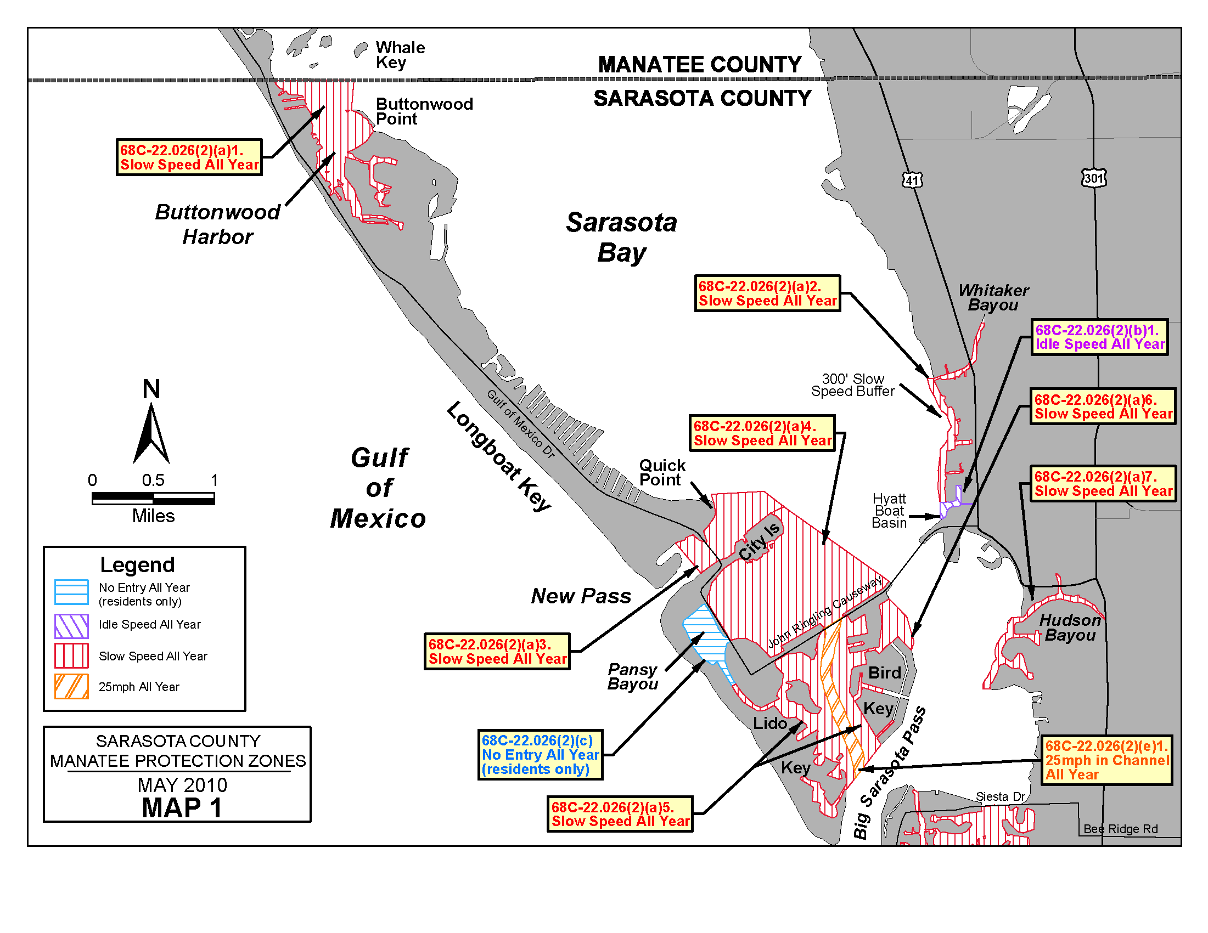
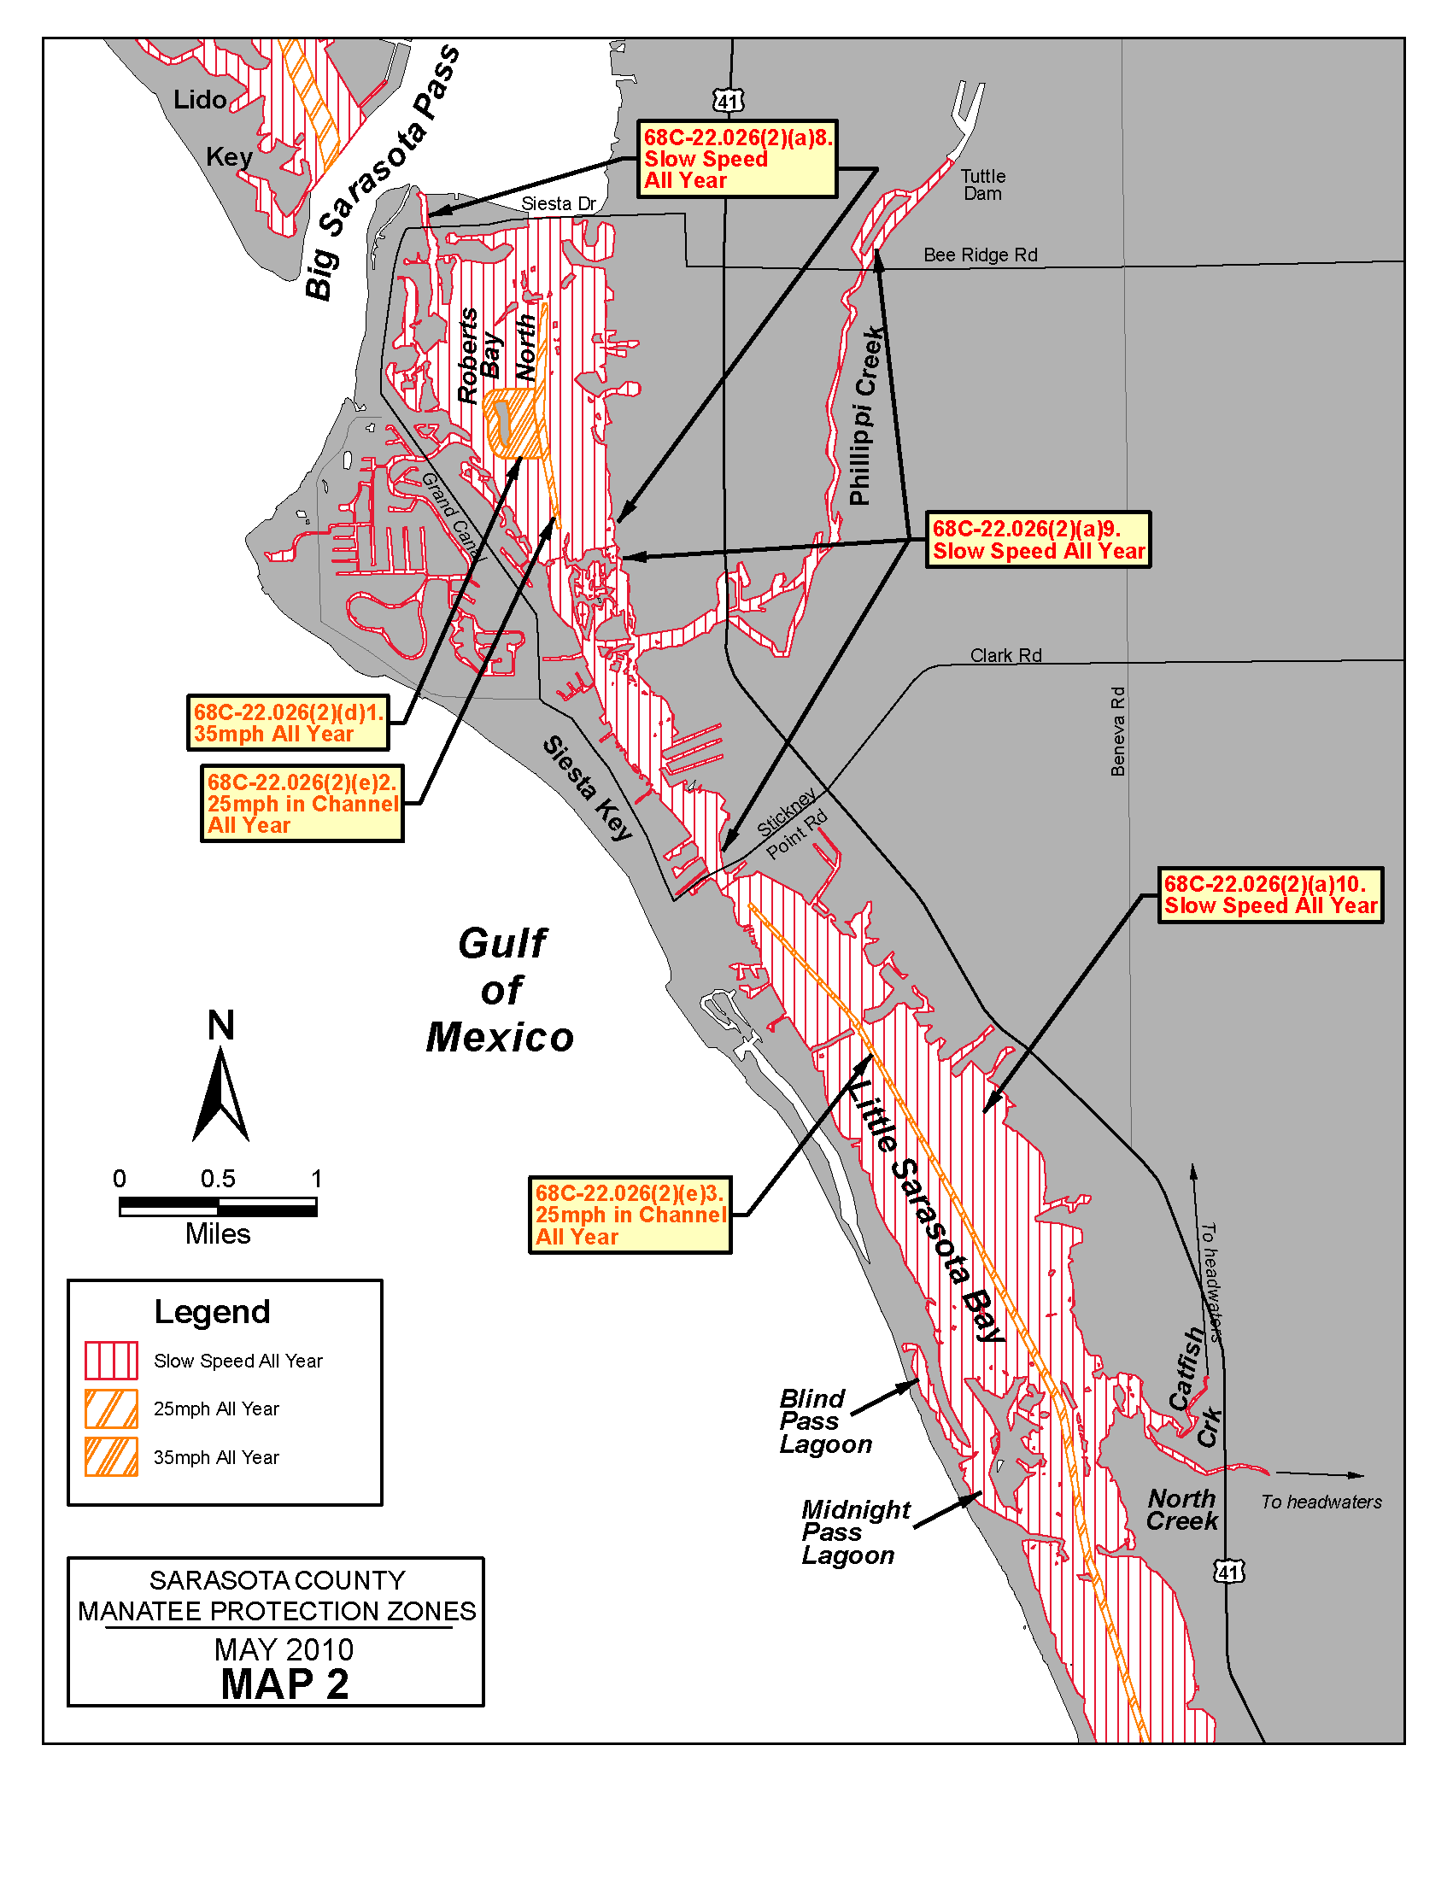
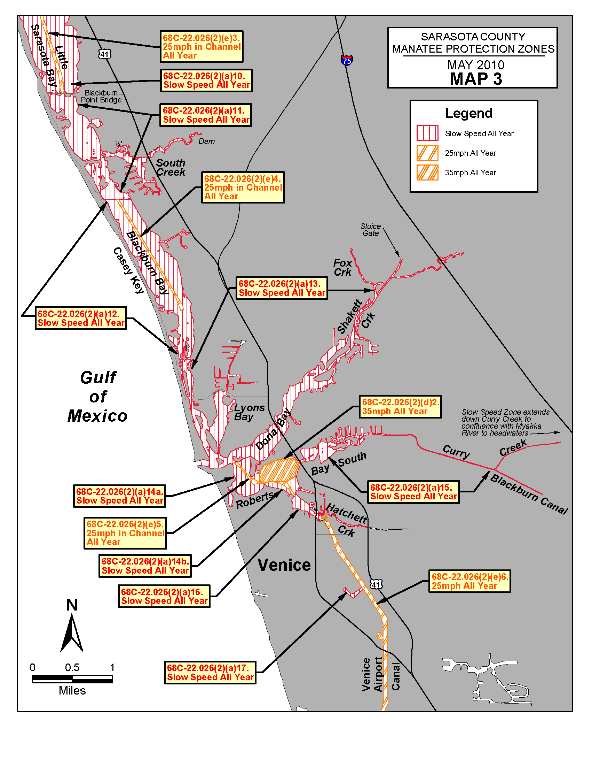
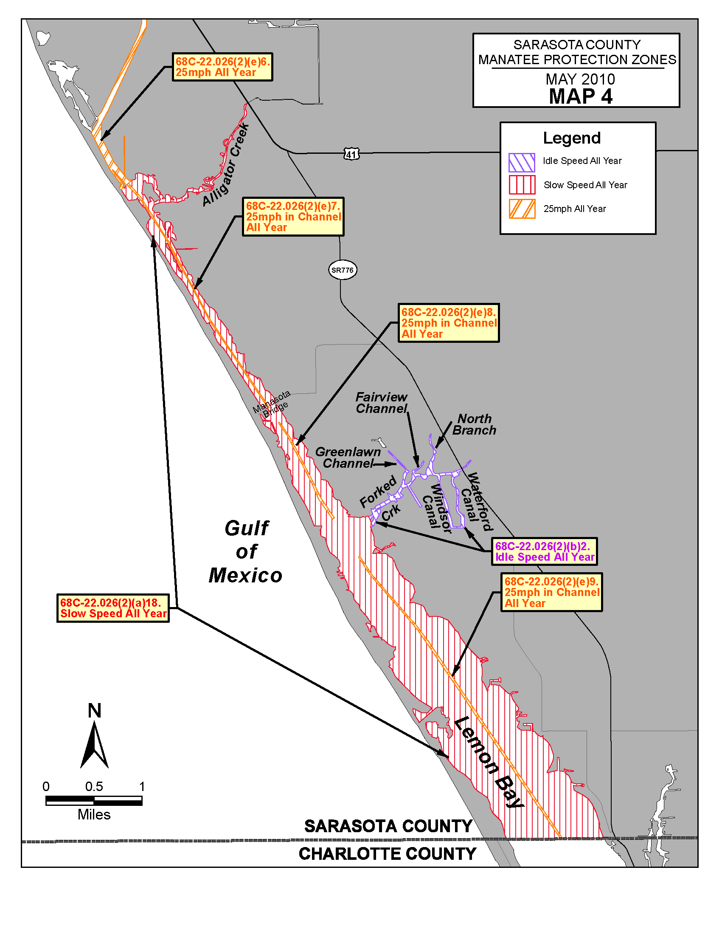
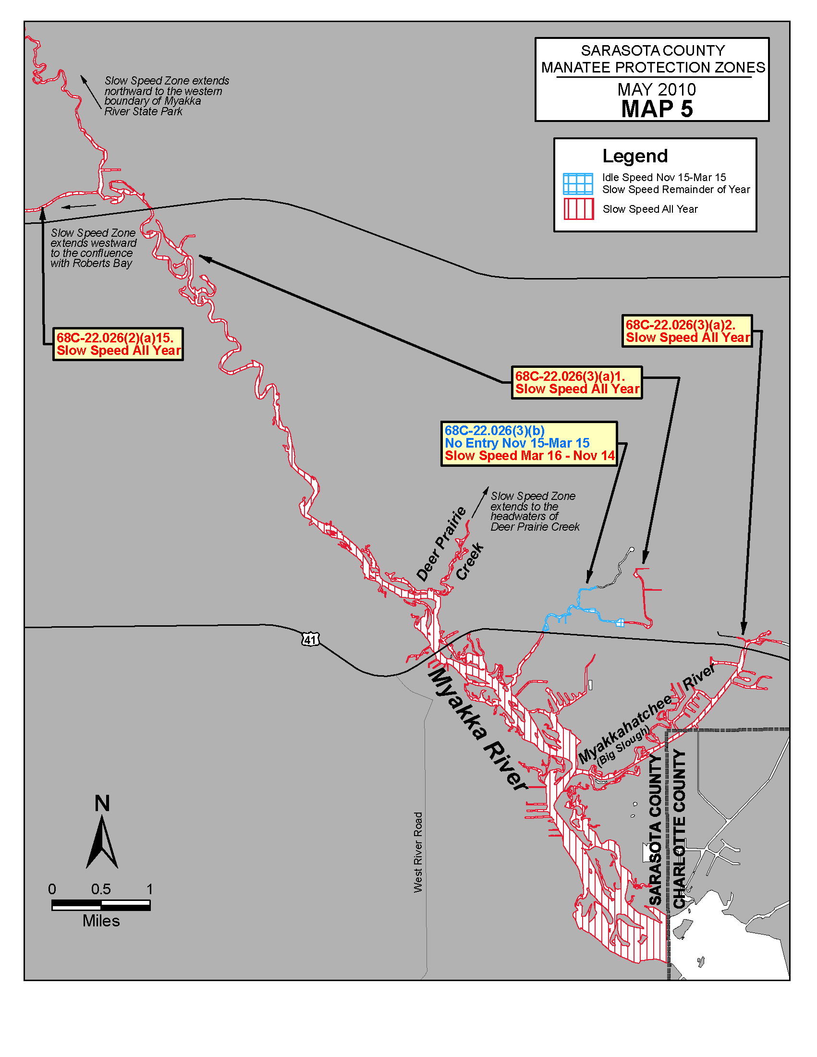
Rulemaking Authority 379.2431(2)(g), (n), (o) FS. Law Implemented 379.2431(2)(d), (k), (n), (o) FS. History–New 1-27-92, Formerly 16N-22.026, 62N-22.026, Amended 12-12-02, 6-24-10.

68C-22.027 Duval County and Associated County (Parts of Clay and St. Johns) Zones.
(1) The Commission hereby designates the waters within Duval County, Clay County, and St. Johns County, as described below, as areas where manatee sightings are frequent and where the best available information supports the conclusion that manatees inhabit these areas on a regular or periodic basis. The primary purpose of this rule is to protect manatees from harmful collisions with motorboats and from harassment by regulating the speed and operation of motorboats within these designated areas. A secondary purpose is to protect manatee habitat. In consideration of balancing the rights of fishers, boaters, and water skiers to use the waters of the state for recreational and commercial purposes (as applicable under Section 370.12(2)(k), F.S.), with the need to provide manatee protection, the Commission has examined the need for limited lanes, corridors, or unregulated areas that allow higher speeds through or within regulated areas. Such lanes, corridors, or areas are provided in those locations where the Commission determined that they are consistent with manatee protection needs. All of the zones set forth below are in effect year-round and, unless otherwise stated, all zones exclude all associated waterways (tributaries, lakes, creeks, coves, bends, backwaters, canals, basins, etc.) unless explicitly included.
(a) Slow Speed, Shore-to-Shore –
1. Atlantic Intracoastal Waterway, Sisters Creek – All waters of Sisters Creek, including the Atlantic Intracoastal Waterway Channel, south of an East-West line running through Flashing Green Atlantic Intracoastal Waterway Channel Marker “83” (approximate latitude 30° 24' 04" North, approximate longitude 81° 27' 16" West), and northeast of a line which bears 310° from the southwestern corner of a seawall at the southwestern tip of Fanning Island (approximate latitude 30° 23' 19" North, approximate longitude 81° 27' 41" West) and including those backwaters east of Sisters Creek lying southwest of a line which bears 140° from the southernmost tip of Shell Island (approximate latitude 30° 23' 52" North, approximate longitude 81° 27' 21" West);
2. Atlantic Intracoastal Waterway, South of the St. Johns River – All waters of the Atlantic Intracoastal Waterway, channel included, southwest of a line which bears 280° North from the westernmost tip (approximate latitude 30° 22' 44" North, approximate longitude 81° 27' 30" West) of a peninsula west of Sherman Point on the southern side of the St. Johns River, north of a line which bears 62° running through a point 600 feet north of and on a bearing of 332° from Flashing Green Atlantic Intracoastal Waterway Channel Marker “9” (approximate latitude 30° 22' 21" North, approximate longitude 81° 27' 01" West), northeast of the general contour of the northeastern shoreline of Great Marsh Island and a line which bears 137° from the easternmost tip of Great Marsh Island (approximate latitude 30° 22' 29" North, approximate longitude 81° 27' 17" West), and west of a line which bears 360° from the northernmost tip (approximate latitude 30° 22' 29" North, approximate longitude 81° 27' 05" West) of the unnamed island east of Green Atlantic Intracoastal Waterway Channel Marker “7”;
3. St. Johns River, Main Street Bridge to Fuller Warren Bridge Area – All waters of the St. Johns River and associated waterways west (upriver) of the Main Street Bridge and north (downriver) of the Fuller Warren Bridge;
4. Julington Creek and Durbin Creek Area – All waters of Julington Creek and Durbin Creek east of a line that bears 180° from a point (approximate latitude 30° 07' 59" North, approximate longitude 81° 36' 02" West) on the northern shoreline of Julington Creek at the mouth of Oilfield Creek and west of a line that bears 180° from a point (approximate latitude 30° 08' 01" North, approximate longitude 81° 35' 43" West) on the northern shoreline of Julington Creek 300 feet east of the southern extension of Hood Landing Road (and extending south across Durbin Creek to its southern shoreline).
(b) SLOW SPEED –
1. St. Johns River, St. Johns Point to Reddie Point – Those waters of the St. Johns River lying within 300 feet of the general contour of the northern and southern shorelines of the river, excluding the federally-marked channels, west of a line that runs from the northeasternmost point of St. Johns Point at the mouth of the river to the southeasternmost point of Wards Bank, east of a line which bears 360° from the easternmost point of Sandfly Point (approximate latitude 30° 23' 10" North, approximate longitude 81° 38' 03" West) across the mouth of the Trout River, and north of a line that runs from said easternmost point of Sandfly Point to the northernmost point of Reddie Point (approximate latitude 30° 23' 22" North, approximate longitude 81° 37' 13" West); included in this zone are those waters lying within 300 feet of the general contour of the shorelines of Blount Island and of the northern shoreline of Quarantine Island (Bartram Island) between the island's easternmost and westernmost points and those waters leading into Mayport Basin within 300 feet of the general contour of the shorelines, excluding the federally-marked channel, east of a line which bears 180° from the easternmost tip of the peninsula on the northern side of Mayport Basin (approximate latitude 30° 23' 51" North, approximate longitude 81° 24' 16" West); also included in this zone are those waters within 300 feet of the general contour of the shorelines of the Broward River and Dunn Creek south of the centerline of the Heckscher Drive (State Road 105) Bridges, and those waters within 300 feet of the general contour of the shorelines of all associated waterways on the north side of the river that are east of where Nichols Creek and San Carlos Creek enter the river and south of the centerline of the Heckscher Drive (State Road 105) Bridges, except as otherwise designated in paragraph (1)(a);
2. Mill Cove – Those waters within 300 feet of the general contour of the southern shoreline of Mill Cove, west of the westernmost point of Pauline Island and east of the northernmost point of Reddie Point (approximate latitude 30° 23' 22" North, approximate longitude 81° 37' 13" West);
3. Trout River – Those waters within 300 feet of the general contour of the shorelines of the Trout River west of a line that bears 360° from the easternmost point of Sandfly Point (approximate latitude 30° 23' 10" North, approximate longitude 81° 38' 03" West) across the mouth of the Trout River and east of the Interstate 95 Bridge;
4. St. Johns River, Reddie Point to Hart Bridge Area – Those waters described below, excluding the federally-marked Florida Intracoastal Waterway channel:
a. Within 300 feet of the general contour of the western (and northern) shoreline of the St. Johns River, south (upriver) of a line that runs from the easternmost point of Sandfly Point (approximate latitude 30° 23' 10" North, approximate longitude 81° 38' 03" West) to the northernmost point of Reddie Point (approximate latitude 30° 23' 22" North, approximate longitude 81° 37' 13" West) and north and east (downriver) of the Hart Bridge, including all associated waterways and all waters of Long Branch Creek easterly of the Buffalo Avenue/Wigmore Street Bridge;
b. Within 1,000 feet of the general contour of the eastern shoreline of the St. Johns River, south (upriver) of a line that runs from the easternmost point of Sandfly Point (approximate latitude 30° 23' 10" North, approximate longitude 81° 38' 03" West) to the northernmost point of Reddie Point (approximate latitude 30° 23' 22" North, approximate longitude 81° 37' 13" West) and north (downriver) of the Hart Bridge, including all associated waterways, and all waters east of Exchange Island and a line that bears 250° from the southernmost point of Exchange Island (approximate latitude 30° 19' 18'' North, approximate longitude 81° 37' 05'' West) and west of a line that bears 73° from a point (approximate latitude 30° 18' 53'' North, approximate longitude 81° 36' 43'' West) on the southern shoreline of the Arlington River at the mouth of Little Pottsburg Creek; and also including those waters within 300 feet of the general contour of the western shoreline of Exchange Island.
5. St. Johns River, Hart Bridge to Main Street Bridge Area – All waters of the St. Johns River and associated waterways, including all waters of Miller Creek north of the Atlantic Boulevard (State Road 10) Bridge, west (upriver) of the Hart Bridge and east (downriver) of the Main Street Bridge, except in the marked channel of the Florida Intracoastal Waterway as designated in sub-paragraph (1)(c)2.
6. St. Johns River, Fuller Warren Bridge to the South Duval County Line – Those waters of the St. Johns River, south of the centerline of the Fuller Warren Bridge, north of the centerline of the Buckman (Interstate 295) Bridge (the Duval County/Clay County line) on the western shore, and west and north of the centerline of the San Jose Boulevard (State Road 13) Bridge crossing Julington Creek on the eastern shore, including: those waters of Big Fishweir Creek east of the centerline of the Herschel Street Bridge; those waters northeast of and within 500 feet of the centerline of the Ortega (Grand Avenue) Bridge; those waters of Pirates Cove (also referred to as the Venetia Yacht Basin); those waters of Mulberry Cove northwest of a line that runs from a point (approximate latitude 30° 13' 05" North, approximate longitude 81° 40' 31" West) on the northern shoreline of the cove to another point (approximate latitude 30° 12' 56" North, approximate longitude 81° 40' 46" West) on the southern shoreline; those waters of Marco Lake; those waters of Craig Creek west of the centerline of the Hendricks Avenue (State Road 13) Bridge; and those waters of Goodby’s Creek. Except for the waters northeast of the Ortega (Grand Avenue) Bridge as described above, the waters described in this paragraph shall be subject to a variable-width shoreline buffer whose width is as set forth in subsection (2), of this rule;
7. Ortega River Area – Those waters within 300 feet of the general contour of the shorelines of the Ortega River, including all associated waterways, south of the centerline of the Ortega (Grand Avenue) Bridge, north of the centerline of the Timuquana Bridge for the buffer along the eastern shoreline, and east of the southernmost point (approximate latitude 30° 15' 57" North, approximate longitude 81° 43' 36" West) of the peninsula that forms the northern shoreline of the Cedar River for the buffer along the western shoreline, including all waters within 300 feet south of the centerline of the Ortega (Grand Avenue) Bridge and all waters within 300 feet of either side of the Roosevelt Boulevard Bridge;
8. Julington Creek – All waters of Julington Creek within 450 feet of either side of the centerline of the San Jose Boulevard (State Road 13) Bridge and those waters within 300 feet of the general contour of the shorelines of Julington Creek and all associated waterways east of the centerline of the San Jose Boulevard (State Road 13) Bridge and west of a line that bears 180° from a point (approximate latitude 30° 07' 59" North, approximate longitude 81° 36' 02" West) on the northern shoreline of Julington Creek at the mouth of Oilfield Creek;
9. St. Johns River in St. Johns County, Julington Creek to Nature’s Hammock Road North – Those waters of the St. Johns River in St. Johns County, west and south of the centerline of the San Jose Boulevard (State Road 13) Bridge, and north of the western extension of Nature’s Hammock Road North. The waters described in this paragraph shall be subject to a variable-width shoreline buffer whose width is as set forth in subsection (2), of this rule;
10. St. Johns River in Clay County, Buckman Bridge to Peter Branch – Those waters of the St. Johns River in Clay County, south of the centerline of the Buckman (Interstate 295) Bridge and north of a line that bears 90° from a point on the shoreline (approximate latitude 30° 06' 05" North, approximate longitude 81° 41' 24"' West) located 300 feet south of Peter Branch. The waters described in this paragraph shall be subject to a variable-width shoreline buffer whose width is as set forth in subsection (2), of this rule;
11. Doctors Lake and Doctors Inlet Area – Those waters of Doctors Lake, Duck Creek, and Swimming Pen Creek, and including those waters of Doctors Inlet 500 feet of either side of the centerline of the US Highway 17 Bridge. Except for the waters of Doctors Inlet described above, the waters described in this paragraph shall be subject to a variable-width shoreline buffer whose width is as set forth in subsection (2), of this rule.
(c) 25 MPH
1. St. Johns River, Reddie Point to Hart Bridge Area – All waters of the St. Johns River outside of the Slow Speed areas designated in subparagraph (1)(b)4.;
2. St. Johns River, Hart Bridge to Main Street Bridge Area – All waters in the marked channel of the Florida Intracoastal Waterway west (upriver) of the Hart Bridge and east (downriver) of the Main Street Bridge.
(2) The width of the variable-width shoreline buffer referenced in subparagraphs (1)(b)6., 9., 10., and 11., above is as follows: The buffer includes at a minimum all waters within 500 feet of the general contour of the shoreline. Where there are docks that extend out farther than 300 feet into the waterway, the buffer extends out beyond the 500-foot line to include all waters shoreward of a line that runs 200 feet beyond and parallel to the dock line. For the purposes of this rule, the dock line shall be defined as a line that runs between the ends of successive docks.
(3) The zones described in subsection 68C-22.027(1), F.A.C., above are depicted on the following maps, labeled “Duval and Associated County Manatee Protection Zones”. The maps are intended to be depictions of the above-described zones. In the event of a conflict between the two, the above descriptions shall prevail.
(4) The amendments to Rule 68C-22.027, F.A.C., as approved by the Commission on December 6, 2006, shall take effect as soon as the regulatory markers are posted.
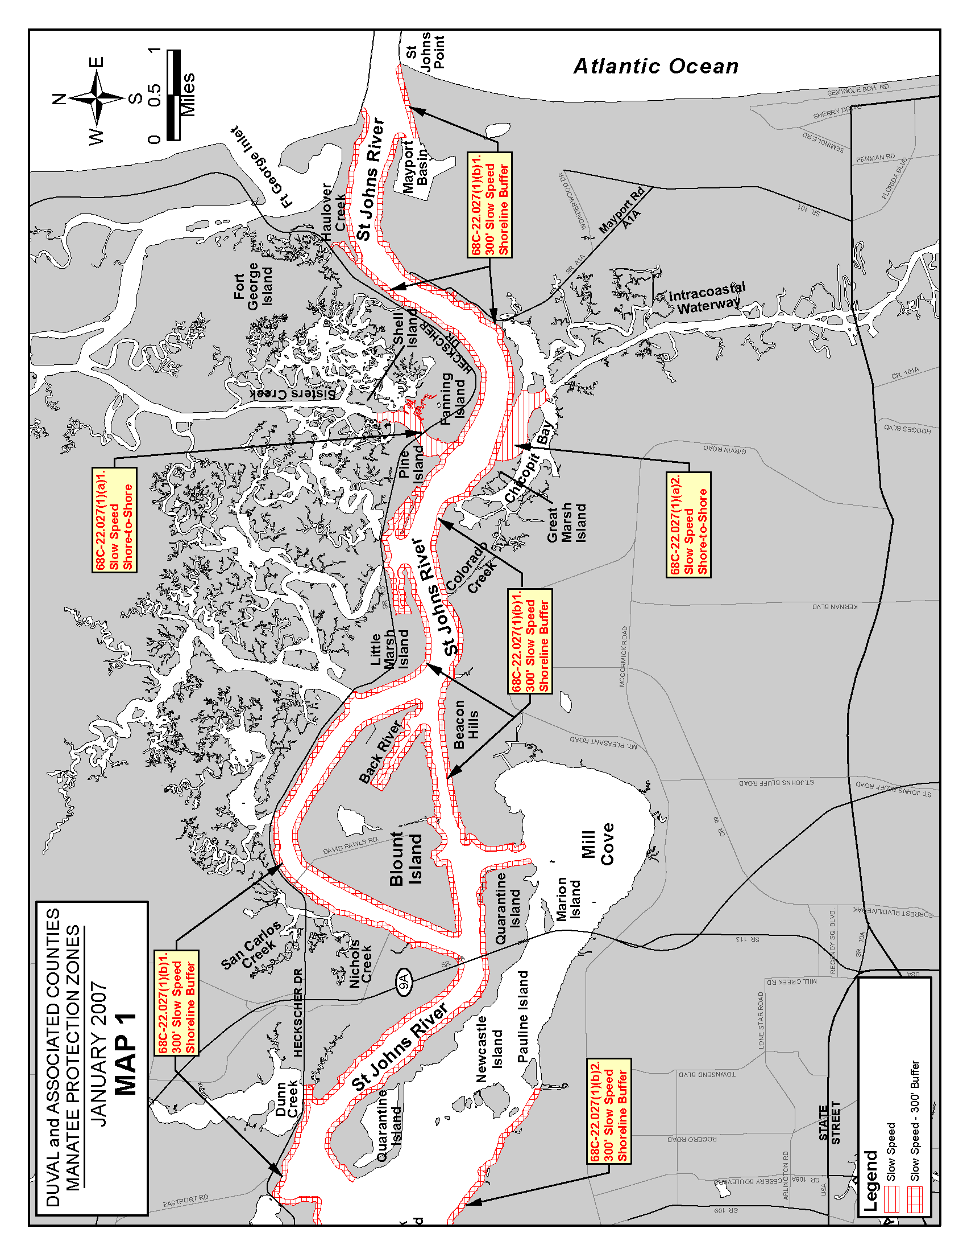
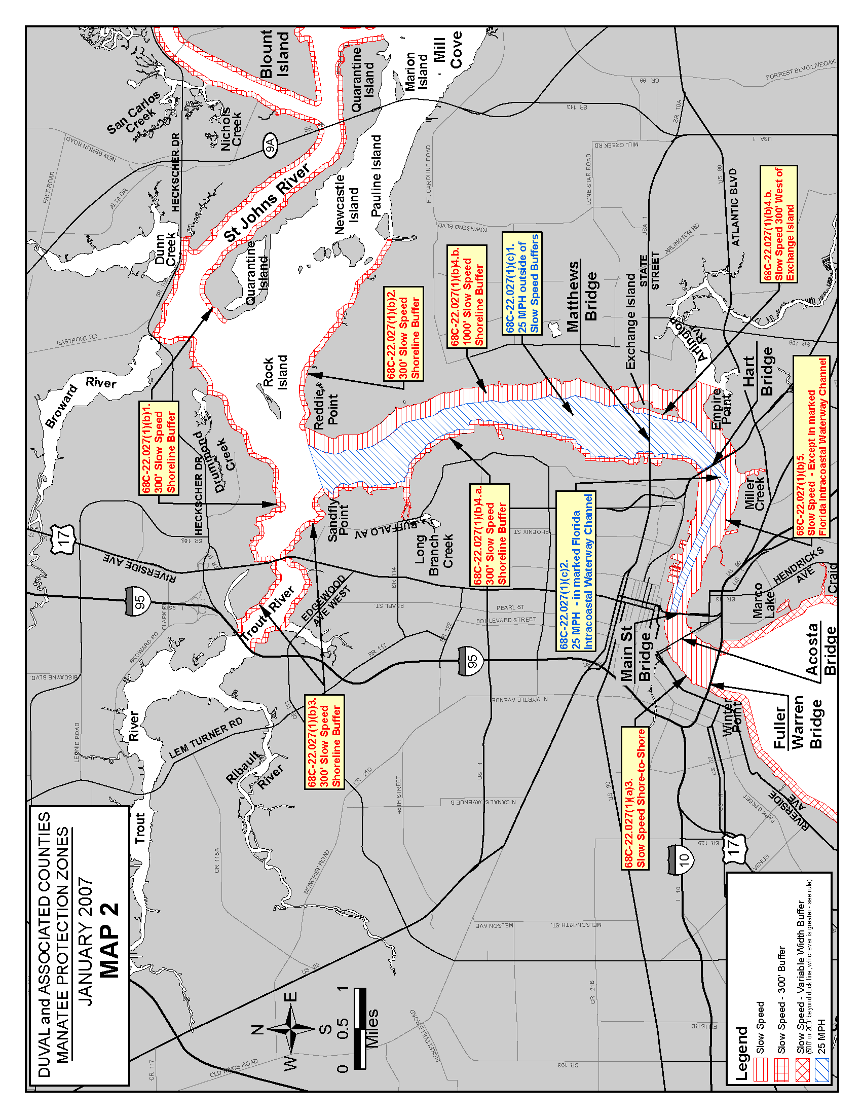
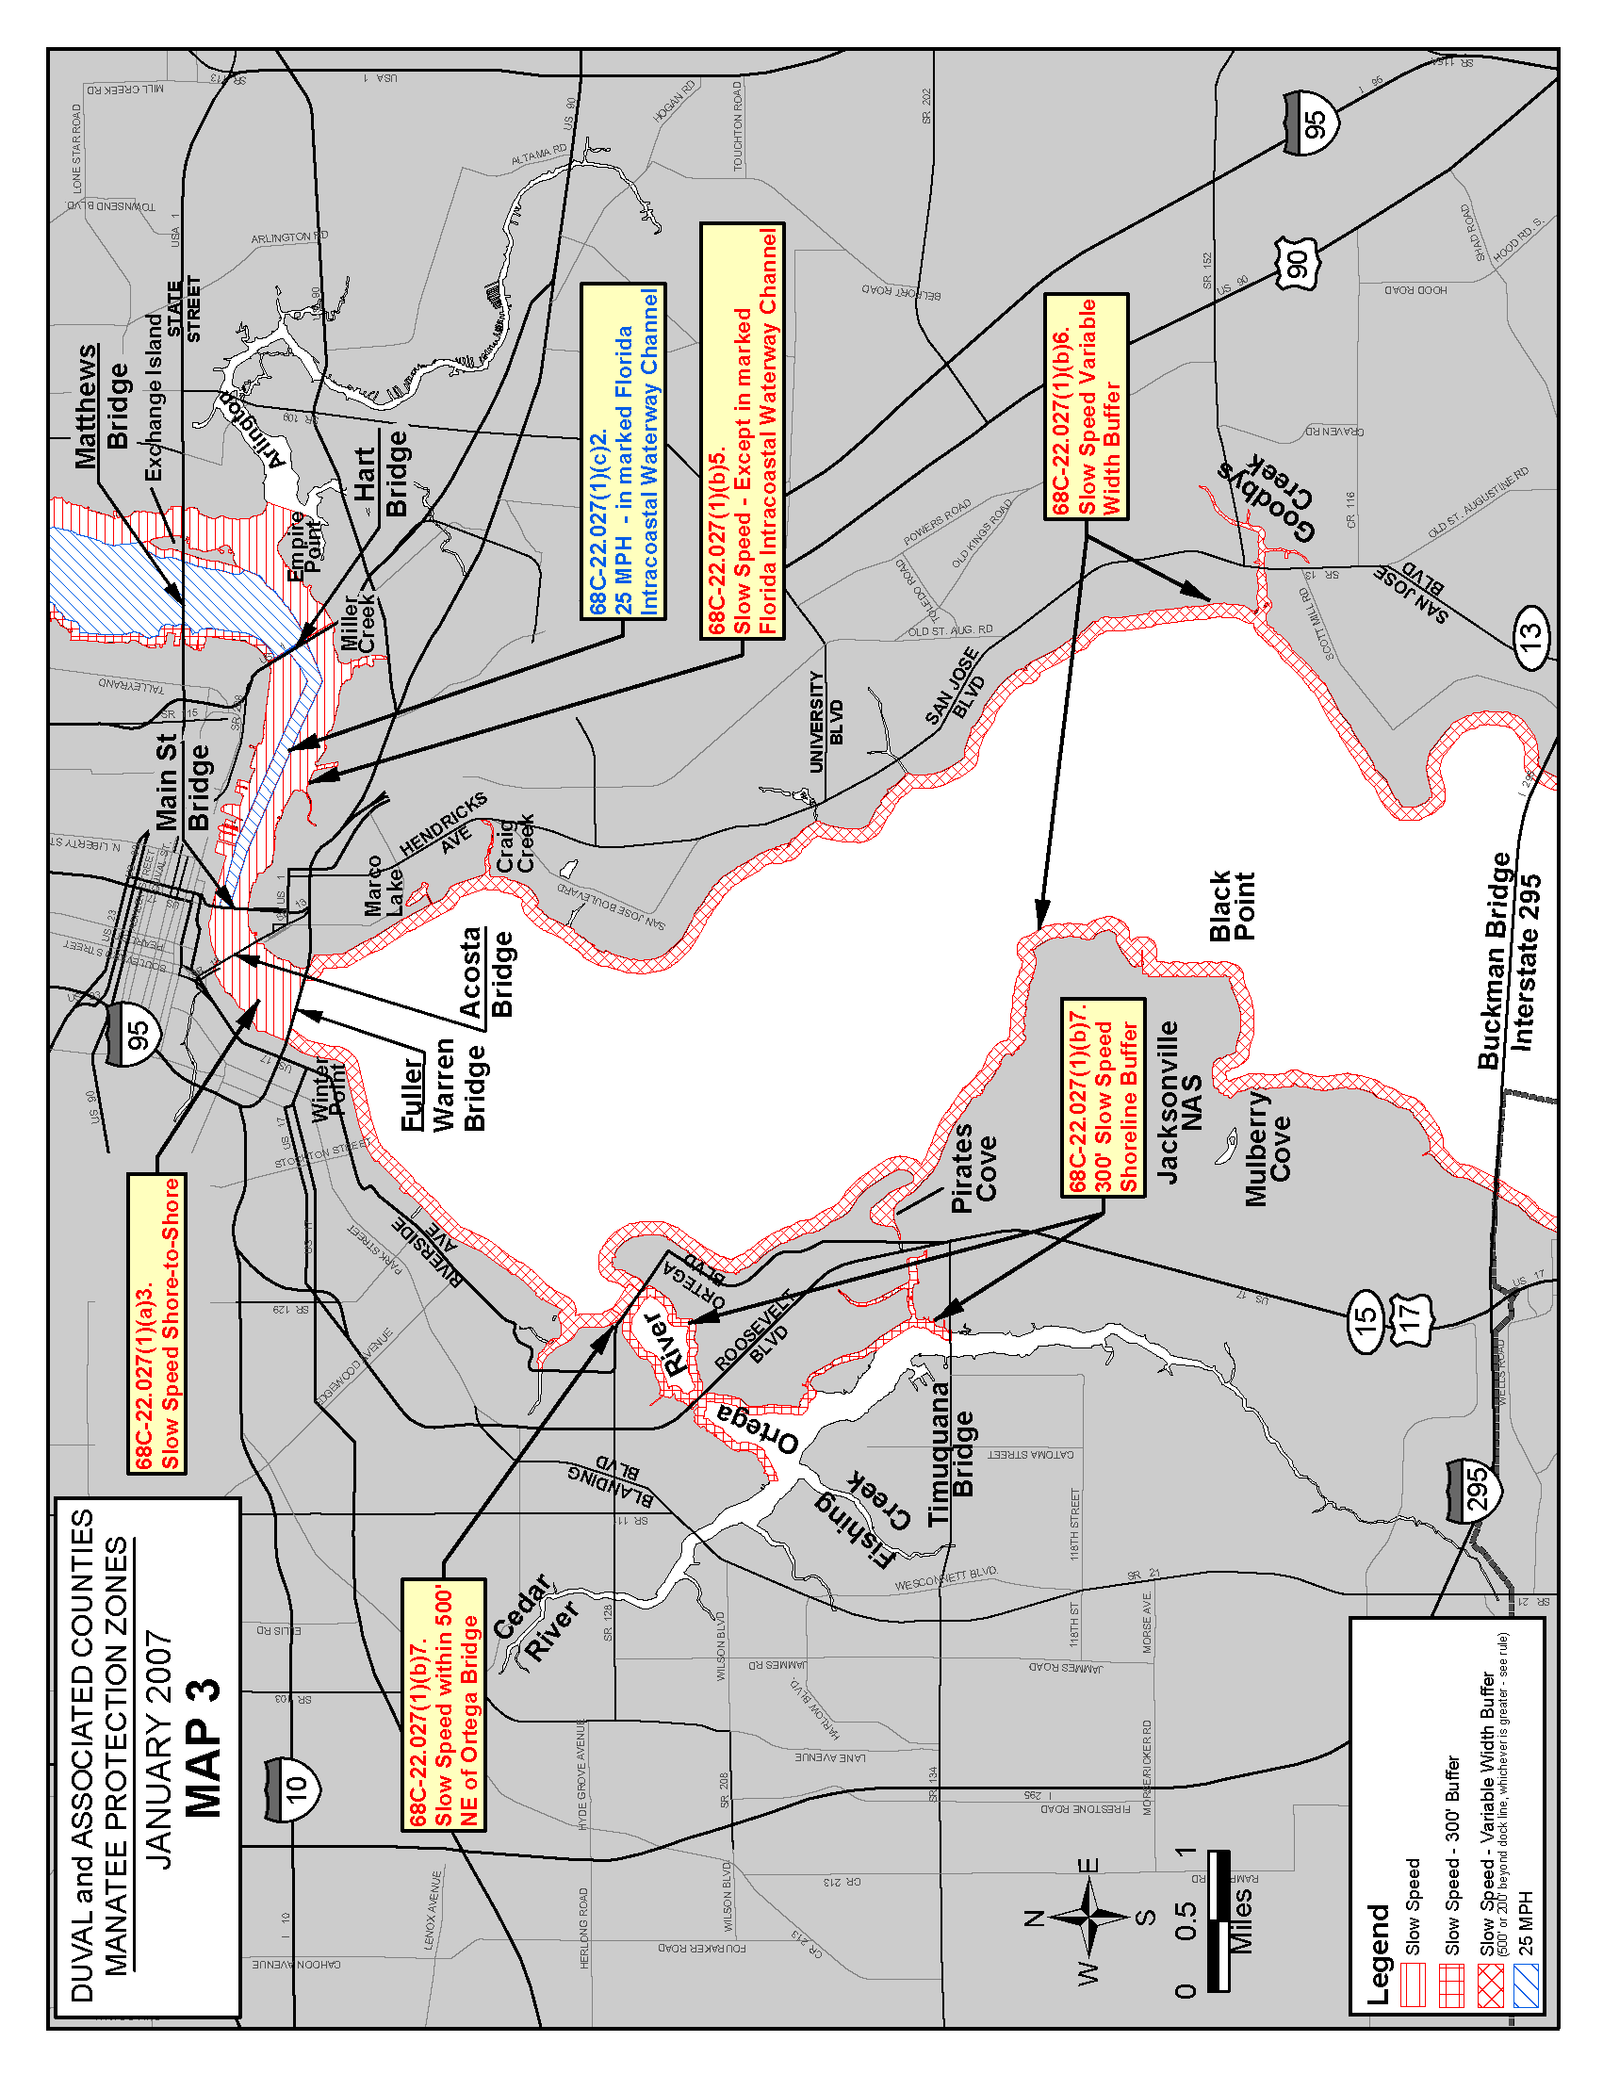
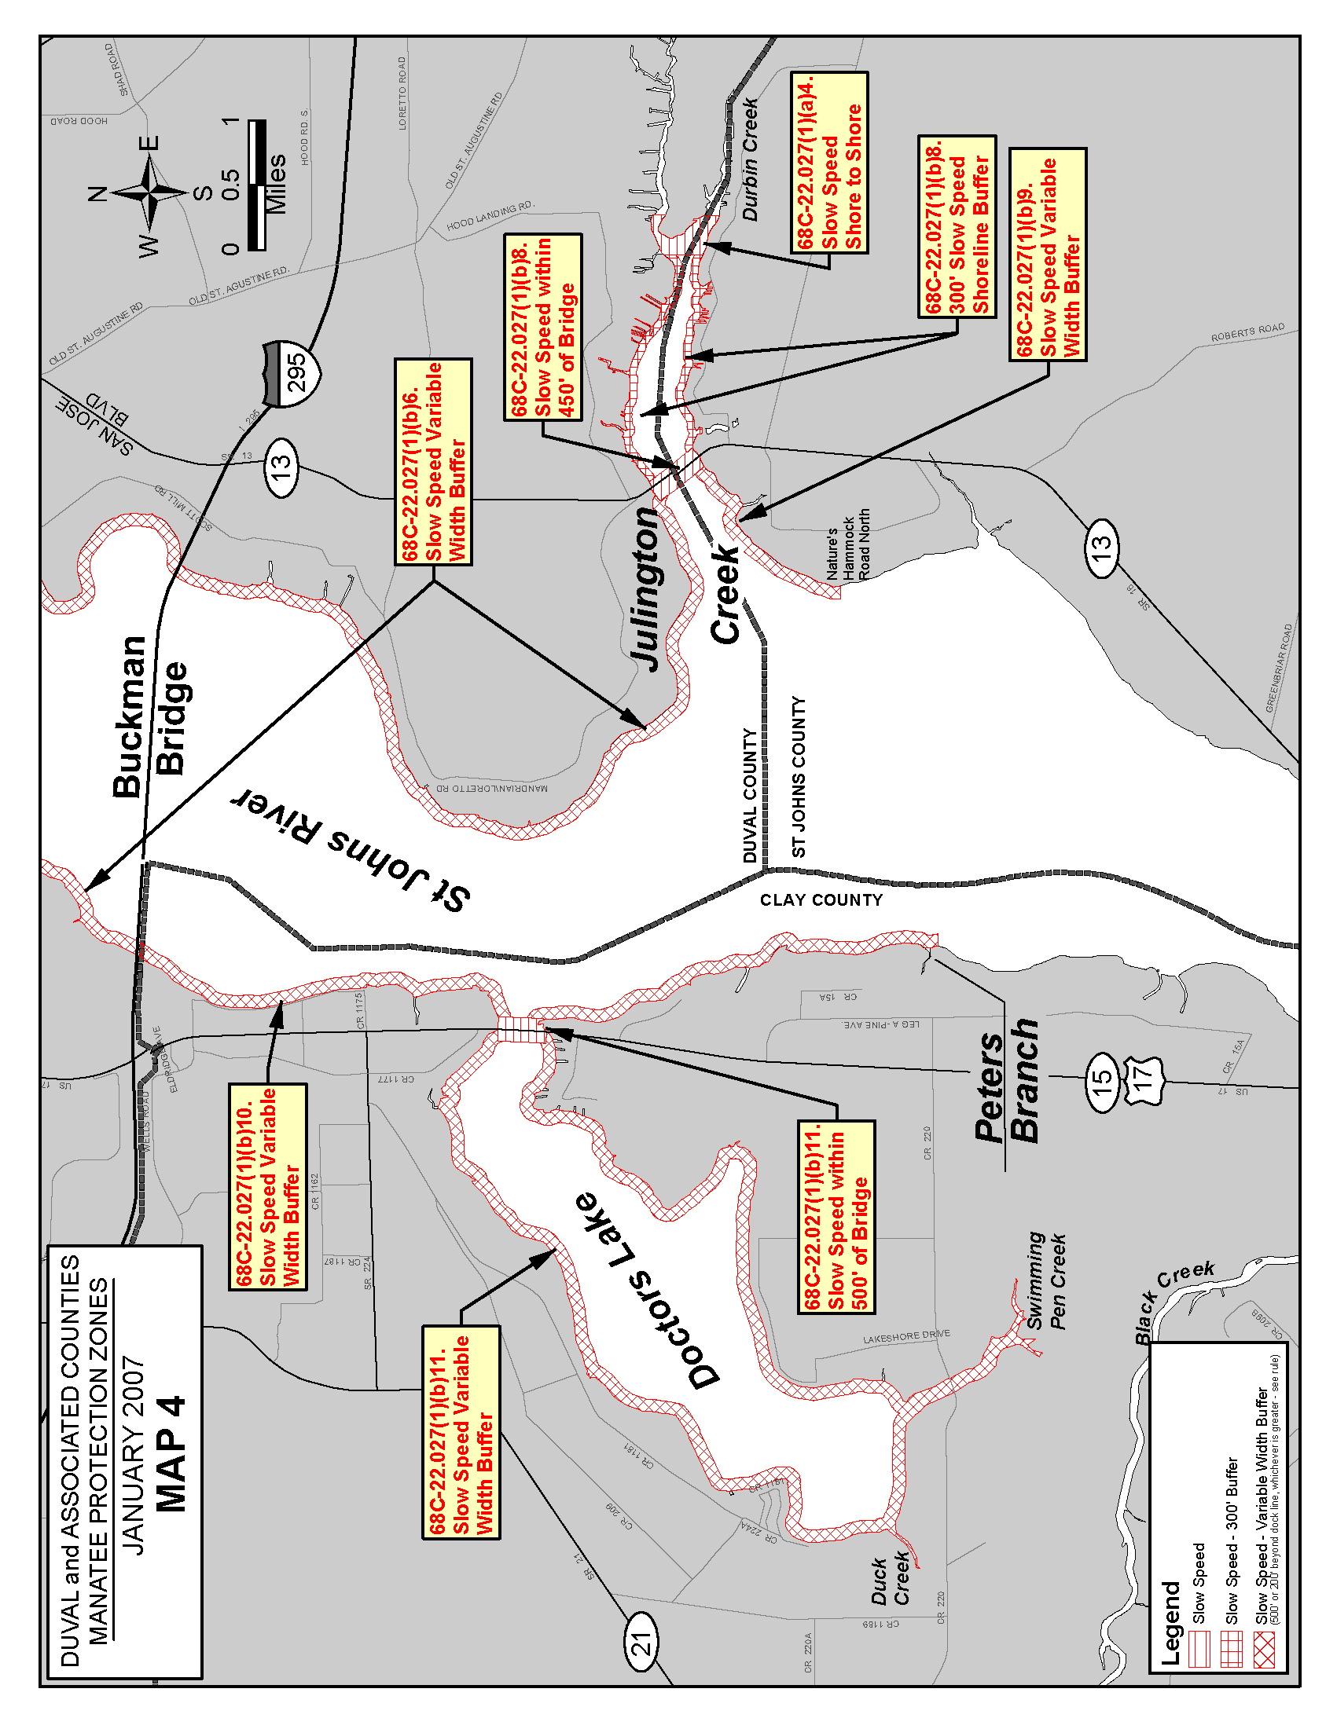
Rulemaking Authority 370.12(2)(n) FS. Law Implemented 370.12(2)(d), (k), (n) FS. History–New 12-22-92, Amended 6-16-93, Formerly 16N-22.027, 62N-22.027, Amended 8-1-00, 1-30-07.
68C-22.028 Flagler County Zones.
(1)(a) The Commission hereby designates the waters within Flagler County, as described below, as areas where manatee sightings are frequent and where the best available information supports the conclusion that manatees inhabit these areas on a regular or periodic basis. The primary purpose of this rule is to protect manatees from harmful collisions with motorboats and from harassment by regulating the speed and operation of motorboats within these designated areas. A secondary purpose is to protect manatee habitat.
(b) In consideration of balancing the rights of fishers, boaters, and water skiers to use the waters of the state for recreational and commercial purposes (as applicable under Section 379.2431(2)(k), F.S.), with the need to provide manatee protection, the Commission has examined the need for limited lanes, corridors, or unregulated areas that allow higher speeds through or within regulated areas. Such lanes, corridors, or areas are provided in those locations where the Commission determined they are consistent with manatee protection needs.
(2) The following zones are established, which include all associated and navigable tributaries, lakes, creeks, coves, bends, backwaters, canals, channels and boat basins, and other waterways unless specifically excluded or otherwise designated for more restrictive regulation. As used in this rule, ICW means the Intracoastal Waterway. Coordinates used in the descriptions of zone boundaries are referenced to the North American Datum of 1983 (NAD83) using the HARN Florida GDL Albers projection.
(a) SLOW SPEED (May 1 – September 7):
1. Hammock Dunes Parkway Area – All waters, including in the ICW channel, south of a line that bears 70° from a point (approximate latitude 29° 34' 49'' North, approximate longitude 81° 11' 34'' West) on the western shoreline of the ICW approximately 2,700 feet north of the Hammock Dunes Parkway Bridge, north of a line that bears 70° from a point (approximate latitude 29° 34' 21'' North, approximate longitude 81° 11' 21'' West) on the western shoreline of the ICW approximately 300 feet south of the Hammock Dunes Parkway Bridge, and east of the Palm Harbor Parkway Bridge;
2. North of Lehigh Canal Area – All waters east of the ICW channel south of a line that bears 70º through Red ICW Channel Marker “6” (approximate latitude 29° 30' 50'' North, approximate longitude 81° 09' 00'' West) and north of a line that bears 70° from a point (approximate latitude 29° 29' 59'' North, approximate longitude 81° 08' 41'' West) on the western shoreline of the ICW approximately 500 feet north of Lehigh Canal;
3. Lehigh Canal to State Road 100 Area – All waters of Lehigh Canal; and all waters, including in the ICW channel, south of a line that bears 70° from a point (approximate latitude 29° 29' 59'' North, approximate longitude 81° 08' 41'' West) on the western shoreline of the ICW approximately 500 feet north of Lehigh Canal and north of a line that bears 70° from a point (approximate latitude 29° 28' 34'' North, approximate longitude 81° 08' 12'' West) on the western shoreline of the ICW approximately 500 feet south of the SR 100 (Moody Blvd.) Bridge; and,
4. Vicinity of Gamble Rogers State Recreation Area – All waters, including in the ICW channel except as otherwise designated in paragraph (2)(b), below, south of a line that bears 70° through Red ICW Channel Marker “20” (approximate latitude 29° 27' 08'' North, approximate longitude 81° 07' 37'' West) and north of the Flagler County/Volusia County line.
(b) MAXIMUM 25 MPH (May 1 – September 7) – Those waters in the marked ICW channel south of a line that bears 70° from a point (approximate latitude 29° 26' 36'' North, approximate longitude 81° 07' 03'' West) on the western shoreline of the ICW approximately 900 feet north of Red ICW Channel Marker “22” and north of the Flagler County/Volusia County line.
(3) Maps depicting the zones described in this rule are available on the agency’s website at http://myfwc.com. The maps are intended only as visual aids and do not have regulatory effect; therefore, in the event of conflict between the maps and the descriptions of the zones provided by this rule, the rule text shall prevail.
Rulemaking Authority 379.2431(2) FS. Law Implemented 379.2431(2) FS. History–New 6-13-12, Amended 5-24-16.

