CHAPTER 68D-24

BOATING RESTRICTED AREAS

68D-24.002 Definitions

68D-24.003 Management Provisions

68D-24.0035 Protection Zones for Springs

68D-24.004 Private Submerged Land Seagrass Protection Boating Restricted Areas

68D-24.0041 Dutchman Key Private Submerged Lands Seagrass Protection Boating Restricted Areas

68D-24.005 Sarasota County Boating Restricted Areas

68D-24.006 Fort Lauderdale Boating Restricted Areas (Repealed)

68D-24.008 Broward County Boating Restricted Areas

68D-24.010 Pinellas County Boating Restricted Areas

68D-24.011 Okeechobee Waterway Boating Restricted Areas

68D-24.013 Dade County Boating Restricted Areas

68D-24.014 Manatee County Boating Restricted Area

68D-24.015 Apalachicola River Boating Restricted Area

68D-24.016 Duval County Boating Restricted Areas

68D-24.017 Palm Beach County Boating Restricted Areas

68D-24.018 St. Johns River Boating Restricted Areas

68D-24.019 Nassau County Boating Restricted Area

68D-24.020 Suwannee and Santa Fe River Boating Restricted Areas

68D-24.021 Ochlockonee River Boating Restricted Areas

68D-24.108 Charlotte County Boating Restricted Area

68D-24.109 Withlacoochee River Boating Restricted Areas

68D-24.117 Escambia County Boating Restricted Area

68D-24.118 Flagler County Boating Restricted Area

68D-24.136 Lee County Boating Restricted Area

68D-24.143 Martin County Boating Restricted Areas

68D-24.144 Monroe County Boating Restricted Areas

68D-24.146 Okaloosa County Boating Restricted Area

68D-24.155 St. Johns County Boating Restricted Areas

68D-24.164 Volusia County Boating Restricted Areas

68D-24.002 Definitions.
When used in these rules, the following words shall have the indicated meanings unless the context clearly indicates otherwise:
(1) Slow Speed Minimum Wake and Slow Down Minimum Wake indicate a boating restricted area which has been established to protect the safety of the public. Slow Speed Minimum Wake and Slow Down Minimum Wake means that a vessel must be fully off plane and completely settled into the water. It may not proceed at a speed greater than that speed which is reasonable and prudent to avoid the creation of an excessive wake or other hazardous condition under the existing circumstances. A vessel that is:
(a) Operating on a plane is not proceeding at slow speed minimum wake;
(b) In the process of coming off plane and settling into the water or coming up onto plane is not proceeding at slow speed minimum wake;
(c) Operating at a speed that creates a wake which unreasonably or unnecessarily endangers other vessels is not proceeding at slow speed minimum wake;
(d) Completely off plane and which has fully settled into the water and is proceeding without wake or with minimum wake is proceeding at slow speed minimum wake. Slow speed minimum wake is the preferred term. Slow Down Minimum Wake may continue to be used except when such a restricted area is contiguous to an Idle Speed No Wake boating restricted area.
(2) Idle Speed No Wake indicates a boating restricted area which has been established to protect the safety of the public. Idle Speed No Wake means that a vessel cannot proceed at a speed greater than that speed which is necessary to maintain steerageway.
(3) “Miles per hour” means speed made good over the bottom measured in statutes miles.
(4) “Wake” means all changes in the vertical height of the water’s surface caused by the passage of a vessel including, but not limited to, a vessel’s bow wave, stern wake, and propeller wash.
(5) “Holiday” means:
(a) New Year’s Day.
(b) Birthday of Martin Luther King, Jr., the third Monday in January.
(c) Memorial Day.
(d) Independence Day, the Fourth of July.
(e) Labor Day.
(f) Columbus Day.
(g) Veterans’ Day, November 11.
(h) Thanksgiving Day.
(i) Friday after Thanksgiving.
(j) Christmas Day.
(k) If any of these holidays falls on Saturday, the preceding Friday shall be observed as a holiday. If any of these holidays falls on Sunday, the following Monday shall be observed as a holiday.
Rulemaking Authority 327.04, 327.46, 370.021 FS. Law Implemented 327.46 FS., Chapter 86-364, Chapter 89-428, Laws of Florida. History–New 8-30-83, Formerly 16N-24.02, Amended 6-14-93, Formerly 16N-24.002, Amended 9-28-98, Formerly 62N-24.002.

68D-24.003 Management Provisions.
(1) Appropriate boating restricted areas are established for the purpose of regulating the speed and operation of vessel traffic for the safety of the public.
(2) Such boating restricted areas shall be marked in accordance with Chapter 68D-18, F.A.C., Florida Intracoastal Waterway Markers.
(3) The drawings provided in this chapter are intended to provide information to assist the boat operator in locating the boating restricted areas depicted. The drawings are not to scale and should not be used for navigation purposes. The text of these rules is controlling and dispositive of the exact location of the boundaries of each boating restricted area.
(4) The executive director may approve for adoption rules establishing boating restricted areas. This delegation of authority is subject to the following criteria:
(a) A local government has passed a resolution requesting or endorsing a request that a boating restricted area be established;
(b) The area is designed to protect public safety;
(c) The requested area is in the vicinity of a bridge, public boat ramp, public dock, public marina, public fueling facility, public sewage pump-out facility, or a specific navigational hazard;
(d) Personnel from the Fish and Wildlife Conservation Commission’s Division of Law Enforcement confirm that the proposed area presents a danger to public safety if it remains unregulated;
(e) The rule regulates the boating restricted area at one of the following levels – “Idle Speed No Wake,” “Slow Speed Minimum Wake,” or “30 miles per hour”;
(f) No written objection to the establishment of the proposed restricted area has been received from the United States Coast Guard, the Army Corps of Engineers, or a Navigation District established under Chapter 374, F.S.
(g) No timely request for a public hearing is received and no timely challenge to the proposed rule is filed;
(h) No correspondence or other written communication is received showing organized public opposition to the proposed rule.
Rulemaking Authority 327.04, 327.46 FS. Law Implemented 327.46 FS. History–New 8-30-83, Formerly 16N-24.03, Amended 6-14-93, Formerly 16N-24.003, 62N-24.003, Amended 6-12-00, 3-16-06.

68D-24.0035 Protection Zones for Springs.
(1) The Commission will establish a springs protection zone restricting speed and operation or prohibiting anchoring, mooring, beaching, or grounding of vessels within a first, second, or third magnitude spring or spring group, and associated spring runs when evidence demonstrates that a zone will protect or prevent the spring, spring group, or spring run from harm of the type identified in Section 327.45, F.S.
(2) Evidence of the need for spring protection or to prevent harm may include vessel carrying capacity studies, vessel traffic studies, vegetation or water quality studies, or any facts or data that are of a type reasonably relied upon by scientists, environmental professionals, boating professionals or engineers.
(3) Any person may provide evidence to the Commission for use in the evaluation of a spring, spring group, or spring run under subsection (1).
(4) Springs protection zones shall be no larger than necessary to protect or prevent specified harms to springs, spring runs, and spring groups.
(5) Following the Commission’s adoption of a springs protection zone by rule, the zone will be enforceable once the Commission posts uniform waterway markers notifying the public of the regulations applicable in the zone.
Rulemaking Authority 327.04, 327.45 FS. Law Implemented 327.45 FS. History–New 2-7-22.

68D-24.004 Private Submerged Land Seagrass Protection Boating Restricted Areas.
(1) Owners of private submerged lands that are adjacent to Outstanding Florida Waters, as defined in Section 403.061, F.S., or an aquatic preserve established under Sections 258.39-258.399, F.S., may apply to the Commission to have a boating restricted area established on the private submerged lands to protect any seagrass or contiguous seagrass habitat from seagrass scarring due to propeller dredging. In order to protect the boating public and prevent navigational hazards, private submerged lands with less than ten acres of seagrass or contiguous seagrass habitat, which would otherwise qualify for boating restricted area under this section shall not be established as seagrass protection boating restricted areas.
(2) Private lands submerged by more than six feet of water at mean lower low water shall not qualify for a boating restricted area under this rule.
(3) For purposes of this rule, the following definitions shall apply:
(a) “Adjacent” means wholly within, partially within, bounded by, or having a common border on at least one side or part.
(b) “Seagrass” means Cuban shoal grass (Halodule wrightii), turtle grass (Thalassia testudinum), manatee grass (Syringodium filiforme), star grass (Halophila engelmannii), paddle grass (Halophila decipiens), Johnson’s seagrass (Halophila johnsonii), or widgeon grass (Ruppia maritima).
(c) “External propeller limitation zone” means a boating restricted area in which all vessels equipped with both an internal combustion motor (e.g. gasoline or diesel motors) and one or more propellers in the water for propulsion must turn off the internal combustion motor and, if possible to do so, tilt or raise the propeller out of the water. Vessels propelled solely by polling, paddling, floating, electric motors, or internal combustion motors without an external propeller may proceed through the zone with no restrictions.
(d) “Straight-line boundary” means an area delineated totally by a series of straight lines without the use of curves or meanders; each straight line generally being a minimum length of 200 feet; interior angles generally being greater than 60 degrees.
(4) To apply for a boating restricted area pursuant to this rule an owner must submit a complete application to the Commission, Division of Law Enforcement, Boating and Waterways Section, in writing, which shall include each of the following, in hard copy no larger than 8 1/2 inches by 11 inches, and in digital format (for example, GIS geodatabase file) for all required surveys and maps:
(a) A cover letter from the owner of the submerged lands for which the boating restricted area is being sought, which includes a statement that the owner is seeking a boating restricted area pursuant to this rule, as well as the date of application and the name, mailing address, electronic mail address, telephone number, and signature of the owner;
(b) A recorded deed from the County in which the property is located, providing proof of ownership by the applicant of the submerged lands for which the boating restricted area is being sought;
(c) Documentation of a title determination request from the Department of Environmental Protection, Division of State Lands verifying the private ownership of the lands for which the boating restricted area is being sought;
(d) Supporting documents provided by a professional surveyor or mapper or a professional engineer licensed to conduct business in the state of Florida that include the following:
1. A survey map, or maps, describing locations and juxtaposition of the following:
a. The submerged private property;
b. The adjacency of the submerged private property with an Outstanding Florida Water or aquatic preserve;
c. The requested straight-line boating restricted area;
d. The seagrass or contiguous seagrass habitat within the submerged private property;
e. Water depths within the submerged private property, along with the 6-foot contour line if applicable, referenced to mean lower low water;
2. Metes and bounds legal descriptions of the following boundaries:
a. The submerged private property;
b. The adjacency of the submerged private property with an Outstanding Florida Water or aquatic preserve;
c. The requested straight-line boating restricted area;
3. Statements as to the acreage encompassed by the following boundaries:
a. The submerged private property;
b. The requested straight-line boating restricted area;
c. The seagrass and contiguous seagrass habitat to be protected within the requested straight-line boating restricted area;
(e) An environmental survey from an environmental consultant or professional with experience in identifying seagrass communities which contains the following:
1. A statement of which species of seagrasses, if any, are present on the private submerged lands for which the owner is seeking a boating restricted area;
2. Maps and detailed physical descriptions of the boundaries of the seagrass and contiguous seagrass habitat which shall be incorporated into the supporting documents to be provided by a professional surveyor or mapper or professional engineer licensed to conduct business in the State of Florida as described above in paragraph (d).
(5) Complete applications may be submitted in the following manner:
(a) By mail or in person to the Fish and Wildlife Conservation Commission, Boating and Waterways Section, 620 South Meridian Street, Tallahassee, Florida 32399-1600; or
(b) By electronic mail to waterway.management@myfwc.com.
(6) The Boating and Waterways Section shall not process partial or incomplete applications.
(7) Upon receipt of all statements and other documents specified above, the Boating and Waterways Section shall determine whether or not the application is complete.
(a) If the application is not substantially complete or has not been completed substantially correctly, the Boating and Waterways Section shall, within 30 days following receipt, return it to the applicant with a statement of the items that are missing or that must be corrected.
(b) If the application is substantially complete and only minor additions or corrections are required, the Boating and Waterways Section shall, within 30 days following receipt, notify the applicant of the apparent errors or omissions and request the required additional or corrected information. If the requested additional or corrected information is not received within 60 days, the Boating and Waterways Section shall deny the application without prejudice.
(8) Within 30 days following receipt of a completed application, the Boating and Waterways Section shall provide notice of such receipt to the applicant by mail or by email.
(9) The Boating and Waterways Section shall within 90 days following receipt of a completed application, approve or deny the application based on whether or not the application meets the requirements of Section 327.46, F.S. and this rule. Upon approval or denial of the application, the Boating and Waterways Section shall provide notice of the approval or denial to the owner. If no request for review is timely received, this notice shall constitute final agency action.
(10) The Florida Fish and Wildlife Conservation Commission, sitting as agency head at its next available regularly scheduled meeting, shall review any approval or denial determination made by the Boating and Waterways Section upon timely receipt of a request for review. Any substantially affected person may request review of the approval or denial; the request must be received by the Boating and Waterways Section within 21 days following the notice of the approval or denial.
(a) Except as provided in paragraph (b), boating restricted areas created pursuant to this rule shall be external propeller limitation zones.
(b) If necessary to ensure that a boating restricted area created pursuant to this rule does not completely cut off all navigability into, through, or out of a waterway, a portion of the boating restricted area shall be slow speed minimum wake, as defined in Rule 68D-23.103, F.A.C.
(11) Following the Commission’s adoption of a boating restricted area pursuant to this rule, the area shall not be enforced until the owner applies to the Commission for a permit pursuant to Rule 68D-23.104, F.A.C. and posts uniform waterway markers delineating the boating restricted area established by the Commission consistent with the requirements of the permit and Chapter 68D-23, F.A.C. The owner shall have a continuing obligation to comply with the requirements of Rule 68D-23.110, F.A.C., as long as the boating restricted area exists.
Rulemaking Authority 327.04, 327.40, 327.41, 327.46 FS. Law Implemented 327.40, 327.41, 327.46 FS. History–New 10-15-18.

68D-24.0041 Dutchman Key Private Submerged Lands Seagrass Protection Boating Restricted Areas.
For the sole purpose of protecting seagrass and contiguous seagrass habitat upon privately-owned submerged lands, the following boating restricted areas are established in the vicinity of Dutchman Key in Pasco County:
(1) North Key: an external propeller limitation zone starting from GPS position 28.206380 N, 82.843960 W, on the southwest shoreline of North Key, bounded by a line following the natural contour of the shoreline to GPS position 28.207066 N, 82.842753 W, then running northeast approximately 262 feet to GPS position 28.207587 N, 82.842192 W, then running southwest approximately 1,544 feet to GPS position 28.203437 N, 82.843217 W, then running westerly approximately 666 feet to GPS position 28.203739 N, 82.845257 W, then running northeast approximately 1,027 feet to GPS position 28.206499 N, 82.844576 W, then running east approximately 203 feet back to the southwest shoreline of North Key.
(2) North Dutchman Key: an external propeller limitation zone starting from GPS position 28.203631 N, 82.845283 W, bounded by a line running easterly approximately 666 feet to GPS position 28.203330 N, 82.843243 W, then running southwest approximately 1,810 feet to GPS position 28.198466 N, 82.844444 W, then running west approximately 64 feet to GPS position 28.198503 N, 82.844639 W, then running westerly following the natural contour of the shoreline to GPS position 28.198838 N, 82.846313 W, then running east approximately 50 feet to GPS position 28.198885 N, 82.846455 W, then running northeast approximately 1,766 feet to the starting GPS position.
(3) South Dutchman Key: an external propeller limitation zone starting from GPS position 28.188163 N, 82.844187 W, on the south shoreline of Dutchman Key, bounded by a line following the natural contour of the shoreline to GPS position 28.188817 N, 82.843475 W, then running southeast approximately 1,962 feet to GPS position 28.185271 N, 82.838884 W, then running southeasterly approximately 1,048 feet to GPS position 28.182788 N, 82.837229 W, then running northwest approximately 2,974 feet back to the south shoreline of Dutchman Key.
(4) Access channel: a slow speed minimum wake zone starting from GPS position 28.203739 N, 82.845257 W, bounded by a line running east approximately 666 feet to GPS position 28.203437 N, 82.843217 W, then running south approximately 40 feet to GPS position 28.203330 N, 82.843243 W, then running west approximately 666 feet to GPS position 28.203631 N, 82.845283 W, then running north approximately 40 feet to the starting GPS position.
(5) The boating restricted areas in subsections (1) through (4) are depicted in Drawing A.
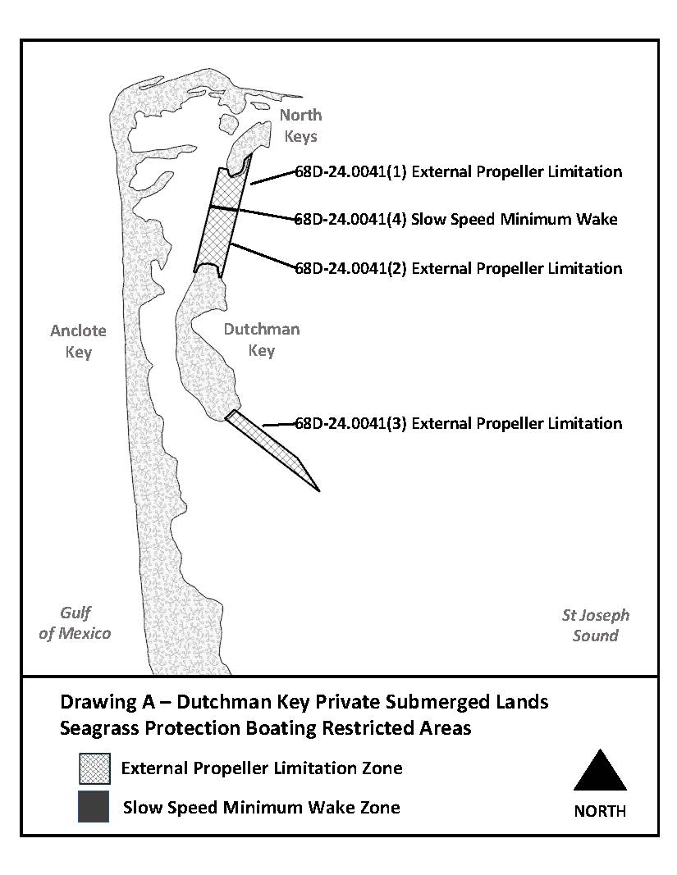
Rulemaking Authority 327.04, 327.46 FS. Law Implemented 327.46 FS. History–New 4-26-22.

68D-24.005 Sarasota County Boating Restricted Areas.
(1) For the purpose of regulating the speed and operation of vessel traffic in and adjacent to the Intracoastal Waterway within Sarasota County, Florida, the following Boating Restricted Areas are established:
(a) Idle Speed No Wake Zones –
1. Stickney Point Bridge – All waters lying within and adjacent to the Intracoastal Waterway, from shoreline to shoreline, from a line drawn perpendicular to the centerline of the Intracoastal Waterway 550 feet north of the Stickney Point Bridge to a line drawn perpendicular to the centerline of the Intracoastal Waterway 650 feet south of said bridge, as depicted in drawing A.
2. Blackburn Point Bridge – All waters lying within and adjacent to the Intracoastal Waterway, from shoreline to shoreline, from a line drawn perpendicular to the centerline of the Intracoastal Waterway 650 feet north of the Blackburn Point Bridge to a line drawn perpendicular to the centerline of the Intracoastal Waterway 500 feet south of said bridge, as depicted in drawing B.
3. Albee Road Bridge – All waters lying within and adjacent to the Intracoastal Waterway, from shoreline to shoreline, from a line drawn perpendicular to the centerline of the Intracoastal Waterway 2,500 feet north of the Albee Road Bridge to a line drawn perpendicular to the centerline of the Intracoastal Waterway 1,000 feet south of said bridge, as depicted in drawing C.
4. Hatchett Creek – All waters lying within and adjacent to the Intracoastal Waterway, from shoreline to shoreline, from a line drawn perpendicular to the centerline of the Intracoastal Waterway 2,000 feet northwest of the US Highway 41 Business) Bridge to a line drawn perpendicular to the centerline of the Intracoastal Waterway 2,000 feet southeast of said bridge, as depicted in drawing D.
5. Circus Bridge (US 41) – All waters lying within and adjacent to the Intracoastal Waterway, from shoreline to shoreline, from a line drawn perpendicular to the centerline of the Intracoastal Waterway 840 feet north of the centerline of the Circus Bridge (US 41) including the marine center boat basin to a line drawn perpendicular to the centerline of the Intracoastal Waterway 300 feet south of the centerline of said bridge, as depicted in drawing E.
6. South Venice Ferry – All waters lying within and adjacent to the Intracoastal Waterway, from shoreline to shoreline, from a line drawn perpendicular to the centerline of the Intracoastal Waterway 500 feet northwest of the South Venice Ferry Dock to a line drawn perpendicular to the centerline of the Intracoastal Waterway 900 feet southeast of said dock, as depicted in drawing F.
7. Siesta Key Bridge – All waters lying within and adjacent to the Intracoastal Waterway, from shoreline to shoreline, from a line drawn perpendicular to the centerline of the Intracoastal Waterway 300 feet north of the centerline of the Siesta Key Bridge to a line drawn perpendicular to the centerline of the Intracoastal Waterway 300 feet south of the centerline of the Siesta Key Bridge, as depicted in drawing G.
8. Manasota Beach Bridge – All waters lying within and adjacent to the Intracoastal Waterway, from shoreline to shoreline, from a line drawn perpendicular to the centerline of the Intracoastal Waterway 300 feet north of the centerline of the Manasota Beach Bridge to a line drawn perpendicular to the centerline of the Intracoastal Waterway 300 feet south of the centerline of the Manasota Beach Bridge, as depicted in drawing H.
(b) Sarasota County shall install and maintain appropriate regulatory markers as directed by the Division of Law Enforcement within such boating restricted areas.
(2) The boating restricted areas described in subsection 68D-24.005(1), F.A.C., are depicted on the following drawings:
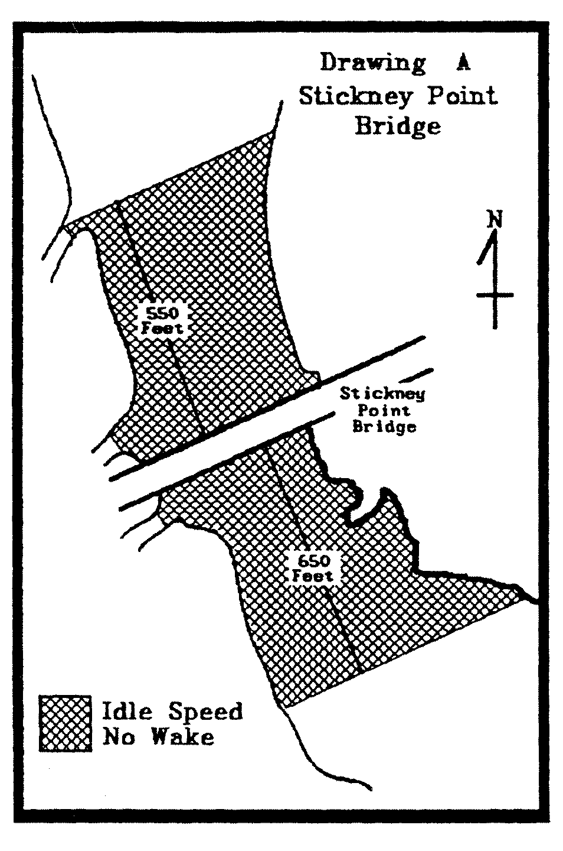 | 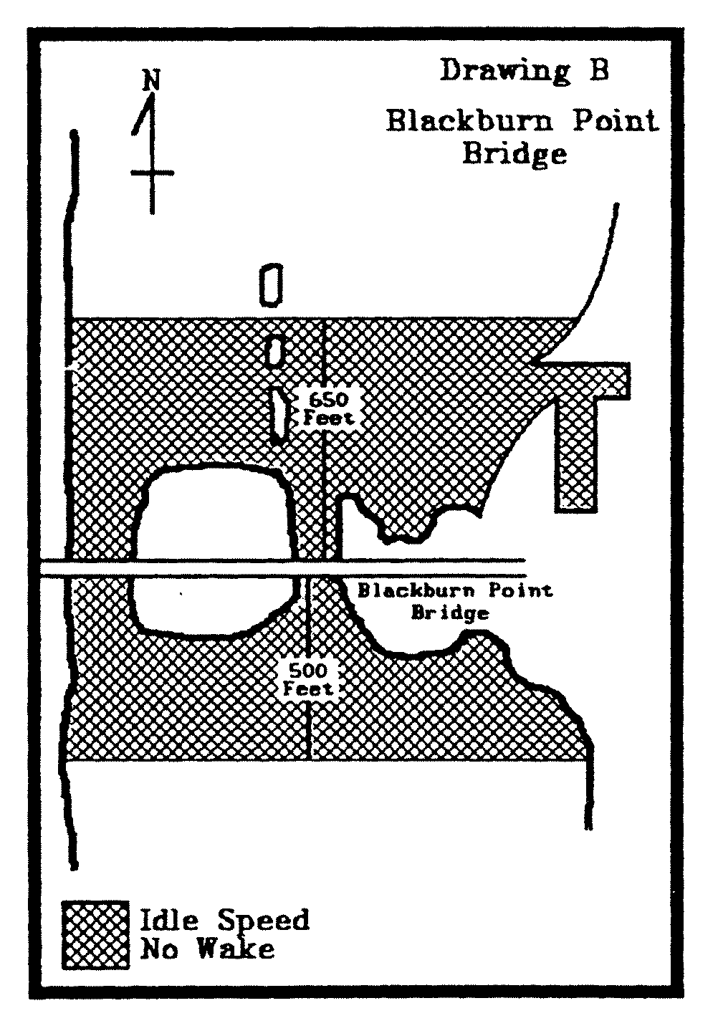
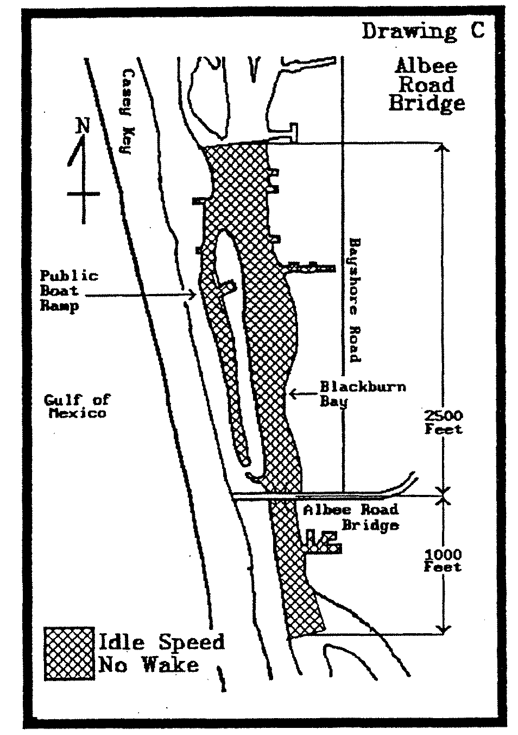

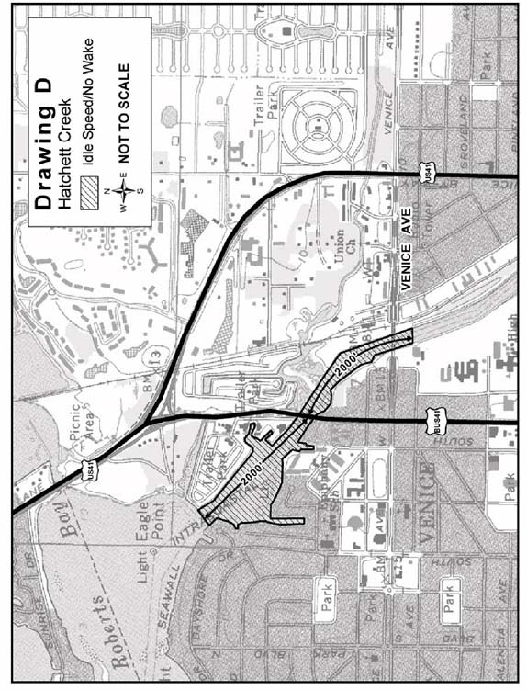
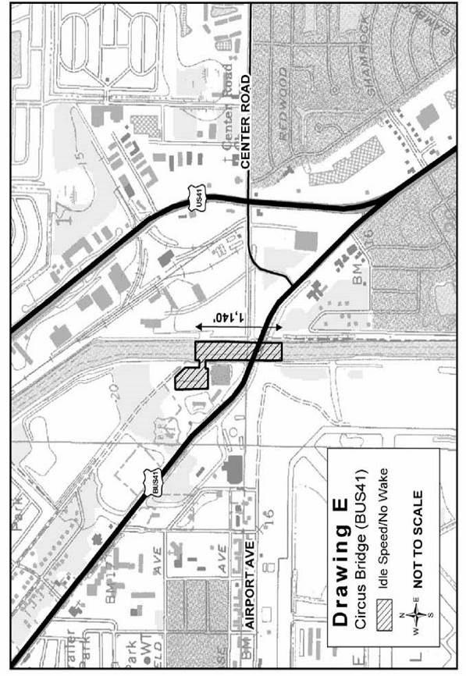
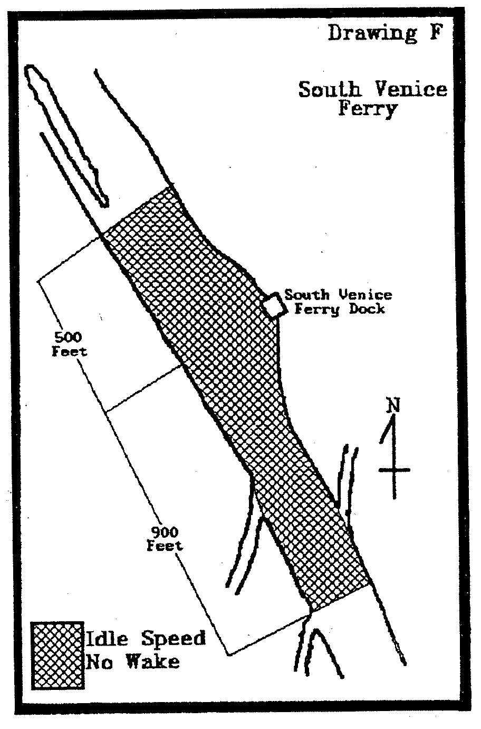
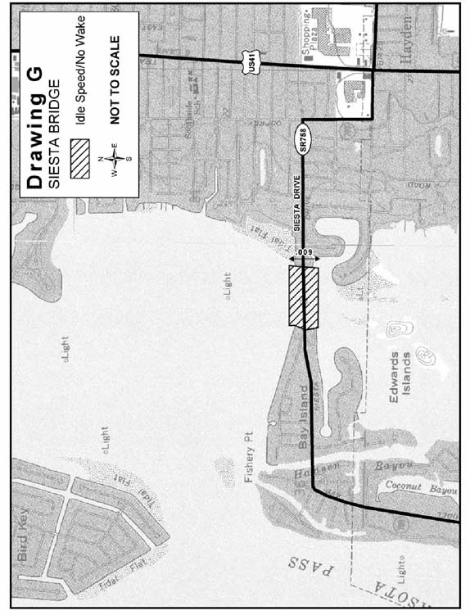
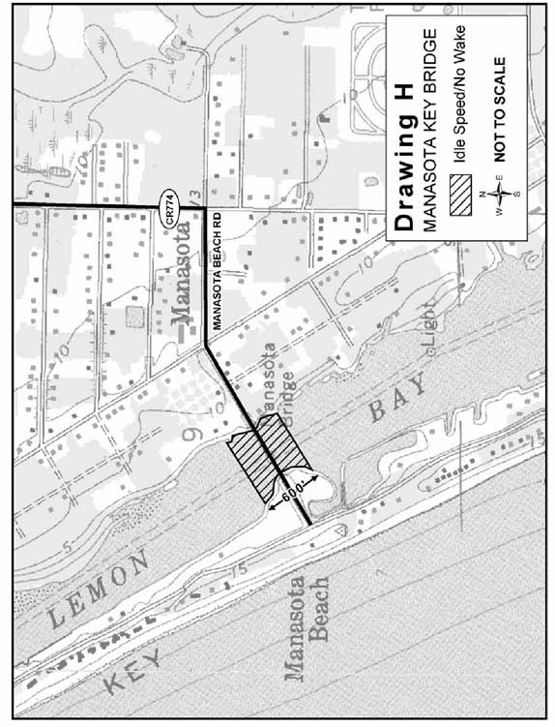

Rulemaking Authority 327.04, 327.46 FS. Law Implemented 327.46 FS. History–New 8-30-83, Formerly 16N-24.05, Amended 12-21-92, Formerly 16N-24.005, 62N-24.005, Amended 1-1-06.

68D-24.006 Fort Lauderdale Boating Restricted Areas.
Rulemaking Authority 327.04, 327.46 FS. Law Implemented 327.46 FS. History–New 11-13-83, Formerly 16N-24.06, Amended 3-12-87, 12-7-89, Formerly 16N-24.006, Amended 9-28-98, Formerly 62N-24.006, Repealed 7-21-13.

68D-24.008 Broward County Boating Restricted Areas.
(1) For the purpose of regulating speed and operation of vessel traffic on and adjacent to the Florida Intracoastal Waterway in Broward County, Florida, the following year-round boating restricted areas are established. The boating restricted areas exclude all associated tributaries, creeks, canals, backwaters, channels, boat basins and other waterways unless otherwise designated or specifically described for inclusion:
(a)1. Hillsboro Boulevard Bridge – An Idle Speed No Wake zone from shoreline to shoreline, in and adjacent to the Florida Intracoastal Waterway, bounded on the north by a line drawn perpendicular to the centerline of the Florida Intracoastal Waterway 750 feet north of the Hillsboro Boulevard Bridge and bounded on the south by a line drawn perpendicular to the centerline of the Florida Intracoastal Waterway 800 feet south of said bridge as depicted in drawing A.
2. Hillsboro Inlet Zones –
a. An Idle Speed No Wake zone from shoreline to shoreline, in and adjacent to the Florida Intracoastal Waterway, bounded on the north by a line drawn perpendicular to the centerline of the Florida Intracoastal Waterway 100 feet north of latitude 26° 17.339' North, longitude 80° 4.842' West (approximately located at Channel Marker “68”), and on the south by a line drawn perpendicular to the centerline of the Florida Intracoastal Waterway 1,050 feet southwest of the intersection of the centerline of the Hillsboro Inlet channel and the centerline of the Florida Intracoastal Waterway, as depicted in drawing B.
b. A Slow Speed Minimum Wake zone from shoreline to shoreline, in and adjacent to the Florida Intracoastal Waterway, and including all waters of the Hillsboro Inlet, bounded on the northwest by a line drawn from headland to headland across the northwestern end of the Hillsboro Inlet at its confluence with the Florida Intracoastal Waterway, and on the southeast by a line drawn perpendicular to the centerline of the inlet channel 150 feet northwest of the seaward extremities of the Hillsboro Inlet jetties, as depicted in drawing B.
c. A Slow Speed Minimum Wake zone from shoreline to shoreline, in and adjacent to the Florida Intracoastal Waterway, bounded on the north by a line drawn perpendicular to the centerline of the Florida Intracoastal Waterway 1,050 feet south of the intersection of the centerline of the Hillsboro Inlet channel and the centerline of the Florida Intracoastal Waterway and on the south by a line drawn perpendicular to the centerline of the Florida Intracoastal Waterway 1,425 feet north of the North East 14th Street Bridge in Pompano Beach, as depicted in drawing B.
3. North East 14th Street Bridge – An Idle Speed No Wake zone from shoreline to shoreline, in and adjacent to the Florida Intracoastal Waterway, bounded on the north by a line drawn perpendicular to the centerline of the Florida Intracoastal Waterway 1,425 feet north of the North East 14th Street Bridge in Pompano Beach and on the south by a line drawn perpendicular to the centerline of the Florida Intracoastal Waterway 300 feet south of said bridge, as depicted in drawing B.
4. Atlantic Boulevard Bridge – An Idle Speed No Wake zone from shoreline to shoreline, in and adjacent to the Florida Intracoastal Waterway, bounded on the north by a line drawn perpendicular to the centerline of the waterway 1,350 feet north of the Atlantic Boulevard Bridge and bounded on the south by a line drawn perpendicular to the centerline of the Florida Intracoastal Waterway 500 feet south of said bridge, as depicted in drawing C.
5. East Commercial Boulevard Bridge – An Idle Speed No Wake zone from shoreline to shoreline, in and adjacent to the Florida Intracoastal Waterway, bounded on the north by a line drawn perpendicular to the centerline of the Florida Intracoastal Waterway 750 feet north of the East Commercial Boulevard Bridge and bounded on the south by a line drawn perpendicular to the centerline of the Florida Intracoastal Waterway 700 feet south of said bridge, as depicted in drawing D.
6. Oakland Park Boulevard Bridge – An Idle Speed No Wake zone from shoreline to shoreline, in and adjacent to the Florida Intracoastal Waterway, and extending 1,500 feet north and south of the Oakland Park Boulevard Bridge, as depicted in drawing E.
7. Sunrise Boulevard Bridge –
a. An Idle Speed No Wake zone from shoreline to shoreline, in and adjacent to the Florida Intracoastal Waterway, from a line drawn perpendicular to the centerline of the Florida Intracoastal Waterway 2,250 feet north of the Sunrise Boulevard Bridge to a line drawn perpendicular to the centerline of the Florida Intracoastal Waterway 1,500 feet south of said bridge, as depicted in drawing F.
b. A Slow Speed Minimum Wake zone to be in effect year-round on Saturdays, Sundays and holidays as defined in Rule 68D-24.002, F.A.C., from shoreline to shoreline, in and adjacent to the Florida Intracoastal Waterway, from a line drawn perpendicular to the centerline of the Florida Intracoastal Waterway 1,500 feet south of the Sunrise Boulevard Bridge to a line drawn perpendicular to the centerline of the Florida Intracoastal Waterway 1,500 feet north of the East Las Olas Bridge, as depicted in drawing F.
8. East Las Olas Bridge – An Idle Speed No Wake zone from shoreline to shoreline, in and adjacent to the Florida Intracoastal Waterway, from a line drawn perpendicular to the centerline of the Florida Intracoastal Waterway 1,500 feet north of the East Las Olas Bridge to a line drawn perpendicular to the centerline of the Florida Intracoastal Waterway 3,300 feet south of said bridge, as depicted in drawing F.
9. Stranahan River – A Slow Speed Minimum Wake zone from shoreline to shoreline, in and adjacent to the Florida Intracoastal Waterway, from a line drawn perpendicular to the centerline of the Florida Intracoastal Waterway 3,300 feet south of the East Las Olas Bridge to a line drawn perpendicular to the centerline of the Florida Intracoastal Waterway 1,500 feet north of the 17th Street Causeway Bridge, as depicted in drawing G.
10. 17th Street Causeway Bridge – An Idle Speed No Wake zone from shoreline to shoreline, in and adjacent to the Florida Intracoastal Waterway, from a line drawn perpendicular to the centerline of the Florida Intracoastal Waterway 1,500 feet north of the 17th Street Causeway Bridge to a line drawn perpendicular to the centerline of the Florida Intracoastal Waterway 800 feet south of said bridge, as depicted in drawing G.
11. Dania Beach Boulevard Bridge – An Idle Speed No Wake zone from shoreline to shoreline, in and adjacent to the Florida Intracoastal Waterway, bounded on the north by a line drawn perpendicular to the centerline of the Florida Intracoastal Waterway 850 feet north of the Dania Beach Boulevard Bridge and bounded on the south by a line drawn perpendicular to the centerline of the Florida Intracoastal Waterway 1,940 feet south of said bridge, as depicted in drawing H.
12. Sheridan Street Bridge – A Slow Speed Minimum Wake zone from shoreline to shoreline, in and adjacent to the Florida Intracoastal Waterway, bounded on the north by a line drawn perpendicular to the centerline of the Florida Intracoastal Waterway, 850 feet north of the Sheridan Street Bridge and bounded on the south by a line drawn perpendicular to the centerline of the Florida Intracoastal Waterway 750 feet south of said bridge, as depicted in drawing I.
13. Hollywood Boulevard Bridge – An Idle Speed No Wake zone from shoreline to shoreline, in and adjacent to the Florida Intracoastal Waterway, bounded on the north by a line drawn perpendicular to the centerline of the Florida Intracoastal Waterway 2,570 feet south of the Sheridan Street Bridge and bounded on the south by a line drawn perpendicular to the centerline of the Florida Intracoastal Waterway 740 feet south of the Hollywood Boulevard Bridge, as depicted in drawing J.
14. Hallandale Beach Boulevard Zones –
a. An Idle Speed No Wake zone from shoreline to shoreline, in and adjacent to the Florida Intracoastal Waterway, bounded on the north by a line drawn perpendicular to the centerline of the Florida Intracoastal Waterway 2,800 feet north of the Hallandale Beach Boulevard Bridge and bounded on the south by a line drawn perpendicular to the centerline of the Florida Intracoastal Waterway 1,325 feet north of said bridge, as depicted in drawing K.
b. A Slow Speed Minimum Wake zone from shoreline to shoreline, in and adjacent to the Florida Intracoastal Waterway, bounded on the north by a line drawn perpendicular to the centerline of the Florida Intracoastal Waterway 300 feet north of the Hallandale Beach Boulevard Bridge and bounded on the south by a line drawn perpendicular to the centerline of the Florida Intracoastal Waterway 400 feet south of said bridge, as depicted in drawing K.
c. A Slow Speed Minimum Wake zone from shoreline to shoreline, in and adjacent to the Florida Intracoastal Waterway, bounded on the north by a line drawn perpendicular to the centerline of the Florida Intracoastal Waterway 400 feet south of the Hallandale Beach Boulevard Bridge and bounded on the south by a line drawn perpendicular to the centerline of the Florida Intracoastal Waterway at the Dade/Broward County line, as depicted in drawing K.
(b) Thirty (30) miles per hour/fifteen inch (15") wake zone –
1. This paragraph applies to all waters of the New River Canal and the Florida Intracoastal Waterway within Broward County.
2. Except where other speed limits or operation restrictions have been lawfully established, the maximum speed on these waters is thirty (30) miles per hour.
a. Any person who operates a vessel in excess of the thirty (30) miles per hour maximum speed limit is guilty of a noncriminal infraction, punishable by a civil penalty. The amount of the civil penalty shall be computed in accordance with the provisions pertaining to penalties for unlawful speed under Section 318.18(3), F.S.
b. For the purposes of enforcement of this subparagraph, law enforcement officers may use aircraft, vessels, manual or electronic timing devices, or radar. If radar is used, the provisions of Section 316.1906, F.S., shall be complied with.
c. This subparagraph shall not be interpreted to mean that thirty (30) miles per hour is a safe speed for all vessels under all circumstances. Inland Navigation Rule 6, as adopted pursuant to Section 327.33(3), F.S., requires that every vessel shall at all times be operated at a safe speed. Compliance with Inland Navigation Rule 6 may require speeds well under thirty (30) miles per hour.
3. The maximum allowable wake created by any vessel on these waters, regardless of the speed or size of the vessel, is fifteen inches (15") in vertical height, measured from the ambient tide level to the crest of the vessel’s wake at a distance of not less than twenty-five feet (25') from the vessel. Violation of this subparagraph is a misdemeanor of the second degree, punishable as provided in Section 775.082 or 775.083, F.S. For purposes of enforcement of this subparagraph, law enforcement officers may use mechanical, electronic, or photographic measuring devices.
4. No person may operate any vessel on these waters in such a manner as to exceed a maximum sound level of eighty (80) dBA, measured at a distance of not less than fifty feet (50') from the vessel. Violation of this subparagraph, or refusal to submit to a sound level test when requested to do so by a law enforcement officer is a misdemeanor of the second degree as provided in Chapter 89-428, Laws of Florida, punishable as provided in Section 775.082 or 775.083, F.S.
(2) Exemption – This rule section shall not apply to any person operating a vessel as a participant in, or during officially sanctioned trial runs preceding or following, a lawfully permitted regatta or boat race.
(3) The boating restricted areas described in Rule 68D-24.008, F.A.C., are depicted on the following drawings:

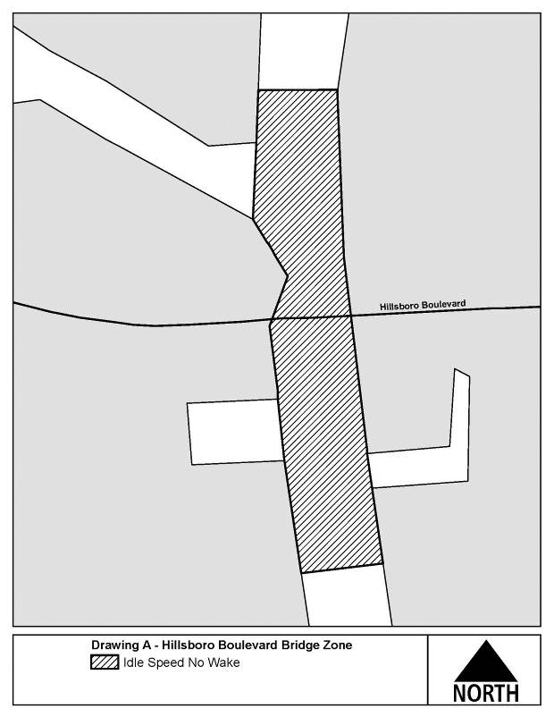

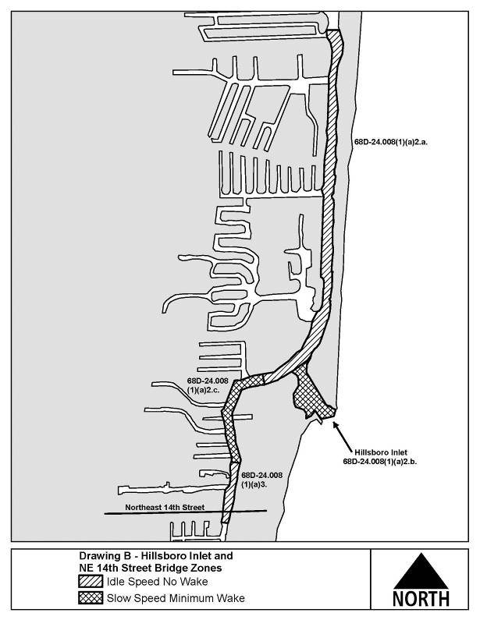
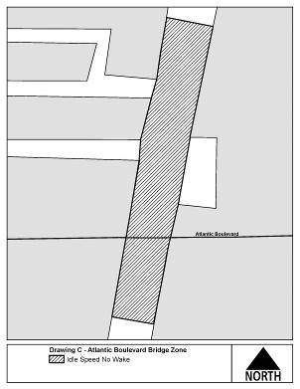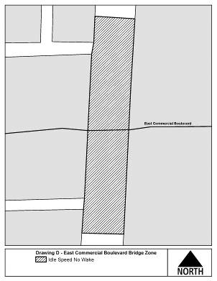

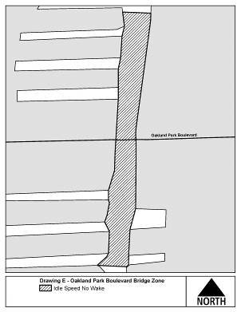
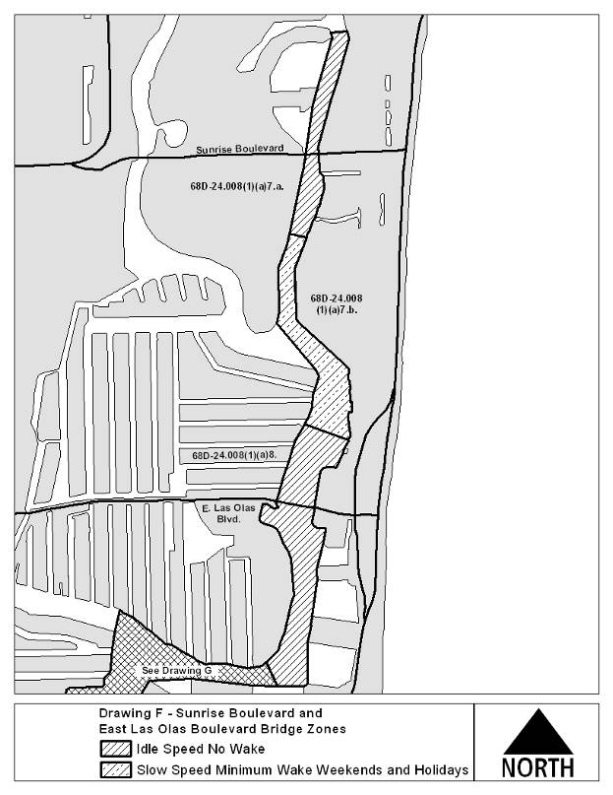

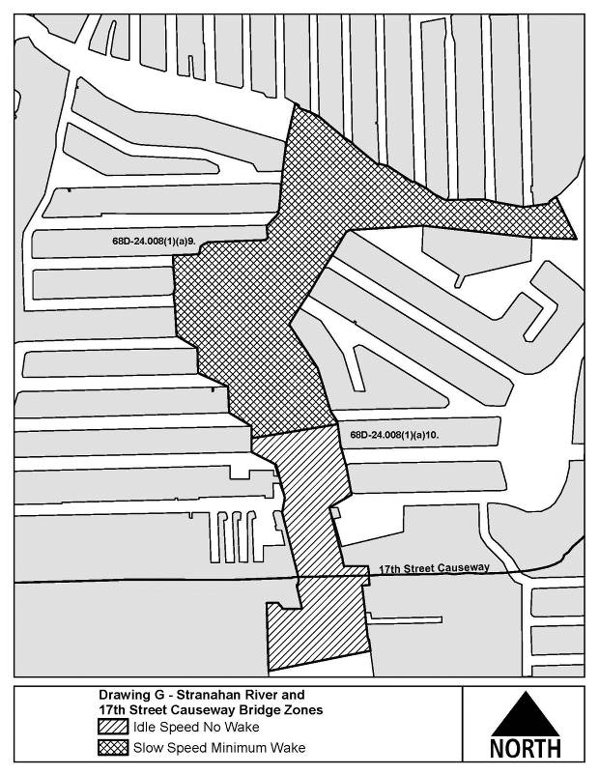
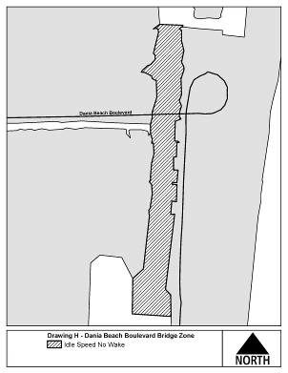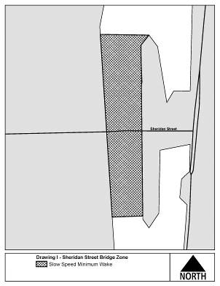
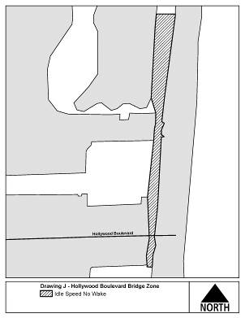

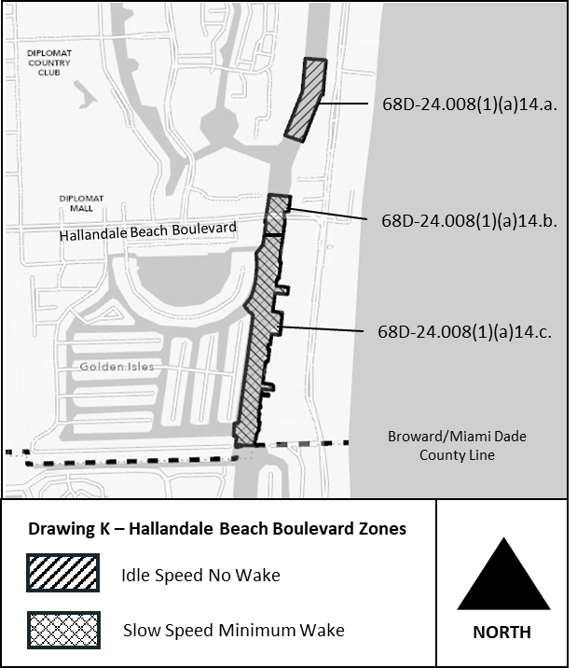
Rulemaking Authority 327.04, 327.46 FS. Law Implemented 327.46 FS., Chapter 86-364, Ch. 89-428, Laws of Florida. History–New 11-9-86, Amended 6-14-93, Formerly 16N-24.008, Amended 12-18-94, Formerly 62N-24.008, Amended 7-21-13, 9-27-21.

68D-24.010 Pinellas County Boating Restricted Areas.
(1) The following year-round zones are established regulating the speed and operation of vessel traffic on and adjacent to the Florida Intracoastal Waterway within Pinellas County. The zones exclude all associated tributaries, creeks, canals, channels, backwaters, boat basins and other waterways unless otherwise designated or specifically described for inclusion:
(a) Slow Speed Minimum Wake Zones.
1. Pinellas Bayway (SR679) (SR 682) Bridges.
a. All waters in and adjacent to the Florida Intracoastal Waterway from a line drawn perpendicular to the centerline of the Florida Intracoastal Waterway 500 feet southeast of the Pinellas Bayway (SR 679) Bridge, to a line drawn perpendicular to the centerline of the Florida Intracoastal Waterway 1,500 feet northwest of said bridge, bounded on the northeast by a line drawn parallel to the Florida Intracoastal Waterway from a point (27 41.748N, 82 42.986W) and bounded on the southwest by the southwestern shoreline as depicted in drawing A.
b. All waters in and adjacent to the Florida Intracoastal Waterway from a line drawn perpendicular to the centerline of the Florida Intracoastal Waterway 500 feet south of the Pinellas Bayway (SR 682) Bridge, to a line drawn perpendicular to the centerline of the Florida Intracoastal Waterway 500 feet north of said bridge, bounded on the east by the eastern shoreline and bounded on the west by a line drawn parallel to the Florida Intracoastal Waterway from a point (27 42.563N, 82 43.583W), as depicted in drawing A.
2. Corey Causeway (SR 699) Bridge to Treasure Island Causeway (SR 150) Bridge – All waters in and adjacent to the Florida Intracoastal Waterway, from shoreline to shoreline, from a line drawn perpendicular to the centerline of the Florida Intracoastal Waterway 800 feet southeast of the Corey Causeway (SR 699) Bridge, to a line drawn perpendicular to the centerline of the Florida Intracoastal Waterway 500 feet north of the Treasure Island Causeway (SR 150) Bridge, as depicted in drawing B.
3. Tom Stuart (Welch) Causeway (SR 666) Bridge – All waters in and adjacent to the Florida Intracoastal Waterway from a line drawn perpendicular to the centerline of the Florida Intracoastal Waterway 1,600 feet southeast of the Tom Stuart (Welch) Causeway (SR 666) Bridge, to a line drawn perpendicular to the centerline of the Florida Intracoastal Waterway 1,000 feet northwest of said bridge, bounded on the northeast by a line drawn parallel to the Florida Intracoastal Waterway from a point (27 48.463N, 82 47.657W) and bounded on the southwest by a line drawn parallel to the Florida Intracoastal Waterway from a point (27 48.383N, 82 47.741W), as depicted in drawing C.
4. Park Boulevard (SR 694) Bridge – All waters in and adjacent to the Florida Intracoastal Waterway, from shoreline to shoreline, from a line drawn perpendicular to the centerline of the Florida Intracoastal Waterway 6,270 feet southeast of the Park Boulevard (SR 694) Bridge, to a line drawn perpendicular to the centerline of the Florida Intracoastal Waterway 3,050 feet north of said bridge, including the backwater immediately adjacent to Bayhaven Drive, as depicted in drawing D.
5. Indian Rocks (SR 688) Bridge – All waters in and adjacent to the Florida Intracoastal Waterway, from shoreline to shoreline, from a line drawn perpendicular to the centerline of the Florida Intracoastal Waterway 7,340 feet south of the Indian Rocks (SR 688) Bridge, to a line drawn perpendicular to the centerline of the Florida Intracoastal Waterway 1,790 feet north of said bridge, as depicted on drawing E.
6. Belleair Causeway (CR-416) Bridge – All waters in and adjacent to the Florida Intracoastal Waterway from a line drawn perpendicular to the centerline of the Florida Intracoastal Waterway 500 feet south of the center bridge span of the Belleair Causeway (CR-416) Bridge, to a line drawn perpendicular to the centerline of the Florida Intracoastal Waterway 500 feet north of the center bridge span of said bridge, bounded on the east by a point (27 54.924N, 82 49.801W) and following the contour of the eastern shoreline north to a point (27 54.954N, 82 49.750W) then running parallel to the channel from said point to the terminus of the north boundary and bounded on the west by a line drawn parallel to the Florida Intracoastal Waterway from a point (27 55.007N, 82 49.970W), as depicted in drawing F.
7. Memorial Causeway (SR 60) Bridge ‒
a. All waters in and adjacent to the Florida Intracoastal Waterway from a line drawn perpendicular to the centerline of the Florida Intracoastal Waterway 1,215 feet southwest of Memorial Causeway (SR 60) Bridge, to a line drawn perpendicular to the centerline of the Florida Intracoastal Waterway 920 feet northeast of said bridge, bounded on the west by a line drawn parallel to the Florida Intracoastal Waterway from a point (27 58.018N, 82 48.429W) and bounded on the east by the City of Clearwater shoreline, as depicted in drawing G.
b. All waters in and adjacent to the Florida Intracoastal Waterway from a line drawn perpendicular to the centerline of the Florida Intracoastal Waterway 920 feet northeast of the Memorial Causeway (SR 60) Bridge, to a line draw perpendicular to the Florida Intracoastal Waterway 3,315 feet north of said bridge, bounded on the west by the boundaries of the marked channel of the Florida Intracoastal Waterway and bounded on the east by the City of Clearwater Shoreline, as depicted in drawing G.
8. Honeymoon Island Causeway (SR 586) Bridge – All waters in and adjacent to the Florida Intracoastal Waterway from a line drawn perpendicular to the centerline of the Florida Intracoastal Waterway 500 feet south of the Honeymoon Island Causeway (SR 586) Bridge, to a line drawn perpendicular to the centerline of the Florida Intracoastal Waterway 500 feet north of said bridge, bounded on the east by a line drawn parallel to the Florida Intracoastal Waterway from a point (28 3.068N, 82 47.621W) and bounded on the west by a line drawn parallel to the Florida Intracoastal Waterway from a point (28 3.070N, 82 47.829W), as depicted in drawing H.
(2) The boating restricted areas are depicted in the following drawings:
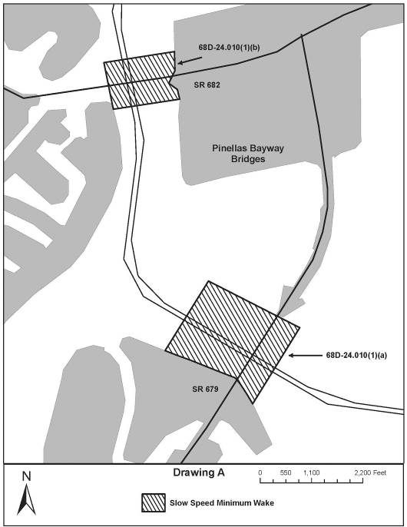
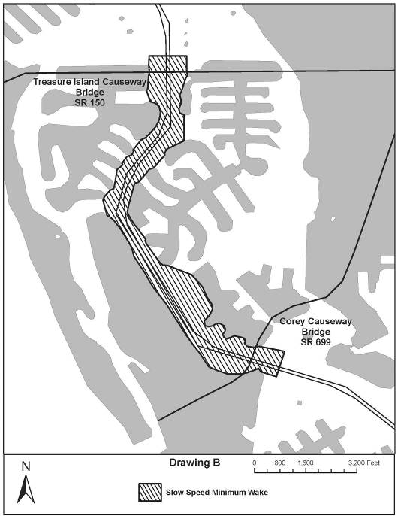
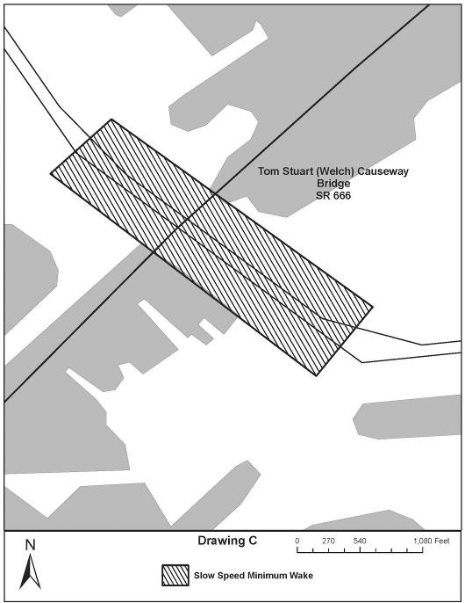
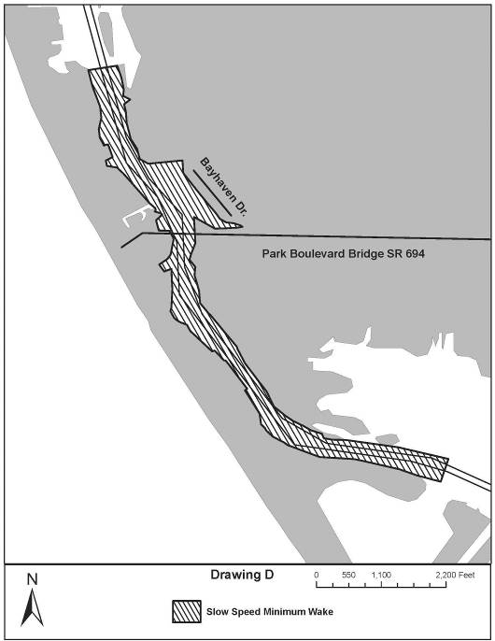
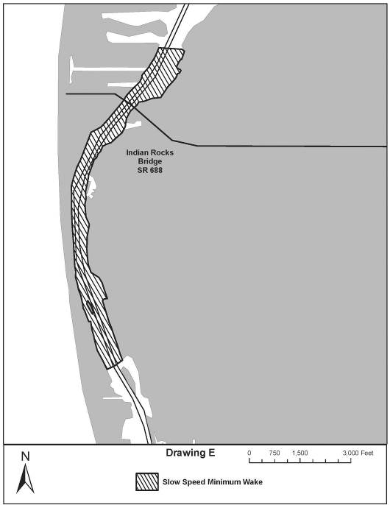
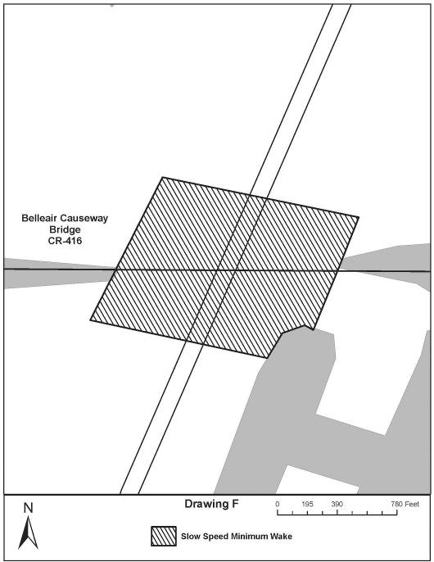
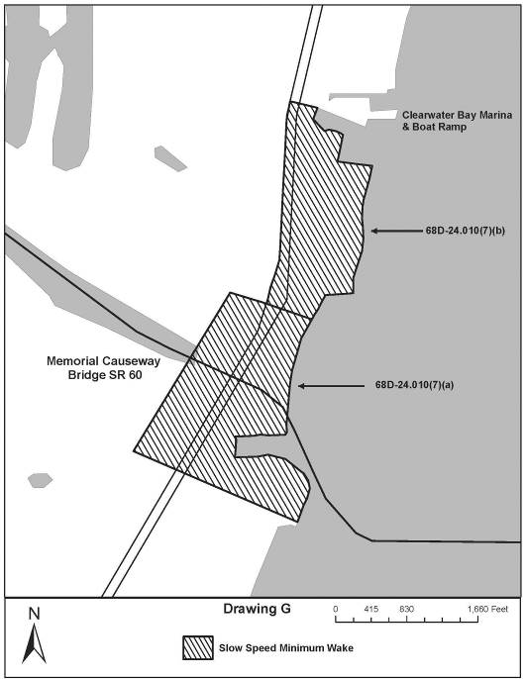
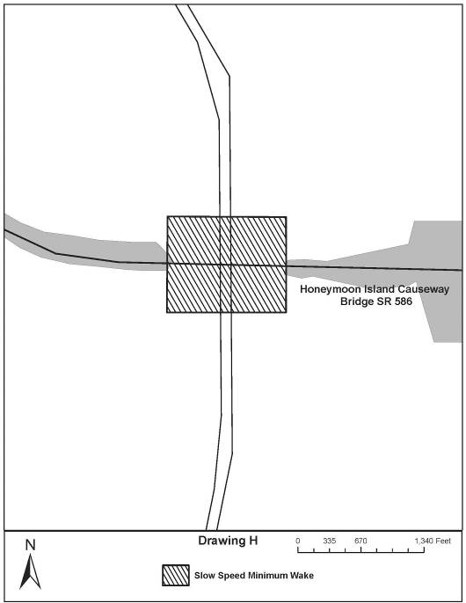

Rulemaking Authority 327.46 FS. Law Implemented 327.46 FS. History–New 9-18-88, Amended 12-7-89, Formerly 16N-24.010, Amended 10-1-96, Formerly 62N-24.010, Amended 10-2-00, 10-30-13.

68D-24.011 Okeechobee Waterway Boating Restricted Areas.
(1) For the purpose of regulating the speed and operation of vessel traffic on the Okeechobee Waterway, the following Boating Restricted Areas are established:
(a) SE Ocean Boulevard – A Slow Speed Minimum Wake boating restricted area from shoreline to shoreline, in and adjacent to the Okeechobee Waterway, bounded on the north by a line drawn perpendicular to the centerline of the Okeechobee Waterway 300 feet north of the centerline of the S.E. Ocean Boulevard (SR A1A) bridge, and bounded on the south by a line drawn perpendicular to the centerline of the Okeechobee Waterway 300 feet south of the centerline of said bridge, as depicted in drawing A.
(b) Stuart “Roosevelt Bridge” Area – A Slow Speed Minimum Wake boating restricted area from shoreline to shoreline, in and adjacent to the Okeechobee Waterway, bounded on the east by a line drawn parallel to and 300 feet east of the centerline of the Roosevelt Bridge (US Highway 1), bounded on the northwest by a line drawn from Britt Point to Arbeau Point across the mouth of the North Fork of the St. Lucie River at its confluence with the Okeechobee Waterway, and bounded on the southwest by a line drawn across the Okeechobee Waterway from Arbeau Point to Bessy Point 3,000 feet southwest of the centerline of North Dixie Highway (SR 707) bridge, as depicted in drawing B.
(c) Palm City Bridge – A Slow Speed Minimum Wake boating restricted area, shoreline to shoreline, in and adjacent to the Okeechobee Waterway, bounded on the northwest by a line drawn parallel to and 300 feet northwest of the centerline of the Palm City Bridge (SR 714), and bounded on the southeast by a line drawn parallel to and 1,500 feet southeast of the centerline of said bridge, as depicted in drawing C.
(d) St. Lucie Lock and Dam Structure, the Florida Turnpike and I-95 Bridges.
1. A Slow Speed Minimum Wake boating restricted area from shoreline to shoreline, in and adjacent to the Okeechobee Waterway, bounded on the northeast by a line drawn parallel to and 1,000 feet northeast of the centerline of the eastern span of the northbound traffic lane of I-95 and bounded on the southwest by a line drawn perpendicular to the centerline of the Okeechobee Waterway 300 feet northeast of the St. Lucie Lock and Dam Structure, as depicted in drawing D.
2. An Idle Speed No Wake boating restricted area from shoreline to shoreline, in the Okeechobee Waterway in and adjacent to the St. Lucie Lock and Dam Structure, bounded on the northeast by a line drawn perpendicular to the centerline of the Okeechobee Waterway 300 feet northeast of the St. Lucie Lock and Dam Structure and bounded on the southwest by a line drawn perpendicular to the centerline of the Okeechobee Waterway 300 feet southwest of the St. Lucie Lock and Dam Structure, as depicted in drawing D.
(e) Arundel Bridge (S. W. 96th Street) – A Slow Speed Minimum Wake boating restricted area from shoreline to shoreline, in and adjacent to the Okeechobee Waterway, bounded on the northeast by a line drawn perpendicular to the centerline of the Okeechobee Waterway 300 feet northeast of the centerline of the Arundel Bridge (S. W. 96th Street), and bounded on the southwest by a line drawn perpendicular to the centerline of the Okeechobee Waterway 300 feet southwest of the centerline of said bridge, as depicted in drawing E.
(f) Timer Powers Park and Boat Ramp – A Slow Speed Minimum Wake boating restricted area from shoreline to shoreline, in and adjacent to the Okeechobee Waterway, bounded on the northeast by a line drawn perpendicular to the centerline of the Okeechobee Waterway 500 feet northeast of the centerline of the Timer Powers Boat Ramp and bounded on the southwest by a line drawn perpendicular to the centerline of the Okeechobee Waterway 500 feet southwest of the centerline of the Timer Powers Boat Ramp, as depicted in drawing F.
(g) SR 710 and Seaboard Coast Line (CSX) Railroad Trestle – A Slow Speed Minimum Wake boating restricted area from shoreline to shoreline, in and adjacent to the Okeechobee Waterway, bounded on the northeast by a line drawn perpendicular to the centerline of the Okeechobee Waterway 300 feet northeast of the centerline of the SR 710 bridge, and bounded on the southwest by a line drawn perpendicular to the centerline of the Okeechobee Waterway 300 feet southwest of the centerline of the Seaboard Coast Line (CSX) Railway Trestle, as depicted in drawing G.
(h) FEC Railroad Trestle – A Slow Speed Minimum Wake boating restricted area from shoreline to shoreline, in and adjacent to the Okeechobee Waterway, bounded on the east by a line drawn perpendicular to the centerline of the Okeechobee Waterway 300 feet east of the centerline of the FEC Railroad Trestle, and bounded on the west by a line drawn perpendicular to the centerline of the Okeechobee Waterway 300 feet west of the centerline of said trestle, as depicted in drawing H.
(i) US 441/US 98 Bridge and Port Mayaca Lock – An Idle Speed No Wake boating restricted area from shoreline to shoreline, in and adjacent to the Okeechobee Waterway, east of the Port Mayaca lock structure and within the right-of-way of the Okeechobee Waterway west of said lock structure, bounded on the east by a line drawn parallel to and 300 feet east of the centerline of the US 441/US 98 bridge, and bounded on the west by a line drawn perpendicular to the centerline of the Okeechobee Waterway 300 feet west of the lock structure, as depicted in drawing I.
(j) Torry Island Bridge – A Slow Speed Minimum Wake boating restricted area from shoreline to shoreline, in and adjacent to the Okeechobee Waterway in Palm Beach County, bounded on the north by a line drawn perpendicular to the centerline of the Okeechobee Waterway 400 feet north of Torry Island Bridge in Belle Glade, Palm Beach County, and bounded on the south by a line drawn perpendicular to the centerline of the Okeechobee Waterway 1,400 feet south of said bridge, as depicted in drawing J.
(k) Clewiston Lock Structure – A Slow Speed Minimum Wake boating restricted area from shoreline to shoreline, in and adjacent to the Okeechobee Waterway in Clewiston, Hendry County, bounded on the northeast by a line drawn perpendicular to the centerline of the Route 1B Approach Channel 150 feet northeast of the confluence of the Okeechobee Waterway Rim Canal and Route 1B Approach Channel, bounded on the north by a line drawn 150 feet north of the confluence of both forks of Cauley Cut and the Okeechobee Waterway Rim Canal, bounded on the northwest by a line drawn perpendicular to the Okeechobee Waterway Rim Canal 300 feet northwest of the centerline of the Hoover Dike Road City Ramp, bounded on the south by a line drawn across the southern entrance to the S-310 Navigation Lock (Clewiston Lock) and bounded on the southeast by a line drawn perpendicular to the centerline of the Okeechobee Waterway Rim Canal 300 feet southeast of the northeastern fender of the S-310 Navigation Lock (Clewiston Lock), as depicted in drawing K.
(l) Liberty Point – A Slow Speed Minimum Wake boating restricted area from shoreline to shoreline, in and adjacent to the Okeechobee Waterway Rim Canal and Mayaca Cut in Glades County, bounded on the west by a line drawn perpendicular to the centerline of the Okeechobee Waterway Rim Canal 300 feet west of Liberty Point, on the southeast by a line drawn perpendicular to the centerline of the Rim Canal 600 feet southeast of Liberty Point, and on the east by a line drawn perpendicular to the centerline of the Mayaca Cut 150 east of its confluence with the Rim Canal, as depicted in drawing L.
(m) Moore Haven Lock Structure and Vicinity – A Slow Speed Minimum Wake boating restricted area from shoreline to shoreline, in and adjacent to the Okeechobee Waterway Rim Canal, the Old Moore Haven Canal and associated canals, and the Caloosahatchee River in the vicinity of the Moore Haven Lock and flood control structure S-77 in Glades County, within the boundaries set forth below, as depicted in drawing M:
1. In the Okeechobee Waterway Rim Canal, shoreline to shoreline, from a line drawn perpendicular to the centerline of the Okeechobee Waterway Rim Canal 1,800 feet northwest of the centerline of the Moore Haven Lock Gates canal (26° 50' 45.2'' N/81° 05' 24.2''W), to a line drawn perpendicular to the centerline of the Okeechobee Waterway Rim Canal 500 feet southeast of the centerline of the Alvin Ward boat ramp (26° 50' 21.8'' N/81° 04' 46.9''W), including the area shoreline to shoreline 500 feet north from the Okeechobee Waterway Rim Canal into the Old Moore Haven Canal (26° 50' 40.9'' N/81° 05' 14.4''W), and including the Moore Haven Locks canal;
2. In the lock structure and approaches, shoreline to shoreline, from the Okeechobee Waterway Rim Canal to the Caloosahatchee River;
3. In the approaches and spillway of flood control structure S-77, shoreline to shoreline, from the Okeechobee Waterway Rim Canal to the Caloosahatchee River; and,
4. In the Caloosahatchee River, shoreline to shoreline, from the river’s northern terminus at the lock structure to a line drawn perpendicular to the centerline of the river 1,450 feet downstream of the centerline of the US 27 Bridge, (26° 49' 48.3'' N/ 81° 05' 30.2''W), including the area, shoreline to shoreline, in the Old Moore Haven Canal south of the Okeechobee Waterway Rim Canal to the Old Moore Haven Canal’s terminus.
(n) SR 29 Bridge – A Slow Speed Minimum Wake boating restricted area in the Caloosahatchee River (Okeechobee Waterway), from shoreline to shoreline from a line drawn parallel to and 500 feet east of the centerline of the SR 29 bridge as it crosses the Caloosahatchee River to a line drawn parallel to and 2,056 feet west of the centerline said bridge, as depicted in drawing N.
(2) The boating restricted areas are depicted in the following drawings:

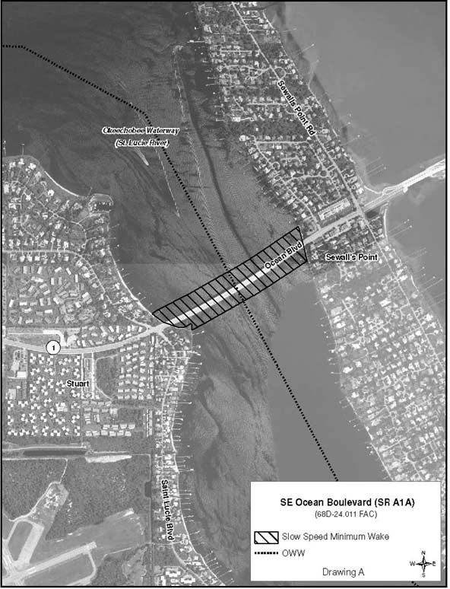

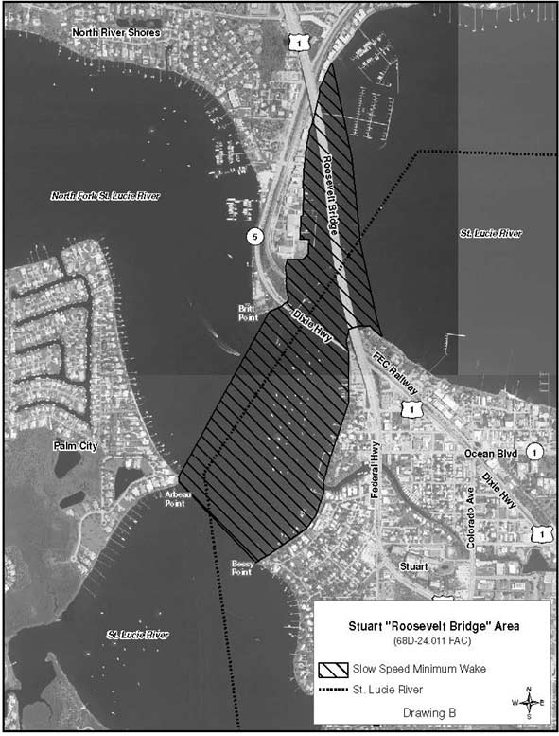
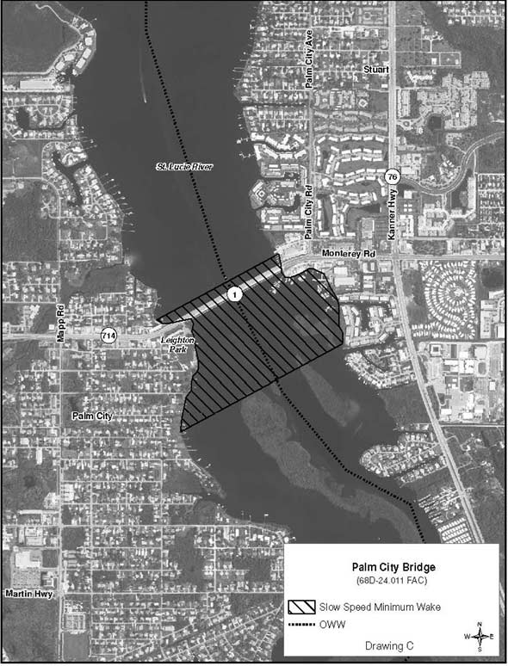
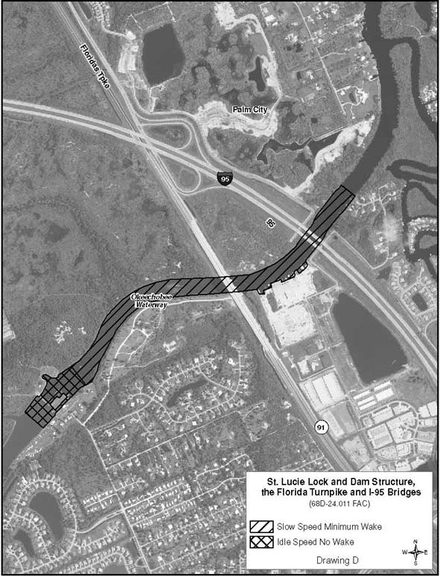
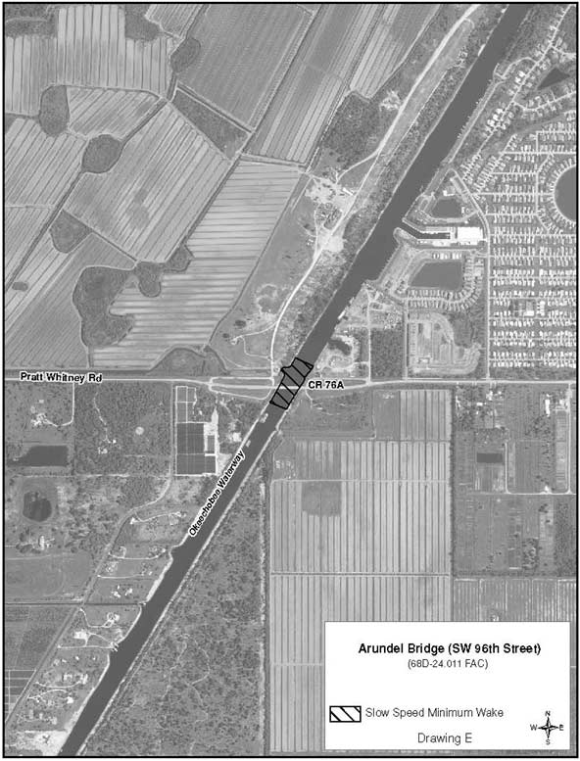
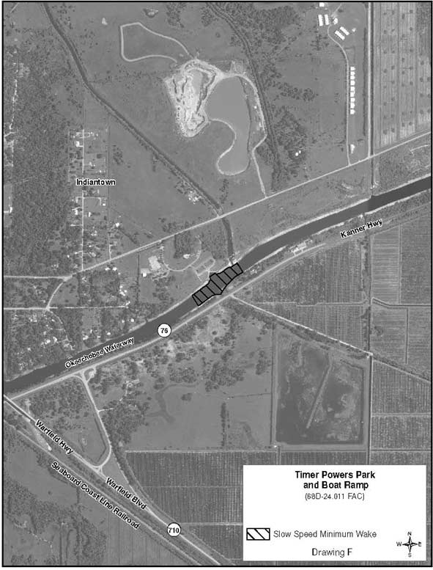
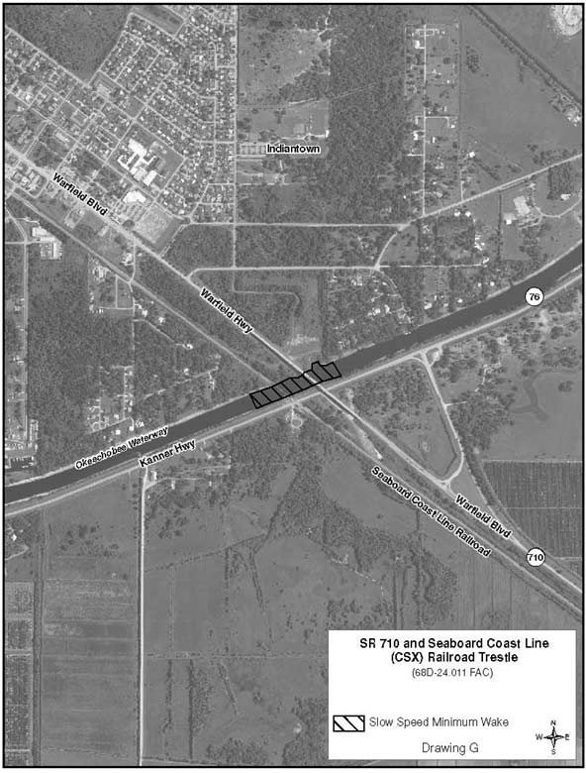
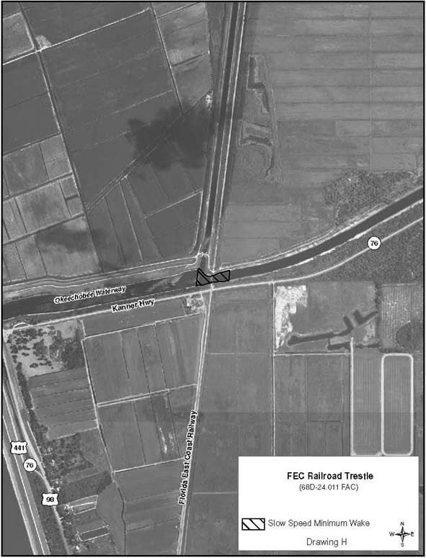
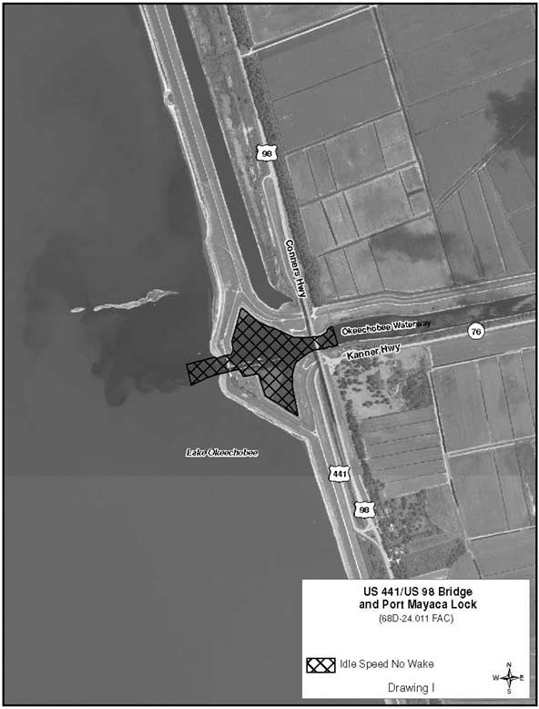
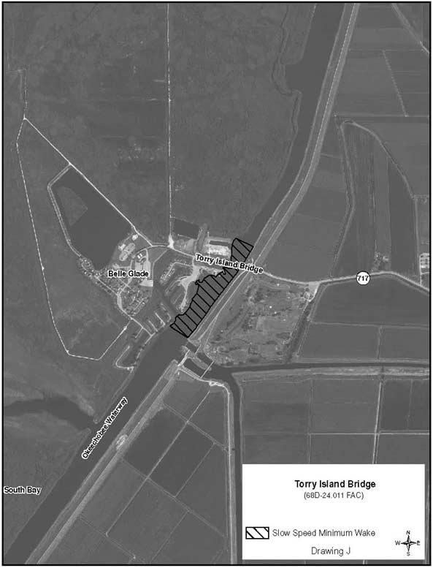
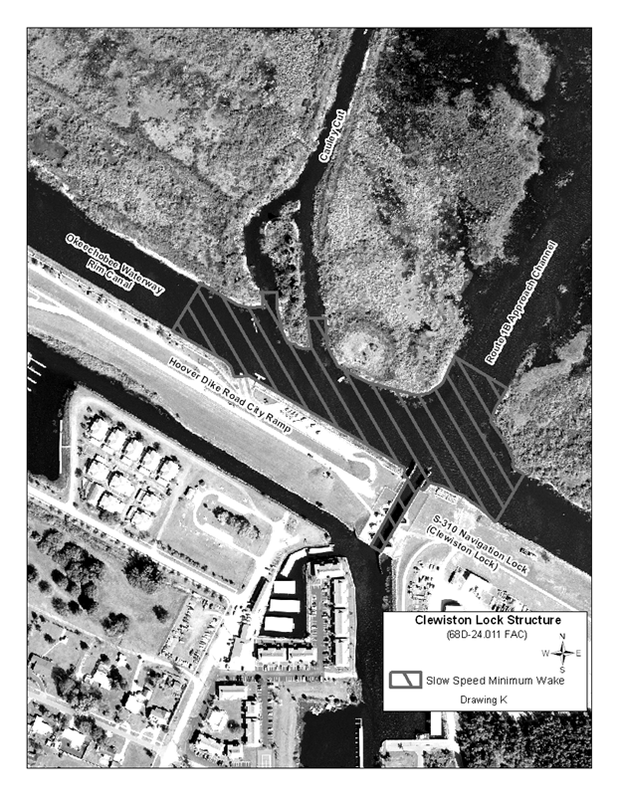
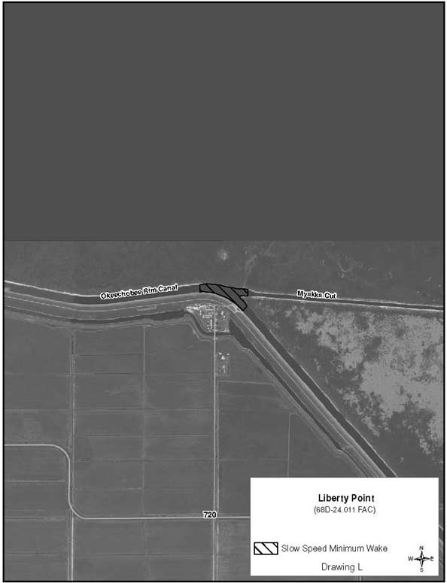
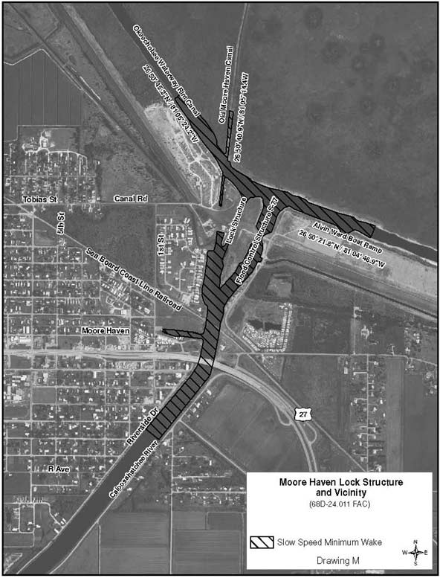
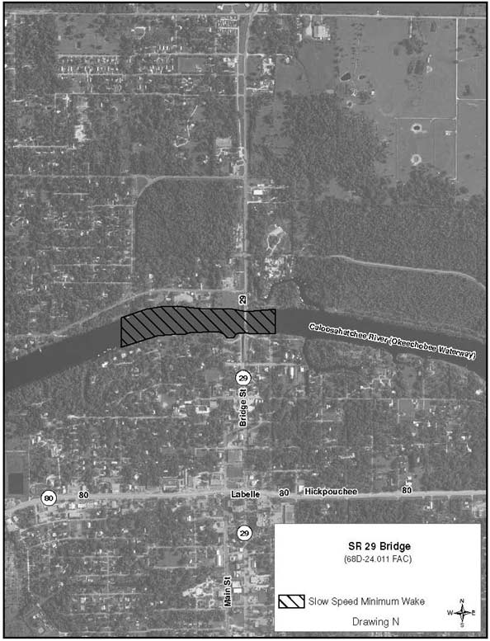
Rulemaking Authority 327.04, 327.46 FS. Law Implemented 327.46 FS. History–New 1-5-88, Formerly 16N-24.011, Amended 1-8-96, Formerly 62N-24.011, Amended 10-2-00, 10-23-05, 1-20-09, 5-12-13.

68D-24.013 Dade County Boating Restricted Areas.
(1) For the purpose of regulating the speed and operation of vessel traffic on and adjacent to the Intracoastal Waterway in the vicinities of Golden Beach, the North East 192nd Street Bridge, Biscayne Creek, Bakers Haulover Inlet, the Broad Causeway Bridge, the 79th Street Causeway Bridge, the Port of Miami, and the Rickenbacker Causeway Bridge in Dade County, Florida, the following Boating Restricted Areas are established:
(a)1. Golden Beach – 192nd Street Bridge: A Slow Down Minimum Wake Zone from shoreline to shoreline, in and adjacent to the Intracoastal Waterway, beginning at the Dade-Broward County Line and extending to a line drawn perpendicular to the centerline of the Intracoastal Waterway 500 feet south of the North East 192nd Street Bridge.
2. Biscayne Creek: An Idle Speed No Wake Zone in the Intracoastal Waterway Channel extending south from Dumfoundling Bay to Biscayne Bay, including all of Biscayne Creek.
3. Bakers Haulover Inlet: An Idle Speed No Wake Zone in and adjacent to the Intracoastal Waterway where the channels converge in the vicinity of the Bakers Haulover Inlet. This area is bounded as follows: on the west by the western edge of the channel of the Intracoastal Waterway; on the south by a line drawn due west from the southernmost point of the A1A Highway Bridge over the Bakers Haulover Inlet; on the east by the A1A Highway Bridge and the shoreline; and on the north by a line drawn due west from the shoreline to the south end of Atlantic Intracoastal Waterway Cut DA-8, approximately 3,440 feet north of the southern boundary of this zone.
4. Broad Causeway Bridge: An Idle Speed No Wake Zone in the Intracoastal Waterway Channel extending 100 yards on both sides of the Board Causeway Bridge.
5. 79th Street Causeway Bridge: An Idle Speed No Wake Zone in the Intracoastal Waterway Channel extending 100 yards on both sides of the 79th Street Causeway Bridge.
6. Port of Miami: An Idle Speed No Wake Zone in the Intracoastal Waterway Channel including approximately 1.75 miles from 100 yards north of the Venetian Causeway Bascule Bridge to the southern tip of Claughton Island.
7. Rickenbacker Causeway Bridge: An Idle Speed No Wake Zone in the Intracoastal Waterway Channel extending 100 yards on both sides of the Rickenbacker Causeway Bridge.
(b) Dade County is authorized to install and maintain appropriate regulatory markers as directed by the Division of Law Enforcement within the restricted areas. The county may enter into agreements with public or private organizations or individuals to effect this purpose.
(2) The boating restricted areas are depicted on the following drawings:
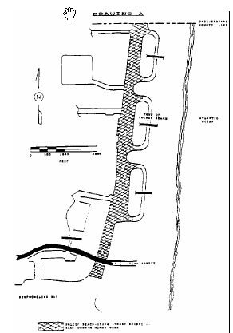
Rulemaking Authority 327.04, 327.46 FS. Law Implemented 327.46 FS. History–New 1-5-88, Amended 8-14-89, Formerly 16N-24.013, 62N-24.013.

68D-24.014 Manatee County Boating Restricted Area.
(1) For the purpose of regulating the speed and operation of vessel traffic on and adjacent to the Florida Intracoastal Waterway within Manatee County, the following Boating Restricted Area is established:
(a) Slow Down Minimum Wake Zone – All waters lying within the channel of the Florida Intracoastal Waterway from a line drawn perpendicular to the centerline of the waterway 550 yards north of the Cortez Bridge to a line drawn perpendicular to the centerline of the waterway 250 yards south of the Cortez Bridge.
(b) Manatee County is authorized to install and maintain Slow Down Minimum Wake regulatory markers within the boating restricted area and shall install and maintain “Resume Normal Safe Operation” markers at the northern and southern boundaries of the boating restricted area.
(2) The boating restricted area is depicted on the following drawing:

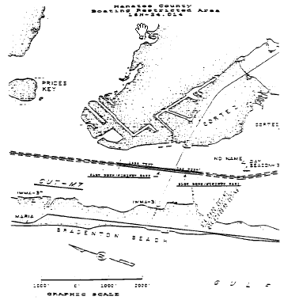
Rulemaking Authority 327.04, 327.46 FS. Law Implemented 327.46 FS. History–New 7-18-89, Formerly 16N-24.014, 62N-24.014.

68D-24.015 Apalachicola River Boating Restricted Area.
(1) For the purpose of regulating the speed and operation of vessel traffic on and adjacent to the Apalachicola River within Franklin County, the following Boating Restricted Area is established:
(a) Slow Down Minimum Wake Zone – All waters lying within the Apalachicola River, from shoreline to shoreline but not including Crooked Channel, from the John Gorrie Memorial Bridge to a line drawn perpendicular to the centerline of the river 1,500 yards generally north of the John Gorrie Memorial Bridge following the thread of the river.
(b) The City of Apalachicola is authorized to install and maintain Slow Down Minimum Wake regulatory markers within the boating restricted area and shall install and maintain “Resume Normal Safe Operation” markers at the northern and southern boundaries of the boating restricted area.
(2) The boating restricted area is depicted on the following drawing:

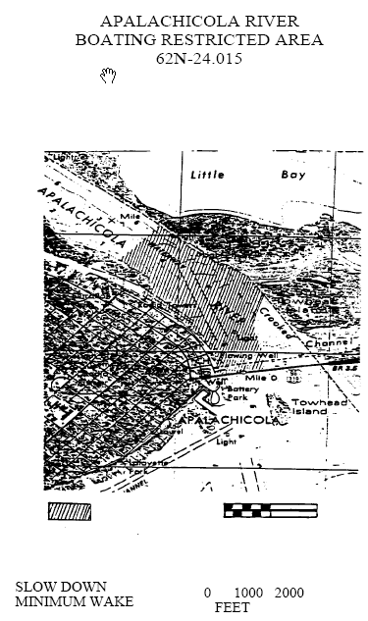
Rulemaking Authority 327.04, 327.46 FS. Law Implemented 327.46 FS. History–New 8-14-89, Formerly 16N-24.015, 62N-24.015.

68D-24.016 Duval County Boating Restricted Areas.
(1) For the purpose of regulating the speed and operation of vessel traffic on and adjacent to the Florida Intracoastal Waterway within Duval County, the following Boating Restricted Areas are established:
(a) Slow Down Minimum Wake Zones.
1. Sisters Creek – All waters in and adjacent to the Florida Intracoastal Waterway within Sisters Creek, from shoreline to shoreline, from a line drawn perpendicular to the center line of the waterway 650 feet north of the Heckscher Drive Bridge to a line drawn from headland to headland across the mouth of Sisters Creek at its confluence with Saint Johns River, as depicted in drawing A.
2. Atlantic Boulevard Bridge – All waters in and adjacent to the Florida Intracoastal Waterway, from shoreline to shoreline from a line drawn perpendicular to the center line of the waterway 1,200 feet north of the Atlantic Boulevard Bridge to a line drawn perpendicular to the center line of the waterway 900 feet south of said bridge, as depicted in drawing B.
3. Beach Boulevard Bridge – All waters in and adjacent to the Florida Intracoastal Waterway, from shoreline to shoreline, from a line drawn perpendicular to the center line of the waterway 1,350 feet north of the Beach Boulevard Bridge to a line drawn perpendicular to the center line of the waterway 900 feet south of said bridge, as depicted in drawing C.
4. Saint Johns River:
a. All waters of the Saint Johns River, from shoreline to shoreline, from the Florida East Coast Railroad Bridge adjacent to the Acosta Bridge to the Main Street Bridge, as depicted in drawing D.
b. All waters of the Saint Johns River, from shoreline to shoreline, from the Main Street Bridge to the Hart Bridge, as depicted in drawing D. The zone established in this sub-subparagraph shall be active and enforceable only during periods of unusually high vessel traffic density. The regulatory markers posted for vessels entering this zone shall read SLOW DOWN MINIMUM WAKE WHEN FLASHING and shall have amber or yellow lights on both sides of the circle geometric shape specified in subsection 62N-18.002(3), F.A.C. The Sheriff of Duval County shall cause the lights to alternately flash whenever the zone is active. For the purposes of this sub-subparagraph, “unusually high vessel traffic density” means vessel traffic associated with: events at Riverwalk or Metropolitan Park; regattas, races, marine parades, tournaments, or exhibitions conducted pursuant to the provisions of section 327.48, F.S.; and legal holidays as specified in Section 683.01, F.S. The Sheriff of Duval County shall notify the Division of Law Enforcement each time the zone is activated or deactivated.
(b) Duval County is authorized to install and maintain appropriate regulatory markers as directed by the Division of Law Enforcement within the boating restricted areas and shall install and maintain “Resume Normal Safe Operation” markers at the boundaries of the boating restricted areas.
(2) The boating restricted areas are depicted on the following drawings:

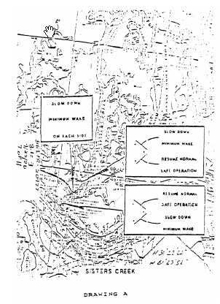

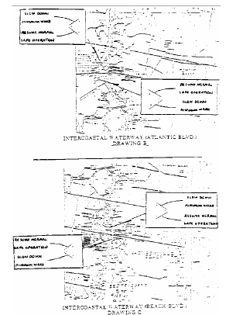

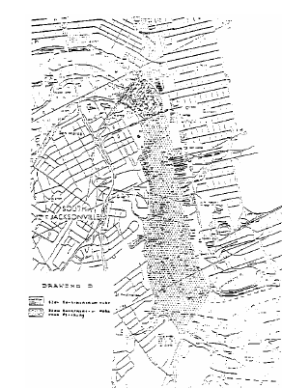
Rulemaking Authority 327.04, 327.46 FS. Law Implemented 327.46 FS. History–New 12-7-89, Formerly 16N-24.016, 62N-24.016.

68D-24.017 Palm Beach County Boating Restricted Areas.
(1) For the purpose of regulating speed and operation of vessel traffic on the Intracoastal Waterway within Palm Beach County, Florida, the following boating restricted areas are established:
(a) Jupiter Inlet – A Slow Speed Minimum Wake zone from shoreline to shoreline, in and adjacent to the Florida Intracoastal Waterway, bounded on the north by a line drawn perpendicular to the centerline of the Florida Intracoastal Waterway 300 feet north of the north end of the fender of the SR 707 (Gomez Rd.) Bridge; bounded on the northwest by a line drawn perpendicular to the centerline of the Loxahatchee River 300 feet northwest of the northwest end of the fender of the Florida East Coast Railroad bridge located adjacent to the SR 811 (Alternate A-1-A) Bridge; bounded on the south by a line drawn perpendicular to the centerline of the Florida Intracoastal Waterway 500 feet south of the south end of the fender of the SR 706 (Indiantown Rd.) Bridge; and bounded on the east by a line drawn due north across the Jupiter Inlet from the western tip of the jetty at DuBois Park to the southwest corner of Jupiter Island, and including all waters of and tributaries to Sawfish Bay and the Jupiter River, as depicted in drawing A.
(b) Donald Ross Bridge – A Slow Speed Minimum Wake zone from shoreline to shoreline, in and adjacent to the Florida Intracoastal Waterway, bounded on the north by a line drawn perpendicular to the centerline of the Florida Intracoastal Waterway 300 feet north of the north end of the fender of the Donald Ross Bridge, and bounded on the south by a line drawn from headland to headland across the mouth of Lake Worth Creek at its southern terminus at Lake Worth, as depicted in drawing B.
(c) Peanut Island, Blue Heron Bridge and Lake Worth Inlet – A Slow Speed Minimum Wake zone from shoreline to shoreline, in and adjacent to the Florida Intracoastal Waterway including all waters of Lake Worth, bounded on the north by a line drawn perpendicular to the centerline of the Florida Intracoastal Waterway at the north shoreline of Phil Foster Island, from the mainland at Riviera Beach to Singer Island; bounded on the southeast by a line drawn from the southwest corner of Singer Island to the nearest channel marker marking the northern edge of the Lake Worth Inlet Channel (flashing marker “8”) and running along the line of channel markers marking the northern edge of the Lake Worth Inlet Channel and the Port of Palm Beach Turning Basin to the westernmost channel marker marking the northern edge of the Port of Palm Beach Turning Basin (flashing marker “12”); and bounded on the south by a line drawn perpendicular to the centerline of the Florida Intracoastal Waterway, from the westernmost channel marker marking the northern edge of the Port of Palm Beach Turning Basin to the mainland at the southeast corner of the Port of Palm Beach Slip 1, Berth 6, Bay 49, as depicted in drawing C.
(d) Flagler Memorial Bridge – A Slow Speed Minimum Wake zone from shoreline to shoreline, in and adjacent to the Florida Intracoastal Waterway, bounded on the north by a line drawn perpendicular to the centerline of the Florida Intracoastal Waterway 1,100 feet north of the north end of the fender of the Flagler Memorial Bridge, and bounded on the south by a line drawn perpendicular to the centerline of the Florida Intracoastal Waterway 1,500 feet south of the south bridge fender, as depicted in drawing D.
(e) SR 704 (Royal Park) Bridge – A Slow Speed Minimum Wake zone from shoreline to shoreline, in and adjacent to the Florida Intracoastal Waterway, bounded on the north by a line drawn perpendicular to the centerline of the Florida Intracoastal Waterway 300 feet north of the north end of the fender of the SR 704 (Royal Park) Bridge and bounded on the south by a line drawn perpendicular to the centerline of the Florida Intracoastal Waterway 300 feet south of the southernmost dock of the Town of Palm Beach Public Docks (Peruvian Ave.), as depicted in drawing E.
(f) SR 80 (Southern Blvd.) Bridge – A Slow Speed Minimum Wake zone, in and adjacent to the Florida Intracoastal Waterway, bounded on the north by a line drawn perpendicular to the centerline of the Florida Intracoastal Waterway 300 feet north of the north end of the bridge fender of the SR 80 (Southern Blvd.) Bridge, and bounded on the east by a line drawn parallel to and 500 feet east of the centerline of the Florida Intracoastal Waterway and the western shoreline of Bingham Island and bounded on the south by a line drawn perpendicular to the centerline of the Florida Intracoastal Waterway 300 feet south of the south end of the bridge fender, as depicted in drawing F.
(g) SR 802 (Lake Worth) Bridge – A Slow Speed Minimum Wake zone from shoreline to shoreline, in and adjacent to the Florida Intracoastal Waterway, bounded on the north by a line drawn perpendicular to the centerline of the Florida Intracoastal Waterway 300 feet north of the north end of the fender of the SR 802 (Lake Worth) Bridge, and bounded on the south by a line drawn perpendicular to the centerline of the Florida Intracoastal Waterway 300 feet south of the centerline of the Bryant Park boat ramp, as depicted in drawing G.
(h) SR 812 (Lantana Ave.) Bridge – A Slow Speed Minimum Wake zone from shoreline to shoreline, in and adjacent to the Florida Intracoastal Waterway, bounded on the north by a line drawn perpendicular to the centerline of the Florida Intracoastal Waterway at the north end of Hypoluxo Island and bounded on the south by a line drawn perpendicular to the centerline of the Florida Intracoastal Waterway 300 feet south of the south end of the bridge fender, as depicted in drawing H.
(i) SR 804 (East Ocean Ave.) Bridge – An Idle Speed No Wake zone from shoreline to shoreline, in and adjacent to the Florida Intracoastal Waterway, bounded on the north by a line drawn perpendicular to the centerline of the Florida Intracoastal Waterway 575 feet north of the north end of the fender of the SR 804 (East Ocean Ave.) Bridge, and bounded on the south by a line drawn perpendicular to the centerline of the Florida Intracoastal Waterway 300 feet south of the south end of the bridge fender, as depicted in drawing I.
(j) 15th Ave. (Woolbright Rd.) Bridge – A Slow Speed Minimum Wake zone from shoreline to shoreline, in and adjacent to the Florida Intracoastal Waterway, bounded on the north by a line drawn perpendicular to the centerline of the Florida Intracoastal Waterway 300 feet north of the north end of the fender of the 15th Avenue (Woolbright Rd.) Bridge, and bounded on the south by a line drawn perpendicular to the centerline of the Florida Intracoastal Waterway 300 feet south of the south end of the bridge fender, as depicted in drawing J.
(k) N.E. 8th Street (George Bush Blvd.) Bridge – An Idle Speed No Wake zone from shoreline to shoreline, in and adjacent to the Florida Intracoastal Waterway, bounded on the north by a line drawn perpendicular to the centerline of the Florida Intracoastal Waterway 300 feet north of the north end of the fender of the N.E. 8th Street (George Bush Blvd.) Bridge, and bounded on the south by a line drawn perpendicular to the centerline of the Florida Intracoastal Waterway 600 feet south of the south end of the bridge fender, as depicted in drawing K.
(l) SR 806 (East Atlantic Ave.) Bridge – A Slow Speed Minimum Wake zone from shoreline to shoreline, in and adjacent to the Florida Intracoastal Waterway, bounded on the north by a line drawn perpendicular to the centerline of the Florida Intracoastal Waterway 675 feet north of the north end of the fender of the SR 806 (East Atlantic Ave.) Bridge, and bounded on the south by a line drawn perpendicular to the centerline of the Florida Intracoastal Waterway, 500 feet north of the centerline of the Knowles Park boat ramp, as depicted in drawing L.
(m) Knowles Park Boat Ramp – An Idle Speed No Wake zone from shoreline to shoreline, in and adjacent to the Florida Intracoastal Waterway, bounded on the north by a line drawn perpendicular to the centerline of the Florida Intracoastal Waterway, 500 feet north of the centerline of the Knowles Park boat ramp, and bounded on the south by a line drawn perpendicular to the centerline of the Florida Intracoastal Waterway 300 feet north of the north end of the fender of the 12th Street (Linton Blvd.) Bridge, as depicted in drawing M.
(n) 12th Street (Linton Blvd.) Bridge – A Slow Speed Minimum Wake zone from shoreline to shoreline, in and adjacent to the Florida Intracoastal Waterway, bounded on the north by a line drawn perpendicular to the centerline of the Florida Intracoastal Waterway 300 feet north of the north end of fender of the 12th Street (Linton Blvd.) Bridge, and bounded on the south by a line drawn perpendicular to the centerline of the Florida Intracoastal Waterway 300 feet south of the south end of the bridge fender, as depicted in drawing N.
(o) SR 800 (Spanish River Blvd.) Bridge – A Slow Speed Minimum Wake zone from shoreline to shoreline, in and adjacent to the Florida Intracoastal Waterway, bounded on the north by a line drawn perpendicular to the centerline of the Florida Intracoastal Waterway 300 feet north of the north end of the fender of the SR 800 (Spanish River Blvd.) Bridge, and bounded on the south by a line drawn perpendicular to the centerline of the Florida Intracoastal Waterway 300 feet south of the south end of the bridge fender, as depicted in drawing O.
(p) SR 798 (Palmetto Park Rd.) Bridge and Silver Palm Park Boat Ramp Zones.
1. Lake Wyman Vicinity to SR 798 (Palmetto Park Rd.) Bridge – A Slow Speed Minimum Wake zone from shoreline to shoreline, in and adjacent to the Florida Intracoastal Waterway, in the vicinity of marker 63 (which is in the southern portion of Lake Wyman), and bounded on the south by a line drawn perpendicular to the centerline of the Florida Intracoastal Waterway 300 feet north of the northern end of the fender system of the SR 798 (Palmetto Park Rd.) Bridge, as depicted in drawing P.
2. Silver Palm Park Boat Ramp and SR 798 Bridge – An Idle Speed No Wake zone from shoreline to shoreline, in and adjacent to the Florida Intracoastal Waterway, bounded on the north by a line drawn perpendicular to the centerline of the Florida Intracoastal Waterway 300 feet north of the north end of the fender of the SR 798 (Palmetto Park Rd.) Bridge, and bounded on the south by a line drawn perpendicular to the centerline of the Florida Intracoastal Waterway 500 feet south of the centerline of the Silver Palm Park boat ramp, as depicted in drawing P.
(q) A-1-A (Ocean Ave). Bridge – A Slow Speed Minimum Wake zone from shoreline to shoreline, in the Boca Raton Inlet, bounded on the northwest by a line drawn perpendicular to the centerline of the channel 300 feet northwest of the northwest end of the fender of the A-1-A (Ocean Ave.) Bridge, and bounded on the south by a line drawn perpendicular to the centerline of the channel 300 feet south of the south end of the bridge fender, as depicted in drawing Q.
(r) Camino Real Zones.
1. Camino Real Bridge – A Slow Speed Minimum Wake zone from shoreline to shoreline, in and adjacent to the Florida Intracoastal Waterway, bounded on the north by a line drawn perpendicular to the centerline of the Florida Intracoastal Waterway 300 feet north of the north end of the fender of the Camino Real Bridge, and bounded on the south by a line drawn perpendicular to the centerline of the Florida Intracoastal Waterway 300 feet south of the south end of the bridge fender, as depicted in drawing R.
2. Camino Real Bridge to Palm Beach-Broward County Line – A Slow Speed Minimum Wake zone to be in effect from 10:00 a.m. to 6:00 p.m. on Saturdays, Sundays, and Holidays, in and adjacent to the Florida Intracoastal Waterway, bounded on the north by a line drawn perpendicular to the centerline of the Florida Intracoastal Waterway 300 feet south of the south end of the fender of the Camino Real Bridge, and bounded on the south by the Palm Beach-Broward County Line, as depicted in drawing R.
(2) The boating restricted areas described in Rule 68D-24.017, F.A.C., are depicted on the following drawings:

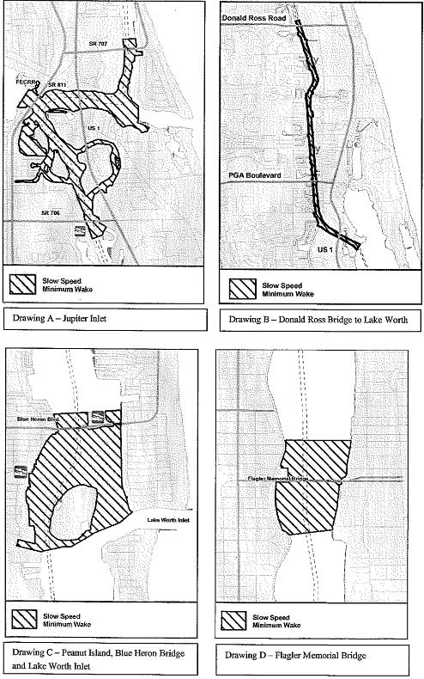
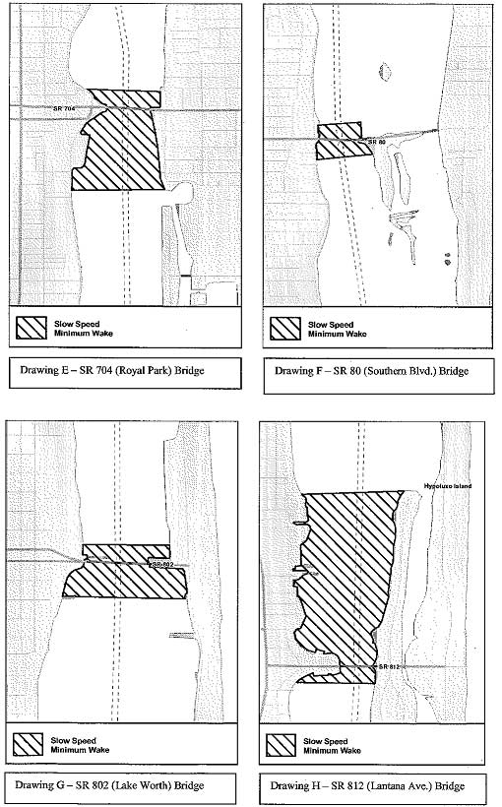
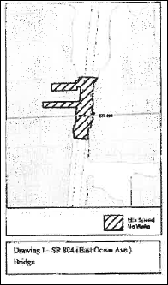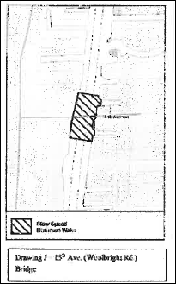

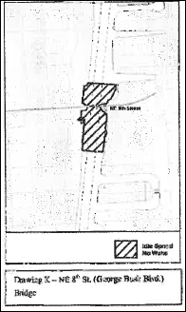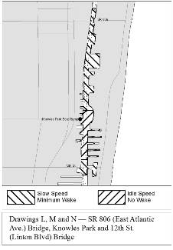
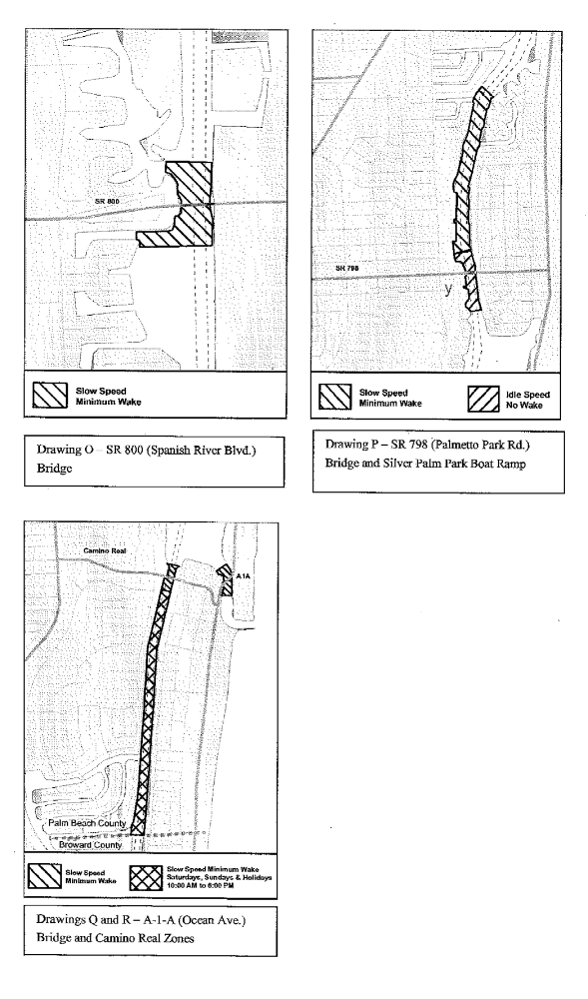
Rulemaking Authority 327.04, 327.46 FS. Law Implemented 327.46 FS. History–New 2-28-91, Amended 8-6-92, 6-14-93, Formerly 16N-24.017, Amended 10-27-97, 3-3-99, Formerly 62N-24.017, Amended 5-20-10, 4-6-15.

68D-24.018 St. Johns River Boating Restricted Areas.
(1) For the purpose of regulating the speed and operation of vessel traffic on the St. Johns River in Lake, Seminole and Volusia Counties, Florida the following boating restricted areas are established. Coordinates used in the description of zone boundaries are referenced to the North American Datum of 1983 (NAD83). The boating restricted areas exclude all associated tributaries, creeks, canals, backwaters, channels, boat basins and other waterways unless otherwise designated or specifically described for inclusion:
(a) Year-Round Boating Restricted Areas.
1. Lake George Fender System: A Slow Speed Minimum Wake zone within the fender system and associated channel at the south end of Lake George, bounded on the north by a line drawn perpendicular to the centerline of the channel at the north end of the fender system and bounded on the southeast by a line drawn perpendicular to the centerline of the channel 1,500 feet south and southeast of the south end of the fender system, as depicted in Drawing A.
2. South Moon Canal:
A Slow Speed Minimum Wake zone from shoreline to shoreline in the St. Johns River, bounded on the northwest by a line drawn perpendicular to the centerline of the St. Johns River 50 feet north of the confluence of South Moon Canal and the St. Johns River and bounded on the south by a line drawn perpendicular to the centerline of the St. Johns River 850 feet south of said confluence, as depicted in Drawing B.
3. Jungle Den Canal:
A Slow Speed Minimum Wake zone from shoreline to shoreline in the St. Johns River, bounded on the northwest by a line drawn perpendicular to the centerline of the St. Johns River 50 feet northwest of the confluence of Jungle Den Canal and the St. Johns River and bounded on the south by a line drawn perpendicular to the centerline of the St. Johns River 1,250 feet south of said confluence, as depicted in Drawing C.
4. SR 40 (Astor) Bridge: A Slow Speed Minimum Wake zone from shoreline to shoreline in the St. Johns River, bounded on the north by a line drawn perpendicular to the centerline of the St. Johns River 875 feet north of the north end of the fender of the SR 40 (Astor) Bridge and bounded on the south by a line drawn perpendicular to the centerline of the St. Johns River 2,125 feet south of the south end of the fender of said bridge, as depicted in Drawing D.
5. SR 44 (Whitehair) Bridge: A Slow Speed Minimum Wake zone from shoreline to shoreline in the St. Johns River, bounded on the north by a line drawn perpendicular to the centerline of the St. Johns River 2,375 feet northwest of the northwest end of the fender of the SR 44 (Whitehair) Bridge and bounded on the south by a line drawn perpendicular to the centerline of the St. Johns River 1,025 feet south of the south end of the fender of said bridge, as depicted in Drawing E.
6. Hontoon Island State Park: A Slow Speed Minimum Wake zone from shoreline to shoreline in the St. Johns River, bounded on the north by a line drawn perpendicular to the centerline of the St. Johns River 4,025 feet northeast of the confluence of the Hontoon Dead River and the St. Johns River and bounded on the southeast by a line drawn perpendicular to the centerline of the St. Johns River 1,950 feet southeast of said confluence, as depicted in Drawing F.
7. Highbanks Boat Ramp:
A Slow Speed Minimum Wake zone from shoreline to shoreline in the St. Johns River, bounded on the north by a line drawn perpendicular to the centerline of the St. Johns River 450 feet north of the centerline of Highbanks Boat Ramp and bounded on the south by a line drawn perpendicular to the centerline of the St. Johns River 350 feet south of the centerline of said boat ramp, as depicted in Drawing G.
8. Lake Monroe: A Slow Speed Minimum Wake zone from shoreline to shoreline in the St. Johns River, bounded on the west by a line drawn perpendicular to the centerline of the St. Johns River 1,075 feet west of the west end of the CSX Railroad Bridge fender and bounded on the southeast by a line drawn perpendicular to the centerline of the St. Johns River 125 feet east of the east end of the I-4 Bridge fender, to include Lake Monroe Park Basin, as depicted in Drawing H.
9. Lemon Bluff:
A Slow Speed Minimum Wake zone from shoreline to shoreline in the St. Johns River, bounded on the northeast by a line drawn perpendicular to the centerline of the St. Johns River at the northeast tip of the unnamed island (located at approximate latitude 28º 48.394' North, approximate longitude 81º 7.799' West) southeast of Lemon Bluff Boat Ramp, and bounded on the south by a line drawn perpendicular to the centerline of the St. Johns River 250 feet northwest of the southern tip of said unnamed island (located at approximate latitude 28º 48.282' North, approximate longitude 81º 7.806' West), as depicted in Drawing I.
(b) Flood Zones.
1. Astor: During flooding, an Idle Speed No Wake zone from shoreline to shoreline in the St. Johns River, bounded on the northwest by a line drawn perpendicular to the centerline of the St. Johns River 50 feet north of the confluence of South Moon Canal and the St. Johns River and bounded on the south by a line drawn perpendicular to the centerline of the St. Johns River 2,125 feet south of the south end of the fender of the SR 40 (Astor) Bridge, as depicted in Drawing J, when the St. Johns River water level is 2.3 feet or higher as indicated by the St. Johns River Water Management District gauge at the SR 40 (Astor) Bridge.
2. Highbanks Boat Ramp: During flooding, an Idle Speed No Wake zone from shoreline to shoreline in the St. Johns River, bounded on the north by a line drawn perpendicular to the centerline of the St. Johns River 1,700 feet north of the centerline of Highbanks Road Boat Ramp and bounded on the southwest by a line perpendicular to the centerline of the St. Johns River 1,800 feet south of the centerline of the Highbanks Boat Ramp, as depicted in Drawing K, when the St. Johns River water level is 5.6 feet or higher as indicated by the St. Johns River Water Management District gauge at the Sanford Station.
3. Mullet Lake Park: During flooding, an Idle Speed No Wake zone from shoreline to shoreline in the St. Johns River, bounded on the east by a line drawn perpendicular to the centerline of the St. Johns River at Mullet Lake Park Boat Ramp and bounded on the west by a line drawn perpendicular to the centerline of the St. Johns River 3,000 feet west of Mullet Lake Park Boat Ramp, as depicted in Drawing L, when the St. Johns River water level is 8 feet or higher as indicated by the National Weather Service gauge at the Lake Harney Station.
4. Lemon Bluff: During flooding, an Idle Speed No Wake zone from shoreline to shoreline in the St. Johns River, bounded on the northeast by a line drawn perpendicular to the centerline of the St. Johns River at the northeast tip of the unnamed island (located at approximate latitude 28º 48.394' North, approximate longitude 81º 7.799' West) southeast of Lemon Bluff Boat Ramp and bounded on the southwest by a line drawn perpendicular to the centerline of the St. Johns River 3,675 feet southwest of the southern tip of said unnamed island (located at approximate latitude 28º 48.282' North, approximate longitude 81º 7.806' West), as depicted in Drawing M, when the St. Johns River water level is 8 feet or higher as indicated by the National Weather Service gauge at the Lake Harney Station.
5. Lake Monroe: During flooding, an Idle Speed No Wake zone from shoreline to shoreline in the St. Johns River, bounded on the southeast by the northwesterly side of the I-4 bridge in Sanford, Florida, and bounded on the northwest by a line drawn perpendicular to the centerline of the St. Johns River at approximate latitude 28° 50.61660ꞌ North, and approximate longitude 81° 20.23200ꞌ West, including all canals associated with St. Johns River Estates, Boat Tree Marina, the intake and discharge canals at the Sanford Power Plant, and the water basin on the north side of the River between US Highway 17/92 and I-4, as depicted in Drawing N, when the St. Johns River water level is 5.5 feet or higher as indicated by the National Weather Service gauge at the Lake Monroe Station.
(c) Lake, Seminole and Volusia counties are authorized to install and maintain appropriate regulatory markers demarcating the flood zones as directed by the Division of Law Enforcement within the boating restricted areas, or portions thereof, located within the respective counties. These counties may enter into agreements with public or private organizations or individuals to effect this purpose. Lake, Seminole and Volusia counties are authorized to make public service announcements to notify the public of the changes in speed zones before, during and after flooding.
(2) The boating restricted areas described in Rule 68D-24.018, F.A.C., are depicted on the following drawings:
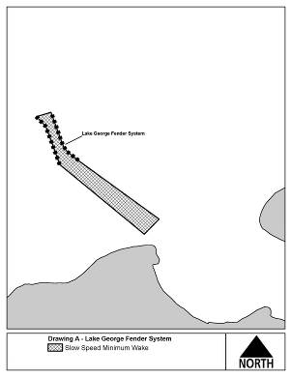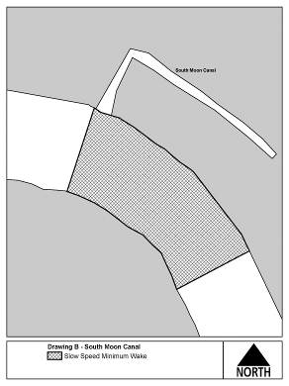

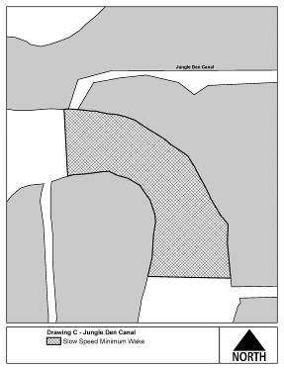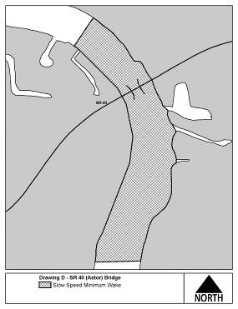

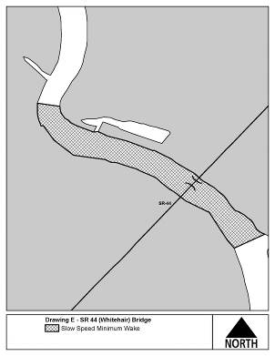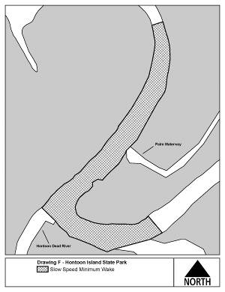

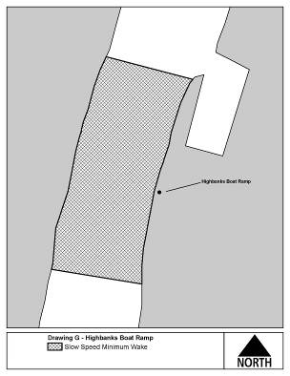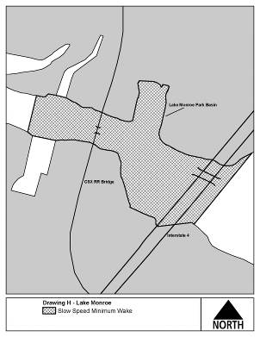

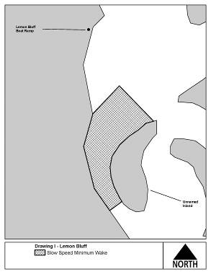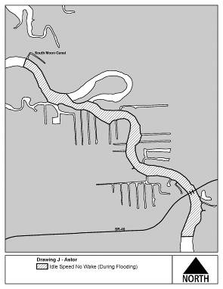

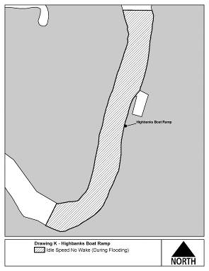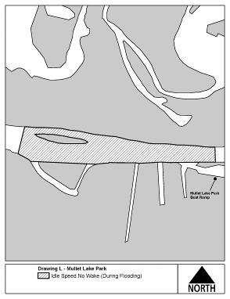

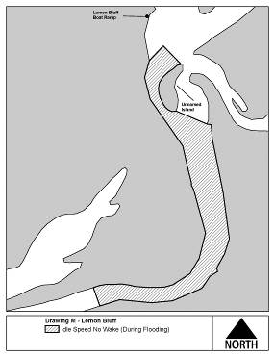

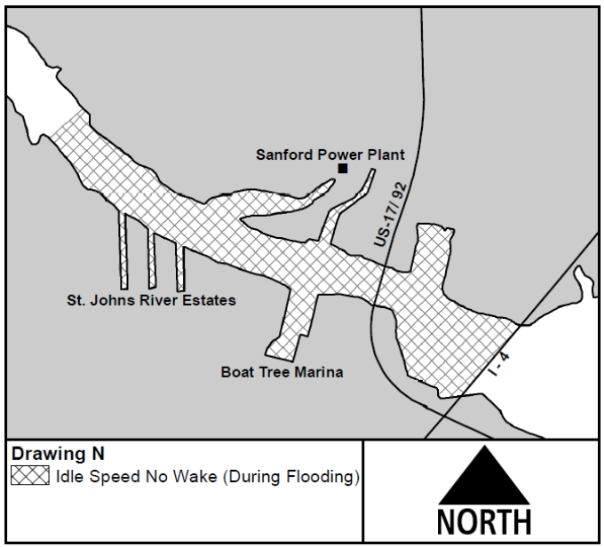
Rulemaking Authority 327.04, 327.46 FS. Law Implemented 327.33(3), 327.46 FS. History–New 6-3-92, Formerly 16N-24.018, Amended 10-3-95, 11-21-96, 2-4-98, Formerly 62N-24.018, Amended 4-22-13, 4-23-14, 2-10-20, 4-20-20, 7-6-20.

68D-24.019 Nassau County Boating Restricted Area.
(1) For the purpose of regulating the speed and operation of vessel traffic on and adjacent to the Intracoastal Waterway within Nassau County, Florida, the following Boating Restricted Area is established:
(a) Fernandina Beach – An Idle Speed No Wake Zone zone from shoreline to shoreline in the Amelia River, from a line drawn perpendicular to the centerline of the Amelia River at the extended centerline of Dade Street to a line drawn perpendicular to the centerline of the Amelia River 400 feet south of the extended centerline of Cedar Street, and bounded on the west by a line drawn across the mouth of Bells River, as depicted in drawing A.
(b) Nassau County is authorized to install and maintain appropriate regulatory markers as directed by the Division of Law Enforcement within such boating restricted area.
(2) The boating restricted area described in Rule 68D-24.019, F.A.C., is depicted on the following drawing:

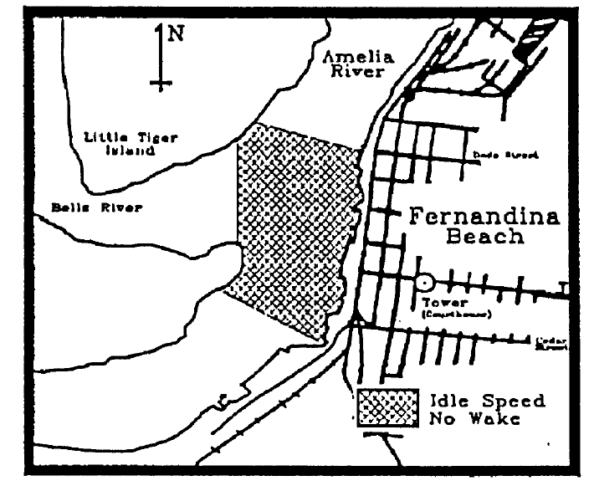
Rulemaking Authority 327.04, 327.46 FS. Law Implemented 327.46 FS. History–New 4-1-93, Formerly 16N-24.019, 62N-24.019.
68D-24.020 Suwannee and Santa Fe River Boating Restricted Areas.
(1) For the purpose of regulating the speed and operation of vessel traffic during flood events, the Suwannee and Santa Fe River Boating Restricted Areas are established, which shall include all associated and navigable tributaries, creeks, coves, bends, and backwaters unless otherwise designated or excluded.
Suwannee River Idle Speed No Wake Zones‒
(a) Zone 1: All waters in and adjacent to the river from the centerline of the U.S. 90 Bridge at Ellaville south to the centerline of the S.R. 51 Bridge at Luraville, in effect and enforceable when the river is 47' or higher (NGVD 29) or 46.25' or higher (NAVD 88) as indicated by the Ellaville gauge (USGS 02319500), as depicted in Drawing A.
(b) Zone 2: All waters in and adjacent to the river from the centerline of the S.R. 51 Bridge at Luraville to a line drawn perpendicular to the centerline of the river at Little River Spring, in effect and enforceable when the river is 26' or higher (NGVD 29) or 25.25' or higher (NAVD 88) as indicated by the Branford gauge (USGS 02320500), as depicted in Drawing B.
(c) Zone 3: All waters in and adjacent to the river from a line drawn perpendicular to the centerline of the river at Little River Spring to the centerline of the C.R. 340 Bridge at Rock Bluff, in effect and enforceable when the river is 24' or higher (NGVD 29) or 23.25' or higher (NAVD 88) as indicated by the Branford gauge (USGS 02320500), as depicted in Drawing C.
(d) Zone 4: All waters in and adjacent to the river from the centerline of the C.R. 340 Bridge at Rock Bluff to a line drawn perpendicular to the centerline of the river approximately 300' southwest of the New Clay Landing Boat Ramp, from a line drawn perpendicular to the centerline of the river approximately 6,000' north of the Camp Azalea Boat Ramp to a line drawn perpendicular to the centerline of the river approximately 1,300' south of the Yellow Jacket Landing, and from a line drawn perpendicular to the centerline of the river approximately 2,000' northeast of the Fowler’s Bluff Boat Ramp to a line drawn perpendicular to the centerline of the river approximately one mile southwest of the Fowler’s Bluff Boat Ramp, in effect and enforceable when the river is 9' or higher (NGVD 29) or 8.35' or higher (NAVD 88) as indicated by the Wilcox gauge (USGS 02323500), as depicted in Drawing D.
Santa Fe River Idle Speed No Wake Zones –
(e) Zone 5: All waters in and adjacent to the river from the River Rise in O’Leno State Park downstream to the centerline of the US 27 Bridge, in effect and enforceable when the river is 35' or higher (NGVD 29) or 34.20' or higher (NAVD 88) as indicated by the High Springs gauge (USGS 02321975), as depicted in Drawing E.
(f) Zone 6: All waters from the centerline of the US 27 Bridge downstream to a line drawn perpendicular to the centerline of the river, shoreline to shoreline, one-half mile upstream from the S.R. 47 Bridge, in effect and enforceable when the river is 24' or higher (NGVD 29) or 23.25' or higher (NAVD 88) as indicated by the Fort White gauge (USGS 02322500), as depicted in Drawing F.
(g) Zone 7: All waters in and adjacent to the river from a line drawn perpendicular to the centerline of the river, shoreline to shoreline, one-half mile upstream from the S.R. 47 Bridge, downstream to a line drawn perpendicular to the centerline of the river, shoreline to shoreline, from the westernmost point of the unnamed island located at 29° 54.527' N, 82° 46.074' W, in effect and enforceable when the river is 19.5' or higher (NGVD 29) or 18.75' or higher (NAVD 88) as indicated by the Three Rivers Estates gauge (USGS 02322703), as depicted in Drawing G.
(h) Zone 8: All waters in and adjacent to the river from a line drawn perpendicular to the centerline of the river, shoreline to shoreline, from the westernmost point of the unnamed island located at 29° 54.527' N, 82° 46.074' W downstream to the confluence of the Suwannee and Santa Fe Rivers, to include the Ichetucknee River upstream to the US 27 Bridge, in effect and enforceable when the river is 17' or higher (NGVD 29) or 16.25' or higher (NAVD 88) as indicated by the Three Rivers Estates gauge (USGS 02322703), as depicted in Drawing H.
(2) When in Effect – The boating restricted areas established in subsection (1) shall be active and enforceable only when the water levels are as specified in each paragraph. For purposes of this rule, all referenced river levels are provided in both the North American Vertical Datum of 1988 (NAVD 88) and the National Geodetic Vertical Datum of 1929 (NGVD 29).
(3) The boating restricted areas described in Rule 68D-24.020, F.A.C., are depicted in the following drawings:

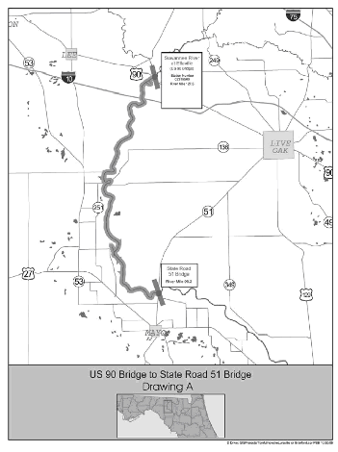
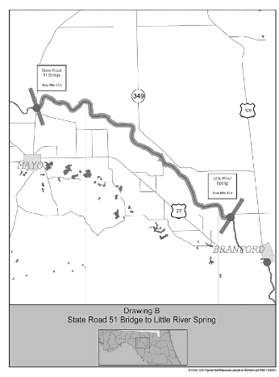

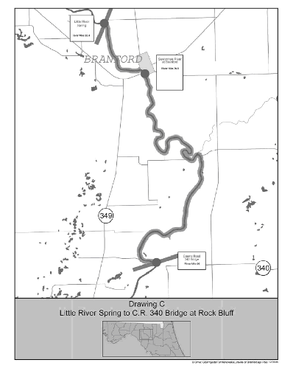

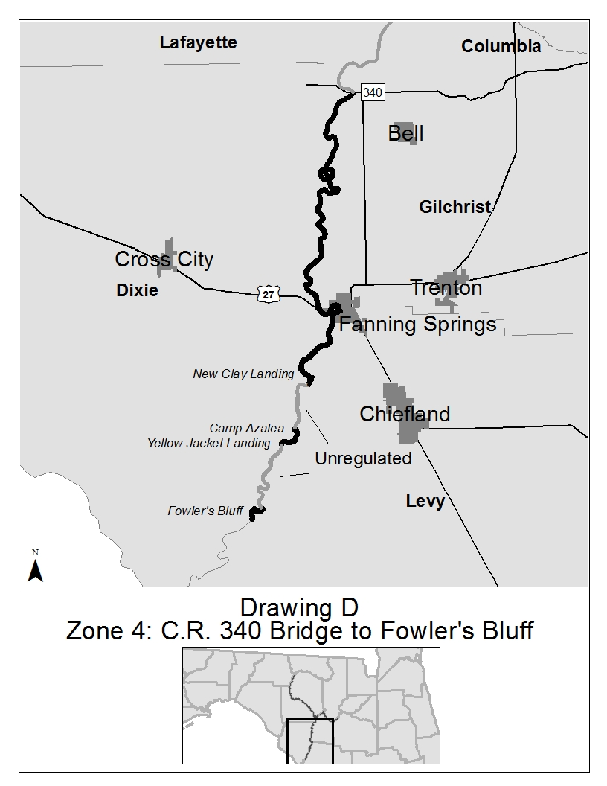

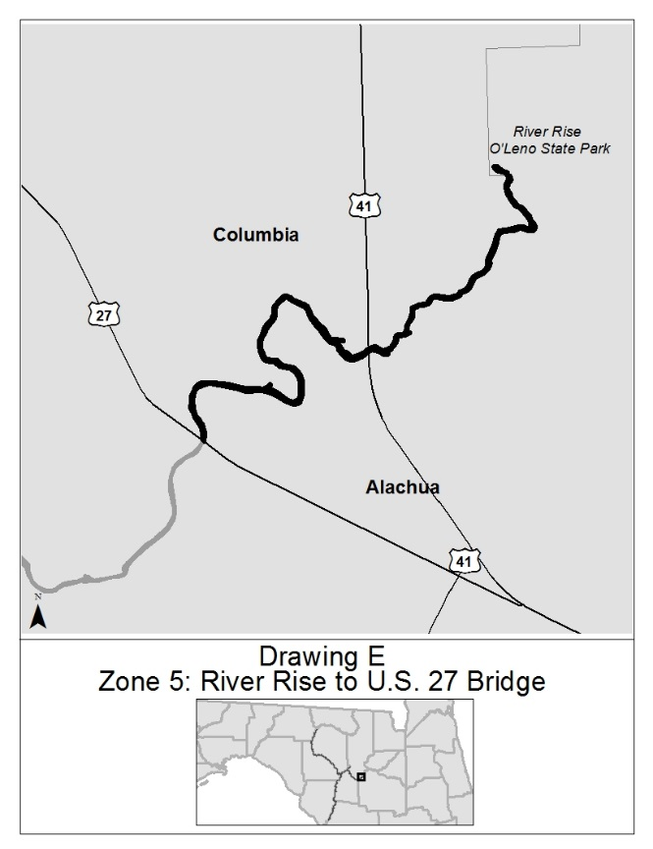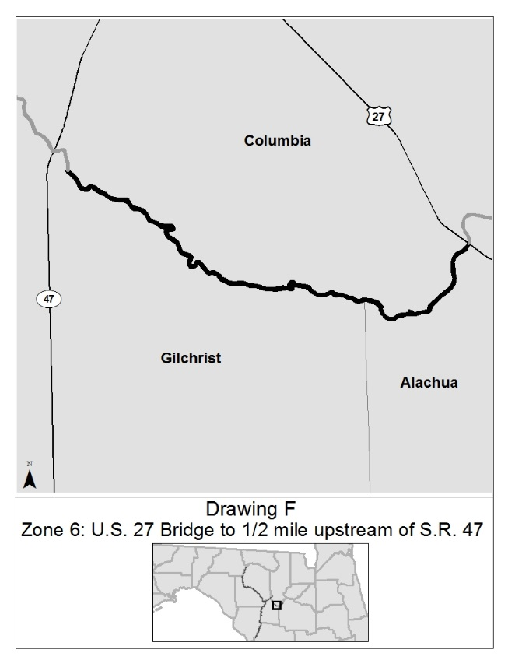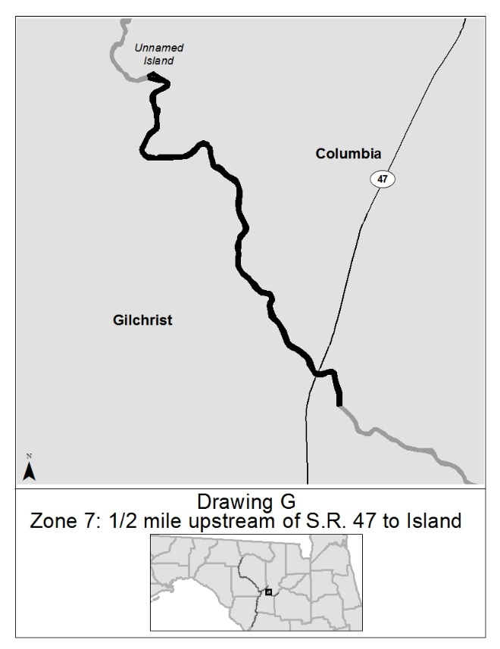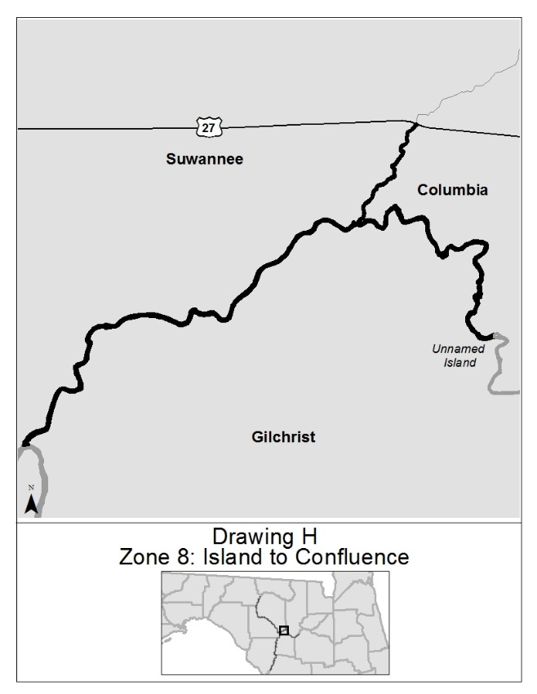

Rulemaking Authority 327.04, 327.46 FS. Law Implemented 327.46 FS. History–New 5-3-94, Formerly 16N-24.020, 62N-24.020, Amended 3-16-06, 11-4-15.

68D-24.021 Ochlockonee River Boating Restricted Areas.
For the purpose of providing for public safety, the following boating restricted areas are established:
(1) A no entry area starting from the northeast (Lake Talquin) side of the spillway of the Jackson Bluff Dam, bounded by a line running northeast approximately 75 feet to GPS position 30° 23ꞌ28.18ꞌꞌ N 84° 38ꞌ55.98ꞌꞌ W, then running southeast approximately 1000 feet to GPS position 30° 23ꞌ20.90ꞌꞌ N 84° 38ꞌ48.73ꞌꞌ W, then running northeasterly approximately 250 feet to GPS position 30° 23ꞌ21.97ꞌꞌ N 84° 38ꞌ46.18ꞌꞌ W, then running southeast approximately 330 feet to GPS position 30° 23ꞌ19.58ꞌꞌ N 84° 38ꞌ43.74ꞌꞌ W, then running southwest, following the natural contour of the shoreline, back to the southeastern base of the dam.
(2) A shoreline to shoreline no entry area from the southwest (Ochlockonee River) side of the Jackson Bluff Dam, bounded by a line running southwest approximately 300 feet, following the natural contour of the shoreline, to GPS position 30° 23ꞌ 15.25Nꞌꞌ/84° 38ꞌ49.31Wꞌꞌ then running northwest approximately 550 feet to GPS position 30° 23ꞌ 19.31Nꞌꞌ/84° 38ꞌ53.38Wꞌꞌ then running easterly approximately 400 feet, following the natural contour of the shoreline, to the northwest side of the dam.
(3) The boating restricted areas in subsections (1) and (2) are depicted in Drawing A.
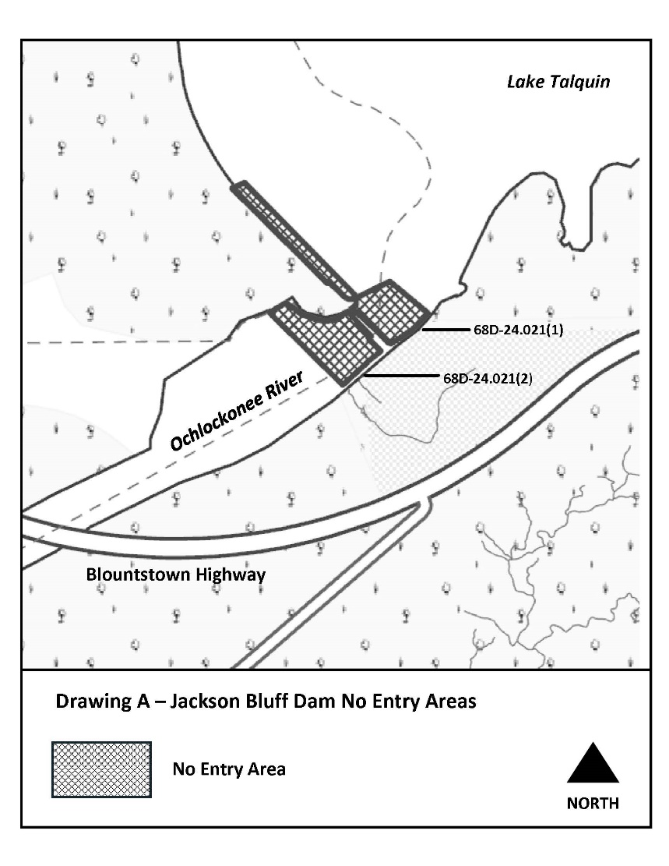
Rulemaking Authority 327.04, 327.46 FS. Law Implemented 327.46 FS. History–New 2-7-22.

68D-24.108 Charlotte County Boating Restricted Areas.
(1) For the purpose of regulating the speed and operation of vessel traffic on and adjacent to the Intracoastal Waterway in Charlotte County, Florida, the following Boating Restricted Areas are established:
(a)1. Cape Haze – A Slow Speed Minimum Wake boating restricted area from shoreline to shoreline, in and adjacent to the Intracoastal Waterway, from a line drawn east/west across the waterway 4,982 feet south east of platted Lot Number 6 within the Cape Haze Subdivision, Section 3, Township 42S, Range 20E, in Charlotte County, Florida, to a line drawn perpendicular to the centerline of the waterway 2,552 feet northwest of said Lot, as depicted in drawing A.
2. Gasparilla Island Bridge – A Slow Speed Minimum Wake boating restricted area within the right-of-way of the Florida Intracoastal Waterway from a line drawn perpendicular to the center line of the waterway 300 feet east-southeast of the abandoned CSX railroad bridge to a line drawn perpendicular to the center line of the waterway 300 feet west-northwest of the center fender system of the Gasparilla Island Causeway Bridge, as depicted in drawing B.
3. Tom Adams Bridge – A Slow Speed Minimum Wake boating restricted area on all waters in and adjacent to the Florida Intracoastal Waterway, from shoreline to shoreline, bounded on the northwest by a line drawn parallel to the center line of the Tom Adams Bridge 300 feet northwest of the centerline of said bridge, bounded on the southwest by the shoreline and by a line drawn perpendicular to the centerline of said bridge running from the southwest terminus of the bridge northwest until it intersects with the northwest boundary line (26° 56' 00"N, 82° 21" 19'W), bounded on the southeast by a line drawn parallel to the center line of said bridge 300 feet southeast of the centerline of said bridge, and bounded on the east and northeast by the shoreline, as depicted in drawing C.
(b) Charlotte County and the Gasparilla Island Bridge Authority are authorized to install and maintain appropriate regulatory markers as directed by the Division of Law Enforcement within such boating restricted area.
(2) The boating restricted areas described in Rule 68D-24.108, F.A.C., are depicted on the following drawings:

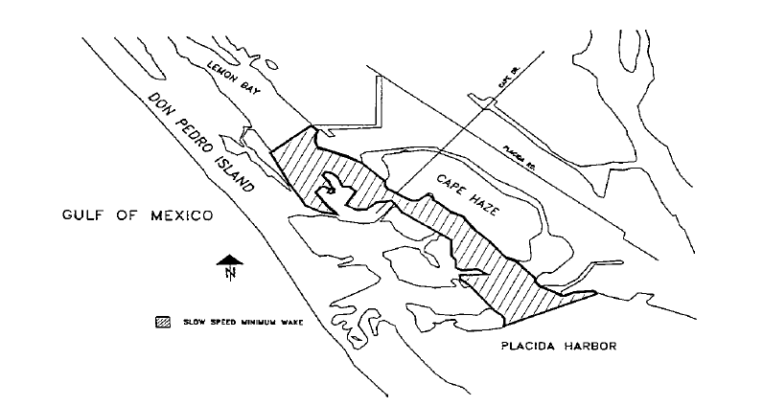

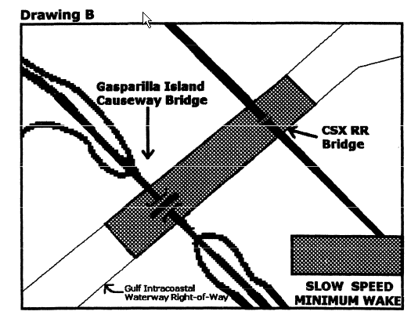
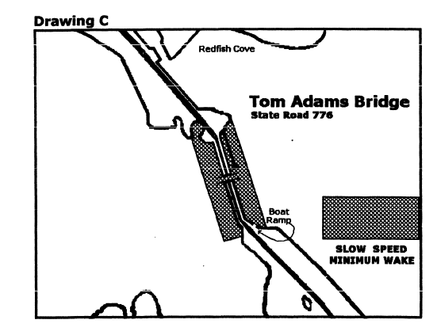
Rulemaking Authority 327.04, 327.46 FS. Law Implemented 327.46 FS. History–New 6-27-95, Formerly 62N-24.108, Amended 4-10-02.

68D-24.109 Withlacoochee River Boating Restricted Areas.
For the purpose of regulating the speed and operation of vessel traffic during flood conditions on the Withlacoochee River within Citrus, Hernando, Marion, and Sumter Counties, the following Boating Restricted Areas are established, which shall include all associated and navigable tributaries, creeks, coves bends, and backwaters unless otherwise designated or excluded:
(1) Idle Speed No Wake and River Closure Restrictions.
(a) Big Flat Rock to Camp Izzard Boat Ramp.
1. All waters of the Withlacoochee River, from the Big Flat Rock (29 00.920N, 82 24.658W) south to Camp Izzard Boat Ramp (29 0.036N, 82 22.030W). This Idle Speed No Wake restriction shall be active and enforceable only when the water level of the river is measured at the USGS Holder gauge (02313000) at 7.0' or higher and will remain in effect until the river recedes below 7.0'.
2. When the river is measured at the USGS Holder gauge (02313000) at 10.0' or higher, this area will be closed to all vessel traffic except emergency, law enforcement, firefighting, or rescue vessels owned or operated by a governmental entity, as depicted in Drawing A. As river levels recede below 10.0', the river will reopen to all vessel traffic at Idle Speed No Wake.
(b) Camp Izzard Boat Ramp to the Marion/Sumter County Line.
1. All waters of the Withlacoochee River, from Camp Izzard Boat Ramp (29 0.036N, 82 22.030W) south to the Marion/Sumter county line (28 57.622N, 82 18.703W). This Idle Speed No Wake restriction shall be active and enforceable only when the water level of the river is measured at the USGS Holder gauge (02313000) at 6.0' or higher and will remain in effect until the river recedes below 6.0'.
2. When the river is measured at the USGS Holder gauge (02313000) at 9.0' or higher, this area will be closed to all vessel traffic except emergency, law enforcement, firefighting, or rescue vessels owned or operated by a governmental entity, as depicted in Drawing B. As the river levels recede below 9.0', the river will reopen to all vessel traffic at Idle Speed No Wake.
(c) North Hooty Point to south of East Newman Drive.
1. All waters of the Withlacoochee River, from North Hooty Point (28 54.527N, 82 16.603W) to south of East Newman Drive (28 53.630N, 82 16.110W). This Idle Speed No Wake restriction shall be active and enforceable only when the water level of the river is measured at the USGS SR 44 gauge (02312722) at 38.0' or higher and will remain in effect until the river recedes to below 38.0'.
2. When the river is measured at the USGS SR 44 gauge (02312722) at 41.0' or higher, this area will be closed to all vessel traffic except emergency, law enforcement, firefighting, or rescue vessels owned or operated by a governmental entity, as depicted in Drawing C.
(d) East Squire Court to south of East Shawnee Trail.
1. All waters of the Withlacoochee River, from East Squire Court (28 52.384N, 82 14.484W), to south of East Shawnee Trail (28 50.117N, 82 12.280W). This Idle Speed No Wake restriction shall be active and enforceable only when the water level of the river is measured at the USGS SR 44 gauge (02312722) at 38.0' or higher and will remain in effect until the river recedes to below 38.0'.
2. When the river is measured at the USGS SR 44 gauge (02312722) at 41.0' or higher, this area will be closed to all vessel traffic except emergency, law enforcement, firefighting, or rescue vessels owned or operated by a governmental entity, as depicted in Drawing D. As river levels recede below 41.0', the river will reopen to all vessel traffic at Idle Speed No Wake.
(e) Citrus/Hernando County Line to south of the Riverside RV Park.
1. All waters of the Withlacoochee River, from the Citrus/Hernando County line (28 40.060N, 82 15.786W) south to south of the Riverside RV Park (28 38.342N, 82 15.606W). This Idle Speed No Wake restriction shall be active and enforceable only when the water level of the river is measured at the USGS Croom gauge (02312500) at 9.0' or higher and will remain in effect until the river recedes to below 9.0'.
2. When the river is measured at the USGS Croom gauge (02312500) at 11.0' or higher, this area will be closed to all vessel traffic except emergency, law enforcement, firefighting, or rescue vessels owned or operated by a governmental entity, as depicted in Drawing E. As river levels recede below 11.0', the river will reopen to all vessel traffic at Idle Speed No Wake.
(f) Iron Bridge Primitive Boat Launch to CSX Railway Trestle.
1. All waters of the Withlacoochee River, from the Iron Bridge Primitive Boat Launch (28 35.600N, 82 13.300W), south to the CSX Railway Trestle (28 34.323N, 82 9.240W). This Idle Speed No Wake restriction shall be active and enforceable only when the water level of the river is measured at the USGS Trilby gauge (02312000) at 12.0' or higher and will remain in effect until the river recedes to below 12.0'.
2. When the river is measured at the USGS Trilby gauge (02312000) at 15.0' or higher, this area will be closed to all vessel traffic except emergency, law enforcement, firefighting, or rescue vessels owned or operated by a governmental entity, as depicted in Drawing F. As river levels recede below 15.0', the river will reopen to all vessel traffic at Idle Speed No Wake.
(2) The boating restricted areas are depicted in the following drawings:
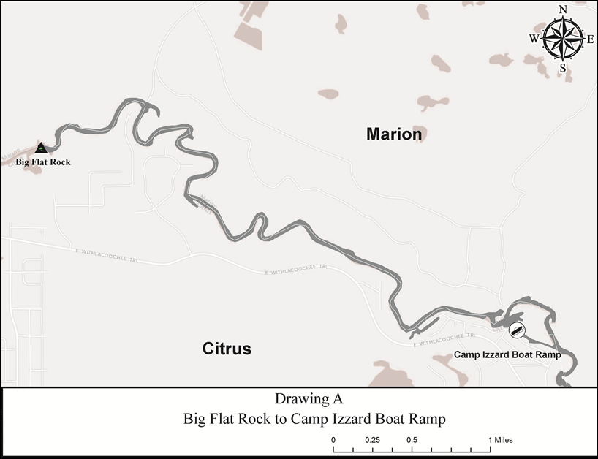

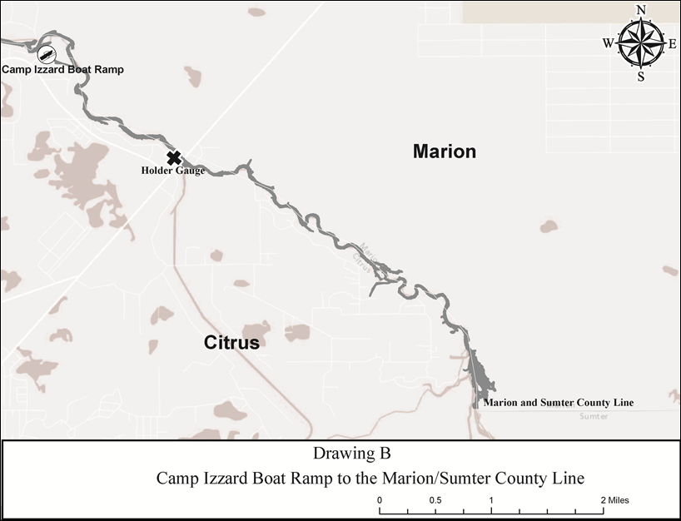

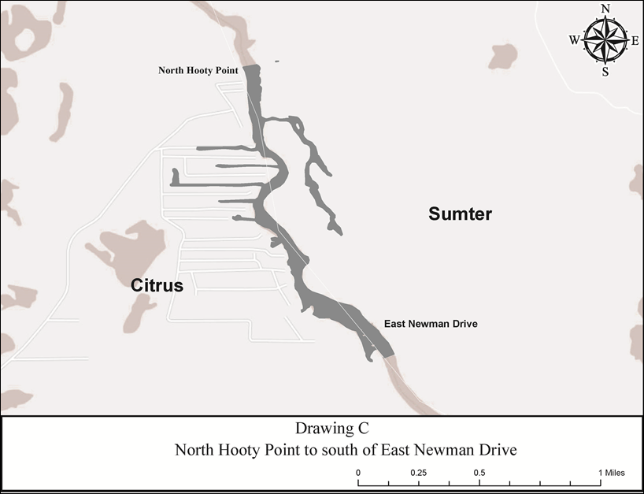

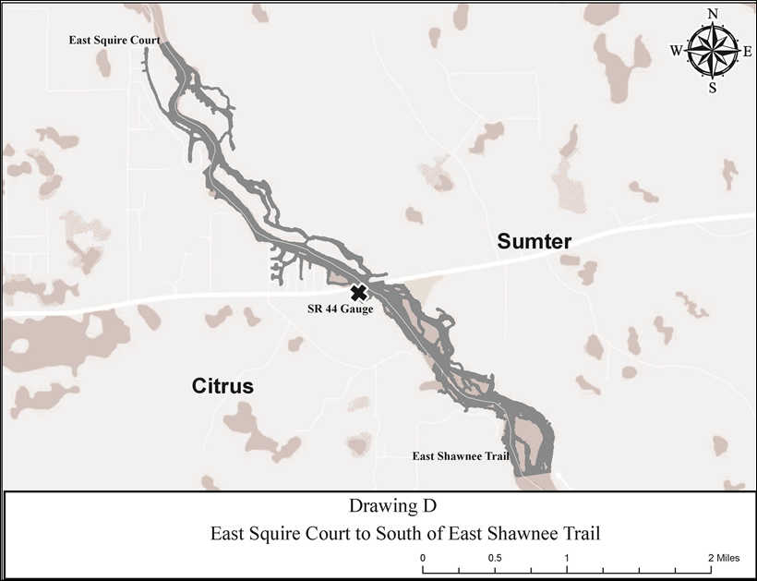
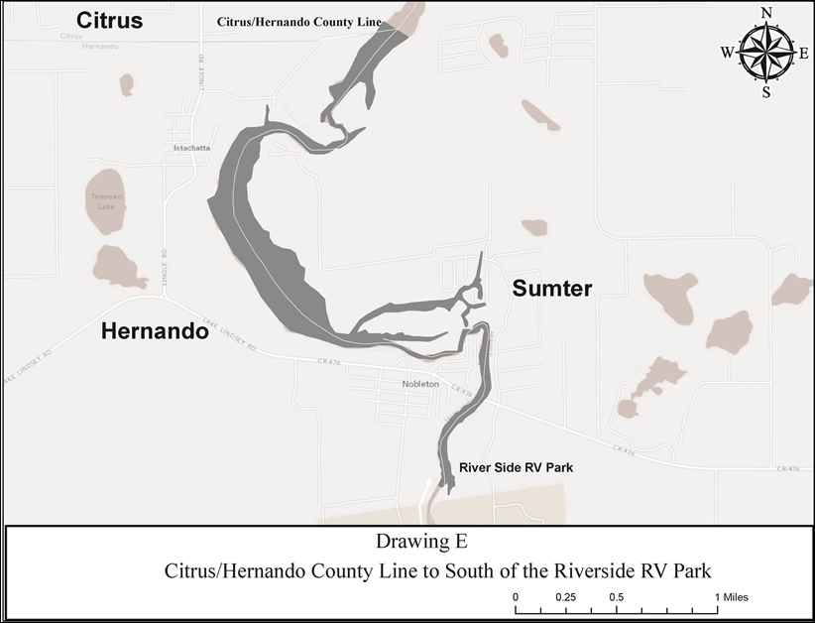

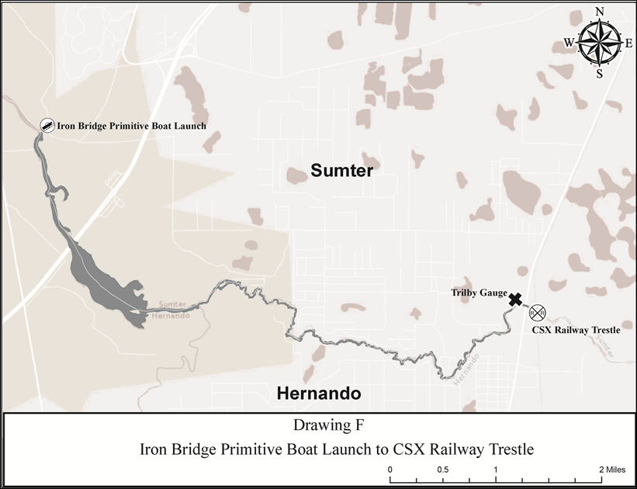

Rulemaking Authority 327.04, 327.40, 327.46 FS. Law Implemented 327.46 FS. History–New 2-10-97, Formerly 62N-24.109, Amended 11-5-07, 9-13-15.
68D-24.117 Escambia County Boating Restricted Area.
(1) For the purpose of regulating the speed and operation of vessel traffic on and adjacent to the Florida Intracoastal Waterway within Escambia County, the following Boating Restricted Area is established: Florida Intracoastal Waterway between a line drawn perpendicular to the centerline of State Road 292 (Perdido Key Bridge) 5,500' feet west (30° 18' 43''/87° 26' 33'') of the Perdido Key Bridge (SR 292) and a line drawn perpendicular to the centerline of State Road 292 (Perdido Key Bridge) 3,500 feet east (30° 18' 06''/87° 25' 00''), including the waters adjacent to the Florida Intracoastal Waterway north and south to the mean high water mark as depicted in drawing A.
(2) Escambia County is authorized to install and maintain appropriate regulatory markers as directed by the Division of Law Enforcement within the boating restricted area and shall install and maintain “Idle Speed No Wake” and “Resume Normal Safe Operation” markers at the east and western boundaries of the boating restricted area.
(3) The boating restricted area is depicted in the following drawing:

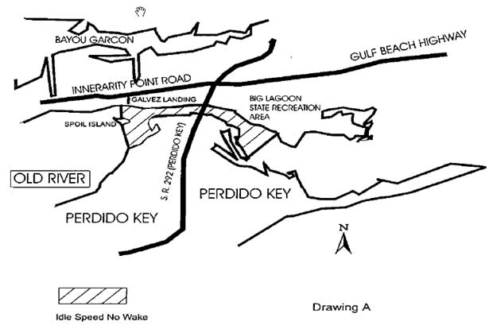

Rulemaking Authority 327.04, 327.46 FS. Law Implemented 327.46 FS. History–New 9-30-97, Formerly 62N-24.117.
68D-24.118 Flagler County Boating Restricted Area.
(1) For the purpose of regulating speed and operation of vessel traffic on the Florida Intracoastal Waterway in Flagler County the following boating restricted area is established:
(a) SR 100 Bridge – A Slow Speed Minimum Wake boating restricted area shoreline to shoreline, in and adjacent to the Florida Intracoastal Waterway, from 500' feet south of the centerline of the SR 100 Bridge to 1,200' feet north of the centerline of the SR 100 Bridge, as depicted in Drawing A.
(b) The City of Flagler Beach is authorized to install and maintain appropriate regulatory markers as directed by the Division of Law Enforcement within the boating restricted area. The City of Flagler Beach may enter into agreements with public or private organizations or individuals to effect this purpose.
(2) The boating restricted area is depicted on the following drawing:

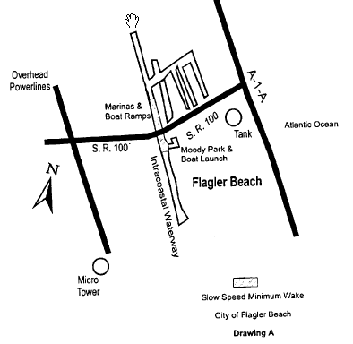
Rulemaking Authority 327.04, 327.46 FS. Law Implemented 327.33(3), 327.46 FS. History–New 3-15-98, Formerly 62N-24.118.
68D-24.136 Lee County Boating Restricted Area.
(1) For the purpose of regulating the speed and operation of vessel traffic on and adjacent to the Florida Intracoastal Waterway within Lee County, the following Boating Restricted Area is established: Caloosahatchee River at the Alva Bridge – All waters of the Florida Intracoastal Waterway, shoreline to shoreline, west from the centerline of the Alva Bridge (SR 78) to 300' feet west of the most western boundary of the fuel facility property (26 42' 50.9"/81 36' 42.1") and an informational marker will be located 300' feet west (26 42' 46.2''/81 36' 43.8") of the regulatory marker and east from the centerline of the Alva Bridge (SR 78) to 300' feet east (26 42' 49"/81 36' 17") of the most eastern boundary of the Alva Public Boat Ramp and an informational marker will be located 2450' feet east (26 42' 50"/81 35' 53.3") of the most eastern boundary of the Alva Boat Ramp, as depicted in drawing A.
(2) Lee County is authorized to install and maintain appropriate regulatory markers as directed by the Division of Law Enforcement within the boating restricted area and shall install and maintain Idle Speed No Wake and “Resume Normal Safe Operation” markers at the east and western boundaries of the boating restricted area.
(3) The boating restricted area is depicted in the following drawing:

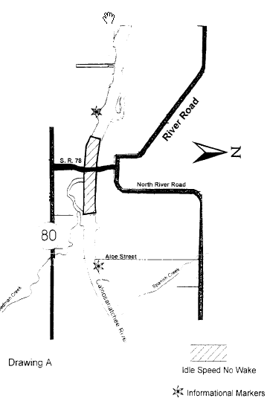
Rulemaking Authority 327.04, 327.46 FS. Law Implemented 327.46 FS. History–New 11-25-96, Formerly 62N-24.136.
68D-24.143 Martin County Boating Restricted Areas.
(1) For the purpose of regulating the speed and operation of vessel traffic on and adjacent to the Intracoastal Waterway in Martin County, Florida, the following Boating Restricted Areas are established:
(a) Jensen Beach Causeway – A Slow Speed Minimum Wake boating restricted area from shoreline to shoreline bounded on the north by a line drawn perpendicular to the centerline of the Florida Intracoastal Waterway 300' feet north of the centerline of the Jensen Beach Causeway (SR 707A) Bridge and on the south by a line drawn perpendicular to the centerline of the Florida Intracoastal Waterway 300' feet south of said bridge, as depicted in drawing A.
(b) N.E. Ocean Boulevard – A Slow Speed Minimum Wake boating restricted area from shoreline to shoreline bounded on the north by a line drawn perpendicular to the centerline of the Florida Intracoastal Waterway 300' feet northwest of the N.E. Ocean Boulevard (SR A1A) Bridge and on the south by a line drawn perpendicular to the centerline of the Florida Intracoastal Waterway 300' feet south of said bridge, as depicted in drawing B.
(c) Hobe Sound Bridge – A Slow Speed Minimum Wake boating restricted area from shoreline to shoreline bounded on the north by a line drawn perpendicular to the centerline of the Florida Intracoastal Waterway 300' feet north of the centerline of the Hobe Sound (SR 708) Bridge and on the south by a line drawn perpendicular to the centerline of the Florida Intracoastal Waterway 300' feet south of said bridge, as depicted in drawing C.
(d) Jupiter Island – A Slow Speed Minimum Wake boating restricted area from shoreline to shoreline bounded on the north by a line drawn perpendicular to the centerline of the Florida Intracoastal Waterway 4,350' feet south of the Hobe Sound (SR 708) Bridge and bounded on the south by a line drawn perpendicular to the centerline of the Florida Intracoastal Waterway 8,295' feet south of said bridge, as depicted in drawing D. The boating restricted area established in this paragraph is applicable only to vessels 35 feet or more in length.
(e) Blowing Rocks – A Slow Speed Minimum Wake boating restricted area from shoreline to shoreline bounded on the north by a line drawn perpendicular to the centerline of the Florida Intracoastal Waterway 500' feet north of the centerline of the fuel dock located at 26° 58.749'' N/80° 05.354'' W and on the south by a line drawn perpendicular to the centerline of the Florida Intracoastal Waterway 500' feet south of said fuel dock centerline, as depicted in drawing E. The boating restricted area established in this paragraph is applicable only to vessels 35' feet or more in length and in effect only from November 1 through April 30 each year. If the fuel dock is closed and its use as a public fueling facility discontinued, the boating restricted area established in this paragraph shall no longer be in force or effect.
(2) The boating restricted areas described in Rule 68D-24.143, F.A.C., are depicted on the following drawings:
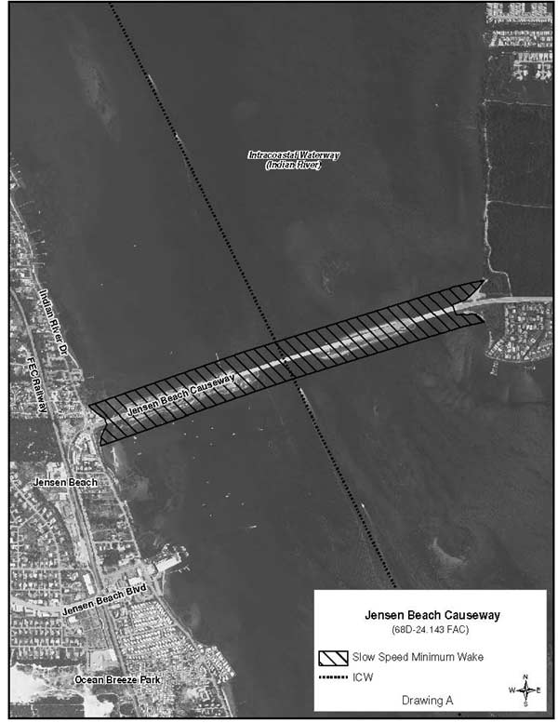
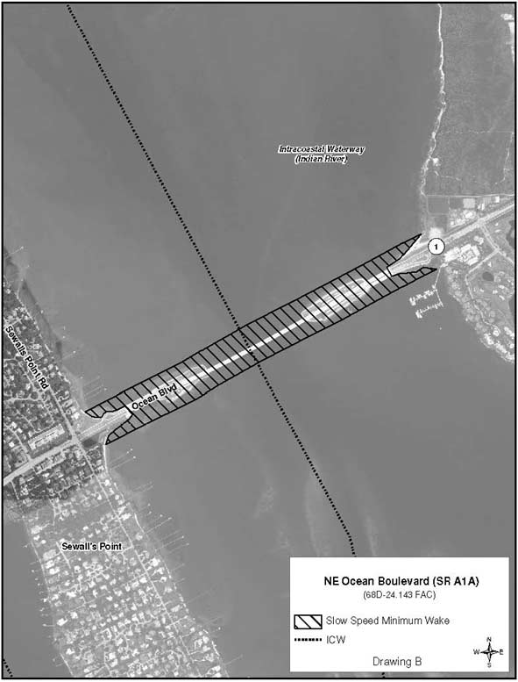

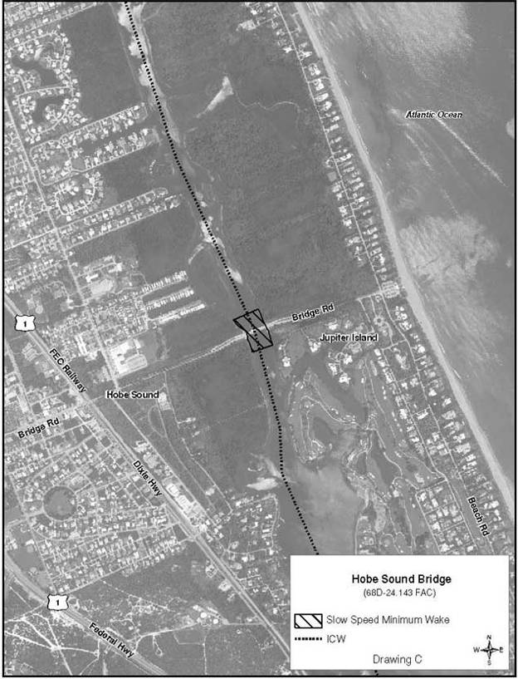
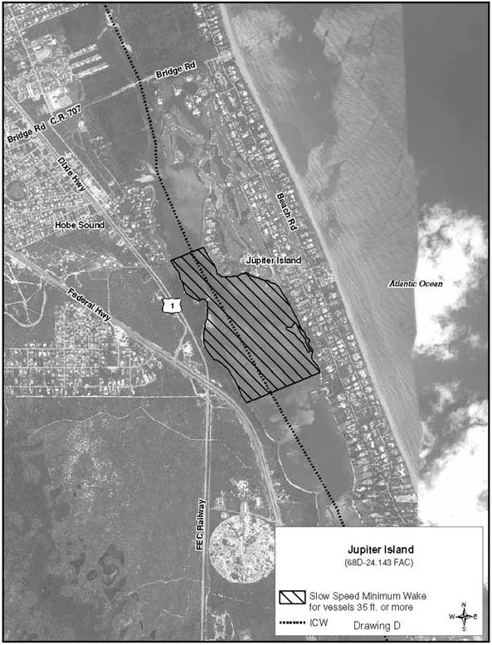
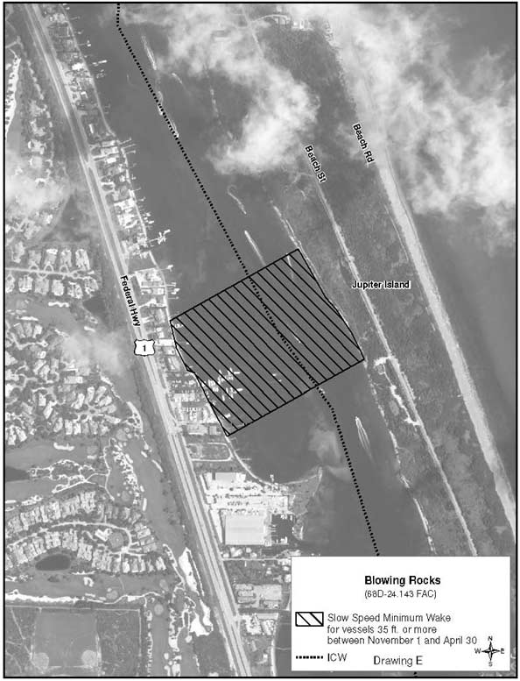

Rulemaking Authority 327.04, 327.46 FS. Law Implemented 327.46 FS. History–New 2-25-96, Formerly 62N-24.143, Amended 1-20-09, 4-22-13.

68D-24.144 Monroe County Boating Restricted Areas.
(1) For the purpose of regulating the anchoring of vessels in and adjacent to the Newfound Harbor Channel (also known as Pine Channel) within Monroe County, the following boating restricted area is established:
Newfound Harbor Channel (Pine Channel) – Anchoring of all sailboats and other vessels with masts is prohibited in Newfound Harbor Channel (Pine Channel), shoreline to shoreline, between Big Pine Key and Little Torch Key, from the centerline of US Highway 1 south to a line drawn from the southernmost point on Little Torch Key to the southernmost point on Big Pine Key (a distance approximately 6,000' feet south of the centerline of US Highway 1), as depicted in Drawing A. If the overhead power lines are removed, the zone established in this paragraph shall no longer be in force or effect.
(2) For the purpose of regulating the speed and operation of vessel traffic on the Florida Intracoastal Waterway (ICW) in Monroe County, the following boating restricted area is established:
Jewfish Creek: A Slow Speed Minimum Wake boating restricted area in and adjacent to the ICW, bounded on the north by a line drawn perpendicular to the centerline of the ICW 300' feet north of the north end of the Jewfish Creek (US Highway 1) Bridge fender system to a line drawn perpendicular to the centerline of the ICW 800' feet south of the south end of the Jewfish Creek (US Highway 1) Bridge fender system, as depicted in Drawing B.
(3) The boating restricted areas are depicted on the following maps:

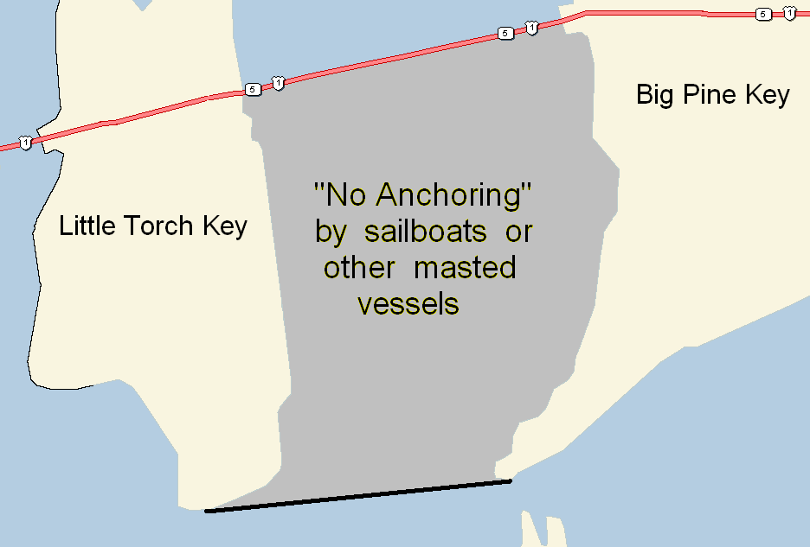
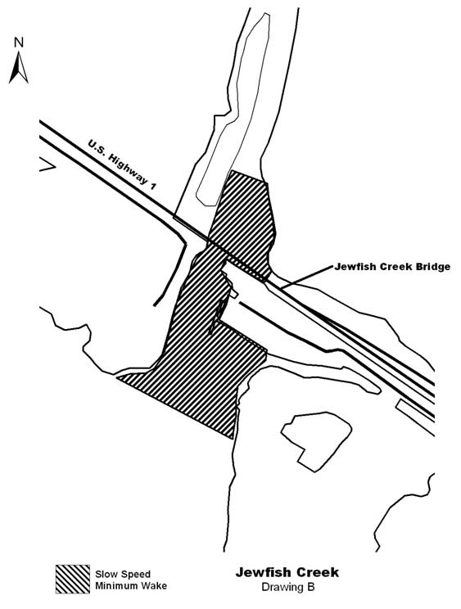
Rulemaking Authority 327.04, 327.46 FS. Law Implemented 327.46 FS. History–New 1-10-07, Amended 8-7-12.

68D-24.146 Okaloosa County Boating Restricted Area.
For the purpose of regulating the speed and operation of vessel traffic on the Florida Intracoastal Waterway within Okaloosa County, Florida, the following boating restricted area is established:
(1) Slow Speed Minimum Wake Zone.
(a) Brooks Bridge – A Slow Speed Minimum Wake zone, shoreline to shoreline, in and adjacent to the Florida Intracoastal Waterway approximately 2,000' feet west from of the centerline of the Brooks Bridge to GPS position 30° 24' 03''/86° 36' 25W", and approximately 3,400 feet east from the centerline of the Brooks Bridge to GPS position 30° 24' 06N''/86° 35' 22W" in Okaloosa County, as depicted in Drawing A.
(b) Okaloosa County is authorized to install and maintain appropriate regulatory markers as directed by the Division of Law Enforcement within the boating restricted area.
(2) The boating restricted area is depicted in Drawing A:
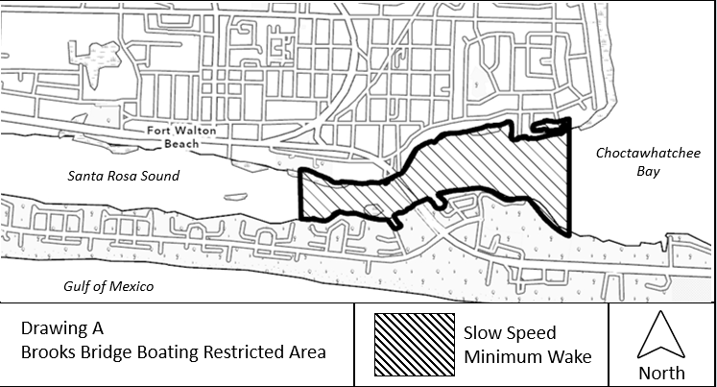
Rulemaking Authority 327.04, 327.46 FS. Law Implemented 327.46 FS. History–New 11-14-01, Amended 9-27-21.

68D-24.155 St. Johns County Boating Restricted Areas.
(1) The following slow speed minimum wake year-round zones are established regulating the speed and operation of vessel traffic on and adjacent to the Florida Intracoastal Waterway within St. Johns County. The zones exclude all associated tributaries, creeks, canals, channels, backwaters, boat basins and other waterways unless otherwise designated or specifically described for inclusion:
(a) Palm Valley Bridge (S.R. 210) – All waters in and adjacent to the Florida Intracoastal Waterway, from shoreline to shoreline, from a line drawn perpendicular to the centerline of the Florida Intracoastal Waterway 500 feet northwest of the Palm Valley Bridge (S.R. 210), to a line drawn perpendicular to the centerline of the Florida Intracoastal Waterway 500 feet southeast of said bridge, as depicted in Drawing A.
(b) Vilano Beach Bridge (A1A) – All waters in and adjacent to the Florida Intracoastal Waterway, from shoreline to shoreline, from a line drawn perpendicular to the centerline of the Florida Intracoastal Waterway 500 feet north of the Vilano Beach Bridge (A1A), to a point on the western shoreline (29° 54.935 N/81° 17.898 W) 200 feet south of the bridge, to a point on the eastern shoreline (29° 54.964 N/81° 18.318 W) 900' feet south of said bridge, as depicted in Drawing B.
(c) Bridge of Lions (A1A) – All waters in and adjacent to the Florida Intracoastal Waterway, from shoreline to shoreline, from a line drawn perpendicular to the centerline of the Florida Intracoastal Waterway 500' feet north of the Bridge of Lions (A1A), to a line drawn perpendicular to the centerline of the Florida Intracoastal Waterway 775' feet southeast of said bridge, as depicted in Drawing C.
(d) S.R. 312 Bridge – All waters in and adjacent to the Florida Intracoastal Waterway, from shoreline to shoreline, from a line drawn perpendicular to the centerline of the Florida Intracoastal Waterway 500' feet north of the S.R. 312 Bridge, to a line drawn perpendicular to the centerline of the Florida Intracoastal Waterway 500' feet south of said bridge, as depicted in Drawing D.
(e) Crescent Beach Bridge (S.R. 206) – All waters in and adjacent to the Florida Intracoastal Waterway, from shoreline to shoreline, from a line drawn perpendicular to the centerline of the Florida Intracoastal Waterway 500' feet northwest of the Crescent Beach Bridge (S.R. 206), to a line drawn perpendicular to the centerline of the Florida Intracoastal Waterway 500' feet southeast of said bridge, as depicted in Drawing E.
(f) Devil’s Elbow Boat Ramp – All waters in and adjacent to the Florida Intracoastal Waterway, from a line drawn perpendicular to the centerline of the Florida Intracoastal Waterway 500 feet northeast of the Devil’s Elbow Boat Ramp, to a line drawn perpendicular to the centerline of the Florida Intracoastal Waterway 500 feet south of said boat ramp, bounded on the west by a line drawn from point (29° 45.112 N/81° 15.071 W) to point (29° 45.263 N/81° 15.092 W), and bounded on the east by the shoreline, as depicted in Drawing F.
(2) The boating restricted areas are depicted on the following drawings:
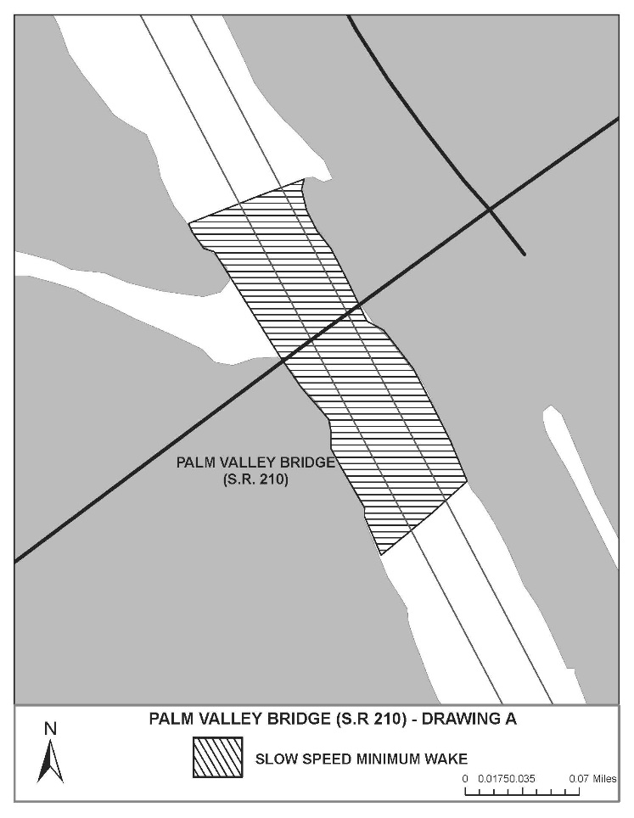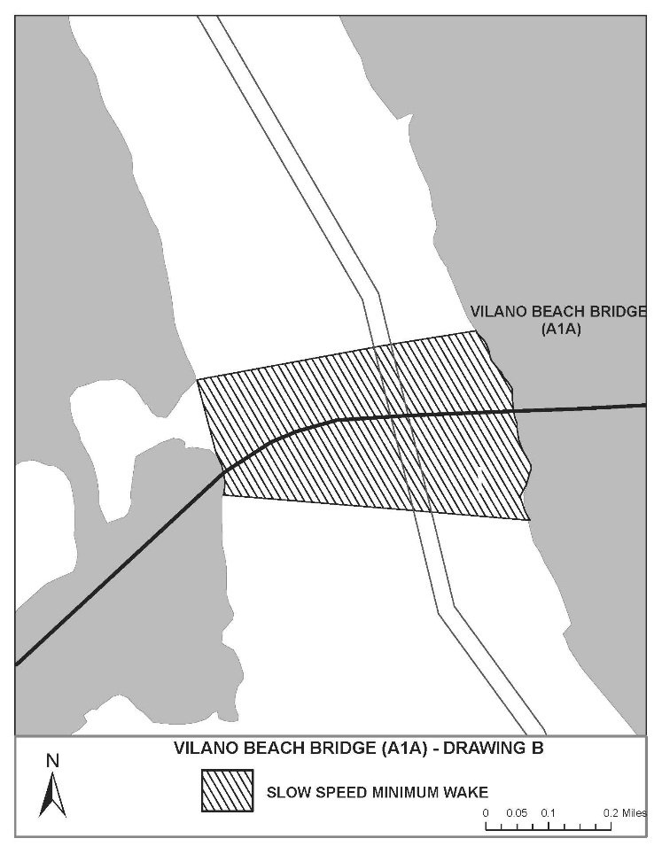
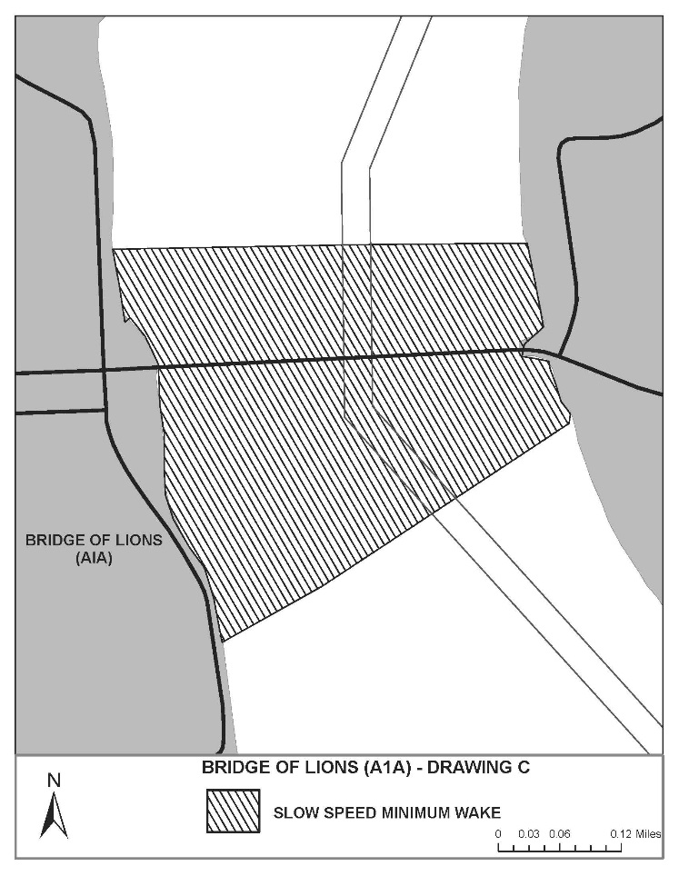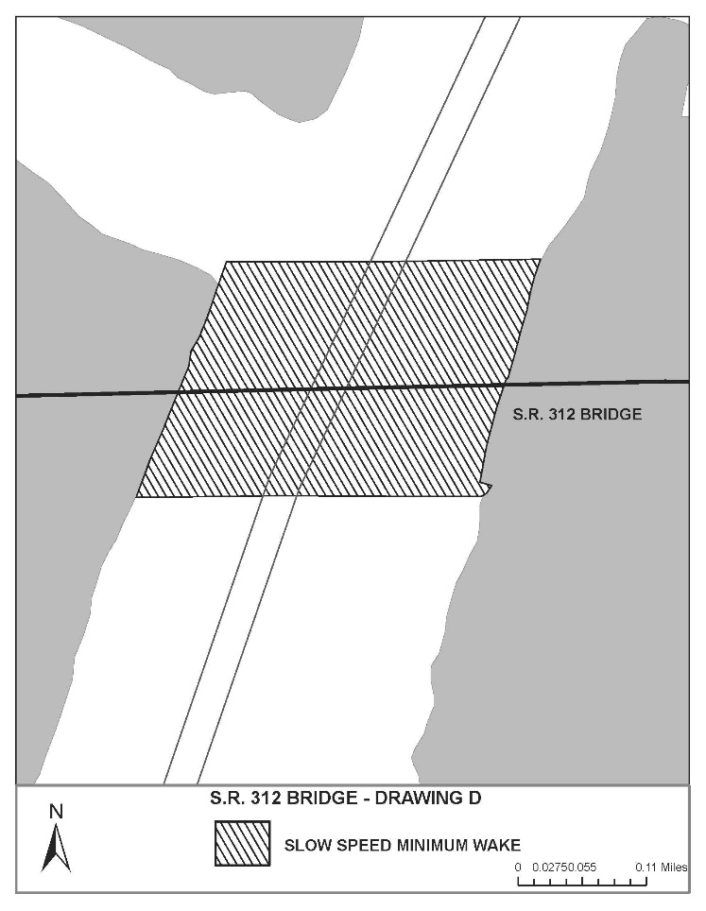
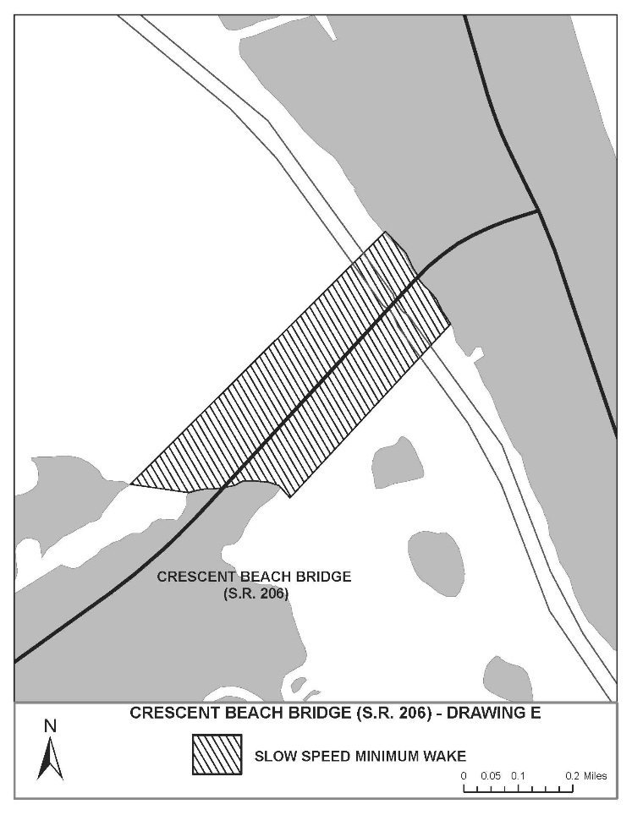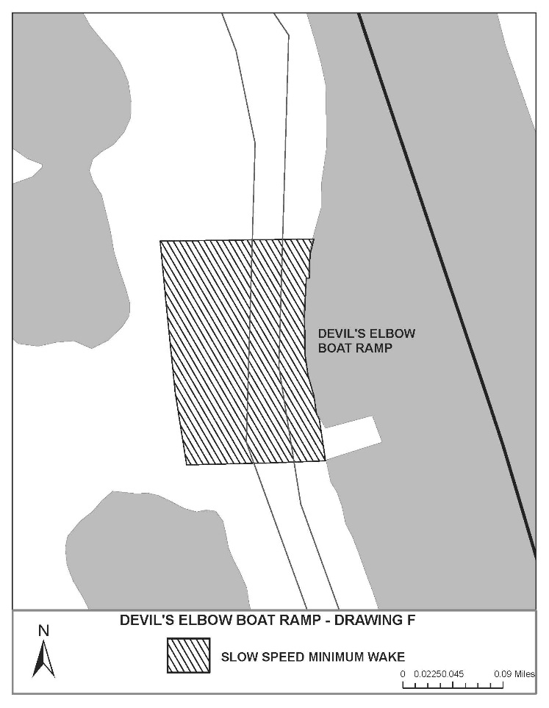
Rulemaking Authority 327.04, 327.46 FS. Law Implemented 327.46 FS. History–New 12-11-97, Formerly 62N-24.155, Amended 11-14-01, 5-23-11, 5-11-15.
68D-24.164 Volusia County Boating Restricted Areas.
(1) For the purpose of regulating the speed and operation of vessel traffic on the Florida Intracoastal Waterway (ICW) bordering eastern Volusia County, including the Indian River and the Halifax River, the following Boating Restricted Areas are established:
(a)1. Ormond Beach: A Slow Speed Minimum Wake boating restricted area from shoreline to shoreline, bounded on the north by a line drawn perpendicular to the centerline of the ICW 300 feet north of the north end of the Highbridge Road Bridge fender system to a line drawn perpendicular to the centerline of the ICW 300 feet south of the centerline of the Highbridge Road Boat Ramp, as depicted in drawing A.
2. Daytona Beach: An Idle Speed No Wake boating restricted area from the western shoreline to the eastern limit of the right-of-way of the ICW from a line drawn perpendicular to the centerline of the ICW 200 feet north of the Main Street Bridge to a line which is 600' feet northerly of and parallel to the centerline of northern span of the Seabreeze Bridge (S. R. 430), as depicted in drawing B.
3. New Smyrna Beach: An Idle Speed No Wake boating restricted area in and adjacent to the ICW, bounded on the north and west by the western shoreline of the Indian River North, bounded on the south by the northern shoreline of Chicken Island and a line drawn due west from the western end of Chicken Island, and bounded on the east by a line drawn due north from the eastern end of Chicken Island, as depicted in drawing C.
4. Edgewater: An Idle Speed No Wake boating restricted area from the western shoreline to the eastern limit of the right-of-way of the ICW from a line drawn perpendicular to the centerline of the ICW 300' feet north of the Kennedy Park boat ramp to a line drawn perpendicular to the centerline of the ICW 500 feet south of the Menard May Park boat ramp, as depicted in drawing D.
(b) Volusia County is authorized to install and maintain Slow Speed Minimum Wake or Idle Speed No Wake markers, as identified herein, and Resume Normal Safe Operation markers at the beginning and end of each of these restricted areas.
(2) The restricted areas are depicted on the following maps:

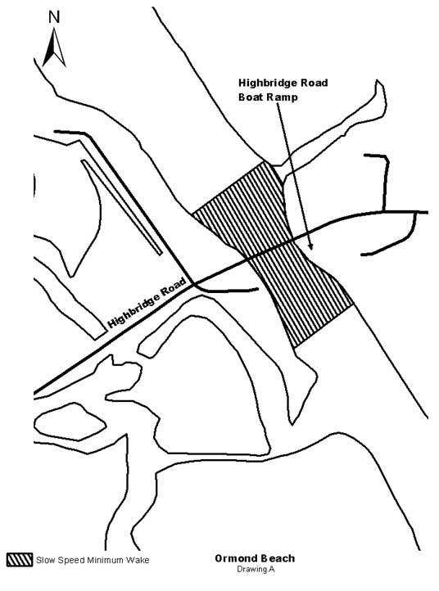

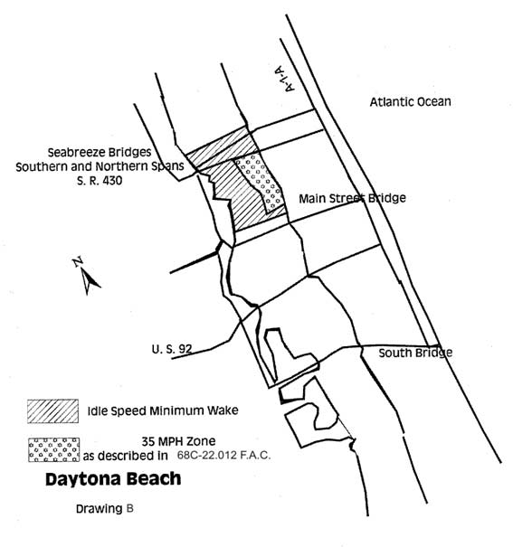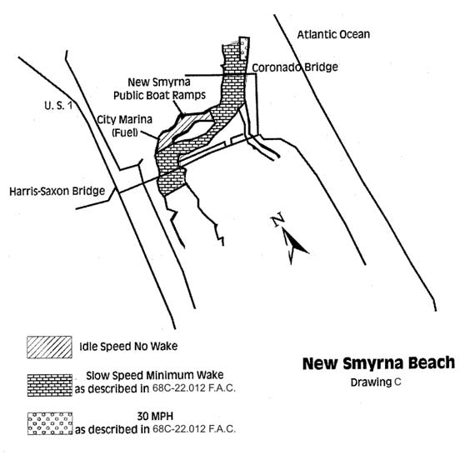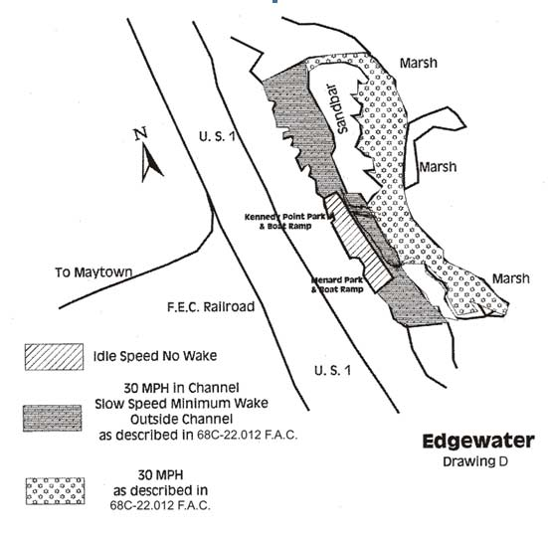
Rulemaking Authority 327.04, 327.46 FS. Law Implemented 327.46 FS. History–New 4-2-87, Formerly 16N-24.009, 62N-24.009, Amended 4-12-99, Formerly 62N-24.164, Amended 10-28-12.

