68C-22.006 Brevard County Zones.
(1) The Commission hereby designates the waters within Brevard County, as described below, as areas where manatee sightings are frequent and where it can be assumed that manatees inhabit on a regular, periodic or continuous basis. The Commission has further determined that a likelihood of threat to manatees exists in these waters as a result of manatees and motorboats using the same areas. The primary purpose of this rule is to protect manatees from harmful collisions with motorboats and from harassment by regulating the speed and operation of motorboats within these designated areas. A secondary purpose is to protect manatee habitat. In balancing the rights of fishers, boaters, and water skiers to use these waterways for recreational and commercial purposes (as applicable under Section 379.2431(2)(k), F.S.) with the need to provide manatee protection, the Commission has examined the need for unregulated areas or higher speed travel corridors through regulated areas. Such areas or corridors are provided in those locations where the Commission determined, on the basis of all available information, (1) there is a need for the area or corridor and (2) the area or corridor will not result in serious threats to manatees or their habitat. Unregulated areas or higher speed corridors are not provided in locations where both of the above findings were not made.
(2) The following year-round and seasonal zones are established, which shall include all associated and navigable tributaries, lakes, creeks, coves, bends, backwaters, canals, and boat basins unless otherwise designated or excluded. As used in this rule, ICW means the Intracoastal Waterway. Access to the No Entry and Motorboats Prohibited zones designated in paragraphs (2)(a) and (b), will be provided in accordance with procedures set forth in subsection (4), hereunder, and applicable provisions of Rule 68C-22.003, F.A.C.
(a) No Entry (November 15 ‒ March 31)
1. Indian River, Reliant Corporation Delespine Power Plant Area: All waters within the discharge canal of the Reliant Corporation Delespine power plant, and; All waters southerly of a line extending eastward from and following the same bearing as the southernmost seawall of the power plant discharge canal, with said line bearing approximately 70°, westerly of a line 250 feet east of and parallel to the western shoreline of the Indian River, and northerly of the jetty on the north side of the power plant intake canal.
2. Indian River, FPL Frontenac Power Plant Area: All waters in the vicinity of the Florida Power and Light (FPL) Frontenac power plant southerly of a line connecting the northern guy wires of the power poles immediately north of the FPL Unit 2 discharge area from the western shoreline of the Indian River to the third power pole east of the western shoreline (approximately 1,650 feet east of the shoreline), and westerly of a line running from said third power pole to the easternmost point (approximate latitude 28° 28' 07'' North, approximate longitude 80° 45′ 19′′ West) of the jetty on the north side of the FPL intake canal.
(b) Motorboats Prohibited (All Year, except as noted) ‒
1. Indian River, Reliant Corporation Delespine Power Plant Area: All waters in the vicinity of the Reliant Corporation Delespine power plant southerly of a line bearing 90° from a point (approximate latitude 28° 29' 41'' North, approximate longitude 80° 46' 35'' West) on the western shoreline of the Indian River ninety-five feet (95') north of the northernmost seawall of the power plant discharge canal, westerly of a line 250 feet east of and parallel to the western shoreline of the Indian River, and northerly of a line extending eastward from and following the same bearing as the southernmost seawall of the power plant discharge canal, with said line bearing approximately 70°. This zone is in effect from November 15 through March 31.
2. C-54 Canal: All waters of the C-54 Canal (South Florida Water Management District Canal 54) east of the spillway (approximate latitude 27° 49' 50'' North, approximate longitude 80° 32' 24'' West) and west of a line drawn perpendicular to the northern shoreline of the C-54 Canal at a point (approximate latitude 27° 49' 55'' North, approximate longitude 80° 32' 00'' West) on the northern shoreline 2,500 feet east of the spillway.
(c) Idle Speed (All Year, except as noted) ‒
1. Indian River, Power Plant Area: All waters west of the western boundary of the ICW channel, south of a line bearing 90° from a point (approximate latitude 28° 30' 13'' North, approximate longitude 80° 46' 48'' West) on the western shoreline of the Indian River approximately three-quarters (3/4) of a mile north of the Delespine power plant discharge canal, and north of a line bearing 90° from a point (approximate latitude 28° 27' 27'' North, approximate longitude 80° 45' 43'' West) on the western shoreline of the Indian River approximately three-fourths of a mile south of the Frontenac power plant discharge canal, except as otherwise designated under paragraph (2)(a) and subparagraph (b)1. This zone is in effect from November 15 through March 31.
2. Banana River, Cape Canaveral Area: All waters north of a line bearing 270° from the southwesternmost point (approximate latitude 28° 23' 29'' North, approximate longitude 80° 37' 10'' West) of Long Point in Cape Canaveral to a point (approximate latitude 28° 23' 29'' North, approximate longitude 80° 37' 49'' West) in the Banana River approximately 3,500 feet west of Long Point, and east of a line bearing 331° from said point in the Banana River to a point (approximate latitude 28° 24' 16'' North, approximate longitude 80° 38' 19'' West) on the State Road 528 Causeway (west of State Road 401).
3. Banana River, Manatee Cove Area: All waters of Manatee Cove (on the east side of the Banana River, just south of State Road 520) east of a line at the mouth of the cove running between a point (approximate latitude 28° 21' 21'' North, approximate longitude 80° 36' 52'' West) on the northern shoreline and a point (approximate latitude 28° 21' 09'' North, approximate longitude 80° 36' 51'' West) on the southern shoreline.
4. Turkey Creek: All waters of Turkey Creek north and east (downstream) of Melbourne-Tillman Drainage District structure MS-1 and south and west of a line at the mouth of Turkey Creek that runs from the southeasternmost point (approximate latitude 28° 02' 21'' North, approximate longitude 80° 34' 48'' West) of Castaway Point to the northeasternmost point (approximate latitude 28° 02' 14'' North, approximate longitude 80° 34' 43'' West) of Palm Bay Point.
5. Sebastian Inlet Area: All waters of the cove on the northern side of Sebastian Inlet (commonly known as Campbell Cove) northwest of a line running between the two (2) rock jetties at the entrance to the cove.
6. Sebastian River Area: All waters of the North Prong of Sebastian River, and; All waters of the North Fork Sebastian River (also known as Sebastian Creek) and the C-54 Canal west of a north-south line from a point (approximate latitude 27° 50' 08'' North, approximate longitude 80° 31' 02'' West) on the northern shoreline of the North Fork Sebastian River at the intersection of the river and the North Prong and east of a line drawn perpendicular to the northern shoreline of the C-54 Canal at a point (approximate latitude 27° 49' 55'' North, approximate longitude 80° 32' 00'' West) on the northern shoreline 2,500 feet east of the spillway.
(d) Slow Speed (All Year)
1. Mosquito Lagoon: All waters west of the ICW channel, south of the Volusia County/Brevard County line, and north of ICW channel marker “43”, and; All waters of Mosquito Lagoon (including the ICW channel) south of ICW channel marker “43,” southwest of a line commencing at ICW channel marker “43” and then running to ICW channel marker “45” and then on a bearing of 132° for a distance of 1,000 feet to the line’s terminus at a point in Mosquito Lagoon (approximate latitude 28° 44' 35'' North, approximate longitude 80° 44' 35'' West), and north of a line running from said point in Mosquito Lagoon on a bearing of 221° to the western shoreline of Mosquito Lagoon.
2. Indian River, Turnbull Basin Area: All waters south and east of a line commencing at a point (approximate latitude 28° 44' 36'' North, approximate longitude 80° 46' 19'' West) on the eastern shoreline of Turnbull Basin (about one (1) mile north of Haulover Canal) and then bearing 193° to a point 1,500 feet northwest of the ICW channel, then running in a southwesterly direction 1,500 feet northwest of and parallel with the ICW channel to a point (approximate latitude 28° 41' 22'' North, approximate longitude 80° 49' 05'' West) 1,500 feet northwest of ICW channel marker “12,” and then running in a southerly direction 1,500 feet west of and parallel with the ICW channel to the Florida East Coast Railroad Bridge, including all waters west of the ICW channel and south of an east-west line 1,500 feet north of the point where the Florida East Coast Railroad Bridge crosses over the ICW, but excluding the ICW channel as designated under subparagraph (2)(e)2.
3. Indian River, Titusville Area: All waters west of the ICW channel south of the Florida East Coast Railroad Bridge and north of the State Road 402 Bridge and Causeway.
4. Indian River, State Road 402 (Max Brewer Causeway) to State Road 405 (NASA Parkway): All waters within 2,000 feet of the general contour of the western shoreline of the Indian River, excluding the ICW channel where the channel is less than 2,000 feet from the western shore; All waters within one (1) mile of the general contour of the eastern shoreline of the Indian River south and east of a point (approximate latitude 28° 36' 04'' North, approximate longitude 80° 44' 44'' West) on the western shoreline of Peacock’s Pocket (northwest of Banana Creek), and; All waters south of an east-west line 3,400 feet north of the point where the State Road 405 Bridge crosses over the ICW, excluding the ICW channel as designated under subparagraph (2)(e)3.
5. Indian River, State Road 405 (NASA Parkway) to State Road 528 (Bennett Causeway): All waters north of an east-west line 3,000 feet south of the point where the State Road 405 Bridge crosses over the ICW, excluding the ICW channel as designated under subparagraph (2)(e)3.; All waters west of the ICW channel and north of the overhead power transmission line that crosses the western shoreline of the Indian River approximately 1,200 feet north of State Road 528, excepting those areas otherwise designated for seasonal regulation under paragraph (2)(a), subparagraphs (b)1. and (c)1., when said seasonal zones are in effect; All waters south of said overhead power transmission line and west of a north-south line running through the second power pole east of the western shoreline; All waters within one half (1/2) mile of the eastern shoreline of the Indian River north of a point (approximate latitude 28° 25' 47'' North, approximate longitude 80° 43' 24'' West) on the eastern shoreline of the Indian River 1,500 feet south of the canal on the southern side of Meadow Lark Lane, including all waters of Rinkers Canal, and; All waters east of the ICW channel and south of the overhead power transmission line that crosses the eastern shoreline of the Indian River approximately 3,900 feet north of State Road 528.
6. Indian River, State Road 528 (Bennett Causeway) to State Road 518 (Eau Gallie Causeway): All waters within 1,000 feet of the general contour of the western shoreline of the Indian River; All waters south of State Road 528 and within 500 feet of the State Road 528 Causeway, within 500 feet of the State Road 520 Causeway, within 500 feet of the State Road 404 Causeway, and north of State Road 518 and within 500 feet of the State Road 518 Causeway; All waters within 1,000 feet of the general contour of the eastern shoreline of the Indian River between State Road 528 and State Road 520; All waters east of the ICW channel from State Road 520 to an east-west line 300 feet south of the southernmost point (approximate latitude 28° 19' 22'' North, approximate longitude 80° 42' 00'' West) of the spoil island east of ICW channel marker “80,” and; All waters within 500 feet of the general contour of the eastern shoreline of the Indian River south of the aforementioned east-west line and north of State Road 404 (Pineda Causeway).
7. Indian River, State Road 518 (Eau Gallie Causeway) to Cape Malabar: All waters within 1,000 feet of the general contour of the eastern shoreline of the Indian River; All waters south of State Road 518 and within 500 feet of the State Road 518 Causeway and within 500 feet of the State Road 192 Causeway; All waters within 1,000 feet of the general contour of the western shoreline of the Indian River south of State Road 518 and north of the easternmost point (approximate latitude 28° 02' 24'' North, approximate longitude 80° 34' 48'' West) of Castaway Point (including all waters of the Eau Gallie River and Crane Creek), and; All waters south of said easternmost point of Castaway Point, north of Cape Malabar, and west of a line commencing at a point (approximate latitude 28° 02' 29'' North, approximate longitude 80° 34' 38'' West) in the Indian River 1,000 feet northeast of said easternmost point of Castaway Point, then bearing 130° to the westernmost point (approximate latitude 28°02' 15'' North, approximate longitude 80° 34' 19'' West) of the spoil site west of ICW channel marker “14,” then bearing 153° to the westernmost point (approximate latitude 28° 01' 32'' North, approximate longitude 80° 33' 55'' West) of the spoil site southwest of ICW channel marker “15,” then bearing 138° to the line’s terminus at a point (approximate latitude 28° 01' 12'' North, approximate longitude 80° 33' 35'' West) in the Indian River approximately 2,400 feet northeast of Cape Malabar.
8. Indian River, Cape Malabar to Grant: All waters within 1,000 feet of the general contour of the eastern shoreline of the Indian River south of Cape Malabar and north of a point (approximate latitude 27° 55' 59'' North, approximate longitude 80° 30' 30'' West) on the eastern shoreline of the Indian River (north of Mullet Creek); All waters south of Cape Malabar, north of the spoil island between ICW channel markers “25” and “27,” and west of a line commencing at a point (approximate latitude 28° 01' 12'' North, approximate longitude 80° 33' 35'' West) in the Indian River approximately 2,400 feet northeast of Cape Malabar, then bearing 157° to the easternmost point (approximate latitude 28° 00' 26'' North, approximate longitude 80° 33' 13'' West) of the spoil site between ICW channel markers “16” and “17,” then bearing 152° to the easternmost point (approximate latitude 27° 59' 21'' North, approximate longitude 80° 32' 35'' West) of the spoil island west of ICW channel marker “22,” then bearing 166° to the line’s terminus at the easternmost point (approximate latitude 27° 57' 50'' North, approximate longitude 80° 32' 10'' West) of the spoil island between ICW channel markers “25” and “27”; All waters within 1,000 feet of the general contour of the western shoreline of the Indian River south of said spoil island between ICW channel markers “25” and “27,” and north of ICW channel marker “35,” and; All waters west of the ICW channel between ICW channel markers “35” and “38.”
9. Indian River, Grant to the Indian River County Line: All waters west of the ICW channel between ICW channel marker “38” and the Brevard County/Indian River County line, including those waters east of the centerline of the U.S. 1 Bridge over the Sebastian River, and; All waters within 1,500 feet of the general contour of the eastern shoreline of the Indian River, south of a point (approximate latitude 27° 55' 59'' North, approximate longitude 80° 30' 30'' West) on the eastern shoreline of the Indian River (north of Mullet Creek) and north of an east-west line running through ICW channel marker “59” (approximate latitude 27° 51' 38'' North, approximate longitude 80° 28' 57'' West), including those waters within 1,500 feet west of the westernmost edge of the Mullet Creek Islands, within 1,500 feet west of the westernmost edge of the islands south of Mathers Cove, within 1,500 feet west of the westernmost edge of Long Point, and within 1,500 feet west of the westernmost extensions of Campbell Pocket south to said east-west line running through ICW channel marker “59,” and; All waters of the Indian River and Sebastian Inlet east of the ICW channel, south of said east-west line running through ICW channel marker “59,” north of the Brevard County/Indian River County line, and west of a line 200 feet southwest of and parallel with the centerline of the State Road A1A Bridge, except as otherwise designated under subparagraph (2)(c)5., and excluding the marked Sebastian Inlet channel.
10. Sebastian River Area: All waters of the Sebastian River (including waters also known as San Sebastian Bay), the South Fork San Sebastian River (also known as St. Sebastian River, Sebastian River and Sebastian Creek), and the North Fork Sebastian River (also known as Sebastian Creek) within Brevard County west of the centerline of the US 1 Bridge and east of a north-south line from a point (approximate latitude 27° 50' 08'' North, approximate longitude 80° 31' 02'' West) on the northern shoreline of the North Fork Sebastian River at the intersection of the river and the North Prong of Sebastian River.
11. Canaveral Barge Canal: All waters of the Canaveral Barge Canal east of the general contour of the eastern shoreline of the Indian River and west of the general contour of the western shoreline of the Banana River.
12. Sykes Creek and Kiwanis Basin: All waters of Sykes Creek and Kiwanis Basin south of the Canaveral Barge Canal and north of the centerline of State Road 520.
13. Newfound Harbor: All waters south of State Road 520 and within 1,000 feet of the State Road 520 Bridge and Causeway; All waters within 1,000 feet of the general contour of the western shoreline of Newfound Harbor north of the runway for the Merritt Island Airport (approximately one mile south of State Road 520), and; All waters within 1,000 feet of the general contour of the eastern shoreline of Newfound Harbor and an extension of said shoreline to a point 1,000 feet south of Buck Point.
14. Banana River, North of State Road 528: All waters within 1,500 feet of the general contour of the western shoreline of the Banana River south of a point (approximate latitude 28° 26' 10'' North, approximate longitude 80° 39' 35'' West) on the shoreline near Kars Park on the boundary of the federal No Motor zone; All waters south of an east-west line running through the westernmost point (approximate latitude 28° 24' 42'' North, approximate longitude 80° 38' 34'' West) of the first spoil island north of the Canaveral Locks (commonly known as Ski Island), including those waters in Port Canaveral west of State Road 401, and; All waters east and south of a line commencing at the northernmost point (approximate latitude 28° 24' 44'' North, approximate longitude 80° 38' 32'' West) of Ski Island, then running to the southernmost point (approximate latitude 28° 24' 55'' North, approximate longitude 80° 38' 31'' West) of the second spoil island north of the Canaveral Locks, then following the eastern shoreline of said spoil island to its northernmost point, then bearing 6° to a point (approximate latitude 28° 25' 09'' North, approximate longitude 80° 38' 29'' West) in the Banana River underneath the overhead power transmission line south of the third spoil island north of Canaveral Locks, then following said transmission line (which is the boundary of the federal No Motor zone) in an easterly direction to the line’s terminus at a point (approximate latitude 28° 25' 16'' North, approximate longitude 80° 36' 13'' West) on the eastern shoreline of the Banana River.
15. Banana River, State Road 528 to State Road 520: All waters south of State Road 528, east of a line bearing 180° from the easternmost point (approximate latitude 28° 24' 18'' North, approximate longitude 80° 38' 53'' West) of the central State Road 528 Causeway, and north of an east-west line 1,000 feet south of the point where the State Road 528 Bridge crosses over the main Banana River channel, except as otherwise designated under subparagraph (2)(c)2.; All waters west of a line running from a point (approximate latitude 28° 24' 16'' North, approximate longitude 80° 39' 30'' West) on the State Road 528 Causeway east of the western State Road 528 Relief Bridge to a point (approximate latitude 28° 21' 26'' North, approximate longitude 80° 39' 32'' West) on the State Road 520 Causeway approximately 1,200 feet west of the water storage tanks, and; All waters south of a line bearing 270° from the southwesternmost point (approximate latitude 28° 23' 29'' North, approximate longitude 80° 37' 10'' West) of Long Point in Cape Canaveral to a point (approximate latitude 28° 23' 29'' North, approximate longitude 80° 37' 49'' West) in the Banana River approximately 3,500 feet west of Long Point, and east of a line bearing 174° from said point in the Banana River to a point (approximate latitude 28° 21' 28'' North, approximate longitude 80° 37' 35'' West) on the State Road 520 Causeway approximately 1,000 feet west of Cape Canaveral Hospital Complex.
16. Banana River, Cocoa Beach Area: All waters east of a line bearing 186° from the westernmost point (approximate latitude 28° 21' 26'' North, approximate longitude 80° 38' 52'' West) of the State Road 520 Causeway east of the main Banana River channel, and within 1,000 feet south of the State Road 520 Causeway; All waters within 1,000 feet of the general contour of the western shoreline of the Banana River, south of State Road 520 and north of Buck Point and an extension of said shoreline to a point 1,000 feet south of Buck Point, excluding the main Banana River channel where the channel is less than 1,000 feet from the western shoreline, and; All waters east of a line commencing at a point (approximate latitude 28° 21' 25'' North, approximate longitude 80° 38' 30'' West) on the State Road 520 Causeway (approximately 2,000 feet east of the State Road 520 Bridge over the main Banana River channel), then bearing 190° to a point (approximate latitude 28° 19' 15'' North, approximate longitude 80° 38' 55'' West) in the Banana River approximately 1,900 feet west of the northwesternmost point of the Cocoa Beach Municipal Park, then bearing 270° to a point (approximate latitude 28° 18' 38'' North, approximate longitude 80° 38' 55'' West) in the Banana River approximately 1,700 feet west of the southwesternmost point of the Cocoa Beach Municipal Park, then bearing 171° for approximately 3,000 feet to a point (approximate latitude 28° 18' 07'' North, approximate longitude 80° 38' 50'' West) in the Banana River east of channel marker “15,” then bearing 124° to a point (approximate latitude 28° 16' 52'' North, approximate longitude 80° 36' 45'' West) in the Banana River 1,000 feet west of the eastern shoreline of the Banana River, then heading in a southerly direction 1,000 feet west of and parallel with the eastern shoreline of the Banana River to the line’s terminus at a point (approximate latitude 28° 15' 51'' North, approximate longitude 80° 36' 38'' West) in the Banana River near the northern boundary of Patrick Air Force Base.
17. Banana River, South of Cocoa Beach to State Road 404 (Pineda Causeway): All waters south of an east-west line running through the southernmost point (approximate latitude 28° 16' 19'' North, approximate longitude 80° 39' 25'' West) of the more southerly of the two islands east of Macaw Way (on Merritt Island) and west of a line bearing 162° from said southernmost point to State Road 404; All waters south and east of the overhead power transmission line in the Banana River adjacent to Patrick Air Force Base, and; All waters north of the centerline of State Road 404 and within 2,000 feet of the State Road 404 Bridges and Causeway, excluding the main Banana River channel as designated under subparagraph (2)(e)5.
18. Banana River, South of State Road 404 (Pineda Causeway): All waters south of the centerline of State Road 404, including those waters east of a line bearing 270° from the southernmost point (approximate latitude 28° 08' 32'' North, approximate longitude 80° 36' 15'' West) of Merritt Island (commonly known as Dragon Point) to the Eau Gallie Causeway, excluding the main Banana River channel as designated under subparagraph (2)(e)5.
(e) 25 MPH (All Year)
1. Mosquito Lagoon: All waters in the ICW channel south of the Volusia County/Brevard County line and north of ICW channel marker “43” (north of Haulover Canal).
2. Indian River, Turnbull Basin and Titusville Area: All waters in the ICW channel southwest of ICW channel marker “1” (southwest of Haulover Canal) and north of an east-west line 1,200 feet south of the point where the Florida East Coast Railroad Bridge crosses over the ICW.
3. Indian River, State Road 405 (NASA Parkway) Area: All waters in the ICW channel south of an east-west line 3,400 feet north of the point where the State Road 405 Bridge crosses over the ICW and north of an east-west line 3,000 feet south of the point where the State Road 405 Bridge crosses over the ICW.
4. South Indian River Area: All waters in the ICW channel south of ICW channel marker “59” and north of the Brevard County/Indian River County line.
5. South Banana River Area: All waters in the main Banana River channel south of a point in the channel 2,000 feet north of the State Road 404 Bridge, and north of a point (approximate latitude 28° 09' 15'' North, approximate longitude 80° 36' 32'' West) in the channel on the northern boundary of the local Idle Speed zone approximately 1,900 feet north of the Mathers Bridge.
(3) Commercial Fishing and Professional Fishing Guide Permits: The following provisions pertain to the issuance of permits to allow individuals engaged in commercial fishing and professional fishing guide activities to operate their vessels in specified areas at speeds greater than the speed limits established under subsection (2), above. Procedures related to the application for and the review and issuance of these permits are as set forth in Rule 68C-22.003, F.A.C.
(a) Permits shall be limited as follows:
1. Permits shall only be available for the zones or portions of zones described under subparagraphs (2)(d)1. through (2)(d)9., and (2)(d)13. through (2)(d)18.
2. Permits shall not apply on weekends or on the holidays identified in Section 110.117, F.S.
(b) Permit applications may be obtained at the Commission’s Law Enforcement office at 1-A Max Brewer Memorial Parkway in Titusville or by contacting the Commission at Mail Station OES-BPS, 620 South Meridian Street, Tallahassee, Florida 32399, (850)922-4330.
(4) Access to the No Entry and Motorboats Prohibited zones is allowed for Reliant Corporation employees or their authorized agents (for the zones designated under subparagraphs (2)(a)1. and (b)1.), and for Florida Power and Light Company employees or their authorized agents (for the zone designated under subparagraph (2)(a)2.) provided that entry into the zones is necessary to conduct activities associated with power plant maintenance, emergency operations or environmental monitoring. The Commission must receive notification of the activity prior to its commencement. In the event of an emergency activity, the Commission shall be notified no more than one week after the activity has been commenced. All vessels used in the operation or associated with the activity shall be operated at no greater than Idle Speed while within the zones and must have an observer on board to look for manatees.
(5) The zones described in subsection 68C-22.006(2), F.A.C., are depicted on the following maps, labeled “Brevard County Manatee Protection Zones.” The maps are intended as depictions of the above-described zones. In the event of conflict between the maps and descriptions, the descriptions shall prevail.
(6) The amendments of subsections 68C-22.006(2) through (5), F.A.C., as approved by the commission on May 23, 2001, shall become effective when the requisite regulatory signage is posted or erected in the designated waterway or segment of waterway of Brevard County or six (6) months from the date the rule amendments are filed for adoption, whichever is sooner.
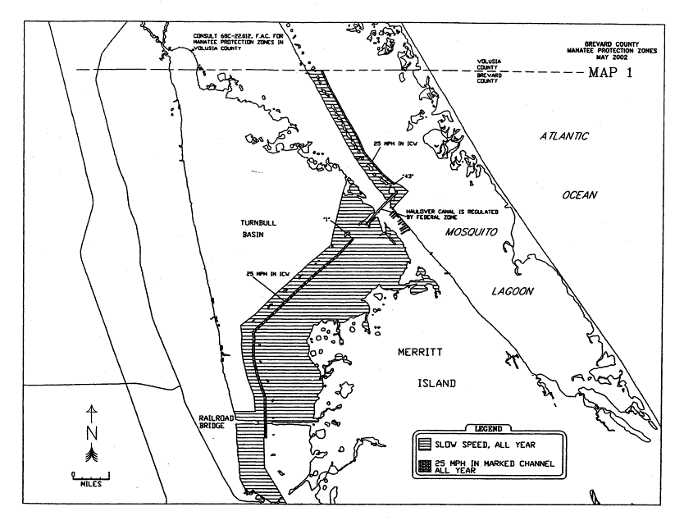
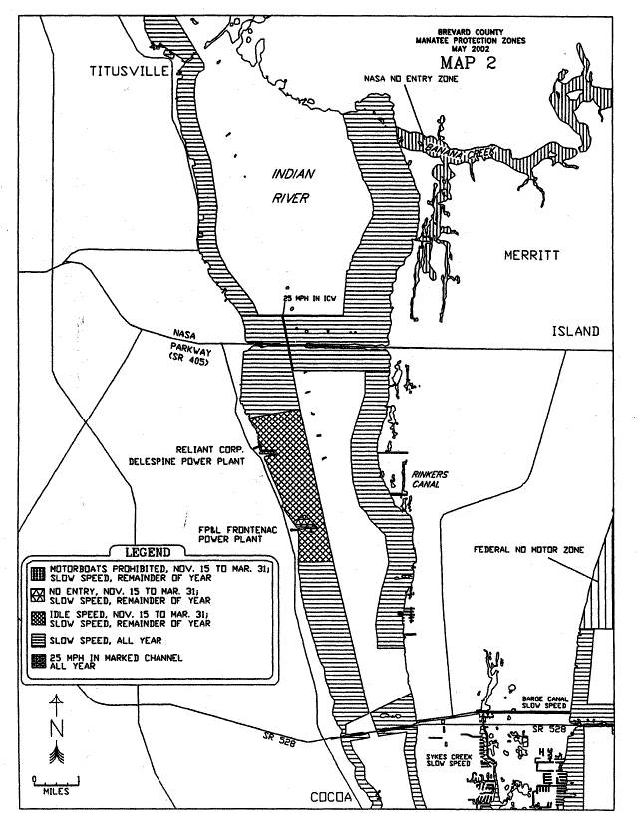
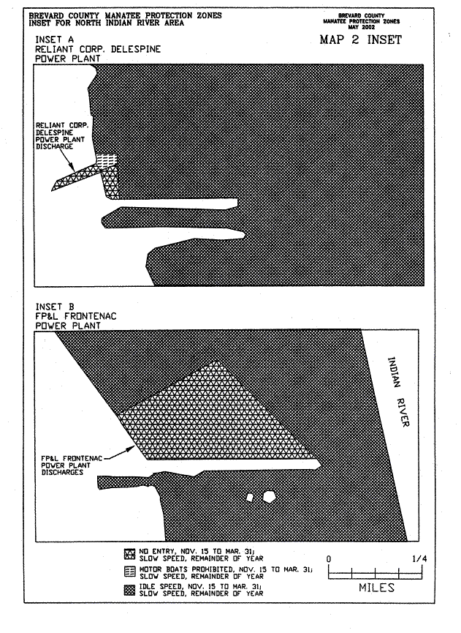
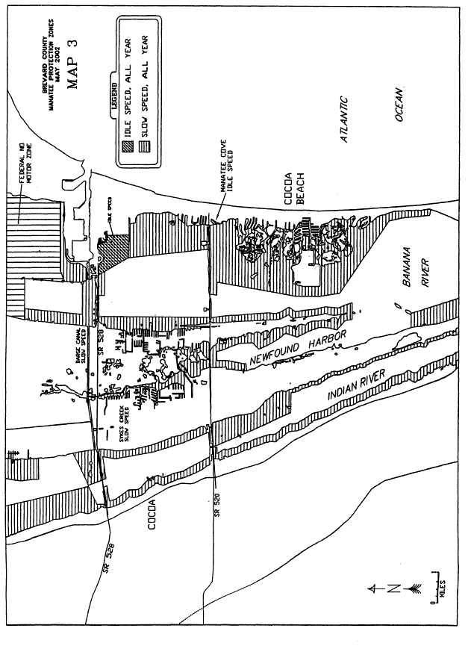
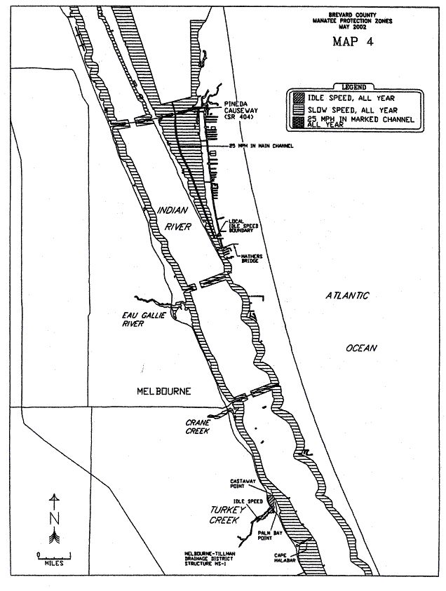
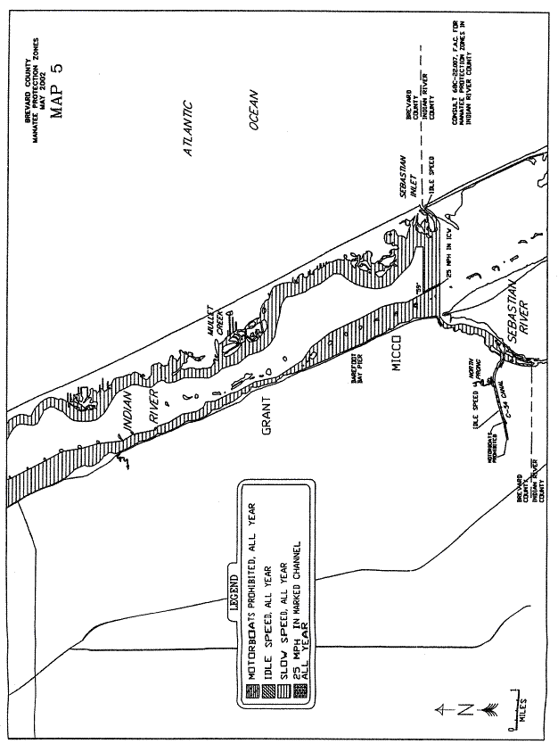
Rulemaking Authority 379.2431(2) FS. Law Implemented 379.2431(2) FS. History–New 3-19-79, Formerly 16N-22.06, Amended 12-20-89, 8-28-90, 7-25-91, 8-18-92, Formerly 16N-22.006, Amended 10-12-94, 12-29-98, Formerly 62N-22.006, Amended 6-24-02.

